Strong and Resilient Communities Evaluation

Report
February 2021




Report prepared for:
Department of Social Services
Report prepared by:
The Social Research Centre
Level 9, 277 William Street
MELBOURNE VIC. 3000

www.srcentre.com.au
Version: 1.2 – 8 February 2021

Contents
List of abbreviations and terms v
Key Messages vi
Executive Summary viii
1. Introduction 1
1.1. What is the Strong and Resilient Communities Activity? 1
1.2. Evaluation aims and objectives 2
2. Methodology 3
2.1. Evaluation approach 4
2.1.1. Evaluation methods 4
2.1.2. Limitations 6
2.1.3. Quality assurance 7
3. Findings 8
3.1. Appropriateness 8
3.1.1. Promotion of the SARC Activity 9
3.1.2. Appropriateness and diversity of SARC Activity funded projects 9
3.2. Process 13
3.2.1. Effectiveness of the SARC Activity governance and reporting systems 13
3.2.2. Lessons learned from the implementation of the SARC Activity 15
3.3. Effectiveness of program design 16
3.3.1. Participants engaged through the SARC Activity 18
3.3.2. Effectiveness of project delivery 20
3.4. Impact of the SARC Activity 21
3.4.1. Short-term outcomes achieved 23
3.4.2. Success factors and barriers 26
3.4.3. Future opportunities for assessing impact 26
3.5. Efficiency 28
3.5.1. Efficiency of project and grant management 29
3.5.2. Economic review 29
4. Conclusion 31
References 35
Appendix A Overview of the SARC Activity 40
Appendix B Conceptual evaluation framework 43
Appendix C Revised Program logic (Version 1.2) 49
Appendix D Evaluation methods 51
Appendix E Evaluation limitations 65
Appendix F Departmental consultation results 71
Appendix G Secondary data analysis 75
Appendix H Online survey of SARC Activity Project Leads results 86
Appendix I Case Study Results 108
Appendix J Economic review results 146
Appendix K Other national data sources reviewed 159

List of figures
Figure 1 Proportion of SARC Activity applications funded (n=1,176) 10
Figure 2 Number of funded projects by target group and SARC Activity stream (n=95) 11
Figure 3 Proportion of population groups supported by SARC Activity projects 19
Figure 4 Conceptual outcomes framework elements 27
Figure 5 Example SARC Activity outcomes, indicators and measures 27
Figure 6 SARC Activity individual clients and group clients, as at 30 June 2020 (n=155,917) 67
Figure 7 Proportion of individual clients with profile data missing or incomplete, as at 30 June 2020 (n=14,013)* 68
Figure 8 Proportion of individual clients assessed for SCORE outcomes, as at 30 June 2020 (n=15,935)* 69
Figure 9 Tools used to assess SCORE outcomes for individual clients 70
Figure 10 Proportion of applications assessed by SARC Activity stream (n=1,176) 75
Figure 11 Proportion of applications assessed by state/territory (n=1,176) 76
Figure 12 Proportion of SARC Activity applications funded and identified as suitable for funding (n=1,176) 77
Figure 13 Inclusive Communities/Community Resilience applications assessed by target group (n=1,176) 78
Figure 14 Proportion of Inclusive Communities/Community Resilience funded projects by target group 79
Figure 15 Proportion of SARC delivery organisation* by remoteness category, as at 30 June 2020 80
Figure 16 Proportion of delivery outlets* by state or territory, as at 30 June 2020 80
Figure 17 Number of funded projects by target group and Activity stream (n=95) 81
Figure 18 Age group of individual clients recorded in DEX over 5 reporting periods to 30 June 2020 83
Figure 19 Average SCORE Circumstances - Community Participation and Networks recorded in DEX to 30 June 2020 84
Figure 20 Average SCORE Circumstances - Employment recorded in DEX to June 2020 84
Figure 21 Average SCORE Goals – Engagement with services in DEX to 30 June 2020 85
Figure 22 Proportion of organisations funded for one, two or three or more projects 86
Figure 23 Proportion of SARC projects by SARC funding stream 87
Figure 24 Proportion of SARC projects being delivered in each state or territory 87
Figure 25 Number of people working in organisations conducting SARC projects 88
Figure 26 Proportion of respondents reporting main area of focus for their organisations 89
Figure 27 Proportion of project leads reporting how their organisation learnt about the SARC activity 90
Figure 28 Proportion of project leads reporting they agree with the following experiences with SARC application and activity 91
Figure 29 Proportion of project leads reporting how their organisation collects and reports performance information 92
Figure 30 Proportion of project leads’ experiences using DEX to report on project performance 94
Figure 31 Proportion of population groups supported by SARC projects 95
Figure 32 Proportion of project leads reporting their experiences of SARC project delivery 96
Figure 33 Proportion of project leads who described the selected SARC project aims, by SARC funding stream 97
Figure 34 Proportion of selected whole of community and early intervention SARC project aims and level of success in achievement 98
Figure 35 Proportion of selected social and economic participation project aims and level of success in achievement 99
Figure 36 Proportion of selected community services engagement project aims and level of success in achievement 100
Figure 37 Proportion of selected positive attitude project aims and level of success in achievement 101
Figure 38 What has supported and/or prevented achievement of project aims 102
Figure 39 Project leads’ suggestions or comments about how the SARC activity could be improved 103
Figure 40 Current status of SARC projects, as at August 2020 105
Figure 41 Proportion of project leads reporting their experiences of SARC project delivery 106
Figure 42 Proportion of project leads reporting SARC funding increased their ability to meet the needs of the following groups in the community to a great extent 107
Figure 43 Success in reducing social isolation in the last 12 months 147
Figure 44 Success in improving physical health in the last 12 months 149
Figure 45 Success in increasing social cohesion in the last 12 months 152
Figure 46 Success in promoting volunteering in the last 12 months 154
Figure 47 Success in improving mental health and wellbeing in the last 12 months 156
Figure 48 ‘To what extent do you have a sense of belonging in Australia?’, 2007-19 (Markus, 2019) 160

List of tables
Table 1 Appropriateness – Evaluation questions, post-implementation outcomes and data sources 8
Table 2 Process – Evaluation questions, process outcomes and data sources 13
Table 3 Effectiveness of program design – Evaluation questions, design outcomes and data sources 17
Table 4 Impact of SARC – Evaluation questions, outcomes and data sources 22
Table 5 Efficiency – Evaluation questions, outcomes and data sources 28
Table 6 List of all documents reviewed 51
Table 7 Number of departmental stakeholders engaged 53
Table 8 Key informants 54
Table 9 Departmental delivery staff consultations 54
Table 10 Selected case study projects 62
Table 11 Overview of case study sample 63
Table 12 Example national sources that may inform future development of SARC outcome measures 163

List of abbreviations and terms
ABN | Australian Business Number
ABS | Australian Bureau of Statistics
AMWCHR | Australian Muslim Women's Centre for Human Rights
AWP | Activity Work Plan
CALD | Culturally and linguistically diverse
DAE | Deloitte Access Economics
DALY | Disability adjusted life years
DEX | Data Exchange
DSS; the Department | Department of Social Services
FAM | Funding Arrangement Manager
OECD | Organisation for Economic Co-operation and Development
PIR | Post Implementation Review
PSG | Program Specific Guidance
QALY | Quality-adjusted life year
SAP | Selection Advisory Panel
SARC | Strong and Resilient Communities
SBS | Special Broadcasting Service
SC | Strengthening Communities
SCORE | Standard Client/Community Outcomes Reporting
SRC | Social Research Centre
VFM | Value for Money assessment

Key Messages
Overall, the evaluation showed Strong and Resilient Communities (SARC) Activity to be an appropriate program that contributes positively to social and economic participation of vulnerable and disadvantaged people and builds strong, resilient and cohesive communities. The evaluation revealed opportunities for ongoing improvements in terms of program design and management. Assessment of the effectiveness of the SARC Activity is currently limited and requires more time, and improvements to data collection and reporting to gather evidence on SARC Activity outcomes.
The key messages from this evaluation include the following:
- The number of SARC Activity applications far exceeded the funding available, with 7% of Inclusive Communities and 11% of Community Resilience applications funded. Many of the applications were assessed unsuitable for funding. More specific guidance would be useful to clarify SARC Activity objectives and the desired outcomes for applicants.
- SARC Activity funded projects targeted many different community groups. Limited numbers of projects were funded that targeted older Australians and those demonstrating intolerance (e.g. on racial, religious or cultural grounds). It may be useful to reassess target groups and a mechanism to ensure all groups are adequately represented in the funding in future grant application processes.
- The Activity Work Plans have been useful for grant recipients and the Department of Social Services (the Department) alike in that they are tailored more for SARC activities and provide a record of approaches that have been utilised during the course of the project. The Data Exchange (DEX) system presents challenges for some SARC activities where client level data is not possible to collect. Ongoing DEX reporting improvements could be achieved by including enhanced guidance on extended demographics and Standard Client/Community Outcomes Reporting (SCORE) in DEX Program Specific Guidance material. Such an enhancement could support a greater number of organisations to complete the non-mandatory reporting requirements. This would also support improvements in accuracy and appropriateness of the DEX data for use in measuring SARC outcomes.
- While grant management arrangements in place for SARC have generally worked well, there is an opportunity to improve the grantee experience and their ‘readiness’ to begin offering funded services through early engagement with the Department. This could focus on new or inexperienced grantees and cover topics such as clarifying grant spending rules to obtaining necessary documentation and assisting grantees with the setup of appropriate accounting and financial reporting mechanisms.
- The evaluation found that the current reporting requirements do not provide the evidence necessary to measure the impact of SARC Activity in the short, medium or long terms. There are several opportunities to address this gap, including enhancing the outcomes to be more relevant and making it mandatory for grantees to report on SCORE to improve completeness of this data.
- The development of an outcomes framework with well-defined indicators, measures and data collection guidance for funded organisation would also provide an opportunity for ongoing improvements in SARC outcomes assessment.
- The evaluation found significant overlap of target groups and aims of projects across Community Resilience and Inclusive Communities funding streams. Future funding rounds may benefit from simplifying SARC into one stream.
- Flexibility in SARC funding has given grant recipient organisations the freedom to deliver activities that are best suited to the needs of target groups in their community and is considered a key strength of the program design. There is a need to provide clearer guidance on what a community-driven approach is and whether this approach is a prerequisite for funding through SARC.
- Value for money was not measured in this evaluation due to data limitations. There is an opportunity to improve the data in the future which would allow value for money to be measured through adapting collection variables, timelines and processes and by focusing on outcomes.

Executive Summary
The Australian population is made up of many culturally diverse communities, which can be considered one of the country’s strengths, but diverse communities have also experienced elements of disadvantage and exclusion. The concepts of social cohesion and community resilience are vital in strengthening not only those who may experience forms of disadvantage, but also the broader community members so that everyone can thrive with a strong sense of belonging. Social cohesion is described well by Dick Stanley (2003) as:
“the willingness of members of society to cooperate with each other in order to survive and prosper”.
The Department of Social Services’ (the Department) Strong and Resilient Communities (SARC) Activity aims to build strong, resilient, cohesive and harmonious communities to ensure that individuals, families and communities have the opportunity to thrive, be free from intolerance and discrimination, and have the capacity to respond to emerging needs and challenges. The SARC Activity has been providing grant funding from 1 April 2018, replacing the previous Strengthening Communities activity, across three grant programs: Community Resilience, Inclusive Communities and National Research.
The evaluation used a mixed methods approach to assess the appropriateness, effectiveness and efficiency of SARC. We drew on evidence and insights from SARC stakeholders and participants, SARC program reports and administrative data. Several limitations were encountered in this evaluation including the impact of COVID-19 on the data collection activities, and data quality limitations of some data sources. Nonetheless, valuable evidence and insights were drawn from multiple sources that have informed the key findings and conclusions of this evaluation.
Promotion of the SARC Activity and appropriateness of SARC Activity funded projects
- The SARC Activity was effectively promoted to the community sector and built upon the existing profile of the previous Strengthening Communities Activity.
- A small number of SARC Activity applications were successful in having their projects funded. The interest in SARC far exceeded available funding and there was also a large number of applications assessed as unsuitable, particularly for the Inclusive Communities Activity stream.
Opportunity: More specific guidance is needed around SARC objectives and the outcomes expected to be achieved through grant-funded projects. The development of an outcomes framework with well-defined indicators, measures and data collection guidance for funded organisation would provide an opportunity for improvements in SARC outcomes assessment for ongoing monitoring and evaluation.
- Representation of target groups was varied. Funded projects covered a range of target groups, particularly socially and economically isolated people, culturally and linguistically diverse groups, and children and youth. Few funded projects targeted older Australians and groups/individuals demonstrating intolerance.
Opportunity: If the Department chooses to continue targeting older Australians and those exhibiting intolerance through SARC funding then more emphasis is needed on these populations in the grant application and selection process.
- The broad scope and flexibility of SARC has been widely applauded by stakeholders. While this has been cited as a key to the success of SARC it also poses challenges in selecting projects that are best suited to improving social cohesion and in measuring the outcomes achieved through the Activity.
Opportunity: A well-designed outcomes framework for SARC could support improvements in the selection of projects that best-fit the clearly defined outcomes. This would also provide a clear, unambiguous foundation for applicants to design effective, evidence-informed projects that directly address the outcomes, indicators and measures included in such an outcomes framework.
Effectiveness of SARC Activity governance & reporting systems and lessons learned from the implementation of the SARC Activity
- Governance and communication with the Department was generally reported to be positive. An issue reported by some project staff was high turnover of Departmental staff, resulting in communication difficulties and delays.
- Grant recipients have found it relatively easy to meet SARC Activity reporting requirements, although there have been some limitations to the data they have reported in the Data Exchange (DEX) and Activity Work Plans (AWPs).
Opportunity: There may be potential to align the two existing SARC Activity reporting systems (DEX and AWPs) with a clear, overarching set of outcomes that would provide grant recipients with a fit-for-purpose system for reporting and tracking progress. Introducing a comprehensive and integrated system with clearly defined outcomes for SARC Activity funded organisations would assist in measuring the impact of the SARC Activity funding more accurately into the future.
- Grant management arrangements in place for the SARC Activity have worked well and have been supported through the effective use of AWPs.
- Some new grant recipient organisations were unable to begin implementation promptly due to lack of understanding of grant spending rules, obtaining required documentation, and setting up appropriate accounting and financial reporting mechanisms.
Opportunity: To improve the grantee experience and their ‘readiness’ to begin offering funded services through early engagement by the Funding Arrangement Managers (FAMs). This intensive engagement is needed to ensure grant recipients can begin implementation as soon as their grant is approved.
Participants engaged through the SARC Activity and Effectiveness of project delivery
- A broad range of target groups have been engaged across both the Community Resilience and Inclusive Community funding streams. Funded projects have supported target groups in line with the objectives of the SARC Activity. There is little distinction between the target groups of each funding stream.
- The flexibility of the SARC funding has given grant recipient organisations the freedom to deliver activities that are best suited to the needs of target groups. As a result, it is evident that there are many similarities in the intended aims of projects across SARC funding streams.
Opportunity: Future funding rounds may benefit from simplifying SARC into one stream. The Department could reassess the target populations included and provide further clarity around the focus and the desired outcomes in the grant selection process. There is also a need to provide clearer guidance on what a community-driven approach is and whether this approach is a prerequisite for funding through SARC.
- SARC funded projects have generally been delivered as intended, although
COVID-19 has posed challenges for some projects and resulted in lower participant numbers and delays to some activities.
- Some projects administer their own participant feedback collection mechanisms (such as post-event surveys). This was identified by some case study participants, but these data sources were not available for assessment in this evaluation.
Opportunity: These may provide an opportunity for gathering information from these participant feedback collection mechanisms to inform future assessment of SARC outcomes.
Short-term outcomes achieved, success factors and barriers
- There is evidence that SARC has been perceived to have positively contributed to whole of community and early intervention responses to address cohesion, improvements in social and economic participation, engagement with services and positive attitudes towards the community. This was reflected in findings drawn from the perceptions of project leads and other SARC project stakeholders and participants. It is not possible to determine the extent to which SARC outcomes have been achieved as the data to support this conclusion is subject to some limitations.
Opportunity: Enhance the ability to measure impact into the future including making SCORE reporting mandatory for grantees and developing an outcomes framework with indicators and measures that can be collected by funded organisations.
- It was not possible to assess the impact of National Research projects because of limited survey responses and no other sources for data triangulation as a result of consultations with National Research project leads being removed from the evaluation design.
Efficiency of project and grant management and extent to which SARC Activity projects represent value for money for the Australian Government
- Some project leads indicated the grant funding was not sufficient to meet the project costs, suggesting that other funding sources were also used by these grant recipients.
- There was also feedback regarding delayed or underspending of SARC Activity funds. Support was provided by the Department to find flexible solutions around possible extensions or alternative uses for the funds.
- Due to data quality limitations, it was not possible to conduct a value for money assessment of the SARC Activity.
Opportunity: There is an opportunity to improve outcomes-focussed data which would allow value for money to be measured. This should include data being collected prior, during, and at the end of the project/program for individual participants. Outcomes data should be captured to avoid self-selection bias (for example by stipulating compulsory reporting of paired data). To support the conduct of a value for money assessment in future, outcomes should be structured so they can be ‘monetised’ where possible, which involves the derivation of monetary values for the outcomes of interest.
Conclusion
This evaluation found that the implementation of the SARC Activity was quite successful at engaging and promoting the goal of greater social cohesion in communities. We have identified opportunities for improving the ongoing implementation, process, design and efficiency of the program which should enhance program management capabilities and grantee performance. That said, the greatest challenge will be building the capability to measure the impact of the program on participants, communities and populations. We have described the need for an overarching outcomes framework which could form the foundation of data collection for measuring impact.

Introduction
In recent years, the Australian Government has introduced a raft of measures to build social cohesion in communities, including initiatives to improve employment, community engagement and encourage tolerance towards culturally and linguistically diverse (CALD) and Aboriginal and Torres Strait Islander communities.
The Social Research Centre (SRC) and their sub-contractor Deloitte Access Economics (DAE) were engaged by the Australian Department of Social Services (DSS, the Department) to evaluate one of these initiatives: the Strong and Resilient Communities (SARC) Activity.

What is the Strong and Resilient Communities Activity?
The SARC Activity is an innovative component of the Department’s Families and Community Program. It focuses on strengthening the capacity of communities experiencing disadvantage to become more resilient and inclusive through greater community engagement, participation and belonging in the local community.
The SARC Activity commenced on 1 April 2018 and replaced the Department’s Strengthening Communities Activity. Organisations are funded up to 30 June 2021 across three grant programs: Community Resilience, Inclusive Communities and National Research.
 |  | 
Inclusive Communities  Increases social and economic participation of vulnerable and disadvantaged people through one-off time-limited projects. | Community Resilience  Builds strong, resilient and cohesive communities by funding projects addressing issues in communities that show early signs of low social cohesion. | National Research  Builds the Government’s understanding of emerging and existing social cohesion issues and increase the evidence base for informing government policies and programs.
Across the three grant programs, the SARC Activity aims to build social cohesion in communities by funding community organisations to deliver one-off and time-limited projects that result in cohesive communities where families and individuals have access to social and economic opportunities without experiencing intolerance.
A broad range of groups were targeted through the SARC Activity including communities at risk of low social cohesion, children and young people, people with a disability and/or mental illness, women, CALD communities, Aboriginal and Torres Strait Islander communities, unemployed people, socially isolated people and older Australians. The SARC Activity funded projects targeting these groups across metropolitan, regional and rural areas across Australia.
A more detailed description of the SARC Activity and its origins is in Appendix A.

Evaluation aims and objectives
The purpose of this evaluation is to assess the appropriateness, effectiveness and efficiency of the SARC Activity against its intended objectives and outcomes. It draws on evidence and insights to inform the design of current and future grant programs of a similar nature. The evaluation:
- Reviews the implementation, governance and reporting arrangements for the Strong and Resilient Communities Activity and identifies areas for improvement to help to ensure successful delivery.
- Documents and synthesises lessons learned during the grant implementation to inform future grant programs of a similar nature.
- Evaluates the short-term impact of the program, including an economic review.

Methodology
To understand the effectiveness and impact of the SARC Activity, the Social Research Centre has undertaken a process and impact evaluation, utilising a range of research methods and data sources, as described in this section and accompanying appendices.
To guide the direction of the evaluation, a set of specific evaluation questions were developed in partnership with the Department across five domains: appropriateness, process, effectiveness, impact and efficiency.
Appropriateness  - How well was the SARC Activity promoted to the community sector?  - Is the grant program the appropriate vehicle for funding a flexible and diverse range of projects?  - How well did the grant program align with the stated objectives?  - Based on their design and location, are funded projects likely to reach the intended target? | Process  - Have governance and reporting systems supported successful delivery?  - Are the current systems sufficiently flexible to allow reporting by the diverse organisations and projects funded by the SARC Activity?  - What lessons were learned through the implementation of the SARC Activity that should inform both future rounds and similar grant programs in the future?
Effectiveness of program design  - Who was reached by the SARC Activity?  - Did participants continue to engage over time?  - Did grant recipients deliver the intended activities and achieve the intended outcomes?  - Which kinds of approaches or organisations worked well, and which met with challenges?  - What were the advantages and disadvantages of the SARC Activity’s broad approach?  - To what extent were the community resilience projects reflective of a community-driven approach? | Impact of SARC  - To what extent were the projects successful in achieving the intended outcomes?  - What have been the critical factors for success and barriers to achieving outcomes?  - Was funding able to support relevant, quality research? (National Research)  - Did the research result in useful findings to inform future projects? (National Research).
Efficiency
- How efficiently has support to funded projects been provided through the SARC Activity?
- To what extent do SARC Activity projects represent value for money for the Australian Government?
As part of the planning phase of the evaluation, an existing program logic for the SARC Activity, developed by the Department, was reviewed and updated by the Social Research Centre to inform development of a full Evaluation Framework. The final Evaluation Framework mapped the evaluation questions to a range of outcomes (where applicable), indicators/measures and data sources. The overarching conceptual Evaluation Framework is in Appendix B and the revised Program Logic is in Appendix C.

Evaluation approach

Evaluation methods
The evaluation of the SARC Activity used a range of methods to answer each of the evaluation questions. A more detailed description of the evaluation methods used is contained in Appendix D. Changes were made to the original methodology owing to the COVID-19 pandemic, as detailed in Appendix E.
Review of existing departmental material | Provided contextual understanding of the origins and objectives of the SARC Activity.
Departmental stakeholder interviews | Informal discussions with eight key departmental representatives and four departmental delivery staff.
Online survey | Survey of 66 project leads from grant recipient organisations across all SARC Activity projects.
Review of administrative data | Review of grant application, attendance, demographic and outcomes data, and project expenditure data. A key data source was the Department’s Data Exchange (DEX).
Remote qualitative case studies | Case studies with six SARC Activity projects including 114 consultations with project leads, delivery staff, participants and community members.
Economic review | Economic review drawing on the online survey results to capture benefits delivered by the SARC Activity.

Ethical conduct of the research
Ethical approval was initially sought from the ANU Human Research Ethics Committee (HREC), with an application submitted on the 10 March 2020 for review at their meeting on 27 March 2020. This application did not proceed due to additional requirements and the unfolding COVID-19 pandemic.
Following the evaluation redesign process, ethical approval was sought from the Bellberry HREC as it was fully operational during COVID-19. Part of the process was to select case study sites and confirm their agreement to participate in the study. It was not possible to include any projects targeting Aboriginal and Torres Strait Islander Australians as Bellberry HREC did not have any Aboriginal or Torres Strait Islander members on their various ethics committees. Further, there was insufficient time in the evaluation timeline to seek approval from an Aboriginal and Torres Strait Islander HREC.
Ethical approval to conduct this evaluation was submitted on 7 September 2020 and approved on 12 October 2020 (Reference 2020-07-664). A variation to lower the age of participants to 8 years was submitted on 28 October 2020 and approved on 29 October 2020
(Reference 2020-07-664-A-1). Further explanation of the ethics approval process is described in Appendix D.

Analysis approach
Quantitative data sources comprised survey, administrative and program activity data.
- Secondary SARC Activity data drawn from:
  - Selection Advisory Panel (SAP) assessment report data and SARC projects funded data were provided by the Department in Microsoft Excel format
  - Data Exchange (DEX) data covering five 6-monthly reporting periods between 1 January 2018 and 30 June 2020
- Primary data collected via an online survey of SARC Activity Project Leads administered from 27 July to 23 August 2020.
SAP assessment report and SARC projects funded data were analysed in Microsoft Excel to assess SARC grant application decisions across target groups and locations. Numbers and proportions of Community Resilience and Inclusive Communities applications across target groups and locations were calculated to examine:
- applications assessed
- applications found to be suitable
- projects recommended for funding
- projects funded.
Relevant quantitative data held in DEX is contained in two sets of data items: priority requirements and partnership approach data. DEX data reports were extracted in Microsoft Excel format for analysis. Priority requirements data were analysed by calculating numbers or proportions of Community Resilience and Inclusive Communities participants by selected demographics. DEX does not contain data on National Research funded projects. Partnership approach data was used to generate Standard Client / Community Outcomes Reporting (SCORE) reports. SCORE was compared across multiple reporting periods to determine any changes in personal circumstances, goals, satisfaction and community engagement. All DEX analysis was performed using Microsoft Excel. To ensure accurate analysis, we conducted data quality checks, in particular through reference to the Organisation Data Quality reports contained in DEX.
The online project lead survey results analysed experiences of applying for and delivering SARC funded projects. Survey responses were aggregated so individuals were not identifiable. Frequencies and proportions for survey questions were reported for total SARC Activity, or by Community Resilience and Inclusive Communities projects. Survey data were analysed using STATA/MP 16.1 for Windows.
All qualitative data collected through departmental stakeholder and case study consultations was thematically analysed using a detailed coding frame. Interview notes and transcripts were collated in NVivo to create a fully searchable coded dataset.
Only de-identified data was reviewed for the evaluation and no information relating to specific SARC Activity participants was accessed. Due to the Department’s confidentialisation requirements for extracting data from the DSS IT environment (see Appendix E), all administrative data was analysed at an aggregate level. For instance, participants who were interviewed for the case studies did not have their personal data contained in DEX accessed by the evaluation team. To ensure accurate analysis, we conducted data quality checks, in particular through reference to the Organisation Data Quality reports contained in DEX.

Limitations
As with any evaluation, a number of limitations were encountered during the evaluation activities:
- Impact of COVID-19. The ongoing public health crisis associated with the COVID-19 pandemic had a significant impact on the SARC Activity evaluation, particularly the ability to conduct qualitative data collection as originally planned.
- Revisions to ethics application and delays to case study fieldwork. The scope of the SARC evaluation changed, particularly due to changes to the case study methodology because of COVID-19. The original ethics application submitted to ANU HREC was re-drafted for submission to Belberry Human Research Ethics Committee.
- Removal of National Research consultations. A small number of consultations were originally planned with National Research grant recipients. However, as part of the change in scope of the evaluation (including the addition of a survey of project leads) it was determined that the consultations would be removed. As a result, National Research grant recipient input is only captured through the survey.
- Data quality and limitations. Some data quality issues that limit analysis were identified in relation to the coherence and interpretability of data sources. These are detailed further in Appendix E.

- Replacement of a value for money assessment with a general economic review. As a result of the data quality issues, it was not possible to conduct a robust value for money assessment of the SARC Activity, as had been originally planned. The scope of this component was reduced to using survey data to provide some insight into the efficiency of SARC Activity funding, contextualised by third-party literature.

Quality assurance
All aspects of this evaluation were undertaken by SRC in accordance with the ISO 20252:2019, the Research Society code of professional practice, ISO 20252 standards, the Australian Privacy Principles and the Privacy (Market and Social Research) Code 2014. This relates to SRC’s quality assurance protocols for conducting evaluation activities.

Findings
This section of the report provides an overview of findings in response to the evaluation questions and outcomes (where applicable) listed for the SARC Activity evaluation across the five categories identified in Section 2.
Outcomes addressed in this section are drawn from the Evaluation Framework (refer to Appendix B) and the revised Program Logic (Appendix C) that were accepted by the Department. The final set of outcomes used for this evaluation include outcomes originally developed by the Department, as well as additional outcomes developed by the Social Research Centre to aid the specificity of the evaluation and provide a more detailed array of findings. Only short-term outcomes were considered in scope for the evaluation given the short period of time that has elapsed since many of the SARC Activity projects were funded.
Due to the broad range of questions included in the SARC Activity evaluation framework, not all questions are addressed equally in this section, with priority given to groupings of questions related to key themes that are of most relevance to the evaluation and the future of the SARC Activity. Full responses to each individual evaluation question by data source are included in Appendices F to J.

Appropriateness
Evaluation questions in this category relate to the extent to which the Department’s approach to promoting the SARC Activity, assessing and selecting projects for funding were successful.
Table 1 Appropriateness – Evaluation questions, post-implementation outcomes and data sources
Evaluation question | Post Implementation Outcomes | Data sources
Promotion of the SARC Activity
How well was the SARC Activity promoted to the community sector? | Awareness raised in the community sector of the re-design of the SARC Activity | - SAP assessment reports  - Project Lead survey  - Case study provider interviews
Appropriateness and diversity of the SARC Activity funded projects
Is the grant program the appropriate vehicle for funding a flexible and diverse range of projects? |  | - DEX data  - SARC projects funded  - Departmental stakeholder interviews  - Case study community stakeholders
How well did the grant program align with the stated objectives? | Appropriate and targeted responses submitted to tender advertisement | - SAP assessment reports  - SARC projects funded  - Departmental stakeholder interviews  - Case study provider and community stakeholder interviews
Based on their design and location, are funded projects likely to reach the intended target? | Diverse range of participants engaged in SARC Activity funded activities | - SAP assessment reports  - SARC projects funded  - Departmental stakeholder interviews  - Case study provider and community stakeholder interviews  - Project Lead survey

Promotion of the SARC Activity
The data suggest that the SARC Activity was effectively promoted to the community sector. Analysis of Selection Advisory Panel (SAP) assessment data shows that DSS assessed a large number (1,176) of applications for SARC across all states and territories indicating that the Activity was widely promoted, although this was heavily weighted towards the Inclusive Communities stream and concentrated in states with the largest populations (NSW, Victoria, Queensland).
According to the survey, the two most common ways project leads heard about the SARC Activity were through the Community Grants Hub (56%) and direct contact from the Department (36%).
A factor that may have contributed to the effective promotion of the SARC Activity was the widespread awareness of its predecessor, Strengthening Communities. Of the project leads who responded to the survey, 32% indicated that they were aware of Strengthening Communities prior to the SARC Activity and 27% had previously received a Strengthening Communities grant. As such, SARC Activity applicants may have been aware of the broad aims and objectives of the Activity, based on their previous experience with Strengthening Communities.

Appropriateness and diversity of SARC Activity funded projects
The SARC Activity has funded a diverse range of projects, although the overall proportion of applications funded was relatively low. As shown in Figure 1, only 7% of Inclusive Communities and 11% of Community Resilience applications were funded. There was some variation in the assessed suitability of Community Resilience and Inclusive Communities applications. SAP assessment data indicated that more than half (55%) of Community Resilience applications were suitable for funding, but only 11% of projects were funded. This suggested that there was reasonably good alignment of Community Resilience applications with the SARC Activity’s objectives, but the limited funding available did not meet the number of suitable applications. In contrast, only 17% of Inclusive Communities applications were found to be suitable by the Panel, indicating that many applications for this SARC Activity stream may not have demonstrated a strong understanding of the Inclusive Communities objectives. This may suggest that more specific guidance is needed around SARC Activity objectives and the outcomes that would be expected to be achieved through grant-funded projects.
Figure 1 Proportion of SARC Activity applications funded (n=1,176)
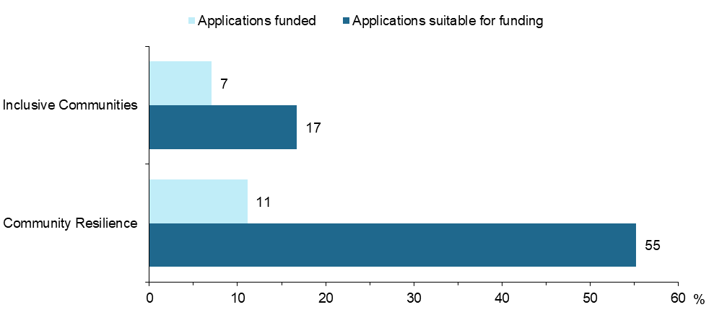
Source: SAP assessment reports, SARC projects funded
Notes: Suitable applications account for 26% of the total applications assessed by the SAP. Suitability was determined by the SAP as part of the assessment process, prior to a determination being made about whether to recommend the project for funding. Not all SARC applications found to be suitable for funding were recommended for funding by the Selection Advisory Panel, depending on their individual scoring.
Applications suitable for funding: number of applications suitable divided by number of applications
Applications funded: number of applications funded divided by number of applications
Despite the relatively low proportion of applications funded, the SARC Activity still funded a diverse range of projects that targeted many different groups, including socially and economically isolated people and children and youth, CALD groups and Indigenous Australians (Figure 2).
Only a limited number of funded projects across both Activity streams targeted older Australians (18) and groups and individuals demonstrating intolerance (13). Departmental stakeholders interviewed noted that groups and individuals demonstrating intolerance were identified as a particularly important target group during the original design of SARC. It is unclear why this target group is not highly represented by grant recipients, despite the original intent of SARC to capture those demonstrating intolerance.
Figure 2 Number of funded projects by target group and SARC Activity stream (n=95)
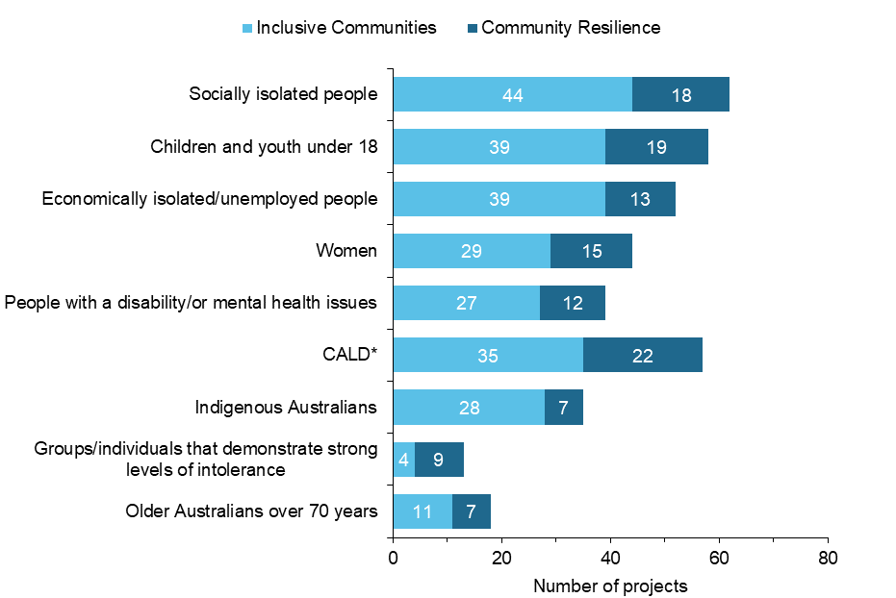
Source: SAP assessment reports, SARC projects funded
Notes: Target groups are standardised categories used by DSS as part of the SARC application and assessment process. Project many include more than one target group.
*CALD includes culturally and linguistically diverse individuals and non-Australian citizens including humanitarian entrants or newly arrived migrants.
Despite some variation in the extent to which groups have been targeted, analysis of DEX data shows that the SARC Activity has funded a geographically diverse spread of projects (see Appendix G Figure 15). Although a majority of projects were delivered in major cities, a significant proportion (approximately 45%) also took place in regional and remote areas.
Overall, departmental stakeholders were confident that the projects that were funded had aligned with the aim of strengthening social cohesion. In part, this was attributed to the scope of the SARC Activity being extremely broad, which made it easier for grant recipients to demonstrate their ability to meet the SARC Activity’s objectives. Although the broad scope appears to have resulted in a wide range of projects being funded, a few stakeholders viewed the broad criteria as also making it more difficult to identify and select projects that were best suited to achieving the SARC Activity objectives.

The case studies revealed that project staff interviewed generally thought there was strong alignment between their project purposes and the SARC Activity objectives. However, many of the objectives and outcomes reported by each case study project were quite similar, for example, promoting social cohesion, supporting the building of networks and connection, and reducing social isolation and discrimination were all common objectives. This is consistent with the findings from other data sources indicating similar aims and objectives of projects across both Community Resilience and Inclusive Communities Activity streams.
A few barriers were also noted by some departmental stakeholders in relation to the assessment and selection of diverse projects. There was some concern that organisations where English was not the first language of staff were at a disadvantage when submitting proposals. The case study interviews with project staff revealed that some organisations had dedicated staff member(s) or had engaged a professional grant writing consultant to keep abreast of finding opportunities and prepare their project grant applications. It is not clear to what extent this dedicated resourcing with specialised grant application skills may or may not have existed in other organisations that were unsuccessful in their applications.

Key Findings - Appropriateness
- The SARC Activity was effectively promoted to the community sector and built upon the existing profile of the previous Strengthening Communities Activity, which many grant applicants were already aware of.
- A small number of SARC applications were successful in having their projects funded, despite there being a greater number of suitable projects identified by the Selection Advisory Panel. Available SARC funding was insufficient to fund all suitable projects. There was also a large number of applications assessed as unsuitable, particularly for the Inclusive Communities Activity stream.
- Representation of target groups was varied. Funded projects covered a range of target groups, particularly socially and economically isolated people, culturally and linguistically diverse groups, and children and youth. Few funded projects targeted older Australians and groups/individuals demonstrating intolerance.
There were some concerns that organisations with limited English were disadvantaged by the application process.
- The broad scope and flexibility of SARC has been widely applauded by stakeholders. While this has been cited as a key to the success of SARC it also poses challenges in selecting projects that are best suited to improving social cohesion. Such challenges commonly related to difficulties in identifying and measuring clear outcomes achieved through the Activity.

Process
Evaluation questions in this category concern the implementation of SARC Activity funded projects and the reporting systems that were in place including Activity Work Plans (AWPs) and the Department’s Data Exchange (DEX). AWPs were not reviewed in detail for the evaluation as an assessment was made that they would not provide usable, quantifiable data to address the evaluation questions and outcomes. An overview of these reporting systems is included in Appendix A.
Table 2 Process – Evaluation questions, process outcomes and data sources
Evaluation question | Process Outcomes | Data sources
Effectiveness of SARC Activity governance and reporting systems
Have governance and reporting systems supported successful delivery? | Effective and efficient program and contract management | - Departmental stakeholder interviews  - Case study provider interviews  - Project Lead survey
Are the current systems sufficiently flexible to allow reporting by the diverse organisations and projects funded by SARC? | Reports submitted on time and to a high standard | - Departmental stakeholder interviews  - Case study provider interviews  - Project Lead survey
Lessons learned from the implementation of the SARC Activity
What lessons were learned through the implementation of SARC that should inform both future rounds of SARC and similar grant programs in future? |  | - Departmental stakeholder interviews  - Case study provider interviews  - Project Lead survey

Effectiveness of the SARC Activity governance and reporting systems
Our analysis indicates that the governance and reporting systems used for the SARC Activity have had mixed results in supporting project delivery and enabling effective reporting by diverse organisations and projects.
In general, the current reporting systems for the SARC Activity appear to have been relatively flexible for the diverse range of funded projects. A majority of project lead survey respondents (61%) reported that it was easy or very easy to fulfil reporting requirements, suggesting that grant recipients generally did not have major difficulties with meeting the reporting requirements. The majority of project staff interviewed through the case studies also supported the view that governance and contact with the Department was generally good. However, some issues were identified with specific aspects of SARC Activity reporting and grant management requirements, which are described below and in Appendix E. A common issue identified in the case studies was that a high turnover of Departmental staff, most notably Funding Arrangement Managers. This resulted in communication difficulties reported by some interviewees that impacted temporarily on effective project delivery.

Effectiveness of DEX
Departmental stakeholders generally felt that DEX reporting was not well suited to the broad scope of the SARC Activity. Despite this, most project leads who were surveyed indicated that they had used DEX for reporting of whom 88% said that DEX reporting deadlines were reasonable and easy to meet (see Appendix H Figure 30), suggesting that DEX reporting requirements had not posed major issues for these organisations.
Although most project leads surveyed indicated that DEX report deadlines were easy to meet, only half agreed that it was clear what information was required by DEX and 36% agreed that it was easy to adjust existing record keeping for DEX reporting (see Appendix H Figure 30), suggesting that this aspect of SARC Activity reporting was not sufficiently flexible for many organisations. This appeared to particularly affect larger organisations (more than 20 employees) with only 26% of these organisations finding it easy to adjust existing record keeping compared to 50% of organisations with 20 or fewer employees, although this difference is not statistically significant.
Departmental stakeholders similarly noted that the nature of some SARC Activity funded projects was not conducive to reporting on demographic and outcomes fields in DEX. This was also evident in our review of DEX data through a range of inconsistencies in data reported by grant recipient organisations (see Appendix E). Some stakeholders interviewed reported that some SARC Activity projects involved large numbers of participants engaging in one-off services or events where it was not possible to record demographic and outcomes information, which is difficult to resolve in any data platform. Some case study project staff also noted that privacy limitations prevented them from reporting identifiable information on participants, particularly for projects delivered by third parties. For example, project leads from Ask Gran Not Google, a project delivered in school settings, described how they were unable to provide identifiable information about project participants, including sensitive information (such as their cultural background) as they did not expect that schools would be willing to provide them with this information. Through discussions with FAMs it was agreed that the organisation would no longer be required to seek this information from schools participating in the program. The Australian Muslim Women's Centre for Human Rights (AMWCHR) described a challenge that their project participants are hesitant to share data with the government. The project delivery staff are sometimes torn between how to respect their participants’ wishes and maintain trust, but at the same time making sure they meet their Departmental contractual requirements. Another challenge related to the reporting of date of birth, which is sometimes not recorded in participants’ countries of origin. Although there was an option in DEX to nominate an estimated date of birth, the organisation received feedback multiple times from the Department that an “estimated” day of birth was poor quality data. These examples provide anecdotal reasons why inconsistencies in the capture of some demographic data items might be observed across different data sources.

Effectiveness of Activity Work Plans and grant management arrangements
Findings regarding the grant management arrangements in place for funded projects being managed by the Department’s FAMs were varied.
Communication experiences with FAMs were generally reported positively by project leads responding to the online survey (refer to Appendix H). A majority (74%) of project leads who responded to the online survey reported having contact with FAMs "several times a year" while delivering their project. Ninety-five per cent of respondents to the project lead survey indicated it had been easy or very easy communicating with FAMs.
Although the overall experience of project leads interacting with FAMs appears to be positive, case study project staff identified some issues. For example, some project staff interviewed in case studies indicated that there had been high turnover of FAMs, which resulted in some inconsistency in the quality of grant management and led to delays in responses to issues raised.
Activity Work Plans were viewed by Departmental stakeholders as effective at enabling effective and efficient grant management, by providing valuable data on project progress, which could be monitored by FAMs. A large proportion (87%) of project leads who were surveyed indicated they had used AWPs for reporting.

Lessons learned from the implementation of the SARC Activity
A range of lessons have been learned through the implementation of the SARC Activity:
- Early preparation - one lesson noted by departmental stakeholders was the need to better prepare grant recipients to begin implementation as soon as funding was approved to avoid delays in project delivery commencing resulting in requests for the rollover of funding.
- Early engagement - was also needed to clarify grant spending rules for grant recipients with limited experience. For example, interviewees from With One Voice Social Franchise (see Appendix I) reported feeling some pressure to spend the allocated grant funds after they found their funding had not been distributed to community partners as quickly as expected. However, they also reported on the flexibility of the Department with ongoing discussion around possible extensions or alternatives for how funds could be used. Project leads also highlighted through the survey that early engagement around what data needed to be collected and recorded would be useful. A few case study projects noted that the quantified targets required for reporting did not fit with the design of their projects and further guidance from DSS would have been appreciated around setting targets that are relevant and achievable.
- Improvements to DEX reporting - was identified, including improvements to the functionality/usability of the platform for monitoring outcomes/indicators and evaluation purposes. Staff from a few case study projects felt there was limited flexibility to effectively report on their project. They reported that the current system is set up for a ‘case management’ style reporting which it was felt did not align well to the project design.
- Ensuring clear SARC objectives and requirements - this aligns with the earlier finding that a large proportion of SARC applications were found to be unsuitable, indicating that there was not always a clear understanding of the Activity stream objectives and requirements. The development of guidance around project outcomes and indicators prior to the grant round opening would likely benefit the implementation of SARC as well, including enabling robust reporting of outcomes in DEX.
Key Findings – Process
- Governance and contact with the Department was generally reported to be positive, however, a common issue was reported by some project staff relating to high turnover of Departmental staff, resulting in communication difficulties and delays.
- In general, grant recipients have found it relatively easy to meet SARC reporting requirements, although there have been limitations to the data they have reported in DEX due to some SARC Activity funded activities being one-off services and events delivered to large numbers of clients who cannot easily be identified. This reflects in the inconsistencies in demographic and outcome data reported in this evaluation.
- Larger organisations appear to have had more difficulty adjusting their reporting systems to align with DEX reporting requirements than smaller organisations, although the difference is not statistically significant.
- Grant management arrangements in place for the SARC Activity have worked well and have been supported through the effective use of Activity Work Plans.
- Some new grant recipient organisations were unable to begin implementation as soon as their grant was approved due to a lack of understanding regarding grant spending rules, obtaining required documentation, setting up appropriate accounting and financial reporting mechanisms.

Effectiveness of program design
Evaluation questions relating to the effectiveness of the SARC Activity program design cover the types of participants engaged in SARC Activity projects and the benefits and challenges of the overarching program design.

Table 3 Effectiveness of program design – Evaluation questions, design outcomes and data sources
Evaluation question | Design Outcomes | Data sources
Participants engaged through the SARC Activity
Who was reached by the SARC grants program? |  | - Project Lead survey  - DEX demographic data  - Case study provider, community stakeholders, participant consultations
Did participants continue to engage over time? | Target populations engaged in SARC Activity funded activities over time | - Project Lead survey  - Case study provider, community stakeholders, participant consultations
Effectiveness of project delivery
Did grant recipients deliver the intended activities and achieve the intended outcomes? | Community sector actively engaged in delivery and implementation | - Departmental stakeholder interviews  - Case study provider, community stakeholders, participants consultations  - Project Lead survey
Which kinds of approaches or organisations worked well, and which met with challenges? |  | - Departmental stakeholder interviews  - Case study provider and community stakeholder consultations  - Project Lead survey
What were the advantages and disadvantages of the SARC Activity’s broad approach? |  | - Departmental stakeholder interviews  - Case study provider and community stakeholder consultations
To what extent were the Community Resilience projects reflective of a community-driven approach? | Community resilience projects reflect community needs | - Case study provider consultations  - Department stakeholder interviews

Participants engaged through the SARC Activity
There is evidence that the SARC Activity reached a broad range of participants through funded projects. The range of demographics was explored in multiple data sources, including DEX, online survey and SAP reports:
- The majority of individual clients were female (63%).
- More than half of individual clients (57%) were under the age of 20.
- Twenty-six per cent of individual clients were reported as CALD. It is acknowledged that the definition used in DEX reporting is based on country of birth and main language spoken at home some data which may differ to the way CALD is captured in other data sources. The online survey shows that 71% of project leads reported their projects had supported CALD people (Figure 3), although the specific number of CALD clients was not quantified in the survey.
- Fourteen per cent of individual clients reported in DEX were Aboriginal and Torres Strait Islander clients. Nearly half (47%) of project leads surveyed indicated that their projects had supported Aboriginal and Torres Strait Islanders, although, the number of Aboriginal and Torres Strait Islander clients cannot be determined from the survey.
- The online survey revealed that many projects supported economically isolated or unemployed people (61%) and socially isolated (58%) people, in line with the SAP data which revealed 55% or funded projects targeted economically isolated or unemployed people and 65% targeted socially isolated groups (refer to 3.1.2).
- The SAP data and online survey both revealed fewer SARC Activity projects had targeted older people compared to other target groups. SAP reports revealed 19% of funded projects targeted older Australians over the age of 70. Project leads surveyed reported 27% of projects supported older people, the higher proportion of which may be due to a broader interpretation of ‘older’ than the specification of over age 70 in the SAP application data.
Figure 3 Proportion of population groups supported by SARC Activity projects
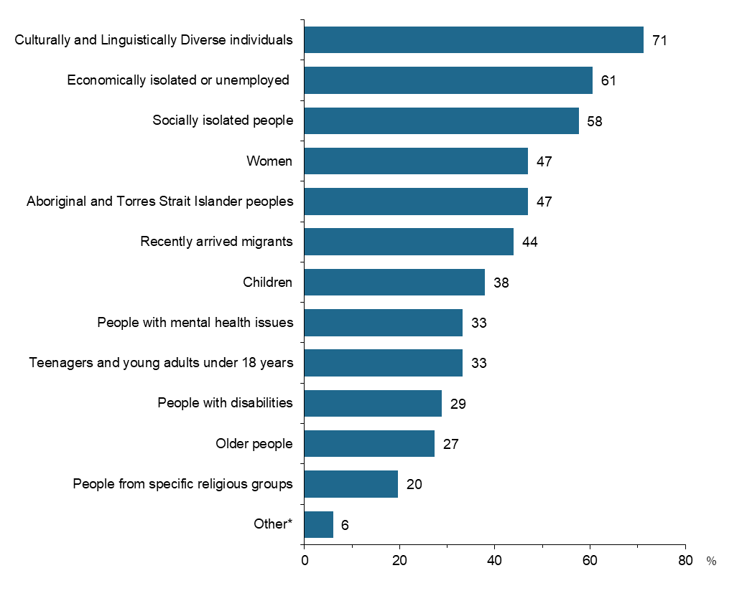
Source: Survey of SARC Activity Project Leads, August 2020
Notes: Question item – C1. Which groups in the community do your organisation’s project(s) support as part of the SARC activity? Please select all that apply.
Base – All survey participants (n=66)
*Other includes groups for which very small numbers were reported, such as people in rural areas and families

Based on the views of project leads, the SARC Activity appears to have successfully engaged a diverse range of groups over time. Most (95%) project leads were generally satisfied with client engagement. Two thirds (66%) of survey respondents reported it was easy or very easy to keep clients involved in the project(s) for the full delivery period (refer to Appendix H).

Effectiveness of project delivery
It appears that SARC Activity funded projects have generally been delivered as intended by their project design, with departmental stakeholders indicating that they had not encountered many issues with projects deviating from their original approach.
The one exception to this has been the impact of COVID-19 which has, according to a few departmental stakeholders, impacted on the ability of some organisations to deliver their activities as intended, resulting in lower participant numbers and delays to project delivery. According to some case study project staff, COVID-19 has prompted them to make modifications to project delivery, such as smaller group sessions and/or making greater use of online delivery methods.
Despite the issues encountered as a result of COVID-19, most (96%) project leads surveyed indicated their projects had been delivered within the project scope and 81% were delivered within the planned timeframe.
Departmental stakeholders highlighted projects that had adopted community development approaches as particularly successful, as well as smaller organisations that had delivered innovative projects that they would not normally be in a position to undertake without funding. There is some evidence of Community Resilience projects in particular adopting community development approaches. For example, the Muslim Women's Leadership in Community Resilience and Human Rights case study project (see Appendix I) recruited project facilitators and interpreters from within the community and this familiarity ensured that the leadership program was delivered within a safe space for participants.
Project staff consulted as part of the case studies highlighted the flexibility of how SARC Activity funding could be used as a particular strength, which enabled effective project delivery and the tailoring of project activities to the needs of target groups. This included the flexibility afforded to grant recipients during the COVID-19 pandemic, which enabled grant recipient organisations to effectively apply new delivery methods such as remote events and consultations.
Staff from some case study projects identified ways in which their projects could be sustained longer term, particularly through the development of tools and resources (such as downloadable project material) that could be distributed without requiring further staffing.
A small number of case study interviews indicated some projects had developed and administered their own participant feedback collection mechanisms (such as post-event surveys). These data sources were not available for assessment in this evaluation. This highlights a valuable source of data that could glean rich information regarding participant experiences to inform future assessment of SARC Activity outcomes.
Key Findings – Effectiveness of Program Design
- A broad range of groups, including many of the SARC Activity target groups, have been engaged, although it is difficult to quantify specific numbers due to the limited demographic data reported by grant recipients through DEX.
- It appears that a large proportion of projects have supported CALD populations, economically and socially isolated individuals in particular, in line with the objectives of the SARC Activity.
- In line with the target groups identified by grant recipients, few project leads reported supporting older people through projects, suggesting that this may have been a gap in the delivery of the SARC Activity.
- SARC Activity funded projects have generally been delivered as intended, although COVID-19 has posed challenges for some projects and resulted in lower participant numbers and delays to some activities.
- The flexibility of SARC Activity funding has given grant recipient organisations the freedom to deliver activities that are best suited to the needs of target groups.
- There is an indication that some projects administer their own participant feedback collection mechanisms (such as post-event surveys); which may provide an opportunity to be explored for gathering information to inform future assessment of SARC Activity outcomes.

Impact of the SARC Activity
Evaluation questions in this category relate to the impacts of the SARC Activity at a community and individual level, as well as the factors contributing to the success of projects and barriers to successful project delivery. This evaluation focussed on short-term outcomes; other longer-term outcomes identified in the program logic (Appendix C) were deemed to be out of scope for the purpose of this evaluation.

Table 4 Impact of SARC – Evaluation questions, outcomes and data sources
Evaluation question | Outcomes | Data sources
Short-term Outcomes Achieved
To what extent were the projects successful in achieving the intended outcomes? | Whole of community and early intervention responses to address cohesion, community belonging and barriers to social and economic participation are established  Vulnerable and disadvantaged individuals improve social and economic participation  Participants engage with community services and activities  Participants display positive attitudes towards their community  Young people improve educational engagement | - DEX SCORE outcomes data  - Project Lead survey  - Case study provider, community stakeholder, participant consultations
Was funding able to support relevant, quality research? (National Research) | Quality research conducted that supports future service delivery | - Project Lead survey
Did the research result in useful findings to inform future projects? (National Research) | Emerging issues addressed and/or innovative solutions provided to issues of national significance, which impact community resilience and social cohesion | - Project Lead survey
Success factors and barriers
What have been the critical factors for success and barriers to achieving outcomes? |  | - Project Lead survey  - Case study provider consultations

Short-term outcomes achieved
There is a range of evidence of SARC Activity projects achieving, to varying degrees, the outcomes identified in the Evaluation Framework (Appendix B) and revised Program Logic (Appendix C). In some instances it is not possible to assess whether outcomes have been fully achieved. Outcomes covered in this section all relate to the impact of the SARC Activity on communities and participants in the short-term. It was evident from multiple data sources that the range of intended outcomes were spread across both Community Resilience and Inclusive Communities Activity streams; there was no clear differentiation. As such, we have presented the findings for SARC Activity rather than by the two separate streams.

Whole of community and early intervention responses to address cohesion, community belonging and barriers to social and economic participation are established
There were a range of project aims identified in the Project Lead survey that align with this outcome including reducing barriers to social participation, improving mental health and wellbeing, reducing barriers to economic participation, increasing work readiness, improving career pathways, improving physical health, promoting volunteering and building understanding of Australia’s democratic principles, rights and values.
The aim of reducing barriers to social participation was most commonly identified aim of which most (83%) of project leads reported they were mostly or extremely successful in achieving (see Appendix H Figure 34). Around half of the respondents identified their projects aimed to improve mental health and wellbeing with the majority (88%) reporting success, and/or to reduce barriers to economic participation with a lower proportion (55%) reporting they were mostly or extremely successful. The lower level of reported success in reducing barriers to economic participation in the last 12 months may reflect that changes in economic participation outcomes often require a longer timeframe to see improvements; this is addressed further in the next section.
Several case study project stakeholders indicated their projects aimed to promote social cohesion and belonging and reduce social isolation, with high levels of reported success. For example, interviewees involved in Ask Gran Not Google considered the project to be highly effective in achieving a range of aims as it provided young people and seniors with an opportunity to form and/or deepen social connection and belonging, helped to promote the sense of self-worth and lessen social isolation among seniors, and promoted attitudinal shifts among young people in terms of building social connections and valuing the wisdom of seniors. AMWCHR project stakeholders also considered their project to have been highly successful in reaching its intended outcomes addressing themes such as belonging, economic participation, and social inclusion. For example, many participants reported that they had gained confidence as well as leadership skills including self-awareness, self-care, active listening, and how to be assertive.

Vulnerable and disadvantaged individuals improve social and economic participation
Many project aims listed in the Project Lead survey related to improving social and economic participation such as developing a sense of belonging to the community, increasing social cohesion and reducing social isolation.
A majority of project leads indicated that their projects had aimed to achieve support for individuals to have a sense of belonging to a wider community, increasing social cohesion and reducing social isolation, with over three quarters of these reporting they were mostly or extremely successful in achieving this in the last 12 months (see Appendix H Figure 35).
Similarly, case study project staff and participants indicated that there had been great improvements in social and economic participation including increased social contacts between participants outside the project activities. There had also been instances of different social groups that would not typically interact developing social connections. For example, staff and participants from a project that provided a sports training program for children with learning and perceptual disabilities (Modified Sports Program – see Appendix I) work directly with a vulnerable cohort of individuals who are more likely to experience social exclusion, isolation and discrimination due to their disabilities. Interviewees described how outcomes were not only achieved through children with disabilities building new social connections and developing a sense of belonging and confidence, but also far reaching and sustainable outcomes through the recruitment and development of peer-based mentors becoming effective leaders who are inclusive and positive role models for people with disabilities.
While there were fewer projects aiming to support women in leadership roles and reduce gender inequality, those projects reported a very high level of success in the Project Lead survey (75% and 100% respectively) in achieving those aims, suggesting that these projects have improved the social and economic participation of women in particular. This was reflected in the findings from the Muslim Women's Leadership in Community Resilience and Human Rights (see Appendix I) that ran a leadership program for women. Project staff and participants indicated that the activity had helped participants to improve their communication skills and pursue new employment opportunities.
Analysis of DEX SCORE data has also shown improvements in the social and economic participation of participants, with increases in the average SCOREs of individual clients for the SCORE Circumstance – Community Participation and networks and Employment domains (see Appendix G Figure 19 and Figure 20).

Participants engage with community services and activities
There were a smaller number of project aims included in the Project Lead survey that aligned with this outcome; namely connecting community members to services and improving collaboration between community services. Amongst survey respondents who selected these aims, there was a very high level of success (81% and 92% respectively reporting they were mostly or extremely successful) for both of these aims, giving some initial indications that participants have engaged with community services and activities. Likewise, DEX data indicates that there were increases in average SCOREs for the SCORE Goals – Engagement with services domain amongst individual clients (see Appendix G Figure 21).

Participants display positive attitudes towards their community
Data collected on this outcome largely relates to improvements to attitudes about diversity in the community. For example, more than half of project leads surveyed identified that their projects aimed to improve attitudes towards diversity in their community (see Appendix H Figure 37). A significant majority (80%) reported they were mostly or extremely successful in achieving this aim.
Stakeholders interviewed from the Modified Sports Program case study (Appendix I) reported that program participants developed positive attitudes towards their community through improved sense of belonging, confidence and connection. Project mentors also developed valuable skills they believe will support social and economic participation of people with disabilities as they progress through life.

Young people improve educational engagement
One quarter of project leads (23%) surveyed identified a project aim of encouraging school retention and attendance and 79% reported they were mostly or extremely successful in achieving this aim (Appendix H Figure 34). A very small number also noted ‘improved educational attainment and outcomes’ as a project aim.
While case studies did not focus on project activity that directly measured school retention or attendance, one case study project, Ask Gran Not Google (refer to Appendix I), explored several of the project’s aims broadly linked to educational engagement relating more directly to strengthening social connection. Stakeholders interviewed reflected on positive experiences in their events, with high engagement from students and grandparents or other seniors participating in the project activities. Similarly, seniors enjoy the social enrichment that comes from their connection with the students. They love telling stories and the engagement helps them to feel valued and not forgotten.

Quality research conducted that supports future service delivery
There was general agreement amongst the small number of National Research project leads surveyed (5) that funding has supported relevant research and the findings of the research projects could easily be applied to the work of other community organisations. However, due to interviews with National Research project leads being removed from the scope of the SARC evaluation, there is no further data available to triangulate these results.

Emerging issues addressed and/or innovative solutions provided to issues of national significance, which impact community resilience and social cohesion
As with the previous outcome, there is limited evidence to address this. National Research survey respondents indicated their projects aimed to develop innovative solutions to community resilience and social cohesion issues in relation to encouraging community participation and the implementation of outcomes and measures for initiatives. However, there is no further data available on the extent to which this was achieved.

Success factors and barriers
According to some case study project staff, the success of their projects had been in part due to the simplicity of the activities they had delivered, which made it easier to implement across a range of delivery locations. Others attributed their success to creating a supportive environment for volunteers.
Unsurprisingly, COVID-19 was the most commonly cited barrier to project delivery. Thirty-three per cent of project leads who were surveyed identified COVID-19 as a barrier while community support (18%) and organisational partnerships (15%) were also cited as barriers by a few respondents (see Appendix H Figure 38).

Future opportunities for assessing impact
It has been identified throughout the sections above that while the broad scope of SARC Activity objectives and requirements have provided flexibility in project delivery, it also poses challenges in measuring the outcomes achieved. Multiple data sources have been used in this evaluation to assess selected short-term outcomes. This has proved challenging where outcomes have not been clearly defined and data quality issues have contributed to limitations in data analysis. A well-designed outcomes framework for the SARC Activity would provide a clear foundation for applicants to design effective and evidence-informed projects. Ideally, this would be supported by data collection instruments and systems that assist measurement and analysis of the defined outcomes and indicators of the framework. A conceptual diagram of the elements of an outcomes framework is presented in Figure 4. Each element provides an increasing level of specificity, working down the framework from the vision through to detailed measures.
Figure 4 Conceptual outcomes framework elements
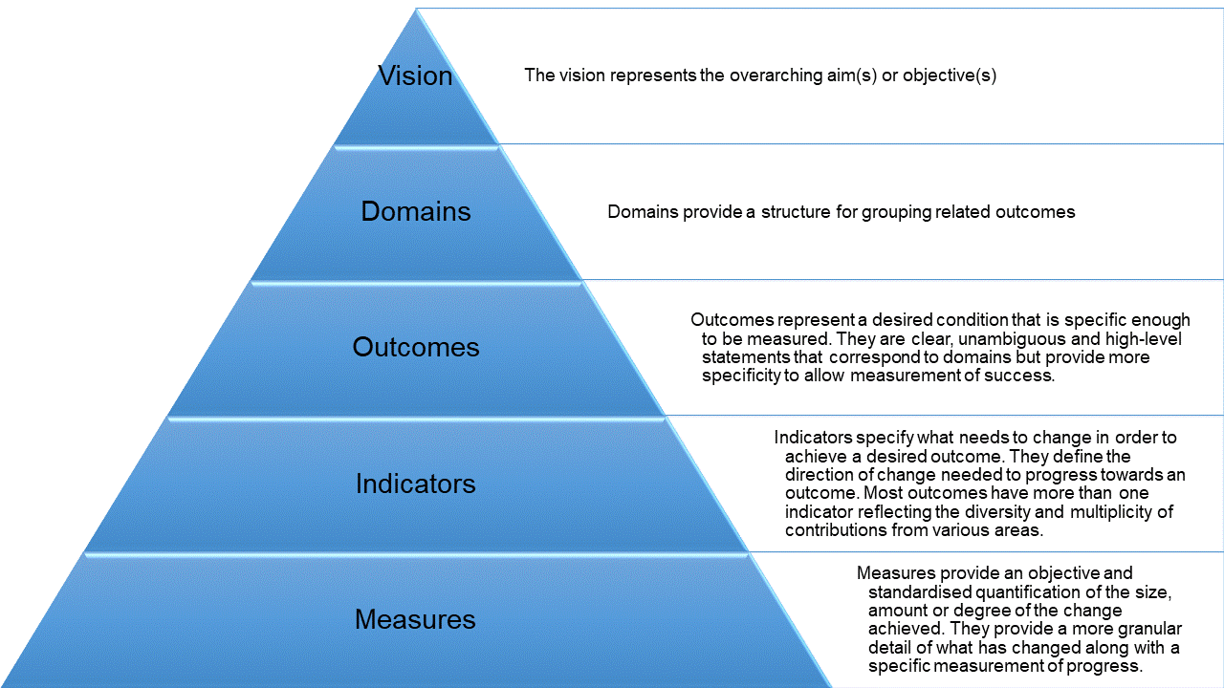
The outcomes framework structure can draw on elements of the SARC program logic presented in Appendix C. A conceptual representation of example outcomes, indicators and measures is presented in Figure 5. This demonstrates an illustrative example only, further work would be required to determine the outcomes framework components and associated definitions to ensure impact of outcomes is assessed appropriately.
Figure 5 Example SARC Activity outcomes, indicators and measures
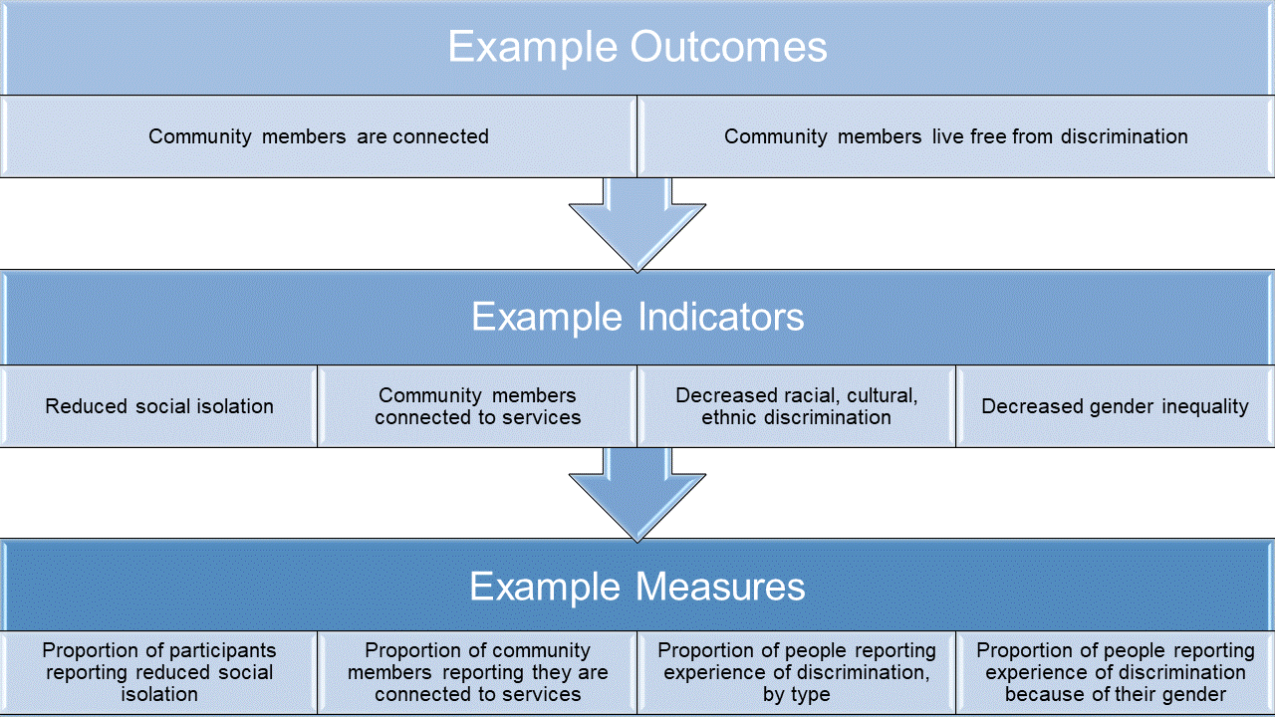

For additional reference, in Appendix K we have collated a list of example national level reports and/or data sources of relevant and established indicators or measures which are supported by collection instruments (e.g. survey questionnaires) that could be considered for future development of a SARC Activity outcomes framework.
Key Findings – Impact of the SARC Activity
- It is not possible to determine the extent to which some SARC Activity outcomes have been achieved and data is primarily drawn from self-assessed sources, which are subject to self-selection bias.
- There is some evidence from the project lead survey, DEX SCORE data and case study consultations that the SARC Activity has been positively perceived to support whole of community and early intervention responses to:
  - address cohesion
  - improve social and economic participation
  - improve engagement with services
  - improve positive attitudes towards the community.
- It is not possible to assess the impact of National Research projects because of limited survey responses and no other sources for data triangulation. Consultations National Research project leads were removed from the evaluation design.
- COVID-19 has been the most common barrier to project delivery, according to project leads.

Efficiency
Evaluation questions in the Efficiency category relate to the extent to which projects have been delivered on time and within budget and represent value for money for the Australian Government. As such, the economic review conducted for the evaluation is a key data source for this category.
Table 5 Efficiency – Evaluation questions, outcomes and data sources
Evaluation question | Efficiency Outcomes | Data sources
Efficiency of project and contract management
How efficiently has support to funded projects been provided through the SARC Activity? | Projects implemented and completed on time and within budget (Short term – DSS) | - Project Lead survey  - Case study provider consultations
 | Sustained effective and efficient program and contract management (Short term – DSS) | - Project Lead survey  - Case study provider consultations
To what extent do SARC Activity projects represent value for money for the Australian Government?
To what extent do SARC Activity projects represent value for money for the Australian Government? | Projects funded through the SARC Activity represent good value for money (Short term – SRC) | - Value for money assessment

Efficiency of project and grant management
Despite COVID-19 being identified by departmental stakeholders and project leads as a barrier for project delivery, only a handful (4%) indicated that their projects had been delayed due to COVID-19. While a majority of project leads agreed that grant funding was sufficient to meet project costs, 39% disagreed with this statement suggesting that some drew on other sources of funding to cover the full costs of their projects. Despite this, almost all (90%) indicated that they had delivered their project within budget.
Mixed feedback was received through case studies regarding sufficiency of grant funding. Some project leads felt that the SARC Activity funding was insufficient for them to deliver the project activities, however in such cases, the projects had been successful in seeking additional funding from other sources. For example, With One Voice Social Franchise stakeholders reported that financial sustainability of the choir relies on a broad mix of participants with varying levels of financial stability, and it had been difficult to attract a sufficient number of participants who were able to afford full membership. In such cases, choir coordinators sought out additional support and funding through local and State funding schemes and philanthropic networks. There were also cases of underspending with one example also arising from With One Voice Social Franchise. They reported that their funding had not been distributed to community partners as quickly as expected and had thus felt pressure to spend the allocated grant funds. They also noted the flexibility of the Department with ongoing discussion around possible extensions or alternative for how funds could be used.

Economic review
As noted in our methodological limitations (see 2.1.2), it was originally planned to conduct a value for money assessment however this was removed from the evaluation design due to the data quality issues detailed further in Appendix E. As a result, it was not possible to conduct a full value for money assessment or determine whether the SARC Activity represents value for money.

Despite this, the economic review conducted in place of a value for money assessment has identified some potential benefits from the SARC Activity across five domains (reducing social isolation, improved physical health, increasing social cohesion, promoting volunteering, improved mental health).
A review of similar projects to those delivered through the SARC Activity indicates that these types of activities can provide value for money to government. The full economic review of comparable programs conducted as part of this evaluation is included in Appendix J.
Key Findings – economic review
- Some project leads indicated the grant funding was not sufficient to meet the project costs. Other funding sources were also used by these grant recipients.
- There was feedback regarding delayed or underspending of SARC Activity funds. Support was provided by the Department to find flexible solutions around possible extensions or alternative uses for the funds.
- Due to data quality limitations, it was not possible to conduct a value for money assessment of the SARC Activity. An economic review provided potential benefits that could be explored further in future.

Conclusion
Overall, the evaluation showed the SARC Activity to be an appropriate program that contributes positively to social and economic participation of vulnerable and disadvantaged people and to build strong, resilient and cohesive communities. The evaluation includes findings in five domains including; Appropriateness, Process, Effectiveness of program design, Impact and Efficiency. This chapter provides an overview of the findings and highlights potential opportunities for improvement that are made on the basis of these findings.

Appropriateness

Providing clear guidance to prospective grantees
This evaluation found there was a high level of interest in the SARC Activity and it was effectively promoted to the community sector. However, many of the applications, especially in the Inclusive Communities stream, were found to be unsuitable by the Selection Advisory Panel. This suggests that more specific guidance is needed around the SARC Activity objectives and the expected outcomes to be achieved through grant-funded projects. An Outcomes Framework describing the results that SARC Activity funding seeks to achieve would provide clear guidance to potential applicants. Such a framework would also provide a sound foundation for project design, monitoring and evaluation.

Targeting a diversity of groups
The SARC Activity funded a diverse range of projects that targeted many different groups, such as socially and economically isolated people, culturally and linguistically diverse, Indigenous Australians and children and youth. A limited number of funded projects targeted older Australians and groups/individuals demonstrating intolerance, even though these groups were specifically considered target groups for funding. The findings suggest that if the Department chooses to continue targeting these through SARC Activity funding, more emphasis is needed on these populations in the grant application and selection process.

Measuring improvement in social cohesion
The broad scope and flexibility of the SARC Activity has been widely commended by stakeholders. While this has been cited as a key to the success of the SARC Activity, it also poses challenges in selecting projects that are best suited to improving social cohesion and in measuring the outcomes achieved through the Activity. A well-designed outcomes framework for the SARC Activity, as discussed above, would provide clarity for the selection of projects that best-fit the intended outcomes. It would also provide a clear, unambiguous foundation for applicants to design effective, evidence-informed projects that directly address the outcomes and indicators included in the framework.

Process

Improving reporting requirements and systems
The evaluation found that in general, the reporting requirements for the SARC Activity have not been onerous or duplicative. The Activity Work Plans have been especially useful and more tailored to SARC Activities than DEX. The AWPs have supported grant management arrangements and have provided a way for grant recipients to report on activities not otherwise captured in DEX. However, one of the limitations of the current data collection systems for the SARC Activity is the lack of an outcomes focus.
The evaluation found that the SCORE outcomes reporting was inconsistent among reporting organisations and is not tailored to measuring outcomes for the SARC Activity. There is an opportunity to update DEX Program Specific Guidance to include further guidance on extended demographics and SCORE outcomes reporting which could improve the number of organisations reporting, the accuracy of the data and the appropriateness of the data for use in measuring SARC Activity outcomes.
An opportunity exists to align the two existing SARC Activity reporting systems (DEX and AWPs) with a clear, overarching set of outcomes and indicators which would provide grant recipients with a fit-for-purpose system for reporting and tracking progress. Introducing a comprehensive and integrated system for SARC Activity funded organisations would move Activity reporting from being an output to an outcomes driven system. This would assist in monitoring and measuring the impact of SARC Activity funding more accurately into the future.

Aligning reporting with outcomes
Regardless of whether an integrated system, as described above, is developed grant recipients need clear guidance early in the implementation phase around data collection and reporting requirement that align with a clear overarching set of Activity outcomes and indicators. Ideally grant recipients will have identified the outcomes and indicators they are seeking to achieve in their application for funding so early engagement with them could focus on assuring they have the capacity to collect the appropriate information through DEX and AWPs for that purpose. An appropriate level of Departmental support will need to provide guidance and assistance to grant recipients on data collection and outcomes-based measurement.

Early engagement with grantees
While grant management arrangements in place for the SARC Activity have generally worked well, there is an opportunity to improve the grantee experience and their ‘readiness’ to begin offering funded services through early engagement by the FAMs. This intensive engagement is needed to ensure grant recipients can begin implementation as soon as their grant is approved. The engagement could focus on new or inexperienced grantees and cover topics such as clarifying grant spending rules, aiding organisations with limited grant funding experience to obtain necessary documentation and assisting grantees with the setup of appropriate accounting and financial reporting mechanisms.

Effectiveness of program design

Defining target groups
A broad range of groups have been engaged in the SARC Activity, although it is difficult to accurately describe the groups due to the limited demographic data reported through DEX. The evaluation found that a significant proportion of projects supported CALD populations, and economically and socially isolated individuals but few reported supporting older Australians specifically. There is an opportunity for the Department to reassess the target populations included in the two streams (Community Resilience and Inclusive Communities) and to define these populations more clearly in the grant application and selection process.
Furthermore, there does not appear to be a need for all three SARC Activity funding streams. Very little information was sourced to assess the National Research stream for this evaluation, and as noted above there appeared to be overlap in the target groups and objectives of the Community Resilience and Inclusive Communities funded projects. Future funding rounds may benefit from simplifying the SARC Activity into one stream only.

Flexibility in program delivery
Flexibility in SARC Activity funding has given grant recipient organisations the freedom to deliver activities that are best suited to the needs of target groups and is considered a key strength of the program design. That said, there remains an opportunity to provide further clarity around the focus of the two streams, the target groups for the individual streams and the desired outcomes for each stream. There is also a need to provide clearer guidance on what a community-driven approach is and whether this approach is a prerequisite for funding through the SARC Activity.

Impact

Building the evidence
There is some evidence from the evaluation that the SARC Activity has contributed to whole of community and early intervention responses to address cohesion, improvements in social and economic participation, engagement with services and positive attitudes towards the community in the short-term. However, it is still not possible to determine the extent to which SARC Activity outcomes have been achieved, as the data to support this conclusion is not robust. While the DEX SCORE data provides some indication of outcomes, it was not consistently collected across funded projects. This results in an important gap in measuring the impact of the SARC Activity. There are several opportunities to enhance the ability to measure impact into the future including making SCORE reporting mandatory for grantees, and developing an outcomes framework with indicators and measures that can be collected by funded organisations as described earlier. If these opportunities were addressed and integrated into standard reporting requirements it would provide the Department with a firm foundation to measure outcomes in the short, medium and long terms.

Efficiency

Managing the program
The evaluation found that current processes generally support effective grant management. Of note was the flexibility displayed by the Department and the FAMs during the COVID-19 pandemic which supported funded organisations to adapt and change their delivery of services with only a small number of projects needing to delay as a result.
The AWPs and the DEX system provide output, procedural and financial information that can be used to manage and monitor progress of funded organisations. However, the inability to measure outcomes is a significant issue that hinders the FAMs ability to fully manage the projects they are responsible for. As discussed previously, there is an opportunity to enhance measurement of outcomes in future funding cycles through requiring enhanced SCORE data to be routinely and consistently collected and by introducing an outcomes framework that provides clarity related to the outcomes, indicators, and measures associated with the SARC Activity.

Measuring value for money
As described previously, due to data quality limitations, it was not possible to conduct a value for money assessment of the SARC Activity as part of this evaluation. There is an opportunity to improve the data in the future which would allow value for money to be measured through the data being:
- Collected prior, during, and at the end of the program. This will ensure that the data can indicate the change in outcomes which are attributed to the project.
- Captured at the individual participant level, rather than at the project level. This will limit the potential bias of program leads overstating the impact delivered by their projects.
- Able to support a cost-benefit analysis of cost-effectiveness analysis, through ensuring that outcomes can be monetised where possible.
- Captured in such a way so as to avoid self-selection bias, for example by stipulating compulsory reporting of paired data.

Overall evaluation conclusion
This evaluation found that the implementation of the SARC Activity was quite successful at engaging and promoting the goal of greater social cohesion in communities. We have identified opportunities for improving the ongoing implementation, process, design and efficiency of the program which should enhance program management capabilities and grantee performance. That said, the greatest challenge will be building the capability to measure the impact of the program on participants, communities and populations. We have described the need for an overarching outcomes framework which could form the foundation of data collection for measuring impact.

References
ABS (Australian Bureau of Statistics) (2009), ABS Data Quality Framework, May 2009, cat. no. 1520.0, ABS, Canberra.
ABS (Australian Bureau of Statistics) (2018). Collection of volunteering data in the ABS <https://www.abs.gov.au/research/people/people-and-communities/general-social-survey-summary-results-australia/collection-volunteering-data-abs>.
AIHW (Australian Institute of Health and Welfare) (2019). Australia’s Welfare 2019. Online reports accessed August 2020: https://www.aihw.gov.au/reports-data/health-welfare-overview/australias-welfare/overview.
AIHW (Australian Institute of Health and Welfare) (2019). Poor diet. Retrieved from <https://www.aihw.gov.au/reports/food-nutrition/poor-diet/contents/dietary-guidelines>.
AIHW (Australian Institute of Health and Welfare) (2020). Insufficient physical activity Retrieved from: < https://www.aihw.gov.au/reports/risk-factors/insufficient-physical-activity/contents/physical-inactivity>.
AIHW (Australian Institute of Health and Welfare)(2019), Social isolation and loneliness. Webpage accessed September 2020: <https://www.aihw.gov.au/reports/australias-welfare/social-isolation-and-loneliness>.
AIHW (Australian Institute of Health and Welfare), (2020) Mental health services in Australia <https://www.aihw.gov.au/reports/mental-health-services/mental-health-services-in-australia/report-contents/expenditure-on-mental-health-related-services>.
Bittman M and Fisher K, (2006). Exploring the economic and social value of present patterns of volunteering in Australia, Analysis & Policy Observatory <https://apo.org.au/sites/default/files/resource-files/2006-10/apo-nid1837.pdf>.
Brown WJ, Bauman AE, Bull FC and Burton NW, (2013). Development of Evidence-based Physical Activity Recommendations for Adults (18-64 years) <https://www1.health.gov.au/internet/main/publishing.nsf/Content/F01F92328EDADA5BCA257BF0001E720D/$File/DEB-PAR-Adults-18-64years.pdf>.
Cadilhac DA, Cumming TB, Sheppard L, Pearce DC, Carter R and Magnus A, (2011) ‘The economic benefits of reducing physical inactivity: an Australian example’ 8 International Journal of Behavioural Nutrition and Physical Activity <https://ijbnpa.biomedcentral.com/articles/10.1186/1479-5868-8-99>.
CDC (Center for Disease Control and Prevention) (2020). Poor Nutrition <https://www.cdc.gov/chronicdisease/resources/publications/factsheets/nutrition.htm>.
Charlesworth G, Shepstone L, Wilson E, Thalanany M and Mugford M, ‘Does befriending by trained lay workers improve psychological well-being and quality of life for carers of people with dementia, and at what cost? A randomised controlled trial’ (2008) 12(4) Health Technology Assessment <https://www.journalslibrary.nihr.ac.uk/hta/hta12040#/abstract>.
Chenhall C, Improving Cooking and Food Preparation Skills: A Synthesis of the Evidence to Inform Program and Policy Development (13 January 2011) <https://www.canada.ca/en/health-canada/services/publications/food-nutrition/improving-cooking-food-preparation-skills-synthesis-evidence-inform-program-policy-development-2010.html#a5>.
Deloitte Access Economics, (2019). The economic benefits of improving social inclusion (report commissioned by Special Broadcasting Service) <https://www2.deloitte.com/au/en/pages/economics/articles/economic-benefits-improving-social-inclusion.html>.
Department of Social Services (2017a). Strong and Resilient Communities (SARC): A paper on the redesign of the Strengthening Communities grants program. Internal document provided by DSS.
Department of Social Services (2017b) Strong and Resilient Communities Activity: National Research Grants Opportunity Guidelines, 28 October 2017. Internal document provided by DSS.
Department of Social Services (2018). Strong and Resilient Communities Activity: Inclusive Communities Grants Opportunity Guidelines. Internal document provided by DSS.
Department of Social Services (2019). Strong and Resilient Communities Activity: Community Resilience Grants Opportunity Guidelines. Internal document provided by DSS.
Department of Social Services. (2019). Building a New Life in Australia (BNLA): The Longitudinal Study of Humanitarian Migrants ─ Wave 5 Update (Addendum to the Wave 3 Report). Canberra: Department of Social Services. [Retrieved July 2020 https://www.dss.gov.au/sites/default/files/documents/07_2020/bnla-longitudinal-study-humanitarian-migrants-wave-5.pdf]
Doran CM, (2013) The costs and benefits of interventions in the area of mental health: a rapid review NSW Mental Health Commission < https://nswmentalhealthcommission.com.au/news/commission-news/research-review-finding-what-works-for-the-mental-health-community>.
Fitzduff M, (2007). Measuring Social Inclusion and Cohesion – the Challenges UN https://www.un.org/esa/socdev/sib/egm%2707/documents/Mari_Fitzduff.pdf>.
Garrett S, Elley CR, Rose SB, O’Dea D, Lawton BA and Dowell AC (2011). ‘Are physical activity interventions in primary care and the community cost-effective? A systematic review of the evidence’ British Journal of General Practice, <https://bjgp.org/content/bjgp/61/584/e125.full.pdf>.
Growing Up in Australia (2020): The Longitudinal Study of Australian Children (LSAC) Retrieved from: https://growingupinaustralia.gov.au/about-study
Haldane AG, (2014). In giving, how much do we receive? The social value of volunteering Bank for International Settlements <https://www.bis.org/review/r141028c.pdf>.
Haldane AG, (2014). In giving, how much do we receive? The social value of volunteering. Bank for International Settlements <https://www.bis.org/review/r141028c.pdf>.
Haldane AG, (2014). In giving, how much do we receive? The social value of volunteering. Bank for International Settlements <https://www.bis.org/review/r141028c.pdf>.
Hasan B, Thompson WG, Almasri J, Wang Z, Lakis S, Prokop LJ, Hensrud DD, Frie KS, Wirtz MJ, Murad AL, Ewoldt JS and Murad MH, (2019). ‘The effect of culinary interventions (cooking classes) on dietary intake and behavioural change: a systematic review and evidence map’ 5 BMC Nutrition <https://bmcnutr.biomedcentral.com/articles/10.1186/s40795-019-0293-8>.
Herbert J, Flego A, Gibbs L, Waters E, Swinburn B, Reynolds J and Moodie M, (2014). ‘Wider impacts of a 10-week community cooking skills program – Jamie’s Ministry of Food, Australia’ 14 BMC Public Health <https://bmcpublichealth.biomedcentral.com/articles/10.1186/1471-2458-14-1161>.
Holt-Lunstad J, Smith TB, Baker M, Harris T and Stephenson D (2015). ‘Loneliness and Social Isolation as Risk Factors for Mortality: A Meta-Analytic Review’ 10(2) Perspectives on Psychological Science, <https://journals.sagepub.com/doi/10.1177/1745691614568352?url_ver=Z39.88-2003&rfr_id=ori:rid:crossref.org&rfr_dat=cr_pub%20%200pubmed>.
Ironmonger D, (2011). The Economic Value of Volunteering in South Australia Government of South Australia <https://dhs.sa.gov.au/__data/assets/pdf_file/0020/80750/economic-value-of-volunteering-in-sa2011.pdf>.
Jenkinson CE, Dickens AP, Jones K, Thompson-Coon J, Taylor RS, Rogers M, Bambra CL, Lang I and Richards SH, (2013). ‘Is volunteering a public health intervention? A systematic review and meta-analysis of the health and survival of volunteers’ 13 BMC Public Health <https://bmcpublichealth.biomedcentral.com/articles/10.1186/1471-2458-13-773?optIn=false>.
Jenkinson CE, Dickens AP, Jones K, Thompson-Coon J, Taylor RS, Rogers M, Bambra CL, Lang I and Richards SH, (2013). ‘Is volunteering a public health intervention? A systematic review and meta-analysis of the health and survival of volunteers’ 13 BMC Public Health <https://bmcpublichealth.biomedcentral.com/articles/10.1186/1471-2458-13-773?optIn=false>.
Lavrakas PJ (ed.) (2008). Social Desirability. Encyclopedia of Survey Research Methods. Retrieved from <https://methods.sagepub.com/reference/encyclopedia-of-survey-research-methods/n537.xml>.
Lim M, Australian Loneliness Report (2018) Swinburne Research Bank, <https://researchbank.swinburne.edu.au/items/c1d9cd16-ddbe-417f-bbc4-3d499e95bdec/1/>.
Lucksted A, Medoff D, Burland J, Stewart B, Fang LJ, Brown C, Jones A, Lehman A and Dixon LB, (2013) ‘Sustained outcomes of a peer-taught family education program on mental illness’ 127(4) Acta Psychiatrica Scandinavica < https://www.ncbi.nlm.nih.gov/pmc/articles/PMC5717754/#__ffn_sectitle>.
Markus, A. (2019). Mapping Social Cohesion: The Scanlon Foundation Surveys. Scanlon Institute and Monash University. [Retrieved July 2020: https://scanloninstitute.org.au/sites/default/files/2019-11/Mapping%20Social%20Cohesion%202019.pdf]
Matrix Research and Consultancy,(2006). Modelling the cost effectiveness of physical activity interventions National Institute of Clinical Excellence <https://www.nice.org.uk/guidance/ph2/documents/physical-activity-economics-modelling-report2>.
McDaid D, Bauer A and Park A-L, (2017). Making the economic case for investing in actions to prevent and/or tackle loneliness: a systematic review. London School of Economics and Political Science <https://www.lse.ac.uk/business-and-consultancy/consulting/assets/documents/making-the-economic-case-for-investing-in-actions-to-prevent-and-or-tackle-loneliness-a-systematic-review.pdf>.
Mead N, Lester H, Chew-Graham C, Gask L and Bower P, (2010) ‘Effects of befriending on depressive symptoms and distress: systematic review and meta-analysis’ 196 The British Journal of Psychiatry <https://www.cambridge.org/core/services/aop-cambridge-core/content/view/FA825A94C8566B3F1A6F24E082A35C17/S0007125000251532a.pdf/effects_of_befriending_on_depressive_symptoms_and_distress_systematic_review_and_metaanalysis.pdf>.
Melbourne Institute (2019). HILDA Survey. Accessed online August 2020: https://melbourneinstitute.unimelb.edu.au/hilda
Mulunga SN and Yazdanifard R, ‘Review of Social Inclusion, Social Cohesion and Social Capital in Modern Organisation’ 14(3) Global Journal of Management and Business Research: Administration and Management <https://globaljournals.org/GJMBR_Volume14/3-Review-of-Social-Inclusion.pdf>.
OECD, (2011). Perspectives on Global Development 2012: Social Cohesion in a Shifting World <https://www.un.org/esa/socdev/ageing/documents/social-cohesion.pdf>.
Onrust S, Smit F, Willemse G, van den Bout J and Cuijpers P, (2008). ‘Cost-utility of a visiting service for older widowed individuals: Randomised trial’, 8 BMC Health Services Research, <https://bmchealthservres.biomedcentral.com/articles/10.1186/1472-6963-8-128>.
Onwuegbuzie AJ & Leech NL (2005) The role of sampling in qualitative research. Academic Exchange Quarterly go.gale.com
Onwuegbuzie AJ & Leech NL (2007) A Call for Qualitative Power Analyses. Quality & Quantity 41:105–121.
Parliament of Australia, (2017). Future of Australia’s aged care sector workforce Retrieved from: <https://www.aph.gov.au/Parliamentary_Business/Committees/Senate/Community_Affairs/AgedCareWorkforce45/Report>.
Patton, M. Q. (2014) Qualitative research and evaluation methods (4th ed.). Sage, Thousand Oaks, CA.
Pickett-Schenk SA, Lippincott RC, Bennett C and Steigman PJ, (2008). ‘Improving Knowledge About Mental Illness Through Family-Led Education: The Journey of Hope’ Psychiatric Services < https://ps.psychiatryonline.org/doi/pdfplus/10.1176/ps.2008.59.1.49>.
Piracha M, Tani M and Vaira-Lucero M, (2013) ‘Social Capital and Immigrants’ Labour Market Performance’ IZA Discussion Paper No. 7274 < https://papers.ssrn.com/sol3/papers.cfm?abstract_id=2238307>.
Productivity Commission (2019). Mental Health’ (Productivity Commission Draft Report Overview & Recommendations, <https://www.pc.gov.au/inquiries/completed/mental-health/draft/mental-health-draft-overview.pdf>.
Roger Wilkins, Inga Laß, Peter Butterworth and Esperanza Vera-Toscano (2019) The Household, Income and Labour Dynamics in Australia Survey: Selected Findings from Waves 1 to 17. Melbourne Institute: Applied Economic & Social Research, University of Melbourne.
Roux L, Pratt M, Tengs TO, Yore MM, Yanagawa TL, Van Den Bos J, Rutt C, Brownson RC, Powell KE, Heath G, Kohl HW, Teutsch S, Cawley J, Lee I-M, West L and Buchner DM, (2008) ‘Cost Effectiveness of Community-Based Physical Activity Interventions’ 35(6) American Journal of Preventive Medicine < https://www.ajpmonline.org/action/showPdf?pii=S0749-3797%2808%2900770-8>.
Scanlon Foundation Research Institute, (2020). What is social cohesion? Retrieved from: <https://scanloninstitute.org.au/what-social-cohesion>.
Stanley, D. (2003). What Do We Know about Social Cohesion: The Research Perspective of the Federal Government's Social Cohesion Research Network. The Canadian Journal of Sociology / Cahiers Canadiens De Sociologie, 28(1), 5-17. doi:10.2307/3341872
VicHealth, (2002). Creative Connections: Promoting Mental Health and Wellbeing through Community Arts Participation <https://www.vichealth.vic.gov.au/-/media/ProgramsandProjects/Publications/Attachments/CreativeConnections-text.pdf?la=en&hash=FFCD227B7E878379FE28B9C0E15E64DAE048E76C>.
VolunteeringWA, (2015). The Economic, Social and Cultural Value of Volunteering to Western Australia <https://volunteeringqld.org.au/docs/The_Economic_Social_and_Cultural_Value_of_Volunteering_to_Western_Australia.pdf>.
VolunteeringWA, (2015). The Economic, Social and Cultural Value of Volunteering to Western Australia <https://volunteeringqld.org.au/docs/The_Economic_Social_and_Cultural_Value_of_Volunteering_to_Western_Australia.pdf>.
VolunteeringWA, (2015). The Economic, Social and Cultural Value of Volunteering to Western Australia <https://volunteeringqld.org.au/docs/The_Economic_Social_and_Cultural_Value_of_Volunteering_to_Western_Australia.pdf>.
Zubrick, S. The Longitudinal Study of Australian Children Review and Revision of the Key Research Questions. Retrieved October 2020: https://growingupinaustralia.gov.au/sites/default/files/key-research-questions-april-15.pdf
- Overview of the SARC Activity
The following overview of the SARC Activity is based on the desktop review conducted as part of this evaluation. Further details of the review of departmental materials, including the specific documents reviewed, is included in Appendix D.
Redesign of Strong and Resilient Communities activity
In the May 2016 Budget, the Commonwealth Government committed to redesigning the Strengthening Communities grants activity to focus on building strong, resilient and cohesive communities (Department of Social Services, 2017). As part of the redesign, a whole-of-community approach was introduced, which encouraged organisations to collaborate on projects in the community. There was also an increase in the maximum amount organisations could apply for; from $100,000 per year under Strengthening Communities to $150,000 per year (per project) under SARC.
Prior to the Strong and Resilient Communities activity launching in April 2018, a consultation round was conducted with organisations funded through the previous Strengthening Communities activity. Over 50 organisations provided feedback on the proposed design for the SARC activity. Some of these organisations highlighted collaboration with other organisations as an important consideration for SARC. Organisations were also supportive of a longer funding period and expressed a desire to be able to draw on multiple data sources in grant applications to illustrate community need.
Some Strengthening Communities grant recipients expressed concern that the change of scope to the grants program would make it more difficult to secure funding and smaller organisations were also concerned that competitive grants programs could result in larger organisations with greater grant writing expertise having a higher success rate. The Department addressed these concerns through the development of the grant opportunity guidelines.
The SARC Activity provided grants between $20,000 and $150,000 per year for up to three and a quarter years. Funding is available from 1 April 2018 to 30 June 2021.
Community Resilience grants
The Community Resilience grants program aims to build strong, resilient and cohesive communities to make Australia more secure and harmonious (Department of Social Services, 2019). To do this, the Community Resilience program funds projects that address issues in communities that show early signs of low social cohesion, racial, religious and cultural intolerance. This can include projects that connect people with government/non-government services, enable community leadership to increase community cohesion, promoting understanding and mutual respect, empowering women through leadership training and engaging with marginalised youth.
It is also a requirement for Community Resilience projects to include a Harmony Day event to raise awareness of the issues being addressed by the project.
Inclusive Communities grants
The Inclusive Communities grants program aims to increase social and economic participation of vulnerable and disadvantaged people through one-off time-limited projects (Department of Social Services, 2018). Inclusive Communities grants can be used for projects aimed at children and youth under 18 years who are disengaged and marginalised, unemployed people, people with a disability or mental illness and Indigenous Australians. Projects aimed at reducing racial, cultural or gender discrimination may also receive funding.
National Research grants
National Research grants are intended to build the Government’s understanding of emerging and existing issues and increase the evidence base for informing government policies and programs (Department of Social Services, 2017). Grants are available for one-off research projects that align with Government priorities relating to social cohesion and community resilience.
Selection process
The SARC activity was run as an open competitive grant. Organisations submitted an application in the form of a service delivery plan, which was assessed by DSS. The criteria used for the assessment of Community Resilience and Inclusive Communities grants included:
- Criterion 1: Demonstrate a strong need for the project within the target community.
- Criterion 2: Describe the project in detail, how the project will be delivered and the intended outcomes for all stakeholders.
- Criterion 3: Demonstrate your organisation’s presence in the local community and how your project will link with or complement existing services.
- Criterion 4: Demonstrate your organisation’s governance and capability to successfully deliver the project.
For National Research grants, the criteria consisted of:
- Criterion 1: Demonstrate the need for your national research proposal and how it relates to the objective of the strong and resilient communities activity.
- Criterion 2: Demonstrate your organisation’s capability and experience to successfully deliver the National Research project.
Based on performance against these criteria, the GrantsHub assessment team then made recommendations to the Branch Manager of the Multicultural and Communities Branch, who made the decision whether to approve a grant. However, a small number of grants were awarded outside of the original funding rounds on a discretionary basis.
Reporting requirements
SARC grant recipients were required to undertake regular reporting on project progress, service delivery, attendance, client demographics and outcomes using the following mechanisms:
- Data Exchange: six-monthly reporting required by Community Resilience and Inclusive Communities grant recipients including mandatory reporting on service delivery and client demographics (where practicable) as well as optional reporting on extended demographics (e.g. employment status, household composition, homelessness status) and Standard Client/Community Outcomes Reporting (SCORE).
- Activity Work Plans: created at the beginning of a SARC-funded project to set out project scope, objectives, delivery timeframes/milestones and measures of success. Progress was reported against AWP fields on at least an annual basis, or when changes were made to project delivery. Only a small sample of National Research AWPs were reviewed as part of the evaluation to provide a contextual understanding of these projects. A wholesale review of AWPs was not undertaken as it was determined that AWPs would not provide relevant data for responding to the evaluation questions and outcomes.

- Conceptual evaluation framework
Appropriateness
Evaluation Question | Outcomes | Indicator/measure | Data source*
How well was the SARC Activity promoted to the community sector? | Short term  - Awareness raised in the community sector of the re-design of the SARC Activity | - Number of SARC Activity applications received  - Spread of applications across states/territories  - Awareness/satisfaction of community organisations | 1 – SARC Activity data  3 – Project Lead survey  4 – Case studies
Is the grant program the appropriate vehicle for funding a flexible and diverse range of projects? |  | - Diversity of SARC Activity funded projects  - Geographic spread of projects | 1 – SARC Activity data  2 – Dept staff  4 – Case studies
How well did the grant program align with the stated objectives? | Short term  - Appropriate and targeted responses submitted to tender advertisement | - Extent to which SARC Activity projects aligned with selected objectives  - Grants submitted compliant with grant opportunity guidelines | 1 – SARC Activity data  2 - Dept staff  4 - Case studies
Based on their design and location, are funded projects likely to reach the intended target? | Short term  - Diverse range of participants engaged in SARC Activity -funded activities | - Reach of SARC Activity projects, by selected population characteristics  - Diversity of target groups identified by grant recipients | 1 – SARC Activity data  2 – Dept staff  3 – Project Lead survey

Process
Evaluation Question | Outcomes | - Indicator/measure | Data source*
Have governance and reporting systems supported successful delivery? | Short term  - Effective and efficient program and grant management  - Projects implemented and completed on time and within budget | - Provider and Departmental experience with governance and reporting systems | 2 – Dept staff  3 – Project Lead survey  4 – Case studies
Are the current systems sufficiently flexible to allow reporting by the diverse organisations and projects funded by the SARC Activity? | Short term  - Reports submitted on time and to a high standard | - Quality of data reported and assessed  - Departmental perceptions on the nature and quality of reporting | 1 – SARC Activity data  2 – Dept staff  3 – Project Lead survey  4 – Case studies
What lessons were learned through the implementation of the SARC Activity that should inform both future rounds of SARC Activity and similar grant programs in future? | Medium-long term  - Evidence from Program Evaluation informs future program/activity design  - Evaluation findings contribute to national policy and evidence base | - Provider and Departmental experience with implementation  - Provider and Departmental perceptions of barriers or areas for improvement | 2 – Dept staff  3 – Project Lead survey  4 – Case studies

Effectiveness
Evaluation Question | Outcomes | - Indicator/measure | Data source*
What was achieved by the SARC Activity grant program:  - Who was reached by the SARC Activity grants program and how well did this align with the intended target populations?  - Did participants continue to engage over time?  - Did grant recipients deliver the intended activities and achieve the intended outcomes? | Short term  - Target populations engaged in SARC Activity funded activities over time  - Community sector actively engaged in delivery and implementation  Medium-long term  - Sector working more cohesively | - Participation numbers and rates over time, by selected demographic characteristics  - Participant access to and knowledge of projects or services  - Provider and Departmental perceptions of participant engagement  - Experiences of community members, project staff, participants and service providers  - Extent to which grant recipients were able to deliver projects as intended | 1 – SARC Activity data  2 – Dept staff  3 – Project Lead survey  4 – Case studies
Which kinds of approaches or organisations worked well, and which met with challenges? |  | - Departmental perceptions of project success  - Experiences of community members, project staff, participants and service providers with positive approaches or challenges | 2 – Dept staff  3 - Project Lead survey  4 – Case studies
What were the advantages and disadvantages of the SARC Activity’s broad approach? |  | - Provider and Departmental perceptions of advantages and disadvantages | 2 – Dept staff  3 – Project Lead survey  4 – Case studies
To what extent were the Community Resilience projects reflective of a community-driven approach? | Short term  - Community Resilience projects reflect community needs | - Satisfaction of community members, project staff, participants and service providers with Community Resilience activities | 2 – Dept staff  4 – Case studies

Impact
Evaluation Question | Outcomes | Indicator/measure | Data source*
To what extent were the projects successful in achieving the intended outcomes? | Short term  - Whole of community and early intervention responses to address cohesion, community belonging and barriers to social and economic participation are established  - Vulnerable and disadvantaged individuals improve social and economic participation  - Young people improve educational engagement  Medium-long term  - Improved social and economic participation of vulnerable and disadvantaged individuals  - Improved educational outcomes/attainment for young people | Project aims  - Increasing social cohesion  - Reducing crime in the community, including youth offending and family violence  - Reducing barriers to economic participation  - Reducing barriers to social participation  - Improving mental health and wellbeing  - Improving physical health  - Connecting community members to non-government and government services  - Individuals having a sense of belonging to a wider community  - Reducing gender inequality  - Reducing discrimination (including racial and cultural discrimination)  - Increasing employment rates  - Improving career pathways  - Increasing work readiness and labour market capability  - Encouraging school retention and attendance  - Building understanding of Australia’s democratic principles, rights and values  - Improving attitudes towards diversity in the community  - Reducing social isolation  - Promoting volunteering  - Women participating in leadership roles in the community  - Improving collaboration between community services  DEX  - Education and skills training  - Employment  - Personal and family safety  - Changed skills  Qualitative  - Project lead, delivery staff and participant perceptions of achievement of outcomes | 1 – SARC Activity data  3 - Project Lead survey  4 – Case studies
What have been the critical factors for success and barriers to achieving outcomes? |  | - Perceptions of factors of success or barriers to achieving outcomes | 2 – Dept staff  3 - Project Lead survey  4 – Case studies
Was funding able to support relevant, quality research? | Short term  - Quality research conducted that supports future service delivery | - Project Lead perceptions of extent to which quality research produced | 3 – Project Lead survey
Did the research result in useful findings to inform future projects? | Short term  - Emerging issues addressed and/or innovative solutions provided to issues of national significance, which impact community resilience and social cohesion  Medium-long term  - Evidence base created that informs innovative solutions to issues which impact community resilience and social cohesion | - Project Lead perceptions of usefulness of findings for future projects | 3 – Project Lead survey
Overall efficiency
Evaluation Question | Outcomes | - Indicator/measure | Data source*
How efficiently has support to funded projects been provided through the SARC Activity? | Short term  - Projects implemented and completed on time and within budget  - Sustained effective and efficient program and grant management | - Perceptions of funding sufficiency  - Cost effectiveness of selected project elements  - Completion dates of projects  - Changes in project scope and budget | 2 – Dept staff  3 - Project Lead survey  4 – Case studies
To what extent do SARC Activity projects represent value for money for the Australian Government? | Short term  - Projects funded through SARC represent value for money | - Economic review – benefits achieved in comparison to similar programs | 5 – Econ assess
*Data sources: 1 SARC Activity data includes sources such as Selection Advisory Panel (SAP) assessment report data, SARC projects funded data, Data Exchange (DEX) data; 2 Interviews with Departmental staff; 3 Project Lead survey; 4 Case Studies; 5 Economic review

- Revised Program logic (Version 1.2)
Inputs | Activities | Outputs | Outcomes
Stakeholders  - Organisations currently funded  - Broader community sector  - Program Management Office  - Minister  - DSS Delivery Network  Resources  Around $40m over 3.25 years from 1 April:  - Approx. $13.8m under Community Resilience  - Approx. $24m under Inclusive Communities  - Approx. $2m under National Research  External Factors  - Machinery of government changes  - Budgetary constraints impacting continuation of program  - Unforeseen events (natural disasters, terrorism)  - Shifting landscape of other programs  - Sector response to changed funding availability | - Develop Stakeholder, Communication and Media Strategy  - Re-design program guidelines and operational procedures  - Develop a Selection Strategy for the SARC Activity program  - Assess applications for SARC Activity grants  - Implement Program Management and Implementation Plan  - Implement Performance Reporting Frameworks  - Develop a monitoring and evaluation framework and design impact evaluation | Stakeholder consultations and communication campaigns conducted with:  - Communities with potential for, or early signs of disunity and/or racial or cultural intolerance, with a potential to pose risk to national security  - Communities which have a need to improve social and economic participation of vulnerable and disadvantaged individuals  Projects funded and delivered  - 102 projects funded between 1 to 3.25 years duration through 3 streams: Community Resilience, Inclusive Communities and National Projects and Research  - Target populations participate in and complete SARC activities  - Research produced on issues and challenges relating to community resilience, social cohesion and inclusion  - Performance reports submitted by grant recipients  - Program monitored and evaluated | Short term (up to 2 years)  - Awareness raised in the community sector of the re-design of the SARC Actiity (new)  - Appropriate and targeted responses submitted to tender advertisement (new)  - Diverse range of participants engaged in SARC-funded activities (new)  - Reports submitted on time and to a high standard (new)  - Projects implemented and completed on time and within budget  - Target populations engaged in SARC-funded activities over time (new)  - Community sector actively engaged in delivery and implementation (new)  - Community resilience projects reflect community needs (new)  - Whole of community and early intervention responses to address cohesion, community belonging and barriers to social and economic participation are established  - Participants engage with community services and activities (new)  - Participants display positive attitudes towards their community (new)  - Vulnerable and disadvantaged individuals improve social and economic participation  - Young people improve educational engagement (new)  - Emerging issues addressed and/or innovative solutions provided to issues of national significance, which impact community resilience and social cohesion  - Quality research conducted that supports future service delivery (new)  - Projects funded through the SARC Activity represent good value for money (new)  Medium-long term  - Evidence from program evaluation informs future program/activity design and contributes to national policy and evidence base  - Evaluation findings contribute to national policy and evidence base  - Sector working more cohesively  - Increased cohesion and community belonging and social and economic participation  - Participants sustain engagement in community services/activities  - Improved social and economic participation of vulnerable and disadvantaged individuals  - Young people improve educational outcomes/attainment  - Evidence base created that informs innovative solutions to issues which impact community resilience and social cohesion

- Evaluation methods

Reviewing existing departmental material
An in-depth review of documentation relating to the SARC Activity was conducted to inform the development of the Evaluation Framework, as well as to prepare for stakeholder consultations. The desktop research provided a contextual understanding of the origins and objectives of the SARC Activity and enabled the development of more detailed and accurate research tools for data collection. It also informed the selection of projects for the case studies component of the evaluation. Desktop research included a review of materials related to the initial consultations with Strengthening Communities stakeholders, grant opportunity guidelines and templates, completed applications and pre-prepared departmental evaluation materials. A full list of documents reviewed as part of the evaluation is provided below.
Table 6 List of all documents reviewed
Document | Date published | Author
SARC Master Spreadsheet Updated | Aug 2019 | The Department
Inclusive Communities Grant Opportunity Guidelines | July 2017 (V1), Sept 2018 (V2) | DSS
Community Resilience Grant Opportunity Guidelines | July 2017 (V1), Mar 2019 (V2) | DSS
National Research Grant Opportunity Guidelines | Sept 2017 | DSS
Strong and Resilient Communities Activity Program Logic | N/A | DSS
SARC Evaluation Readiness Service Report | Nov 2018 | DSS
National Research Grants Feedback for applications | N/A | DSS
DSS Streamlined Grant Agreement - General Grant Conditions | Nov 2014 | DSS
SARC Inclusive Communities Grants Questions and Answers | N/A | DSS
SARC Inclusive Communities Sample Application Form | N/A | DSS
SARC Inclusive Communities Feedback for applicants | N/A | DSS
SARC Inclusive Communities Budget Template | N/A | DSS
SARC Feedback Master Spreadsheet | Apr 2017 | DSS
SARC Presentation for consultation sessions | Feb 2017 | DSS
SARC Key themes from consultations | Apr 2017 | DSS
SARC: A paper on the redesign of the Strengthening Communities grants program | Feb 2017 | DSS
Community Resilience applications | N/A | DSS
Inclusive Communities applications | N/A | DSS
National Research applications | N/A | DSS
Community Resilience Expert Panel Report spreadsheet | N/A | DSS
Inclusive Communities Expert Panel Report spreadsheet | N/A | DSS
Inclusive Communities Assessment Report 2016-595 | Nov 2017 | DSS
Inclusive Communities Generic Feedback | N/A | Community Grants Hub
Inclusive Communities Sample Application Form | N/A | Community Grants Hub
Data Exchange Protocols | Oct 2019 | DSS
Community Resilience Activity Work Plan Template | N/A | DSS
Inclusive Communities Activity Work Plan Template | N/A | DSS
National Research Activity Work Plan Template | N/A | DSS
The University of Adelaide National Research AWP Progress Report | Jan 2020 | University of Adelaide
Neighbourhood experience and Islamophobia in Sydney and Melbourne: survey findings Stage 3 National Research Interim Report | Apr 2020 | RMIT
Data Exchange presentation | Aug 2019 | DSS
Data Exchange SCORE Translation Matrix V3 | Mar 2019 | DSS
RDA Wheatbelt Inclusive Communities Evaluation Report | Jul 20 | RDA Wheatbelt

Departmental stakeholder interviews
Two rounds of consultations were conducted with departmental stakeholders as part of the SARC Activity evaluation: initial informal discussions with key informants within the Department and a further round of formal interviews with Departmental staff involved in the delivery of the SARC Activity.

Recruitment and sampling
Stakeholders for these consultations were identified and recruited through the Department. Selection was based on the level of involvement in the development and delivery of the SARC Activity. For the key informant interviews the key selection criteria related to input to grant decision-making while for the departmental delivery staff interviews selection was based on involvement in overseeing delivery of the SARC Activity at a national and state/territory level, as well as input to the grant assessment process.
The two rounds of departmental consultations were intended to be limited to a small range of stakeholders with high-level involvement in the SARC Activity, who could broadly comment on its implementation, delivery and effectiveness. As such, a total of 12 stakeholders were engaged through the two consultation rounds.
Table 7 Number of departmental stakeholders engaged
Consultation round | Number of stakeholders
Key informant interviews | 8
Consultations with departmental delivery staff | 4
Total | 12
Identified stakeholders were initially contacted by the Department’s Families and Communities Program to request participation in the consultations. The Social Research Centre then followed up by email to provide further information about the research and to schedule an interview time. All consultations were conducted remotely either by phone or video-conferencing, either as one-to-one or small group discussions.

Key informant interviews
Informal interviews were conducted with eight key departmental representatives. These discussions provided important insight into the political environment and evaluation context, as well as sensitivities that needed to be considered for the other consultations.
These interviews were informal in nature, with no discussion guide, to enable free-flowing discussion. Stakeholders consulted are listed in Table 8.

Table 8 Key informants
Stakeholder group | Number of participants
Community Programs Policy | 3
Community Grants Hub | 1
Outcomes and Policy Strategies | 1
State offices | 3
Total | 8

Consultations with departmental delivery staff
The purpose of these consultations was to collect qualitative data related to the research questions from departmental stakeholders who have knowledge of the implementation and delivery of the SARC Activity components.
Telephone interviews were conducted with four departmental staff including Funding Arrangement Managers and an additional stakeholder involved in the design of the SARC Activity. These consultations were guided using a discussion guide that covered a range of topics relevant to the evaluation including experiences of implementing the SARC Activity, reporting, communicating with grant recipients and the effectiveness of the SARC Activity.
All discussions were recorded, with the consent of interviewees, to aid analysis and reporting of the qualitative data collected. Table 9 provides a breakdown of the types of stakeholders consulted during this data collection activity.
Table 9 Departmental delivery staff consultations
Stakeholder group | Number of participants
Funding Arrangement Managers | 3
Community Cohesion Policy | 1
Total | 4

Review of administrative and activity data
During the evaluation, quantitative data was reviewed and analysed for two key purposes:
- To place the qualitative data within the broader context of activity performance and triangulate these data sources.
- More fully assess the extent to which the activity has met its objectives and achieved the intended outcomes.

Selection Advisory Panel assessment reports
The Department provided the Social Research Centre with spreadsheets containing the individual Selection Advisory Panel (SAP) assessments for all Community Resilience and Inclusive Communities grant applications to understand the types of projects that were funded/not funded and the groups commonly targeted by SARC Activity applications.
The SAP assessments include:
- details on the applicant organisation
- proposed project
- overall ranking
- overall score and scores against each criterion (including score justification)
- geographical areas targeted
- target groups
- project timeframe
- funding requested and whether the expert panel recommends funding.
SAP report data was reviewed with reference to the standardised set of target groups identified for the SARC Activity which include:
- children and youth under 18
- culturally and linguistically diverse people (includes non-Australian citizens and humanitarian entrants or newly arrived migrants)
- economically isolated/unemployed people
- socially isolated people
- women
- groups or individuals that demonstrate strong levels of intolerance towards CALD people and Indigenous Australians
- Indigenous Australians
- people with a disability/or mental health issues
- older Australians over 70 years.
The geographic spread of proposed projects was also examined using the categories of Major city of Australia, Regional Australia (inner regional and outer regional) and Remote Australia (remote and very remote).

Departmental projects funded dataset
The Social Research Centre was provided with a master spreadsheet of funded SARC Activity projects for each stream, which included:
- project description
- service delivery areas
- target participants
- funding approved (total and annual)
- project contact person.
This data was used to compare the number and types of projects funded with the SAP assessment report data on applications assessed and recommended for funding.
Analytical approach
Using summary measures, an assessment was made of Community Resilience and Inclusive Communities applications based on the number/proportion of applications assessed, applications found to be suitable, projects recommended for funding and projects funded across the target groups and locations listed earlier.

Data Exchange
One of the primary sources of quantitative data used for these purposes was the Department’s Data Exchange (DEX). Members of the SRC evaluation team had access to the reports produced by DEX, which enabled a thorough review of the data collected on SARC Activity funded projects across the Community Resilience and Inclusive Communities programs. DEX does not contain data on National Research funded projects.
Relevant quantitative data held in DEX is contained in two sets of data items: priority requirements and partnership approach data.

Priority requirements data
Priority requirements data is a set of mandatory data items collected by grant recipient organisations that capture the demographics of clients accessing an activity or program, including personal details (name, date of birth, gender address, cultural background, health conditions) and service delivery information (activity type, location, session types and dates, and client attendance).

Partnership approach data
Partnership approach data is an optional set of data items organisations can choose to collect as part of their service delivery reporting. The data collected for this dataset includes information about client reasons for participating in a program, needs and circumstances, referrals, household composition, education level, employment status and income. Data is also collected on client outcomes primarily using Standard Client / Community Outcomes Reporting (SCORE).
SCORE enables service providers to measure client and community outcomes using their own methods while still achieving consistent reporting of outcomes to the Department. SCORE uses a five-point rating scale that is intended to be recorded at the beginning and end of a funded project to measure whether change has occurred over time.
SCORE outcomes are reported across four components:
- Client Circumstances: 10 outcome domains showing changes related to health and wellbeing, safety, community participation, family circumstances, finances, employment and education and housing.
- Client Goal: six goal domains showing changes in knowledge, skill, behaviour, confidence, engagement and impact of immediate crisis.
- Client Satisfaction: three domains showing client perceptions of responsiveness and value of service accessed.
- Community: four domains showing change for groups / communities in relation to knowledge, skills, behaviours, practices and community structures / networks and social cohesion.
DEX data examined for this evaluation report covers five 6-monthly reporting periods between 1 January 2018 and 30 June 2020. The specific DEX reports that have informed this analysis include:
- Organisation Data Quality
- FAM Data Quality
- Program Overview
- Client Outcomes Program View
- Community Outcomes.

Analytical approach
This evaluation developed summary measures for the demographics of Community Resilience and Inclusive Communities participants, presented as numbers or proportions, which provide evidence against the evaluation questions and outcomes.
To assess the impact of SARC Activity funded projects on participants, SCORE reports have been compared across multiple reporting periods to determine any changes in personal circumstances, goals, satisfaction and community engagement, noting the limitations identified earlier in this appendix.

National data sources
The evaluation team reviewed a range of external data sources to identify outcomes and associated measures that relate to the SARC Activity outcome areas assessed from SARC Activity administrative or primary data collected as part of this evaluation. These external sources provided contextual whole-of-population benchmarks, but due to differences in definitions of the measures developed from SARC Activity program data for this evaluation, direct comparative analysis with population level measures was not possible. We have collated a list of example national level reports and/or data sources of key relevant and well-established indicators or measures which are supported by collection instruments that could be considered for future development of methods for SARC Activity outcomes and measures in Appendix K.

SARC Activity Project Leads Survey

Methodology approach
An online survey was administered to all project leads of the SARC Activity from 27 July to 23 August 2020. The survey took an open link voluntary participation approach, achieving a total of 66 completed surveys for 75 projects.

Questionnaire design
The questionnaire was developed collaboratively by the Department and the Social Research Centre. The survey included questions about perceptions and experiences of project activities against intended objectives and outcomes across three funding streams – Community Resilience, Inclusive Communities and National Research. The survey also asked questions regarding governance and reporting processes and grant applications.

Conduct of the survey

Instrumentation
The online survey was programmed and tested in-house by the Social Research Centre. Our online survey software is specifically designed for survey research. It has the functionality to allow for ease of completion on a range of devices, including the ability to identify and tailor design for mobile devices.
The survey went through a thorough pre-testing phase before fieldwork. Standard operational testing procedures were applied to ensure that the script truly reflected the agreed final version of the questionnaire. These included:
- Programming the skips and sequencing instructions as per the final questionnaire.
- Rigorous checking of the questionnaire in ‘test mode’, including checks of the on-screen presentation of questions and response frames on a range of devices.
- Randomly allocating dummy data to each field in the questionnaire and examining the resultant frequency counts to check the structural integrity of the script.
Representatives from the Department also contributed to testing the online survey prior to data collection.

Sampling and recruitment
An email invitation containing an open survey link was sent to all project leads by the Department, inviting them to take part in the research. An open link was used to ensure total anonymity was provided to all participants. Using this method, the Department was not required to provide the Social Research Centre with any details of project leads in order to distribute individual links, as well as the Department having no access to or record of who responded to the survey.
Limitations of this approach include participants being unable to save their survey progress and individuals potentially completing the survey multiple times. These limitations were addressed by the use of automated emails via Vision 6. Vision 6 is used by the Social Research Centre as an email platform for management and distribution of bulk email invitations or reminders. This offered participants the option to provide their email address, which would then prompt an automated email containing a new link being sent to them and allow them to continue working on the survey later.
Throughout the fieldwork period, further reminders were sent to all staff to encourage participation from those who had not already taken part.

Coding survey data
Back-coding of ‘other specify’ responses was undertaken once the survey closed. Verbatims were monitored and cleaned progressively throughout the fieldwork period. Verbatim cleaning was conducted on completion to ensure there was no identifying information in the verbatims.

Data cleaning rules
Rules used to clean the online data to ensure data integrity and logic flow included:
- If a numeric response was given as a decimal, numbers were rounded up.
- If a verbatim response did not match the code selected, the item was reviewed.
- Variable naming and cleaning conventions were applied for consistency.

Analytical approach
The online survey of SARC Activity Project Leads was analysed to explore the views and experiences of project leads of Community Resilience, Inclusive Communities and National Research (where available) projects. The survey results respond to selected evaluation questions and are presented (refer to 0) in line with the overarching domains of the evaluation framework:
- survey respondent profile
- appropriateness
- process
- effectiveness of program design
- impact of the SARC Activity.
Survey questions related to either the respondent and/or their organisation, or their SARC Activity projects. The data were aggregated so individuals were not identifiable. Frequencies and proportions for survey questions were reported for the total respondents or total projects as appropriate. Where relevant, selected questions were reported by organisation size (less than 20, 21 or more) or SARC Activity (Community Resilience, Inclusive Communities, National Research). Questions that asked for level of agreement to statements are presented in charts showing the proportion of agreement, where ‘agree’ and ‘strongly agree’ were combined. Standard notation used in the results include:
- 'n' – base size or number of respondents used when calculating results
- '%' – proportion of responses within the base size.
Significance testing was conducted at the 95% confidence level (p<.05). Statistically significant differences between groups involving less than 30 respondents should be interpreted with caution. Survey data were analysed using STATA/MP 16.1 for Windows (StataCorp. 2019. Stata Statistical Software: Release 16. College Station, TX: StataCorp LLC.)

Remote case studies

Methodology
Case studies were conducted with six different SARC Activity funded projects with a selection of project stakeholders. The purpose of the case study component was to understand how the funded projects work on the ground, including:
- How they have implemented a community-driven approach (for the Community Resilience projects).
- How successful they have been in achieving intended outcomes.
- What barriers and facilitators may have contributed to success (or otherwise).

Ethical conduct of the research
Ethical approval was initially sought from the ANU Human Research Ethics Committee (HREC), with an application submitted on the 10 March 2020 for review at their meeting on 27 March 2020. This application did not proceed for the following reasons:
- On the 11 March 2020, we were advised that in order for our application to be reviewed, it was a requirement that project sites which worked with Aboriginal and Torres Strait Islander communities be identified, and evidence of consultation between the Social Research Centre and the local Indigenous community be provided.
- On the 24 March 2020, we were further advised that due to the unfolding COVID-19 pandemic, the ANU HREC (and delegated committees) would only consider ethics applications/variations that:
  - are required for research directly related to COVID-19, or
  - are essential variations to existing protocols that will minimise risk to/distress to participants.
At that time, we were unable to meet ANU’s requirement to demonstrate evidence of consultation between the Social Research Centre and the local Indigenous community, as our process for selecting the 6 case study sites was intended to be informed through an analysis of secondary data and discussions with Departmental stakeholders. This process was due to occur some 1-2 months before we had planned to conduct the case study fieldwork.
Following the evaluation redesign process, we approached Bellberry HREC to explore the feasibility of obtaining ethical approval for this evaluation. Initial discussions took place during July 2020. We chose to seek approval from Bellberry HREC as it was fully operational during COVID-19.
Part of the ethics submission preparation was to select the case study sites and confirm they were agreeable to participate in the study. One of the sites selected in collaboration with the Department’s project team was a project targeting Aboriginal and Torres Strait Islander Australians. During discussions with the Bellberry HREC team, we were advised that the HREC was unable to provide approval for this project as they did not have any Aboriginal or Torres Strait Islander members on their various ethics committees. (This information had not been provided to our team during our earlier scoping discussions.) This project was not selected as a case study because ethical approval from an Aboriginal and Torres Strait Islander HREC could not be obtained within the evaluation timeline.
Ethical approval to conduct this evaluation was hence sought from the Bellberry HREC on
7 September 2020 and approved on 12 October 2020 (Reference 2020-07-664). A variation to lower the age of participants to 8 years was submitted on 28 October 2020 and approved on 29 October 2020 (Reference 2020-07-664-A-1).

Qualitative research design
The case studies followed the online survey of Projects Leads, which enabled the qualitative researchers to learn from information drawn from the survey regarding the general experiences of project leads with project delivery and the COVID-19 impacts on SARC Activity community members.
The design of the qualitative research involved engaging with up to 23 individuals per project site, with the focus on covering perspectives from three broad groups:
- service provider organisations and/or project delivery staff
- participants who have taken part in project activities
- members from the broader community (such as other community service organisations, schools and participants’ family members).
The Social Research Centre’s Qualitative Research Unit undertook all qualitative data collection activities remotely via videoconference or telephone facilities, due to the restrictions associated with the COVID-19 pandemic.

Selection of case study projects
The Social Research Centre reviewed a broad range of applications for SARC Activity funded projects provided by the Department. Through this review, a matrix was developed to identify suitable case study projects across a range of variables including Activity stream, location, target population, nature of project, grant size and type of delivery organisation.
Based on an initial assessment of funded projects using the matrix, a shortlist of potential case study projects was created and shared with the Department. The Department also identified a shortlist of projects for consideration and the final list of ten potential case studies incorporated projects from both shortlists.
The Department initially contacted the grant recipient organisations for these projects to request their participation in the case studies, of which eight agreed to participate. Due to the need to ensure a mix of projects were selected and to accommodate project teams’ availability during the evaluation timelines, six projects listed in Figure 10 below were selected.

Table 10 Selected case study projects
Community Resilience
Project name | Delivery organisation | Locations
Ask Gran Not Google | Feros Care | NSW, QLD, TAS, VIC
Muslim Women's Leadership in Community Resilience and Human Rights | Australian Muslim Women's Centre for Human Rights | VIC
Skylight Activity Groups | Mental Illness Fellowship of South Australia | SA
Inclusive Communities
Project name | Delivery organisation | Locations
The Kitchen Table Project | Healthy People Illawarra | NSW
With One Voice | Creativity Australia | National
Modified Sport Program | Gingercloud Foundation | ACT, QLD

Sampling and recruitment
Qualitative research sampling strategies use non-probability methods for selecting participants – that is, not all of the target ‘population’ will have an equal chance of selection. Rather, characteristics of the ‘population’ of interest are used for the basis of selection, and soft quotas are then established. Thus, a qualitative sample will not, and does not need to, represent (in any statistical sense) the population but will include people with a range of characteristics, backgrounds and experiences to provide a comprehensive source of in-depth evidence on a particular topic or issue.
The specific characteristics of participants depended on the type of project and the target groups it was reaching. For example, one project targeting school aged children, children aged eight years and over were included in the sample.
An opt-in recruitment approach was used for the case studies. Case study project leads circulated an information sheet about the research to potential participants who then contacted the Social Research Centre to arrange an interview time. In some instances, project leads identified specific stakeholders who would be suitable participants and facilitated contact with these individuals.
In total, 114 stakeholders were consulted for the case studies.
Table 11 provides an overview of the case study sample including the number of project staff (including project leads), project participants and community stakeholders consulted for each case study.
Table 11 Overview of case study sample
Case study project | Project staff | Project participants | Community stakeholders
Ask Gran Not Google | 5 | 11 | 2
Muslim Women's Leadership in Community Resilience and Human Rights | 3 | 12 | 3
Skylight Activity Groups | 6 | 7 | 3
The Kitchen Table Project | 9 | 9 | 3
With One Voice | 6 | 5 | 0
Modified Sport Program | 5 | 8 | 4
Total | 34 | 52 | 15

Fieldwork
Participants were provided with an information sheet at recruitment. Discussion guides were used to structure the interviews; these allowed the researchers to cover key themes, whilst also allowing for the discussion to flow in a conversational manner.
Interview participants were asked to provide oral consent stating that they agreed to take part in the research. These discussions were audio recorded (with consent) for analysis purposes.

Qualitative data analysis
A sample of the audio recordings were transcribed by an external specialist transcription agency, and interview notes were also compiled for analysis purposes. A single analytical framework, which organised data into ‘themes’, was formulated from the discussion guides and an initial review of the qualitative data. Using this analytical framework, transcripts and interview notes were ‘coded’ using NVivo to enable a thematic analysis of the data. The use of this thematic coding technique ensures that findings are directly traceable back to the raw data.

Economic review
A value-for-money (VFM) assessment was originally planned to form part of the SARC Activity evaluation. VFM measures whether a program has efficiently spent its funding by assessing the achievement of program outcomes relative to program costs. The ability to perform a VFM assessment is dependent on the quantity and quality of data collected. Depending on the data that is available, there are several economic models which can be used, such as cost-effectiveness analysis or cost-utility analysis, cost-benefit analysis, and break-even analysis.
For this project, the nature of the data available for analysis meant that it was not possible to conduct a VFM assessment. Key to the success of a robust VFM assessment is the ability to establish baseline measurements pre-program, which can then be compared to measurements post-program to demonstrate the impact that the program has had in achieving its intended outcomes.
The economic review conducted instead of value for money draws on post-program survey results to discuss the potential benefits delivered by programs and contextualises these findings with reference to relevant third-party literature which link stated project aims with quantifiable outcomes. It is important to note that this methodology does not compare program outcomes (benefits) and costs directly. Thus, it has not been possible to assess whether the programs funded through the SARC Activity are efficiently using their inputs to produce outcomes.

- Evaluation limitations
A range of limitations were encountered during this evaluation. These limitations relate to data collection and analysis as described in further detail in this appendix.

Data collection limitations

Impact of COVID-19
The public health crisis associated with the COVID-19 pandemic throughout 2020 has had a significant impact on the SARC evaluation, the methodology of which was revised after commencement of the evaluation, in consultation with DSS, to mitigate the impact on planned collection activities. The original evaluation design included conducting eight face-to-face case study visits to SARC funded projects across Australia. Due to travel restrictions and the risk of COVID-19 transmission associated with face to face interviews, this aspect of the evaluation methodology was shifted to online, remote methods with a reduced number of projects (six instead of eight). The revised methodology also implemented a new online survey of SARC project lead staff members.

Revision to the ethics application and delay to case study fieldwork
There were also indirect COVID-19 impacts on the timeliness of ethics review. The original ethics application was delayed due to COVID-19. Subsequently, due to this delay and the change in scope of the SARC Activity evaluation, particularly the changes to the case study methodology, the original ethics application had to be re-drafted for submission to a different HREC, Bellberry Human Research Ethics Committee.

Removal of National Research consultations
Consultations were originally planned with the National Research grant recipients. However, as part of the change in scope of the evaluation (including the addition of a survey of project leads) it was determined that the consultations would be removed. As a result, National Research grant recipient input was captured through the survey only. Only a small number (5) of National Research grant recipients responded to the survey from which limited conclusions can be made about the success of this Activity stream.

Data analysis limitations
The quality, or ‘fitness for purpose’ of evaluation data sources is assessed against relevant dimensions of a data quality framework (ABS, 2009)..The main dimensions relating to our assessment of data sources relate to interpretability, accessibility and coherence.

Interpretability
The limitations of the Department’s program data reporting primarily relate to the interpretability of the data. For example, while the Department’s confidentialisation protocols exist to adhere to privacy requirements, there are limitations to be aware of when interpreting such results. For example, some small numbers/percentages may be inaccurate where small number suppression has been applied. Interpretability of aggregate level DEX data also needs to be considered with caution, where underlying confounding factors may not be apparent where DEX data is presented at an aggregate level only (refer also to Accessibility section below). For example, some selected DEX data elements appear to have a higher number of records represented by selected organisations, which may skew the aggregate results to be more heavily weighted to the characteristics of those selected organisations rather than be representative of all organisations. Where such interpretability limitations apply to DEX data analysis, appropriate notes or caveats have been included, or in some cases we have elected not to present results that we believe cannot be interpreted correctly at an aggregate level.
The Project Lead survey responses are also subject to interpretability limitations as they represent experiences and perceptions of the project leads, which cannot be interpreted to be representative of all project stakeholders. For example, the extent to which SARC Activity projects have achieved ‘success’ is based on the subjective perceptions of project leads and may be subject to self-selection bias. One of the key themes of the survey was the perceived level of success projects had achieved in their delivery to date. If respondents representing less successful projects were less likely to participate in the survey, the results will over-estimate the success of the program as the sample is not representative.
In addition to the self-selection bias, questions related to effectiveness were asked retrospectively, with respondents having to consider the previous twelve months of activity. Answers collected in this manner are vulnerable to recall bias, particularly the respondent’s ability to accurately recall the baseline scenario. If respondents are more likely to remember negative aspects of the baseline compared to positive aspects, perceived success may be overestimated as a result.
Given the extent to which respondents answered positively to this question, there may have been a bias towards providing a socially acceptable answer, rather than an accurate reflection of events (Lavrakas, 2008). As respondents were aware that the survey would be used in an evaluation of the program, they may have perceived a relationship between the extent of self-reported success and the likelihood of further grant funding being made available in the future.
There are also some limitations to the interpretation of qualitative data, including the interviews with departmental stakeholders and case study consultations. Qualitative research is not designed to be representative, in a statistical sense, of the wider population from which participants are drawn, but purposive sampling of the cohort ensured a wide variety of participants were consulted (Onwuegbuzie, 2007)(Onwuegbuzie, 2005)(Patton, 2014). The approach to qualitative sampling means that caution should always be exercised expanding the findings of qualitative research to the wider population.
The use of quantitative measures, such as statistical averages, within reported findings is generally avoided within qualitative research. Indeed, one of its defining features is that numbers are not used to indicate prevalence or patterns. However, it is common practice in qualitative reporting to provide some indication of the commonality of themes, issues or experiences, using terms such as nearly all, most, some, or a few/on occasion. This provides the reader with some indication of the salience of themes or findings, and how widespread they were across the purposively selected sample. This, in turn, provides some insight into the importance that can be attributed to such findings.

Accessibility
The Department provided access to authorised members of the evaluation team to some departmental administrative data (DEX) via the DSS IT network. For the purpose of this evaluation, the standard DEX Reports were used. Analysis was conducted using the customised filters and tools available. The Department’s DEX Reports provide aggregate level DEX data; as such, some DEX data elements could not be analysed or presented by selected characteristic breakdowns where confidentialisation protocols prevented release external to the DSS network

Coherence
A greater variety of limitations were encountered with the coherence of DEX data explored by our evaluation team, resulting in some internal inconsistencies encountered in the analysis conducted for the purpose of this evaluation. We have noted some examples below.
Due to the nature of many SARC Activity projects, only limited data (e.g. demographics) were able to be collected by organisations on individual clients, with a large majority of participants recorded as group clients in DEX (refer to Figure 6) with no profile information attached.
Figure 6 SARC Activity individual clients and group clients, as at 30 June 2020 (n=155,917)
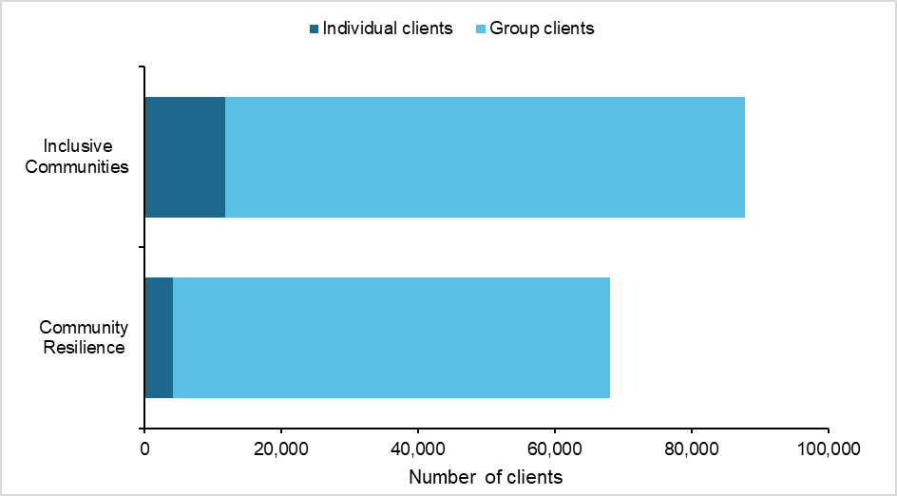
Source: DEX Program Overview report extracted 11/08/2020
Notes: Individual clients are attendees who had a client record created that may contain data on demographics and outcomes. Group clients are unidentified people who attended project sessions who do not have demographic or outcome data recorded.
The entry of demographic data by organisations for individual clients was also inconsistent. When demographic data is broken down by different characteristics (e.g. age, gender, CALD status etc.) the client totals are in some cases different. There is also insufficient data for individual clients within some SARC Activity data items such as disability status.
A high number of individual clients do not have any data recorded on additional demographic data items including homelessness status, income status, household composition, years living in Australia, visa flag and referrals information (Figure 7). These demographic fields are part of the extended ‘partnership approach’, which is not compulsory for SARC Activity grant recipients to report on. The Data Exchange Program Specific Guidance (PSG) for the SARC Activity does not currently provide guidance on reporting against these extended demographic fields.
Figure 7 Proportion of individual clients with profile data missing or incomplete, as at 30 June 2020 (n=14,013)*
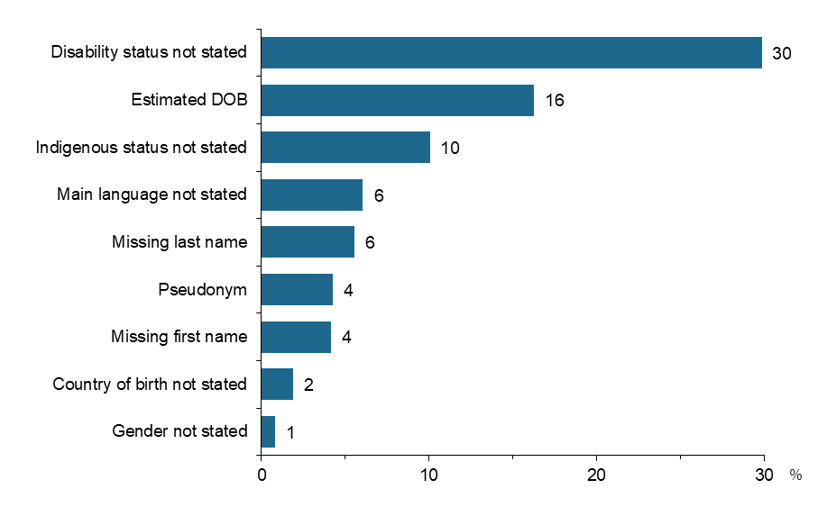
Source: DEX Organisation Data Quality report extracted 12/10/2020
Notes: *Total number of individual clients captured I this dataset is 14,013, which differs from total individual client counts contained in other DEX reports (e.g. DEX Program Overview report – Activity sheet).
As recording progress towards SCORE outcomes is also optional for the SARC Activity, SCORE outcomes data has been inconsistently collected by delivery organisations, and many organisations have not reported any outcomes data, which limits the utility of SCORE data to measure performance against the evaluation outcomes or determining pre/post assessment of benefits for the purpose of assessing value for money. The DEX data reports indicate that there were a large number of SARC Activity records in recent reporting periods but very few data points from the start of the program, which makes it difficult to assess pre/post changes. Likewise, the reported SCORE outcomes are based on a limited number of organisations, which makes it difficult to interpret whether outcomes for this small sample is representative of all SARC Activity.
As shown in Figure 8, there is some variation in the proportion of clients that were assessed for each of the three individual SCORE components. According to the Department’s Data Exchange Protocols, grant recipient organisations are given flexibility in how they record SCORE outcomes for individual clients. Organisations are able to choose between using a validated assessment tool or their own tool that has not been validated. This data is also voluntarily reported in DEX including:
- An ‘assessed by’ field that captures whether a validated tool was used or the organisation’s own tool (recorded as ‘SCORE directly’)
- Who conducted the assessment: practitioner professional assessment, client self-assessment, joint client/practitioner assessment, client support person (e.g. carer).
An analysis of this data indicates that a range of different assessment methods have been used across the three individual SCORE components, although at least half of assessments for each component were conducted using validated tools, primarily by support persons (Figure 9). While it is positive that a significant proportion of individual clients were assessed using a validated outcomes tool, the variety of assessment methods used coupled with the relatively high proportion of individual clients who were assessed by unknown methods limit the usability of the SCORE data that has been collected for the SARC Activity.
Figure 8 Proportion of individual clients assessed for SCORE outcomes, as at 30 June 2020 (n=15,935)*
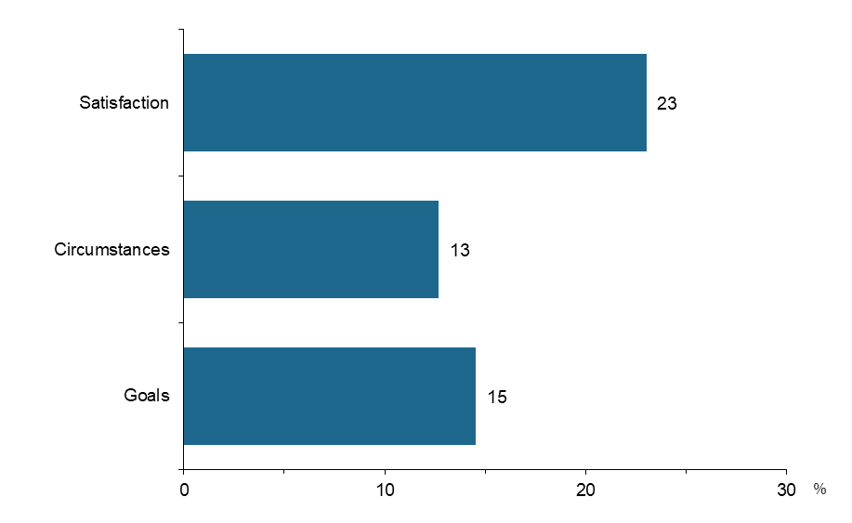
Source: DEX Client Outcomes Program Overview report extracted 12/10/2020
Notes: *Total number of individual clients is taken from the DEX Program Overview report – Activity sheet

Figure 9 Tools used to assess SCORE outcomes for individual clients
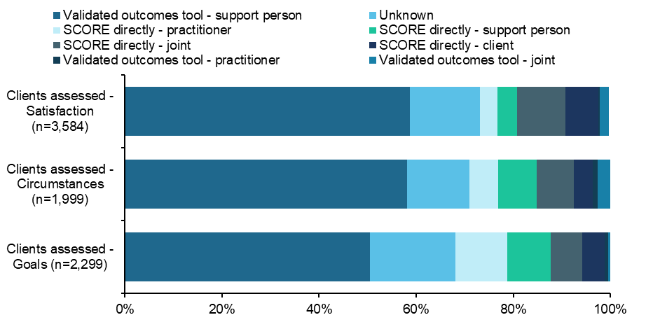
Source: DEX Client Outcomes Program Overview report extracted 12/10/2020
Notes: Individual clients may be recorded against one or more SCORE Outcome components
SCORE Community Outcomes reporting was also reviewed and underwent data quality checks. For Community Resilience projects, there were a disproportionate number of Community SCOREs recorded in the most recent reporting period with very few records created in previous reporting periods. While there were a higher number of Community SCOREs (both paired with sessions and paired with cases) for Inclusive Communities projects, these were concentrated amongst a handful of delivery outlets. As a result, it was not feasible to assess change over time for this component of DEX data.
Given the discrepancies in the total number of individual clients recorded in different DEX reports and the concentration of individual clients recorded/assessed by a small selection of grant recipient organisations, both demographic and SCORE outcomes data have been interpreted with great caution.
Following a review of the outcomes data, it was determined that the data was of insufficient coherence to support a robust VFM approach that relied on the use of pre/post program data to be drawn from DEX. Because most organisations had not provided any data on outcomes it was difficult to identify whether the outcomes for the small sample of organisations was representative of all organisations funded through the program.

- Departmental consultation results
The results presented here are based on qualitative analysis of notes taken during consultations with the 12 departmental stakeholders (including key informants and departmental delivery staff). The results have been mapped to relevant evaluation questions.

Appropriateness
Is the grant program the appropriate vehicle for funding a flexible and diverse range of projects?
Departmental stakeholders commented on the broad range of projects that have been funded and cited this as a key strength of the SARC Activity, due to the broad scope of the grant opportunity guidelines. This was viewed by these stakeholders as a key point of difference from other DSS grants programs, which were more limited in scope.
However, a few barriers were noted by stakeholders in relation to the assessment and selection of diverse projects. In particular, there was some concern that organisations where English was not the first language of staff were at a disadvantage when submitting proposals and required further support to ensure these types of organisations could develop quality proposals.
How well did the grant program align with the stated objectives?
Overall, departmental stakeholders felt that the SARC Activity had aligned well with its stated objectives and had successfully funded projects that achieved the aim of strengthening social cohesion.
A few departmental stakeholders expressed concern that the requirement for Community Resilience projects to include a Harmony Day was too restrictive and led to suitable organisations being ineligible despite their projects aligning with the stated objectives of the Activity. This was identified as an issue particularly for projects in remote communities where Harmony Days were seen as less relevant.
Despite this, departmental stakeholders noted that SARC Activity funded projects were generally a good fit for the SARC Activity and aligned closely with the objectives of the Community Resilience and Inclusive Communities funding streams. Stakeholders acknowledged that the alignment of projects with the objectives of the SARC Activity was due in part to the scope being extremely broad, which made it easier for grant recipients to achieve the objectives SARC aimed to achieve. However, a few stakeholders viewed the assessment criteria as too broad, which made it more difficult to select projects that were best suited to achieving the SARC Activity objectives.
Based on their design and location, are funded projects likely to reach the intended target?
Anecdotally, departmental stakeholders provided evidence of funded projects reaching a broad range of target groups including Aboriginal and Torres Strait Islander Communities, Muslim communities and disadvantaged people living in remote areas, as intended by the SARC Activity grant guidelines.

Process
Have governance and reporting systems supported successful delivery?
Departmental stakeholders reported mixed experiences with the reporting undertaken by SARC grant recipient organisations, including DEX reporting and Activity Work Plans.

Experiences with DEX
Consultations with Departmental stakeholders revealed that most thought DEX was not tailored or well suited to the broad scope of SARC and the variation in the size of funded organisations. In particular, stakeholders indicated that smaller organisations with limited experience of delivering government-funded grant projects struggled to put in place the data collection required by DEX.
Due to many organisations delivering projects that involved participants attending events or accessing services on a one-off or infrequent basis, departmental stakeholders felt it was difficult for delivery organisations to collect meaningful data tracking progress over time. Departmental stakeholders also noted that some communities were wary of providing personal information due to concerns about privacy.
Stakeholders noted that there were delays in delivery organisations gaining access to DEX at the beginning of project delivery, particularly if they had not received grant funding from DSS previously and did not have an ABN set up. In some instances, delivery organisations did not receive guidance and training on using DEX straight away, which delayed their ability to begin submitting reports.

Activity Work Plans
Departmental stakeholders identified fewer issues with Activity Work Plans than DEX, indicating that this could be a more valuable source of data, particularly in relation to project deliverables, outcomes, aims and objectives.

Interaction with Funding Arrangement Managers
Funding Arrangement Managers noted that they had not encountered any significant issues with maintaining effective communication with the delivery organisations they were overseeing.

Are the current systems sufficiently flexible to allow reporting by the diverse organisations and projects funded by SARC?
Despite the issues identified with DEX, departmental stakeholders indicated that delivery organisations were generally able to meet reporting deadlines, particularly those that had previously received grant funding from DSS and were familiar with the Department’s reporting systems and processes.

What lessons were learned through the implementation of SARC that should inform both future rounds of SARC and similar grant programs in future?
Funding Arrangement Managers generally felt that the implementation of SARC had been relatively smooth but other departmental stakeholders noted that there were some lessons that should be considered for future funding rounds. Some stakeholders indicated that more work needed to be done in preparing organisations to begin implementation as soon as funding was approved, as there had been delays in SARC delivery organisations commencing their projects and recruiting staff. This initial delay resulted in requests from delivery organisations to rollover funding.
Similarly, departmental stakeholders noted that some delivery organisations lacked capacity to manage funds and did not understand the spending rules for the grant program, with issues not being identified until after End of Financial Year. As a result, early engagement with organisations to discuss spending rules was seen as a lesson for future funding rounds.
There were also concerns about the sustainability of projects beyond the one-off funding period. Despite the Grant Opportunity Guidelines stating that SARC grants were for one-off limited projects, Departmental stakeholders indicated that many grant recipients did not seem prepared for the funding to be discontinued after the initial grant cycle and were ill-equipped for transitioning to a self-sustainable model.

Effectiveness of program design

Did grant recipients deliver the intended activities and achieve the intended outcomes?
Departmental stakeholders indicated that the SARC Activity funded projects had delivered the activities as intended and had achieved a range of outcomes. Several stakeholders noted that SARC Activity projects they were aware of had successfully achieved social and economic participation outcomes such as connecting socially isolated people to services and educational outcomes for long-term unemployed people.
Stakeholders noted the impact of COVID-19 on the ability of organisations to deliver SARC Activity projects as intended. COVID-19 impacts identified by stakeholders ranged from moderate to significant including small reductions in the number of participants and moving to conduct activities remotely. A few stakeholders also indicated that some projects would need to be extended due to delays caused by COVID-19.

Which kinds of approaches or organisations worked well, and which met with challenges?
Projects that had adopted community development approaches, whereby the community was involved in identifying the needs the project would address, were seen by stakeholders as particularly effective. Similarly, smaller organisations that had delivered innovative projects that would not usually receive government funding were also viewed as exemplars of the SARC Activity’s aim to fund innovative and flexible projects that address social cohesion and community participation issues.
Stakeholders did not identify any types of projects that had met with challenges, although some noted that it was too early to tell whether all projects had been successful at achieving their aims.

What were the advantages and disadvantages of the SARC Activity’s broad approach?
As previously noted, stakeholders highlighted the flexibility and broad scope of the SARC Activity’s approach to funding projects as a key advantage of the Activity, which had resulted in organisations and projects that would not normally be eligible for government grants, receiving valuable funding.
However, some stakeholders also viewed the scope of SARC as a disadvantage as it tried to fund a broad range of projects with a limited funding pool, which resulted in a large number of projects not being funded, even if they met the eligibility requirements.

To what extent were the community resilience projects reflective of a community-driven approach?
As noted above, departmental stakeholders indicated that a range of successful projects had reflected a community-driven approach and had clearly reflected the needs of communities by engaging community members in the development of projects.

- Secondary data analysis
The secondary data analysis for the SARC Activity evaluation includes the Selection Advisory Panel (SAP) assessment report data for the 1,176 SARC Activity applications assessed, as well as DEX priority requirements data reports and partnership approach reports (where available), and an administrative dataset on projects funded through the SARC Activity.

Appropriateness

How well was the SARC Activity promoted to the community sector?
Based on the SAP application assessment data analysed, it is clear that a broad range of organisations were aware of the SARC Activity and chose to submit applications. However, a significantly higher number of applications were received for the Inclusive Communities grant stream, suggesting that there was greater interest amongst community organisations in this aspect of SARC.
Figure 10 Proportion of applications assessed by SARC Activity stream (n=1,176)
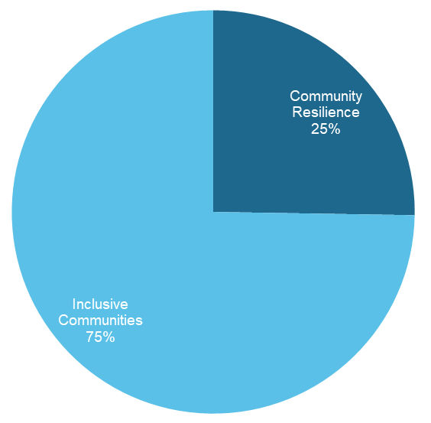
Source: SAP Assessment Reports
Applications were broadly distributed across all states and territories, indicating that the grant opportunity was widely promoted to community organisations, although higher numbers of applications were submitted by organisations in states with the largest populations, particularly New South Wales, Victoria and Queensland (Figure 11).
Figure 11 Proportion of applications assessed by state/territory (n=1,176)
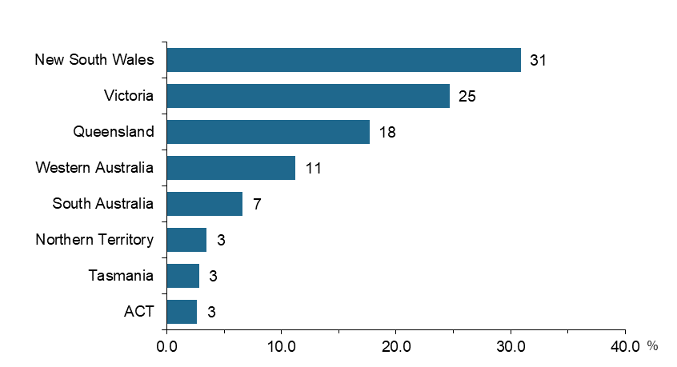
Source: SAP Assessment Reports

Is the grant program the appropriate vehicle for funding a flexible and diverse range of projects?
According to an analysis of SAP assessment data (Figure 12), 55% of Community Resilience and 17% of Inclusive Communities applications were assessed as suitable for funding. Of those, 20% of suitable Community Resilience and 42% of suitable Inclusive Communities applications were actually funded, indicating available funding was not sufficient to meet all suitable applications. The proportion of total SARC applications funded was low overall. As shown in Figure 12, only 7% of Inclusive Communities and 11% of Community Resilience applications were funded.

Figure 12 Proportion of SARC Activity applications funded and identified as suitable for funding (n=1,176)
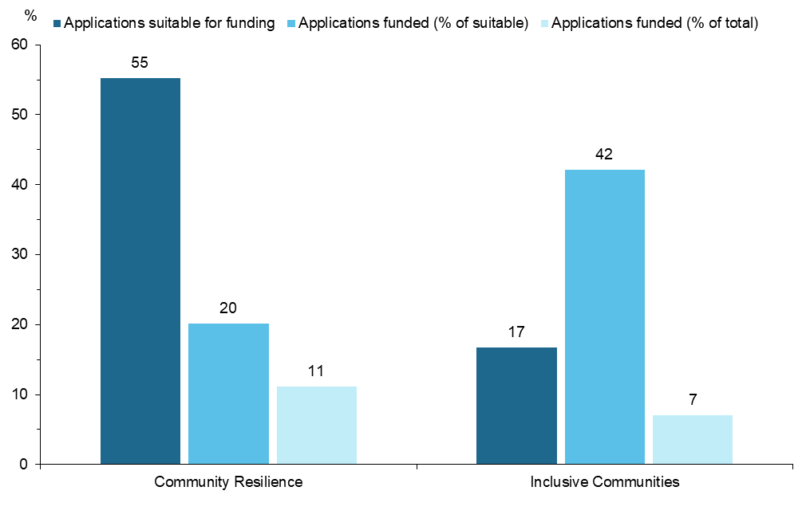
Source: SAP Assessment Reports
Notes: Suitable applications account for 26% of the total applications assessed by the SAP. Suitability was determined by the SAP as part of the assessment process, prior to a determination being made about whether to recommend the project for funding. Not all SARC applications found to be suitable for funding were recommended for funding by the Selection Advisory Panel, depending on their individual scoring.
Applications suitable for funding: number of applications suitable divided by number of applications
Applications funded (% of suitable): number of applications funded divided by number of applications suitable
Applications funded (% of total): number of applications funded divided by number of applications
Based on our analysis of SAP Assessment Reports, applications for SARC grants were submitted that targeted a broad range of groups. As shown in Figure 13, both Community Resilience and Inclusive Communities applications targeted a diverse range of groups identified for the SARC Activity. Four target groups were more commonly represented in Community Resilience applications, namely, socially isolated people (70%), children and youth (60%), economically isolated/unemployed people (56%) and women (55%). A relatively smaller proportion of applications for both Inclusive Communities and Community Resilience funding targeted CALD groups (22% and 34%, respectively) and even fewer targeted groups and individuals demonstrating intolerance (4% and 29%, respectively), indicating that these groups were not as well represented in the applications received. However, the proportion of SARC projects funded by target group (Figure 14) that a similar proportion of projects targeting CALD individuals were funded as other key target groups.
Figure 13 Inclusive Communities/Community Resilience applications assessed by target group (n=1,176)
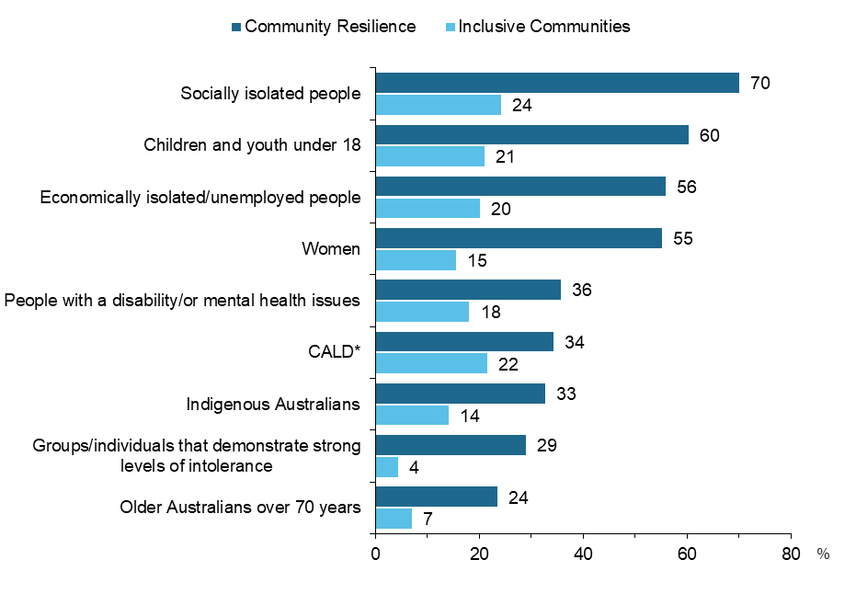
Source: SAP Assessment Reports
Notes: Target groups are standardised categories used by DSS as part of the SARC application and assessment process. Percentages add to more than 100% as applicants were able to select multiple target group categories.
Proportion calculated as the number of applications within each target group divided by the total number of applications in each Activity stream
*CALD includes culturally and linguistically diverse individuals and non-Australian citizens including humanitarian entrants or newly arrived migrants.

Figure 14 Proportion of Inclusive Communities/Community Resilience funded projects by target group
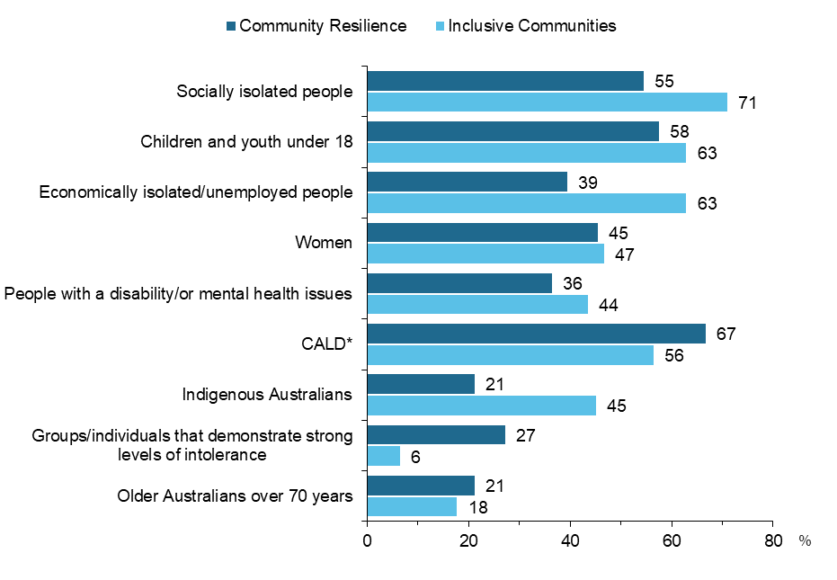
Source: SAP assessment report, SARC projects funded data
Notes: Target groups are standardised categories used by DSS as part of the SARC application and assessment process. Percentages add to more than 100% as applicants were able to select multiple target group categories.
Proportion calculated as the number of projects funded within each target group divided by the total number of projects funded in each Activity stream.
*CALD includes culturally and linguistically diverse individuals and non-Australian citizens including humanitarian entrants or newly arrived migrants.
Our analysis of the diversity of SARC projects also included the geographic spread of funded projects. According to DEX data, a majority of SARC funded projects took place in major cities, although a sizable number also took place in regional areas, while only a few were delivered in remote areas (Figure 15). Given the small proportion of Australia’s population that lives in regional and remote areas (29% according to the 2017 Census) it appears that SARC is funding a geographically diverse range of projects in metropolitan, regional and remote communities, particularly through the Inclusive Communities stream.

Figure 15 Proportion of SARC delivery organisation* by remoteness category, as at 30 June 2020
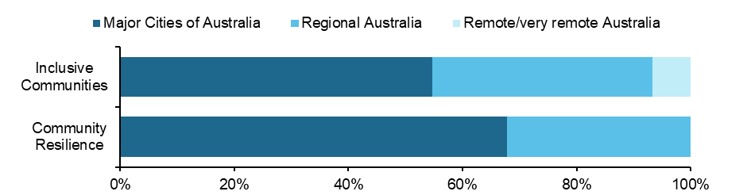
Source: DEX Program Overview report, extracted 11/08/20
Notes: *Approximately 103 organisations are included. Some organisations are excluded due to the suppression of small numbers of organisations by remoteness, in accordance with Departmental confidentialisation protocols.

Based on DEX data, there was also a spread of projects across all states and territories, although Tasmania, NT and the ACT accounted for only a small fraction of delivery outlets. Likewise, NSW accounted for almost half of Inclusive Communities delivery outlets suggesting that projects through the grant stream were heavily concentrated in this state (Figure 16).
Figure 16 Proportion of delivery outlets* by state or territory, as at 30 June 2020
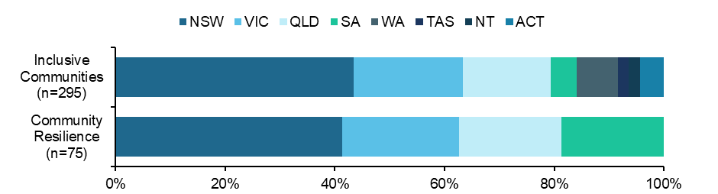
Source: DEX Program Overview report, extracted 11/08/20
Notes: *Some delivery outlets are excluded due to the suppression of small numbers of organisations by state or territory, in accordance with Departmental confidentialisation protocols.

How well did the grant program align with the stated objectives?
SAP assessment data indicates that many of the applications that were assessed were found to be suitable for funding, prior to the Selection Advisory Panel determining which applications would be recommended for funding. Despite the Inclusive Communities Activity stream receiving a significantly higher number of applications (879 versus 297), far fewer of these were suitable for funding (17%), while more than half of Community Resilience applications were suitable (55%) (Figure 12).

Based on their design and location, are funded projects likely to reach the intended target?
As indicated above, funding data suggests that funded SARC projects have targeted many of the target groups identified in the program design (Figure 14). Socially isolated people, children and youth and CALD people represented the three groups most commonly targeted groups. However, only a limited number of funded projects across both Activity streams targeted Older Australians and groups and individuals demonstrating intolerance, indicating that projects were unlikely to intentionally reach these groups through their activities despite the SARC design identifying these populations as key target groups (Figure 17).
Figure 17 Number of funded projects by target group and Activity stream (n=95)
Source: SAP assessment report, SARC projects funded data
Notes: Target groups are standardised categories used by DSS as part of the SARC application and assessment process. *CALD includes culturally and linguistically diverse individuals and non-Australian citizens including humanitarian entrants or newly arrived migrants.

Effectiveness of program design

Who was reached by the SARC grants program?
Where demographic data has been reported in DEX for individual clients who have received a service during the five reporting periods it shows that:
- Around one third (36%) of Community Resilience and Inclusive Communities clients were male and nearly two-thirds (63%) were female.
Nearly half (46%) of Community Resilience clients were aged between 0 to 19 and almost two thirds (61%) of Inclusive Communities clients were in this age range (Figure 18).
- Around 12% of Community Resilience and 15% of Inclusive Communities clients were reported to be Aboriginal and Torres Strait Islander.
- Based on the culturally and linguistically diverse (CALD) status derived in DEX, 31% of Community Resilience clients and 25% of Inclusive Communities clients were identified as CALD.
Although the Community Resilience stream was aimed at addressing issues relating to low social cohesion, a relatively small proportion (25%) of individual clients reported in DEX were identified as CALD, which was one of the key target groups the Activity stream was intended to support. However, nearly half (46%) of Community Resilience clients were aged between 0-19, suggesting that Community Resilience projects have reached marginalised youth as intended.
Inclusive Communities projects have reached an even larger proportion of children and young people with nearly two thirds (61%) of individual clients aged 0-19, aligning with a key focus of the program stream. Although Inclusive Communities projects were also intended to reach Aboriginal and Torres Strait Islanders and people with disabilities and/or mental illnesses, there is little evidence in the DEX data that a large proportion of participants in these categories have been engaged in the program stream. 15% of Inclusive Communities individual clients reported in DEX were identified as Aboriginal and Torres Strait Islander while only 8% were identified as having a disability. However, 12% of Inclusive Communities individual clients had no information recorded about their Indigenous status while 37% had no disability status recorded indicating that there are currently significant gaps in the demographic data recorded in DEX. Clearer guidance and reporting requirements for these items are required to ensure more consistent data collection for future funding rounds.

Figure 18 Age group of individual clients recorded in DEX over 5 reporting periods to 30 June 2020
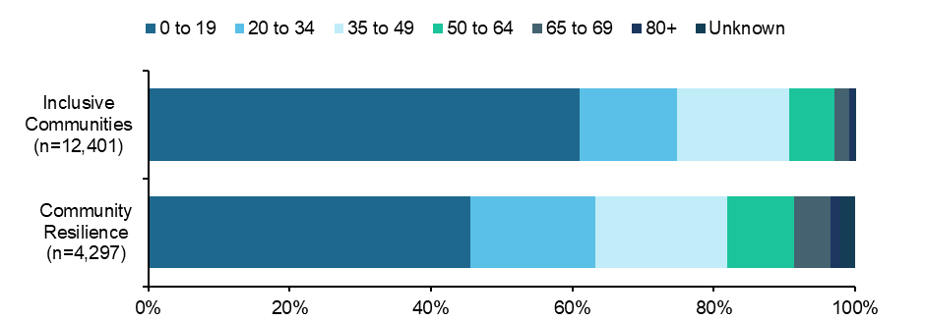
Source: DEX Program Overview report, extracted 11/08/20
Notes: A high number (84) of Community Resilience clients had age > 105. To improve data quality these clients have been re-classified as having their age unknown.

Impact of SARC

To what extent were the projects successful in achieving the intended outcomes?
Despite the limitations noted in Appendix E, DEX reporting provides some indication of the extent to which SARC Activity projects have achieved some of their intended outcomes.
Vulnerable and disadvantaged individuals improve social and economic participation
According to DEX SCORE outcomes data, individual clients had improved their social and economic participation. For example, data on the SCORE Circumstances - Community participation and networks domain indicated that on average Community Resilience and Inclusive Communities individual clients have improved their participation in the community. As shown in Figure 19, there was a noticeable increase in the average SCORE of individual clients participating in Inclusive Communities funded projects. There was also some improvement in the average Circumstances – Employment SCORE, suggesting that clients have improved their economic participation as well, with Inclusive Communities projects in particular recording a significant increase in SCORE in this domain (Figure 20).
Figure 19 Average SCORE Circumstances - Community Participation and Networks recorded in DEX to 30 June 2020
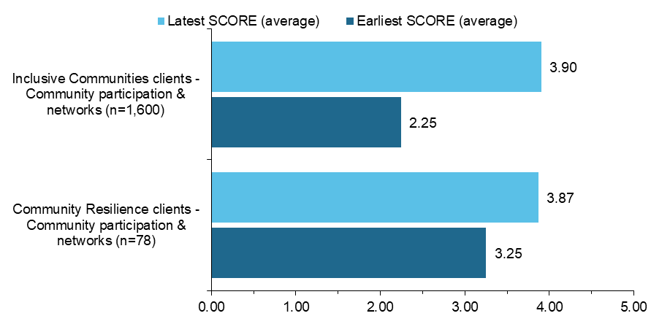
Source: DEX Client Outcomes program view, extracted 12/10/20
Notes: There is significant variation in the number of individual clients with recorded SCOREs at an organisational and Activity stream level. There is also variation in the number of times a client may have a SCORE recorded and when this takes place, which may also skew SCORE averages.

Figure 20 Average SCORE Circumstances - Employment recorded in DEX to June 2020
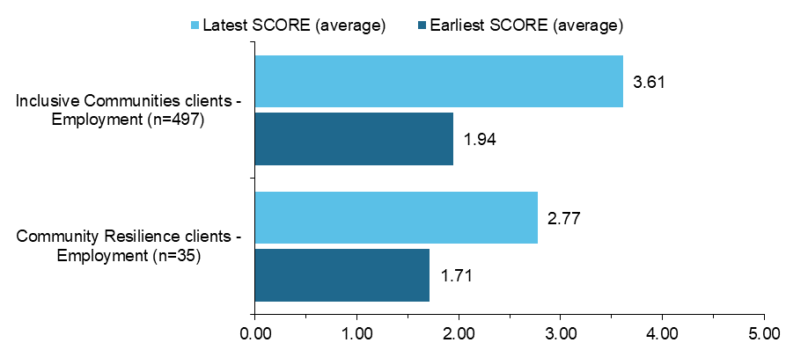
Source: DEX Client Outcomes program view, extracted 12/10/20
Notes: There is significant variation in the number of individual clients with recorded SCOREs at an organisational and Activity stream level. There is also variation in the number of times a client may have a SCORE recorded and when this takes place, which may also skew SCORE averages.

Participants engage with community services and activities
Based on SCORE Goals data that has been collected for SARC, both Community Resilience and Inclusive Communities clients who were assessed on average experienced an increase in their scores during the course of SARC project delivery (Figure 21). This could indicate that clients have increased their engagement with community services and activities as part of/during their participation in SARC projects.
Figure 21 Average SCORE Goals – Engagement with services in DEX to 30 June 2020
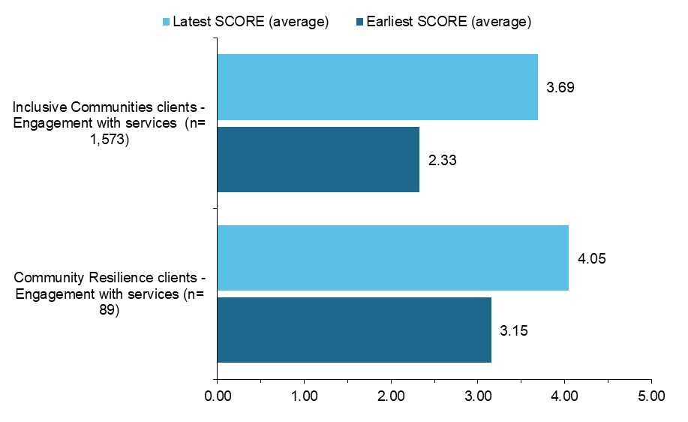
Source: DEX Client Outcomes program view, extracted 12/10/20
Notes: There is significant variation in the number of individual clients with recorded SCOREs at an organisational and Activity stream level. There is also variation in the number of times a client may have a SCORE recorded and when this takes place, which may also skew SCORE averages.

Online survey of SARC Activity Project Leads results
Survey respondent profile data
The online survey received complete responses from project leads from 66 organisations, 11% of which had two SARC projects funded and 2% had three SARC projects funded (Figure 22). This represented 75 projects in total, nearly two thirds (63%) of which were funded by the Inclusive Communities stream, 30% Community Resilience and 7% were National Research (Figure 23). Of the projects reported on in this survey, just over one third were being delivered in New South Wales, one quarter in Victoria, followed by Queensland (21%), Western Australia (16%), South Australia (11%), Tasmania (9%), ACT (5%) and Northern Territory (4%) (Figure 24).
Figure 22 Proportion of organisations funded for one, two or three or more projects
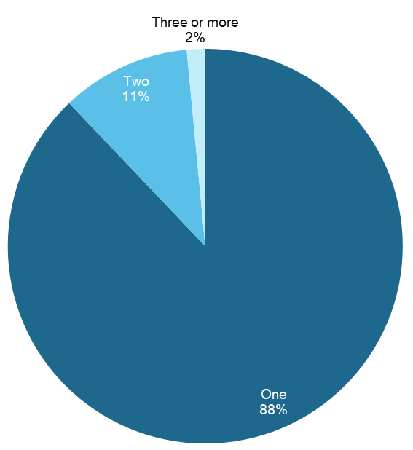
Source: Survey of SARC Activity Project Leads, August 2020
Notes: Question item – A3. Please specify the total number of projects funded by SARC for your organisation.
Base: All survey participants (n=66)
Figure 23 Proportion of SARC projects by SARC funding stream
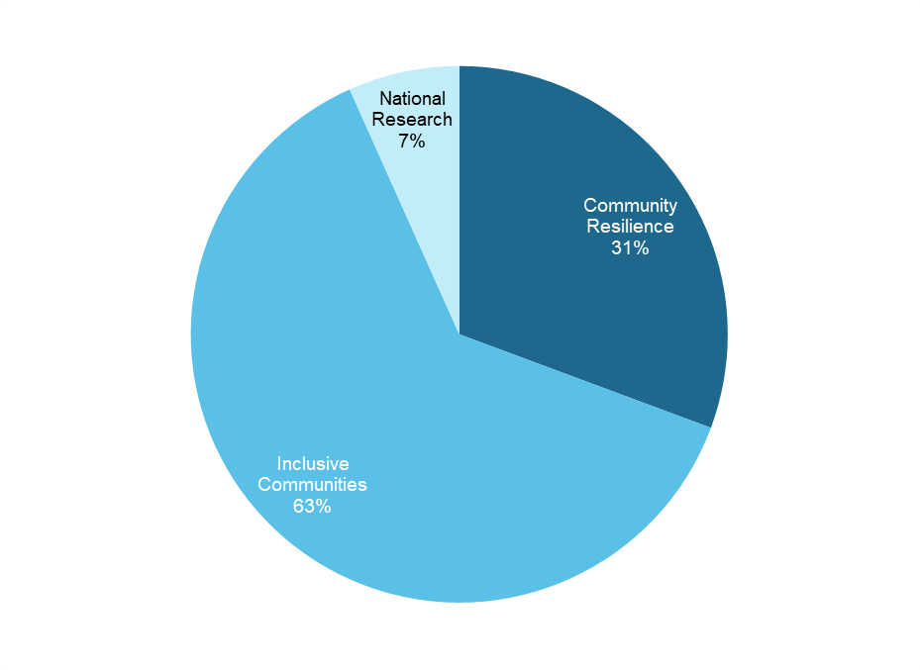
Source: Survey of SARC Activity Project Leads, August 2020
Notes: Question item – A4. Which of the following SARC grant programs is funding your <NUMBER> project?
Base – All SARC projects reported by participants (n=75)
Figure 24 Proportion of SARC projects being delivered in each state or territory
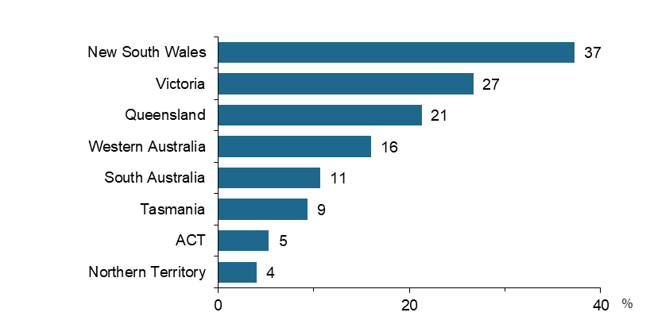
Source: Survey of SARC Activity Project Leads, August 2020
Notes: Question item – A12. In which state or territory does your organisation deliver the project?
Base – All SARC projects reported by participants (n=75)
A large proportion (41%) of the organisations delivering SARC projects were small with 20 or less people working in these organisations, whilst around 35% were larger sized organisations with 100 people or more (refer to Figure 25). The most common areas of focus of these organisations were centred around supporting community engagement and participation, social cohesion, social isolation, community education and youth development and support (refer to Figure 26).
Figure 25 Number of people working in organisations conducting SARC projects
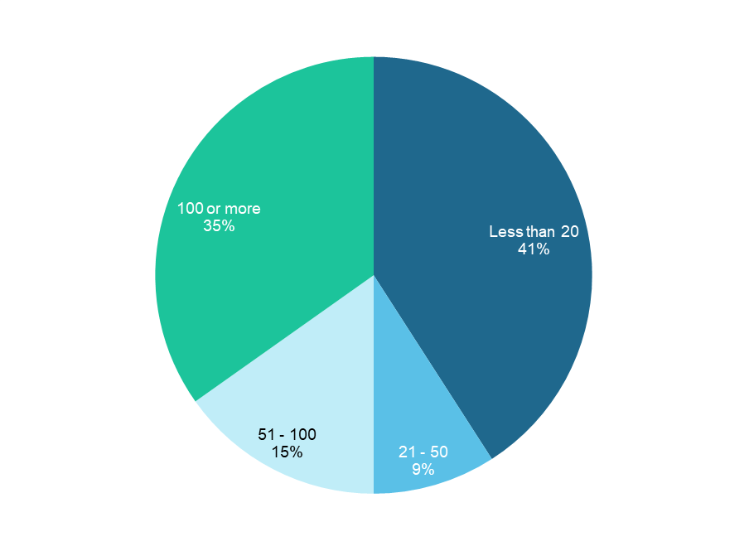
Source: Survey of SARC Activity Project Leads, August 2020
Notes: Question item – A1. Overall, approximately how many people currently work at your organisation?
Base – All survey participants (n=66)

Figure 26 Proportion of respondents reporting main area of focus for their organisations
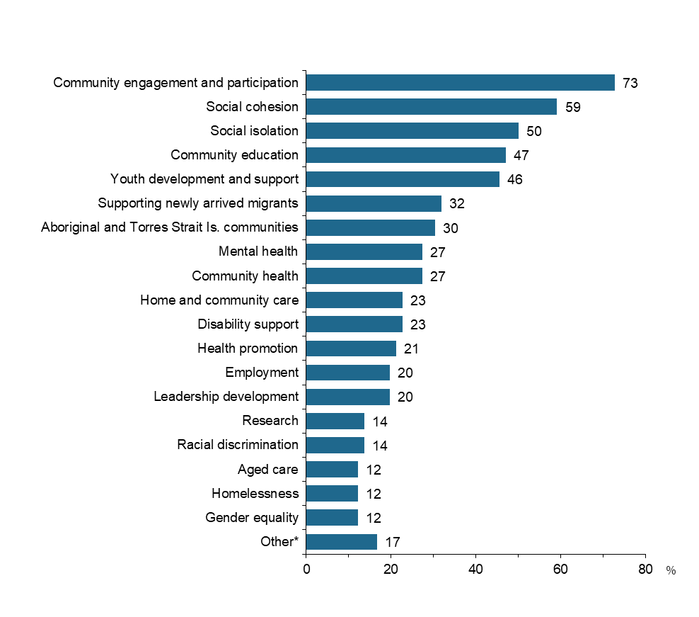
Source: Survey of SARC Activity Project Leads, August 2020
Notes: Question item – A2. What are the main areas of focus for your organisation?
Base – All survey participants (n=66)
Respondents may report more than one main area of focus
*Other includes areas such as children and families, religious activities

Appropriateness

How well was the SARC activity promoted to the community sector?
The survey data relating to respondent’s knowledge and experience about how they learnt about SARC addresses this evaluation question.
32% of respondents reported they were aware of the Strengthening Communities activity prior to it being replaced by SARC and 27% of respondents' organisation had previously received a Strengthening Communities grant.
Of the 18 organisations that previously received a Strengthening Communities (SC) grant, 5 of the respondents were not aware of the SC activity prior to it being replaced by SARC.
Project leads were also asked about how their organisation leant about the SARC activity; over half reported this was via the Community Grants Hub website, and just over one third though direct contact from DSS (Figure 27).
Figure 27 Proportion of project leads reporting how their organisation learnt about the SARC activity
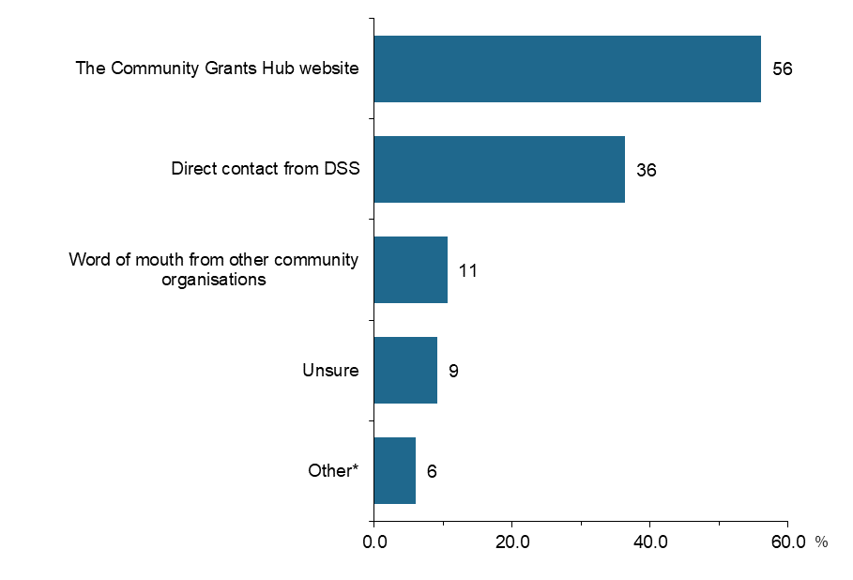
Source: Survey of SARC Activity Project Leads, August 2020
Notes: Question item – B3. How did your organisation learn about the SARC activity?
Base – All survey participants (n=66)
Respondents may report more than one way of learning about SARC activity
*Other includes ways such as word of mouth from other sources, tender search, consultation with previous Strengthening Communities funded organisations
Project leads were also asked about their general experiences with the SARC Activity application and assessment processes. Eighty per cent of the project leads reported they thought the Community Grants Hub is easy to access, the grant guidelines and assessment criteria are clear and easy to understand (76%) and the funding period for their project was adequate (74%). Slightly less thought the grant application form was easy to understand and fill out and the length of time between submitting a grant application and signing the grant agreement was reasonable (59%) (refer to Figure 28).
Figure 28 Proportion of project leads reporting they agree with the following experiences with SARC application and activity
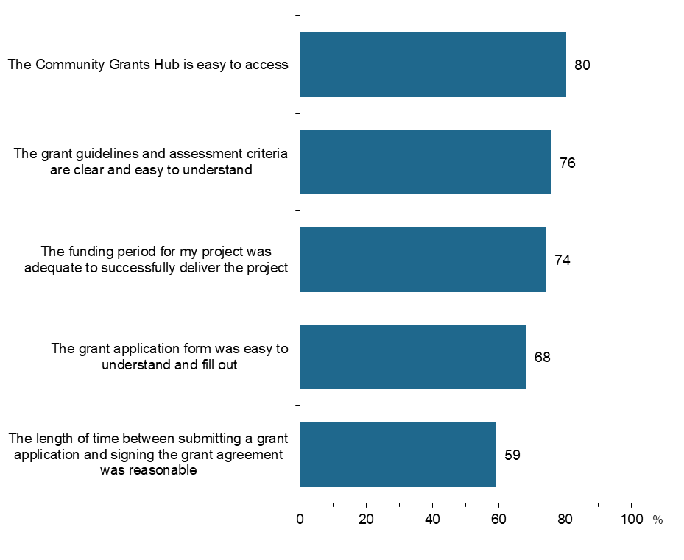
Source: Survey of SARC Activity Project Leads, August 2020
Notes: Question item – B4. Thinking now about the SARC activity in general. Please indicate how much you agree or disagree with the following statements about SARC.
Base – All survey participants (n=66)
Proportion of agreement includes those who responded “strongly agree” or “agree”

Process

Have governance and reporting systems supported successful delivery?
Survey respondents reported on their experiences with governance and reporting arrangements put in place for the SARC Activity.
The majority of project leads delivering Community Resilience and Inclusive Communities projects report their client demographic and service delivery data through DEX (93%) and Activity Work Plans (87%), while just less than half also use their own internal databases. Slightly less use DEX (74%) and Activity Work Plan (67%) for reporting on client outcomes (refer to Figure 29).
Figure 29 Proportion of project leads reporting how their organisation collects and reports performance information
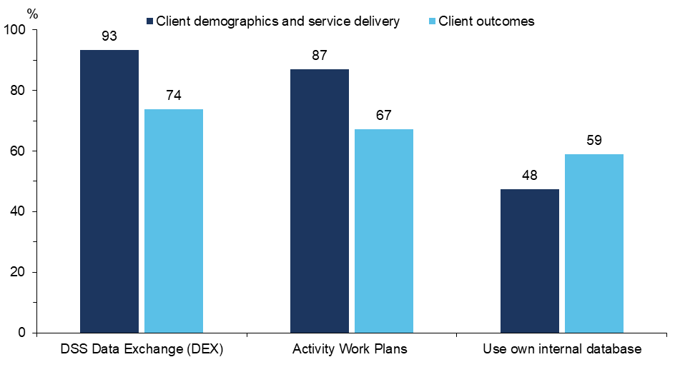
Source: Survey of SARC Activity Project Leads, August 2020
Notes: Question item D2-D3. How does your organisation collect and report performance information for client demographics and service delivery / client outcomes? Please select all that apply.
Base – All survey participants (n=66)
Includes responses from project leads from Community Resilience or Inclusive Communities projects only (n=61); excludes response options where number of responses < 5

There were very few respondents (<5) who reported they did not use DEX; however, of those who did not use DEX, the reasons flagged for non-use were:
- using DEX was an unnecessary duplication of existing data collection
- the data required for DEX did not seem relevant to the project
- functionality and usability of the platform.
Respondents were asked about their contact with a DSS Funding Arrangement Manager. Organisations most commonly had contact with DSS Funding Arrangement Mangers "several times a year" while delivering the project (74%). Almost all participants (95%) indicated that it was easy or very easy to communicate with the FAMS when required.

Are the current systems sufficiently flexible to allow reporting by the diverse organisations and projects funded by SARC?
Project leads were asked about their general experiences with SARC reporting requirements. Nearly two thirds of project leads (61%) reported that it was easy or very easy to fulfil reporting requirements. Respondents also reflected on their satisfaction with DSS's governance and reporting systems, with 61% satisfied or very satisfied, however a small proportion (11%) were dissatisfied.
Regarding DEX users’ experiences to report on project performance:
- most thought DEX reporting deadlines were reasonable and easy to meet (88%)
- half through uploading data to DEX was a manageable task (55%) and that it was clear what information was required to be reported through DEX (50%)
- one third found it was easy to adjust existing record keeping for submitting reports through DEX (36%), or it was easy to navigate the DEX system when uploading data (refer to Figure 30).
Figure 30 Proportion of project leads’ experiences using DEX to report on project performance
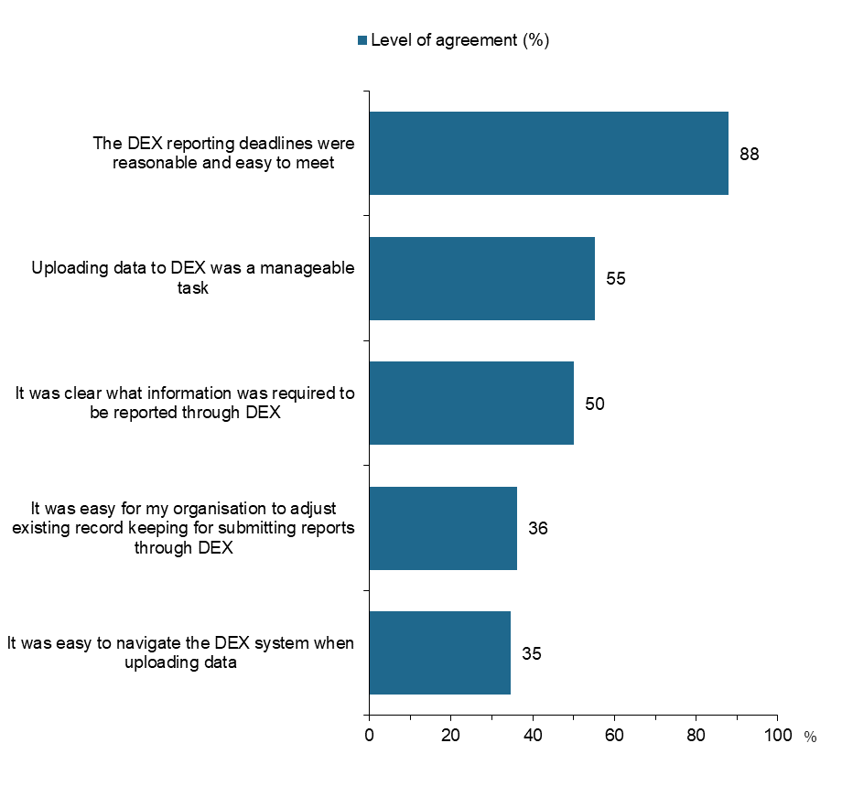
Source: Survey of SARC Activity Project Leads, August 2020
Notes: Question item – D6. Thinking now about using DEX to report on your project performance. Please indicate how much you agree or disagree with the following statements about DEX.
Base – Survey participants who reported using DEX to report on project performance (n=58)
Proportion of agreement includes those who responded “strongly agree” or “agree”

What lessons were learned through the implementation of SARC that should inform both future rounds of SARC and similar grant programs in future?
DEX users were asked what, if any, improvements could be made to the DEX reporting system. The most commonly cited reason was functionality/usability of the platform (48%), while on the contrary 33% of respondents identified no improvements were needed.
Respondents were asked about their experience with the implementation process for their projects. The majority (73%) of respondents reported that they thought it was successful but there were some challenges.

Effectiveness of program design

Who was reached by the SARC grants program?
Project leads were asked to identify which groups in the community their SARC projects support. The most common was Culturally and Linguistically Diverse individuals with just over 70% of respondents reporting their projects support this group. Many projects supported economically isolated or unemployed (61%) and socially isolated (58%) people, followed by women (47%), Aboriginal and Torres Strait Islander peoples (47%), recently arrived migrants (44%). Around one third supported children or teenagers/young adults under 18, people with mental health issues or disabilities (refer to Figure 31).
Figure 31 Proportion of population groups supported by SARC projects
Source: Survey of SARC Activity Project Leads, August 2020
Notes: Question item – C1. Which groups in the community do your organisation’s project(s) support as part of the SARC activity? Please select all that apply.
Base – All survey participants (n=66)
*Other includes groups for which very small numbers were reported, such as people in rural areas and families

Did participants continue to engage over time?
Respondents were asked about their experience with the implementation process for their SARC projects. The majority (73%) of respondents reported that they thought it was successful but there were some challenges.
Respondents also reported on the extent to which their expectations of client engagement were met on a scale from 1 (hardly at all) through to 5 (completely). Client engagement met expectations with 95% of respondents reporting a score of 3 or more. Two thirds (66%) of participants reported that it was easy or very easy to keep clients involved in the project(s) for the full delivery period. There was a high level of satisfaction reported with the experience of delivering a SARC Activity project, with 85% responding they were satisfied or very satisfied.

Did grant recipients deliver the intended activities and achieve the intended outcomes?
Project leads reported that the majority of projects have been delivered within the planned timeframe (81%), project budget (91%) and project scope (96%) (Figure 32).
Figure 32 Proportion of project leads reporting their experiences of SARC project delivery
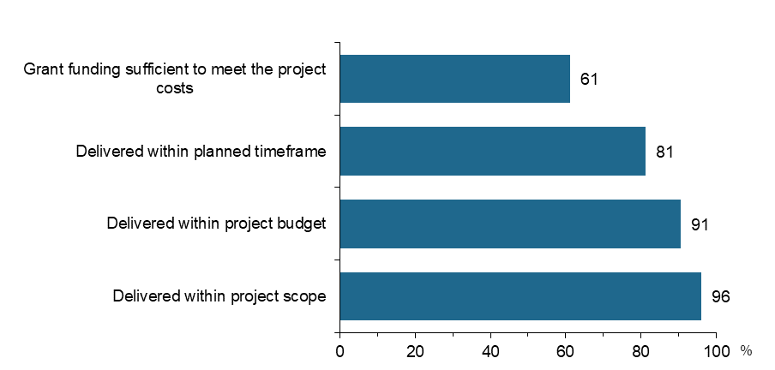
Source: Survey of SARC Activity Project Leads, August 2020
Notes: Question item – A15. Has the project been delivered within the… ?
Base – All SARC projects reported by participants (n=75)

Impact of SARC

To what extent were the projects successful in achieving the intended outcomes?
The conceptual evaluation framework (Appendix B) and revised program logic (Appendix C) outline the broad categories of intended outcomes of the SARC program. This survey identifies some of the more specific project aims reported by project leads that most relate to their SARC projects, the results of which explore how these measures contribute to the broader intended outcomes in order to address this evaluation question.
To provide some initial context regarding the coverage of aims that projects that were funded by the separate Community Resilience and Inclusive Communities streams, the proportion of project leads reporting their selected project aims, by SARC funding stream, was explored (Figure 33). There was a similar proportion of Community Resilience and Inclusive Communities projects aiming to achieve selected aims, suggesting there was not a clear differentiation between the types of project aims applicable to the two funding streams.
Figure 33 Proportion of project leads who described the selected SARC project aims, by SARC funding stream
Whole of community and early intervention responses to address cohesion, community belonging and barriers to social and economic participation  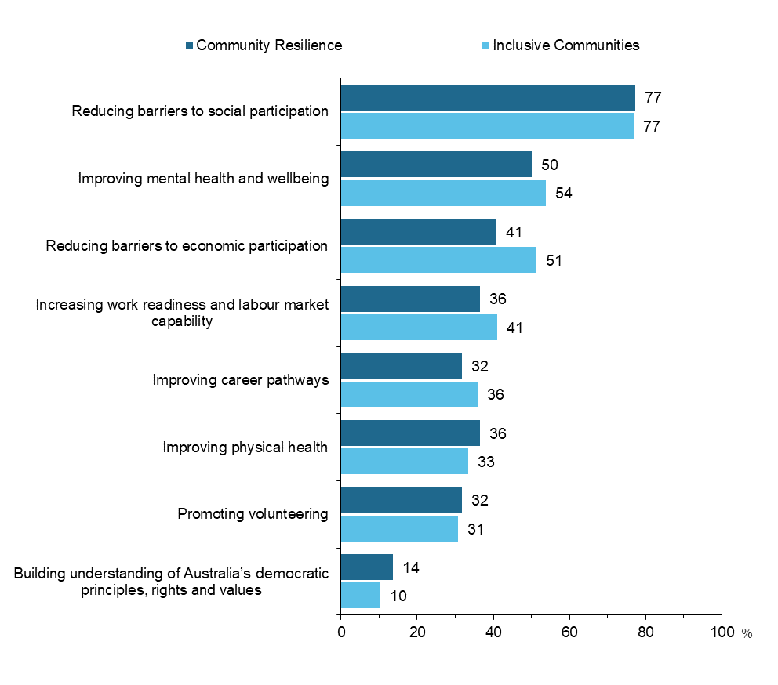 | Vulnerable and disadvantaged individuals improve social and economic participation  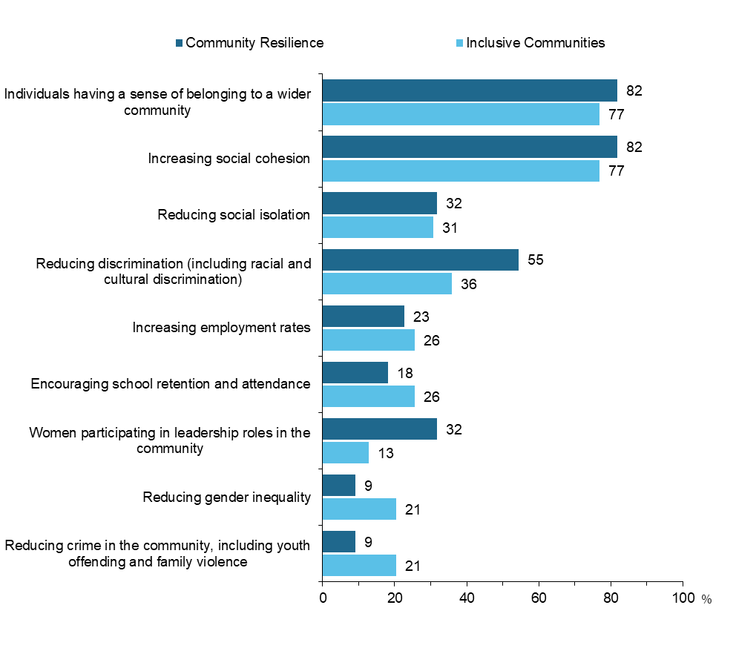
Participants engage with community services and activities  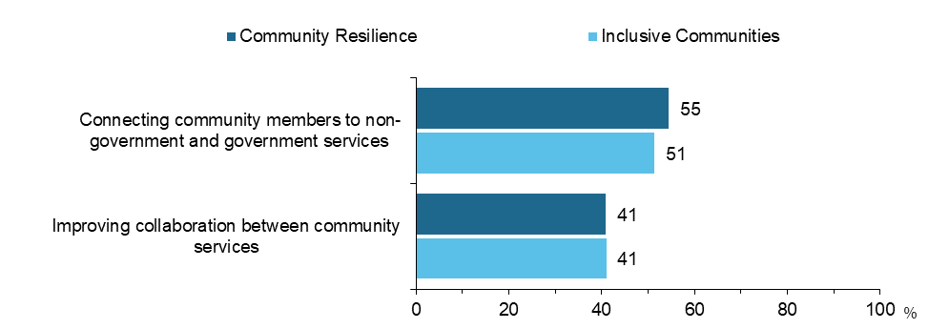 | Participants display positive attitudes towards their community  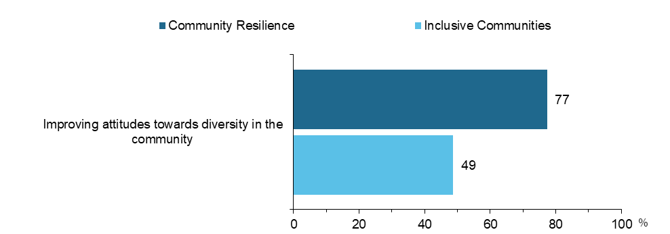
Source: Survey of SARC Activity Project Leads, August 2020
Notes: Question item – E1. Thinking about the project(s)… Which of the following best describe the aims you hoped to achieve through the project(s)? Please select all that apply.
Base – All survey participants (n=66)

Respondents may select more than one aim for their SARC projects

Whole of community and early intervention responses to address cohesion, community belonging and barriers to social and economic participation are established
The selected aims identified by project leads that relate to community and early intervention responses to address cohesion, community belonging and barriers to social and economic participation are displayed in Figure 34. The aim of reducing barriers to social participation was the most common aim identified by 77% of project leads, of which 83% reported they were mostly or extremely successful in achieving this aim. Around half of the respondents identified their projects aimed to reduce barriers to economic participation, of which 55% were mostly or extremely successful. Only one third of projects reported a project aim of promoting volunteering, but of these nearly 80% were successful in achieving this aim.
Figure 34 Proportion of selected whole of community and early intervention SARC project aims and level of success in achievement
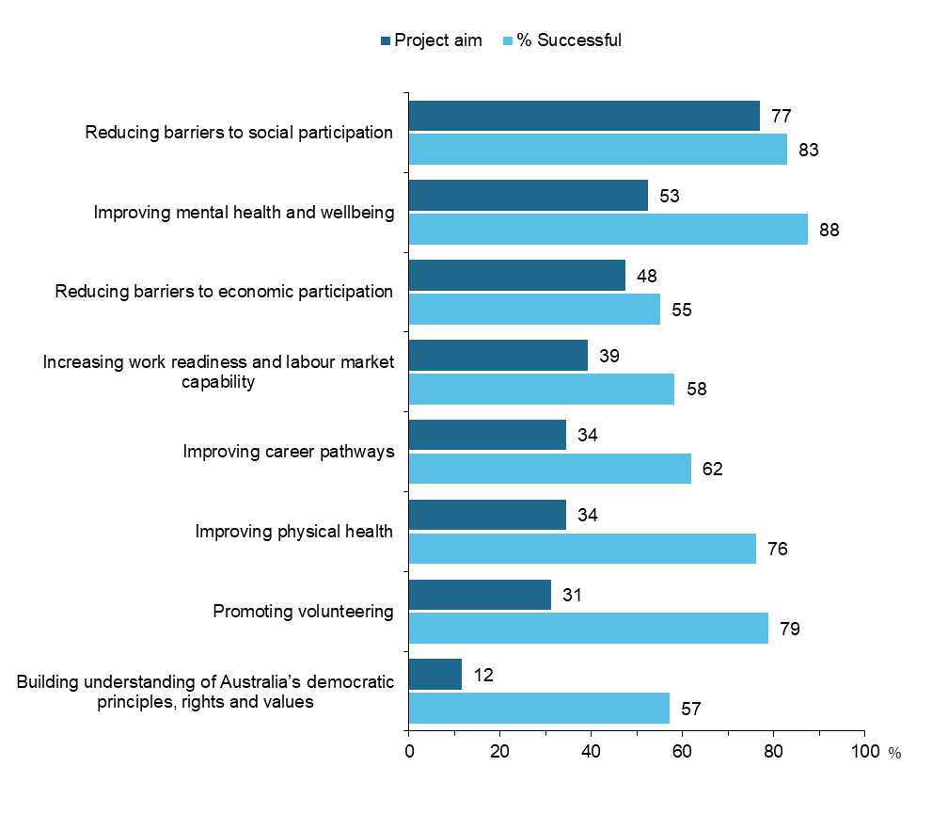
Source: Survey of SARC Activity Project Leads, August 2020
Notes: Question items:
-E1. Thinking about the project(s)… Which of the following best describe the aims you hoped to achieve through the project(s)? Please select all that apply.
-E2. Thinking about the last 12 months how successful has the project(s) been at achieving the following aims?
Base – All survey participants (n=66). Respondents may select more than one aim for their SARC projects. % successful represents mostly or extremely successful responses.

Vulnerable and disadvantaged individuals improve social and economic participation
There are many project aims identified in this survey that contribute to the outcome of improving social and economic participation (Figure 35). A majority of projects aimed to achieve support for individuals to have a sense of belonging to a wider community, increasing social cohesion and reducing social isolation, with over three quarters of these project reporting they were mostly or extremely successful in achieving this. Just under half (43%) aimed to reduce discrimination, of which 58% reported success. While there were fewer (less than 20%) projects aiming to support women in leadership roles and reduce gender inequality, those projects reported a very high level of success (75 % and 100% respectively) in achieving those aims.
Figure 35 Proportion of selected social and economic participation project aims and level of success in achievement
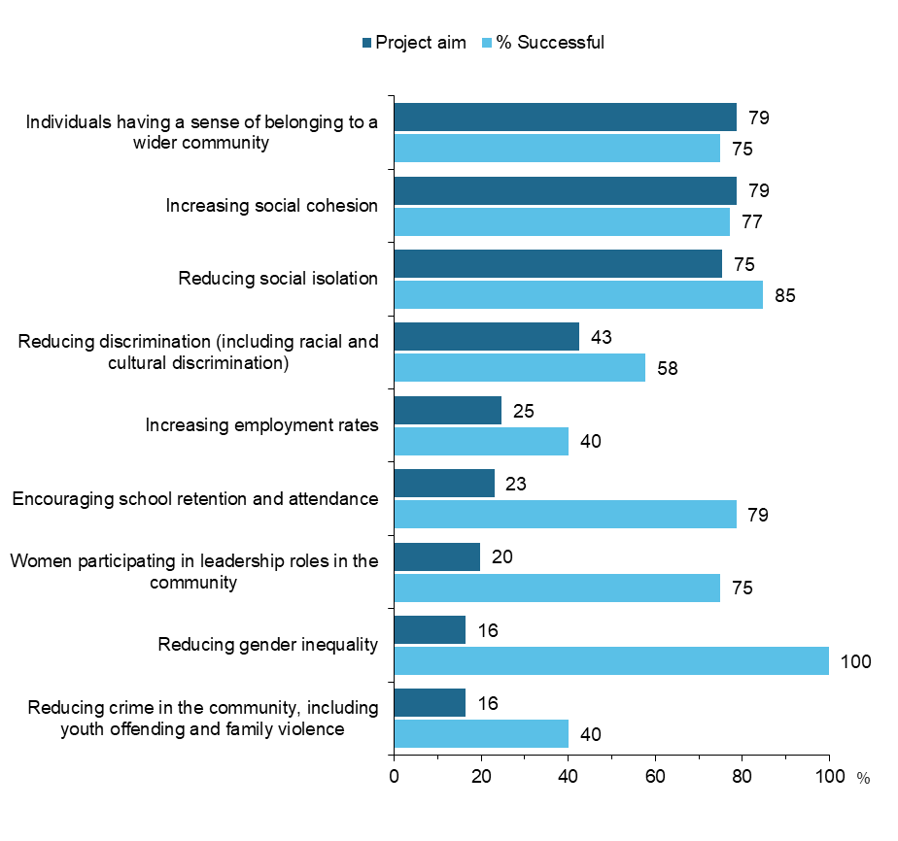
Source: Survey of SARC Activity Project Leads, August 2020
Notes: Question items:
-E1. Thinking about the project(s)… Which of the following best describe the aims you hoped to achieve through the project(s)? Please select all that apply.
-E2. Thinking about the last 12 months how successful has the project(s) been at achieving the following aims?
Base – All survey participants (n=66). Respondents may select more than one aim for their SARC projects. % successful represents mostly or extremely successful responses.

Participants engage with community services and activities
There were two main project aims that can be considered to contribute to the outcome of engagement with community services and activities (refer to Figure 36). Just over half of the project leads reported the aim of connecting community members to services, while 41% identified the aim of improving collaboration between community services. There was a very high level success (81% and 92% respectively reporting they were mostly or extremely successful) for both of these aims.
Figure 36 Proportion of selected community services engagement project aims and level of success in achievement
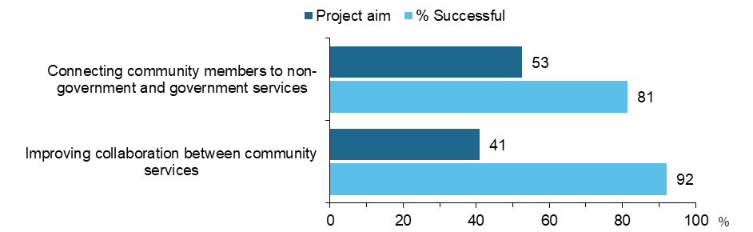
Source: Survey of SARC Activity Project Leads, August 2020
Notes: Question items:
-E1. Thinking about the project(s)… Which of the following best describe the aims you hoped to achieve through the project(s)? Please select all that apply.
-E2. Thinking about the last 12 months how successful has the project(s) been at achieving the following aims?
Base – All survey participants (n=66). Respondents may select more than one aim for their SARC projects. % successful represents mostly or extremely successful responses.

Participants display positive attitudes towards their community
59% of project leads identified their projects aimed to improve attitudes towards diversity in the community, of which 80% reported they were mostly or extremely successful in achieving this aim (Figure 37).
Figure 37 Proportion of selected positive attitude project aims and level of success in achievement
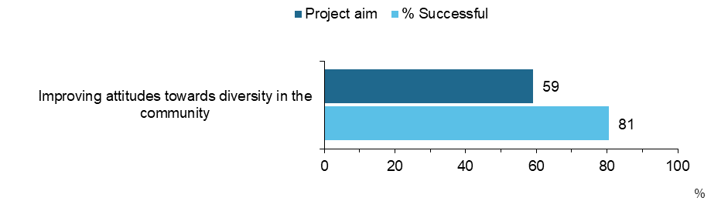
Source: Survey of SARC Activity Project Leads, August 2020
Notes: Question items:
-E1. Thinking about the project(s)… Which of the following best describe the aims you hoped to achieve through the project(s)? Please select all that apply.
-E2. Thinking about the last 12 months how successful has the project(s) been at achieving the following aims?
Base – All survey participants (n=66). Respondents may select more than one aim for their SARC projects. % successful represents mostly or extremely successful responses.

Young people improve educational engagement
One quarter of project leads (23%) identified a project aim of encouraging school retention and attendance and 79% reported they were mostly or extremely successful in achieving this aim (Figure 35). A very small number also noted ‘improved educational attainment and outcomes’ as a project aim, although there was insufficient data to make any analysis of the success of these projects.

What have been the critical factors for success and barriers to achieving outcomes?
Project leads provided feedback regarding barriers that may have hindered their ability to successfully achieve their project aims, the most common of which is COVID-19 related delays and resourcing impacts (33%), followed by community support (18%), organisation partnerships (15%), limited funding (12%), changes in project scope (10%), funding arrangements (10%) and community resistance (8%) (refer to Figure 38).
Figure 38 What has supported and/or prevented achievement of project aims
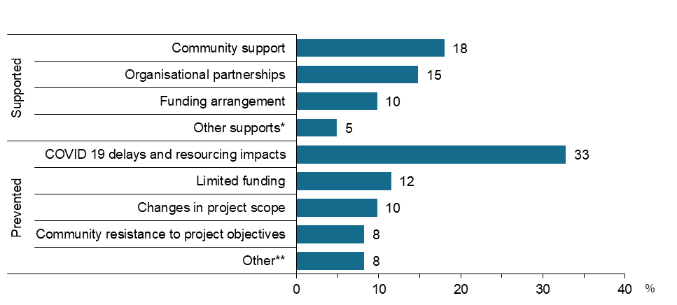
Source: Survey of SARC Activity Project Leads, August 2020
Notes: Question items: E2a. What has supported and/or prevented you from achieving these aims?
Base – All survey participants (n=66). Respondents may identify more than one reason. Excludes unknown reasons not categorised elsewhere.
*Other supports include leadership and FAMs support. **Other includes staff retention and bureaucratic limitaitons
Respondents provided suggestions for how the SARC activity could be improved in future, the broad categories of which are displayed in Figure 39. One fifth noted improvements relating to longer term sustainability of programs, while 15% cited improved reporting requirements. It is noted that nearly half (46%) of the project leads did not have any suggestions on improvements indicating they were reasonably satisfied.
Figure 39 Project leads’ suggestions or comments about how the SARC activity could be improved
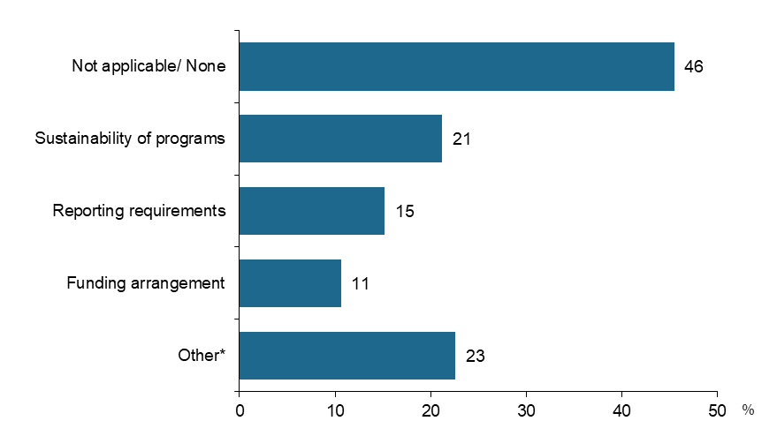
Source: Survey of SARC Activity Project Leads, August 2020
Notes: Question item: G1. Do you have any suggestions or comments about how the SARC activity could be improved?
Base – All survey participants (n=66). Respondents may identify more than one reason. * Other* includes suggestions not identified elsewhere, relating to supports provided, communicaiton and governance. Excludes <5 unsure respones.

Was funding able to support relevant, quality research? (National Research)
National Research respondents were asked about their experiences and opinions of delivering a project funded by a National Research grant. The majority agreed or strongly agreed that:
- The information provided on the National Research program clearly outlined the types of research that would be funded.
- The National Research grant funded project has identified solutions for issues relating to social cohesion and/or community resilience
- The research project would not have been conducted without the funding provided through SARC
- The findings of the research project could easily be applied to the work of other community organisations
There was a high level of satisfaction with the experience of the National Research project, with the majority of respondents reporting they were satisfied or very satisfied
It is noted that the survey findings for National Research projects is limited given the small number of projects (5) from which to analyse results. While the perceptions of the 5 National Research projects highlighted above provide insights regarding the SARC funding support, the survey data is not sufficient to determine the relevance and quality of the research.

Did the research result in useful findings to inform future projects? (National Research)
Some of the National Research project aims described by project leads included:
- Building government’s understanding of emerging and existing issues:
  - Improving social cohesion
  - Developing economic modelling
  - Informing settlement programs
  - Building volunteer participation
- Innovative solutions to issues which impact community resilience and social cohesion Improving social cohesion:
  - Encouraging community participation
  - Implementation of outcomes and measures for initiatives
There is insufficient evidence that can be drawn from the survey regarding the nature of National Research project findings and whether they can be used to inform future projects.

Efficiency

How efficiently has support to funded projects been provided through SARC?
The survey explored the current status of SARC projects at the time of the survey (August 2020). The majority of projects (92%) were still in progress, with a small proportion (4%) delayed due to COVID-19 (refer to Figure 40).
Figure 40 Current status of SARC projects, as at August 2020
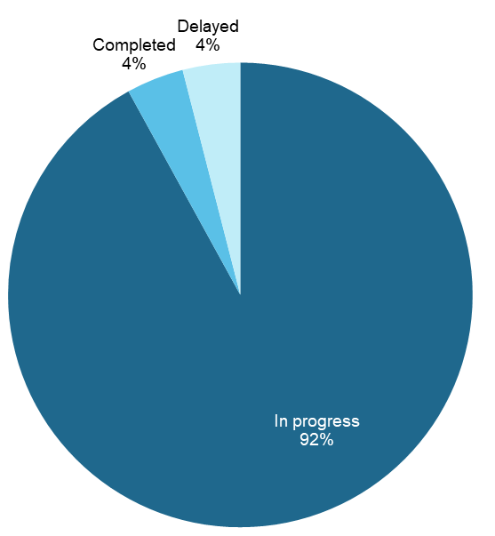
Source: Survey of SARC Activity Project Leads, August 2020
Notes: Question item: A5. What is the current status of the project? Base – All SARC projects reported by participants (n=75)
Grant funding received was reported by project leads to be sufficient to meet the project costs for 61% of projects. A majority of project leads also reported that projects have been delivered within the planned timeframe (81%), project budget (91%) and project scope (96%) (refer to Figure 41).
Figure 41 Proportion of project leads reporting their experiences of SARC project delivery
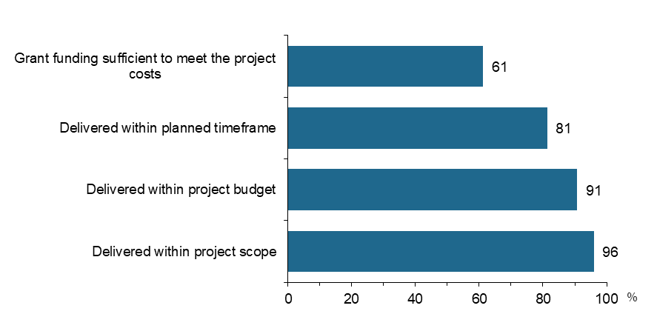
Source: Survey of SARC Activity Project Leads, August 2020
Notes: Question items:
A14. Has the grant funding received by your organisation been sufficient to meet the project costs?
A15. Has the project been delivered within the...?
Base – All SARC projects reported by participants (n=75)

Project leads indicated the extent to which SARC funding increased their ability to meet the needs of the community groups identified in Figure 31. Over 70% reported SARC funding increased their ability to meet the needs of economically isolated or unemployed groups, children, teenagers or young adults. Whereas project leads met the needs of older people, religious groups to a lesser extent (refer to Figure 42).
Figure 42 Proportion of project leads reporting SARC funding increased their ability to meet the needs of the following groups in the community to a great extent
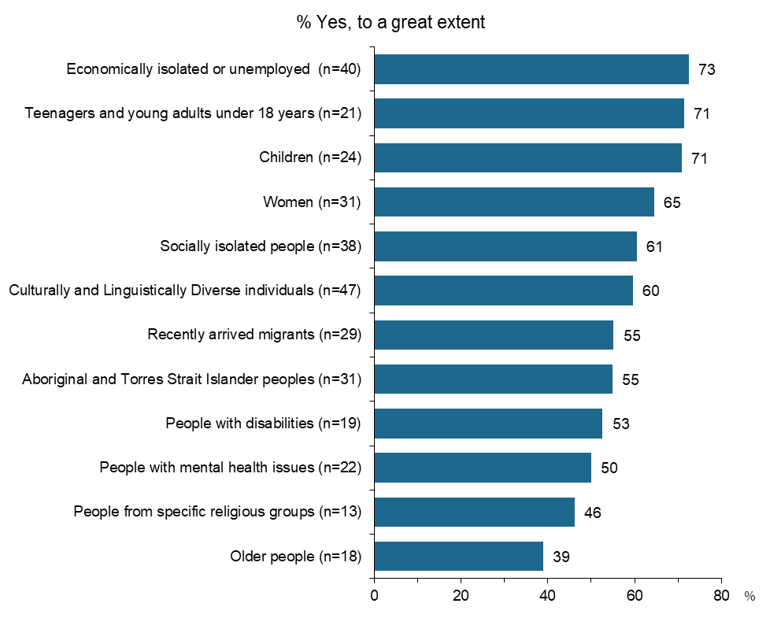
Source: Survey of SARC Activity Project Leads, August 2020
Notes: Question item: C2. To what extent has SARC funding increased your ability to meet the needs of the following groups in the community?
Base – n represents survey participants who selected each community group; respondents may identify more than one group. Excludes ‘other’ where n <5.

Case Study Results

Case study 1: Ask Gran Not Google
Organisation: Feros Care
Grant Stream: Community Resilience
Project description
"Ask Gran Not Google" is an intergenerational campaign, aimed to coincide with the annual Seniors Week in key States in Australia. In a co-ordinated program, working with selected schools, children will be given the opportunity to meet with seniors and to tap into their wealth of knowledge by asking Gran not Google.
The project aims to involve 3,600 schools and 246,000 participants. Social cohesion is promoted both practically, by organised activities, but also by raising broader awareness through marketing and social media.
The project was piloted in 2017 at ten schools in Queensland during Seniors Week. The SARC grant funding was used to implement the program further in Queensland as well as in New South Wales, Victoria and Tasmania.
Interviews and small group discussions were conducted with a total of 18 participants (5 project delivery staff from Feros Care, 2 teachers and 11 primary school students from Years 3 to 5) during October and November 2020.

Appropriateness
Project delivery staff reported that the organisation kept abreast of various government funding opportunities and hence sought funding for the program’s expansion when the SARC funding round first opened.
They considered the alignment between the project’s purpose and the objectives of the Community Resilience grants to be strong for the following reasons:
- The project aims to address age discrimination by raising awareness of the value of seniors and normalising the ageing process.
- The project promotes social cohesion and belonging and reduces social isolation through bringing seniors and young people together (in person as well as virtually) and building social connections
- Local communities delivering the project, in this context schools, have the flexibility to tailor their approaches to harness local solutions to age discrimination.
When first developed, Ask Gran Not Google was the first intergenerational connection project to be established in Australia. The SARC funding thus supported the extended implementation of a project which filled a gap in the market.
At the time of the research, program delivery staff confirmed that the project had met its 2019-20 targets and was on track to meet its targets by the end of June 2021.

Process
Overall, project delivery staff felt that the program’s governance and reporting systems had supported successful service delivery. They did, however, report encountering one issue in the early days of program delivery which was subsequently resolved.
The issue related to the requirement for them to provide DEX with identifiable data on all project participants, including participants’ cultural backgrounds. Project staff recognised that they would be unable to meet this requirement as schools would be unwilling to provide them with personally identifiable information about students on privacy grounds. They felt that any requirement to compel schools to provide them with this information would act as a barrier to program take up. Following discussions with the Funding Arrangement Managers, they reported that that this issue was resolved, and they were no longer required to seek this information from schools participating in the program.
Learnings reported by project delivery staff through the implementation of Ask Gran Not Google that should inform both future rounds of SARC and similar grant programs in future were as follows:
- There is an appetite for intergenerational social cohesion initiatives in the community: schools like the project as it provides them with a structure and resources which spares them the need to develop activities. In turn, students and seniors like the activity because it is fun and enjoyable.
- The project is sufficiently flexible that it can be delivered in multiple formats, including virtually. There is also evidence that the program has been successfully adapted to be delivered in different environments, such as in subacute hospital settings.
- Although in its current format schools can order a range of resources (such as pencil cases and pens, posters, stickers and postcards) from Feros Care, delivery can be modified to allow for it to become online only, which will support the future sustainability of the project.

Effectiveness of program design
For most schools, Ask Gran Not Google is generally delivered as part of their local Seniors Week activities and/or during a school’s annual Grandparents’ Day. Take up has been greatest among primary schools.
Between July 2018 and October 2020, the project has been delivered in around 700 schools, reaching approximately 83,000 students. Feros Care does not have data on the number of seniors who have participated in these events.
Project delivery staff reported that they closed registrations between March and June 2020 as they were unable to restock the project’s supplies to distribute to schools. This period coincided with the escalation of the COVID-19 pandemic, a time when many schools across the country had shifted to remote schooling.
Project delivery staff also confirmed that there was evidence that many schools who had registered to participate in Ask Gran Not Google during the first year of the grant (2018/19) had participated in subsequent years. However, they reported that they were unable to provide specific details as it was possible that schools had delivered the project without notifying Feros Care and/or ordering project materials.
Project staff reported that they had engaged schools through two main channels:
- direct approaches to schools via email, informing schools about the opportunity for them to participate in a “free Government-funded project”
- enquiries from schools in response to media stories; Ask Gran Not Google attracted a lot of media coverage during 2018, appearing on Channel 7 and 10 and in newspaper articles. It was also championed by some politicians.
Project delivery staff reported that they collected feedback from schools about their delivery experiences through a post-event survey; some also had discussions with schools following the event. Overall, they reported that schools had had positive experiences on the day, with high engagement from students and grandparents or other seniors participating in the day’s activities. They further understood that schools had implemented Ask Gran Not Google in a variety of ways:
- Across most primary schools, the event typically involved grandparents (or other seniors) visiting the school; in some cases, schools had sought to have grandparents “shared” with other students who did not have grandparents.
- Some schools had shifted their focus from students’ grandparents and had instead sought to engage other groups of seniors, such as former alumni of the school and residents of their local aged care facility, in events.
- One subacute hospital had implemented the activity, with staff members’ children coming to the facility to ask questions of inpatients; these children subsequently became pen pals with these seniors.
Some questions are hilarious, and the seniors do a great job responding. One of the funniest was ‘what was it like to walk with dinosaurs?’ (Project delivery staff)
For schools, part of the appeal of Ask Gran Not Google was the flexibility and latitude they had in how they delivered the project. The concept was simple, and the event was easy for them to organise.
Project delivery staff reported that they were unaware of schools encountering any challenges associated with project delivery. The only real constructive feedback they received from some schools related to the sustainability of some of the project materials (which schools are free but not required to order). For example, the pencil case is manufactured overseas using plastic and the postcards were initially printed using non-recyclable paper. Feros Care have since begun to print postcards on recyclable paper.

School example
A small regional school has held an Ask Gran Not Google event for the past three years. The school principal first learned about the project after reading about it in a newspaper article. There had been some upheaval in the local community, and part of the appeal of the project lay in its capacity to promote social cohesion and in closing the intergenerational gap.
From a small start in 2018, the school hosted a community Grandparents’ Day event in 2019 which was open to everyone in their local area. Participants in this event included seniors from the local aged care facility and families from neighbouring schools. The day featured a complimentary morning tea and BBQ lunch at the school, along with a range of activities catering for younger and older people (including lawn bowls and tai chi), tours of the local history museum and market stalls. One activity using materials supplied by Feros Care involved students and seniors painting oversized jigsaw pieces together. The school received a grant and support from the local council.
Due to the COVID pandemic, in 2019 the school opted to involve residents of the local aged facility in the day’s event. Engagement took place using Zoom videoconferencing, with small groups of students meeting a resident, asking them a question and having a conversation about their life.

Impact of the SARC Activity
Overall, stakeholders involved in Ask Gran Not Google considered the project to be effective in achieving its intended outcomes for the following reasons:
- The activity provided young people and seniors with an opportunity to form and/or deepen social connection and belonging across the two groups.
- The activity helped to promote the sense of self-worth and lessen social isolation among seniors.
- The activity also promoted attitudinal shifts among young people around building social connections and the valuing the wisdom of seniors.
Project delivery staff reported that the project benefits groups in the following ways:
- Students enjoy having discussions with seniors and learning more about their lives. Their conversations have helped spark their curiosity about seniors’ lived experiences, and they have increased awareness that they can talk to seniors if they have questions in the future.
- Similarly, seniors enjoy the social enrichment that comes from their connection with the students. They love telling stories and the engagement helps them to feel valued and not forgotten.
- Schools and teachers enjoy watching the interaction between younger and older groups, and seeing students ask some very thoughtful and considered questions.
“For me, personally, [the project’s main achievement] was to see … the encouragement of social engagement with seniors and seeing the enrichment that brought to the students’ lives through connection … seniors really offer us so much. They are an oracle of information; oracle of lived experience. Their pearls of wisdom and their life advice goes beyond anything that you could find on the internet”. (Project delivery staff)
School example
Students participating in the school’s Ask Gran Not Google activities reported a range of learnings. The most commonly asked questions related to the lives of seniors when they were younger.
Students reported that they enjoyed having these conversations and learning about the contrast between the lives of seniors when they were younger and their lives. For example, some stated that they were interested to learn that many seniors in their rural community had milked cows in the morning before travelling to school on horseback. Others stated that they were interested to learn about seniors’ wartime experiences.
They [seniors] teach you stuff you didn't even know about {Student)
You say to Google. How old are you? It'll come up with, I don't understand what you mean … You get better answers from grandparents sometimes. (Student)
Through their Zoom discussions with aged care residents, students also learned that older people can become their friends. Due to the success of the Zoom discussions, the school plans to hold weekly sessions with residents until the end of the school year.
I’d like to do it [Zoom discussion with aged care facility residents] because I liked seeing the smiles on their faces. (Student)
The main outcomes for students were thus an increased appreciation of the value of seniors as well as the development of closer bonds with seniors. Teachers also felt that these social connections were helping students to develop empathy and respect for others, and in turn, to become good community leaders.
… one day these children may be my grandchild’s or her child’s teacher, local member of parliament, sporting coach, so I’m hoping that by what we are teaching them now, we are able to prepare them to be really good community and civil minded people … [we’re] giving them these strategies to learn how to be responsible and show empathy and be mindful of other people (School stakeholder)

Participants identified several critical factors for success, as follows:
- The simplicity of the project and flexibility provided to schools around implementation makes it easy for schools to deliver the event.
- The availability of project materials, such as postcards, made it easier for teachers as it meant that they didn’t need to invest as much time thinking up activities for the event.
- Feros Care had effective management processes in place for managing logistics which meant that schools were able to receive any materials ordered in advance of their event.
From the perspective of project delivery staff, the only real barrier to success related to school engagement. They acknowledged that schools are busy, receive numerous emails a day and that it can be hard for them to ensure that they are able to reach schools through their emails.
The SARC grant will end in June 2021. The main project costs are for the resources distributed to schools. In future, Feros Care plan to continue to retain ownership of the campaign but put all the project resources (such as postcards and posters) online for schools to download. This approach will help ensure the sustainability of the project. Other future plans for Ask Gran Not Google are as follows:
- Promoting the concept of a two-way conversation, so that seniors can learn from young people.
- Implementing the project in non-school settings such as shopping centres and healthcare facilities.

Case study 2: Muslim Women's Leadership in Community Resilience and Human Rights

Organisation: Australian Muslim Women's Centre for Human Rights Inc.
Grant Stream: Community Resilience

Project description
The Leadership Program (“the project”) consists of a series of workshops for Muslim women living across Melbourne who come from diverse (cultural, social, and migrant) backgrounds. These workshops were developed by the Australian Muslim Women's Centre for Human Rights (AMWCHR). Each series comprises of 10 weekly interactive group sessions covering topics such as human rights, gender equity, self-awareness, confidence and capacity building and other leadership skills, followed by a series of workshops on community project design and development. Through these workshops, the project aims to create a greater sense of belonging, resilience, and wellbeing, for both women participating in the program, their families and the Muslim community.
The program was initially designed to be delivered to participants using face-to-face delivery methods, with sessions to be held in local schools and community hubs, with food and childcare provided. During COVID-19 the program was adjusted after a short break to be delivered using fully online methods via Zoom, supported with WhatsApp messaging groups.
For this case study about the project, interviews and small group discussions were held with 19 people during October and November 2020 with: 3 representatives from the organisation delivering the program; 12 participants from 4 different Leadership Program groups (some had taken place more than a year ago, others had finished recently); and 2 members from the wider community (a multicultural aid at a local school, and support worker from a Community Hub).

Appropriateness
The staff from AMWCHR reported that they had limited information about the current SARC funding opportunity and the application process, as the funding manager who had led the development of the application had left organisation prior to the evaluation. However, staff reported the organisation kept abreast of funding opportunities. Their general way of finding out about grants is via Grant-Connect, and their relationships within the sector and with funding organisations. The AMWCHR has an appointed funding manager who takes care of those contacts, finding opportunities and writing applications. Notably, the AMWCHR has a long-lasting relationship with the Department of Social Services through other funding programs such as the previous Settlement Grants Program and the Children and Parenting Support Program (CAPS).
The project delivery staff viewed the SARC activity as a flexible funding program. Project delivery staff reported that they were very excited when they heard of this funding opportunity, because “we were looking for a very long time for this type of program”. The organisation wanted to deliver a leadership program based on the needs they observed in the community and on their positive experiences with a similar (successful) program they ran fourteen years ago, but it never fit the criteria outlined in other funding programs. The SARC activity thus gave them the opportunity to:
- include women who usually are often not eligible for funded projects, because they have lived in Australia longer or don’t have the right visa. However, these women feel socially isolated and never get the opportunity to get out of the home
- design their program in a way that allowed for attitudinal change. This required longer series and longer sessions than they usually can offer under other funding programs
- design a program that supports the creation of tight and supportive networks.
Both the intended goals and the results based on discussions with participants, the project appeared to align well with the stated objectives from the SARC activity. At the forefront of this project are objectives around belonging, resilience, and wellbeing, for both women participating in the program, their families and the Muslim community.

Process
The staff delivering the project felt that the systems in place supported a successful delivery, however there were a few suggestions for improvement.
Staff reported that contact with the Department has been positive overall and viewed their contact with the Funding Arrangement Manager (FAM) as beneficial. Their positive feedback included:
- The regularity of the contact and the ease with the FAM could be reached.
- Their FAM always had a helpful and supportive attitude and was always happy to help or to take on feedback.
- The AMWCHR always had one FAM for multiple DSS funding programs, which they found to be an efficient manner of managing their time and communication.
However, they reported that during a period of reorganisation at DSS, there was a high turnover of FAMs, with new staff not always comprehensively abreast of past developments and conversations. The project delivery staff felt the handovers were often poorly organised, but noted the last handover was organised much better thanks to a meeting that involved all parties. Furthermore, project delivery staff felt that their FAM’s sphere of influence was limited. Although the contact person was happy to take on feedback about issues (for example, reporting systems), follow up action and/or communication back to the AMWCHR did not occur.
In terms of the Activity Plan, project delivery staff thought the template allowed enough flexibility. They used the template for their working plan internally, found it easy to use, and thought this requirement did not duplicate their work.
The main challenges relating to the SARC reporting systems related to reporting and data exchange in DEX. Feedback reported by project delivery staff included:
- There is too much focus on numbers, with almost no space to record qualitative components such as inclusion, belonging, and wellbeing. Staff worried, for example, how the smaller groups that they designed for women facing family violence throughout COVID-19, would reflect on their reported achievements. Even though this group was the smallest out of all groups, the staff felt it had the highest qualitative outcomes.
- The focus on numbers is furthermore challenging because many of the AMWCHR participants are hesitant to share data with the government. The project delivery staff are sometimes torn between how to respect their participants’ wishes and maintain trust, but at the same time making sure they meet their DSS contractual requirements.
- The reporting system did not appear to be designed for diverse target groups and does not allow for flexibility. For example, project delivery staff noted that some data required by DSS, such as date of birth, are sometimes not recorded in participants’ countries of origin, or culturally do not have the same weight as in Australia. Although there was an option in DEX to nominate an estimated date of birth, the organisation received feedback multiple times from DSS that an “estimated” day of birth was poor quality data.
- Extracting reports from DEX was found to be very difficult and time consuming, and the staff would highly be interested in training or facilitation around how to extract and use DEX reports more efficiently.
Learnings reported by project delivery staff through the implementation of the project that should inform both future rounds of SARC and similar grant programs in future were as follows:
- The length of the SARC activity (3 years as opposed to shortened) supported a program design with a bigger impact, both qualitatively and quantitatively, and allowed the organisation to make more efficient use of funds.
- There is a high demand in the community for projects around leadership development and that allows for more flexibility, both in terms of program design and in terms of target groups.
- The project is sufficiently flexible that it can be delivered in multiple formats, including virtually if needed. There was also evidence that the program has been successfully adapted to be delivered in different groups with different needs.

Effectiveness of program design
The project delivery staff reported that they have been able to reach those people for whom the project was intended: Muslim women from diverse cultural and migrant backgrounds. Some women had arrived in Australia as recently as a few weeks earlier while others had migrated over 10 years ago. Despite their different backgrounds, all participants reported that prior to their engagement with the project, they had lacked a strong support network, experienced stress, felt socially isolated and were generally unaware of their own skills and potential.
The project successfully reached their target groups thanks to the AMWCHR’s strong roots in the community and existing connections established with local schools through their existing programs. For instance, many participants reported that they were already familiar with the organisation and the facilitator through a parenting program they had participated in previously.
Overall, project delivery staff reported that the project was on track to reach most of its intended targets – both in terms of quality and quantity. However, some of the quantitative targets have been impacted by COVID-19 (as previously discussed under “Process”), especially the targets related to the Harmony day. Which had to be cancelled last-minute in 2020, and in 2021 will be depending on the restrictions at the time.
During COVID-19, the staff identified a gap in their target audience and established a group specifically for women experiencing family violence. As family violence increased dramatically during COVID-19 restrictions, staff delivering the project realised that the pandemic had placed this cohort of women at greater risk.
Furthermore, the staff also had to adjust their approach during COVID-19. After a break, they managed to transition to online delivery via Zoom, supported with a WhatsApp group. This required considerable organisation and individual support to encourage participants to take part online as this idea was initially foreign and not appealing to many. It also took project delivery staff time and effort to ensure that all participants were set up with the right skills and tools.
Overall, participants remained engaged in project activities over time, including those who participated in the project online during COVID-19. There were several key enablers which contributed to the effectiveness of the leadership program:
- Childcare is provided for project participants; without childcare most participants would be unable to join or would be distracted by their children.
- The project is held at local schools and community hubs, accessible places that participants are already familiar with.
- The possibility for participants to speak their mother language for those who are not yet fluent in English. The project was delivered by either bilingual staff or supported by an interpreter who women were (or became) familiar and comfortable with.
- Highly skilled facilitators that were able to communicate in an engaging way, relate to the group, and adapt to the needs of each group.
- Participants felt welcomed and included. Some people were only in the country for a few weeks, but after a few weeks they felt comfortable enough to bring someone else along.
- Many participants reported it was the value of the group sessions, that made them come back every week - both what they learned, and the social aspect of coming together as a group. Participants felt the project was their highlight of the week and wanted to make sure they would not miss a single session.
Friday was a joyful day. I looked forward to Friday, because I knew was learning different skills, meeting people that had similar interests, and they were almost all in a similar level of wanting to mix outside the community and learn more about what’s happening around them. (Participant)

Impact of SARC
Overall, project stakeholders considered the project to have been highly successful in reaching its intended outcomes. The impact of the project was evident through participants’ stories which often addressed themes such as belonging, economic participation, and social inclusion (without prompting). Not only the participants’ verbal communication but also their nonverbal communication (tone and body language) in the interviews underlined the project’s success as they spoke about their experiences and achievements with great enthusiasm.
Some of the key outcomes from the project included the following.
- Many participants reported that they had gained confidence as well as leadership skills including self-awareness, self-care, active listening, and how to be assertive. They also reported feeling inspired and supported by hearing their fellow participants as they realised they were not alone experiencing their challenges.
So that was one thing that I saw [me and] every single woman be more confident in their skins, and just be themselves and happy about it.(Participant)
But you know when you start talking to other women and share your experiences, it turns out we are all fighting the same demons. And you’re like, okay, I’m not the only one facing those things. So that was my push to [continue] the course. (Participant)
- Participants gained a strong supportive network. For many participants, their weekly leadership group was their first social contact apart from their own children and/or partner. These groups quickly became a (often their only) safe space where they were able to discuss emotions, challenges and thoughts about themselves, that they generally were unable to share anywhere else. The women left the Leadership Program with a network full of women with shared experiences who understood each other.
…[the most challenging] thing was isolation. Because when I moved here in Australia in I just completed university and I was very party girl then I went to (remote) Perth. And it was isolation and pregnancy complications. And then delivery and the first child. And there are lots of burdens. These things lead me to the depression and anxiety and missing families. (Participant)
And after the program, we introduced each other’s families as well, so now we are family friends…And during the program, we laughed together, we discussed together, we cried together. There were lots of emotional moments as well. [We are] more than our family now. (Participant)
- Through the development of new skills and capabilities and a support network, participants developed the courage to pursue employment and educational opportunities. A few had started (new) studies, others had started their own businesses or found employment. Furthermore, their newly acquired network now promoted each other’s businesses, asked each other for help, and looked out for other opportunities.
- Participants reported they took on leadership roles in their families, at their work, in their community and beyond. Their leadership skills turned out to be especially useful during the social lockdown. Furthermore, participants also reported passing on their leadership skills to their partners, their children and nieces and nephews. Other participants for example decided to join the school board.
…no family members or any friends in a new country, new problems, with something that you are going to start from the very beginning... That’s difficult to manage… It [leadership skills] is something which could help me so that I could take the power back in my life.
The most important thing I learnt was communication. Having good communication with your partner, especially now in the lockdown. It was really important how you control your anger, self-control. How to manage … how to control the anger of everyone in the house, especially now with the lockdown. (Participant)
- Participants felt more resilient. Many women reported they had experienced racism and discrimination first-hand, and some noted they had previously felt too scared to wear a hijab and demonstrate their Muslim faith in Australia. The project helped them to better cope with these experiences. Participants for example reported that they became aware that the Australian laws are not only for others but can also protect them.
- Staff delivering the project also played a key role connecting participants to relevant services and activities through the provision of individual support. This varied from assisting with financial support to pay the rent, to connecting into language courses and so forth.
Critical factors for the project’s success mentioned by participants, staff, and members from the community included:
- Every week the group shared a lunch after an (often emotionally) intense session. Sharing a meal helped them to end on a positive note, debrief and bond with each other. Participants felt that sharing a meal was key for developing as a group into a strong and supportive network.
- The length of the program and sessions that allowed time for a learning curve: for repetition, development, a change of mindset, and growing tight with the group. The program was designed for 10 weeks (a full morning), but lasted a few sessions longer if a group felt they needed more insight or practice on a certain topic.
- Participants found the facilitators highly skilled and knowledgeable in the topics discussed, with highly developed interpersonal skills that created a safe group environment, where everything could be discussed in confidence. Furthermore, the participants felt the facilitator was always “there for them” and felt comfortable to reach out for help.
- Sessions are run by people from the community with strong roots in the community, who could relate to challenges and experiences in the group.
- A group consisting of women with shared experiences, but difference in terms of how long they had lived in Australia. Some women lived in Australia as short as 2 weeks, where others lived here for closer to two decades. Participants thought that added a lot of value. The women who lived in Australia longer were able to help those who arrived only recently navigate Australia.
The staff delivering the program also experienced some challenges, mostly relating to the COVID-19 pandemic. The biggest challenge was that there was much more individual support needed than anticipated, which required the staff to invest additional time and effort in developing and delivering the project. They were unsure for how much longer they could keep offering this. Other barriers related to finding and organising a way to continue during COVID-19. This included practical challenges such as, participants not having access to a smartphone (for example using their child’s smartphone), internet connections, encouraging participants to give online groups a try, familiarise participants with Zoom, but also how to create a safe space online.
In terms of sustainability, the project delivery staff felt that the project is only feasible with government funding due to the high involvement of project staff in the delivery. A suggestion made by staff was that the Department could provide examples of a sustainable model, if one exists, and support organisations for example through training, to build internal capacity towards sustainability as part of the funding program.

Case study 3: Skylight Activity Groups – Southern Fleurieu

Organisation: Skylight Mental Health
Grant Stream: Community Resilience

Project background
The Skylight Activity Groups – Southern Fleurieu project utilises a community development approach to address the needs of vulnerable and disadvantaged individuals and families in the Southern Fleurieu Peninsula in South Australia. The Southern Fleurieu has a high rate of disadvantage with a high prevalence of unemployment, social isolation and mental health challenges.
The project targets those experiencing economic or social isolation, mental health issues and disability through a community-driven response. This project aims to create environments where individuals and groups are empowered and supported to build more connected communities in order to increase social and economic participation as well as enhance wellbeing and belonging. Central to this approach is relationship building, community consultation and community capacity building. This includes forming partnerships with service organisations, councils, community organisations and business, as well as with community leaders.
The project aim is to conduct 600 instances of group-based support activities which are co-designed in consultation with community members across several locations including Victor Harbor, Goolwa, Wilunga and Yankalilla. Activities have included art and music groups, mindfulness and nature therapy groups, support groups for parents with LGTBQI+ children, community consultation and capacity building sessions, walking groups and manual skills-sharing groups. Activities vary from ongoing weekly sessions to one-off events.
During October and November 2020 in-depth interviews were conducted with a total of 16 participants (5 staff from Skylight Mental Health including project delivery staff, 4 community partners and 7 participants from several activities).

Appropriateness
Skylight Mental Health had undertaken similar community development activities in other regional areas of South Australia. The organisation has dedicated resources for identifying appropriate grant opportunities. Upon discovering the SARC program, Skylight Mental Health applied for several activities, though was only successful with the Southern Fleurieu application. The organisation had not previously received funding through the Strengthening Communities programs.
The SARC funding program and its inherent flexibility was seen to be an important vehicle for Skylight Mental Health to run a project such as this. Stakeholders from Skylight Mental Health highlighted that within the mental health services sector, relational-based community development and primary prevention approaches had diminished with the introduction of the NDIS with many small, regionally based services discontinuing in lieu of larger, more centralised service offerings. This has left limited opportunity for community development work.
Funding through SARC offers the opportunity to address mental health issues in a regional context on the community level. This allows for crucial elements such as relationship and trust building, community-led initiatives, understanding community needs and establishing soft-entry points into services. SARC further allows Skylight Mental Health to build their own organisational capacity through relationship building in order to establish a meaningful presence in region.
… it has allowed for some of that older style approach where it’s more relational; it’s supporting the process of community engagement and community partnerships and it’s provided that flexibility to be able to offer some group based stuff and individual capacity building stuff that existed before and doesn’t now. (Project delivery staff)
It was noted however that, given the length of time that is required to establish relationships and effectively consult with community, a longer period than the 3-year timeframe would have been more appropriate.
In terms of the objectives linked to the Community Resilience grant program, the assessment reveals that the Skylight Activity Groups project has strongly aligned. Through a community development approach, the project seeks to enhance community resilience across the Southern Fleurieu region by mobilising communities to identify and address local challenges related to mental illness and wellbeing, disadvantage and isolation. Through a multifaceted approach, the project seeks to support individuals through activity settings, form relationships and linkages with government, service organisations and community organisations, and foster greater awareness and trust for health services in the region. With a focus on capacity building and consultation with community members, the approach is community-led and community-owned.

Process
In terms of governance and reporting systems, project delivery staff reported that these have not always supported them in the delivery of the activity. Firstly, with some project delivery staff only starting after the commencement of the project, they expressed that more orientation and training around the reporting process would have helped significantly. Secondly, due to internal governance processes, they reported that communication was impacted between the Department of Social Services and the project staff as the project lead was not the point of contact.
Project staff also reported some difficulties with the flexibility of the current reporting systems:
- Reporting emphasised quantitative data with a particular focus on the number of groups and participants in attendance which was not always practical to record given the variety of activity types.
- The current system does not provide sufficient opportunity for reporting on other vital aspects of the project such as relationship building and broader qualitative outcomes for the communities.

Effectiveness of program design
As a whole-of-community approach, the Skylight Activity Groups project has engaged with a range of community stakeholders and community members in a variety of ways. In terms of the activities themselves, a broad range of participant types were reached. These ranged from participants with severe mental health challenges through to individuals wanting to play a more prominent role in their communities. They included:
- people living with serious mental health conditions
- people with disabilities
- people experiencing subclinical anxiety, depression, grief or loss
- people experiencing social and economic isolation
- people experiencing homelessness and/or drug and alcohol abuse
- elderly people with low social participation
- community leaders and community stakeholders.
In terms of broader relationship building, project staff connected with:
- local council and government services
- local service organisations and visiting service organisations
- community workers and community stakeholders.
With a focus on a community-led approach, where possible, the project prioritised seeking out local facilitators and volunteers to run activities.
Overall, participation numbers were relatively low in activities. Participation varied between activities and between locations. While some activities such as the music group maintained high numbers, others saw relatively low attendance. However, project staff emphasised that whilst activities were delivered in consultation with community, low numbers did not equate to the impact of a particular activity but rather the needs of participants. Activities were strongly focused and tailored to meet the unique needs of community members across several distinct contexts. Participants consistently reported having positive experiences and an increased sense of belonging in the community.
Yeah, well, again, I think they’re getting some kind of satisfaction of being needed and accepted and, you know, I think it brings that value of worth for people. I think that’s probably the best word. It’s a sense of worth within a community (Activity participant)
The COVID-19 pandemic caused a significant disruption to the delivery of activities in the region. Most group activities were unable to continue in-person, with some subsequent disengagement from participants. However, project staff reported that they were able to adapt some activities or transition online to achieve some continuity during this time. For example:
- A walking group was established where participants were able to be socially distanced outside, while still being able to take part in mindfulness, nature therapy and social activities.
- The musical group moved online where facilitators were able to connect with participants through video conferencing.
There were however some participants for whom the online format was not appropriate. Project staff maintained contact with these participants through regular phone calls and were able to link people in with online services such as free online counselling through Skylight Mental Health.
In general, project staff expressed experiencing some challenges around balancing the competing priorities of the broader project. Although only one aspect of the broader project, they felt that the activity groups required significant effort and time to facilitate. The significantly high number of groups that needed to be delivered was seen to detract from other important work such as relationship building across the region. Project staff emphasised the importance of relationships for successful community development work, rather than a top-down approach to achieve the required number of groups.
So this 150 groups and trying to apply that there just wasn’t going to work. There were other aspects of my funding—capacity building where I was able to justify spending time—and also, I have to report against the relationships I’ve made and how we’ve gone about identifying community needs etcetera, etcetera. Which is a real community development approach. So I’ve been able to tick that over on the side while still trying to get these groups running in other places. I feel like the actual, real work, the best part of the work has been this little thing on the side that’s started to get bigger but it really takes—it takes time. And that’s the issue with funding like this. (Project delivery staff)
Another challenge commonly identified in the region was that the community has traditionally been resistant to outside services. For this reason, project staff again emphasised the importance of relationship building as a critical factor of their work. This has required time and flexibility to successfully achieve.
And so community development approaches are often difficult, because—or the relationship work, because it takes time and others don’t have funding, either. And so you have to take time trying to find people who can fit with what you’re trying to do, as well. (Project delivery staff)
Lastly, project staff expressed that the large regional distances and remoteness of some of the communities created logistical challenges. These included:
- participants not having adequate transport
- difficulty finding appropriate activity facilitators in region
- staff having to travel significant distances
- no centralised presence in region.

Impact of SARC
In terms of the intended impacts of the project, project delivery staff reported that the outcomes have largely been achieved. These have included:
- Relationship building with community stakeholders. While this is an ongoing process, Skylight Mental Health has established numerous key partnerships throughout the region and have successfully leveraged these. These partnerships have resulted in key events and initiatives and have, to a degree, renewed the community’s trust in outside services.
Well, from what I see, she’s gathered different groups and agencies together from community and I know [project coordinator] has been strong in doing that and involving the community people and not having the agencies coming in and being involved in the initial stages and so really wanting to hear what is wanting because once again, there have been agencies that have come in and run a parenting group because that’s what they’ve got the background in and that’s what community wants rather than thinking what is going to suit? And that takes years to get that trust in. I feel there’s been some value added there… And Skylight has got its fingers in a lot of pies in a good way but not dominating but doing the strength sort of stuff around that. (Community partner)
- Created opportunities for community ownership. Through a community-led approach, the project has engaged broad participation from community members, mobilising and connecting individuals and community organisations through consultation, awareness raising, activity design, training, leadership opportunities and volunteering.
- Related to this last point, key activities have provided opportunities for community capacity building for community organisations, community leaders as well as for a range of individuals.
- Growing recognition and awareness of mental health, social isolation and wellbeing challenges in communities among community organisations, individuals and services more broadly.
- Skylight Mental Health has been able to lay the foundations for an ongoing presence in the region.
At the time of research, outcomes related to the activities had been partially achieved:
- Overall, numbers within activities has been relatively low. General awareness in the community as well as COVID-19 have been barriers. However, where successful, activities have provided focused, tailored opportunities for individuals to reintegrate into community networks, to address some of their challenges in a safe, inclusive space, and provided a soft entry point to engage with key services.
- Participants involved in activities consistently expressed strong satisfaction with the activities and the facilitators. Commonly, participants expressed a sense of ownership, empowerment, group identity, and increased participation in the broader community.
So, it was there to offer assistance in helping people feel togetherness and that even though you have a disability, you are still capable, without judgement, of what you’re facing or what your challenges are. And I really liked that. People are very friendly and everybody was given a fair choice to be heard and not just because you have a disability of some kind to be heard. And also, in this, I love it because everybody can get involved and everybody can have a moment to shine so that they feel important. (Activity participant)

Case study 4: The Kitchen Table Project (Cook Chill Chat)

Healthy People Illawarra
Grant Stream: Inclusive Communities

Project background
The Kitchen Table Project, known by all participants as Cook Chill Chat, is an 8-week community building cooking program that aims to bring 300 community members together to cook and share a meal within 30 existing local community services in the Illawarra-Shoalhaven region in New South Wales. This activity provides a soft entry and supportive environment for participants to meet new people within their communities from a diverse range of backgrounds, link in with existing community services, and increase nutritional knowledge and budget-friendly cooking skills.
The program was initially designed to be delivered face-to-face in mostly community centres where food and childcare were provided. However, during COVID-19 the project was adjusted to allow for delivery via Facebook, returning to in-person delivery as soon as the COVID-19 restrictions had eased.
For this case study with the Cook Chill Chat, interviews and small group discussions were held with 21 people during October and November 2020. This sample comprised: 4 project delivery staff from Healthy People Illawarra (the organisation delivering the program); 6 volunteers, 8 participants from different Cook Chill Chat groups (some had taken place more than a year ago, others had finished recently); and 3 members from the wider community (the city council, educational representative, and a representative from an Aboriginal Cultural Centre).

Appropriateness
Staff at Healthy People Illawarra became aware of the SARC funding through their existing contact with DSS. Healthy People Illawarra had been a recipient DSS funding previously (Strengthening Communities), through which they had developed the initial concept of Cook Chill Chat. They noted that their funding manager at the time had been very supportive and brought the SARC activity to their attention.
Project delivery staff were aware of the three different streams and identified the Inclusive Communities stream as being the most aligned with their project.
We felt that that our program Cook Chill Chat actually supported the outcomes that [Inclusive Communities] were set up for. (Cook Chill Chat, Interview 1, Project Staff)
At the forefront of Cook Chill Chat are objectives around improving social inclusion and enhancing community networks, improving wellbeing for individuals as well as developing a greater sense of belonging for participants in their local communities.
Project delivery staff reported that they had invested significant resources in the application process but did not think the requirements were too onerous. However, staff did note that they felt there was a big emphasis on new projects, and recalled their project needed to have a new name. As Cook Chill Chat was an existing concept, they significantly re-designed the project and made sure they were able to showcase the differences.
Furthermore, staff had found it challenging to set project targets which demonstrate the quality of their project, such as impact in reducing social inclusion. They thought it might be beneficial if the Department were able to provide support for how to set targets that capture the essence of projects such as Cook Chill Chat - both quantitatively and qualitatively – previous to or at the start of programs similar to the SARC activity.
Project delivery staff expressed that the SARC funding had been an important vehicle for the organisation on several accounts:
- It allowed them to continue and utilise a concept they had been developing under previous funding for two years.
- The SARC funding allowed for continuous innovation, to ensure the project continued to address the needs in communities for social inclusion and connection.
- Thanks to the SARC funding, Cook Chill Chat is now an established project with a strong network, which Healthy People Illawarra hoped to continue delivering after the funding finished.

Process
Staff at Healthy People Illawarra reported that their relationship with the Department’s Funding Arrangement Manager (FAM) had been positive and beneficial.
We've definitely experienced the relationship to be a two-way street and really kind of working towards the best outcome, which has been really positive. (Project delivery staff)
Examples of the support they received from the funding managers included:
- open and regular communication
- flexibility and support for changes to the project (based on feedback from participants and Healthy People Illawarra’s internal project evaluation)
- connecting Healthy People Illawarra to relevant contacts from the FAM’s network.
In relation to the current reporting systems, staff felt there was limited flexibility to effectively report on their project’s performance. The current system, with its emphasis on DEX, was seen to prioritise quantitative data and was too “black and white”. Project delivery staff thus felt that DEX was unable to capture the essence or the effectiveness of their project. Staff also felt the Activity Plan allowed only space for the quantified targets set at the start of the project, and that there was no opportunity to showcase some of their most important achievements, such as improved wellbeing, belonging and social connection. Furthermore, staff felt that importing data into DEX was time consuming.
Learnings reported by project delivery staff through the implementation of Cook Chill Chat that should inform both future rounds of SARC and similar grant programs in future were as follows:
- The funding term (3 years as opposed to shorter time), allowed the organisation to make more efficient use of funding.
- Building strong partnerships needed to get a project up to full speed takes time and thus benefits from the longer timeframe for funding.
- Staff felt that support from the Department to capture the effectiveness and the qualitative outcomes in their targets would be beneficial, as it would allow for these types of outcomes to be included throughout the reporting cycle.
- Regarding the sustainability of the program, project delivery staff expressed concern of an uncertain future of Cook Chill Chat, despite it being one of their most successful projects. They suggested that thinking about ‘the next step’ could be part of the grant program process, for example, how to deliver the activity independently of government funding and/or linking into next grant opportunities.

Effectiveness of program design
The initial intention of the Cook Chill Chat project was to reach a diverse range of participants including people who are marginalised, face disadvantage, social isolation, are living with a mental illness, and/or who lack skills and knowledge about healthy food. One key objective behind the Cook Chill Chat groups was to build networks and connections between such people with other services in and members of in the community.
With inclusivity at the centre of the Cook Chill Chat model, the project has been successful in attracting a wide range of participant types, from young adults through to people aged in their 80s, people with an interest in cooking to those who lack knowledge of healthy food, and professionals through to people who experience social isolation. Staff and volunteers delivering the project, described a range of participant groups:
- elderly people
- young families
- people with disabilities and mental illness
- first Nations Australians
- socially isolated individuals
- financially disadvantaged individuals
- people from CALD backgrounds and newly arrived immigrants.
In terms of community partners, most are local city councils or community-based social services organisations. In many cases, key individuals from these organisations have taken on the responsibility of promoting the project and recruiting participants. Volunteers co-delivering the project felt that the most successful advertisement was through local communication channels such as community centres, local Facebook groups, and word of mouth.
For the most part, Healthy People Illawarra has been able to deliver the intended activities. However, COVID-19 has had a significant impact on the project activities. From the onset of the COVID-19 pandemic, Cook Chill Chat groups were required to follow social distancing measures which meant the discontinuation of in-person activities. Staff delivering the project identified that their priority was to keep momentum and keep participants engaged and decided to transition to an adjusted model on Facebook. The facilitator made a Facebook group where she regularly posted videos of cooking recipes, instructions, and facilitated contact between participants.
Even though staff and volunteers felt that the social aspect was not as powerful online, they felt proud that they managed to keep participants engaged during the challenging restrictions. An unexpected benefit of the online model was that Cook Chill Chat now reached people who would have previously been impossible to reach face-to-face, for example people living remotely in Western Australia.
As soon as the restrictions eased, staff delivering the project adjusted Cook Chill Chat to be continued face-to-face safely. Some amendments that were made included:
- smaller groups (the groups went from between 12 and 20 participants to 5 to 8 participants, depending on the size of each space)
- different set-ups: all participants now worked on their own meal, with their own tools, to both apply to the safety restrictions and make participants feel safe
- if possible, cooking (and eating) was done in an outdoor area.
Overall, engagement on all levels has continued, and improved over time. The number of successful partnerships to run Cook Chill Chat has steadily increased since the start of SARC activity. While initially Healthy People Illawarra would reach out to community partners for opportunities to run Cook Chill Chat in local areas, the organisation is now being approached with requests from community organisations, and currently have a waiting list.
Overall, project participants remained engaged throughout the 8-week cooking workshop, close to a 100% attendance rate. Initially the Cook Chill Chat was designed as a 12-week project, but when staff noticed that participants generally participated in 8 out of 12 weeks, they decided to reduce the project to 8 weeks, a decision which was supported by the Department.
There were several key enablers which contributed to the effectiveness of the Cook Chill Chat project across different sites:
- Childcare was provided, without childcare, many young parents would not have been able to join Cook Chill Chat.
- Weekly reflection and gathering of feedback from both participants and the team delivering the project, ensured continuous improvements to the program design. This way any challenges or problems were quickly dealt with.
- The facilitator’s level of organisation and openness, made of positive collaborations with local community partners.
- A strong collaboration between Healthy People Illawarra with a few other organisations such as Food Fairness Illawarra and the University of Wollongong has been beneficial to Cook Chill Chat, for example for advertisement, continuous evaluation, and the partnerships served as a quality check and a sounding board.

Impact of SARC
Overall, stakeholders involved in Cook Chill Chat considered the project to be effective in achieving its intended outcomes for the following reasons:
- Positive relationships and connections have been formed between participants. A few participants reported they felt very isolated. Cook Chill Chat not only gave them a weekly social contact moment for 8 weeks, but also built up connections which they maintained after the project had finished.
I have suffered from depression and PTSD for a long time and so I need to get out and do things otherwise I just get more and more depressed…. you’ve got to keep active. (Participant)
They [the group] were nice people. And [still] I talk to one of them every once a week (Participant)
- Participants felt more confidence in their social interactions. A few participants who reported they suffered from social anxiety felt that Cook Chill Chat helped them to feel more socially confident.
[The most important thing for me was] just like … getting back my confidence with myself…getting out and reengaging with the community again and meeting other people (Participant)
- Some reported increased social participation and community engagement, as they had been connected with other services or employment through their involvement in the project.
…and now I go to a knitting group, as well. (Participant)
- Participants made positive changes to their diet and other food-related habits such as producing less food waste. Some mentioned they found a new interest in cooking. Others mentioned they developed an increased understanding of food labels or were finally able to make healthy changes in their diet, and in a few occasions, their children’s diets.
One time we went to the supermarket to read packaging and all that sort of stuff… [some things look] healthy, but you've got a ton of sugar. Yeah, so. that was a bit of an eye opener for me… (Participant)
From the perspective of the community partners, the project had resulted in some important outcomes for their organisations:
- Community partners enhanced their reach in the community with the Cook Chill Chat acting as a soft entry point to their services. For example, they found this an effective approach for engaging younger people.
Cook Chill Chat attracted other people than [we] usually [reach] … people that we were unable to attract before and who felt socially isolated. (Community partner)
We were able to attract a group of women who have continued engaging with our community partner’s activities even after we left. These women also formed an organising committee for [name of a local festival]. They intend to do a stall for the event and serve healthy foods. This event will take place next year. (Project delivery staff)
- Community partners were able to enhance their trust in their communities through Cook Chill Chat.
Overall, feedback from project participants was largely positive, and participants identified several critical factors for success, as follows:
- The facilitator’s friendliness, flexibility and interpersonal communication skills, which helped people to feel comfortable and at ease. Adjustments were made to each group’s individual needs (for example to mental disabilities or food allergies), which made participants feel included.
- They appreciated the knowledge and skills in relating to food, and the facilitator’s ability to explain these in an easy way.
- They were provided with choices (as a group) about what they wanted to cook.
- The recipes were found to be easy and budget friendly, and able to be found back in the Cook Chill Chat recipe book. Most participants referred to the recipe book, which they still used (for some even a year after the program had finished).
- Each group facilitator was supported by a volunteer, which meant that the facilitator was able to give everyone enough individual attention.
Above all, a few community partners and volunteers identified another critical factor for success: the fact that sharing a meal and cooking food relate to universal skills and social needs that we have.
Some challenges mentioned by delivery staff and volunteers included:
- As the projects were depended on (community) kitchens available on each site, some kitchens were challenging to work with in a group setting.
- Some groups had such diverse needs (for example interpretation needed for multiple languages at the time, or very explicit mental needs) that it was difficult for the volunteers to adjust to all needs at once.
As discussed under ‘Effectiveness of program design’, these and other challenges were quickly identified and addressed by project staff thanks to the processes they have in place to continuously improve Cook Chill Chat.

Case study 5: With One Voice Social Franchise

Organisation: Creativity Australia Limited
Grant Stream: Grant: Inclusive Communities

Project Description
With One Voice is a social franchise model developed by Creativity Australia which seeks to partner with community stakeholders across Australia to establish community choirs. The community choirs program employs community singing as a vehicle for building inclusive communities, fostering supportive networks and connections between individuals who may experience disadvantage with others who may be more fortunate. Community singing is seen to be a holistic approach which can achieve neurological, social and musical outcomes in an inclusive, safe and enjoyable environment.
The program is structured so that community organisations can apply for a $10K seed grant through Creativity Australia. Successful applicants work in partnership with Creativity Australia to establish and launch a community choir. Over a 24-month period, Creativity Australia provides mentorship and guidance, materials and tools to establish choirs which are locally owned and locally driven. Each choir hires a professional conductor who is paid through membership fees and appoints volunteers to positions such as the choir coordinator or as part of the committee.
Initially launched in 2017, the With One Voice program required further funding to expand the program more broadly throughout Australia. The project aims to establish choirs in twenty communities across Australia, with each choir able to cater for up to 100-150 participants.
During October and November 2020 in-depth interviews were conducted with a total of 11 participants (2 staff from Creativity Australia, 3 community partners and 6 choir participants from several locations).

Appropriateness
Staff at Creativity Australia became aware of the SARC funding through desktop research. A dedicated member of staff is generally responsible for identifying appropriate funding opportunities. Creativity Australia has also been a recipient of funding through the Community Capacity Building program through the Department of Social Services.
Staff from Creativity Australia expressed that SARC had been an important vehicle for the organisation on several accounts:
- There are limited opportunities to access funding to support community music interventions.
- Funding within the community sector is often siloed and tailored towards a specific vulnerable cohort or particular intervention style.
The SARC Activity was seen as having the flexibility to address a whole-of-community approach, which instead of focusing on specific disadvantages, seeks to establish supportive networks between individuals in the community.
Well, it was great for us. Often we get missed. I think the good thing about SARC was that it—because we don’t do anything in particular; we don’t just deal with elderly people; we don’t just deal with disabilities; we don’t just deal with homeless people—and we include a certain percentage (maybe 40%) of people that don’t really need any help at all, often government departments overlook us. They go “you’re not being specific enough; we can’t fund you because only 10% of your membership is disabled” or “40% of your people are over 55.” So we’ve really found it difficult to get into both state and federal funding areas in any substantial way. (Project coordinator)
Furthermore, staff expressed that the amount of funding coupled with the three-year funding cycle gave Creativity Australia the ability and security to expand their work and establish a more extensive footprint than would have been possible with the precarity of shorter-term grant programs.
The With One Voice choir program has aligned well with the Inclusive Communities grant objectives. At the forefront of this project are objectives around improving social participation and enhancing community networks, improving wellbeing for individuals as well as developing a greater sense of belonging for participants in their local communities.
Through the social franchise model, Creativity Australia seeks to establish partnerships with community actors who firstly align with the objectives stated above, and secondly, who are well placed in their communities to effectively establish supportive networks. Each individual choir should foster wellbeing and a sense of belonging through music making and through community connectivity and inclusivity.
While the choirs are not solely focused on reaching specific vulnerable populations, they emphasise the importance of inclusivity and supportiveness in order to attract a range of individuals from differing backgrounds in the community. Through this whole-of-community approach, the choirs seek to connect and reintegrate individuals who may have otherwise been disengaged or socially isolated in their communities.
Creativity Australia promote and advertise the seed funding grants across Australia. There are three funding rounds annually. The social franchise model means that community partnerships can be formed with community actors across Australia and acknowledges that community partners are best placed to establish the choirs. Community partners identify the needs and challenges facing their communities and identifying which cohorts are likely to benefit from the establishment of a choir. Community partners are often able to leverage their local knowledge and networks to reach out to individuals in the community as well as address their needs and barriers.
The staff from Creativity Australia play an active role in guiding and mentoring community partners over the course of establishing and launching the choir. They also provide oversight to ensure the individual choir is financially viable, aligns with the program principles and is meeting the required milestones.
It was suggested that the choir model was not optimal for regional Australian contexts. This was because the viability and effectiveness of the choir rely on broad and mixed participation which can be a challenge in more regional areas. However, through discussions with one choir located regionally, it was described that the model provided sufficient flexibility for local community partners to adapt and adjust aspects of the design to meet their needs.

Process
Staff at Creativity Australia reported that contact with the Department has been overall good. However, it was reported that the high turnover and shuffling of staff at the Department impacted on the effectiveness of communication with new FAMs not always comprehensively abreast of past developments and conversations.
Staff also reported feeling some pressure to spend the allocated grant funds. It was reported that funding had not been distributed to community partners as quickly as expected. It was felt that the Department did not fully appreciate the social franchise model which seeks to ensure successful community partnerships through vetting and incremental payments. However, staff reported on the flexibility of the Department with ongoing discussions around possible extensions or alternatives for how funds are used (e.g. further training programs for volunteers).
Staff also noted some technical difficulties in relation to DEX and the functionality of the AUSKey. This was reported as not working for an extended period of time and not working from one computer to the next. This resulted in staff failing to successfully report on two occasions. Staff reported receiving limited help through the FAMs and DEX helpdesk to resolve these issues.
In relation to the current reporting systems, staff felt there was limited flexibility to effectively report on their project. It was expressed that the current system is set up for a ‘case management’ style reporting which it was felt did not align well with the project design. The current system was seen to prioritise quantitative data which was not always feasible to report on. Staff noted that documenting attendance over the COVID-19 period was not achievable as most choir activities had moved to an online format where it was not possible to monitor attendance. In terms of reporting on the Activity Plan, staff felt that the reporting format was limited and did not provide an opportunity for a more in-depth, narrative style report which in turn was seen to be a more appropriate way of reporting on the project.

Effectiveness of program design
The initial intention of the With One Voice model was to reach a range of participants who face disadvantage, mental illness and/or social isolation. One key objective behind the choirs is to build networks and connections between disadvantaged people and other more fortunate individuals in the community.
The model seeks to ensure that each choir is inclusive and accessible for all. One key element to this is the membership fee. Membership for each choir relies on a sliding scale model whereby each participant pays what they can. No one is pressured to pay any particular amount, though the understanding is that if you are able to afford full membership, you will contribute that amount. This ensures that the overhead costs are met without diminishing the accessibility of the choir for some.
In terms of community partners, most come from community-based social and health service organisations. In many cases, key individuals from these organisations have taken on the responsibility of choir coordination, dealing with many of the day-to-day requirements. As the seed funding does not support a paid coordinator, these individuals take on this role voluntarily. These individuals were often seen to be the champions behind the choir, taking on a pastoral role, an administration role, a community liaison role, and as an active participant in the choir. These individuals were particularly effective as they are able to draw on their professional experience and professional networks to support the varying needs of participants.
With inclusivity at the centre of the With One Voice model, choirs have been successful in attracting a wide range of participant types, including those with an interest in singing, professionals, staff from other community organisations, through to individuals facing a range of challenges. Roughly, choirs had a core group of around 20 members, with broader attendance billowing out to as many as 60 participants on occasion. Partnering organisations already work with a range of vulnerable populations and have sought to engage these populations in their local choirs. Choir coordinators described a range of participant groups:
- elderly women
- people with disabilities and mental illness
- First Nations Australians
- people experiencing homelessness, domestic violence, and/or drug and alcohol abuse
- socially isolated individuals
- financially disadvantaged individuals
- people from CALD backgrounds and newly arrived immigrants.
In a few cases coordinators reported that, given the financial sustainability of the choir relies on a broad mix of participants with varying levels of financial stability, it had been difficult to attract a sufficient number of participants who were able to afford full membership. In such cases, choir coordinators sought out additional support or funding through local and State governments as well as through philanthropic networks (for example, waivered venue hire fees or donations of food).
Overall, participation in the choirs has remained stable over time, however with some reduction over the COVID-19 period (in one exceptional case, participant numbers grew). With the introduction of social distancing measures, both Creativity Australia and their community partners put in place measures to retain participants and offer alternative formats for participation. This is discussed further below.
For the most part, Creativity Australia has been able to deliver the intended activities. Early in the project there appeared to be underspending, with slow uptake of With One Voice seed funding by community organisations.
This in turn saw lower numbers of choirs established than anticipated. Staff at Creativity Australia indicated two key reasons for this:
- The social franchise model ensures that applicants commit to the social franchise model requirements, align with the project aims and are likely to be successful in establishing a viable and sustainable community choir.
- Seed funding is given to community partners incrementally, with payments attached to key milestones. Funding is only distributed to the community partners when they have adequately progressed.
The number of successful partnerships has steadily increased with a growing number of choirs being established around the country. Furthermore, established choirs appear to be on track in the following ways:
- Participant numbers have remained stable.
- Choirs have taken part in a range of community events and performances.
- Positive relationships and connections have been formed between participants.
- Strong sense of ownership among choir members has been achieved.
COVID-19 has had a significant impact on the project activities nationwide. From the onset of the COVID-19 pandemic, all choirs were required to follow social distancing measures which meant the discontinuation of weekly rehearsals and other in-person activities. In response, Creativity Australia was able to coordinate and fund a national effort to transition the choirs online. Using live streaming on Facebook, choir conductors from across the country facilitated singing sessions nightly which choir members from across Australia could engage with. These sessions have helped to foster a greater sense of connection and unity between choirs from across the country, creating a broader sense of belonging to choir members.
Furthermore, individual choirs quickly started running weekly online rehearsals through Zoom where choir participants could socialise as well as achieve musical progress. Choir coordinators also reported organising ‘calling trees’ whereby the choir committee would systematically call each choir member to touch base and check in. Some participants also reported receiving care packages. These efforts were effective at not only retaining participants, but also at maintaining a sense of connectedness and supportiveness for participants. Several participants reported that these gestures had a positive impact on their lives and that the online choir sessions became a central part of their week and a source of wellbeing during the COVID-19 period.
I’m finding the zooming quite tiring, because I'm on zoom all day… And I put it out to the choir, we had 12 people on that night, and I said you know, “How's everybody feeling, is everybody burnt out?” because I could tell the conductor's been a little burnt out… “we could close it down for a few months, it'd be fine”. So, I put it to them, at wish time. And I said, “How's everyone feeling?” … well, every single one of them, it went around the whole zoom screen: “Please don't stop. It's the only thing I’ve got on this week”, or “I look forward to it all week”, or “if I stopped now, I might not ever come back and it really needs to be in my life” or “it’s the thing I do on a Wednesday”. And so, I just said “okay. We need to keep going…” So, just for the people who can come and the people who have joined us, it's been so successful to keep going. (Choir coordinator)
Choirs across the country are gradually transitioning back to in-person rehearsals. However, some challenges have arisen with this in terms of finding appropriate, COVID-safe venues.
There were several key enablers which have contributed to the effectiveness of the With One Voice project across different localised sites:
- The inclusiveness of the choirs was strongly appreciated by participants who described the choirs as a safe, welcoming space without judgement or pressure. Choirs do not have any requirements around musical ability and efforts are made by both the choir coordinator and conductor to ensure accessibility.
- Elements of the With One Voice model such as the ‘Wish List’ and the post-rehearsal suppers played an important part in forming relationships between choir members and establishing networks of support. These elements were able to be adapted to the local context to best serve each choir.
- Focused and tailored guidance and mentorship provided by Creativity Australia. Choir coordinators also reported that Creativity Australia had been understanding and flexible around issues specific to localised contexts.
- Strong community partners who are established in the local community and are able to leverage networks with target populations, other community service organisations and with philanthropic contacts, as well as having knowledgeable individuals that are willing to volunteer their time to champion the project.
- The committee model gave both participants and members from community networks to take ownership of the choir and ensure that it was community-driven.
There were some limitations to the social franchise model that were highlighted in some localised contexts:
- The absence of funding for the choir coordinator role means that some key individuals did not feel they could sustain the role long-term as the role could be quite intensive. This brought about some uncertainty around the future of the choir.
- The sliding scales payment system for membership was not seen as effective in all locations. This is related to those choirs where a large proportion of members are disadvantaged and there has been difficulty attracting full fee-paying members. This brought some uncertainty around the long-term feasibility of the choir.
Well it’s not sustainable. It’s not sustainable. Just not. I don’t think you need too many. I think you only need twenty, but we can’t get twenty people paying five hundred bucks a year, unfortunately. We’d get twenty to thirty people every week. Four of those would be fee paying. If we get forty … similar … just the proportion doesn’t change, really. Because most of our members are social housing. (Choir coordinator)
- Choirs did not always have the resources to address specific participatory barriers in their communities. In several cases however, additional funding or support was sought out to address transport needs, catering, access venues and access to support workers. Funding and support were sought from State funding programs, philanthropy or through partnerships with councils and other local service organisations.
- Not all choirs saw the value in the social franchise model long-term. While the partnership with Creativity Australia had been critical to establishing the choirs, some community members felt that going forward, the choir could be successful without this association in place. This was judged in relation to the ongoing franchise fees that each choir would be required to pay to Creativity Australia in the future, as well as the broader value the association with Creativity Australia attracts.

Impact of SARC
Despite the disruptions experienced as a result of COVID-19, individuals involved in the With One Voice project felt that the project had been effective in reaching its intended outcomes. These included:
- The establishment of productive relationships between Creativity Australia and community partners.
- Established choirs on track to transition to a self-sustaining operational model in association with Creativity Australia.
- Creativity Australia has built up their organisational capacity and achieved an expanded reach across Australia.
- Choirs reached participants facing a range of challenges.
From the perspective of the community partners, the With One Voice project had resulted in some important outcomes for their organisations:
- Community partners were able to enhance their reach in the community with the choir acting as a ‘soft entry point’ to their services
So, as I said, for us it's a soft entry point. So, when you enter, we have all the brochures, everything there. So that they can… they can make a choice... “Hello, how are you going”, and they look around and they're drawn into whatever they want to do. It’s advertised that way. But sometimes when we have conversations with them and they say “A, B, C, D”, and then we say, “I can connect you to this, you know, here are the details here”. And that's happened a lot. (Community partner)
- Enhanced networks and linkage were established between community sector organisations.

People involved with the community choirs expressed that the choirs had a range of positive impacts on individuals:
- Community connections and networks were established between participants. This in turn achieved greater community integration for some.
- The choirs provided a space of inclusiveness both on a community level for participants as well as through a broader association between choirs across Australia. Participants reported a greater sense of community and belonging.
I’m usually a bit more isolated and it’s hard to connect socially. My only contact is through my neighbours and carers each week. Being part of the choir makes me feel more at home in this community… and as I enter old age, I need to earn this community’s support… (Choir member)
- Choir activities including performances provided a sense of accomplishment and comradery.
- Members reported improved confidence and social interaction for some participants.
- Others reported reduced social isolation and increased social participation.

Case study 6: Modified Sport Program

Organisation: Gingercloud Foundation
Grant Stream: Inclusive Communities

Project description
The Modified Sports Program (MSP) was established to enable children with learning and perceptual disabilities (including Autism Spectrum Disorder) to participate in sport and physical activity. The program is delivered through rugby as the Modified Rugby Program (MRP), a new, modified form of touch-only rugby, developed by GingerCloud Foundation (“GingerCloud”). A key feature of this program is that each player has their own club PlayerMentor on the field supporting them.
The MRP began in Brisbane in 2014 with 8 players, supported by 8 PlayerMentors. Over this time, the MRP has grown, and currently comprises 17 clubs with 420 players. The MRP is currently delivered at several sites in Brisbane as well as in Toowoomba, Townsville and Canberra. To date, the MRP is the only modified team sport for children with disabilities in Australia, and possibly globally.
To be eligible to become a PlayerMentor, young people need to be aged 13 years and over and agree to commit to attending one training session and one match each week over a 14-week season. Whilst PlayerMentors are volunteers, there is a pathway for them to progress to Assistant Coaches, Coaches and Regional Coordinators, roles for which they would receive payment due to their greater responsibilities. (For simplicity, this group is referred to as peer-based mentors.)
The SARC grant funding is for the MSP Alumni Program (“the project”), an extension of the MSP Leadership Program which develops the skills of peer-based mentors to support MRP players, and people with a disability in the community more broadly. The Alumni Program aims to support these peer-based mentors to remain actively engaged in the MSP community and with past and current PlayerMentors, nurture a generation of young people for whom disability is normalised, and be champions of inclusion and participation.
One-on-one and paired interviews were conducted during October and November 2020 with a total of 16 participants. The sample comprised the following cohorts: 4 project delivery staff from GingerCloud, 8 peer-based mentors (PlayerMentors, Assistant Coaches and Coaches), 2 school stakeholders and 2 parents of players and/or PlayerMentors. Some of the sample had dual roles, for example, some GingerCloud staff and Coaches had commenced with the program as PlayerMentors.

Appropriateness
GingerCloud has a dedicated project management consultant whose role includes searching for funding support opportunities. This consultant first identified the SARC funding round and led the development of the application. GingerCloud has previously received funding from local and state government sources and various charitable foundations. The SARC grant was the first time the organisation has received federal funding.
GingerCloud staff considered the SARC grant program to have a strong alignment between its stated objectives and the aims of the project for several reasons:
- Peer-based mentors work directly with children with disabilities. This vulnerable cohort are more likely to experience social exclusion, isolation and discrimination due to their disabilities, including exclusion from participation in sport and physical activity due to their disability and other people’s perceptions of their disability.
- Peer-based mentors are the backbone of the MRP as their role involves creating a safe place where the players feel supported and understood and improve their wellbeing and sense of community belonging.
- The project aims to develop leaders who are inclusive and are positive role models for people with disabilities. The skills and attitudes they develop through the program will be used to support social and economic participation of people with disabilities as they progress through life.
- Funding for sport and recreation programs is typically oriented towards the delivery of activities. The SARC funding met a gap as it supported the implementation of leadership development for peer-based mentors.
[The players] just want to play sport or do things that normal kids would do … it just gives them an opportunity to be like a normal kid, and play on the big fields and use all the stuff that the kids in other teams use, and feel like they are also a part of this sport thing that everyone else gets to do. (Peer-based mentor)
GingerCloud staff report that the organisation is on track to meet its targets for the engagement and development of peer-based mentors. The main channels for recruitment of mentors were as follows:
- GingerCloud’s Managing Director has established relationships with several schools in Brisbane and Toowoomba, and will regularly speak at school assemblies about the MRP, the PlayerMentor role and development pathways and the value of giving back to the community. These schools are active supporters of the MRP and provide encouragement for students to participate in the program.
- Existing peer-based mentors recommending the MRP to their friends and families.
- Some players’ siblings had also become peer-based mentors after seeing them first-hand performing this role.
Overall, GingerCloud staff reported that they had not experienced any difficulty attracting young people to the PlayerMentor roles. For example, after one school speaking engagement, GingerCloud received 57 expressions of interest from students when they were seeking mentors for 17 players. GingerCloud did not wish to exclude students who had shown an interest in the role and instead managed this situation by allocating more than one mentor to each player.
The main motivation for becoming a PlayerMentor, reported by peer-based mentors, was the desire to support players who had not been able to access the same opportunities they had had growing up to play sport due to their disabilities.
I’ve been playing sport my whole life and [have] been able to sign up and do whatever sport I wanted. And I never realised that that was lacking for some people … it’s so obvious, when you do go to the MRP, to see that kids just didn’t get the opportunity because no-one ever tried for them. (Project delivery staff)
As a mentor, you want to support someone—especially with these children—so they can experience success. So that’s something we talk about a lot: having these wins; that they are improving; they are progressing as a skill. That’s something that is very nice to feel. (Peer-based mentor)

Process
Overall, GingerCloud staff reported that the governance and reporting systems which supported program delivery were effective. However, they reported mixed experiences with their Funding Arrangement Managers (FAMS). They noted that the turnover of FAMS had been high, with around 5 or 6 different ones over the past three years. As a consequence, they felt that there had been a lack of consistency in approach across these FAMS; while some were very helpful and responsive, others had appeared less engaged.
The main learning from the implementation of the MSP Alumni Program that could inform both future rounds of SARC and similar grant programs in future related to the value of extending eligibility to include leadership development programs. GingerCloud staff noted that developing the skills and capabilities of their peer-based mentors was a core component of the broader program’s sustainability.

Effectiveness of program design
Activities delivered as part of the project have included:
- community engagement (through events, activities and social media)
- the development and delivery of an online leadership training program
- the development of MRP resources and the PlayerAlumni e-news.
Underpinning these activities are opportunities for peer-based mentors to further develop their leadership skills through the provision of mentoring and access to events with guest presenters specialising in inclusive leadership.
Overall, feedback from peer-based mentors who have participated in these activities has been consistently positive.
To date, 80 people have completed “Inspire and Include”, the new online leadership training program. Feedback from peer-based mentors was as follows:
- The online training format, with a series of short videos followed by short answer response questions, was accessible, relevant and engaging.
- The content had an appropriate balance between technical (rugby-specific) and leadership development content, with no gaps identified.
- The training was useful and provided them with a suite of tools which they could apply in their roles as peer-based mentors as well as in wider contexts, such as school and workplace leadership-based roles.
… the online stuff was fantastic as well … there was really good stuff—rugby related as well as what they call “disability knowledge.” There were a lot of key things that I learnt from the online stuff about consistency, about your behaviour and your body language and how that impacts your player. So it sort of went a bit more into the emotional, social side of things; which I think was really good, ‘cos that’s what a lot of people get scared of when it comes to working with kids with disabilities. So it made it very familiar. It had videos of training; it had videos of the kids and things so that it all became very familiar; it wasn’t just someone standing there telling you what to do. It was “this is what this actually looks like; this is what will happen at training. These are some tips and ways that you can do your best as well.” (Project delivery staff)
Several peer-based mentors also reported participating in community engagement activities in a leadership capacity. For example, SARC funding has been used to establish a GingerCloud Podcast Series. Some peer-based mentors were interviewed as part of this series about their experiences as disability inclusion leaders about their experiences and how they are working to champion change for people with perceptual and learning disabilities. Other PlayerMentors had spoken about their experiences with the MRP at public events. These peer-based mentors reported that they had enjoyed these experiences and had felt well supported by the GingerCloud Managing Director in terms of what to expect and how to share their stories effectively.
Whilst peer-based mentors considered these leadership development opportunities to be helpful and relevant to their roles, it was evident that their perceptions of these activities were indistinguishable from their broader enthusiasm for the MRP. That is, they found these activities beneficial because they enjoyed supporting the players, watching them develop and were thus highly motivated to become supportive and inclusive leaders.
I love the sporting community; I’ve coached in other sports as well. So from a purely sporting perspective, I actually love the inclusion that comes from sport … GingerCloud is a lovely program to be a part of. And as part of that community … I find myself being inspired by a lot of the kids I work with, every day … it benefits me in a way in that I get a lot out of it. More than just coaching. (Peer-based mentor)
Of note, retention of participants was high, which many attributed to the “joy” and “satisfaction” they get from their role. Five of the original 8 PlayerMentors are still involved in the MRP, and many peer-based supporters who had planned to volunteer for a single season reported that they had remained involved in the program for several years.
COVID-19 has had a limited impact on the delivery of activities due to both the existing focus on online delivery and the relatively shorter period of lockdown in both Queensland and Canberra compared to other parts of the country. However, during the lockdown period, some PlayerMentors at a Brisbane school used this time to work with GingerCloud to create new content for videos about what this role involves. GingerCloud is planning to use these materials as part of their recruitment activities.

Impact of SARC
Overall, participants considered that the various components of the project had been delivered well and had been effective in cultivating the skills and capabilities of disability inclusive leaders. There was, however, less evidence provided to support the establishment of social and professional networks and work with people with disabilities outside of the GingerCloud environment.
To appreciate the impact of the project, it is worth exploring the outcomes reported by peer-based mentors followed by other stakeholders’ perspectives of the MRP given the pivotal role played by peer-based mentors in program delivery.
Through their involvement in the project and the broader MRP, key outcomes for peer-based mentors, as identified by all cohorts of project stakeholders, are outlined below.

Develop empathy and understanding of people with disabilities
Peer-based mentors consistently reported that through their involvement with players with disabilities, they had developed greater empathy for this cohort. As they learned more about their lives and aspirations, they came to appreciate that people with disabilities were fundamentally not that dissimilar to themselves and consequently, came to view disability through a normalised lens.

Builds confidence and self-worth
Peer-based mentors could see they were having a direct impact on the lives of players and their families. This knowledge made them feel good about themselves and enhanced their feelings of self-worth and confidence in their abilities to support and help others.

Develop interpersonal communication skills (or “soft” skills)
Peer-based mentors acknowledged that their work with players could be challenging at times, for example, when players became upset. They felt that the training and mentoring they had received had helped them develop their interpersonal communication skills, including their capacity to actively listen to different points of view, communicate in a clear and effective manner and engage in potentially difficult conversations (for example, around players’ behaviours). .
From the leadership side … I was incredibly confident in dealing with uncertainty and ambiguity, primarily because, if you’re a coach of people in your team who you can’t necessarily talk to or you can’t necessarily have these very straightforward conversations with them that you have with neurotypical children or neurotypical adults, you almost become much more adaptable at listening. More adaptable at communicating with people. So there are these other intangible things that I’ve learnt (Peer-based mentor)
The PlayerMentors deal with a lot of intense situations and emotional meltdowns. They become very skilled social workers. (Parent)
Several peer-based mentors also acknowledged that through the MRP, they had developed skills which are, or would be, invaluable in the workplace, for example, teamwork, problem solving and conflict resolution skills.

Builds inclusive leadership and advocacy skills
Peer-based mentors considered that their training had equipped them to be inclusive leaders who treated people with empathy and respect. Some reported that they felt more empowered to stand up for things that matter, for example, allowing people to be themselves and engaging people in discussions to help break down the stigma associated with disability. Some also stated that they had learned how to create environments in which people felt safe and free to be themselves.
I’ve learnt a lot about community; I’ve learnt a lot about the impacts that community can have on people … So it’s really interesting looking at society now and understanding that if we tailored things differently, we could include a lot more people and get a lot more out of it. (Project delivery staff)
Several reported that they had assumed leadership positions in other contexts, such as school prefects, and acknowledged that they had applied skills gained through their involvement in the MRP in these roles.

Find purpose and meaning in life
Some peer-based mentors reported that their involvement in the MRP had given their lives purpose and meaning. Indeed, several stated that since first becoming involved in the MRP, they had undertaken volunteer work with people with disabilities (both in Australia and internationally). A few had also chosen to pursue undergraduate and postgraduate studies in fields that would allow them to work with people with disabilities.
[The MRP] has made me want to become someone who helps others. It’s given me purpose (Peer-based mentor)
The skills and capabilities that peer-based mentors developed through their involvement in the Alumni Program activities and broader involvement in the MRP were reflected in outcomes observed among other cohorts.

Player outcomes
Peer-based mentors, GingerCloud staff and parents of players and/or PlayerMentors all noted that as the season progressed, players developed physical and technical skills as well as social and emotional skills, for example, saying “well done” to their team members and learning how to play within the rules. More significantly, participants felt that the MRP had enabled players to experience social connection and belonging that comes from being part of a team sport and a community they can call their own.
I didn’t realise how much difference sport makes in the way that these kids learn how to socialise and learn physical things: their motor skills improve; their social skills improve; their school—their education improves ‘cos they’re focusing more in class, all that sort of stuff. (Project delivery staff)
I think there are families in there that have absolutely seen their children become different people. And knowing some of these people very closely and having known them for six, seven years, I don’t think they would ever be in the same position without [the MRP] (Peer-based mentor).
To a large extent, the development of skills and capabilities among players were attributed to the support and encouragement provided by their peer-based mentors. Parents expressed deep appreciation to these peer-based mentors for enabling their children to play modified rugby and were grateful for the bonds that they had established with these players.
[My son] was very shy … I mean, the first session, he was pretty much wanted me to hold his hand the whole time … And, you know, towards the end [of the season], he was running out of my car door when we arrived. That’s the confidence, and the evidence of how inclusive and welcoming they are. (Parent)

Parent outcomes
It was also apparent that parents of players have benefited through their child’s involvement in the MRP. Stakeholders reported that parents experience delight at seeing their child playing a sport and having fun, especially when they had assumed that their child would never be able to participate in a team sport due to their disability. Parents valued the safe environment created by the peer-based mentors, noting that this was often the first time since becoming parents to a child with a disability that they had not felt judged in public settings. As a consequence, friendship groups had often formed between players’ families.
[We see] a lot of proud dads: their son’s playing rugby; they never thought they’d have that. So it’s really great to see, as well. It’s fantastic … It’s a very powerful place to be and it is very much a community that doesn’t judge and is very supportive, which is fantastic. Not a lot of places exist like that. (Project delivery staff)
… you hit common ground pretty quickly with these people [other parents] … There’s an unspoken appreciation that everyone’s going through different challenges and so you strike up a relationship pretty quickly. (Parent).
Stakeholders identified a range of critical success factors, as follows:
- GingerCloud staff have created a safe, supportive and non-judgmental environment for player-based mentors which is conducive to learning; for example, they understand that it’s okay to ask questions and that they won’t be judged if they don’t know the answer.
- The leadership development training is accessible, relevant and engaging, providing player-based mentors with a suite of “tools” they can apply in their work.
- The satisfaction and personal fulfillment that player-based mentors derive through their role keeps them engaged, motivated and further helps to retain talent.
- The GingerCloud Managing Director is a skilled leader and communicator who has been instrumental in recruiting player-based mentors to the MRP and supporting their development.
- GingerCloud has a strong social media presence and has developed a range of public-facing materials which help people to understand the purpose of the program.
- GingerCloud has received considerable support from rugby clubs in the community through to support from current and former players and Rugby Australia.
Stakeholders did not identify any real barriers to achieving the outcomes identified. They acknowledged that the MRP involved a time commitment, and that while some peer-based mentors have stepped down during their final year of secondary school, many have returned to their roles once they have started their university studies.
In the future, GingerCloud staff reported that they have received interest in the MRP from six overseas counties and are planning to set up a licencing model which will help fund future service delivery and ensure the ongoing sustainability of the MRP, and by extension, its Alumni Program.

Economic review results
As outlined in Appendix E, due to the limitations in the data available for the analysis, a VFM assessment was not able to be performed for this evaluation. The following response to the evaluation question ‘To what extent do SARC projects represent value for money for the Australian Government?’ explores the available data across five domains:
- reducing social isolation
- improved physical health
- increasing social cohesion
- promoting volunteering
- improved mental health.
These domains were selected after consideration of the stated aims of the grant programs, the number of projects self-reporting their aim to address these issues, and the availability of third-party literature to support the analysis. They do not necessarily align with the overarching objectives and aims of SARC but nonetheless represent benefits commonly considered by VFM assessments of comparable programs.
This appendix presents relevant data from the survey in regard to the retrospective review of the aims of funded projects. These aims are then contextualised with reference to a discussion of the benefits arising, and the results of existing VFMs which have been conducted on similar programs.
Efficiency

To what extent do SARC projects represent value for money for the Australian Government?
The existing evidence base demonstrates that projects similar to those delivered through SARC can provide value-for-money to government. However, the relative performance of these programs is heavily dependent on the specific design and implementation of the program, and as such further data is needed before the value-for-money of SARC-funded programs can be properly assessed.
Domain 1 – Reducing social isolation
The projects funded under SARC, which aimed to reduce social isolation included projects which connected culturally and linguistically diverse communities with support services, improved community participation and social networks among disadvantaged cohorts, and enabled participation in creative activities for elderly individuals.
Social isolation is often differentiated from loneliness in academic literature. Social isolation is an objective description of having little contact with others, whereas loneliness is a subjective negative experience of having less social contact than preferred (AIHW, 2020). However, given that reducing loneliness did not appear in the pre-supplied list of project aims to survey respondents, literature related to both definitions has been included in the following discussion.
Overall, social isolation and loneliness are important targets for community-related interventions as these issues have been proven to be associated with poorer health outcomes. A meta-analytic review by Holt-Lunstad et al. (2015) found an increased likelihood of mortality associated with social isolation (odds ratio = 1.29), loneliness (odds ratio = 1.26) and living alone (odds ratio = 1.32). A national survey by the Australian Psychological Society in 2018 (n=1,678) also found increased loneliness to be associated with less social interaction, poorer psychological wellbeing, poorer quality of life and higher levels of social interaction anxiety (Lim, 2018).
Approximately half of SARC program survey respondents stated that social isolation was the main area of focus for their organisation, and 70% of respondents stated that reducing social isolation was the best description of the aims they hoped to achieve through their project/s. There were 46 organisations with a project which specified ‘reducing social isolation’. Figure 43 shows the level of success that organisations perceived they had achieved over the prior 12 months at reducing social isolation. Approximately 85% of organisations rated their project/s as either ‘extremely’ or ‘mostly’ successful.
Figure 43 Success in reducing social isolation in the last 12 months
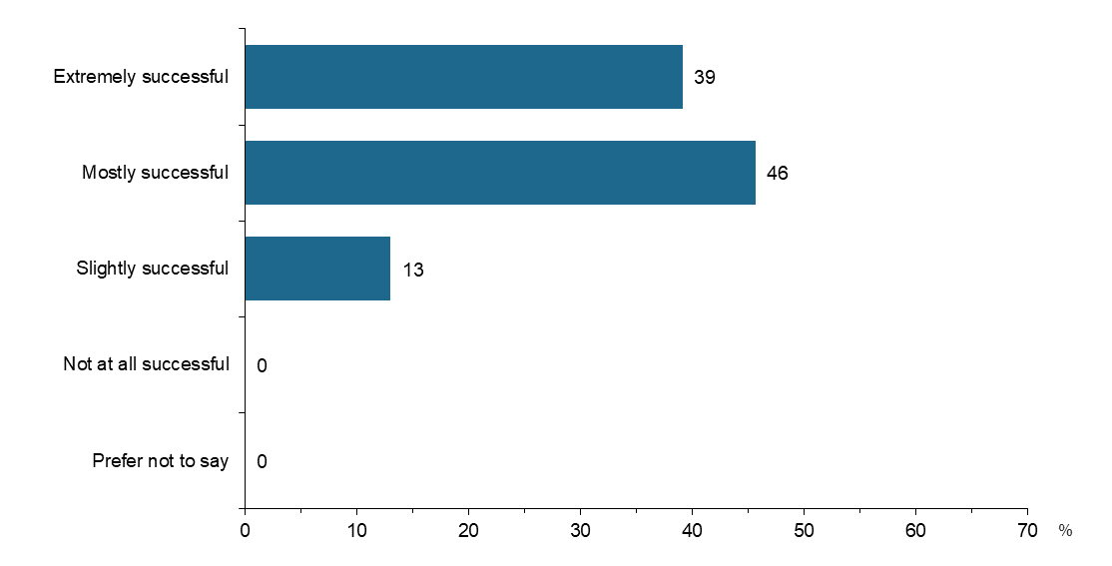
Source: Survey of SARC Activity Project Leads, August 2020
Notes: Question item – E2(17). Thinking about the last 12 months how successful has the project(s) been at achieving the following aims: Reducing social isolation
Base – Respondents who identified ‘reducing social isolation’ as a project aim in E1(17) (n=46)
Data not shown where n<5; percentages may not sum to 100%

For the 41 organisations with a single grant listing ‘reducing social isolation’ as an aim, 59% stated that the grant funding received had been sufficient to meet that project’s costs, while 39% said that it had not.
In regard to the literature reporting the outcome of VFM assessments related to community-based interventions targeting social isolation and loneliness, McDaid et al. (2017) conducted a systematic review of economic outcomes associated with interventions preventing/addressing loneliness. The scope of literature was restricted to interventions which targeted those over the age of 55, and the studies included tended to focus on either navigation services for community activities, participation in lifestyle activities or befriending services. As a broad trend, the paper stated, “several studies report strong levels of cost effectiveness and/or positive returns on investment…however these studies appear to be exceptional; overall there have been very few attempts to assess the economic benefits of addressing loneliness” (p.8).
A 2017 study included in the paper found a social return on investment of £1.26 for every £1 invested over a time horizon of five years, for delivering signposting services for self-identified lonely people in the UK. Here, it was specified that the benefits accrued were solely related to mental health, and thus represent an intrinsically conservative estimate. Overall however, the McDaid et al. (2017) review noted mixed evidence for befriending and healthy lifestyle activities across the few economic evaluations able to be examined. A program which targeted bereaved widows/widowers in the Netherlands (n=216) (Onrust et al 2008) to provide friendship recorded an incremental cost-effectiveness ratio of €6,827 per quality-adjusted life year (QALY) gained. However, a randomised controlled trial in England which offered befriending services to carers of individuals with dementia (n=236) recorded an incremental cost-effectiveness ratio of greater than £100,000 per QALY gained. This value was compared to a £30,000 per QALY threshold to conclude that the intervention was not cost-effective (Charlesworth et al, 2008).
Domain 2 – Improved physical health
SARC projects which aim to improve physical health include projects which provide education/skills regarding nutrition and food preparation, projects which provide information regarding health and health care, and community sporting programs (particularly targeted to youth and marginalised communities).
In 2015, the Australian Institute of Health and Welfare estimated that 2.5% of the total disease burden in Australia was due to physical inactivity (AIHW, 2020). In a report prepared by Brown et al. (2013) for the Department of Health, the relationship between physical activity and health was broadly described as curvilinear, with risk reduction concentrated in the extent to which people who do not participate in any moderate/vigorous exercise change their behaviour to participate in some activity. Physical activity was associated with a mortality risk reduction of 30% in active participants (commonly defined as meeting the physical activity recommendations) in comparison with the least active group. Results were also significant after controlling for body mass index.
Similarly to physical health, poor nutrition has also been linked to conditions including obesity, Type 2 diabetes, cancer as well as heart disease and stroke (CDC, 2020). The Australian Institute of Health and Welfare (2019) estimated that 7.3% of the total Australian burden of disease in 2015 was caused by a poor diet. A review of literature regarding cooking and food preparation skills by Chenhall (2011) also noted that a self-perceived inadequacy at these skills had been highlighted as a barrier to food choice.
From the survey, there were 21 (32%) recipient organisations who stated that ‘improved physical health’ was the best descriptor of the aims that they hoped to achieve from funded project/s. Most of these organisations (18) delivered a single program. Considering the previous 12 months before the survey was completed, 75% of organisations considered that they had been either ‘mostly’ or ‘extremely’ successful at achieving this aim, shown in Figure 44.
Figure 44 Success in improving physical health in the last 12 months
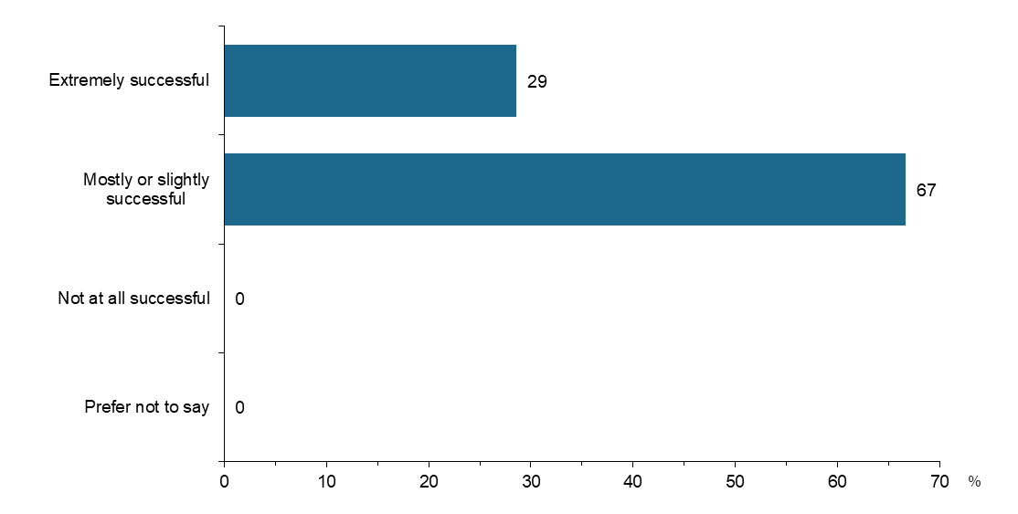
Source: Survey of SARC Activity Project Leads, August 2020
Notes: Question item – E2(6). Thinking about the last 12 months how successful has the project(s) been at achieving the following aims: Improving physical health
Base – Respondents who identified ‘improving physical health’ as a project aim in E1(6) (n=21)
Data not shown where n<5; percentages may not sum to 100%

SCORE data collected for 856 clients measuring the outcome domain of ‘physical health’ also showed an increased average measurement to 3.92, from a baseline of 2.28. However, it is noted that this data was collected on clients participating across the full range of SARC projects and cannot be linked to projects specifying an aim of ‘improved physical health’. For the 18 organisations which delivered a single project that listed ‘improved physical health’ as a best descriptor of the aim, grant funding was sufficient to meet project costs in 55% of cases.
The cost-effectiveness of interventions aimed at improving physical health has been commonly reported over recent decades in third-party literature. A report by Cadilhac (2011) using the 2008 Australian population, estimated the economic and health benefits of reducing the prevalence of physical inactivity by assuming a 10% reduction from the 70% level at baseline. Factors considered included health benefits (reduced incident cases of preventable physical inactivity-related diseases, disability adjusted life years [DALYs] and deaths) as well as the subsequent impact on paid and unpaid production and leisure. Results included 25,000 fewer DALYs, 2,000 fewer deaths, a reduction in health sector costs of $96 million, as well as providing 180,000 days of home-based production and 114,000 working days. It is noted that the cost of the intervention to achieve the reduction in prevalence of physical inactivity was not modelled in the study.
Several studies have presented evidence of the value for money associated with public health interventions which aim to increase levels of physical activity:
- Roux et al. (2008) used a simulated cohort of US adults to conduct a lifetime cost-effectiveness analysis of seven public health interventions (broadly categorised as individually adapted health behaviour change, community social support, community-wide campaigns and the enhanced access/creation of information related to physical activity and associated opportunities). The cost effectiveness ratios developed were below the $50,000 per QALY gain threshold quoted for all interventions except one of the two community-wide campaigns.
- Garrett et al. (2011) performed a systematic review focusing on randomised controlled trials which looked at primary care/community interventions to increase physical activity in adults between 2002 and 2009. The cost-effectiveness estimated across nine studies was between €348 and €86,877 per QALY gained. The author noted that the majority of interventions studied were considered cost-effective, particularly where instruction/direct supervision was not included.
- A National Institute of Clinical Excellence modelling study (Matrix Research and Consultancy, 2006) assessed the cost-effectiveness of physical activity interventions including pedometers, exercise referral, walking and cycling programs in the community and brief interventions in primary care. When costs were limited to the cost of the intervention, cost per QALY gained was between £20 and £670. When the scope of costs considered was widened to include avoided healthcare costs, each intervention was considered dominant, in that it resulted in both a cost saving to the health system and a QALY gain.
A number of SARC projects also involved volunteers preparing meals for delivery to people in need, or community kitchens and cooking programs. These project descriptions highlighted education around nutrition and food preparation skills as examples of intended outcomes. Hasan et al. (2019) undertook a systematic review of cooking classes and their effect on behavioural change and dietary intake. Overall, classes were associated with improvements in self-efficacy, attitudes and a healthier dietary intake (particularly when accompanied by additional components such as nutritional education), however the impact on cardiometabolic risk factors was not significant.
In addition, Herbert et al. (2014) evaluated a 10-week long community cooking skills program in Ipswich (Queensland), which found a statistically significant increase in the ability to prepare a meal in half an hour post-participation, a reduction in spending on fast food as well an ability to make a meal with staple ingredients which were low in cost. The report also found a sustained improvement in general health and self-esteem at the six-month follow-up mark for the intervention group.
Domain 3 – Increasing social cohesion
A primary aim of the SARC activity is increasing social cohesion, as the language of the Community Resilience and Inclusive Communities grant programs refer to ‘building strong, resilient and cohesive communities’. SARC projects which aimed to increase social cohesion included sports and arts-based activities in multicultural and/or disadvantaged communities; workshops, community events and increased engagement with community members of specific demographic and cultural backgrounds; and capacity-building activities for existing community groups. Several projects funded under the Inclusive Communities stream addressed social cohesion by focusing on issues including volunteerism, ethnic diversity, disadvantage and racially-based social commentary.
The importance of social cohesion was highlighted in the OECD’s Perspectives on Global Development 2012: Social Cohesion in a Shifting World (Scanlon Foundation Research Institute, 2020), which advanced the argument that social cohesion was not only a valuable goal, but also a contributing factor to long-term economic growth. Furthermore, it noted that social instability was a risk associated with governments ignoring issues of social cohesion. These benefits are broadly aligned with the Scanlon Foundation Research Institute’s view of the Australian government’s activities in this area, with social cohesion as a foundational building block for social harmony, and as a measure to curb radical behaviour (Scanlon Foundation Research Institute, 2020).
Across the 66 organisations surveyed, 39 (59%) stated that social cohesion was a main area of focus for their organisation, and 48 (72%) stated that increasing social cohesion was a best description of the aims they hoped to achieve through their project/s. Of the 48 projects, most (42) were delivering a single project. Figure 45 shows that 77% of respondents perceived their project to have been either ‘mostly’ or ‘extremely’ successful at increasing social cohesion over the preceding 12 months.
Figure 45 Success in increasing social cohesion in the last 12 months
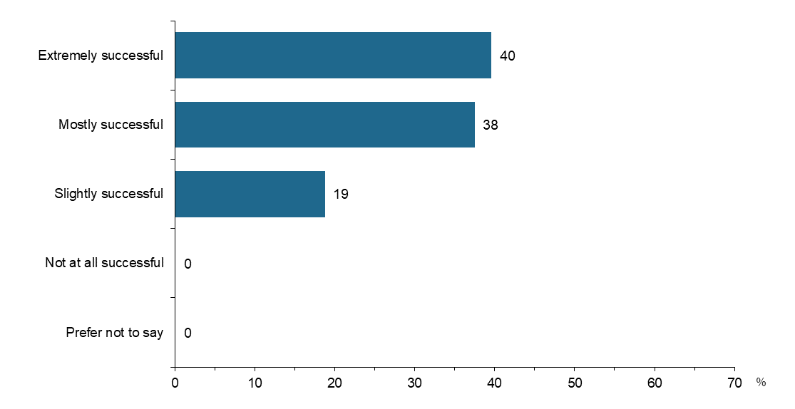
Source: Survey of SARC Activity Project Leads, August 2020
Notes: Question item – E2(1). Thinking about the last 12 months how successful has the project(s) been at achieving the following aims: Increasing social cohesion
Base – Respondents who identified ‘increasing social cohesion’ as a project aim in E1(1) (n=48)
Data not shown where n<5; percentages may not sum to 100%
Literature regarding social cohesion is characterised by differing definitions and frameworks. For example, Mulunga and Yazdanifard (2014) and Fitzduff (2007) have previously discussed challenges delineating social inclusion and social cohesion. In addition, the OECD’s framework for social cohesion includes components of social inclusion, social capital and social mobility.
In light of these issues, a review of SARC project descriptions noted several examples where both social inclusion and social cohesion were mentioned as intended goals of the project. Social cohesion was also referenced alongside the presence of culturally and linguistically diverse communities for certain projects. As well, when considering the survey, the following project aims were available for potential selection by respondents, which were frequently chosen:
- individuals having a sense of belonging to a wider community
- increasing social cohesion
- reducing barriers to social participation
- improving attitudes towards diversity in the community.
In recognition of the potential overlap between academic discourse, and the extent to which survey respondents may have regarded these concepts and aims as reasonably similar, a broader approach was undertaken to review the third-party literature for this domain.
In 2019, Deloitte Access Economics (2019) released a public report commissioned by Australia’s Special Broadcasting Service (SBS) regarding the economic benefits of social inclusion. Econometric analysis conducted found that the extent to which Australian migrants felt socially included was associated with a statistically significant (though small) reduction in the probability of being unemployed.
Piracha et al. (2013) identified that social capital had a statistically significant positive effect on Australian migrant’s employment outcomes and wages, particularly for women. The paper distinguishes that this effect is present in white-collar jobs rather than blue-collar jobs. One SARC funded project specifically targets women from a culturally and linguistically diverse background for activities including capacity-building and leadership skills, though the extent to which white collar jobs are matched to participant’s labour market skills is unknown.
VicHealth’s Participation in Community Sport and Active Recreation program was also identified in the literature as a grant program with the aim of adding to the evidence base in terms of how sport and recreation can promote social inclusion (among other objectives). Funding 61 projects between 2007 and 2011, targeted cohorts included Aboriginal Victorians, people from low socio-economic backgrounds and culturally diverse communities. An evaluation of the program found participants reporting increased confidence and pride, as well as physical health benefits. The ability to socially integrate and build social networks was also reported.
Domain 4 – Promoting volunteering
Projects funded under SARC, which may be categorised as aiming to promote volunteering include engaging employers to generate volunteering positions as a means to providing a path to paid employment, as well as research regarding the benefits of volunteering in a community sporting program. In addition, the use of volunteers to deliver many SARC-funded projects was captured in the survey, underlining the importance of this contribution as an input to the aims achieved.
Volunteers are utilised across many sectors of Australia including sports and community welfare. For example, in 2016 there were 23,537 volunteers who contributed close to 115,000 hours of care to Australians in residential aged care facilities (Parliament of Australia, 2017). It is also estimated that there are five volunteers for each paid worker in the not-for-profit sector (Parliament of Australia, 2017). Consequently, promoting volunteering is vital to the ongoing provision of goods and services of high social value to Australians. Haldane (2014) cites three broad types of personal benefits to volunteers: enhanced wellbeing, health benefits and increased skills and employability. In a systematic review and meta-analysis of health and survival associated with volunteering, Jenkinson et al. (2013) found that cohort studies demonstrated positive effects on life satisfaction, wellbeing and depression, though not physical health. It was noted that experiment-based studies could not provide confirmation of these impacts. A lower risk of mortality in volunteers was also calculated via meta-analysis of five cohort studies (risk ratio: 0.78; 95% CI: 0.66, 0.90).
Of the 66 organisational survey respondents, 19 (29%) stated ‘promoting volunteering’ as the best description of the aims hoping to be achieved through the project/s. There were 17 organisations delivering one project and two organisations delivering two projects in this group. Figure 46 shows the level of success organisations perceived they had achieved over the preceding 12 months, with 79% stating that they had been either ‘mostly’ or ‘extremely’ successful. Grant funding had been sufficient to meet the project needs in 53% of organisations delivering a single project.
Figure 46 Success in promoting volunteering in the last 12 months
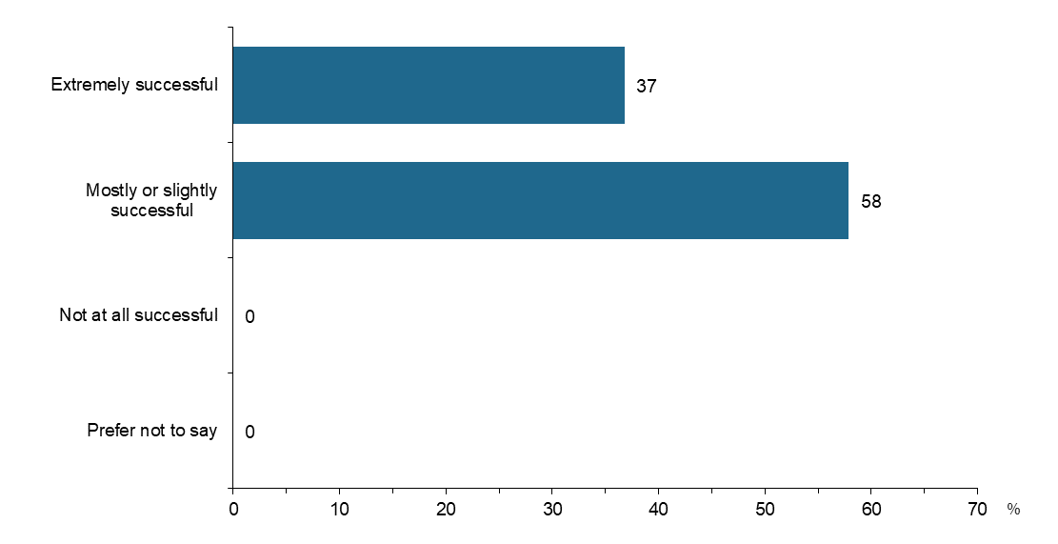
Source: Survey of SARC Activity Project Leads, August 2020
Notes: Question item – E2(18). Thinking about the last 12 months how successful has the project(s) been at achieving the following aims: Promoting volunteering
Base – Respondents who identified ‘promoting volunteering’ as a project aim in E1(18) (n=19)
Data not shown where n<5; percentages may not sum to 100%
Irrespective of whether organisations received grant funding with a specific aim of ‘promoting volunteering’, volunteer work was also a contributing input to a range of SARC-funded projects. Survey responses identified:
- 377 volunteers per week across 66 organisations associated with their ‘first’ project
- 15 volunteers per week across 8 organisations associated with their ‘second’ project
- 5 volunteers per week for the ‘third’ project recorded by a sole organisation.
Based on these results, approximately 397 volunteers per week were engaged by organisations who responded to the survey. This approximation is a theoretical maximum, as a single volunteer may be associated with multiple projects within the same organisation. Organisations were also asked to estimate the number of hours individual volunteers worked per week. From these responses, 573 volunteer-hours per week were calculated across all projects surveyed. However, further information is required to understand the length of time that each project required volunteers for (relative to the overall funding period) to accurately monetise total volunteer hours.
Economic literature discussing the value of volunteering is heterogeneous in nature. Key methodological differences in approach includes the definition of a volunteer, valuation techniques for non-market goods and goods associated with market failure (e.g. positive externalities), as well as different theoretical frameworks for describing the value to the volunteer and to society (ABS, 2018) (Volunteering WA, 2015)( Jenkinson, 2013)( Haldane, 2014)(Ironmonger, 2011)(Bittman et al, 2006). For example, Haldane (2014) distinguishes between the economic value of goods and services provided by volunteers, the social value of the activities undertaken and the private value which accrues to the volunteer (Haldane, 2014). Studies measuring the cost-effectiveness of volunteering include:
- Haldane (2014) in discussing the work of the charity Pro Bono Economics, stated that the smallest social welfare multiplier to date compared to the cost of the labour input of volunteering had been calculated at 2.5. Gains to societal welfare may include avoided expenditure on social services, justice and health systems.
- VolunteeringWA (2015) reported approximately $4.50 of community benefits received for every dollar invested in volunteering.
- Volunteering Tasmania (2019) reported $3.50 of community benefits for every dollar invested.
Domain 5 – Improved mental health outcomes
SARC projects with the aim of improving mental health outcomes include recreational and/or pre-employment activities for vulnerable groups; provision of education, life skills development, communication and relationship strategies for families impacted by mental illness; and providing social connections to patients in mental health recovery.
The Productivity Commission’s draft report (2020) into mental health estimated that the cost to the Australian economy of mental ill-health and suicide in 2018-19 was approximately $43-51 billion per year, using a conservative methodological approach. The Australian Institute of Health and Welfare (2020) estimates that national recurrent expenditure on mental health-related services in 2017-18 was approximately $9.9 billion. Consequently, the incentives to support cost-effective interventions improving mental health outcomes specific to a population level or targeted toward a community with existing mental health issues are clear.
Almost half (32) of the 66 organisations surveyed stated that ‘improving mental health and wellbeing’ was a best description of the aims hoping to be achieved through the funded project/s. The link between physical health and improved mental health outcomes was also noted in survey responses, where 90% of organisations which selected ‘improved physical health’ also selected ‘improved mental health outcomes’ as an aim hoping to be achieved. In the preceding 12 months before the survey was completed, 88% of organisations stated their project/s had been either ‘mostly’ or ‘extremely’ successful at improving mental health and wellbeing, as shown in Figure 47. Among organisations delivering a single project with this aim, grant funding was sufficient to meet project costs in 57% of cases.
Figure 47 Success in improving mental health and wellbeing in the last 12 months
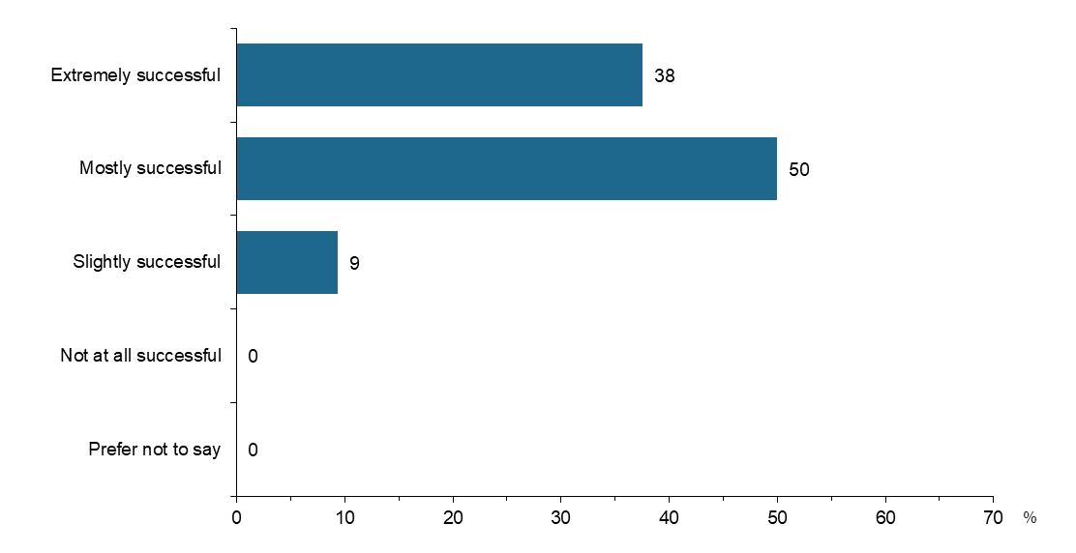
Source: Survey of SARC Activity Project Leads, August 2020
Notes: Question item – E2(5). Thinking about the last 12 months how successful has the project(s) been at achieving the following aims: Improving mental health and wellbeing
Base – Respondents who identified ‘improving mental health and wellbeing’ as a project aim in E1(5) (n=32)
Data not shown where n<5; percentages may not sum to 100%
Half of the total number of organisations listing ‘improved mental health and wellbeing’ as an aim stated that people with mental health issues were a community group supported as part of the SARC activity. Thus, it may be hypothesised that a separate group of organisations do not view their projects as targeting those community members with existing mental health issues, and that improved mental health outcomes is a by-product of planned project activities. In the subset of organisations targeting people with mental health issues, 56% stated that SARC funding increased their ability to meet the needs of people with mental health issues ‘to a great extent’, and 44% stated ‘to some extent’. The mean SCORE data collected for 1,016 clients assessed along the ‘mental health, wellbeing and self-care’ outcome domain also showed an increase to 3.82 out of 5, in comparison to 2.47 at baseline.
When considering the third-party literature, a lack of economic evaluations considering the costs and benefits associated with mental health interventions was noted by Doran (2013) in a review completed for the Mental Health Commission of NSW. This review found 47 studies from Australia, Canada and the United Kingdom published between 2000 and 2013, relating to depression, mental disorder, panic disorder, schizophrenia, generalised anxiety disorder, conduct disorder and attention deficit hyperactivity disorder. Across the studies under analysis, evaluations had been conducted more frequently for pharmacological treatments rather than psychosocial interventions. A health-system perspective was common. One of the review’s recommendations was to pursue economic evaluations of music, art and body movement-based interventions (which several SARC-funded projects would be classified as), rationalising that they were likely to be low-cost.
A government program identified in the literature with similarities to SARC was the Victorian Health Promotion Foundation’s Community Arts Participation Scheme (VicHealth, 2002), established in 1999. This scheme was developed as a result of the Foundation’s Mental Health Promotion Plan, which focused on social connectedness, valuing diversity and economic participation as three determinants of mental health. An evaluation of this scheme reported participants developing positive relationships with project peers and the community, participants getting referrals to services and organisations aligned with their needs, as well as skills development in areas considered competencies for effective participation in the workplace.
Two interventions were also identified in the literature providing community-based interventions for families of patients with mental illness. Firstly, Picket-Schenk et al. (2008) explored the use of trained volunteers to provide education to families of adults with mental illness in Louisiana. The trial was conducted using a randomised wait-list design (n=462) and found the intervention group had significantly fewer information needs at the six-month follow-up mark regarding how to cope with negative and positive symptoms, problem management, community resources, and facts regarding mental health and treatment.
In a similar style of intervention, Lucksted et al. (2013) examined a peer-driven family support and education program in Maryland undertaken with a randomised controlled study design (n=158). It found that six months after program cessation participants had increased empowerment, knowledge and coping skills.
A systematic review and meta-analysis by Mead (2010) found that befriending programs in community-based settings had significant (though small) effects in reducing depressive symptoms in the short and long-term. However, the author observed that only 3 of the 24 studies included undertook any economic evaluation, and none of these studies reported statistically significant clinical benefits in participants.

Requirements for a future Value for money assessment
There are a wide range of participant outcomes which can be included in a VFM assessment. The following examples for each domain provide examples of the types of data that could be collected to enable a VFM assessment.
Reducing social isolation – improvements in this domain can be assessed through using a validated tool such as the EQ-5D or SF-36. These tools can measure changes in health-related quality of life, which can support a cost-effectiveness analysis and/or be monetised in a cost benefit analysis.
Improved physical health – data collected from participants could record their change in physical health markers, such as the number of weeks in the previous month where the participant achieved the physical activity guidelines, or biomarkers such as body mass index. Over the course of the program, these outcomes can be monetised to demonstrate savings to the health sector, and/or increases in participant quality of life.
Data can also be collected regarding how participant use of health services has changed, to identify whether the program has successfully reduced costs to the health system. However, it is more likely that use of health services would increase in the short term, and improve long term health outcomes, which should be the primary measure. For example, it may be the case that a participant takes more responsibility for their health through their participation in the program, and so engages with the health system at a higher rate which is more appropriate for their needs. Thus, an appropriate measure to use could be participant use of hospital services – such as the number of admissions to the emergency department in the preceding year, and any associated hospital admissions – to assess whether the program has been successful in reducing health system expenditure.
Increasing social cohesion – achievement of this domain delivers outcomes such as a reduction in re-offending rates, and improvements in employment rates. Data can be captured on both these aspects. For example, data could be collected on contact with the justice system in the previous 12 months: court appearances, intervention orders, incarceration, etc. Data captured on the last 12 months of the program, or the 12 months following program completion, could assess how these rates have changed for participants who took part in the program. A reduction in these rates could be monetised through assessing per unit costs for items such as court appearances and incarceration, and calculating the costs which are “avoided” by the program.
Data could also be captured on employment rates in the target cohort at program commencement, and at the end of the program. Each additional person in employment delivers economic benefits such as increased output (contribution to gross domestic product). From the perspective of government, employment delivers increased tax revenue and reduced spending on welfare.
Promoting volunteering – the data required to measure the value of volunteering generated by the project depends on the conceptual framework for the analysis. A standard model is to use the replacement cost method, which measures the value of “replacing” the volunteers with paid staff. This approach requires data to be collected on the number of volunteer hours, the industry in which the volunteering was provided, and average wage rates in each industry of interest. The value of the volunteering can then be compared against the cost of the programs.
Improved mental health – this domain can be assessed through use of a validated scale for assessing changes in the prevalence and/or severity of mental health conditions, such as the Beck Depression Inventory or the Kessler K10 scale. Improvements on these scales can be readily monetised through applying an estimated cost per case of depression or anxiety that is removed (or reduced) due to the program, through using existing literature which places a monetary cost on these mental health conditions.

Other national data sources reviewed
The evaluation team reviewed a range of external data sources to identify outcomes and associated measures that relate to the SARC outcome areas assessed from SARC administrative or primary data collected as part of this evaluation. These external sources provided contextual whole-of-population benchmarks, but due to differences in definitions of the measures developed from SARC program data for this evaluation, direct comparative analysis was not possible. Nonetheless, we have collated a list of example national level reports and/or data sources of key relevant and well-established indicators or measures which are supported by collection instruments that could be considered for future development of methods for SARC outcomes and measures. These are described below and summarised in Table 12.
Mapping Social Cohesion Survey
The Mapping Social Cohesion national survey has been undertaken by the Scanlon Foundation since 2007. Each survey builds on the previous year and informs the Scanlon-Monash Index (SMI) of Social Cohesion. The surveys have been undertaken since 2007 where the original survey provided the benchmark against which the SMI is then measured. In addition to the national surveys, local area and minority group surveys have been conducted by the Scanlon Foundation. These surveys enable annual tracking of public opinion on social cohesion, immigration and population issues (Markus, 2019). One indication is provided by the Scanlon Monash Index (SMI), which aggregates response to 18 questions. It measures attitudes within the five domains which conceptualise:
- Belonging: Indication of pride in the Australian way of life and culture; sense of belonging; importance of maintaining Australian way of life and culture.
- Worth: Satisfaction with present financial situation and indication of happiness over the last year.
- Social justice and equity: Views on the adequacy of financial support for people on low incomes; the gap between high and low incomes; Australia as a land of economic opportunity; trust in the Australian government.
- Participation (political): Voted in an election; signed a petition; contacted a Member of Parliament; participated in a boycott; attended a protest.
- Acceptance and rejection, legitimacy: The scale measures rejection, indicated by a negative view of immigration from many different countries; reported experience of discrimination in the last 12 months; disagreement with government support to ethnic minorities for maintenance of customs and traditions; feeling that life in three or four years will be worse.
The individual questions not only contribute the determination of the SMI, but themselves elicit valuable findings on important aspects of social cohesion. For example, Figure 48 displays the extent that respondents’ have a sense of belonging in Australia, which appears to be declining over time.
Figure 48 ‘To what extent do you have a sense of belonging in Australia?’, 2007-19 (Markus, 2019)
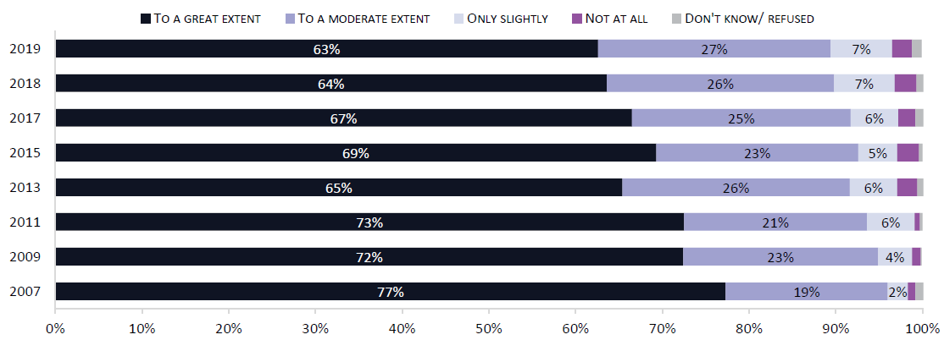
The survey instrument and SMI validation is currently undergoing revisions to update the survey questionnaires to be used for the next round of collection planned for 2021 through the Life in AustraliaTM online panel, administered by the Social Research Centre. These survey instruments could provide appropriate methods for collecting and assessing outcome measures for the SARC communities and participants. Furthermore, the national Mapping Social Cohesion survey measures would be able to provide a useful benchmark for comparative analysis and ongoing monitoring.

The Household, Income and Labour Dynamics in Australia (HILDA) Survey
The Household, Income and Labour Dynamics in Australia (HILDA) Survey is a household-based panel study that collects valuable information about economic and personal well-being, labour market dynamics and family life (Melbourne Institute , 2019). It aims to tell the stories of the same group of Australians over the course of their lives. The HILDA Survey is funded by the Australian Government through the Department of Social Services, with the intention of providing policy-makers with unique insights about Australia to make informed decisions across a range of policy areas, including (but not limited to) social services (Wilkins, 2019). It would be valuable to utilise this valuable data source, to assess the usefulness and applicability of selected outcomes and associated measures, including the collection instruments. Examples are provided in Table 12.

Building a New Life in Australia: the Longitudinal Study of Humanitarian Migrants
Building a New Life in Australia: The Longitudinal Study of Humanitarian Migrants (BNLA) is a long-term project researching how humanitarian migrants settle into life in Australia (Department of Social Services, 2019). The study provides a broad evidence base to assist policy development and program improvement for humanitarian migrants to Australia. It follows a large cohort of humanitarian migrants to increase knowledge around the factors that support successful settlement. The study also identifies barriers that hinder positive settlement outcomes.

Three broad questions guide the study.
- What are the settlement outcomes of humanitarian migrants and how are they faring on a range of key measures? (For example, employment, education, English language and health).
- How does access to and use of government services and non-government services and welfare benefits contribute to humanitarian migrants’ successful settlement?
- Do the settlement experiences and outcomes of humanitarian migrants vary according to the differing migration pathways taken? (for example, offshore, onshore).
The BLNA allows policy makers to look at outcomes over time, and being a DSS resource, it would be valuable to utilise this data source, to assess the usefulness and applicability of selected outcomes and associated measures, some examples of which are outlined in Table 12.

Growing Up in Australia: The Longitudinal Study of Australian Children (LSAC)
Growing Up in Australia: The Longitudinal Study of Australian Children (LSAC) follows the development of 10,000 young people and their families from all parts of Australia. It is conducted in partnership between the Department of Social Services, the Australian Institute of Family Studies and the Australian Bureau of Statistics with advice provided by a consortium of leading researchers (Growing Up in Australia, 2020). The study began in 2003 with a representative sample of children from urban and rural areas of all states and territories in Australia and it will continue to follow participants into adulthood. This LSAC takes a developmental pathways approach, emphasising trajectories of development across the lifespan. This perspective seeks to identify the factors that influence pathways for good and for poor outcomes (Zubrick, 2020). Specific high level outcome domains relating to transition to adulthood include:
- Economic participation
- Social participation
- Civic participation and citizenship
- Educational attainment and skill development (cognitive and non-cognitive skills)
- Relationships within and outside the family
- Family formation and parenting
- Personal safety/security and housing
- Health status
- Social and emotional adjustment.

Australia’s welfare
The Australian Institute of Health and Welfare (AIHW) compiles a biennial national report card on the welfare of Australians and the role of welfare services and supports (AIHW, 2019). The biennial Australia’s welfare reports are a source of independent and accessible information collated from multiple data sources. They are a mix of short statistical updates and longer discussions exploring selected topical issues. Australia’s welfare also serves as a ‘report card’ on the welfare of Australians by looking at how we are faring as a nation. While these reports and underlying data sources are very broad, there are some selected outcomes, indicators or measures that are applicable to SARC, and may provide valuable reference or benchmarking tools for consideration in future development of SARC outcomes and appropriate data collection approaches to support ongoing measurement and monitoring of outcomes. Some selected examples are listed in Table 12.

Other outcomes sourced for the economic review
The economic review results presented in Appendix J assessed selected outcome areas reported in the online survey of project leads as stated aims of their projects, supported by third-party literature where available. It was noted the third party sources don’t necessarily align directly with the overarching objectives and aims of SARC, but rather contextualise with reference to related benefits commonly considered by VFM assessments of similar programs.

Future Opportunities
While this evaluation has assessed impact of SARC by addressing some shorter term outcomes that have been developed and measured using data sourced specifically for this purpose, it has become clear that there are ongoing opportunities to improve the way in which outcomes could be assessed in future. A supporting outcomes framework structure would be valuable to identify the overarching objectives of the SARC program, the high level outcomes that it is intending to achieve in the longer term, linking back to the shorter term outcomes, outputs, activities and inputs that have been identified in the program logic (refer to Appendix C). Importantly, outcomes should be measurable and well-defined with appropriate indicators, measures and data sources identified to support ongoing measurement and monitoring of the SARC’s progress towards achieving those appropriate outcomes. It is also important to note that outcomes are often represented by more than one indicator or measure and can be drawn from or adapted from many existing sources. The reference material presented in this appendix is not an exhaustive list but is intended to provide some example material to inform potential future work on development of an outcomes framework to support ongoing measurement and assessment of clearly defined SARC outcomes.

Table 12 Example national sources that may inform future development of SARC outcome measures
Report / data source | Organisation | Most recent reported year | Example outcome areas with relevance to SARC
Mapping Social Cohesion Survey (Markus, 2019) | Scanlon Foundation | 2019 | Scanlon-Monash Index (SMI) of Social Cohesion, 5 domains include  - Sense of belonging  - Sense of worth  - Social Justice and equity  - Political participation  - Acceptance (rejection)
Building a New Life in Australia: The Longitudinal Study of Humanitarian Migrants (BNLA) (Department of Social Services, 2019) | Department of Social Services / Australian Institute of Family Studies) | 2019 | - Self-reported Understanding of English in Migrants across six time points  - Employment and job search status  - Perceptions of neighbourhood (e.g. safe neighbourhood)  - Self-Sufficiency in Migrants  - Migrants using Government payments; Employment as a main source of income  - Principal respondents who found it easy or very easy to interact with the wider Australian community  - Adult respondents who experienced discrimination
Household, Income and Labour Dynamics in Australia (HILDA) Survey (Melbourne Institute, 2019) | Department of Social Services / Melbourne Institute | 2019 | - Household and family life  - Household economic wellbeing
Growing Up in Australia: The Longitudinal Study of Australian Children (LSAC) | Department of Social Services, the Australian Institute of Family Studies and the Australian Bureau of Statistics | 2018 | - Economic participation  - Social participation  - Civic participation and citizenship  - Educational attainment and skill development (cognitive and non-cognitive skills)  - Relationships within and outside the family  - Family formation and parenting  - Personal safety/security and housing  - Health status  - Social and emotional adjustment
Australia’s Welfare (AIHW, 2019) | Australian Institute of Health and Welfare, drawing on several data sources including (but not limited to):  - Australian Bureau of Statistics (ABS) surveys – Crime Victimisation; Personal Safety; General Social Survey  - HILDA (see above)  - LSAC (see above) | 2019 | Determinants of wellbeing:  - Family relationships - Family Cohesion  - Social engagement - Social Connectedness  - Social isolation and loneliness  - Learning potential - School readiness  Wellbeing:  - Personal Safety  - Crime victimisation  - Perceptions of Safety in the Community  - Community engagement – Level of generalised trust  - Education and skills – engagement  - Experience of employment

Stanley, D (2003). What Do We Know about Social Cohesion: The Research Perspective of the Federal Government's Social Cohesion Research Network. The Canadian Journal of Sociology / Cahiers Canadiens De Sociologie, 28(1), 5-17. doi:10.2307/3341872
DEX is a standardised performance reporting system for client facing funding agreements, incorporating mandatory priority reporting and optional partnership approach reporting on client and community outcomes.
NVivo is a qualitative data analysis software package designed for qualitative researchers, where deep levels of analysis are required on textual data.
The proportion is estimated as a result of some DEX fields needing to be suppressed for extraction due to low cell counts.
Individual clients are attendees who had a client record created in DEX that may contain data on demographics and outcomes.
These domains were selected based on the stated aims of the grant programs and the availability of third-party literature to support the analysis. They do not necessarily align with the overarching aims of SARC but represent benefits commonly considered by VFM assessments of comparable programs.
Organisations were able to select multiple aims from a list of twenty pre-supplied options, as well as a free-response category of ‘other’. Aims hoping to be achieved were not able to be matched to individual projects from a respondent with multiple grants.
Quality-adjusted life years are a theoretical measure of the gain achieved from a health care intervention. It is estimated as the product of the health state preference improvement achieved and the years spent in this improved state.
The author quotes a willingness-to-pay ratio of approximately €20,000 per QALY for preventative interventions.
SCORE data collected should be considered within the context of low response rates overall, discussed in the ‘Approach to the value-for-money assessment’ section.
For organisations which received grant funding for more than one project, it is not possible to identify how many projects ‘improved physical health’ as an aim is applicable. Consequently, only organisations with a single project have been analysed here.
Disability-adjusted life years is a measurement of the burden of disease within a population. It is calculated as the sum of years of life lost due to premature mortality and years of life lost due to disability.
As previously noted, this data was collected on clients participating across the full range of SARC projects, and cannot be linked to projects specifying an aim of ‘improved mental health outcomes’.

