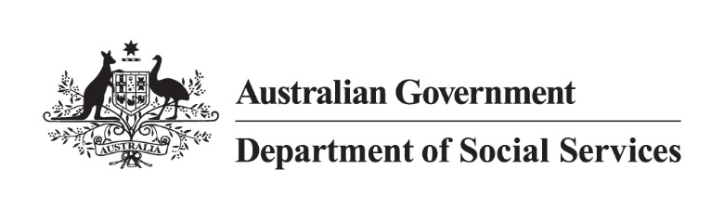

Independent Investigation into Historical Intercountry Adoptions from the Republic of Korea to Australia
Stage 2 Participation Information
Last updated 27 October 2026

Purpose
This document provides an overview of ways to participate in Stage 2 of the Independent Investigation into Historical Intercountry Adoptions from the Republic of Korea (ROK) to Australia (the Investigation) for adoptees, their families and advocates.
The Investigation is led by Robert Cook, with support from the Department of Social Services (the Department) and independent auditors, Cobalt Consulting (Cobalt). Cobalt’s role is to provide a robust evidentiary base for the Investigation by reviewing historical adoption files and associated policy and procedural documents, identifying irregularities, and supporting Robert with evidence for the final report.
The Investigation is being conducted in two stages. Stage 1, which is now complete, focused on gathering information across Commonwealth and state and territory governments. Stage 2 will centre the voices of adoptees and will focus on reviewing adoption files against relevant policies and procedures.
More information about the Investigation, including the Terms of Reference (ToR), is available on the Investigation website.

Who can participate in Stage 2?
The Investigation welcomes participation from individuals and organisations with relevant experiences or knowledge of ROK-Australia intercountry adoptions between 1964 and 1999. The primary participants in Stage 2 are:
- People who were adopted from the ROK to Australia between 1964 and 1999
- Adoptive parents of children adopted from the ROK to Australia between 1964 and 1999
- Family members of adoptees
- Organisations, advocates, researchers and other individuals with relevant professional or personal knowledge of ROK-Australia intercountry adoptions during the investigation period.
The eligibility requirements for each pathway are outlined in the sections below.

Three ways to participate
The Investigation is seeking to understand the full range of adoption experiences. You do not need to be aware of, or have concerns about, irregularities in your adoption, or your child’s adoption, to participate.
There are 3 primary ways to participate in the Investigation;
- Written submissions,
- Interviews with Robert Cook, and
- Adoption file inspection.
Expressions of interest for file inspection and interview will close on 13 November 2026, and written submissions will close on 4 December 2026. The three options are described in the following sections and in a flowchart below.

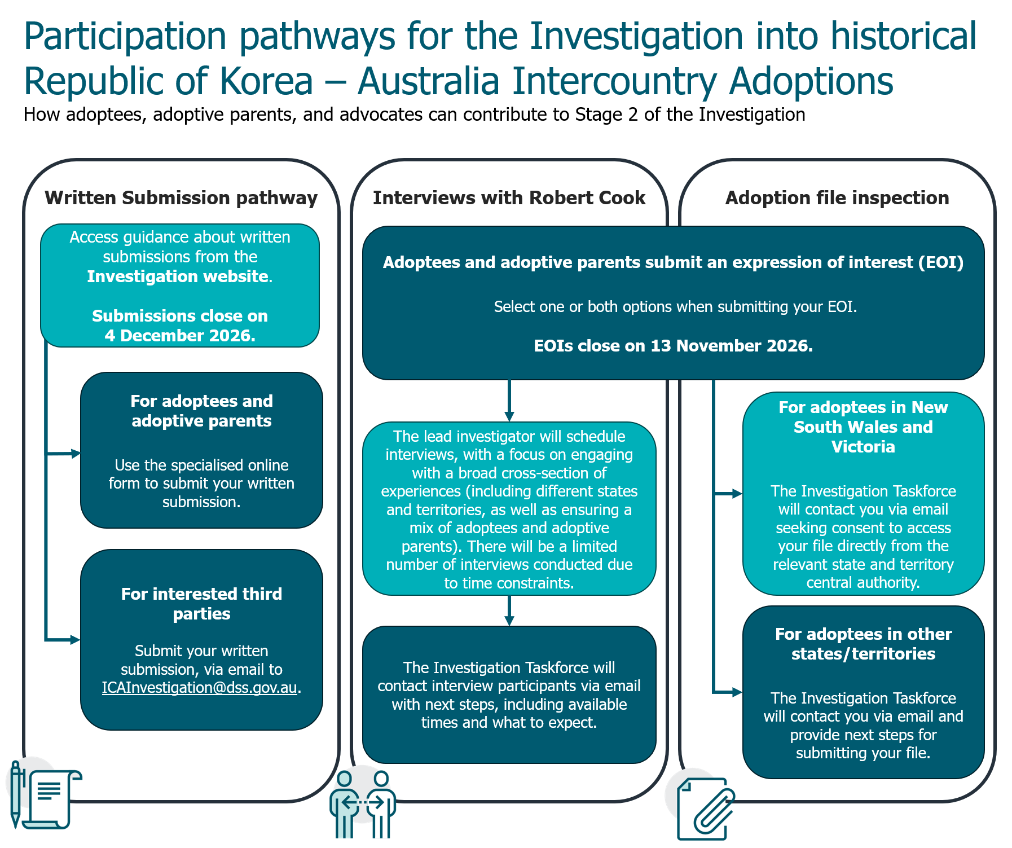

Written submissions
Written submissions will assist the lead investigator to understand the concerns and lifelong impacts of historical intercountry adoptions on adoptees from the ROK and their families. It will also provide an opportunity for third parties, including organisations, to provide their views to the lead investigator for consideration.
Submissions can be made between 26 October 2026 and 4 December 2026. Late submissions will not be accepted.

How to provide a written submission
Adoptees from the ROK and adoptive parents (only those whose adoptions occurred from 1964 to 1999) may provide a written submission through a specialised online form. This form has been designed to ensure compliance with the legislative requirements of the jurisdiction in which the adoption occurred. The form asks specific questions to ensure any content submitted is relevant to the Investigation’s Terms of Reference.
Organisations and third parties can make submissions via email, to the ICAInvestigation@dss.gov.au mailbox. These can be made in any format but should not include third party personal or sensitive information. Please note that the Investigation’s Terms of Reference limit the scope of what will be considered from written submissions. Written submissions should be limited to information regarding adoptions from the ROK to Australia between the years 1964 and 1999.
The Investigation Taskforce can be contacted directly with any concerns about the type of information that can be submitted in accordance with legislative restrictions.

Information required to participate
Adoptees from the ROK and their families can make an anonymous written submission if they would prefer to do so.
There will be minimal mandatory information required to establish eligibility: whether the adoption occurred from the ROK to Australia, and whether it occurred between 1964 and 1999. These eligibility requirements match the scope of the Investigation, as defined in the Terms of Reference.

How written submissions will contribute to the Investigation
Your individual submission may contribute to:
- identifying systemic patterns or trends that emerge from adoptee engagement and are also evident in the inspection of files conducted by the independent auditors
- interpreting documentary evidence
- understanding the impacts of policies and practices on adoptees and their families
- informing findings.
Please note, you will not receive an individual response or outcome if you choose to provide a written submission.

Interviews with Robert Cook
Adoptees and adoptive parents can express interest in attending an interview with lead investigator Robert Cook to discuss their individual stories. If you are interested in participating in an interview, you should submit an EOI via the online form by 13 November 2026. The EOI form can be accessed on the Investigation website.

How will individuals be prioritised to participate in an interview?
It is Robert’s intention to meet with as many individuals who express interest as possible.
Due to time constraints, there will be a limited number of interviews conducted. Robert will seek a broad cross-section of experiences, with representation from adoptees and adoptive parents from a wide range of states and territories and across the time period of the Investigation. Robert may not be able to interview everyone that has an expressed an interest to be interviewed.

What information can be shared during an interview?
Interviews provide an opportunity to share your experiences directly with Robert and discuss matters that may be difficult to capture through an adoption file review or written submission.
Individuals may be invited to share information such as:
- Personal experiences, suspicions, or concerns relating to their adoption or their child’s adoption
- Information about how adoption processes affected them or their family
- Concerns or observations regarding adoption practices.
Participants will not be able to provide sensitive personal information to the Investigation relating to third parties. Sensitive information is personal information that includes information or opinion about an individual’s:
- racial or ethnic origin
- political opinions
- membership of a political association
- religious beliefs or affiliations
- philosophical beliefs
- membership of a professional or trade association
- membership of a trade union
- sexual preferences or practices
- criminal record
- health and genetic information.
Participants can provide personal or sensitive information about themselves if they choose.

Interview Format
Robert will lead interviews in a respectful and trauma informed manner. Every interview will be different. Robert will first hear from participants and any questions he might have will be guided by their circumstances, experiences and any information available to the Investigation. Interviews will be guided by the Investigation’s Terms of Reference and will focus on experiences and information that may assist the Investigation.
Participants are not expected to provide evidence or have detailed recollection of processes that occurred, or the dates that events happened.
Participants may have a support person of their choice be present with them during the interview. This may be a family member, friend, counsellor, advocate or another trusted person.
Further information about the interview process will be provided to participants who have consented to being contacted and are invited to participate in interviews.

How interviews will contribute to the Investigation
Information discussed during interviews may assist the Investigation by:
- identifying systemic patterns or trends that emerge from adoptee engagement and evident in the audit of files conducted by the independent auditors
- interpreting documentary evidence
- understanding the impacts of policies and practices on adoptees and their families
- informing findings.
Please note, you will not receive an individual response or outcome regarding your adoption, or your child’s adoption, if you choose to participate in an interview.

Inspection of ROK-Australia adoption files
Through Stage 2 of the Investigation, Cobalt will examine and review Australian adoption files to ascertain whether there is evidence that Australian authorities were aware of, or took necessary action, in relation to irregularities, inconsistencies, or inadequate evidence found within an adoptee’s paperwork. They will also review adoption files to understand the prevalence of irregularities and inconsistencies.
The inspection approach will vary depending on the jurisdiction in which the adoption was registered, due to different legislative requirements. It will involve:
- Inspection of adoption files by the auditors in New South Wales and Victoria, accessed directly from the relevant state government.
- Individuals in other jurisdictions providing their adoption files to the Investigation, where permitted by legislation, for the auditors to review.
In New South Wales and Victoria, the independent auditors supporting the Investigation will be able to access adoption files directly for inspection from the state governments.
Adoptees in other jurisdictions will be able to submit their files to the Department for review. The files will undergo a redaction process to ensure the Department does not collect sensitive third-party information without consent (e.g. information about birth and adoptive parents). The independent auditors will review these redacted files.
Cobalt will review each adoption file to compile aggregated and anonymised information. The information provided will support the Investigation in identifying themes, trends, and patterns across adoption experiences while protecting the privacy of individuals. A summary of de-identified key findings will be provided to Robert and the Department’s Investigation Taskforce at the completion of their review. These findings will not have identifying personal information and will be aggregate only.
Process to participate in adoption file inspection
To have your adoption file inspected by the Investigation, you need to have been adopted from the ROK to an Australian state or territory between 1964 and 1999.
The Investigation recognises that individuals may have different levels of access to adoption records, depending on their circumstances and the jurisdiction where the adoption occurred:
- If your adoption occurred in New South Wales or Victoria, you may advise the Investigation that you would like your adoption file to be inspected, regardless of whether you have access to your file or not. The relevant authority will provide direct access to the adoption file for Cobalt to review.
  - If your adoption occurred in New South Wales, auditors will only be able to inspect your file with your consent.
  - If your adoption occurred in Victoria, auditors may review your files as part of a random sample, however your consent will be needed if you wish to ensure that your file is included in the sample.
- If your adoption occurred in another state or territory, you may submit your adoption file to the Investigation for inspection. Cobalt will review these files directly.
If you have submitted an EOI and selected the option to participate in the file inspection, the Department will contact you to facilitate submission (or, if you are in New South Wales or Victoria, to seek consent to access your file directly from the relevant state government body). Please do not email your adoption file before receiving advice from the Investigation Taskforce. You may submit an EOI until 13 November 2026, in order for the Investigation Taskforce to contact you to submit your adoption file by 4 December 2026.
Please note, you will not receive an individual response or outcome if you choose to submit your adoption file for inspection. The Investigation cannot assist with accessing adoption records, family finding, birth family searches, reunification, identity verification or identity resolution, as these are outside the Investigation’s scope.

Participating in the Investigation

The Expression of Interest (EOI) process
If you are interested in participating in an interview or file inspection, you should submit an EOI via the online form. The EOI form can be accessed on the Investigation website.
The EOI form allows you to indicate the way(s) you would like to participate in the Investigation, as described above, noting that you will be able to provide a written submission even if you have not completed the EOI.
The EOI form on the Investigation website is designed for adoptees and adoptive parents. Third parties who wish to contribute to the Investigation should contact the Investigation Taskforce directly via email at ICAInvestigation@dss.gov.au.

Information needed to submit an EOI
When submitting an EOI, participants are only required to provide basic information to register interest.
Adoptee participants do not need individual evidence or in-depth knowledge about their adoption to express interest. They do not need to have concerns or knowledge about irregularities, unethical practices or administrative errors relating to their adoption to participate. They do not need to have access to their adoption file.
The Investigation is seeking to understand both adoption processes that took place between 1964 and 1999 as part of the ROK-Australia adoption program, and the impacts of those adoption processes on adoptees and their families. Where legally permissible, participants may choose to share their personal experiences, records, observations or concerns. Information suggesting wrongdoing is not required. Information provided by participants will contribute to a broader understanding of practices and experiences during the period.
Further guidance about documents, records, personal experiences or other information that may assist the Investigation will be provided to participants who have consented to being contacted and are invited to participate in Stage 2.

Access to adoption records
Participants will not need to have access to their adoption files to submit an EOI or to participate in Stage 2 of the Investigation via a written statement or interview.
Participants that were adopted in New South Wales or Victoria may request that their adoption files be inspected by Cobalt without having access to a copy themselves.

How EOI information will be used and stored
If you consent to being contacted, we will use the information provided in your EOI to contact you about ways that you can share further information, experiences or records during Stage 2.
Participant information will be stored on the Department’s protected network and secure document management system, ARC. Information will only be accessed by the lead investigator, Cobalt, and Departmental staff on a need-to-know basis.

Managing participation in Stage 2
The Investigation Taskforce will contact all individuals who submitted an EOI to confirm the next steps for their participation.
If you would like to participate in an interview or have your file inspected as part of the Investigation, please indicate this via an EOI. You will be able to submit a written submission even if you have not previously submitted an EOI.

Individuals who are not adoptees from the ROK (e.g. social workers, adoption workers)
The Investigation welcomes information from individuals and organisations that may have professional, historical, or other relevant knowledge about ROK-Australia intercountry adoptions from the Investigation period.

Participation in the Investigation and the third ROK Truth and Reconciliation (TRC) Investigation
Participation in the Investigation is not affected by an individual’s participation in, or submissions to, the ROK’s third TRC Investigation. Individuals may choose to participate in both processes should they wish to do so.
While both processes relate to historic ROK-Australia intercountry adoptions, they have different purposes and areas of focus. The ROK’s TRC investigation examines matters within the ROK, including the practices and actions of Korean institutions and authorities. The Australian Investigation separately focuses on the role, actions and oversight of Australian governments, authorities and systems involved in ROK-Australia intercountry adoptions between 1964 and 1999.

Privacy
The Investigation’s final report will not identify individuals. Information provided to the Investigation will be handled in accordance with applicable privacy and secrecy laws and will be used to inform analysis of broader themes, processes and experiences. Any reporting will focus on systemic issues, trends, and findings rather than individual cases.
Where personal experiences are referenced, they will be de-identified or presented collectively so no individual’s information can be identified.

Support
The Investigation is committed to undertaking engagement in a manner that is respectful, trauma-informed and sensitive to participants’ experiences. The Investigation recognises that discussing adoption experiences may be distressing for some individuals. You may withdraw your consent at any time by contacting the Department at ICAInvestigation@dss.gov.au and you may stop participating at any time during an interview or written submission.
If you withdraw your consent, the Department will not collect further information from or about you and, where possible, will stop using your information for the Investigation. Information already included in the Investigation's analysis, findings or reports may not be able to be removed.
Participants may also wish to access support through the Intercountry Adoptee and Family Support Service (ICAFSS), which is a free national service funded by the Australian Government that provides free support including counselling, information and case management services. ICAFSS can be contacted on 1800 422 377 or by email at icafss@rasa.org.au.

Frequently Asked Questions

Will participation assist with accessing records, family finding or identity concerns?
No. The Investigation cannot assist with accessing adoption records, family finding, birth family searches, reunification, identity verification or identity resolution, as these are outside the Investigation’s scope. While the Investigation may consider information relating to adoption records and documentation, it cannot undertake birth family searches, verify family relationships or resolve individual identity concerns.
The intercountry adoption process is managed by government departments in each state and territory, known as central authorities. If you are seeking access to your Australian-based adoption records, you may wish to contact the central authority in the state or territory where you were adopted.
If you wish to undertake a birth family search or gain access to your Korean-based records, you can initiate an application with the Korean National Centre for the Rights of the Child (NCRC). Birth family search is no longer handled by the Australian central authorities nor by Eastern Social Welfare Society. You can find more information and create an account and application at https://www.kadoption.or.kr/home/eng/main.do.
Individuals seeking support with family finding, reunification or identity concerns may also wish to contact ICAFSS on 1800 422 377 or by email at icafss@rasa.org.au.

What should individuals who provide contributions expect back from the Investigation?
Information provided by adoptees, their families and supporters will aid in informing the Investigation to identify systemic failures or unethical practices relating to historic ROK-Australia intercountry adoptions. It will also assist the Investigation in understanding the systems and processes in place at the time, and the impacts of historical practices on adoptees, their families and supporters.
The Investigation will not make findings about individual adoptions.

Will participants receive the Investigation findings?
The Investigation has provided an Interim Report to the Australian Government and is expected to submit a Final Report this year. Following receipt of each report, the government will consider the findings and any appropriate next steps.
The Investigation is focused on identifying systemic failures or unethical practices within Australia during the relevant timeframe. It will not provide individual assessments, determinations or findings regarding specific adoptions.
The Interim Report is available on the Department’s website. The Minister for Social Services has noted her intention to make as much of the Investigation’s reporting public as possible, subject to legal, ethical, privacy or confidentiality requirements, including where individuals have requested that their information be kept confidential.

