
Strong and Resilient Communities – Inclusive Communities Grant Evaluation | Final Report
Department of Social Services
10 April 2026



Nous Group acknowledges Aboriginal and Torres Strait Islander peoples as the First Australians and the Traditional Custodians of Country throughout Australia. We pay our respect to Elders past and present, who maintain their culture, Country and spiritual connection to the land, sea and community.
This artwork was developed by Marcus Lee Design to reflect Nous Group’s Reconciliation Action Plan and our aspirations for respectful and productive engagement with Aboriginal and Torres Strait Islander peoples and communities.
Disclaimer:
Nous Group (Nous) has prepared this report for the benefit of the Department of Social Services (the Client).
The report should not be used or relied upon for any purpose other than as an expression of the conclusions and recommendations
of Nous to the Client as to the matters within the scope of the report (Permitted Purpose). Nous and its officers and employees expressly disclaim any liability: (i) to any person other than the Client, and (ii) to the Client to the extent the report is used or relied upon for any purpose other than the Permitted Purpose.
Nous has prepared the report with care and diligence. The conclusions and recommendations given by Nous in the report are given in good faith and in the reasonable belief that they are correct and not misleading. The report has been prepared by Nous based on information provided by the Client and by other persons. Nous has relied on that information and has not independently verified or audited that information.
© Nous Group

Contents
1 Glossary 1
2 Preface to the report 2
2.1 Program evaluated 2
2.2 Report authorship 2
3 Executive summary 4
Findings 5
Recommendations 7
4 Project background 9
4.1 Summary of the SARC – IC Activity 9
4.1.1 The SARC – IC Activity has supported 144 projects and almost 32,000 people since 2022 10
4.2 Purpose of the evaluation 11
5 Evaluation methodology 12
5.1 The evaluation takes a mixed-methods approach, with a scope defined by four Key Evaluation Questions (KEQs) 12
5.2 Data limitations affected the depth and robustness of findings 13
6 Findings 15
6.1 Appropriateness and design 15
6.1.1 Key findings on appropriateness and design 15
6.1.2 SARC – IC is designed to improve social and economic participation for young people, vulnerable women, unemployed people and people with disability 15
6.1.3 SARC – IC’s design aligns with literature on good practice, but broad scope and key design tensions limit its effectiveness 17
6.1.4 SARC – IC’s objectives align to the broader policy landscape 23
6.2 Implementation 26
6.2.1 Key findings on implementation and administration 26
6.2.2 While the application process was simple to navigate, the broad eligibility criteria resulted in additional effort for many applicants and the Department 26
6.2.3 The successful delivery of SARC – IC funded services depends on FAMs, recruitment and community trust 28
6.2.4 Challenges with DEX resulted in limited standardised reporting on outcomes 29
6.2.5 While flexible funding helped grant recipients tailor services, the two-year funding model had limited pathways to long-term funding 31
6.3 Effectiveness and impact 33
6.3.1 Key findings effectiveness and impact 33
6.3.2 Projects funded through SARC – IC saw improvements in the social and economic participation of most of their participants (pre/post) 33
6.3.3 Building community helped to increase social and economic engagement 41
6.3.4 Sustainability of outcomes 43
6.4 Cost-effectiveness and cost-efficiency 45
6.4.1 The SARC – IC Activity is relatively cost efficient at delivering services through a broad range of providers and to a broad range of participants 45
7 Recommendations 49
Appendix A – Program logic 52
Appendix B – KEQs and sub-KEQs 53
Appendix C – Detailed evaluation methodology 54
C.1 A variety of evidence informed the final report 54
C.1.1 Stakeholder engagement 54
C.1.2 Program documents and data 55
C.1.3 Literature and grey literature 55
C.2 Data analysis methods 56
C.2.1 Quantitative data analysis methods 56
C.2.2 Qualitative data analysis 58
Appendix D – Potential areas of duplication between SARC – IC and other programs 59
Appendix E – Literature review findings 64
Appendix F – Literature on target cohorts 66
Appendix G – Figure descriptions 69

Glossary
Term | Definition
Commonwealth Grant Rules and Principles (CGRPs) | The CGRPs are a legislative instrument made by the Minister for Finance under section 105C of the PGPA Act. The CGRPs apply to accountable authorities and officials of NCEs, as well as ministers and third parties undertaking grant administration activities on behalf of non-corporate commonwealth entity (NCEs). The CGRPs do not place mandatory requirements on grantees.
Data Exchange (DEX) | The Data Exchange system (DEX) is DSS primary digital platform for contract management. It enables a two-way partnership of information sharing between funding agencies and service providers. This can help the Government find smarter and more efficient ways of improving service delivery and understanding the overall outcomes being achieved for individuals, families and their communities.
Funding Arrangement Managers (FAMs) | DSS staff responsible for managing grant agreements, support reporting, and act as the primary contact for grant recipients.
Grant recipients | Organisations funded through SARC – IC to deliver projects.
Key Evaluation Questions (KEQs) | Key Evaluation Questions (KEQs) are the high-level questions that an evaluation is designed to answer.
Long-term unemployment (LTU) | Typically, unemployment lasting longer than 12 months.
Not in employment, education or training (NEET) | Refers to young people who are not engaged in any form of employment, formal education, or training activities.
Participants/participants | Individuals who received support through SARC – IC funded projects.
Priority cohorts | The four target groups for SARC – IC: disengaged young people, people with disability, women at risk of isolation or discrimination, and unemployed people facing barriers.
Projects | Funded initiatives and services delivered by organisations under SARC – IC to support target cohorts through community‑driven and/or innovative approaches.
SARC Activity | The earlier Strong and Resilient Communities grant (2018–2022), comprising three streams: Inclusive Communities, Community Resilience, and National Research; replaced by SARC – IC
SARC – IC Activity (SARC – IC) | The Strong and Resilient Communities – Inclusive Communities Activity (2022–2028), the subject of this evaluation, focused on improving social and economic participation for four priority cohorts.
SCORE | A 1–5 outcome measurement scale used in DEX to track progress across four areas: employment, education, community participation, and mental health/wellbeing.

Preface to the report

Program evaluated
This report is a final evaluation of the Department of Social Services’ Strong and Resilient Communities – Inclusive Communities Activity. The evaluation includes rounds 1-3 of the grant as well as early insights from round 4 and ad hoc grants.

Report authorship
This report has been drafted by Nous Group on behalf of the Department of Social Services.

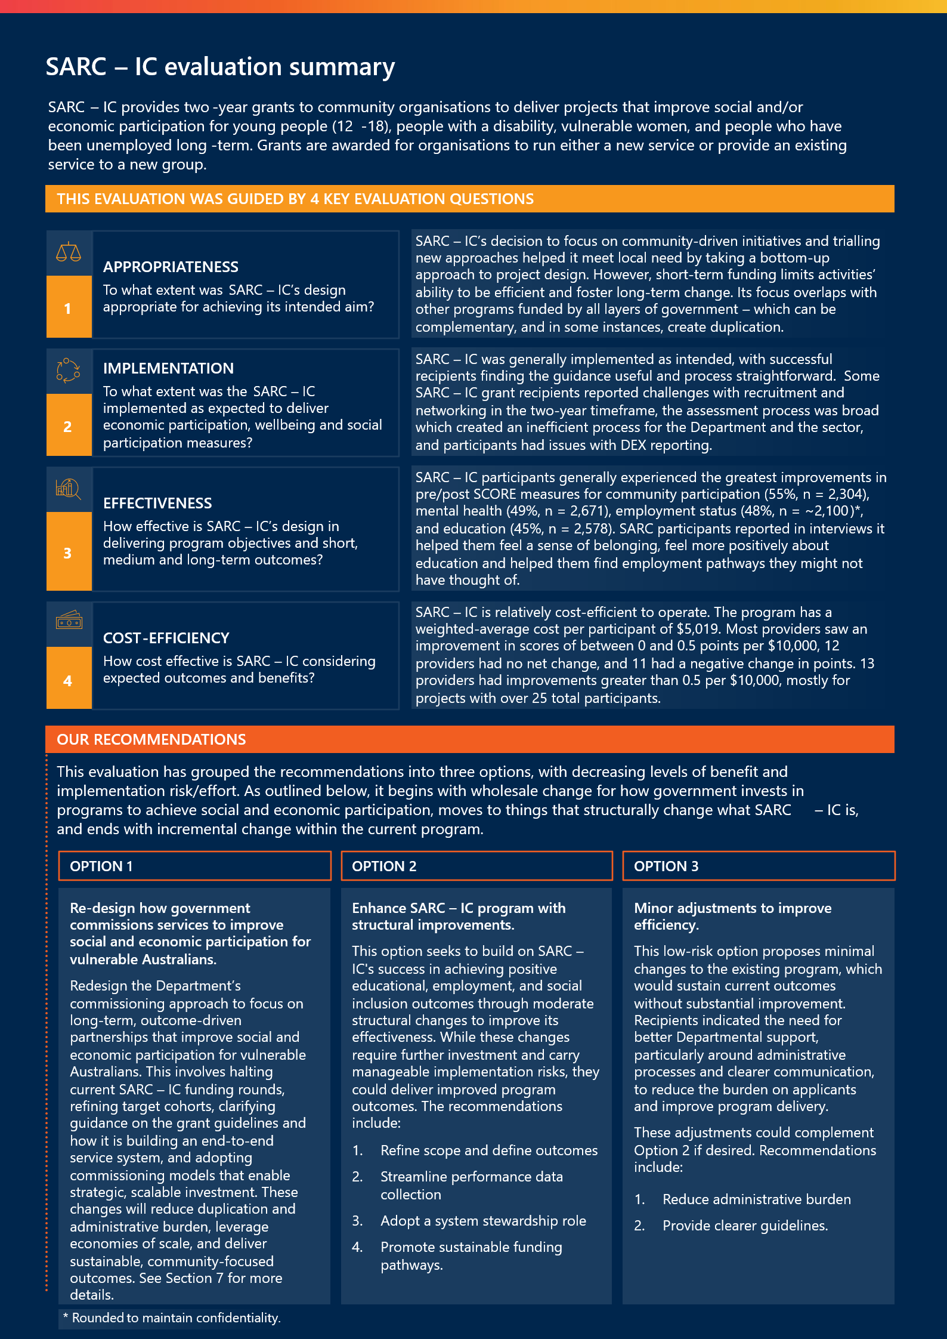
Read the SARC – IC evaluation summary full description

Executive summary
Social and economic participation are foundational to the health and prosperity of Australia. However, many people face significant barriers that prevent them from participating fully in economic and social life. Recent literature suggests more than 1.2 million Australians experience deep social exclusion0F, something that is disproportionately felt by disengaged young people,1F people with a disability,2F women at risk of isolation or discrimination, and unemployed people who face barriers to employment.3F The effects of this are significant, often leading to reduced earning potential, increased stress and anxiety, and poorer health outcomes.4F
The Strong and Resilient Communities Activity (SARC – IC) is designed to address barriers to social and economic participation. SARC – IC uses two-year grants for participating organisations to trial new approaches with these four groups and relies on local design and delivery of services. It is funded by a $63m commitment from the Australian Government from July 2022 to June 2028, and has reached around 32,000 people from 2022 to 2025.F SARC – IC operates alongside a broader range of investments across all layers of government to address social and economic exclusion (see section 5.1.4).
This evaluation has been designed to answer four key questions about SARC – IC:
- To what extent was SARC – IC’s design appropriate for achieving its intended aim?
- To what extent was SARC – IC implemented as expected to deliver economic participation, wellbeing and social participation measures?
- How effective is SARC – IC design in delivering program objectives and short, medium and long-term outcomes?
- How cost effective is SARC – IC considering expected outcomes and benefits?
It has taken a mixed methods approach to answering these questions, through primary data sources (23 interviews with, and 51 survey responses from, grant recipients; 39 interviews/focus groups with, and 21 survey responses from, participants) and secondary data collected through the Data Exchange (DEX, 9,902 unique participants) and Activity Work Plans (72 AWPs). Collectively this represents a significant evidence base to inform future investment decisions. The key limitations in the evaluation include: The evaluation relies on observational administrative data and does not include a randomised control group or a clearly defined counterfactual6F and the secondary data had some completeness and quality limitations (see Section 4.2). Below is a summary of our findings.

Findings
SARC – IC’s decision to focus on community driven initiatives and trialling new approaches helped it meet local need, but it overlaps with other programs and short-term funding limits long-term change.
SARC – IC has two key design choices that shape its design: trialling new approaches and focusing on community driven initiatives. These then underpin a cohort specific approach, as outlined below.
The community-driven design choices are about giving recipients flexibility. This approach aligns with growing government investment in place-based approaches7F and recommendations from recent consultations with Community Sector Organisations that underscore the need for increased opportunities to engage community members in co-design.8F Interviews with recipients suggest they valued the flexibility in the grant guidelines, that allowed them to use funding to remove barriers to access, such as transport or session costs, and to tailor the focus of the project to meet client needs and requests. The flexibility also allowed them to build on their local networks, invest in local capability and fill gaps in the system.
The trialling new approaches elements focused on short-term funding, filling a gap in a system and building evidence on what works through evaluation. While the SARC – IC Activity is clearly meeting need (see section 5.1.2), grant recipients consistently commented on the negative effect of the short funding rounds with limited pathways to sustainable funding. The short turnaround time from being awarded the grant to beginning delivery encouraged ‘shovel ready’ projects which may have reduced levels of co-design after the grant was awarded, as there was not much time to conduct additional consultation or design after funding, and any co-design before receiving the grant was unpaid. Whilst it was made clear to applicants that funding was only for two years, survey data suggests that only 16 per cent of services (n = 51) were able to find funding afterwards, meaning there is considerable time being spent by grant recipients standing up and standing down projects, with a smaller window for delivery. When SARC – IC projects close, it can create an unintentional perception of loss when a community loses something that was seen to be improving the lives of its residents, and workers lose their jobs.
The focus on the four cohorts generally aligned with literature by offering holistic, flexible support that addressed barriers for social and economic participation. The four current priority cohorts reflect key groups the Department has had responsibility for (which has changed as the Department’s remit changes between machineries of government). However, the evaluation notes that SARC – IC operates in isolation from other funding sources, without links to other Department or state/territory funding sources. This is an especially critical gap given SARC – IC only provides short-term once-off funding, and the policy and program mapping in this evaluation suggests there is significant overlap across other Australian and state government investments (see Section 5.1.4).
SARC – IC generally delivered its design as intended, but broad eligibility criteria created a laborious application and assessment process, and recipients struggled with FAM turnover and DEX reporting.
The grant was largely delivered as planned against the program design. It delivered more than 95,000 sessions to around 32,000 people across three years. Projects across the four cohorts emphasised creating safe spaces, peer mentoring and connecting into other services. The grant process complied with all nine of the Australian Government’s Grant Rules and Principles, and successful grant recipients found the guidance easy to follow.
The breadth of the eligibility and assessment criteria was appreciated by many successful grant recipients who felt it allowed them the flexibility to deliver a project tailored to their community. However, while this breadth supported a community-driven grant process, it also unintentionally fostered a high volume of applications that were never likely to be successful. Across the SARC – IC rounds, there were between 1100-1,400 applications per round, of which 33-40 were successful, and all of which were manually reviewed by the assessment centre. This meant a significant number of community organisations invested time and resources in a detailed application process in which they were very unlikely to be successful in. The Department’s process was also time-consuming, requiring the Selection Advisory Panel to manually assess more than 700 applications each round. Some grant recipients noted there would be value in adapting the application process to include an initial Short Expression of Interest submission (EOI), with only applicants successful in the EOI round required to develop a full application. Further investigation into how to streamline the grant process may help guide the sector and make the process more efficient in the future.
Grant recipients also spoke of the role of their Funding Arrangement Managers (FAMs) inconsistently. Where there was a good ongoing relationship, this was spoken of highly. However, many grant recipients were frustrated by the high turnover of FAMs and felt this was a missed opportunity for the Department to play a more active role and receive consistent advice. Whilst turnover of FAMs is not SARC – IC’s responsibility, it is a common finding across Department grants which can negatively affect the longer continuity in grant administration, as has been noted by SARC – IC recipients.
It is also clear that while SARC – IC’s funding supported evaluation, that participants valued, there was no formal mechanism to share findings within a round or to inform the design of future rounds. Grant recipients also consistently talked about DEX data reporting not being fit for purpose, time consuming and often duplicating their existing data collection within a service.
SARC – IC participants experienced the strongest improvements in pre/post outcomes across community participation, mental health, work status and education.
Projects funded through SARC – IC saw outcomes improve for most participants, with the most significant changes occurring in mental health (49 per cent improving, n = 2,671), employment (48 per cent improving, n = ~2,100), community participation (55 per cent improving, n = 2,304), and education (45 per cent improving, n = 2,578). These changes were experienced strongly by participants that were young people, unemployed individuals, and women at risk of disadvantage. Interviewees suggested the program helped them reduce social isolation and build their confidence, which helped them engage with their communities and access further services. Furthermore, projects were effective at reaching and supporting the most vulnerable members of the community with a significant reduction in the number of participants recording very low (1 or 2 out of 5) SCORE outcomes against key outcomes at the end of the program (average of 29 per cent across target groups).

“The difference in me is incredible. I started applying for work and building confidence.
I just feel myself again.”

For many participants, especially vulnerable women and people with a disability, it was the first time they had found a community of people who had been through similar experiences and had similar perspectives. This created a sense of psychological safety that allowed participants to come out of their shell and connect with others both inside and outside of the project they had accessed.

SARC – IC’s cost efficiency is similar to other programs, with larger recipients generally delivering greater cost effectiveness
SARC – IC is similar in its cost efficiency to other programs targeted at social and economic inclusion (see Section 5.3 for further detail). SARC – IC has a weighted-average cost per participant of $5,019. This compares favourably with similar programs (see Table 6), noting that there is a substantial range of cost efficiency for some of these programs. Higher costs often reflect more intensive services, lower-than-planned participation, or incomplete DEX data. In general, most providers under SARC – IC are similarly cost-effective. However, cost‑effectiveness does vary with change in outcome scores and sample size; medium and large providers tend to be more cost‑effective due to economies of scale and stronger average gains, with most achieving 0–0.5 points improvement per $10,000 (some higher, a minority negative).

Recommendations
This evaluation has grouped the recommendations into three options, with decreasing levels of benefit and implementation risk/effort. As outlined below, it begins with wholesale change for how government invests in projects to achieve social and economic participation, moves to things that structurally change what SARC – IC is, and ends with incremental change within the current design. For full details see Section 7.
OPTION 1 Re-design how government commissions services to improve social and economic participation for vulnerable Australians.
Redesign the Department’s commissioning approach to focus on long-term, outcome-driven partnerships that improve social and economic participation for vulnerable Australians. This involves halting current SARC – IC funding rounds, refining target cohorts, clarifying guidance on the grant guidelines and how it is building an end-to-end service system, and adopting commissioning models that enable strategic and scalable investment. These changes will reduce duplication and administrative burden, leverage economies of scale, and deliver sustainable, community-focused outcomes. See Section 6 for more details.
OPTION 2 Enhance SARC – IC Activity with structural improvements.
This option seeks to build on SARC – IC's success in achieving positive educational, employment, and social inclusion outcomes through moderate structural changes to improve its effectiveness. While these changes require further investment and carry manageable implementation risks, they could deliver improved program outcomes. The recommendations include:
- Refine scope and define outcomes: Narrow the focus to specific target cohorts or place-based community interventions to better align applications with clear program priorities and ensure investment is achieving value. Current broad outcomes and wide-ranging target groups dilute effectiveness.
- Streamline performance data collection: Reduce the administrative burden by focusing data collection on key outcomes (e.g., employment, education, and community participation). Simplify DEX requirements and provide training to enhance data quality and reporting.
- Adopt a system stewardship role: The Department can play a more active role in how it is stewarding the social services sector through its grants. As first steps, it could establish communities of practice to share insights and promote learning between participants. This enables the Department to refine future rounds by leveraging successful models and targeting funding more effectively.
- Promote sustainable funding pathways: Transition to longer-term grants and foster co-funding partnerships with state and territory governments to support recipients in achieving sustainable funding. Alignment with broader initiatives, such as the proposed five-year community funding agreements, should be considered.

OPTION 3 Minor adjustments to SARC-IC Activity to improve efficiency
This low-risk option proposes minimal changes to the existing program, which would sustain current outcomes without substantial improvement. Recipients indicated the need for better Departmental support, particularly around administrative processes and clearer communication, to reduce the burden on applicants.
These adjustments could complement Option 2 if desired. Recommendations include:
- Reduce administrative burden: Implement a two-stage application process, beginning with an Expression of Interest (EOI). This would streamline application and assessment, saving time and resources for both applicants and the Department.
- Provide clearer guidance: Introduce engagement mechanisms such as briefing or Q&A sessions to clarify grant guidelines and assessment criteria. This would enhance the quality and alignment of applications, as well as foster trust and transparency in the process.

Project background

Summary of the SARC – IC Activity
The Strong and Resilient Communities – Inclusive Communities (SARC – IC) Grant Activity is part of a suite of initiatives under the Australian Government’s commitment to improving social and economic outcomes for people experiencing vulnerabilities.
SARC – IC targets four priority cohorts that experience vulnerability and disadvantage:
- young people aged 12 to 18 years who are disengaged or at risk of disengaging from education
- people with disability
- women who experience, or are at risk of experiencing, isolation or discrimination
- unemployed people facing barriers to employment or training.
In 2022, SARC – IC replaced the SARC Activity grant, which ran from 2018 and was comprised of three streams of programs: Inclusive Communities, Community Resilience and National Research. SARC Activity sought to strengthen community cohesion, promote racial, religious and cultural tolerance, enhance resilience, and improve government insight into social cohesion challenges.
SARC – IC’s design has since evolved and now has two core design elements: trialling new approaches and a community-driven focus. From July 2022 to June 2028, $63 million will be available to organisations through SARC – IC grants.
Figure 1 overleaf gives an overview of SARC – IC at a high-level. Appendix A outlines the theory of change and program logic underpinning the SARC – IC.
Figure 1 | SARC – IC overview
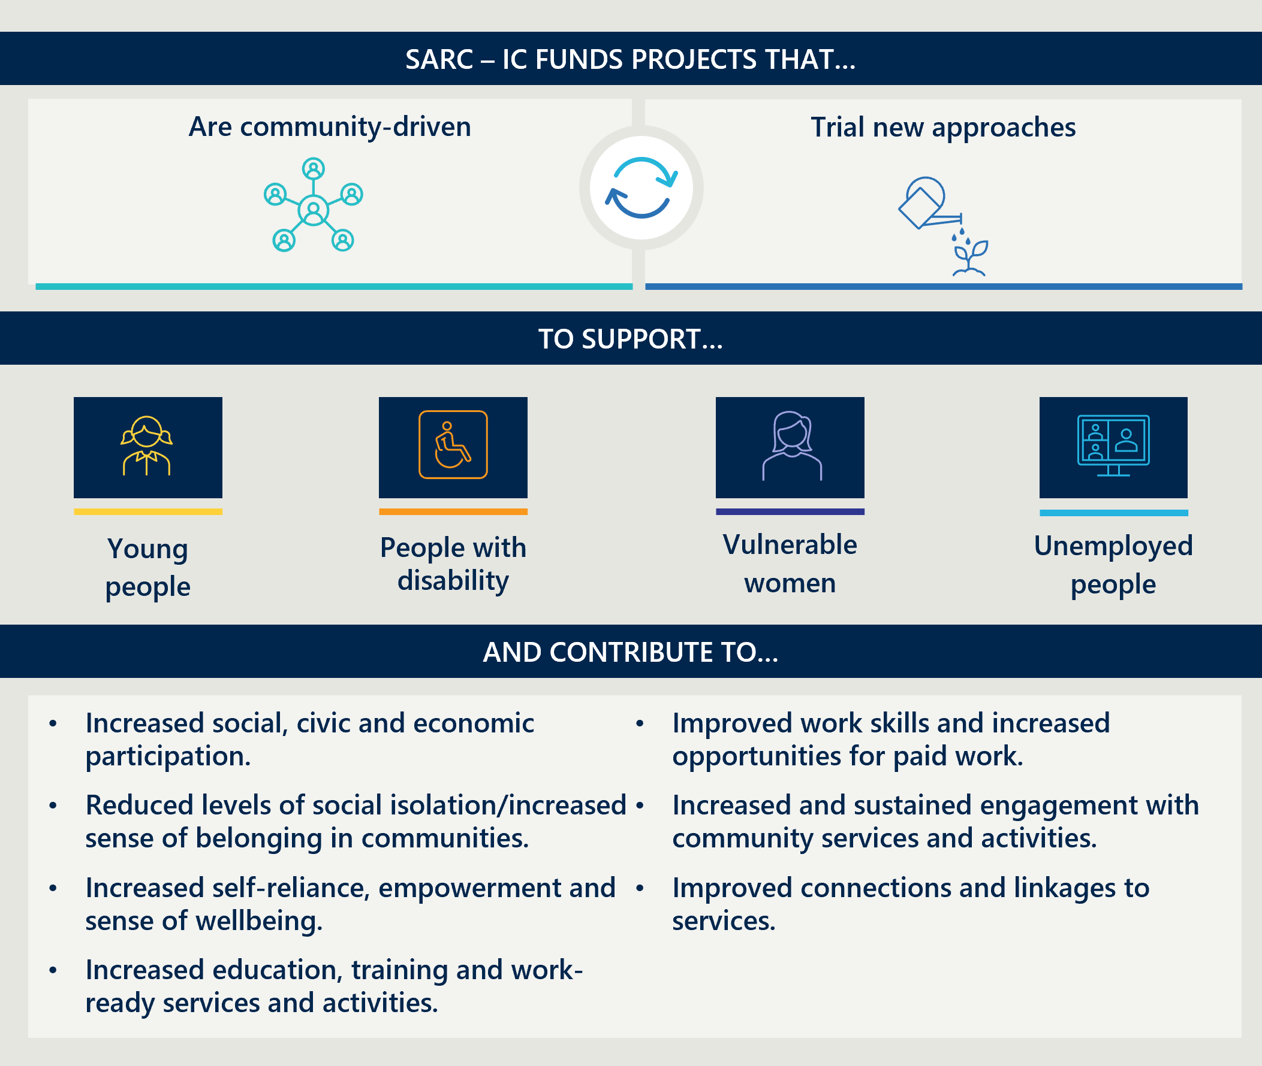

The SARC – IC Activity has supported 144 projects and almost 32,000 people since 2022
SARC – IC has funded projects across Australia since 2022 to increase social and economic participation. Figure 2 overleaf provides an outline of the service location and cohorts funded by the grant.
Figure 2 | Summary of program delivery to date
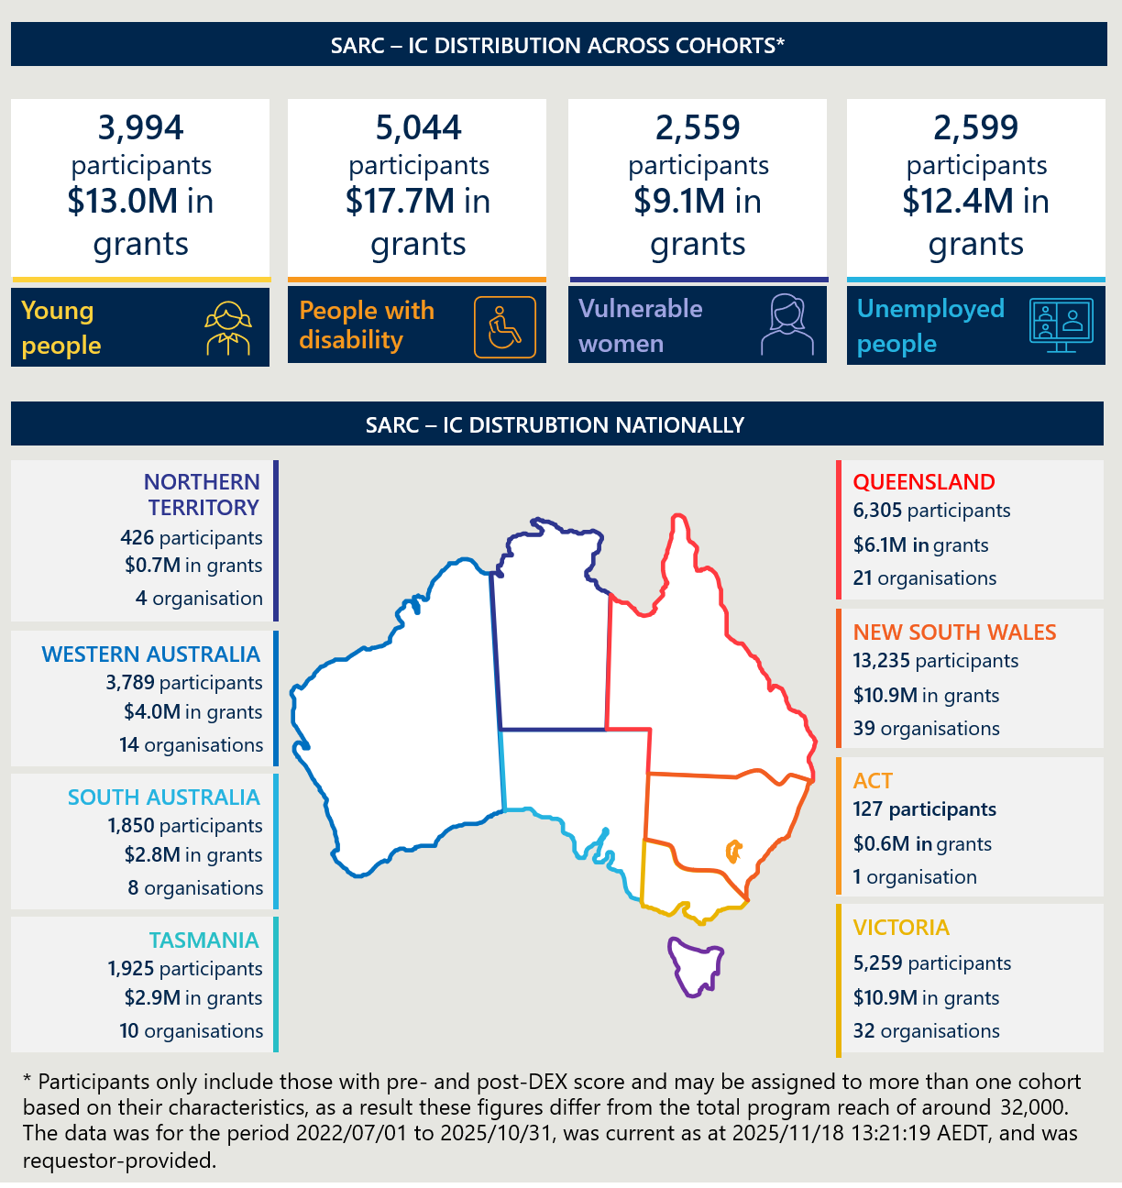

Purpose of the evaluation
This evaluation of the SARC – IC Activity assesses the extent to which the Commonwealth’s investment in SARC – IC supports its intended objectives11F and complements related Commonwealth, State, and Territory programs, and identifies opportunities for continuous improvement. The evaluation considers both the implementation and outcomes of rounds one to three of the grant, and the process and implementation of the fourth round.

Evaluation methodology

The evaluation takes a mixed-methods approach, with a scope defined by four Key Evaluation Questions (KEQs)
The evaluation methodology for the SARC – IC Activity considers four KEQs and applies a non-experimental, mixed-methods approach that draws on quantitative and qualitative data. Given the limitations in the data available, the evaluation has chosen not to use an experimental design and has focused on understanding what has changed and the design of SARC – IC. This evaluation received HREC approval from Bellberry (application no. 2025-09-1427). Figure 3 below sets out the overarching evaluation framework used to guide this evaluation. Appendix B outlines the sub-KEQs.
Figure 3 | SARC – IC Grant evaluation overview
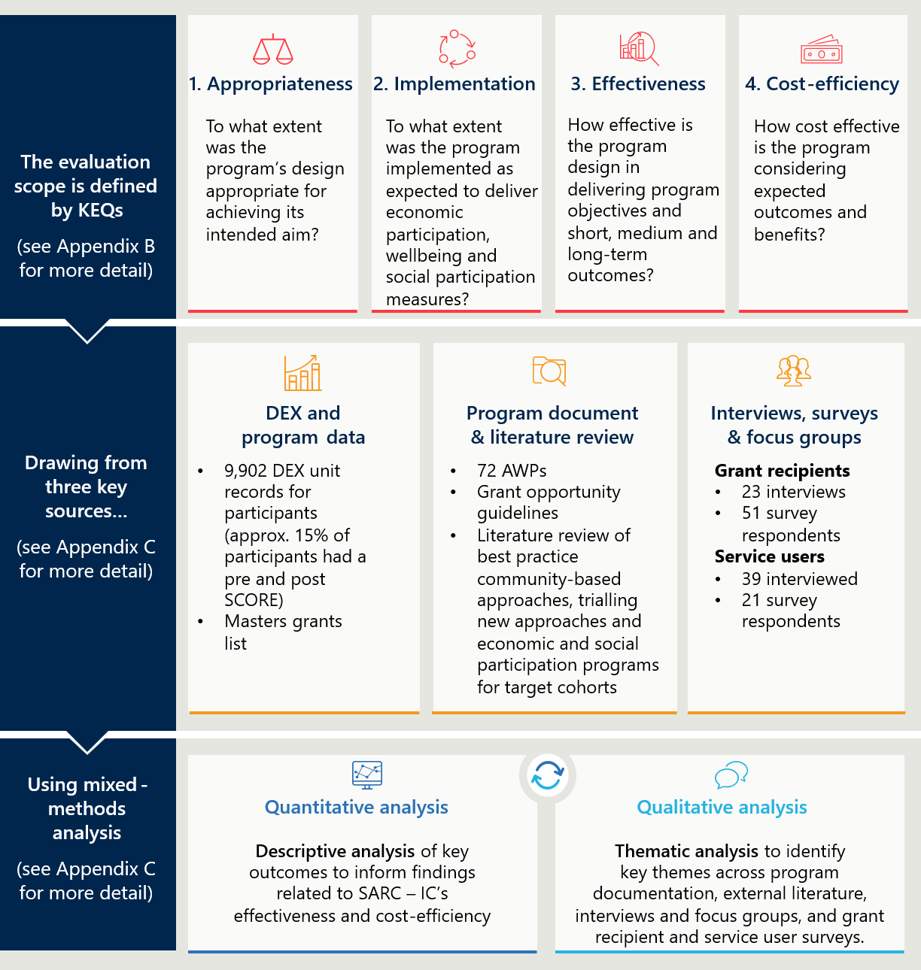
Figure 3 full description

Data limitations affected the depth and robustness of findings
The results presented in this report provide a robust evidence base for the Department on the appropriateness and effectiveness of SARC – IC. However, the study design was limited in a number of ways. Particularly the decision to evaluate SARC – IC without a control group due to data limitations. The details of the data limitations are provided below in Table 1 below.
Table 1 | Data limitations
Limitation | Description | Impact | Mitigation
Incomplete participant outcome records | The evaluation intended to use complete outcome data for all participants. In practice, only around 15 per cent (n = 9,902) of participants had pre and post project outcome scores available in the dataset. | This reduced analytic sample increases uncertainty around estimated outcome changes (standard errors are approximately 2.6 times larger than under full coverage), limiting the ability to detect very small effects and reducing the strength of inferences that can be drawn from measured changes alone. | Analyses were explicitly framed as associative. Sample sizes are reported for all outcome estimates to make uncertainty transparent. Findings were interpreted cautiously and not generalised beyond participants with observed pre–post data without further qualitative evidence.
Data duplication and missing values | SARC – IC data contained duplicate client and session records and missing or partially completed fields, particularly for education and employment indicators.  Duplicates were most often additional post-project observations and accounted for less than 4 per cent of all records. | Data quality challenges introduce uncertainty into measures of project exposure and effectiveness. It can distort relationships between engagement, outcomes, and cost-effectiveness. | A transparent, rule-based data cleaning protocol was applied to remove duplicate records. The rules looked for duplicates of distinct combinations of client, session, assessment type, and outcome IDs.  This broad net minimised the risk of removing legitimate entries, for example where a pre and post score were recorded in the same session.
Small sample sizes and confidentiality requirements | For some providers, the number of individuals with complete pre and post scores was very small, often below the confidentiality thresholds set by the Department, see Table 2 below for further details.  Confidentiality requirements prohibit reporting results where cell sizes fall below 5 contributors which limits the data available to report. | Small sample sizes reduce the reliability and stability of outcome estimates and increase volatility in cost-effectiveness metrics (this is discussed in further detail in section 5.3).  For most target groups sample sizes were large enough to be confident in the results. However, for many organisations fewer than 5 participants had completed outcomes data limiting the accuracy of outcomes analyses. | Results were reported using aggregated summaries where counts were too small to support reliable inference. Low-cell categories were suppressed or combined in line with confidentiality rules.  The report clearly notes where small numbers limit precision and where results should be interpreted as indicative rather than definitive, particularly in section 5.3 on cost-effectiveness.
Associative analysis | The evaluation relies on observational administrative data and does not include a randomised control group or a clearly defined counterfactual. outcomes analysis therefore compares participants to themselves over time or examines associations between target groups, or organisations, and outcomes. | Without an appropriate counterfactual or comparison group, the evaluation identifies patterns and correlations rather than causal impacts. Observed changes may reflect concurrent services, participant characteristics, or other unmeasured influences. This reduces certainty about SARC – IC impact. | All quantitative findings are framed as associational and descriptive rather than causal. Statistical results are interpreted alongside qualitative evidence and SARC - IC context to support explanations of observed patterns. The report explicitly states that causal impact and counterfactual effects are outside the scope of the analysis.

Only a small proportion of unit records have both pre and post scores
Table 2 below reports the number of unique participants each organisation serviced and Table 3 shows the number of participants that have reported pre and post scores. There was substantial attrition in the data collection after the initial session with the participant. It is not possible to determine whether the missing post-program outcome entry is because the participant did not complete the project’s activities or the outcome was not entered into DEX.
Table 2 | Organisation count by participant volume
All participants | Organisation count
0-25 | 14
26-50 | 24
51-100 | 15
101-150 | 11
151-200 | 5
151-200 | 5
201+ | 6
Source: extract from DSS data release published 31/10/2025

Table 3 | Organisation count by participants with pre- and post-scores
Participants with pre and post outcomes | Organisation count
<5 | 37
5-10 | 10
11-25 | 12
26-50 | 9
51+ | 7
Source: extract from DSS data release published 31/10/2025

Findings

Appropriateness and design
This section outlines findings relating to the appropriateness of the SARC – IC Activity to achieve its intended outcomes (KEQ 1).
- KEQ1: To what extent was SARC – IC’s design appropriate for achieving its intended aim?

Key findings on appropriateness and design

KEY FINDINGS
KEQ 1 | To what extent was SARC – IC’s design appropriate for achieving its intended aim?
6.1.2 SARC – IC is designed to address social and economic exclusion driving negative outcomes for many Australians| SARC – IC is strongly aligned to government priorities for addressing social and economic exclusion and supporting place-based, community-driven approaches.
6.1.3 SARC – IC’s design aligns with literature on good practice, but broad scope and key design tensions limit its effectiveness
  - The grants approach is built on two key design elements: community-driven projects and trailing new approaches.
  - The literature shows that the key design elements each require different conditions to be effective, creating tensions in the grant’s approach and limiting overall effectiveness.
  - Noting this critical tension, SARC – IC does demonstrate strong alignment with the literature in many areas.
6.1.4 SARC – IC’s objectives align to the broader policy landscape| SARC – IC’s objectives overlap with but are not linked to existing Commonwealth, state and territory, and philanthropic programs.

SARC – IC is designed to improve social and economic participation for young people, vulnerable women, unemployed people and people with disability

SARC – IC is designed to address social and economic exclusion driving negative outcomes for many Australians
Social and economic exclusion can lead to a range of negative impacts across a lifetime, such as reduced earning potential, stress and anxiety and poorer health outcomes.12F 13F Research has identified that 1.2 million Australians experience deep social exclusion, with particular prevalence in vulnerable cohorts including those supported through SARC – IC.14F Whilst there are many services which provide supports across Australia, the most vulnerable cohorts risk falling between the gaps of different services and programs on offer which can continue to increase their social and economic isolation. One of the key intentions of SARC – IC was to encourage community organisations to provide new types of support or reach into new communities to provide support to re-engage with the community.
This also plays out at a societal level, reducing social and economic disengagement helps to increase social cohesion in communities, increase skills in the workforce and overall levels of workforce participation, and decreases pressure on the health system from long-term adverse health outcomes. 15F The drivers of social and economic inclusion vary across SARC – IC’s four cohorts. For example, young people especially benefit from receiving multiple or complementary supports, and that disability projects need to enable participation outside of specialist disability spaces.16F More detail on the individual barriers and enablers for each cohort can be found in Appendix F.
First Nations people, older Australians, people experiencing long-term unemployment, individuals and families living with a disability and mental health issues, and people living in areas of high socio-economic disadvantage are at higher risk of social and economic exclusion. The 2025 Mapping Social Cohesion Report also found young people felt social isolation at higher rates than older people.17F Figure 4 overleaf highlights some of the cohorts who still experience social and economic exclusion.
Figure 4 | Economic exclusion in Australia18F
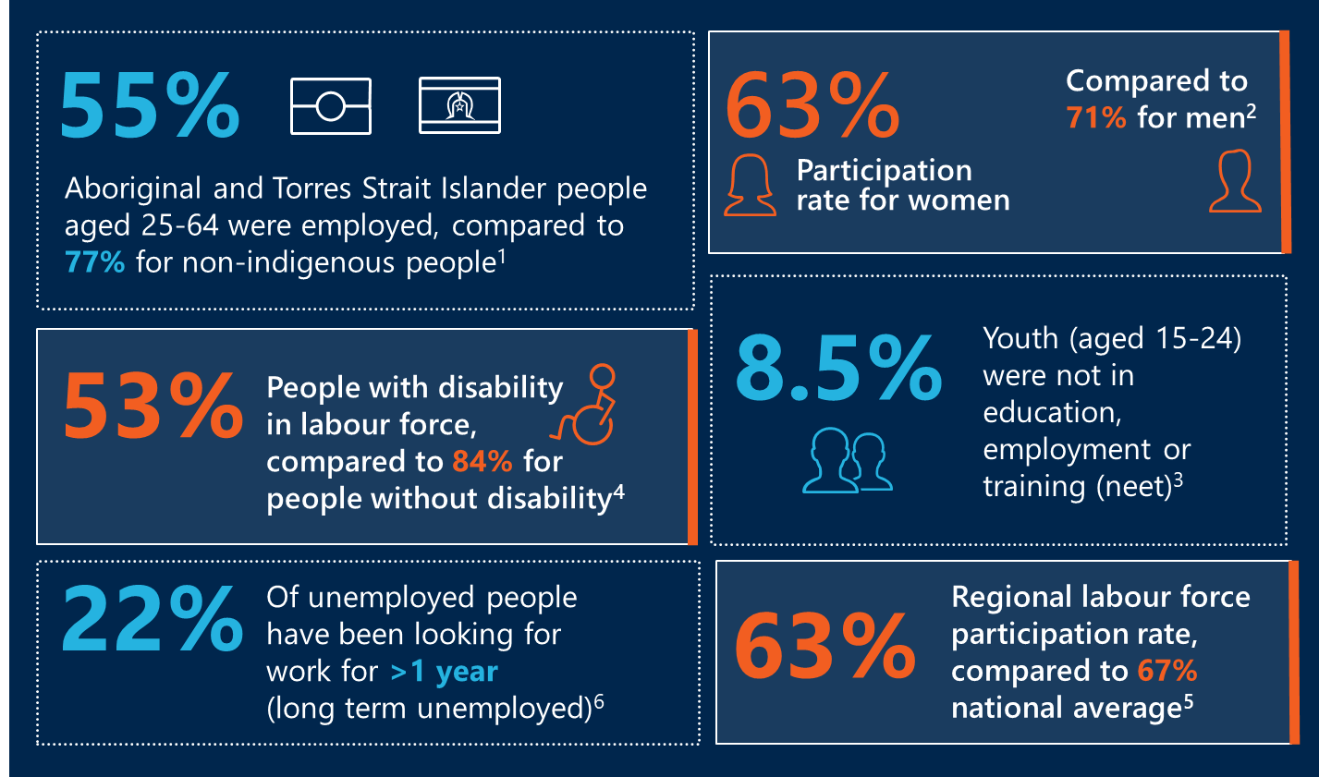

SARC – IC’s design aligns with literature on good practice, but broad scope and key design tensions limit its effectiveness
The grants approach is built on two key design elements: community-driven projects and trialling new approaches
A community-driven approach aligns with the evidence-based shift to focus more on centring people with lived experience in service design and designing programs that are tailored to local community needs.19F This approach aligns with growing government investment in place-based approaches such as through the Stronger Places, Stronger People20F initiative, Partnerships for Local Action and Community Empowerment (PLACE)21F and recommendations from recent consultations with Community Sector Organisations that underscore the need for increased opportunities to engage community members in co-design processes.22F This approach encourages active participation from community members and people with lived experience of social and economic exclusion, and ensures initiatives are responsive to local needs.
The grant’s focus on trialling new approaches for the cohorts and outcomes in scope of SARC – IC remains unique, however many projects overlap with existing initiatives targeting similar outcomes, as outlined further in section 5.1.4.
SARC – IC has been designed broadly in line with Commonwealth Grant and Reporting Principles (CGRPs), including clear governance, transparency and an outcomes focus.23F While the process is merit based as required through an open application process and assessment criteria, this could be strengthened by providing a more focused grant activity, that works with the sector in an open and transparent process. Examples of where the Department is doing this is outlined in DSS’ 2025 Discussion paper on A new approach to programs for families and children. 24F While this would somewhat reduce the flexibility of the criteria, which was valued by some successful applicants, it would narrow down the applicant pool and reduce the number of applications overall.

The literature shows that the key design elements each require different conditions to be effective, creating tensions in the grant’s approach and limiting overall effectiveness
The literature (see Table 3 for full details and analysis) shows that what is needed to be effective in community-driven approaches and in trialling new approaches can diverge. This is clearest regarding funding approach, as community-driven approaches benefit from long-term funding, whereas trialling new approaches benefit from short-term, phased funding.
Further, SARC – IC’s combination of short-term funding, absence of a clear pathway to long-term funding or support, and limited mechanisms for sharing lessons learned constrains SARC – IC’s effectiveness. These design features reduce its ability to:
- Enable community-driven approaches, which typically require longer-term investment or a pathway to sustainable funding.
- Support innovation, which benefits from phased or outcomes based funding and systematic learning about impact.

Noting this critical tension, SARC – IC does demonstrate strong alignment with the literature in many areas
Overall, the SARC – IC Activity aligns with the literature on community-driven programs and trailing new approaches.
Through a rapid literature review, the evaluation identified key features of effective programs that take a community-driven approach and trial new approaches (see Appendix E for full details). The literature review also identified best practice for the key cohorts specifically, outlined in Table 4. Table 3 overleaf sets out the key features of good practice and assesses SARC – IC’s alignment to the literature on each feature.

Table 4 | Assessment of SARC – IC against literature
Key feature | What the literature says | SARC – IC’s alignment with literature | Level of alignment
Key feature | What the literature says | SARC – IC’s alignment with literature | Community driven | Trialling new approaches
Community-driven and designed25F | - Community driven design and delivery helps to identify key needs in the community and adapt throughout implementation.  - Top-down, inflexible program structures make it difficult to tailor solutions locally. | The grant enabled recipients to design projects for, and with their communities.  - The grant aimed to support ‘community-driven solutions’ and allowed for up to three months‘ community or participant consultation or co-design.’26F The assessment criteria included a requirement for grant recipients to have consulted with the community to identify areas of need and design the project.  - The short turnaround time from being awarded the grant to beginning delivery encouraged ‘shovel ready’ projects which may have reduced levels of co-design after the grant was awarded as there was not much time to conduct additional consultation or design after funding, and any co-design before receiving the grant was unpaid. | Moderate | Moderate
Funding approach | For community-driven approaches:  - Short-term funding and resource constraints are barriers to community engagement and participation.27F Long-term funding allows planning and provides stability and time to build an evidence base, partnerships and local leadership and mature the sector more broadly.28F  - Projects that are funded short-term can face barriers to building trust, or experience distrust in staff and target communities as they emphasise short-term outcomes and brief interventions.29F 30F  - Evidence is limited on the relationship between intervention length and outcomes, with the exception of addressing LTU. In this context, longer term interventions (> one year) produce stronger outcomes.31F  For trialling new approaches:  - Seed funding can encourage creativity, but a pathway to long-term delivery is required to sustain impact.32F Social innovators and governments can partner to drive innovation through Outcomes Based Funding. | The short-term nature of the funding had mixed effects and limitations for designing new approaches and driving innovation.  SARC – IC funding is intended to help participants in funded activity strengthen community connections, economic and social participation. 33F These are entrenched issues which take time for organisations to build effective networks and achieve outcomes, but the funding activity is structured as short-term, innovation-focused grant round.  While participants can (and do) achieve outcomes in the two year period, there is considerable time spent standing up projects, recruiting and training staff and building awareness in a community – which is then lost when the funding finishes. This can affect trust in staff and communities in working with government, and can limit the length of an intervention.  In terms of trialling new approaches, the grant provided short-term funding for services to deliver either a new service model or for a new cohort, aligned to a seed funding approach, however there are no clear pathways to long-term funding for successful projects. This means it is more difficult, by design, for SARC – IC to strengthen the community sector over time using the initial two year funding. | Low | Moderate
Flexibility of funding | - Flexible funding: enables tailored program design, which supports operational flexibility, local autonomy and helps to remove key access barriers and target the program to local needs.34F,35F | Flexible use of the grant money enabled recipients to design projects that were tailored, accessible and inclusive.  Grant recipients were allowed to spend grant funds on staff salaries, training, operating and administration expenses, assets that helped meet deliverables and evaluation of projects.36F This allowed grant recipients to use funding to remove barriers to access such as transport or session costs, and also to iteratively tailor the focus of the project to meet specific client needs and requests. | High | High
Early investment in local capability and governance | - Early investment in local capability and governance: enables place ‘readiness’ and inclusive, diverse and structured governance that enables the sharing of power and lessons learnt.37F Staff and leadership empowerment through skills development enables stronger project delivery.38F | Investment in local capability and governance was possible through the grant.39F  The grant guidelines did not prescribe investment in local capability and governance but eligible expenditure included ‘operating and administration expenses’ and training for paid and unpaid staff.40F  The short-term nature of the funding may limit efforts to build and sustain local capability, and organisations may build capability in one program then be forced to pivot, rather than continue to build capability in one area. | Moderate | Moderate
Systematic learning and evaluation | - Evaluation and learning: is essential to both trialling new models and supporting community led projects.41F  - For funders, systematic learning helps to inform future funding directions. Shared monitoring, evaluation and learning frameworks support meaningful data collection and learning at the whole of government policy level.42F  - For grant recipients, a culture of learning and sharing supports continuous feedback loops to foster continuous improvement such as through effective use of local data and evaluation across the lifecycle of the program, not only at the completion.43F | Program design supported evaluation, however there was no mechanism to share or use findings.  Grant recipients could spend up to 7.5 per cent of their total grant on evaluation.44F This encourages participants to track and measure their outcomes to gain new funding or inform future service delivery. However, the design of SARC – IC did not include:  - A mechanism to share learnings between grant recipients during delivery or following an evaluation.  - Support for recipients to use evidence of successful outcomes from the evaluation to access more funding from the Department, other departments, or States and Territories (as discussed below in ‘trialling new approaches’). | Low | Low

Literature shows that effective approaches differ across target cohorts because the drivers of social and economic exclusion vary
Table 4 below sets out the key features for projects that provide effective support for each of the target cohorts and assesses SARC – IC’s alignment to these features. These design elements have been informed by a literature review incorporating meta-analyses, systemic reviews, single studies and discussion papers. More detail on good practice supports for each cohort can be found in Appendix F.
Table 5 | Assessment of SARC – IC against cohort best practice
Cohort | Literature on effective projects | SARC – IC alignment with best practice | Level
  Young people who are disengaged or at risk of disengaging | Offer multiple, holistic supports including training, placements, social-skill development and counselling  Address underlying issues beyond the curriculum  Link and integrate support at key transition periods, particularly from school to work | Many projects for young people aimed to enhance skills, link to employment and training, and holistically address the underlying drivers of disengagement.  Projects emphasised transitioning students from school to the workforce by improving work readiness and facilitating placements. Many also targeted the underlying causes of disengagement by addressing factors beyond the school setting, such as wellbeing, healing, transportation, and cultural connection. Furthermore, the design of the projects included referrals and outreach to complementary support services that would help the young person holistically. | High
  Tailoring to vulnerable women | Address barriers to project access and entry (e.g. transport and childcare)  Create women only spaces  Provide holistic support to refugee women | Women-only support groups were common and tailored to enable women to manage caring responsibilities.  The design of these projects often enabled women to learn skills and knowledge, and receive support inside and outside their homes, for themselves and their families. Many included peer-support and mentor elements, and were flexible in design, both in terms of content covered and logistics. | High  Note: literature is limited for this cohort.
  Tailoring to people with disability | Support open employment  Design interventions that connect people to activities, and build skills and capacity  Employ skilled, empathetic support workers to improve results | Projects for people with disability were thoughtfully tailored to individual needs, emphasising participation in inclusive environments.  Projects for people with a disability were designed to facilitate open employment and work placements in diverse community organisations and industries, promoting participation beyond the disability-specific sector. However, there was limited evidence of projects that provided all elements of the open employment model such as intensive on-site support and ongoing support once employment was attained.  Projects also reflected best practice by looking to employ skilled social work staff and peers as facilitators and mentors, and by designing accessible learning modules and skill-building opportunities. | Moderate/ High
  Tailoring to unemployed people facing barriers | Provide vocational training  Combine specific skill training with soft skill building (such as confidence and social skills)  One stop shop models have been increasingly adopted | Projects for people who are unemployed generally aligned to best practice but may be limited by short duration.  The projects included hard measures such as placements and traineeships, and linking participants with employment services. They also incorporated soft measures through group mentoring, group activities and one-on-one sessions to enhance confidence, motivation, and work readiness and address mental health barriers.  The grant's design may hinder the projects' capacity to align with the literature due to the grant’s short-term nature which limits the provision of sustained support. | Moderate/ High

SARC – IC target cohorts have evolved over time to align with government priorities
The SARC – IC Activity has evolved over time. It began as the MUSTER program, followed by the original SARC Activity with three streams of funding which focused on supporting vulnerable cohorts by filling the gaps where mainstream services are not cutting through. Different elements of design have changed in each evolution, and so the policy rationale for each design element is no longer clear in the current iteration. Following the evaluation of the SARC Activity in 2022 the grant was narrowed down from the previous three streams to just fund the Inclusive Communities Stream, and in doing so the target groups were reduced.

SARC – IC’s objectives align to the broader policy landscape
The Australian Government is committed to improving wellbeing and economic outcomes for people experiencing vulnerabilities. SARC – IC’s objectives demonstrate strong alignment with Commonwealth policy priorities and objectives by contributing to improving social and economic inclusion and participation in the target cohorts. These include Outcome 2 in the Department’s Corporate Plan 2025–26: Promote stronger and more resilient families, children, individuals and communities by providing targeted supports, and the following Department priorities:
- Get more people into work
- Break the cycle of entrenched disadvantage
- Enable people to be well connected to their community
- End violence in families, relationships and communities. 45F
SARC – IC also aligns with recent calls by key peak bodies to establish a National Strategy to Address Loneliness and Social Isolation, and the establishment of the Department’s Economic Inclusion Advisory Committee in 2022.46F, 47F The grant also aligns with and supports many state and territory policies, plans and strategies that focus on improving the social and economic participation of the key cohorts, including but not limited to ACT’s Disability Strategy 2022–2032, Young Queenslanders Strategy Action Plan 2024–2026 and Stronger Together: WA’s Plan for Gender Equality. Appendix D provides a more detailed list of state and territory commitments that SARC – IC is aligned with.
Figure 5 below outlines SARC – IC objectives and alignment with key national strategies and objectives.
Figure 5 | Alignment with national strategies and objectives
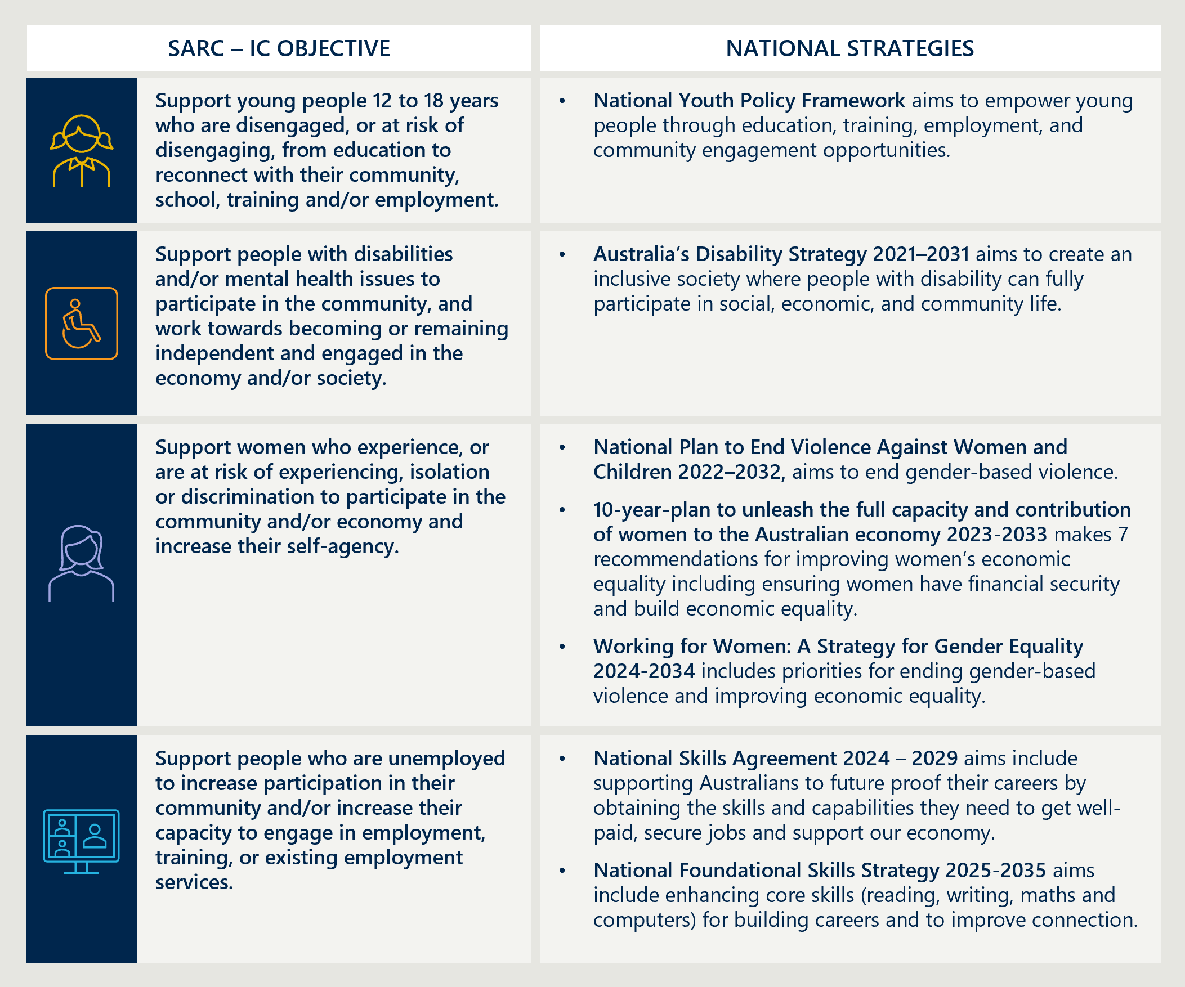
Figure 5 full description

The objectives of SARC – IC overlap but are not linked with existing Commonwealth, state, territory and philanthropic programs
SARC – IC’s objectives are very broad, which means that inevitably there is overlap with other state, territory and philanthropic projects targeting the same cohorts and outcomes. As shown overleaf in Figure 6 and Appendix D, there are active programs with similar aims targeting each cohort. This is not necessarily a policy failure for SARC – IC, given its purpose is to fill funding gaps and provide niche approaches to helping the most vulnerable people get support who are not currently reaching traditional services. Furthermore, as these are vulnerable and underfunded groups there will always be a need for further funding which can be used effectively by community organisations.

“We helped many individuals in a unique, niche program that does not exist anywhere else.
It was soul enriching to know we changed lives."

The missed opportunity is that SARC – IC operates in isolation from other funding sources, without formal or informal links to other Department or state/territory funding and programs. Examples of where this has occurred more systematically, include DSS’ Outcomes Fund, which works with state and territory governments at the outset to leverage investment and coordinate on the administration of funding.48F At a systems level, this isolation makes it difficult for the Department to map where the funding is duplicative or addressing a funding need. At an individual grant recipient level, it makes it difficult for grant recipients to identify future funding sources for projects which have proved their outcomes through the initial SARC – IC funding. It means that organisations are reliant on their own local networks to identify funding opportunities, rather than having the structures in place nationally to support them transitioning between funding sources. Whilst this is not unique to SARC – IC and is a feature of the grant system more broadly, the siloed and short-term funding makes it difficult to create continuity. In practice this means that SARC – IC adds another layer of fragmented funding to the service landscape. Figure 6 overleaf provides a summary of other programs that target similar outcomes across the same priority cohorts, Appendix D outlines in more detail what these programs do and how they overlap with SARC – IC.
"Cessation of the program due to inability to secure continued grant funding has left a huge gap in the community that is unable to be delivered by anyone else... means [we] can't continue a highly successful initiative!"

Figure 6 | Summary of overlap between SARC – IC and other programs
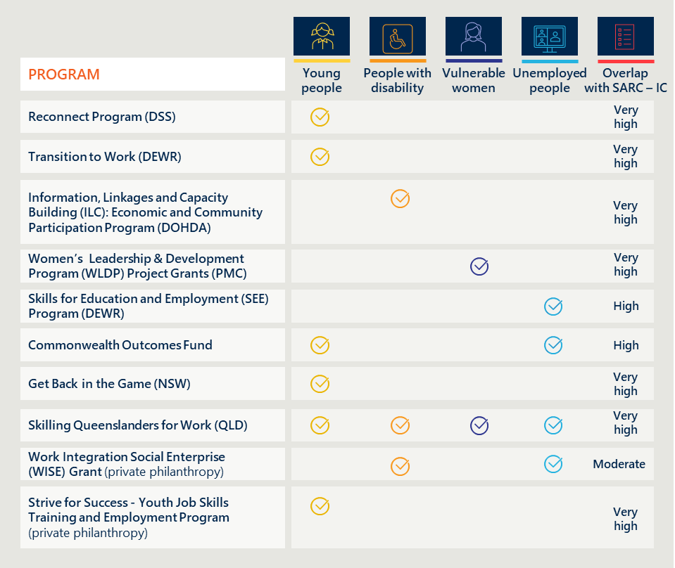
Figure 6 full description

Implementation

Key findings on implementation and administration
This section outlines findings relating to the implementation of the SARC – IC Activity (KEQ 2).
- KEQ 2: To what extent was SARC – IC implemented as expected to deliver economic participation, wellbeing and social participation measures?

KEY FINDINGS
KEQ 2 | To what extent was SARC – IC implemented as expected to deliver economic participation, wellbeing and social participation measures?
6.2.2 While the application process was simple to navigate, the broad eligibility criteria resulted in additional effort for many applicants and the Department | This led to an oversubscribed grant which took up valuable time for organisations applying, and in the manual assessment process by the Department.
6.2.3 The successful delivery of SARC – IC-funded services depends on FAMs, recruitment and community trust
6.2.4 Challenges with DEX resulted in limited standardised reporting on outcomes | Despite the introduction of 80 per cent reporting requirements for grant recipients, only 15 per cent (n = 9,902) of clients with attendance records had both a pre and post SCORE limiting the ability of the evaluation to assess cost-effectiveness and outcomes
6.2.5 While flexible funding helped grant recipients tailor services, the two-year funding model without pathways to further funding for effective projects did not support trialling new approaches or community-driven programs | Some choices in the design of the grant created challenges for grant recipients during implementation. These primarily stemmed from the short-term nature of the funding, and issues meeting reporting requirements.

While the application process was simple to navigate, the broad eligibility criteria resulted in additional effort for many applicants and the Department

The grant eligibility criteria were clear to applicants, but broad, resulting in significant oversubscription
While other grant programs face issues with oversubscription, the broad scope of the eligibility criteria meant that an overly large range of projects met the criteria for SARC - IC, resulting in large numbers of unsuccessful applications in each round. In most rounds, there were up to 30-40 times as many unsuccessful applicants compared to the number of grants awarded. This meant a significant number of community organisations invested time and resources in a detailed application process in which they were very unlikely to be successful. Table 5 overleaf provides details on the numbers of applications and grants awarded for rounds 1 to 4.
Table 6 | Number of applications and grants awarded in each funding round49F
Funding round | Number of applications | Number of grants awarded (percentage of eligible applications which were successful)
1 | 1250 (1206 eligible) | 38 (3 per cent)
2 | 1188 (1174 eligible) | 33 (2.7 per cent)
3 | 1408 (1358 eligible) | 33 (2.4 per cent)
4 | 1260 (1177 eligible) | 40 (3.2 per cent)
Total | 5106 | 144

While this evaluation did not engage with unsuccessful applicants, some successful grant recipients noted the value of adapting the application process to include an initial short Expression of Interest submission (EOI), with only applicants successful in the EOI round required to develop a full application. Peak bodies and successful grant recipients all reiterated the resource constraints on organisations in the sector, and the amount of time and resources required to submit a high-quality grant application meant that significant oversubscription of grants was not preferable. This is a recommendation that has also been previously considered by the Department following SARC – IC Round 2.

The Department’s deliberately broad eligibility and assessment criteria meant it was a laborious assessment process, which could be more targeted in the future
The Department’s assessment process involved three main assessment stages: a grants hub assessment against the eligibility criteria, an initial filtering process to remove the bottom third of applicants by the SARC – IC policy team, and the assessment panel review and scoring against the assessment criteria. The assessment criteria evolved slightly across rounds but included coverage of SARC – IC’s policy objectives (target cohorts, community driven and trialing a new approach) alongside organisational capacity to deliver and value for money.
The assessment criteria were quite broad and did not appear to provide clear guidance on how policy priorities, and consequently applications, should be prioritised. The assessment process itself was also highly manual and time-consuming, requiring the assessment panel to manually assess over 700 applications each round, and requiring the panel to convene for 12 days or more each round.50F
This increased workload was also seen across the community sector, as the combination of broad eligibility criteria and assessment criteria meant that many organisations invested a significant amount of time (between days and weeks depending on their organisational maturity) developing applications which were eligible but did not meet the unstated policy intent of SARC – IC.

Most grant recipients found the application process clear and simple to navigate
Seventy-five per cent (n = 51) of grant recipients told us the grant guidelines were easy to understand,51F and most (over 95 per cent, n = 51) of applicants met the eligibility criteria, suggesting that applicants understood SARC – IC requirements. Where there was confusion in early rounds, the Department made small changes to the guidelines between rounds to increase their clarity, including making the time limited nature of the grant clearer and revising application criteria to reduce duplication.
Most grant recipients reported that the application process for the SARC – IC Activity was like other Commonwealth grants and relatively easy to navigate. Feedback from the interview process suggests that organisations which found the application process challenging and time consuming tended to have low maturity in grant applications, or very limited resources for grant writing, such as volunteer-run organisations.
A handful of grant recipients noted the short word limit discouraged more innovative projects as there was not sufficient space to set out the evidence base for a program or explain a complex service model. This may have encouraged applicants to put forward different versions of existing projects, with one grant recipient interviewed noting it ‘was impossible to demonstrate a completely innovative program [for the} hardest cohorts- but in no words.’
A small number of organisations received ad hoc funding outside of the main grant application rounds. No significant feedback was received through the evaluation on ad hoc grants interviews.

The successful delivery of SARC – IC funded services depends on FAMs, recruitment and community trust

FAMs play a critical role in the overall experience of grant recipients of grant management
FAMs were responsible for working directly with grant recipients throughout the delivery period, including ensuring they submitted all their required reporting. Grant recipients who had a consistent FAM usually found the role “made a world of difference, helping to answer questions and provide assistance” and helping them navigate interactions with the Department. Many grant recipients, especially those with lower organisational maturity, found it useful to have an ongoing point of contact with the Department who could support them through the grant delivery and reporting process.
However, around 20 per cent (n = 51) of grant recipients surveyed reported there was high rotation of FAMs and interviewees reported that they had more than three (sometimes as many as six) FAMs over the course of their two-year grant.52F Grant recipients reported that they received different guidance from different FAMs, which sometimes meant having to rework AWPs multiple times or in new templates. Additionally, a high turnover in FAMs meant that grant recipients invested a lot of time in bringing new FAMs up to speed on the purpose and design of their project. The evaluation notes that the turnover in FAMs and the impact on grant recipients is a broader challenge across Department grants which is not limited to delivery of the SARC – IC Activity.

Building trust with the community was an important upfront investment for grant recipients
Grant recipients often needed to invest a significant amount of time at the beginning of their grant period building trust and relationships within the new community/cohort they were delivering services for. This was for two reasons: recruiting participants, and having connections across the community to support them in achieving their desired outcomes. The grant selection criteria required grant recipients to set out the community need and support for the project, suggesting that some of the organisations who struggled to build attendance initially were not able to deliver on the plans they set out in their application.
A range of grant recipients (small and large) reported through their AWPs that they struggled with low attendance and a slow build in participant recruitment.53F As with similar grant programs, this issue likely stems from many projects relying on word-of-mouth referrals and referrals from other services for participant recruitment, which require time and trust to establish.
Grant recipients also needed time to develop formal and informal relationships with other service providers in the local community to build referral pathways. Many of the intended short-term outcomes of the grant were focused on helping link participants to services, including education, employment, training and health services. Organisations that invested in building those referral pathways had significantly better self-reported outcomes for their participants, and grant recipients identified having built this referral pathway as a critical success factor in their AWPs. For example, one grant recipient noted that they had partnered with a handful of local companies and were providing job training to unemployed participants that was relevant to working at those partner companies. As a result, they had created a clear employment pathway for participants which was mutually beneficial to employee and employer.
"Without established trust you can't move a project forward."

The right program staff was an important enabler; recruitment was often more difficult due to the short-term funding
Grant recipient AWP reporting consistently (around 15 per cent, n = 72) noted that highly capable staff who either brought lived experience, or were relatable to participants, was a key factor which supported ongoing participation. Participants echoed this sentiment, noting that it helped them feel safer to open up and seek support.
The short-term funding available through SARC – IC made it more difficult for grant recipients to recruit and onboard appropriately qualified staff when establishing a program in a new community. Some grant recipients (approximately 5 per cent, n = 72) reported in their AWPs that they struggled to get the workforce they needed because organisations were only able to offer short-term contracts. This was especially the case for rural and remote locations already facing workforce shortages.
"To have someone to relate to who knows what it is like is amazing."

Challenges with DEX resulted in limited standardised reporting on outcomes

Difficulties using DEX resulted in low reporting rates on outcomes data
One of the refinements made to SARC – IC in its most recent iteration (since 2022) was introducing an increased DEX reporting threshold as part of the grant agreement. Grant recipients were required to provide at least one pre and post SCORE for at least 80 per cent of their participants. This requirement was introduced as the previous evaluation found the limited data meant it was difficult to come to any findings on long-term impact and cost-effectiveness. Despite this change in requirements, around 15 per cent (n = 9,902) of participants with an attendance record have both a pre and a post SCORE recorded. In 2022, the Department revised the DEX reporting requirements but the low adherence rates suggests these changes were not effective.
The vast majority of grant recipients struggled to meet DEX data requirements and 50 per cent of grant recipient (n = 51) survey respondents strongly disagreed or disagreed that it was easy to meet data collection requirements on DEX. This has directly impacted the quantity and quality of user outcomes data collected. Grant recipients who engaged in the evaluation identified DEX reporting as the most difficult and time-consuming part of the delivery.
A key issue that grant recipients experienced was navigating the system. Whilst training was made available, many recipients noted in interviews that it was not sufficient to help them use the system and that they needed additional support from their FAM or the DEX helpdesk. As a result, many grant recipients invested large amounts of time trying to work out how to use the system to meet their reporting requirements and sometimes needed to enter data multiple times. Some grant recipients also struggled to take their DEX data off the system once they had input it, which means they ‘can’t use DEX data as proven impact to use in future applications.’ It also meant they were less confident they were entering data correctly, which may have flow on effects to the quality of outcomes data at a program level.

The structure of DEX reporting meant grant recipients struggled to communicate the outcomes of their program
Many grant recipients found that the data reporting fields within DEX were not fit for purpose, and as a result did not allow them to fully demonstrate the outcomes of their project. Whilst many recipients would have liked the entry process to be simpler, their fundamental issue with DEX was that it did not allow them to paint the full picture of the impact the project had on the lives of participants.
Interviews with grant recipients suggest that the reporting fields in DEX are inappropriate for the type of activity they were funded to deliver, because outcomes they were delivering did not neatly fit into the categories available on DEX, and the demographic options that were available did not reflect their cohort (for example, multiple grant recipients noted that neurodivergence could not properly be captured through the system, nor could broader outcomes like increased confidence, empowerment and facilitator skill growth). More broadly, some grant recipients felt that the outcomes reporting was not appropriate for vulnerable cohorts where their standard practice was to minimise the amount of sensitive information collected. This was especially the case for grant recipients providing a service for women and for young people. Grant recipients found these reporting limitations frustrating because their reporting did not fully reflect the impact the project was having on clients.

"SCORE reporting was not appropriate or accessible for vulnerable target user groups."

Grant respondents dealt with this situation in different ways; some reached out to FAMs for clarification about how to approach vague fields, others used the closest relevant field and then used their own system to collect data that met their own requirements resulting in wasted time for duplicate data handling. Some recipients admitted the data they entered into DEX was unlikely to be usable or meaningful. This is likely to have significantly impacted the reliability of outcomes data across the Activity.

Most grant recipients thought the AWPs were useful for tracking progress and reporting outcomes through case studies
Grant recipients valued being able to demonstrate the nuance of their project and its outcomes through Activity Work Plans (AWPs) and generally found them simple to complete. The structure of the AWP, which allowed grant recipients to provide case studies and report their progress against their specific intended outcomes and activities, was flexible enough to accurately reflect their project. The short-term nature, and quick reporting turnaround, of the grant also meant that many grant recipients found individual case studies were the most effective way of demonstrating the impact of their project before they could collect longer term measures.
The main group of grant recipients who found the AWP process onerous were grant recipients who had multiple FAMs over the course of their grant. Some of these organisations found that each FAM had a different view on the right template to use and approach to take to reporting, and so ‘would provide different instructions on how to do the AWP each time which was very frustrating’ so that they had to rework or sometimes completely rewrite their reporting to meet a new set of guidance.

Grant recipients felt lessons learned should have been shared more broadly across government
At a systems level, one of the objectives of the grant was to understand what service models work in what context so that these lessons learned could inform future funding decisions. The Department does not appear to be collecting, analysing and sharing back with the sector lessons learned at an aggregate level. The Department does monitor outcomes through AWPs, DEX and point in time evaluations (such as this one). However, a small number of grant recipients interviewed reported this gap as a ‘missed opportunity, because social problems are only solved when you watch what is happening on the ground and learn how to address them.’ These organisations felt that lessons they had learned and outcomes they had demonstrated should be fed into how policy is made across the Department more broadly.
There is currently a missed opportunity at a systems level to collate lessons learned from these projects to understand what types of projects work. While this would be valuable from a funding perspective, some grant recipients also expressed interest in some of these learnings being circulated between grant recipients so they could learn from each other. As discussed further below in section 5.3.4, this also limited the ability of grant recipients to obtain long-term funding as there was not a clear mechanism for them to demonstrate their impact to funding bodies.
There is also a missed opportunity to share lessons learned between SARC – IC participants to improve their project implementation during their delivery. Some grant recipients expressed it would have been useful to understand what other organisations were delivering and how they had overcome common barriers, as this would have helped them especially during the initial design phase.

While flexible funding helped grant recipients tailor services, the two-year funding model had limited pathways to long-term funding

Flexibility in the use of funding enabled grant recipients to tailor projects to participant needs
Whilst the flexibility of the funding did make the assessment process more difficult, the benefit of the flexibility was that it allowed grant recipients to involve their participants in ongoing program design and continue to adapt delivery to meet changing needs. This was important because many grant recipients found that as they began delivery the shape of the project needed to change because new issues and needs emerged as they built relationships with participants. For example, one grant recipient who was focused on supporting vulnerable women into employment found that many of the women were still in crisis and not yet in a position to be employed, and so had to pivot their service delivery to helping prepare their users to be ready for employment.
"We've learnt a lot of skills here, did money matters and other financial stuff... coming here gives you the courage to help yourself."

The design of the grant also encouraged organisations to actively engage participants in design of the project overall, and of individual sessions, which meant sessions met their needs and were delivered in a way they felt comfortable. This helped participants gain relevant skills but also created a space where they could build a community away from other stressors in their life including financial difficulties and domestic violence. For example, one women’s group interviewed explained that they made suggestions about what sessions would be useful for them in their daily lives and as a result they have gained skills and confidence that are relevant to their lives.
"The group there are so good at listening to what is needed and actually acting on it.
We were all in the centre of every decision they were making."

Participants highlighted how much they valued being invited to help shape the project, and that they felt seen and understood when participating in the service and where other participants ‘had been through the same thing.’ This benefit can be directly linked to requirements in the grant guidelines for applicants to actively work with the community to understand and identify a need to be addressed.

Most grant recipients had to stop their project at the end of the grant period due to an inability to source long-term funding
Survey results suggest 84 per cent (n = 51) of organisations delivering SARC – IC had to stop their project at the completion of their funding round (or have not yet been able to identify a new funding source). This challenges one of the design choices to focus on trialing new service models to inform future funding. The nature of the type of projects funded means that their objectives will likely never be fully ‘achieved’ as even if they have finished providing support to particular individuals, more people need their support over time to address the particular need. As such, for most organisations, they stopped delivering the project after the funding because they could not afford to run it rather than because they felt like they had finished delivering on their objective.
Many grant recipients interviewed highlighted that they had used the funding available within the grant to conduct an evaluation of the project, which had shown significant positive outcomes, but that the funding streams were not available or too competitive to receive long-term funding.

"A lot of the time funders wants new things all the time and want things to change ... but what is needed is the stability of having things that work."

This suggests that the barrier to getting further funding is not that the projects could not demonstrate impact, but that the fundings streams do not exist (or are too competitive) to continue funding these projects. Many grant recipients noted in interviews that they did not have the budget to continue the project as BAU operations while they looked for additional funding. This challenges whether SARC – IC is delivering on its policy aim, as there do not appear to be clear pathways for effective new service models to gain further funding or be rolled out more broadly.
Whilst grant recipients understood from the beginning of the grant that it was time limited, nearly all grant recipients reflected that they would have benefited from more support identifying future funding sources. The small number of organisations who have been able to secure additional funding to continue their project are mainly larger organisations who already have multiple funding sources they could use to cross-subsidise the project, for example, local councils, charities and universities.

"[the Department] linking us into other sources of funding would have really helped."

Of the small proportion of organisations who have been able to continue delivery, many are doing so on reduced budgets or ‘are reliant on a donor providing monthly support, which makes it hard to plan ahead.’ Grant recipients consistently provided the feedback that it would have been useful for the Department to provide guidance during the process on how to identify other possible funding sources, or more actively support the process, for example by running presentation sessions where grant recipients could showcase their outcomes to potential funders/donors.

Effectiveness and impact
This section outlines findings relating to the effectiveness and impact of the SARC – IC Activity (KEQ 3).
- KEQ 3: How effective is SARC – IC design in delivering program objectives and short-, medium- and long-term outcomes?

Key findings effectiveness and impact

KEY FINDINGS
KEQ 3 | How effective is SARC – IC design in delivering program objectives and short-, medium- and long-term outcomes?
6.3.2 Projects funded through the grant saw their participants improve outcomes (pre/post), especially in social participation and wellbeing. This was highlighted in both qualitative and quantitative data
- There was relatively little variation in the outcomes recorded by each target cohort, with about 40-55 per cent of participants with a pre and post SCORE recording an improvement in each key SCORE.
- It is difficult to assess the impact of intensity of service on outcomes as not all organisations accurately recorded the number of sessions participants accessed.
- Anecdotally the projects that created the greatest improvement in outcomes were those structured over a set period of time, and ongoing projects that adapted their focus based on participant feedback.
6.3.3 The sustainability of outcomes varied depending on the structure of the project | Grant recipients and participants reported that for structured short-term projects funding ending did not impact their long-term outcomes, however for ongoing support services, participants actively missed being able to attend the project activities.

Projects funded through SARC – IC saw improvements in the social and economic participation of most of their participants (pre/post)

Projects funded through SARC – IC saw most participants improve their pre/post SCOREs
Program data and feedback from grant recipients and participants show that projects funded through SARC – IC had a meaningful, positive impact on the majority of participants who had recorded SCORE data. Figure 7 overleaf shows the proportion of participants in all target groups that increased their score in a key outcome domain over the duration of the project. The reported sample sizes represent the number of clients with both pre- and post-assessment scores for each outcome. These may vary between cohorts and may be lower than the total number of clients with pre- and post-scores, as not all clients have scores recorded for every outcome. Over 55 per cent (n = 2,304) of participants improved their community participation and networks, around 50 per cent increased employment (n = ~2,100) and mental health (n = 2,671), and around 45 per cent (n = 2,578) increased their education and skills score.
Figure 7 | Proportion of participants that increased their score by key outcome
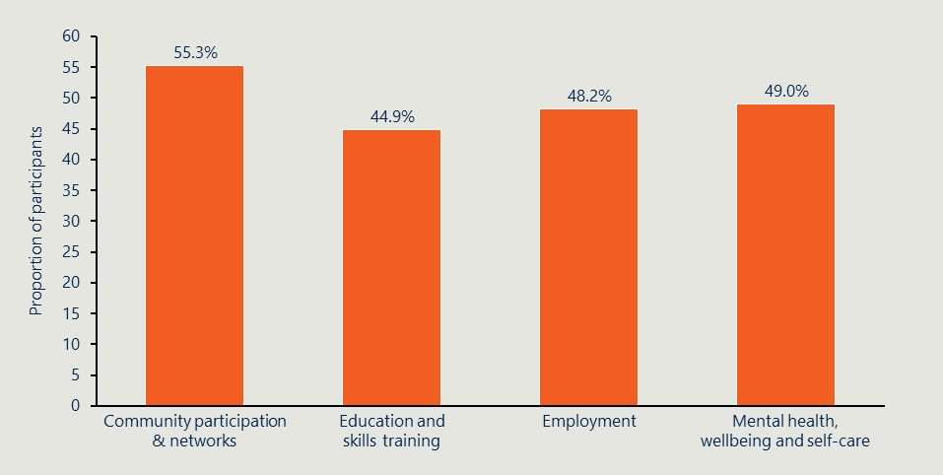
Source: extract from DSS data release published 31/10/2025
The outcomes were relatively similar across the four target cohorts, with significant decreases in the number of participants with very low outcome scores (1 or 2) over the course of participating in their project. An employment SCORE of 1 or 2 means the individual is unemployed or only in short-term work. Across most outcomes approximately 25-40 per cent of participants (n = 9,902) began the project with a SCORE of 1 or 2, while only around 10 per cent of participants (n = 9,902) had a SCORE of 1 or 2 by the end of the project. A change in DEX score from 1-2 to 3 or higher represents a very substantial life change for participants. For example, under the community participation and network outcome, moving from feeling “very isolated” or “fairly isolated” to “somewhat connected” means individuals are no longer completely cut off from their communities and have begun establishing meaningful relationships. Similarly, in employment, progressing from “no work” (SCORE 1) to “sometimes I have work and my ability to find work is improving” (SCORE 3) reflects a critical shift toward meaningful economic participation and the significant benefits that brings people.

The SARC – IC Activity has improved mental health outcomes for large proportions of participants across all target groups
Projects funded through SARC – IC were associated with improved outcomes for large proportions of participants in target groups. Significant improvements in the mental health outcome were observed (Figure 8 overleaf) for women at risk of disadvantage and, unemployed people, and 12- to 18-year-olds, with 55 per cent (n = 738), 51 per cent (n = 831), and 49 per cent (n = 231) of participants, respectively, recording improved outcomes respectively. A smaller but still significant proportion (42 per cent, n = 871) of people with a disability improved their score. The SARC – IC Activity appears to be effective at helping to protect and improve the mental health of participants across most target groups, however there is an opportunity to further examine how SARC – IC could be better tailored to address the needs of participants with a disability.

"I now feel empowered, because of that program. Has given meaning to my life, have suffered severe depression and was very lonely; gave me confidence that I belong to a community.
I suffer from anxiety ... it has made it a safe space to meet new people and not feel judged or out of place - just really welcoming and open."

Figure 8 | Mental health, wellbeing, and self-care scores, by target group and period
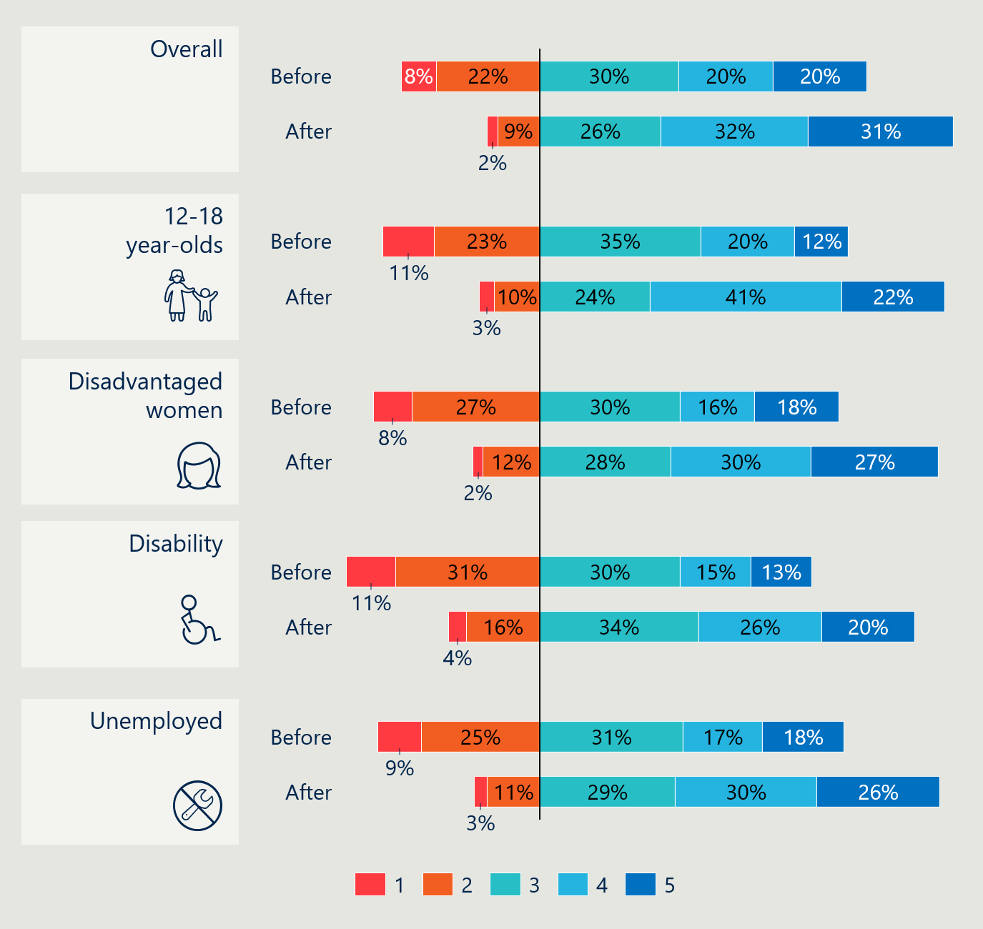
Figure 8 full description
Source: extract from DSS data release published 31/10/2025
Case study | Improving mental health
A SARC – IC funded project aimed at improving wellbeing and mental health outcomes for people with mental health conditions in regional areas was designed to use animal therapy to support participants experiencing severe mental health difficulties. The service ran a short structured service for participants to provide them with connections to animals and people, and a sense of purpose. Many participants reported that attending the project activities helped them build confidence and overcome trauma, with some participants returning as volunteers after the project finished. An evaluation of the project found that the vast majority of participants had significant and sustained improvements in their mental health and wellbeing as a result of attending the project.

The SARC – IC Activity has improved employment scores of many participants across all target groups
Participants engaging with SARC – IC funded projects began with very low employment rates, 51 per cent of employment pre-SCOREs were a 1 or 2 showing the participant was unemployed or underemployed. Employment outcomes for all target cohorts significantly increased over the course of engaging with SARC – IC projects.
Young people (12-18) saw significant benefits from SARC – IC with over 60 per cent (n = suppressed) of participants with SCORES recorded increasing their employment score, and only 18 per cent (n = suppressed) of participants recording a post SCORE of 1 or 2 (compared with 67 per cent pre SCORE, n = suppressed). It should be noted that some young people in this category started with a low employment SCORE because they were not yet seeking employment rather than because they could not find work. Unemployed people and women at risk of disadvantage also saw around half of participants increase their scores. People with a disability saw a smaller proportion increase their scores but a larger proportion than other groups recorded no change. The employment outcome saw very low rates of participants decreasing their score over the course of the project, as in Figure 9 overleaf. Ultimately this suggests the SARC – IC Activity is effective at improving employment outcomes and protecting participants from backsliding given almost no scores went backwards while individuals were engaged with the project, although these changes cannot necessarily be fully attributed to their participation in the project. These results align to anecdotal feedback received from grant recipients and participants, who reported the projects were useful in helping them build practical skills that helped them gain employment, and in some instances directly linked them into future employers. Participants noted that organisations which ran practical skills building projects and/or which had strong links to other community organisations and employers were most effective as they created clear pathways to employment from participation.

"The difference in me is incredible, starting applying for work and building confidence, just feel myself again."

Figure 9 | Employment scores, by target group and period
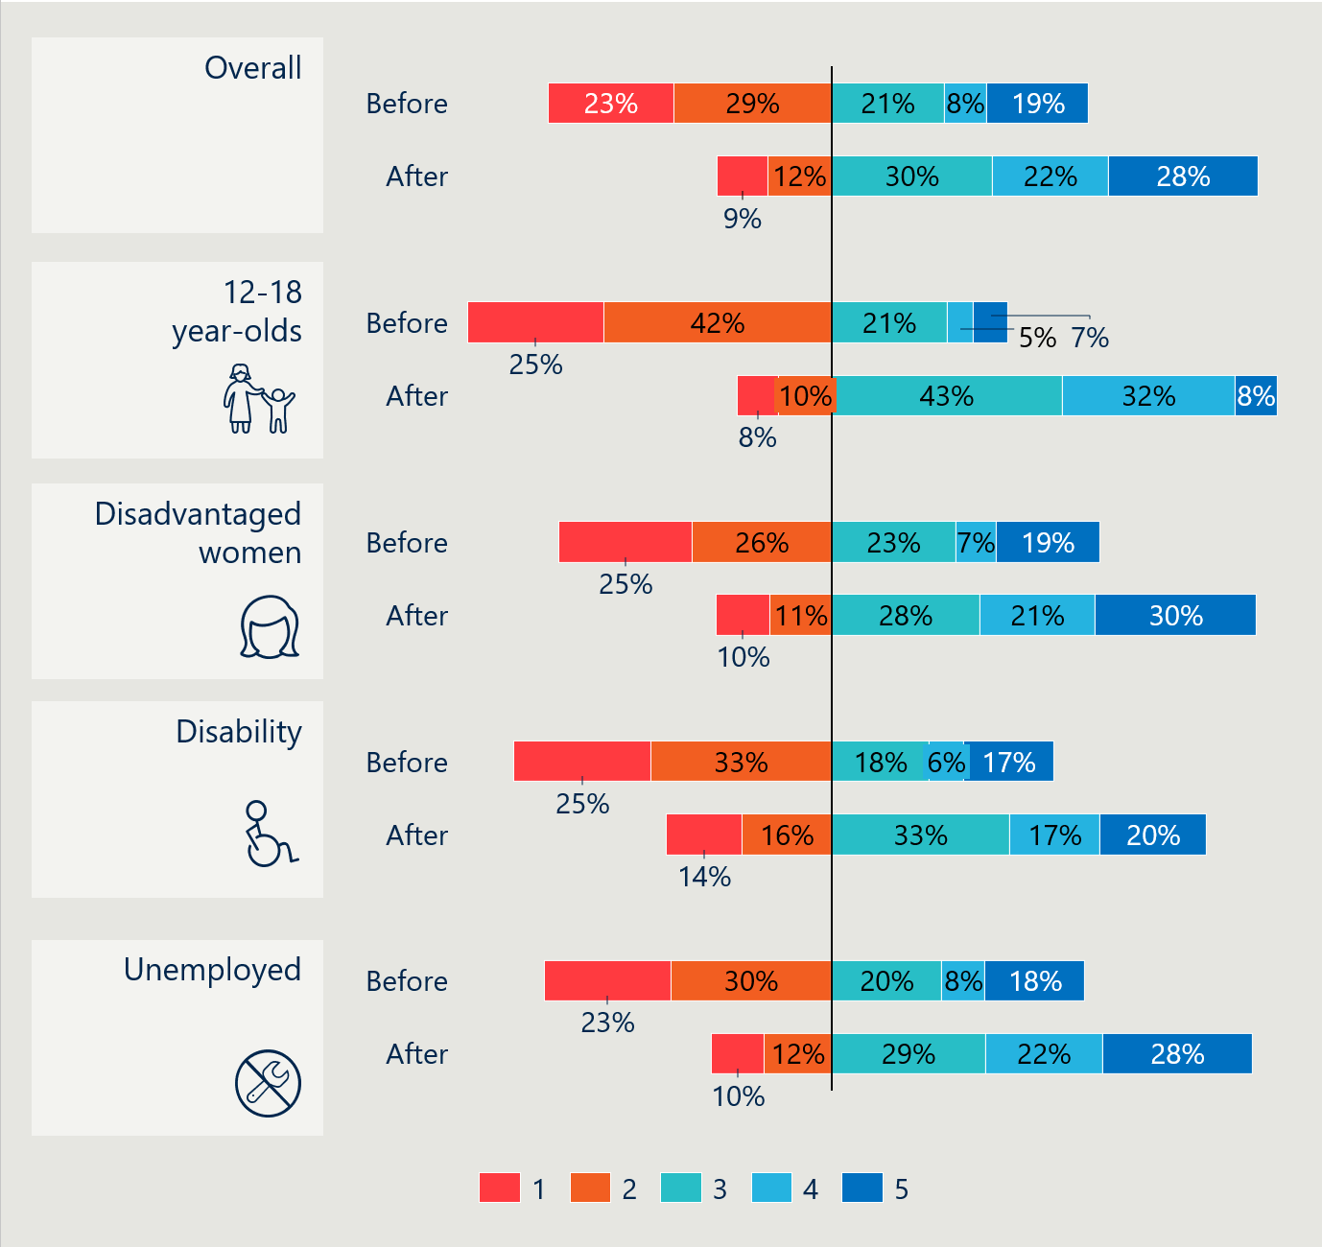
Figure 9 full description
Source: extract from DSS data release published 31/10/2025
Case study | Improving employment outcomes
A SARC – IC funded project in a rural community focused on increasing employment for vulnerable women by helping them build the skills that were required for jobs in the local community. The project worked with the women to build their skills and get them work ready, and then linked them directly to jobs in the local community. This was beneficial as it helped more than 50 women secure employment whilst also filling gaps in the workforce in a regional community.

The SARC – IC Activity has improved community participation scores for a majority of participants in all target groups
All target groups had strong improvements in their community participation and networks outcome (Figure 10 overleaf), with more than 50 per cent of participants (who had SCORE data) in each cohort improving their outcome over the course of the project. Around three in five participants in the young people and unemployed people target groups saw an improvement in their score. All target groups had 5 per cent or fewer participants decrease their score. Both people with a disability (n = 1,007) and women at risk of disadvantage (n = 395) saw around a 50 per cent rate of score increases, meaning that after they accessed the SARC – IC project they felt more connected to their community. The nature of the SARC – IC Activity appears to be effective at increasing community engagement and building stronger networks for its participants. This aligns strongly with anecdotal feedback provided by participants that building community engagement and confidence was the key outcome they had taken away from the project. More detail on the impact of increasing community participation is set out in section 5.2.8.
Figure 10 | Community participation and networks scores, by target group and period
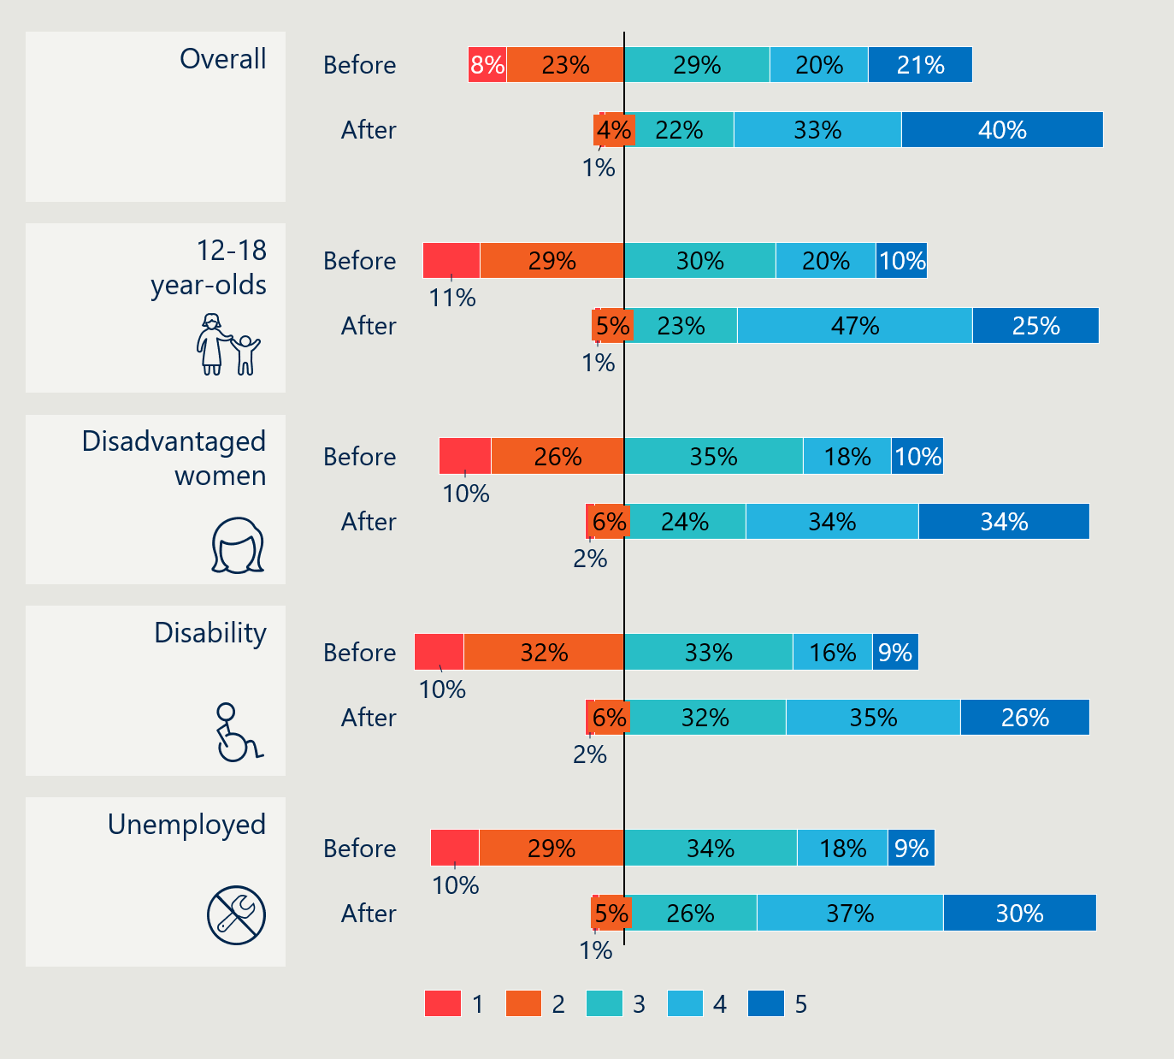
Figure 10 full description
Source: extract from DSS data release published 31/10/2025
Case study | Improving community participation
A SARC – IC funded project in rural areas focused on increasing the sense of community in the local area and supporting isolated residents to build relationships and access relevant services. The service ran weekly sessions with different activities. Participants valued that the facilitators listened to what they were interested in and shaped future sessions to meet those needs, for example, art therapy sessions, financial planning, and spending time in nature.
Participants reported ongoing benefits for their mental health and wellbeing during and after the project due to the relationships developed through attending the project.
“It helped me connect and meet more people.”

The SARC – IC Activity has improved education outcomes for many participants across target groups
Education skills did not see as strong an improvement across all target groups compared with other outcomes, as can be seen in Figure 11 below. This is not unexpected, as it would not have been a target for many projects unless they were aimed at young people (or in some cases vulnerable women). For those who would presumably benefit most, young people (n = 321) and women at risk of disadvantage (n = 698), SARC – IC improved scores for around 50 per cent of participants. The total number of young people with a pre and post SCORE for education was also higher than other SCORE categories, suggesting that education (alongside community participation) was the key intended outcome of most projects designed for young people. People with a disability and unemployed people only saw around a 40 per cent increase in their scores, most likely due to different focuses within those projects. Grant recipients and participants interviewed noted that the projects for young people were effective in increasing educational engagement because it helped students understand the skills they built outside of school could be valuable in their adult life and helped them identify things they were passionate about, which gave them a direction and purpose when engaging with school.
Figure 11 | Education and skills training scores, by target group and period
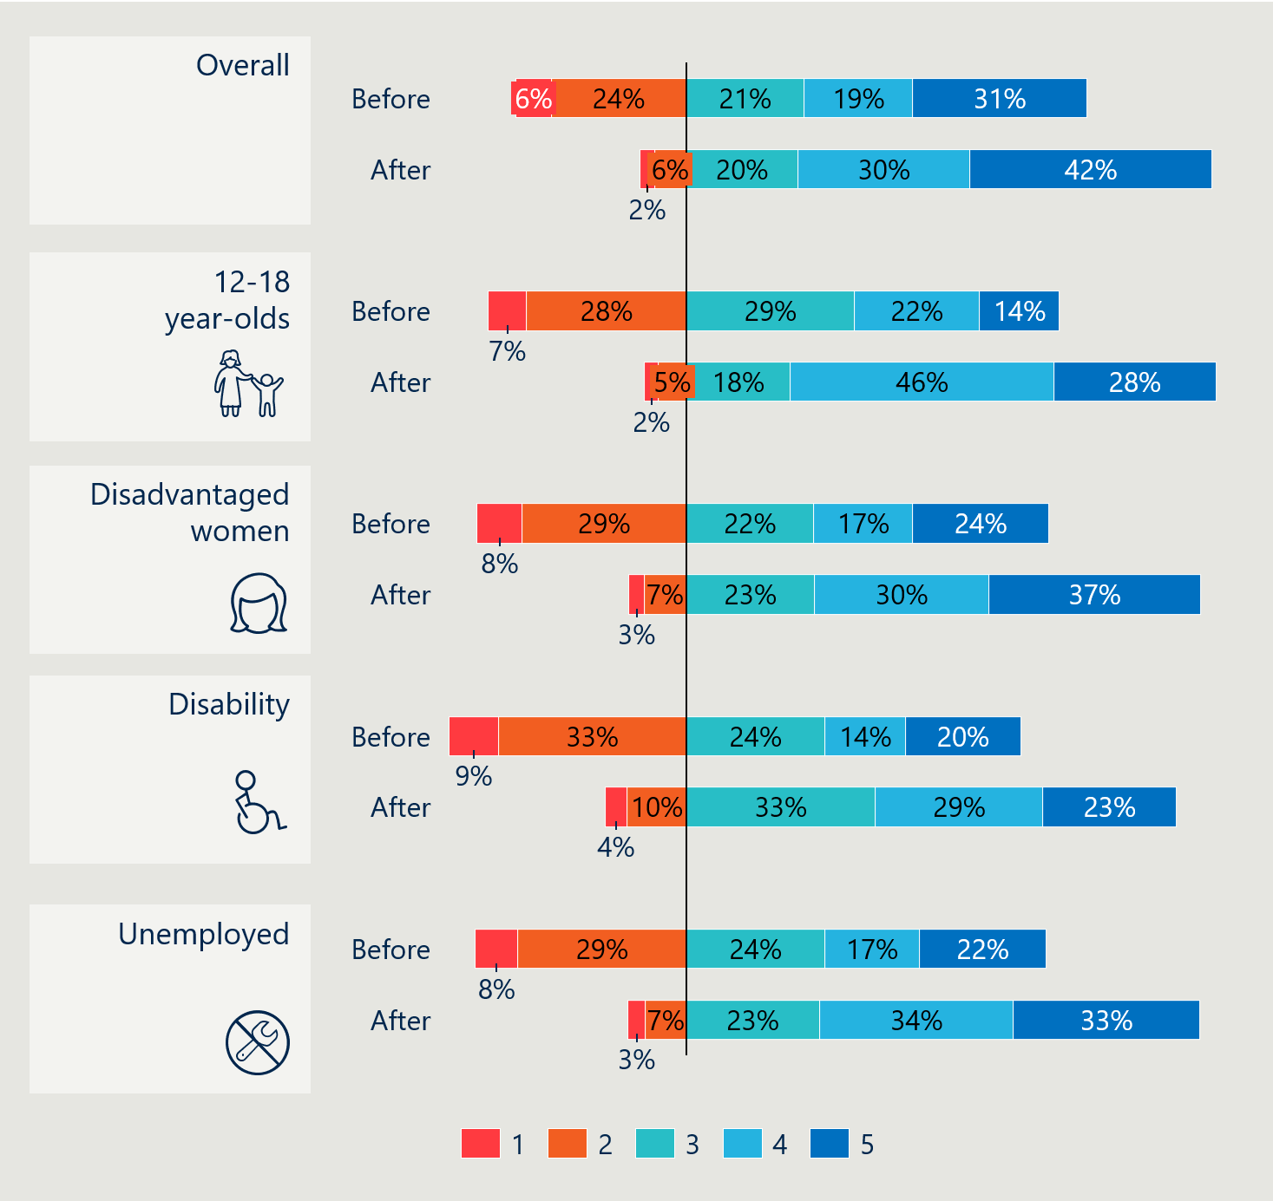
Figure 11 full description
Source: extract from DSS data release published 31/10/2025
Case study | Improving educational outcomes
A SARC – IC funded project focused on supporting young people who were at risk of disengaging from school by providing practical training in skills they could take forward into employment, while encouraging them to stay at school. The service ran a structured term-long project for a small group of students, where they were supported to identify skills that they were passionate about and to build those skills, and to identify how they could translate those skills into a job in the future.
The service found that the majority of participants were more engaged at school after attending the project. These improved outcomes were due to a range of reasons. Some participants attributed their increased attendance to the project’s support in helping them work out what they wanted to do with their life, and the value that attending school would provide in achieving this. Other participants noted that the project had helped them build their social network and improved their wellbeing, which helped make attending school feel more manageable.

A very small number of participants saw their outcomes decrease over the project
While most participants saw positive results, a very small number had their scores fall. The proportion of participants who had lower scores after the project ranged from around 2 per cent (n = suppressed) for young people in employment to 9 per cent (n = 732) for unemployed people in education and skills training. There are multiple potential reasons for this decline. Many grant recipients and participants highlighted that many people initially engaging with projects were hesitant to fully open up about their circumstances but became more willing to share as they built a relationship and trust with the provider. In these cases, the actual circumstances of the user may well not have declined, but by the time the grant recipient was recording post SCOREs, they would have had a clearer picture of the individual’s circumstances, which could have resulted in a lower score.
The decline does suggest that for some individuals, project engagement may not have met their needs or external factors hindered progress. The remaining participants saw no change in their pre and post program scores. This is not necessarily a negative outcome because the SARC – IC projects may have helped these people maintain their scores despite potentially facing significant challenges. Due to the nature of constructing the target groups, where participants needed only one low score to qualify, the results include people who started with a high score, like a 4 or 5, in some outcomes that they maintained during the project. Around 90 per cent (n = 9,902) of people with a score of 5 maintained it throughout the project, and 91 per cent (n = 9,902) of people with a 4 maintained or increased their score.
Participants across many of the cohorts, especially women, were very vulnerable and required complex support to meet their needs. A number of providers who focused on supporting these particularly vulnerable groups found that they could not achieve their original project objective of helping women (or others) access their service to find employment. Instead, the providers that were most effective for these cohorts helped to provide mentoring, build confidence, and address the underlying needs that needed to be addressed first, such as homelessness and domestic violence. Other organisations were able to provide more specific supports, for example funding and support to pass drug dependency tests to regain a driving licence, without which the service user believed they ‘would never have been able to get the job [I got].’

Building community helped to increase social and economic engagement

The most significant outcomes of SARC – IC were building confidence and community that reduced social isolation
Before engaging in a program funded by SARC – IC many participants were extremely isolated, with limited interactions outside the house, and the projects helped them start engaging with the community. Participants interviewed reported how beneficial finding this community, often for the first time or for the first time after an extended period of isolation, was for their mental health, confidence, and for improving other aspects of their life. DEX outcomes data reinforced this narrative; 31 per cent (n = 9,902) of users with pre and post SCOREs had a community participation SCORE of 1 or 2 before they accessed the project, and this number dropped to only 5 per cent (n = 9,902) after participating in the project, suggesting a significant reduction in isolation. This benefit was seen strongly across all four target cohorts, with similar reflections on the importance of community for mental health and wellbeing.

"She was amazing, she helped me understand how common my situation was and what I needed to do.
It opened up accessibility for people that tend not to have the ability to get support.
It has just opened up so many doors for us."

For many participants, especially vulnerable women and people with a disability, it was the first time they had found a community of people who had been through similar experiences and had similar perspectives. This created a sense of psychological safety that allowed participants to come out of their shell and connect with others both inside and outside the project they had accessed. For participants with lived experience of trauma, engaging with peers or facilitators who had been through a similar experience reduced isolation and created an opportunity to formally and informally support each other through both grief and practical processes like navigating the legal system. Even for projects which have ended, participants from some programs noted that they still have enduring contact and friendships with other participants, and that having someone they can message and talk to has been critical to supporting their mental health and wellbeing over the long-term, as they have a community they can tap into when things get tough.
An important part of this sense of community was helping participants build their confidence and embrace their personality and interests. Projects took different approaches to achieving this, including using peer facilitators to create psychological safety, and delivering a range of activities to allow participants to explore different areas of interest. This also came through strongly in feedback from young people who participated in projects, where one of the key benefits was that the project helped them explore their interests and identify things they could pursue into the future.

"Just getting to know each other because one of the benefits of it is form a support network and each of us has the ability to help and support others."

Project participation was often an important first step for participants to build the skills and confidence they needed to access other services
A key benefit of increased community participation was that it helped prepare participants to access other services and increase their engagement. Improving lifelong outcomes is a journey, and it can be difficult for traditional support services to reach individuals who are disengaged from the community. One of the key benefits of this Activity was that it provided the targeted link that helped isolated people who were not accessing other services connect back into the community, which helped reduce their isolation and created the opportunity to refer them to other services. Grant recipients interviewed repeatedly reinforced that one of the most important outcomes they saw among their participants was that they had the skills and confidence to begin participating in the community and economy more broadly.
Some services also helped to create these linkages directly, introducing their users to other programs and services so that participants knew what was available and had an easy way of accessing those services. The intensity of these supports varied, and some grant recipients, especially those supporting very vulnerable women, found that many participants were not having enough of their basic needs met to be ready to engage in employment or education, and so their focus became helping to increase confidence and start building skills so that participants would be ready for employment/education rather than helping them access it right away.

"They felt confident in their identity and how they express themselves.
Being able to advocate for who they are.
They have a feeling of connection and belonging they have never had before.
It is nice to not be the weird one in the room, and feel they can speak freely and not be judged for that."

Grant recipients who were focused on helping their users find employment were most effective when their training or project had a direct pathway into employment or volunteering, as it provided an immediate opportunity to apply skills and build experience. This approach also ensured that there were opportunities available in the community that matched the skills being built. Organisations took different approaches; some directly employed participants or provided volunteering opportunities, whilst others set up formal partnerships with local businesses.

"Equipped them with the tools to remove their own barriers to participation."

Sustainability of outcomes

Most projects could not continue, eroding trust with community and limiting long-term outcomes
As outlined in section 5.2.5, the vast majority of projects funded through SARC – IC have not been able to secure long-term funding and so have ceased operations. Some participants noted the negative impact that wrapping up the project had, reporting some decline in their mental health and wellbeing since the project ended, and worrying about people who would need the service and not be able to access it. Some grant recipients also noted that running a project with a new community for such a short period of time had eroded the community’s trust in the grant recipient and other service providers who had referred people into their service.

"Endings can be hard for some people, can build someone up for it for so long but when something ends always that want for it continue."

The impacts of funding ending were not uniform across types of programs funded. Services that offered short-term structured projects tended to see more sustainable impacts for individuals who were able to participate in their full program, as it was not designed for them to have contact with participants. Alternatively, peer support groups and other support services tended to have more ongoing participants, or those most in need, dropping into the service at different points. Users of these services noticed the loss of the service more, especially when the service had not invested the time in helping them find and move into other programs before the project ended.

The sustainability of outcomes was highly dependent on the structure of each project
The majority of grant recipients have not been able to continue running the project that was funded through SARC – IC once the funding ended. For projects that were structured to have a set length, for example, a participant would take part in a structured eight-week program, ending funding did not impact their ongoing outcomes, as they were able to benefit from full participation in the project. Projects that used this structure tended to focus on a more defined outcome, for example supporting skills building and employment, as compared to services focused on helping to build community and social participation. For projects run as groups, for example weekly support groups, participants reinforced that they had benefited greatly from the project. However, they also highlighted the loss they felt from the service being taken away, with a small number of participants noting that their wellbeing had decreased since the funding stopped. Participants from all types of projects that had ended expressed that they felt lucky they had the opportunity to access the service but worried for similar people who would need it in the future and not have access to it.

The funding helped organisations build their workforce capability and capacity, but these changes were difficult to sustain if they could not source additional funding after the grant ended
One of the intended benefits of SARC – IC was to help boost the capacity and capability of the community sector workforce, and support organisations to begin working in new spaces. The short funding term, combined with limited opportunities for long-term funding, meant that whilst grant recipients built temporary capability, most were unable to carry this forward into the future. This significantly limited the benefit for community organisations, because it meant that at the end of the funding, they lost access to staff who had built institutional knowledge and relationships.
There were some ongoing benefits for community organisations, especially for those who were able to secure additional funding, with organisations gaining the opportunity to build a greater understanding of the needs of different groups and what types of service models worked. This was incredibly valuable for organisations that could secure additional funding.

Cost-effectiveness and cost-efficiency
This section outlines findings relating to the cost-effectiveness and cost-efficiency of the SARC – IC Activity (KEQ 4).
- KEQ 4: How cost effective is SARC – IC considering expected outcomes and benefits?

KEY FINDINGS
KEQ 4 | How cost effective is SARC – IC considering expected outcomes and benefits?
6.4.1 The SARC – IC Activity is relatively cost efficient at delivering services through a broad range of providers and to a broad range of participants
- The weighted average cost per participant under SARC – IC is $5,019, which compares favourably with the cost per participant values available to compare among similar programs.
- In general, it costs around $10,000 per improved SCORE point across all providers and participants.
- Based on the available data, noting the limitations, medium-sized providers (those with between 25 and 100 participants) generally achieve the most cost-effective outcomes. They can benefit from economies of scale but still provide relatively well tailored support to their participants.

The SARC – IC Activity is relatively cost efficient at delivering services through a broad range of providers and to a broad range of participants
This section examines the economic efficiency of organisations participating in the SARC – IC Activity by comparing the resources invested with the outcomes achieved. The analysis uses grant financial records and participant outcome data to provide a standardised comparison of program performance.

SARC – IC is relatively cost efficient compared to other similar programs
The SARC – IC Activity is relatively cost-efficient to operate. SARC – IC has a weighted-average cost per participant of $5,019. This compares favourably with similar programs (Table 6), noting that there is a substantial range of cost efficiency for some of these programs. It is not unexpected that SARC – IC would be at the upper end of the cost efficiency spectrum given set up costs for new short-term projects are likely to make many projects expensive to run in the beginning.
Table 7 | Cost-efficiency of similar programs
Program | Aim | Cost per participant
Homeless Youth Assistance Program | Designed to address a gap in the delivery of homelessness services to unaccompanied children under 16 years. | $1,215 - $34,16954F
Skills for Education and Employment | An Australian Government program that delivers free language, literacy, numeracy and digital skills training to eligible Australians to support workers and vulnerable Australians to gain secure employment choices. | $4,20655F
Reconnect | Early intervention to prevent youth homelessness and disengagement. Provides counselling, family mediation, and practical support to at-risk youth and families, aiming to keep young people in a stable home and connected to school or work. | $2,17556F
Skilling Queenslanders for Work | Funds NGOs, RTOs, peak bodies, community organisations and councils to run training courses, paid work placements (traineeships), and job prep programs that address barriers and lead to jobs. | $880 - $10,80057F
If the Department is able to improve the collection of longitudinal data on the outcomes of participants in SARC – IC it would be well-placed to consider undertaking a full cost benefit analysis to deepen the evidence base surrounding SARC – IC.

The cost of providing the SARC – IC Activity to participants is largely similar across providers of the same size
To enable a consistent comparison across organisations, total grants were aggregated at the organisation level from 2022–23 to 2024–25 and calculated per participant. Since 2022–23, 144 grants have been made to individual organisations with a total value of $83.2 million.58F Due to outcomes data limitations, as discussed in Section 4.2, the cost-effectiveness analysis is only able to consider 75 organisations that have received a combined $32.5 million in grants.59F This approach, while only examining a subset of all participating organisations, produces a standard estimate of cost-effectiveness which allows for a general comparison of organisations.
There is a strong relationship between the number of participants and the cost per participant of delivering the SARC – IC Activity. Figure 12 overleaf presents the cost per participants and total number of participants for each provider. The variable grant amounts available to providers ensures that, in general, the cost of providing SARC – IC is around $10,000 per participant or less, with two thirds of providers falling into that range. Another 30 per cent of providers operated with a cost per participant of between $10,000 and $20,000. Only 6 providers had a cost per participant over $20,000. For this subset it is not clear why the cost per participant is significantly higher, several possibilities exist:
- the provider offered more intensive services
- the provider failed to attract the number of participants they planned for in their grant application, or
- the provider did not enter data for all participants into DEX.
For most providers it is likely to be a combination of all three.
This standardisation is important because comparing only gross funding figures can be misleading. Larger organisations naturally attract higher funding levels but can achieve significant economies of scale from their larger participant numbers. This means that any cost per participant measure disadvantages smaller organisations. It is possible that smaller organisations may be providing deeper engagement, more bespoke support, or targeting a more disadvantaged cohort which would generally be expected to translate to larger improvements in outcomes and to generally cost more when compared to larger organisations, however this was not a clear insight from either interviews or DEX data.
Figure 12 | Cost per participant and the number of participants for SARC – IC providers
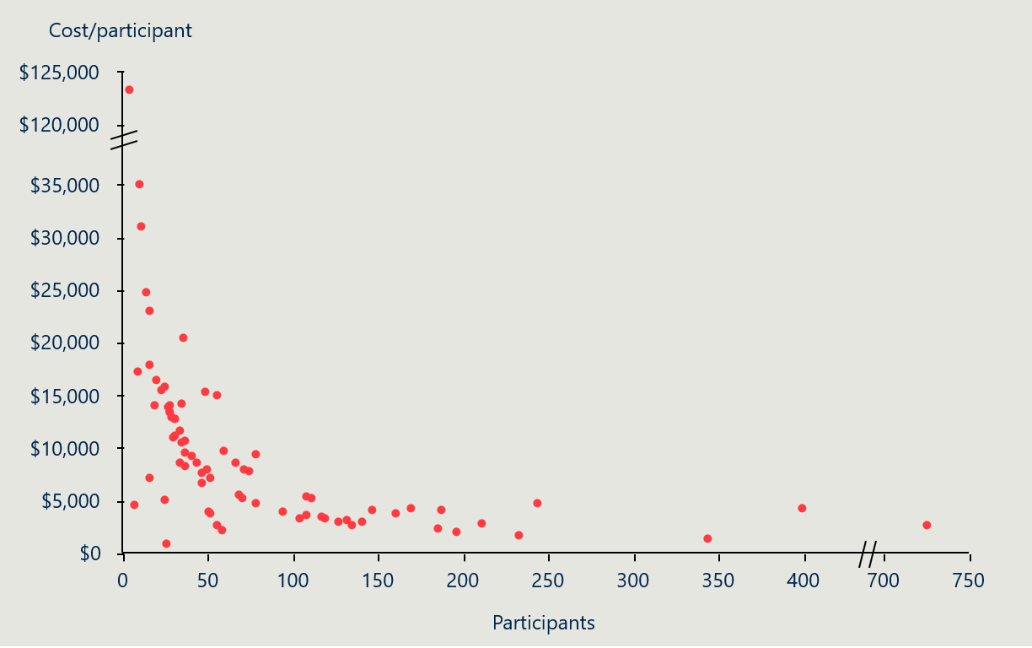
Source: extract from DSS data release published 31/10/2025

There is significant variation in the cost-effectiveness of organisations driven by differences in outcome measures
In general, most providers under SARC – IC are similarly cost-effective at delivering improvements in the outcomes of interest. Figure 13 overleaf shows the cost-effectiveness of providers, as measured by the net change in points per $10,000, and grouped by the number of participants. Most providers saw an improvement in scores of between 0 and 0.5 points per $10,000, 12 providers had no net change, and 11 had a negative change in points. There were 13 providers that had improvements greater than 0.5 per $10,000, they were concentrated among providers with over 25 total participants. Ultimately, medium and large sized providers offer relatively higher cost-effectiveness due to a combination of economies of scale and higher outcomes.
Figure 13 | Change in points per $10,000 by provider and participant numbers
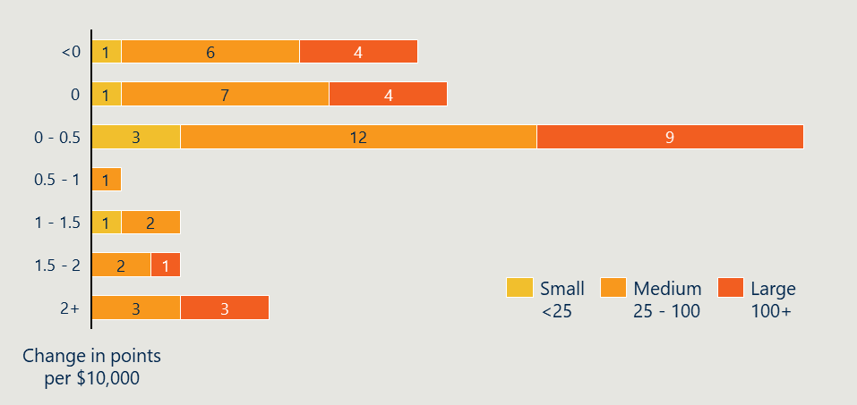
Source: extract from DSS data release published 31/10/2025
The outcomes analysis showed a broad variance in the mean change in participant outcomes for providers that had recorded pre and post program scores. Around 25 per cent of organisations had participants with a negative change in their score after the project. For most of these organisations the reported reduction in scores was calculated based on fewer than 5 participants, there are only four organisations that had more than 10 participants with pre and post scores that recorded a decrease in average scores. It is also the case that the 17 per cent of providers that reported no change, on average, in outcome scores had fewer than 5 participants with pre and post scores recorded. The key trend is that as organisations had more participants with pre and post scores recorded, the average change in scores was most likely because of the increased sample size, resulting in a more representative sample of participant outcomes.
Cost-effectiveness is calculated by measuring the relationship between costs and outcomes. For the SARC – IC Activity, cost-effectiveness can be measured by analysing the net change in points associated with participating. For example, if a participant moved from a score of 2 to 4 on employment, that is 2 additional points, and if they moved from 3 to 2 on community participation then the net change in points is 1. This net change and the cost of providing the SARC – IC Activity can be used to measure the cost-effectiveness of providers.
Looking at only the key outcomes of interest, the net change in points for providers with participants who had pre and post scores ranged from -10 to 2,068, and normalising for total participant numbers, the change in points per participant ranged from -0.14 to 6.9. It is important to note that these cost-effectiveness and cost-efficiency measures are relative and should only be used to compare similar providers. Looking at the tightest cluster of providers, those with between 10 and 75 participants, providers achieved relatively similar outcomes per participant. The outliers are explained by relatively low rates of missing outcomes data coupled with relatively large average improvements in outcomes.

Recommendations
This evaluation has grouped the recommendations into three options, with increasing levels of benefit and implementation risk/effort. As outlined below, it begins with incremental change within the current program, moves to things that structurally change what SARC – IC is, and then to wholesale change for how government invests in projects to achieve social and economic participation.

OPTION 1 Re-design how government commissions services to improve social and economic participation for vulnerable Australians.
Proposal:
Redesign the Department’s commissioning approach to focus on long-term, outcome-driven partnerships that improve social and economic participation for vulnerable Australians. This involves:
- Stop further funding rounds under SARC – IC in its current form.
- Refine the cohorts SARC – IC is targeting to align with current priorities, reduce the breadth and address overlap.
- Review programs outlined in Appendix D, and create a consolidated funding stream akin to DSS’ A new approach to programs for families and children.
- Shift the role the Department plays to more of an active system steward, that uses its investment, engagement with grant recipients and data to more actively work towards the desired system outcomes. This could consider the appropriate governance model for individual grants and the collective program.
- The Department can provide more detailed guidance on the parts of the system it is trying to effect change in (for example it could consider; early intervention and prevention; direct service provision / therapeutic supports; better system integration and navigation).
- Consider the commissioning model that is appropriate for delivering these outcomes. This could be anything from relational grants, through to outcomes-based funding models. The choice depends on what the Department is trying to optimise for and the scale of money invested.
- Better leverage partnerships with state and territory governments to increase investment and interface more systematically with other service systems the state runs. A key part of this would be increasing the visibility and role of the new program, as SARC – IC is relatively small and not well known.
- Streamline the data that is being collected and closely tie it to performance and the commissioning model.
Supporting evidence:
- The review of government policy and programs to address social and economic participation suggests SARC – IC overlaps with a large number of other programs (at a national and state/territory level).
- Almost all SARC – IC grant recipients were delivering other services outside of SARC – IC, often to similar client groups. This means they are having to navigate themselves a wide range of government procurements, creating duplicate administration.
- The Australian Government is running a laborious process for administering a relatively small sized grant, there would be significant economies of scale if it could combine funding pools.
- The current grant funding arrangement is short-term and is not supporting providers to transition to a sustainable funding pathway, this is limiting the long-term capacity building in the sector.
- The government could use data better to inform its commissioning decisions and follow a more relational approach.

OPTION 2 Enhance SARC – IC Activity with structural improvements.
Proposal:
Continue to fund SARC – IC, but with structural changes. This option builds on the outcomes that SARC – IC is achieving (strong changes in educational, employment and social inclusion). However, this moderate change would require restructuring key parts of the grant and further investment. It has a moderate amount of implementation risk, with moderately sized benefits. Note that there are some interdependencies between each recommendation:
- Refine the scope of the cohorts and more clearly define outcomes | Tighten the intended outcomes of the grant so that it is clear to applicants and the assessment panel what SARC – IC is trying to achieve, and the hierarchy of different policy priorities. This could include introducing a specific focus cohort for each round to target applications or narrowing focus of the grant to place-based community-driven interventions. At the moment, the intended outcomes and the priority cohorts are too broad, and it is spreading a small amount of funding too thin.
- Improve collection of fit for purpose performance data to reduce burden and change practice | Streamline DEX data collection requirements to increase outcomes reporting and reduce the amount of sensitive demographic information which needs to be collected. This evaluation suggests the Department focuses on the primary outcomes of interest (employment, education and community participation) to reduce the amount of collection, and increase the completeness and quality. It is likely educational materials or training from the Department would help with the uptake. It should be noted this recommendation is already being separately addressed by the Department, with a rationalisation of SCORE domains and reduction in required demographic data from March 2026.
- Play more of a system steward role in the sector, supporting communities of practice | Interviews with SARC – IC grant recipients noted that they did not see any insights from the data they have inputted and were interested and open to a community of practice style arrangement. This would allow the Department to take a more active role in shaping how evidence supports program delivery (through a CoP), and allow it to use what was effective in each round to help it further target the next round (in terms of location, delivery organisations, models and cohorts).
- Shift the funding to longer term grants and take a more active role in creating a pathway to sustainable funding | Invest in building partnerships and co-funding relationships with state and territory government to support grant recipients to source long-term funding. The Department could consider aligning these grants with the proposal for families and communities (reference) that is moving to a 5-year funding agreement and a more relational style of commissioning.
Supporting evidence:
- SARC – IC does help people improve their life through education, work and community connection. Maintaining some investment in this space is important to local communities in which it operates.
- A significant amount of time is taken by Government to assess over 1200 eligible applications each round. Likewise, this represents a huge amount of time wasted by the 97 per cent of applicants that do not receive a grant.
- The Department has an opportunity to re-structure the grant process to play more of a system steward role that would address this, and better share evidence with providers to improve implementation. If this was supported by longer term funding agreements. This would greatly improve the strength of the sector.

OPTION 3 Minor adjustments to improve efficiency.
Proposal:
This option would largely keep SARC – IC the same and allow it to continue delivering the current level of outcomes. It represents the smallest level of implementation risk, and has the smallest pay off in terms of changing outcomes. These outcomes could be done in combination with the moderate change recommendations (they are not mutually exclusive).
- Reduce administrative burden on applicants and the assessment panel | Introduce a two-stage application process to funnel applications through an EOI to reduce the burden on applicants and the Department in preparing/assessing detailed applications. This would create significant savings of time and money for the Department and the sector. The focus should be on tightening the assessment criteria and creating a staged process that allows providers to put in a small amount of effort (their pitch / initial idea) and have the first-round narrow down the applicant pool, before a more fulsome application afterwards.
- Provide clearer guidance in grant opportunity guidelines and assessment criteria. The Department has an opportunity to shape the market through the communication and engagement it does around the formal assessment process. This could look like briefing sessions or Q&A sessions that the Commonwealth runs during procurement processes and would allow for a two-way dialogue that builds trust and the quality of potential bids. It would also allow some providers to understand if the grants are not aligned to their offer.
Supporting evidence:
- SARC – IC recipients felt that there could be better support from the Department around the grant process to reduce the burden on participants.
- SARC – IC recipients identified a two-stage assessment process as an easy way to reduce the amount of time wasted by organisations that are unlikely to be successful and the Department in assessing those applications.

Appendix A – Program logic
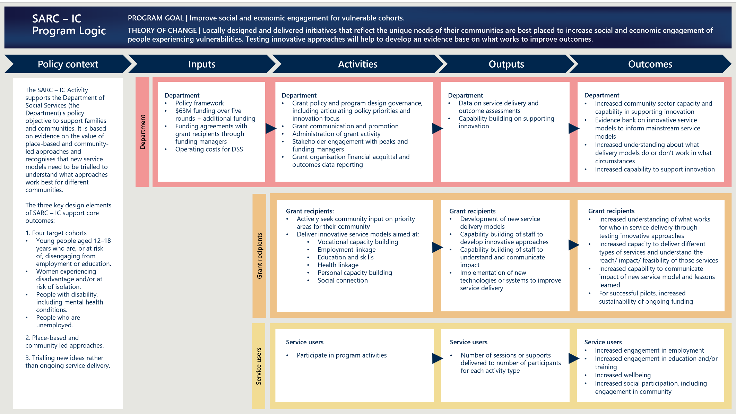
Appendix A full description

Appendix B – KEQs and sub-KEQs
Table 7 below outlines the overarching KEQs and sub-KEQs that guided the evaluation’s research.
Table 8 | KEQs and sub-KEQs
KEQ | Sub-KEQs
1 Appropriateness  To what extent was SARC – IC’s design appropriate for achieving its intended aim? | - To what extent were SARC – IC objectives and activities responsive to the needs/priorities of the four target groups?  - To what extent are the target cohorts appropriate focus areas for the grant?  - To what extent do application assessment criteria support selection of the most appropriate organisations?  - To what extent do SARC – IC funded projects both align with the program intent and meet an identified need in the community in which it is being delivered?  - In what ways do the funded projects complement or duplicate services for the SARC – IC cohorts delivered by other service systems?  - To what extent does SARC – IC support community-led approaches?  - To what extent does SARC – IC align with good practice, including current evidence on community resilience?  - To what extent does SARC – IC encourage innovation in service delivery through its design and assessment criteria?  - How can the design of the SARC – IC be improved?
2 Implementation  To what extent was SARC – IC implemented as expected to deliver economic participation, wellbeing and social participation measures?   | - Was the SARC – IC implemented as planned, against the Program Logic, and how effectively has SARC – IC been managed?  - Did any changes and/or modifications take place over the course of its implementation and delivery, and were these positive or negative?  - To what extent is the SARC – IC collecting fit for purpose performance data for monitoring and future evaluations?  - What was the experience of grant recipients and other stakeholders in relation to the implementation of SARC – IC?  - What challenges and successes can be identified in the implementation of SARC – IC?  - How effective have changes been over grant rounds in improving program delivery?
3 Effectiveness  How effective is SARC – IC design in delivering program objectives and short, medium and long-term outcomes? | - What short, medium and longer-term outcomes, intended and unintended, have been observed to date – from who, in what circumstances, when and how?  - How do the outcomes achieved vary across target cohorts, geographies, and the manner and intensity of delivery?  - How sustainable are these outcomes following the cessation of SARC – IC funded projects?  - How could program design be adapted into the future to improve outcomes for target cohorts?
4 Cost-effectiveness  How cost effective is SARC – IC considering expected outcomes and benefits?   | - How cost-efficient and/or cost-effective is the SARC – IC?  - How sensitive are the benefits and costs to inputs and assumptions?

Appendix C – Detailed evaluation methodology

C.1 A variety of evidence informed the final report

C.1.1 Stakeholder engagement

Interviews and focus groups
A total of 62 grant recipients and participants were consulted through interviews and focus groups. Another four interviews were also run with SES across the Department and representatives of peak bodies. Engagement with Indigenous Corporations will occur in 2026 and inform the Final Evaluation Report. All grant recipients were contacted through the Grants Hub and invited to participate in an interview and survey. They were also asked to send on an invite to their participants inviting them to participate in an interview, focus group or survey. All consultation, with the exception of one service user focus group, was conducted virtually either over the phone or via a Microsoft Teams call. Participants who participated in an interview or focus group were reimbursed with a $50 voucher. The average duration of grant recipient interviews was 30-minutes and service user interviews ranged from 15-30 minutes. Minimal demographic information was captured about survey users to protect their confidentiality.
The grant recipient survey was open for one month (October-November 2025) and the service user survey was open for one month (November-December 2025). Surveys took approximately 10 minutes to complete. While it was not possible to calculate the exact sample size of participants who participated in the evaluation, it was a very small percentage.
Table 8 below lists the organisations whose representatives participated in interviews and focus groups.
Table 9 | Organisations represented in consultation
Stakeholder | Organisations | Purpose
Grant recipients  23 interviews | 23 grant recipient organisations | To understand what’s working well in implementation of the grant program, overlap with other services, access to long-term funding, what could be improved, and any outcomes observed in participants.
Participants  39 interviewed | 39 participants from across 13 different grant recipient organisations | To understand why participants got in touch with the service, what was good about the service, what could be improved, and any impacts it created.
Peak bodies | 1 x Disability peak body  1 x Working women’s peak body | To understand SARC – IC at a system level, what is working well, what could be improved, and any meaningful outcomes observed for participants.
DSS SES | Key Department staff | To understand program background, evolution and purpose, strategic alignment, what can be improved and what is working well.

Surveys
The evaluation collected quantitative and qualitative data from two surveys on Qualtrics, outlined in Table 9.
Table 10 | Overview of surveys
Stakeholder group | Number of responses | Purpose
Grant recipients | 51 | To understand what’s working well in implementation of the grant program, what could be improved, ability to access long-term funding, and any outcomes observed in participants.
Participants | 21 | To understand why participants got in touch with the service, what was good about the service, what could be improved, and any impacts it created.

C.1.2 Program documents and data
The evaluation analysed the following program documents:
- Grant guidelines
- Lessons learnt reports
- Activity Work Plans
- DEX unit record data
- Grants Master List

C.1.3 Literature and grey literature
The review analysed literature and grey literature on best practices for:
  - community-driven programs
  - trialling new approaches and innovation
  - social and economic inclusion for programs targeting each of the key cohorts economic and social inclusion programs from Australia and overseas.

Literature review methodology
The evaluation followed a structured approach to identify best practice features and make an assessment of SARC – IC’s level of alignment. Key elements of the literature review included:
- Scope and sources
The review targeted meta-analyses, systematic reviews, and grey literature (e.g., government reports, policy papers). This included both Australian and international evidence to capture best practice and emerging trends. Where meta-analysis and systematic reviews were unavailable, limited or inconclusive, single studies from countries similar to Australia and consultation reports from the sector were included.
- Search strategy
Searches were conducted primarily through Google Scholar and PubMed, supplemented by targeted searches of relevant organisational (e.g. Paul Ramsay Foundation) and government websites (e.g. Australian Institute of Family Studies).

C.2 Data analysis methods
The evaluation has employed a quantitative approach, focusing on measuring changes in key outcomes for target groups participating in the SARC – IC Activity. The analysis is complementary to qualitative findings from stakeholder interviews and aims to understand how program participation influenced participants’ outcomes.

C.2.1 Quantitative data analysis methods

Data
The analysis used unit-level data obtained from the Department’s Data Exchange (DEX) system. It includes comprehensive information on program participants. The dataset contained:
- participant demographic information, including gender, age, location, employment and education status, disability, Indigenous status, main language spoken, and birth country, among others
- records of sessions attended, including information on dates, organisation, referrals to internal and external services, and the number of participants in the session
- scores recorded during sessions for twenty outcomes with a flag for whether the score is pre or post program completion, and
- details of which organisation is providing a session.
Outcomes were measured using a Likert scale ranging from 1 to 5, with standardised definitions for each outcome and score provided in the Program Specific Guidance for Outcome 2.1 Families and Communities Program in the Data Exchange.60F This allowed for consistent assessment of participant progress across multiple program areas.

Analysis Techniques
Two main techniques were employed:
- Descriptive statistics: Means, distributions, and changes in scores were calculated to summarise participant characteristics, views on implementation and outcomes.
- Probability modelling: This approach measured the likelihood of participants achieving improved outcomes, the results of this modelling are associative in nature.
The data analysis followed a structured procedure:
- Identification of target group participants
Participants were classified into the following key target groups based on age, gender, disability, and employment status:
  - Young people at risk of disengaging from education or employment: participants aged 12–18.
  - Women experiencing disadvantage or at risk of isolation: participants identified as female and either homeless, or scoring 1 or 2 in community participation, access to information, skills development, or empowerment measures.
  - People with a disability (including mental health conditions): participants with a recorded disability in DEX.
  - People who are unemployed: participants scoring 1 or 2 on the employment outcome or classified as unemployed or not looking for work.
There are some limitations on these definitions, for example the assumption that all participants under the age of 18 were participating because they were at risk of disengaging from education or employment and not because they fit into one of the other groups. It should be noted that some participants fell into multiple groups and it was not possible to track which of those needs the service they attended was addressing, which is a limitation of the data collection and analysis process.
- The following outcomes were tracked for each target group:
  - community participation and networks
  - employment
  - education and skills training, and
  - mental health, wellbeing, and self-care.
Participants were tracked over time and had their pre and post scores matched to measure any changes resulting from program participation. Table 10 below provides detailed assessment criteria for each outcome and DEX score.
Table 11 | Outcome and score definition
Outcome | 1 | 2 | 3 | 4 | 5
Community participation and networks | I feel very isolated. I have no contact with family, friends or my community. I have no support. | I feel fairly isolated. I have little contact with family, friends or my community. I have little support. | I feel somewhat connected. I have some contact with family friends, or my community. I have some support. | I feel reasonably connected. I have a reasonable amount of contact with family, friends or my community. I have good support. | I feel very connected. I have a lot of contact with family, friends or my community. I have great support.
Employment | I have no work, and this has a negative impact on my daily life. | I have some short-term work, but I’d like to work more. | Sometimes I have work and my ability to find work is improving. | I am in work that is suitable in most ways. | I am in work that is very suitable in all ways.
Education and skills training | I have a lot of difficulty finding or remaining in education or training. | I have some difficulty finding and remaining in education or training. | I occasionally have difficulty finding and remaining in education. | I am in education or training that is suitable in most ways. | I am in education or training that is very suitable in all ways.
Mental health, wellbeing, and self-care | My mental health and well-being is very poor. | My mental health and well-being is somewhat poor. | My mental health and well-being is okay. | My mental health and well-being is quite good. | My mental health and well-being is very good.
- Collate descriptive statistics
Understand the distribution of participants in the SARC – IC Activity by gender, age, and main language spoken.
- Outcome analysis
The outcome evaluation aimed to assess the extent to which participation in the SARC – IC Activity was associated with measurable improvements across the key outcomes of interest. Pre and post program scores were matched at the individual level. This allowed for within-participant comparison which controls for baseline confounding factors.
Mean changes in DEX scores was calculated for each target group and outcome to quantify the size and direction of change. In addition to overall program effects, outcomes were stratified by participants’ remoteness areas,61F as measured by their Statistical Area 1,62F to identify potential geographic effects. This stratification enables a more nuanced understanding of how the impact of the SARC – IC Activity might differ among metropolitan, regional, remote and very remote communities.
Mean score changes were also aggregated at the organisational level to identify variations in program impact across service providers and to build a distribution of organisational effectiveness. This allowed for comparisons between organisations, highlighting where potential differences in program delivery, participant engagement, or contextual factors could influence outcomes.
Combined, these analytical steps provide a comprehensive view of program effectiveness and highlight areas where outcomes may be strengthened or where additional support may be required.

C.2.2 Qualitative data analysis
Qualitative analysis drew on a range of documents including interview notes, survey results, program documents and activity work plans. Qualitative data supplemented quantitative analysis to provide a rich view of how funding was used, the experience of the grant process and outcomes and impacts of projects run through the grant funding.
Qualitative analysis underpinned by thematic analysis was used to identify, analyse and report on themes and patterns related to the SARC – IC impact, challenges and strengths. This method helps to summarise key points and provide a nuanced understanding of stakeholder perspectives, program effects and contextual information.

Appendix D – Potential areas of duplication between SARC – IC and other programs
Table 11 below provides a brief overview of some of the key programs across Commonwealth, state, territory and philanthropic programs and initiatives where there is potential overlap with SARC – IC.
Table 12 | Comparison of SARC – IC and other programs and initiatives
Initiative | Objectives | Outcomes | Target Population/s | Overlap with SARC – IC
Reconnect Program63F  Department of Social Services | Early intervention to prevent youth homelessness and disengagement. Provides counselling, family mediation, and practical support to at-risk youth and families, aiming to keep young people in a stable home and connected to school or work. | Stabilise housing  Improve family relationships  Re-engage with education/training/employment/community | Young people (12–18) at risk of homelessness or school drop-out (up to 21 for newly arrived migrants). | Very high overlap: SARC – IC’s youth component (12–18 disengaged from education) aligns closely with Reconnect’s mission to keep 12–18 year-olds engaged in school/training.
Transition to Work (TtW)64F  Department of Employment and Workplace Relations | Intensive pre-employment program for youth (15–24) to build skills, confidence, and connections needed for work or further education. | Entry into employment and apprenticeships  Returning to school | Young people (~15–24) who are out of work and not studying (particularly early school-leavers, Indigenous youth, young parents, etc.). Many are on income support (e.g. Youth Allowance) and have moderate barriers to employment. | Very high overlap: Focuses on disengaged youth unemployment, overlapping with SARC – IC’s objective for youth to reconnect with training or employment. Both provide individualised support to improve a young person’s “work-readiness” and engagement in education/work.
Information, Linkages and Capacity Building (ILC): Economic and Community Participation Program – DHDA65F | Funds community-led projects to increase social and economic participation of people with disability. | Greater independence, choice and control  Increased connection to community and sense of belonging  Greater economic, social and community participation  People with disability are represented in leadership and high-profile positions66F | People with disability (physical, intellectual, psychosocial) of all ages, and their families/carers. Recent rounds emphasised autistic people and those with mental health conditions as high-need subgroups. | Very high overlap: Directly aligns with SARC – IC’s goal to support people with disabilities/mental health issues to participate socially and economically.
Women’s Leadership & Development Program (WLDP) Project Grants67F –Office for Women, Prime Minister & Cabinet | A grants program to improve outcomes for women in key areas: economic security and employment, workforce participation, leadership, safety, and international engagement. | - Women’s job creation  - Women’s economic security  - Women’s workforce participation; women’s leadership  - Women’s safety  - International engagement68F | Women | High overlap: In particular, WLDP’s “economic security” and “job creation” projects overlap with SARC – IC initiatives that would help women gain skills, confidence, and jobs.
Skills for Education and Employment (SEE) Program69F Department of Employment and Workplace Relations | An Australian Government program that delivers free language, literacy, numeracy and digital skills training to eligible Australians to support workers and vulnerable Australians to gain secure employment choices.70F | - Improved verbal and written communication skills  - Increased confidence in professional relationships with stakeholders  - Enhanced digital and numeracy skills  - Increased knowledge and morale  - Reduced staff turnover | - An Australian citizen or  - a permanent visa holder or  - on a provisional or temporary visa with working rights  - and eligible for the Adult Migrant English Program or  - a Pacific Australian Labour Mobility visa holder.71F | Very high overlap: Directly aligns with SARC – IC’s goal to increase economic participation.
Commonwealth Outcomes Fund72F | The fund aims to reduce disadvantage in Australia through innovation. It will improve the evidence base for social policy interventions and will grow social impact investing in Australia. | Focus area 1:  - Break cycles of intergenerational and community disadvantage  Focus area 2:  - Improve employment readiness and participation  Focus area 3:  - Improve access to homelessness prevention and early intervention services | Three focus areas, which include these cohorts:  - vulnerable adolescents who have had disrupted and poor engagement with the education system and/or experience of the youth justice system  - young Australians aged 15 to 24 years who are not considered to be in employment, education or training  - other groups of people who are at risk of long-term unemployment or who face barriers to work. | High overlap: Focuses on youth at risk of disengaging from education and employment or NEET, as well as long-term unemployed. Also shares similar outcomes related to these cohorts.
Sample of state level initiatives and programs
Get Back in the Game (GBIG)  NSW Department of Education | Reconnect disengaged youth with education or work. Funds local service providers to deliver one-on-one case management for youths (15–21) who are not in school or training, helping them to re-enrol in education, start vocational training, or gain employment. | - Enrolment and commencement of a Career and Transition Plan  - Engagement in education, employment or training | - Disadvantaged young people, 15–21, in NSW who are not in any other education or employment program. | Very high overlap: Directly aligns with SARC – IC’s goal to increase engagement with education and economic participation.
Skilling Queenslanders for Work (SQW)  Department of Trade, Employment and Training | Funds NGOs, RTOs, peak bodies, community organisations, councils to run training courses, paid work placements (traineeships), and job prep programs that address barriers and lead to jobs.73F | - Improve skills  - Improve employment opportunities  - Improve social inclusion of disadvantaged Queenslanders | - Young people  - Mature-age job seekers  - Aboriginal and Torres Strait Islander people, people with disability  - Women re-entering the workforce  - Australian Defence Force veterans  - Recently released prisoners  - People from culturally and linguistically diverse backgrounds | Very high overlap: Directly aligns with SARC – IC’s goal to increase employment and social and economic participation.
Sample of philanthropic initiatives and programs
Work Integration Social Enterprise (WISE) Grant74F  Collaborative philanthropy with corporate foundations | Strengthen social enterprises that employ people with high barriers to mainstream employment. | - Increase job placements for disadvantaged Australians | - People facing challenges getting into the workforce including refugees and asylum seekers, First Nations people and people living with disability or mental health challenges. | Moderate overlap: By supporting social enterprises to create jobs and employment pathways, WISE aligns with SARC – IC’s goal to increase employment and economic participation for people with disability and others.
Strive for Success - Youth Job Skills Training and Employment Program  Paul Ramsay Foundation, Community Resources and Homebase Youth Services | Support young people disconnected from education, training or work to re-engage, build skills and confidence, and take meaningful steps toward long-term employment.75F | - Confidence  - Employment  - Increased job readiness | - Young people | Very high overlap: Directly aligns with SARC – IC’s goal to increase employment and economic participation.

Appendix E – Literature review findings
The literature across both community-driven approaches and trialling new approaches shows that:
- Community driven and designed: helps address local needs. Top-down, inflexible program structures make it difficult to tailor solutions locally.76F
- Flexible funding: enables tailored program design, which supports operational flexibility, local autonomy and helps to remove key access barriers and target the program to local needs.77F, 78F
- Early investment in local capability and governance: enables place ‘readiness’ and inclusive, diverse and structured governance that enables the sharing of power and lessons learnt.79F Staff and leadership empowerment through skills development enables stronger program delivery.80F
- Evaluation and learning: is not only essential for building an evidence base when trialling new services and delivery models, but also best practice in refining approaches for vulnerable populations and community-led programs in general. Shared monitoring, evaluation and learning frameworks support meaningful data collection and learning at the whole of government policy level.81F For funders, systematic learning helps to inform future funding directions. For grant recipients, a culture of learning and sharing supports continuous feedback loops to foster continuous improvement such as through effective use of local data and evaluation across the lifecycle of the program not only at the completion.82F
For community-driven approaches specifically, the literature shows that:
- Long-term funding83F and delivery: Short-term funding and resource constraints are known barriers to community engagement and participation.84F Long-term funding allows certainty for planning and provides stability and time to build an evidence base, partnerships and local leadership.85F Programs that are funded short-term can face barriers to building trust, or experience distrust in staff and target communities as they emphasise short-term outcomes and brief interventions.86F Sustained commitment and dedicated time is required to grow relationships and build trust to deliver programs.87F Evidence is limited on the relationship between intervention length and outcomes, with the exception of addressing LTU. In this context, longer term interventions (greater than one year in this instance) produce stronger outcomes.88F Service providers in Australia consistently call for longer funding cycles (minimum 5 years) to strengthen planning, resourcing, efficient use of funds and outcomes.89F Further short-term funding may influence organisations to focus on ‘easier’ clients and less ambitious outcomes.90F
For programs that trial new approaches specifically, literature shows that:
- Short-term, seed funding: using small amounts of initial funding can encourage creativity, but a pathway to ongoing delivery is required to sustain impact.91F Governments across Australia increasingly partner with private and non-government organisations to drive innovation through Innovation Funds, Outcomes Based Funding/Contracting and Social Investment Bonds.92F

Appendix F – Literature on target cohorts


Young people
While much of the evidence on what works for NEET individuals is low quality,93F one meta-analysis found there is a strong benefit in receiving multiple or complementary supports at the same time, which is further supported by single studies in the literature.94F For vulnerable youth this may look like access to industry-specific and transferable skill development programs as well as more personalised supports,95F including explicitly addressing needs across the whole school and learning environment, not just in the curriculum.96F Young people benefit from integrated support at key transition periods, such as transitioning from school to the workforce.97F They also benefit from ongoing support and real-world training through ‘place train approaches.’98F


People with disability
Best practice for improving economic inclusion of people with disability differs depending on the nature of the disability. For people with intellectual disability, the open employment (OE) model is highlighted as an effective evidence-based practice, leading to superior employment outcomes compared to other approaches.99F This model includes personalised client assessments, individualised job development and placement, intensive job site training, and ongoing support throughout employment. For people with psychosocial disability, effective programs include Individualised Placement Support (IPS).100F
A large, recent systematic review found that three main types of interventions showed positive results for achieving positive social, community or civic outcomes for people with disability:
- Interventions that helped people to identify and connect with participation opportunities
- Interventions that were a participation opportunity
- Interventions to build skills and capacity to participate socially and in the community.101F Programs included peer support, dog walking, social prescribing, community groups, camps, horticulture, art and social skill training.
Overall, evidence shows programs need to be design beyond specialist disability spaces and enable meaningful participation in community and open employment settings. Literature also supports employing skilled, empathetic support workers which are particularly important for fostering trust, engagement, and meaningful participation.102F There should be flexibility to tailor skill building.103F


Vulnerable women
Note: Overall, evidence for what works for vulnerable women in countries like Australia is limited to single studies, not meta-analyses or systematic reviews.
There is limited evidence on what programs are effective for women in high-income countries like Australia. The diverse experiences of women, such as being migrants, refugees, victim-survivors, unemployed, or living with disability, also make it challenging to identify a single best practice approach. Further, many analyses focus on interventions outside the scope of SARC – IC such as cash transfers and family tax reforms to encourage economic and social inclusion.104F
Literature shows that transport barriers, including long commutes, can affect women’s participation, by making it more difficult to manage care and work responsibilities.105F The growth and success of women’s circles reflects the potential of women-only spaces to create connections, empowerment and support, as well as improve health outcomes.106F For refugee women in Australia specifically, wrap around holistic supports are more effective in helping them gain employment by addressing underlying drivers such as mental health and other personal circumstances.107F


People who are unemployed and facing barriers
One recent meta-analysis of Active Labour Market Policies (ALMPs) found vocational training had a positive impact, with longer programs tending to be more effective.108F Another review identified that for people who are unemployed and facing barriers, programs should combine hard measures like training and job placement with soft supports that build confidence, motivation and readiness for work.109F One stop shop models are increasingly being adopted to provide place-based, wrap-around supports that coordinate employment, social, and community services to meet complex needs.110F Personalised case management and ongoing support address a need for continuous support that builds skills for long-term unemployed people rather than repeating the cycle of ‘intensive assistance’.111F

Appendix G – Figure descriptions

Page 3 SARC – IC evaluation summary description
A blue and orange infographic titled “SARC – IC evaluation summary.” The content is as follows.
SARC – IC provides two-year grants to community organisations to deliver projects that improve social and/or economic participation for young people (12–18), people with a disability, vulnerable women, and people who have been unemployed long-term. Grants are awarded for organisations to run either a new service or provide an existing service to a new group.
The Evaluation was guided by 4 key Evaluation Questions:
1. Appropriateness: To what extent was SARC – IC’s design appropriate for achieving its intended aim?
SARC – IC’s decision to focus on community-driven initiatives and trialling new approaches helped it meet local need by taking a bottom-up approach to project design. However, short-term funding limits activities’ ability to be efficient and foster long-term change. Its focus overlaps with other programs funded by all layers of government, which can be complementary, and in some instances, create duplication.
2. Implementation: To what extent was the SARC – IC implemented as expected to deliver economic participation, wellbeing and social participation measures?
SARC – IC was generally implemented as intended, with successful recipients finding the guidance useful and process straightforward. Some SARC – IC grant recipients reported challenges with recruitment and networking in the two-year timeframe, the assessment process was broad which created an inefficient process for the Department and the sector, and participants had issues with DEX reporting.
3. Effectiveness: How effective is SARC – IC’s design in delivering program objectives and short, medium and long-term outcomes?
SARC – IC participants generally experienced the greatest improvements in pre/post SCORE measures for community participation (55%, n = 2,304), mental health (49%, n = 2,671), employment status (48%, n = 2,100)*, and education (45%, n = 2,578). SARC participants reported in interviews it helped them feel a sense of belonging, feel more positively about education and helped them find employment pathways they might not have thought of.
4. Cost – Efficiency: How cost effective is SARC – IC considering expected outcomes and benefits?
SARC – IC is relatively cost-efficient to operate. The program has a weighted-average cost per participant of $5,019. Most providers saw an improvement in scores of between 0 and 0.5 points per $10,000, 12 providers had no net change, and 11 had a negative change in points. 13 providers had improvements greater than 0.5 per $10,000, mostly for projects with over 25 total participants.
The Recommendations
This evaluation has grouped the recommendations into three options, with decreasing levels of benefit and implementation risk/effort. As outlined below, it begins with wholesale change for how government invests in programs to achieve social and economic participation, moves to things that structurally change what SARC – IC is, and ends with incremental change within the current program.
Option 1: Re-design how government commissions services to improve social and economic participation for vulnerable Australians.
Redesign the Department’s commissioning approach to focus on long-term, outcome-driven partnerships that improve social and economic participation for vulnerable Australians. This involves halting current SARC – IC funding rounds, refining target cohorts, clarifying guidance on the grant guidelines and how it is building an end-to-end service system, and adopting commissioning models that enable strategic, scalable investment. These changes will reduce duplication and administrative burden, leverage economies of scale, and deliver sustainable, community-focused outcomes. See Section 7 for more details.
Option 2: Enhance SARC – IC program with structural improvements.
This option seeks to build on SARC – IC’s success in achieving positive educational, employment, and social inclusion outcomes through moderate structural changes to improve its effectiveness. While these changes require further investment and carry manageable implementation risks, they could deliver improved program outcomes. The recommendations include:
- Refine scope and define outcomes
- Streamline performance data collection
- Adopt a system stewardship role
- Promote sustainable funding pathways.
Option 3: Minor adjustments to improve efficiency.
This low-risk option proposes minimal changes to the existing program, which would sustain current outcomes without substantial improvement. Recipients indicated the need for better Departmental support, particularly around administrative processes and clearer communication, to reduce the burden on applicants and improve program delivery.
These adjustments could complement Option 2 if desired. Recommendations include:
- Reduce administrative burden
- Provide clearer guidelines.
*Rounded to maintain confidentiality
Return to SARC – IC evaluation summary

Figure 3 description
Infographic showing the methodology for the SARC–IC evaluation.
The evaluation was guided by four key evaluation questions:
Appropriateness – To what extent was the program's design appropriate for achieving its intended aims?
Implementation – To what extent was the program implemented as expected to deliver economic participation, wellbeing and social participation outcomes?
Effectiveness – How effective was the program design in delivering program objectives and short-, medium- and long-term outcomes?
Cost-efficiency – How cost-effective was the program in achieving expected outcomes and benefits?

To address these questions, the evaluation drew on three key evidence sources:
- DEX and program data, including 9,902 DEX participant records (approximately 15 per cent of participants had pre- and post-SCORE data available) and the grants master list.
- Program documentation and literature, including 72 Activity Work Plans (AWPs), grant opportunity guidelines, and a review of evidence on community-based approaches, innovation trials, and programs supporting economic and social participation for target cohorts.
- Interviews, surveys and focus groups, including 23 interviews and 51 survey responses from grant recipients, and 39 interviews and 21 survey responses from service users.
The evaluation applied a mixed-methods approach. Quantitative analysis involved descriptive analysis of outcome data to assess program effectiveness and cost-efficiency. Qualitative analysis used thematic analysis of program documentation, literature, interviews, focus groups and surveys to identify key themes and explain how and why outcomes were achieved.
Return to Figure 3

Figure 5 description
The figure demonstrates how the SARC–IC program objectives align with Australian Government policy priorities for four target cohorts.
For young people aged 12–18 years who are disengaged or at risk of disengaging from education, SARC–IC aims to support reconnection with community, school, training and employment. This aligns with the National Youth Policy Framework, which promotes education, training, employment and community participation opportunities for young people.
For people with disability and/or mental health issues, SARC–IC aims to increase community participation, independence and engagement in economic and social life. This aligns with Australia’s Disability Strategy 2021–2031, which seeks to create an inclusive society where people with disability can participate fully in social, economic and community life.
For women experiencing, or at risk of experiencing, violence, isolation or discrimination, SARC–IC aims to increase participation in the community and economy and strengthen self-agency. This aligns with the National Plan to End Violence Against Women and Children 2022–2032, the 10-year Plan to Unleash the Full Capacity and Contribution of Women to the Australian Economy 2023–2033, and Working for Women: A Strategy for Gender Equality 2024–2034, all of which focus on preventing gender-based violence and advancing women's economic equality, participation and financial security.
For people who are unemployed, SARC–IC aims to increase participation in community life and improve capacity to engage in employment, training and employment services. This aligns with the National Skills Agreement 2024–2029 and the National Foundational Skills Strategy 2025–2035, which focus on developing workforce skills, improving employability and supporting pathways to secure employment.
Return to Figure 5

Figure 6 description
Table comparing SARC–IC target cohorts with existing government and philanthropic programs and assessing the level of overlap. Reconnect (DSS), Transition to Work (DEWR), Information, Linkages and Capacity Building (ILC): Economic and Community Participation Program (DOHDA), Women’s Leadership and Development Program (WLDP) Project Grants (PMC), Get Back in the Game (NSW), Skilling Queenslanders for Work (QLD) and Strive for Success – Youth Job Skills Training and Employment Program were assessed as having very high overlap with SARC–IC. Skills for Education and Employment (SEE) Program (DEWR) and the Commonwealth Outcomes Fund were assessed as having high overlap, while the Work Integration Social Enterprise (WISE) Grant was assessed as having moderate overlap. The figure indicates substantial alignment between SARC–IC and existing programs targeting similar cohorts and outcomes.
Return to Figure 6

Figure 8 description
Stacked bar chart comparing participant mental health, wellbeing self-assessment scores before and after participation in SARC–IC activities across all four target cohorts: young people aged 12–18, disadvantaged women, people with disability, and unemployed people. Scores range from 1 (lowest) to 5 (highest).
Overall, the proportion of participants scoring 4 or 5 increased from 40% before participation to 63% after participation, while those scoring 1 or 2 decreased from 30% to 11%. Similar patterns are evident across all target cohorts. For young people aged 12–18, scores of 4 or 5 increased from 32% to 63%; for disadvantaged women, from 34% to 57%; for people with disability, from 28% to 46%; and for unemployed participants, from 35% to 56%. The proportion of participants recording the lowest scores (1 or 2) decreased substantially across all cohorts, suggesting positive changes in participant outcomes following program involvement.
Return to Figure 8

Figure 9 description
Stacked bar chart comparing participant self-assessment employment outcomes before and after participation in SARC–IC activities across all participants and four target cohorts: young people aged 12–18, disadvantaged women, people with disability, and unemployed people. Scores range from 1 (lowest) to 5 (highest). Across all cohorts, the distribution shifts from lower scores (1 and 2) before participation toward higher scores (3, 4 and 5) after participation, indicating improved employment-related outcomes following program involvement.
Overall, the proportion of participants reporting higher employment outcome scores (4 or 5) increased from 27% before participation to 50% after participation, while those reporting lower scores (1 or 2) decreased from 52% to 21%. Improvements were evident across all target cohorts. For young people aged 12–18, scores of 4 or 5 increased from 12% to 40%; for disadvantaged women, from 26% to 51%; for people with disability, from 23% to 37%; and for unemployed participants, from 26% to 50%. The proportion of participants reporting the lowest employment outcome scores (1 or 2) declined substantially across all cohorts, particularly among young people, disadvantaged women and unemployed participants.
Return to Figure 9

Figure 10 description
Stacked bar chart comparing self-reported ratings of community participation and network scores (1 to 5) before and after participation in SARC – IC activities for overall respondents and four cohorts: 12-18 year-olds, disadvantaged women, people with disability, and unemployed participants. Across all groups, ratings shift from lower scores (1-2) before participation to higher scores (4-5) after participation. Overall, the proportion rating 4 or 5 increased from 41% before to 73% after, while ratings 1 or 2 decreased from 31% to 5%. Similar improvements are evident across all cohorts, with scores of 4 -5 increasing. The largest increase in positive ratings was for young people aged 12–18, scores of 4 or 5 increased from 30% to 72%; for disadvantaged women, from 28% to 68%; for people with disability, from 25% to 61%; and for unemployed participants, from 27% to 67%.
Return to Figure 10

Figure 11 description
This stacked bar chart compares participant ratings of education and skills training scores on a five-point scale (1 = lowest, 5 = highest) before and after participation in SARC – IC activities for all respondents and four target cohorts: 12-18 year-olds, disadvantaged women, people with disability, and unemployed participants. Across all cohorts, responses shifted towards higher ratings following participation. Overall, the proportion of participants reporting higher education and training outcome scores (4 or 5) increased from 50% before participation to 72% after participation, while ratings of 1 or 2 decreased from 30% to 8%. Improvements were evident across all target cohorts. For young people aged 12–18, scores of 4 or 5 increased from 36% to 74%; for disadvantaged women, from 41% to 67%; for people with disability, from 34% to 52%; and for unemployed participants, from 37% to 67%.
Return to Figure 11

Appendix A- Program Logic description
Program logic diagram for the SARC–IC program showing how policy objectives are translated into inputs, activities, outputs and outcomes for the Department, grant recipients and service users. The overall program goal is to improve social and economic engagement for vulnerable cohorts. The theory of change is that locally designed and delivered initiatives that reflect the unique needs of their community are best placed to increase social and economic engagement of people experience vulnerabilities. Testing innovative approaches will help to develop and evidence based on what works to improve outcomes.
The policy context explains that SARC–IC supports the Department’s objective of supporting families and communities through place-based and community-led approaches. The program targets four cohorts: young people at risk of disengaging from education or employment, women experiencing disadvantage or isolation, people with disability including mental health conditions, and unemployed people. Core design elements are targeted cohorts, place-based delivery, and testing new approaches rather than ongoing service delivery.
For the Department, inputs include policy frameworks, approximately $63 million in funding over five rounds, funding agreements, grant management and operating resources. Activities include program design and governance, grants administration, stakeholder engagement, communications and monitoring of financial and outcomes reporting. Outputs include service delivery and outcomes data and capability-building products. Outcomes include increased sector capability, evidence on innovative service models, greater understanding of what works in different circumstances, and increased capacity to support innovation.
For grant recipients, activities include consulting communities to identify priorities and delivering innovative service models focused on vocational capacity building, employment linkages, education and skills, health linkages, personal capacity building and social connection. Outputs include development of new service models, staff capability building, improved impact measurement and communication, and implementation of technologies or systems to improve service delivery. Outcomes include improved understanding of effective service delivery approaches, increased capability to deliver and evaluate innovative services, stronger communication of impact and lessons learned, and greater sustainability for successful pilots.
For service users, activities consist of participation in program activities. Outputs are measured as the number of sessions or supports delivered and participant engagement in those activities. Outcomes include increased engagement in employment, education and training, improved wellbeing, and increased social participation and community engagement.
Arrows connecting each stage show the intended pathway from inputs to activities through to outputs and outcomes for all stakeholder groups.
Return to Appendix A – Program Logic

A

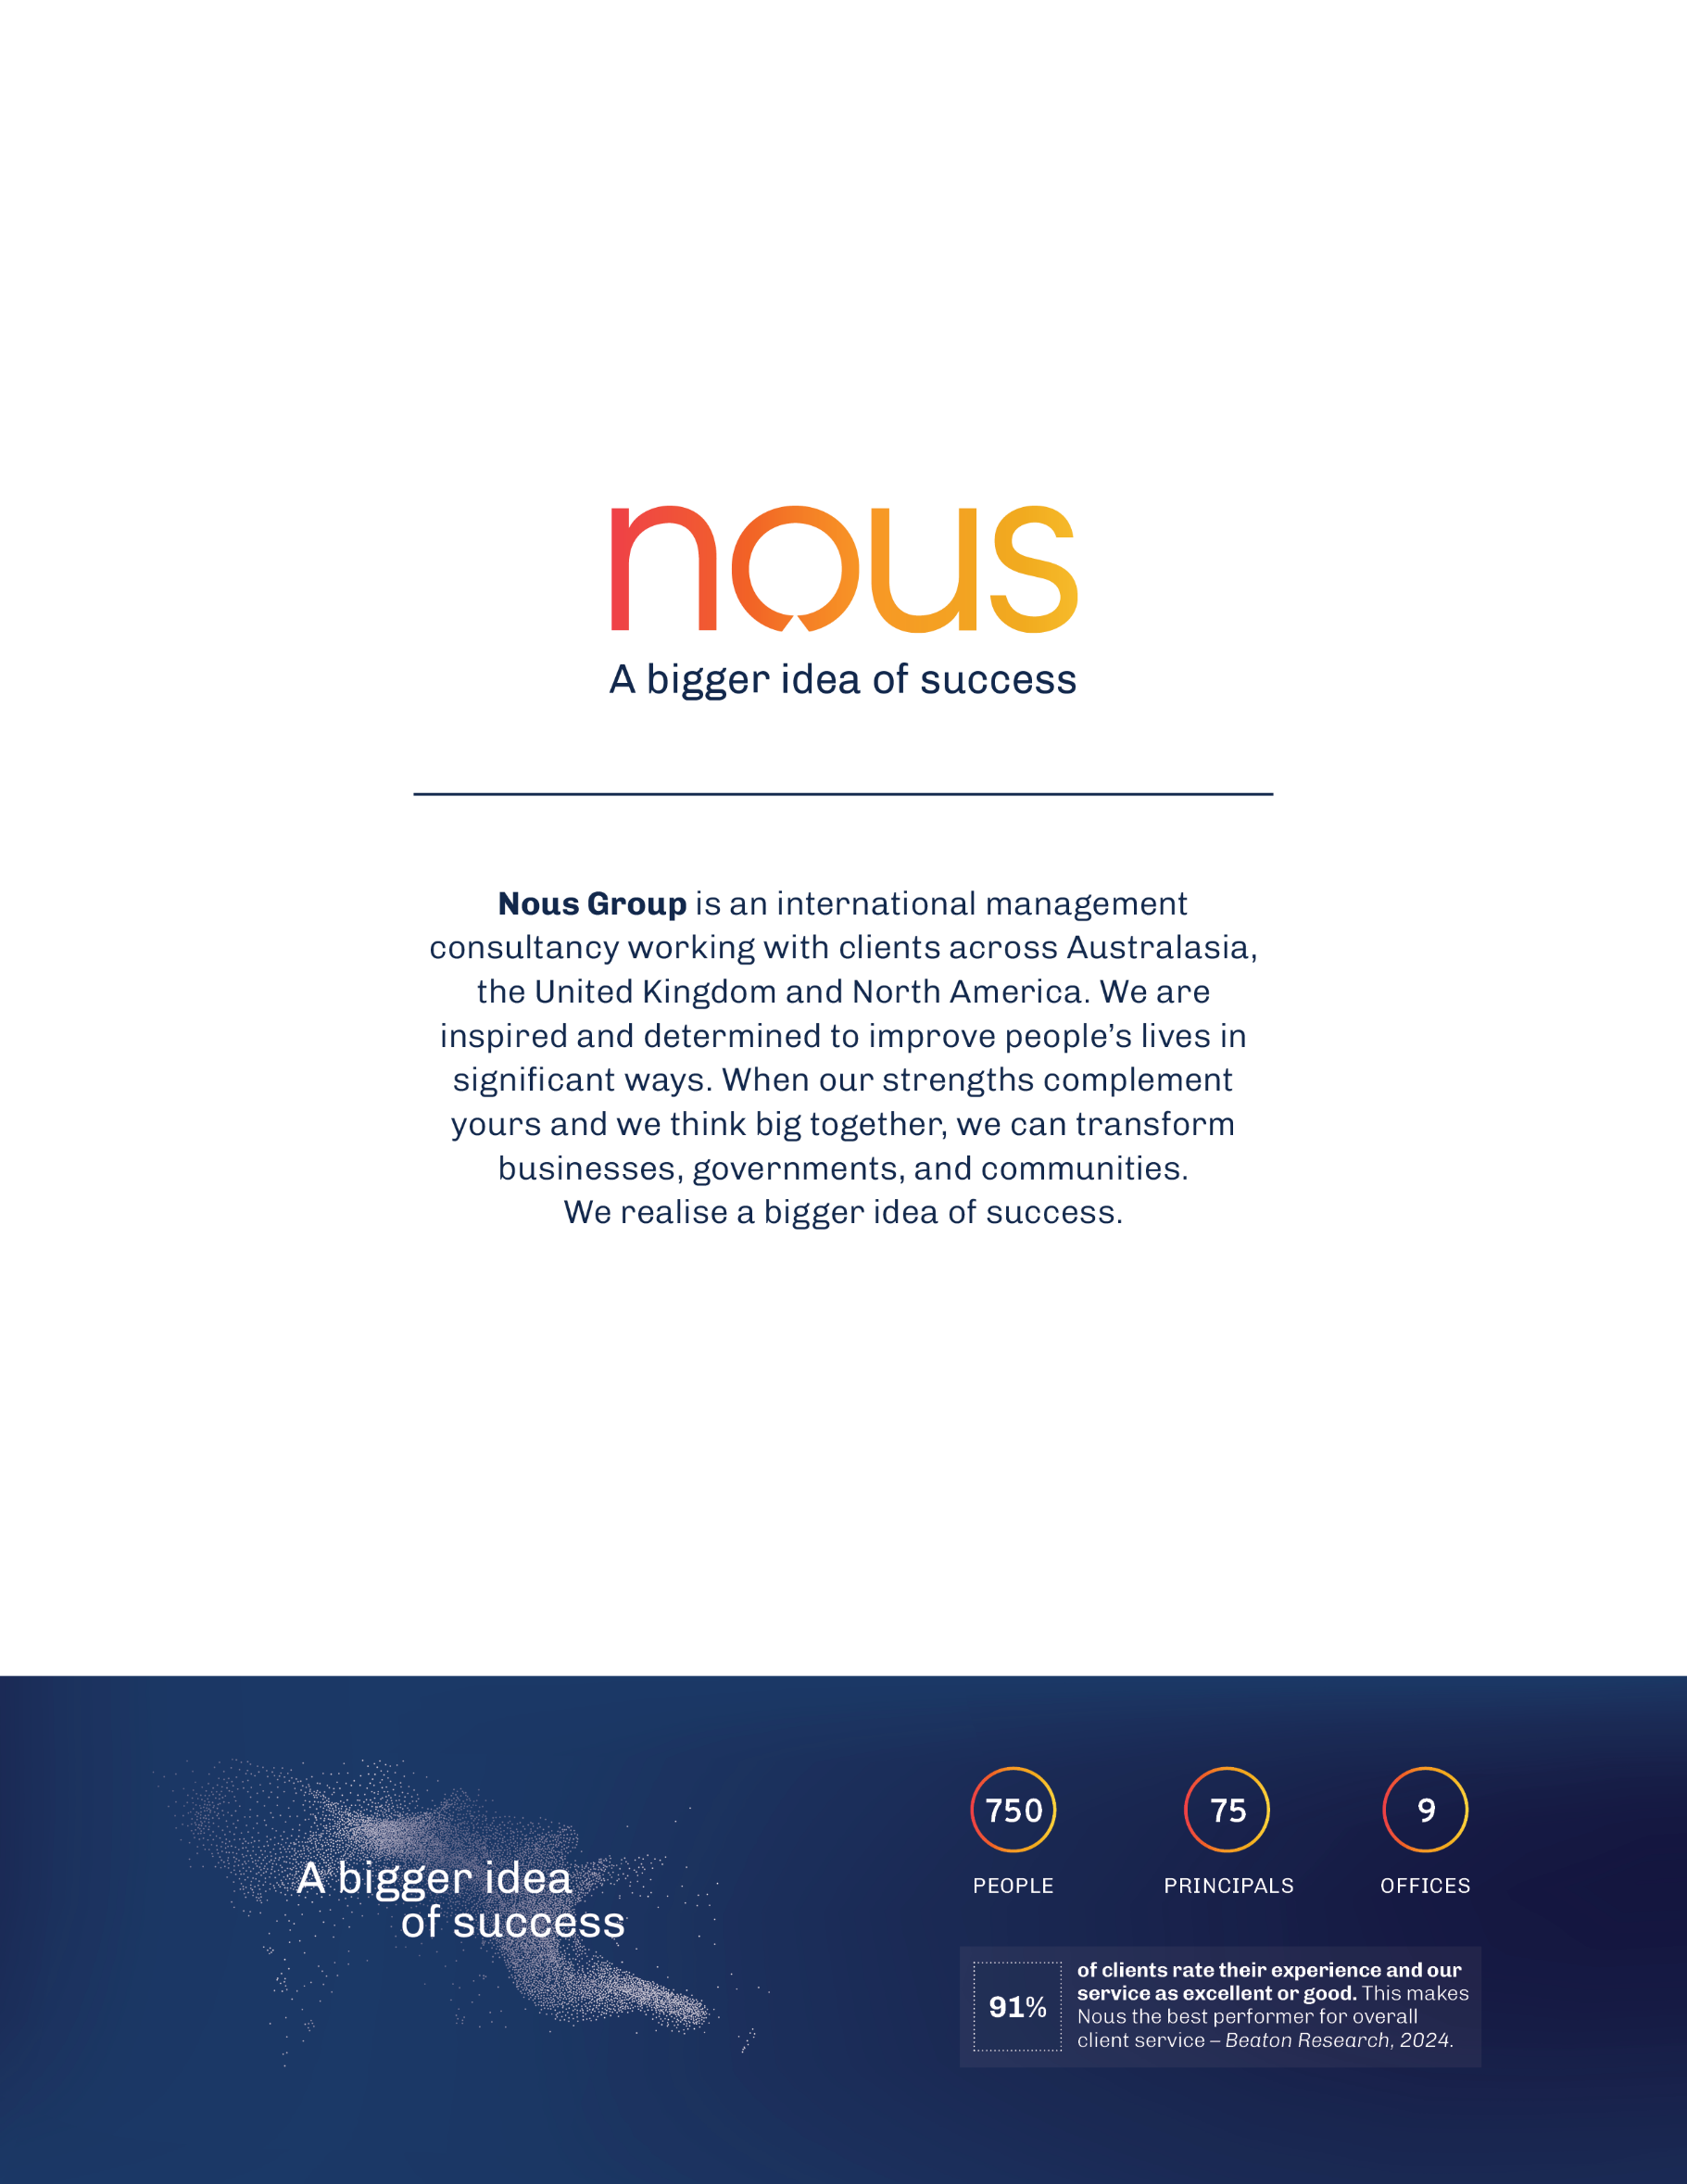

Brotherhood of St Laurence, Social Exclusion Monitor, https://www.bsl.org.au/research/our-research-and-policy-work/social-exclusion-monitor/. Accessed on 22 April, 2025
O’Donnell, James, Alice Falkiner and Katarzyna Szachna. Mapping Social Cohesion 2025. Scanlon Foundation Research Institute, 2025. https://scanloninstitute.org.au/mapping-social
Macdonald, S. J., Deacon, L., Nixon, J., Akintola, A., Gillingham, A., Kent, J., … Highmore, L. (2018). ‘The invisible enemy’: disability, loneliness and isolation. Disability & Society, 33(7), 1138–1159. https://doi.org/10.1080/09687599.2018.1476224
Albath, E. A., Büttner, C. M., Rudert, S. C., Sibley, C. G., & Greifeneder, R. (2023). Young, unemployed, excluded: Unemployed young adults report more ostracism. European Journal of Social Psychology, 53, 1078–1097. https://doi.org/10.1002/ejsp.2953
Australian Institute of Health and Welfare, Social determinants of health, Social determinants of health - Australian Institute of Health and Welfare. Social determinants of health - Australian Institute of Health and Welfare. Accessed on 22 April 2025
Department of Social Services administrative data.
Outcomes analysis therefore compares participants to themselves over time or examines associations between target groups, or organisations, and outcomes.
These include the Stronger Places, Stronger People initiative, Partnerships for Local Action and Community Empowerment (PLACE)
Department of Social Services, Reforms to strengthen the community sector, March 2024, p 13 https://engage.dss.gov.au/wp-content/uploads/2024/05/summary-reportfinal23-april-2024.pdf
Australian Government. (2024). Commonwealth Grants Rules and Principles 2024. Accessed from, https://www.legislation.gov.au/F2024L00854/latest/downloads
Nous notes the assessment centre looked at all applications, just the Selection Advisory Panel manually assessed 700 applications at a later stage in the assessment process.
Rounded to maintain confidentiality.
The reported sample sizes represent the number of clients with both pre- and post-assessment scores for each outcome. These may vary between cohorts and may be lower than the total number of clients with pre- and post assessment scores (n = 9,902), as not all clients have scores recorded for every outcome.
SARC – IC’s objectives include: a) Support young people 12 to 18 years who are disengaged, or at risk of disengaging, from education to reconnect with their community, school, training and/or employment, b) Support people with disabilities and/or mental health issues to participate in the community, and work towards becoming or remaining independent and engaged in the economy and/or society, c) Support women who experience, or are at risk of experiencing, isolation or discrimination to participate in the community and/or economy and increase their self-agency, d) Support people who are unemployed to increase participation in their community and/or increase their capacity to engage in employment, training, or existing employment services.
Australian Institute of Health and Welfare, Social determinants of health, Social determinants of health - Australian Institute of Health and Welfare. Social determinants of health - Australian Institute of Health and Welfare. Accessed on 22 April 2025
Productivity Commission. (2020). Mental Health, Report no. 95, Canberra, p 149-162. Accessed from, https://assets.pc.gov.au/inquiries/completed/mental-health/report/mental-health-volume2.pdf
Brotherhood of St Laurence, Social Exclusion Monitor, https://www.bsl.org.au/research/our-research-and-policy-work/social-exclusion-monitor/. Accessed on 22 April, 2025
Deloitte Access Economics. (2019). The economic benefits of improving social inclusion: A report commissioned by SBS. Access from, https://www.deloitte.com/content/dam/assets-zone1/au/en/docs/services/economics/deloitte-au-economics-benefits-improving-social-inclusion-181119.pdf
Mawn et al. “Are we failing young people not in employment, education or training (NEETs)?A systematic review and meta-analysis of re-engagement interventions”. Systematic Reviews (2017) 6:16, DOI 10.1186/s13643-016-0394-2; Wilks, S., Lahausse, J., Edwards, B.. (2015). Commonwealth Place-Based Service Delivery Initiatives: Key Learnings project. Accessed from, https://aifs.gov.au/sites/default/files/publication-documents/rr32_0.pdf; National Disability Insurance Agency 2021. Interventions to improve social, community & civic participation of adults on the Autism Spectrum or living with Intellectual or Psychosocial Disability, National Disability Insurance Agency, Australian Government. Prepared by MJ Giummarrra, I Randjelovic & L O’Brien.
O’Donnell, James, Alice Falkiner and Katarzyna Szachna. Mapping Social Cohesion 2025. Scanlon Foundation Research Institute, 2025. https://scanloninstitute.org.au/mapping-social
1. Productivity Commission, Closing the Gap Dashboard – Economic Participation, 2021 (accessed 24 November 2025). https://www.pc.gov.au/closing-the-gap-data/dashboard/outcome-area/economic-participation/; Australian Bureau of Statistics, 2. Labour Force, Australia, December 2024 (accessed 24 November 2025) https://www.abs.gov.au/articles/spotlight-changes-participation-rates-men-and-women-australia#recent-changes-in-the-participation-rate; 3. Australian Institute of Health and Welfare (AIHW), Employment and Unemployment, 16 October 2025 (accessed 24 November 2025) Employment and unemployment - Australian Institute of Health and Welfare; 4. Australian Bureau of Statistics, Disability and the labour force, 24 July 2020 (accessed 24 November 2025) https://www.abs.gov.au/articles/disability-and-labour-force ; 5. Regional Australia Institute, Regional Labour Markets Update – September 2025, October 2025 (accessed 24 November), https://regionalaustralia.org.au/Web/Web/Toolkits-Indexes/Regional-Jobs-. Update/Updates/2025/Regional_Labour_Markets_Update_September_2025.aspx; Australian Bureau of Statistics, Labour Force, Australia, (accessed 24 November 2025) https://www.abs.gov.au/statistics/labour/employment-and-unemployment/labour-force-australia/oct-2025; 7. AIHW, Employment and unemployment, 16 October 2025 (accessed 3 December 2025) https://www.aihw.gov.au/reports/australias-welfare/employment-unemployment
Paul Ramsay Foundation, Where are We? Place-based approaches to tackling community challenges in Australia, June 2023
Department of Social Services. (2024). Stronger Places, Stronger People. Accessed from, https://www.dss.gov.au/stronger-places-stronger-people
Department of Social Services. (2025). Partnerships for Local Action and Community Empowerment. Accessed from, https://www.dss.gov.au/supporting-community-change/partnerships-local-action-and-community-empowerment
Department of Social Services, Reforms to strengthen the community sector, March 2024, p 13 https://engage.dss.gov.au/wp-content/uploads/2024/05/summary-reportfinal23-april-2024.pdf
Australian Government. (2024). Commonwealth Grants Rules and Principles 2024. Accessed from, https://www.legislation.gov.au/F2024L00854/latest/downloads
Department of Social Services (2025), A new approach to programs for families and children: Discussion paper, accessed January 12 2025, https://engage.dss.gov.au/wp-content/uploads/2025/11/discussion-paper-1.pdf
Jesuit Social Services Centre for Just Places, RMIT University and Centre for Community Child Health, What works for place based approaches in Victoria – A review of the literature, 2022; Rong, T., Restevski, E., Carroll, M.. (2023). Exploring community engagement in place-based approaches in areas of poor health and disadvantage: A scoping review. Health & Place. https://doi.org/10.1016/j.healthplace.2023.103026; Wilks, S., Lahausse, J., Edwards, B.. (2015). Commonwealth Place-Based Service Delivery Initiatives: Key Learnings project. Accessed from, https://aifs.gov.au/sites/default/files/publication-documents/rr32_0.pdf
Department of Social Services, Grant Opportunity Guidelines: Strong and Resilient Communities – Inclusive Communities
Jesuit Social Services Centre for Just Places, RMIT University and Centre for Community Child Health, What works for place based approaches in Victoria – A review of the literature, 2022; Rong, T., Restevski, E., Carroll, M.. (2023). Exploring community engagement in place-based approaches in areas of poor health and disadvantage: A scoping review. Health & Place. https://doi.org/10.1016/j.healthplace.2023.103026; Wilks, S., Lahausse, J., Edwards, B.. (2015). Commonwealth Place-Based Service Delivery Initiatives: Key Learnings project. Accessed from, https://aifs.gov.au/sites/default/files/publication-documents/rr32_0.pdf
Alderton, A., et al. (2022). What works for place-based approaches in Victoria. Part 1: A review of the literature. Report prepared for the Victorian Department of Jobs, Precincts and Regions. DOI:10.25439/rmt.19304123.v1, p 12, 28, 36, 53.
Jesuit Social Services Centre for Just Places, RMIT University and Centre for Community Child Health, What works for place based approaches in Victoria – A review of the literature, 2022; Rong, T., Restevski, E., Carroll, M.. (2023). Exploring community engagement in place-based approaches in areas of poor health and disadvantage: A scoping review. Health & Place. https://doi.org/10.1016/j.healthplace.2023.103026; Wilks, S., Lahausse, J., Edwards, B.. (2015). Commonwealth Place-Based Service Delivery Initiatives: Key Learnings project. Accessed from, https://aifs.gov.au/sites/default/files/publication-documents/rr32_0.pdf
Department of Social Services. (2025). A new approach to programs for families and children. Accessed from, https://engage.dss.gov.au/wp-content/uploads/2025/11/discussion-paper-1.pdf
Note: longer programs were defined as ‘more than a year’ but dose and contact hours were not available. Yeyati, Eduardo Levy, et al. "What Works for Active Labor Market Policies? A Meta-Analysis of RCT Findings." Economía LACEA Journal 24.1 (2025). https://economia.lse.ac.uk/articles/10.31389/eco.450
Perla, R. J., Pham, H., Gilfillan, R., Berwick, D. M., Baron, R. J., Lee, P., McCannon, C. J., Progar, K., & Shrank, W. H. (2018). Government As Innovation Catalyst: Lessons From The Early Center For Medicare And Medicaid Innovation Models. Health affairs (Project Hope), 37(2), 213–221. https://doi.org/10.1377/hlthaff.2017.1109
DSS (2023), SARC – IC Inclusive Communities Grants Round 3 Grant Opportunity Guidelines, p 7
Jesuit Social Services Centre for Just Places, RMIT University and Centre for Community Child Health, What works for place based approaches in Victoria – A review of the literature, 2022; Rong, T., Restevski, E., Carroll, M.. (2023). Exploring community engagement in place-based approaches in areas of poor health and disadvantage: A scoping review. Health & Place. https://doi.org/10.1016/j.healthplace.2023.103026; Wilks, S., Lahausse, J., Edwards, B.. (2015). Commonwealth Place-Based Service Delivery Initiatives: Key Learnings project. Accessed from, https://aifs.gov.au/sites/default/files/publication-documents/rr32_0.pdf
Lata et al. (2024). Advancing collaborative social outcomes through place based solutions – aligning policy and funding systems. Policy and Society. https://doi.org/10.1093/polsoc/puae018
Department of Social Services. Grant Opportunity Guidelines p 11
Jesuit Social Services Centre for Just Places, RMIT University and Centre for Community Child Health, What works for place based approaches in Victoria – A review of the literature, 2022
Wilks, S., Lahausse, J., Edwards, B.. (2015). Commonwealth Place-Based Service Delivery Initiatives: Key Learnings project. Accessed from, https://aifs.gov.au/sites/default/files/publication-documents/rr32_0.pdf
Department of Social Services. Grant Opportunity Guidelines p 11
Department of Social Services. Grant Opportunity Guidelines p 11
Liebman, J.. (2013). Building on recent advances in evidence-based policy making. Accessed from, https://www.hamiltonproject.org/assets/legacy/files/downloads_and_links/THP_LiebmanF2_4-13_1.pdf
Lata et al. (2024). Advancing collaborative social outcomes through place based solutions – aligning policy and funding systems. Policy and Society. https://doi.org/10.1093/polsoc/puae018
Paul Ramsay Foundation. (2023). Where are We? Place-based approaches to tackling community challenges in Australia. Accessed from, https://www.paulramsayfoundation.org.au/news-resources/where-are-we-place-based-approaches-to-tackling-community-challenges-in-australia
Department of Social Services. Grant Opportunity Guidelines p 11
Department of Social Services (2022), DEX Program Specific Guidance. Accessed from, https://dex.dss.gov.au/sites/default/files/documents/2022-08/1471-program-specific-guidance.pdf
Department of Social Services. (2025). Corporate Plan 2025-26. Accessed from, https://www.dss.gov.au/system/files/documents/2025-08/dss-corporate-plan-2025-26.pdf
Department of Social Services. (2025). Economic Inclusion Advisory Committee. Accessed from, https://www.dss.gov.au/committees/economic-inclusion-advisory-committee
Ending loneliness together. (2025). A National Strategy to Address Loneliness and Social Isolation. Accessed from, https://treasury.gov.au/sites/default/files/2021-05/171663_ending_loneliness_together.pdf
DSS, Commonwealth Outcomes Fund, Accessed 20 January 2025, https://www.dss.gov.au/social-impact-investing/commonwealth-outcomes-fund
Based on data provided in the Department’s Lessons Learned and Feedback Reports (Rounds 1-3)
Interviews with Departmental staff; Round One Lessons Learned and Feedback Report
Grant recipients who participated in the survey who responded ‘somewhat agree’ or ‘strongly agree’ to ‘to what extent do you agree it was easy to understand the grant guidelines?’
8 per cent of AWPs also referenced a high turnover of FAMs, and 5/51 survey respondents referenced high turnover in a non compulsory open text response.
10 per cent of AWPs mentioned low attendance and time taken to build stronger attendance numbers as a barrier. Roughly 20-30 per cent of grant recipients interviewed noted that it took 3-6 months to build attendance numbers.
Rounded to maintain confidentiality.
Centre for Evidence and Implementation, Monash University, The Behavioural Insights Team. (2020). Evaluation of the Homeless Youth Assistance Program. Access from, https://www.ceiglobal.org/sites/default/files/uploads/files/Evaluation%20of%20the%20Homeless%20Youth%20Assistance%20Program.pdf
Acil Allen Consulting. (2015). SEE Programme Evaluation. Accessed from, https://www.dewr.gov.au/download/7096/see-programme-evaluation-report/11100/see-programme-evaluation-report/pdf
Nous Group. (2024). Review of the Reconnect program. Accessed from, https://treasury.gov.au/sites/default/files/2025-07/review-reconnect-program-final-report.pdf
Deloitte. (2012). Evaluation of Skilling Queenslanders for Work. Accessed from, https://alt-qed.qed.qld.gov.au/our-publications/reports/Documents/evaluation/evaluation-skilling-queenslanders-work.pdf
GrantConnect. (2025). GrantConnection Grant Award List. Retrieved from https://www.grants.gov.au/Ga/DownloadResult?Type=Ga&AgencyStatus=-1&Keyword=strong+and+resilient+communities&KeywordTypeSearch=AllWord&DateType=Publish+Date&page=13
Retrieved from internal DSS grants reporting system.
The data was for the period 2022/07/01 to 2025/10/31, was current as at 2025/11/18 13:21:19 AEDT, and was requestor-provided.
The Program Specific Guidance assists service providers on entering data into the Data Exchange in a consistent way.
Remoteness Areas divide Australia into five classes of remoteness which are characterised by a measure of relative geographic access to services.
A geographical area built from whole Mesh Blocks, it is the smallest geographic area available in DEX.
Department of Social Services. (2023). Reconnect Program Operational Guidelines1 July 2023 to 30 June 2026. Accessed from, https://treasury.gov.au/sites/default/files/2025-07/reconnect-operational-guidelines-2023-2026.pdf
Workforce Australia. (2025). Transition to Work. Accessed from, https://www.dewr.gov.au/download/6263/transition-work-fact-sheet/37679/transition-work-fact-sheet/pdf
Department of Health, Disability, and Ageing. (2025). Funding for disability projects. Accessed from, https://www.health.gov.au/our-work/information-linkages-and-capacity-building?language=en
Department of Social Services. (2023). ILC Program Performance Measurement Framework. Accessed from, https://www.health.gov.au/sites/default/files/2025-07/ilc-outcomes-framework_0.pdf
Commonwealth of Australia. (2021). Women’s Budget Statement 2021-22. Accessed from, https://archive.budget.gov.au/2021-22/womens-statement/download/womens_budget_statement_2021-22.pdf
Community Grants Hub. (2025). Women's Leadership and Development Program - Project Grants. Accessed from, https://www.communitygrants.gov.au/grants/womens-leadership-development
Department of Employment and Workplace Relations. (2022). Discussion Paper – Delivery of the SEE Program 2023. Accessed from, https://www.dewr.gov.au/skills-education-and-employment/resources/see-discussion-paper-2023
Department of Employment and Workplace Relations. (2024). Expanding language, literacy, numeracy and digital skills training opportunities. Accessed from, https://www.dewr.gov.au/newsroom/articles/expanding-language-literacy-numeracy-and-digital-skills-training-opportunities-0
Department of Employment and Workplace Relations. (2022). SEE Program factsheet. Accessed from, https://www.dewr.gov.au/skills-education-and-employment/resources/see-program-factsheet
Department of Social Services. (2025). Commonwealth Outcomes Fund. Accessed from, https://www.dss.gov.au/social-impact-investing/commonwealth-outcomes-fund
Queensland Government. (2025). Skilling Queenslanders for Work – General. Accessed from, https://dtet.qld.gov.au/__data/assets/pdf_file/0021/7833/sqw-fact-sheet.pdf
Greater Melbourne Foundation. (2025). Work Integration Social Enterprise (WISE). Accessed from, https://www.greatermelbournefoundation.org.au/strategy-2030/initiatives/work-integration-social-enterprise-wise
Community Resources. (2025). With 89% Job Retention, Strive for Success Shows a New Way to Solve Youth Unemployment. Accessed from, https://static1.squarespace.com/static/5b2b4577b10598b2166a065f/t/68a513558da0a82c77028484/1755648853734/MEDIA+RELEASE+-+Strive+for+Success+Shows+a+New+Way+to+Solve+Youth+Unemployment+-+August+2025.pdf
Paul Ramsay Foundation, Where are We? Place-based approaches to tackling community challenges in Australia, June 2023; Jacob Torfing, Collaborative innovation in the public sector: the argument, Public Management Review (2018) DOI: 10.1080/14719037.2018.143024; Treasury, Australian Government principles for social impact investing, Accessed at: https://treasury.gov.au/programs-initiatives-consumers-community/social-impact-investing/australian-government-principles-for-social-impact-investing
Wilks, S., Lahausse, J., Edwards, B.. (2015). Commonwealth Place-Based Service Delivery Initiatives: Key Learnings project. Accessed from, https://aifs.gov.au/sites/default/files/publication-documents/rr32_0.pdf
Lata et al. (2024). Advancing collaborative social outcomes through place based solutions – aligning policy and funding systems. Policy and Society. https://doi.org/10.1093/polsoc/puae018
Jesuit Social Services Centre for Just Places, RMIT University and Centre for Community Child Health, What works for place based approaches in Victoria – A review of the literature, 2022; Tendulkar, Shalini A., et al. "A Funding Initiative for Community-Based Participatory Research: Lessons from the Harvard Catalyst Seed Grants." Progress in Community Health Partnerships: Research, Education, and Action, vol. 5 no. 1, 2011, p. 35-44. Project MUSE, https://dx.doi.org/10.1353/cpr.2011.0005.
Rong, T., Restevski, E., Carroll, M.. (2023). Exploring community engagement in place-based approaches in areas of poor health and disadvantage: A scoping review. Health & Place. https://doi.org/10.1016/j.healthplace.2023.103026
Lata et al. (2024). Advancing collaborative social outcomes through place based solutions – aligning policy and funding systems. Policy and Society. https://doi.org/10.1093/polsoc/puae018; Treasury, Australian Government principles for social impact investing, Accessed at: https://treasury.gov.au/programs-initiatives-consumers-community/social-impact-investing/australian-government-principles-for-social-impact-investing; Australian Centre for Evaluation, Evaluating Pilot Programs (2025) Accessed at https://evaluation.treasury.gov.au/sites/evaluation.treasury.gov.au/files/2025-07/guide-evaluating-pilot-programs.pdf
Paul Ramsay Foundation, Where are We? Place-based approaches to tackling community challenges in Australia, June 2023; Jesuit Social Services Centre for Just Places, RMIT University and Centre for Community Child Health, What works for place based approaches in Victoria – A review of the literature, 2022
Note: the literature rarely defines what is meant by ‘long-term’ funding. In Australia, organisations have recently called for long-term funding, with most suggesting this would be 5 years. See: https://engage.dss.gov.au/wp-content/uploads/2024/05/summary-reportfinal23-april-2024.pdf;
Jesuit Social Services Centre for Just Places, RMIT University and Centre for Community Child Health, What works for place based approaches in Victoria – A review of the literature, 2022; Rong, T., Restevski, E., Carroll, M.. (2023). Exploring community engagement in place-based approaches in areas of poor health and disadvantage: A scoping review. Health & Place. https://doi.org/10.1016/j.healthplace.2023.103026
Alderton, A., et al. (2022). What works for place-based approaches in Victoria. Part 1: A review of the literature. Report prepared for the Victorian Department of Jobs, Precincts and Regions. DOI:10.25439/rmt.19304123.v1, p 12, 28, 36, 53.
Jesuit Social Services Centre for Just Places, RMIT University and Centre for Community Child Health, What works for place based approaches in Victoria – A review of the literature, 2022; Rong, T., Restevski, E., Carroll, M.. (2023). Exploring community engagement in place-based approaches in areas of poor health and disadvantage: A scoping review. Health & Place. https://doi.org/10.1016/j.healthplace.2023.103026
Jesuit Social Services Centre for Just Places, RMIT University and Centre for Community Child Health, What works for place based approaches in Victoria – A review of the literature, 2022; Rong, T., Restevski, E., Carroll, M.. (2023). Exploring community engagement in place-based approaches in areas of poor health and disadvantage: A scoping review. Health & Place. https://doi.org/10.1016/j.healthplace.2023.103026
Note: longer programs were defined as ‘more than a year’ but dose and contact hours were not available. Yeyati, Eduardo Levy, et al. "What Works for Active Labor Market Policies? A Meta-Analysis of RCT Findings." Economía LACEA Journal 24.1 (2025). https://economia.lse.ac.uk/articles/10.31389/eco.450
ACOSS. (2021). Valuing Australia’s Community Sector: Better Contracting For Capacity, Sustainability And Impact. Accessed from, https://www.acoss.org.au/wp-content/uploads/2021/06/ACSS-2021_better-contracting-report.pdf; Department of Social Services. (2024). Department of Social Services – Reforms to strengthen the community sector. Accessed from, https://engage.dss.gov.au/wp-content/uploads/2024/05/summary-reportfinal23-april-2024.pdf; Lata, Lutfun Nahar, et al. "Advancing collaborative social outcomes through place-based solutions – aligning policy and funding systems." Policy and Society (2024) https://doi.org/10.1093/polsoc/puae018
Irvine, Annie, et al. "‘Less Money, Less Time, More Complex Clients’: The Impacts of Short‐Term Funding for Third Sector Employability Programmes and Potential for Moral Distress." Social Policy & Administration 59.5 (2025): 749-761 https://doi.org/10.1111/spol.13089; Department for Work and Pensions (UK). (2018). Evaluation of the Innovation Fund pilot: quantitative assessment of impact and social return on investment. Accessed from,, https://assets.publishing.service.gov.uk/media/5b87ce4440f0b63cacd32743/evaluation-of-the-innovation-fund-pilot-quantitative-assessment-of-impact-and-social-return-on-investment.pdf
Wilson et al., Use of small grants to support and enable innovation in teen pregnancy prevention, 2018; Perla et al’, Government as Innovation Catalyst: Lessons from the Early Centre for medicate and Medicaid Innovation models
Prime Minister and Cabinet, Final Report of the Australian Social Impact Investing Taskforce: A Commonwealth strategy to build a mature and self-sustaining social impact investing market that improves the lives of vulnerable Australians (2020), Accessed at https://treasury.gov.au/sites/default/files/2023-12/p2023-391009-taskforce-final-report-2020.pdf ; Urbis, Social Impact Investing Program Evaluation: final report (2023), Accessed at https://treasury.gov.au/sites/default/files/2023-12/p2023-391009-taskforce-final-report-2020.pdf; Western Australian Future Health Research and Innovation Fund, Innovation Seed Fund 2024-25 Guidelines and Conditions, Accessed at https://fhrifund.health.wa.gov.au/~/media/FHRI/Documents/Innovation-Seed-Fund-24-25/Innovation-Seed-Fund-2024-25---Guidelines-and-Conditions.pdf; Commonwealth Outcomes Fund, accessed at Commonwealth Outcomes Fund | Department of Social Services; Department of Social Services, Try, Test And Learn Fund accessed at https://www.dss.gov.au/try-test-and-learn; FitzGerald, C., Fraser, A., Kimmitt, J., Knoll, L., & Williams, J. (2023). Outcomes-based contracting and public management reform: Lessons from a decade of experimentation. International Public Management Journal, 26(3), 329–338. https://doi.org/10.1080/10967494.2023.2170504; FitzGerald, C., et al., Outcomes-based contracting and public management reform: Lessons from a decade of experimentation. International Public Management Journal (2023), 26(3), 329–338. https://doi.org/10.1080/10967494.2023.2170504; Coram, Veronica, et al. "The Aspire Social Impact Bond: How social impact bond financing can promote positive social and economic outcomes." Australian Journal of Social Issues 60.1 (2025): 176-195 https://doi.org/10.1002/ajs4.354; Broom, Jacob. "Social impact bonds and fast policy: Analyzing the Australian experience." Environment and Planning A: Economy and Space 53.1 (2021): 113-130 https://doi.org/10.1177/0308518X20941522.
Mawn et al. “Are we failing young people not in employment, education or training (NEETs)?A systematic review and meta-analysis of re-engagement interventions”. Systematic Reviews (2017) 6:16, DOI 10.1186/s13643-016-0394-2; Stea, Tonje Holte, et al. "Interventions targeting young people not in employment, education or training (NEET) for increased likelihood of return to school or employment—A systematic review." Plos one 19.6 (2024): e0306285; Apunyo, Robert, et al. "Interventions to increase youth employment: An evidence and gap map." Campbell Systematic Reviews 18.1 (2022): e1216.
Mawn et al. “Are we failing young people not in employment, education or training (NEETs)?A systematic review and meta-analysis of re-engagement interventions”. Systematic Reviews (2017) 6:16, DOI 10.1186/s13643-016-0394-2; Wilks, S., Lahausse, J., Edwards, B.. (2015). Commonwealth Place-Based Service Delivery Initiatives: Key Learnings project. Accessed from, https://aifs.gov.au/sites/default/files/publication-documents/rr32_0.pdf
Wilks, S., Lahausse, J., Edwards, B.. (2015). Commonwealth Place-Based Service Delivery Initiatives: Key Learnings project. Accessed from, https://aifs.gov.au/sites/default/files/publication-documents/rr32_0.pdf
OECD. (2023), Adolescent Education and Pre-Employment Interventions in Australia: Keeping Young People in Education, Employment and Training, OECD Publishing, Paris, https://doi.org/10.1787/7bf19171-en.
Donaldson, C., Moore, G., & Hawkins, J. (2023). A systematic review of school transition interventions to improve mental health and wellbeing outcomes in children and young people. School Mental Health, 15(1), 19-35.
Stea TH, Bertelsen TB, Fegran L, Sejersted E, Kleppang AL, et al. (2024) Interventions targeting young people not in employment, education or training (NEET) for increased likelihood of return to school or employment—A systematic review. PLOS ONE 19(6): e0306285. https://doi.org/10.1371/journal.pone.0306285
Kregel, J., et al. “A Comprehensive Review of Evidence-Based Employment Practices for Youth and Adults with Intellectual and Other Developmental Disabilities: Final report.” (2020). Rehabilitation Research and Training Center at Virginia Commonwealth University in Richmond, Virginia and Centre for Disability Studies, affiliated with the University of Sydney, Australia
Kavanagh, A., et al. "b, Evidence review: Strategies to increase employment and economic participation for people with a cognitive disability." (2021), p 2, 22. https://apo.org.au/node/319836
National Disability Insurance Agency 2021. Interventions to improve social, community & civic participation of adults on the Autism Spectrum or living with Intellectual or Psychosocial Disability, National Disability Insurance Agency, Australian Government. Prepared by MJ Giummarrra, I Randjelovic & L O’Brien.
Gooding, P., Anderson, J. and McVilly, K., “Disability and social inclusion ‘Down Under’: A systematic literature review.” (2017), p 14-15.
Monroe, M. C., & McDonell, L. (2012). Flexible Training Program Builds Capacity for Diverse Challenges. The Journal of Extension, 50(5), Article 4. https://doi.org/10.34068/joe.50.05.04
McKenzie, D. (2017). How effective are active labor market policies in developing countries? a critical review of recent evidence. The World Bank Research Observer, 32(2):127–154; Omidakhsha, Negar, et al. "Changes in women’s economic participation after the implementation of national and subnational policies: a global systematic review."n.d. https://www.worldpolicycenter.org/sites/default/files/2022-07/Women_Economic_Participation_Systematic_Review.pdf; Peterman, Amber, et al. "Social safety nets, women’s economic achievements and agency." Centre for Global Development, n.d., Social Safety Nets, Women’s Economic Achievements and Agency: A Systematic Review and Meta-Analysis
Ieva, G., & Andrius, J. (2024). Women in transport: Systematic literature review of mobility barriers to women's employment. International Journal of Employment Studies, 32(2), 48-72.
Díaz-Martin, Lucía, et al. "Greater than the sum of the parts? Evidence on mechanisms operating in women's groups." The World Bank Research Observer 38.1 (2023): 1-35. https://doi.org/10.1093/wbro/lkac001; Brody, C., Hoop, T. de, Vojtkova, M., Warnock, R., Dunbar, M., Murthy, P., & Dworkin, S. L. (2017). Can self-help group programs improve women’s empowerment? A systematic review. Journal of Development Effectiveness, 9(1), 15–40. https://doi.org/10.1080/19439342.2016.1206607; Gaston MH, Porter GK, Thomas VG. Prime Time Sister Circles: evaluating a gender-specific, culturally relevant health intervention to decrease major risk factors in mid-life African-American women. J Natl Med Assoc. 2007 Apr;99(4):428-38 https://pubmed.ncbi.nlm.nih.gov/17444433/; Canuto K, et al. How and why do women's groups (WGs) improve the quality of maternal and child health (MCH) care? A systematic review of the literature. BMJ Open. 2022 Feb 21;12(2):e055756. doi: 10.1136/bmjopen-2021-055756. PMID: 35190438; PMCID: PMC8862452.
Ziersch A, Due C, Howe J, Walsh M, Miller E & Flavel J. (2022). Pathways to employment for social inclusion, health and wellbeing for women from refugee backgrounds. Flinders University, Adelaide, p 9, 55. https://mrhresearchgroup.com.au/wp-content/uploads/2022/06/Public-Report_Pathways-to-Employment-for-Social-Inclusion-Health-Wellbeing-for-Women-from-Refugee-Backgrounds_2022.pdf
Note: longer programs were defined as ‘more than a year’ but dose and contact hours were not available. Yeyati, Eduardo Levy, et al. "What Works for Active Labor Market Policies? A Meta-Analysis of RCT Findings." Economía LACEA Journal 24.1 (2025). https://economia.lse.ac.uk/articles/10.31389/eco.450
Cross, Suzanne L. "Long term unemployed: barriers and approaches to optimise return to work outcomes."(2021), p 3, 12. https://www.atworkaustralia.com.au/wp-content/uploads/2021/08/atWork-Australia-LTU-Barriers-and-strategies-Final.pdf
Cross, Suzanne L. "Long term unemployed: barriers and approaches to optimise return to work outcomes."(2021), p 4, 5, 7. https://www.atworkaustralia.com.au/wp-content/uploads/2021/08/atWork-Australia-LTU-Barriers-and-strategies-Final.pdf
Cross, Suzanne L. "Long term unemployed: barriers and approaches to optimise return to work outcomes."(2021), p 4, 5, 7. https://www.atworkaustralia.com.au/wp-content/uploads/2021/08/atWork-Australia-LTU-Barriers-and-strategies-Final.pdf

