May 2026

Stream 2 report (appropriateness and implementation analysis)

Independent evaluation of the Home Interaction Program for Parents and Youngsters (HIPPY)

Acknowledgement of Country
The Parenting Research Centre acknowledges and respects the diverse Aboriginal and Torres Strait Islander people of this country and the Elders of the past and present.
Contributing authors
Dr Gina-Maree Sartore, Parenting Research Centre (PRC)
Dr Lillian de Bortoli, IPS
Hannah Burgess, IPS
Kay Esensoy, IPS
Conrad Forrest, IPS
Belinda Kendall, Curijo
Zane Kendall, Curijo
Colette McEntee, IPS
Shaquille McKenzie, IPS
Zvezdana Petrovic, PRC
Dr Catherine Wade, PRC
Kira Small, Curijo

The authors acknowledge with thanks the invaluable contributions of the following to the work reported here: Nataja Witbreuk (Curijo), Stanley Jarrett (Curijo), Amy Graham (PRC), and Jan Matthews (PRC). We also express our thanks to the teams at Department of Social Services and the Brotherhood of St. Laurence for their ongoing support.

Recommended citation
Parenting Research Centre, IPS Management Consultants, and Curijo (2026). Stream 2 Report (Appropriateness and Implementation analysis). Independent evaluation of the Home Interaction Program for Parents and Youngsters (HIPPY). Melbourne, Australia.
Contact
Melbourne office
Hub Southern Cross
Level 2, 696 Bourke Street
Melbourne, Victoria, 3000
Sydney office
Hub Hyde Park
Level 3, 223 Liverpool Street
Darlinghurst NSW 2010

P: +61 3 8660 3500
E: info@parentingrc.org.au
www.parentingrc.org.au

© Parenting Research Centre, May 2026. No part of this publication may be reproduced, stored in a retrieval system or transmitted in any form or by any means without the prior written permission of the publisher.
Contents
Executive summary 5
Section 1: Overview of findings and recommendations 7
Introduction 7
Summary of Stream 1 findings 7
Stream 2 methodology 8
Is HIPPY accessible and inclusive? 9
Has the HIPPY program been implemented as intended? 16
Summary and recommendations 17
Section 2: Site consultations 20
Evaluation framework and methodology 20
Cultural safety 20
Site selection 21
Recruitment process 21
Data collection methodology 22
Coding for analysis 22
Evaluation analysis 23
Engagement details 26
Site demographics 27
Participant demographics 28
Results and findings 29
Implementation domain as a measure of accessibility 29
Appropriateness domain as a measure of inclusiveness 50
Section 3: Survey and program data 70
Survey and administrative data methodology 70
Findings: DEX data 71
Findings: Parents and carers survey 71
Findings: Tutor and Coordinator survey 87
Findings: Tutor administrative data 98
Section 4: Limitations and challenges 103
Section 5: Conclusion and recommendations 105
Is HIPPY accessible? 105
Is HIPPY inclusive? 106
Has the HIPPY program been implemented as intended? 107
Recommendations 107
Appendix 1: Cultural Alignment Charter 109
Appendix 2: HIPPY sites 110
Appendix 3: Emails to sites 112
Appendix 4: Interview questions 114
A4.1: Parent interview questions 114
A4.2: Staff interview questions 115
Appendix 5: Parent/carer survey questions 119
Appendix 6: Tutor/coordinator survey questions 121

Executive summary
This document reports on Stream 2 of our independent evaluation of the Home Interaction Program for Parents and Youngsters (HIPPY) Australia, for the Department of Social Services (DSS). HIPPY is delivered nationally by the Brotherhood of St. Laurence (BSL). The evaluation was conducted by the Parenting Research Centre (PRC), Curijo, and IPS Management Consultants (IPS), who jointly developed the evaluation plan, conducted qualitative and quantitative work, developed findings, and wrote this report.
Our report has five sections:
Section 1: a stand-alone, detailed summary of the full evaluation questions, methods, findings, and recommendations (sections two to five). This section can be read in isolation but does not include the detailed data and analyses on which the findings and recommendations are based.
Section 2: detailed methods, qualitative analyses, and findings from our site consultations.
Section 3: detailed methods, quantitative data, and findings from our parent survey, our Tutor/Coordinator survey, and program data.
Section 4: limitations and challenges.
Section 5: conclusion and recommendations.
The Stream 2 evaluation comprises consultation with 35 current HIPPY sites and survey data from HIPPY parents, Tutors, and Coordinators who had previously agreed to be contacted for evaluation purposes. We also examined de-identified administrative data on Tutor demographics and training histories, and DSS Data Exchange (DEX) data about HIPPY client demographics and satisfaction ratings.
Our site consultations found that HIPPY is widely regarded as an accessible and equitable program, succeeding through its flexibility, relational delivery, cultural responsiveness, and no-cost (to families) model. HIPPY sites demonstrate strong organisational readiness supported by clear communication, hands-on training, and flexible local operations. Access to HIPPY is largely community-driven and inclusive, which fosters trust among culturally and linguistically diverse and First Nations families, but which can also lead to low public visibility of the program.
HIPPY is a structured but flexible program. Tutors and Coordinators blend fidelity to the HIPPY model with adaptation to local circumstances and parent need, supporting widespread parent engagement. Parents and staff view HIPPY as highly sustainable if funding and workforce support continue. Challenges to sustainability include increasing infrastructure costs, workload and emotional demands on staff, and excessive adaptation which may compromise the model.
HIPPY is regarded as an inclusive and empowering program that strengthens family engagement, school readiness, and community belonging. While some parents and staff suggested a need for greater representation of marginalised groups, improved scheduling flexibility, and greater community and social media outreach, the program is seen as accessible and welcoming with strong benefits for participants.
Our surveys and examination of administrative data indicate that HIPPY has good reach into priority populations and very high client satisfaction. HIPPY sites have a strong presence in locations outside major Australian cities, and the program is attended by people with a variety of educational and employment backgrounds. It is accessible to people experiencing a range of health challenges.
Parents are highly satisfied with HIPPY and feel that the program is good fit for them; for the minority of parents where this was not the case, it was generally because they were already doing many activities at home (or at early education and childcare) that support the home learning environment. The majority of parents indicated that HIPPY is worthwhile to them, attributing this mainly to the increase in their child’s increase in learning and confidence.
Our survey, while limited in sample size, had good reach within the four priority groups which are a focus of this evaluation. Representation amongst First Nations people, people from a culturally and linguistically diverse background, people who identify as LGBTQIA+, and people with a disability was very similar to representation in the general Australian population. All priority groups were highly satisfied with HIPPY, and Tutors and Coordinators endorsed this finding. Tutors and Coordinators generally felt that HIPPY is appropriate for, easy to access, and regularly accessed by all four priority groups.
Tutors and parents report that the transition to a new age cohort has been well implemented with Tutors in particular feeling that the ‘stage not age’ emphasis of HIPPY in conjunction with the earlier entry of children allows greater ability to manage family needs. All Coordinators and a high proportion of Tutors report that HIPPY is delivered in accordance with program guidelines, and administrative data shows extensive training is provided over a wide range of relevant topics. Tutors are overwhelmingly drawn from previous HIPPY participants, which is a significant component of the HIPPY model. Tutors represent a diverse set of personal demographics which reflects the broader HIPPY client base.
Considering the findings from site consultations, surveys, and examination of administrative data, we conclude that:
- HIPPY is accessible and inclusive for all parents, including for priority groups
- HIPPY is being implemented as intended (including the shift to a younger cohort) while remaining responsive to differing site contexts and the individual needs of families.
Based on our findings, we recommend that:
- Program funding and workforce support reflect contemporary needs regarding infrastructure cost increases, workload pressures, and salary expectations.
- Professional development is expanded to include trauma-informed practice, LGBTQIA+ inclusion, strategies for supporting families with complex needs, and enhancing cultural competence.
- Accessibility and outreach are improved (for example by broadening eligibility criteria and increasing marketing and site-specific community engagement).
- The potential to embed HIPPY in schools and early childhood education and care (ECEC) is considered; noting, however, that this is already occurring in some locations and that HIPPY is primarily based in the home.
- Digital and flexible delivery options are explored.
- Program flexibility and sustainability are supported through improved communications and increased monitoring of adaptation to balance flexibility with fidelity
- Multicultural representation in materials and activities is increased.

Section 1: Overview of findings and recommendations

Introduction
This document reports on Stream 2 of our independent evaluation of the Home Interaction Program for Parents and Youngsters (HIPPY) Australia for the Department of Social Services (DSS). HIPPY is delivered nationally by the Brotherhood of St. Laurence (BSL).
This evaluation focuses on identifying who benefits from HIPPY (including different cultural and other priority groups), and how appropriate and accessible the program is for priority groups. The evaluation also explores how recent reforms to the HIPPY program (including transition from delivery to 4-5-year-olds to delivery to 3-4-year-olds) have been experienced by families and staff.
Our evaluation was conducted by the Parenting Research Centre (PRC), Curijo, and IPS Management Consultants (IPS), who jointly developed the evaluation plan, conducted qualitative and quantitative work, developed findings, and wrote this report.
This report should be read in conjunction with our Stream 1 report which addresses program efficiency and effectiveness.
This section is a high-level summary of findings across multiple data sources, structured according to the evaluation questions:
- Is HIPPY accessible and inclusive, overall and for four different cohorts?
  - First Nations people
  - People who are from a culturally and linguistically diverse (CALD) background
  - People who identify as Lesbian, Gay, Bisexual, Transgender, Queer or Questioning, Intersex, Asexual, and other identities (LGBTQIA+)
  - People with disability.
- Have the HIPPY program reforms announced in 2021-22 been implemented as intended (including transition to age 3 and 4 cohorts)?
This section also contains our recommendations from our evaluation of HIPPY. More detailed analyses of data, on which these findings and recommendations are based, can be found in sections 2 (consultations) and 3 (survey responses and administrative data).

Summary of Stream 1 findings
Stream 1 investigated three questions:
- What client outcomes are associated with the HIPPY program?
- To what degree does HIPPY provide value for money?
- How does the HIPPY model compare to other similar Australian models in terms of outcomes achieved and cost effectiveness?
For Stream 1, we reported on our analysis of HIPPY outcomes data, a propensity score matching comparison with similar outcomes for Australian parents and carers and children, and a review of similar programs. Briefly, we found that:
- HIPPY is associated with a range of positive outcomes for parents and children, namely
Enhancing the home learning environment
Improving indicators of early literacy
Strengthening the parent-child relationship
Increasing parents’ sense of connection to their communities
- These positive outcomes were seen in parent participants as a whole, and also for First Nations and culturally and linguistically diverse parents (the two priority groups for whom subgroup analyses were possible).
- Effect sizes showed meaningful improvements in all outcomes we could measure, but improvements were largest for those relating to community connection, confidence in finding support, and successfully finding support.
- Moderate improvements were seen for home learning and early literacy outcomes, and smaller improvements were seen in the parent-child relationship.
- This pattern was seen for First Nations and culturally and linguistically diverse parents.
- HIPPY shares core features with other early childhood programs, with a focus on play-based learning, parental engagement, and universal access.
- HIPPY delivers a relatively broad and sustained intervention (relative to comparable programs) at a moderate cost.
Our Stream 1 evaluation could not include data for the new 3-4-year-old-cohort as this was not available at the time of analysis.
HIPPY demonstrates positive outcomes for families and children, particularly in supporting early learning and parental engagement. While further work is needed to assess long-term impacts and refine cost-effectiveness estimates, this component of our evaluation, finalised in July 2025, suggested that the program offers a valuable and scalable model for early childhood intervention in Australia.

Stream 2 methodology

Qualitative method in brief
We engaged 35 HIPPY sites in either in-person or online consultations with parents and carers, program staff, and community stakeholders. Interviews and focus groups were recorded, transcribed, de-identified, and coded for analysis. Initial coding was undertaken separately by IPS and Curijo using their own participant data; regular meetings and workshops were held between coders to ensure a consistent approach was adopted for subsequent coding and analysis. A second round of coding was held to develop higher-level conceptual categories and to interpret findings. The final analysis addressed questions of accessibility and inclusivity via constructs such as organisational readiness, adaptation and fidelity, reach and accessibility, and acceptability of the program. In this evaluation we operationalise ‘accessibility’ as relating to the extent to which program design and delivery addresses barriers to participation. Furthermore, we operationalise the concept of ‘inclusion’ as participants’ subjective experience that the program is a good fit for them.

Quantitative method in brief
We collected survey data relating to HIPPY implementation and appropriateness from 319 parents and 134 Tutors and Coordinators (84% Tutors) who had previously agreed to be contacted for evaluation purposes. Invitations were sent by BSL and their sub-licensees to just over 4000 parents and carers, giving a response rate of 8% for parents. Invitations were sent to 480 Tutors and Coordinators for a response rate of 38% for Tutors/Coordinators.
Of the 319 parents, 79% were in the cohort targeted in the revised HIPPY program as outlined in reforms to the delivery of the program announced in 2021-22 (i.e., most survey respondents are parents and carers of children aged 3-4 years). As nearly all respondents (96%) identified themselves as parents of the child enrolled in HIPPY, we will generally refer to parents only in the remainder of these findings; however, all responses are included in analyses unless otherwise stated.
In addition to the surveys we developed, we analysed de-identified administrative data provided by BSL on Tutor demographics and training histories, as well as DEX administrative data about HIPPY client demographics and satisfaction ratings.

Is HIPPY accessible and inclusive?

Findings from site consultations

Is HIPPY accessible?
HIPPY is widely regarded as an accessible and equitable program that succeeds through its flexibility, relational delivery, cultural responsiveness, and no-cost (to families) model. The design and delivery of the HIPPY program generally address barriers to participation experienced by program participants.
However, its accessibility could be further improved through expanded outreach, simpler administrative processes, stronger public visibility, and sustained investment in the workforce. These measures would ensure that HIPPY’s accessible design fully translates into equitable reach and participation for all families.

Organisational Accessibility
HIPPY sites demonstrate strong organisational readiness supported by clear communication, hands-on training, and flexible local operations. Coordinators and Tutors benefit from strong supervision and peer learning that promote cultural competence and confidence. However, limited funding, workload pressures, and slow communication from the HIPPY national office reduce consistency and capacity. In some cases, restricted professional development opportunities pose an ongoing challenge to full accessibility particularly in trauma-informed practice, inclusion of LGBTQIA+, and complex family support.

Referral Pathways and Awareness
Access to HIPPY is largely community-driven and inclusive, with referrals often arising from word of mouth, playgroups, and social media. This organic approach fosters trust among culturally and linguistically diverse (CALD) families and First Nations families but also reveals low public visibility. Barriers include limited marketing reach, English-only materials, strict catchment zones, heavy paperwork, and capped intakes reported at some sites (while noting other sites are not reading enrolment maximums). Coordinators address these by simplifying forms, using plain language, and helping low-literacy or non-English-speaking families navigate entry. Greater awareness and broader eligibility would strengthen equitable access.

Program Delivery and Adaptability
Tutors and Coordinators deliver a structured yet flexible program, blending fidelity to the HIPPY model with practical adaptation. They adjust language, pacing, and mode of delivery to meet family needs, including for disability, trauma, or socio-economic disadvantage. Tutors often use first languages, modify activities for neurodivergent children, and meet families in accessible spaces or at convenient times. This adaptability is HIPPY’s central strength, ensuring engagement across varied contexts.

Barriers and Resource Constraints
Despite strong accessibility in principle, challenges persist. Workload and emotional demands on Tutors, limited funding in the context of increasing infrastructure costs, and lack of substitute staff can restrict reach and sustainability. Excessive adaptation, while beneficial for families, risks blurring roles and increasing burnout without adequate support. Improved training, communication systems, and resourcing are needed to maintain both accessibility and program fidelity.

Sustainability and Scalability
Both parents and staff view HIPPY as a highly sustainable and scalable model if funding and workforce support continue. Local flexibility, cultural responsiveness, and peer advocacy are crucial for maintaining its inclusivity and success.

Is HIPPY inclusive?
HIPPY is widely recognised as an inclusive and empowering program that strengthens family engagement, school readiness, and community belonging across diverse backgrounds. Participants generally feel that HIPPY is a good fit for them. Overall, HIPPY demonstrates strong inclusivity through its flexible, culturally aware, and cost-free (to users) design, effectively supporting families of varied backgrounds and abilities while fostering belonging, confidence, and community participation.

Inclusivity and Accessibility
Parents and staff consistently describe HIPPY as flexible, culturally respectful, and equitable. Its home-based design and free materials remove cost barriers, making it accessible for low-income, First Nations peoples, culturally and linguistically diverse (CALD), and disability-affected families. Tutors play a key role in inclusivity by adapting materials for language, ability, or cultural needs, and by connecting families with services like the NDIS.

Cultural and Community Responsiveness
First Nations families feel HIPPY acknowledges their culture, while CALD participants appreciate learning about Australia’s education system. However, some parents (across all groups) seek greater multicultural representation, improved scheduling flexibility, and stronger community and social media outreach.

Empowerment and Outcomes
HIPPY enhances children’s literacy, numeracy, confidence, and emotional regulation, while empowering parents to teach at home and engage in schooling. Many families describe the experience as life-changing due to improved confidence, English language skills, and social connections.

Barriers and Challenges
Challenges included staff workload, time constraints, financial or housing instability experienced by families, and limited rural access. Staff cited funding delays and administrative burdens as constraints on outreach and sustainability.
Some site consultations revealed scope to refine training, consultation, and the funding model. For example:
- Some Coordinators working with families who have complex trauma, self-medicating behaviours, and domestic violence (especially in rural and remote areas) expressed concerns about how sharing their experiences was received by other Coordinators.
- Where HIPPY sites are partnered or collocated with other services, this can create inconsistencies in support and resources provided across all sites; on the other hand, it can create opportunities for bridging access to mainstream services.
- Funding and costs can be a concern for sites, where hours are reduced with minimal notice or costs have increased significantly. This has placed extra pressure on sites to continue delivering the same standard of service with fewer resources and has contributed to difficulty recruiting Tutors.
Nonetheless, and despite these challenges, Tutors’ and Coordinators’ commitment and adaptability sustain engagement with the program.

Findings from DEX data
DEX data indicate strong program reach into priority populations and very high client satisfaction with HIPPY. Between 1 January 2023 and 30 June 2025, 20,709 clients attended at least one HIPPY session. One in five clients identified as Aboriginal and/or Torres Strait Islander (22%), demonstrating substantial engagement with Indigenous families. Thirteen per cent of clients reported that they or their child had a disability, and 17% were culturally and linguistically diverse. Most clients were born in Australia (76%) and spoke English at home (67%), with Urdu the most common other language spoken. Data on LGBTQIA+ identification were not available in DEX.
Client satisfaction data were available through DEX for 6,212 participants over this period, with almost all respondents (99.5%) rating the program positively across assessed domains.

Findings from survey and administrative data
In this section, we look at how our survey participants compare to the Australian population in general, and how well the four priority groups are represented in our survey sample. This allows us to understand the extent to which our survey sample was representative of the general and priority populations.

Is HIPPY accessible and inclusive overall?
Survey respondents were overwhelmingly female (95%). The age of respondents varied from 25 to over 65 years, with some variability in distribution of parent age between subgroups. For example, the culturally and linguistically diverse subgroup tended to have a greater proportion of respondents in the 61-65-year age category and there was a larger proportion of First Nations respondents in the youngest age category.
The majority of survey respondents were first-time HIPPY participants (n = 228, 72%) and this was mirrored in all priority groups and in the 3-4-year-old cohort). The majority of respondents were also current attendees (n = 228, 72%).

HIPPY is accessible across Australia
With the caution that some respondents noted issues with individual site catchment areas restricting access to some potential members, at the national level HIPPY is accessible. More than half of all parent survey respondents (54%) resided outside major cities of Australia. This is much higher than the national average of 33% of Australians living outside capital cities (ABS 2021). With the exception of First Nations survey respondents, very few respondents lived in remote or very remote areas. Nevertheless, close to 10% of First Nations respondents lived in very remote areas, and 3% lived in remote areas – attesting to the geographic reach of the HIPPY program into Indigenous communities.
The majority of parents (79%) were able to attend HIPPY gatherings without incurring any additional costs. Of the minority who indicated they had experienced costs to attend gatherings AND who provided details (65 respondents) the majority had spent less than $50, with a very small number (10 respondents) indicating costs of $100—300. Where a description was given, respondents listed transport (petrol, uber or taxi), childcare, and stationery as contributing to their costs.

HIPPY is attended by people of a variety of educational and employment backgrounds
Parents responding to the survey tended to have high levels of educational attainment, with 81% of respondents reporting study past year 12 (including TAFE and vocational training). Only 19% of participants reported education of year 12 or lower.
Overall, and for most priority groups, the greatest proportion of parents were engaged in home duties (32% overall). Participants could select multiple options, so for many, home duties may be paired with other categories including paid employment, volunteer or unpaid work, seeking employment, retirement, being on leave and studies. Of note, many respondents were in part-time paid employment (25%), but few were in full-time employment (9%). LGBTQIA+ parents had a somewhat different profile to other subgroups, with a greater proportion engaged in studies and being on leave from work.

HIPPY is accessible to people experiencing a range of health challenges
Parents responding to the survey generally described their physical health as good to excellent (91%). First Nations respondents, those with disability and LGBTQIA+ parents tended to report somewhat poorer health. While around 20% of the sample overall identified that they had a physical or medical condition, this was much higher for the LGBTQIA+ cohort (38%), and while it was lower for the First Nations respondents in the sample (16%), there was a large number in this cohort (22%) who preferred not to say whether they had a physical or medical condition. LGBTQIA+ (38%) and First Nations respondents (16%) also had higher rates of sensory impairments and learning difficulties compared to the overall sample (8%). Understandably the Disability cohort had the highest ratings of medical and physical conditions (84%) and sensory impairment or learning difficulties (34%)

Parents are highly satisfied with HIPPY
Survey respondents were highly satisfied with the current HIPPY program (274 respondents from the 3-4-year-old cohort), strongly agreeing that:
- HIPPY is a good fit for them and their family (83%)
- HIPPY is worthwhile for them and their family (84%)
- They are very satisfied with HIPPY (72%)
Satisfaction rates for the four priority groups are detailed below.

HIPPY is a good fit for families
Parents indicated that the program strengthened their relationship with their children and enhanced parent-child interactions. They noted a greater sense of connection with their children, with more opportunities for one-to-one quality time and shared activities, either with their children or as a family. Parents frequently commented that their children enjoyed the program and related activities.
Some of the parent-reported benefits included: improvements in children's social and emotional development, greater confidence and independence, better school readiness, and reduced anxiety. Many parents indicated that the program helped to improve their own confidence and skills, particularly in relation to observing and understanding their child, learning how to teach at their child's pace and how to use play as a learning tool.
Some parents noted that the program fostered social and community connections and was described as inclusive, welcoming and friendly. One parent highlighted that the program provided appropriate resources for First Nations families.
Overall, parents provided positive views on the program resources and materials, describing them as 'great', 'fabulous' and 'amazing'. They also shared positive feedback about HIPPY staff and valued structured activities which reduced the need to plan activities independently.
Where parents did not find the program to be a good fit, this was generally because they were already doing many activities at home or at early education and childcare. HIPPY reinforced what they were already doing but did not provide them with further learnings. For these parents, or for parents who were not sure about how good a fit the program was for them, appeared to be a mismatch between program activities and their child’s developmental needs.

HIPPY is worthwhile for families
The majority of parents who indicated that HIPPY was worthwhile for them described the increase in their child’s learning and confidence as the reason they found it worthwhile. Parents reported that the activities helped to build their child’s independence and skills, such as skills required for school. Parents also expressed how much their children enjoyed the activities and looked forward to receiving the HIPPY activity packs.
Additionally, parents reported on the increase in their own knowledge and confidence in supporting their child’s learning. Some parents felt more empowered and enjoyed the new ideas for activities that they had learned through HIPPY.
Another key theme that made HIPPY worthwhile for families was how it aided family bonding and quality time spent together. Some parents also credited the social connections they made though HIPPY and that their child could play with other children of the same age. Other parents said that the resources made the program worthwhile for them and that the program was welcoming.
Again, parents who did not find HIPPY to be a good fit for their families indicated they were already doing many activities at home or their children were exposed to these activities at daycare. Some parents also experienced time pressure that prevented them fully participating in HIPPY.

How could HIPPY improve?
Following the question about satisfaction with HIPPY, we asked survey respondents if they had suggestions for improving the program.
The most common response from the participants who were satisfied or very satisfied with HIPPY (over 95%) was that they were happy with the program as it is. However, there were some suggestions to vary the days gatherings are held and promote them more, to increase the reach of HIPPY.
The few parents who were not satisfied with the HIPPY program cited a preference for more modelling of activities, additional materials and resources for their child, better alignment with their child's developmental needs, and more support for literacy, numeracy, and fine motor skill development.

Is HIPPY accessible across the four priority groups?

HIPPY is accessible to priority groups
Our survey had good reach within the four priority groups which are a focus of this evaluation. Membership of these priority groups was determined by self-reported demographic questions. Categories were not exclusive, and intersectionality was observed with parents able to be counted in more than one priority group. Representation of priority groups in our sample was very similar to representation in the Australian population.
- First Nations people: 10% (n = 32); Australian population 3%
- People who are from a CALD background: 26% (n = 84); Australian population 28%
- People who identify LGBTQIA+: 5% (n = 16); Australian population 5% (ABS 2021)
- People with a disability: 24% (n = 77); Australian population 21%

Parent satisfaction across priority groups
Breaking down the satisfaction responses for the four priority groups, all groups are highly satisfied with HIPPY. Percentages of each group endorsing the highest rating for each question are shown in Table 1. This table is compiled from full client satisfaction tables relating to goodness-of-fit of the program, perception of the program being worthwhile, and overall satisfaction. As the ratings were overwhelmingly positive and reasonable constant across priority groups, we are including just the highest ratings here. See Figures 9, 10, and 11 in Section 3 for full details.
Table 1. Percentages of parents endorsing highest level of agreement with statement (strongly agree)
 | First Nations people (n = 32) | People who are from a CALD background  (n = 84) | People who identify as LGBTQIA+  (n = 16) | People with a disability  (n = 77)
HIPPY is a good fit for me and my family  (Yes, very much) | 96.9 | 89.3 | 100.0 | 87.0
HIPPY is worthwhile for me and my family  (Yes, very much) | 93.8 | 85.7 | 100.0 | 89.6
Satisfaction with HIPPY  (Very satisfied) | 81.3 | 72.6 | 81.3 | 81.8

We asked Tutors to assess the accessibility and appropriateness of HIPPY for priority groups, and to comment on the level of support for participation (and actual participation) of the groups. Tutors and Coordinators agreed or strongly agreed that HIPPY is accessible to parents from the four priority groups (see Table 2).
Table 2. Percentages of Tutors/Coordinators agreeing with statement about HIPPY accessibility for parents in four priority groups.
 |  | First Nations people | People who are from a CALD background | People who identify as LGBTQIA+ | People with a disability
Tutors  (n = 112) | Strongly agree | 49.1 | 51.8 | 42.0 | 47.3
Tutors  (n = 112) | Agree | 35.7 | 35.7 | 30.4 | 33.9
Tutors  (n = 112) | Unsure | 7.1 | 4.5 | 22.3 | 12.5
Tutors  (n = 112) | Disagree | 3.6 | 3.6 | 1.8 | 2.7
Tutors  (n = 112) | Strongly disagree | 4.5 | 4.5 | 3.6 | 3.6
Coordinators (n = 22) | Strongly agree | 45.5 | 49.1 | 40.9 | 45.5
Coordinators (n = 22) | Agree | 45.5 | 40.9 | 45.9 | 45.5
Coordinators (n = 22) | Unsure | 4.5 | 0.0 | 9.1 | 4.5
Coordinators (n = 22) | Disagree | 0.0 | 0.0 | 4.5 | 4.5
 | Strongly disagree | 4.5 | 0.0 | 0.0 | 0.0

Perception of support for HIPPY access, appropriateness of content, and perception of regular access from First Nations people
The majority of Tutors and coordinators perceived that HIPPY was accessible to First Nations parents (85% and 91% respectively). Most Tutors (74%) and coordinators (82%) also believed that adequate support was provided for First Nations parents to access HIPPY.
However, there were some differences between Tutors and coordinators in relation to the appropriateness of the program content for First Nations parents. Around 81% of Tutors believed that the program content was suitable compared to approximately 64% of coordinators. Nearly one in four coordinators were unsure about the appropriateness of the program content. A similar proportion of Tutors and Coordinators (around 45%) reported that First Nations parents regularly accessed HIPPY.

Perception of support for HIPPY access, appropriateness of content, and perception of regular access from people from a CALD background
The majority of Tutors (84%) and coordinators (82%) reported that adequate support was provided to help CALD parents to access HIPPY. Similarly, 76% of Tutors and 77% reported that CALD parents regularly accessed HIPPY. Regarding the appropriateness of the program content, a higher proportion of Tutors (81%) believed that it was suitable for CALD families, compared to 63% of Coordinators. Notably, around 23% of Coordinators were unsure whether the content was appropriate for this group compared to less than 10% of Tutors.

Perception of support for HIPPY access, appropriateness of content, and perception of regular access from people who identify as LGBTQIA+
Most Tutors (72%) and Coordinators (86%) perceived that HIPPY was accessible to LGBTQIA+ parents. Around 64% of Tutors and 59% of Coordinators reported that adequate support to access HIPPY was provided to this group of parents, although around 30% of Tutors and Coordinators indicated being unsure about this aspect. Only 41% of Tutors and 32% of Coordinators indicated that the LGBTQIA+ parents regularly accessed the program, with a large proportion of Tutors (45%) and Coordinators (32%) indicating uncertainty about regular attendance. Regarding the appropriateness of the program content, 67% of Tutors and 64% of Coordinators believed that it was suitable for LGBTQIA+ parents/caregivers. However, many Tutors (21%) and Coordinators (27%) remained unsure about the appropriateness of the program content for LGBTQIA+ parents.

Perception of support for HIPPY access, appropriateness of content, and perception of regular access from people with a disability
The majority of Tutors (81%) and Coordinators (91%) reported that HIPPY was accessible to parents with a disability. In relation to providing adequate support to access the program, 73% of Tutors and 64% of Coordinators believed that adequate support was provided to parents with a disability, though 18% of Tutors and 23% of Coordinators were unsure. Just under 70% of Tutors and Coordinators indicated that parents with a disability were accessing HIPPY regularly, with Tutors being twice as likely as Coordinators to express uncertainty about regular access. When asked about the appropriateness of the program content, 77% of Tutors and 64% of Coordinators perceived that it was appropriate for parents with disability.

Has the HIPPY program been implemented as intended?
All current groups are consistent with the new age cohort (this was also covered in our Stream 1 report). Feedback from parents and Tutors related to how the recent changes have been experienced. Respondents, especially Tutors, emphasised the ‘stage not age’ approach of HIPPY, allowing for flexibility in implementing activities and managing family needs and Tutor workloads.
All Coordinators reported that HIPPY was delivered in accordance with the program guidelines, compared to 76% of Tutors. The emphasis on Tutor and Coordinator training and support is reflected in participants’ experiences: administrative data shows extensive training was provided over a wide range of relevant topics, and the majority of Tutors (83%) and Coordinators (86%) reported they had no out-of-pocket costs either to be trained in HIPPY or to deliver HIPPY. For the minority of Tutors and Coordinators who reported incurring costs, the most frequently reported source was transport (petrol, mileage, and parking). Some participants also reported bearing the cost of training and obtaining compliance certificates.
Implementation adjustments suggested by Tutors and Coordinators included:
- Increasing emphasis on including disadvantaged and/or non-nuclear families
- Reducing the number and frequency of packs in the second year
- Integrating digital resources to increase accessibility and reach
- Improving the clarity and cultural responsivity of program materials including activity booklets
- Increasing promotion and community engagement efforts
- Increasing training and support, especially around working with diverse families and families experiencing economic pressure and domestic violence
- Improving salary and benefits for Tutors and Coordinators
Based on de-identified data provided for 774 Tutors, Tutors are overwhelmingly (87%) drawn from previous HIPPY participants, in accordance with the HIPPY model. Tutors represent a diverse set of personal demographics, also reflecting the HIPPY participant characteristics: 93% of Tutors are women, 24% identified as First Nations people, and 29% speak a language other than English at home.
HIPPY Tutors are split between casual (56%) and part time (44%) employment. They receive regular training in a wide range of skills and knowledge, some directly related to elements of HIPPY such as home visits and the HIPPY curriculum framework, and many others providing HIPPY-relevant enrichment (such as communication skills, early childhood development, and employment and study skills). The training supports HIPPY implementation by supporting key program delivery priorities:
- HIPPY administration and delivery
- Working with parents and carers as their child’s first teacher
- Increasing parents’ connection to community
- Developing the Tutor’s own community knowledge and study/employment skills

Summary and recommendations

Is HIPPY accessible and inclusive, including for priority groups?
HIPPY is widely regarded as accessible and inclusive. Accessibility may be further improved through expanded outreach, simpler administrative processes, stronger public visibility, and sustained investment in the HIPPY workforce.
HIPPY is reported by Tutors and Coordinators to be well-supported and well-accessed for First Nations and CALD individuals. Content is considered appropriate for these groups. Some Tutors and Coordinators felt uncertain about the appropriateness of content for HIPPY for CALD families, although as a group Tutors and Coordinators were generally positive about content appropriateness for CALD families.
Some Tutors/Coordinators were unsure that appropriate support is provided for LGBTQIA+ parents to participate in HIPPY. This was reflected in lower perception of attendance at HIPPY by LGBTQIA+ parents. This may be due to relatively lower representation in the local population or lower levels of self-identification as LGBTQIA+ among participants. There was reasonable agreement among Tutors and Coordinators that HIPPY content is appropriate for LGBTQIA+ parents, but some were uncertain.
Tutors and Coordinators felt that HIPPY is accessible to people with disabilities and that the content is appropriate for this group. Some Tutors and Coordinators expressed uncertainty about the adequacy of support provided for HIPPY members with a disability to access the program and about whether they are accessing the program.

Has the HIPPY program been implemented as intended?
HIPPY appears to be broadly implemented as intended, including the adjustments made as part of the reforms of 2021-22. Sites have successfully transitioned to the 3-4-year-old cohort, navigating a sometimes-increased workload and retaining a focus on working with children at their developmental stage in preference to their age, while offering families some flexibility in how they engage with the program.
Implementation sites demonstrate strong organisational readiness and adaptability, underpinned by clear communication, hands-on training, and flexible local operations. Coordinators and Tutors benefit from supervision and peer learning that foster cultural competence and confidence. However, systemic challenges such as limited funding, workload pressures, and communication from the national office constrain consistency, capacity and local adaptability. Professional development gaps—particularly in trauma-informed practice, LGBTQIA+ inclusion, and complex family support—also limit full accessibility of the program.
HIPPY is widely recognised as an inclusive and empowering program that strengthens family engagement, school readiness, and community belonging across diverse backgrounds. Its home-based, cost-free design removes financial barriers, while Tutors adapt materials and delivery to meet cultural, linguistic, and disability-related needs. Greater program flexibility when supporting families who have experiences of complex trauma, self-medicating behaviours, and domestic violence may be required. Families report significant benefits, including improved literacy, numeracy, confidence, and social connection. Despite these strengths, barriers persist low public visibility, strict catchment zones, capped intakes, and administrative burdens restrict equitable access. Staff workload, funding delays, and limited rural reach further challenge sustainability.
Based on our site consultations and our examination of survey and administrative data, we make the following recommendations that pertain to the key areas of inquiry:
- Ensure funding for program delivery and workforce support reflects contemporary needs
- Provide sustained and flexible funding to address infrastructure cost increases post-COVID, to alleviate workload pressures, enable substitute staff, and improve salary and benefits for Tutors and Coordinators.
- Ensure funding covers professional development and compliance costs to reduce any out-of-pocket expenses for staff.
- Expand professional development
- Invest in targeted training for trauma-informed practice, LGBTQIA+ inclusion, and strategies for supporting families with complex needs, including for those with intersectionality across priority groupings.
- Enhance cultural competence and skills for working with disadvantaged and non-nuclear families.
- Provide resources for complex needs: Tutors often act as informal case managers; structured support and referral pathways are needed.
- Improve accessibility and outreach
- Broaden eligibility criteria, streamline enrolment processes and reduce administrative barriers such as burdensome paperwork and strict catchment zones.
- Increase marketing and community engagement through multilingual materials, social media campaigns, and partnerships with local organisations.
- Keep and increase flexibility in program delivery to meet families where they are at. For example, if families find the jump from fortnightly (age 3) to weekly (age 4) overwhelming, consider reducing the number of packs or spreading them across two years. Also, consider allowing participation up to age 5 or offering a slower pace for families with disability or complex needs.
- Embed HIPPY in schools and ECEC centres, to increase reach and support children and families holistically.
- Consider developing an option for the younger siblings of children enrolled in HIPPY to assist with early preparations for school readiness via ECEC centres. Although HIPPY is an in-home program, greater presence within early education may improve program reach and provide support for more siblings.
- Explore digital and flexible delivery options
- Consider offering digital program resources and online engagement tools, such as an app or video-based resources, to complement home visits and increase reach, particularly in rural and remote areas and for families with low literacy or limited time.
- Offering flexible scheduling and alternative delivery modes would help to better cater to diverse family circumstances, including community-based meeting options.
- Increase program flexibility and sustainability
- Implement systems for clearer communication between HIPPY national office and site providers, where needed, to ensure consistency.
- Monitor adaptation practices to balance flexibility with fidelity, reducing risks of role confusion and Tutor burnout.
- Increase multicultural representation
- Develop more stories and activities reflecting diverse cultures, not only First Nations.

Section 2: Site consultations

Evaluation framework and methodology
This section of the report details site selection, recruitment processes, including Cultural Safety and how data was collected and analysed for the consultation component of the evaluation.
In preparation for the national evaluation, PRC led initial communications with HIPPY delivery sites, as approved by BSL and DSS, to introduce the evaluation. Initial communications were targeted for Coordinators and Tutors and later, to parents using simple, active language and included visuals through webinars and newsletters.

Cultural safety
IPS and Curijo provided Cultural oversight for the entire evaluation project and were responsible for the development and implementation of the Cultural Alignment Charter (see Appendix 1), the First Nations Stakeholder Engagement Strategy, and the qualitative data collection and analysis component of the HIPPY evaluation. PRC was responsible for the Non-Indigenous Stakeholder Engagement Strategy which shaped communications over the whole project.

Cultural Alignment Charter
To support Cultural Safety throughout the evaluation, IPS led the co-design and development of a Cultural Alignment Charter (see Appendix 1), using a process underpinned by inclusion and collaboration. All evaluation parties, including IPS, Curijo, PRC, BSL and DSS, participated in the workshop. The workshop was guided by five principles (Self Awareness and Cultural Identity, Power, Cultural Approach, Colonial Load and Cultural Protocols) and adopted a yarning approach using key questions.

First Nations Stakeholder Engagement Strategy
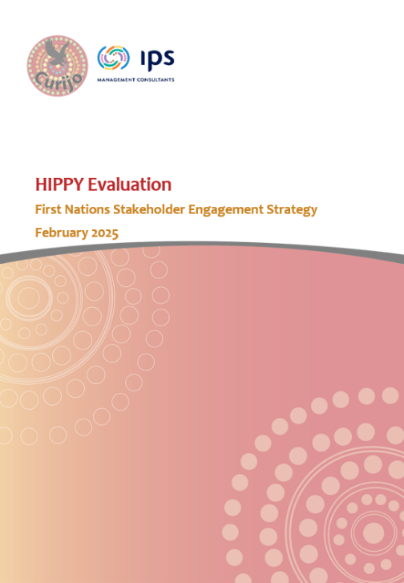
The Engagement Strategy was developed collaboratively by IPS and Curijo, set out the HIPPY Evaluation Project Team’s commitment to authentic, respectful, and culturally responsive engagement.
The Strategy is guided by the Productivity Commission’s Indigenous Evaluation Strategy principles of being credible, useful, ethical, and transparent. Foundational principles embedded include respect and recognition, self-determination, cultural safety, free, prior and informed consent, strengths-based and trauma-informed practice, and active involvement of First Nations team members.
Consultations were designed to be culturally safe and inclusive, using yarning circles, small group discussions, and semi-structured interviews. This emphasised relationship building, storytelling, and deep listening, allowing participants to share comfortably. Intersectionality was included, ensuring meaningful engagement of voices across LGBTQIA+, CALD, and people with disability cohorts.

Core aspects of the Strategy included:
- Indigenous Data Sovereignty where First Nations stakeholders retained ownership and control of their data, with collaborative decisions about storage, use, and sharing. Feedback loops enabled communities to determine how and when findings were returned in meaningful, accessible formats.
- Reciprocity and partnerships with First Nations organisations and leaders, transparent communication, and adherence to local cultural protocols (such as seeking permission from Elders before engaging with communities). Risk management measures safeguarded cultural integrity and ensured ethical and transparent processes.
- A culturally grounded framework for engaging First Nations stakeholders, embedding their voices, knowledge, and priorities in evaluation findings.

Site selection
Sites were selected by IPS and Curijo (with support from BSL who informed site selection via their understanding of broader challenges and work underway across all sites) to reflect a balance of geographical areas and community contexts and determined by locations with a mix of families from diverse cultural backgrounds (CALD and First Nations people), and where a range of organisations, such as Aboriginal Community Controlled Organisations (ACCOs), delivered the HIPPY program. Practical factors were also considered in the selection of sites to maximise the potential for in-person data collection and to remain within the evaluation budget.
Curijo and IPS followed recruitment processes as described in the evaluation plan approved by DSS and PRC’s Human Research Ethics Committee and the First Nations Stakeholder Engagement Strategy, both of which were subject to ethics approval.
All sites were approved by BSL and DSS to ensure they did not have other commitments or that they were sites undergoing the process of transition to a different provider. In these cases, IPS and Curijo worked with PRC and BSL to identify the next most suitable sites, ensuring continuity and representation across urban, regional and remote areas in the consultation process (Appendix 2). The analysis reported here is from the 35 sites that were engaged with during the evaluation.

Recruitment process
Once sites were identified, a communication support pack was provided to Coordinators and Tutors, enabling IPS and Curijo to engage directly with the HIPPY sites. Consultations with the three stakeholder groups were conducted via Microsoft Teams, in person, or by telephone. Interested parents were identified and invited to participate by Tutors. Parents were consistently interviewed either individually or in focus groups comprising only parents. Tutors and Coordinators were all employed within the HIPPY program at the time of the engagement. Depending on availability, Tutors and Coordinators participated in individual or joint interviews; in focus groups that included both participant roles, the facilitator directed role-specific questions to each participant throughout the session. Community members were not subject to formal eligibility criteria; rather, suitability was jointly determined by the prospective participant and the Tutor or Coordinator, and Community members were always interviewed individually.
Recruitment support was provided via email from IPS or Curijo (see Appendix 3), comprising scripts and information sheets for staff when recruiting parents. Only parents who were identified as willing to be contacted for evaluations during the initial HIPPY registration process could be approached for participation. In most cases, phone or email contact was followed up with Coordinators/Tutors to communicate the details of parents who confirmed their willingness to participate in the HIPPY evaluation. These parents were contacted directly by the evaluation team to arrange interviews at a suitable time, including after-hours, to ensure individuals with other daytime commitments could participate. For focus groups and in-person engagements, planning communications tended to take place via HIPPY Coordinators/Tutors.
Curijo and IPS maintained strong communication with sites to arrange interviews and focus groups and, if requested, provided additional support, such as translation for CALD stakeholders. Further cultural supports across participant cohorts were not requested or identified by IPS and Curijo.
As a token of appreciation, HIPPY parent/carers were provided with a $50 Visa/Coles gift card which was distributed via their nominated email or through site Coordinators. Gift cards were not provided to Coordinators, Tutors, or community members.

Data collection methodology
Designated Curijo and IPS trained consultants with the appropriate Australian Government Security Vetting Agency (AGSVA) baseline clearance conducted interviews, focus groups and had access to data. Interviews were recorded, transcribed verbatim and checked for accuracy and anonymised to protect interviewee confidentiality. For meetings held on Microsoft Teams, the recording was used to transcribe discussions. For in-person meetings, recordings were made with a Dictaphone and later uploaded to a secure SharePoint site. Interviews ranged from between 40-60 minutes in length and ran for 45 minutes on average. Focus groups ranged from 1-3 hours, with average duration of two hours. See Appendix 4: Interview questions.
All participants were assigned an anonymous identifier based on whether they were in an interview or part of a focus group. Identifiers were recorded to prevent the risk of creating duplicates and protecting the integrity of participant anonymity. All participants provided verbal consent before any recording commenced. Transcripts and recordings were securely stored, with access restricted to project staff with clearance approval. These will be destroyed in line with ethics approval processes.

Coding for analysis
For analysis, a Microsoft Excel spreadsheet was used for summaries/themes and key quotes from each participant question, noting that not all participants answered every question. Each question was located on separate tab. Participant demographics relating to diversity characteristics (CALD, First Nations, LGBTQIA+ and disability) were recorded in this file for analysis and reporting.
The approach for coding transcripts is described in The Coding Manual for Qualitative Researchers where the first round of coding generated descriptive codes based on the transcripts. Depending on the questions, the coding may have been based more on, for example, emotive, values or process content. This stage was undertaken separately by IPS and Curijo with their own participant data. Regular meetings and workshops were held to ensure a thorough and consistent approach was adopted by IPS and Curijo when coding the data. A small number of Curijo participants were co-coded by IPS as a process of quality control. However, the selection of key quotes ultimately rested with either Curijo or IPS as the responsible organisation, a process that relied on trusting each organisation to portray the responses in the most accurate way. This approach was aligned across IPS, Curijo and PRC to limit data sharing between organisations.
From these findings a second round of coding involving the development of higher-level conceptual categories was used to interpret findings in the context of the question. Relevant categories were identified through pattern recognition and question context. A cultural lens that communicates values, processes and concepts was retained in the analysis process to ensure that findings related to the evaluation questions were culturally relevant. Coded and personal data was collated into a separate and secure file; all personal data has been deleted from all files related to the HIPPY evaluation, post-analysis.

Evaluation analysis
In this section we present the coding constructs developed during analysis that connect participant responses to the evaluation questions assessing the implementation and appropriateness of HIPPY. These constructs feed into the domains of implementation and accessibility via considerations of accessibility and inclusivity, which in this approach to analysis provide insight into how well the domains have been achieved.
- Accessibility, as a measure of implementation, can be used to judge how well a program has been put into practice for diverse families. It is about assessing whether HIPPY has been successfully delivered in real-world settings so as to be accessible to diverse families.
- Inclusivity, as a measure of appropriateness, can be used to judge whether the fit is a good one for diverse families engaging with the HIPPY program.
Table 3 shows a visualisation of the framework for the qualitative findings by construct as they relate to implementation and acceptability domains.

Table 3. Constructs and domains addressing the evaluation question, showing informant groups contributing to each construct.
To what extent is HIPPY accessible and inclusive, overall and for four cohorts, specifically Aboriginal and Torres Strait Islander people, people who are from a culturally and linguistically diverse (CALD) background, people who identify as LGBTQIA+, and people with disability?
Constructs | Parents | Staff | Coordinators | Community
Organisational readiness (Implementation domain (I)) |  | X | X | X
Training (I) |  | X | X
Supervision (I) |  | X | X
Referral pathways (I) | X | X | X | X
Reach and accessibility (I) |  | X | X | X
Acceptable (Appropriateness domain (A)) | X | X | X | X
Implementation (I) |  | X | X | X
Adaptation (I) |  | X | X | X
Fidelity (I) |  | X | X
Participation (A) |  | X | X
Adoption and engagement (A) |  | X | X | X
Feasibility and practicality (A) |  | X | X | X
Cost (A) | X | X | X
Effectiveness and perceived Impact (A) | X | X | X | X
Scalability and sustainability (A) | X | X | X | X
Other (A) | X | X | X | X

The constructs listed in Table 3 were identified from the Evaluation Plan and used to develop participant questions. Definitions for indicators related to participant questions are listed in Table 4.

Table 4. Domains, constructs and definitions for questions posed to consultation participants
Domain | Constructs | Definition
Implementation (as a measure of accessibility) | Organisational readiness and staff training | Implementation is the process of evaluating the preparations required to deliver the HIPPY program in the real world.  Scalability refers to the ability of the HIPPY program to be adapted to other settings or broader population groups, while maintaining its effectiveness.
Implementation (as a measure of accessibility) | Referral pathways, reach and accessibility
Implementation (as a measure of accessibility) | Adaptation and fidelity
Implementation (as a measure of accessibility) | Scalability and future inclusion
Appropriateness (as a measure of inclusivity) | Acceptability | Relevance considers whether the HIPPY program reflects the rights of all HIPPY families and includes feedback from a diverse range of local stakeholders.  Effectiveness considers the extent to which the intervention has achieved its objectives and contributes to equity and equality across the population.  Impact considers what differences HIPPY is perceived to be making to children, parents and families.
Appropriateness (as a measure of inclusivity) | Participation and engagement
Appropriateness (as a measure of inclusivity) | Feasibility, cost and practicality
Appropriateness (as a measure of inclusivity) | Effectiveness and perceived impact

Engagement details
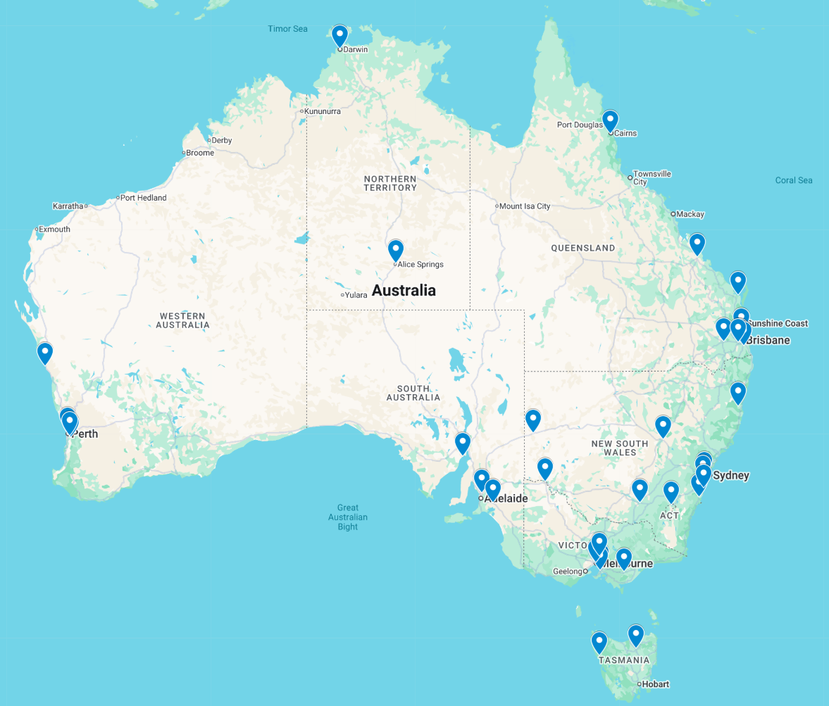
A total of 35 sites across Australia engaged with IPS and Curijo for the consultation component of the HIPPY evaluation. Participating sites are illustrated in Figure 1 and a list is provided in Appendix 2.
Figure 1. HIPPY evaluation sites participating in consultations.

Site demographics
Nineteen of the 35 sites were contacted with face-to-face engagements (54%), and a further 16 sites were contacted online or via the telephone, where online was not possible (46%). Thirteen of the 35 sites were First Nations focused (37%).
Of the sites contacted, 43% were in major cities and 31% in inner regional cities. Just over one quarter (26%) of sites were in outer regional or remote areas. Although contacted, very remote sites were not engaged with for the consultations due to scheduling conflicts, lack of interest or lack of response from sites. See Figure 2 for a visualization of site locations engaged by remoteness.
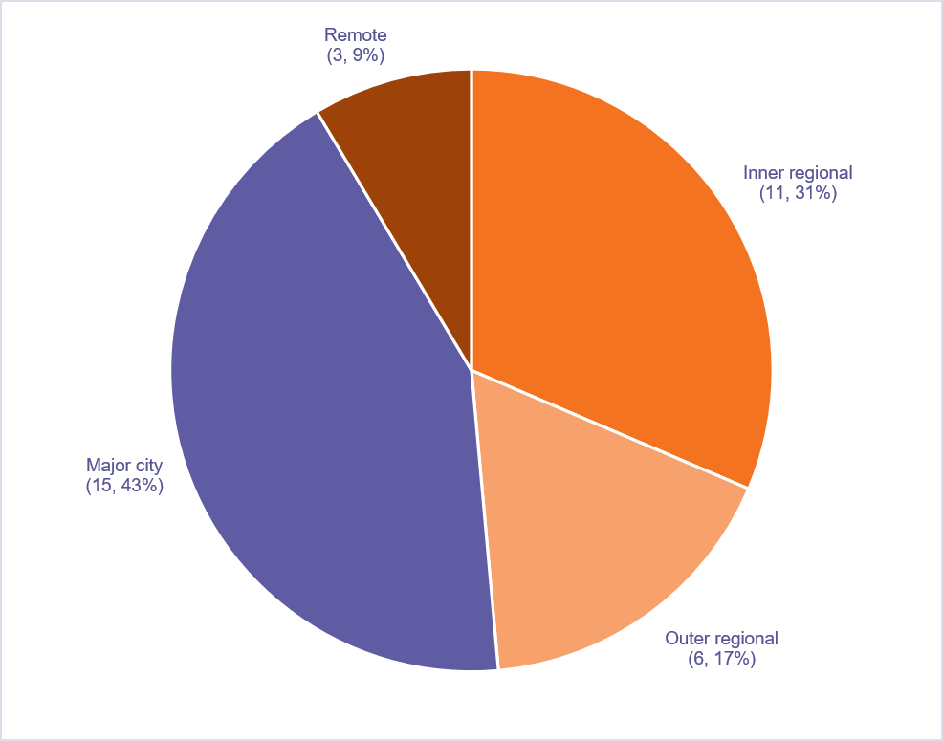
Figure 2. Remoteness category of sites engaged in consultations.

Participant demographics
Among HIPPY staff (Tutors and Coordinators) and community members, a total of 32 participants engaged with the HIPPY evaluation. Seventeen (17) of the HIPPY staff and community members cohort were Tutors (53%) and 11 were Coordinators (34%). A total of four members of the cohort were community members involved in the program, including site managers for the community organisation that operates the HIPPY program.
A total of 47 parents engaged with the consultations for the HIPPY evaluation. Figure 3 indicates that the largest group of parents/caregivers identified as CALD (n=22, 47%). Similar numbers of parents/caregivers identified as First Nations or having a disability (n=11, 23%). A small number of parents/caregivers identified as LGBTQIA+ (n<5 (reporting small numbers using ABS guidelines)). The diversity status of seven parents was unknown. Parents could identify with one or more category.
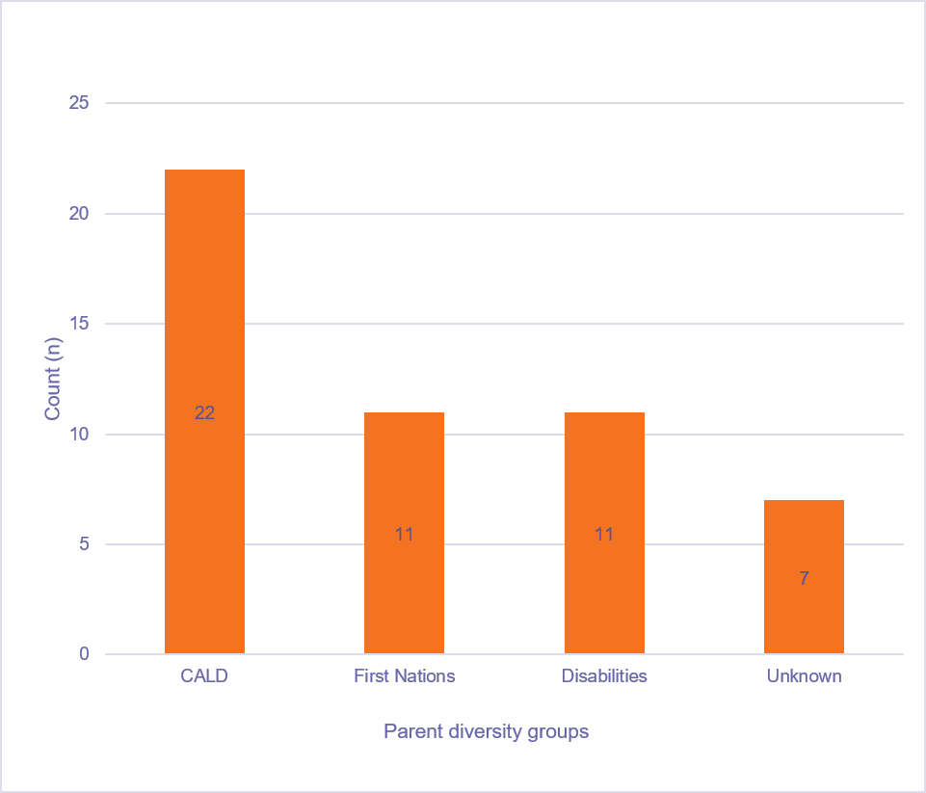
Figure 3. Number of parent/caregiver consultation participants in each diversity group (total n=47; multiple choices were possible)

Results and findings
The following sections detail the results from the qualitative component of the HIPPY evaluation. For each construct, findings are summarised in the page preceding detailed results.

Implementation domain as a measure of accessibility
Accessibility and implementation are very tightly linked as HIPPY’s design and delivery are important for removing barriers for families or unintentionally creating them. Implementation decisions about location, timing, communication, staffing, and cultural safety all shape which families can realistically participate and benefit from HIPPY. Accordingly, for the context of the current evaluation, accessibility will be determined by how HIPPY was implemented, a domain that will cover the following constructs.
- Organisational readiness and staff training involves assessing the organisation’s internal communication processes, the reliability and limitations of materials supplied by HIPPY administrators, and the practicality of accessing specialised support. This also includes cultural responsiveness, professional development, and effective supervision to support staff in delivering a program that is flexible and adapts to meet the diverse needs of families and communities.
- Referral pathways, reach and accessibility involve identifying the level of parental awareness of the HIPPY program, as well as understanding the key facilitators and barriers that affect program access. It also considers the role of flexible service delivery models in determining accessibility and ensuring that the program effectively reaches diverse families within the community.
- Adaptation and fidelity explore common challenges and complexities that arise when working with HIPPY families and actual difficulties experienced by families participating in the program. The need for ongoing adaptation to meet their individual circumstances and needs are described as well as the need to maintain fidelity to the HIPPY program model to ensure the quality and integrity of program delivery.

Organisational readiness
HIPPY sites demonstrate strong organisational readiness through collaborative communication, supportive supervision, and well-resourced local operations. Coordinators and Tutors benefit from regular updates, open-door leadership, and practical, hands-on training that builds confidence and cultural competence. Training and supervision are continuous, with frequent opportunities for reflection and peer learning.
However, readiness is sometimes hindered by time and funding constraints, slow communication from the HIPPY Australia National Office, and limited backup when Coordinators are unavailable. Professional development is valued but restricted by workload and resource limitations. There is a clear need for more specialised training in safeguarding, trauma-informed practice, and inclusion for LGBTQIA+ and complex family contexts. Cultural responsiveness remains a major strength, supported by flexible materials, translation, and First Nations and CALD community engagement. Overall, strong relational culture, adaptability, and peer support drive high readiness, though improved resourcing and communication could further strengthen implementation.

Communication and feedback
Communication within HIPPY is described by HIPPY staff (and some community stakeholders who work with HIPPY staff in day-to-day operations) as generally regular, practical, and supportive at the site level, with more mixed feedback between HIPPY Australia and site providers.
Coordinators and Tutors receive frequent updates, usually via a Learning Management System (LMS), team meetings, emails, and WhatsApp groups. Tutor and Coordinator accounts highlight strong peer support and collegiality, with a positive team culture, mentoring, and supervisory relationships that support wellbeing and learning.
Organisational preparedness is also boosted by resource provision, flexibility, and regular updates:
“Every fortnight we do have Coordinator to train us how to go and do role play. Before the role the activity week we have training then we go to the family. Every time we have the training done by the Coordinator and then we go to the family.” (Tutor)

“We do have very clear communication between our Coordinator and us. It's properly communicated. Yes. Even if we can email her and call her… And we can meet with her anytime… door always open.” (Tutor)
Organisational structures are generally described as supportive with Line Managers and Coordinators regularly available, Coordinator peer mentoring, and wrap-around supports from host organisations. Team relationships foster trust and holistic support:
“My line manager is fantastic. Absolutely. I can ring her, I can email her, she’s great.” (Coordinator)

“I think the beautiful relationship that HIPPY and the [provider organisation] have is that there’s a lot of, I want to say, cross-pollination. So everyone knows everyone. Yeah, and the faces are all familiar. So there’s a lot of real close inter-gelling which makes it really familiar.” (Coordinator)
Some Coordinators noted communication from the National Office could be slow, generic, or last minute, impacting broader planning and the relevance of HIPPY materials for parents in the community:
“Communication from HIPPY Australia has decreased. Sometimes we have to search for answers that previously would have had easy access to. They do communicate, but a lot of things are very last minute, and they're sprung on you very quickly.” (Coordinator)

“The consistency and continuum of that information getting into the Community [from the National Office] is I think could be improved. Maybe information could be written in that language in the posters be done in the language of... the highest percentage demographic.” (Community Member)

Local teams often feel their voices are respected, with feedback acted on by Coordinators and Site Advisors. Tutors report their suggestions for activities, resources, or cultural adaptation are trialled and shared:
“If we think something could work better or families are struggling with an activity, we can talk about it and try new things for next time. Yeah, if I have a suggestion about how to do an activity, or easier wording for the families, my Coordinator will say give it a go, and if it works, we can share it with everyone.” (Tutor)
Coordinators also shared experiences of having influence over processes, budgets, and curriculum decisions at the HIPPY provider site level:
“I was able to communicate back to them and say I didn’t feel that was appropriate and they acknowledged my response to that. We have communicated a lot about the financial situations many, many times.” (Coordinator)
A contrasting view from a Tutor highlighted vulnerabilities in the delivery of the program and gaps in the communication pathways between Tutors and other HIPPY staff if Coordinators were absent:
“I wouldn't know how to contact anybody within HIPPY if the Coordinator was sick... I'd have no idea.” (Tutor)

Reliability of HIPPY materials
Coordinators and Tutors have reliable access to learning packs, training modules, and supplementary materials, plus flexible support for family variation and special needs:
“We always have what we need for activities because the team is organised and if a family needs something different, or they lost something, we'll get it for them. No problem. If there's ever a time when I needed more resources, like for a kid with special needs or a big group---my Coordinator just says, let's make it work and it does.” (Tutor)
Coordinators often described the need for local creativity in sourcing materials, although reimbursement processes could be slow and sometimes shifted costs onto staff:
“The amount of things that I have bought out of my own money. It's not worth trying to get reimbursement because the process is so long.” (Coordinator)
One Tutor explained the way material provision supports program inclusion. The Tutor highlights that, by having all materials included within the learning packets instead of requiring parents to seek out materials to complete the HIPPY activities, it assists in planning the delivery of the program when they work with parents:
“In the HIPPY box there is a set of crayons, colour pencil, scissor, sharpener, eraser, scrapbook, whiteboard marker, whiteboard eraser, a whiteboard and a hat and a T shirt. And if it's finished we can provide them more. Beforehand we planned everything. We unpack the pack, we do the role play, we do prepare everything. I have paints in my car boot.” (Tutor)

Perceptions about limitations of HIPPY materials
While organisational readiness of HIPPY sites and of HIPPY Australia is rated highly overall by consultation respondents, there are important barriers. Time and funding constraints limit training depth, with some Coordinators reporting a lack of specific or translated resources needed to cater for CALD, disability, and other Culturally specific adaptations that are required for community-specific demographics, such as higher demographics of CALD participants from a specific language background:
“I asked one of the mums, would you translate this about HIPPY into Dari for everyone?”. (Community Member)

Importance of supports being practical
Other key drivers include strong teamwork, openness, and creative adaptation at both the site and Coordinator level as a means of overcoming some of the limitations:
“I always make sure I have the resources... I will go and find the resources, you know. I've driven out and cut down coconut fronds for weaving. So I think I'm probably a little bit different in, you know and I always make sure that I will go and find that, you know.” (Coordinator)
A Coordinator illustrated how practical supports are targeted towards HIPPY staff at a site, meaning that resources go to the diverse families enrolled in the program:
“We do have two vehicles dedicated for staff to use and they're only used by HIPPY staff. And they have all the HIPPY resources and then ... it's a very well-resourced program. [Name] is really good at training the Tutors for new material and stuff that comes in as well.” (Coordinator)

Most interviewees regard training for Tutors and Coordinators as hands-on, continuous, and relevant. Initial and ongoing sessions are described as practical and supportive, particularly valued for building confidence before home visits and supporting diverse cohorts:
“No, I think we had the beginning of the year like May, when we start like one-week complete training. Then we go to the family. So I think that way training is actually done nicely. And every fortnight we do have Coordinator to train us how to go and do role play.” (Tutor)

Need for more specialised guidance
Organisational resourcefulness, supervisor encouragement, and adaptable support structures are frequently cited as strengths. Tutors state that they feel well prepared for cultural, linguistic, and disability inclusion, with supervision and training giving them confidence to manage regular cases. However, some recognised a need for more resources and formalised peer forums for complex situations:
“It’s really a small amount of time if we would like to provide the quality of the program delivery. We don’t have so much time to educate our Tutors properly and let them go and be confident.” (Coordinator)
While HIPPY Tutors indicate that the program affords substantial opportunities for professional development and accessing peer mentorship, there is limited training to assist Tutors acting as informal case managers. This additional expectation effectively limits the time they have available to support their families. Many Tutors argued for more specific training and support with additional paid hours.
Coordinators echo the importance of robust induction and peer support but note that time and funding limitations sometimes constrain depth:
“They are hearing a lot, they are internalising a lot. And I think there needs to be more support into recognising that. I don't want to go on the whole funding thing, but I think we need to start to look at how we support funding around that. Because you're actually putting people out there and more professional development opportunities are needed. But also looking at the time that's been able to put in the allocated hours for Tutors to be able to have this sort of work, because they are. They're coming back, they're talking to parents. While the intention of HIPPY is just parent with engagement, they are a first point of call.” (Tutor)

However, for particularly complex issues, such as family violence or LGBTQIA+ support, more time, professional development, and specialist referral processes are needed:
“They’re (Tutors) coming back to me because always I told them if you don’t feel confident because you’re not professional it’s very sensitive issues sometimes, better come here.” (Coordinator)

“Yeah, look, there’s training at the start of your role and then, you know, there’s sort of professional development that is very encouraged ... It can be hard to find the time to do the professional development that’s outside of the really mandatory stuff. But there’s certainly lots of encouragement about doing professional development...” (Coordinator)
One Coordinator highlights the value of reflective supervision for ongoing support needs:
“You have access to supervision or supports when you need it, scheduled in every fortnight. Supervision is for them. It’s not me checking up on them, it’s about what do you need from me and me getting a better understanding of the family so that I can really help support the Tutor.” (Coordinator)
Some Tutors felt that lived experience was valuable to bridge skill gaps:
“I haven’t come across anything that threw me beyond like just saying, [name] what do you think about this?... I think it’s set up early that you’re not a professional, you are developing, delivering a program that is this.” (Tutor)
One parent suggested that trained professionals should be employed as Tutors:
“Tutor role is very hard … More time and maybe, I don't know, to hire somebody who is not just who went through HIPPY as a parent, like somebody who have some skills actually for that role.” (Parent)

Importance of Cultural responsiveness
Training is described as strong in cultural responsiveness and peer learning, intentionally adapted to suit language, context, and cohort. Materials and delivery are flexible, using both translation and family-driven adaptation:
“We do a lot of work around culturally safe practice and being trauma-informed, use online resources. Our organisation is very inclusive of all cultures.” (Tutor)

“I think we get enough training. We’re well equipped when we head out, lots of training before start and ongoing training throughout two years. Have done a number of trainings about cultural safety and awareness.” (Tutor)
Coordinators and Tutors repeatedly emphasise the importance of 'meeting families where they're at' and adapting for kinship, cultural context, and household logistics:
“My Coordinator before me... was very big on making HIPPY fit into families rather than families having to fit this very structured program...” (Coordinator)

“We adapt HIPPY to suit families because that way the book way and the rules just... doesn't work for everybody.” (Coordinator)
One Coordinator described the ongoing process required by Tutors to adapt the material so from a cultural perspective:
“...the family community activity at every book, there is always that opportunity to tweak it to what you’re seeing in front of you, like. And you get to know the families.” (Coordinator)
And some Tutors highlighted the need for more explicit inclusion and co-designed training for evolving cohort needs. Other Tutors felt similarly endorsed the notion of true inclusivity as a process that adopts local and cultural adaptations. Adaptations are shaped by local context, cultural knowledge and active community involvement:
“The names are more culturally representative of the children, which is fantastic. But the only thing for me is like the pride community. I don’t feel like they’re represented at all. There’s nothing in the books or anything in the stories or anything like that that I’ve seen that connect them to the program.” (Tutor)

“It comes down to the skills of the Coordinator to know their cohort, know their demographic, and targeting it specifically.” (Coordinator)
Participants emphasised the program’s efforts to be welcoming and culturally competent, with Tutors drawn from the communities they serve:
“I’ve had almost half of my cohort being First Nations. It’s very culturally safe for people to come into like working for the organisation. The organisation is working really hard to make it inviting to LGBT or the trainings and all that have come across. We’ve all got committees. Anyone can be part of those committees, as a Tutor, right up to an exec manager if you want to be part of it.” (Coordinator)

Professional development and supervision
Supervision and ongoing professional development are valued, and Tutors praise practical resourcefulness and mentorship:
“Yeah, look, there’s training at the start of your role and then professional development that is very encouraged. Lots of encouragement about doing professional development.” (Coordinator)

“Theres always a Manager or Coordinator in the office while I’m working the hours. I can bring up supervision if I wanted just one on one.” (Tutor)
Gaps are largely around time and funding for deeper professional development, onboarding for Tutors new to working with specific communities, and explicit representation or training concerning LGBTQIA+ inclusion. Some Coordinators call for more training in safeguarding, trauma, and case management:
“Safeguarding modules. more hours for those Tutors or bring them together somewhere on a state level and do proper training for them on that case management.” (Coordinator)
Most Tutors and Coordinators described supervision as accessible, timely, and structured, with Coordinators maintaining open-door policies and rapid responsiveness to need. Supervisors are available by phone, email, in person, and digital channels, ensuring regular and in the moment support:
“Her door is almost always...you can just wander on in whatever issue it is. The regular supervision with the Coordinator. It doesn’t have to be that scheduled.” (Tutor)

“Yeah, absolutely. Yeah... Even if we can email her and call her… And we can meet with her anytime. She takes care of all our needs and she makes sure that she hears us. We are truly blessed to have her.” (Tutor)
However, a minority note that their support is highly dependent on the presence of their Coordinator, with limited backup connections to others in the organisation:
“She makes sure that if there’s something she thinks that we shouldn’t have to stress about, she makes sure that that’s something we don’t stress about. Away from [name], I wouldn’t know where to start.” (Tutor)

Supervision usually occurs fortnightly or monthly, comprising scheduled and informal conversations, team meetings, feedback sessions, and opportunities for reflection on challenging cases. Areas of guidance include curriculum delivery, adaption for CALD and disability, and emotional support:
"We have our training once a fortnight. For age three, weekly for age four. So I do that, I plan and deliver that training and then we have a HIPPY team meeting once some month ideally. And supervision once a month." (Tutor)

Importance of flexibility in program delivery
Additional focus is given to supporting CALD and First Nations families, with peer support and role play acting as important elements:
“Very, very diverse in every way. Mainly the language. If I touch the language diversity it would be that curriculum is set in a very simplified version that they can be done in different languages” (Coordinator)
Some Coordinators specifically mention frequent guidance around adapting for disability, emotional regulation, child behaviour, and making practical, family-specific adjustments:
“With neurodivergent families I’ve had to change HIPPY a lot. Make it fit for them. I had to break everything down.” (Coordinator)
Interviewees describe strong efforts to ensure cultural inclusion through language translation, cultural adaptation of materials and practice, and peer learning. Supervisors encourage Tutors to use their own languages and share culturally relevant ways of engaging families:
“For the parents who don’t speak English, we try to translate and we do it in their language and we also tell them, you know, you can modify it like ... just give us the ideas that we can share to other parents. No, we learn from them.” (Tutor)

“We’re also big advocators for keeping language and culture strong. And not just Indigenous families. Every family. So I’ll tell all of our CALD families, if you won’t talk like this to your child, then don’t ... talk in your language. Keep your language strong....” (Coordinator)

“If you are not comfortable with us coming to your house. We can always meet you at the office, after playgroups, or at a playground.” (Tutor)

Referral Pathways, Reach and Accessibility
Parents view HIPPY’s referral pathways as largely flexible, inclusive, and community-driven, although limited by location and visibility. Families typically learn about HIPPY through trusted, informal networks such as friends, playgroups, expos, or social media. Word of mouth is the strongest referral driver, particularly amongst CALD and Aboriginal and Torres Strait Islander families. It is believed, even amongst parents, that overall public awareness remains low.
Similarly, staff and Community members emphasise access to HIPPY is generally through self-referral, outreach events, and supportive mentoring, but also cite barriers such as strict catchment zones, annual intakes, and extensive paperwork. Coordinators mitigate these challenges by creating steps to make form completion easier and adapting communication for low-literacy or non-English-speaking families. Many local health and education providers remain unaware of HIPPY, and promotional materials are often only written in English.
Coordinators identify the need for clearer, more visible marketing that highlights HIPPY’s free, inclusive, and educational focus. Other stakeholders suggest that improved outreach, streamlined processes, and broader eligibility are seen as key to strengthening referral pathways and program access.
Targeted strategies using culturally tailored communication, school partnerships, and active social media outreach are also seen as key to improving accessibility. Both parents and staff value HIPPY’s flexibility, meeting families in preferred settings, using multiple languages, and tailoring activities for disability or trauma contexts.

Parents’ awareness of HIPPY
Generally, families became aware of HIPPY through informal, community-based channels, including word of mouth from friends, neighbours, community leaders, playgroups, and day care contacts, as well as from health professionals and school staff. Trusted peer recommendations were particularly influential among CALD and First Nations families, while “chance encounter” stories for example, “by fluke,” seeing a flyer, Facebook posts, were commonly cited. Social media groups (especially culturally or linguistically specific ones), flyers at community centres or Expos were also sources of information. A few parents noted that clear advertising about HIPPY’s free and inclusive nature would support broader engagement and that print-based and face-to-face outreach proved effective, especially for new arrivals and families who may not follow mainstream channels:
“The reason I even joined HIPPY in the first place is just something that popped up on Facebook. In one of my Facebook groups someone had posted, you know... and being a teacher I was immediately like okay...” (Parent)

“I saw it at the shopping centre. They had one of those little set up stalls... I read the little brochure and yeah, maybe advertising in clear words that it's free, free funded program or something would help too.” (Parent)

Some describe HIPPY as the “best kept secret”, however some families stressed that a lack of linguistically and culturally tailored outreach meant most in their communities simply did not know HIPPY existed:
“No, I don't think a lot of people do know about it. Like, I know our little one's kinder, there's flyers and all that up on the notice board. But I think the kinder kids are a little old for it. I think it's more of a best kept secret.” (Parent)

“There were a lot of people that don’t know about HIPPY... the health service hadn’t heard of it... I even spoke to the school prep teacher, the Coordinator, and I said to her, there’s a stepping stone program that’s called HIPPY ... we need to advertise this for some of the parents...” (Parent)
Many families act as informal ambassadors for HIPPY, urging friends, relatives, mums’ groups, and community contacts to join. This grassroots promotion is especially effective for CALD and First Nations families whose trust is built on shared experience. However, stringent catchment restrictions and age criteria mean that many eligible and interested families are excluded, leading to frustration among both would-be participants and existing families who want to help others join. Some try to share curriculum materials with friends outside their region but recognise that such sharing cannot substitute for full program access. The need for HIPPY to expand geographically and demographically is clear across all cohorts:
“By word of mouth it spreads around the family, the neighbours...” (Parent)

“I plug the program wherever I can and I'm like oh you're three you should look at HIPPY. Yeah, I would suggest, I suggest. And some of the families were requested to enrol in the HIPPY program.” (Parent)

“I do often have families that I actually give this back to my friends because she lives far away. She's not in the zone. So I pass this on because she'll loves to do it with her kids.” (Parent)
Similarly, most Tutors and Coordinators report that the referral pathway is flexible, accessible, and welcoming for diverse families, including CALD, First Nations, LGBTQIA+, and families with disability. Referrals are known to frequently occur through networking, word-of-mouth, community events, playgroups, flyers, self-referral via website, and outreach, with strong support from Tutors. Acceptance and awareness of HIPPY is much higher among families who hear about it through word-of-mouth or community settings, playgroups, and multicultural events:
“It can be, but it can be self-referred as well. So we have a lot of family who do like self-referral. You see us at the expos, they might see our flyer and they might contact us or put their information through the website. I think the biggest one is still word of mouth, we have lots of Pakistani families all friends with each other. When I first got to know HIPPY was through a pamphlet at the library Also the expositions we have been at the last two years.” (Tutor)

“We've had a few potential families that once they see the books they don't want to do the program because they think it's only for blackfellas. I'm like no, it's for everybody and nah, it's okay. Ok. And you've got to respect that. That's fine." (Coordinator)
Some community members misunderstand the logo or flyers, mistaking the program for something unrelated or lacking clear connection to early learning.
A different view emphasises the need for more outreach and advertising to increase access for all families:
“It would be good to see it advertised through kindies and childcares more. I heard about it from my sister-in-law and lots of my families have heard about it from their family members. Community events are really good to get out and have some fun with the kids and slip the parents some information.” (Tutor)

“I didn't find out about HIPPY until it was too late. That's a really common theme. There might have been a misconception that HIPPY was only for really struggling families but I like to always say HIPPY is really for all families.” (Coordinator speaking as a parent)

Facilitators and barriers for accessing HIPPY
The main facilitators of reach include trusted community relationships, home-based models, bilingual Tutors, and word-of-mouth recruitment. Tutors often share language and cultural backgrounds with participants resulting in improved trust and comfort.
The main challenges posed by parents related to geographic and eligibility barriers. HIPPY's services are restricted to specific suburbs or catchment zones, meaning that parents in neighbouring areas were excluded even if they were interested. For CALD and some First Nations communities, language barriers, especially with English-only flyers or web instructions, created confusion with many potential families requiring explanations or assistance. Some experienced frustration or disconnect during initial contact but this was not usual. For families with mobility barriers or seeking privacy, HIPPY's flexibility about meeting location was appreciated. Overall, when the process worked smoothly, it was due to proactive support, flexible options, and word-of-mouth guidance:
“Because HIPPY exists just in [large suburb A] and [large suburb B]. Maybe just two areas in [capital city], which is nothing. Yeah... If we recommend someone from [large suburb C], you know, they can't. So some of the parents were not accepted because of the region reason.” (Parent)
A recurring theme was the ambiguity and inflexibility of eligibility, which was exacerbated for families with disability or outside strict catchment areas:
“Our recruitment eligibility criteria that I feel very strongly is that it doesn’t matter whether it’s mum, dad, the child itself or a sibling that has a disability, the needs upon that family as a unit are just as high, if not higher, than just having that child in HIPPY with a disability.” (Tutor)

“One of the hardest things was because we had a catchment area and then I had people just outside wanting to come in, but I had to say no.” (Tutor)

One parent recounted a negative experience and was made to feel unwelcome. This Coordinator left the organisation and was replaced with a new Coordinator, who was, according to the parent, ‘completely different’; a finding that emphasises the importance of frontline contact:
“I really felt very, very disconnected. When I called up the Coordinator asking for the material. I haven’t got any material, any support.” (Parent)

“[name of new Coordinator] was very, very sweet. She waited until there was a slot left. Then she offered it to me. She was very accommodative, very supportive. She formed a very strong supportive system to me.” (Parent)
Other challenges cited by HIPPY staff included program catchment restrictions but also included limited funding, annual intake policies, heavy paperwork (especially at initial visits), low literacy or language proficiency, and administrative workload for Coordinators and Tutors. Staff try to provide support that is based on family needs and flexible administration practices:
“People keep regularly saying, oh, why doesn’t this area have it? We’ve been told 100 sites only ... Unless we change a site, that’s what we’re saying. They won’t give us more money to open another site unless we change a site.” (Coordinator)

“If you had to go to seven different towns, it’d take you two days… they only do city areas where we can provide more.” (Tutor)

“HIPPY gets in families for the first half of the year. So when you have families who actually want to come in at the third or fourth term, they kind of can’t get in.” (Tutor)
Paperwork is often reported as lengthy and sometimes overwhelming, particularly for new or vulnerable families. Nevertheless, mentors and Coordinators adapt, offering support by breaking forms into smaller steps, reading forms aloud, or returning later, as needed, to make the process manageable:
“If it’s too much, I say, okay, let’s just do the enrolment part so I can at least add you to the enrolment. Then I’ll come back in a couple of weeks and then we’ll do the privacy consent and then we’ll do this. It is a lot on that first initial visit.” (Coordinator)

“I don’t drop off the paperwork. Most of the time I’ll sit with families and do it... asking somebody that is like, you know, it’s like oh hey, I’m [name], nice to meet you. When did you drop out of school?... can come across that’s like, what do you say? Like a bit not strength-based, like a little opposite strength-based.” (Tutor)
In contrast, others spoke about the ease associated with signing up:
“For me it was really seamless. I just saw the ad and I rang them and they rang me back and then came to the house and I was like, yeah, I’m in.” (Parent)

Flexible service delivery in determining accessibility
Referral and program delivery are adapted to fit family schedules, language needs, disability access, trauma, and neurodiversity. Adaptations extend to delivery locations, including home or if preferred, a park or a fast-food chain like McDonalds. Flexible service delivery also includes the format of activities, visual aids, and cultural representation in materials or outreach. Whilst this is well documented, staff still call for ongoing flexibility and co-design in other areas:
“With the neurodivergent families I’ve had to change HIPPY a lot, like make it fit for them.” (Coordinator)

“Roleplay never works for my Aboriginal and Torres Strait Islander families. We just sit down, side by side and talk. Things like behaviour-specific praise, the three Cs, role play, all those things, when there are other complexities in people’s lives, much less possible. If HIPPY is willing to listen to how it can work in different communities and talk about the structures where it gets let down.” (Coordinator)
Broader outreach including playgroups, partnerships, and online/remote options, further boosts inclusion for First Nations, CALD, LGBTQIA+, and disability cohorts:
“For those families that are really remote it could be great to do it online... during COVID times sites were doing like Teams things... families were joining in.” (Coordinator)

“Just the flexibility of the in-house visits. Maybe being flexible to the parent needs, like if it works as a phone call sometimes and not have a stranger in your house necessarily.” (Parent)

“We try our best... if it doesn't happen we change the day. Delivering in their own language, delivering at a different place, safe place, that's all adaptation.” (Tutor)

HIPPY implementation, adaptation and fidelity
HIPPY staff view implementation as strong, community-focused, and underpinned by flexibility and relational trust. Tutors and Coordinators deliver the program faithfully to its model—using structured learning packs, role play, and home visits—while adapting language, pacing, and materials to meet families’ diverse needs. Flexibility is considered HIPPY’s greatest strength, enabling inclusion for Aboriginal and Torres Strait Islander, CALD, disability, and socioeconomically disadvantaged families. Tutors often deliver sessions in first languages, modify activities for neurodivergent children, and adjust scheduling or locations for accessibility.
Adaptation sometimes blurs role boundaries, with Tutors acting as informal case managers and facing emotional load, heavy paperwork, and limited paid hours. Staff express concern that excessive adaptation or underfunding may erode program fidelity. In the context of the current evaluation, fidelity of the program refers to the degree of alignment and exactness of the program’s actual delivery to its intended delivery. Although concerns are present from staff, most agree that personalisation enhances engagement while maintaining the program’s core intent. Overall, HIPPY is regarded as both faithful and adaptive—a structured model delivered with contextual sensitivity—requiring sustained funding, training, and autonomy to support diverse families effectively.

Challenges and complexities working with HIPPY families
Staff and community describe HIPPY’s implementation as strongly shaped by the skill, adaptability, and lived experience of Tutors. Tutors who share language or cultural backgrounds with families experience enhanced trust and engagement, particularly among First Nations, CALD, and low-literacy groups. Tutors frequently adapt materials, deliver sessions flexibly, and go beyond program guidelines to meet families’ individual needs, though some feel public perceptions still underestimate HIPPY’s educational value.
HIPPY Tutors frequently go beyond program prescriptions to respond to families' unique contexts. Some Tutors highlighted the way by sharing lived experience, language, or cultural background with participants, in an effort to adopt natural rapport and responsive support:
“So family group setting, understanding that it might be mum who comes next week, it might be auntie, it might be a grandparent, that there’s that kinship flexibility in raising children and building in that flexibility in my conversations with HIPPY management.” (Coordinator)

“The curriculum is set in a very simplified version that can be done in different languages. …There is always that opportunity to tweak it to what you’re seeing in front of you.” (Coordinator)
While some Tutors see their role as universally inclusive in adapting the HIPPY program, some Tutors expressed concern that too much flexibility might dilute program fidelity or burden Tutors with functions for which they lack training and support. While Tutors described their work as rewarding, they were often overwhelmed given their complex caseloads and the limited time in which they are expected to conduct their work.
Cultural training, flexible delivery (meeting at parks, community centres), and group-based sessions were all highlighted as ways of managing diverse learning and engagement needs, especially in First Nations and CALD cohorts:
“Time. Sometimes you just run out of time. 15 hours, 13 families every single week. And then you got to do all of the paperwork” (Tutor)

“We step outside the box. We can engage by meeting in small groups or, you know, just two parents and a mentor going to the playgroup. So, I find there are some children that are like timid, in group gatherings, it does work well.” (Tutor)
Some Tutors highlighted the struggles with some CALD and First Nations parents with language and literacy barriers. But over time and with continued effort, rapport was established, making the effort worthwhile:
“We have trouble when we go to some of the CALD families and the grandparents at home with their kids. Quite often don’t speak any English at all. And you try and deliver the book and that is so hard.” (Tutor)

“But they are happy when they see us. Building rapport. What’s really good with HIPPY only employing parents that have done the program is super beneficial.” (Tutor)
The growing complexity of family needs (disability, trauma, hardship) calls for more training and flexibility. Most Tutors feel the program meets their professional and personal needs but recommended more hours, funding, and locally relevant resources:
“Before it used to be an easy job, but now Tutors are taking a load on a lot more. They are not a social worker, not a financial counsellor and the parents want them to help them with everything.” (Coordinator)

“Would be nice to have funding to offer more hours to the mentors... it would be amazing.” (Tutor)

Challenges experienced by HIPPY families
Tutors report their role as being rewarding but increasingly demanding, with blurred boundaries, heavy caseloads, and limited funding. They often act as informal social workers, supporting families with paperwork, translations, and emotional or logistical help. Families facing diverse challenges, language barriers, disability and time pressures will respond positively with flexibility, cultural sensitivity, and rapport. Despite any structural constraints, Tutor creativity and empathy underpin HIPPY’s success.
For families, a range of barriers that intersected with individual circumstances, life stage and backgrounds, made engagement challenging. There were sometimes nuanced differences in how Tutors interpreted and responded to these challenges. Families appreciate the home-based, cost-free model and any opportunities that can be provided to learn in both first languages and English.
Flexibility, through adjusted scheduling, remote options, use of kin support, and capacity to pause or rejoin, makes the program accessible for families facing disability, trauma, or complex life pressures:
“We had full NDIS, plus I was getting into kinder, plus I had gone back to work two days a week, and it wasn’t working. But then things calm down again and I reached out again” (Parent).
Some families experienced cultural and logistical barriers such as attitudes toward program engagement in home visits, but Tutors worked with parents to identify better locations. Tutors are trained to respect cultural boundaries, shift session locations, adapt content for trauma, disability, or learning needs, and use visual aids and demonstrations as needed:
“Mostly with First Nations, they find it a bit hard to do it because they do not want us to be in their house or like they can’t actually go outside. I told them wherever you’re comfortable.” (Tutor)

“With some families they will just stand out the door and talk to us. They won't let us into their home. You can see it's because they've got other things going on.” (Tutor)

Some parents experienced guilt or pressure from perceived expectations:
“That mum guilt that happens if you’re not doing it the way you want, that can be really hard. There’s a small portion of my families that have an expectation that their child at age three should actually be being taught to read. Sometimes that happens, but that’s not normal for most. It’s okay to relax about that.” (Tutor)
Other parents misunderstood HIPPY as a childcare solution:
“They think that we’re a childcare and they can just get rid of their kids. We’re not a childcare, you got to do the work with your little one, not us.” (Tutor)

“She wanted more from us and wanted me to use sign languages more and then spend more time with him. I did mention it's about mentoring parents not me getting more engaged with the child.” (Tutor)

Adapting to family needs
Flexibility is widely regarded as a defining strength of HIPPY, primarily realised through the ingenuity and responsiveness of Tutors and Coordinators at the community level. Program activities are frequently adapted according to situational context, which includes switching learning environments, employing families’ first languages, modifying materials for developmental or disability needs, engaging kinship or community networks, and responding to specific family circumstances.
The genuine adaptability of HIPPY is relationship-based, highly context-dependent, and often reliant upon the initiative of ground-level staff. Operational rules are frequently reinterpreted or adjusted to facilitate genuine inclusion, particularly for neurodivergent, working, or marginalised families. Coordinators value the ability to be flexible in order to maximise inclusivity, while also maximising fidelity. While it may be possible that there is a trade-off between flexibility and fidelity, the autonomy of Coordinators to adapt to local conditions should be seen as a strength of the program.
“We adapt HIPPY to suit families because that way the book way and the rules just it doesn't work for everybody. So we have learned to be flexible in the way that we deliver.” (Coordinator)

“If it's an activity like doing something, they [Tutors and parents] can make it just a thinking and do some creativity activity because some activities cover more learning areas and they would change. It's really good because they can think about the activities they haven't done before and adjust for the current state of learning and state of the child to do it actually when they want. So it's good to have that flexibility.” (Coordinator)

For families in crisis, or those with disabilities, flexibility to pause, re-engage, or adapt methods is valued:
“Families benefit from provided resources, structured yet adaptable format, and emotional support from Tutors with lived experience.” (Tutor)

HIPPY fidelity
Most Tutors and Coordinators describe program delivery as highly faithful to the HIPPY model, with core curriculum and structured activities implemented as intended. Essential elements cited across sites include learning packs, role play, home visits, group sessions, and ongoing training that builds parent and Tutor confidence:
“I think it’s been delivered exactly as HIPPY Australia would expect it to be delivered. Okay. I think, yeah.” (Coordinator)

“We’re pretty loyal to the model.” (Coordinator)

“The program is so easy to learn and we get all the training that we need and when we see the families, we’re confident in delivering these packs and then these families take away like knowledge in their back pocket that they can use on their kid and that gives them confidence...” (Tutor)
Adaptation of timing, activities, language, and delivery mode is widely practiced to maximise engagement for CALD, First Nations, LGBTQIA+, and families with disability. Tutors modify, translate, and tailor sessions responsively, often with site advisor approval, and cite this as vital for maintaining participation without breaking fidelity:
“So, as a Tutor, that regular pattern is helpful to me, talking to the families, but also the family taking the information in. It gives a real easy-to-follow format for everyone. But you really can’t just say oh, you know, here can we do this like that. We have a pack and then we go through beforehand and give it to them the way the family would take it in.” (Tutor)

“I think we do meet their needs and we do try and really accommodate and we really do talk to them a lot about how we want this program to work for you. So, yes, there's a pack to go through, but it does not need to be done exactly as it's prescribed in this pack.” (Coordinator)

“We put in our own extra additional resources, such as laminates and add to the pack so it's less stress. If they have a split family, I have extra so if they go to their dad they can do it twice.” (Tutor)

“With neurodivergent families, I've had to change HIPPY a lot. I had to break everything down so it was easier.” (Coordinator)

Delivery is often modified for diverse families including language, cultural understanding, disability, and family structure. All of these are reflected in the Tutor practice. The program is described as culturally safe and welcoming, with First Nations, CALD, and disability inclusion supported by active adaptation:
“For the parents who don't speak English, we try to translate and we do it in their language. You just don't want to stick onto the same thing. Like, do it their own way and give us ideas we can share to other parents. We learn from them.” (Tutor)

“Some of them we have to change how we show the activity because the child has autism so he likes the ones where he can move. So he's still getting the activity and he's still learning, but he's learning in his way.” (Tutor)
Tutors and Coordinators highlight a strong match between training and real practice, noting additional adaptations for family needs, resource gaps, and emotional support. While all are confident in core delivery, the day-to-day reality demands improvisation, advocacy, and further learning from experience:
“I learned really from A-Z, like from how to talk to the child, how to see things from the child's perspective. Now as a Tutor, I also get to strengthen all these things that I learned as a HIPPY parent. We do try and maintain the integrity of the HIPPY model but there have to be changes because we have to accommodate diverse families. Changes occur and we have to adapt our delivery to that family. Follow the model as closely as possible.” (Tutor)

“You don't have to do all of the activities, pick one or two…It’s about learning and having fun. Not getting your child to sit and like do all the activities. Like it’s not a chore, it’s fun. So pick...what your child will want to do.” (Tutor)

Scalability and sustainability of the HIPPY program
HIPPY parents and staff view the program as highly scalable and sustainable if supported by adequate funding, workforce capacity, and localised delivery. Both groups strongly advocate for expansion into new regions, particularly for Aboriginal and Torres Strait Islander, CALD, migrant, and disadvantaged communities, citing HIPPY’s proven inclusivity and social impact. Expansion is seen as most effective when embedded in schools or early learning centres and delivered through partnerships with community-led or culturally specific organisations.
Staff emphasise the importance of steady funding, increased Tutor hours, and professional development to maintain program quality and expand reach. Many warn that scaling without these supports risks overburdening existing staff. COVID-19 demonstrated that hybrid and online models can sustain engagement, increasing accessibility for remote or working families.
Sustainability hinges on maintaining local flexibility, cultural responsiveness, and peer-to-peer outreach. Participants agree that HIPPY’s core structure, if adequately funded and contextually adapted, is fully scalable and capable of continuing long-term community benefit.

Opportunities for expanding HIPPY
Most participants strongly advocate for expanding HIPPY into new regions and diverse communities, repeatedly stressing its unique impact, inclusive reach, and value for families lacking early learning support, including First Nations, CALD, and migrant peoples.
Parents saw the geographic and cultural expansion as vital to sharing the benefits of HIPPY, which is important for families experiencing social or economic disadvantage. However, many voices recognise limitations on budget and staffing, and the importance of targeting local demand, as not everyone will necessarily want or need the service.
Effective scaling should include partnerships with First Nations and CALD organisations and deeply localised outreach. Suggestions for sustainable growth included peer-to-peer referral, local champions, mentor recruitment, and further embedding HIPPY in mainstream settings such as schools and early learning centres (where this is not already done). Some stressed that working and busy families require flexible schedules alongside broader access:
“Yeah, absolutely. It might just be a little bit difficult with so many. Most families and parents are working like, you know, not many people can take as much time off…I don’t know whether they can access those families who maybe are working during the day.” (Parent)

“I would like to see more focus on Aboriginal kids because they are intelligent. I want to see more engagements with them so they can work with the local Aboriginal organisations in order to develop this program. I think the kids will benefit a lot.” (Parent)

“I think it could even be embedded in early learning Centres as a stepping stone to prep. And I spoke to the school prep teacher about this and she’s like, I would love to know about this because I think parents in this class, like, if every parent in the kinder class had their child also in a HIPPY program, I think it would be great to trial it and see what this, like.” (Parent)
Views were split on ideal program length and target age brackets. Some families, especially those whose children needed extra stimulation, wanted longer engagement, suggesting that eligible ages should stretch to five or more, or that “denser” content like the age-four curriculum be delivered over a longer, more manageable period. Families supporting children with disability or developmental delay particularly underlined the value of extending or slowing the program:
“Just if it’s gonna be longer maybe when they turn 5. It can be another fortnightly or once monthly because they’re already in school.” (Parent)

“I feel as though it needs to be extended to the four terms. I just think at the end of term four. Right. They’d have graduation like so, it’s going as a school term. I think that would be fantastic because we finish in October.” (Parent)

Other parents felt the current structure was just right and reported that two years provided a clear, bounded experience that fitted with children’s transition into school and did not risk burnout. Many appreciated finishing the program after two years, noting that the level of participation required could become taxing if the program were much longer, especially for working or busy families:
“So, I like the two-year program and I think it works well if you are doing the three-year-old when they’re in three-year-old kinder, four when they’re in four-year-old kinder and then when they go to prep there’s so much other stuff going on for them and for the families. So I think it’s an appropriate length of time now. Structured. Yeah. Well, I think.” (Parent)

“I think one year is a perfect time. I know everyone is not available a lot of time, but they stretch it for two years. If they fit everything in one year, it will suit more parents because, kids start kindy and then mum obviously starts working.” (Parent)
From the perspectives of Tutors and Coordinators, there is strong demand for expansion to additional locations, particularly for CALD and disadvantaged families, as they note unmet needs outside current catchments:
“We have a certain number of phone calls from areas that are out of our area. They are very interested to join from [location] area and even [location] they call us sometimes. In [location] for example, many disadvantaged people are there and we need to just open more sites.” (Coordinator)

“I think it would be incredible. Certainly to broaden it a little bit so that people weren’t missing out that could really benefit from it. But yeah, I definitely get people coming. You know, we might see them at an event and talk to them about HIPPY and then they find out it’s not in their area. And you know, everyone was always a bit disappointed when they find out that it’s not necessarily something that they’ll be able to access.” (Coordinator)
However, several perspectives reveal frustration at limits of what flexibility and goodwill can achieve, particularly from Tutors working with highly mobile, marginalised, or families with complex needs. Deeper social policy and system issues cannot be addressed with limited funding:
“By the time you pay the mentors travel and wages, there's nothing left.” (Coordinator)

“Recently the contract has changed, encouraging us to take on another extra 10 families... without additional funding... mentors are already just, with having 11 to 12 families, they are working at their maximum.” (Coordinator)

“We need more Tutors. We could take on more families. That could be expanded with funding and extra mentor. It’d be nice to say, you know, what did it mean for your handprints to be on the rock art? Why did the ancestors put that handprints on the rock? I’ve brought cornflour from my own cupboard because we're about to make slime. We’ll just go grab a pack from Kmart.” (Coordinator)

Funding barriers are bound to impact fidelity, given limited session times, tight budgets, parental disengagement, and competing demands on families. Flexible scheduling, teamwork, peer support, and creative resource use are principal supports for maintaining fidelity:
“I would give more hours. It's very tight. Very tight. If we look at the quality for those people, especially CALD communities, I'm sure that other economically disadvantaged families are also feeling a bit of pressure.” (Coordinator)

“We need more funding. Yeah. Really. If we can't afford it, then we don't do it. So if we can't afford to guest speaker then we just don't do. Do it.” (Coordinator)
COVID-19 adaptation proved the HIPPY model could be delivered effectively online or hybrid formats, which improved accessibility for remote or time-poor families. Coordinators reported success combining Teams, home delivery, and virtual engagement:
“We adapted a little bit after COVID to do some of it online. We like to do it face to face where possible, but it has been really helpful to be able to have that flexibility to offer online. If that’s what suits, then awesome. It absolutely can be done that way, and we have definitely allowed some families to do it like that.” (Coordinator)

“COVID has taught us so much. So we can do the delivery via video call to these mums out on stations and send them the books. We've done it.” (Coordinator)

“As long as you’re within the catchment area, I can send stuff and you want to have Teams with me once a fortnight and we’re still getting the information. They come back for graduation. Everyone.” (Coordinator)

Appropriateness domain as a measure of inclusiveness
Inclusiveness and appropriateness are closely connected, where HIPPY is genuinely appropriate only when it is designed and delivered in ways that include and respond to the diversity of the people it aims to serve. Inclusiveness focuses on who can participate and feel that they belong, while appropriateness is about how well the content, methods and environment fit families’ needs, cultures and circumstances. Accordingly, for the context of the current evaluation, inclusiveness will be determined by how HIPPY is regarded as being appropriate and will cover the following constructs:
- Acceptability focuses on families’ engagement with the HIPPY program, exploring the aspects they find most and least enjoyable and valuable. It considers the role of HIPPY Tutors in supporting participation and how the program’s materials and activities are perceived for their relevance and usefulness. The section also highlights HIPPY’s contribution to children’s school readiness, improved access to services, and role it plays in strengthening of community connections. In addition, opportunities to enhance community acceptability and the impact of the program’s extension to a younger cohort.
- Participation and engagement examine the key motivators that encourage parents and children to remain actively involved in the HIPPY program. It highlights the importance of maintaining a balance between flexibility and stability to support consistent participation and foster long-term engagement.
- Feasibility, cost and practicality consider the overall practicality of the HIPPY program for participating families. It examines both the direct and indirect costs associated with program involvement. It explores how resources, materials, and skill-building opportunities are provided to support parents in teaching and engaging their children effectively.
- Effectiveness and perceived impact explore parent perceptions of the effectiveness of the HIPPY program and identifies opportunities to enhance the program to better meet family needs and strengthen positive outcomes for both parents and children.
- Scalability and future inclusion explore suggestions for expanding HIPPY by participants.

HIPPY acceptability
Parents widely viewed HIPPY as being an appropriate, inclusive, and empowering program for their family.
Parents spoke about its simple, flexible activities and how mentors helped parents teach their children confidently to improve school readiness. Tutors were almost always cited as being central to success as they offered personal support, adapted materials for language or ability needs, and connected families to services such as NDIS.
First Nations families appreciated cultural recognition, while CALD participants valued learning about Australia’s education system. However, a number of parents requested broader multicultural representation, more flexible scheduling, and better outreach through social media and community hubs.
Overall however, the program was seen as adaptable for parents and children with disabilities and effective in building social connections. Criticisms cited by staff related to workload and limited accessibility in rural areas.
Overall, HIPPY was considered a culturally respectful, practical, and highly acceptable program that strengthened family engagement, inclusion, and community belonging across many diverse backgrounds.

Families engaging with HIPPY
Staff and community regard HIPPY as a highly appropriate, inclusive, and adaptable program that serves diverse families, including First Nations, CALD, single-parent, and disability households. Tutors describe it as a “melting pot” program that builds educational confidence, parenting capacity, and social promotes connection. Many families are ‘repeat’ clients. Early engagement through schools and community networks increases trust and participation, though visibility and representation of LGBTQIA+ families remain limited. HIPPY staff describe the diversity of families engaging with HIPPY:
“It's a bit of everything. It's the perfect little melting pot... we've got First Nations families, Swahili families, like beautiful mixture, lovely little kids.” (Coordinator)

“I have two families who had a child in age four last year and now their child is in age three ... parents have been more engaging that second time, I think, because they kind of know what to expect.” (Tutor)
The LGBTQIA+ cohort was less visible, a finding that may be due to nondisclosure. However, support for gender-diverse children and carers was noted amongst parents. Many Tutors highlighted the fluid, evolving nature of their caseload, with significant local and regional differences:
“We don't actually ask our families if they're the LGBTQ community, you don't walk to somebody's door and say, hi are you a lesbian? I have one family that does identify that way and she benefits from the support coming into the house.” (Tutor)
Families from CALD backgrounds are often highly motivated and appreciative, driven by a desire to support their children’s education and language skills:
“A lot of the Pakistani, a lot of the Indian families and when they know that there's something out here doing this, they want it and they’re not going to accept no for an answer. So they want it.” (Coordinator)
HIPPY is well accepted in the community especially when the program is made visible and accessible through schools and trusted local organisations. First Nations families may be cautious at first, especially if the program seems unfamiliar or designed for other groups, but engagement grows through relational trust. Sometimes local First Nations culture and language is not reflected in the materials.

Enjoyable aspects about HIPPY
Families across all backgrounds overwhelmingly praised HIPPY for its accessible design, practical activities, and strong family focus. Activities were described as easy to follow and made it possible for both children and parents of varying educational and linguistic backgrounds to engage meaningfully:
“She loves doing all the HIPPY stuff. She knew her colours and all that, but she learned so much more numbers. And I just wanted to say, everyone was just amazing.” (Parent)
First Nations participants benefited from cultural recognition, while CALD participants valued the understanding the program provided them into the Australian education system and parenting culture. CALD families found HIPPY crucial for understanding local education methods and facilitating smoother integration:
“When you came to Australia you don't know that good school system here and then through HIPPY you can realise how it works from the beginning, from the kindergarten. It's much more play here than in Europe, not just learning.” (Parent)
HIPPY enabled parents to become better educators at home and in doing so, enhanced their children’s readiness for school and built confidence in both parents and children. The regularity of activities and scaffolded materials allowed for parental choice, empowering parents to decide on activities for their child.
The social aspects of HIPPY, including group meetings and connections with other parents. These were also highlighted as being beneficial, particularly for caregivers who might otherwise feel isolated. Some people describe the organic, peer-driven spread of HIPPY as a testament of its acceptance:
“I think just meeting other families and helping other families and building their confidence... and seeing these people fortnightly at a gathering. I love coming to a gathering and sharing and making friendships with other parents. And doing the activities. Yeah, I love a craft and spending time with her.” (Parent)

“Word of mouth maybe around 11, 12 annually we get from word of mouth. Families talk to each other about the very nice activity program. So they are telling other friends.” (Tutor)

“I think everyone sort of really enjoys HIPPY. Lots of parents have met through the program and now meet outside of it. It’s a good way to connect to the Community.” (Tutor)

The role of HIPPY Tutors
Tutors repeatedly emerged as vital to the positive program experience, providing encouragement, adaptability, and individualised support. This held true across demographic groups, and particularly for participants facing language or access challenges. Tutors played roles that extended beyond program delivery. They acted as supports for personal and family issues (food, mental health, disability access) and advocated for families navigating complex services (such as NDIS for disability):
“She's one of the best people I've ever known in my life. She's very skilled with treating kids... She always gives support for myself like yeah, if I'm like she loves talking and chatting to me.” (Parent)
For First Nations families and CALD families, Tutors’ cultural respect and ability to become “like family” deepened the sense of belonging. Relationships were occasionally dependent on the particular Tutor; negative experiences generally stemmed from mismatches or poor communication as opposed to the program structure:
“It's good. They are supportive. They help us a lot with their engagement, they engage and their focus on their job...If she wasn't there, I don't know how I would manage with all of it.” (Parent)
Families generally engage well, develop confidence, and benefit from peer-to-peer support and community connection. Engagement levels are generally high when rapport and flexible delivery are prioritised, however, significant adaptation is required for families facing language barriers, neurodivergence, mental health issues, or precarious life circumstances. There is broad satisfaction among parents of children living with disability. Some disengagement occurs but is almost always attributed to life events, not a rejection of the program’s intent or relevance:
“Our role as a Tutor is to connect parents with some services for help, somebody of them are struggling with. I don't know, with food, with clothes, with mental issues... it's not just activity, it's not just that. It's like really, really much, much more.” (Tutor)
Tutors regularly extend support beyond program content for example, helping with translation, logistics, and referrals. Children’s engagement with HIPPY varies, where some are shy, some outspoken, but both benefit from group learning environments. Remote and flexible delivery methods are used for those who need them:
“Acceptance is usually high when the program is adapted to meet needs flexibly. Some of them do start to disengage when life happens. HIPPY would usually be the first thing that people would try and drop.” (Tutor)
Participating Tutors and Coordinators often exceed expectations as they are educators, case managers, and adapt program delivery to suit family context and needs. Commitment is high and there is a sense of pride, but note that the workload is sometimes underappreciated:
“We are going to their house. They are very happy. They are welcoming us. When I go home from here now, I’m working with HIPPY. It’s very good, makes me proud that I am a mum and teacher of my daughter.” (Tutor)

HIPPY materials and activities
While most Tutors find HIPPY materials accessible, the need for ongoing adaptation and cultural tailoring is universal, especially for low-literacy, CALD, and neurodivergent families:
“You’re able to cater for their needs. Everybody can do the activity in their own way. We bring everything to you. So we bring the extra paper, we give you scissors, we give you colouring, we give you glue sticks. We give you the resources that you need for the activities.” (Tutor)
Tutors routinely translate, simplify, and increase hands-on or visual activities. For First Nations and some vulnerable families, the program is most effective when its structure is relaxed, prioritises everyday learning and respects family routines. Disability inclusion is pragmatically addressed by removing pressure to use written materials for those with literacy challenges, focusing instead on verbal and memory-based engagement:
"For disability or literacy barriers I did the whole HIPPY program with my two children, and they never saw a HIPPY book. You can do the HIPPY program without even looking at the books. You don’t have to read them if you don’t want to." (Tutor)
Role-play, for instance, is controversial; some families find it difficult but respond when it is reframed as informal play or conversation. Language simplification and role play adaptations are common ways mentors modify the program for families who find parts of the materials daunting or linguistically inaccessible:
“The key components of the program are role play; families have left the program because of role play. Some find it intimidating, patronising... Parents have asked Tutors not to read to them, but that’s the expectation from HIPPY Australia.” (Coordinator)
To overcome this:
“We don't say role play, we say practice. Not all families do [role play]. There are a number of families that are like, no. Not doing that. We don't want to push families so that they don't engage with us anymore.” (Coordinator)

Adaptability of HIPPY activities
Acceptance is strongest when delivery is flexible, family-centred, and culturally responsive. Tutors often tailor activities, provide translation, and assist with complex family issues, acting as informal case managers. While materials are generally accessible, further adaptation is needed for low-literacy, neurodivergent, and CALD families. Some families resist elements like role-play unless reframed more naturally. HIPPY’s structure was broadly recognised as adaptable and inclusive, supporting a diversity of families including those with disability, young or less-educated parents, and CALD backgrounds.
Activities were well acknowledged as being modifiable for different literacy, language, or mobility needs, and Tutors played a key role in facilitating equitable access. Tutors reported adapting materials for parents with limited English, offering additional demonstrations and joint activity completion. Some activities were cited as inherently flexible allowing for adaptation for parents or children with physical or intellectual disabilities:
“Because it’s been fantastic for me, and they do have disabilities and I feel that that helped them, you know, because I was struggling how to, you know, get them to learn. But, to have someone, you know, show me how I can get them school-ready to then put it in place was good for me.” (Parent)

Tutors describe adaptability as central to HIPPY’s success, often “meeting families where they’re at.” They employ creative, relational approaches and local knowledge to maintain inclusion for First Nations, CALD, and socioeconomically disadvantaged participants. While flexibility is occasionally constrained by funding or administrative structures, staff agree it remains the program’s defining strength. Ongoing support, professional development, and resourcing are needed to sustain its responsiveness:
“Using first languages at home is stressed for CALD families, with gradual support for English through activities. For families with younger children, the number of weekly activities can create pressure, so a reduced frequency is suggested.” (Tutor)

“We deliver packs in families' homes and in their own language. It's crucial for CALD and newly arrived communities.” (Tutor)

“We are quite flexible like with matching their schedule and our schedule. We try our best. Sometimes it is hard, but honestly if it doesn't happen we change the day.” (Tutor)
Families find practical support with routines and school readiness, inclusion across backgrounds, and emotional support. The home visit model is valued, especially for families with accessibility issues:
“For parents that are new in the country, kids are just here and HIPPY gives them tools, gives them activities. Okay, I know 15 minutes a day or a week makes a big challenge and big difference because they know they do something good for their child.” (Coordinator)
Some barriers include the pressure around the number of activities, especially for families with younger children or experiencing crisis. For families in crisis, or those with disabilities, flexibility to pause, re-engage, or adapt methods is valued:
“It never used to be as flexible, but it's a lot more flexible now. And I also make it more flexible. ... If someone goes to India for more than six weeks, I'm meant to take them off and delete them out of the system. I never do that.” (Tutor)

“Some of our families have so much else going on. There's DV, there's mums leaving, kids, grief... When I go there and see them, it's nice to just do a fun activity together. If we were to stick to the structure, then we would miss those families. So I think it's important that HIPPY know that we can make it work differently.” (Tutor)

Adaptations for Aboriginal and Torres Strait Islander, CALD, disability, and LGBTQIA+ cohorts include activity translation, cultural events, individualised pacing, visual supports, inclusion of kin, and acceptance of various family forms:
“The connection to Aboriginal Torres Strait Islander culture through the HIPPY packs is significantly valuable.” (Tutor)

“So when I work with Aboriginal families, it's never like the role-playing. I don't do that. We don't do that. We'll sit down side by side and just talk about the things. I was told, no, you do that wrong. You need to do this. Role play is important. You have to do role play. And [after training] I left there completely flat.” (Coordinator)

School readiness and access to services
HIPPY was also seen as bridging access to mainstream services. Some parents only became aware of NDIS or school-readiness pathways because of their Tutors. For people with disability (either caregivers or children), participants noted that with thoughtful support from Tutors, activities could be adapted to physical needs. For example, activities involving outdoor observations without needing to walk:
“A psychosocial program that links the two is so important because a lot of the parents are also receiving NDIS and they’re trying to get supports for kids externally. That’s all embedded in the HIPPY framework, so you’re getting it in a program that’s free.” (Parent)

Opportunities for improving Community acceptability
Most criticisms of HIPPY were constructive, focusing on logistics and the desire for greater flexibility rather than making comments about the HIPPY content. Key areas included scheduling group sessions, the need for more multicultural content, and occasional gaps in inclusiveness for children with special needs. Some participants, particularly those with disabled children or those working, found group schedules inflexible and program content, while inclusive, sometimes overwhelming, especially during the second year:
“I think it needs to be a little bit more inclusive. So we have a few families that have nonverbal children... a lot of the activities I have to change to cater for his needs.” (Parent)
The program’s inclusion of Acknowledgement of Country, First Nations stories and images were broadly appreciated and cited as strengths of the program, alongside inclusive practices more generally.
“When we have the gathering, there's a lot of cultures from different countries and I love it because they acknowledge us as well. Right. It like because I'm Muslim and most of them have different religions and when they cater us gathering, they also think of each of us as well. So we don't feel left out.” (Parent)
Related to opportunities for improvement, the strongest calls were for expanded multiculturalism, more flexible (after-hours or weekend) session times, and greater outreach, particularly through the less traditional channels, such as social media, kindergartens, and ethnic community groups. Barriers for rural, working, and immigrant families were also highlighted.
CALD families highlighted a need for content reflecting cultures beyond First Nations, noting they sometimes felt like “piggy-backers.” They called for stories that reflect broader multicultural realities and for the content to evolve based on community consultation.
A few parents expressed discomfort with excessive repetition or lack of adaptation to their child's developmental level, especially those managing multiple responsibilities:
“Maybe just include more cultures to be more multicultural. So not just focus on like Aboriginal culture, focus on like all cultures as a whole.” (Parent)

“Maybe like just last thing come to me but a little bit help with something I said before a book. A lot of book is about Aboriginal, First Nation culture. Yeah, I would like more multicultural. More inclusion.” (Parent)
Many respondents however, described the content as “universal” and based on shared values, but multicultural families sought more tailored representation of their histories and experiences, not just general inclusiveness. Beneficial for migrants and families with English as a second language:
“It's culturally inclusive material, no matter which culture, which religion you follow, the material is like universal because it covers the core values. You know, the core human values, which is the same for every culture.” (Parent)
There was also recognition that greater diversity in staff, for example, Tutors from CALD and First Nations backgrounds, could reinforce cultural safety. Diversity in families were portrayed in the materials; further suggested engaging male Tutors or fathers to reflect diverse family structures:
“Absolutely. It was really inclusive. All the books were about definitely different families. Like they weren't just Caucasian [but] male Tutors are so important. Like those little boys.” (Parent)

Transition to younger cohort
Accessibility for non-drivers and those with limited English could be improved by offering transport or meeting in community spaces rather than relying on home visits. Rural and regional communities expressed frustration that HIPPY was not consistently available outside metropolitan catchments.
Overall, the new age-three cohort was viewed positively but can be demanding; flexible pacing and “stage not age” approaches were recommended. Most Coordinators and Tutors view the introduction of three-year-olds as positive and developmentally appropriate. Early engagement supports better educational and behavioural outcomes, especially for children with disabilities or delays.
However, transitioning to the younger cohort (age three) was mixed where some families adapted easily, while others struggled with the increased commitment when children moved from age three to age four and weekly sessions.
They described a significant jump in workload from age three (fortnightly, 15 books) to age four (weekly, 30 books), which can burden families, especially as children start school and parents return to work:
“The transition from fortnightly visits to weekly visits, I noticed when I was there, it wasn't a smooth transition. The frequency of engagement may be burdensome [for some families].” (Coordinator)

“Year four program is quite intense... So maybe if they even just reduced the second half of the year to seven books instead of 15.” (Tutor)
Adjustments are needed, however, since younger children (and some families) find the program’s structure or weekly pace intense. Some Tutors offered flexible delivery arrangements, delivering two books fortnightly for those unable to meet weekly requirements, or began year four materials earlier, when possible, to ease the transition. Suggestions about adjusting the content or structure, either by reducing the content or planning earlier delivery, were identified to ensure families did not fall behind:
“Big believer in stage, not age because some of these kids might be 8 or 9 years old and they still can’t write their name, they can’t read simple books. So doing a three-year-old book is like, that’s what they’re up to and that’s what we do with them.” (Coordinator)

“Sometimes they [families] get overwhelmed with the amount of information and how it’s presented. So they feel like sometimes it’s too much and they’re trying to fit it into their lifestyle we just sort of say, you know, as long as you pick one or two activities. Pick something your child will want to do rather than try and get all of the book done.” (Tutor)

Participation and engagement with HIPPY
HIPPY staff perceive participation, engagement, and adoption as strong overall, with high retention and completion rates driven by family satisfaction and Tutor rapport. Families typically remain engaged unless external factors—such as relocation, work, or crisis—intervene. Engagement thrives where flexibility, cultural safety, and trust are prioritised; Tutors adapting visits, language, and pacing report stronger participation, particularly among CALD, Aboriginal and Torres Strait Islander, and disability-affected families.
Barriers include time constraints, administrative load, housing or financial instability, and family pressures, especially in the second year. Families who complete tend to have more stable circumstances or stronger support networks. Tutors mitigate challenges by personalising delivery, translating materials, and encouraging partial or phased participation rather than strict adherence.
Adoption of HIPPY is deeply community-centred, relying on relationships, peer advocacy, and local adaptation. Staff emphasise that responsiveness, home-based accessibility, and emotional support make HIPPY not just an educational model, but a valued, holistic lifeline for many families.

Key motivators for keeping parents and children involved
Completion and retention rates are described as generally high. Most families who discontinue, will do so due to external factors rather than dissatisfaction with the program itself:
“They do drop but we don’t have, we have a high retention, we always have like the reason is not HIPPY why they leave. Yeah, the main reason is they move to [location] because there is more affordable housing. So, not many drop out when they start. Around 24 to 25 families graduate, but the target enrolment is 30. Very high retention and that’s great.” (Coordinator)

“Recognising that families that come into HIPPY in a specific LGA often and move to other areas where it’s easier for them financially.” (Tutor)
Key motivators for parent involvement include seeing examples of HIPPY’s hands-on, activity-based learning; receiving direct, personal invitations or demonstrations (primarily through cultural channels); and clear, accessible information about the benefit to children and families. Social media, community events, playgroups, and demonstrations at child health clinics, libraries, and preschools are seen as high-value outreach points. However, particularly important were increased outreach targeting CALD, newcomer, and working families by collaborating with kindergartens, schools, and community hubs. These approaches were considered vital to reaching the most excluded families.
For First Nations and CALD participants, culturally relevant messaging (including materials in their language) and Tutor diversity are vital. Parents and professionals agreed that a targeted approach, involving trusted locations, real-life stories and free resources, are important for engaging potential families:
“The activity-based learning. That's the most interesting part of the program. Plus the group gathering... there will be other community... events which bring the speakers, talk about things in the community.” (Parent)
Barriers to participation include time poverty (especially among CALD and working families), instability (housing, work, crisis), paperwork, and the challenge of balancing HIPPY with other commitments:
“If you have five activities every week parents don’t find time because of the kinder extended hours... that’s the CALD community.” (Coordinator)

“I’ve had one dropout and she was part of another program, the Strengthening Families. She had DV, went to jail, really bad mental health. She kind of just was like, there’s no space. She’s like, I’ll try because she’s got a younger son and she’s I’ll try with him next year. Or I’ve gone back to work too much and the work, we can work around. But yeah, the whole my kids at kindy now, I don’t need you.” (Tutor)

“Children getting diagnosed with a disability. Then they have many specialist appointments. Families drop out more in second year, 30 packs is a big commitment, kids are in care, parents are returning to work. Then we tend to have that focus around the everywhere learning.” (Coordinator)
Despite the many challenges, one Tutor comments that:
“It’s a hit and miss in my experience, I feel like they all really enjoy HIPPY, but time constraints and a lot of that mentality around just surviving in getting by so they can at times feel a bit pressured. But we try to make it so that it’s not an extra pressure...” (Tutor)

Flexibility and stability retain families
Program flexibility, allowing adaptation to family needs, home visits, pauses for crises, and using parents’ languages, supports completion and engagement, notably for CALD and First Nations families. The importance of trust, Tutor continuity, and adapting to kinship arrangements, crisis, or frequent moves is repeatedly noted as critical to supporting families:
“We retain families because we allow flexibility.” (Coordinator)
As a result, program completers are typically families with greater stability (e.g., two-parent households, steady income, supportive networks) and strong rapport with Tutors:
“Most people in [location] that do complete [the program] are two-parent families with a good income. It all depends on how good the Tutor connects with the family.” (Coordinator)

“You’re really building that relationship over the course and it’s not just with the parent, it’s the whole thing with the whole family... have the grandma there, the husband or the other kids... it’s very flexible. We want to make wherever’s coming in... tailored to them.” (Tutor)
Non-completers more often experience adversity such as housing instability, work and study commitments, domestic violence, mental health challenges, or find the program demands (length, paperwork, visits) overwhelming:
“The reasons why most people pull out include health concerns, housing problems, and domestic violence. This is just too much on top of.” (Coordinator)
HIPPY flexibility adapts to family routines, needs and contexts and allows choices and modifications to core activities:
“We had a lovely scenario yesterday... She said that she’s done HIPPY three or four times before with the children over the years. There’s one activity out of all of the packs that she’s refused to do every single year. We don’t care. We’re giving you the stuff. What you do with it is up to you.” (Coordinator)

“So we’re delivering at two town camps once a week. There’s that kinship flexibility in raising children...building in that flexibility.” (Coordinator)

Feasibility, cost and practicality of HIPPY
HIPPY is widely viewed by both parents and staff as a highly feasible and cost-effective program, celebrated for its accessibility, practicality, and complete lack of participant costs. Families consistently praise the home-based, flexible model that accommodates varying schedules, cultural contexts, and children’s developmental needs. All learning materials—crafts, books, stationery, and even transport or event costs—are fully provided, making participation possible for low-income, Aboriginal and Torres Strait Islander, CALD, and disability-affected families. The absence of hidden or out-of-pocket expenses is identified as a key reason for the program’s success and equity.
From a delivery perspective, staff describe solid resource and training support but express concern about funding adequacy and workload pressures. Coordinators often subsidise activities or wait long periods for reimbursements, citing inconsistent budgets and administrative overheads that restrict outreach. Despite these constraints, Tutors’ adaptability and personal investment sustain high engagement. Overall, HIPPY’s free, flexible, and inclusive design delivers strong value and community impact at minimal cost to families.

Program practicality for HIPPY families
HIPPY is consistently praised for its practical design, with flexible and accessible activities that fit a wide range of family situations. The home-based delivery mode overcomes barriers like transport and allows sessions to be adapted for parents’ schedules, children’s needs, or language contexts:
“The good thing about HIPPY is it’s a home-based program. So some families are not driving. Those are new here. So we are going to their house and meet them, and they are very happy. They are welcoming us, warm welcome, you know, asking for tea, coffee. They are my friends, you know. Whenever they see me outside, they are asking ‘are still working with HIPPYs?” (Tutor)
Another Tutor explains how the program's flexibility benefits neurodiverse children and busy households:
“My son is now doing it and he loves it. Like as soon as we bring home a pack we have to do it right then and there. He loves all the stories and he loves all the hands-on stuff but he doesn’t like the sitting down stuff so he much rather do like the gaming and the reading of the stories and any of the activities where he can craft and move around.” (Tutor, speaking as a parent)
For some families, challenges such as transport, life stress, or newly arrived migrants, participation is important as they gain social and parental confidence with HIPPY:
“I think parents have become a lot more confident with their children. I think that its working, people are attending, they’re getting to meet new people within the community and this gives pride to the families knowing that they were a big part of their child’s school readiness. Practicality depends on family, the resources needed to support families” (Tutor)
Families repeatedly highlight the sufficiency and convenience of the resources provided for activities. These reduce financial and logistical barriers for parents:
“No, I don’t have any families that say we haven’t had enough support. So, yes, in that regard, 100%. And in fact, sometimes they feel the opposite, that there’s a bit too much at the end. Wow. And to have even some of the materials to come out and bring stuff just so that its easy. You don’t have to go and source paper plates. If it’s a paper plate Frisbee, we make sure that they’re being supported obviously elsewhere.” (Tutor)

Direct and indirect HIPPY costs
Across all cohorts, participants consistently reported that HIPPY involved no unexpected or hidden costs. Materials, activities, excursions, and even extras like snacks and gifts were universally described as free, removing a significant barrier for low-income, First Nations, remote, CALD, and disability-impacted families. The absence of participant cost is one of the key reasons the program feels accessible to all, especially for cohorts accustomed to hidden expenses in other programs. Families did not report needing to purchase any materials, stationery, or pay for events and even special events, transportation (such as taxis for those unable to drive), and small gifts for holidays were fully covered.
The program was described as going above expectations, with Tutors supplying any needed extras, including food or specialty items. For many CALD or First Nations families, this made the difference between participation and non-participation. This lack of cost contributed to strong perceptions of equity and reduced stigma for those unable to afford paid services, enhancing universal access and trust in the program:
“We get it for free. And like, the gatherings are always amazing and they’ve always got the best resources... extra special gatherings and things like that, which is really good. No, I don’t think so. I can’t think of anything.” (Parent)

“No out-of-pocket costs... HIPPY base everything including the taxi ride, if I don’t have vehicle they are provide the taxi ... everything will be taken care of ... snacks ... hats.” (Parent)

Many Coordinators and Tutors described the program as sufficiently funded to deliver its core elements, including materials, training, and key resources, were provided to families at no charge. The most cited cost-related barriers were workforce constraints (such as limited hours, part-time roles, and high caseloads, as already described), funding pressures, and challenges for families with complex life circumstances, such as disability or very remote settings. Notably, some sites managed easily, while others felt “run off their feet,” pointing to inconsistent funding needs between regions and organisational contexts:
“HIPPYs really well funded ... whenever I’ve asked for things, it’s always, yep ... go buy that stuff. Doing the ACCO transition, I’ve heard that it’s not well funded. We’ll be operating at a loss.” (Coordinator)

“Nope. It’s a full-time job. But it is going to start impacting the services and the types of services that we can provide.” (Coordinator)

“So everyone gets the same amount, but you can only spend it on these things. So we might not be able to provide all the resources. I think there needs to be little bit more funding. Especially because we pay our host providers a lot of money and that’s the most frustrating thing to me.” (Coordinator)

“It’s a really involved role and sometimes because the Coordinators work 34 hours a week so not quite full time. But I feel like in terms of how much there is to do. Maybe the opportunity to be able to job share as a Coordinator would be really valuable.” (Coordinator)
Creative local adaptation and a spirit of “going above and beyond” are frequent solutions, with Coordinators and Tutors willing to tailor support and source extra materials:
“Sometimes we have to get a bit creative, don’t we? But we do it and it works out well. And the families really appreciate that extra effort…” (Tutor)
The core HIPPY model generally protects families and Tutors from out-of-pocket expenses. Nearly all required activity materials and resources are supplied, and parents repeatedly express gratitude for receiving essentials at no cost. However, there are some exceptions:
“My running up biggest tab on my card… Six weeks nearly for reimbursement. I’ve just like. I’ve done a big order on Temu… this is your own expenses, [it] probably needs to be changed…” (Coordinator)
Some Tutors also mention occasional unreimbursed travel, voluntary extras, or delays in getting paid back for costs, especially when adapting extra resources for children with additional needs.
From a different perspective, some sites note resource limitations tied to funding, underlining the need for site-level innovation and sometimes personal investment:
“I don’t think the funding is there for the Coordinator to do that... She puts a lot of money into this program...” (Tutor)

Resourcing parents
Interviewees overwhelmingly affirmed that all necessary resources (stationery, craft materials, books) were provided, usually in the welcome “HIPPY box” or regular top-ups throughout the year. Multiple parents described the excitement the box generated from their children.
Participants also described a valuable and expanding role for HIPPY in supporting broader family and community needs, such as linking families to food banks, providing emotional support, or assisting with referrals to additional services such as for clothing, NDIS, mental health resources. This was seen as essential by First Nations families, single parents, CALD and refugee communities, and parents of children with disability.
For all surveyed backgrounds, there was unanimous praise for the sufficiency of resources: from the very first kit onward, all needed items were supplied, and HIPPY Tutors were happy to refill contents, as needed. Several families reported that HIPPY’s support extended well beyond educational resources, facilitating access to financial and social support and building a sense of connectedness and confidence that enabled broader wellbeing.
The Tutor’s role was often regarded as connectors between families and the local support ecosystem, and this aspect of their role was described as transformative, particularly for First Nations and CALD families. No cohort reported having to purchase any materials. Even additional materials were provided for non-participating siblings were provided by Tutors:
“No material, nothing. And that’s the best thing. That’s the positive part of the whole program, that you don’t have to buy the stationery or the books or the copies or anything... if we need like balloons or something or anything, they provide the resources for us as well.” (Parent)

“[HIPPY staff] here are fantastic. You know, they even invited us to the local food bank... because they had seen us through the HIPPY program, you know, and that helps a lot when you’re low income.” (Parent)

“They’re very generous. If you need anything, just let me know. It will be in the storeroom. I can get it to you.” (Parent)
Participants felt that HIPPY was an exceptional program, especially parents from low-income families, First Nations, CALD, and disability backgrounds noting that all resources, activities, and even some therapeutic elements, such as activities otherwise available through paid therapists, were included at no cost.
HIPPY was contrasted with both commercial therapy/early learning options and informal playgroups, with participants stating they knew of no other comparable programs that included such a comprehensive range of supports for free. Families valued not only free access, but also the cultural and social inclusion, individualised support from Tutors, and material generosity that allowed repeat or extended usage.

Participants frequently remarked on the positive ripple effect in the broader family unit and community, particularly for those less likely to engage with mainstream educational services due to cost, cultural, or accessibility concerns. The program’s “value for money” was not just about cost savings, but about broad social and developmental impact, especially for marginalised cohorts. The holistic support, particularly through the intergenerational impact of parental capacity building and the lack of eligibility barriers, confirms that HIPPY is an asset in the community landscape:
“Those sensory activities are all things that you would get from an OT [occupational therapist], but you’re getting it in a program that’s free.” (Parent)

“Like giving me stuff to improve my child. It’s fantastic program. I don’t see any reason why anyone would say no to it to be honest.” (Parent)

“HIPPY was better for me than for him. It was really good for me to go there to talk to other people [and] my other two [children], they love it.” (Parent)

Effectiveness and perceived impact of HIPPY
Parents and staff regard HIPPY as highly effective and transformative, producing measurable benefits for children, parents, and communities. The program is credited with enhancing children’s school readiness, confidence, literacy, numeracy, and emotional regulation, while also strengthening parent–child relationships and building parental confidence in home learning and navigating school systems.
For CALD families, HIPPY improves English proficiency and understanding of Australian education; for Aboriginal and Torres Strait Islander families, it aligns with cultural values and community connection. Families with disabilities benefit from inclusive, adaptable materials and exposure to allied supports.
HIPPY’s holistic impact extends beyond education, fostering social inclusion, confidence, and wellbeing for parents—many describing it as “life-changing”. Tutors highlight that its flexible, play-based, home-learning model supports diverse learning styles and community contexts.
While overwhelmingly positive, feedback suggests improvements in group engagement, multicultural representation, and workload balance for families. Staff call for sustained funding and resource updates to maintain HIPPY’s high impact and inclusivity.

Perception of effectiveness by HIPPY parents
Families and Tutors highlighted a broad spectrum of benefits from participating in the HIPPY program. Perceived benefits included improving academic readiness, social skills, improved confidence, and emotional regulation for children. Parents reported enhanced knowledge of educational systems, practical parenting skills, stronger relationships with their children, increased self-efficacy, and improved community connection.
For CALD families, HIPPY introduced the Australian school system and promoted social integration, while First Nations families found the program respectful of core cultural values. For families with disability, the inclusive, adaptable activities and exposure to services were highlighted. Parents reported Tutors linking them to foodbanks, and providing referrals for clothing, NDIS services, and mental health resources.

The program’s low-barrier, practical, play-based approach and focus on home engagement reduced isolation, particularly important for newcomer households:
“When you came to Australia, you don’t know the good school system here and then through HIPPY you can realise how it works from the beginning, from the kindergarten and then for prep. It’s very different than Europe school system.” (Parent)

“HIPPY had really, really big impact on me and my child and our connection, our relationships. It helps meet parents through sharing stories we can help each other; we can support one another. My son, he had really, really good recognising literacy, literacy and numeracy.” (Parent)

“Huge benefits. Awareness of what speech pathology is, for example. And then from that learning. Oh, maybe we should go and have assess her speech. Just exposing parents to services that are available and giving education.” (Parent)

“Yeah, so for me yeah I really like I can improve my English skills as well. We read the books so we can improve our English and we can involve, like in Australia education.” (Parent)

“It makes it easy and you can have, oh, let’s do HIPPY together. It’s a set. Let’s do our special time together. And not only is it a bonding thing. It’s educational and learning things for them as well.” (Parent)

“I always say that HIPPY was better for me than for my son. Because I had like the gathering. So for me was so good to go there to talk to other people and then to my kids to play with other people. But my other two, they love it. So for me, it was really good for me.” (Parent)
Similarly, Tutors and Coordinators overwhelmingly endorsed HIPPY’s impact on children's learning, development, confidence, and school readiness. The curriculum fostered foundational literacy, numeracy, and socio-emotional skills, and is especially beneficial for children with developmental delays or additional needs:
“We had only that funding to support and it was really a big change I noticed in those parents who had three years of HIPPY. They say it’s because of HIPPY my child is really up. If we compare that with others, it’s not all about the curriculum, it’s that connection that they have with a child and how much they learn out of those roles play with their child.” (Coordinator)

“By the end of HIPPY, I really was not worried at all anymore. HIPPY really helped me put everything in perspective. There was always a way and that my son was totally getting all of the concepts. HIPPY stopped me worrying and had me fall back in love with playing with my child again because I was really getting frustrated. I was really feeling like I wasn’t good enough and I couldn’t reach him.” (Tutor, speaking as a parent)

“It gives them confidence, gives them the skills to, like, when they go to school, they’re already going to have that confidence that, you know what, I can do this... And it sets them up for lifelong achievements because they’ve achieved so much.” (Tutor)
Coordinators and Tutors also recognised the role of HIPPY extending beyond the individual child, strengthening whole families and building the community. Tutors and Coordinators highlight how community events, word-of-mouth, and playgroups foster connection and spread HIPPY’s reach:
“It’s a community, strengthening and making people feel safe living here.” (Coordinator)

“The impact that it has, not just for our children, but for the Community is insane. And for the Tutors as a wraparound program, I’ve never seen anything like it. It actually has a really good framework and structure to be able to be creative and meet the needs of the families and meet the needs of the community and meet the needs of the children.” (Coordinator)

“It’s not just weaving with the parent, it’s the whole thing with the whole... have the grandma there, like, you know, the husband or the other kids that you’ve seen in their family.” (Coordinator)

Opportunities for improving HIPPY
Most participants were very satisfied with HIPPY, however, some parents provided constructive suggestions for better inclusiveness, flexibility, and outreach. Families called for more group activities and social sessions for children to reduce isolation and enhance peer interaction; expanded multicultural and CALD representation in materials; more visual and hands-on resources; and increased flexibility, such as after-hours or weekend sessions and options for remote (phone/online) visits:
“Probably could have been a little bit more group involvement. I just thought that maybe if they could do one of the activities like once a month or something with the group or everyone who was participating. They just might make the kids feel like they’re not doing activities on their own or just with their parents or it’s not just a home thing.” (Parent)

“Maybe I was thinking that when we are doing things like gathering or group meetings, we should have group activities with children. More time. More time for that group. If we are doing activities with children, we don’t rush them.” (Parent)
Some parents requested program expansion for children with disability or nonverbal children, tailored resources and clearer communication about program expectations. Suggestions also included extending eligibility to age five or adapting the volume and delivery of four-year-old activities to reduce parental burden:
“The increase in the number of tasks between the three-year-old and the four-year-old program was significant. Probably reducing the four-year-old one to maybe get greater depth in the learning.” (Parent)

“I do find like 30 packs are quite extensive ... Some of them you know they have done it before and then it’s just repeat. We can try to concise it so it’s yeah. It's not as overwhelming.” (Parent)
Barriers are rarely related to the program itself. As previously mentioned, most challenges arise from life circumstances such as housing, mental health, crisis, compounding commitments, time pressures, and lack of funding to expand or adapt further. Flexible visits or virtual sessions offer solutions, but dropouts occur. Contributing to this is parental guilt or feeling overwhelmed with activities:
“Some parents actually in the age 4 now saying they feel a bit pressure because they had every fortnight five activities. When children are age three, age four, parents struggle a little bit. It would be much easier to continue with fortnightly because they feel a little bit stressed.” (Coordinator)

“You do what you can and you do what works. But you know that mum guilt that happens if you’re not doing it the way you want to be doing it and you think it should be done, that can be really hard... It’s okay, it’s not a problem. And you’re told that and you’re supported and your Coordinator supports that message.” (Coordinator)
Limitations and challenges of this work are covered Section 4: Limitations and challenges.

Section 3: Survey and program data

Survey and administrative data methodology

Data Exchange (DEX) data
DSS provided data extracted from the administrative DEX database regarding representation of priority cohorts along HIPPY program participants, as well as program satisfaction information from participants. The DEX data used in this report relates to the period from 1 January 2023 (the first DEX reporting period including the age 3 HIPPY cohort) to 30 June 2025 (the most recent completed DEX reporting period). It should be noted that the period covered by the DEX data will not match the period covered by the survey sample described below, which also include participants from earlier cohorts. Nonetheless, the DEX data extract used here provides data specifically about the age 3 cohort. The DEX data includes all individual HIPPY clients recorded in DEX (including children, parents and Tutors) who attended at least 1 session of any service type within the 2023 to end June 2025 period.

Parent and carer survey
PRC (with input from IPS and Curijo) developed a Parent and Carer Survey, administered to respondents within the PRC’s proprietary survey design and dissemination platform, PRISE. This ensured that all data could remain within Australian servers. Likert scale and open-ended questions were developed with DSS oversight to assess parent and carer satisfaction with HIPPY and their sense of the program’s appropriateness for their family (Appendix 5).
The Parent and Carer Survey was disseminated by BSL as the national provider of HIPPY. They emailed potential participants for groups they run (or had previously run) directly and via providing agencies where groups were delivered by subcontracting agencies.
The Parent and Carer survey was in the field from 6 June to 31 July 2025. Just over 4,000 (4009) invitations were sent to parents and carers who had previously opted into being contacted for evaluation purposes, representing a response rate of 8%. Note that we are not aware of how long ago those parents and carers originally joined HIPPY and it is possible that many of the invitations went to potential participants who were not recent members and thus may have been less likely to participate.

Tutor and Coordinator survey
The Tutor and Coordinator Survey was conducted between 2 July and 31 July 2025. Likert scale and open-ended questions were developed with DSS oversight to address questions of HIPPY implementation, appropriateness, and support for all members and for people from the four priority groups (Appendix 6). 480 invitations were issued by BSL on our behalf, to 480 Tutors and Coordinators who had opted in to being contacted for evaluation. We received 134 responses, for a response rate of 28%.

Tutor and training data analysis
BSL provided files containing de-identified administrative information on Tutors (such as date they joined HIPPY, whether or not they had previously been HIPPY parents, etc) and on training delivered to Tutors. Files were transferred via a secure, restricted access OneDrive folder.

Findings: DEX data
Over the period from 1 January 2023 to 30 June 2025, 20,709 HIPPY clients (children, parents or Tutors) attended at least one HIPPY session. Of these, 4,149 (20%) identified as Aboriginal, 134 (1%) as Torres Strait Islander and 257 (1%) as both Aboriginal and Torres Strait Islander. A small proportion did not indicate their Indigenous status (n = 514, 3%).
Most HIPPY clients over this time period did not have a disability (n = 17,381, 84%), yet 2,645 (13%) indicated they (or their child) did have a disability, and 683 did not articulate their disability status.
A large proportion of HIPPY clients were described as culturally and linguistically diverse (n = 3,563, 17%) based on their country of birth being listed as neither “Australia” nor “not stated” and their main language spoken at home being listed as something other than “English” or “not stated”. Data on cultural and linguistic diversity was not available for a small proportion of clients (n = 253, 1%).
Over three quarters of HIPPY clients in this period were born in Australia (n = 15,676, 76%), with small numbers of clients born in a range of other counties, including India (3%), Pakistan (2%) as the next two largest represented nationalities. For the majority of HIPPY clients, English was the main language spoken at home (n = 13,848, 67%) with Urdu (4%) being the next most common main language).
DEX data does not provide information on client identification as LGBTQIA+.
DEX data was also available about client satisfaction for 6,212 HIPPY clients over the 2023-June 2025 time interval. Almost all (99.5%) clients who completed a satisfaction assessment rated HIPPY positively (i.e., their ratings were 4 or 5 on greater than half of the domains they were assessed on; rating of 4 = ‘tend to agree, rating of 5 = ‘agree’).

Findings: Parents and carers survey
To determine how parents and carers felt about their HIPPY experience, we surveyed 319 parents using an online survey (questions are provided in Appendix 5: Parent/carer survey questions). Of these, the majority (n=274, 86%) were in the cohort targeted by the revised format of the HIPPY program as outlined in reforms to the delivery of the program announced in 2021-22 (i.e., most survey respondents are parents of children aged 3-4years). We had some respondents who had enrolled in HIPPY as far back as 2015, but the large majority (86%) were people who enrolled in 2022 or later. Of the 84 respondents who had already graduated from HIPPY, most of them (80%) had graduated in 2024, with 6% and 5% graduating in 2022 and 2023, respectively. The remaining 9% of respondents had graduated between 2017 and 2021.
Our survey covered HIPPY attendance and participation, and prior enrolments in HIPPY. We also asked about participants’ feelings about the overall suitability of HIPPY for their family, and whether they felt the program was worthwhile for them. We also asked about their satisfaction with HIPPY and any suggestions for improving the program. Finally, we asked respondents about their backgrounds and other demographic characteristics in order to assess the degree to which our findings apply to the four predetermined priority groups:
- First Nations parents
- Culturally and linguistically diverse parents
- Parents with a disability
- LGBTQIA+ parents
First, we present data about the backgrounds and demographic characteristics of survey respondents, in order for the reader to understand the nature of the sample, particularly as it relates to how the program was accessed and viewed by members of the four priority groups targeted by the program.
Subgroups were formed based on participants’ self-reported information collected in the survey. The 3-4-year-old cohort (n = 274) included families who enrolled in the program from 2022. The First Nations group (n = 32) included respondents who identified as Aboriginal and/or Torres Strait Islander. The culturally and linguistically diverse group (n = 84) comprised those who spoke a main language other than English at home. The disability group (n = 77) included respondents who reported having a physical or medical condition, and/or a sensory impairment or learning difficulty. The LGBTQIA+ group (n = 16) comprised those who identified as gay or lesbian, bisexual, or used another term such as queer. The responses for each priority group are presented in the tables below.
Most survey respondents (96%) identified themselves as a ‘parent’ of the child, with a small proportion of grandparents (2%). Close to one in ten (9%) First Nations survey respondents said they were the child’s grandparent and 6% described themselves as fitting in the ‘other’ category. LGBTQIA+ respondents also had greater proportions of grandparent and ‘other’ respondents, although noting the overall sub-sample size of 16 LGBTQIA+ survey respondents, the actual number of grandparent and ‘other’ respondents in this priority cohort is small.
Respondents were overwhelmingly female (95%) and, as shown in Table 5, this pattern was consistent across all priority groups.
Table 5. Parent gender for survey respondents
Parent gender | All respondents  (n = 319)  (Frequency) | All respondents  (%) | 3-4-year-old cohort  (n = 274)  (%) | First Nations  (n = 32)  (%) | CALD  (n = 84)  (%) | Disability (n = 77)  (%) | LGBTQIA+  (n = 16)  (%)
Woman | 306 | 95.9 | 96.0 | 93.8 | 92.9 | 93.5 | 81.3
Man | 9 | 2.8 | 2.6 | 3.1 | 6.0 | 2.6 | 6.3
Other | 2 | 0.6 | 0.7 | 0 | 1.2 | 2.6 | 6.3
Prefer not to say | 2 | 0.6 | 0.7 | 3.1 | 0.0 | 1.3 | 6.3
Note: we also asked respondents to tell us their current gender identification, to enable a count of transgender individuals. However, fewer than 1% of respondents so identified and so we have excluded this category from further reporting.

Membership of priority groups
In this section, we report on our estimation of how many respondents belong to the four priority groups specified above. It is important to note that there is considerable intersectionality within HIPPY participants, as for the population at large, and any one participant may belong to more than one priority group. For this reason, we report figures for all priority groups rather than reporting percentages for priority groups in isolation.
Table 6 and Table 7 summarise the cultural backgrounds of parent survey respondents. As shown in Table 6 close to one in ten parents identified as Aboriginal and/or Torres Strait Islander. We assessed culturally and linguistically diverse status by considering whether English was the main language spoken at home (Table 7). Using this metric, 26% of respondents are culturally and linguistically diverse.

Table 6: First Nations status of parent survey respondents
First Nations | All respondents  (n = 319)  (Frequency) | All respondents (%) | 3-4-year-old cohort  (n = 274)  (%) | CALD  (n = 84)  (%) | Disability  (n = 77)  (%) | LGBTQIA+  (n = 16)  (%)
No | 283 | 88.7 | 90.1 | 97.6 | 87.0 | 75.0
Yes, Aboriginal | 31 | 9.7 | 8.8 | 1.2 | 11.7 | 18.8
Yes, Torres Strait Islander | 0 | 0.0 | 0.0 | 0.0 | 0.0 | 0.0
Yes, both Aboriginal and Torres Strait Islander | 1 | 0.3 | 0.4 | 1.2 | 0.0 | 0.0
Prefer not to say | 4 | 1.3 | 0.7 | 0.0 | 1.3 | 6.3
Table 7. Main language spoken at home for parent survey respondents
Languages | All respondents  (n = 319)  (Frequency) | All respondents (%) | 3-4-year-old cohort  (n = 274)  (%) | First Nations  (n = 32)  (%) | CALD  (n = 84)  (%) | Disability  (n = 77)  (%) | LGBTQIA+  (n = 16  (%)
English | 235 | 73.7 | 74.5 | 93.8 | 0.0 | 79.2 | 100.0
Arabic (or Lebanese) | 8 | 2.5 | 1.5 | 0.0 | 9.5 | 3.9 | 0.0
Mandarin | 7 | 2.2 | 2.2 | 0.0 | 8.3 | 3.9 | 0.0
Vietnamese | 6 | 1.9 | 1.5 | 0.0 | 7.1 | 2.6 | 0.0
Cantonese | 2 | 0.6 | 0.4 | 0.0 | 2.4 | 0.0 | 0.0
Italian | 2 | 0.6 | 0.4 | 0.0 | 2.4 | 0.0 | 0.0
Australian Aboriginal language | 1 | 0.3 | 0.4 | 3.1 | 1.2 | 1.3 | 0.0
Khmer | 1 | 0.3 | 0.4 | 0.0 | 1.2 | 1.3 | 0.0
Korean | 1 | 0.3 | 0.4 | 0.0 | 1.2 | 0.0 | 0.0
Persian | 1 | 0.3 | 0.4 | 0.0 | 1.2 | 0.0 | 0.0
Spanish | 1 | 0.3 | 0.4 | 0.0 | 1.2 | 0.0 | 0.0
Other | 54 | 16.9 | 17.9 | 3.1 | 64.3 | 8.0 | 0.0
Comparing survey respondents to the DEX sample described in the previous section, there are some differences in the cultural diversity of the two samples. Specifically, the survey may under-represent Aboriginal and/or Torres Strait Islander clients, and a larger than would be expected proportion of parents who spoke English as the main language at home completed the survey (74%) compared to DEX records about their representation in the client database (67% in DEX spoke English as their main language at home).
About a quarter of parents (n = 77) completing the survey reported having a physical or medical condition, and/or a sensory impairment or learning difficulty. Parents who reported any one of these conditions were part of the disability group for subgroup analyses. Compared to the DEX data for HIPPY clients from 2023 to June 2025 (13% of either parents, children or Tutors have a disability), survey completers were more likely to report having a disability.
Overall, around 5% of participants identified as LGBTQIA+ (Table 8). This is consistent with the national average (5%). There was significant intersectionality with other priority groups. DEX does not collect data about LGBTQIA+ status of clients.
Table 8. Parent and carer sexual orientation
Sexual orientation | All respondents Frequency  (n = 319) | All respondents  (%) | 3-4-year-old cohort  (n = 274)  (%) | First Nations  (n = 32)  (%) | CALD  (n = 84)  (%) | Disability  (n = 77)  (%)
Straight (heterosexual) | 268 | 84.0 | 83.6 | 81.3 | 76.2 | 84.4
LGBTQIA+ | 16 | 5.0 | 4.8 | 9.4 | 1.2 | 11.7
Prefer not to answer/Don’t know | 35 | 11.0 | 11.7 | 9.4 | 22.7 | 3.9

The age range of survey respondents varied from 25 to over 65 years, with some variability in distribution of parent age between subgroups (Figure 4) (we also include the 3-4-year-old cohort for comparison).
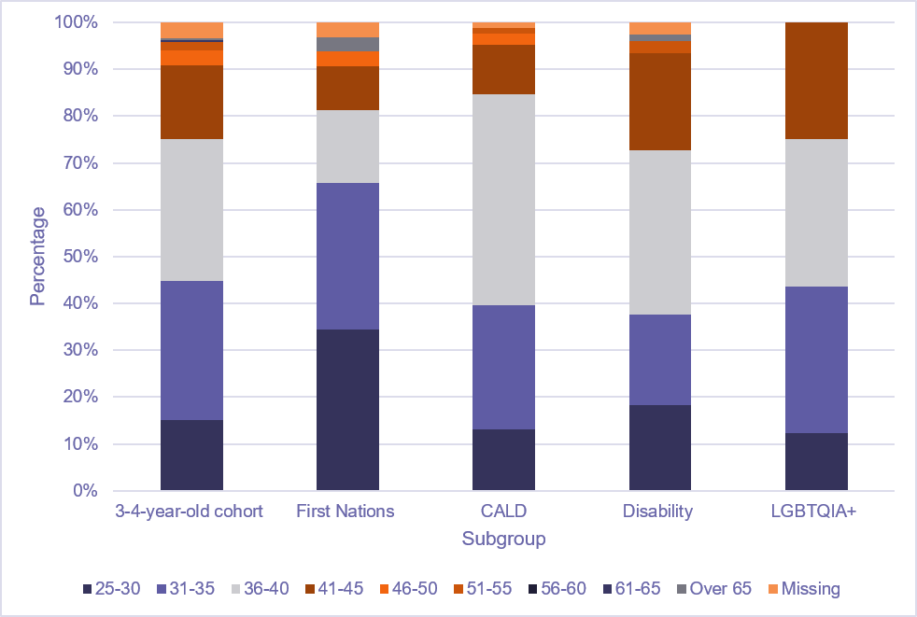
Figure 4. Parent age distribution by subgroup for parent survey respondents.

More than half of all parent survey respondents (54%) resided outside major cities of Australia. This is much higher than the national average of 33% of Australians living outside capital cities (ABS 2021)
The proportion of First Nations survey respondents living outside major cities was far higher (72%) while the proportion of culturally and linguistically diverse parents living outside major cities was much lower (31%). With the exception of First Nations survey respondents, very few respondents lived in remote or very remote areas. Nevertheless, close to 10% of First Nations respondents lived in very remote areas, and 3% lived in remote areas – attesting to the geographic reach of the HIPPY program into Indigenous communities.
Parents responding to the survey tended to have high level of educational attainment, although there was a mix of parents with vocational (e.g., trade certificates) and Year 12 or below as their highest level of education. Figure 5 shows parent education level for all respondents and also by subgroups. Notable differences between the subgroups are evident for the culturally and linguistically diverse, LGBTQIA+ and First Nations groups. The culturally and linguistically diverse group had a higher proportion of Bachelor and post-graduate qualified respondents than all other subgroups. First Nations respondents had a greater proportion of vocational qualified (‘TAFE’ in the charts) respondents and fewer parents with Bachelor degree or post-graduate qualifications compared to other sub-groups. LGBTQIA+ respondents had a more even spread of respondents across the eight different educational categories, noting smaller sample size for this cohort overall.
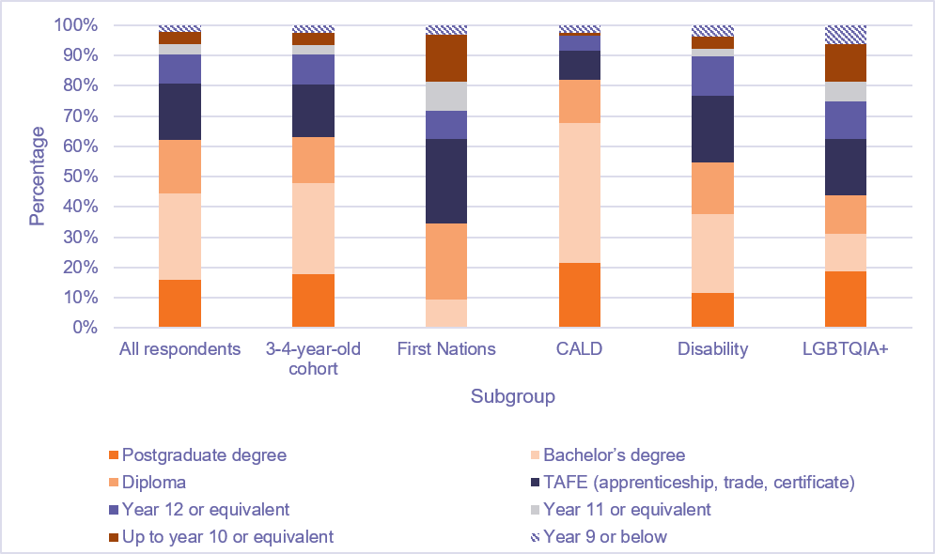
Figure 5. Parent education level distribution by subgroup for parent survey respondents.

Overall, and for most subgroups the greatest proportion of parents were engaged in home duties (see Figure 6). Participants could select multiple options, so for many, home duties may be paired with other categories including paid employment, volunteer or unpaid work, seeking employment, retirement, being on leave and studies. Of note, many respondents were in part-time paid employment, but few were in full-time employment. LGBTQIA+ parents had a somewhat different profile to other subgroups, with a greater proportion engaged in studies and being on leave from work.
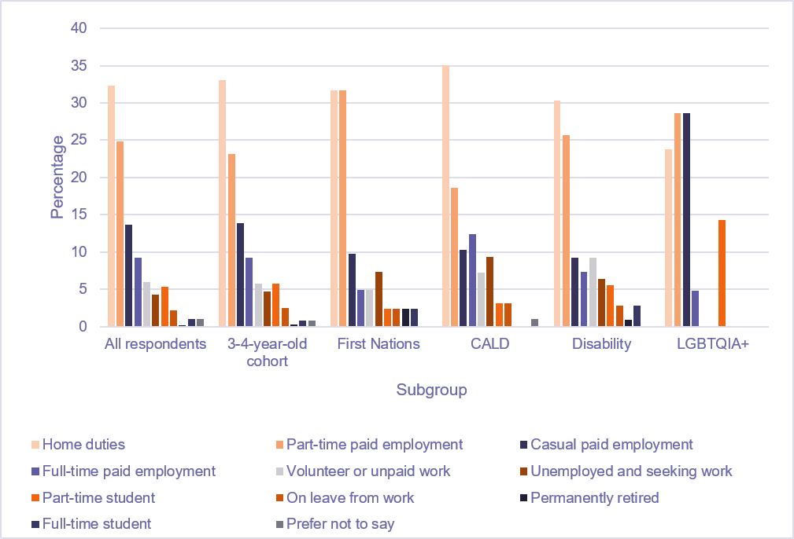
Figure 6. Employment status of parent survey respondents for subgroups.
Figure notes: Participants were able to select multiple responses. The percentage values in this chart represent how many activities were selected overall (not the number of participants).

Parents responding to the survey generally described their physical health as good to excellent (91%) (see Figure 7). First Nations respondents, those with disability and LGBTQIA+ parents tended to report somewhat poorer health. This aligns somewhat with data about respondents’ reports of their own physical or medical conditions and their sensory impairments or learning difficulties. While around 20% of the sample overall identified that they had a physical or medical condition, this was much higher for the LGBTQIA+ cohort (38%), and while it was lower for the First Nations respondents in the sample (16%), there was a large number in this cohort (22%) who preferred not to say whether they had a physical or medical condition. LGBTQIA+ (38%) and First Nations respondents (16%) also had higher rates of sensory impairments and learning difficulties compared to the overall sample (8%). Understandably the Disability cohort had the highest ratings of medical and physical conditions (84%) and sensory impairment or learning difficulties (34%).
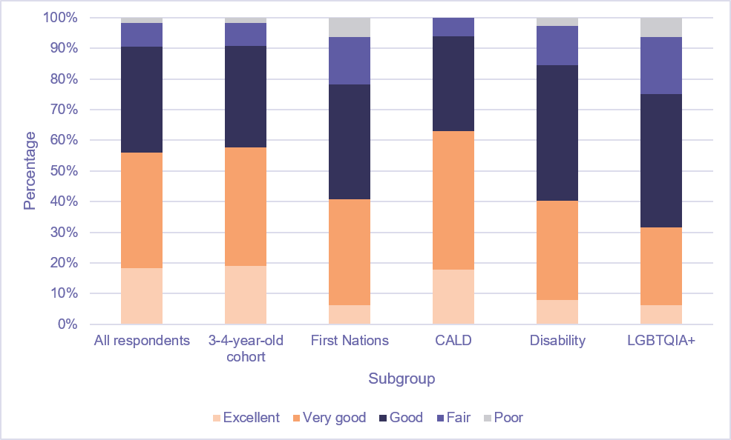
Figure 7. Parent ratings of their physical health for those completing the parent survey.

HIPPY program attendance
Here we present findings relating to program attendance patterns. Parents are able to participate in HIPPY as often as they prefer. As Table 9 shows, the majority of survey respondents were first-time participants in HIPPY; this is true of the overall set of respondents, and for all subgroups of interest (i.e., the 3-4-year-old cohort, First Nations parents, culturally and linguistically diverse parents, parents with a disability, and LGBTQIA+ parents).
Table 9. How often parent survey respondents had commenced a HIPPY program
How often they have started HIPPY | All respondents  (n = 319)  (Frequency) | All respondents  (%) | 3-4-year-old cohort  (n = 274)  (%) | First Nations  (n = 32)  (%) | CALD  (n = 84  (%) | Parents have disability  (n = 77)  (%) | LGBTQIA+  (n = 16)  (%)
Once | 228 | 71.5 | 78.8 | 62.5 | 69.0 | 71.4 | 87.5
Twice | 68 | 21.3 | 16.8 | 31.3 | 20.2 | 18.2 | 6.3
Three times | 14 | 4.4 | 1.1 | 6.3 | 4.8 | 6.5 | 6.3
More than three times | 9 | 2.8 | 3.3 | 0.0 | 6.0 | 3.9 | 0.0

The same pattern of new to returning members is reflected in parents’ attendance status (Table 10): the majority are current attendees, although around a quarter have already graduated. In our analyses we have not excluded either the graduated parents or 4-5-year-old cohorts, given the possibility that a current parent may have previously attended with an older child. Only a very small proportion of respondents (2% overall) ceased attending HIPPY before graduation. We have included these parents as their responses may give some insight into why people may drop out of HIPPY. Reassuringly, the proportion of parents who ceased HIPPY before completions is consistent across the group as a whole and priority groups.
Table 10. Current attendance for parent survey respondents
Current attendance | All respondents  (n = 319)  (Frequency) | All respondents (%) | 3-4-year-old cohort  (n = 274)  (%) | First Nations  (n = 32)  (%) | CALD  (n = 84)  (%) | Disability  (n = 77)  (%) | LGBTQIA+  (n = 16)  (%)
Currently attending | 228 | 71.5 | 75.2 | 68.8 | 76.2 | 67.5 | 68.8
Already graduated | 84 | 26.3 | 22.3 | 28.1 | 21.4 | 29.9 | 31.3
Stopped attending before graduating | 7 | 2.2 | 2.6 | 3.1 | 2.4 | 2.6 | 0.0

We asked parents about their ability to attend HIPPY gatherings (Figure 8). The majority (81%) indicated they were able to attend, and this was consistent across the current cohort and the priority groups.
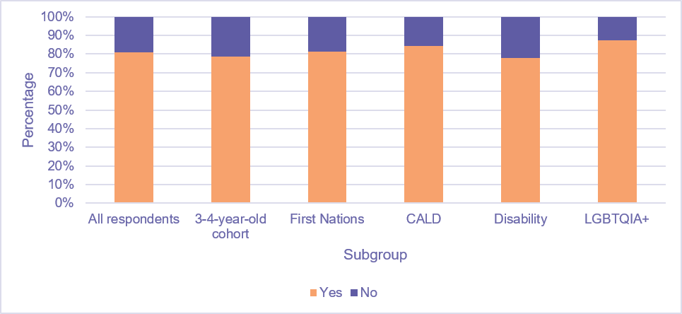
Figure 8. Percentage of parent survey respondents who said they had attended HIPPY gatherings.

We asked parents if they experienced any costs associated with attending HIPPY (Table 11). The majority (79%) of all respondents did not. Sixty-five parents provided more details regarding the costs. More than half on these parents cited that they had spent under $50 (the most common answer was $30). About 10 parents spent between $100 and $300, with one parent reporting spending $500. About half of the parents didn’t give a description of what the costs were for. Where costs were described, they related to transport costs such as petrol, uber or taxi. A couple of parents also described paying for childcare or stationary.
Table 11. Costs associated with participating in HIPPY as reported by parent survey respondents
Costs | All respondents  Frequency (n = 319) | All respondents  (%) | 3-4-year-old cohort  (n = 274)  (%) | First Nations  (n = 32)  (%) | CALD  (n = 84)  (%) | Disability  (n = 77)  (%) | LGBTQIA+  (n = 16)  (%)
No costs | 253 | 79.3 | 78.5 | 75 | 70.2 | 76.6 | 93.8
Some costs | 51 | 16.0 | 16.4 | 18.8 | 20.2 | 22.1 | 6.3
Not sure | 15 | 4.7 | 5.1 | 6.3 | 9.5 | 1.3 | 0.0

Parent satisfaction with the program
We asked survey participants if they felt that HIPPY was a good fit for them and their family (Figure 9) and asked them to explain why they gave the answer they did. Their responses are summarised below, grouped by how they responded to the “good fit” question. Parents felt strongly that HIPPY is a good fit (84%), with even higher levels of agreement in the four priority groups (ranging from 87% to 100% strongly agreeing). These positive results concur with DEX ratings regarding client satisfaction (99.5% gave an overall positive score in DEX data).
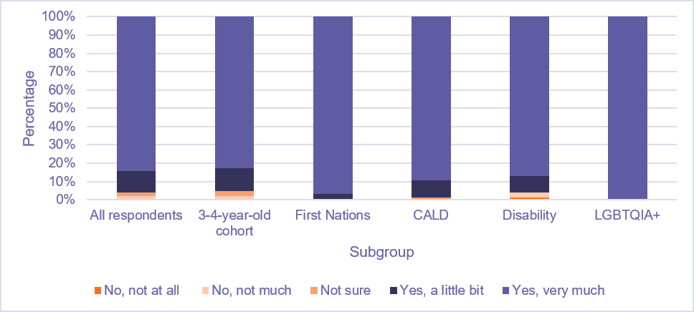
Figure 9. Parent survey respondents’ ratings of whether HIPPY is a good fit for themselves and their family.

In the following sections we report on participants’ free-text responses to prompts asking for their reasons for feeling satisfied or unsatisfied with HIPPY, their perceptions of goodness-of-fit, and whether or not the program was worthwhile. We also asked for their suggestions for improvements to HIPPY. Responding to prompts was optional; we have summarised the range of responses textually as providing percentage breakdowns is not appropriate for qualitative data.

Parents who felt the program was not a good fit
Most parents who did not find HIPPY to be a good fit for their families indicated they were already doing many activities at home or their children were exposed to these activities at daycare. While these parents viewed that HIPPY reinforced what they were already doing, it did not provide them with any further learnings.
For one parent, there was a misalignment between their expectation about the program and the program structure in relation to an educational approach the program was taking. This parent also indicated some difficulties with the delivery of the program due to their Tutor’s large workload which resulted in missed sessions and running out of resources to complete the program activities.
Several parents noted that the program did not match their child's developmental needs, with some perceiving the HIPPY activities as too easy while others finding them too hard for their children.
Despite these limitations, parents who felt the program was not a good fit to their needs did express positive views about HIPPY staff and acknowledged that while the program did not meet their specific circumstances, they could see it was valuable for other families, particularly those with different backgrounds and needs to their own.

Parents who weren’t sure
Some parents who were unsure whether HIPPY was a good fit for their families viewed that the program activities were too simple for their children or did not provide flexibility for children to engage in more complex learnings based on their needs. One parent noted they needed to adjust most of the sessions to make them work for their child. Regardless of these difficulties, one parent indicated positive views about the program and staff, describing them as positive and kind.
Time pressure and scheduling challenges were also noted. One parent indicated that organising and completing the structured program activities was ‘stressful’, particularly when the child was not interested in taking part.
One parent noted that attending gatherings with their 4-year-old child was difficult while the other caregiver in that family found the social aspect of gathering personally challenging. Another parent viewed the program was better suited for families who might require more intensive supports.

Parents who felt HIPPY was a reasonable fit
Parents frequently mentioned that they were already doing or had done many similar activities to those they were exposed to through HIPPY. However, they still appreciated the program due to its structured approach, providing resources, new ideas and fun activities, and the guidance from staff in implementing the program.
A few parents noted that completing the program with their 4-year-old children was challenging due to school demands and extracurricular activities. Taking part in program activities was also difficult when children were tired or not interested in activities.
Several parents mentioned challenges related to time pressure, finding it hard to fit activities into their busy routine, to attend mentoring sessions or gatherings.
Some parents reported they enjoyed the social aspect of the Gatherings and indicated that the program supported building social connection and sense of community.

Parents who strongly felt HIPPY was a good fit
For most of the overwhelming majority of parents who viewed the program was a very good fit for their family, they indicated that the program strengthened their relationship with their children and enhanced parent-child interactions. They noted a greater sense of connection with their children, with more opportunities for one-to-one quality time and shared activities, either with their children or as a family.
Parents frequently commented that their children enjoyed the program and related activities. Some of the parent-reported benefits included: improvements in children's social and emotional development, greater confidence and independence, better school readiness, and reduced anxiety.
Many parents indicated that the program helped to improve their own confidence and skills, particularly in relation to observing and understanding their child, learning how to teach at their child's pace and how to use play as a learning tool.
Some parents noted that the program fostered social and community connections and was described as inclusive, welcoming and friendly. One parent highlighted that the program provided appropriate resources for First Nations families.
Overall, parents provided positive views on the program resources and materials, describing them as 'great', 'fabulous' and 'amazing'. They also shared positive feedback about HIPPY staff and valued structured activities which reduced the need to plan activities independently.
We asked parents to consider if HIPPY was worthwhile for their family (Figure 10). Parents felt very strongly that HIPPY is worthwhile (86%), again with strong agreement across the various priority groups. We asked respondents about the reasons for the rating they made. Responses below are grouped by how strongly they rated their agreement or disagreement with HIPPY being worthwhile for them.
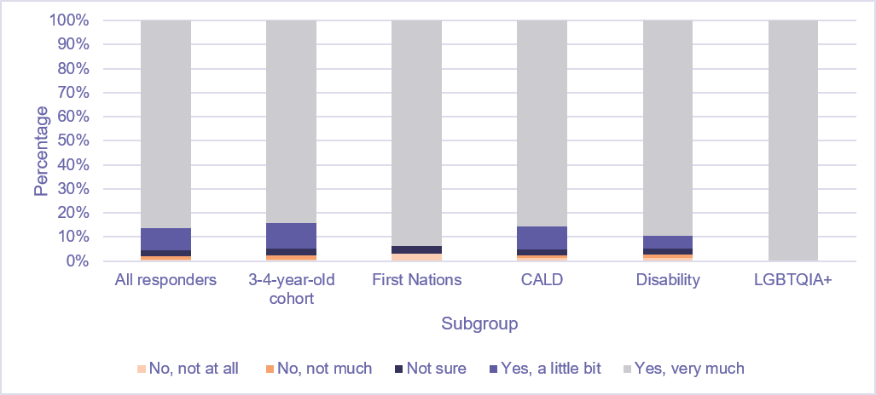
Figure 10. Parent survey respondents’ ratings of whether HIPPY is worthwhile for their family.

Parents who did not find the program worthwhile
The small number of parents who did not find the program worthwhile indicated they were already doing most of the program activities and viewed that activities were too simple or not a good match for their children's needs. Nonetheless, these parents did note that their children enjoyed some of the program activities and that they liked their facilitator.
Parents who were unsure of the worth of the program reported they were already doing most of HIPPY activities. One parent reported that the program confirmed they were already doing the right things when teaching their child which they felt positive about. Some parents noted time pressure to do activities while others felt pressured by HIPPY staff to attend a playgroup. One parent perceived that the program was better suited for other families who might need a greater level of support.

Parents who slightly agreed that the program was worthwhile
A few parents indicated that the program provided them with new ideas and additional guidance in supporting their child learning. Other positive aspects mentioned by parents who only slightly agreed the program was worthwhile include assisting parents to better understand how their child learns, provision of good resources and activities, and the structured approach of the program.
A few parents noted that the program was enjoyable for them and their children. Some limitations were related to time pressure, the program not fitting their child's needs and, at times, their participation in the program feeling like a chore.

Parents who strongly agreed that the program was worthwhile
The vast majority of parents who indicated that HIPPY was worthwhile for them described the increase in their child’s learning and confidence as the reason they found it worthwhile. Parents reported that the activities helped to build their child’s independence and skills such as skills required for school. Parents also expressed how much their children enjoyed the activities and looked forward to receiving the packs.
Additionally, parents reported on the increase in their own knowledge and confidence in supporting their child’s learning. Some parents felt more empowered and enjoyed the new ideas for activities that they had learned through HIPPY.
Another key theme that made HIPPY worthwhile for families was how it aided family bonding and quality time spent together. Some parents also credited the social connections they made though HIPPY and that their child could play with other children of the same age. Other parents said that the resources made the program worthwhile for them and that the program was welcoming
Some examples of what parents said include:
“We live in rural Victoria and don’t have a lot of facilities here, the HIPPY program fills a much-needed gap”

“As my child's first teacher, the HIPPY activities are great prompts and reminders of the things I should be teaching my child”

“Absolutely, HIPPY was incredibly worthwhile for me and my family. It gave me practical tools and the confidence to support my child’s early learning at home. Beyond that, it helped me build a stronger bond with my son through meaningful, quality time together. The program also connected me with a supportive community, which made the whole experience even more valuable. I’d highly recommend it to other families.”
Finally, we asked parents how satisfied they are with HIPPY (Figure 11). and if they had suggestions for improving the program. The overwhelming majority (95%) of parents were satisfied or very satisfied with HIPPY, and this pattern was repeated for the current cohort and all priority groups.
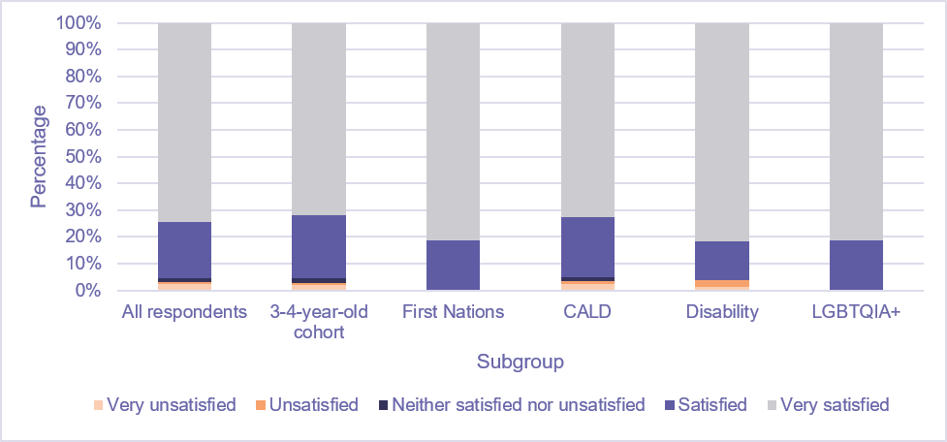
Figure 11. Parent survey respondents’ satisfaction with HIPPY.

Improvement suggestions from parents who were not satisfied
The few parents who were not satisfied with the HIPPY program cited a preference for more modelling of activities, additional materials and resources for their child, better alignment with their child's developmental needs, and more support for literacy, numeracy, and fine motor skill development.

Improvement suggestions from parents who were neutral
Parents who were neither satisfied nor unsatisfied felt the program was too simple for their child's level and suggested including more complex stories and activities. They also recommended adjusting the frequency of sessions, preferring weekly or fortnightly sessions in the first year and monthly sessions in the second year. They also noted that the program may be better suited to different family demographics. Despite these suggestions, parents appreciated the Tutor's interaction with their child.

Improvement suggestions from parents who were satisfied or very satisfied.
Most parents (over 95%) were either satisfied or very satisfied with HIPPY. When asked about ways in which HIPPY could be improved, the most common response from these parents was that no improvements are needed as they were happy with HIPPY as it was. Some example responses are:

“Very satisfied. HIPPY gave us the tools, structure, and confidence to make learning at home both effective and enjoyable”

“I think the care and preparation of the mentors really showed when they delivered the program, and I don't think anything needs to change”

“You are doing an amazing job. Just keep up the good work. Thank you from the heart.”

The next most common response from these parents was to have gatherings on different days so that more families can attend, and more advertising so that more families can be made aware of HIPPY. Some example responses include:

“More support to more families. It's a great program but not many people know about it.”

“Honestly more advertising! Allowing more families to be made aware! I honestly wished my first born did the program it would have helped so much with his development”

“More exposure in kindergarten for parents to take part in.”

Suggestions for improvements that were mentioned a couple times include offering the program in other catchment areas, including more science experiments and more variety of activities, as well as having more gatherings.

Parent knowledge and confidence
Parents’ confidence in doing learning activities with their child improved from the beginning of HIPPY to the time they were completing the survey. At the beginning of HIPPY, less than half (47%) of the 3-4-year-old cohort felt very or highly confident in doing learning activities, with even lower levels across priority groups: First Nations parents (41%), CALD parents (39%), parents with a disability (43%), and LGBTQIA+ parents (31%). When asked how confident they currently were (at the time of completing the survey), these figures increased greatly to 89% for the 3-4 cohort, 81% for First Nations parents, 89% for CALD, 91% for parents with a disability, and 94% for LGBTQIA+ parents.

Participants were asked how HIPPY has influenced how confident they feel in being their child’s first teacher, in supporting their child's learning, and in working with others who support their child's learning (e.g. teachers, HIPPY staff). As can be seen in Table 12, parents felt very strongly that HIPPY improved their confidence in supporting their child’s learning.
Table 12. Percentage of parents who reported that HIPPY had a positive or very positive impact on their confidence
 | 3-4-year-old cohort  (n = 274)  (%) | First Nations  (n = 32)  (%) | CALD  (n = 84)  (%) | Disability  (n = 77)  (%) | LGBTQIA+  (n = 16)  (%)
Feeling confident in being child’s first teacher | 93.5 | 96.9 | 97.5 | 92.2 | 100
Feeling confident in supporting child’s learning | 92.7 | 90.7 | 96.4 | 90.9 | 93.8
Feeling confident in working with others who support child’s learning | 94.1 | 96.9 | 95.2 | 88.3 | 100
Similarly, parents were asked about how HIPPY has influenced their understanding of how their child likes to learn and their knowledge of how their child learns through everyday activities.
Table 13 shows that HIPPY helped parents feel that they gained understanding of their child’s early learning.
Table 13. Parents’ perception of their understanding of child’s early learning.
 | 3-4-year-old cohort  (n = 274)  (%) | First Nations  (n = 32)  (%) | CALD  (n = 84)  (%) | Disability  (n = 77)  (%) | LGBTQIA+  (n = 16)  (%)
I have more/a lot more knowledge of how my child likes to learn | 85 | 93.8 | 86.9 | 88.3 | 100
HIPPY has influenced this somewhat or a large amount | 73.4 | 81.3 | 88.1 | 79.2 | 75

Findings: Tutor and Coordinator survey
Tutors and Coordinators have key responsibilities in delivering HIPPY at each site. A tertiary qualified Coordinator supports a team of home Tutors who live in the local community and schedule regular visits with parents to work through HIPPY activities in families’ homes. Tutors and Coordinators encourage parents to participate in regular group meetings (called ‘Gatherings’). Tutors and Coordinators are paid employees; Tutors are usually past or current parent participants in HIPPY.
The 134 respondents to the Tutor and Coordinator Survey (questions in Appendix 6: Tutor/coordinator survey questions) were mainly Tutors (84%) with two or fewer years of experience in the Tutor role (96% of Tutors). Coordinators had a range of experience in the role: mainly two years or fewer (55% of Coordinators) but also some with more than four years of experience (27% of Coordinators) (Table 14 and Figure 12).
Table 14. Survey respondents’ role in HIPPY
Role | Frequency (n = 134) | Percentage (%)
Tutor | 112 | 83.6
Coordinator | 22 | 16.4
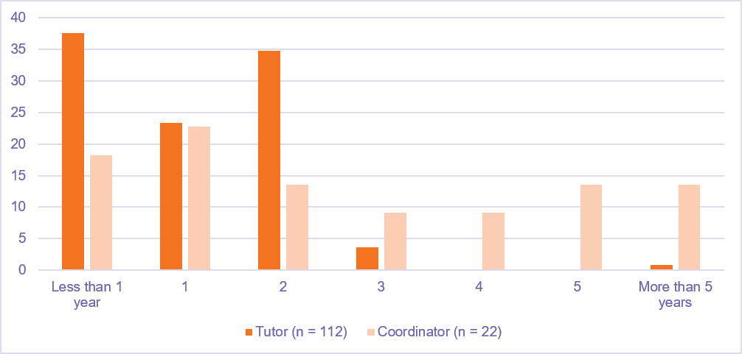
Figure 12. Tutor and Coordinator time in role
Most Tutors (90%) and Coordinators (55%) had previous experience of HIPPY as a parent participant in the program (Table 15).
Table 15. Tutors who had previously experienced HIPPY as a parent participant
 | Tutor (n = 112)  (%) | Coordinator (n = 22)  (%)
Yes | 90.2 | 54.5
No | 9.8 | 45.5
There was a good spread of respondents from around Australia, with a slight skew towards New South Wales (Figure 13) and good coverage of all remoteness classification (Figure 14).
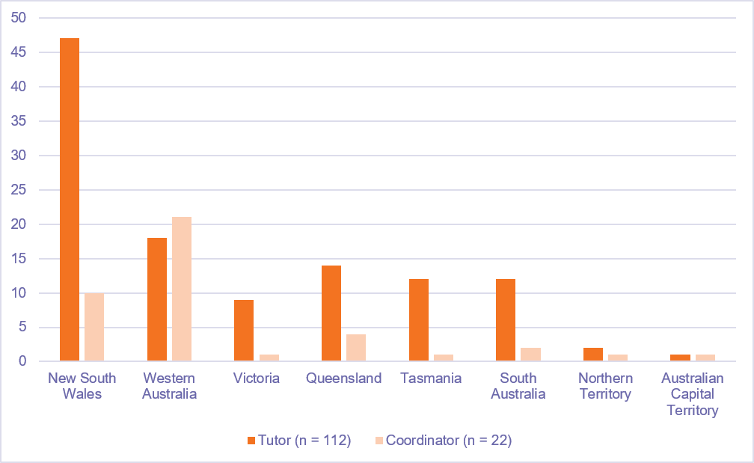
Figure 13. National spread of respondents
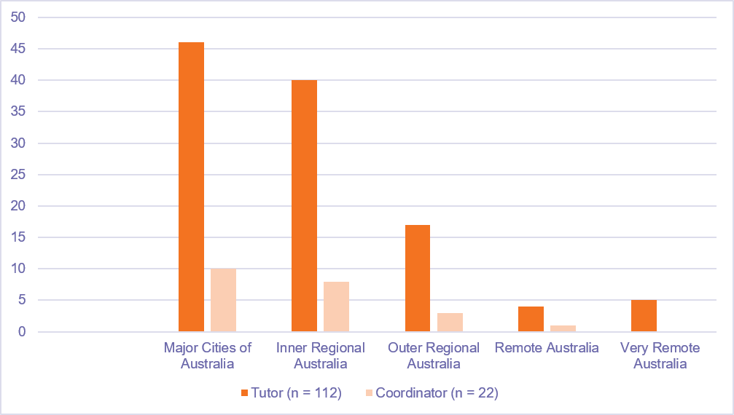
Figure 14. Spread of respondents by remoteness classification

Accessibility and appropriateness of HIPPY content for priority groups
Tutors and Coordinators largely agree that HIPPY is accessible to all four priority groups
The majority of Tutors (n = 112) and Coordinators (n = 22) perceived that HIPPY was accessible to First Nations parents (85% and 91% agree/strongly agree) (Figure 15). Most Tutors (74%) and Coordinators (82%) also believed that adequate support was provided for First Nations parents to access HIPPY.
However, there were some differences between Tutors and Coordinators in relation to the appropriateness of the program content for this group of parents. Around 81% of Tutors believed that the program content was suitable compared to approximately 64% of Coordinators Nearly 1 in 4 Coordinators were unsure about the appropriateness of the program content. A similar proportion of Tutors and Coordinators (around 45%) reported that First Nations parents regularly accessed HIPPY.
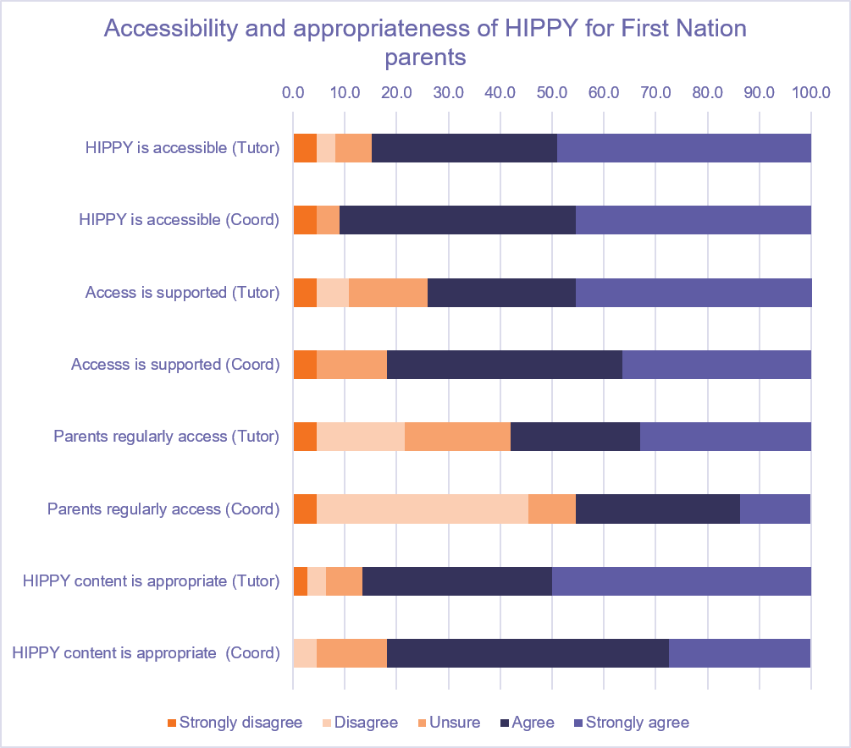
Figure 15. Appropriateness and accessibility of HIPPY for First Nations parents

Nearly 90% of Tutors (n = 112) and all Coordinators (n = 22) (100%) indicated that HIPPY was accessible to parents from CALD backgrounds (Figure 16).
The majority of Tutors (84%) and Coordinators (82%) reported that adequate support was provided to help CALD parents to access HIPPY. Similarly, 76% of Tutors and 77% of Coordinators perceived that CALD parents regularly accessed HIPPY Regarding the appropriateness of the program content, a higher proportion of Tutors (81%) believed that it was suitable for CALD families, compared to 63% of Coordinators. Notably, around 23% of Coordinators were unsure whether the content was appropriate for this group compared to less than 10% of Coordinators.
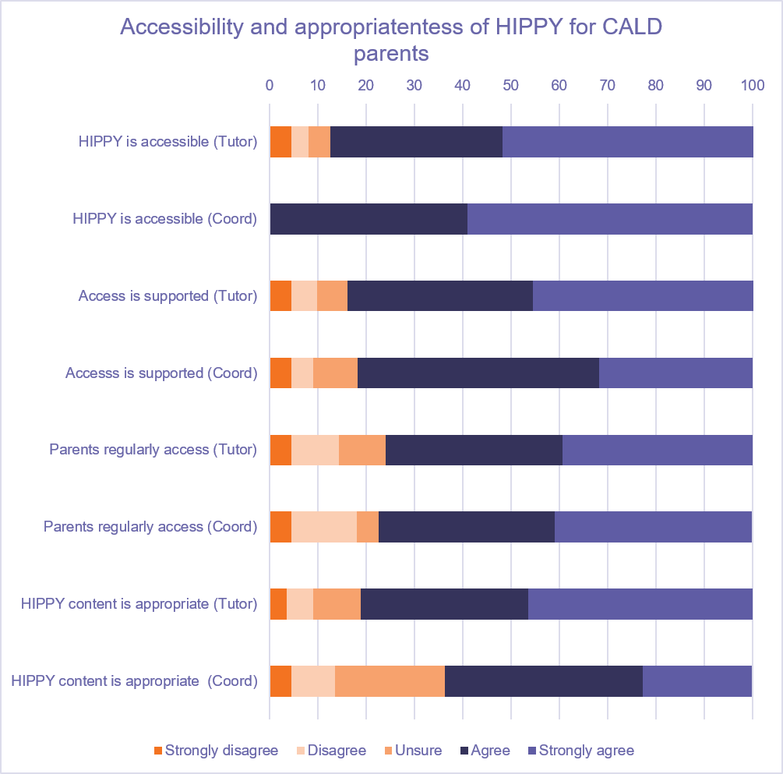
Figure 16. Appropriateness and accessibility of HIPPY for CALD parents

Most Tutors (72%) (n = 112) and Coordinators (86%) (n = 22) perceived that HIPPY was accessible to LGBTQIA+ parents (Figure 17).
Around 64% of Tutors and 59% of Coordinators reported that adequate support to access HIPPY was provided to this group of parents, although around 30% of Tutors and Coordinators indicated being unsure about this aspect. Only 41% of Tutors and 32% of Coordinators indicated that the LGBTQI+ parents/caregivers regularly accessed the program, with a great proportion of Tutors (45%) and Coordinators (32%) indicating uncertainty about regular attendance. Regarding the appropriateness of the program content, 67% of Tutors and 64% of Coordinators believed that it was suitable for LGBTQIA parents/caregivers. However, many Tutors (21%) and Coordinators (27%) remained unsure about the appropriateness of the program content for LGBTQIA+ parents. Note that this may be to low numbers of parents identifying as LGBTQIA+ across the program: Tutors responding to the survey may have had new or no such parents in their cohorts.
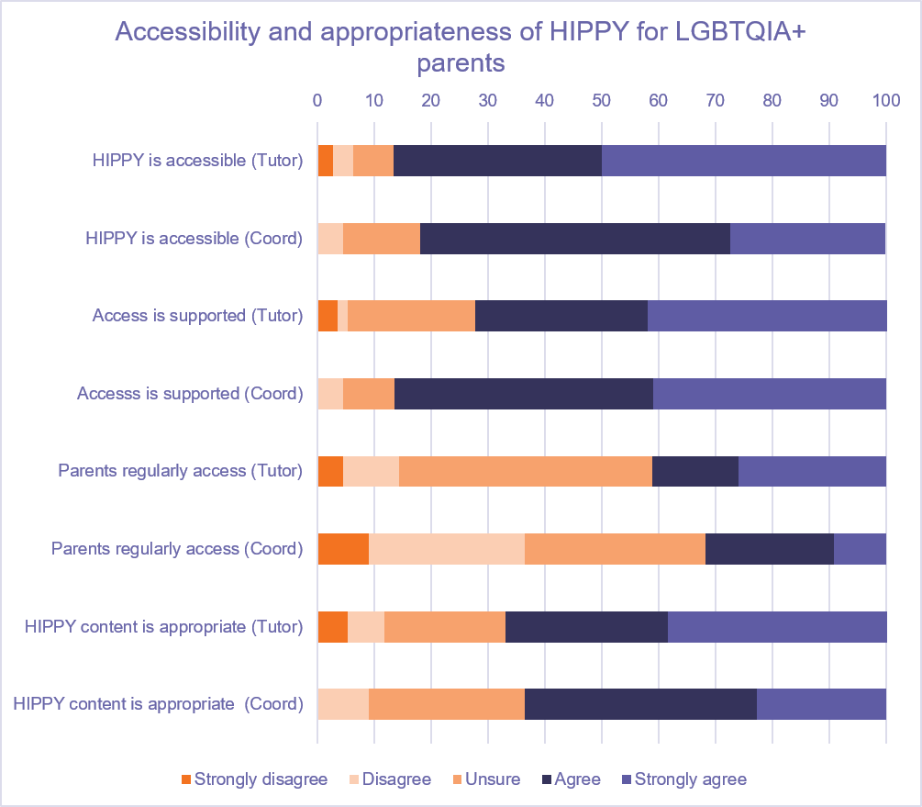
Figure 17. Appropriateness and accessibility of HIPPY for LGBTQIA+ parents

The majority of Tutors (81%) (n = 112) and Coordinators (91%) (n = 22) reported that HIPPY program was accessible to parents with disability (Figure 18).
In relation to providing adequate support to access the program, 73% of Tutors and 64% of Coordinators believed that adequate support was provided, though 18% of Tutors and 23% of Coordinators were unsure. Just under 70% of Tutors and Coordinators indicated that parents were accessing HIPPY regularly, with Tutors being twice as likely as Coordinators to express uncertainty about regular access. When asked about the appropriateness of the program content, 77% of Tutors and 64% of Coordinators perceived that it was appropriate for parents with disability.
Figure 18. Appropriateness and accessibility of HIPPY for parents with disability
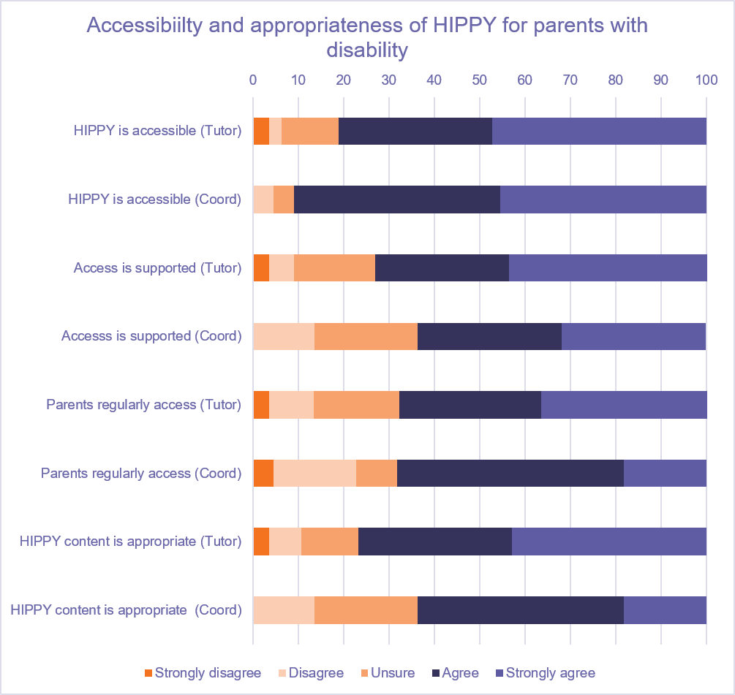

Implementation of HIPPY
All Coordinators who completed the survey reported that HIPPY was delivered in accordance with the program guidelines, compared to 76% of Tutors (Table 16).
Regarding costs, the majority of Tutors (83%) and Coordinators (86%) reported they had no out-of-pocket costs for either to be trained in HIPPY or to deliver HIPPY.
Table 16. Delivery of HIPPY according to program guidelines
 | Tutor (n = 112)  (%) | Coordinator (n = 22)  (%)
Strongly disagree | 13.4 | 0.0
Disagree | 6.3 | 0.0
Unsure | 4.5 | 0.0
Agree | 26.8 | 63.6
Strongly agree | 49.1 | 36.4
Tutors and Coordinators were most likely to report transport as an out-of-pocket expense, noting that while mileage is often reimbursed, parking, petrol, and general wear and tear are at their own expense. Although the mileage rate may be intended to cover the latter two of these three costs, Tutors clearly feel that it is inadequate. This issue may be of greater concern in rural and remote HIPPY sites where travel may be substantial.
“Kms are paid for by employer, but wear and tear of car and reduction in value due to increased milage isn't considered. The role, especially in our catchment area should include company vehicle.”
Multiple respondents stated that even when there is an option to claim mileage reimbursements, they often don’t have enough time to do their admin before the claim needs to be submitted, so they miss out. Some even said that if the budget is low, they don’t put their claims in. One Tutor said that “[Company] cars are often booked and not easily accessible. I wish that HIPPY Tutors were given a travel allowance as we do a lot of travelling. Claiming petrol at tax time is not enough, especially when I personally struggle to even fill my car with petrol which leaves me stressing each week…” which indicated that some Tutors may not have the option to claim mileage or do not know that they can. Another Tutor said “We do get paid for KMs travelled, but it doesn't cover my fuel usage. I'm spending about $50-$100 per week”.
Tutors and Coordinators reported purchasing supplies for activities and food for gatherings. They noted that administration (including communicating with parents, planning activities, finding parking) can take much more time than is allowed for in the program. Multiple respondents expressed that there isn’t enough time in their allocated hours to do all they work that is required, resulting in them working extra hours every week.
Finally, a small number of Tutors reported paying the expenses of training and obtaining compliance certificates such as Working With Children Checks and their police checks. This also highlights the additional time commitment involved in delivering the program.

Ways of improving HIPPY

Fewer packs in the second year
Many Tutors and Coordinators suggested that the number and frequency of packs in the second year can be overwhelming for families and should be reduced or spaced out more:
“Yes!!! Less packs in the second year, weekly is just too much for families as they are going into school/kindy. Switch it around or spread the total packs over the 2 years. My families are telling me there seems a never-ending flow of packs they just get started on one and are getting another one”

“I think the frequency on the Age 4 delivery should be changed to fortnightly. This has been somewhat of a concern to some parents who are sometimes feeling overwhelmed by the weekly visits.”

More accessible to more families: Digital delivery
Tutors and Coordinators highlighted that the integration of digital resources, tools, or online delivery could make the program more accessible and engaging for a broader range of families:
“Yes, while HIPPY is a valuable program, there is always room for improvement. Enhancing culturally tailored resources, increasing support for Tutors, and integrating more digital learning tools could further strengthen its impact and accessibility”

“Yes, while HIPPY is a valuable and impactful program, there are always opportunities for improvement. One area could be enhancing cultural responsiveness by developing more tailored materials that reflect the diverse backgrounds of participating families. Additionally, incorporating more digital resources and interactive tools could increase accessibility and engagement, especially for families with limited time or mobility”

“Yes, I believe that HIPPY needs to become more digital. An App would be ideal, with visual role plays in video form. This would be beneficial for families with disabilities and Indigenous people, where reading is difficult. The visual videos would also help these families to understand the requirements of the activities, instead of being required to partake in role play which is intimidating and potentially off putting”

“HIPPY might have to evolve into an online program in order to be successful with the demands of 21st century parents. Parents are being forced to go back to work sooner and sooner and that's where I lost a lot of families who left the program.”

More accessible to more families: Inclusive materials
Tutors and Coordinators reported the need for materials that are clearer, more culturally responsive, and better suited to families with diverse needs and circumstances.
“Some of the material is too stilted/wordy for people especially CALD or ATSI community”

“Translations for HIPPY Activity Booklets”

“More capacity for disadvantaged families to participate e.g. Abbreviated version, enrolment at any time during the year, option to go at own pace. Currently there is a disincentive to enrol families in crisis/ higher disadvantage due to their inability to complete 2 years”

“Inclusion of non-nuclear families. Most of the stories have extended family relationships. For CALD families extended family members can be a source of isolating feelings. For displaced or trauma survivors the nuclear family dynamics can be trauma provoking.”

More reach/advertising
Another improvement suggested by Tutors and Coordinators centred around greater community engagement and promotion to help the program reach more families who may benefit.
“I think that doing community outreach activities days would be great and more advertising so the HIPPY program is known about by more in the community”

“I think HIPPY can do more marketing or seminar in the community in order for parents to be familiar with the program”

“HIPPY could benefit linking in with local services and attending and/or being more involved in community events. This will help to get more exposure and to promote the program so that it could reach the families that could benefit most from HIPPY.”

Increasing hours/salary/benefits
Tutors and Coordinators reported that improved pay, more hours, and better resourcing would support staff to deliver the program more sustainably and effectively.
“Yes, by increasing hours for Hippy Tutors and increasing the salary”

“Would LOVE a company car to do pack deliveries with. This would honestly make the job perfect in my opinion. Everything else I am really enjoying”

“Better funding to account for CPI and Inflationary pressures”

“The current funding model may appear to promote equality by allocating the same base/block funding to all sites; however, it does not ensure equity. Each HIPPY site operates at different levels of recruitment and retention, and a one-size-fits-all funding approach fails to account for this variation”

“Offering funding for transport costs in delivering packs to the families”

“HIPPY's guidelines for the expectations of Tutors and the program is unrealistic. HIPPY curriculum is clunky and overly repetitive causing families to disengage with the activities. A lot of activities could benefit from intentional planning and thought to make improvements.”

More training and support
Some Tutors and Coordinators expressed the need for additional training and support to help staff work effectively with families experiencing a range of challenges.
“More support. More training in dealing with families that are low economic/high anxiety. Training to deal with potential dv issues”

“Having more training for staff that has focus on working with diverse families and those with
disabilities would be helpful.”

Findings: Tutor administrative data
BSL supplied us with administrative data for 774 Tutors with the earliest records being for Tutors commencing in 2011.
Most Tutors have commenced in recent years, as shown in Figure 19. A majority of Tutors (677, 87%) indicated that they are current or previous HIPPY parents, the majority (535 or 69%) from 2020 or later but stretching back to 2007.
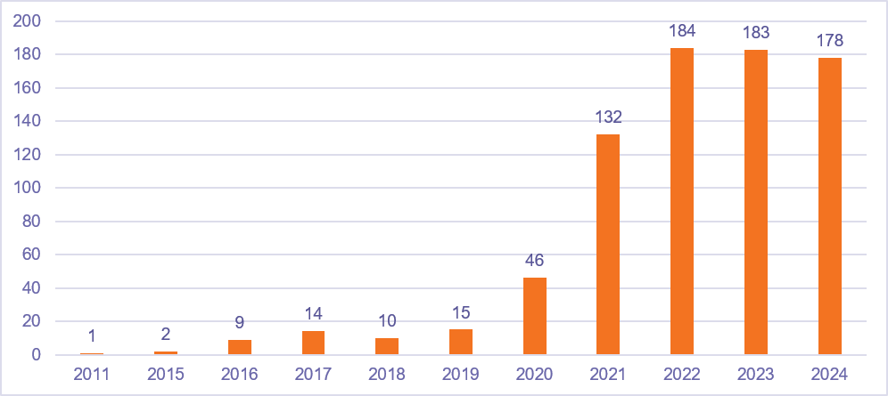
Figure 19. Commencement year of Tutors (N=774)
Most (764, 93%) Tutors were women, 10 (1%) were men, and 44 (6%) did not specify.
Of the 774 Tutors for whom we have data, 186 (24%) identified as First Nations (Aboriginal, Torres Strait Islander, or Aboriginal and Torres Strait Islander) and 578 (75%) did not (10 people did not state) (Figure 20).
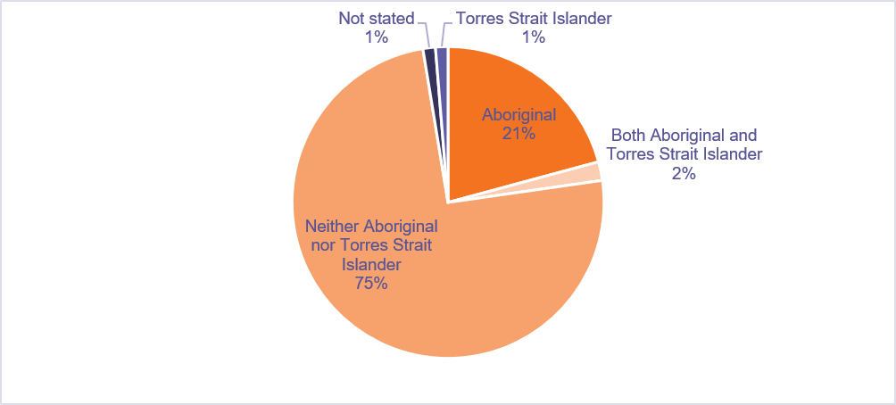
Figure 20. First Nations status of Tutors (N=774)
A total of 255 (29%) Tutors speak a language other than English at home. They have a wide range of educational backgrounds: 31% have a TAFE qualification, 25% have a university degree, 19% completed some high school but did not complete year 12, and 16% completed year 12. The full range of educational experiences is shown in Figure 21.
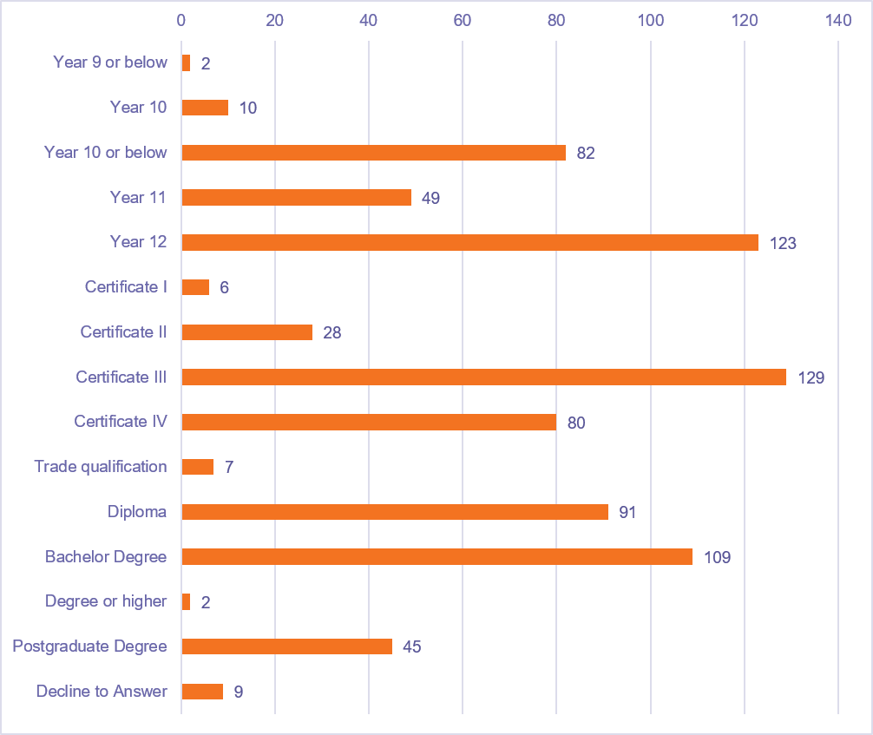
Figure 21. Education background of Tutors.

Employment type and previous employment
HIPPY Tutors are split between casual (n=433, 56%) and part time (n=339, 44%) employment on HIPPY (with one Tutor each listing employment type as full time and other). The average number of hours worked per week on HIPPY was 15, with a range of 1—35 hours. The mode and median were also 15 hours.
Details of Tutor training dating back to 2014 were provided, reporting dates of training, packs trained, skills trained, and enrichment topics delivered. This is a large file of more than 33,000 entries. We will describe training provided in 2023, 2024, and 2025 (up until 2 September 2025). This is a file of 17,528 entries so we will report aggregate data only.
Training was recorded for 595 Tutors over the years 2023-2025. An overview of the numbers of packs, skills, and enrichment topics for which training was provided is shown in Table 17.
Table 17. Overview of Tutor training
 | Packs trained | Skills trained | Enrichment topic (non-HIPPY) | Enrichment topic (HIPPY)
2023 | 3214 | 5789 | 2636 | 1528
2024 | 8521 | 8520 | 3835 | 2098
2025 (to Sept) | 3214 | 3213 | 1589 | 594
Totals | 14949 | 17522 | 8060 | 4220
The types of skills and topics on which training was delivered relate to HIPPY skills (that is, those on which Tutors work with parents) (Table 18), to HIPPY-related enrichment topics, and to enrichment topics for Tutors that do not directly relate to HIPPY skills but which complement program delivery (see Table 19).
Table 18. HIPPY skills training received by HIPPY Tutors between 2023 and 2025
HIPPY Skills trained
Behaviour specific praise | Relationship building
Community knowledge | Reviewing
Cultural knowledge | Role play confidence
Cultural sensitivity | Role play frequency
Everywhere learning | Role playing
Explaining educational language | Supporting parent learning
Pack Delivery form reporting | Supporting parents
Parents as first teachers | Using technology
 | Time management

Table 19. Enrichment training received by HIPPY Tutors between 2023 and 2025
HIPPY Enrichment topic | Other Enrichment topic
Behaviour-specific praise | Communication skills
Building community knowledge | Community safety
Building confident & competent learners | Counsellor Skills
Building relationships with HIPPY families | Early childhood development
Child Agency and Children's voices | Early literacy & numeracy
Engaging families with complex needs | Employment/study skills
Everywhere Learning | Events & celebrations
Group Meetings | Family health, nutrition & wellbeing
HIPPY Curriculum Framework | ICT & computer skills
Home visits | Induction & policies
Integrated Learning: Exploring STEM activities 1 | Parenting techniques for understanding children
Introducing Pathways to Possibilities (P2P) 1 | Preparing families for the transition to school
Key milestones of brain development | Relationship-building skills
Learning styles | Services in the community
Little brains, learning & trauma | Supporting the Home Learning Environment
Managing difficult conversations | Team building
Parents as their child's first teacher | Time management & organisational skills
Play based learning | Working with First Nations families
Professional boundaries | Working with Culturally and Linguistically Diverse (CALD) families
Reflective practice
Role play & 3Cs: engaging families
Supporting Tutors to use ICT
Sustainability
The power of storytelling
Transitions as families engage in HIPPY: Age 4 to Age 5
Transitions for Tutors
Tutors: Self-care
Understanding how to support families with diverse literacy skills
Unpacking social & emotional development
Training was delivered on 45 different HIPPY packs over the 2023-2025 period; we do not have information regarding what was covered in those packs.
In the period from 2023 to 2025, the medians for training completion by Tutors were 30 HIPPY packs, 28 skills units, 6 HIPPY enrichment topics, and 12 other enrichment topics. The breakdown of median training components for Tutors by year is shown in Table 20. These data suggest there has been an increase in training over time, especially evident considering that the 2025 figures are not for a complete year.
Table 20. Tutor completion of training over time
 | HIPPY packs | Skills | Other enrichment | HIPPY enrichment
2023 | 14 | 15 | 7 | 4
2024 | 19 | 19 | 10 | 5
2025 (to September) | 19 | 19 | 8 | 4

Section 4: Limitations and challenges
While this evaluation captured valuable insights, limitations must be acknowledged.
Site selection for consultations underwent several changes, with some original locations replaced by others. While these adjustments were feasible, they were not expected to significantly influence the diversity of results. Challenges also arose in contacting sites, as communication delays and varying levels of responsiveness led to inconsistent coordination. Additionally, the cohort selection process was affected by each site's discretion in sharing parent and carer details, which may influence the representativeness of the participant pool.
HIPPY operates as a national program, but only a small proportion of participants engaged in this evaluation (either via site consultations or the online surveys) relative to the broader pool of program participants. Excluded participants may have included cohorts such as parents and/or HIPPY staff who were no longer involved in the program or parents who dropped out of the program before completing it. As a result, less engaged or dissenting voices may not have been fully captured and would have the effect of limiting the diversity of perspectives. We acknowledge that there may be potential bias introduced by recruiting only current Tutors and Coordinators, who may have been concerned about potential impacts to employment despite assurances regarding the confidentiality of their responses.
There is some evidence also that parent survey respondents as a group may be less culturally diverse than the broader cohort of HIPPY clients, although the voices of culturally and linguistically diverse clients are present in survey data. Although questions of representativeness are not appropriate to our qualitative work (site consultations), the low response rates for the surveys mean that these findings should be viewed with some caution. Within our already limited samples, representation of people identifying as LGBTQIA+ was particularly low, both in the site consultations and for the parent survey.
Taken together, these factors mean that our findings should be viewed as indicative rather than representative. Nonetheless, the participants contributed rich, authentic insights and detailed reflections that highlighted perceived strengths and limitations associated with the program. We suggest that the overall agreement between our site consultation and survey findings lends support to each individual set of findings.
While transcription was effective, challenges arose where English was not a first language and exact translations were difficult to ascertain. Online consultations were also difficult for some parents due to limited technological access or a lack of digital confidence. Some parents attended interviews while caring for children resulting in their attention being divided during sessions. In other cases, parents were unable to attend scheduled interviews due to competing priorities. These factors affected the depth or continuity of data collected in online settings. Similar challenges may have been experienced by parents, carers, Tutors, and Coordinators who completed online surveys (or may have experienced barriers to completing such surveys).
While limitations existed, the strong collaborative relationship between IPS and Curijo offered distinct strengths to the site consultation work. Their shared approach, grounded in a robust cultural lens, ensured that data were handled securely, interpreted with cultural integrity, and underpinned by a credible and trustworthy foundation for the findings. Similarly, PRC worked with BSL, DSS, IPS, and Curijo to attempt maximum acceptability of and engagement with our surveys. We also worked with the Australian Centre for Evaluation on a shared delivery approach, including questions relating to their separate evaluation components in our site consultations and parent survey. While this impacted our planning and our original approach to site engagement, it enabled more streamlined delivery and lower participant and organisational burden.
Both evaluation components were the subject of outreach to Tutors and Coordinators (on whom we relied for assistance with recruitment) via workshops, newsletters, and individual correspondence. We acknowledge that participation in this evaluation represented a significant time investment for families and professionals which may have been less salient than other demands on their time.

Section 5: Conclusion and recommendations

Is HIPPY accessible?
Our site consultations show that HIPPY is widely regarded as an accessible and equitable program that succeeds through its flexibility, relational delivery, cultural responsiveness, and no-cost model. However, its accessibility could be further improved through expanded outreach, simpler administrative processes, stronger public visibility, and sustained investment in the workforce. These measures would ensure that HIPPY’s accessible design fully translates into equitable reach and participation for all families.
Organisational Accessibility
HIPPY sites demonstrate strong organisational readiness supported by clear communication, hands-on training, and flexible local operations. Coordinators and Tutors benefit from strong supervision and peer learning that promote cultural competence and confidence. However, limited funding, workload pressures, and slow communication from the national office reduce consistency and capacity. In some cases, restricted professional development opportunities, particularly in trauma-informed practice, LGBTQIA+ inclusion, and complex family support, pose ongoing challenges to full accessibility.

Referral Pathways and Awareness
Access to HIPPY is largely community-driven and inclusive, with referrals often arising from word of mouth, playgroups, and social media. This organic approach fosters trust among CALD and First Nations families but also reveals low public visibility. Barriers include limited marketing reach, English-only materials, strict catchment zones, heavy paperwork, and capped intakes. Coordinators address these by simplifying forms, using plain language, and helping low-literacy or non-English-speaking families navigate entry. Greater awareness and broader eligibility would strengthen equitable access.

Program Delivery and Adaptability
Tutors and Coordinators deliver a structured yet flexible program, blending fidelity to the HIPPY model with practical adaptation. They adjust language, pacing, and mode of delivery to meet family needs, including for disability, trauma, or socio-economic disadvantage. Tutors often use first languages, modify activities for neurodivergent children, and meet families in accessible spaces or at convenient times. This adaptability is HIPPY’s central strength, ensuring engagement across varied contexts.

Barriers and Resource Constraints
Despite strong accessibility in principle, challenges persist. Workload and emotional demands on Tutors, limited funding in the context of increasing infrastructure costs, and lack of substitute staff can restrict reach and sustainability. Excessive adaptation, while beneficial for families, risks blurring roles and increasing burnout without adequate support. Improved training, communication systems, and resourcing are needed to maintain both accessibility and program fidelity.

Sustainability and Scalability
Both parents and staff view HIPPY as a potentially sustainable and scalable model if funding and workforce support continue. Local flexibility, cultural responsiveness, and peer advocacy are crucial for maintaining its inclusivity and success.
Our parent and staff surveys suggest that HIPPY is accessible across Australia and is accessible to the four priority groups. HIPPY is attended by people from a wide range of educational and employment backgrounds living within and beyond major capital cities. Parents are able to attend HIPPY gatherings without incurring extra costs.

Is HIPPY inclusive?
Site consultations revealed that HIPPY is widely recognised as an inclusive and empowering program that strengthens family engagement, school readiness, and community belonging across diverse backgrounds. Overall, HIPPY demonstrates strong inclusivity through its flexible, culturally aware, and cost-free design, effectively supporting families of varied backgrounds and abilities while fostering belonging, confidence, and community participation.
DEX data confirms the program is well-accessed by Aboriginal clients and by other culturally diverse groups with at least one in five HIPPY clients being culturally or linguistically diverse.
Our survey respondents were highly satisfied with HIPPY and felt the program is a good fit and worthwhile for their families. Tutors and Coordinators felt, with some reservations, that HIPPY is accessible to and appropriate for the four priority groups: First Nations parents, CALD parents, LGBTQIA+ parents, and parents with disability. DEX data regarding client satisfaction with HIPPY also overwhelmingly endorses the value from clients’ perspectives.

Inclusivity and Accessibility
Parents and staff consistently describe HIPPY as flexible, culturally respectful, and equitable. Its home-based design and free materials remove cost barriers, making it accessible for low-income, First Nations peoples, culturally and linguistically diverse (CALD), and disability-affected families. Tutors play a key role in inclusivity by adapting materials for language, ability, or cultural needs, and by connecting families with services like the NDIS.

Cultural and Community Responsiveness
First Nations families feel HIPPY acknowledges their culture, while CALD participants appreciate learning about Australia’s education system. However, some parents seek greater multicultural representation, improved scheduling flexibility, and stronger community and social media outreach.

Empowerment and Outcomes
HIPPY enhances children’s literacy, numeracy, confidence, and emotional regulation, while empowering parents to teach at home and engage in schooling. Many families describe the experience as life-changing due to improved confidence, English language skills, and social connections.

Barriers and Challenges
Challenges included staff workload, time constraints, financial or housing instability experienced by families, and limited rural access. Staff cited funding delays and administrative burdens as constraints on outreach and sustainability.
Some site consultations revealed scope to refine training, consultation, and the funding model. For example:
- Some Coordinators working with families who have complex trauma, self-medicating behaviours, and domestic violence (especially in rural and remote areas) expressed concerns about how sharing their experiences was received by other Coordinators.
- Where HIPPY sites are partnered or collocated with other services, this can create inconsistencies in support and resources provided across all sites.
- Funding and costs can be a concern for sites, where hours are reduced with minimal notice or costs have increased significantly. This has placed extra pressure on sites to continue delivering the same standard of service with fewer resources and has contributed to difficulty recruiting Tutors.
Nonetheless, and despite these challenges, Tutors’ and Coordinators’ commitment and adaptability sustain engagement with the program.

Has the HIPPY program been implemented as intended?
HIPPY appears to be broadly implemented as intended, including the adjustments made as part of the reforms of 2021-22. Sites have successfully transitioned to the 3-4-year-old cohort, navigating a sometimes-increased workload and retaining a focus on working with children at their developmental stage in preference to their age, while offering families some flexibility in how they engage with the program.
Implementation sites demonstrate strong organisational readiness and adaptability, underpinned by clear communication, hands-on training, and flexible local operations. Coordinators and Tutors benefit from supervision and peer learning that foster cultural competence and confidence. However, systemic challenges such as limited funding, workload pressures, and communication from the national office constrain consistency, capacity and local adaptability. Professional development gaps—particularly in trauma-informed practice, LGBTQIA+ inclusion, and complex family support—also limit full accessibility of the program.
HIPPY is widely recognised as an inclusive and empowering program that strengthens family engagement, school readiness, and community belonging across diverse backgrounds. Its home-based, cost-free design removes financial barriers, while Tutors adapt materials and delivery to meet cultural, linguistic, and disability-related needs. Greater program flexibility when supporting families who have experiences of complex trauma, self-medicating behaviours, and domestic violence may be required. Families report significant benefits, including improved literacy, numeracy, confidence, and social connection. Despite these strengths, barriers persist; low public visibility, strict catchment zones, capped intakes, and administrative burdens restrict equitable access. Staff workload, funding delays, and limited rural reach further challenge sustainability.

Recommendations
Based on our site consultations and our examination of survey and administrative data, we make the following recommendations:
- Ensure funding for program delivery and workforce support reflects contemporary needs
- Provide sustained and flexible funding to address infrastructure cost increases post-COVID, to alleviate workload pressures, enable substitute staff, and improve salary and benefits for Tutors and Coordinators.
- Ensure funding covers professional development and compliance costs to reduce any out-of-pocket expenses for staff.
- Expand professional development
- Invest in targeted training for trauma-informed practice, LGBTQIA+ inclusion, and strategies for supporting families with complex needs, including for those with intersectionality across priority groupings.
- Enhance cultural competence and skills for working with disadvantaged and non-nuclear families.
- Provide resources for complex needs: Tutors often act as informal case managers; structured support and referral pathways are needed.
- Improve accessibility and outreach
- Broaden eligibility criteria, streamline enrolment processes and reduce administrative barriers such as burdensome paperwork and strict catchment zones.
- Increase marketing and community engagement through multilingual materials, social media campaigns, and partnerships with local organisations.
- Keep and increase flexibility in program delivery to meet families where they are at. For example, if families find the jump from fortnightly (age 3) to weekly (age 4) overwhelming, consider reducing the number of packs or spreading them across two years. Also, consider allowing participation up to age 5 or offering a slower pace for families with disability or complex needs.
- Embed HIPPY in schools and ECEC centres, to increase reach and support children and families holistically.
- Consider developing an option for the younger siblings of children enrolled in HIPPY to assist with early preparations for school readiness via ECEC centres. Although HIPPY is an in-home program, greater presence within early education may improve program reach and provide support for more siblings.
- Explore digital and flexible delivery options
- Consider offering digital program resources and online engagement tools, such as an app or video-based resources, to complement home visits and increase reach, particularly in rural and remote areas and for families with low literacy or limited time.
- Offering flexible scheduling and alternative delivery modes would help to better cater to diverse family circumstances, including community-based meeting options.
- Increase program flexibility and sustainability
- Implement systems for clearer communication between HIPPY national office and site providers, where needed, to ensure consistency.
- Monitor adaptation practices to balance flexibility with fidelity, reducing risks of role confusion and Tutor burnout.
- Increase multicultural representation
- Develop more stories and activities reflecting diverse cultures, not only First Nations.

Appendix 1: Cultural Alignment Charter
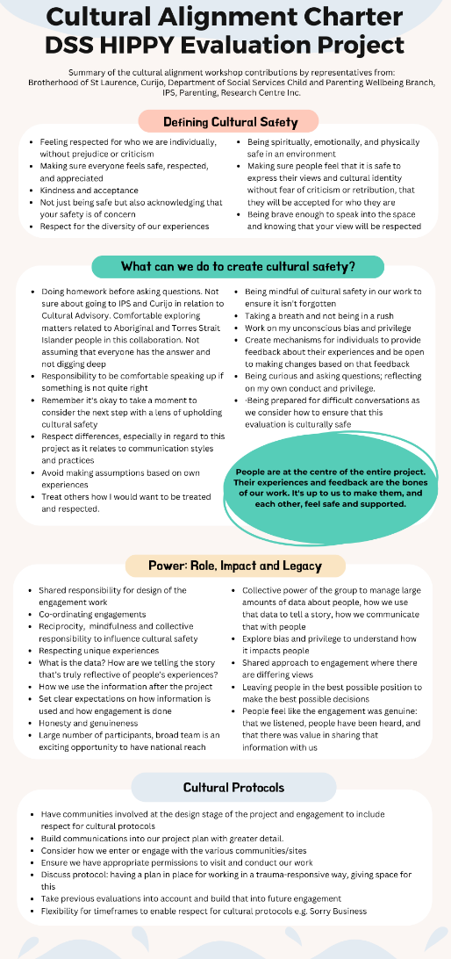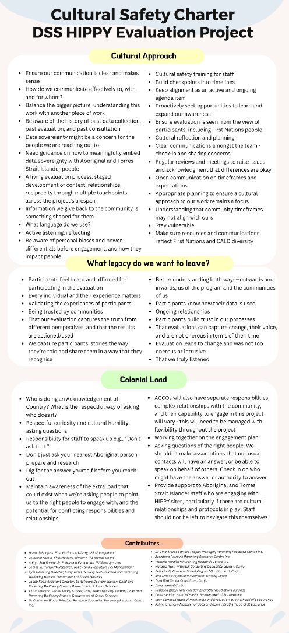

Appendix 2: HIPPY sites
The following table lists the HIPPY sites that were engaged with during the evaluation. This list is limited to sites engaged with during the evaluation and does not include HIPPY sites that have operated and/or still operate but who did not participate in the evaluation.
Online or In-person | Sub-contractor engaging site | State / Territory | First Nation focused site | Site | Remoteness Area Category | Program Provider | Year established
Online | Curijo | NSW | No | Ashmont | Inner regional | Anglicare NSW South, NSW West and ACT | 2011
Online | Curijo | NSW | Yes | Broken Hill | Outer regional | Maari Ma Health Aboriginal Corporation | 2014
In-person | Curijo | NSW | No | Cabramatta | Major city | Learning Links | 2010
In-person | Curijo | NSW | No | Campbelltown | Major city | Focus Connect | 2009
In-person | Curijo | NSW | No | Dubbo | Inner regional | Centacare Central West and Orana | 2010
Online | Curijo | NSW | Yes | Warranwong | Inner regional | Samaritans Foundation | 2015
Online | Curijo | NSW | Yes | Nambucca Valley | Inner regional | MiiMi Aboriginal Corporation | 2015
In-person | Curijo | NSW | No | Nowra | Inner regional | Family Services Australia | 2011
In person | IPS | VIC | No | Dandenong | Major city | Southern Migrant and Refugee Centre | 2011
In-person | Curijo | VIC | No | Fitzroy | Major city | Brotherhood of St Laurence | 1998
In-person | IPS | VIC | No | Frankston North | Major city | Brotherhood of St Laurence | 2011
Online | Curijo | VIC | Yes | Latrobe | Inner regional | Anglicare Victoria | 2014
In-person | Curijo | VIC | Yes | Mildura | Outer regional | Mallee District Aboriginal Services | 2014
In-person | Curijo | VIC | No | North Melbourne | Major city | Brotherhood of St Laurence | 2007
In person | IPS | VIC | Yes | Whittlesea | Major city | Life Without Barriers | 2015
Online | Curijo | QLD | No | Caboolture | TBD | Younity Community Services | 2011
Online | IPS | QLD | Yes | Cairns South | Outer regional | Wuchopperren Health Service | 2015
In-person | Curijo | QLD | No | Goodna | Major city | Playgroup Queensland | 2009
Online | Curijo | QLD | Yes | Hervey Bay | Inner regional | Central Queensland Indigenous Development | 2014/2024
In-person | Curijo | QLD | No | Logan | Major city | Kingston Eastern Neighbourhood Group | 2010
Online | Curijo | QLD | No | Rockhampton | Inner regional | Life Without Barriers | 2019
Online | IPS | QLD | Yes | Toowoomba | Inner regional | Goolburri Aboriginal Health Advancement | 2014
Online | Curijo | QLD | No | West Ipswich | Major city | Mission Australia | 2011
In-person | IPS | SA | No | Elizabeth | Major city | Anglicare South Australia | 2009
In-person | IPS | SA | No | Whyalla | Outer regional | Uniting Country SA | 2010
In-person | IPS | WA | Yes | Armadale | Major city | Communicare | 2014
Online | IPS | WA | No | Geraldton | Outer regional | Child Australia | 2011
In-person | IPS | WA | No | Girrawheen | Major city | Ngala Community Services | 2009
In person | IPS | WA | Yes | Gosnells | Major city | Communicare | 2014
Online | IPS | WA | Yes | Hedland | Remote | Child Australia | 2015
Online | Curijo | TAS | No | Launceston | Inner regional | Anglicare Tasmania | 2009
Online | Curijo | TAS | No | West Coast | Remote | Rural Health Tasmania | 2009
In-person | IPS | NT | No | Alice Springs | Remote | Tangentyere Council Aboriginal Corporation | 2009
In-person | IPS | NT | Yes | Darwin North | Outer regional | Anglicare NT | 2015
In-person | Curijo | ACT | No | Belconnen | Major city | Uniting Care Kippax | 2009

Appendix 3: Emails to sites
Note that the wording of these emails will have changed slightly for sites that were visited in person or online and whether they were sent from Curijo or IPS.
Hello [HIPPY Coordinator name]

I’m writing to you about the evaluation of the HIPPY program. It is finally happening!
You may recall from the webinar meeting in September last year and the other day, that some sites will be selected for interviews and focus groups. Your site has been selected by Curijo/IPS based on your location in Australia.

As a recap….
The Parenting Research Centre (PRC) are working with IPS Management Consultants and Curijo to conduct an evaluation of the HIPPY program. The evaluation has the support of Brotherhood of St Laurence, is funded by the Department of Social Services (DSS) and has been approved by the PRC Human Research Ethics Committee.

We are seeking your assistance with this evaluation in the following ways:

PARENTS/CARERS INTERVIEWS/FOCUS GROUPS
Encouraging and supporting parents/carers to take part in interviews/focus groups. Please note that at this stage, Curijo/IPS is looking for parents/carers who:
- have been HIPPY clients between January 2022 and August 2024 (recently completed the HIPPY program) AND
- identify with at least one of four diverse groups:
  - First Nations
  - Culturally and Linguistically Diverse
  - LGBTQIA+
  - Having a disability.

This will involve the following steps:

[For Interviews/Focus Groups] Speaking or emailing HIPPY parents/carers about the evaluation interviews and focus groups.

To assist you with this process, there are three attachments to this email
- Attachment 1: Easy English Invitation Email/Script. This will help you know what to say when it comes to introducing the evaluation.
- Attachment 2: Communicating contact details to Curijo/IPS. This will help you know what to say about the evaluation so that parents/carers know that you will pass on their details to Curijo/IPS.
- Attachment 3: Detailed evaluation information. You can pass this attachment directly to parents/carers for their information or you can use it to answer any questions from HIPPY parents/carers.

If parents/carers express interest in participating in the interview/focus groups, could you pass on their name, email and phone number to an evaluation team member at Curijo/IPS.

If the parent/carer prefers to reach out, you can provide them with Curijo’s contact details.
Our contact details are:

Contact details for Curijo/IPS staff | Contact details for Curijo/IPS staff

STAFF INTERVIEWS/FOCUS GROUPS
If you would like to take part in the staff interviews/focus groups, this involves the following steps:

- [For staff Interviews/Focus Groups] Please email Curijo/IPS to express your interest in taking part in an interview or group discussion about HIPPY. They will provide more information and organise a time to meet that suits you. The discussion will take about 40-60 minutes.
- [For other stakeholder Interviews/Focus Groups] If you know of any other community stakeholders who might be able to comment on HIPPY and its role in their community, please provide:
  - their contact details to Curijo/IPS and they will contact the person; or
  - forward the details of Curijo/IPS if they wish to discuss further.

If you have any questions about the evaluation more broadly, please contact:

[Contact details for Parenting Research Centre researcher]

Many thanks from the evaluation teams at Curijo/IPS and PRC.

Appendix 4: Interview questions

A4.1: Parent interview questions
Construct | Corresponding sample question(s)
About you | Can you tell me a bit about yourself  Where are you from? Who is your Mob? Who is your tribe?  What about your family and community?
Acceptability and appropriateness of the program for families | Can you tell me about your involvement with HIPPY so far?  What are the things you enjoy about HIPPY? How well did it work for you?  What is it like working with your HIPPY tutor?  What didn’t you like? What would you change if you could?  Are there ways we could make HIPPY be more acceptable to your community?  Do you think HIPPY is culturally appropriate for your community (service provision, interaction with the community)? (wording can be changed for participants) What do you think would make it more culturally appropriate?  Do you think HIPPY would be good for parents of different abilities and backgrounds (disability, different cultural groups, etc.) – why? Why not?
Referral pathways and mechanisms | How did you find out about HIPPY?  Are there any challenges you’ve experienced getting to HIPPY (geographical)?  Are there any challenges you’ve experienced getting access to HIPPY?  Do you think lots of people know about HIPPY?  Have you suggested HIPPY to other parents? Could you do that easily?  Do you have friends or family somewhere else that might like it but don't currently have access to it?  What do you think might get parents involved in HIPPY?
Cost | Were there any unexpected costs you had when attended HIPPY?  Do you have the resources to support your children to participate HIPPY program? Is there a role for HIPPY to provide assistance to families?  Compared with other programs like this, do you think HIPPY provided good value for money?
Sustainability and scalability | Do you think HIPPY should be grown in other areas and communities?  Have you referred someone to HIPPY? Were you able to easily?  Would you like the program to be longer?
Effectiveness | What kinds of benefits did you see?  How could HIPPY be improved?
Other | Any other comments that you would like to make about HIPPY?

A4.2: Staff interview questions
 | Corresponding sample question(s)
Construct | Tutors | Coordinators | Community stakeholders
About you | Can you tell me about HIPPY?  How long have you been working for HIPPY?  How did you come about being a HIPPY tutor? | Can you tell me about HIPPY?  How long have you been working for HIPPY?  How did you come about being a HIPPY Coordinator? | What is your role in the community?  What is your connection to HIPPY?
Acceptability and appropriateness of the program for families | Can you tell us about the mix of parents and carers you work with? For example,  - CALD  - First Nations  - LGBTQIA+  - Disability/Abilities  What is your sense of how the families are engaging with HIPPY? Do you need to offer extra support to some families?  How well do you think HIPPY is accepted by the families?  Do you think the materials are delivered in a way for people to understand, or relate to, easily?  Tell us about how the transition to the younger cohort has gone?  On a scale from 1 to 5 stars (1-low, 5 very high), how appropriate do you think HIPPY is for your families? Why did you give that response? | Can you tell us about the mix of parents and carers that are in your community? For example,  - CALD  - First Nations  - LGBTQIA+  - Disability/Abilities  Have you noticed differences in how HIPPY is accepted across your communities?  - culture,  - language,  - background,  - abilities  Have you noticed differences in how HIPPY is more (or less) appropriate across your communities?  - cultural appropriateness,  - language,  - background  - abilities  Tell us about how the transition to the younger cohort has gone?  On a scale from 1 to 5 stars (1-low, 5 very high), how appropriate do you think HIPPY is for your community? Why did you give that response? | From your understanding, is HIPPY well accepted by people in the community?  Any impressions of how families like the program? Does it seem helpful for families? How? In what ways?  Do you have any concerns about accessibility or concerns about the safety and appropriateness of HIPPY for families in your area?  On a scale from 1 to 5 stars (1-low, 5 very high), how appropriate do you think HIPPY is for your community? Why did you give that response?
Implementation facilitators and barriers | How well do you think HIPPY has been working for you and your families?  As a tutor, what barriers or challenges have you identified and what kind of impact did they have?  What barriers or challenges have you identified for your families and children and what kind of impact did they have?  How do you work around the challenges? | How well do you think HIPPY has been working for tutors and families?  As a Coordinator, what barriers or challenges have you identified and what kind of impact did they have?  What barriers or challenges have you identified for your communities and tutors and what kind of impact did they have?  How do you work around the challenges? | How well do you think HIPPY has been working for everyone involved?  Do you know of any reasons why families and communities would choose not to engage with HIPPY?  How could this be overcome?
Required adaptations | How flexible do you think the program is for the families and children?  - For example, thinking about different learning styles of children  Does HIPPY meet the needs of the families? If not, what changes do you recommend? | How flexible do you think the program is for communities and tutors?  Does HIPPY meet the needs of the communities and tutors? If not, what changes do you recommend?  Does HIPPY meet the needs of the families? If not, what changes do you recommend? | Does HIPPY meet the needs of the:  - communities and  - families?  If not, what changes do you recommend?
Adoption | From your experience, how well do you think the HIPPY lifestyle been fully adopted or incorporated by families? | From your experience, how well do you think the HIPPY lifestyle been fully adopted or incorporated by families/communities? | How well has HIPPY lifestyle been fully incorporated by communities?
Reach and penetration | How has the program spread to other families?  Do you think there are other families/communities that would benefit from HIPPY? Is so, where and why? | How has the program spread to other families?  Do you think there are other families/communities that would benefit from HIPPY? Is so, where and why? | How has the program spread to other families?  Do you think there are other families/communities that would benefit from HIPPY? Is so, where and why?
Feasibility | Do you think HIPPY is practical for families?  Do tutors have the resources to support families?  Do families have the resources to support their children to participate HIPPY program? Is there a role for HIPPY to provide assistance to families? | Do coordinators have the resources to support tutors with various needs?  Do coordinators have the resources to support communities? | Do you think families and/or communities have the resources to engage with HIPPY on an ongoing basis?  If not, how could this be overcome?
Organisational readiness  (Using communication and the availability of up-to-date resources as signs of organisational readiness) | How well do you think information is communicated about HIPPY to you as a tutor?  - Regular/ timely  - Relevant  - Forward-looking  Do you have a voice (as a tutor) for the HIPPY program?  Do you have access to up-to-date resources that help you in your role as a tutor? | How well do you think information is communicated about HIPPY to you as a coordinator?  - Regular/ timely  - Relevant  - Forward-looking  Do you have a voice (as a coordinator) for the HIPPY program?  Do you have access to up-to-date resources that help you in your role as a Coordinator? | How do you think HIPPY has been communicated to the community?  Do you receive any information or updates (verbal or written) about HIPPY?
Training | Do tutors have the right level of training to support their families?  Do they feel well prepared to tutor families and children? If not, what would you need to help you in your role?  How does your organisation ensure culturally appropriate best practice? | Do coordinators have the right level of training to support their tutors and communities?  Do they feel well prepared to take on the role to be a HIPPY coordinator? If not, what would you need to help you in your role?  Can you comment on your organisation’s relationship with BSL? How well does BSL implement culturally appropriate best practice/ recommended practice for CALD and LGBTQI clients and clients with a disability?  OR  How does your organisation ensure culturally appropriate best practice? | [Blank]
Supervision | Do you have access to supervision and support when you need it?  - Accessible (timely and easy to access)  How well supported do you feel as a HIPPY tutor? | What type of supervision guidance do you provide most frequently to tutors?  - Themes (e.g. child behaviour, family violence, language, culture etc.)  How well are you supported in your role? | [Blank]
Referral pathways and mechanisms | How easy do you think the referral pathway is for families?  How are families referred into the program?  What is the referral process like for you?  - How do you manage the referral process?  - To what extent does this impact on your workload?  How do the families deal with managing HIPPY paperwork?  - Time consuming?  - Cumbersome? | What improvements to the referral process would you like to see?  - Communities/ accessibility  Paperwork | Have you previously referred a family to the HIPPY program?  How did you do this?  How did they go?
Fidelity | What you learned about HIPPY, does that reflect your actual experience for tutoring? How are they different? | As a coordinator, is the HIPPY program being delivered as intended by BSL? | [Blank]
Program participation and completion rates | Have you had many families that drop out? Do you know why?  Are there any considerations impacting completion rates and retention rates?  - Why do you think the completion/retention rates are as they are?  What are the main differences between families who complete and those who don’t? | Are there any considerations impacting completion rates and retention rates? What factors do you think impact the completion/retention rates? | Same question as Implementation facilitators and barriers  Do you know of any reasons why families and communities would choose not to engage with HIPPY?  How could this be overcome?
Cost | Do you think HIPPY is funded well enough to support the program in your community/families?  Have you been out of pocket for any costs related to HIPPY? | Do you think HIPPY is funded well enough to support the program in your community/families?  Have you been out of pocket for any costs related to HIPPY? | [Blank]
Sustainability and scalability | What kind of commitment is it for you as a tutor?  How much of your approach is personalised to the children and to what extent can this be expanded without compromise?  - Thinking about the style/intent of the program  Do you think that HIPPY needs more funding? | Do you think this program is ready to be expanded:  - grow to other locations?  - other age groups?  - other diversity groups?  Could it be delivered online? | Would you like to see the program grow to reach other locations that don’t have access to the HIPPY program? Why or why not?
Effectiveness | From your perspective, how well does the HIPPY model work to bring learning benefits to children participating in HIPPY? | From your perspective, how well does the HIPPY model work to bring learning benefits to communities participating in HIPPY? | From your perspective, how well does the HIPPY model work to bring learning benefits to communities participating in HIPPY?
Other | Do you have any other comments about HIPPY? | Do you have any other comments about HIPPY? | Do you have any other comments about HIPPY?

Appendix 5: Parent/carer survey questions

What year did you first enrol in HIPPY?
How many times have you started HIPPY
Are you currently attending HIPPY?
What month and year did you graduate from HIPPY

For the following questions, please think about your time in HIPPY, and how things have been for you and your family since you joined HIPPY
Are you/were you able to attend HIPPY gatherings?
Were there any costs for you to participate in HIPPY? (for example, paying for childcare for other children, transport costs to get to gatherings, etc)
If yes, can you estimate how much you spent in total?

Do you feel that HIPPY was a good fit for you and your family?
Can you tell us a bit about why?
Do you feel that HIPPY was worthwhile for you and your family?
Can you tell us a bit about why?

How satisfied are/were you with HIPPY?
Are there ways in which HIPPY could be improved?

Finally, we'd like to collect some information about you and your family, to help us understand the kinds of families that HIPPY reaches
What postcode did you live in while attending HIPPY?
What is your current age?
How many children do you have in your care (including grandchildren and nieces and nephews if you care for them)?
We are asking the next few questions because we really want to hear the views of people from a range of diverse backgrounds, so we can make sure that HIPPY is acceptable and welcoming to everyone.
What was your sex recorded at birth?
What is your gender?
What is your relationship with the child you did or are doing HIPPY with?
Do you identify as being of Aboriginal and/or Torres Strait Islander descent?
What is the main language you speak at home?
How do you describe your sexual orientation?
Straight (heterosexual)
Gay or lesbian
Bisexual
I use a different term (please say: __)
Don't know
Prefer not to say
In general, how would you rate your physical health?
Excellent
Very good
Good
Fair
Poor
Do you have any physical health or medical conditions that have lasted or may last for 6 months or more?
If yes, please specify?

Do you have any sensory impairments or learning difficulties?
If yes, please specify

What are your main work or study activities at present?
Select as many as apply
Full-time paid employment
Part-time paid employment
Casual paid employment
Unemployed and seeking work
Home duties
Full-time student
Part-time student
Permanently retired
On leave from work
Volunteer or unpaid work
Other (please say: ___)

What is the highest education level that you have achieved? (select one)
Year 9 or below
Up to year 10 or equivalent
Year 11 or equivalent
Year 12 or equivalent
TAFE (apprenticeship, trade, certificate)
Diploma
Bachelor degree
Postgraduate degree

Appendix 6: Tutor/coordinator survey questions
What is your role on HIPPY?
How long have you been in this role?
Were you previously a HIPPY parent/carer?
What is the postcode where you have your main involvement with HIPPY?
How much do you agree or disagree with the following statements?
HIPPY is accessible to parents/carers from CALD backgrounds in this community
There is adequate support for parents/carers from CALD backgrounds to access HIPPY
Parents and carers from CALD backgrounds regularly access HIPPY
HIPPY content is appropriate for CALD parents/carers in this community
How much do you agree or disagree with the following statements?
HIPPY is accessible to Aboriginal and Torres Strait Islander parent/carers in this community
There is adequate support for Aboriginal and Torres Strait Islander families to access HIPPY
Aboriginal and Torres Strait Islander families regularly access HIPPY
HIPPY content is appropriate for Aboriginal and Torres Strait Islander parents/carers in this community
How much do you agree or disagree with the following statements?
HIPPY is accessible to LGBTQIA+ parents/carers in this community
There is adequate support for LGBTQIA+ families to access HIPPY
LGBTQIA+ families regularly access HIPPY
HIPPY content is appropriate for LGBTQIA+ parents/carers in this community
How much do you agree or disagree with the following statements?
HIPPY is accessible to parents/carers with a disability in this community
There is adequate support for parents/carers with a disability to access HIPPY
Families where people are living with a disability regularly access HIPPY
HIPPY content is appropriate for parents/carers with a disability in this community
Thinking about your HIPPY site, how much do you agree with the following statement:
HIPPY is delivered as outlined in the program guidelines
Were there any out-of-pocket costs for you to be trained in HIPPY or for you to deliver HIPPY, that were NOT covered by your employer? (For example, materials you have to purchase or transport costs)

Are there ways in which you think HIPPY could be improved? We'd love to hear your suggestions

This includes any adult who is eligible for participation in the HIPPY program by virtue of their role as a primary caregiver to a child or children 3-5 years of age. Parents/parents and carers are used interchangeably throughout this report; usually, “parents” is preferred for brevity.
Australian Bureau of Statistics (2021), Location: Census, ABS Website, accessed 14 November 2025.
Our Stream 1 notes good representation for First Nations people and people from a CALD background in the program; other priority groups were not able to be identified from the data available for that report.
Australian Bureau of Statistics (1 July 2022), Australia: Aboriginal and Torres Strait Islander population summary, ABS Website, accessed 14 November 2025.
Australian Bureau of Statistics (2021), Cultural diversity: Census, ABS Website, accessed 14 November 2025.
Australian Bureau of Statistics (2021), Cultural diversity: Census, ABS Website, accessed 14 November 2025.
Australian Bureau of Statistics (2022), Disability, Ageing and Carers, Australia: Summary of Findings, ABS Website, accessed 14 November 2025.
Saldaña, J. (2016). The coding manual for qualitative researchers (3rd ed.). Sage Publications.
Descriptive coding refers to short phrases or themes that are related to the responses and are regarded as key to the coder.
For example, parents answering questions about their Tutor may have been emotive as they are describing a wonderful connection.
For example, parents answering questions about the cultural appropriateness of HIPPY and the inclusivity of the program leading to friendships with families of different cultures
For example, HIPPY staff describing processes associated with adapting the HIPPY program to the needs of children and parents
Categories are interpretive constructs that are based on patterns of responses.
Definitions are adapted from: OECD (2023) “Applying a human rights and gender equality lens to the OECD evaluation criteria”, Best Practices in Development Co-operation, OECD Publishing, Paris; OECD (2021), Applying Evaluation Criteria Thoughtfully, OECD Publishing, Paris, https://doi.org/10.1787/543e84ed-en
https://www.abs.gov.au/about/data-services/data-confidentiality-guide/treating-aggregate-data
Note that in the current model, the role of the Tutor is not intended to be that of a case manager, but rather to support the learning, skills, and confidence of other parents in the program. This may be an opportunity for further development of the model, depending on site needs, Tutor skills and background, etc.
Figures from ABS 2022: https://www.abs.gov.au/statistics/people/people-and-communities/estimates-and-characteristics-lgbti-populations-australia/latest-release
Australian Bureau of Statistics (2021), Location: Census, ABS Website, accessed 14 November 2025.

