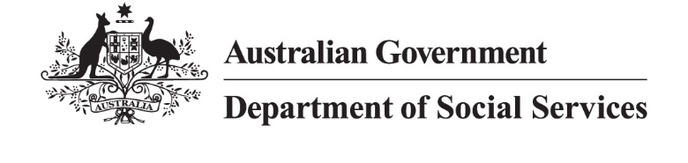

Outcomes-based contracting

Outcomes payments
Outcomes payments are linked to the achievement of an agreed outcome, within an outcomes-based contract.
Choosing the right outcomes payment is important, because it:
- creates conditions to foster innovation in service delivery
- builds a healthy ecosystem of service providers by reflecting the true cost of delivering outcomes
- demonstrates value for money with prices reflecting benefits of the outcomes achieved
- aligns incentives and manages risk for commissioners, service providers and other stakeholders.

How funding is different
Funding under an outcomes-based contract is different to most traditional funding approaches across a range of dimensions.
Dimension | Traditional funding arrangements | Outcome based  contracting
Types of payment | Payments based on inputs or outputs. | A mixture of fixed and outcomes-based payments.
Payment timing | Regular payments paid in advance or based on completion of activity reports or milestones. | Fixed payments paid in advance, with outcome payments paid after achievement and verification of outcomes.
Price | Based on cost of service delivery. | Determined using a combination of cost to achieve outcomes and value of the outcomes.
Financial risk allocation | Lower financial risk for service providers as payments are fixed or volume-based. | Shared financial risk with service providers for proportion of funding contingent on achieving outcomes.
Funding sources | Typically one source of funding. | Can involve multiple funders including other commissioners (i.e. philanthropy).

Key concepts related to outcome pricing

Fixed funding
Fixed funding refers to the amount of funding under an outcomes-based contract that will be paid regardless of what outcomes are achieved. This funding is used to help cover the cost of service delivery until outcomes are achieved and paid on.

The amount of fixed funding also reflects the level of financial risk allocated to a service provider (and other stakeholders in some cases) and should be considered with reference to the policy objectives of the outcomes-based contract.
The amount of fixed funding can vary between having no fixed payments, to having a small proportion linked to outcomes (i.e. ~95% fixed payments).
Key considerations for determining this amount and, therefore, the financial risk allocated to the service provider include:
- Financial capacity of service providers: do service providers have the financial reserves to fund the service until the outcomes are achieved and paid on?
- Track record of the service: Has the service or a similar intervention model previously achieved the outcomes?

- The policy context: Is it appropriate to be shifting this amount of financial risk to service providers operating in this policy area?
- Ability to access external funding: Can service providers access funding from private investors or philanthropic funders to fund the service and share financial risk?

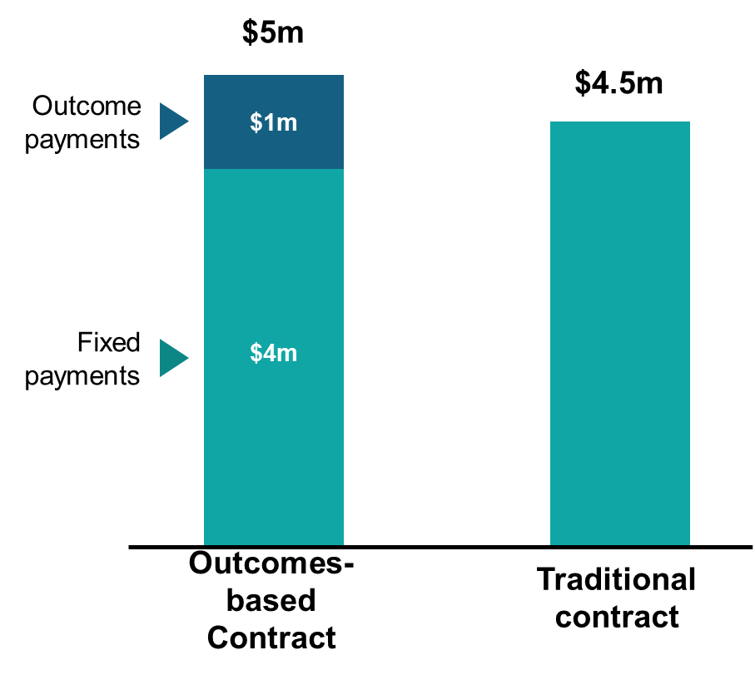

Price of an outcome
The price is the amount agreed by the service provider and commissioner for achievement of agreed outcomes. This is the level of funding that is ‘at risk’ if outcomes are not achieved.
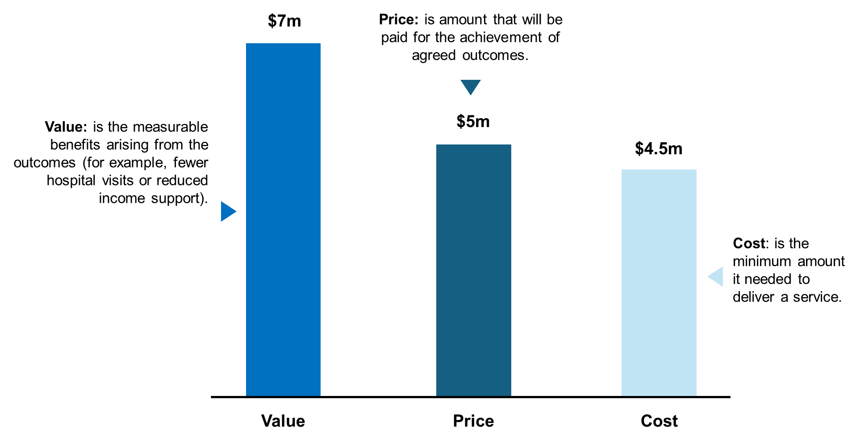
The price is different to the cost to achieve the outcome for the service provider and the value generated for the commissioner. The cost and the value are the bookends for determining the price of an outcome, with the price of an outcome usually being somewhere between.
In determining the price of outcomes, commissioners need to consider the minimum cost needed to deliver a service, without creating undue financial pressure or risks for service providers. Pricing should consider locational differences, for example remote locations may have higher costs. Commissioners should also recognise that different services providers or sectors may have key differences, for example smaller organisations may have higher relative administration costs or may be less able to bear risks than a larger organisation delivering programs nationally.
Additional considerations for determining price include:
- The level of certainty about whether the outcomes will be achieved, as service providers may require a higher price with more uncertainty
- The complexity and the characteristics of the target cohort, which impacts the level of support and amount of time required to achieve the outcomes and, therefore, the cost of the service
- The timing of payments, as longer-term outcome payments may require interim funding from a private investor or philanthropic funder, which may come with additional costs
- Whether outcomes would have happened anyway, as ideally the price should only reflect ‘additional’ outcomes that are achieved by the service provider.

Funding cap
The cap on funding (or funding envelope) refers to the maximum amount of funding available, which ensures that the commissioner does not pay more than the maximum amount it is prepared to pay for outcomes.
The cap is typically higher than the expected funding to be made available to the service provider as it allows service providers to outperform agreed performance targets, whilst ensuring that overall payments made to the service provider are not excessive.

Engaging the market on outcome pricing
There are two ways to engage the market in relation to outcome pricing:
- Commissioner set price: the commissioner defines the price it is willing to pay for a specified outcome and communicates this to the market (e.g., $5,000 per employment outcome sustained for 26 fortnights), which is typically closer to the value. Service providers can then propose pricing and a set of payment terms for their service based on this information and their estimated cost to achieve the outcomes.
- Provider proposed pricing: service providers propose pricing and payment terms based on the cost to achieve the outcomes, with some additional upside to reflect the financial risk taken on by the service provider (and other stakeholders) and the value to the outcome payer.

Case study: Many Rivers Payment by Outcomes Trial

Overview
The Many Rivers Payment by Outcomes (PBO) Trial aims to support unemployed or underemployed people into microenterprise development and self-employment.

Outcome measurement
There were two outcome metrics linked to payments:
- Business establishments: the number of businesses established by program participants
- Welfare payments: the amount of income support payments received by program participants over a three-year period (compared to the three years prior to participating in the program)
The business establishment metric was not measured relative to a counterfactual. Payments were provided at a fixed rate for each business established.
The welfare payment for each individual participant was measured relative to a counterfactual. This compared the amount of income support payments received by each participant in the three years before participating in the program, to the amount of income support received in the three years after participating in the program.

Pricing
The payment terms agreed by the commissioner (the Department of Social Services) and Many Rivers at the start of the PBO were as follows:
- Cap on funding: a maximum of $3.8 million was available under the contract.
- Proportion of fixed funding: around 40% of the expected funding ($1.3 million in total) was paid up front to support service delivery.
- Outcomes Payments: The remaining 60% was linked to outcomes payments ($2 million) split across two outcomes metrics. This included:
  - $4,500 was paid for every business established; and
  - $0.50 of every $1 of welfare savings recorded over three years, was paid to the service provider.

Learn more
- Understand the basics of outcomes-based contracting in Introduction to outcomes-based contracting
- Define who a service is for in Identifying a Target Cohort guidance
- Identify indicators of real-world changes in Defining Outcome Metrics guidance
- Develop an approach to assessing impact in Understanding Outcome Measurement guidance
- Self-assess your readiness for outcomes-based contracting in the Readiness Checklist

