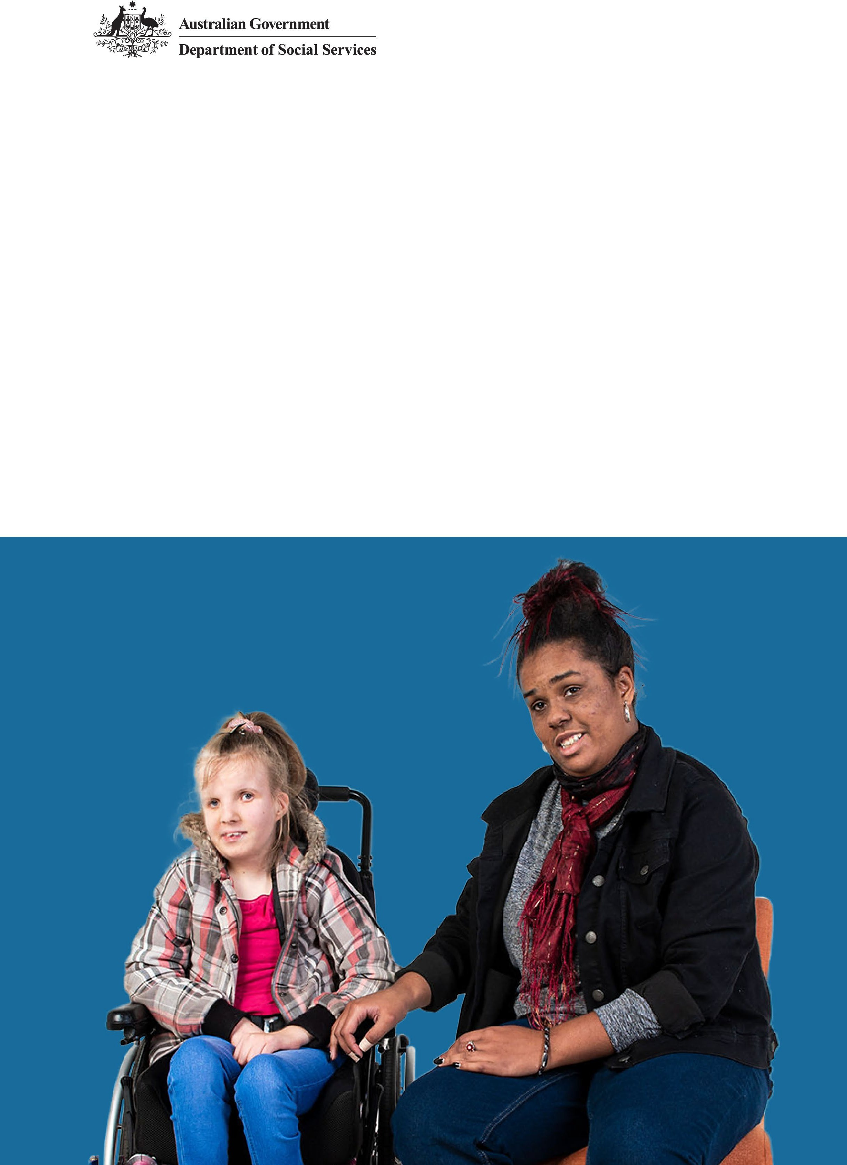
Protecting women and children with disability

Disability Lens on the
First Action Plan 2023–2027
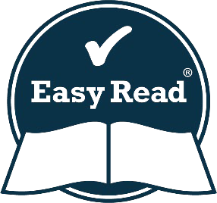
Easy Read version

How to use this document
 | The Australian, state and territory governments wrote this paper together.  When you read the word ‘we’ it means:  - the Australian Government  - state and territory governments.
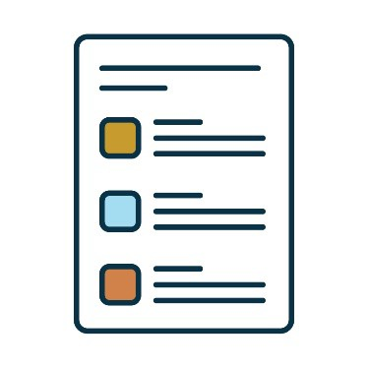 | We wrote some words in bold  We explain what these words mean.  There is also a list of these words on page 30.
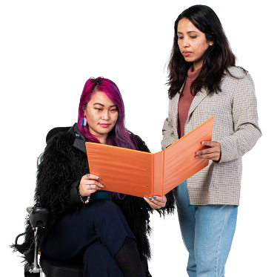 | You can ask someone you trust for support to:  - read this plan  - find more information.

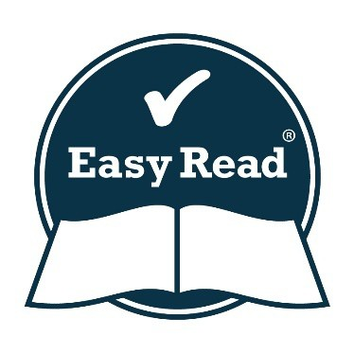 | This is an Easy Read summary of another plan.  It only includes the most important ideas.
 | You can find the other plan on our website.  https://www.dss.gov.au/national-plan-end-gender-based-violence

What’s in this plan?
The National Plan 5
About this document 6
Our actions 7
How we will make sure our plan works well 28
Word list 30
Contact us 33

The National Plan

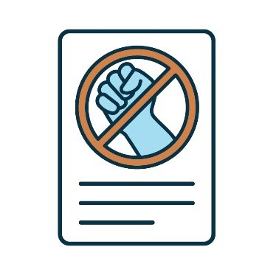 | We wrote the National Plan to End Violence against Women and Children 2022–2032.  We call it the National Plan.
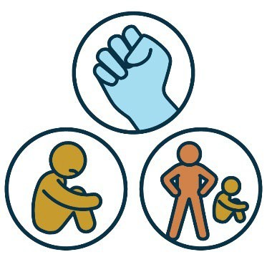 | Violence is when someone:  - hurts you  - scares you  - controls you.  It can also be called abuse
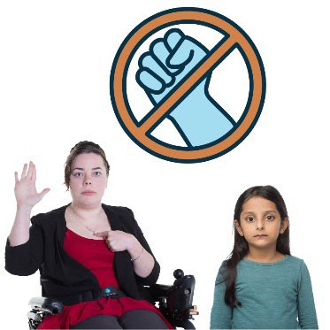 | The National Plan explains what we will do to help end violence against women and children.
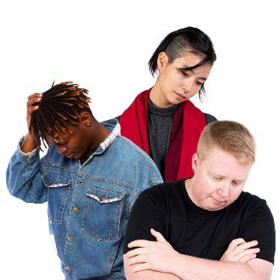 | But other people also experience this violence.  And they experience this violence in  different ways.

About this document
 | This document supports our First Action Plan 2023–2027.
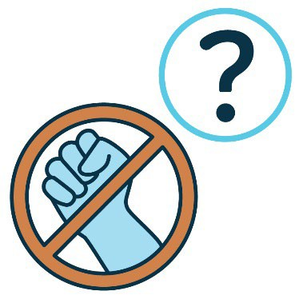 | Our First Action Plan explains the actions we will take to stop violence against all women and children.
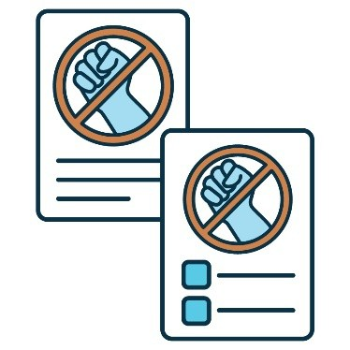 | This document is about:  - the National Plan  - the First Action Plan
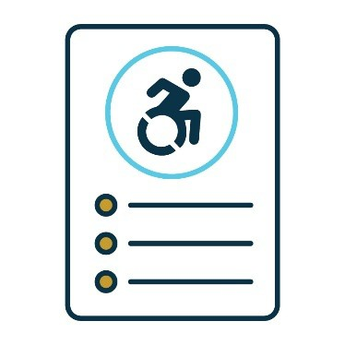 | It is a guide to how these plans help women and children with disability.  We call it our Disability Lens.

Our actions
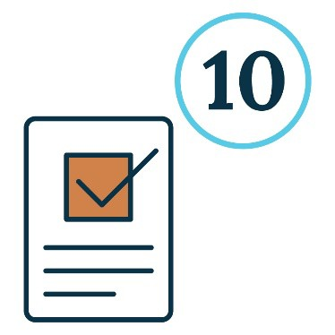 | Our First Action Plan has 10 actions.
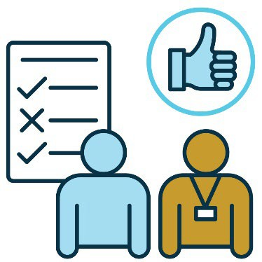 | Governments want to use these actions to  make sure new rules and services work well  for everyone.
 | This includes:  - the Australian Government  - state and territory governments.
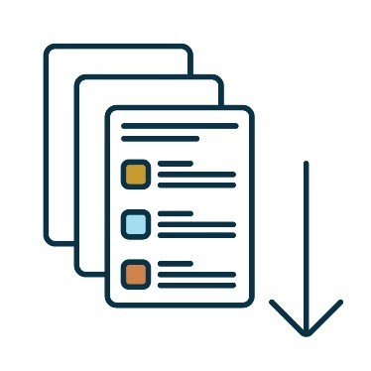 | We explain each action on the following pages.

Action 1
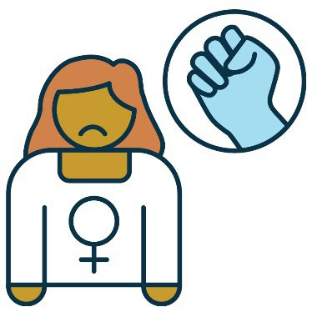 | Some people use violence against people because of their gender.
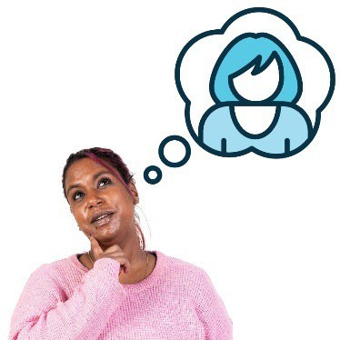 | Your gender is what you feel and understand about who you are as a person.  You might think of yourself as a man or woman or something different.  You can choose the words that are right for you.
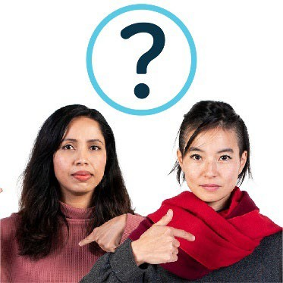 | We want to find out why violence happens because of someone’s gender.
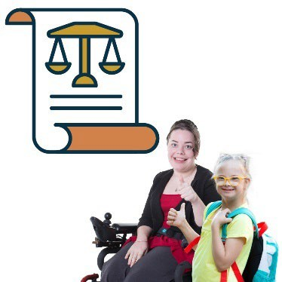 | We will make sure laws and rules are fair for women and children with disability.

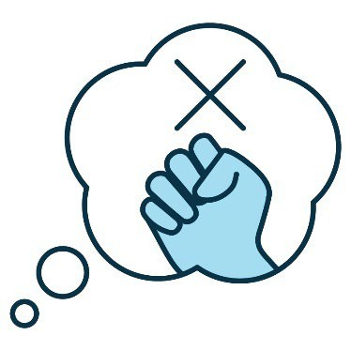 | We will help people understand that hurting women and children with disability is wrong.
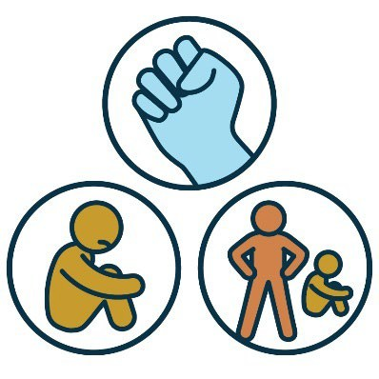 | We will also help people learn about the different types of violence.
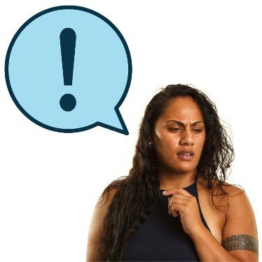 | This will help them see when violence  is happening.
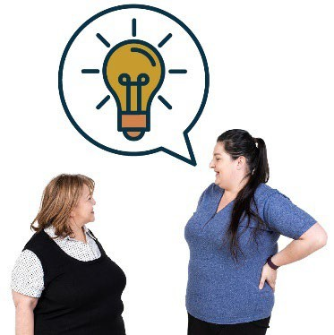 | We will listen to ideas from women and children with disability about how to  stop violence.

Action 2
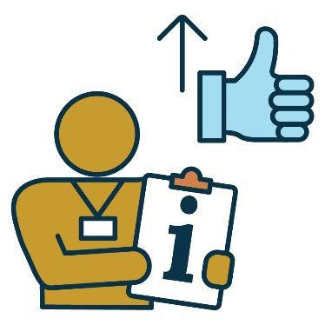 | We want better information in the National Plan about violence against women and children  with disability.
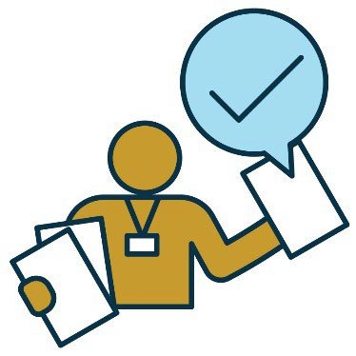 | We will make sure we collect information in  ways that are:  - easy to understand  - the same every time.
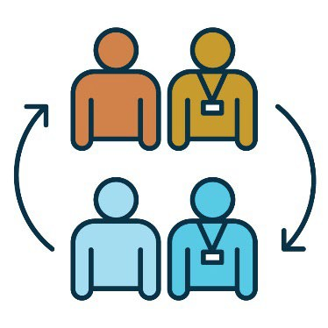 | We will link information from different services.  This will help us understand how disability and violence are connected.
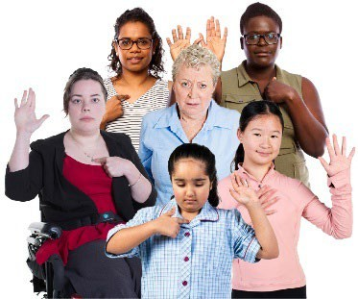 | We will look at how violence affects people  with disability from different communities.  For example, people from different backgrounds.

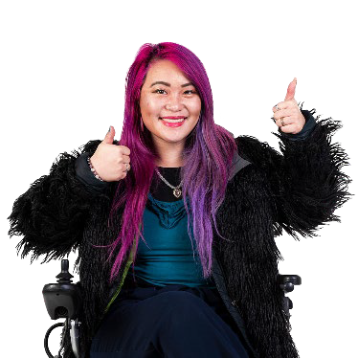 | This will help us support people in ways that work for them
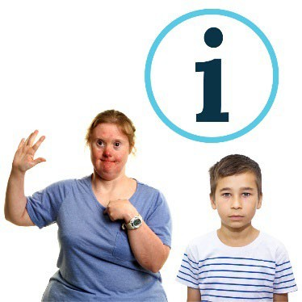 | We will collect information about  people’s experiences.  This includes people who:  - have a disability  - don’t know that they have a disability.
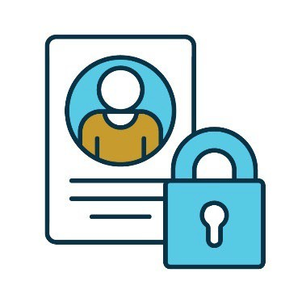 | We will keep this information private.  This means it won’t include personal information, like names.

Action 3
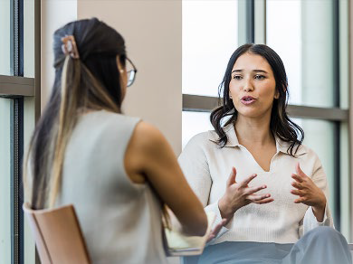 | We want workers and services to have the right skills to support women and children with disability who experience violence.
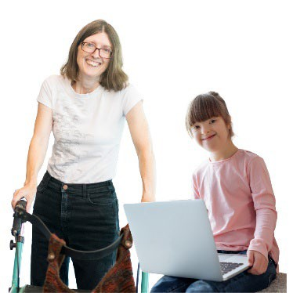 | We also want accessible violence support services for women and children with disability.
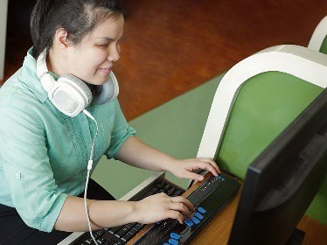 | When services are accessible, they’re easy to:  - find and use
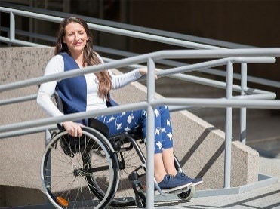 | - move around.

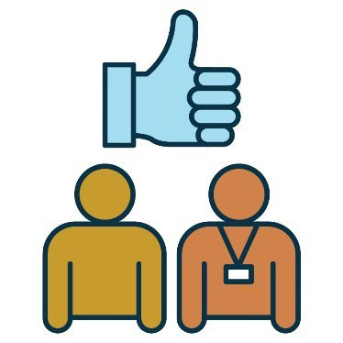 | We will find ways to make it easier for women and children with disability to use services.
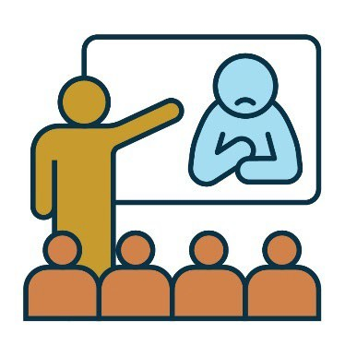 | We will keep training workers to understand:  - how violence affects women and children  with disability  - how to support them.
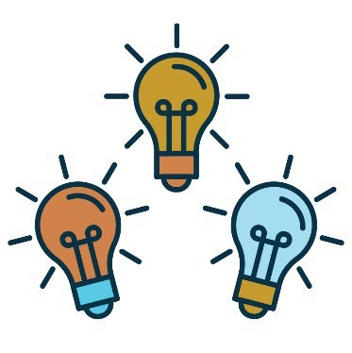 | We will bring together ideas from different areas.
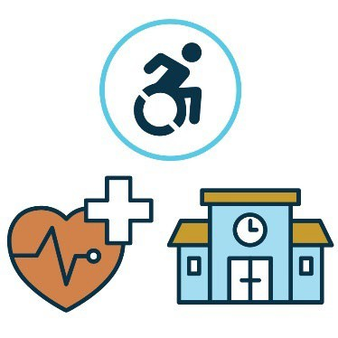 | This includes:  - disability services  - health services  - schools.

Action 4
 | We want services to work together to support women and children with disability who experience violence.
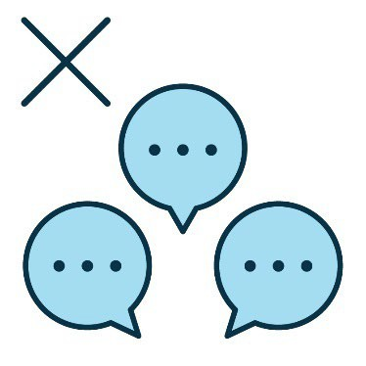 | We will make sure services work together  so people:  - don’t have to tell their stories again and  again to different people
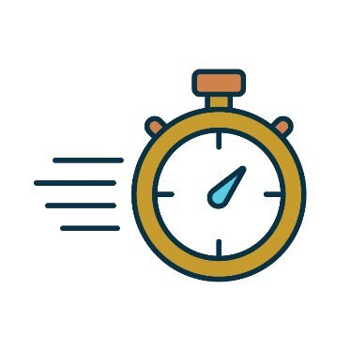 | - get the help they need quickly.

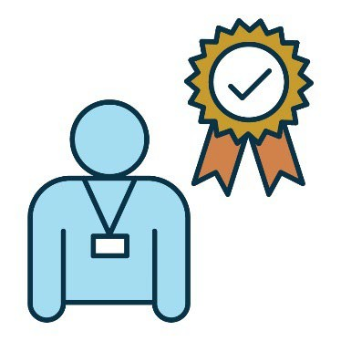 | We will support services to:  - hire and train skilled workers
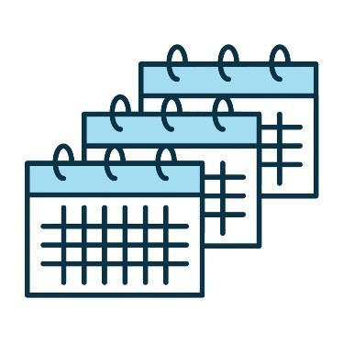 | - keep people working for them for  a long time.
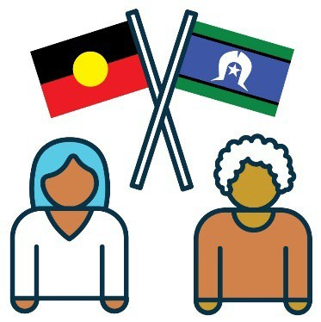 | This includes workers who know people need support in different ways.  For example, First Nations people.

Action 5
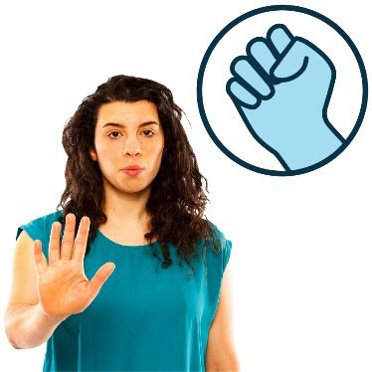 | We want violence against women and children with disability to stop.
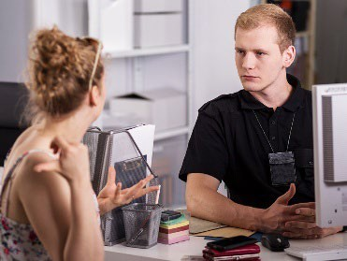 | We will make it easier for women and children with disability to report violence.
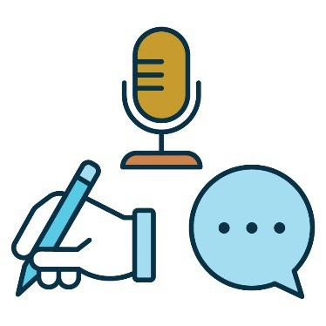 | We will do this by making sure people can report violence in a way that works for them.
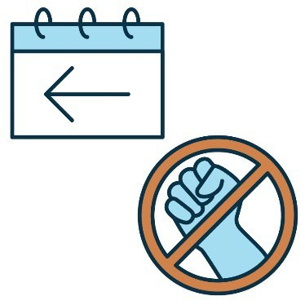 | We will focus on:  - stopping violence early
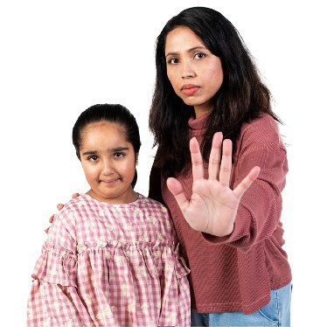 | - teaching carers and workers how to  stop violence from happening
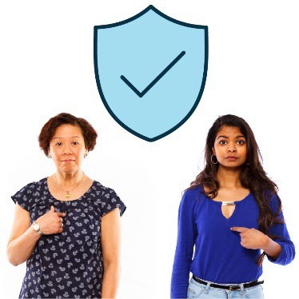 | - making sure support is safe for people  from different backgrounds
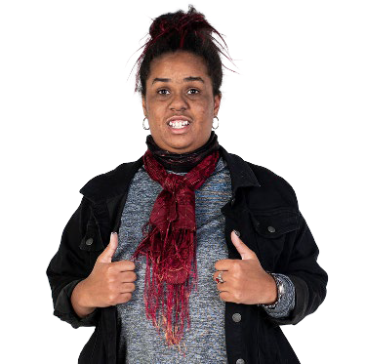 | - making sure support fits the needs  of people with disability.

Action 6
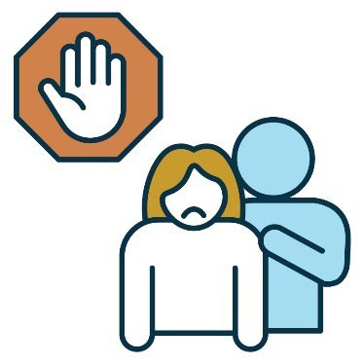 | We want to find better ways to stop  sexual violence.
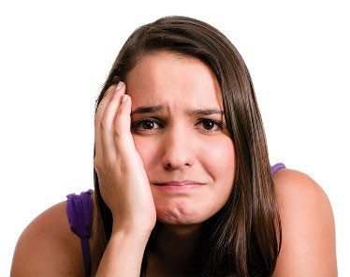 | Sexual violence is when someone hurts you  in a sexual way.  For example, if someone does something  sexual to you that you don’t want them to do.
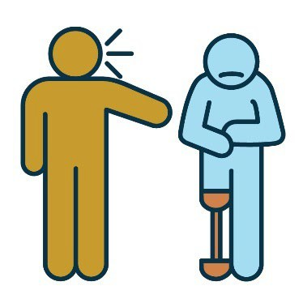 | We also want to find better ways to  stop harassment.  Harassment is when someone treats you in a way that makes you feel uncomfortable or unsafe.
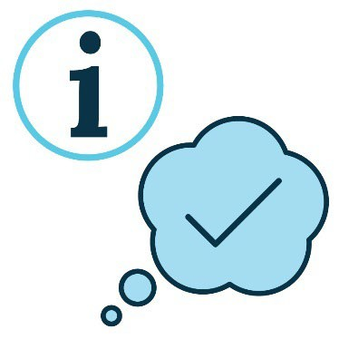 | We will share information in ways that are  easy to understand.
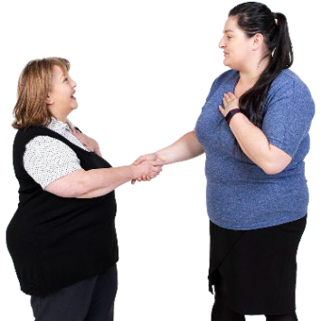 | This includes information about:  - how people must treat you  - where you can get help.
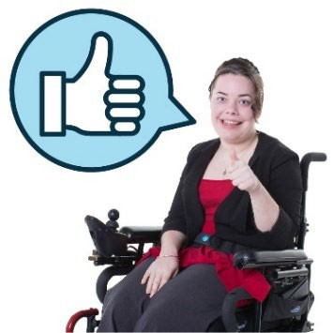 | We will train people to know what consent  might look like for people with disability.  Consent is when you say it is okay for someone to do something.
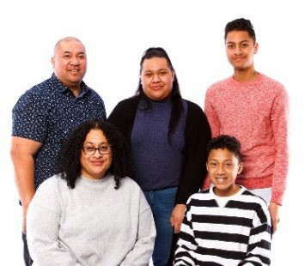 | This includes:  - family and friends
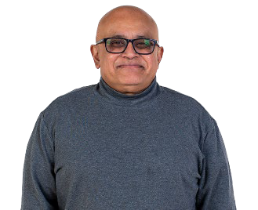 | - carers
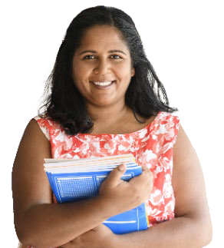 | - teachers.

Action 7
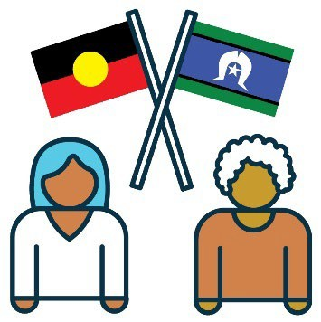 | We want to make sure services work well for  First Nations people.
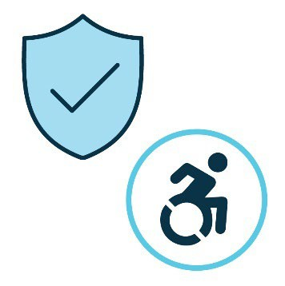 | This includes making sure services are:  - safe  - accessible.
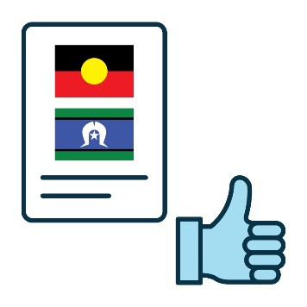 | We will follow the Australian Government’s  plan to make sure services and rules support  First Nations women and children with disability.
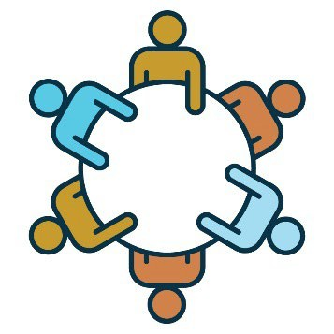 | We will work closely with First Nations communities so their ideas can help us make new laws and services that work well.
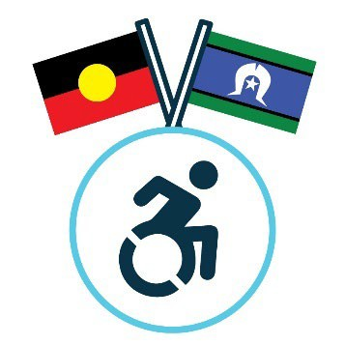 | We will train workers to understand and  respect what First Nations people believe about disability.
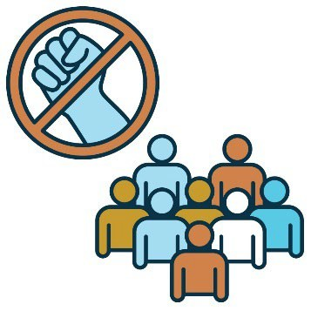 | We will support First Nations communities to think about how to stop violence in ways that work best for their community.

Action 8
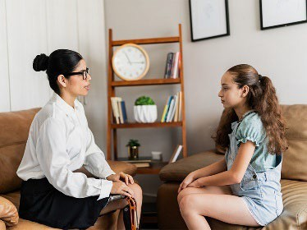 | We want to support children and young people with disability who experience violence.
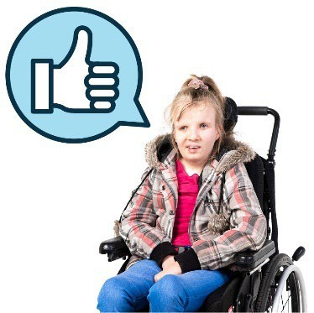 | We will make sure all children and young  people with disability can learn about:  - consent
 | - how to stay safe
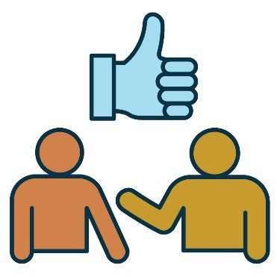 | - healthy relationships.  Your relationship with someone is how you are connected to them.
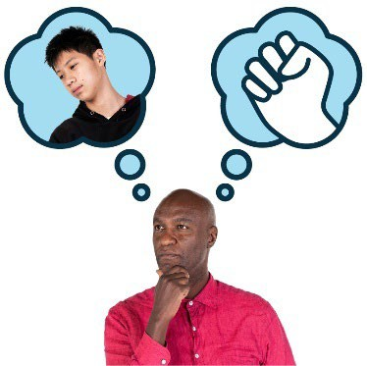 | We will train services how to know when  a child with disability is experiencing violence.
This includes training workers to support
children as soon as they can.
 | We will try to understand why some children  with disability behave in a violent way.
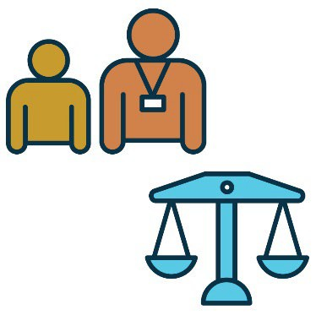 | We will also:  - support them  - treat them fairly.

Action 9
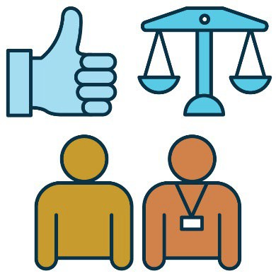 | We want the justice system to better support people who experience violence.
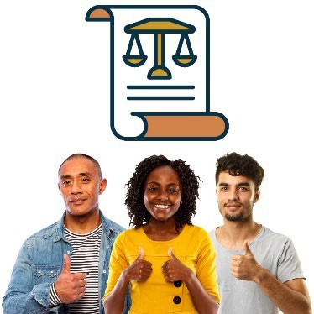 | The justice system makes sure everyone is treated fairly and follows the law.
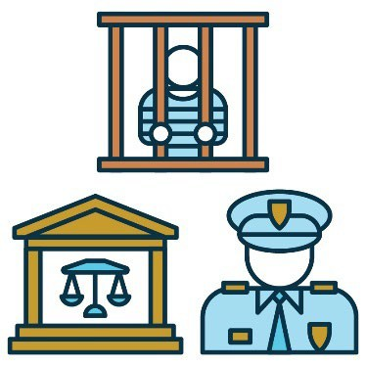 | The justice system includes:  - prisons  - courts  - police.
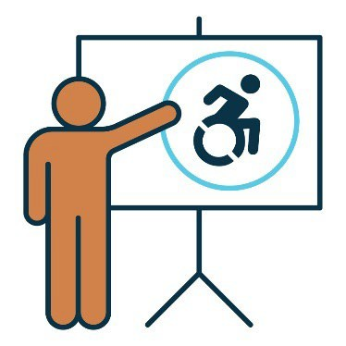 | We will train workers in the justice system to understand disability.
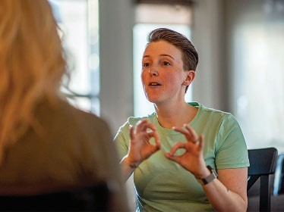 | This includes training on how to communicate with people in the ways they need.
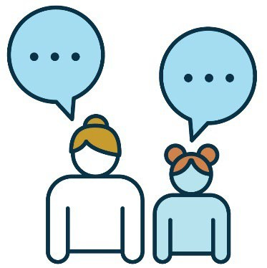 | We will make sure women and children with disability can use services that help them:  - have their say
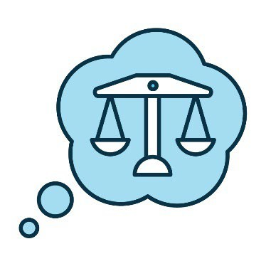 | - understand the justice system.

Action 10
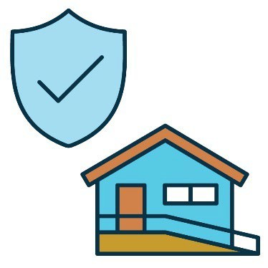 | We want women and children with disability to have a home that is:  - safe  - accessible.
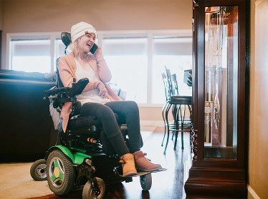 | When a home is accessible it:  - supports people the way they need  - is easy to move around in.
We will find out how women and children with disability can get a home that:
- is safe
 | - doesn’t cost a lot of money.
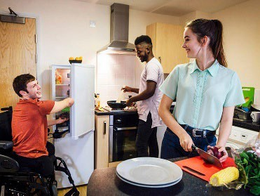 | We will also work to improve homes where people with disability:  - live together  - get support.
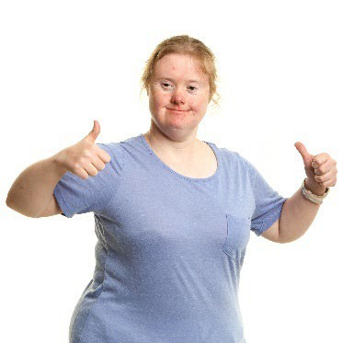 | We will try to make sure these homes:  - work well for people with disability
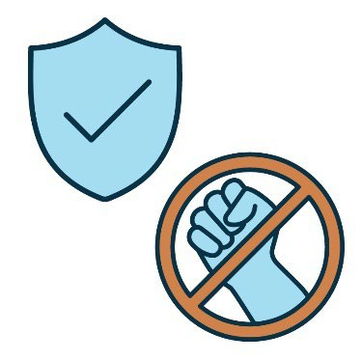 | - keep people with disability safe  from violence.

How we will make sure our plan works well
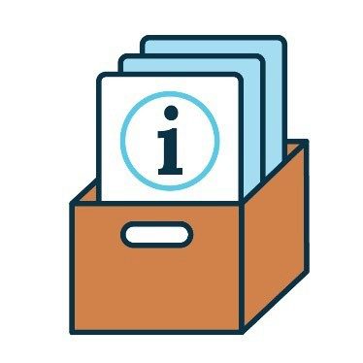 | Governments will collect information to check how well the disability plan is working.  This includes information from services,  like the NDIS.
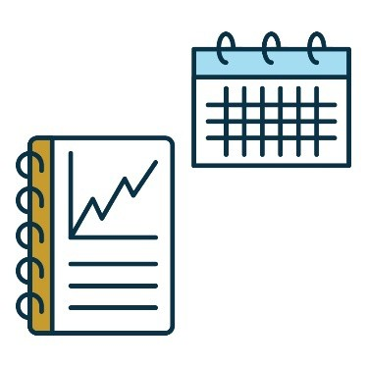 | We will write a report about what we find out every year.
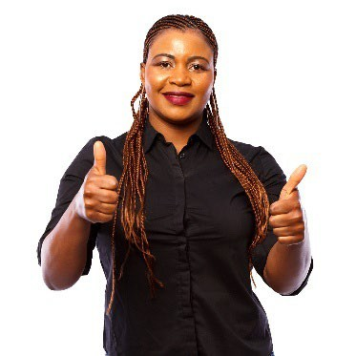 | This report will explain:  - what is working well
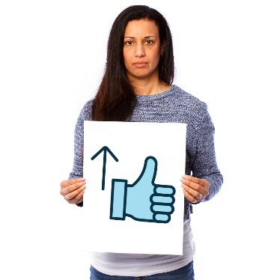 | - what we need to improve.
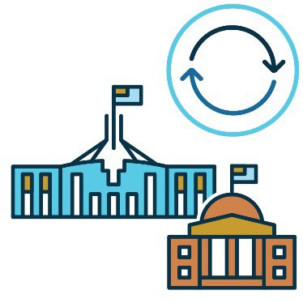 | Governments will use this report to make more changes to help end violence against women and children with disability.

Word list
This list explains what the bold words in this plan mean.
Accessible
When services are accessible, they’re easy to:
- find and use
- move around.
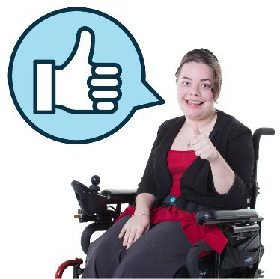 | Consent  Consent is when you say it is okay for someone to do something.
Gender
Your gender is what you feel and understand about who you are as a person.
You might think of yourself as a man or woman or something different.
You can choose the words that are right for you.
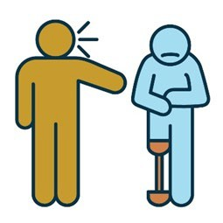 | Harassment  Harassment is when someone treats you  in a way that makes you feel uncomfortable  or unsafe.
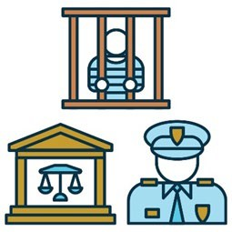 | Justice system  The justice system makes sure everyone  is treated fairly and follows the law.  The justice system includes:  - prisons  - courts  - police.
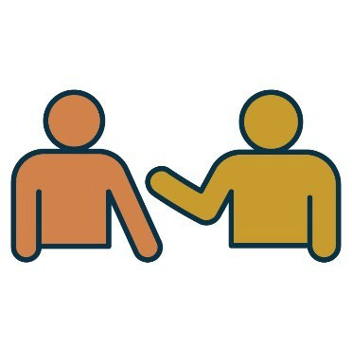 | Relationship  Your relationship with someone is how you are connected to them.
Sexual violence
Sexual violence is when someone hurts you
in a sexual way.
Violence
Violence is when someone:
- hurts you
- scares you
- controls you.
It can also be called abuse.

Contact us
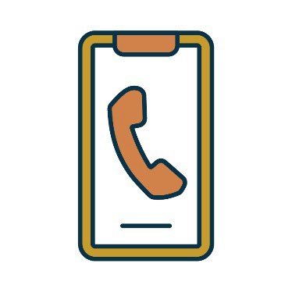 | You can call us from 8:30 am to 5:00 pm,  Monday to Friday.  Phone 1300 653 227
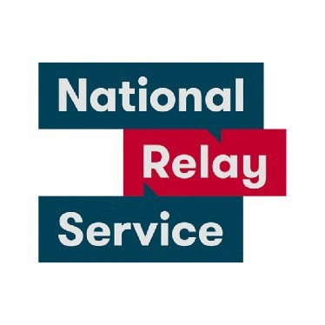 | If you are deaf, or have a hearing or speech impairment, you can also call the National Relay Service.  Phone 133 677

 | You can send us an email.  enquiries@dss.gov.au
 | You can write to us.  Department of Social Services  GPO Box 9820  Canberra  ACT 2601
 | You can visit our website. www.dss.gov.au/ending-violence

 | The Information Access Group created this Easy Read document using stock photography and custom images.  The images may not be reused without permission.  For any enquiries about the images, please visit www.informationaccessgroup.com. Quote job number 6280.

