POLIS: The Centre for Social Policy Research  ANU College of Arts & Social Sciences | POLIS WORKING PAPER  NO. ##/2024



Bruce Smyth, Markus Hahn, AND Matthew Gray

Working Paper No. ##/2024
DOI XXXX
POLIS: The Centre for Social Policy Research
Research School of Social Sciences
College of Arts & Social Sciences
The Australian National University
Front cover image:
Bruce Smyth (detail), Coloured wooden letters on white background © Bruce Smyth
Suggested citation:
Smyth, B. Hahn, M., & Gray, M. (2024), Public Attitudes to Child Support in Australia: A contemporary snapshot (Working paper Report No. ##), POLIS: The Centre for Social Policy Research, Australian National University.
Bruce Smyth is Professor of Family Studies at POLIS: The Centre for Social Policy Research at the Australian National University. Markus Hahn is a Research Fellow at POLIS: The Centre for Social Policy Research at the Australian National University. Matthew Gray is Professor and Director of POLIS: The Centre for Social Policy Research at the Australian National University.

Public Attitudes to Child Support in Australia: A contemporary snapshot
Bruce Smyth, Markus Hahn, and Matthew Gray
Abstract
This study seeks to obtain a contemporary snapshot of public attitudes to child support. Samples from the general population of Australian adults (including independent samples of separated mothers and fathers with a child support case) were drawn from two online panels: the Life in AustraliaTM (LinA) panel, and the Online Research Unit (ORU) panel. Data were collected over a two-week period in 2024. Key findings included the following: (a) separated fathers generally felt the system was unfair to paying parents, while many separated mothers believed it was unfair to both parents; (b) most respondents believed child support should be paid even if the paying parent has little contact with the child, is on a low income, only receives government assistance and/or has never lived with the other parent; (c) there was solid support across all groups for the use of penalties for non-compliance, and for the idea that child support should increase if there are more than three children; (d) majority care mothers strongly supported financial help for young adult children if young adults were unemployed, had a disability, or were studying full-time; (e) medical, dental, and school books were the most likely items to be seen as intended to be covered by child support, apart from the obvious necessities of food, housing and children’s clothes; (f) parents should be required to apply for child support to receive government benefits (such as Family Tax Benefit), especially if parents had never lived together; and (g) Services Australia should check on compliance in Private Collect. Although many of the issues raised by participants have dogged the system since it first began, the issues of privacy, family violence, and shared costs in the context of shared care, represented newer concerns.

Acknowledgments
First and foremost, we would like to thank participants for responding to the survey and for their views on the difficult subject of child support. Talking about money is never easy, especially when it involves keeping children and families out of poverty. This work would not have been possible without the support of the survey participants. We would also like to thank the Australian Government Department of Social Services (DSS) for its generous support of this study, and for helpful feedback and discussion throughout the life of this project. Finally, we are also indebted to: Professor Nicholas Biddle for technical advice on recruitment and sampling related to the LinA sample; the Social Research Centre for data collection and technical advice on question wording and order, and the development of study weights. That said, any errors or shortcomings are ours alone. In the spirit of transparency, two of the authors (Gray & Smyth) were members of the Ministerial Taskforce and are currently members of the DSS Child Support Expert Panel. The views expressed in this report do not necessarily reflect those of any affiliated organizations involved in this research.

Abbreviations
AIFS | Australian Institute of Family Studies
ANU | Australian National University
CATI | Computer-Aided Telephone Interviewing
CSA | Child Support Agency (now Services Australia)
DSS | Department of Social Services
Expert Panel | Child Support Expert Panel
FTB | Family Tax Benefit
LinA | Life in AustraliaTM (LinA)
MAT | Maintenance Action Test
MIT | Maintenance Income Test
ORU Panel | Online Research Unit panel
POLIS | POLIS: The Centre for Social Policy Research
Scheme | Child Support Scheme
SRC | Social Research Centre

Executive Summary

The present mixed methods study sought to revisit and expand on a study of community attitudes to child support conducted almost two decades ago by Smyth and Weston (2005). The present study’s aim was to obtain a fresh snapshot of these attitudes by re-examining many of the key policy questions in the earlier study, and to explore attitudes to emerging pressure points within the current scheme.

Five research questions (RQs) guided the study:

RQ₁. What are the views of the Australian public, especially separate parents, on key aspects of the current child support system?
RQ₂. What are the views of separated parents on several emerging challenges to child support policy?
RQ₃. Do any of the above vary by cohort (general population sample vs separated parent sample), parental care time level (majority care vs minority care vs shared-care); or method of collection (Private Collect vs Agency Collect)?
RQ_{4.} What is the main reason that separated parents, either with majority time care or shared care, choose to transfer child support privately instead of using Services Australia?
RQ_{5.} What would separated parents with a child support case like to see changed in the current child support system?
Both quantitative and qualitative data were collected. The fieldwork was conducted in April 2024. Respondents were drawn from two online panels: the Life in Australia (LinA) panel and the Online Research Unit (ORU) panel. The LinA panel employs probability-based recruitment methods, while the ORU panel does not. That said, sophisticated calibration and blending methods can be, and were, used to combine both panel samples. Specifically, ORU panel members were assigned pseudo-selection probability weights before re-weighting them to create the combined sample.

The final sample comprised 2,328 respondents: 1,191 from the general population (588 women, 603 men); and 1137 from the separated parent population: 483 majority care mothers (‘resident mothers’); 94 minority care fathers (‘non-resident fathers’); 37 minority care mothers (‘non-resident mothers’); 207 majority care fathers (‘resident fathers’); 132 shared care mothers; and 184 shared care fathers.

Key Findings: Re-examining issues from the 2005 study

General perceptions and awareness
- Half of all women and men in the general population in Australia reported having heard of the Scheme or the Child Support Agency (CSA). Women were more likely than men to report having had contact with the CSA at some point.
- Separated parents with minority care of children believed the child support system was not working well and were the most likely of the groups to see the child support system as unfair.
- Separated fathers irrespective of their parenting arrangement were the most likely of the groups to believe the child support system was unfair to the paying parent. By contrast, sizeable proportions of separated mothers saw the system as being unfair to both parents.

The public–private compact
- There was little support for the idea that the financial support of children after separation should primarily be the government’s responsibility. Respondents in both the general population sample, and separated parent sample (apart from majority time fathers), were inclined to believe that children should be financially supported by parents. That said, a substantial percentage of respondents (range 32%–44%) thought child support should be a shared responsibility between parents and the government.
- The issue of reducing government payments in the context of child support (i.e., the Maintenance Income Test) revealed a complex pattern of responses. Overall, most respondents believed that government payments should be able to be kept in full or partly reduced by the total amount of child support received (i.e., no or partial ‘clawback’).
- Reducing government expenditure as the main priority of the child support system was the least favoured preference (range: 5%–19%). Rather, men and women in the general population, and mothers in the separated parent sample, thought that helping children should be the main priority. For separated fathers, fairness mattered most.

Income and capacity to pay
- Respondents across all groups believed that child support should always be paid, apart from the small group of mothers with minority care.
- There was solid support for the idea that a parent who has little or no contact with a child should still pay some child support even if their earnings are very low or they only receive government income support payments.
- Minority care parents (male and female) and shared care fathers supported having no minimum payment, whereas over half of majority care mothers would set the minimum annual rate at $50 or more per week.
- The idea that there should be a maximum amount of child support payable for high-income parents largely diverged along gender lines, with men in the general population and the separated father groups favouring a cap. By contrast, women in the general population and the separated mother groups were more equivocal, with around half opposed to a cap on the maximum amount payable.
- Shared care mothers and majority time fathers were inclined to support the payment of child support in a 50/50 parenting arrangement even when one parent was earning more than the other parent. By contrast, fathers with minority care were the group most opposed to this.

The number of children and prolonged dependence
- Majority care mothers were mostly likely to be supportive of ongoing financial support for young adult children if young adults were unemployed, had a disability, and/or were studying full-time. By contrast, minority care fathers, minority care mothers, and shared care fathers were the most likely of the separated parent groups to oppose ongoing financial support for young adult children regardless of their circumstances. Young adults with a disability received the strongest support for ongoing child support compared with the alternative scenarios of young adult unemployment or full-time study.
- There was solid support, especially by the female groups, for the idea that child support should increase if there are more than three children.

Compliance and enforcement
- A clear majority of respondents believed that without the government, most parents would not pay child support (excluding majority care fathers). Women were more likely than men to believe this, except for those with shared care.
- There was overwhelming support across all groups for the use of penalties for non-compliance. Women were more likely than men to support the use of penalties.

New partners and second families
- Majority care mothers were the group most likely to believe child support should continue if a receiving parent repartners. Most other groups of separated parents (as well as respondents in the general population sample) were inclined to believe child support should continue or cease depending on the financial situation of both parents.
- There was solid support for the idea that if the paying parent has repartnered and has stepchildren to support, they should not they be allowed to pay less child support for the children of their previous relationship. Females held stronger views on this issue than males.
- Women in the general population, as well as all three female separated mother groups, were more likely than their male counterparts to believe payers should not be allowed to pay less for first family children if they have a new biological child.

Parent–child contact
- Men in the general population, as well as the three male separated father groups, were more likely than their female counterparts to believe payers should not have to pay child support if fathers are denied contact by the other parent.

Key Findings: Emerging policy issues
- Most separated parents in the study were inclined to seek information about child support from Services Australia, followed by a family member or friend.
- There was strong support for the idea that separated parents should have the opportunity to be able to discuss child-related expenses during mediation.
- There was a fair degree of support for the idea a parent should be required to apply for child support to receive government benefits (such as Family Tax Benefit), especially if parents had never lived together.
- Medical, dental, and school books were the most likely items to be seen as intended to be covered by child support, whereas digital devices and generic expenses were the least likely to be endorsed as child support items.
- There was broad support, especially by female groups, for the idea that a parent should be exempt from applying for child support because of fear of violence. Minority care fathers were the least supportive of exemptions for family violence.
- There was solid support for the idea that a parent with a lower income in a 50/50 arrangement should be able to elect not to receive child support and still be eligible to receive government benefits.
- There was generally strong support for the proposition that Services Australia should check on compliance in Private Collect. This was less likely to be the case, however, for minority care fathers (most of whom are likely to be payers).
- Women in the general population believed direct payment via an app was the most appropriate method of collection of child support, followed by Agency Collect (including employer-withholding); their male counterparts had a similar set of preferences but favoured Agency Collect over the use of an app to transfer child support. By contrast, majority care mothers favoured employer-withholding and Agency Collect whereas minority care fathers favoured Agency Collect followed by private transfer and employer-withholding or use of an app.
- Around half of majority care parents (mothers and fathers) and half of parents in Private Collect or Agency Collect said they would not forgive a debt, whereas almost half under various debt thresholds would if it ensured future payments.

Key Findings: Why transfer child support privately?
- In total, 275 separated parents provided data on why they transferred child support privately rather than using Services Australia to collect child support.
- Over one-third (39%) of respondents reported that a ‘cooperative arrangement / private agreement’ was the main reason given for transferring child support privately. This was the most common reason given, with many of these respondents reporting a cooperative co-parental relationship, cooperating to ensure fairness, ease in managing payments, and being child-focussed.
- Another group (16%) chose private transfers because they found it simpler, faster, and more convenient than going through formal bureaucratic processes. Some parents appreciated the flexibility that private transfers offered, with arrangements allowing for adjustments in payment amounts based on income changes or agreements between parents.
- A smaller group of respondents (7%) preferred to avoid Services Australia altogether, citing dissatisfaction or concerns about fairness, with some wanting to protect their privacy and avoid the complications that might arise from involving a formal agency.
- Another small group of respondents (7%) opted for private transfers to minimize interparental conflict, stating that avoiding disputes was in the best interest of the child.
- A small group of respondents (n=9/275) indicated that private transfers were chosen due to fear of violence from the other parent. These parents appeared to feel coerced into accepting private arrangements to avoid potential aggression or repercussions. That said, family violence, coercive control around money, and financial abuse are likely to be under-reported in this context as is the case in general.
These qualitative data may not reflect the frequency or nature of responses from the general population of child support payees in the Private Collect group. They nonetheless suggest that the reasons for transferring child support privately are very varied and highlight the motivational complexity of those who use this method of collection of child support.

Key Findings: What would Australians like to see changed?
- Many respondents perceived the scheme as not being fair. Four areas attracted comments from respondents about what needed to be changed with the system: (a) administrative formulaic assessment; (b) child support compliance and enforcement; (c) service delivery issues; and (d) family violence, including financial abuse.
- The ‘free-rider’ principle (which, in the post-separation parenting context, refers to the situation where one parent tries to shift the costs of raising a child onto the other parent), and the ‘monitoring’ problem (i.e., that payers that have little or no visibility, or control on how child support is spent) was alluded to by some respondents.
- Some paying parents (mostly fathers) believed they were paying too much whereas some receiving parents (mostly mothers) believed the child support amount did not reflect the cost of raising children, especially in the current ‘cost of living crisis’ and that the minimum payment amount was too low.
- Paying parents were inclined to believe a new partner’s income should be included in the formula while some receiving parents thought that any new children in second families should not reduce payments for first family children.
- Some parents with 50/50 believed that child support should not apply even where there were income differentials.
- Many respondents wanted to see income minimisation by payers and ‘life-style choices’ by some parents addressed by system; and penalties for non-compliance and/or the late lodgement of tax returns. A number of respondents (fathers and mothers) also suggested that if parent–child contact is denied by a receiving parent, child support should not have to be paid.
- A number of respondents were frustrated with many aspects of the service delivery system: letters of assessment were long and overly complicated; Services Australia seemed to lack ‘policing powers’ to enforce compliance; and staff sometimes seemed to lacked empathy and provided inaccurate advice.
- The potential for family violence, coercive and controlling dynamics, and financial abuse—though not reportedly widespread here—warrants increasing recognition in this complex, highly contested and emotional space.
- Although many of the issues raised above have dogged the Australian child support system since it first started in the late ‘80s, the issues of privacy, family violence, and shared time arrangements and shared costs, represented newer concerns.

Conclusion
The Australian Child Support Scheme was introduced in the late ‘80s to improve the economic circumstances of children of separated parents, to reduce interparental conflict over money, and to minimise public expenditure. Although the Scheme has been in place for over three decades, it continues to be reworked to keep pace with changing social values, norms, demographic trends, economic shifts, and emerging pressure points. These refinements seek to improve the balance between ‘adequacy’ and ‘equity’, and to reflect the increasingly complex and fluid nature of contemporary families and relationships (e.g., second families and new children; shared-time arrangements). The complexity of our findings illuminates why there are never any simple policy fixes when it comes to improving both adequacy and fairness in the context of child support. Our hope is that the data presented in this report provide a solid basis on which to shape future policy directions, and to better understand ongoing and emerging pressure points within the system.

Contents
Abstract ii
Acknowledgments ii
Abbreviations iii
Executive Summary iv
Tables ix
Figures ix
1 Introduction 1
2 Research design 10
3 Re-examining attitudes to the broad principles of the Scheme 18
4 Emerging issues 42
5 Parents’ reasons for transferring child support privately 53
6 Improving the Child Support System and changes to the scheme 59
7 Discussion and Conclusions 72
References 77
Appendix 1—Additional tables and figures 82
Appendix 2—Questionnaire 89

Tables
Table 2.1 Number of observations of each sample 15
Table 2.2 Demographic profiles of each sample, using population weights (%) 17

Table 3.1 What do you think should be the absolute minimum amount of child support that a parent should pay regardless of their income or the number of children they are supporting? Would it be: Nothing, $0 to $19 a week, $20 to $29 a week, ..., $50 or more a week? Attitudes of women and men in the general population, and of separated parents (%) 29

Table 4.1 Apart from food, housing and clothes, what child-related expenses do you think child support payments are meant to/should cover? Attitudes of separated parents Attitudes of separated parents (%) 42
Table 4.2 Would you consider forgiving a child support debt owed by the other parent if it ensured future child support payments? If yes, how much debt? Attitudes of majority care parents and of those in Private and Agency Collect (%) 47
Table 4.3 If you had a question about child support, who would you ask? Attitudes of separated parents (%) 52

Table A.1 Demographic profiles of each sample, reporting sample sizes 82
Table A.2 Demographic profiles of each sample, unweighted proportions (%) 83

Figures
Figure 3.1 Have you ever heard of the Child Support Scheme or the CSA (now Services Australia)? If so, have you ever had any contact with the CSA? Attitudes of women and men in the general population (%) 19
Figure 3.2 Thinking overall, would you say that the child support system is working well? Attitudes of separated parents (%) 20
Figure 3.3 To what extent do you agree or disagree that the child support system is ‘fair’ for both parents? Attitudes of separated parents (%) 21
Figure 3.4 For whom is the child support system ‘unfair’? Attitudes of separated parents (%) 22
Figure 3.5 When couples separate, or are not partnered when a child is born, which of the following parties should have the main responsibility for financial support of their children: parents, government, or both? Attitudes of women and men in the general population, and of separated parents (%) 23
Figure 3.6 If either or both of the parents receive government income support payments, should their government payments be reduced by the total amount of child support, reduced by some of it, or not reduced at all? Attitudes of women and men in the general population, and of separated parents (%) 24
Figure 3.7 Which of the following should be the main priority of the Child Support Scheme: helping children, being ‘fair’ for both parents, or reducing the amount the Government has to spend on benefits? Attitudes of women and men in the general population, and of separated parents (%) 26
Figure 3.8 Do you think a parent who does not usually live with their child or children should always pay child support? Attitudes of women and men in the general population, and of separated parents (%) 27
Figure 3.9 Do you think a parent who has little or no contact with a child should pay some child support even if their earnings are very low or they only receive government income support payments? Attitudes of women and men in the general population, and of separated parents (%) 28
Figure 3.10 Should there be a maximum amount of child support payable for high-income parents? Attitudes of women and men in the general population, and of separated parents (%) 30
Figure 3.11 Should a parent with a 50/50 parenting arrangement who has a higher income than the other parent be required to pay child support? Attitudes of women and men in the general population, and of separated parents (%) 31
Figure 3.12 Should child support be paid for a child over 18 years who is a full-time student aged under 22 years, an unemployed youth aged under 22 years, a child living with disability, all of these, or none of these? Attitudes of women and men in the general population, and of separated parents (%) 32
Figure 3.13 To what extent do you agree or disagree that the amount of child support required to be paid should increase if the number of child support children is more than three? Attitudes of women and men in the general population, and of separated parents (%) 33
Figure 3.14 Do you think most parents would pay child support without any government involvement? Attitudes of women and men in the general population, and of separated parents (%) 34
Figure 3.15 Should a parent face a penalty (such as a fine) if they fail to make their child support payments? Attitudes of women and men in the general population, and of separated parents (%) 35
Figure 3.16 If the receiving parent remarries or starts living with a new partner, which of the following best describes what the paying parent should be expected to do: keep paying child support, stop paying, or should payment depend on the financial situation of both parents or on other circumstances? Attitudes of women and men in the general population, and of separated parents (%) 36
Figure 3.17 If the paying parent has repartnered and now has step-children to support, should they be allowed to pay less child support for the children of their previous relationship? Attitudes of women and men in the general population, and of separated parents (%) 37
Figure 3.18 If the paying parent has another child with a new partner, should they be allowed to pay less child support for the children of their previous relationship? This doesn’t include step-children. Attitudes of women and men in the general population, and of separated parents (%) 38
Figure 3.19 Should a parent have to pay child support if they want contact with their children but the other parent is preventing it? Attitudes of women and men in the general population, and of separated parents (%) 39

Figure 4.1 Should a parent have to apply for child support to receive government children-related payments (e.g., Family Tax Benefit)? Attitudes of women and men in the general population, and of separated parents (%) 43
Figure 4.2 If the parents have never lived together, should the parent who lives with the child be required to apply for child support from the other parent? Attitudes of women and men in the general population, and of separated parents (%) 44
Figure 4.3 For the purpose of receiving government benefits, should a parent with a 50/50 parenting arrangement be able to elect not to receive child support from the parent with the higher income? Attitudes of women and men in the general population, and of separated parents (%) 45
Figure 4.4 To what extent do you agree or disagree that parents who have a fear of violence (from the other parent) should be able to seek an exemption from applying for child support? Attitudes of women and men in the general population, and of separated parents (%) 46
Figure 4.5 To what extent do you agree or disagree that if parents transfer money privately, the Child Support Agency (Services Australia) should check that child support has been paid in full? Attitudes of women and men in the general population, and of separated parents (%) 48
Figure 4.6 Which of the following child support collection options is most appropriate to be used for new parents entering the child support system: employer deducts portion from an employee’s wage, payment to Services Australia, private transfer, private transfer via app or other method? Attitudes of women and men in the general population, and of separated parents (%) 49
Figure 4.7 To what extent do you agree or disagree that recently separated parents who get along should have the opportunity (provided by the government) to talk to a mediator about child support and child-related expenses in general? Attitudes of women and men in the general population, and of separated parents (%) 51

Figure A.1 To what extent do you agree or disagree that the child support system is ‘fair’ for both parents? Attitudes of separated parents [Strongly agree to Strongly disagree] (%) 84
Figure A.2 To what extent do you agree or disagree that the amount of child support required to be paid should increase if the number of child support children is more than three? [Strongly agree to Strongly disagree] (%) 85
Figure A.3 To what extent do you agree or disagree that parents who have a fear of violence (from the other parent) should be able to seek an exemption from applying for child support? [Strongly agree to Strongly disagree] (%) 86
Figure A.4 To what extent do you agree or disagree that if parents transfer money privately, the Child Support Agency (Services Australia) should check that child support has been paid in full? [Strongly agree to Strongly disagree] (%) 87
Figure A.5 To what extent do you agree or disagree that recently separated parents who get along should have the opportunity (provided by the government) to talk to a mediator about child support and child-related expenses in general? [Strongly agree to Strongly disagree] (%) 88

1 Introduction
Child support0F is money paid by one parent (mostly fathers) to the other parent (mostly mothers) to help cover the costs of raising children.1F Before 1989, judges in Australia decided child support orders on a case-by-case basis. But this changed when the Child Support (Assessment) Act 1989 (Cth) introduced administrative formulaic assessment by the Child Support Scheme (Scheme) to determine the amount of child support to be paid.2F The original formula was largely based on a percentage of the minority care parent’s gross taxable income; collection of child support was initially done automatically through employer-withholding via the taxation system.

Although Australia’s Scheme has been in place for over three decades, it has been refined over time to improve the balance between adequacy and equity, and to take account of changing social trends (see e.g., House of Representatives Standing Committee on Social Policy and Legal Affairs, 2015; Joint Select Committee on Australia’s Family Law System, 2021; Ministerial Taskforce on Child Support, 2005). Much of the policy refinement has centred on equity issues related to financial adjustments for shared-time parenting; second and subsequent families; and taking better account of both parents’ income. Changes have sought to reflect the increasingly complex and fluid nature of contemporary families and relationships.

Three core principles have guided the Scheme since its inception: that (a) children of separated parents receive adequate financial support (‘adequacy’); (b) both parents contribute to the cost of supporting their children according to their respective capacities to do so (‘equity’); and (c) government expenditure is restricted to the minimum necessary to attain these objectives (equity between parents and the State—i.e., the ‘public–private compact’3F) (Joint Select Committee on Certain Family Issues, 1994).

In the Arizona and broader US context, Ellman et al, (2009b), drawing on Ellman and Ellman’s (2008) Theory of Child Support, offered a similar yet distinct set of core principles: (a) the Well-Being Principle, which is akin to the adequacy principle except that at ‘higher incomes,… additional dollars may add so little to child wellbeing that this principle ceases to have policy importance’ (which is why some schemes, such as the Australian system, have a cap on child support payments above a certain income threshold); (b) the Dual-Obligation Principle, which is akin to the ‘equity’ principle because it seeks ‘[to enforce the social consensus that both parents have an obligation to financially support the child, even if the child lives primarily with only one of them’ (the minimum annual rate in Australia reflects the dual-obligation principle); (c) the Gross-Disparity Principle, seeks to ‘limit the size of the gap that may otherwise arise between the child’s living standard, and the potentially higher living standard of the paying parent; and (d) the Earner’s Priority Principle, which ‘is the simple idea that the earner’s needs have priority claims on the earner’s income, and that the law needs a good reason to require one person to share their income with another’ (pp. 5–6). Ellman et al (2009b, p. 8) suggested:

that support payments justified as necessary to ensure the child’s well-being, or to fulfill the earner’s duty to contribute to his children’s support, satisfy this requirement more readily than are payments justified only by the Gross Disparity Principle.

[The Ellmans’ (2008)] Theory [of Child Support] does not assert that everyone would equally endorse all four principles. It does make the normative claim that these are the appropriate principles to apply, and the empirical claim that the strength of a person’s commitment to them, relative to one another, will predict the level of child support that a person believes correct in particular cases.

No matter which set of core principles a system endorses—be those based on ‘adequacy’ and ‘equity’ (Eekelaar, 1988a, 1988b, 2000), or Ellman and Ellman’s (2008) four core principles—a fundamental challenge for all child support systems is striking the right balance between the complex, competing and valid needs of children, parents with different levels of care time, and the State (Blumberg, 1999; Elman & Braver, 2023). To further complicate matters, social and demographic trends,4F COVID-19, and a range of economic challenges in recent years (e.g., wage stagnation, rising housing costs and interest rates, and the ‘cost of living crisis’) have placed many families under increasing financial pressure—especially single parent households. Child support policy as well as government income support and family payments are thus also under increasing pressure.

The politics of competing interests
Child support policy is an area fraught with intense personal emotions for many separating parents and family members. Many parents have shared their emotions in submissions to parliamentary inquiries and more directly to Members of Parliament and the Commonwealth Ombudsman over the years.5F Value judgments about what constitutes ‘fairness’, highly technical legislation, rules and processes, and intricate interactions between the child support system, the tax and transfer systems, and the adversarial Australian family law system create a complex policy terrain for separating families to traverse (Fehlberg & Behrens, 2008; Fehlberg et al, 2015). This difficult mix of technical complexity, raw emotions, and the often-diverse competing interests of both parents makes child support a highly contested area of public policy. Specifically, since fathers more often pay child support and mothers receive it, policy disputes are often framed along gender lines (Braver et al., 2015) and ‘winners/losers’, rather than focusing on children’s—basic and developmental—needs and their overall wellbeing (see e.g., United Nations Convention on the Rights of the Child, 1989).

According to Millman (1991), money is tangible, concrete, measurable, objective, definite, and precise. This tangibility makes it prone to acting as a lightning rod for a range of less-tangible deeper emotional issues. Child support issues, in particular, can involve a strong sense of justice about procedures and outcomes. They can become a focal point for anger, grief, and disappointment related to relationship breakdown and the loss of family life, affecting those who have personally experienced parental separation or know someone who has (Joint Select Committee on Certain Family Issues, 1994, p. 11). Money is also a potent form of power in relationships—especially in emotionally-bonded intimate relationships (Millman, 1991). Separating financial decisions from emotional ones can be extremely difficult in the context of close interpersonal relationships (Millman, 1991).

In the political context, child support is an area in which personal anecdotes often reign supreme. This is because it is easy to relate to personal stories, and empirical data are frequently lacking on highly contested policy issues. Smyth and Weston (2005) urged policymakers to avoid solely relying on anecdotal evidence when shaping policy, to ensure that child support policy benefits the majority rather than a minority, given the complexity of the issues involved. In this respect, modern child support policy leans towards a compromise between both values-based principles and a technical econometric exercise (Ellman et al, 2009a, 2009b).6F Value neutrality is likely to be a fundamental aspect of perceptions of fairness.

It is well documented that dissatisfaction with child support tends to diverge along on parenting role and/or gender lines (Smyth & Weston, 2005; see also Ellman et al, 2009b). Payers (mostly fathers) tend to believe they are paying too much, are obliged to pay even when they have little or no contact with their children, and that child support is alimony by another name. By contrast, payees (mostly mothers) tend to maintain that payments are inadequate, irregular, that debts are not pursued, and that the system can be manipulated to avoid payments such that non-lodgement of tax returns, persistent underpayment and/or non-payment of child support can act as a form of financial abuse (see e.g., Australian Law Reform Commission, 2019; Cook et al, 2024). That said, differentiating ‘ability to pay’ from ‘willingness to pay’ can be difficult at times: financial resources that supported one family are usually insufficient to support two households; many separated parents are already not well off even before separating—especially in recent years amid the ‘cost of living crisis’; and distinguishing between the costs for children and the parent with whom the children live is difficult.

Moreover, whether gendered perceptions about fairness in the context of child support reflect the tendency for men to subscribe to an ‘ethics of justice’ (i.e., a focus on rules and fairness) and for women to favour an ‘ethics of care’ (i.e., a focus on relationships, empathy, connectedness, and responsibility for others) remains unclear (see e.g., Gilligan, 1993; Smart & Neale, 1998).

Overhauling the Child Support System: The Ministerial Taskforce on Child Support
In 2005, sweeping changes to the child support system were recommended by the Ministerial Taskforce on Child Support (2005). These changes were implemented between 2006 and 2008. The total reform package became fully operational on 1 July 2008, featuring a markedly different and more complex system for the calculation of child support. Key differences between the old and new schemes included: (a) replacing the original percentage-of-obligor-income model with an income-shares approach (whereby the incomes of both parents are now taken into account and treated the same way); (b) changing the number of nights at which child support liability is reduced (i.e., shared parenting-time formula adjustments and introduction of regular care ), and Family Tax Benefit (FTB) can be split between parents; and (c) the use of contemporary research on the costs of children in the new formula. A study of community attitudes influenced the design of some of these changes (see next section).

Key among the 30 recommendations made by the Ministerial Taskforce (2005) was that:

[t]he Department of Family and Community Services should undertake or
commission periodic updates to research on:
- the costs of raising children;
- the circumstances of payers and payees;
- the interaction of the Child Support Scheme with related policy on tax,
- income support, family payments, and family law;
- the impact of the Scheme (in combination with effective marginal tax
rates) on workforce participation;
- compliance amongst CSA collect and private collect payers; and
- community perceptions of the fairness and effectiveness of the Scheme, and of the way it is administered. (Recommendation 29.1, p. 29)

Only recently (i.e., almost 20 years later), however, has this recommendation been followed up with commissioned research. This is also largely the case for Recommendation 30, which stated:

The currency of the Scheme should be monitored, with reference to significant changes to child-related payments and in the light of ongoing research on child support issues (Ministerial Taskforce on Child Support, 2005, p. 30).

Three major inquiries over the last decade have made similar and new recommendations about the operation and monitoring of the child support system, especially in relation to compliance and enforcement. These inquiries were:
- The House of Representatives Standing Committee on Social Policy and Legal Affairs (2015) report: From conflict to cooperation—Inquiry into the Child Support Program
- The Australian Law Reform Commission’s (2019) report: Family Law for the future — An Inquiry into the Family Law System: Final Report (ALRC Report 135);7F and
- The report by the Joint Select Committee on Australia’s Family Law System (Joint Select Committee, 2021).
In response to a recommendation made in the Third Interim Report of the Joint Select Committee, 2019, the Government established an independent Child Support Expert Panel (the ‘Expert Panel’). The terms of reference8F for the Expert Panel are to:
- support the Department to commission cost of children and related research;
- consider technical details of the operation of the Child Support Scheme; and
- develop a methodology to review the child support formula more regularly when routine expenditure data is published (such as the Australian Bureau of Statistics’ Living Costs in Australia Survey).

The Australian Government has also recently established a Child Support Stakeholder Consultation Group to play a key advisory role for Government on the Scheme.9F This body comprises several advocacy groups (e.g., Lone Fathers’ Association Australia; Single Mother Families Australia; National Children’s Commissioner) to bring citizen’s voices and lived experience into the policy mix.

Public attitudes as a window into perceptions of ‘fairness’
Perceptions of ‘fairness’ have always played a central role in the formulation and refinement of child support policy in Australia (see e.g., Joint Select Committee on Certain Family Issues, 1994) as well as overseas (see e.g., Garrison, 1998; Minow, 1998). Public attitudes are a powerful lens to understanding a community’s sense of fairness. A perceived lack of fairness might prompt policy changes, better explanation of the reasons behind the policy, better education of the policy, or some or all of these.

Three fundamental principles underpin perceptions of fairness about child support policy. Drawing on the work of others, Smyth and Weston (2005, p. 8) noted that:

[F]irst, difficult choices and ‘trade-offs’ will always need to be made in relation to balancing the various competing interests in any model (Bassi & Barnow, 1993; Betson et al, 1992);[10F] second, assessment of a model’s adequacy and fairness will always require some level of subjective assessment of ‘what’s fair’; and third, a child support system is unlikely to be effective unless it is perceived to be reasonably ‘fair’ for everyone since laws applying to parenting require reasonably wide acceptance for their compliance and success (Garrison, 1998; Lin, 2000; Minow, 1998). These axioms highlight the importance of considering community perceptions, values and expectations (including those of separated parents) in thinking about child support policy.

At the same time, placing too much emphasis on community attitudes in shaping policy can be risky, especially when the reasoning behind policy choices involves complex technical issues that may not be well understood or even known. For instance, people’s views on fairness are often influenced by their own interests and experiences, those of their friends and family, and groups with which they identify (Clayton & Opotow, 2003). Second community attitudes generally do not reflect the tradeoffs, cost or risks associated with a policy or alternative policy options. Finally, attitudinal questions are notoriously sensitive to anchoring,11F question order, and question-wording effects—especially in the context of child support research (Braver et al., 2008).

One of the many influential pieces of research conducted for the Ministerial Taskforce (2005) was a study of community attitudes to child support in Australia (Smyth & Weston, 2005). This study helped to shape the direction of several major changes to the original child support formula. Specifically, the study found, among other things, that there was broad public support for: (a) moving from a percent-of-obligor-income model to an ‘income shares’ approach to calculate child support payments; (b) setting the same self-support amount for both payers and payees; (c) increasing child support for teenagers; (d) recalibrating parenting time thresholds to help with the infrastructure costs of regular overnight stays; (e) treating children from first and second families more equally; (f) increasing the minimum child support liability; and (g) lowering the ‘cap’ on the assessed income of parents (Smyth & Weston, 2005).12F

However, much has changed in Australia since the Taskforce’s work. The generosity of the Family Tax Benefit payment has been reduced for middle-income families and some middle-income and higher income families are no longer eligible for the payment. Increases in interest rates and the ‘cost of living crisis’ post-Covid have put significant financial pressure on households (see e.g., Kelly, 2023; O’Keeffe, 2024).

Ongoing and emerging pressure points
In the current socio-economic and political context, there is strong interest by the current government to revisit the cost of children tables used in the child support formula. For instance, new pressure points have emerged in relation to recognising the serious and potentially long-lasting impacts of coercive control and financial abuse on parents in the child support system—in both ‘Agency Collect’ and ‘Private Collect’ cases. The term ‘Agency Collect’ (i.e., state-enforced transfers) refers to cases in which the government collects and transfers child support. By contrast, the term ‘Private Collect’ (i.e., self-enforced transfers) refers to cases in which the child support receiving parent opts to have the payer transfer child support privately.

Parents are required to apply for a child support assessment or agreement to receive more than the base rate of FTB Part A and Rent Assistance for a child from a previous relationship. This is known as the Maintenance Action Test, and parents can apply for an exemption from this requirement (such as due to a fear of violence). There is also emerging concern that some single or separated parents may be eligible for more than the base rate of FTB Part A but are missing out due to the MAT.13F It is unclear whether this is because they are electing to not apply for a child support assessment or are simply unaware that they need to apply or that they can apply for an exemption.

In addition, little is known about the motivational complexity and demographic composition of the Private Collect group. This group comprises about half of the Scheme’s caseload. For those parents who receive child support through Private Collect and FTB Part A, the FTB Part A Maintenance Income Test (MIT) assumes that Private Collect cases are 100 percent compliant (that is, 100% of child support is received on time). This assumption likely overestimates actual compliance, masks cases where financial abuse is occurring, and reduces the amount of FTB that some payees are eligible to receive. While payees can opt to move into Agency Collect at any point, a number may not do so because of safety concerns or to ‘keep the peace’ (see the Joint Select Committee on Australia’s Family Law System, 2021, p. 27, para 3.18).

Compliance among Private Collect and Agency Collect cases continues to be a source of concern. In a large cross-sequential study investigating the impacts of the child support changes implemented between 2006 and 2008, Smyth, Vnuk, Rodgers, and Son (2015) found that (a) little change in child support compliance occurred over a four year period following the introduction of a new formula and stronger enforcement regime; (b) not surprisingly perhaps, male payers reported higher rates of compliance than female payees at all three waves of data collection; and (c) female payees in Private Collect cases consistently reported higher rates of compliance than female payees in Agency Collect cases. Compliance rates according to female payees in the Private Collect group were far from 100%, with 69% being the highest percentage reported across a four-year period.14F

Another concern is that separated parents appear to be unclear about what ‘child support’ is intended to cover. This can lead to misunderstandings and disputes between parents about the financial support of children, and can result in one parent unfairly having to bear all additional expenses (the so called ‘free-rider’ problem; see Willis, 2004). Child support is intended to cover basic day-to-day child-related expenses (e.g., food, clothing, shoes, housing, and child-care costs). Most child support systems do not specify in any detail what child support is intended to cover because parents with the day-to-day care of children were originally assumed to be best placed to know what children need (Child Support Consultative Group, 1988). But over time, and with increasing financial pressures on families, a lack of clarity here is increasingly becoming wedge for some families.

In a conference paper presented in 2010, Smyth, Rodgers, Temple, Esler and Sheppard (2010) asked: What counts as child support in the eyes of payers and payees? What is ‘additional’ and what is part of ‘the package’? Do payers and payees differ on this? Are two different ‘accounting systems’ at play? One of the standout patterns in these dyadic ex-couple data was that payers almost always reported providing non-periodic child support, whereas payees rarely if ever reported receiving or acknowledging this form of support. The presenters wondered whether payers and payees had very different understandings of what counts as child support: payees often saw non-periodic support as part of the package or as something discretionary in the margins.15F They tended not to report receiving additional money or if they did, tended to report fewer items and lower amounts of money than reported by their ex-partners. In marked contrast, payers often appeared to see non-periodic support as an add-on or an extra.16F (It was unclear if payers were including money that they spent on children when in their care as ‘child support’.) Parents with primary care of children are likely to be very aware of the numerous costs of raising children. Smyth et al (2010) went on to suggest that these apparent competing perceptions of what counts as child support may well foster—or indeed reflect—different perceptions of fairness. (e.g., Payers think: ‘I’m doing more than I should…’ whereas payees might think: ‘This might cover the basics, but it doesn’t cover all the other things…’).

Moreover, in the UK context, Simpson (1997, p. 739) argued that divorced mothers and fathers see private financial transfers as different ways of expressing discontinuities and continuities in their relationships: Fathers view money as an ‘expressive gift’ to children, which contrasts with a more pragmatic view held by mothers ‘as instrumental to the running of a household of which children are an integral part’. (Might these different ways of thinking about money reflect a differential awareness of the daily costs of children?) The issue of what counts as child support has been an ongoing issue since the Scheme’s introduction and might sometimes act as the spark to ignite conflict over money.

Finally, shared-time parenting (i.e., equal or near-equal time arrangements17F) appears to be the fastest rising family form in many Western countries (see e.g., Hakovirta, Cuesta, Haapanen, & Meyer, 2022; Hakovirta, et al, 2023), aside from ever-increasing numbers of single person households (Qu et al, 2023). Recent administrative data provided by DSS indicate that there has been a steady increase in the percentage of children in shared-time arrangements in new entrant cases in Australia starting from a relatively low base of 9% in 2002–2003 peaking to 26% in 2021–2022. Around one-quarter (24%) of children whose parents were new entrants into the child support system as of June 30, 2023 were in shared-time arrangements in which each parent had children in their care for at least 30% of nights (Smyth & Chisholm, forthcoming). Some work from overseas (e.g., Hakovirta et al, 2022; Wikeley, 2023) has begun to explore child support in the context of 50/50 arrangements. Whether the Australian community believes child support should apply to these arrangements remains under-explored.

Prior work18F
There is now an emerging body of work on attitudes to child support. Early work out of the United Kingdom (UK) and Australia investigated community attitudes on a broad range of child support principles. By contrast, more recent work in the USA and UK has asked citizens what they think child support amounts should be, and sought to identify the principles behind their views.

Studies from the United Kingdom
In an early study, White (2002) analysed data from several British longitudinal surveys on public attitudes to child support. She found strong support for the following principles: (a) parents, not the government, should be responsible for child support; (b) all non-resident parents should pay some child support; (c) payments should be based on the ability to pay; and (d) most mothers on government support should keep some or all the child support received.

White (2002) also found that people were split on whether to cap child support for high-income fathers and whether overnight stays should count in child support calculations. Most men and women felt that a father’s new family responsibilities should not affect his child support for his first family, but this view was more common among women. Non-resident parents were more likely to think that denying contact should reduce child support payments. Peacey and Rainford’s (2004) subsequent study obtained similar results.

More recently, Bryson et al (2015) sought to determine whether the amount of child support that should be paid in a range of circumstances varied according to: each parent’s personal income, parenting time, and the family structure of ex-couple’s household.19F Data were collected via the 2012 British Social Attitudes survey, a national random sample of British adults (N=2,984). The data were collected face-to-face using computer-assisted personal interviews. This study drew heavily on vignette methods developed by Ellman and colleagues in the USA (see below).

Five clear findings were reported by Bryson and colleagues (2015). First, on average, the public thought non-resident fathers should pay more child support than what the law in Britain required at that time. Second, the public believed child support should do more than just prevent child poverty; it should exceed a basic minimum when payers can afford to pay more (i.e., higher-earning fathers should pay a higher percentage of their income on a sliding scale rather than a flat percentage of child support). Third, the public did not distinguish between married, never-married, or never lived together parents when setting child support amounts. Fourth, the public believed non-resident fathers should still pay child support even if they have no contact with their child. However, if this is due to the mother’s resistance, the public believed fathers should pay less child support, but still pay something. If fathers chose not to have contact with their children despite the mother’s encouragement, the public believed fathers should pay ‘somewhat more’ child support. Finally, on average, the public disagreed with any reduction in child support for non-resident fathers who had their child stayover one night a week. By contrast, in the case of parents with equal-time arrangements, the public believed child support payments should be reduced by less than half. (The latter view acknowledged that mothers still had fixed expenses irrespective of how much time children stayed with their father).20F

Studies from North America
In the United States, where the bulk of the empirical work has been conducted, multi-factorial experimental designs using vignettes have mainly been adopted.⁹ This work has sought to determine the amount of child support to be paid, and the extent to which different family circumstances influence these estimates (see, e.g., the early work by Bergmann & Wetchler 1995; Corbett et al., 1992).

Among the early US studies (e.g., Schaeffer, 1990) found that people preferred child support to be based on the ability to pay, both parents’ incomes, and reduced payments should occur if the mother had a new partner. Moreover, Ganong and Coleman (1999) found that ideas about fairness influenced views on child support but people disagreed on whose fairness to prioritise: the mother and children’s, the father’s, or all family members’ (i.e., the adequacy vs equity conundrum).

More recently, Ellman, Braver and colleagues conducted an extensive series of studies of citizens’ assessments of child support order amounts for specific prototypical cases, as well as identify which principles underpin citizens’ thinking (see Braver et al, 2014; Braver et al, 2015; Ellman, 2009a, 2009b; Ellman & Braver, 2011, 2015). These studies drew on random samples of citizens awaiting jury service, thus allowing long form questionnaires to be used while jurors waited to be called up. Over time, different conditions were investigated, such as marital status (Ellman & Braver, 2011); resident mothers’ relocation or remarriage (Ellman & Braver, 2015); parenting time adjustments in child support awards (Braver et al, 2015); and child support models of formulaic assessment (percent-of-obligor-income vs income shares vs ‘fair shares’ systems) (Braver et al, 2014).21F

A common finding across studies was that:

citizen assessments of child support for particular cases conform to the pattern that Ariely and his co-authors [2003] have called ‘coherent arbitrariness’: the respondent’s choice of dollar magnitude may be arbitrary, but relative values respond coherently to case variations, within and across citizens (Ellman et al., 2009a, p. 69).

In other words, people’s initial estimates may be somewhat arbitrary but once these are established, they remain consistent and coherent in relation to subsequent assessments. In the context of asking individuals to set child support awards, initial estimates act as a coherent anchor in subsequent estimates. Might this also be the case for their initial choice of the underlying principle(s) that inform their dollar estimate?

Most recently, cross-cultural differences in attitudes to child support have begun to be explored. For instance, Kang et al (2024) compared attitudes about child support between the United States and South Korean respondents using a multi-factorial vignette design (n=132 Americans, n=132 South Koreans). They found that South Koreans were more likely than Americans to believe child support should be paid. Respondents in both countries thought fathers should pay more child support when mothers had sole custody than when both parents shared custody. Americans focused on fairness, whereas Koreans emphasised fathers’ responsibilities and obligations.

Australian studies
Early studies by the Australian Institute of Family Studies (AIFS) found strong public support for both parents providing financial support after separation (Funder & Smyth, 1996). Another study found that divorced men were more likely than divorced women to think child support should end when children turn 18 (Smyth, 2002).

In an unpublished study by the AIFS in 2003, over half (55%) of the resident mothers reported being dissatisfied with the amount of child support paid, compared with around one-third (36%) of non-resident fathers. Those who were most dissatisfied were: resident mothers who reported father-child contact occurring but without any child support being paid (79% of resident mothers in this group reported dissatisfaction); and non-resident fathers who reported paying child support but who had no contact with children (68% of fathers in this group reported dissatisfaction). Not surprisingly, those who were the least likely to express dissatisfaction with child support payments were separated parents who reported the co-occurrence of father–child contact and the payment of child support (46% of resident mothers; 28% of non-resident fathers).22F

In the first major study of community attitudes in Australia, Smyth and Weston (2005), data were obtained from two national random samples: a general population sample comprising 1,001 people aged between 18 and 64 years; and a sample of 620 separated/divorced parents with at least one child under 18 years. Telephone interviews lasting approximately 12–15 minutes were conducted with respondents in both samples. Four issues about some of the broad principles of the Scheme were examined: (a) the extent to which payers and payees23F believed that the Scheme was working well and was fair; (b), whether non-resident parents should always pay, even those on low incomes; (c), whether both parents’ income should be taken into account in assessing liability; and (d), whether the age of children should count.

Seven key findings emerged. First, most non-resident fathers (62%) believed the child support system was not working well, while resident mothers were split on the issue. Second, most respondents, regardless of gender or group, believed non-resident parents should always pay child support. Third, most respondents felt that even low-income non-resident parents should pay some child support. Fourth, most respondents thought child support payments should be based on both parents’ incomes (i.e., they favoured the income shares model). Fifth, most believed the age of the children should be considered when determining child support amounts. Fifth, most respondents thought a father’s child support payments shouldn’t be affected by his new family responsibilities but should depend on the financial status of the stepfather. Sixth, fathers should continue paying child support even if the mother moves interstate, but many men, especially non-resident fathers, felt payments should not be required if the mother moves overseas. Finally, most respondents, especially non-resident fathers, believed overnight stays should be considered when setting child support payments (Smyth & Weston, 2005). One of the most interesting features of this study was the complex nature of attitudes: some attitudes seemed to be driven by self-interest; others appeared to be guided by group interests; and still other attitudes leaned towards social interests. An obvious question to ask is: where is the child in these various interests?

The need for a contemporary snapshot
Obtaining a contemporary snapshot of attitudes to child support has much relevance in Australia at present. As noted, two decades have passed since the Ministerial Taskforce overhauled key aspects of the Scheme. Second, Australian families (especially single parent families and separated parents more broadly) are under increasing financial hardship related to several mutually reinforcing economic forces. Third, on the back of the most recent parliamentary inquiry, a Child Support Expert Panel along with a Child Support Stakeholder Consultation Group are helping Government better understand certain aspects of the current system’s operation and to help shape future policy directions. Contemporary data are needed in these endeavours. Community attitudes are an important foundation stone for identifying core community values and guiding key principles underpinning any policy change. Attitudinal data also provide a national benchmark against which comparisons can be made in subsequent years on this and other major policy changes being considered in the future.

Aims and research questions
The present study sought to expand on the attitudinal study conducted by Smyth and Weston (2005) for the Ministerial Taskforce.24F The study’s central aim was to obtain a present-day snapshot of community attitudes to child support by re-examining many of the key policy questions in the 2005 study as well as exploring attitudes to emerging pressure points.

To reflect the gender-neutral language used in the survey questions, the terms ‘majority care’ and ‘minority care’ are used to describe the separated parent groupings rather than the now-dated ‘resident’ and ‘non-resident’ parent terms. This also reflects that parents with minority care in the separated parent group can have 0–34% of nights and those in majority care 66–100% of nights; the terms ‘minority care’ and ‘majority care’ are used to be more inclusive of the range of parenting time covered by these broad groupings.

Table 1.1 Comparison of Care Ranges and Terminology between the 2005 and 2024 Community Attitudes Surveys
2005 Survey |  | 2024 Survey
0–30% of nights: | ‘Non-resident parent’ | 0–34% of nights | Minority care
31–69% |  | 35–65% of nights | Shared care
70-100% of nights | ‘Resident parent’ | 66–100% of nights | Majority care
ª Excluded from the analysis due to the small number of respondents in this situation.

Five research questions guided the study:

RQ₁. What are the views of the Australian public, especially separated parents, on key aspects of the current child support system?
RQ₂. What are the views of separated parents on several emerging challenges to child support policy?
RQ₃. Do any of the above vary by cohort (general population sample vs separated parent sample), parental care time level (majority care vs minority care vs shared-care); or method of collection of child support (Private Collect vs Agency Collect)?
RQ_{4.} What is the main reason that separated parents, either with majority time care or shared care, choose to transfer child support privately instead of using Services Australia?
RQ_{5.} What would separated parents with a child support case like to see changed in the current child support system?

Structure of the report
Following a brief overview of the study’s design and methods (Chapter 2), a series of questions from the Smyth and Weston (2005) attitudinal study are re-examined and the results presented in Chapter 3 [RQ_{1,} RQ₃]. Chapter 4 then presents new data on the community’s views on emerging issues [RQ_{2,} RQ₃]. In Chapter 5, qualitative data are presented about the main reason that separated parents, either with majority or shared care, choose to transfer child support privately [RQ₄]. Chapter 6 examines what changes to the child support system both the general population and the separated parent population would like to see [RQ₅]. The final chapter (Chapter 7) summarises our key findings, revisits and ties together some of the earlier conceptual threads, and notes the study’s limitations.

2 Research design
In February 2024, DSS commissioned POLIS: The Centre of Social Policy Research to conduct a national survey of attitudes to child support in Australia (the Community Attitudes to Child Support Survey 2024). The present study draws on a previous survey conducted almost two decades ago by Smyth and Weston (2005). The data collected by the new survey aims to support the Child Support Expert Panel in reviewing aspects of the Scheme.

The questionnaire was designed by POLIS researchers with substantial input from members of the Child Support Expert Panel and DSS. The starting point was the 2005 survey. As almost two decades have passed, the content needed to be refreshed to reflect current norms and issues around child support. Gender-specific wordings were changed to gender-neutral language. Some of the original questions were dropped to make space for new ones to collect data on emerging issues.

The Social Research Centre (SRC) was commissioned by POLIS to conduct the survey. Ethical approval was granted by the ANU Human Research Ethics Committee (Protocol 2021/430). Fieldwork then began in the second week of April 2024 and lasted two weeks. Respondents were drawn from two online panels: the Life in Australia panel and the Online Research Unit (ORU) panel. Data from a total of 2,408 respondents were collected: 1,652 from the Life in Australia panel and 756 from the ORU panel. Almost all respondents completed the online self-completion questionnaire, with only six respondents opting for Computer Assisted Telephone Interviewing (CATI).

The larger sample sizes achieved in the 2024 survey allowed more parenting arrangements to be examined than was possible in the 2005 study, which only focused on resident mothers and non-resident fathers25F. Other arrangements, such as shared care, which have since become more common, could be examined in the current study due to the larger number of such cases in the data.

Child support payments are transferred privately between parents (Private Collect) or via the Services Australia (formerly the Child Support Agency [CSA]), which collects the payment from one parent and transfers it to the other parent (Agency Collect). Private Collect and Agency Collect arrangements are equally common, but the proportion of Private Collect arrangements has been slowly declining since the early 2010s (it peaked at 54% in 2010/11) after increasing during the preceding decade.26F The present study reports attitudinal data separately by the method of collection of child support (Private Collect and Agency Collect).

All results reported in this study were derived using population weights to increase representativeness and to lessen the impact of biases, such as non-response bias. Weights were also needed because survey respondents were drawn from different panel sources. A calibration and blending strategy was employed to integrate both samples into one coherent sample. The weights ensure that both samples are ‘stitched’ together appropriately.

Some of the details on sampling, data collection, and weighting were sourced from a technical report that the Social Research Centre provided to POLIS. Broad parenting time bands (e.g., majority time, minority time, and equal time) were used in the survey to route different parenting arrangements to relevant questions. We have used more granular survey questions to refine the various parenting time arrangements in this report. The unit record survey data is available through the Australian Data Archive.

Samples and recruitment
Conducting surveys using online panels is more convenient and faster than recruiting directly from a sampling frame. Panel members have already been signed up and encouraged to participate in future surveys, and some key demographic characteristics are already known. When probability-based sampling methods, such as random digit dialling (RDD) or address-based sampling, are used in the recruitment, members will have a known probability of selection. Knowing this probability is crucial for deriving population weights, enabling researchers to make inferences about the target population.

LinA employs probability-based recruitment methods, while the ORU panel does not. To lessen the impact of recruitment and non-response biases, the ORU panel uses predominately offline recruitment of its members (telephone, print and postal recruitment). Using a non-probability panel alone is not recommended when the aim is to conduct surveys that are representative of the target population. It is, however, possible to use non-probability samples in combination with probability samples. As described in more detail below, calibration and blending methods are used to combine the LinA and ORU samples. The procedure assigns ORU sample members pseudo-selection probabilities before re-weighting them to create the combined sample.

Data from a total of 2,408 respondents (53% female; 47% male27F) were collected—1,652 from the LinA panel and 756 from the ORU panel. Of the 1,652 recruited from LinA, 1,220 were from the general population sample and 432 from the separated parent sample. All 756 recruited from the ORU panel were from separated parent sample.

The general population sample (n=1,220) was recruited by stratified random selection. A sample was drawn from LinA panel members on strata defined by age (18–34, 35–44, 45–54, 55–64), gender, education (less than a bachelor’s degree, bachelor’s degree or above) and speaking a language other than English at home.

The filter question used to identify the two samples was: ‘Do you currently pay or receive any child support, or are meant to be paying or receiving any child support?’ Those who responded ‘yes’ were selected into the separated sample population; those who said ‘no’ were selected into the general population sample. Those who answered ‘not sure’ or ‘prefer not to say’ were excluded from analysis for conceptual clarity. It is important to note that there are likely to be some separated parents in the general population sample because some do not, or are not meant to, receive or pay child support due to (a) staying outside of the child support system (i.e., self-administration); (b) have no arrangement in place; or (c) have a child support assessment with a nil liability where neither parent needs to pay.

The LinA separated parent sample (n=432) was drawn from all panel members who indicated in a prior survey that they were paying or receiving, or meant to be paying or receiving, any child support.28F

The ‘separated parents’ sample comprised separated parents with a child under the age of 18 (including parents who were not together when the child was born) and who pay or receive child support or are meant to pay or receive child support (but excluded those with a nil liability, as noted above).

The ORU separated parent sample (n=756) was drawn from all panel members profiled as parents due to the low incidence of separated parents. Some respondents were drawn from the general population at a later stage of the fieldwork to increase the number of minority care parents. These panel members were selected by random stratified sampling based on age and location.

LinA panel members were invited to take part in the survey via email and SMS, followed by multiple email reminders and a reminder SMS. ORU panel members were invited to complete the survey via initial invitation emails, and non-completers were followed up with targeted reminder emails. LinA members were offered a $10 incentive to complete the survey, such as gift cards or donations to a charity. Respondents could choose to opt out of receiving an incentive. ORU panel members received reward points for completing the survey. These points were credited to members’ panel accounts as either cash rewards, reward points, or prize draw entries.

A total of 2,446 LinA panel members were invited to the survey, and 1,652 (67.5%) completed it. The separated parent sample had higher completion rates (74.9%) than the general population sample (65.3%). Given the survey’s focus on issues around child support, it is not surprising that separated parents were more motivated to complete it. Refusal or mid-survey termination rates were also lower for separated parents (0.3% compared to 2.0%).

A total of 5,294 ORU panel members were invited, 4,168 were screened out because they were not separated parents, and 756 completed the survey. Because of the high number of ineligible respondents among those invited, completion rates are not strictly comparable between ORU and LinA. A roughly equivalent completion rate is 67.1%29F, which is higher than the completion rates for LinA’s general population sample (65.3%) and lower than LinA’s separated parent sample (74.9%).

The cumulative response rate30F for all LinA members in this survey was 2.6%. It was 2.8% for separated parents and 2.5% for the general population. The cumulative response rates for ORU sample members are unknown.

Data Collection
Both quantitative and some qualitative data were collected. The survey was conducted from 8 April to 21 April 2024 for the LinA panel, and from 9 April to 21 April 2024 for the ORU panel. Almost all respondents completed the online questionnaire (n=2402 or 99.8%), with a small minority completing interviews offline via telephone (n=6 or 0.2%).

All respondents were encouraged to self-complete the online questionnaire. However, all had the opportunity to participate in CATI if they chose to do so. Both modes offer numerous practical benefits, including significant cost efficiencies, especially for specialised populations. Both allow for a fast turnaround from data collection to analysis and provide flexibility in question manipulation and sequencing (Smyth & Weston, 2005). Response options were often randomised or reversed. The question order, however, remained the same throughout.

CATI also enables interviewers to record unprompted responses. For example, the yes-no questions in the 2005 survey (CATI-based) recorded unprompted ‘It depends’ responses. In the 2024 survey, neither the online self-complete nor the CATI questionnaire allowed the recording of unprompted responses. Respondents had to choose from the given response options (including ‘not sure’ or ‘prefer not to say’).

Respondents in the general population took an average of 18.1 minutes to complete the survey. Separated parents from LinA completed the survey in 20.8 minutes and separated parents from ORU in 17.3 minutes.

Weighting approach
The usual approach to weighting random (probability) samples31F is a two-step process that aims to reduce biases caused by non-coverage and non-response and to align weighted sample estimates with external data about the target population (Kalton & Flores-Cervantes, 2003). First, base weights are calculated to account for each respondent’s initial chance of selection and for the survey’s response rate. Next, the base weights are adjusted to align respondents with the population on key socio-demographic characteristics.

The simple approach outlined above cannot be used for the community attitudes survey because it comprises not only a probability sample (LinA panel) but also a non-probability sample (ORU panel). The ORU sample is based on a non-random mechanism to recruit respondents. There are several methods for weighting such samples and making estimates from them (refer to Valliant, 2020). One of these methods, used here, is ‘quasi-randomisation’ which requires a reference sample chosen at random from the target population. The reference sample is used to estimate pseudo-selection probabilities for the non-probability sample, to adjust for selection bias. For this survey, the reference sample were the probability cases from LinA.

The combined sample then had base weights for the two groups—a probability-based one for LinA cases and an estimated one for non-probability cases. To derive the adjusted weights, consideration then had to be given to the characteristics on which to align the base weights with the population. The choice of characteristics was guided by three factors:

- Which characteristics are most different between the probability and non-probability samples?
- Which characteristics are most associated with the survey’s key questionnaire items?
- Which characteristics are most different between the combined sample and the population?

The following characteristics were used to adjust the weights: state; section of state (capital city, rest of state); gender (male, female); intersection of age (18–24, 25–34, 35–44, 45–54, 55–64) and education (less than a bachelor’s degree, bachelor’s degree or above); number of adults in the household; speaking a language other than English at home; and number of adults giving or receiving child support.

Most of the population benchmarks came from Census 2021 TableBuilder (Australian Bureau of Statistics, 2021), except number of adults in the household and number of adults paying or receiving child support. The former came from the National Health Survey 2020-21 (Australian Bureau of Statistics, 2021–22) and the latter from the Household, Income and Labour Dynamics in Australia Survey 2022.

The method used to adjust the base weights was regression calibration (Deville et al., 1993), implemented in R (R Core Team, 2023) using the survey package (Lumley, 2020).

Survey Content
The survey comprised five parts: (a) general perceptions or, in the case of the general population sample, general awareness of the Scheme; (b) general attitudes to child support (c) attitudes to broader policy issues; d) budget standards questions32F and (e) demographics33F and some questions regarding the Scheme.

The survey questions were designed to be largely the same for both the general population and the separated parent samples. Only a few questions were restricted to the separated parent sample whenever respondents were required to have in-depth knowledge of the child support scheme or to have had a relationship with it. For example, the general population sample was asked if they had heard of the Scheme or Services Australia (previously the CSA), and if they had ever had any contact with Services Australia. However, it was assumed that all separated parents were aware of the Scheme, so they were not asked the first question. Instead, they were asked more direct questions about whether they believed the Scheme was ‘working well’ and was ‘fair’.

The questionnaire concluded with two open-ended questions about whether respondents wanted anything changed in the Scheme and whether respondents wanted to add anything, with no further instructions given. Only respondents who had heard of either the Scheme or the Agency were asked whether they wanted anything changed in the scheme. However, all respondents were asked whether they wanted to add anything else.

The current survey retained many of the original questions from the 2005 survey, but it used a self-administered online questionnaire rather than CATI.34F The retained questions were changed from gender-specific language that referred to mothers and fathers to gender-neutral language that simply referred to parents. The terms ‘paying parent’ and ‘receiving parent’ are used whenever a question needs to refer to a particular parenting role in a child support arrangement. Questions that were not needed to support the 2024 review of the child support formula (including the Costs of the Children Table) were not retained from the 2005 questionnaire. This opened up space in the questionnaire for new questions on emerging issues around child support.

Added were attitudinal questions on what expenses child support payments were intended to cover and what expenses should be covered. Should parents be required to apply for child support even if they do not want to do so? For example, should parents be required to apply for child support so they can receive child-related government payments? New questions were added on forgiving child support debts. Other questions covered the preferred payment method for newly registered child support cases, sources from which respondents would seek information on child support, and reasons why parents choose Private Collect or Agency Collect to transfer child support payments.

Analytic strategy
The broadest distinction this report makes is between separated parents (parents aged 18-64 years who have at least one child support child) and the general population (adults aged 18-64 years who do not have a child support child). To recap: at the beginning of the survey, respondents were asked, ‘Do you currently pay or receive any child support, or are meant to be paying or receiving any child support?’ Those who responded ‘yes’ comprise the separated parent sample, and those who responded ‘no’ comprise the general population.35F

The separated parent sample was further divided into majority care parents, shared-care parents, and minority parents. To recap: ‘shared care’ is defined as an arrangement in which a child stays overnight 35% to 65% of nights per year with either of the two parents.36F Ideally, the same thresholds would be used in this study. A majority care parent would provide care for more than 65% of nights, a minority care parent would provide care for less than 35% of nights, and a shared care parent would provide care between 35% and 65% of nights per year. However, since the survey did not collect data on overnight stays for all children (only for the youngest), the thresholds are only approximated to define the separated parent samples.

Separated parents were asked, ‘Which of the following best describes the amount of time your biological or adopted children under 18 years usually live with you?’ Respondents could choose from the following options:

- All the time
- More than 50% of the time
- Roughly a 50/50 split
- Less than 50% of the time
- Never
- More complex arrangement
- Other (please specify)

Verbatim responses (‘Other (please specify)’) were coded as one of the other six options. Respondents with complex arrangements) e.g., split residence arrangements, or where different children had different parenting arrangements) were asked a simple follow-up question, ‘Do any of your children spend more than 50% of their time with their other parent?’ Where possible, answers were back coded.

Three of the five response options fell neatly into one of the three separated parent groups: majority care parent (‘All the time’); shared care parent (‘Roughly a 50/50 split’); and minority care parent (‘Never’). ‘More than 50% of the time’ and ‘Less than 50% of the time’, required further information.

Respondents were asked, ‘Thinking about your youngest child under 18 years from your most recent separation, how often does your child stay overnight with their other parent?’, with possible answers ranging from ‘At least once a week’ to ‘Less than once a year’. The next question determined the number of nights per week, per fortnight, per month, per quarter, half, or entire year. From both questions, it was possible to calculate the percentage of care for the youngest child from the most recent separation.

The percentage of care (for the youngest child) was used to classify the remaining parents. A parent who previously said that ‘More than 50% of the time’ best described their parenting arrangement was treated as a majority care parent if the percentage of care exceeded 65%. They were treated as a shared-care parent if that percentage was lower than 65%. A parent who previously said that ‘Less than 50% of the time’ best described their parenting arrangement was treated as a shared-care parent if the percentage was 35% or higher and as a minority care parent if it was less than 35%. Complex parenting arrangements were classified directly. If the percentage of care (for the youngest child) was more than 65% to 100%, between 35% to 65%, or between 0% to less than 35%, that parent was respectively classified as a majority care, share-cared, or minority care parent.37F

The general population sample and the three separated parent samples were further divided by male and female gender. Non-binary respondents were dropped from the analysis because their numbers were too low. Table 2.1 shows the sample size for each of the seven groups that are examined in this report: men and women in the general population, majority care mothers and fathers, shared-care parents, and minority care mothers and fathers. The total number of respondents is 2,328, which is less than the 2,408 respondents for which we have valid data. The loss in the sample is due to missing values (refused, unknown, or invalid responses) for the various questions that were used to define the seven groups.

The relatively high number of majority care fathers and low number of minority time fathers may be related to recruitment via online panels as well as the way in which split residence of children was treated in the question routing. Separated fathers are typically hard to recruit (Smyth, 2004b).
Table 2.1 Number of observations of each sample
 | Number of observations
Entire sample | 2,408
Missing values | 80
Sample used in the analysis | 2,328
General population (n=1,191)
Women | 588
Men | 603
Separated parents (n=1,137)
Majority care mothers | 483
Majority care fathers | 207
Shared care mothers | 132
Shared care fathers | 184
Minority care mothers | 37
Minority care fathers | 94
Method of Collection (n=887)
Agency collect | 477
Private collect | 410
Note. The method of collection sample (n=887) is derived from originally 1,148 separated parents (1,137 mothers and fathers plus 9 parents with a non-binary or unknown gender). Of those 1,148 parents, 261 could not be assigned to agency or private collect: 74 said that no money was exchanged (due to 50/50 split care), and 187 said they were not meant to be paying or receiving child support.
Source. Community Attitudes to Child Support Survey 2024

The report examines two additional categories, whether child support payments were Private Collect or Agency collect. Respondents were asked, ‘Is the Child Support Agency (now Services Australia) in charge of collecting your child support payments?’, with ‘yes’ coded as Agency Collect and ‘no’ as Private Collect. Table 2.1 shows the sample size for each of these two groups: 477 are Agency Collect and 410 Private Collect.38F

Demographic profile
Table 2.2 presents key demographic characteristics of the nine groups. All numbers were derived using population weights. Appendix Table A.1 and Appendix Source. Community Attitudes to Child Support Survey 2024
Table A.2 report the corresponding sample sizes and unweighted characteristics, respectively.

The section will initially examine the characteristics of men and women in the general population sample and mothers and fathers in the separated parent sample. A little later, it will examine whether parents who transfer child support payments via Services Australia (Agency Collect) differ from those who do so via Private Collect.

The reported proportions for state/territory and capital city/rest of state are generally what would be expected in the Australian population. This is not surprising since both variables were used to derive the population weights for this survey.

Consistent with many Australian studies of parental separation (see e.g., Kaspiew et al, 2009), across all groups, men were older than women. Separated parents were more likely to be middle-aged than in the youngest or oldest age groups. Majority care parents were younger than minority care parents.

Women and men in the general population had lower education levels than separated parents, though this might in part be age-related Among separated parents, majority care and shared care parents were more likely to have a university degree than minority care parents. Majority care fathers were the most educated group. It is worth noting that the separated parent sample is highly educated even after using population weights (which adjusts for education to some degree). Population benchmarks for this group are difficult to obtain, but the number of separated parents with a degree is certainly too high. This needs to be considered when interpreting any attitudinal data from the separated parent sample. The results were derived from a sample with disproportionally higher education levels than would be expected in the population.

Most respondents in the general population were married. Parents who experienced a separation in the past were more likely to be single, especially majority care mothers. By contrast, majority care fathers were least likely to be single and most likely group to be (re-)married.

Earnings were the main source of income for most respondents. The proportion was a bit lower in the separated parent sample, except for minority care fathers. Majority care mothers were more likely to receive government income support than the other groups. The proportion for majority care mothers was the highest (30%); the proportion for majority care fathers was lower (21%), just above the proportion for shared-care parents (19%).

Women tended to have lower household incomes than men. Majority care and minority care mothers had the lowest incomes. These mothers were more likely single and relied more often on income other than earnings, both of which contributed to their lower household incomes. Majority care and minority care fathers had the highest household incomes.

Most respondents were employed full-time, with men having a higher proportion than women. Majority care and minority care fathers were more likely to be employed full-time than men in the general population, which is not surprising given that this group is predominantly middle-aged. Part-time employment was quite common among women. Almost a quarter of majority care mothers had exited the labour force, a larger share than in any other group.

All groups had similar ethnic backgrounds. Majority and minority care mothers were somewhat more likely to be Indigenous than other groups. Minority care parents were more often born outside Australia than majority care or shared-care parents. Separated parents were more likely to only speak English at home than the general population.

Some demographic questions were only asked of separated parents. Majority care fathers more often reported that the other parent had a non-English-speaking background than other separated parents. Conversely, minority care fathers reported the lowest proportion.

Majority care fathers tended to report relatively good relationships with the other parent (75% described this as ‘friendly’ or ‘co-operative’), followed by shared-care parents and majority care mothers. Minority care parents more often reported conflict. More mothers than fathers reported being fearful of the other parent (10–11% of minority care and majority care mothers). Majority care parents, especially fathers, reported higher levels of satisfaction with the current parenting arrangement than other separated parents. Minority care parents reported the lowest satisfaction levels.

That 10 out of 37 of the minority time separated mothers reported a fearful relationship with their former partner is consistent with research by Vnuk (2017) that found that 17% of minority time mothers with a child support liability reported a fearful relationship with their former partner.

The section has so far examined the demographic profiles of the general population and the separated parent groups. Table 2.2 also reports demographic characteristics for separated parents by whether they use Agency Collect and Private Collect for their child support payments (far right two columns). Both these groups are very similar with some exceptions. Parents who used Private Collect generally lived in the capital cities in the Eastern states. They were also somewhat more likely to have a university degree than parents using Agency Collect, though the household incomes of those in each group did not appear to differ markedly.

Relationship quality with the other parent and satisfaction with parenting arrangements are related to whether parents choose Agency Collect or Private Collect. Parents who use Agency Collect are more likely to report interparental conflict (19% vs 7%) and less cooperation in their relationship with the other parent (18% vs 36%). Similarly, satisfaction with the parenting arrangement is lower among parents who use Agency Collect.
Table 2.2 Demographic profiles of each sample, using population weights (%)
Proportion (%) | General population |  | Separated parents |  |  |  |  |  | Collect method
Proportion (%) | Women (n=588) | Men (n=603) | Majority care mothers (n=483) | Majority care fathers (n=207) | Shared care mothers (n=132) | Shared care fathers (n=184) | Minority care mothers (n=37) | Minority care fathers (n=94) | Agency collect (n=477) | Private collect (n=410)
State / Territory
NSW/ACT | 32 | 35 | 27 | 32 | 31 | 32 | 42 | 24 | 27 | 31
VIC/TAS | 31 | 24 | 28 | 29 | 30 | 32 | 29 | 33 | 27 | 30
QLD | 20 | 21 | 23 | 22 | 18 | 21 | 21 | 22 | 23 | 23
SA/NT | 8 | 7 | 7 | 7 | 7 | 7 | 6 | 12 | 8 | 6
WA | 9 | 12 | 14 | 10 | 14 | 9 | 3 | 9 | 15 | 11
Capital city / Rest of state
Capital city | 66 | 71 | 67 | 79 | 71 | 78 | 58 | 71 | 65 | 71
Rest of state | 34 | 29 | 33 | 21 | 29 | 22 | 42 | 29 | 35 | 29
Age (years)
18-24 | 17 | 12 | 1 | 0 | 2 | 1 | 0 | 0 | 0 | 1
25-34 | 27 | 21 | 23 | 15 | 33 | 8 | 11 | 6 | 18 | 17
35-44 | 19 | 25 | 39 | 44 | 39 | 38 | 31 | 40 | 42 | 42
45-55 | 19 | 20 | 31 | 33 | 22 | 39 | 47 | 42 | 33 | 33
55+ | 18 | 21 | 6 | 7 | 4 | 13 | 12 | 13 | 6 | 7
Education
Bachelor degree or higher | 39 | 33 | 48 | 67 | 64 | 65 | 38 | 40 | 52 | 55
Diploma/vocational training | 36 | 44 | 38 | 24 | 32 | 24 | 37 | 43 | 35 | 34
No post-secondary school | 25 | 22 | 13 | 9 | 4 | 11 | 25 | 17 | 13 | 12
Marital status at interview
Married | 43 | 47 | 33 | 69 | 36 | 43 | 39 | 32 | 39 | 32
Cohabiting | 19 | 20 | 14 | 14 | 17 | 22 | 27 | 31 | 21 | 13
Single | 38 | 33 | 53 | 17 | 47 | 35 | 34 | 37 | 41 | 55
Main source of income
Earnings | 76 | 81 | 65 | 74 | 62 | 84 | 61 | 83 | 67 | 69
Government income support | 15 | 10 | 30 | 21 | 28 | 14 | 14 | 14 | 29 | 25
Something else | 9 | 9 | 5 | 4 | 11 | 2 | 26 | 3 | 4 | 7
Household disposable income
$0 to $52,884 | 27 | 20 | 37 | 18 | 35 | 14 | 43 | 24 | 29 | 33
$52,885 to $109,304 | 36 | 35 | 40 | 31 | 34 | 36 | 29 | 33 | 37 | 37
$109,305 to $168,688 | 27 | 25 | 14 | 23 | 15 | 22 | 14 | 23 | 18 | 17
$168,689 or more | 10 | 20 | 8 | 27 | 15 | 27 | 14 | 20 | 16 | 13
Labour force status
Employed full-time | 41 | 62 | 44 | 69 | 55 | 76 | 30 | 71 | 54 | 56
Employed part-time | 34 | 18 | 28 | 15 | 29 | 15 | 40 | 16 | 24 | 22
Unemployed | 4 | 5 | 4 | 5 | 4 | 3 | 13 | 1 | 4 | 5
Not in the labour force | 21 | 15 | 24 | 11 | 12 | 6 | 17 | 12 | 18 | 17
Ethnicity
Indigenous | 3 | 2 | 7 | 3 | 6 | 1 | 7 | 2 | 5 | 6
Other Australian born | 69 | 66 | 68 | 68 | 75 | 71 | 62 | 65 | 74 | 71
Mainly NESB | 18 | 22 | 17 | 21 | 18 | 21 | 21 | 20 | 13 | 17
Mainly ESB | 10 | 10 | 7 | 8 | 1 | 7 | 10 | 13 | 8 | 6
Language other than English
Speaks another language at home | 25 | 27 | 18 | 21 | 15 | 17 | 21 | 17 | 14 | 17
Speaks only English at home | 75 | 73 | 82 | 79 | 85 | 83 | 79 | 83 | 86 | 83
Non-English Speaking background
Yes, me | n/a | n/a | 10 | 11 | 21 | 9 | 11 | 6 | 11 | 11
Yes, the other parent | n/a | n/a | 8 | 8 | 7 | 8 | 12 | 7 | 7 | 9
Both of us | n/a | n/a | 10 | 15 | 7 | 9 | 4 | 10 | 6 | 10
Neither of us | n/a | n/a | 71 | 66 | 65 | 73 | 72 | 77 | 76 | 70
Relationship with other parent
Friendly | n/a | n/a | 28 | 51 | 35 | 36 | 26 | 26 | 27 | 30
Co-operative | n/a | n/a | 25 | 24 | 29 | 35 | 13 | 21 | 18 | 36
Distant | n/a | n/a | 22 | 19 | 20 | 20 | 25 | 27 | 24 | 23
Lots of conflict | n/a | n/a | 14 | 1 | 11 | 7 | 25 | 23 | 19 | 7
Fearful | n/a | n/a | 11 | 4 | 4 | 2 | 10 | 3 | 12 | 4
Satisfaction with parenting arrangement (0-10 scale)
Low (0-2) | n/a | n/a | 21 | 10 | 17 | 19 | 45 | 42 | 30 | 16
Medium (3-7) | n/a | n/a | 23 | 28 | 34 | 33 | 27 | 30 | 20 | 34
High (8-10) | n/a | n/a | 56 | 61 | 50 | 48 | 27 | 28 | 49 | 50
Note. Household disposable income is based on the after-tax household income question used by ANUPoll for many years. The original 10 categories have been reduced to four due to small cell sizes. The income thresholds have no inherent meaning; they do not correspond to thresholds used by the income tax system or the child support system.
Source. Community Attitudes to Child Support Survey 2024

3 Re-examining attitudes to the broad principles of the Scheme
Most of the issues examined in this chapter were examined in the attitudinal study conducted in 2005 (Smyth & Weston, 2005). These issues remain relevant today. The same survey questions were used but the precise question text has been updated to reflect gender-neutral language. That is, whereas the earlier questions were framed so that the target was either a ‘resident father’, or ‘non-resident mother’, the current suite of questions simply refer to ‘separated parents’.

Results are presented in seven sections:

- General perceptions and awareness examines how well the Scheme is known and whether respondents think that it is fair.
- The public–private compact examines the role of parents and the government within the child support system.
- Income and capacity to pay analyses the interplay of child support and the income of the paying parent.
- The number of children and prolonged dependence looks at and parenting arrangements with more than three children and whether the costs of adult children should be covered.
- Compliance and enforcement examines whether and how much government involvement is needed to ensure child support payments occur in full and on time.
- New partners and second families examines how parents’ new relationships may impact existing child support arrangements.
- Parent-child contact examines community views toward child support when contact with the paying parent is denied.

Each table and figure in this chapter examines one question. The question text is used as the title.

General perceptions and awareness

How well known is the Scheme?
The general population was asked two questions: whether they had heard about the Scheme or the CSA, and if they had, whether they ever had contact with the CSA.39F The responses to both questions are shown in Figure 3.1.
Figure 3.1 Have you ever heard of the Child Support Scheme or the CSA (now Services Australia)? If so, have you ever had any contact with the CSA? Attitudes of women and men in the general population (%)
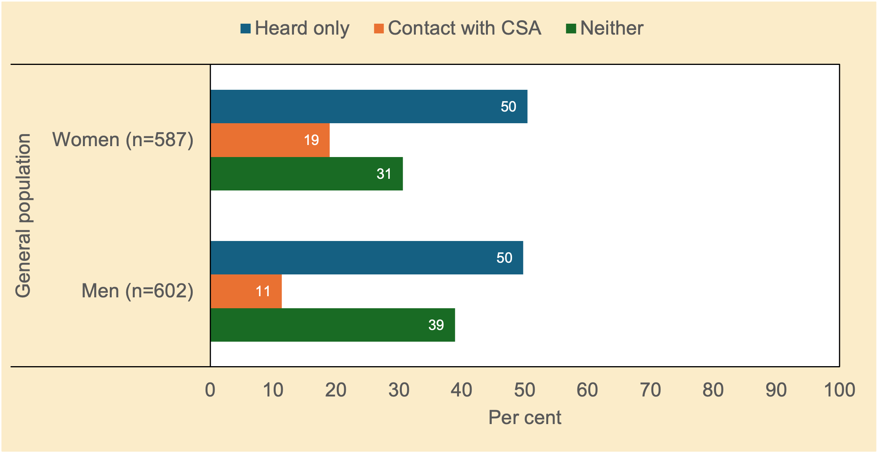
Note. n unweighted; % weighted; chi²(2)=17.28, p<.01.
Source. Community Attitudes to Child Support Survey 2024

Half of all women and men in the general population in Australia reported having heard of the Scheme or the Child Support Agency. However, women were more likely than men to report having had contact with the CSA at some point.

How well is the Scheme working? How fair is it?
Separated parents were asked whether they thought that the child support system was working well (see Figure 3.2).
Figure 3.2 Thinking overall, would you say that the child support system is working well? Attitudes of separated parents (%)
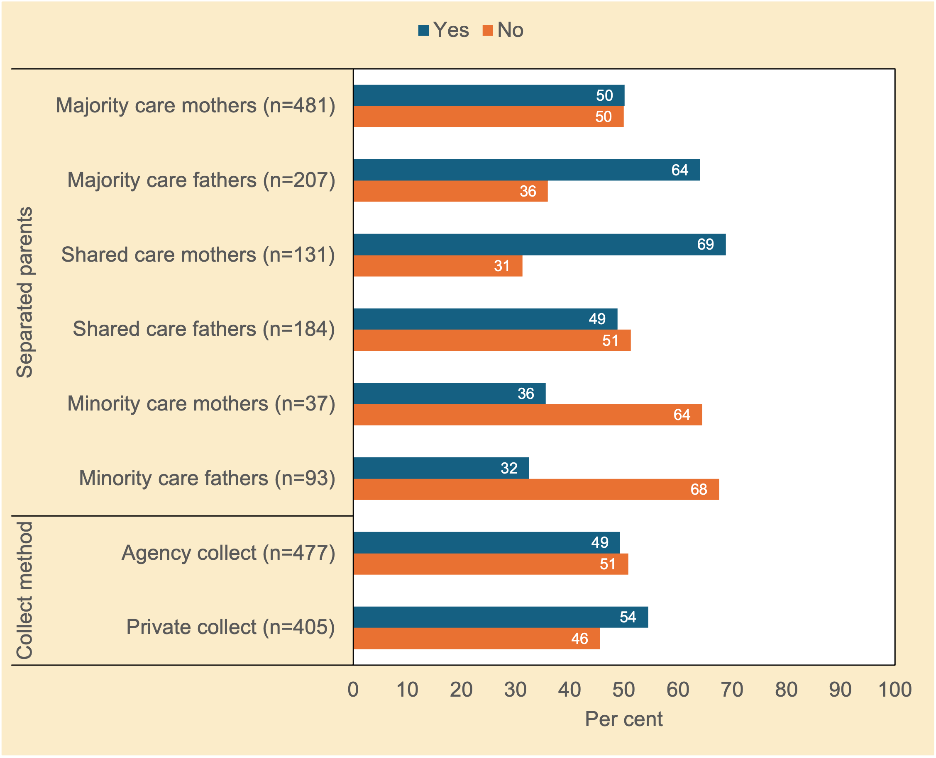
Note. n unweighted; % weighted; chi²(5)=45.97, p<.001 (separated parents); chi²(1)=2.35, p=0.138 (method of collection).
Source. Community Attitudes to Child Support Survey 2024

Around two-thirds of majority care fathers and shared care mothers thought the child support system was working well. In marked contrast, around two-thirds of minority care parents held the opposite view. Parenting roles appear to underpin this pattern rather than gender and might in part reflect parents’ (dis)satisfaction with their parenting arrangement and the nature of the co-parental relationship.

Figure 3.340F explores a similar question: to what extent do parents agree or disagree that the child support system is fair?
Figure 3.3 To what extent do you agree or disagree that the child support system is ‘fair’ for both parents? Attitudes of separated parents (%)
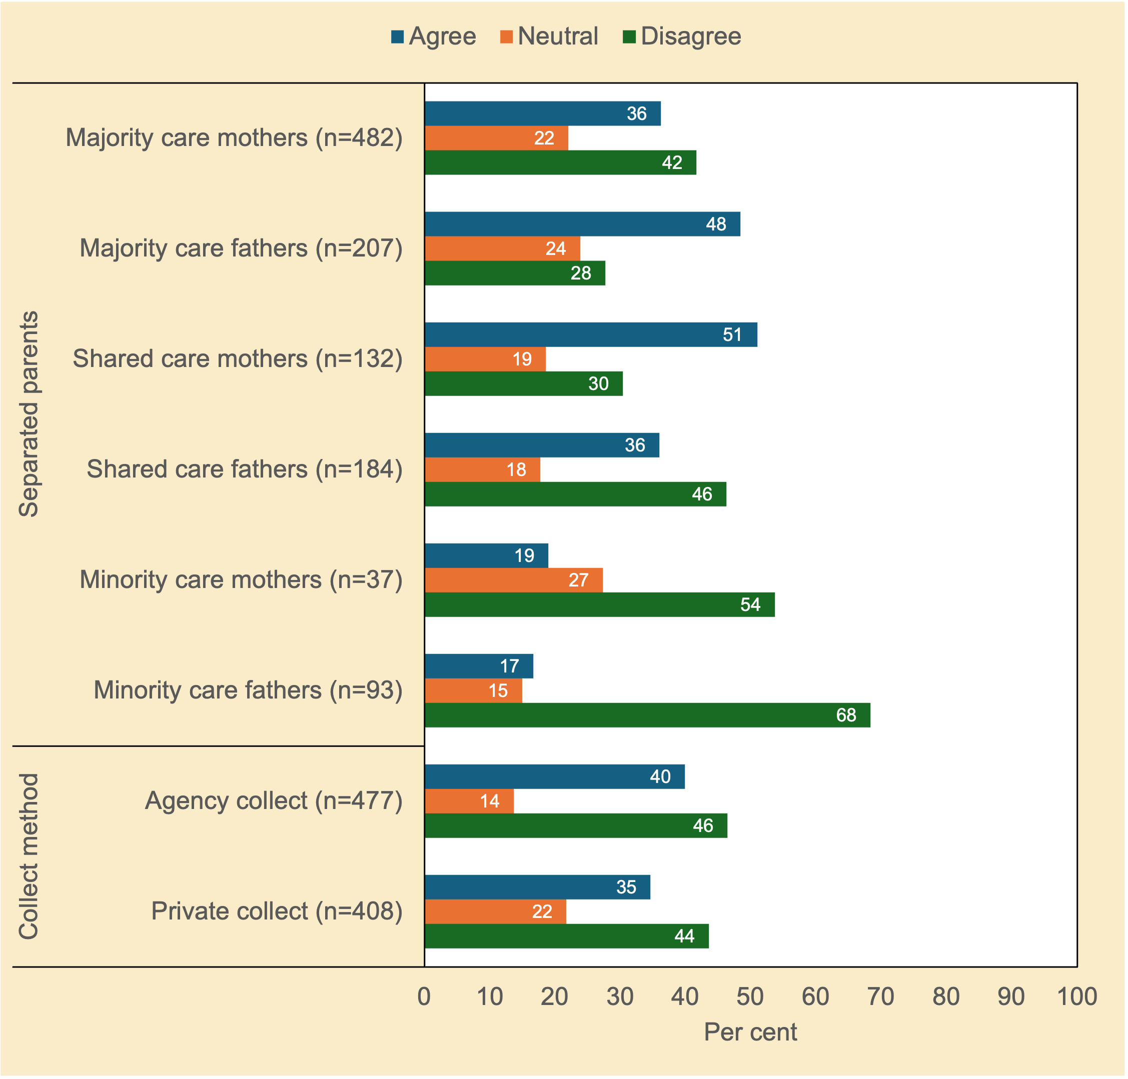
Note. n unweighted; % weighted; chi²(10)=63.46, p<.001 (separated parents); chi²(2)=10.28, p<.01 (method of collection of child support).
Source. Community Attitudes to Child Support Survey 2024

Consistent with Figure 3.2, mothers with shared care and fathers with majority care were the most likely of the separated parent groups to believe that the child support system was fair for both parents. In marked contrast, minority care parents were most likely to see the system as unfair.

Figure 3.4 shows the responses to a follow-up question, in which those who judged the child support system as unfair (neutral or disagree) were asked for whom it was unfair: was it unfair for the paying parent, the receiving parent, or both parents. A paying parent would typically be a minority care parent and, in some cases, a shared-care parent; a receiving parent would typically be a majority care parent (typically a majority care mother) and in some cases a shared care parent. That said, mothers with majority care and fathers with minority care can still be payers in some circumstances depending on income disparities and children of mixed ages in split residence or different living arrangements.
Figure 3.4 For whom is the child support system ‘unfair’? Attitudes of separated parents (%)
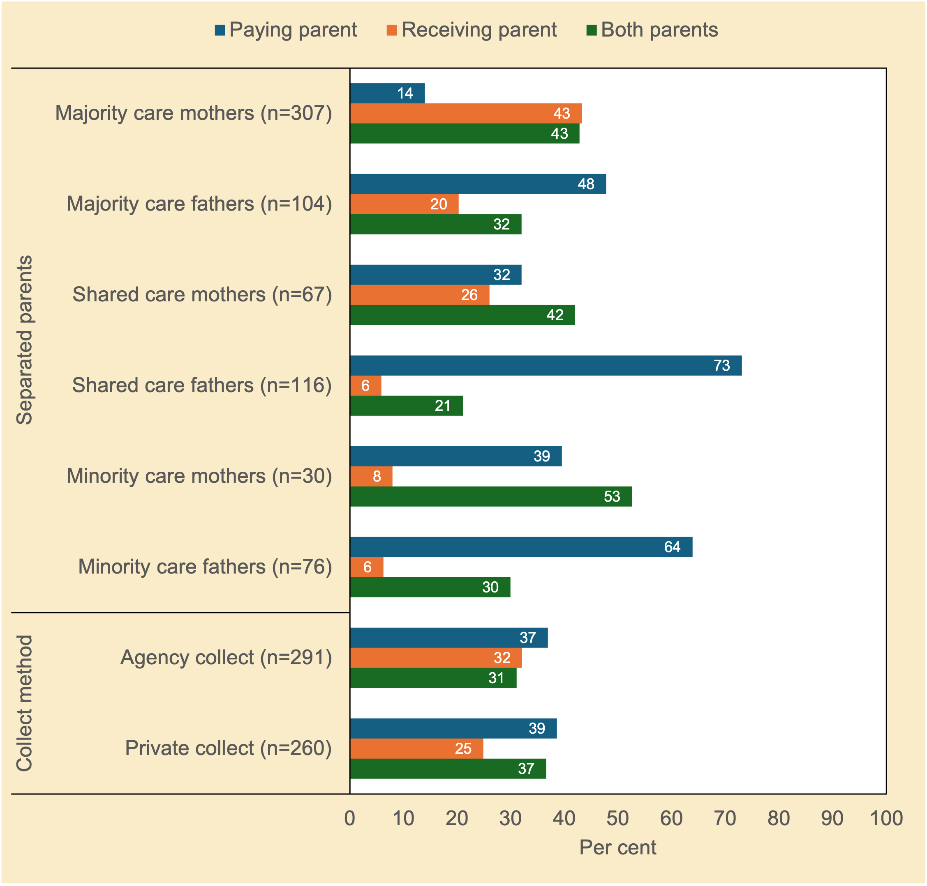
Note. n unweighted; % weighted; chi²(10)=187.74, p<.001 (separated parents); chi²(2)=3.84, p=0.167 (method of collection of child support).
Source. Community Attitudes to Child Support Survey 2024

Separated fathers irrespective of their parenting arrangement were the most likely to believe the child support system was unfair to the paying parent. By contrast, sizeable proportions of separated mothers mentioned the system was unfair to both parents, with majority care mothers evenly split on unfair to receiving parents and both parents. Whether these gendered perceptions reflect the tendency for men to subscribe to an ‘ethics of justice’ and for women to favour an ‘ethics of care’ is not unclear.

There are no statistically significant differences in views according to method of collection of child support.

The public–private compact

Whose responsibility: Parents, government, or both?
Figure 3.5 examines respondents’ views of who should be responsible for providing financial support to children whose parents are not living together. Should it be the parents or the government, or should that responsibility be shared between the parents and the government?
Figure 3.5 When couples separate, or are not partnered when a child is born, which of the following parties should have the main responsibility for financial support of their children: parents, government, or both? Attitudes of women and men in the general population, and of separated parents (%)
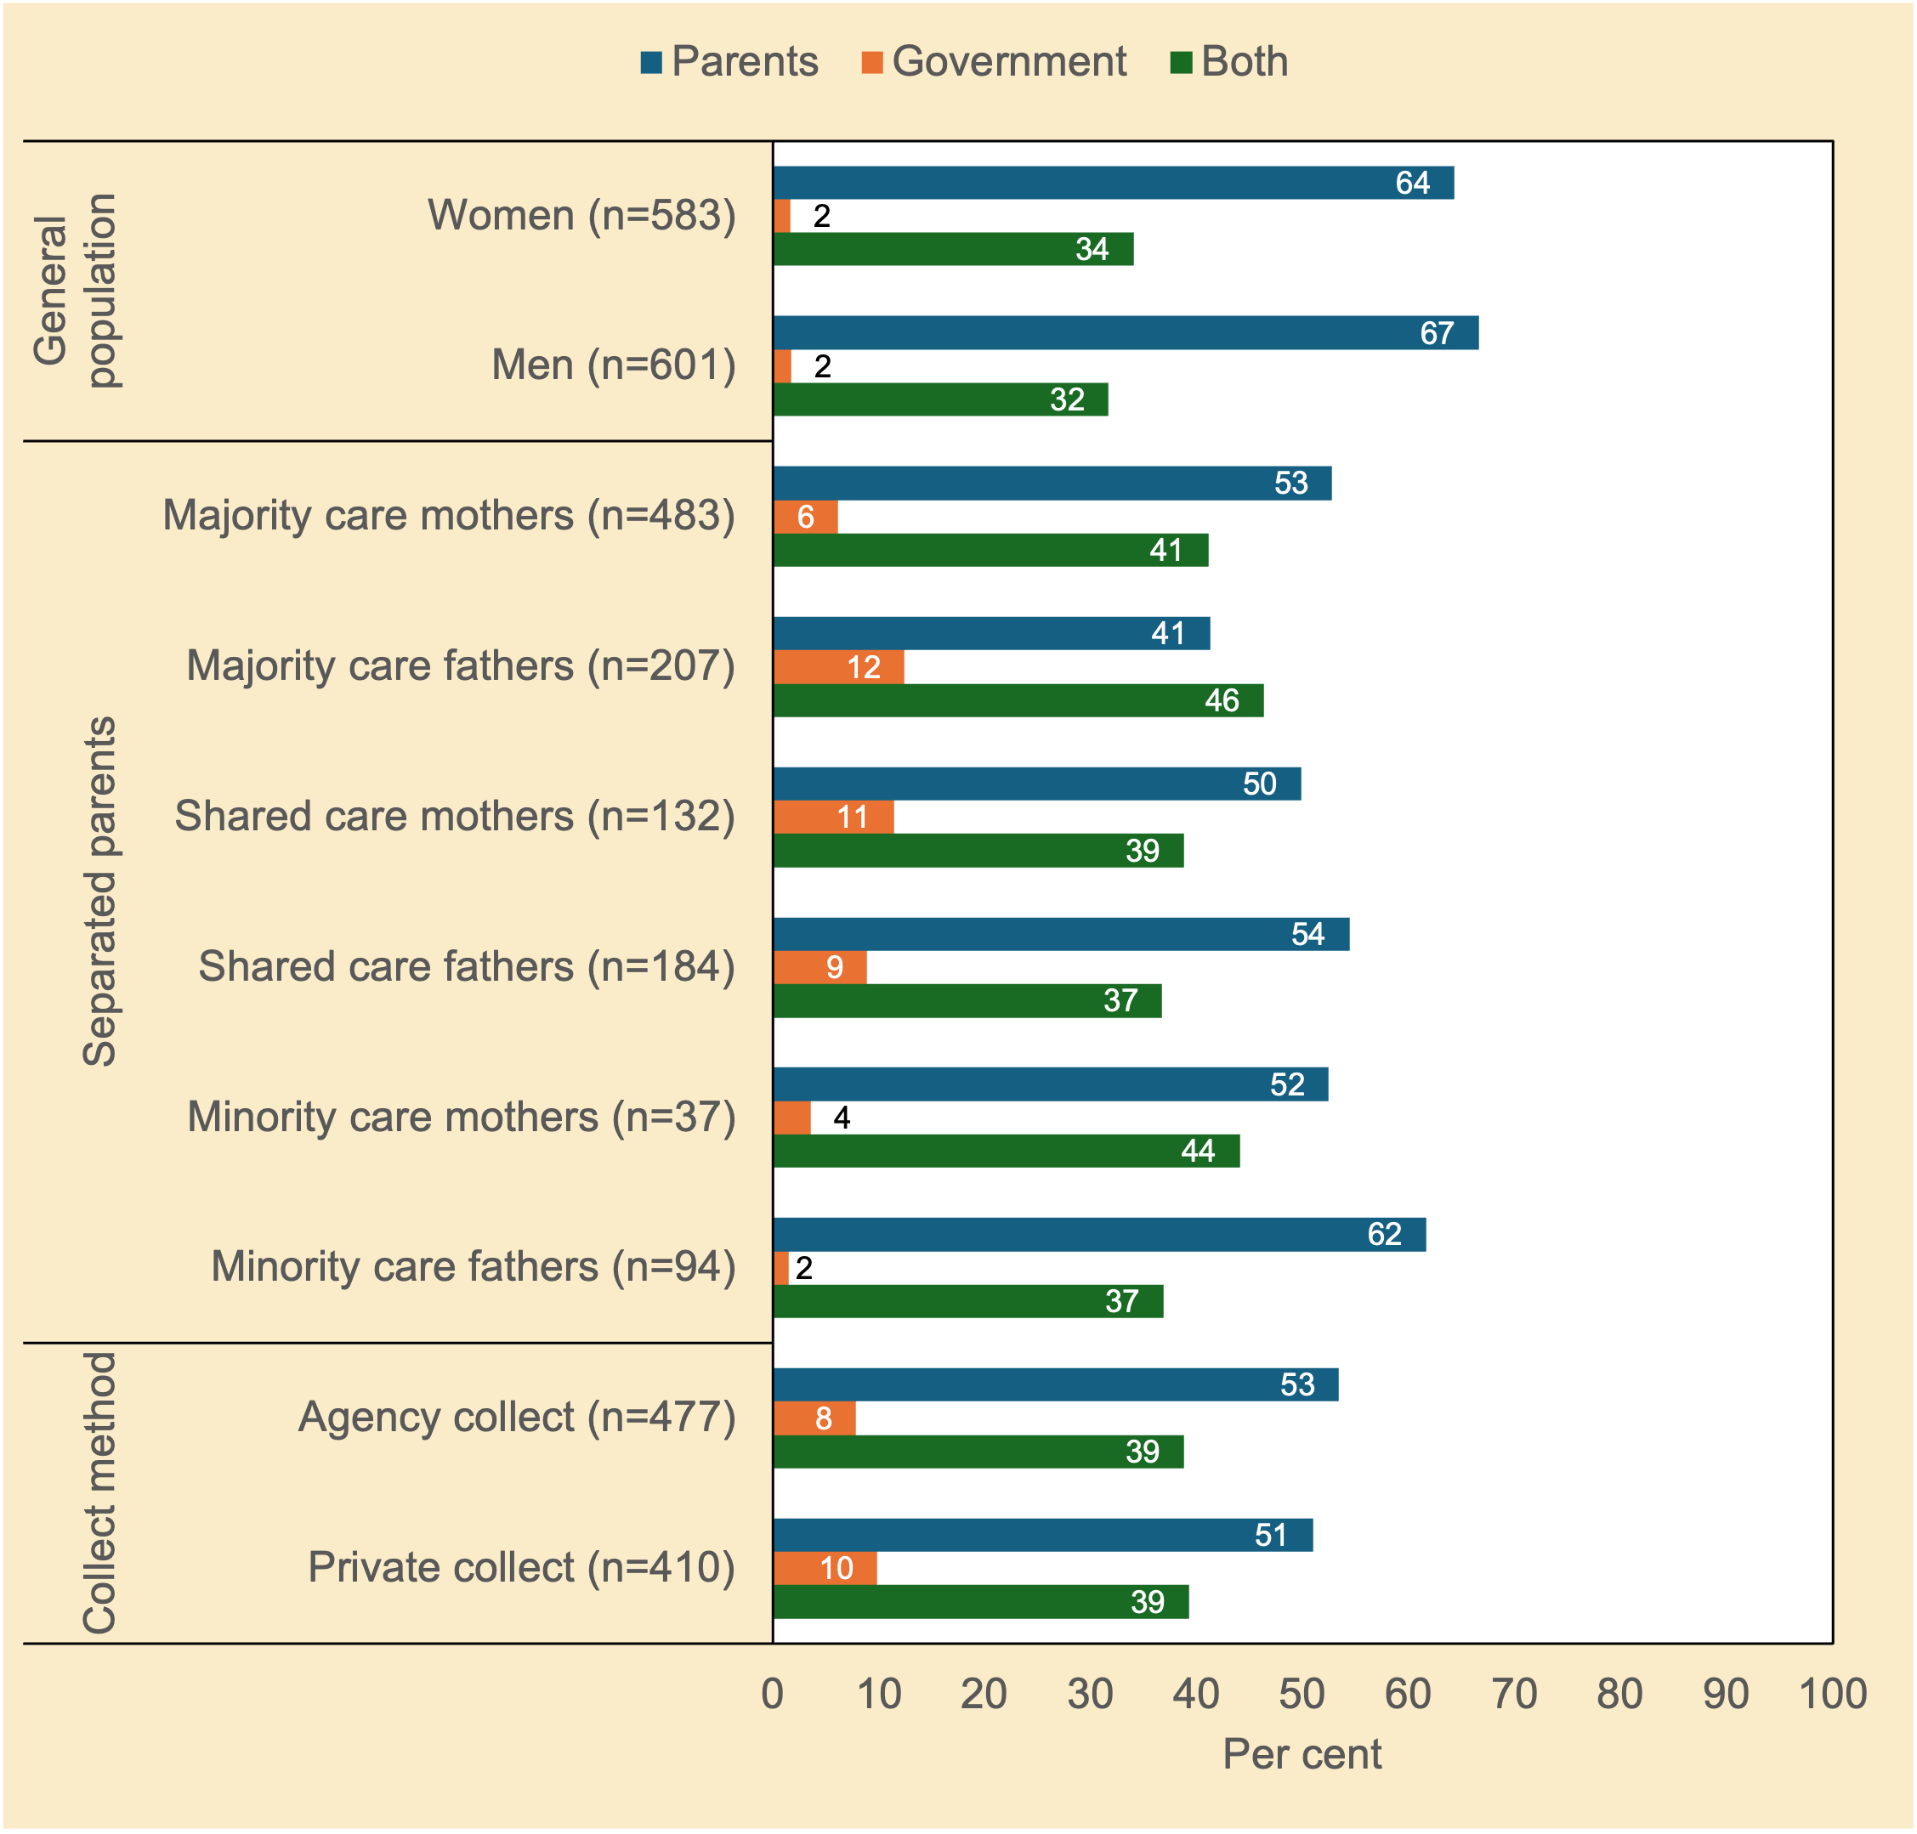
Note. n unweighted; % weighted; chi²(2)=0.76, p=0.734 (general population); chi²(10)=24.72, p<.01 (separated parents); chi²(2)=1.28, p=0.545 (method of collection of child support).
Source. Community Attitudes to Child Support Survey 2024

There was little support in the general population, and among majority care mothers and minority care fathers, that the financial support of children after separation should primarily be the government’s responsibility—as was also the case two decades ago (c.f., Smyth & Weston, 2005, p. 23). Support for this idea was also not strong among the other parent groups.

Respondents in both the general population, and separated parent population (apart from majority time fathers), were inclined to believe that children should be financially supported by parents. That said, a substantial percentage of respondents (range 32%–44%) thought child support should be a shared responsibility between parents and the State.

How much should child support affect the receiving parent’s benefits?
Figure 3.6 focuses on the interaction between child support and family assistance payments provided by government. Should income support be reduced by all child support received, by some amount, or not reduced at all?
Figure 3.6 If either or both of the parents receive government income support payments, should their government payments be reduced by the total amount of child support, reduced by some of it, or not reduced at all? Attitudes of women and men in the general population, and of separated parents (%)
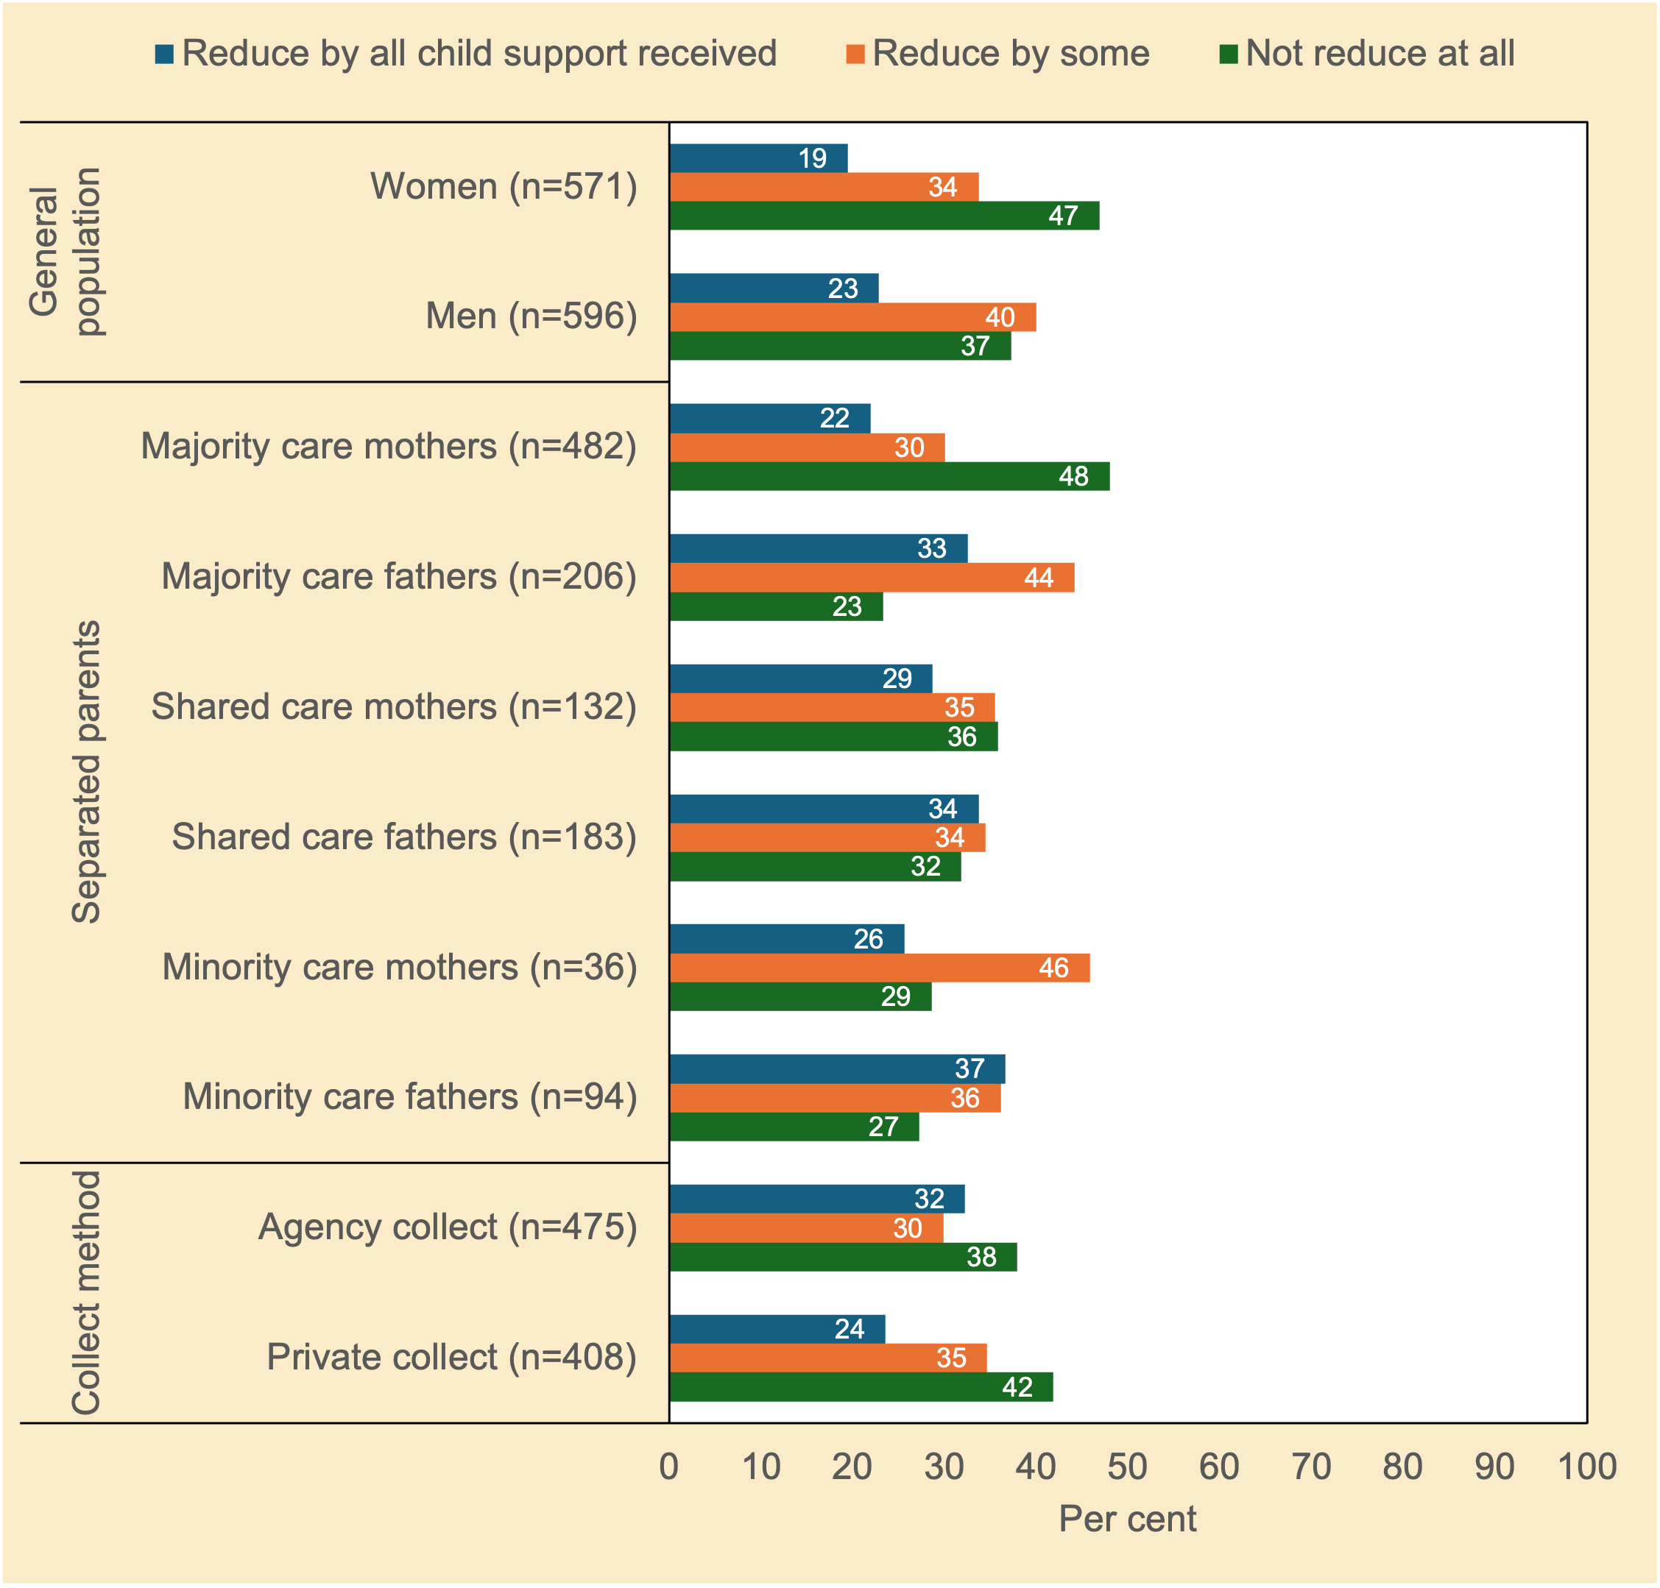
Note. n unweighted; % weighted; chi²(2)=11.15, p<.01 (general population); chi²(10)=53.00, p<.001 (separated parents); chi²(2)=8.22, p<.05 (method of collection of child support).
Source. Community Attitudes to Child Support Survey 2024

The issue of reducing government payments in the context of child support (i.e., the Maintenance Income Test) revealed a complex pattern of responses. Overall, most respondents believed that government payments should be able to be kept in full or partly reduced by the total amount of child support received (i.e., no or partial ‘clawback’). The two groups most opposed to any reduction in government payments were women in the general population and majority care mothers.

What’s the main aim of the Scheme?
The next question focussed on the Scheme and what its main priority should be. Should the Scheme prioritise helping children, being ‘fair’ for both parents, or reducing the amount the government spends on benefits?41F Figure 3.7 shows the responses.

Figure 3.7 Which of the following should be the main priority of the Child Support Scheme: helping children, being ‘fair’ for both parents, or reducing the amount the Government has to spend on benefits? Attitudes of women and men in the general population, and of separated parents (%)
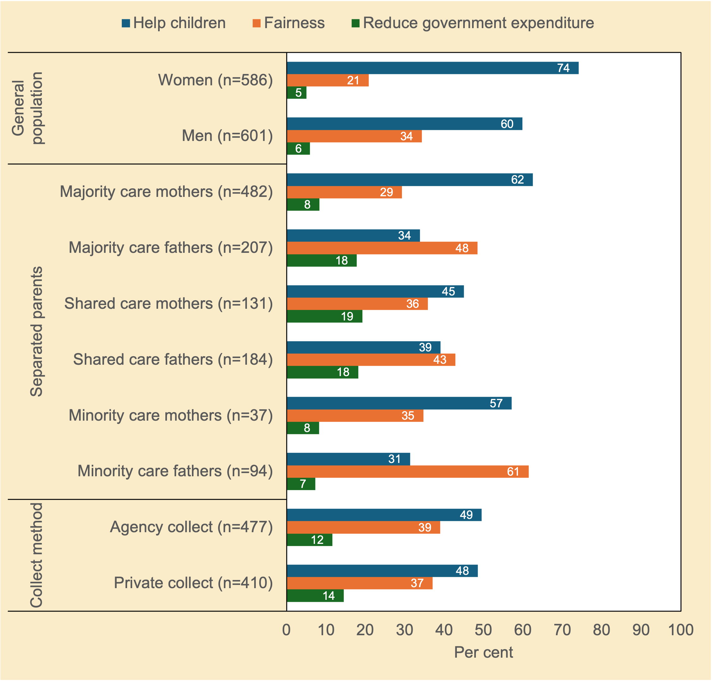
Note. n unweighted; % weighted; chi²(2)=28.92, p<.001 (general population); chi²(10)=91.54, p<.001 (separated parents); chi²(2)=1.71, p=0.443 (method of collection of child support).
Source. Community Attitudes to Child Support Survey 2024

Reducing government expenditure as the main priority of the child support system was the least favoured preference (range: 5%–19%). Rather, men and women in the general population, and mothers in the separated parent sample, thought that helping children should be the main priority. For separated fathers, fairness mattered most—suggesting they favoured an ‘ethic of justice’.

Income and capacity to pay

Should minority care parents always pay?
Figure 3.8 presents participants’ responses about whether child support should always be paid by parents who do not usually live with their children.
Figure 3.8 Do you think a parent who does not usually live with their child or children should always pay child support? Attitudes of women and men in the general population, and of separated parents (%)
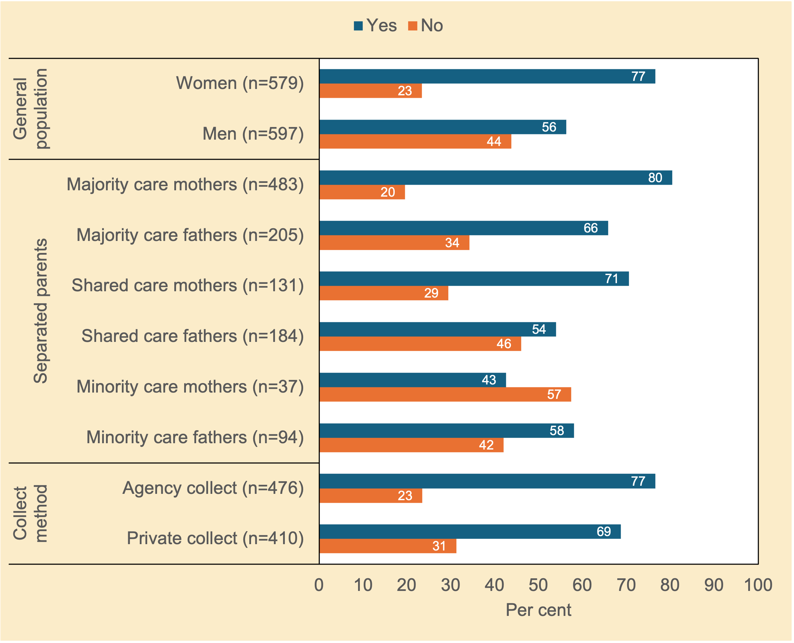
Note. n unweighted; % weighted; chi²(1)=54.24, p<.001 (general population); chi²(5)=68.33, p<.001 (separated parents); chi²(1)=6.80, p<.05 (method of collection of child support).
Source. Community Attitudes to Child Support Survey 2024

Respondents across all groups believed that child support should always be paid, except for the small group of mothers with minority care (over half disagreed with this proposition). The latter group is likely to be sensitive to a range of extenuating circumstances related to capacity to pay, and include mothers in fearful or enduring high conflict relationships, and/or who have complex needs (see e.g., Moloney, 2001; Vnuk, 2017.)

Should minority care parents with low incomes pay?
The previous section reported that most respondents believed parents with little or no contact with a child should still have to pay child support. But what if the parent with little or no contact is on a low income? Should they still have to pay some child support?.42F Figure 3.9 sets out participants’ responses to this question.
Figure 3.9 Do you think a parent who has little or no contact with a child should pay some child support even if their earnings are very low or they only receive government income support payments? Attitudes of women and men in the general population, and of separated parents (%)
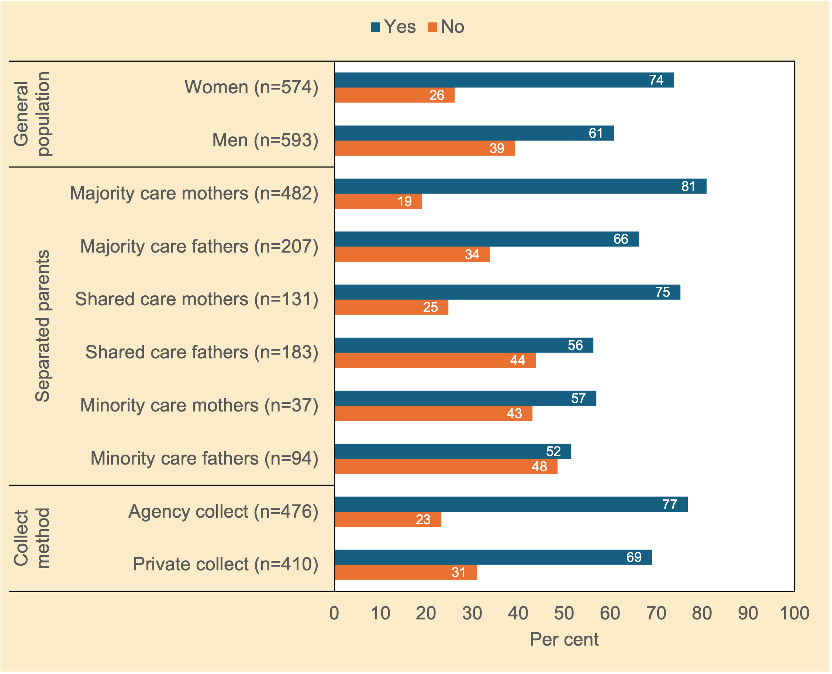
Note. n unweighted; % weighted; chi²(1)=22.62, p<.001 (general population); chi²(5)=65.89, p<.001 (separated parents); chi²(1)=6.80, p<.05 (method of collection of child support).
Source. Community Attitudes to Child Support Survey 2024

There was solid support for the idea that a parent who has little or no contact with a child should still pay some child support even if their earnings are very low or they only receive government income support payments (as was also the case two decades ago; see Smyth & Weston, 2005, p. 29). Figure 3.9 thus closely mirrored Figure 3.8 even with the low-income qualifier added. The greatest endorsement of this proposition was by majority care mothers, shared care mothers, women in the general population, and separated parents in Agency Collect.

It is noteworthy that the small group of mothers with minority care were more likely to believe that parents with little or no contact with a child should still have to pay some child support (57% agreement, see Figure 3.9), whereas the same group reported the identical percentage against the idea of paying child support when living apart from children (57% disagreement). This is a curious finding, notwithstanding that small samples are less reliable than larger samples. We would have predicted that introducing the low-income condition is likely to have softened attitudes towards the ability to pay, and thus reduced agreement rather than increasing it. One possible explanation comes to mind. Mothers with little or contact with their children might believe they should not have to pay child support because they are sensitive to their own circumstances (self-referencing bias). But when they are reminded that minority care mothers may be in receipt of government income support or some earnings, they may accept that they have some, albeit limited, capacity to pay something.

Vnuk (2017) found that minority time liable mothers with little or no parenting time were significantly more compliant than their female counterparts with more parenting time. It is unclear if the phrase ‘does not usually live with’ (see question wording for Figure 3.8) may have been interpreted as ‘but spends some time with’, and the responses by minority time mothers shown in Figure 3.8 reflect this. By contrast, the phrase ‘ little or no contact’ (see question wording for Figure 3.9) may have been salient and priming in this context to minority time mothers. As noted, attitudinal data are sensitive to order and priming effects.

Both possibilities offered above are speculation.

What is the minimum amount that should be paid?
Table 3.1 explores attitudes towards minimum amounts of child support that should be paid regardless of income and the number of children. Respondents who said ‘yes’ to the question in the previous section (whether a low-income parent who has little or no contact with a child should pay some child support) were given a follow-up question: ‘What do you think should be the absolute minimum amount of child support that a parent should pay regardless of their income or the number of children they are supporting?’ Table 3.1 reports these minimum amounts, with the ‘no’ responses to the earlier question shown in the ‘Nothing’ row.
Table 3.1 What do you think should be the absolute minimum amount of child support that a parent should pay regardless of their income or the number of children they are supporting? Would it be: Nothing, $0 to $19 a week, $20 to $29 a week, ..., $50 or more a week? Attitudes of women and men in the general population, and of separated parents (%)
 | General population |  | Separated parents |  |  |  |  |  | Collect method
 | Women (n=588)  % | Men (n=603)  % | Majority care mothers (n=482)  % | Majority care fathers (n=207)  % | Shared care mothers (n=131)  % | Shared care fathers (n=184)  % | Minority care mothers (n=37)  % | Minority care fathers (n=94)  % | Agency collect (n=477)  % | Private collect (n=410)  %
Nothing | 26 | 39 | 19 | 34 | 25 | 44 | 43 | 48 | 23 | 31
Pay something
$1 to $19 a week | 6 | 5 | 4 | 7 | 9 | 4 | 4 | 8 | 6 | 5
$20 to $29 a week | 6 | 8 | 10 | 10 | 20 | 5 | 18 | 4 | 12 | 11
$30 to $39 a week | 8 | 5 | 9 | 8 | 7 | 6 | 7 | 3 | 10 | 6
$40 to $49 a week | 9 | 7 | 5 | 10 | 7 | 7 | 0 | 6 | 8 | 5
$50 or more a week | 41 | 32 | 53 | 31 | 30 | 34 | 28 | 31 | 41 | 42
Don’t know | 5 | 3 | 0 | 0 | 1 | 0 | 0 | 1 | 0 | 0
Total | 100 | 100 | 100 | 100 | 100 | 100 | 100 | 100 | 100 | 100
Notes. n unweighted; % weighted; chi²(6)=30.89, p<.001 (general population); chi²(30)=126.18, p<.001 (separated parents); chi²(6)=11.70, p<.1 (method of collection of child support); the ‘Nothing’ group comprises those who said ‘no’ to the survey question: Do you think a parent who has little or no contact with a child should pay some child support even if their earnings are very low or they only receive government income support payments?
Source. Community Attitudes to Child Support Survey 2024

Table 3.1 tells a story of extremities. Many respondents supported having no minimum payment, especially minority care parents and shared care fathers. Conversely, many others believed the minimum child support should be $50 or more per week, particularly majority care mothers. For those on income support or in unstable casual jobs, $50 a week may be very hard if not impossible to afford.

Income cap or no cap?
Should there be a maximum amount of child support payable for high-income parents? Figure 3.10 explores whether there should be a cap on how much child support should be paid for high income paying parents.

It is worth noting that the income of the paying parent is an important factor in determining the amount of child support payable to the other parent. The child support formula caps the costs of the children for a case (at a combined child support income of $213,473 in 2024). Any extra dollar of parental income above the cap will not change the costs of the children but may affect a parent’s income percentage and their share of the costs.
Figure 3.10 Should there be a maximum amount of child support payable for high-income parents? Attitudes of women and men in the general population, and of separated parents (%)
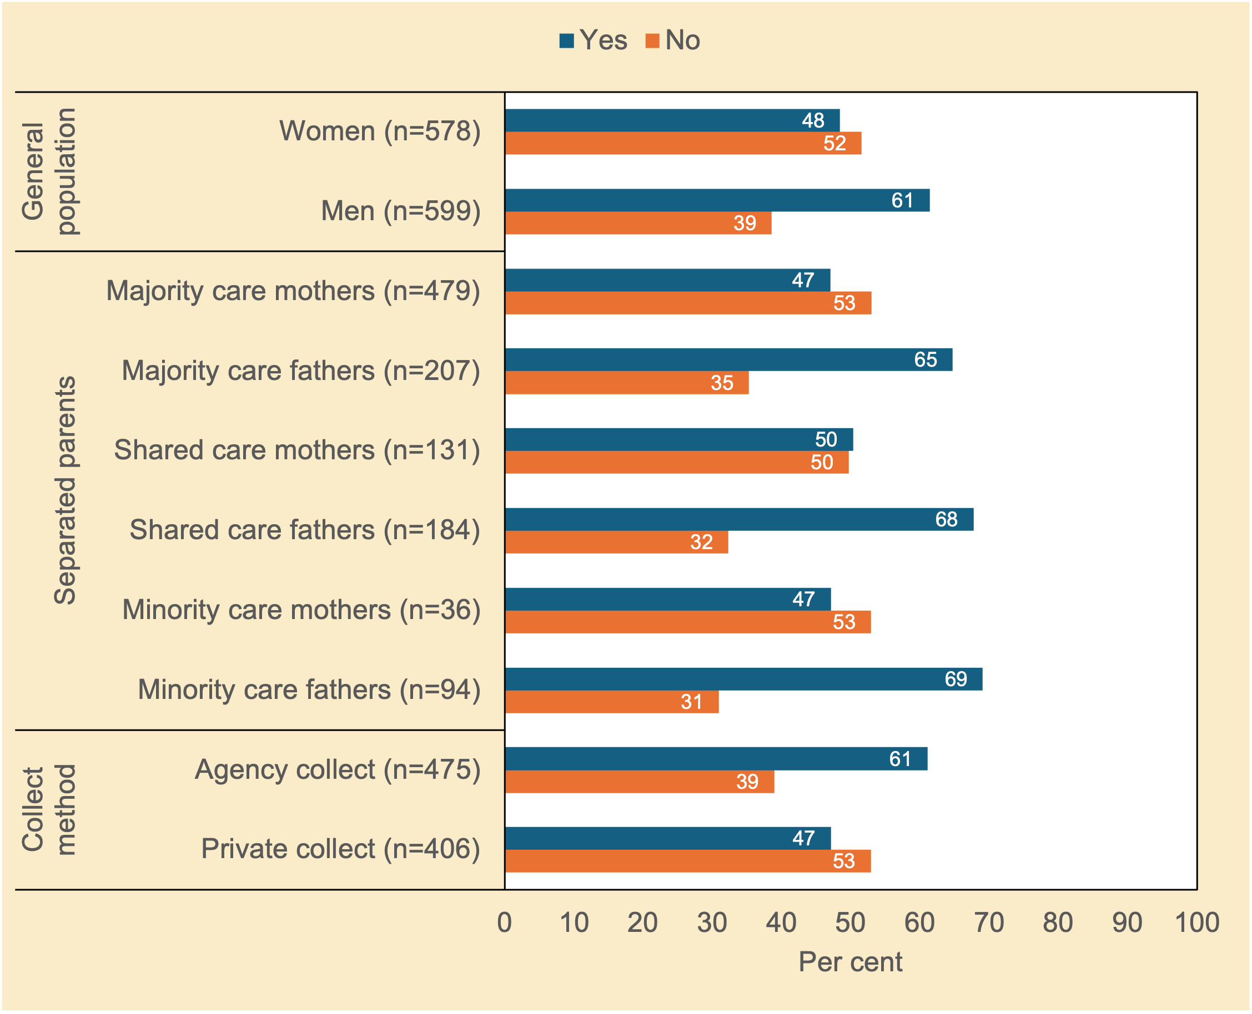
Note. n unweighted; % weighted; chi²(1)=20.06, p<.001 (general population); chi²(5)=41.59, p<.001 (separated parents); chi²(1)=17.22, p<.001 (method of collection of child support).
Source. Community Attitudes to Child Support Survey 2024

The idea that there should be a maximum amount of child support payable for high-income parents diverged significantly along gender lines. Men in the general population, and the separated father groups favoured a cap on the maximum amount payable at high incomes. So too did the Agency Collect group. By contrast, women in the general population, the separated mother groups, and the Private Collect group, were more equivocal, with around half opposed to a cap on the maximum amount payable.

Should the higher income parent pay child support in 50/50 parenting arrangements?
Where care of children is equally shared between both parents, one parent may still have a child support liability to the other parent where there is an income differential. The parents’ income difference, which determines their relative ability to provide resources, is deemed to contribute to child costs borne by the lower-income parent. The higher-income parent, therefore, is usually required to pay some child support to compensate the other parent for the additional costs. Some parents might of course call it ‘even-stevens’ for the sake of good will, to avoid money becoming a wedge in the parental alliance, or to minimise contact in parallel parenting arrangements.

The data presented in Figure 3.11 examine whether a parent with a 50/50 parenting arrangement and a higher income than the other parent should be required to pay child support. This question has not been previously asked in prior Australian studies.
Figure 3.11 Should a parent with a 50/50 parenting arrangement who has a higher income than the other parent be required to pay child support? Attitudes of women and men in the general population, and of separated parents (%)
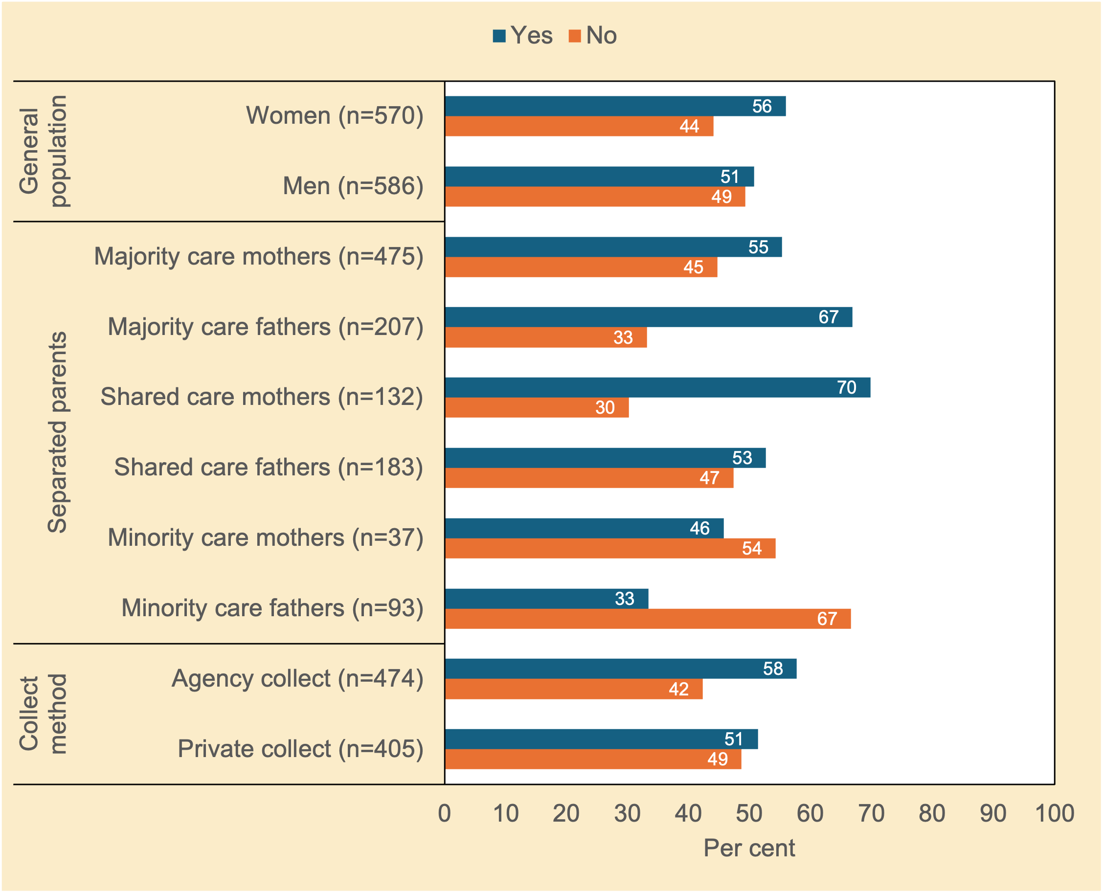
Note. n unweighted; % weighted; chi²(1)=3.19, p<.1 (general population); chi²(5)=41.72, p<.001 (separated parents); chi²(1)=3.60, p<.1 (method of collection of child support).
Source. Community Attitudes to Child Support Survey 2024

Shared care mothers and majority time fathers were inclined to support the payment of child support in a 50/50 parenting arrangement even when one parent was earning more than the other parent. By contrast, fathers with minority care were the group most opposed to this.

The number of children and prolonged dependence

Should any children over 18 continue to receive support?
In some situations, child support continues to be payable even after the child has turned 18 (Smyth, 2002). In the Scheme an assessment can continue to the end of the secondary school year in which a child turns 18. Adult children who pursue secondary or tertiary education full-time or children living with disability may be eligible for adult child maintenance under the Family Law Act 1975 and can apply to the court for an order but not under a child support assessment. Child support ceases for young people who turn 18 while in full-time study at the end of the calendar year.

Figure 3.12 sets out participants’ responses to the question of whether child support should be paid for a child over 18 years who is (a) a full-time student aged under 22 years; (b) an unemployed youth aged under 22 years; and (c) a child living with disability, all of these, or none of these.
Figure 3.12 Should child support be paid for a child over 18 years who is a full-time student aged under 22 years, an unemployed youth aged under 22 years, a child living with disability, all of these, or none of these? Attitudes of women and men in the general population, and of separated parents (%)
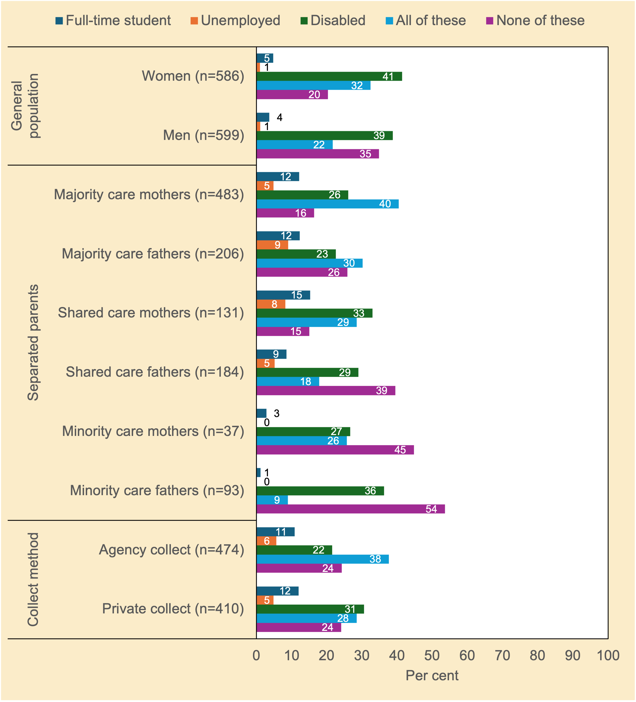
Note. n unweighted; % weighted; chi²(4)=36.79, p<.001 (general population); chi²(20)=144.51, p<.001 (separated parents); chi²(4)=13.06, p<.05 (collect method).
Source. Community Attitudes to Child Support Survey 2024

It should be noted at the outset that this survey question did not allow respondents to select multiple responses: only one category, all three, or none. A complex pattern of results emerged. For simplicity, we only report the broad brushstrokes. Majority care mothers were mostly likely to be supportive of ongoing financial support for young adult children if young adults were unemployed, had a disability, and/or were studying full-time. By contrast, minority care fathers, minority care mothers, and shared care fathers were the most likely of the separated parent groups to oppose ongoing financial support for young adult children regardless of their circumstances. Young adults with a disability received the strongest support for ongoing child support compared with the alternative scenarios of young adult unemployment or full-time study.

Should child support be paid for more than three children?
Under the current child support formula, child support payments do not increase for four or more children. The maximum amount of child support payable is reached after the first three children.

Figure 3.1343F explores the community’s view on increasing child support if the number of children is more than three. This is a new question that was not previously asked in the survey conducted by Smyth and Weston (2005).
Figure 3.13 To what extent do you agree or disagree that the amount of child support required to be paid should increase if the number of child support children is more than three? Attitudes of women and men in the general population, and of separated parents (%)
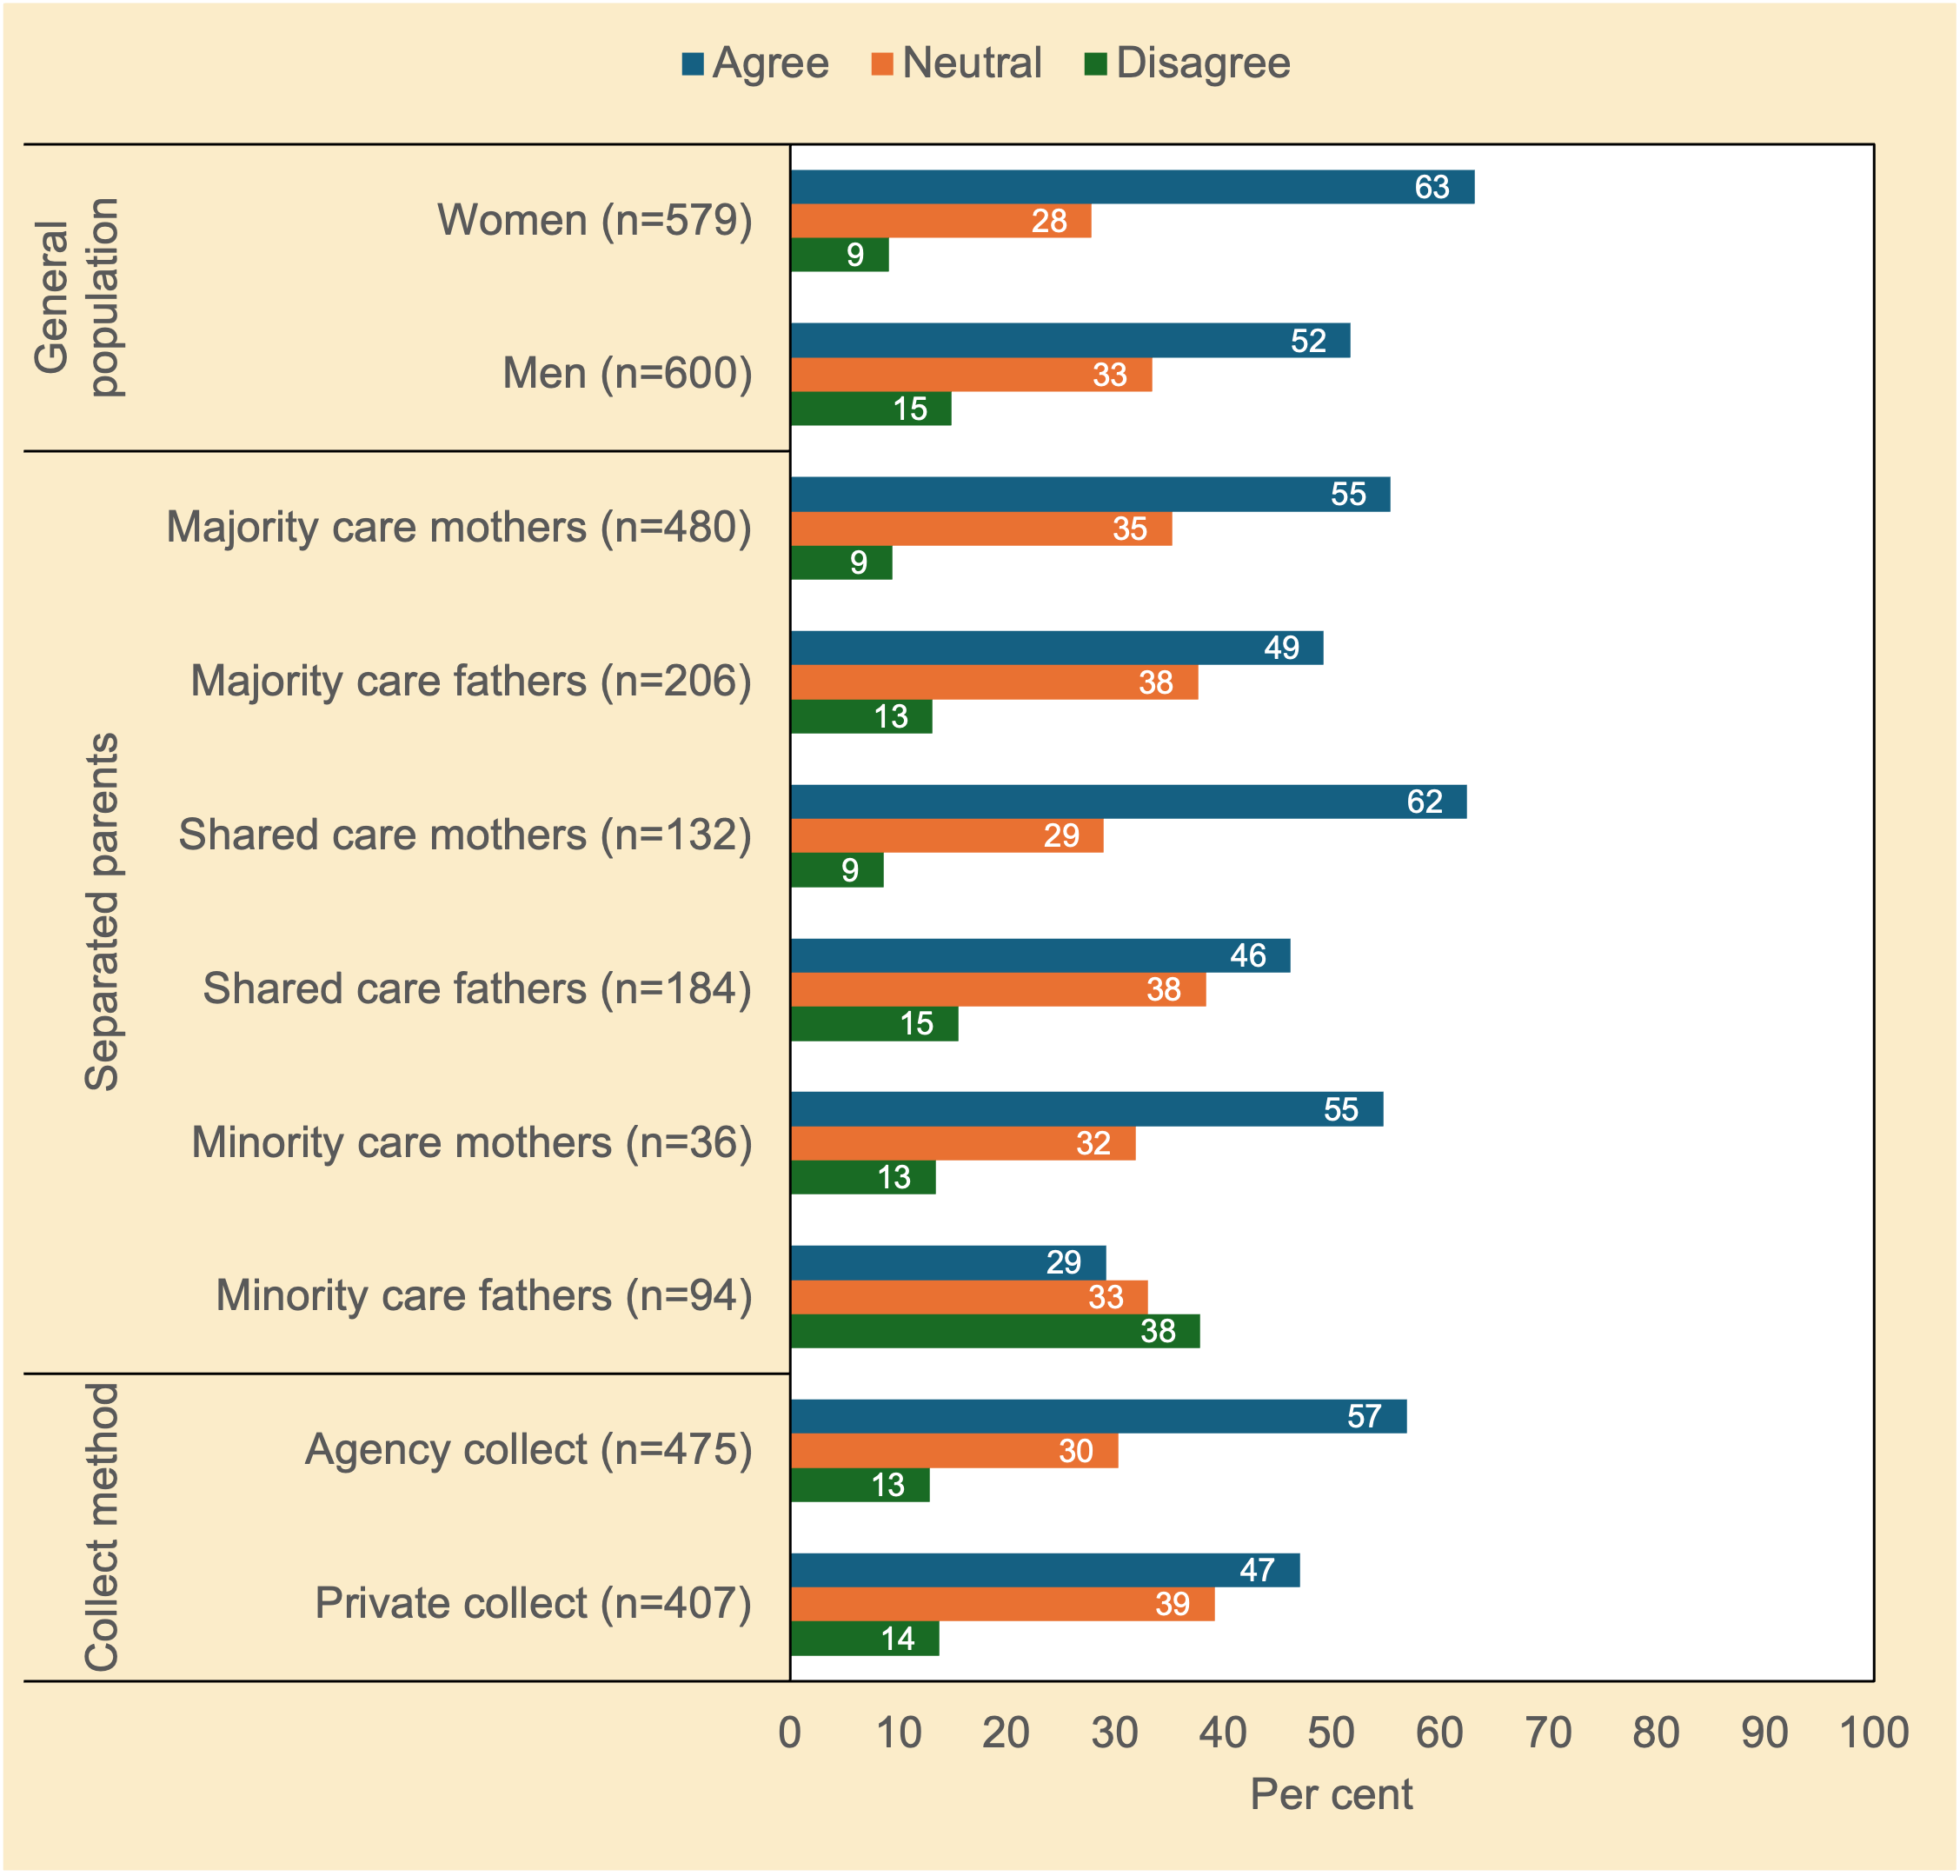
Note. n unweighted; % weighted; chi²(2)=18.02, p<.001 (general population); chi²(10)=67.68, p<.001 (separated parents); chi²(2)=9.25, p<.05 (collect method).
Source. Community Attitudes to Child Support Survey 2024

There was solid support, especially by the female groups, for the idea that child support should increase if there are more than three children (range: 46–63%), likely reflecting the tendency for mothers to manage household finances and prioritise expenditures related to children's needs rather than fathers.

Compliance and enforcement

Would parents pay without government involvement?
Figure 3.14 explores whether parents would pay child support even if the government was not involved. The question did not further elaborate on what government involvement would entail, but it can safely be assumed that the common understanding would be that the government would enforce payments to be made.
Figure 3.14 Do you think most parents would pay child support without any government involvement? Attitudes of women and men in the general population, and of separated parents (%)
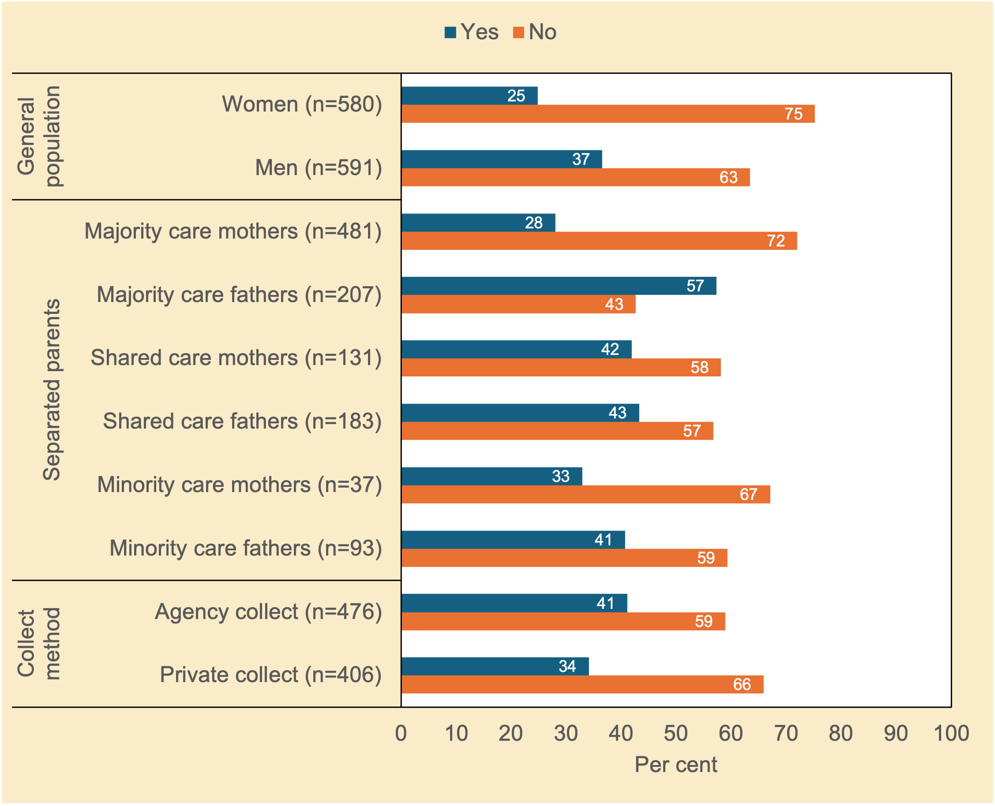
Note. n unweighted; % weighted; chi²(1)=19.05, p<.001 (general population); chi²(5)=56.59, p<.001 (separated parents); chi²(1)=4.55, p<.05 (method of collection of child support).
Source. Community Attitudes to Child Support Survey 2024

A clear majority of respondents believed that without the government, most parents would not pay child support (range: 57%–75%, excluding majority care fathers: 43%). Women in the general population sample, and mothers with majority or minority care, were more likely than their male counterparts to believe this across all groups. Curiously, parents in Private Collect were more likely than those in Agency Collect to believe government involvement was required to enforce compliance.

Should non-payers be penalised?
Figure 3.15 reports respondents’ views on whether penalties should be imposed on paying parents who do not make child support payments.
Figure 3.15 Should a parent face a penalty (such as a fine) if they fail to make their child support payments? Attitudes of women and men in the general population, and of separated parents (%)
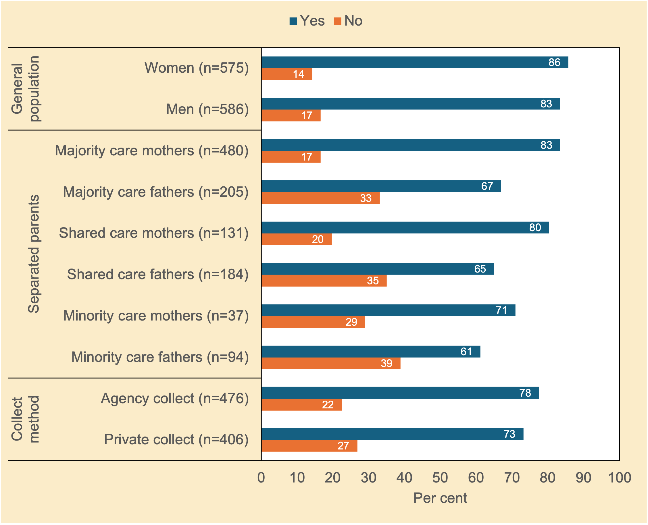
Note. n unweighted; % weighted; chi²(1)=1.15, p=0.310 (general population); chi²(5)=47.03, p<.001 (separated parents); chi²(1)=2.24, p=0.150 (method of collection of child support).
Source. Community Attitudes to Child Support Survey 2024

There was overwhelming support across all groups for the use of penalties for non-compliance (range: 61%–86%). Women were more likely than men across all the groups to support the use of penalties for non-compliance.

New partners and second families
This section looks at situations in which separated parents repartner or have new children. Such life events change the parents’ family composition and in turn their economic circumstances. A new partner may contribute to joint family income. A new child requires additional resources, which will then be unavailable to fulfil existing child support obligations.

Respondents were presented with three scenarios and asked how it should affect existing child support payments: (a) a parent who receives child support re-marries or starts living with a new partner; (b) a parent who pays child support now has stepchildren; and (c) a parent who pays child support has a new biological or adoptive child.

Scenario 1: Where the receiving parent remarries
Figure 3.16 shows that this question elicited a complex pattern of responses by different groups, with some groups more equivocal than others.

Figure 3.16 If the receiving parent remarries or starts living with a new partner, which of the following best describes what the paying parent should be expected to do: keep paying child support, stop paying, or should payment depend on the financial situation of both parents or on other circumstances? Attitudes of women and men in the general population, and of separated parents (%)
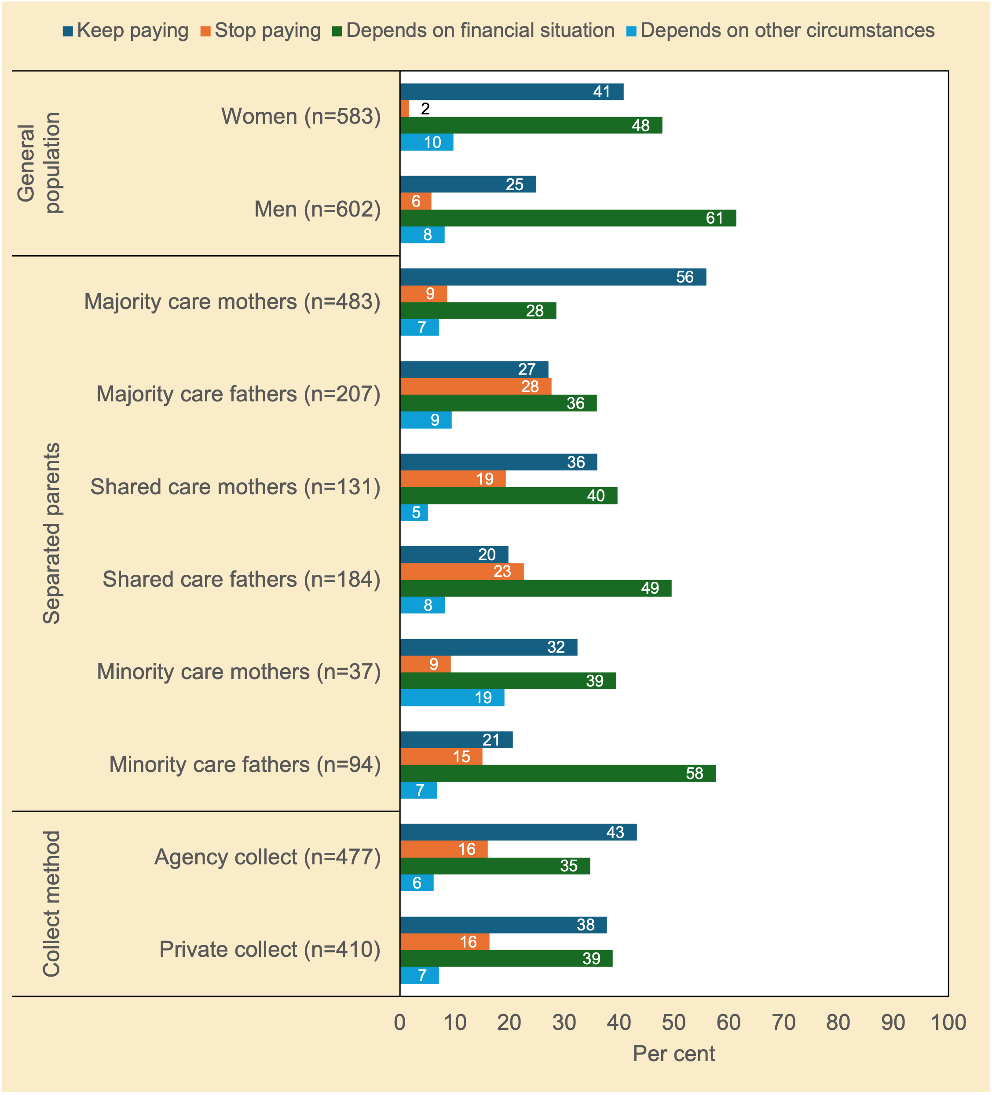
Note. n unweighted; % weighted; chi²(3)=47.33, p<.001 (general population); chi²(15)=147.01, p<.001 (separated parents); chi²(3)=2.92, p=0.436 (method of collection of child support).
Source. Community Attitudes to Child Support Survey 2024

Majority care mothers were the group most likely to believe child support should continue if a receiving parent repartners (i.e., they should keep receiving child support if they repartner). Most other groups of separated parents (as well as respondents in the general population sample) were inclined to believe child support should continue or cease depending on the financial situation of both parents.

Scenario 2: Where the paying parent has step-children
Figure 3.17 shows that there was solid support by all groups, apart from shared care fathers (48%) who were somewhat equivocal, that the presence of stepchildren should not reduce payment (range: 54%–86%). This view was also held by minority care fathers (unlike two decades ago). Females held stronger views on this issue than males. Figure 3.16 in juxtaposition with Figure 3.17 suggest that children are typically given primacy over adult relationships, most likely due to their perceived vulnerability.
Figure 3.17 If the paying parent has repartnered and now has step-children to support, should they be allowed to pay less child support for the children of their previous relationship? Attitudes of women and men in the general population, and of separated parents (%)
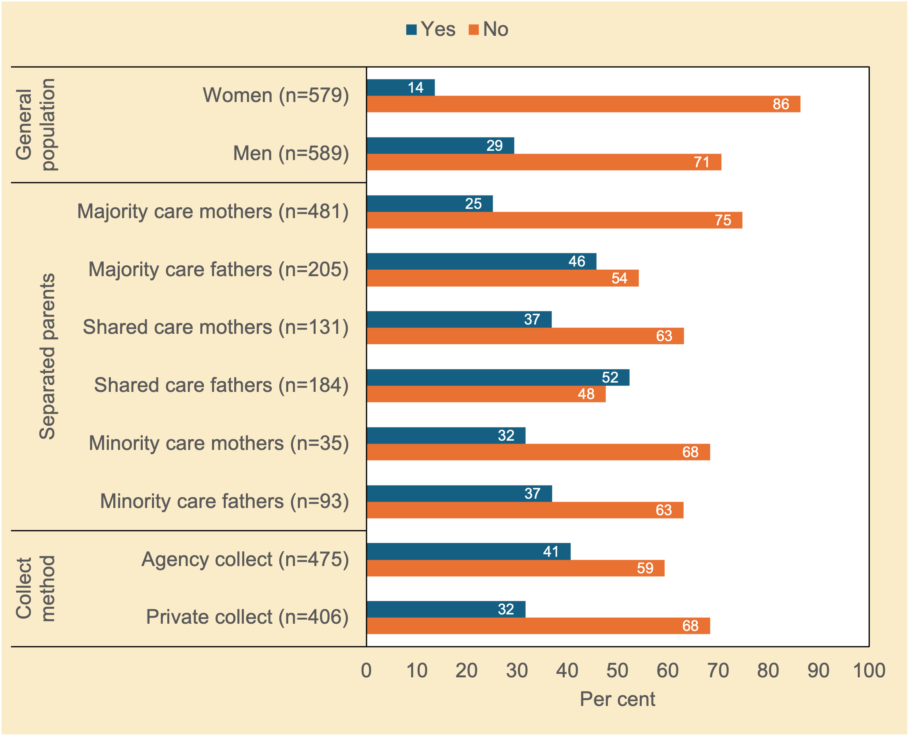
Note. n unweighted; % weighted; chi²(1)=42.74, p<.001 (general population); chi²(5)=54.85, p<.001 (separated parents); chi²(1)=7.68, p<.01 (method of collection of child support).
Source. Community Attitudes to Child Support Survey 2024

Scenario 3: Where the paying parent has a new child
What about if the paying parent has another child with a new partner? Should they be allowed to pay less child support for the children of their previous relationship (see Figure 3.18)? Should all children be treated equally?
Figure 3.18 If the paying parent has another child with a new partner, should they be allowed to pay less child support for the children of their previous relationship? This doesn’t include step-children. Attitudes of women and men in the general population, and of separated parents (%)
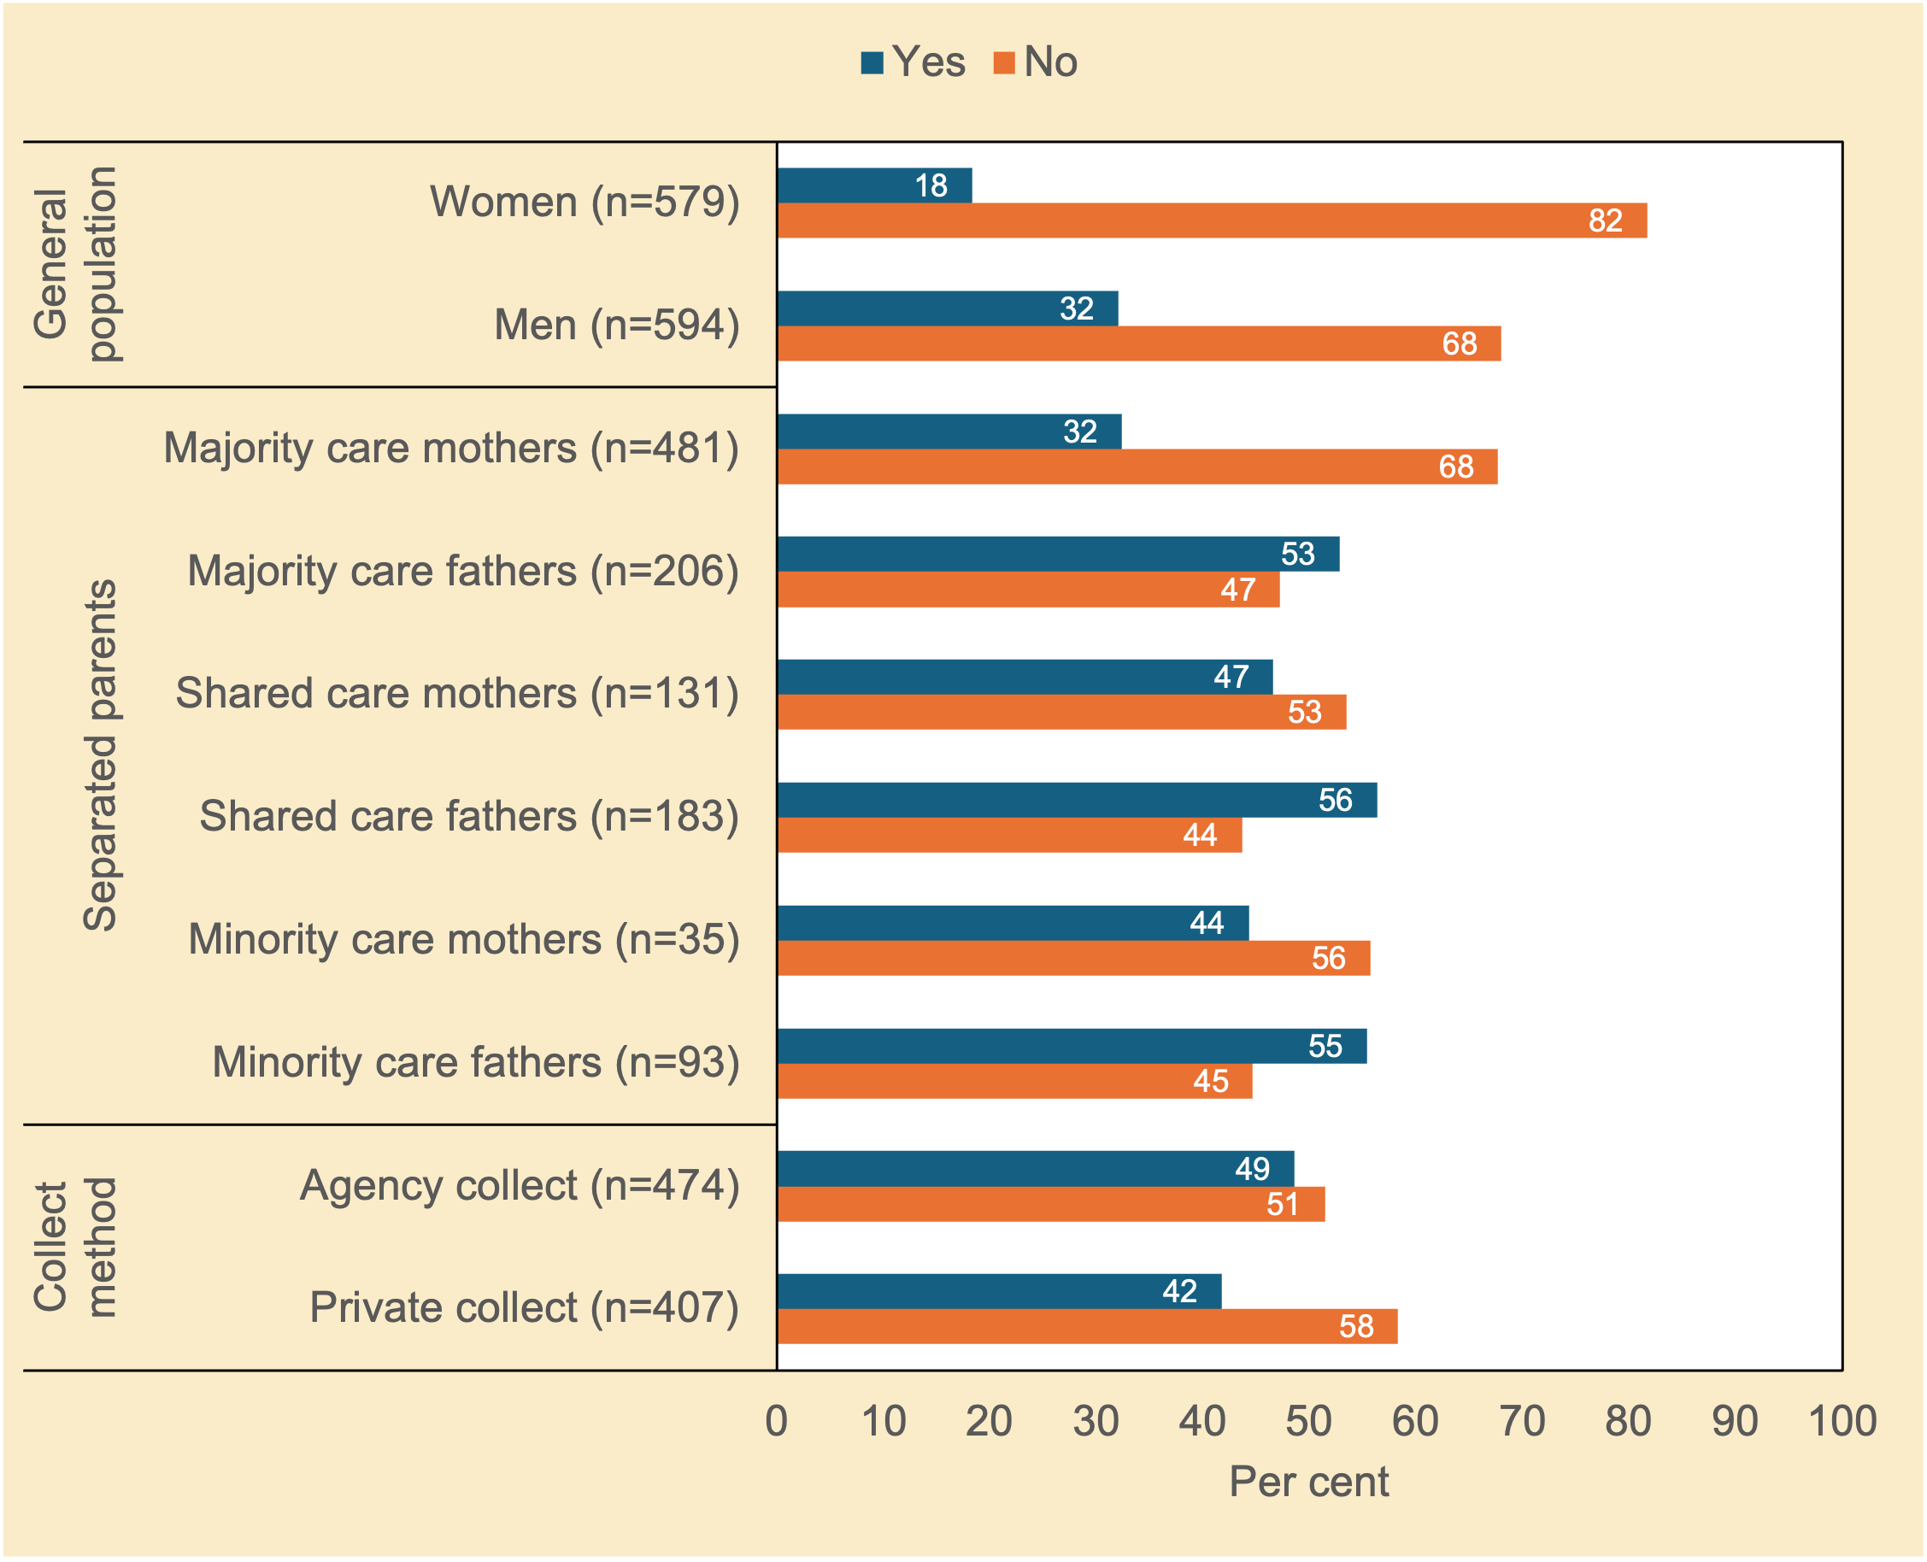
Note. n unweighted; % weighted; chi²(1)=29.08, p<.001 (general population); chi²(5)=49.70, p<.001 (separated parents); chi²(1)=4.13, p<.05 (method of collection of child support).
Source. Community Attitudes to Child Support Survey 2024
Women in the general population, as well as all three female separated mother groups were more likely than their male counterparts to believe payers should not be allowed to pay less for first family children if they have a new biological child.

Parent–child contact
Should the paying parent be given the allowed to withhold payments if contact with their child is denied by the other parent (see e.g., Ellman, 2004)? Figure 3.19 examines this question. Legally, child support payments must still be made in this situation.
Figure 3.19 Should a parent have to pay child support if they want contact with their children but the other parent is preventing it? Attitudes of women and men in the general population, and of separated parents (%)
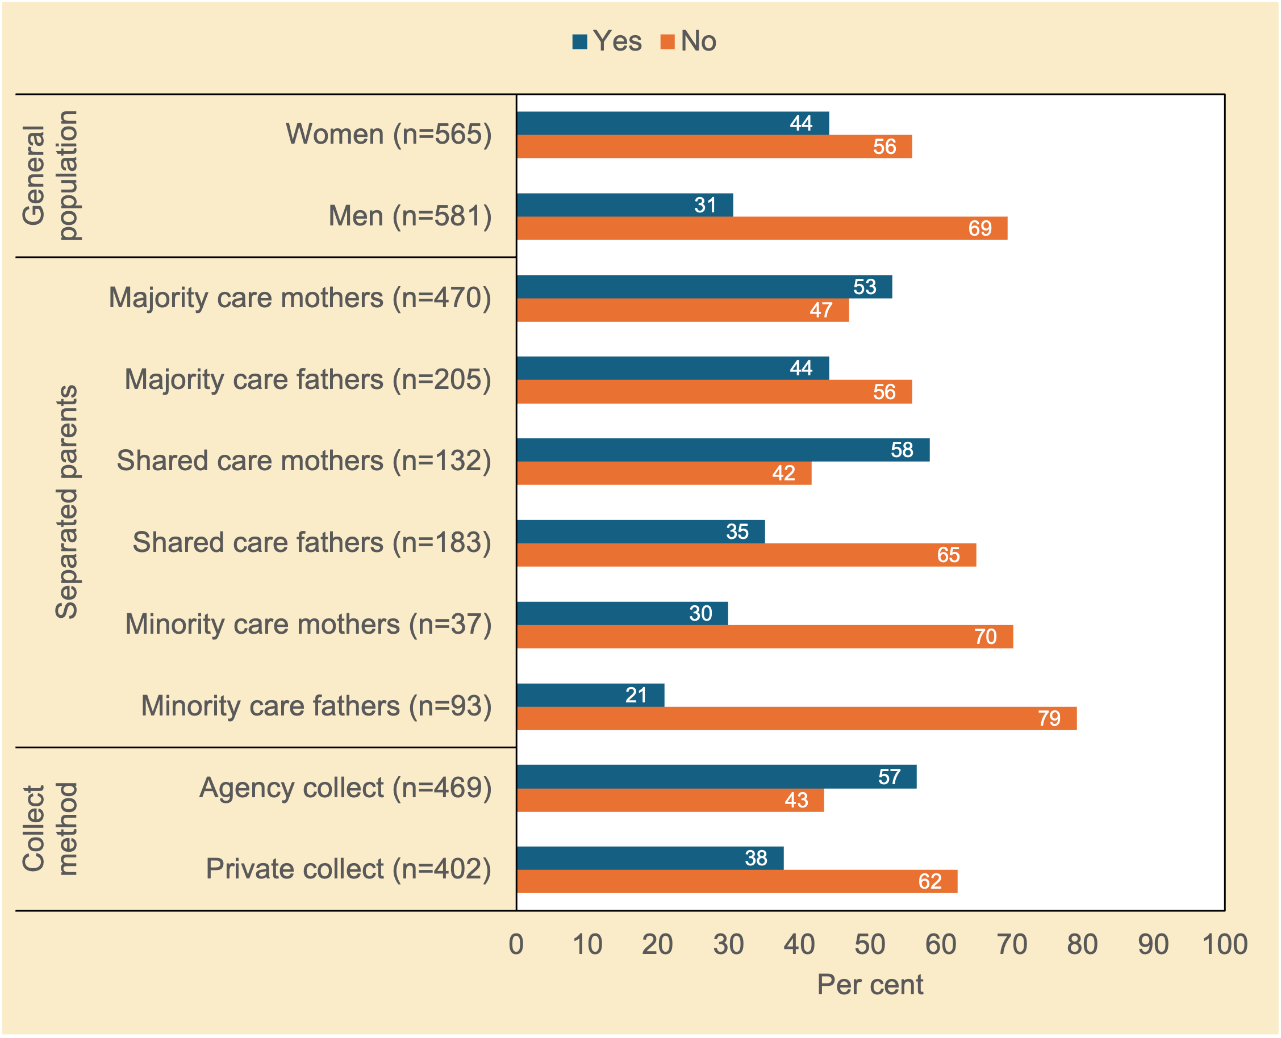
Note. n unweighted; % weighted; chi²(1)=22.30, p<.001 (general population); chi²(5)=53.72, p<.001 (separated parents); chi²(1)=30.68, p<.001 (method of collection of child support).
Source. Community Attitudes to Child Support Survey 2024

Once again, a gendered pattern of responses was evident. Men in the general population, as well as the three male separated father groups, were more likely than their female counterparts to believe payers should not have to pay child support if a paying parent is denied contact by the other parent. In addition, parents in Private Collect were also more likely than their Agency Collect counterparts to believe payers should not have to pay child support if a paying parent is denied contact by the receiving parent.

To what extent have attitudes changed since 2005?
Although the survey retained many of the original questions from the 2005 survey, the sampling strategy and data collection method were markedly different. Whereas the 2024 survey recruited participants from two online panels and used a self-administered online questionnaire, the 2004 survey was based on two probability samples: participants in the general population sample were randomly selected from the 2004 DtMS Electronic White Pages, which lists all Australian residential landline telephone numbers (Smyth & Weston, 2005, p. 11); the separated sample was drawn from the second wave of a prior study of post-separation parenting arrangements based on a probability sample. It also used computer-assisted telephone interviews. Another important difference is that the retained questions from the earlier study were changed from gender-specific language that referred to ‘resident mothers’ and ‘non-resident fathers’ to gender-neutral language that simply referred to ‘separated parents’. This allowed for a more diverse range of parenting roles to be reported, including mothers and fathers with shared care, and minority time mothers and majority time fathers.

Because our results are not directly comparable to the 2005 study for the reasons outlined above, changes over time are not systematically examined but some general observations are made about apparent changes in attitudes are made in section.

Awareness of the Scheme amongst the general population appears to be lower in 2024 than it was in 2005. The proportion of men and women who had neither heard of the Scheme nor any contact with the CSA have increased substantially.

Broadly speaking views about the how well the child support system is working are similar in 2024 to what they were in 2005. While a change to the response options for the survey question means that the results are not directly comparable, around half of majority care mothers (resident mothers in the 2005 survey) thought the system is working and about a half thought it was not working well and for minority care fathers around two-thirds in both 2005 and 2024 thought that the system was not working well. In both 2005 and 2024 around four-in-ten think that the system is fair for both parents and around seven-in-ten of minority care fathers that the system is not fair for both parents.

Focusing on views about some of the key principles/design features of the Scheme there are some changes in views and attitudes. There has been a fall in the proportion of the women in the general population, majority care mothers and minority care fathers in favour of a cap on the maximum amount of child support payable at high incomes between 2005 and 2024. No change is evident for men in the general population.

It appears that the proportion of the men and women in the general population and minority care fathers who think that the minimum amount of child support a parent should have to pay regardless of their income or the number of children they are supporting should be zero.

Gender differences in views about whether a parent should have to pay child support if they want contact with their children but the other parent is preventing it appears to have increased although it is important to bear in mind that the question wording change from referring to the father having to pay child support and the mother preventing contact in the 2005 survey to the gender neutral language of one parent and the other parent in 2025. Minority care fathers and men in the general population have become less likely to believe that fathers should still have to pay child support if denied contact by the other parent and majority care mothers more likely to believe that the parent should have to still pay child support if the other parent prevents contact with the children.

In relation to the question as to whether a paying parent should be able to pay less if they have another child with a new parent majority care mothers have become more likely to agree that the other parent should be able pay less child support for the children of their previous relationship.

Summary
A complex pattern of results emerged.

Perceptions of fairness: separated parents with minority care of children believed the child support system was not working well. They were also the most likely of the groups to see the system as unfair. Moreover, separated fathers were most likely to believe the child support system was unfair to them as payers, whereas sizeable proportions of separated mothers saw the system as being unfair to both parents.

The role of government: a substantial percentage of respondents thought child support should be a shared responsibility between parents and the State. There was little support for the idea that government should primarily be responsible for child support. In addition, most respondents believed that government payments should be able to be kept in full, or partly reduced by the total amount of child support received. Men and women in the general population sample, and mothers in the separated parent sample, thought that supporting children should be the main priority, whereas fairness seemed to matter most to separated fathers. This pattern contrasts an ethics of care with that of justice, acknowledging that both can co-exist and are not mutually exclusive (Gilligan, 1993).

Parental income and the capacity to pay child support: apart from mothers with minority care, respondents across all groups believed that child support should always be paid—even if a paying parent has little or no contact with a child, or if their earnings are very low or they only receive government income support. However, males in both samples were more likely than their female counterparts to believe payers should not have to pay child support if a paying parent is denied contact by the receiving parent (equity). In addition, females in both samples were more likely than their male counterparts to believe child support should continue if a receiving parent repartners—in contrast to fathers with shared or majority care. Moreover, there was solid support for the idea that if the paying parent has repartnered and has stepchildren to support, they should not then be allowed to pay less child support for the children of their previous relationship (adequacy and equity). Females held stronger views on this issue than males. Females in both samples were more likely than their male counterparts to believe payers should not be allowed to pay less for first family children if they have a new biological child.

Minimum and maximum payments: The survey question on the minimum amount of child support to be paid each year produced polarised amounts. Minority care parents (male and female) and shared care fathers supported having no minimum, whereas over half of majority care mothers would set the minimum annual rate at $50 or more per week. In addition, the idea that there should be a maximum amount of child support payable for high-income parents largely diverged along gender lines: males favoured a cap, whereas females were more equivocal (around half opposed a cap). Finally, the proposition that a parent with a 50/50 parenting arrangement who has a higher income than the other parent should still be required to pay child support was mostly supported by shared care mothers and majority time fathers; fathers with minority care were the group most opposed to this.
Number of children and prolonged dependence: There was solid support for the idea that child support should increase if there are more than three children. In addition, majority care mothers strongly supported financial help for young adult children if young adults were unemployed, had a disability, or were studying full-time. By contrast, minority care mothers and shared care fathers were the most likely of the separated parent groups to oppose ongoing support, regardless of the child’s situation.
Compliance and enforcement: The majority of respondents, apart from minority care fathers, believed that without government involvement, most parents would not pay child support. There was also strong support across all groups for the use of penalties for non-compliance.

4 Emerging issues
This chapter examines seven emerging issues for child support policy in Australia. It does so by presenting the results from a suite of new survey questions on: (a) the cost of raising children; (b) the requirement by social security for the receiving parent to take reasonable action to obtain child support (the ‘Maintenance Action Test’ [MAT]); (c) 50/50 shared care in the context of income disparities; (d) exemptions where family violence is a concern; (e) whether child support debt could be waived in some circumstances; (f) service delivery issues; and (g) the potential value of discussing child-related expenses in person or using an app during mediation soon after separation?

The cost of raising children

What child-related expenses are meant to be covered? What should be covered?
Table 4.1 examines which child-related expenses were thought to be intended as, or should be covered by, child support, apart from children’s food, housing, and clothes. These data sought to identify what should be included under the costs of the children and if any new—more contemporary—items (such as mobile phones) should be included.
Table 4.1 Apart from food, housing and clothes, what child-related expenses do you think child support payments are meant to/should cover? Attitudes of separated parents Attitudes of separated parents (%)
 | Separated Parents |  |  |  |  |  | Method of Collection
 | Majority care mothers (n=483)  % | Majority  care fathers (n=207)  % | Shared  care mothers (n=132)  % | Shared  care fathers (n=184)  % | Minority care mothers (n=37)  % | Minority  care fathers (n=94)  % | Agency collect (n=477)  % | Private collect (n=410)  %
Medical expenses
Meant to cover | 85 | 89 | 82 | 83 | 85 | 76 | 84 | 82
Should cover | 90 | 87 | 77 | 83 | 87 | 75 | 86 | 83
Dental expenses
Meant to cover | 82 | 81 | 75 | 81 | 80 | 74 | 80 | 78
Should cover | 90 | 87 | 77 | 80 | 85 | 69 | 86 | 80
After-school activities (music lessons, sports)
Meant to cover | 73 | 73 | 74 | 75 | 78 | 58 | 72 | 72
Should cover | 78 | 79 | 73 | 73 | 82 | 55 | 77 | 74
School books and materials
Meant to cover | 87 | 90 | 79 | 86 | 86 | 82 | 87 | 85
Should cover | 90 | 87 | 85 | 86 | 90 | 78 | 89 | 85
School events and excursions
Meant to cover | 79 | 83 | 80 | 82 | 85 | 78 | 82 | 78
Should cover | 87 | 82 | 80 | 81 | 85 | 74 | 85 | 81
Digital devices
Meant to cover | 56 | 62 | 69 | 62 | 59 | 44 | 60 | 57
Should cover | 63 | 66 | 71 | 60 | 66 | 41 | 66 | 59
Other expenses
Meant to cover | 43 | 35 | 36 | 41 | 40 | 35 | 40 | 41
Should cover | 41 | 35 | 30 | 29 | 28 | 24 | 38 | 36
Notes. n unweighted; % weighted; the question allowed respondents to choose multiple options; all response options were randomised to avoid potential order effects.
Source. Community Attitudes to Child Support Survey 2024

Table 4.1 shows that, apart from food, housing and clothes, medical and dental expenses and school books, and, to a slightly lesser extent, school events and extra-curricular activities were intended to be covered by child support. These items were favoured over digital devices and other generic expenses. Minority care fathers were generally less supportive of including digital devices and other generic expenses than other groups. Such items are likely to increase child support payments for this group.

Requirement to take reasonable action to obtain child support

Should a parent be required to apply for child support to receive benefits?
An individual is required to take reasonable maintenance action to obtain child support if they are entitled to apply for child support and Centrelink considers that it is reasonable that they should take this action. This requirement also applies to an individual’s current partner.44F

Table 4.1 presents respondents views about whether a parent should have to apply for child support to receive government payments towards the cost of raising children (e.g., Family Tax Benefit).
Figure 4.1 Should a parent have to apply for child support to receive government children-related payments (e.g., Family Tax Benefit)? Attitudes of women and men in the general population, and of separated parents (%)
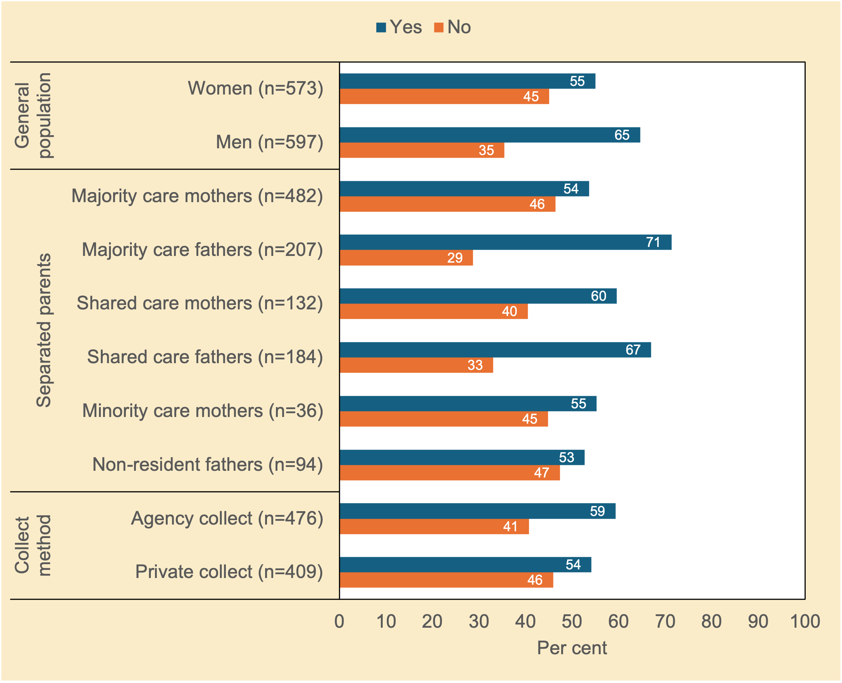
Note. n unweighted; % weighted; chi²(1)=11.27, p<.01 (general population); chi²(5)=25.27, p<.001 (separated parents); chi²(1)=2.42, p=0.132 (method of collection of child support).
Source. Community Attitudes to Child Support Survey 2024

There was a fair degree of support for the principle behind the Maintenance Action Test. That said, just under one-third to one-half were not supportive of the idea that a parent should have to apply for child support to receive government children-related payments—highlighting the complexity of this issue in relation to the public–private compact (range: 29%–47%).

Should a parent be required to apply for child support to get FTB even if they never lived with the other parent?
A more pronounced pattern emerged for the Maintenance Action Test scenario when parents had never lived together (Figure 4.2). Specifically, there was broad support by all population groups for the principle behind the Maintenance Action Test requirement. That said, around one-fifth to just over one-third of respondents nonetheless were not supportive of the Maintenance Action Test when parents had never lived together (range: 24%–36%). (It is worth reiterating here that the selection criteria for separated parents did not capture the views of those with a nil liability, were self-administration cases, or had no child support arrangements in place.)
Figure 4.2 If the parents have never lived together, should the parent who lives with the child be required to apply for child support from the other parent? Attitudes of women and men in the general population, and of separated parents (%)
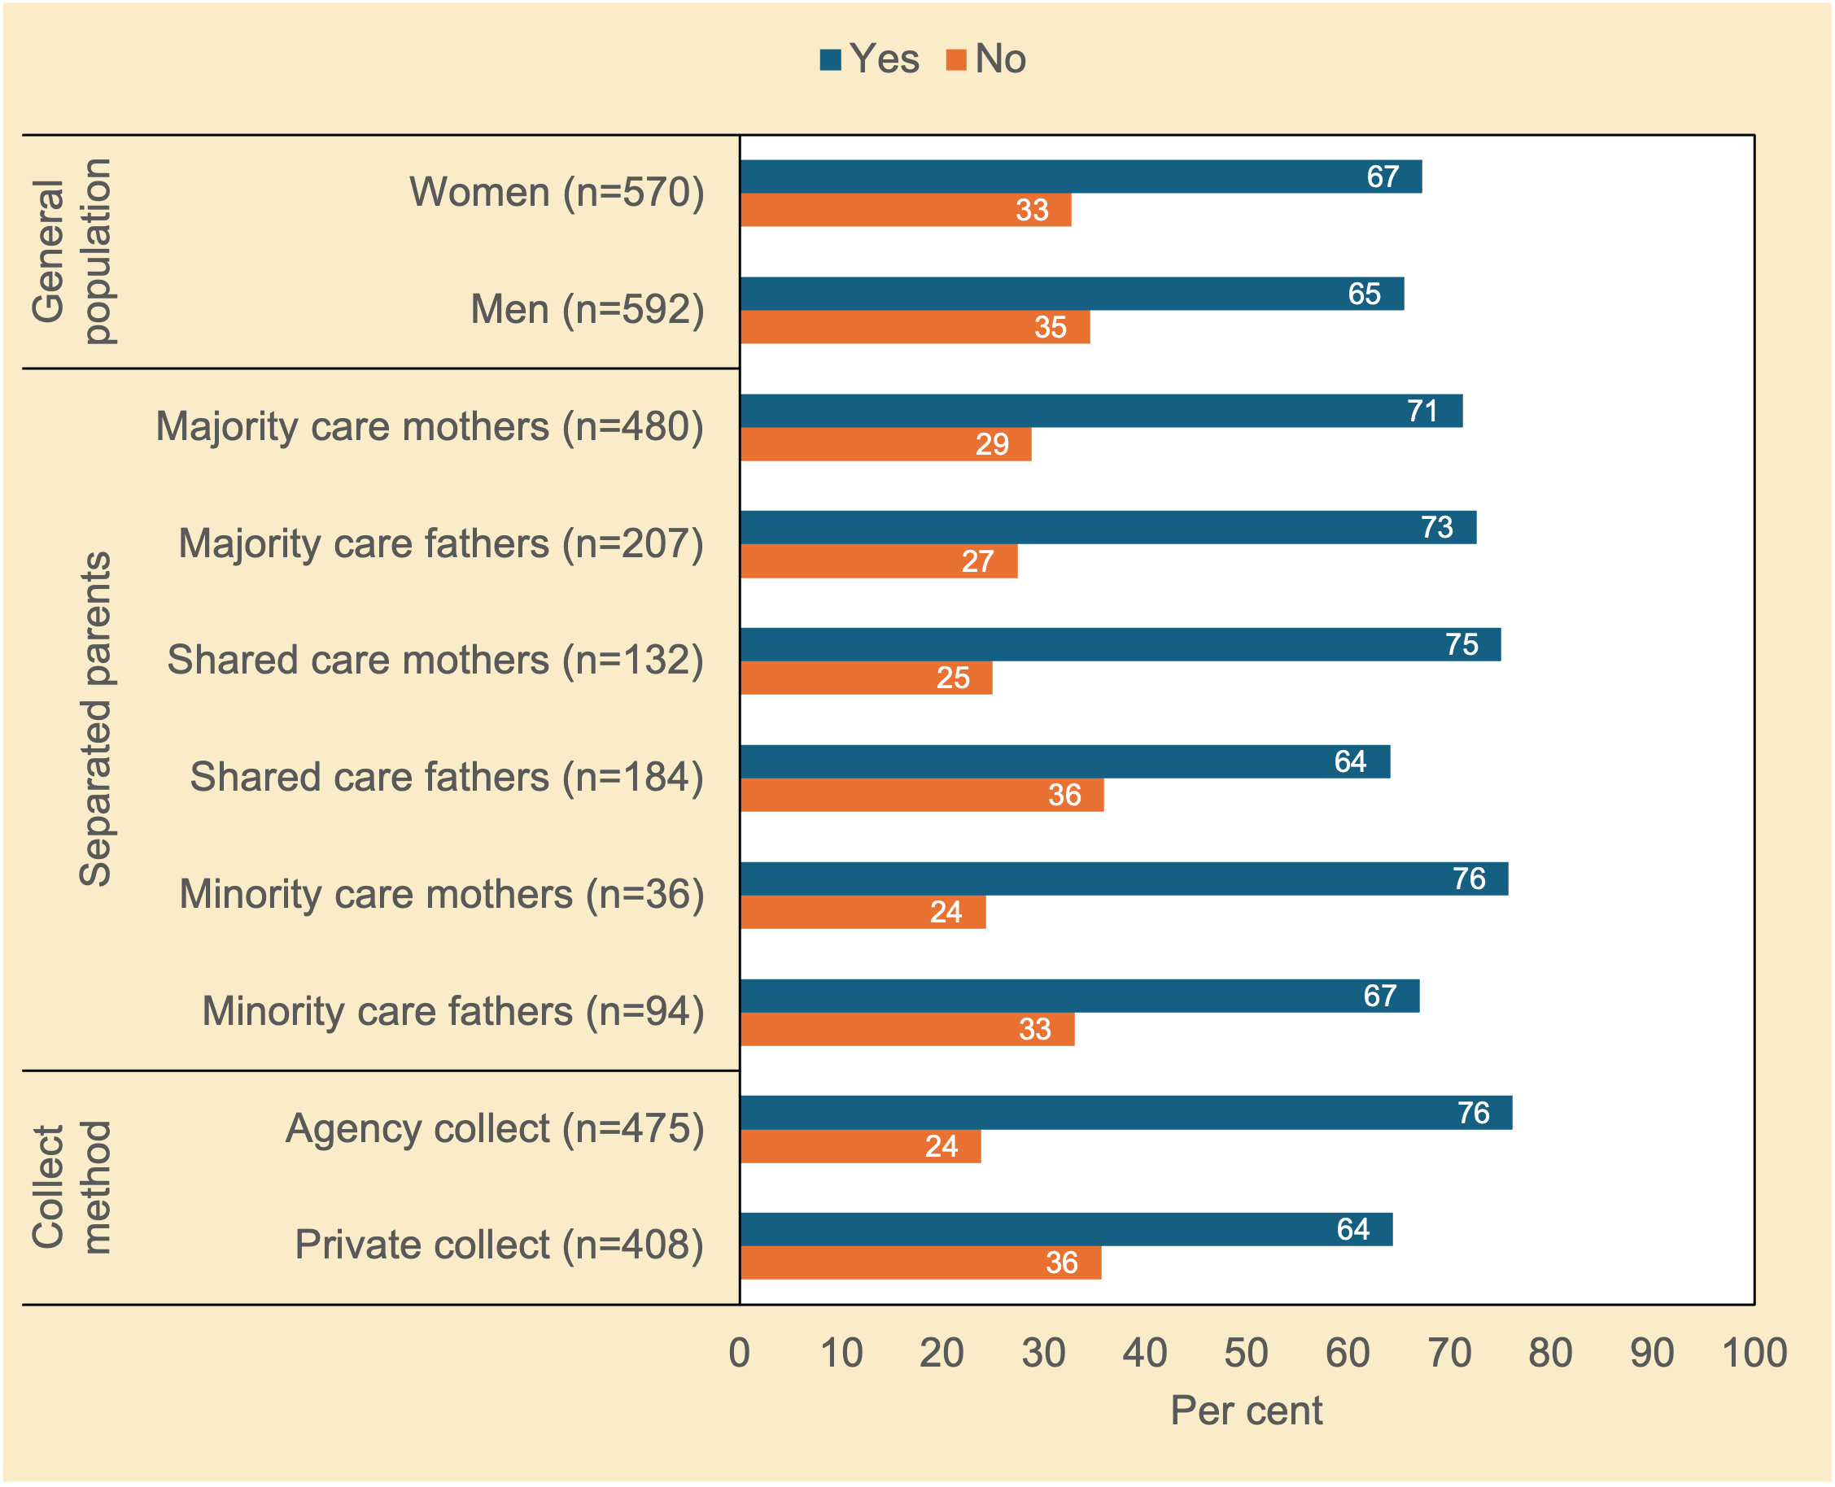
Notes. n unweighted; % weighted; chi²(1)=0.42, p=0.544 (general population); chi²(5)=6.51, p=0.297 (separated parents); chi²(1)=14.79, p<.001 (method of collection of child support).
Source. Community Attitudes to Child Support Survey 2024

Should the lower income parent in 50/50 shared care be able to not receive child support from the other parent?
Notwithstanding single person households, shared care post-separation is the fastest rising family form in many Western countries (see Hakovirta et al., 2023; Smyth, 2017). Child support policy has sought to deal with shared care arrangements in various ways (see, e.g., in the US context, Czapanskiy, 2015; O’Brien, 2021). Likewise, the sharing of care and money has played out in different ways on the ground (see e.g., Haapanen et al, 2023).

Figure 4.3 shows that there was solid support for the idea that a parent with a lower income in a 50/50 arrangement should be able to elect not to receive child support and still be eligible to receive government benefits. This suggests that many respondents in both samples believed that separated parents with a 50/50 arrangement should be able to come to their own arrangement for splitting costs regardless of whether one parent has greater resources than the other.

On the one hand, goodwill can go a long way in post-separation parenting. On the other hand, Ellman et al’s (2009b) ‘gross-disparity’ principle set out in Chapter 1 proposes that child support policy should seek to restrict the size of the gap in children’s living standards between homes. Moreover, Eekelaar’s (1988a, 1988b) ‘equity’ principle and Ellman et al’s (2009b) ‘dual-obligation’ principle are both also germane (see Chapter 1). Quick surveys are not well placed to capture subtle but important considerations for respondents.
Figure 4.3 For the purpose of receiving government benefits, should a parent with a 50/50 parenting arrangement be able to elect not to receive child support from the parent with the higher income? Attitudes of women and men in the general population, and of separated parents (%)
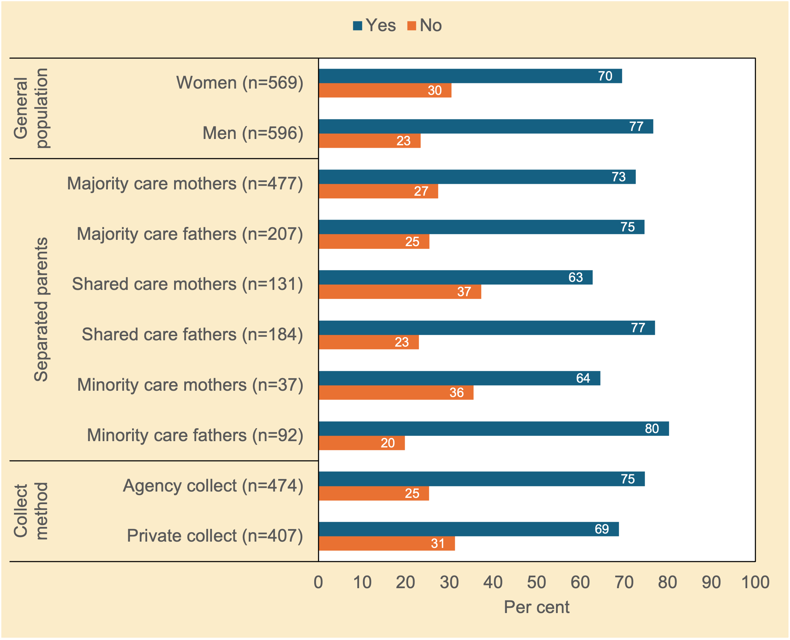
Notes. n unweighted; % weighted; chi²(1)=7.53, p<.05 (general population); chi²(5)=12.47, p<.05 (separated parents); chi²(1)=3.82, p<.1 (method of collection of child support).
Source. Community Attitudes to Child Support Survey 2024

Should a parent be exempt from applying for child support because of fear of violence?
Figure 4.445F shows that there was broad support—especially by the separated and non-separated female groups—for the idea that a parent should be exempt from applying for child support because of fear of violence. By contrast, minority care fathers were the least supportive of exemptions for family violence.
Figure 4.4 To what extent do you agree or disagree that parents who have a fear of violence (from the other parent) should be able to seek an exemption from applying for child support? Attitudes of women and men in the general population, and of separated parents (%)
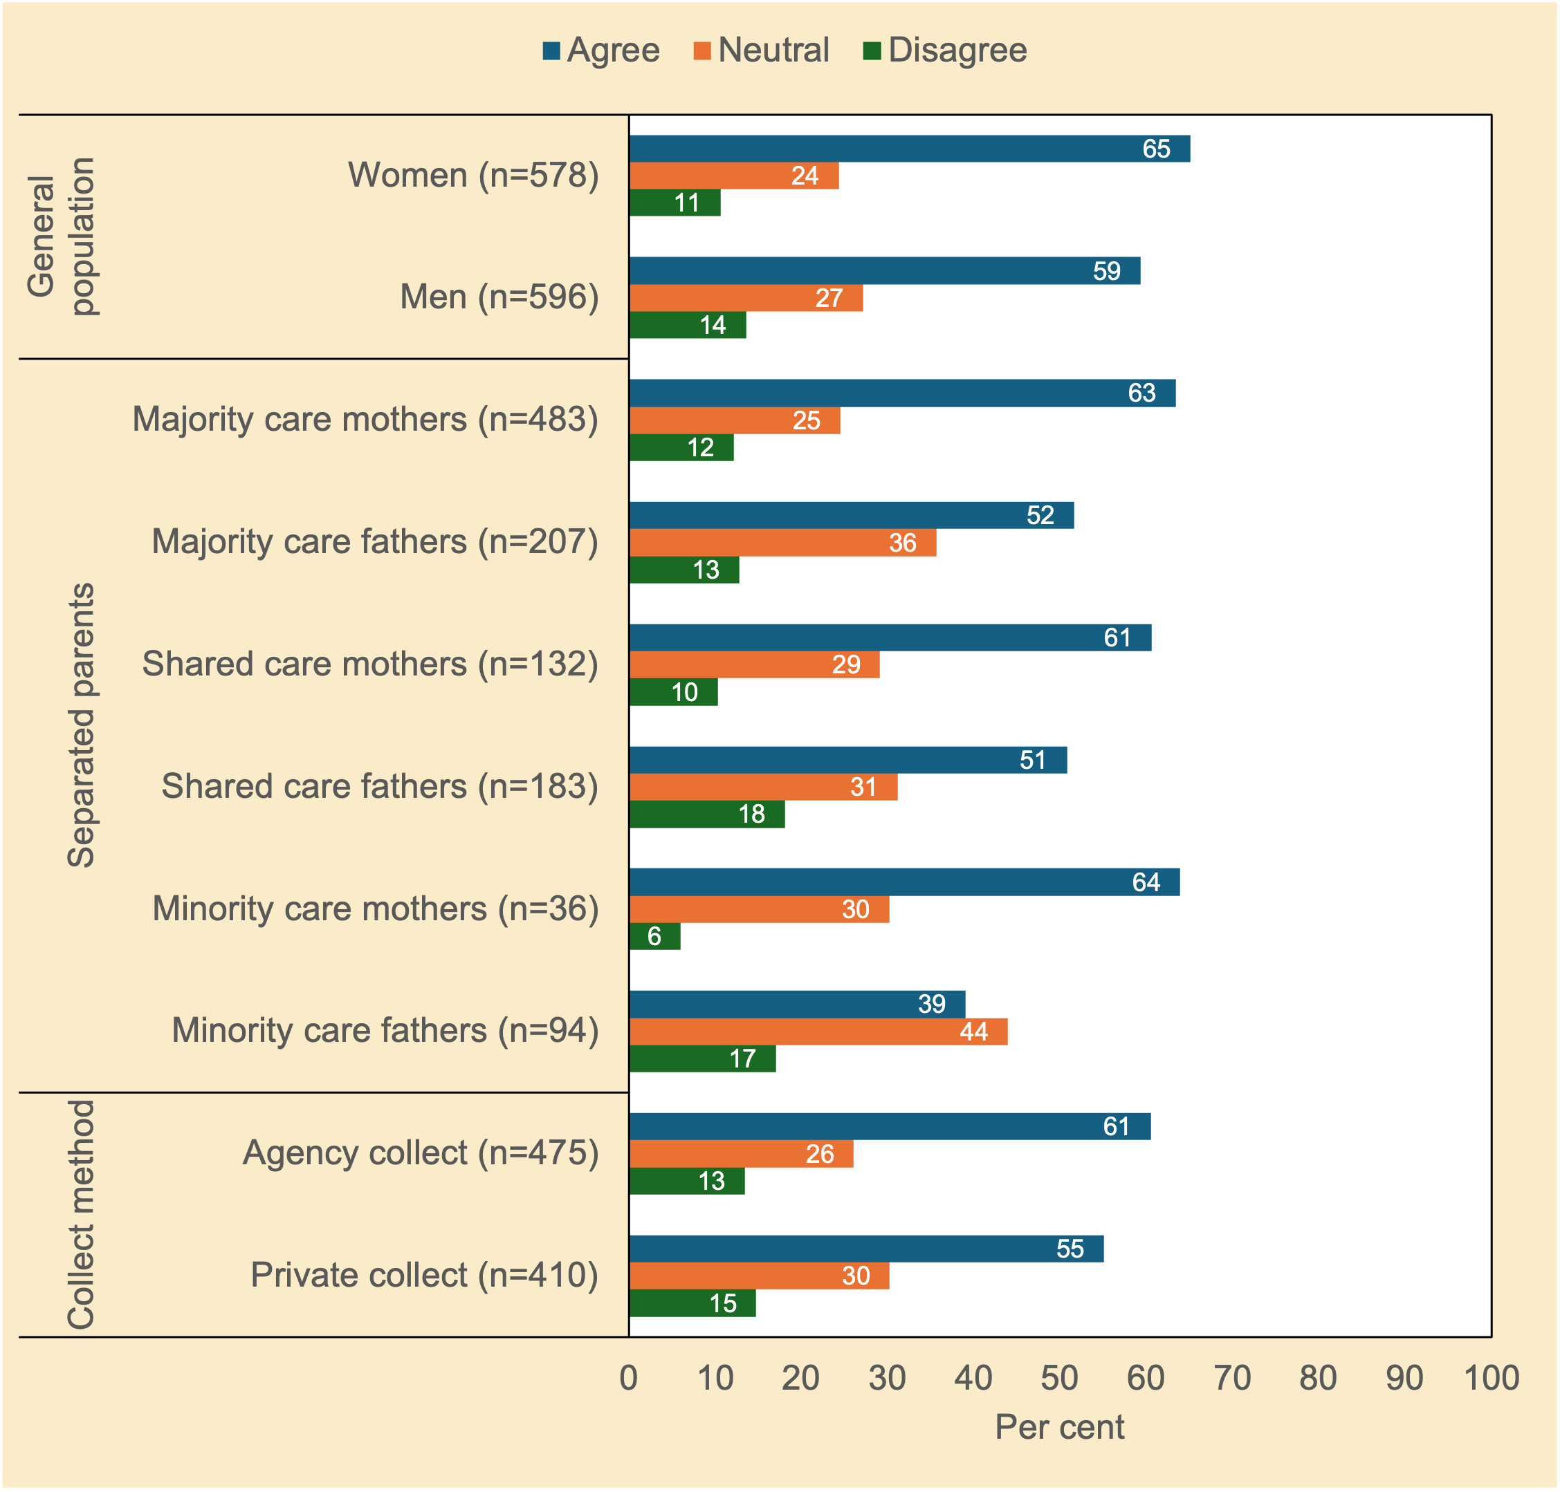
Notes. n unweighted; % weighted; chi²(2)=4.63, p=0.136 (general population); chi²(10)=32.09, p<.01 (separated parents); chi²(2)=2.75, p=0.278 (method of collection of child support).
Source. Community Attitudes to Child Support Survey 2024

Forgiving child support debt

Would you consider forgiving child support debt?
Table 4.2 shows the extent to which separated parents would consider forgiving a child support debt owed by the other parent if it ensured future child support payments, and if so, the size of that debt parents would be prepared to waiver.
Table 4.2 Would you consider forgiving a child support debt owed by the other parent if it ensured future child support payments? If yes, how much debt? Attitudes of majority care parents and of those in Private and Agency Collect (%)
 | Separated Parents |  | Method of Collection
 | Majority care mothers (n=458)  % | Majority care fathers (n=197)  % | Agency Collect (n=365)  % | Private Collect (n=313)  %
No, would not forgive a debt | 51 | 51 | 53 | 51
Yes, would forgive…
Less than $500 | 11 | 7 | 9 | 12
$500 to $999 | 10 | 5 | 9 | 10
$1,000to $1,499 | 13 | 13 | 12 | 10
$1,500 to $1,999 | 4 | 5 | 4 | 4
$2,000 or more | 11 | 18 | 13 | 13
Total | 100 | 100 | 100 | 100
Note. n unweighted; % weighted; chi²(5)=11.75, p<.05 (separated parents); chi²(5)=2.46, p=0.805 (method of collection of child support).
Source. Community Attitudes to Child Support Survey 2024

Around half of the majority care parents (mothers and fathers), and half of parents in the child support system (Private Collect and Agency Collect), would not forgive a debt (Table 4.2). From a ‘glass half full’ perspective this suggests that around half of respondents might if it ensured future payments.

While there was a relatively even spread across the range of debt sizes, majority care fathers were more likely than majority care mothers (18% vs 11%) to forgive a child support debt of over $2,000. This is likely to reflect the typically higher earning capacity of minority care fathers compared with their former partners (see Vnuk, 2017). That the majority care father group is likely to include parents with divided care or where care arrangements had changed during the life of their child support case might also reflect that some of the fathers had been the paying parent previously and therefore more generous about forgiving debt.

Involvement of Services Australia

Should Services Australia check payments that are transferred privately?
Figure 4.546F shows that there was generally strong support for the idea that Services Australia should check on compliance in Private Collect. This was less likely to be the case, however, for minority care fathers, with around one-third opposing the idea.

Support was lower in Private Collect than in Agency Collect. Females were more likely than males in each group to support Services Australia checking compliance among Private Collect cases (Private Collect: 51% vs 40%; Agency Collect: 68% vs 58%) (data not shown).

Figure 4.5 To what extent do you agree or disagree that if parents transfer money privately, the Child Support Agency (Services Australia) should check that child support has been paid in full? Attitudes of women and men in the general population, and of separated parents (%)
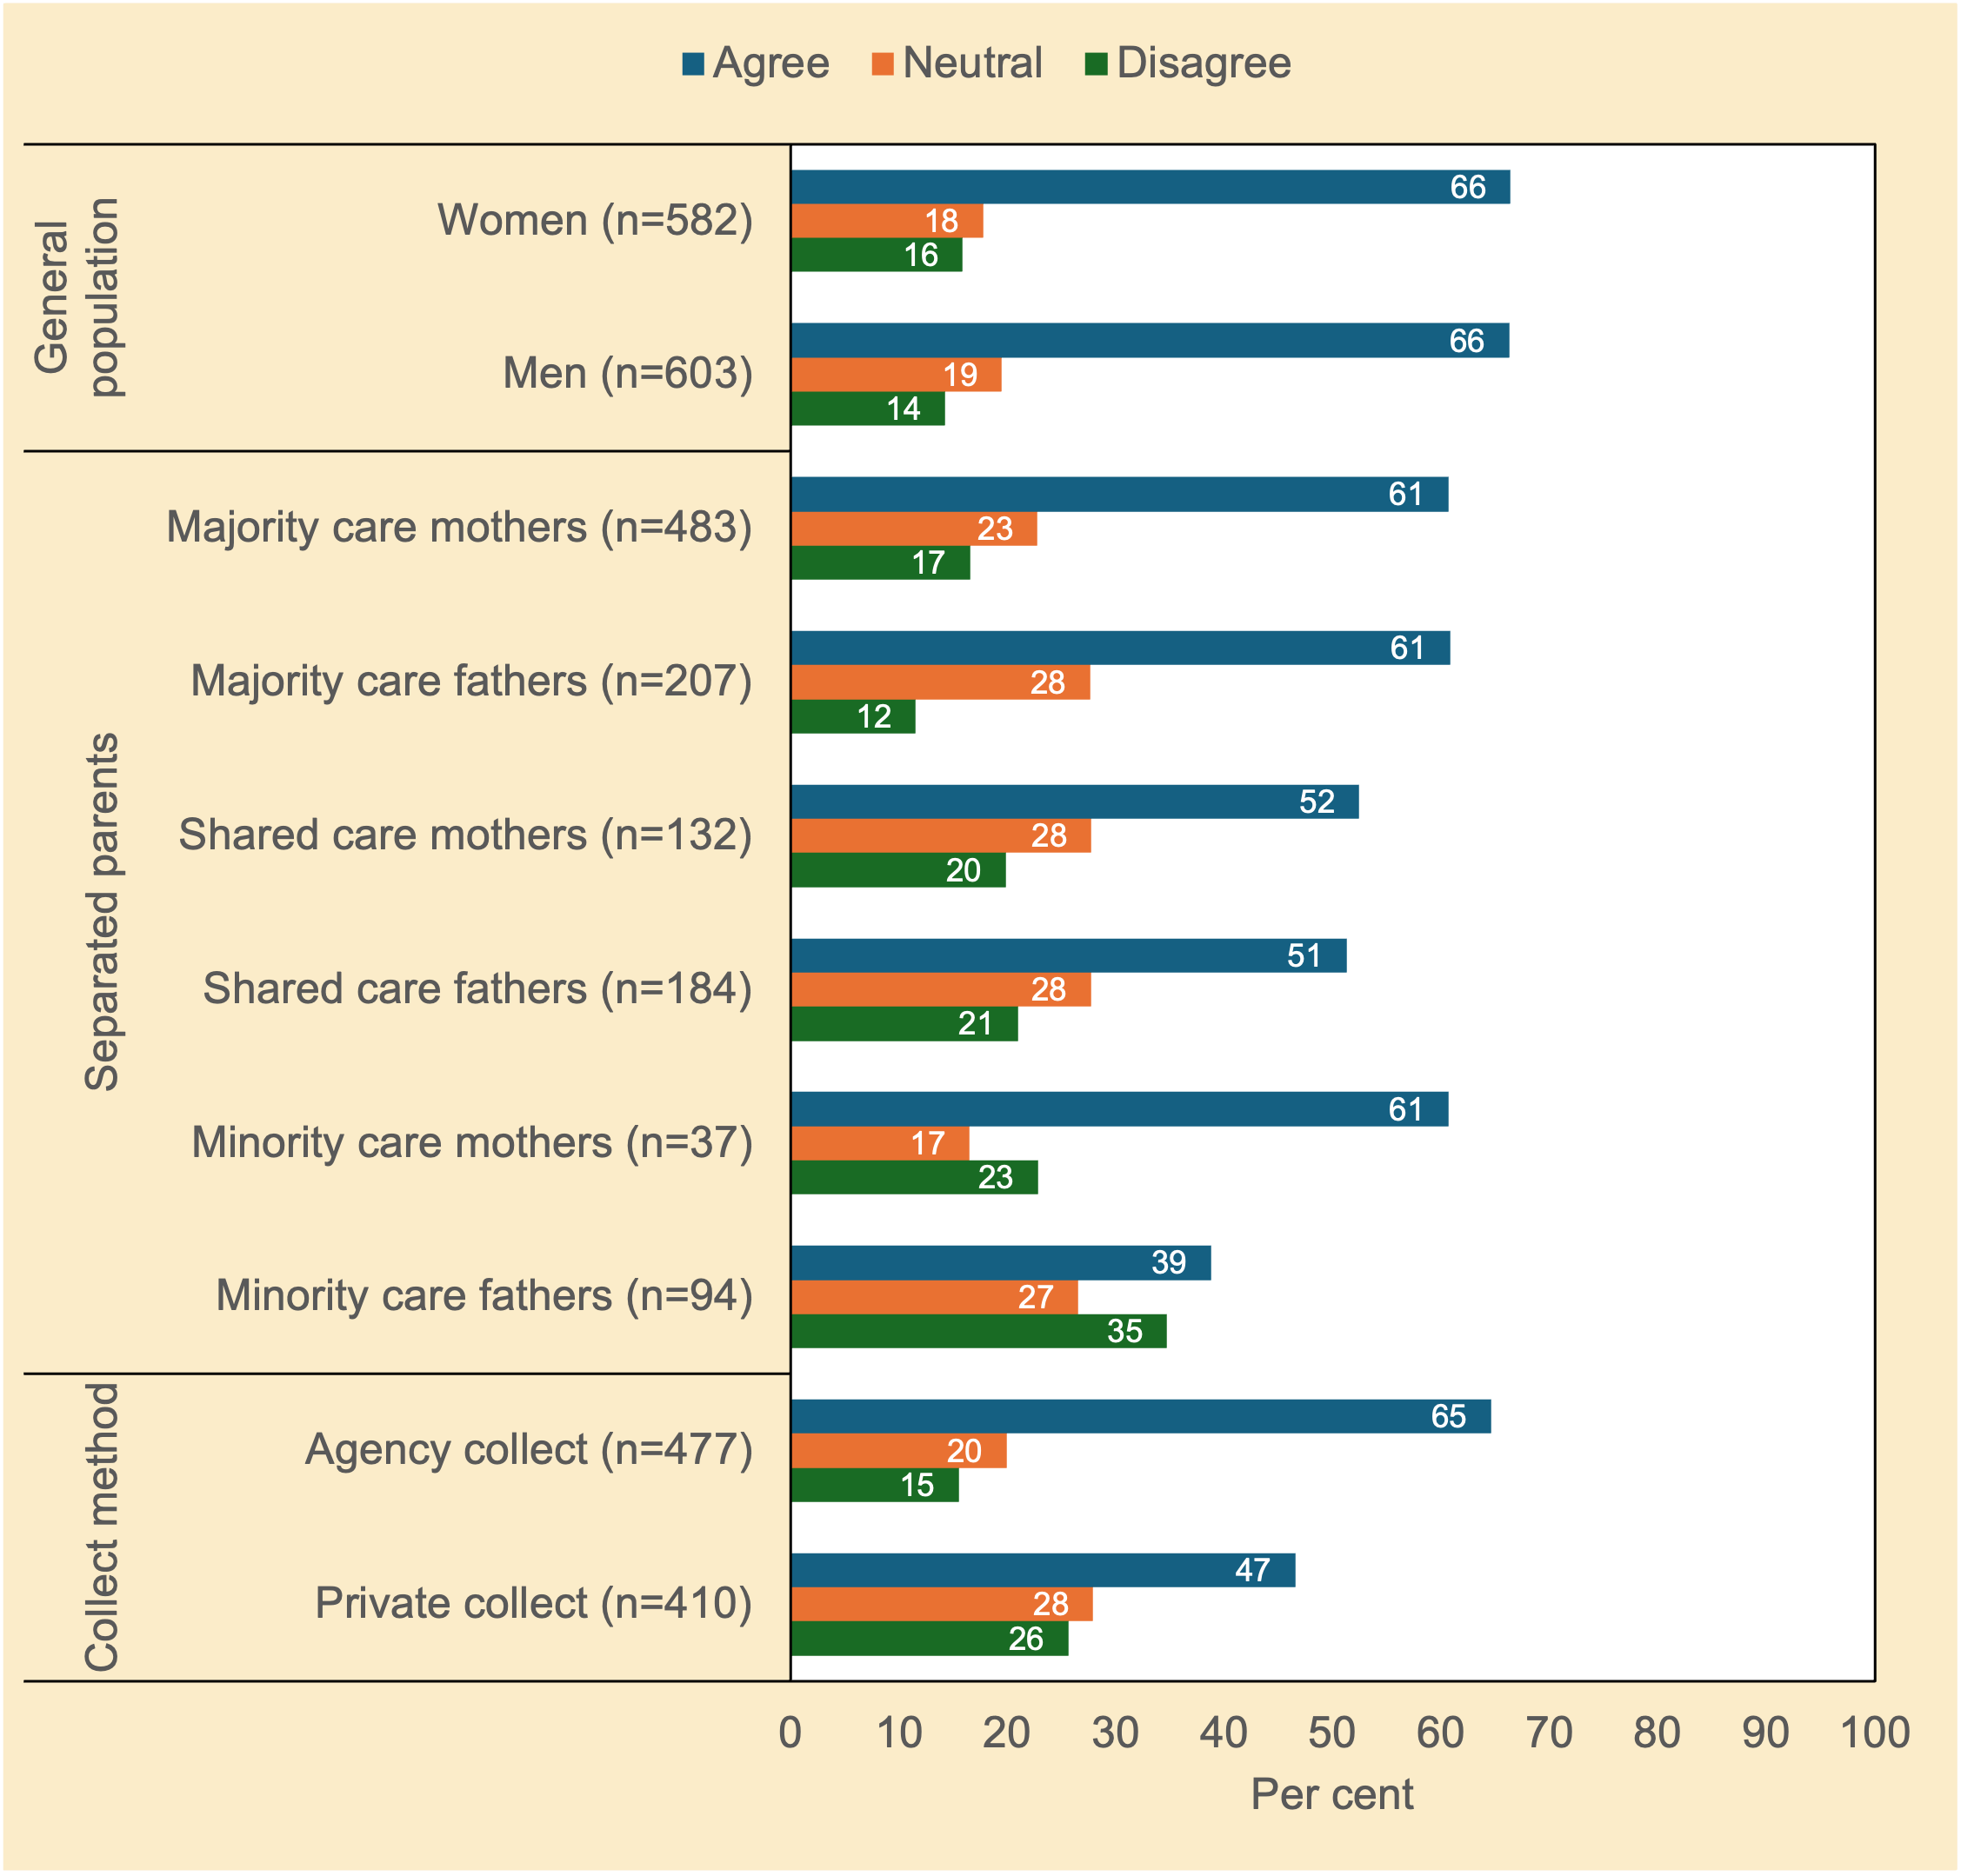
Notes. n unweighted; % weighted; chi²(2)=0.99, p=0.662 (general population); chi²(10)=33.41, p<.01 (separated parents); chi²(2)=29.87, p<.001 (method of collection of child support).
Source. Community Attitudes to Child Support Survey 2024

What is the most appropriate child support collection option for newly registered cases?
Table 4.6 examines which method of collection of child support seemed most appropriate for recently separated parents entering the child support system. Two response options were offered for Agency Collect: employer withholding, or payers pay direct to CSA; two response options were offered for Private Collect: private transfer of money between parents (e.g., cash or direct deposit), or money privately transferred via an app; a fifth response option was simply ‘other’ (responses included ‘direct to child’, and ‘depends on the circumstances’).
Figure 4.6 Which of the following child support collection options is most appropriate to be used for new parents entering the child support system: employer deducts portion from an employee’s wage, payment to Services Australia, private transfer, private transfer via app or other method? Attitudes of women and men in the general population, and of separated parents (%)
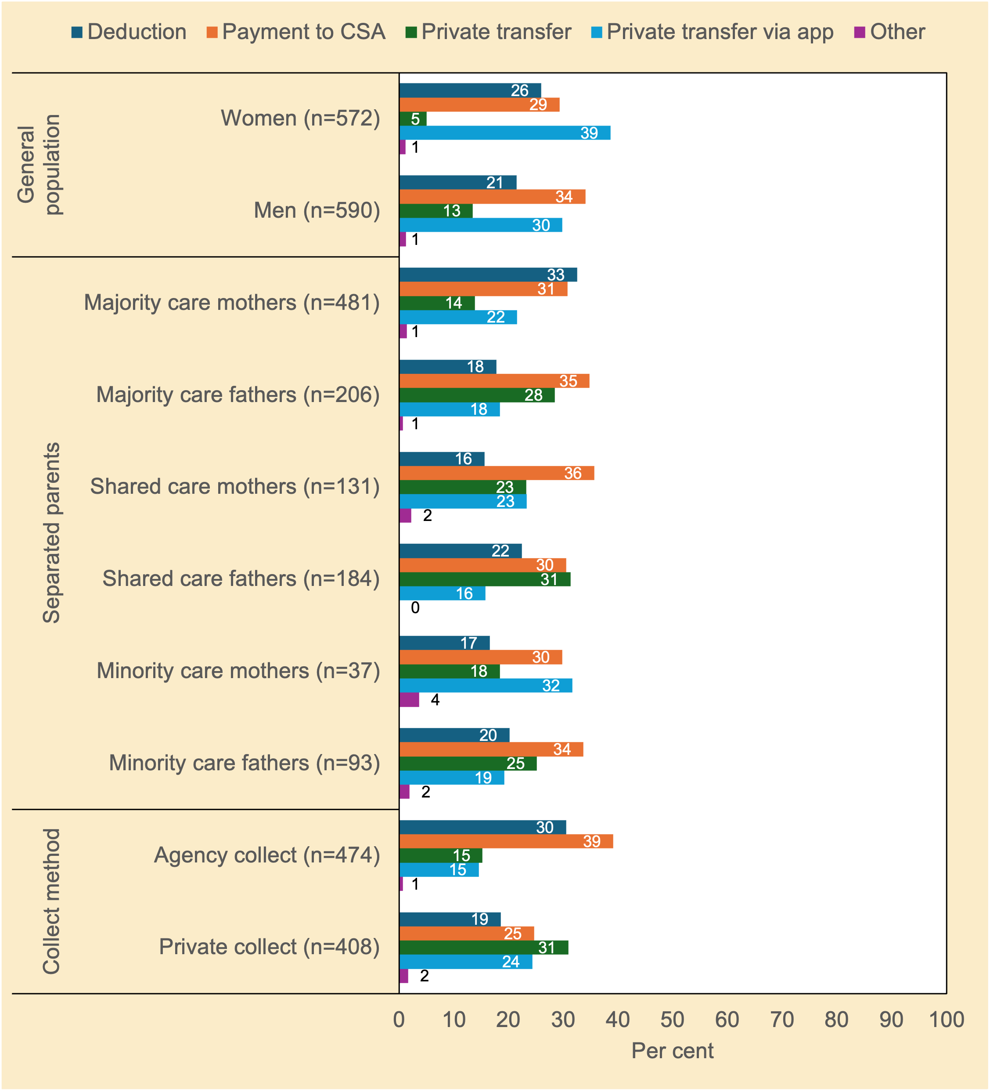
Notes. n unweighted; % weighted; chi²(4)=33.38, p<.001 (general population); chi²(20)=62.90, p<.001 (separated parents); chi²(4)=63.36, p<.001 (method of collection of child support).
Source. Community Attitudes to Child Support Survey 2024

A complex set of preferred collection methods emerged across the groups (Figure 4.6). For instance, among the general population sample, women believed direct payment via an app was the most appropriate method of collection of child support, followed by Agency Collect (including employer-withholding); their male counterparts had a similar set of preferences but favoured Agency Collect over the use of an app to transfer child support.

Majority care mothers favoured employer-withholding and Agency Collect whereas minority care fathers favoured Agency Collect followed by private transfer and employer-withholding. Not surprisingly, consistent with cognitive dissonance theory,47F those in Private Collect favoured private transfers whereas those in Agency Collect favoured Agency Collection.

Discussing child-related expenses during mediation
The question of whether child support falls within the Australian family law and dispute resolution systems is unclear—or at least certainly not well-defined. Many years ago, Moloney and colleagues (2010) asked: ‘where can separating parents go to get help to talk with each other about child support?’. They argued that some families, notably those who get along and communicate with low levels of conflict, would benefit from facilitated joint discussions about workable financial solutions to sharing child-related expenses—solutions that may fall outside the administrative assessment guidelines, especially given that what is intended as child support is not specified. Figure 4.7 explores this.
Figure 4.7 To what extent do you agree or disagree that recently separated parents who get along should have the opportunity (provided by the government) to talk to a mediator about child support and child-related expenses in general? Attitudes of women and men in the general population, and of separated parents (%)
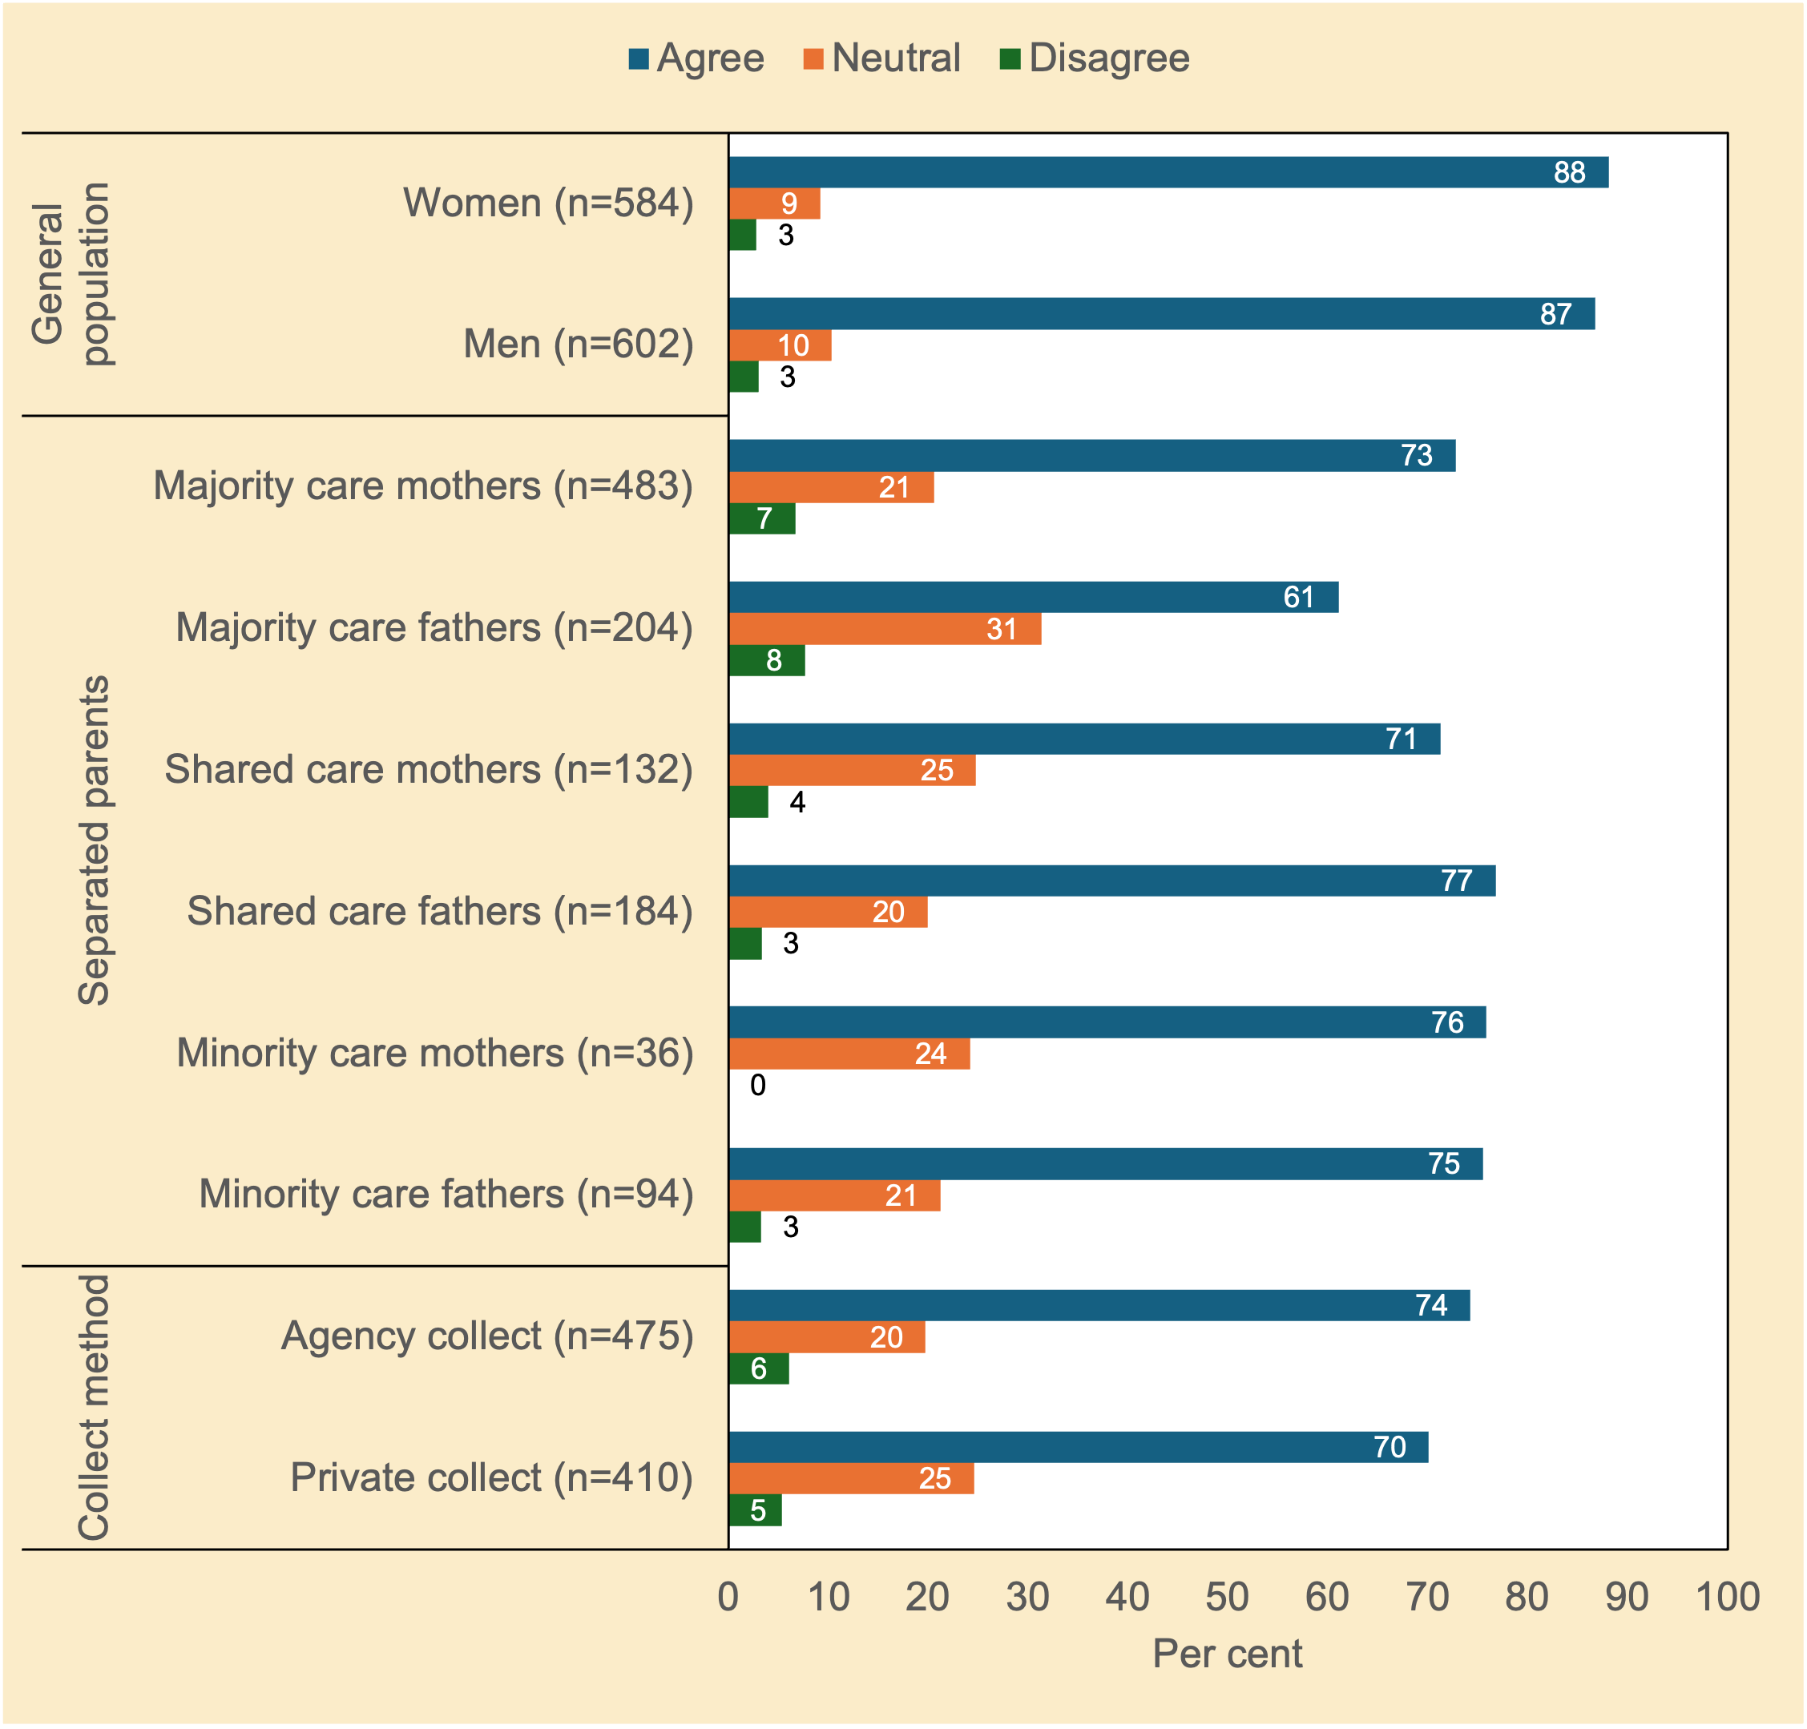
Note. n unweighted; % weighted; chi²(4)=33.38, p<.001 (general population); chi²(20)=62.90, p<.001 (separated parents); chi²(4)=63.36, p<.001 (method of collection of child support).
Source. Community Attitudes to Child Support Survey 2024

The question of whether child support falls within the Australian family law and dispute resolution systems is unclear—or at least certainly not well-defined. Many years ago, Moloney and colleagues (2010) asked: ‘where can separating parents go to get help to talk with each other about child support?’. They argued that some families, notably those who get along and communicate with low levels of conflict, would benefit from facilitated joint discussions about workable financial solutions to sharing child-related expenses—solutions that may fall outside the administrative assessment guidelines, especially given that what is intended as child support is not specified. Figure 4.7 explores this.
Figure 4.748F shows that there was strong support for the idea that separated parents should have the opportunity to be able to discuss child-related expenses during mediation.

Who would you ask about child support?
Table 4.3 shows that most respondents were inclined to seek information from Services Australia, followed by a family member or friend, followed by child support advocates or a family law professional. The potential for misinformation from family, friends or advocates runs the risk of escalating disputes over money.
Table 4.3 If you had a question about child support, who would you ask? Attitudes of separated parents (%)
 | Separated Parents |  |  |  |  |  | Method of Collection
 | Majority care mothers (n=483)  % | Majority care fathers (n=207)  % | Shared care mothers (n=132)  % | Shared care fathers (n=184)  % | Minority care mothers (n=37)  % | Minority care fathers (n=94)  % | Agency Collect (n=477)  % | Private Collect (n=410)  %
Services Australia | 83 | 75 | 79 | 79 | 84 | 72 | 87 | 76
Family or a friend | 48 | 53 | 54 | 41 | 47 | 45 | 48 | 46
Facebook or social media group | 28 | 30 | 29 | 15 | 15 | 11 | 31 | 18
Community Organisations | 25 | 39 | 31 | 21 | 19 | 29 | 31 | 24
Child Support Advocates | 42 | 43 | 44 | 31 | 28 | 41 | 45 | 33
Community leader | 17 | 26 | 28 | 16 | 8 | 11 | 24 | 15
Legal aid/Family Law practitioner | 45 | 47 | 45 | 41 | 41 | 48 | 47 | 41
Other | 8 | 12 | 6 | 9 | 15 | 11 | 9 | 11
Note. n unweighted; % weighted; the question allowed respondents to choose multiple options;; chi²(20)=62.90, p<.001 (separated parents); chi²(4)=63.36, p<.001 (method of collection of child support).
Source. Community Attitudes to Child Support Survey 2024

Summary
Participants’ responses to surveys questions addressing some of the emerging policy issues were far more straight-forward than those examined in the prior chapter about the broad principles of the Scheme.

There was generally solid support for the idea that:
- separated parents should have the opportunity to be able to discuss child-related expenses during mediation;
- apart from food, housing and clothes, medical and dental expenses and school books, and, to a slightly lesser extent, school events and extra-curricular activities were intended to be covered by child support. These items were favoured over digital devices and other generic expenses;
- a parent should be required to apply for child support to receive government benefits (such as Family Tax Benefit), especially if parents had never lived together;
- parent should be exempt from applying for child support because of fear of violence;
- Services Australia should check on compliance in Private Collect; and
- a parent with a lower income in a 50/50 arrangement should be able to elect not to receive child support and still be eligible to receive government benefits.

Further, most separated parents in the study were inclined to seek information about child support from Services Australia, followed by a family member or friend.

But not all the attitudes were as clear cut. Regarding the method of collection of child support, for instance, majority care mothers favoured the use of employer-withholding and Agency Collect, while minority care fathers preferred Agency Collect, then private transfers and employer-withholding. More broadly, women in the general population reported preferring the use of an app for child support payments, followed by Agency Collect, while men appeared to prefer the use of private transfers over an app.

5 Parents’ reasons for transferring child support privately

Introduction
This chapter explores the main reason that parents, either with majority or shared care, chose to transfer child support privately instead of using Services Australia.49F Why focus on this group?

As noted, in most cases, child support is determined by administrative assessment. By contrast, collection and disbursement involves a roughly 50/50 split between cases in which the government collects and transfers child support (Agency Collect—that is, state-enforced transfers), and cases in which parents make their own arrangements for the transfer of child support (Private Collect—that is, self-enforced transfers) (51% vs. 49%, respectively). A third—albeit small but likely growing—group self-administer their child support.50F This group does not have an administrative assessment and make decisions about child support with no Government involvement. Parents who report private arrangements for the purposes of this survey includes both Private Collect cases and potentially those who self-administer their child support arrangements privately.

In Private Collect, Services Australia issues periodic assessment notices but does not keep records of what payments have been made or any arrears—that is, it assumes full compliance. The practical implication of this assumption for families is that Family Tax Benefit (FTB) is paid on the expected amount, unlike in Agency Collect cases where additional FTB can be paid if child support payments do not occur or are not made in full. The issue of compliance among Private Collect cases has been an ongoing concern because the make-up and dynamics within this group represent somewhat of a ‘black box’. While many parents who can cooperate and communicate with low levels of conflict are likely to opt to transfer child support privately between each other, other dynamics within this group may also be at play (e.g., promotion of goodwill for the sake of children; a lack of trust of government; and/or coercive control and financial abuse).

Data corpus
As shown in Table 2.1 in Chapter 2, the Private Collect sample comprised 410 respondents (180 male, 228 female, 2 non-binary). However, only those with majority care or shared care (n=364: 144 male, 218 female, 2 non-binary) were asked the question (PE10): ‘What’s the main reason that child support payments are transferred privately—and not through the CSA (now Services Australia)?’ (emphasis in original). Of these, 44 respondents (21 female, 22 male, 1 non-binary) preferred not to respond, while another 21 respondents (12 male, 9 female) provided responses that were indeterminate (e.g., ‘not qualified’; ‘Thanks’). Thus, the final useable sample comprised 275 individual responses.

Analytic approach
The 275 qualitative responses were interpreted using a version of reflexive thematic analysis (Braun & Clarke, 2019). This analytic approach involved one of the research team (in this case Smyth) engaging with the data, and moving back and forth between coding and theme development in several iterations, refining the analysis after each iteration.

Reflexive thematic analysis involves constructing themes that best represent the complexity of the data. No attempt was made to fit the data to any pre-existing theoretical framework or coding scheme—i.e., the approach was primarily inductive. The key themes are set out below and interpreted referencing the respondent's own words. Our choice of quotes seeks to capture the essence of each theme and to honour respondents' diverse points of view. Although we offer the number of related comments within each theme to show how common or rare certain views or experiences were among respondents, primacy should be given to the insights offered by the quotes.

Results
Table 5.1 presents the main reason that child support payments were transferred privately between parents, as reported by survey respondents with children in their care for the majority of time or shared care (68% female; 31% male; 0.4% non-binary).
Table 5.1 What’s the main reason that child support payments are transferred privately—and not through the CSA (now Services Australia)? Main response by parents in Private Collect with majority or shared care by gender (%)
 | Female |  | Male |  | Non-binary |  | All
Response Theme | n | % | n | % | n | % | n | %
Cooperative arrangement / private agreement | 73 | 39 | 33 | 38 | 1 | – | 107 | 39
Easier / Simpler / Faster / More convenient | 25 | 13 | 19 | 22 | 0 | – | 44 | 16
Not sure why in Private Collect | 21 | 11 | 18 | 21 | 0 | – | 39 | 14
Other | 25 | 14 | 4 | 5 | 0 | – | 29 | 11
Avoid conflict with the other parent | 17 | 9 | 2 | 2 | 0 | – | 19 | 7
Prefer to avoid dealing with Services Australia | 11 | 6 | 7 | 8 | 0 | – | 18 | 7
Family violence / Coercive control | 9 | 5 | 1 | 1 | 0 | – | 10 | 4
Not given option of Agency Collect | 7 | 4 | 2 | 2 | 0 | – | 9 | 3
Total | 188 | 100 | 86 | 100 | 1 | – | 275 | 100
Notes. * = ‘Other’ responses comprised varied reasons, but these could not be readily coded into any existing categories.
Source. Community Attitudes to Child Support Survey 2024

‘Cooperative arrangement / private agreement’ was the most common main reason given for transferring child support privately (39%: n=107/275 [n=91/107, n=16/107 respectively, data not shown]), followed by the belief that private transfers between parents was easier, simpler, faster, and more convenient (16%: n=44/275).

As several mothers remarked:
[The] father and I have a good relationship and continue to work together as parents … to keep things friendly and civil. (Female, shared care, friendly relationship, survey #492)
My ex-partner and I have always been on good terms and can fairly work payments out without any bother. (Female, majority care, friendly relationship, survey #1858)
Because that’s how we want to do it. We are friends. (Female, shared care, friendly relationship, survey #983)
My ex-partner and I get on well and I trust that he will do the right thing by our child. (Female, majority care, friendly relationship, survey #5093)
The flavour of the above comments typifies many of the parents’ reasons for the use of private transfers. A strong parental alliance and interparental cooperation featured in many of the other comments related to the mutual agreement theme. Private transfers are the ideal method in these cases. As noted by the Ministerial Taskforce (2005), ‘[i]t is a fundamental axiom of family law that the best arrangements are those that the parties negotiate for themselves (p. 207).

In some cases, Private Collect enabled some flexibility in payments whereby some payers paid more than their liability, while others paid less than required—or nothing at all:
Both parents are amicable and have agreed to an amount which is more than what Services Australia recommends. (Female, shared care, friendly relationship, survey #245)
I am understanding that his circumstances regularly change and that he cannot always pay on that exact day, but he always pays, and it is what works for us. (Female, majority care, cooperative relationship, survey #308)
Because my child’s mother is on low income while I’m on high income and I don’t need child support. That extra money comes in handy for her, and if I applied to receive through Services Australia they would force her to pay. (Male, majority care, distant relationship, survey #2693)
I actually don’t want his money. We have an agreement, but he doesn’t pay, and I don’t complain. (Female, majority care, cooperative relationship, survey #881)
Still others (n=44/275: 16%) believed private collection was easier, simpler, and more convenient:
Too much administrative hassle. We get on OK and came to a mutual agreement. (Female, majority care, friendly relationship, survey #5143)
Ex-husband was willing to pay, and thought it was easier to manage this ourselves. He has been very responsible with this side of things. (Female, majority care, cooperative relationship, survey #5568)
I thought it would be easier between us both without having an agency [CSA] as I’m not sure he would agree to that as we find this way a lot simpler and easier. (Female, majority care, cooperative relationship, survey #5872)
It is easier and allows us to adjust according to changes in income in a more timely manner, instead of waiting for tax time. (Female, shared care, cooperative relationship, survey #910)
[We’re] [s]till living in the same house and [it’s] too hard to work out split expenses so private [transfers] was the easiest. (Male, shared care, cooperative relationship, survey #4413)
A small group of respondents (n=18/275: 7%) were clear that they wanted to avoid dealing with Services Australia for a range of reasons:
CSA are awful to deal with. They initiate conflict and don’t take into account individual circumstances. They are NOT fair. My ex and I have a mature relationship where we have agreed to a private collection and the amount. We both HATE CSA. (Male, shared care, cooperative relationship, survey #466)
They are hopeless and rarely helpful. (Female, majority care, cooperative relationship, survey #3318)
Was afraid to involve Services Australia. (Female, majority care, distant relationship, survey #4315)
[I] [h]ad difficult speaking to CSA. Had difficulty not wanting to have issues with ex-partner so instead of going through CSA, if there’s something my child needs, we email [each other] or at times have gone through mediation instead. (Female, majority care, friendly relationship, survey #26)
I don’t want to have to lose payments because CSA keeps in arrears, and I wouldn’t cope financially with that. (Female, majority care, lots of conflict, survey #21)
It is unclear if any of these separated parents had private arrangements because we asked for the main (ie., single) reason, and answers were typically very brief.

Moreover, some parents in this group (n=7/18: 4 female, 3 male) avoided Services Australia primarily to protect their privacy:
Have recently cancelled the assessment so that my income remains private. (Female, majority care, cooperative relationship, survey #1724)
We don’t need supervision and middlemen. (Female, majority care, cooperative relationship, survey #3818)
It’s private matter. (Female, majority care, friendly relationship, survey #6005)
None of their business. (Male, shared care, distant relationship, survey #6978)
To keep the information safe. (Male, majority care, cooperative relationship, survey #7092)
And in a small number of cases (n=9/275: 7 female, 2 male), some respondents alluded to private transfers as being the default option offered. For four female respondents:
‘[It was] [t]he only way I could’. (Survey #3407, #3674, #3679, #221).
Other mothers with majority care responded:
It was suggested to my ex- to set it up that way. They tell him the amount and then he transfers it each fortnight. (Female, majority care, distant relationship, survey #4614)
[That was] [j]ust how it was setup. (Female, majority care, cooperative relationship, survey #5426)
In stark contrast to the use of private transfers reached by mutual agreement, a small group of majority care parents (9 mothers, and 1 father) appeared to be coerced into private collection:
Because he got very aggressive when I organised it to be collected through Services Australia and I was very scared. (Female, majority care, fearful relationship, survey #41)
I have always been fearful of him and any repercussions that would occur if I requested CSA collect the money. (Female, shared care, cooperative relationship, survey #7110)
[I had] [n]ot asked for anything as he was violent in the past and I had a VRO [Violence Restraining Order]. (Female, cooperative relationship, survey #6935)
[I’m] scared of ex-husband. [He] pays a lot less than he is supposed to. (Female, majority care, cooperative relationship, survey #7176)
It is noteworthy that 14 (5%) of the 275 respondents in this analysis reported a ‘fearful’ relationship. Disclosure of family violence or abuse is a sensitive and complex process, as individuals may fear repercussions, feel shame, or face barriers to reporting, such as concerns about safety, legal consequences, or lack of support. As noted by Chisholm (2009, p. 51),

[t]there are factors that tend to inhibit victims of violence from disclosing it at all. When it is disclosed, understanding what is involved may be no easy task—family violence takes many forms, and it is easy to miss, or misunderstand, what is going on. Most obviously, even when family violence is disclosed and understood, the task of responding appropriately to it can present very difficult choices.

That said, as maintained by Chisholm (2009, p. 6), ‘[a] theme that recurred during the Review was that family violence must be disclosed, understood, and acted upon’. It may also need more than a single attempt to identify once trust has been established. Our survey did not seek to elicit disclosures of family violence or abuse for reasons of research ethics such that any disclosures were unsought or expected.

There were also those parents (n=19/275: 7%; 16 mothers, 2 fathers) with Private Collect arrangements who sought to avoid any interparental conflict for their and their children’s wellbeing:
Because I thought we should leave the CSA alone for the cases that are very difficult. My partner of 10 years left me when I was 30 weeks pregnant, but I have (a great personal cost) always tried to put the best interest of my daughter first, which means trying my best to keep the contact with her dad free from conflict (it’s not about me, it’s about my daughter). (Female, majority care, cooperative relationship, survey #298)
Because I couldn’t be bothered to set it up [Agency Collect] over such a small amount of money, and the dad would just make life harder. (Female, majority care, distant relationship, survey #6720)
Don’t want the arguments. I find that this way the father has no say in anything. (Female, majority care, distant relationship, survey #1013)
To try and reduce conflict with the children’s father. (Female, majority care, friendly relationship, survey #764)
Because I don’t care if I receive child support regularly from the [other[ parent or not and I am happy to have my family payments adjusted as if I was receiving child support because I just cannot cope with the aggravation. (Female, majority care, relationship quality not stated, survey #1897)
Keeping the parenting relationship co-operative to have less effect on the child. (Male, shared care, cooperative relationship, survey #3347)
I don’t want to apply for child support because one—I don’t need it financially, and 2—I don’t want to rely on it & have that ‘dependency’ work against me in future. (Female, majority care, cooperative relationship, survey #3806)
It was not always clear from the very brief responses whether coercion was at play. For instance, it was unclear whether responses such as: ‘ex-wanted it that way’ (female, survey #58); ‘ex-husband insisted’ (female, survey #75); ‘he wanted to go privately’ (female, survey #93) reflected one parent’s preference or a unilateral decision involving some duress.

Twenty-nine responses were coded as ‘other’. These comprised a diverse range of responses that did not fall neatly into the above themes. For example:
That was how we set it up originally although I wish I had of set it up via CSA. (Female, majority care, lots of conflict, survey #917)
We chose to do so when we separated. I shouldn’t have because he hasn’t paid what he is supposed to have paid. (Female, majority care, distant relationship, survey #5249)
I tried to cease child support when I was the receiver of payments. My ex-declared he earned lower income and it was reset to him, [and] now back to me but I don’t want to bother with the process again. (Female, shared care, lots of conflict, survey #5078)
He fled to overseas to avoid child support. (Female, majority care, fearful relationship, survey #646)
Father not on birth certificate. (Female, majority care, lots of conflict, survey #3074)
Finally, a small but sizeable group (n=39/275: 14%; 11 female, 21 male) stated that they were unsure why they had private collect arrangements.

Data limitations
Although the above responses were drawn from a national random sample, no weights could be applied given the nature of the data. These data thus may not reflect the frequency of responses from the general population of child support payees in the Private Collect group.

Summary
Several key themes emerged from the main reason that respondents transferred child support privately. A ‘cooperative arrangement / private agreement’ was the most common reason given (39%), with many of these respondents reporting a cooperative co-parental relationship, cooperating to ensure fairness, ease in managing payments, and being child-focussed. Another group (16%) chose private transfers because they found it simpler, faster, and more convenient than going through formal bureaucratic processes. Some parents appreciated the flexibility that private transfers offered, with arrangements allowing for adjustments in payment amounts based on income changes or agreements between parents. Other respondents (7%) preferred to avoid Services Australia altogether, citing dissatisfaction or concerns about fairness, with some wanting to protect their privacy and avoid the complications that might arise from involving a formal agency. Still other respondents (7%) opted for private transfers to minimize interparental conflict, stating that avoiding disputes was in the best interest of the child.
A small group of respondents (n=9/275) explicitly indicated that private transfers were chosen due to a fear of violence from the other parent. These parents appeared to feel coerced into accepting private arrangements to avoid potential aggression or repercussions. That said, family violence, coercive control around money, and financial abuse are likely to be under-reported in this context as is the case in general.
The preceding qualitative data suggest that the reasons for transferring child support privately are very varied and highlight the motivational complexity of those who use this method of collection of child support.

6 Improving the Child Support System and changes to the scheme

Introduction
This chapter summarises key aspects of the Australian child support system that study respondents wanted to see changed.51F The qualitative data below, as with the previous chapter, help to put a human face on the bald numbers presented earlier.

Respondents were asked: ‘Finally, is there anything that you’d like to see changed about the Child Support Scheme as it currently stands? What is the MAIN change you would make?’.52F In total, 438 respondents (277 female, 161 male) from the separated parent sample provided suggestions.

Analytic approach
One of the research team (Smyth) initially developed the higher order codes on the first pass of the data corpus. To reduce the possibility of researcher bias, gender bias or both, two female subject matter experts checked the initial codes, refined them, added new codes, and then coded respondent's responses independently. Discrepancies in the coding were then resolved by Smyth in discussion with both subject matter experts until there was unanimous agreement. Key themes are presented below in a narrative format, supported by direct quotes to give the flavour of each theme.

Key themes
For brevity, we focus on four areas that attracted comments from respondents about what needed to be changed with the system: (a) administrative formulaic assessment; (b) child support compliance and enforcement; (c) service delivery issues; and (d) family violence, including financial abuse

Perceptions of fairness
The overarching theme of ‘fairness’ cut across one-third (n=145/438) of the respondent's suggestions for change. For instance, females with majority care were mindful of issues such as the ‘cost of living crisis’ in the context of raising children, multi-family situations, asymmetric access by one parent (generally payers) to time and resources, and non-compliance. As noted by mothers with majority care, change is needed with regard to:
Fairness for both parents, especially with multiple-children cases to different partners. (Female, majority care, cooperative relationship, survey #655)
Making parents accountable to help with raising, and the rising costs of, children. (Female, majority care, lots of conflict, survey #3019)
A fairer system. The children are 16 and 17 and their father only pays me $55.20 per week. I have to cover all of their school, dental, medical, clothing etc. I do not earn that much more than him, so it seems very unfair. (Female, majority care, distant relationship, survey #1150)
While some fathers with minority care suggested that the assessment of child support could be fairer (see below), at least one father prioritized goodwill over fairness to avoid potential conflict over parenting time:
[Child support payments need] to be fairer as I pay over the expected amount plus all school fees, uniforms, extra food, etc just to keep things easier with my ex-. If I didn’t, [it] would make time with the child harder to arrange with the other parent. (Male, minority care, distant relationship, survey #370)
On the flip side, some receiving parents took less child support out of fear:
I had difficulty through private payment that he did not pay the required amount—only what suited him. My only option was to receive nothing. I came from a DV background and was scared that he would take the kids away or make life more difficult. I often try and keep the peace. (Female, majority care, cooperative relationship, survey #1194)
The rise of shared-time arrangements in Australia has recently brought the issue of shared costs in these arrangements to the fore. Some fathers with shared care believed the amount of child support they paid was unfair given the shared parenting arrangement:
We share the 3 kids 50/50 but just because my income is higher, I have to pay a massive amount of child support. I still have expenses to pay for looking after the kids. Child support should be calculated based on time first, and income second. (Male, shared care, cooperative relationship, survey #4413)
My ex-was able to take an easier job paying 40% less than her old job and subsequently my child support payments increased dramatically, which has crippled me financially. This is completely unfair and should be considered when calculating child support. (Male, shared care, cooperative relationship, survey #427)
Others believed that equal-time parenting should not involve a child support liability at all:
Parents should not have to pay when there is a 50/50 or 60/40 shared care arrangement regardless of income. (Female, majority care, lots of conflict, survey #3094)
If the parents are in a 50/50 agreement, no money should change hands regardless of each household’s income. (Male, shared care, lots of conflict, survey #981)
50/50 care should mean no payments. (Male, shared care, distant relationship, survey #53)
50/50 [parenting arrangement should mean] no child support! (Female, majority care, cooperative relationship, survey #6957)
If 50/50 care arrangements, no child support [should be] payable. (Female, majority care, friendly relationship, survey #3870)
A decade or so ago, Smyth and Rodgers (2011) reported that men’s groups tended to assert that mothers were refusing children’s overnight stays with fathers to get more child support and government benefits while women’s groups tended to assert that fathers wanted more time with their children to reduce their child support payments (i.e., that strategic bargaining over parenting time and child support was occurring). But the idea that some parents were trying to ‘game’ the system was hardly mentioned in the present study. For example:
Some parents manipulate their children[‘s living arrangements] to get the other parent to pay them more, as in my case. (Female, minority care, lots of conflict, survey #839)
I want my children more, but the mother refuses and those lost times reflect on my child support payments. (Male, minority care, lots of conflict, survey #882)
If a receiving parent denies the other parent access to the child, they should not be allowed to claim more child support because their care percentage has increased. (Female, majority care, friendly relationship, survey #1100)
Far more prevalent was the suggested change to the Scheme that denial of parent–child contact should result in nil liability (i.e., the so-called ‘I pay–I see’ relation). This issue was raised by fathers, mothers, majority care parents, minority care parents, and shared care parents. For instance, a number of mothers with the majority care suggested:
Dads shouldn’t have to pay if the other parent refuses contact. (Female, majority care, friendly relationship, survey #2795)
If a parent refuses access for no reason, no child support should be paid. (Female, majority care, lots of conflict, survey #3318)
If parents are not getting access to their kids, they should not be made to pay child support. (Female, majority care, friendly relationship, survey #1858)
If the paying parent wants contact with the children, he or she should not pay if the other parent denies [it]. (Female, majority care, distant relationship, survey #4838)
Some mothers with majority care qualified their responses:
If the primary parent is withholding children from the other parent without good reason, the other parent should not have to pay child support. (Female, majority care, lots of conflict, survey #3453)
If a parent stops the other parent from seeing the child, the other parent should not have to pay unless it was for a valid reason such as a Violence Restraining Order etc. (Female, majority care, distant relationship, survey #6935)
Fathers and mothers with minority care also supported the ‘no see-no pay’ nexus:
I have to pay child support for children I’m obstructed from seeing through circumstance and a bitter ex-partner who has made my life hell for the last nine years. (Male, minority care, lots of conflict, survey #1714)
If a parent is prevented from seeing their children, they should not have to pay child support. (Female, minority care, distant relationship, survey #97)
I’d like contact with my children and if it’s not granted, I’d rather not pay. (Male, minority care, distant relationship, survey #2327)
If a child is being withheld from the other parent, then that parent should not have to pay child support. It is not fair. (Female, minority care, lots of conflict, survey #940)
Shared care parents (male and female) held a similar view:
No [child support] payment to those who defy court orders about access to children. (Male, shared care, friendly relationship, survey #5331)
All payments suspended permanently if one party refuses access, plus substantial fines for this behaviour (Male, shared care, distant relationship, survey #3728)
If the other parent withholds access, then they should receive zero parenting payment. (Male, shared care, distant relationship, survey #783)
Not forcing parents who have no contact with their kids as a result of alienation to pay child support. (Male, minority care, lots of conflict, survey #3931)
Finally, some separated parents suggested a reduced rate of payment rather than zero payments if parent–child contact is denied:
Less payments if children withheld. (Male, minority care, lots of conflict, survey #1180)
… if the paying parent does not see the child/children due to parent alienation, they should not have to pay the full child support amount until the parent alienation ceases. (Female, shared care, cooperative relationship, survey #5727)
Reduce debt for paying parent on high income that is prevented from seeing children. (Male, majority care, fearful relationship, survey #687)
There should be a reduced rate if the paying parent has no contact with the child/ren. (Female, minority care, lots of conflict, survey #2101)
One of the axioms of the original Scheme is that no contingent link should ever be made between child support payments and parent–child contact because such a link is unlikely to be in children’s best interests (Joint Select Committee on Family Law Issues, 1994). Non-payment of child support, moreover, is likely to mean that one parents will be responsible for child-related expenses, and it is well-known that persistent poverty is one of the key factors most likely to lead to poor child outcomes (Pryor & Rodgers, 1998; Schaffer, 1998).

Relatedly, one father alluded to two well-known economics principles in the child support literature: the ‘free-rider’ principle (which, in the post-separation parenting context, refers to the situation where one parent tries to shift the costs of raising a child on to the other parent), and the ‘monitoring’ problem (i.e., that payers that have little or no visibility or control on how child support is spent) (see e.g., Willis, 2004, p. 48):
… Check how money is spent on the receiving parent. Check the parent who doesn’t want to work to receive child support. (Male, shared care, friendly relationship, survey #2976)
The monitoring problem was also mentioned by other separated fathers with shared care:
More openness by the receiving parent on what the money is being spent on. (Male, shared care, distant relationship, survey #748)
The other parent should be required to show proof that ALL of the money is going towards the child. (Male, shared care, lots of conflict, survey #7159)
Making sure my money for child support goes directly to benefit my children not my ex who is using it selfishly for herself. (Male, shared care, lots of conflict, survey #4029)
Other respondents (male and female) seemed to suggest that a return to a court-based discretionary system would be fairer than the current administrative system based on formulaic assessment:
Each case should be looked at individually as to what is fair rather than a blanket calculation. (Female, majority care, friendly relationship, survey #1100)
Make it fairer on a case-by-case basis. (Male, majority care, distant relationship, survey #4868)
Also mentioned were the old chestnut issues of the inclusion of a new partner’s income in the assessment; parent–child contact denial; income minimisation by self-employed parents; and the non-lodgement of tax returns:
[It should be] [f]air for both parents. If my ex-partner has been living together with [an]other guy who earns good wages, my child support payments should be reduced. (Male, shared care, cooperative relationship, survey #2279)
A complete overhaul [of the system] to make it fair for both parents—not just the mother. If the primary parent is withholding children from the other parent without good reason, the other parent should not have to pay child support. (Female, majority care, cooperative relationship, survey #3453)
Be fair and proactive in checking and assessing correctly of parents with own business who choose to receive little salary from their own company to avoid child support
Currently it’s completely unfair. (Female, majority care, lots of conflict, survey #2841)
[I]f one party is being paid cash-in-hand or not completing tax returns, there is NOTHING that the Child Support Agency can do. [It is] [t]erribly unfair for the other parent. (Female, majority care, distant relationship, survey #805)
Many of the above comments about improving perceptions of fairness related to the way in which child support is currently assessed, an issue to which we now turn.

Administering the formula: Assessment
The Assessment of Child Support theme covered eight subdimensions comprising beliefs that: (a) paying parents were paying too much in child support (according to paying parents); (b) receiving parents were receiving too little child support (according to receiving parents); (c) child support should be calculated differently; (d) assessment should include a new partner’s income (according to paying parents); assessment should not include a new partner’s income (according to receiving parents); (e) no child support should be paid when 50/50 arrangements are occurring; (f) the minimum child support amount should be higher; and (g) too much information about each parent’s circumstances is shared between parents.

Specifically, some paying parents (mostly fathers) believed they were paying too much:
The system is biased and weighted toward the receiving parent. The payment is too excessive. (Male, shared care, lots of conflict, survey #4556)
I just think I pay too much, I was paying $33k cash for two children + half of school fees, sporting memberships and other ‘extras’ my ex-partner requests. … I just don’t think it’s fair. (Male, minority care, cooperative relationship, survey #2108)
In marked contrast, some receiving parents (mostly mothers) believed the child support amount did not reflect the cost of raising children:
Make the payments realistic, stop paying parents from cheating the system, currently get $134/month from paying parent which pays for next to nothing for my child. (Female, majority care, distant relationship, survey #7251)
$ 41 dollars a month for a 12 and a 14 year old is ridiculous. [This] [d]oes not cover their lunch orders once a week. (Female, majority care, fearful relationship, survey #4891)
I have two kids and only get $18 a fortnight in total for both kids. My boys are worth $9 each a week? (Female, majority care, lots of conflict, survey #279)
The amount that my child’s father has been paying is too low. He has no care of the child and has plenty of money to spend on himself and overseas holidays. (Female, majority care, cooperative relationship, survey #5049)
Relatedly, some receiving parents believed that the minimum annual rate of payment was too low:
Increase in payments, even if the partner who pays child support is on Centrelink benefits. (Female, majority care, lots of conflict, survey #630)
When on government benefits, the paying parent should still have to pay $50 a fortnight. (Female, majority care, distant relationship, survey #615)
The minimum payment is way too low. This needs to change. (Female, majority care, friendly relationship, survey #4141)
Not surprisingly given the above suggestions for change, some respondents (mothers and fathers) believed the method of assessment should be calculated differently:
The calculation of payments should be in line with the cost of living. (Female, majority care, lots of conflict, survey #6109)
Child support payments [should be] based on yearly base rate salary. Being penalised for working extra hours defeats trying to get ahead. (Male, shared care, friendly relationship, survey #6096)
He has three investment properties and is using negative gearing and lowering his taxable assets. That income base doesn’t capture the whole picture; he is really wealthy by his assets. They [Services Australia] should conduct the assessment like the assets test for the aged pension and the pension income test. He has multi-millions in assets and still seeks child support. It doesn’t make sense to me. (Female, minority care, fearful relationship, survey #553)
[It is] [t]otally unrealistic assessment of the cost of raising a child for the primary carer. [It] [n]eeds to be a % of the contributing parent’s total wage with a higher minimum (Female, minority care, fearful relationship, survey #525)
Paying parents should pay child support on net income not gross income. (Male, minority care, distant relationship, survey #512)
The issue of the use of before-tax versus after-tax income has been another perennial issue since the Australian Scheme first began 35 years ago (see Child Support Evaluation Advisory Group, 1992, p. 200).53F

Another ongoing issue with the Scheme since it first began has been whether a new partner’s income, or any new children from subsequent relationships, should be included in the assessment of child support. Both issues resurfaced in the present study. Specifically, the inclusion of a new partner’s income was raised primarily by fathers:

A parent who remarries into wealth should have that new partner’s wealth counted as income. (Male, shared care, distant relationship, survey #53)
… [t]he receiver’s household income should be calculated if they are living with a new partner that can easily afford the cost. [Otherwise] they will not try to get a job … [and try] to stay home to keep the child support payments high. (Male, shared care, lots of conflict, survey #2954)
More investigation into the parent receiving payment to assess whether they have a partner on high income and hence their new family really needs child support. (Male, shared care, distant relationship, survey #6070)
Take into better account the total financial circumstances of the receiving parent, including any income the new partner earns. (Male, minority care, cooperative relationship, survey #623)
If the parent with the most custody of the children lives with a new partner, that partner’s income should be considered. (Male, shared care, distant relationship, survey #659)
Some mothers suggested that any new children in second families should not reduce payments for first family children:
Child support assessment should not include any subsequent children from new relationships. (Female, shared care, lots of conflict, survey #696)
… that the other parent producing more children doesn’t decrease payment to original children (Female, majority care, lots of conflict, survey #667).
Two mothers wanted to ensure that each parent’s income was kept private in the annually updated Letter of Assessment:
There should be a way to present the assessment without disclosing the incomes. (Female, majority care, cooperative relationship, survey #1724)
Needs to ensure that the paying parent is not incentivised to ... use primary care [parent’s] income information for coercion and surveillance purposes. (Female, majority care, fearful relationship, survey #525)
A common theme to emerge for mothers with majority care related to income minimisation, and child support not covering the cost of raising children—especially during the recent ‘cost of living crisis’:
Payment should be equal to what it is to raise a child. My ex-partner had other children and payment for my daughter was reduced. He pays $17 a month which is a total insult. I would rather have no money from him but have to [take reasonable action to obtain child support] in order to get the childcare rebate. [This is] [a] total insult when he has another partner earning a good wage and our child receives $17 because he manipulates how much income he receives. (Female, majority care, distant relationship, survey #5712)
Take into account ALL costs for the children. If I had stayed married, we would have had to somehow pay for everything I’ve covered on my own because my ex-partner declares a low income every year. (Female, majority care, lots of conflict, survey #4334)
I am owed $5,000 in child support, which I desperately need, but haven’t received a cent since February. CSA is trying to work out a ‘payment plan’ with him, which I’m told could take months before I get any payment. Very unfair. He gets a plan, while the debt is costing me a fortune in interest on my debts…. (Female, majority care, cooperative relationship, survey #366)
Greater consideration for the cost of living which has risen; bills and groceries have doubled. (Female, majority care, distant relationship, survey #2301)
Give receiving parents more money to cope with the cost of living and rent. (Female, shared care, lots of conflict, survey #388)
By contrast, separated fathers wanted to see the other parent’s lifestyle choices taken into account, while others alluded to the potential for child support to impair their own, or their former partner’s, incentive to participate in the labour force:

The other parent makes no attempt to better their life, living solely on government handouts and child support payments. I, on the other hand, work three jobs to keep the roof over our heads and all the bills paid, every extra dollar I earn a portion goes to her which further reinforces her worldview that she can stay out of the workforce and receive handouts. Why should I work harder just to have it taken away from me? This has impacted my desire to find better paying positions, promotions, and [make] further improvements in my life. I’m essentially feeding a leech more and more with every year that passes. People who are capable of working, but choose not to, should have the payments reduced. (Male, shared care, cooperative relationship, survey #164)
… incentivises other parents to be less productive in the economy to lower their repayment obligations. (Male, majority care, distant relationship, survey #6409)
The current child support and government assistance landscape weaponises custody of children to maximise child support and is heavily antagonistic to male parents—basing it solely on income rather than actual costs, [which] ends up supporting the other parent’s lifestyle, not the child’s needs. It encourages dependence on support payments rather than empowering parents to find joint means to support the child. (Male, minority care, cooperative relationship, survey #842)

A set rate to cover basic needs, not a supplementary income for the recipient. (Male, shared care, friendly relationship, survey #7049)

The last comment suggests that some payers are inclined to believe there is a fixed cost of raising a child. Yet it is well established that there is no true ‘fixed cost’ for raising a child—rather, ‘the ‘cost’ of a child depends on how much money is available to the household’ (Eekelaar & Maclean, 1986, p. 839). As Gray and Stanton (2020, p. 100) also note 'There is also no consensus on how to either define or estimate the costs of children …'.

Compliance and enforcement
Unsurprisingly, many parents who were meant to receive child support believed compliance and enforcement needed to be improved—specifically that:
(a) parents’ incomes needed to be assessed more accurately (according to receiving parents), and the ability of payers to minimise their income needed to be curtailed;
- penalties for non-compliance should be imposed;
- late lodgement of tax returns needed to be stopped; and
- not enough was being done to enforce compliance;

With respect to the accurate assessment of income, respondents believed:

Parents who deliberately do not work [i.e., the so-called ‘stuff it’ option] or have their own business and lie about how much they earn to avoid paying child support need to be investigated thoroughly to stop this happening. [And there should be] [p]enalties for parents who pay late or don’t pay [at all]. (Female, majority, fearful relationship, survey #407)

Low income earning parents should have to prove their income. … My child’s father finds cash jobs, so [he] only reports minimal (if any) earnings, and Services Australia just accept that he is living on under $100 a fortnight… If investigated, he (and I’m sure many others) would be forced to stop hiding their true incomes. (Female, majority care, distant relationship, survey #7376)

A bigger effort [is needed] to obtain accurate information regarding parents’ income—not just accepting estimates that are extremely inaccurate. (Female, minority care, distant relationship, survey #61)

Parents that hide their income with cash earnings are the most unfair elements of CSA. (Male, minority care, distant relationship, survey #2758)

Power is needed to be legislated to allow reasonable deeming of income removing all of these tax minimisation methods so a fair notional amount is arrived at as the child payment amount. (Male, majority care, distant relationship, survey #4707)

The CSA is easily deceived. I’ve seen so many wealthy people declare less than they earn so pay nothing in child support (Female, majority care, distant relationship, survey #3533)

He gets cash in the hand now but it’s best not to say anything as I have been threatened (Female, majority care, lots of conflict, survey #5529)

Many respondents wanted to see penalties for those who either failed to pay anything or were frequently late. Common responses were:

Consequences for parents who do not pay child support, generate large debts, or lie about their income. (Female, shared care, cooperative relationship, survey #6701)

Penalties/fines for parents who don’t pay the child support they are meant to. (Female, majority care, distant relationship, survey #4677)

Harsher penalties for not paying any child support for years on end—not just fines that the government benefits from but access to super or personal assets to cover child support where the children benefit financially from such penalties. Harsher penalties to employers that don’t comply with child support. (Female, majority care, fearful relationship, survey #4917)

Legislative power to penalise non-payment of child support by paying parent. (Female, majority care, fearful relationship, survey #6996)

Penalties for parents who refuse to pay, such as loss of licence etc. (Female, majority care, fearful relationship, survey #13)

Late lodgement of tax returns by paying parents was another area of compliance and enforcement in which receiving parents wanted to see change:

Paying parents forced to pay. Not allowed to not do their tax, lie about income, and [continue] financial abuse still. (Female, majority care, fearful relationship, survey #542)

Enforce both parents to file income taxes each year so that assessments of both parents are based on actual income. It is too easy for uncooperative parents to avoid paying a fair amount by not filing tax returns for several years. Currently CSA advises me that when (i.e., if) the other parent finally files their tax return that I will receive a ‘windfall’ from back payment over the years. This does nothing to address the purpose of Child Support, which is to help pay for the child’s needs as they occur. (Female, majority care, lots of conflict, survey #2892)

Paying parents who are not … doing tax returns should be penalised. (Female, majority care, fearful relationship, survey #4265)

Absolutely unacceptable that the parent with care pays for everything because absent parent declares themselves self-employed and refuses to lodge a tax return. (Female, majority care, fearful relationship, survey #4980)

The assurance that both parents are filing true and correct tax assessments each financial year (Female, majority care, friendly relationship, survey #5259)

… ensure tax returns are done in order to receive fair child support. (Female, majority care, fearful relationship, survey #5923)

It is noteworthy that several of the above comments were from female respondents who reported fearful relationships with their children’s father.

Service delivery issues
Among other things, the introduction of the Australian system and the Child Support Agency sought to improve the working relationship between parents by reducing the stress and fear often associated with ‘bargaining’ over money (Carberry, 1992; Harrison et al, 1984, p. 25; Child Support Evaluation Advisory Group, 1992, p. 22). From this perspective, the Child Support Agency is meant to act as a buffer between parents and thus is likely to have to absorb some of the anger and frustration from separated parents that would normally occur between parents.

Common grievances with service delivery issues related to formal communication sent out by Services Australia:

I would make it [communication] much, much simpler. Every assessment [letter] is five letters, and almost impossible to understand. Why isn’t it all set out in one letter? It is so complex that an ‘expert family lawyer’ such as mine …. clearly didn’t understand it… (Female, majority care, distant relationship, survey #5834)

The letters and changing of amounts and assessments etc. very confusing, and too many letters. (Male, majority care, friendly relationship, survey #4986)

Clear written information sent to parents after they have negotiated and filed all the paperwork with a lawyer regarding payments. (Female, majority care, lots of conflict, survey #917)

Feeling heard, accepted, and understood, and receiving high quality advice was also found to be wanting:

The way in which child support operates is not easy to understand, and it is almost impossible to get hold of a human at the CSA who is capable of explaining it. (Male, shared care, lots of conflict, survey #1027)

Better trained representatives—I have been given incorrect information multiple times that due to time delay could not be claimed back leaving me out of pocket. I submitted a complaint due to an inappropriate response from a representative. (Male, minority care, distant relationship, survey #1933)

Make it … easier to contact an empathic person. (Female, majority care, lots of conflict, survey #354)

CSA staff should immediately accept when I state I want the paying parent to pay through them instead of trying to pressure me (quite excessively) to try and collect payments myself ‘to see how it goes’. I know my ex-and I know he’ll walk all over me given the chance, then my parenting payments are affected, and he gets away with no consequences for not paying. (Female, shared care, fearful relationship, survey #539)

Child support [staff] being more understanding and supportive to individual cases than just being there to collect money. (Female, majority care, friendly relationship, survey #764)

My husband won’t contact CSA because of how they have treated him in the past. (Female, shared care, lots of conflict, survey #942)

Finally, a number of receiving parents expressed disappointment with the ability of Services Australia to enforce compliance:

The Child Support Agency will not chase money outstanding, and it takes too long to pass over money they have collected. (Female, majority care, lots of conflict, survey #5458)

The mental effort required to deal with my ex-about the money stuff is beyond difficult and it feels like it all comes down to me. There seems to be no ‘policing power’ of the Child Support Agency and the one with less income (and less assets, who takes less holidays but does all the running around for the children, and suffers the break in career and ability to earn income, loss of skills etc) seems to come off worse... in my case anyway. (Female, majority care, cooperative relationship, survey #298)

Would love for Services Australia to actually be able to collect the paid/owed child support easier. I rarely get paid child support even though the paying parent is supposed to be paying fortnightly and it’s collected by Services Australia. Paying parent is on significant amount of money and yet I’m on barely anything, doing and paying everything for our child with no assistance. (Female, majority care, lots of conflict, survey #860)

I’ve given his bank details and they [Services Australia] still can’t deduct payments. I’d like them to change the system so there are consequences if he doesn’t pay the amount, or be able to deduct payments by researching into ways to garnish wages. (Female, majority care, distant relationship, survey #396)

CSA have never recouped missed payments from other parent even though I was informed by them they would either garnish the other party’s wages or intercept their annual tax return to settle the debt. (Male, majority care, lots of conflict, survey #4292)

They [Services Australia] need to liaise with the tax office more. I always had to find out where my ex- was working for them. (Female, majority care, lots of conflict, survey #83)

Some time ago, the CSA shifted from the opportunity for clients to have face-to-face meetings with staff to recorded telephone conversations or online interactions. These meetings were available in some locations up until 2014, when they were stopped due to increasing incidents of client aggression. The impact of this shift on child support parents’ perceptions of procedural justice remains unclear.

Family violence
Family violence and coercive control are serious social problems in Australia. For some time now, the potential for child support to be used as a form of financial abuse has been noted (more recently, see e.g., Cook et al, 2024). For instance, payers may pay child support late or irregularly, pay less child support than an assessment stipulates, or not pay anything at all (Australian Law Reform Commission, 2011). These behaviours may be an issue for a number of child support parents, especially those in Private Collect cases where child support is assumed to be received in full and on time for the purposes of the Maintenance Income Test.

Family violence and coercive control often co-exist with other factors in perpetrators’ lives (e.g., substance misuse, mental health issues, deeply ingrained ideological beliefs, or some combination of these) and typically involve complex family dynamics. In 2011, as part of its investigation into Family Violence and Commonwealth Laws—Child Support and Family Assistance, the Australian Law Reform Commission (2012) noted that:

[a] victim of family violence may hide the abuse due to feelings of shame, low self-esteem or a sense that he or she, as the victim, is responsible for the violence. A victim may feel that he or she will not be believed. A victim may hope that the violence will stop or might believe that violence is a normal part of relationships. Because of the family violence, a victim may feel powerless and unable to trust others or fear further violence if caught disclosing it… (p.14).

In total 24 respondents (5%) made explicit reference to family violence or financial abuse or duress in this subsample. The presence and impact of family violence and its intersection with money is not something that is likely to be discussed easily (as noted above by the Australian Law Reform Commission).

A minority care mother who was fearful of her former partner offered a detailed explanation of how family violence in the context of child support had affected her, and how income minimisation can be part of this pernicious behaviour:
During the divorced settlement, my ex-partner took more portion of our matrimonial assets due to [our] parenting arrangement (he looks after the children 100% of the time). But [the] court order didn’t mention about the ongoing child support [he] omits due to both legal representatives negotiating the amounts verbally. He took 80% of our assets. I escaped from DV (coercive control and financial abuse), and our children are alienated from me. I’m demonised by my ex-, and our kids don’t see or talk [to me] anymore. But I have to keep paying money. Every payment reminder from Services Australia traumatised me emotionally and financially. He has three investments properties and [is] using negative gearing and lowering his taxable assets. Those income bases don’t capture the whole picture; he is really wealthy by his assets. They should conduct the assessment like pension’s assets & income test. He has multi-millions in assets and still seeks the child support. [It] doesn’t make sense to me. (Female, minority care, fearful relationship, survey #553).
Vnuk (2017) found that around one-in-five mothers with minority care who had a child support liability reported a fearful relationship with their former partner. Separated mothers likely to be in this group made the following suggestions:
To make sure that parents being kept from their children and not being financially abused by the system. (Female, minority care, lots of conflict, survey #676)
Where there is Family Violence, such as an FVIO [Family Violence Intervention Order], and parental alienation there needs to be greater scrutiny on the FV parent. Child support acts as financial coercion from the abusive partner. (Female, minority care, fearful relationship, survey #1115)
More support to woman who are escaping from financial controlled DV to help them have access to emergency funds and support sooner, especially those who weren’t in the system and so aren’t eligible for crisis payments until they are in the system. (Female, minority care, fearful relationship, survey #1382)
I had difficulty through private payments: he did not pay the required amount—only what suited him. My only option was to receive nothing. I came from a DV background and was scared that he would take the kids away or make life more difficult. I often try and keep the peace. (Female, majority care, cooperative relationship, survey #1194)
The reference to family violence or financial abuse was not only made by those with minority care:
Paying late or withholding payment is also a form of financial abuse. (Female, majority care, fearful relationship, survey #1716)
Most parents would go through CSA if [a payer’s] wages were garnished and there was no fear of retribution for doing so. Money isn’t worth putting your child in danger. (Female, majority care, distant relationship, survey #1790)
Parents who are victims of domestic violence shouldn’t have to contact or arrange payments from the attacker. They should be able to receive help for their child without putting themselves in a dangerous situation. And child support should approve all DV cases so the receiving parent can have the correct support they are entitled to. (Female, majority care, fearful relationship, survey #2309)
If a … man refuses to get a job to avoid [paying] child support, someone needs to step in—not the mother that he tried to kill and went to prison for. (Female, majority care, fearful relationship, survey #4337)
My ex- is rorting the system as he can having his own business. Yet at times I, as an unemployed full-time carer, was at one time expected to pay him child support. This does not make sense. My only option was to ask for him to be reviewed but I was fearful of what would happen if I did that. I ended up just asking services Australia to take me off receiving child support as it was too painful and I was not really receiving anything even though I had [majority] care. (Female, shared care, fearful relationship, survey #4573)
He gets ‘cash in the hand’ now but it's best not to say anything as I have been threatened. (Female, majority care, lots of conflict, survey #5529)
As noted by Millman (1991), money is a potent form of power in relationships—especially in emotionally-bonded intimate relationships. It can represent danger for some, especially women, in the context of child support.

Caveats
Two caveats warrant brief mention. First, respondents’ comments presented above should not be seen to be representative of the views of separated parents with a child support case in the general population. Although the samples from which respondents are drawn are benchmarked non-probability purposive online panels, several selection biases are apparent (e.g., well-educated participants, and high rates of participation by separated fathers) (see Chapter 2). Respondents’ responses to open-ended questions will also necessarily be brief because online surveys comprising primarily closed questions train respondents to be brief. Second, given the questions about improvements was the final question asked, some of the suggestions are likely to have been primed by earlier survey questions.

Summary
Five areas featured as to what respondents believed needed to be changed with the child support system: (a) the perceived fairness of the Scheme; (b) administrative formulaic assessment; (c) child support compliance and enforcement; (d) service delivery issues; and (e) family violence.

The ‘free-rider’ principle and the ‘monitoring’ problem were alluded to by some respondents.

With respect to the perceived fairness of the Australian Scheme, some paying parents (mostly fathers) believed they were paying too much whereas some receiving parents (mostly mothers) believed the child support amount did not reflect the cost of raising children, especially in the current ‘cost of living crisis’ and, relatedly, the minimum payment amount was too low.

Moreover, paying parents were inclined to believe a new partner’s income should be included in the calculation of liability while some receiving parents thought that any new children in second families should not reduce payments for first family children. Some parents with 50/50 believed that child support should not apply even where there were income differentials.

Many respondents wanted to see income minimisation by payers and ‘life-style choices’ addressed; and penalties for non-compliance or the late lodgement of tax returns. A number of respondents (fathers and mothers) also suggested that if parent–child contact is denied by the receiving parent, child support should not have to be paid.

Further, a number of respondents were frustrated with many aspects of the service delivery system: letters of assessment were long and overly complicated; Services Australia lacked ‘policing powers’ to enforce compliance; and staff frequently lacked empathy and provided inaccurate advice.

The potential for family violence, coercive and controlling dynamics, and financial abuse—though not reportedly widespread here—warrants increasing recognition in this complex and highly contested space.

Almost all the issues raised have dogged the Australian child support system since it first started in the late 1980s, though the issues of privacy, shared care and shared costs, and the potential for financial abuse, represent newer concerns.

7 Discussion and Conclusions
The present study sought to obtain a contemporary snapshot of public attitudes to child support. Although a similar mixed methods study was conducted two decades ago (Smyth & Weston, 2005), much has changed since then with respect to the complex and fluid nature of families and relationships, various demographic shifts, and the Australian economy. For instance, shared-time parenting after separation has become one of the fastest rising family forms in Australia; birth rates continue to fall; the crude marriage and divorce rates remain volatile (Australian Bureau of Statistics, 2024); several family assistance savings measures have since been implemented (including tighter restrictions on access to Family Tax Benefit). Moreover, relatively high interest rates, wage stagnation, and the ‘cost of living crisis’ post-Covid have put significant financial pressure on families, especially those headed by single parents. Amid the current social and economic landscape, and to support the work of the Child Support Expert Panel, now is an ideal time to gauge public attitudes to child support.

Five research questions (RQs) guided the present study:

RQ₁. What are the views of the Australian public, especially separated parents, on key aspects of the current child support system?
RQ₂. What are the views of separated parents on several emerging challenges to child support policy?
RQ₃. Do any of the above vary by cohort (general population sample vs separated parent sample), parental care time level (majority care vs minority care vs shared-care); or method of collection of child support (Private Collect vs Agency Collect)?
RQ_{4.} What is the main reason that separated parents, either with majority time care or shared care, choose to transfer child support privately instead of using Services Australia?
RQ_{5.} What would separated parents with a child support case like to see changed in the current child support system?

Samples were drawn from two online panels: the Life in Australia™ panel (an online probability-based panel representative of the Australian population), and the Online Research Unit panel (currently the largest research-only panel in Australia). Data were collected over a two-week period in April 2024. The total sample comprised 2,408 respondents.54F The final useable sample comprised 2,328 respondents due to missing information on key variables. More specifically, the general population sample consisted of 1,191 respondents (588 women, 603 men [49% vs 51%]); the separated parent sample comprised 1,137 respondents (652 mothers, 485 fathers [57% vs 43%]). Of the 887 separated parents who reported the method of collection of child support, 477 reported Agency Collect and 410 reported Private Collect (54% vs 46%).

Key Findings
A complex pattern of results emerged.

As with the study conducted in 2005, separated fathers with minority care believed the child support system was not working well; around half of separated mothers with majority care held a similar view. Moreover, separated fathers with minority care were the most likely of the groups to see the system as unfair.

Broad principles of the Scheme
Men and women in the general population, and mothers in the separated parent sample, believed that supporting children should be the main priority, whereas fairness seemed to matter most to separated fathers.

Most groups of participants (apart from majority care fathers) favoured parents taking the main responsibility for the financial support of their children after separation (i.e., adequacy for children and equity between parents and the State). That said, a sizeable minority (32–46%) of participants maintained that child support should be a shared responsibility between parents and the State. In addition, respondents were inclined to believe that government payments should be able to be kept in full, or partly reduced by the total amount of child support received.

Respondents across all groups believed that child support should always be paid—even if a paying parent has little or no contact with a child, or if their earnings are very low or they only receive government income support (i.e., adequacy for children). However, males in both samples were more likely than their female counterparts to believe payers should not have to pay child support if a paying parent is denied contact by the receiving parent.

Majority care mothers were the group most likely to believe child support should continue if a receiving parent repartners. Most other groups of separated parents were inclined to believe child support should continue or cease depending on the financial situation of both parents.
Most respondents, except minority care mothers, believed child support should be paid even if the paying parent has little contact with the child, low income, or only receives government assistance. Females were more likely than males to believe child support should continue if the receiving parent has a new partner. There was also solid support against reducing child support payments if the paying parent has stepchildren or a new biological child, with females holding stronger views on this than males.

The survey question on the minimum amount of child support to be paid each year produced polarised amounts. Minority care parents (male and female) and shared care fathers supported having no minimum, whereas over half of majority care mothers would set the minimum annual rate at $50 or more per week. Gender differences were also seen on the issue of a cap for high-income parents' child support: males generally favoured a cap, while women were more divided. The idea that a parent with higher income in a 50/50 parenting arrangement should still pay child support was mostly supported by shared care mothers and majority-time fathers; minority care fathers were the most opposed group.
There was solid support for the idea that child support should increase if there are more than three children. In addition, majority care mothers strongly supported financial help for young adult children if young adults were unemployed, had a disability, or were studying full-time. By contrast, minority care mothers and shared care fathers were the most likely to oppose ongoing support, regardless of the child’s situation. The strongest support was for young adults with a disability.
A majority of participants (apart from minority care fathers) believed that without government involvement, most parents with a child support liability would not pay child support. There was also strong support across all groups for the use of penalties for non-compliance.

Emerging Issues
There was generally solid support for the idea that:
- separated parents should have the opportunity to be able to discuss child-related expenses during mediation;
- apart from food, housing and clothes, medical and dental expenses and school books, and, to a slightly lesser extent, school events and extra-curricular activities were intended to be covered by child support; these items were favoured over digital devices and other generic expenses;
- a parent should be required to apply for child support to receive government benefits (such as Family Tax Benefit), especially if parents had never lived together;
- a parent should be exempt from applying for child support because of fear of violence;
- Services Australia should check on compliance in Private Collect cases; and
- a parent with a lower income in a 50/50 arrangement should be able to elect not to receive child support and still be eligible to receive government benefits. Further, most separated parents in the study were inclined to seek information about child support from Services Australia, followed by a family member or friend.

With regard to the method of collection of child support, majority care mothers favoured the use of employer-withholding and Agency Collect, while minority care fathers preferred Agency Collect, then private transfers and employer-withholding. More broadly, women in the general population reported preferring the use of an app for child support payments, followed by the use of Agency Collect, while men appeared to prefer the use of private transfers over an app.

Around half of parents in the child support system (Private Collect and Agency Collect) and half of majority care parents said they would not forgive a debt, whereas almost half—albeit under different debt thresholds—would if it ensured future payments.

Main reason for using private transfer of child support rather than Agency Collect
A ‘cooperative arrangement / private agreement’ was the most common reason (given by 39% of participants) given for transferring child support privately. Many of these participants reporting a cooperative co-parental relationship, cooperating to ensure fairness, ease in managing payments, and being child-focussed. Another group (16%) chose private transfers because they found it simpler, faster, and more convenient than going through formal bureaucratic processes. Some parents appreciated the flexibility that private transfers offered, with arrangements allowing for adjustments in payment amounts based on income changes or agreements between parents. Other participants (7%) preferred to avoid Services Australia altogether, citing dissatisfaction or concerns about fairness, with some wanting to protect their privacy and avoid the complications that might arise from involving a formal agency. Another small group (7% of participants) opted for private transfers to minimize interparental conflict, stating that avoiding disputes was in the best interest of the child.
A small group of participants (n=9/275) indicated that private transfers were chosen due to fear of violence from the other parent. These parents appeared to feel coerced into accepting private arrangements to avoid potential aggression or repercussions. That said, family violence, coercive control around money, and financial abuse are likely to be under-reported in this context as is the case in general.

Changes to the Child Support Scheme suggested by participants
Consistent with prior work in Australia and elsewhere, some paying parents (mostly fathers) thought they were paying too much child support, whereas some receiving parents (mostly mothers) believed the child support amount did not cover the true cost of raising children, especially in the current ‘cost of living crisis’ and believed the minimum annual rate was too low.

Paying parents often thought a new partner’s income should be considered in child support calculations, while some receiving parents believed new children in second families should not reduce payments for children from the first family. Some parents with 50/50 custody felt child support should not apply, even with parental income differences. Many wanted issues like income minimization by payers, lifestyle choices by receiving parents, and penalties for non-compliance to be addressed. Others suggested that if parent–child contact is denied by a receiving parent, child support should not have to be paid.

Further, participants were frustrated with many aspects of the service delivery system: letters of assessment were long and overly complicated; Services Australia seemed to lacked ‘policing powers’ to enforce compliance; and staff were thought to provide inaccurate advice and/or lack empathy at times. The potential for family violence, coercive and controlling dynamics, and financial abuse—though not reportedly widespread by participants—was also raised.

Discussion
Two important conceptual threads run through our key findings. The first thread relates to the underlying key principles—indicative of core values—of adequacy and equity and their inherent ongoing tension; the second, to what Gilligan (1993) refers to as the ‘ethic of justice’ and the ‘ethic of care’.

Many of the survey questions act as short-form pseudo-vignettes that work as a mirror to reflect the values of different groups of individuals with different lived experiences. The survey questions sought to present complex child support issues in a neutral way, allowing for a nuanced exploration of attitudes among participants from the general population and the separated parent population with a child support case. These attitudes shed light on the extent to which the various groups subscribe to the values-based principles of adequacy and equity.

Adequacy for children (and parents) is a fundamental tenet of the Australian child support system but perceptions of fairness (i.e., equity between parents, between first and second family children, between separated parents and the state) are also fundamental—a child support system is unlikely to be effective unless everyone sees it as ‘fair’ (Garrison, 1998; Lin, 2000; Minow, 1998).

There are many examples of adequacy being prioritized over equity and vice versa in the preceding chapters, including: women and separated mothers prioritising ‘helping children’ as the main priority of the Scheme over fairness whereas separated fathers generally favoured fairness over helping children (i.e., adequacy over equity);55F that a parent who lives elsewhere should always have to pay child support, even if they are on a low income or on government income support, or have never lived with the other parent (i.e., adequacy);56F that mothers with majority care believed that child support should be paid for young adult children who had a disability, were unemployed, or were full-time students unlike minority care parents or shared care fathers (i.e., adequacy vs equity); the solid support for the proposition that the amount of child support should increase if there are more than three children (i.e., adequacy for children, and equity between children);57F and that child support should not have to be paid if parent–child contact is being denied by the receiving parent (i.e., equity over adequacy).58F Values underpin principles; participants’ suggestions reflect their core belief systems. Policy that ignores people’s lived experience of an issue, and the views and values of those deeply affected by a policy, runs the risk of being ineffective—or worse, dangerous—leading to unintended consequences, and failing to address the actual needs and concerns of the community it aims to serve.

Another lens worthy of being applied to participants’ attitudes and suggestions is that of participants’ moral position on different aspects of child support. Gendered perceptions about fairness in the context of child support did at times reflect the tendency for men to subscribe to an ‘ethics of justice’ (i.e., a focus on rules and fairness) and a tendency for women to favour an ‘ethics of care’ (i.e., a focus on relationships, empathy, connectedness, and responsibility for others) (see e.g., Gilligan, 1993; Smart & Neale, 1998). Both moral stances can easily be applied to the above examples related to adequacy or equity. Gilligan acknowledged that both moral stances can co-exist, and are not mutually exclusive (Gilligan, 1993). While many fathers favoured equity between parents over adequacy for children, most generally believed minority care fathers should pay child support (including poor fathers) (i.e., adequacy); men in the general population, and majority and shared care fathers believe child support should be paid for more than three children (i.e., adequacy); and that the government should generally be involved in the enforcement of child support (i.e., adequacy). That a complex amalgam of values and principles is evident likely underpins the complex pattern of results found. It also throws down the gauntlet for policymakers to find a way through this difficult and contested landscape.

Study limitations
Several study limitations warrant mention. First, even though study weights have been applied to the various online samples, there are still some selection effects likely to be at play related to the nature of online panels (e.g., high educated level; generally high participation by males unlike most other surveys that seek to recruit separated fathers). Second, as noted, our results are not directly comparable to prior studies due to the sampling, data collection method, and gender-neutral language in the question wording. Third, there are also likely to be some separated parents in the general population sample because some do not, or are not meant to, receive or pay child support due to (a) staying outside of the child support system (i.e., self-administration); (b) have no arrangement in place; (c) have a child support assessment with a nil liability where neither parent needs to pay. Finally, attitudinal questions are notoriously sensitive to anchoring, question order, and question-wording effects, especially in the context of child support research (Braver et al., 2008; Smyth & Weston, 2005). That said, these new data are the best snapshot of present-day public views on child support.

Conclusion
In the family law arena where adults’ needs often usurp those of children (Fehlberg et al., 2022), family law scholars, such as Eekelaar (2017) in the UK, have almost invariably given primacy to children’s needs over those of their parents due to ‘children’s vulnerability …[,] the likely longer-term impact of most decisions on children than on the adults involved, and the likelihood that children bore none, or less, responsibility than relevant adults for the circumstances that have arisen’ (p. 60). At the risk of stating the obvious, child support is—and should always be—about children. Yet, money is a potent form of power in relationships, especially in emotionally-bonded intimate relationships, and separating financial decisions from emotional ones can be extremely difficult in the context of relationship breakdown (Millman, 1991).

The Australian Child Support Scheme was introduced in the late 1980s to improve the economic circumstances of children of separated parents, to reduce interparental conflict over money, and to minimise public expenditure. Although the Scheme has been in place for over three decades, it continues to be reworked to keep pace with changing social values, norms, demographic trends, economic shifts, and emerging pressure points. These refinements seek to improve the balance between ‘adequacy’ and ‘equity’, and to reflect the increasingly complex and fluid nature of contemporary families and relationships.

Perceptions of ‘fairness’ have always played a central role in the formulation and refinement of child support policy in Australia. Public attitudes are a powerful lens to understanding a community’s values and sense of fairness. A child support system is unlikely to be effective unless it is perceived to be reasonably ‘fair’ for everyone. But striking the right balance between what is fair for both parents and the government along with what is sufficient to meet the needs of children is no easy task, especially in a rapidly changing social, economic, and intensely political policy environment. Service delivery systems with clear and fair processes that help to make clients feel heard and understood are essential for enhancing perceptions of fairness (see e.g., Treskon & Groskaufmanis, 2022; Treskon et al., 2022).

The complexity of our findings illuminates why there are never any simple policy fixes when it comes to improving both adequacy and equity in the context of child support. Our hope is that the attitudinal data presented in this report provide a solid basis on which to shape future policy directions, and to better understand ongoing and emerging pressure points within the system.

References
Ariely, D., Loewenstein, G., & Prelec, D. (2003). Coherent arbitrariness: Stable demand curves without stable preferences. Quarterly Journal of Economics, 118(1), 73–105.
Australian Bureau of Statistics (2021). Counting Persons, Place of Usual Residence [Census TableBuilder]. Accessed 12 February 2024.
Australian Bureau of Statistics (2021–22). National Health Survey, 2020-21 [TableBuilder]. Accessed 17 February 2023.
Australian Bureau of Statistics. (2024). Marriages and Divorces, Australia. (Cat No. 3310.0). ABS.
Australian Law Reform Commission. (2012). Family Violence and Commonwealth Laws—Improving Legal Frameworks (ALRC Report 117). ALRC.
Australian Law Reform Commission. (2019). Family Law for the Future: An Inquiry into the Family Law System (ALRC Report 135). ALRC.
Bassi, L. J. & Barnow, B. S. (1993). Expenditures on children and child support guidelines. Journal of Policy Analysis and Management, 12(3), 478–497.
Bergman, B. R. & Wetchler, S. W. (1995). Child support awards: State guidelines vs public opinion, Family Law Quarterly, 29(3), 483–493.
Betson, D., Evenhouse, E., Reilly, S. & Smolensky, E. (1992). Trade-offs implicit in child support guidelines. Journal of Policy Analysis and Management, 11(1), 1–20.
Blumberg, G. G. (1999). Balancing the Interests: The American Law Institute’s treatment of child support. Family Law Quarterly, 33, 39–110.
Bowen, J. (1994). Child Support: A Practitioner’s Guide. Law Book Company.
Braun, V., & Clarke, V. (2006). Using thematic analysis in psychology. Qualitative Research in Psychology, 3(2), 77–101.
Braun, V., & Clarke, V. (2019). Reflecting on reflexive thematic analysis. Qualitative Research in Sport, Exercise and Health, 11, 589–597.
Braver, S. L., Ellman, I. M., & Fabricius, W. V. (2015). Public sentiments about the parenting time adjustment in child support awards. Family Law Quarterly, 49, 433.
Braver, S. L., Ellman, I. M., & MacCoun, R. J. (2014). Public intuitions about fair child support allocations: Converging evidence for a ‘Fair Shares’ rule. Psychology, Public Policy, and Law, 20(2), 146.
Braver, S. L., MacCoun, R., & Ellman, I. M. (2008, April). Converting sentiments to dollars: scaling and incommensurability problems in the evaluation of child support payments. In 3rd Annual Conference on Empirical Legal Studies Papers.
Bryson, C., Ellman, I. M., McKay, S., & Miles, J. (2015). Child maintenance: how would the British public calculate what the State should require parents to pay. Nuffield Foundation.
Carberry, F. (1992). The Child Support Scheme: An evaluation of its personal impact. Social Security Journal, Autumn, 43–48.
Child Support (Assessment) Act 1989.
Child Support Consultative Group. (1988). Child support: Formula for Australia. Australian Government Publishing Service.
Cabinet Sub-Committee on Maintenance. (1986). Child support: A discussion paper on child maintenance (Parliamentary Paper No. 292). Parliament of Australia.
Child Support Evaluation Advisory Group. (1990). The Child Support Scheme: Adequacy of child support and coverage of the sole parent pensioner population. Australian Government Publishing Service.
Child Support Evaluation Advisory Group. (1992). Child Support in Australia: Final report of the evaluation. Volume 1: Main report of the Child Support Scheme. Commonwealth of Australia.
Chisholm, R. (2009). Family Courts Violence Review. Attorney General’s Department.
Clayton, S. & Opotow, S. (2003). Justice and identity: Changing perspectives on what is fair. Personality and Social Psychology Review, 7, 298–310.
Cook, K., Byrt, A., Edwards, T., & Burgin, R. (2024). Postseparation financial abuse perpetrated through government systems: A survey of Australian mothers’ experiences of child support. Violence Against Women, 10778012241280057.
Corbett, T., Garfinkel, I. & Schaeffer, N. C. (1992). Public opinion about a child support assurance system. In I. Garfinkel, S. S. McLanahan & P. Robins (Eds.), Child Support Assurance: Design Issues, Expected Impacts, and Political Barriers Seen from Wisconsin. Urban Institute Press.
Czapanskiy, K. S. (2015). The shared custody child support adjustment: Not worth the candle. Family Law Quarterly, 49(3), 409–431.
Department of Social Services; Melbourne Institute of Applied Economic and Social Research (2023), ‘The Household, Income and Labour Dynamics in Australia (HILDA) Survey, GENERAL RELEASE 22 (Waves 1-22)’, https://doi.org/10.26193/R4IN30, ADA Dataverse, V7
Deville, J.C., Särndal, C.E., & Sautory, O. (1993). Generalized raking procedures in survey sampling. Journal of the American Statistical Association, 88(423), 10131020. DOI: 10.1080/01621459.1993.10476369.

Eekelaar, J. (1988a). Equality and the purpose of maintenance. Journal of Law and Society, 15(2), 188–200.

Eekelaar, J. (1988b). England and Wales. In A. J. Kahn & S. B. Kamerman (Eds.), Child Support: From Debt Collection to Social Policy. Sage.
Eekelaar, J. (2000). Child support as distributive and commutative justice: The United Kingdom experience. In J. T. Oldham & M. S. Melli (Eds.), Child Support: The Next Frontier. Sage.
Eekelaar, J. (2017). Family Law and Personal Life (2nd ed). Oxford University Press.
Eeekelaar, J., & Maclean, M. (1988). Maintenance for children—More facts behind the figures, New Law Journal, September 5, 838– 839.
Elliott, M.R. & Valliant, R. (2017). Inference for nonprobability samples. Statistical Science, 32(2), 249–264.
Ellman, I. M. (2004). Should visitation denial affect the obligation to pay support? In W. S. Comanor (Ed.), The Law and Economics of Child Support Payments (pp 178–209). Elgar.
Ellman, I. M., & Braver, S. L. (2011). Lay intuitions about child support and marital status. Child & Family Law Quarterly, 23, 465.
Ellman, I. M., & Braver, S. L. (2015). Child support and the custodial mother’s move or remarriage: What citizens believe the law should be. Psychology, Public Policy, and Law, 21(2), 145.
Ellman, I. M., & Braver, S. L. (2023). When Laws Seem Fair: The Example of Family Law. Elvira.
Ellman, I. M., Braver, S., & MacCoun, R. J. (2009a). Intuitive lawmaking: The example of child support. Journal of Empirical Legal Studies, 6(1), 69–109.
Ellman, I. M., Braver, S. L., & MacCoun, R. (2009b). Intuitive lawmaking II: The relationship between citizens’ endorsement of principles and their resolution of cases. Available at SSRN 1397669.
Ellman, I. M., & Ellman, T. O. T. (2008). The theory of child support. Harvard Journal on Legislation, 45, 107–163.
Ellman, I. M., McKay, S., Miles, J., & Bryson, C. (2014). Child support judgments: Comparing public policy to the public’s policy. International Journal of Law, Policy and the Family, 28(3), 274–301.
Family Law Amendment Act 1975 (Cth).
Fehlberg, B. & Behrens, J. (2009). Australian Family Law: The Contemporary Context. Oxford University Press.
Fehlberg, B., Kaspiew, R., Millbank, J., Kelly, F., & Behrens, J. (2015). Australian family law: The contemporary context (2nd ed.). Oxford University Press.
Fehlberg, B., Natalier, K., Smyth, B. M., & Campo, M. (2022). Exploring the ‘best interests’ principle: ‘Home’ after parental separation for children and young people who have experienced domestic abuse. In J. M. Scherpe & S. Gilmore (Eds.), Family Matters: Essays in Honour of John Eekelaar (pp. 853–868). Intersentia.
Funder, K., & Smyth, B. (1996). Evaluation of Part VII of the Family Law Reform Act 1995: Public Attitudes to Parental Responsibilities and Children’s Rights after Parental Separation. Australian Government Publishing Service.
Garrison, M. (1998). Autonomy or community: An evaluation of two models of parental obligation. California Law Review, 86, 41–117.
Ganong, L. H. & Coleman, M. (1999). Changing Families, Changing Responsibilities: Family Obligations Following Divorce and Remarriage. Lawrence Erlbaum.
Gilligan, C. (1993). In a Different Voice: Psychological Theory and Women’s Development. Harvard University Press.
Gray, M. and Stanton, D. (2010). Costs of children and equivalence scales: A review of methodological issues and Australian estimates. Australian Journal of Labour Economics, 13(1), 99–115.
Haapanen, M., Riser, Q. H., Bartfeld, J., Berger, L. M., Hakovirta, M., Meyer, D. R., & Miettinen, A. (2024). Sharing care and sharing costs? Child support and child-related expense-sharing post-separation in Finland and Wisconsin, US. Children and Youth Services Review, 162, 107676.
Hakovirta, M., Cuesta, L., Haapanen, M., & Meyer, D. R. (2022). Child support policy across high-income countries: Similar problems, different approaches. ANNALS of the American Academy of Political and Social Science, 702(1), 97–111.
Hakovirta, M., Meyer, D. R., & Skinner, C. (2022). Child support in shared care cases: Do child support policies in thirteen countries reflect family policy models?. Social Policy and Society, 21(4), 542–559.
Hakovirta, M., Meyer, D. R., Salin, M., Lindroos, E., & Haapanen, M. (2023). Joint physical custody of children in Europe. Demographic Research, 49, 479–492.
Harrison, M., Harper, P., & Edwards, M. (1984). Child Support—Public or private?. Conference proceedings from Family Law in ‘84, 16–17 November, Vol. II, Hobart.
House of Representatives Standing Committee on Social Policy and Legal Affairs. (2015). From conflict to cooperation: Inquiry into the Child Support Program. Commonwealth of Australia.
Joint Select Committee on Certain Family Issues. (1994). The Operation and Effectiveness of the Child Support Scheme. Australian Government Publishing Service.
Joint Select Committee on Australia’s Family Law System. (2021). Australia’s Child Support Scheme: Third Interim Report. Commonwealth of Australia.
Kalton, G. & Flores-Cervantes, I. (2003). Weighting methods. Journal of Official Statistics, 19(2), 81–97.
Kelly, C. (2023). Australia in the midst of a food security crisis as 3.7 million households struggle to buy enough to eat. The Guardian. https://www.theguardian.com/australia-news/2023/oct/23/australia-in-the-midst-of-a-food-security-crisis-as-37m-households-struggle-to-buy-enough-to-eat#:~:text=7%20months%20old-,Australia%20in%20’the%20midst%20of%20a%20food%20security%20crisis’%20as,to%20buy%20enough%20to%20eat&text=Across%20Australia%2C%203.7m%20households,annual%20hunger%20report%20has%20revealed.
Kang, Y., Ko, K., Ganong, L., & Chapman, A. (2022). Perceived norms of child support payments: a comparative study of South Korea and the United States. Journal of Family Studies, 28(2), 460–476.
Lin, I-F. (2000). Perceived fairness and compliance with child support obligations. Journal of Marriage and the Family, 62, 388–398.
Lumley, T. (2020) Survey: Analysis of complex survey samples. R package version 4.0. https://cran.r-project.org/package=survey.
Millman, M. (1991). Warm Hearts and Cold Cash: The Intimate Dynamics of Families and Money. Free Press.
Ministerial Taskforce on Child Support. (2005). In the Best Interests of Children—Reforming the Child Support Scheme. Commonwealth of Australia.
Minow, M. (1998). How should we think about child support obligations?. In I. Garfinkel, S. McLanahan, D. Meyer, & J. Selzter (Eds.), Fathers Under Fire: The Revolution in Child Support Enforcement (pp. 302–330). Sage.
Moloney, L. (2001). Do fathers ‘win’ or do mothers ‘lose’? A preliminary analysis of closely contested parenting judgments in the Family Court of Australia. International Journal of Law, Policy and the Family, 15(3), 363–396.
Moloney, L., Smyth, B., & Fraser, K. (2010). Beyond the formula: Where can parents go to discuss child support together?. Journal of Family Studies, 16(1), 33–47.
O’Brien, R. C. (2021). Child support and joint physical custody. Catholic University Law Review, 70, 229–271.
Parkinson, P. (2007). The future of child support. University of Western Australia Law Review, 33, 179–206.
Peacey, V. & Rainford, L. (2004), Attitudes towards child support and knowledge of the Child Support Agency (Research Report 226). Department of Work and Pensions.
O’Keeffe, P. (2024). Power, Privilege and Place in Australian Society. Springer Nature Singapore. Sage.
Pryor, J. & Rodgers, B. (1998). Divorce and Separation: The Outcomes for Children. Joseph Rowntree Foundation.
Qu, L. & Weston, R. (2008). Snapshots of Family Relationships. Australian Institute of Family Studies. https://aifs.gov.au/research/research-snapshots/snapshots-family-relationships
Qu, L., Baxter, J., & Gorniak, J. (2023). Media Release: Households shrink as more people living alone. AIFS.
R Core Team (2023). R: A language and environment for statistical computing. R Foundation for Statistical Computing, Vienna, Austria. https://www.R-project.org/.
Schaeffer, N. C. (1990). Principles of justice in judgements about child support. Social Forces, 69(1), 157–179.
Schaffer, H. R. (1998). Making Decisions about Children: Psychological Questions and Answers. Blackwell Publishing.
Simpson, B. (1997). On gifts, payments and disputes: divorce and changing family structures in contemporary Britain. Journal of the Royal Anthropological Institute, 3(4), 731–745.
Smart, C., & Neale, B. (1999). Family Fragments. Polity Press.
Smyth, B. (2002). Child support for young adult children in Australia. International Journal of Law, Policy and the Family, 16, 22–37.
Smyth, B. (2004a). Child support policy in Australia: Back to basics? Family Matters, 67, 42–45.
Smyth, B. (2004b). Post-separation fathering: What does Australian research tell us?, Journal of Family Studies, 10(1), 20–49.
Smyth, B. (2005). Modernising the Child Support Scheme: Some reflections. Family Matters, 71, 58–61.
Smyth, B. (2017). Special Issue on shared time parenting. Family Court Review, 55, 494–499.
Smyth, B., & Chisholm, R. (forthcoming). Shared-time parenting after separation in Australia: How much does the law matter? Journal of Family Transitions.
Smyth, B., & Weston, R. (2005). A Snapshot of Contemporary Attitudes to Child Support (Research Report 13). AIFS.
Smyth, B., & Henman, P. (2010). The distributional and financial impacts of the new Australian Child Support Scheme: A ‘before and day-after reform’ comparison of assessed liability. Journal of Family Studies, 16(1), 5–32.
Smyth, B. M., Oldham, J. T., & Aleema, P. (2023). Child support in the twenty-first century: The importance of flexibility in changing times. In J. M. Scherpe & S. Gilmore (Eds.), Family Matters: Essays in Honour of John Eekelaar (pp. 883–897). Intersentia.
Smyth, B., & Rodgers, B. (2011). Strategic bargaining over child support and parenting time: A critical review of the literature. Australian Journal of Family Law, 25, 210–235.
Smyth, B., Rodgers, B., Son, V. & Vnuk, M. (2015). The Australian Child Support Reforms: A critical evaluation. Australian Journal of Social Issues, 50(3), 217–232.
Smyth, B., Rodgers, B., Temple, J., Esler, M., & Sheppard, A. (2010). An ex-couples approach to understanding bargaining over child support and parenting time. Paper presented at the Australian Institute of Family Studies Conference.
Treskon, L., & Groskaufmanis, J. (2022). Parents’ Reflections on their Experiences with the Child Support Program in the Procedural Justice-Informed Alternatives to Contempt Demonstration (Project Brief, August 2022). MDRC. https://www.mdrc.org/work/publications/parents-reflections-their-experiences-child-support-program-procedural-justice
Treskon, L., Phillips, D., Groskaufmanis, J., & Skemer, M. (2022). Procedural Justice in Child Support Enforcement: Lessons from an Implementation Study of the Procedural Justice-Informed Alternatives to Contempt Demonstration. MDRC. https://www.mdrc.org/work/publications/procedural-justice-child-support-enforcement
United Nations Convention on the Rights of the Child (1989).
Valliant, R. (2020). Comparing alternatives to estimation from nonprobability samples. Journal of Survey Statistics and Methodology, 8(2), 231–263. DOI: 10.1093/jssam/smz003.
Vnuk, M. (2017). Separated Mothers with a Child Support Liability in Australia: Does the Gender of the Liable Parent Matter for Compliance? Doctoral dissertation, Department of Demography, Australian National University.
White, D. (2002). Attitudes toward child support and the Child Support Agency (In-house-report 100). Department for Work and Pensions, Analytical Services Directorate.
Wikeley, N. (2023). Shared care in the UK Child Support Scheme. In J. M. Scherpe & S. Gilmore (Eds.), Family Matters: Essays in Honour of John Eekelaar (pp. 899–912). Intersentia.
Willis, R. J., (2004). Child support and the problem of economic incentives. In W. S. Comanor (Ed.), TheLlaw and Economics of Child Support Payments (pp. 31–59). Elgar.

Appendix 1—Additional tables and figures
Table A.1 Demographic profiles of each sample, reporting sample sizes (%)
Number of observations  (sample size) | General population |  | Separated parents |  |  |  |  |  | Collect method
Number of observations  (sample size) | Women (n=588) | Men (n=603) | Majority care mothers (n=483) | Majority care fathers (n=207) | Shared care mothers (n=132) | Shared care fathers (n=184) | Minority care mothers (n=37) | Minority care fathers (n=94) | Agency collect (n=477) | Private collect (n=410)
State / Territory
NSW/ACT | 208 | 220 | 142 | 71 | 44 | 62 | 14 | 25 | 140 | 136
VIC/TAS | 201 | 175 | 151 | 66 | 41 | 61 | 13 | 32 | 139 | 134
QLD | 86 | 102 | 95 | 39 | 19 | 31 | 7 | 18 | 92 | 77
SA/NT | 48 | 44 | 31 | 12 | 10 | 14 | 2 | 11 | 39 | 23
WA | 45 | 62 | 64 | 19 | 18 | 16 | 1 | 8 | 67 | 40
Capital city / Rest of state
Capital city | 416 | 444 | 326 | 164 | 91 | 142 | 22 | 68 | 312 | 292
Rest of state | 172 | 157 | 147 | 39 | 34 | 36 | 14 | 24 | 151 | 109
Age (years)
18-24 | 89 | 89 | 7 | 2 | 3 | 2 | 0 | 0 | 2 | 7
25-34 | 142 | 137 | 104 | 31 | 41 | 16 | 4 | 5 | 86 | 67
35-44 | 120 | 140 | 188 | 94 | 54 | 72 | 12 | 38 | 201 | 171
45-55 | 123 | 122 | 156 | 64 | 28 | 69 | 16 | 39 | 159 | 134
55+ | 114 | 115 | 28 | 16 | 6 | 25 | 5 | 12 | 29 | 31
Education
Bachelor degree or higher | 243 | 178 | 257 | 143 | 89 | 122 | 16 | 40 | 265 | 243
Diploma/vocational training | 200 | 269 | 166 | 46 | 38 | 42 | 13 | 38 | 153 | 125
No post-secondary school | 141 | 148 | 57 | 18 | 5 | 20 | 8 | 16 | 56 | 42
Marital status at interview
Married | 251 | 259 | 146 | 141 | 43 | 74 | 13 | 28 | 171 | 123
Cohabiting | 99 | 116 | 61 | 27 | 20 | 39 | 10 | 27 | 90 | 52
Single | 236 | 227 | 276 | 38 | 69 | 71 | 14 | 39 | 215 | 235
Main source of income
Earnings | 449 | 481 | 313 | 152 | 85 | 154 | 24 | 78 | 315 | 288
Government income support | 82 | 64 | 145 | 44 | 34 | 26 | 5 | 13 | 141 | 97
Something else | 52 | 57 | 25 | 9 | 13 | 4 | 8 | 3 | 20 | 24
Household disposable income
$0 to $52,884 | 154 | 129 | 184 | 37 | 45 | 27 | 16 | 24 | 142 | 129
$52,885 to $109,304 | 207 | 207 | 192 | 62 | 47 | 68 | 12 | 29 | 174 | 155
$109,305 to $168,688 | 137 | 145 | 67 | 48 | 21 | 38 | 4 | 20 | 84 | 69
$168,689 or more | 66 | 108 | 38 | 56 | 18 | 49 | 5 | 18 | 73 | 53
Labour force status
Employed full-time | 242 | 352 | 200 | 131 | 73 | 135 | 13 | 65 | 249 | 220
Employed part-time | 194 | 110 | 133 | 29 | 37 | 29 | 14 | 15 | 112 | 89
Unemployed | 22 | 32 | 18 | 9 | 4 | 6 | 4 | 1 | 18 | 18
Not in the labour force | 121 | 90 | 115 | 21 | 16 | 11 | 6 | 12 | 87 | 65
Ethnicity
Indigenous | 20 | 12 | 30 | 6 | 7 | 2 | 2 | 2 | 21 | 21
Other Australian born | 405 | 408 | 331 | 135 | 91 | 132 | 24 | 60 | 346 | 290
Mainly NESB | 105 | 125 | 79 | 42 | 24 | 35 | 8 | 18 | 57 | 67
Mainly ESB | 52 | 57 | 31 | 15 | 1 | 12 | 3 | 12 | 36 | 23
Language other than English
Speaks another language at home | 148 | 159 | 85 | 43 | 21 | 29 | 9 | 18 | 67 | 70
Speaks only English at home | 440 | 444 | 397 | 163 | 110 | 155 | 28 | 76 | 409 | 340
Non-English Speaking background
Yes, me | n/a | n/a | 49 | 23 | 28 | 14 | 4 | 6 | 49 | 45
Yes, the other parent | n/a | n/a | 37 | 17 | 8 | 16 | 4 | 6 | 33 | 38
Both of us | n/a | n/a | 49 | 31 | 10 | 17 | 2 | 8 | 30 | 40
Neither of us | n/a | n/a | 348 | 136 | 85 | 136 | 27 | 73 | 365 | 286
Relationship with other parent
Friendly | n/a | n/a | 126 | 102 | 45 | 63 | 9 | 23 | 125 | 116
Co-operative | n/a | n/a | 122 | 51 | 39 | 65 | 5 | 21 | 84 | 155
Distant | n/a | n/a | 103 | 38 | 27 | 38 | 9 | 24 | 112 | 93
Lots of conflict | n/a | n/a | 71 | 3 | 16 | 13 | 9 | 19 | 93 | 28
Fearful | n/a | n/a | 57 | 8 | 5 | 5 | 5 | 3 | 60 | 18
Satisfaction with parenting arrangement (0-10 scale)
Low (0-2) | n/a | n/a | 105 | 20 | 21 | 34 | 17 | 38 | 148 | 64
Medium (3-7) | n/a | n/a | 118 | 59 | 47 | 63 | 10 | 30 | 98 | 147
High (8-10) | n/a | n/a | 259 | 128 | 64 | 87 | 10 | 26 | 231 | 199
Source. Community Attitudes to Child Support Survey 2024
Table A.2 Demographic profiles of each sample, unweighted proportions (%)
Proportion (%)  (unweighted) | General population |  | Separated parents |  |  |  |  |  | Collect method
Proportion (%)  (unweighted) | Women (n=588) | Men (n=603) | Majority care mothers (n=483) | Majority care fathers (n=207) | Shared care mothers (n=132) | Shared care fathers (n=184) | Minority care mothers (n=37) | Minority care fathers (n=94) | Agency collect (n=477) | Private collect (n=410)
State / Territory
NSW/ACT | 35 | 36 | 29 | 34 | 33 | 34 | 38 | 27 | 29 | 33
VIC/TAS | 34 | 29 | 31 | 32 | 31 | 33 | 35 | 34 | 29 | 33
QLD | 15 | 17 | 20 | 19 | 14 | 17 | 19 | 19 | 19 | 19
SA/NT | 8 | 7 | 6 | 6 | 8 | 8 | 5 | 12 | 8 | 6
WA | 8 | 10 | 13 | 9 | 14 | 9 | 3 | 9 | 14 | 10
Capital city / Rest of state
Capital city | 71 | 74 | 69 | 81 | 73 | 80 | 61 | 74 | 67 | 73
Rest of state | 29 | 26 | 31 | 19 | 27 | 20 | 39 | 26 | 33 | 27
Age (years)
18-24 | 15 | 15 | 1 | 1 | 2 | 1 | 0 | 0 | 0 | 2
25-34 | 24 | 23 | 22 | 15 | 31 | 9 | 11 | 5 | 18 | 16
35-44 | 20 | 23 | 39 | 45 | 41 | 39 | 32 | 40 | 42 | 42
45-55 | 21 | 20 | 32 | 31 | 21 | 38 | 43 | 41 | 33 | 33
55+ | 19 | 19 | 6 | 8 | 5 | 14 | 14 | 13 | 6 | 8
Education
Bachelor degree or higher | 42 | 30 | 54 | 69 | 67 | 66 | 43 | 43 | 56 | 59
Diploma/vocational training | 34 | 45 | 35 | 22 | 29 | 23 | 35 | 40 | 32 | 30
No post-secondary school | 24 | 25 | 12 | 9 | 4 | 11 | 22 | 17 | 12 | 10
Marital status at interview
Married | 43 | 43 | 30 | 68 | 33 | 40 | 35 | 30 | 36 | 30
Cohabiting | 17 | 19 | 13 | 13 | 15 | 21 | 27 | 29 | 19 | 13
Single | 40 | 38 | 57 | 18 | 52 | 39 | 38 | 41 | 45 | 57
Main source of income
Earnings | 77 | 80 | 65 | 74 | 64 | 84 | 65 | 83 | 66 | 70
Government income support | 14 | 11 | 30 | 21 | 26 | 14 | 14 | 14 | 30 | 24
Something else | 9 | 9 | 5 | 4 | 10 | 2 | 22 | 3 | 4 | 6
Household disposable income
$0 to $52,884 | 27 | 22 | 38 | 18 | 34 | 15 | 43 | 26 | 30 | 32
$52,885 to $109,304 | 37 | 35 | 40 | 31 | 36 | 37 | 32 | 32 | 37 | 38
$109,305 to $168,688 | 24 | 25 | 14 | 24 | 16 | 21 | 11 | 22 | 18 | 17
$168,689 or more | 12 | 18 | 8 | 28 | 14 | 27 | 14 | 20 | 15 | 13
Labour force status
Employed full-time | 42 | 60 | 43 | 69 | 56 | 75 | 35 | 70 | 53 | 56
Employed part-time | 34 | 19 | 29 | 15 | 28 | 16 | 38 | 16 | 24 | 23
Unemployed | 4 | 5 | 4 | 5 | 3 | 3 | 11 | 1 | 4 | 5
Not in the labour force | 21 | 15 | 25 | 11 | 12 | 6 | 16 | 13 | 19 | 17
Ethnicity
Indigenous | 3 | 2 | 6 | 3 | 6 | 1 | 5 | 2 | 5 | 5
Other Australian born | 70 | 68 | 70 | 68 | 74 | 73 | 65 | 65 | 75 | 72
Mainly NESB | 18 | 21 | 17 | 21 | 20 | 19 | 22 | 20 | 12 | 17
Mainly ESB | 9 | 9 | 7 | 8 | 1 | 7 | 8 | 13 | 8 | 6
Language other than English
Speaks another language at home | 25 | 26 | 18 | 21 | 16 | 16 | 24 | 19 | 14 | 17
Speaks only English at home | 75 | 74 | 82 | 79 | 84 | 84 | 76 | 81 | 86 | 83
Non-English Speaking background
Yes, me | n/a | n/a | 10 | 11 | 21 | 8 | 11 | 6 | 10 | 11
Yes, the other parent | n/a | n/a | 8 | 8 | 6 | 9 | 11 | 6 | 7 | 9
Both of us | n/a | n/a | 10 | 15 | 8 | 9 | 5 | 9 | 6 | 10
Neither of us | n/a | n/a | 72 | 66 | 65 | 74 | 73 | 78 | 77 | 70
Relationship with other parent
Friendly | n/a | n/a | 26 | 50 | 34 | 34 | 24 | 26 | 26 | 28
Co-operative | n/a | n/a | 25 | 25 | 30 | 35 | 14 | 23 | 18 | 38
Distant | n/a | n/a | 22 | 19 | 20 | 21 | 24 | 27 | 24 | 23
Lots of conflict | n/a | n/a | 15 | 1 | 12 | 7 | 24 | 21 | 20 | 7
Fearful | n/a | n/a | 12 | 4 | 4 | 3 | 14 | 3 | 13 | 4
Satisfaction with parenting arrangement (0-10 scale)
Low (0-2) | n/a | n/a | 22 | 10 | 16 | 18 | 46 | 40 | 31 | 16
Medium (3-7) | n/a | n/a | 24 | 29 | 36 | 34 | 27 | 32 | 21 | 36
High (8-10) | n/a | n/a | 54 | 62 | 48 | 47 | 27 | 28 | 48 | 49
Source. Community Attitudes to Child Support Survey 2024

Figure A.1 To what extent do you agree or disagree that the child support system is ‘fair’ for both parents? Attitudes of separated parents [Strongly agree to Strongly disagree] (%)
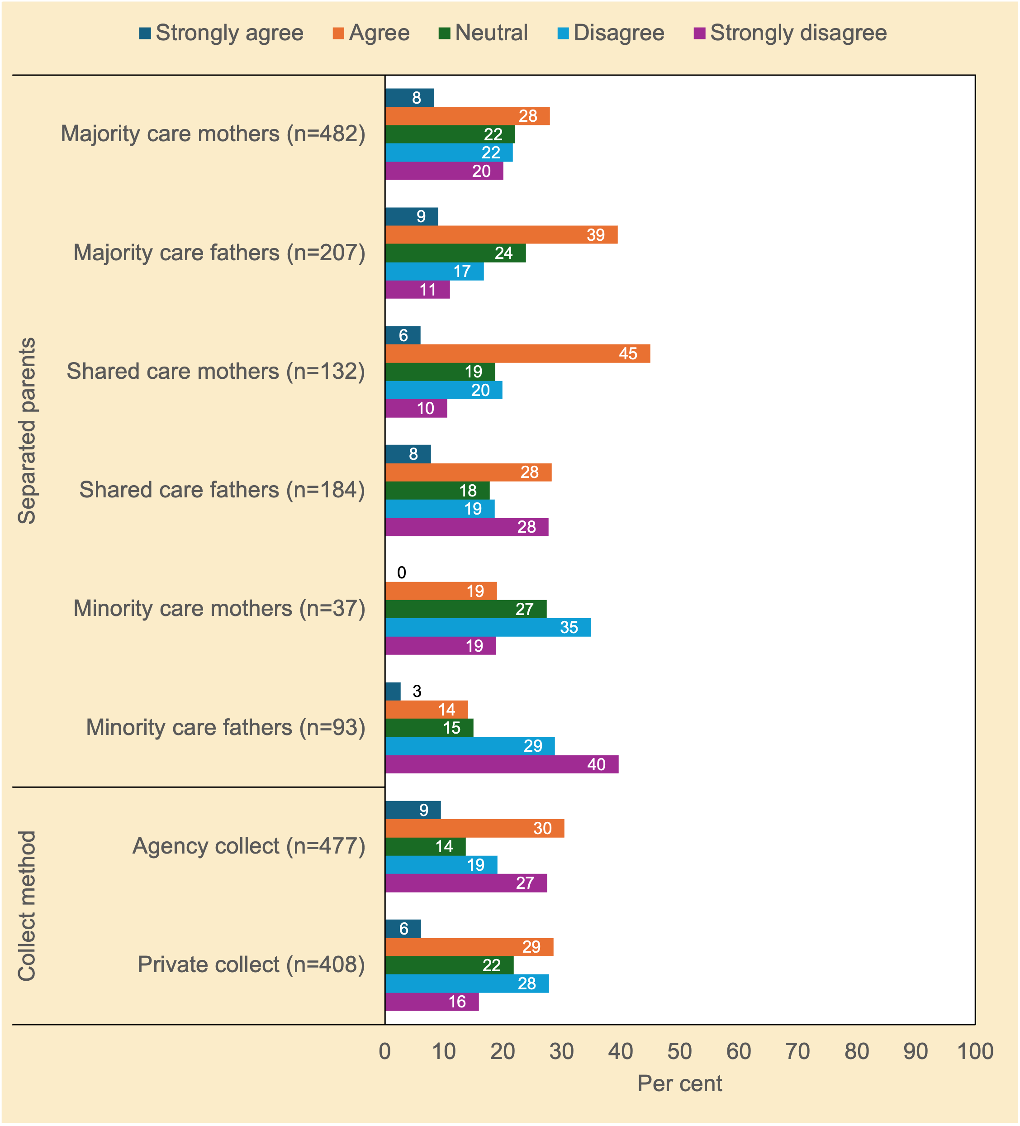
Source. Community Attitudes to Child Support Survey 2024

Figure A.2 To what extent do you agree or disagree that the amount of child support required to be paid should increase if the number of child support children is more than three? [Strongly agree to Strongly disagree] (%)
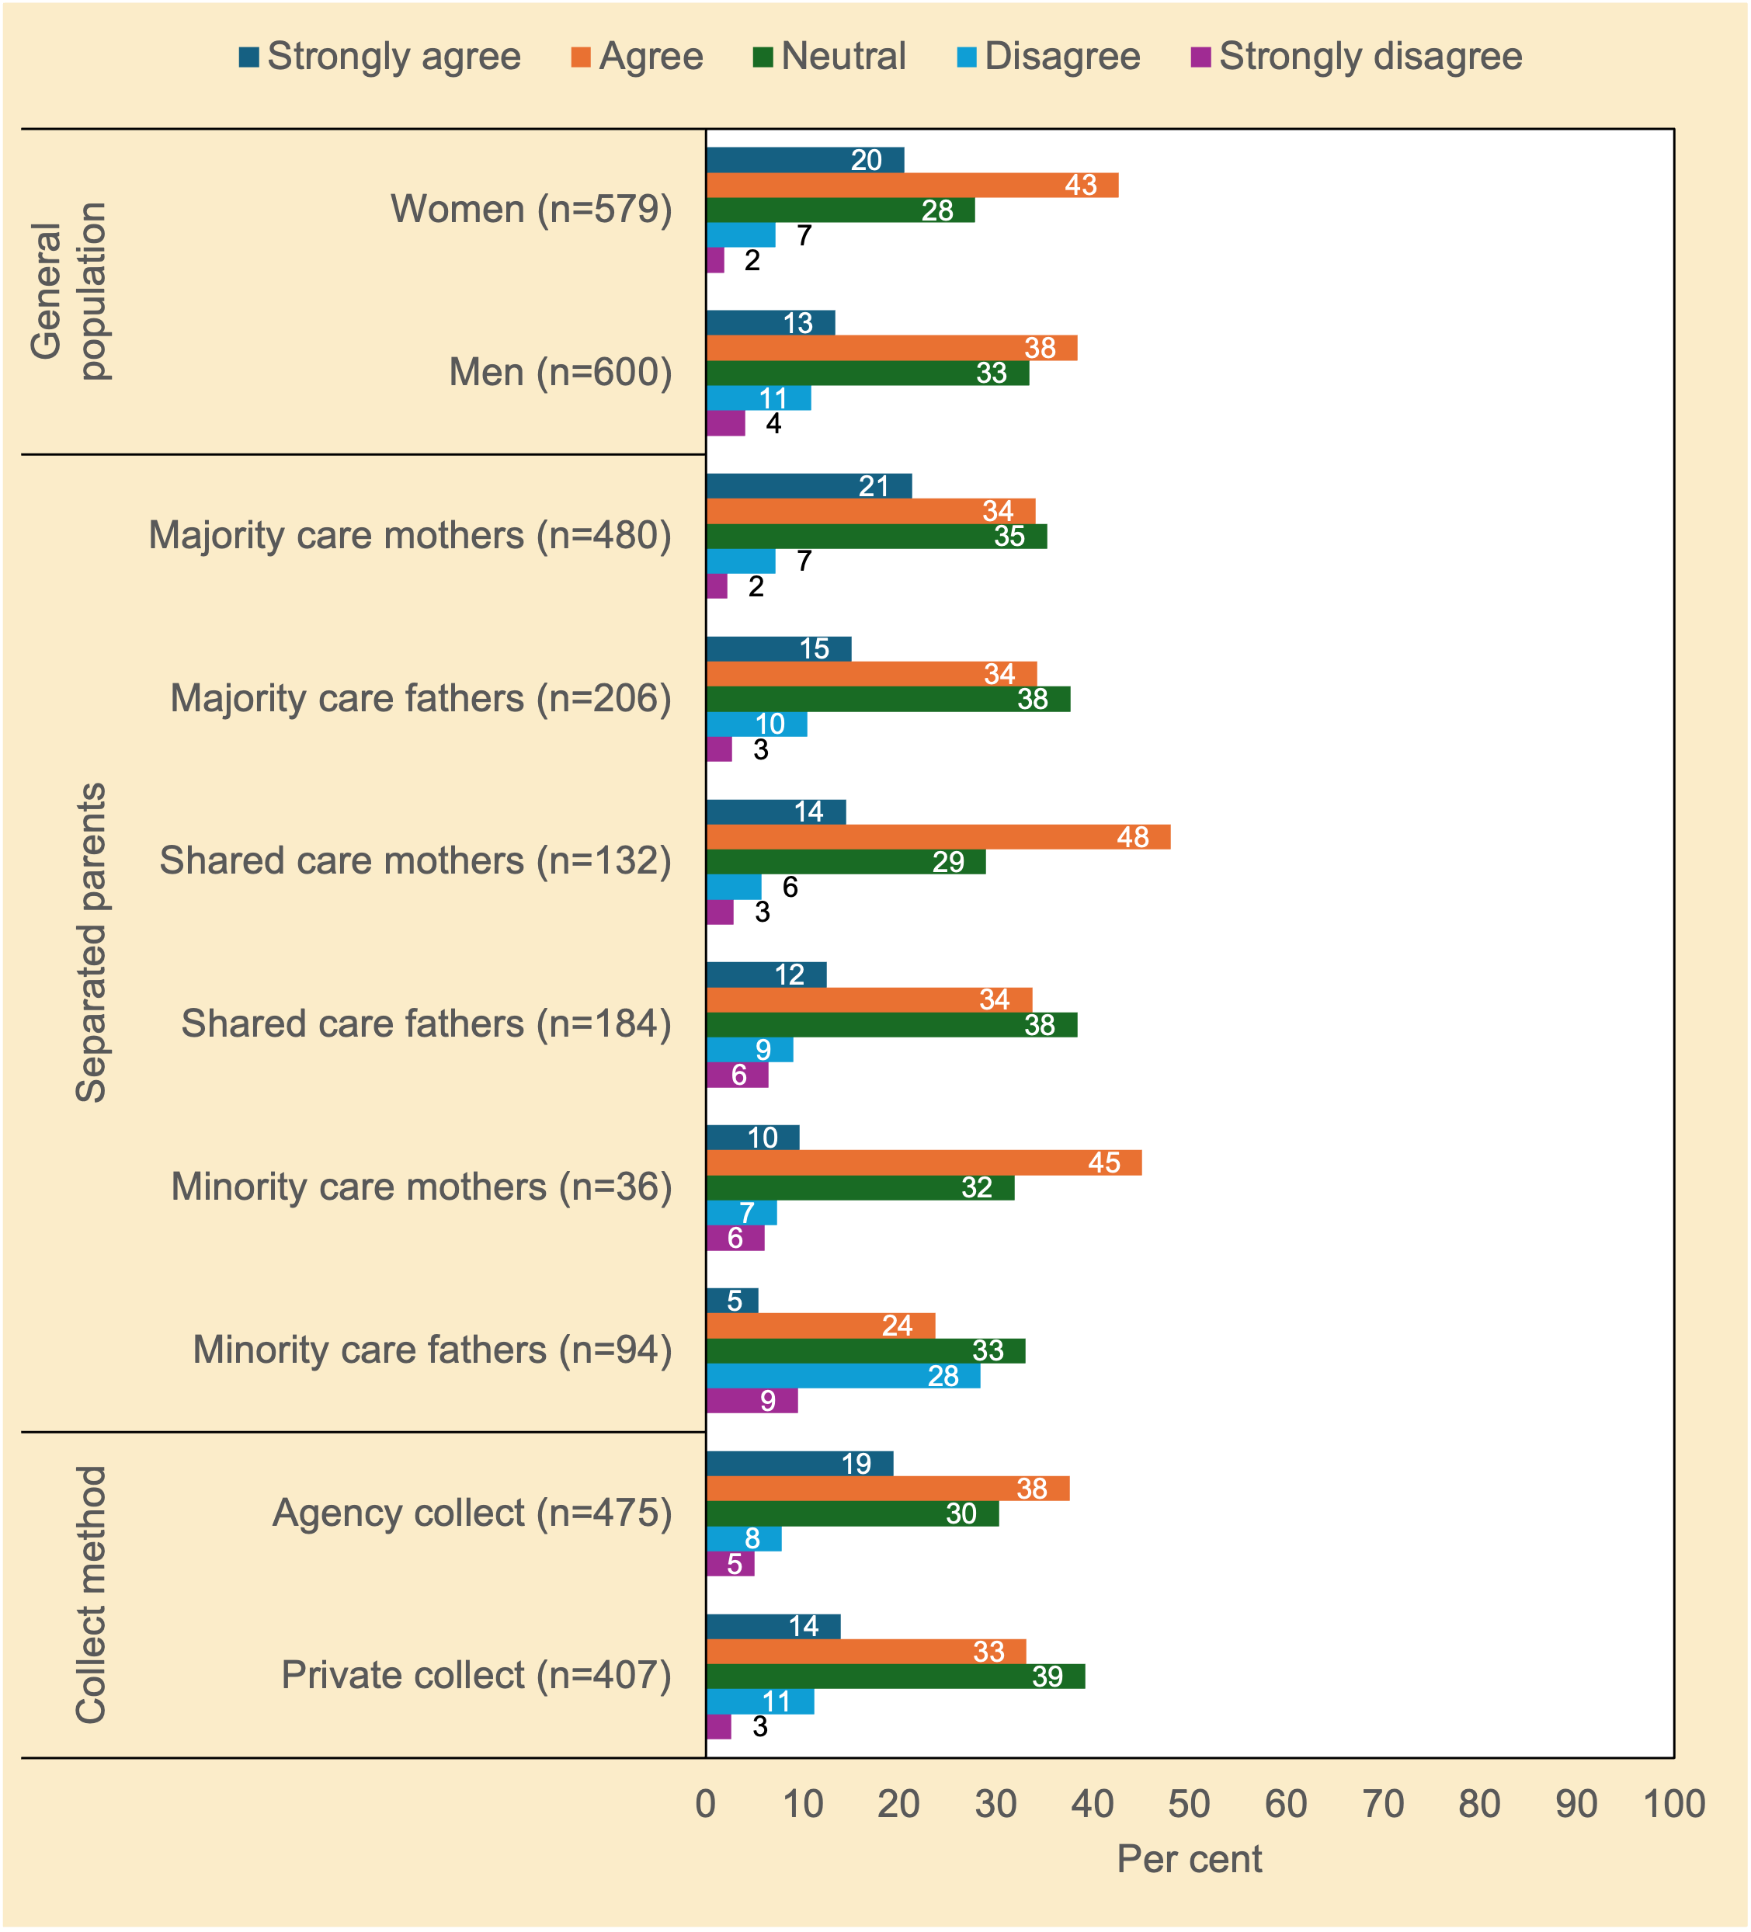
Source. Community Attitudes to Child Support Survey 2024

Figure A.3 To what extent do you agree or disagree that parents who have a fear of violence (from the other parent) should be able to seek an exemption from applying for child support? [Strongly agree to Strongly disagree] (%)
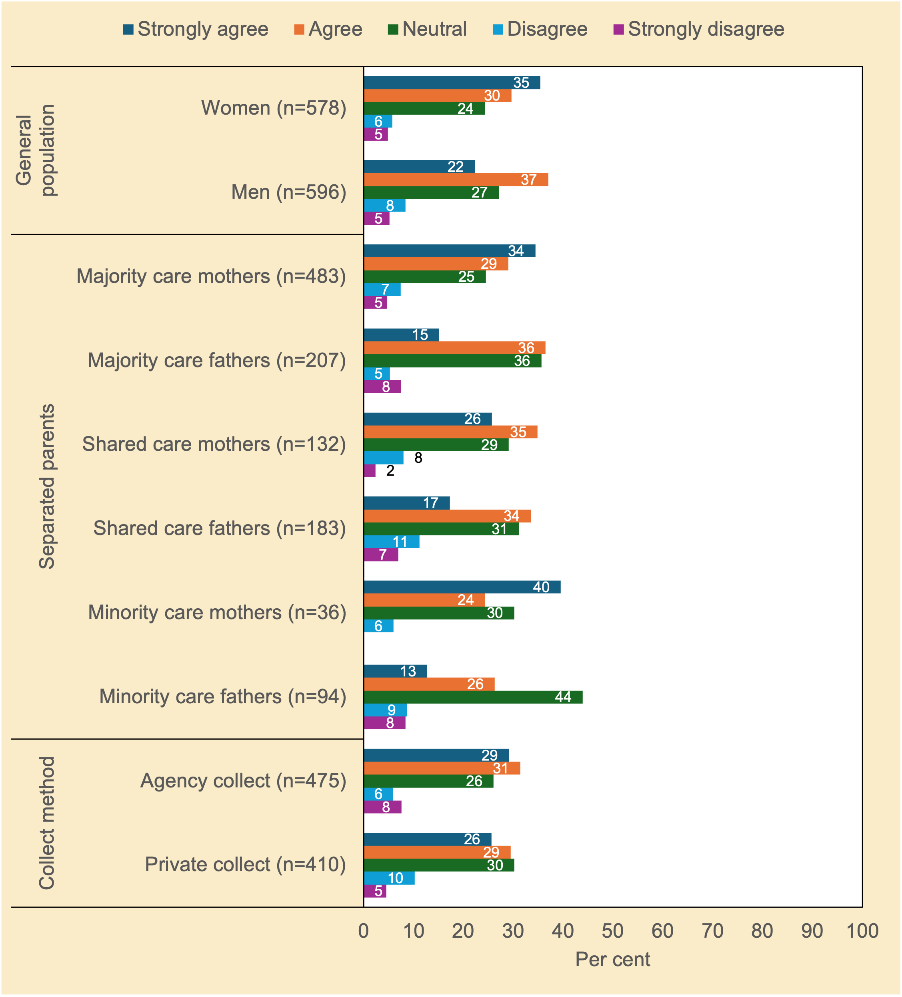
Source. Community Attitudes to Child Support Survey 2024

Figure A.4 To what extent do you agree or disagree that if parents transfer money privately, the Child Support Agency (Services Australia) should check that child support has been paid in full? [Strongly agree to Strongly disagree] (%)
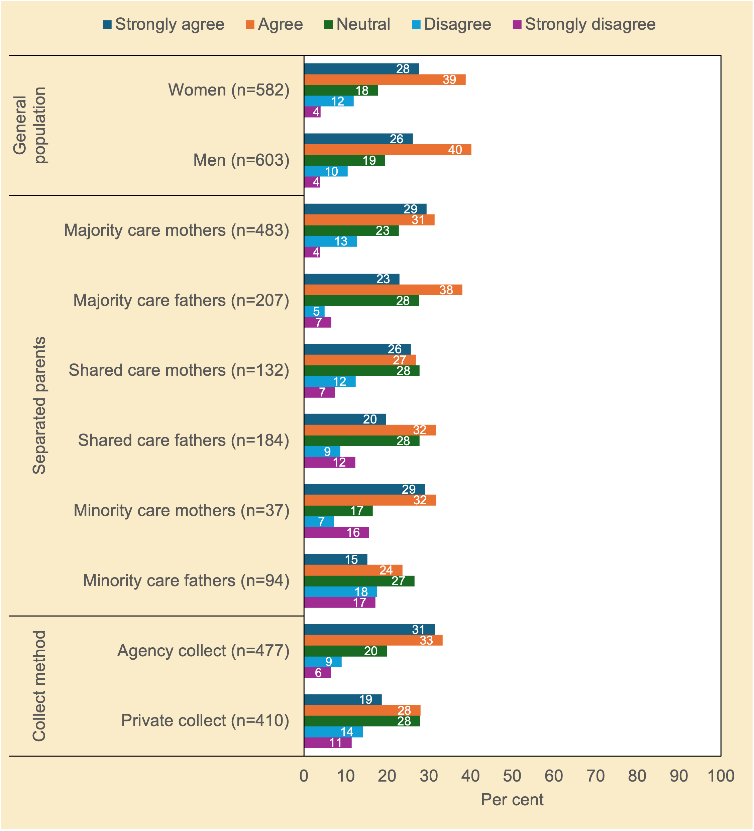
Source. Community Attitudes to Child Support Survey 2024

Figure A.5 To what extent do you agree or disagree that recently separated parents who get along should have the opportunity (provided by the government) to talk to a mediator about child support and child-related expenses in general? [Strongly agree to Strongly disagree] (%)
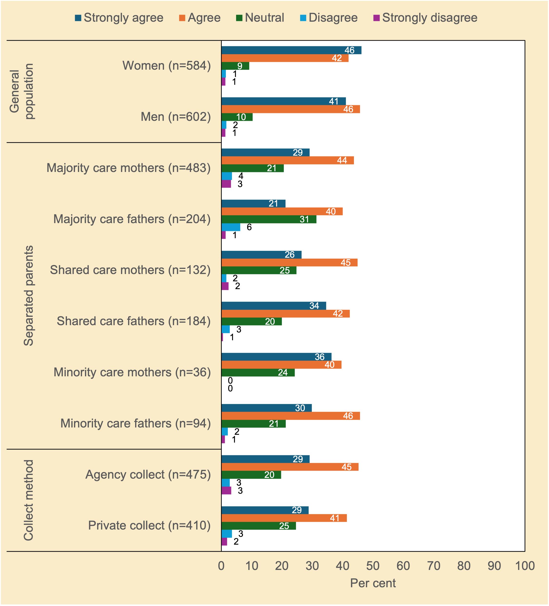
Source. Community Attitudes to Child Support Survey 2024

Appendix 2—Questionnaire
The survey questionnaire (next page) is only attached to the PDF version of this report. It is available as a separate file for the Microsoft Word version.

2024 Community Attitudes Survey to Child Support

PROJECT NOTES
- Data collection in 8-21 April Life in Australia™ wave (project number = 3130) o 3130: General community (n=1,200) and separated or divorced RESIDENT parents (n=250)
- 3130 via ORU non-probability panel: Boost of separated or divorced RESIDENT parents (n=350) and NON-RESIDENT parents (n=600)

GENERAL PROGRAMMING NOTES
- All question text in BLUE is CATI only and in ORANGE is web only. Text in BLACK is for both. \
- Please ensure that the full list of support services included in the closing script is added to the footer throughout the survey.
- Unless otherwise specified, all grid questions are to be displayed as a grid (i.e. table)
- For INTERVIEWMODE=WEB, always hide options 98, and 99. If respondent doesn’t answer, please then add them to the frame o MESSAGE ON POP-UP: You have not provided a response. Is that because you’re not sure, or you would prefer not to answer?
*(ALL)
S_ORDER READ IN DUMMY VARIABLE RANDOMLY ASSIGNED IN SAMPLE

- Normal code frame order [50%]
- Reverse code frame order [50%]
Table 1 Sample breakdown overview
 | General community | Separated or divorced parents* Resident parents Non-resident parents
Sample frame | Life in Australia™ n=1,200 | Life in Australia™  Life in Australia™ n=250  n=100  Non-probability panel  Non-probability panel  (ORU): n=350  (ORU): n=500
Total sample size | n=1,200 | n=1,200
*Conservative estimate for separated or divorced parents is n=600 in total

*PROGRAMMER NOTE: STANDARD CATI INTRODUCTION BELOW.
CATI INTRODUCTION

*(CATI ONLY)
WELCOME SCREEN
Name: <firstname>
PopulationTXT: <populationtxt>
EndQ: <EndQ>
Email outcome: <email_outcome>

Good (…), my name is (…) from the Social Research Centre, part of the Australian National University. May I please speak with <title> <firstname> <surname>?

IF NECESSARY: <title, firstname, surname> is a participant in our Life in Australia™ study and today we are calling to follow up on that.

*(CATI ONLY)
AM_FLAG Are you leaving an answering machine message?

- No continue to introduction
- No message left
- Yes (Left answering machine 1 message) [DISPLAY IF SAMPLETYPE=LANDLINE]
- Yes (Left mobile answering machine message) [DISPLAY IF
SAMPLETYPE=MOBILE]

*(SAMPLETYPE=LANDLINE)
ANSM1 Good morning. My name is (…) from the Social Research Centre, part of the Australian National University. Getting in touch about the Life in Australia™ study. Sorry we missed you, we’ll try again later. Please call 1800 023 040 to make an appointment or to opt out.

*(SAMPLETYPE=MOBILE)
ANSM3 Good morning. My name is (…) from the Social Research Centre, part of the Australian National University. Getting in touch about the Life in Australia™ study. Sorry we missed you, we’ll try again later. Please call 1800 023 040 to make an appointment or to opt out.

*(PROGRAMMER NOTE: IF AMFLAG=2 STOP AS ANSWERING MACHINE NO MESSAGE LEFT)

*(POPULATION = 1, ONLINE)
PRESAFE (INTERVIEWER: Are you calling a mobile number?)

- Yes
- No

*(POPULATION = 1 AND PRESAFE=1)
SAFE1 May I just check whether it is safe for you to take this call at the moment, you’re not driving (for example)? If not, we’d be happy to call back when it is more convenient for you.

- Safe to take call
- Not safe to take call
- (Respondent refusal)

*(POPULATION = 1 AND SAFE1=2, NOT SAFE)
MOBAPPT Would you like me to call you back on this number or would you prefer I call back on another phone?

- This number (MAKE APPOINTMENT)
- Alternative number (MAKE APPOINTMENT)

*(POPULATION = 1, ONLINE)
ALLOWMONITORING This call may be monitored or recorded for quality assurance purposes. Is that ok?

- Yes
- No

*(CATI ONLY)
INTRO1 REINTRODUCE IF NECESSARY: Good (…), my name is (…) from the Social Research Centre, part of the Australian National University. Can I confirm I am speaking with <TITLE>
<FIRSTNAME> <SURNAME>?

[DISPLAY IF POPULATION=1] You may recall we recently contacted you about the Life in Australia™ study and invited you to take part in the community attitudes on child support survey.

[DISPLAY IF POPULATION=2] The reason I’ve called is to invite you to participate in this month’s Life in Australia™ survey. We are conducting the community attitudes on child support survey.

This survey will only take 20 minutes. Participation in this survey is voluntary and you can withdraw at any point.

For completing this survey, you’ll receive a $10 thank you or you can donate the same amount to one of our selected charities. This will be processed in the next few weeks.

All responses are completely confidential and your information is protected by Australian Privacy Laws.

(IF NECESSARY: We understand that some of the questions have been asked multiple times. We do this to make sure we collect the most up to date opinions and circumstances of our participants. This also helps us understand how views change over time. Please bear with us if you feel you're repeating yourself!)

[DISPLAY IF POPULATION=1] Would you be willing to help us out by completing the survey online?

[DISPLAY IF POPULATION=2] Would you be willing to help us out by completing the survey today?

- Requested to do survey over the phone now (SHOW FOR POPULATION=2 OFFLINE ONLY)
- Wants to go online to do survey
- Household refusal (ATTEMPT CONVERSION / RECORD REASON) (GO TO RR1)
- Respondent refusal (ATTEMPT CONVERSION / RECORD REASON) (GO TO RR1)
- Queried about how telephone number was obtained
- Refused participation in Panel (GO TO TERM3)
- Away from Panel (RECORD RETURN DATE) (GO TO AWAY)

*(INTRO1=1 OR 2 AND POPULATION=2 OFFLINE)
PRESAFE (INTERVIEWER: Are you calling a mobile number?)

- Yes
- No

*(PRESAFE=1 AND POPULATION=2 OFFLINE)
SAFE1 May I just check whether it is safe for you to take this call at the moment, you’re not driving (for example)? If not, we’d be happy to call back when it is more convenient for you.

- Safe to take call
- Not safe to take call
- (Respondent refusal)

*(SAFE1=2 AND POPULATION=2, OFFLINE NOT SAFE)
MOBAPPT Would you like me to call you back on this number or would you prefer I call back on another phone?

- This number (MAKE APPOINTMENT)
- Alternative number (MAKE APPOINTMENT)

*(POPULATION = 2, OFFLINE)
ALLOWMONITORING This call may be monitored or recorded for quality assurance purposes. Is that ok?

- Yes
- No

*(INTRO1=5)
TELINFO <FIRSTNAME, SURNAME> is a participant in our Life in Australia™ study and today we are calling to conduct the <month> survey.

*(INTRO1=1 or 2 AND FIRSTNAME IS NULL, REQUESTED LINK TO COMPLETE ONLINE OR REQUEST TO DO SURVEY OVER THE PHONE NOW AND FIRSTNAME IS BLANK) FN1 Can I please have your first name or a nick name? 1. First name: [TEXT BOX FOR first name]

99. Refused

*(INTRO1=2 REQUESTED LINK TO COMPLETE ONLINE)
EC1 (POPULATION=1 ONLINE) No problem, I can send you an email with the link to the online portal where you can login to see surveys available for completion. Can I please confirm your email address?
IF NECESSARY: The email will come from lifeinaus@srcentre.com.au. Follow the link, then login to the portal. Go to the ‘My Surveys’ page from the menu and select ‘Complete now’ to start the survey.
IF NECESSARY: If you are having trouble logging in, go to ‘Forgot password’ from the login page to reset your password. If you continue to have issues, please contact the helpdesk on 1800 023 040.

IF NECESSARY: The new portal allows you to view your surveys, rewards and more:
- View and complete surveys o View your rewards balance o Redeem your rewards
- Update your contact details

(POPULATION=2 OFFLINE) No problem, I can send you an email with the link to the survey. Can I please confirm your email address?

Email: <email>
First name: <firstname>
Surname: <surname>

- Email address shown is correct [ONLY DISPLAY IF email IS NOT NULL]
- Email address: [TEXT BOX FOR EMAIL]

*(INTRO1=7, REFUSED PARTICIPATION IN PANEL ONGOING)
QTERM3 What are the reasons why you have decided to leave the Life in Australia™ study?

INTERVIEWER NOTE: Collect as much information as possible.

1. <verbatim text box> (GO TO QUAL)

*(INTRO1=7, REFUSED PARTICIPATION IN PANEL ONGOING)
QUAL Thanks for being part of Life in Australia™, your contribution has been greatly appreciated.

From time to time, the Social Research Centre conducts paid focus groups, in-depth interviews over the phone or in-person, and online discussion boards. The payment is generally between $50-$100.

Would you be interested in occasionally being invited to take part in this type of research?

- Yes
- No

*(INTRO1=7)
AWAY No worries, remember you can either participate online or over the phone. When will you be able to take part again?

- Enter date: DD MM YYYY (GO TO TERM3)
- (Refused) (GO TO TERM3) (PROGRAMMER: ADD 2 MONTHS TIME FOR THE PAUSED_END)

*PROGRAMMER: SET UP DAILY EXCEL OUTPUT FOR ICS TO ENTER IN PORTAL - PAUSED_START AND PAUSED_END FIELDS WITH YYYY-MM-DD FORMAT.

*[TIMESTAMP]

SAVE SCREEN

Thanks for your time so far. Your answers have been saved. You can use your original survey link to return to the survey and continue from where you left off.

[PROGRAMMER NOTE: PLEASE INCLUDE ‘PREVIOUS’ BUTTON ON SAVE SCREEN]

FOOTER

For any queries, please call the Social Research Centre on 1800 023 040 or email
LifeInAus@srcentre.com.au. You are able to stop the survey at any time by clicking save and return to complete it later. You can re-start the survey by clicking on the same link, it will take you to where you left.

INTRODUCTION

INTRODUCTION – ALL ADULTS

(TIMESTAMP: MAIN INTRODUCTION)

*(PROGRAMMER: ORU and Life in Australia™ Online)
*(PROGRAMMER: ALL)

Welcome to the Community Attitudes survey!

The Australian Government Department of Social Services has commissioned the Australian National University, the University of New South Wales, and the Social Research Centre to conduct a survey on community attitudes around child support. This survey will feed into a review of the Child Support Scheme and help make improvements to recognise changes in the way separated parents support and care for their children, and more accurately reflect the costs of providing care.

The survey should take you approximately 20 minutes to complete, though it may take longer depending on your responses. [PROGRAMMER NOTE: DISPLAY TEXT FOR Life in Australia™ ONLY <You will receive a $10 giftpay voucher as a thank you for doing the survey.>]

Participation is entirely voluntary and you can stop or withdraw at any time. Your responses will be combined with other participants and your individual responses will not be identifiable.

The ethical aspects of this research have been approved by the ANU Human Research Ethics Committee (2021/430). Please click here to view and download the full participant information sheet before starting the survey questions.

SECTION PA: SCREENING AND FOR MONITORING TARGET COMPLETES

*(ALL) [ASK ALL ORU RESPONDENTS]

P_CHILDSUP Do you currently pay or receive any child support, or are meant to be paying or receiving any child support?
*PROGRAMMER NOTE: SHOW IF DUM_SELECTION=2 “We understand you were asked a similar
question recently and appreciate you confirming here to make sure we show you the right sections in this survey”
Child support is money paid by one separated parent to the other parent (or carer) to support the cost of raising children under 18 years after a separation or divorce.
(READ OUT)

- Yes
- No

- (Don’t know) / Not sure
- (Refused) / Prefer not to say

*(P_CHILDSUP=1, PAYING/RECEIVING CHILD SUPPORT)
PC3a Which of the following best describes the amount of time your biological or adopted children under 18 years usually live with you?

This helps us in asking you the right questions in this survey.

(READ OUT)

- All the time
- More than 50% of the time
- Roughly a 50/50 split
- Less than 50% of the time
- Never

- More complex arrangement
96. Other (please specify)

- (Don’t know) / Not sure
- (Refused) / Prefer not to say

*(PC3a=6, 96, 98, 99, MORE COMPLEX RELATIONSHIP, OTHER, NOT SURE OR PREFER NOT TO SAY)
PC3d Do any of your children spend more than 50% of their time with their other parent?

[PROGRAMMING: IF PC3a=98 OR 99, DISPLAY TEXT AND REQUEST RESPONSE AGAIN: “This question will be used to direct you through the survey, please use your best judgement otherwise you can refuse the question”.]

(READ OUT)

- Yes
- No

- (Don’t know) / Not sure
- (Refused) / Prefer not to say

DUM_GRP
- Separated / divorced parents (P_CHILDSUP=1)
- General community (P_CHILDSUP=2 OR P_CHILDSUP=98 or 99)

DUM_SEP
- Resident parents ((PC3a=1,2 OR 3) OR (PC3a=6, 96, 98, 99 AND PC3d=2))
- Non-resident parents ((PC3a=4 OR 5) OR (PC3a=6,96,98,99 AND PC3d=1))
- Undefined (PC3d=98 OR 99)

INCLUDE DUMMY VARIABLE OR QUOTA TABLE:
 | Question(s) base
Separated / divorced parents | P_CHILDSUP=1 | Resident parents |  | (PC3a=1,2 OR 3) OR (PC3a=6, 96, 98, 99 AND PC3d=2)
Separated / divorced parents | P_CHILDSUP=1 | Non-resident parents |  | (PC3a=4 OR 5) OR (PC3a=6, 96, 98, 99 AND PC3d=1)
Separated / divorced parents | P_CHILDSUP=1 | Undefined |  | PC3d=98 OR 99
General community | P_CHILDSUP=2 OR  P_CHILDSUP=98 OR 99

*(P_CHILDSUP=2, 98 or 99, NOT PAYING/RECEIVING CHILD SUPPORT OR UNKNOWN)
*(AUTOPOPULATE PA1=1 IF P_CHILDSUP=1, YES CURRENTLY PAY CHILD SUPPORT)
PA1 Have you ever heard of the Child Support Scheme or the Child Support Agency (now Services Australia)?

- Yes
- No

- (Don’t know) / Not sure
- (Refused) / Prefer not to say

*(PA1=1, HAS HEARD OF CHILD SUPPORT SCHEME OR CSA (NOW SA))
PA2 Have you ever had any contact with the Child Support Agency (now Services Australia)?

- Yes
- No

- (Don’t know) / Not sure
- (Refused) / Prefer not to say

SECTION PA: GENERAL PERCEPTIONS

*(P_CHILDSUP=1, PAYING/RECEIVING CHILD SUPPORT) Now some questions on how you think the child support system is working.

*(P_CHILDSUP=1, PAYING/RECEIVING CHILD SUPPORT)
PA3 Thinking overall, would you say that the child support system is…?

[CODE FRAME ORDER BASED ON ‘S_ORDER’ VARIABLE]

- Working well
- Not working well

- (Don’t know) / Not sure
- (Refused) / Prefer not to say

*(P_CHILDSUP=1, PAYING/RECEIVING CHILD SUPPORT)
PA4 To what extent do you agree or disagree that the child support system is “fair” for both parents?

(READ OUT)
[CODE FRAME ORDER BASED ON ‘S_ORDER’ VARIABLE]

- Strongly agree
- Agree
- Neither agree nor disagree
- Disagree
- Strongly disagree

- (Don’t know) / Not sure
- (Refused) / Prefer not to say

*(PA4=3-5, DOESN’T AGREE CHILD SUPPORT SYSTEM IS FAIR) PA5 Who is it unfair for?

- The parent who pays child support
- The parent who receives child support
- Both

- (Don’t know) / Not sure
- (Refused) / Prefer not to say

*(P_CHILDSUP=1, PAYING/RECEIVING CHILD SUPPORT) [MULTI-RESPONSE]
PA6 Apart from food, housing and clothes, what child-related expenses do you think child support payments are meant to cover?

*(RANDOMISE)

- Medical expenses
- Dental expenses

- After-school activities (music lessons, sports)
- School books and materials
- School events and excursions
- Digital devices
- Other
(READ OUT)
- Yes
- No

- (Don’t know) / Not sure *(EXCLUSIVE)
- (Refused) / Prefer not to say *(EXCLUSIVE)

*(PA6g=1,’ YES’ TO OTHER EXPENSES)
PA7 What other child-related expenses do you think child support payments are meant to cover?
1. [Verbatim box]

- (Don’t know) / Not sure
- (Refused) / Prefer not to say

*(P_CHILDSUP=1, PAYING/RECEIVING CHILD SUPPORT) [MULTI-RESPONSE]
PA8 Apart from food, housing and clothes, what child-related expenses do you think child support payments should cover?

*(RANDOMISE)

- Medical expenses
- Dental expenses
- After-school activities (music lessons, sports)
- School books and materials
- School events and excursions
- Digital devices
- Other
(READ OUT)
- Yes
- No

- (Don’t know) / Not sure *(EXCLUSIVE)
- (Refused) / Prefer not to say *(EXCLUSIVE)

*(PA8g=1,’ YES’ TO OTHER EXPENSES)
PA9 What other child-related expenses do you think child support payments should cover?
1. [Verbatim box]

- (Don’t know) / Not sure
- (Refused) / Prefer not to say

*(TIMESTAMP)

SECTION PB: ATTITUDES TO CHILD SUPPORT

*(ALL)
PB1_INTRO We would now like to ask you about whether you think child support should be paid under different situations.

Just to clarify: Under the Child Support Scheme, parents not living with their children pay a certain proportion of their income to the other parent – depending on the income of both parents, the number of children they have and the amount of time each parent spends with their children.

*(ALL)
PB1  *(ALL) | Do you think a parent who does not usually live with their child or children should always pay child support?  - Yes  - No  - (Don’t know) / Not sure  - (Refused) / Prefer not to say
PB2  *(ALL) | Do you think most parents would pay child support without any government involvement?  - Yes  - No  - (Don’t know) / Not sure  - (Refused) / Prefer not to say
PB3  *(ALL) | Should a parent have to apply for child support to receive government children-related payments (e.g., Family Tax Benefit)?  - Yes  - No  - (Don’t know) / Not sure  - (Refused) / Prefer not to say
PB4  *(ALL) | If the parents have never lived together, should the parent who lives with the child be required to apply for child support from the other parent?  - Yes  - No  - (Don’t know) / Not sure  - (Refused) / Prefer not to say
PB5  *(ALL) | If either or both of the parents receive government income support payments, should their government payments be…?  (READ OUT)  - Reduced by the total amount of child support they receive  - Reduced by some of the total amount of child support  - Not reduced at all  - (Don’t know) / Not sure  - (Refused) / Prefer not to say
PB6 | If the paying parent has another child with a new partner, should they be allowed to pay less child support for the children of their previous relationship? This doesn’t include stepchildren.
- Yes

- No

- (Don’t know) / Not sure
- (Refused) / Prefer not to say
*(ALL)
PB7  *(ALL) | If the paying parent has re-partnered and now has step-children to support, should they be allowed to pay less child support for the children of their previous relationship?  - Yes  - No  - (Don’t know) / Not sure  - (Refused) / Prefer not to say
PB8  *(ALL) | If the receiving parent remarries or starts living with a new partner, which of the following best describes what the paying parent should be expected to do…  (READ OUT)  - Paying Parent should keep paying child support  - Paying Parent should stop paying child support  - Depends on the financial situation of the receiving and paying parents  - Depends on other circumstances  - (Don’t know) / Not sure  - (Refused) / Prefer not to say
PB9 | Do you think a parent who has little or no contact with a child should pay some child support even if their earnings are very low or they only receive government income support payments?  - Yes  - No  - (Don’t know) / Not sure  - (Refused) / Prefer not to say
*(PB9=1, THINKS A PARENT SHOULD PAY SOME CHILD SUPPORT REGARDLESS INCOME)
PB10  *(ALL)  *(ALL) | What do you think should be the absolute minimum amount of child support that a parent should pay regardless of their income or the number of children they are supporting? Would it be…  (READ OUT)  - $0 to $4 a week  - $5 to $19 a week  - $20 to $29 a week  - $30 to $39 a week  - $40 to $49 week  - $50 or more a week  - (Don’t know) / Not sure  - (Refused) / Prefer not to say
PB11 | Should there be a maximum amount of child support payable for high-income parents?
- Yes
- No

- (Don’t know) / Not sure
- (Refused) / Prefer not to say
*(ALL)
PB12  *(ALL) | Should a parent with a 50/50 parenting arrangement who has a higher income than the other parent be required to pay child support?  - Yes  - No  - (Don’t know) / Not sure  - (Refused) / Prefer not to say
PB13  *(ALL) | For the purpose of receiving government benefits, should a parent with a 50/50 parenting arrangement be able to elect not to receive child support from the parent with the higher income?  - Yes  - No  - (Don’t know) / Not sure  - (Refused) / Prefer not to say
PB14  (*ALL) | Should a parent face a penalty (such as a fine) if they fail to make their child support payments?  - Yes  - No  - (Don’t know) / Not sure  - (Refused) / Prefer not to say
PB15  (*ALL) | To what extent do you agree or disagree that parents who have a fear of violence (from the other parent) should be able to seek an exemption from applying for child support.  (READ OUT)  [CODE FRAME ORDER BASED ON ‘S_ORDER’ VARIABLE] 1. Strongly agree  - Agree  - Neither agree nor disagree  - Disagree  - Strongly disagree  - (Don’t know) / Not sure  - (Refused) / Prefer not to say
PB16 | To what extent do you agree or disagree that the amount of child support required to be paid should increase if the number of child support children is more than three?
(READ OUT)

[CODE FRAME ORDER BASED ON ‘S_ORDER’ VARIABLE]
- Strongly agree
- Agree
- Neither agree nor disagree

- Disagree
- Strongly disagree

- (Don’t know) / Not sure
- (Refused) / Prefer not to say
*(ALL)
PB17  *(ALL) | Should a parent have to pay child support if they want contact with their children but the other parent is preventing it?  - Yes  - No  - (Don’t know) / Not sure  - (Refused) / Prefer not to say
PB18 | Should child support be paid for a child over 18 years who is …  *(RANDOMISE 1-3, ANCHOR 4-5 at the bottom)  - A full-time student aged under 22 years living at home  - An unemployed youth aged under 22 years living at home  - A child living with disability  - All of these, or  - None of these  - (Don’t know) / Not sure *(EXCLUSIVE)  - (Refused) / Prefer not to say *(EXCLUSIVE)
*(TIMESTAMP)

SECTION C: POLICY ISSUES

*(ALL)
PC1_INTRO Now, thinking about broader policy issues...

*(ALL)
PC1 | When couples separate, or are not partnered when a child is born, which of the following parties should have the main responsibility for financial support of their children?  *(RANDOMISE)  (READ OUT)  - Parents  - Government  - Both parents and government  - (Don’t know) / Not sure  - (Refused) / Prefer not to say

*(ALL)
PC2a Which of the following should be the main priority of the Child Support Scheme?

Select one option only

*(RANDOMISE)
(READ OUT)

- Helping children by ensuring both parents contribute to child costs
- Being “fair” for both parents
- Reducing the amount that the government has to spend on family payments

- (Don’t know) / Not sure *(EXCLUSIVE)
- (Refused) / Prefer not to say *(EXCLUSIVE)

*(PC2a=1,2 OR 3)
PC2b And, which one do you think is the second highest priority?

Select one option only

*[PROGRAMMER NOTE: ONLY DISPLAY OPTIONS NOT SELECTED AT PC2a]
- Helping children by ensuring both parents contribute to child costs
- Being “fair” for both parents
- Reducing the amount that the government has to spend on family payments
- (Don’t know) / Not sure
- (Refused) / Prefer not to say

*(PROGRAMMER NOTE: AUTOPOPULATE PC2c USING OPTION THAT WAS NOT SELECTED AT
PC2a (1-3) OR PC2b (1-3) AS THE THIRD HIGHEST PRIORITY)
*((PC2a=1-3) AND (PC2b=1-3))
PC2c And, which one do you think is the third highest priority?

*(PC3a=2,3,4,6,96,98,99, CHILD DOES NOT LIVE WITH THEM ALL THE TIME OR NEVER)
PC3b Thinking about your youngest child under 18 years from your most recent separation, how often does your child stay overnight with their other parent?

- At least once a week
- At least once a fortnight
- At least once a month
- At least once every 3 months
- At least once every 6 months
- At least once a year
- Less than once a year

- (Don’t know) / Not sure
- (Refused) / Prefer not to say

*(PC3b=1-6)
PC3c Still thinking about the same child under 18 years from your most recent separation, how many nights every (PERIOD IN PC3b) does that child usually stay overnight with their other parent?

*PROGRAMMER NOTE: ONLY INSERT THE TIME PERIOD FROM PC3B. E.G. IF
PC3B=1, PC3C SHOULD READ '…HOW MANY NIGHTS EVERY WEEK DOES THAT CHILD USUALLY STAY OVERNIGHT…'

1. Number of nights (_________)

- (Don’t know) / Not sure
- (Refused) / Prefer not to say

(*PC3a=1-3)
PC4a Would you consider forgiving a child support debt owed by the other parent if it ensured future child support payments?

(READ OUT)

- Yes
- No

- (Don’t know) / Not sure
- (Refused) / Prefer not to say

(*PC4a=1, WOULD CONSIDER FORGIVING DEBT)
PC4b |  | How much debt would you consider forgiving?
 | 1. | Less than $500
 | 2. | $500-$999
 | 3. | $1,000-$1,499
 | 4. | $1,500-$1,999
 | 5. | $2,000 or more
 | 98. | (Don’t know) / Not sure
 | 99. | (Refused) / Prefer not to say
(*PC3a=4-5, NON-RESIDENT PARENT)
DUM1 DUMMY VARIABLE, RANDOMLY ASSIGNED IN SAMPLE

- <$500> [50%]
- <$2,000> [50%]

(*PC3a=4-5, NON-RESIDENT PARENT)
PC5  (*ALL) | If you had a long-standing child support debt of less than <DUM1>, would having it forgiven improve the chances of you meeting your ongoing child support payments?  (READ OUT)  [CODE FRAME ORDER BASED ON ‘S_ORDER’ VARIABLE]  - Yes, but not willing to pay off some of the debt  - Yes, and would be willing to pay off some of the debt  - Possibly  - Unlikely  - Never  - (Don’t know) / Not sure  - (Refused) / Prefer not to say
PC6  (*ALL) | Child support payments can be made either directly between parents, which is known as private collection, or collected by the Child Support Agency (now Services Australia).  To what extent do you agree or disagree that if parents transfer money privately, the Child Support Agency should check that child support has been paid in full?  [CODE FRAME ORDER BASED ON ‘S_ORDER’ VARIABLE]  - Strongly agree  - Agree  - Neither agree nor disagree  - Disagree  - Strongly disagree  - (Don’t know) / Not sure  - (Refused) / Prefer not to say
PC7 | Which of the following child support collection options is most appropriate to be used for new parents entering the child support system?

Select one option only

(READ OUT)

- Employer deducts a portion of an employee's wages
- Parent pays the Child Support Agency (now Services Australia)
- Parent transfers money privately to the other parent
- Parent transfers money privately to the other parent via a child support app
96. Other (please specify)

- (Don’t know) / Not sure *(EXCLUSIVE)
- (Refused) / Prefer not to say *(EXCLUSIVE)

(*ALL)
PC8 | To what extent do you agree or disagree that recently separated parents who get along should have the opportunity (provided by the government) to talk to a mediator about child support and child-related expenses in general.  [CODE FRAME ORDER BASED ON ‘S_ORDER’ VARIABLE]  - Strongly agree  - Agree  - Neither agree nor disagree  - Disagree  - Strongly disagree  - (Don’t know) / Not sure  - (Refused) / Prefer not to say
*(TIMESTAMP)

SECTION PD: BUDGET STANDARD QUESTIONS

DUM3 | DUMMY VARIABLE, RANDOMLY ASSIGNED IN SAMPLE  - <The couple are both employed in low-wage jobs, with one full-time and the other part-time.> [50%]  - <The couple are both unemployed.> [50%]
DUM4  *(ALL) | DUMMY VARIABLE, RANDOMLY ASSIGNED IN SAMPLE  - < girl aged 8 and a boy aged 11> [50%]  - < boy aged 8 and a girl aged 11 > [50%]  *[PRPGRAMMER NOTE ENSURE AS EQUAL FINAL SAMPLES IN EACH DUM3 AND SUM4 SCENARIO AS POSSIBLE]
PD1 | We would like you to consider the situation of a household comprising a couple with two children. [INSERT TEXT FROM DUM3] The children are a [INSERT TEXT FROM  DUM4], and everyone is generally in good health. These ages are often used to calculate living standards.  We are thinking of how much a family should have as a minimum living standard to lead a full healthy life in all aspects in Australia today. In particular, should they be able to afford…  Please answer each statement.  *(RANDOMISE A-M AND N-Q BUT KEEP N-Q AT END)  *[PROGRAMMER NOTE: GROUP B/C, F/G, I/J]  (READ OUT)  - To pay for a private GP consultation (vs finding a bulk-billing doctor)  - A cheap laptop for the 11 year old< boy / girl >  - A cheap laptop for the 8 year old < boy / girl >  - To pay the standard fee for school camps and excursions (vs asking the school for a reduced payment)  - Branded school uniforms (vs similar generic items)  - Fees and equipment for the 11 year old < boy / girl > to play out-of-school soccer  - Fees and equipment for the 8 year old < boy / girl > to have swimming classes  - An international holiday once every two years  - A mobile phone for the 11 year old < boy / girl >  - A mobile phone for the 8 year old < boy / girl >  - A family subscription to an online subscription streaming service such as Netflix  - One standard alcoholic drink per day (beer/wine) for each adult
- Modest gift for celebrations such as family birthdays and festivals
- Afford after school care
- A family meal eating out at a modestly priced restaurant
- Vacation care during school holidays
- A holiday in a cabin at a holiday park once a year

(RESPONSE FRAME)

- Yes
- No

- (Don’t know) / Not sure *(EXCLUSIVE)
- (Refused) / Prefer not to say *(EXCLUSIVE)

*(PD1n=1, YES)
PD2n Earlier you mentioned that a family should be able to afford after school care…How many days per week?

(RESPONSE FRAME)

- 1 day a week
- 2 days a week
- 3 days a week
- 4 days a week
- 5 days a week

- (Don’t know) / Not sure *(EXCLUSIVE)
- (Refused) / Prefer not to say *(EXCLUSIVE)

*(PD1o=1, YES)
PD2o Earlier you mentioned that a family should be able afford a family meal eating out at a modestly priced restaurant … How many days per month?

(RESPONSE FRAME)

- 1 time a month
- 2 times a month
- 3 times a month
- 4 or more times a month

- (Don’t know) / Not sure *(EXCLUSIVE)
- (Refused) / Prefer not to say *(EXCLUSIVE)

*(PD1p=1, YES)
PD2p Earlier you mentioned a family should be able to afford vacation care during school holidays…How many weeks per year?

(RESPONSE FRAME)

- 1 week a year
- 2 weeks a year
- 3 weeks a year
- 4 weeks a year

- (Don’t know) / Not sure *(EXCLUSIVE)
- (Refused) / Prefer not to say *(EXCLUSIVE)

*(PD1q=1, YES)
PD2q Earlier you mentioned a family should be able to afford a holiday in a cabin at a holiday park once a year…How many weeks per year?

(RESPONSE FRAME)

- 1 week a year
- 2 weeks a year
- 3 weeks a year
- 4 weeks a year

- (Don’t know) / Not sure *(EXCLUSIVE)
- (Refused) / Prefer not to say *(EXCLUSIVE)

ANU POLL QUESTIONS – GENERAL

S_ORDER READ IN DUMMY VARIABLE RANDOMLY ASSIGNED IN SAMPLE

- Normal code frame order [50%]
- Reverse code frame order [50%]

*(ALL) [PROGRAMMER NOTE: HIDE CODE 3 WITH 98 AND 99 FOR ONLINE]
A1 Next, a general question about your views on living in Australia. All things considered, to what extent are you satisfied or dissatisfied with the way the country is heading?

(PROBE FOR VERY OR JUST)

(CODE FRAME ORDER BASED ON ‘S_ORDER’ VARIABLE FROM SAMPLE)
- Very satisfied
- Satisfied
- (Neither satisfied nor dissatisfied)
- Dissatisfied
- Very dissatisfied

- (Don’t know) / Not sure
- (Refused) / Prefer not to say

*(ALL)
A6 If a federal election for the House of Representatives was held today, which one of the following parties would you vote for?

(READ OUT) (IF ‘UNCOMMITTED’, SAY: ‘TO WHICH ONE OF THESE DO YOU HAVE A LEANING?’)
*(RANDOMISE)

- Liberal
- Nationals
- Labor
- Greens
6. Liberal National Party (LNP) [ONLY DISPLAY FOR P_STATE=’QLD’]
96. Some other party (please specify) <text box>

- (Don’t know) / Not sure
- (Refused) / Prefer not to say

*(ALL)
A3 The following question asks how satisfied you feel about life in general, on a scale from 0 to 10. Zero means you feel 'not at all satisfied' and 10 means 'completely satisfied'. Overall, how satisfied are you with life as a whole these days?

[ORDER BASED ON ‘S_ORDER’ VARIABLE]
- 0 – Not at all satisfied
- 1
- 2
- 3
- 4
- 5
- 6
- 7
- 8
- 9
- 10 – Completely satisfied

- (Don’t know) / Not sure
- (Refused) / Prefer not to say
*(ALL)
A4 To what extent do you have confidence in the following institutions…?

*(RANDOMISE STATEMENTS)
- The Federal Government in Canberra
- The public service
- The State / Territory Government where you live

(READ OUT)

[CODE FRAME ORDER BASED ON ‘S_ORDER’ VARIABLE]
- A great deal of confidence
- Quite a lot of confidence
- Not very much confidence
- None at all

- (Don’t know) / Not sure
- (Refused) / Prefer not to say

*(TIMESTAMP)

ANU POLL QUESTIONS – MENTAL HEALTH

*(ALL)
D1 The next questions ask about how you have been feeling in the last four weeks. For each question, choose the answer that best describes how often you felt this way.

In the past four weeks how often did you feel…?

- Nervous
- Hopeless
- Restless or fidgety
- That everything was an effort
- So sad that nothing could cheer you up
- Worthless

(READ OUT)

[CODE FRAME ORDER BASED ON ‘S_ORDER’ VARIABLE]
- None of the time
- A little of the time
- Some of the time
- Most of the time
- All of the time

- (Don’t know) / Not sure
- (Refused) / Prefer not to say

*(ALL)
D3 In the past week, how often have you felt lonely?

(READ OUT)

[CODE FRAME ORDER BASED ON ‘S_ORDER’ VARIABLE]
- Rarely or none of the time (less than 1 day)
- Some or a little of the time (1 to 2 days)
- Occasionally or a moderate amount of time (3 to 4 days)
- Most or all of the time (5 to 7 days)

- (Don’t know) / Not sure
- (Refused) / Prefer not to say
*(TIMESTAMP)

ANU POLL QUESTIONS – EMPLOYMENT, INCOME AND FINANCIAL HARDSHIP

*(ALL)
E1 Which of the following have you been doing during the last 7 days?

Please just tell me ‘yes’ or ‘no’ after each.

- In paid work (or away temporarily) (employee, self-employed, working for your family business)
- In education (not paid for by employer), even if on vacation
- Unemployed and actively looking for a job
- Unemployed, wanting a job but not actively looking for a job
- Permanently sick or disabled
- Retired
- Doing housework, looking after children or other persons h) Other

(RESPONSE FRAME)
- Yes
- No

- (Don’t know) / Not sure
- (Refused) / Prefer not to say

*(E1=MORE THAN ONE OPTION SELECTED)
E2 And, which of these best describes your situation in the last 7 days?

(READ OUT)

*[PROGRAMMER NOTE: ONLY DISPLAY OPTIONS SELECTED AT E1]
- In paid work (or away temporarily) (employee, self-employed, working for your family business)
- In education (not paid for by employer), even if on vacation
- Unemployed and actively looking for a job
- Unemployed, wanting a job but not actively looking for a job
- Permanently sick or disabled
- Retired
- Doing housework, looking after children or other persons
96. Other

- (Don’t know) / Not sure
- (Refused) / Prefer not to say

*(E1a=1, IN PAID WORK)
E4 Regardless of your basic or contracted hours, how many hours did you work last week across all of your jobs, including any paid or unpaid overtime?

1. Number of hours (Specify_________) (RANGE 0 TO 168; WHOLE NUMBERS)

- (Don’t know) / Not sure
- (Refused) / Prefer not to say

(*ALL)
E5 People often get income from a number of sources. Is your main source of income…?

(READ OUT)

- Earnings
- Government income support
- Something else

- (Don’t know) / Not sure
- (Refused) / Prefer not to say

*(ALL)
E10 Please indicate which of the following describes What is your household's total income, after tax and compulsory deductions, from all sources?

(PROBE TO CODE FRAME)
INTERVIEWER NOTE: IF “DON’T KNOW” AND VOLUNTEERS “ON A PENSION”; AGE
PENSION / WIDOWS ALLOWANCE / DISABILITY SUPPORT PENSION (SINGLE) CODE AS 1. IF COUPLE ON A PENSION, CODE AS 2

- $0 to $24,554 ($0 to $472 weekly)
- More than $24,554 to $38,896 (more than $472 to $748 weekly)
- More than $38,896 to $52,884 (more than $748 to $1,017 weekly)
- More than $52,884 to $69,524 (more than $1,017 to $1,337 weekly)
- More than $69,524 to $88,452 (more than $1,337 to $1,701 weekly)
- More than $88,452 to $109,304 (more than $1,701 to $2,102 weekly)
- More than $109,304 to $134,784 (more than $2,102 to $2,592 weekly)
- More than $134,784 to $168,688 (more than $2,592 to $3,244 weekly)
- More than $168,688 to $222,300 (more than $3,244 to $4,275 weekly)
- More than $222,300 (more than $4,275 weekly)

- (Don’t know) / Not sure
- (Refused) / Prefer not to say

*(ALL)
E11a Which of the following best describes how you feel about your household’s income nowadays?

(READ OUT)

[CODE FRAME ORDER BASED ON ‘S_ORDER’ VARIABLE]
- Living comfortably on present income
- Coping on present income
- Finding it difficult on present income
- Finding it very difficult on present income

- (Don’t know) / Not sure
- (Refused) / Prefer not to say

CALIBRATION QUESTIONS

*(ALL)
BENTYPE Do you currently receive any of the following government pensions, benefits or allowances?

[STATEMENTS]
- Age pension
- Newstart Allowance / Jobseeker Payment
- Disability Support Pension
- Carer Allowance / Carer Payment
- Parenting payment

- Yes
- No

- (Don’t know) / Not sure
- (Refused) / Prefer not to say

Internet use
*(ALL)
INTERNET How often do you…?

[STATEMENTS]
a) Look for information over the Internet
d) Read comments or view posts, images, and videos on social media sites

(READ OUT)

- More than once a day
- About once a day
- Three to five days a week
- One to two days a week
- Every few weeks
- Once a month
- Less than once a month
- Never

- (Don’t know) / Not sure
- (Refused) / Prefer not to say

TV viewing habits
*(ALL)
TV_TIME On average, how many hours per week do you spend watching each of the following?

[STATEMENTS]
- Free video streaming services - e.g., YouTube, Twitch, Vimeo
- Online subscription services - e.g., Netflix, Disney+, Amazon Prime Video, Stan, Binge, YouTube Premium

(READ OUT)

[CODE FRAME ORDER BASED ON ‘S_ORDER’ VARIABLE]

- 0 hours per week
- 1-5 hours per week
- 6-10 hours per week
- 11-15 hours per week
- 16-20 hours per week
- More than 20 hours per week

- (Don’t know) / Not sure
- (Refused) / Prefer not to say

*(TIMESTAMP)

SECTION PE: DEMOGRAPHICS

*(ALL)
PE1_INTRO Now some questions about your yourself. Please remember that all the information you provide will be treated in the strictest confidence.
(*ALL)
PE1 | What is your marital status? Are you currently…  (READ OUT)  - Married  - In de facto relationship  - Separated (including trial separation)  - Divorced  - Widowed  - Never been married  - (Don’t know) / Not sure  - (Refused) / Prefer not to say
*(PE1=1,2,5,6, CURRENTLY MARRIED, DEFACTO, WIDOWED OR NEVER MARRIED) [IF P_CHILDSUP=1, AUTOCODE PE1b=1]
PE1b Have you ever been separated or divorced?

- Yes
- No

- (Don’t know) / Not sure
- (Refused) / Prefer not to say

*(PE1=3-6 OR 98, SEPARATED, DIVORCED, WIDOWED, OR NEVER BEEN MARRIED) *PROGRAMMER NOTE: AUTOPOPULATE PE2=1 IF PE1=1 OR 2
PE2 Are you currently in an ongoing relationship with someone?

- Yes
- No

- (Don’t know) / Not sure
- (Refused) / Prefer not to say

*(PE2=1, IN AN ONGOING RELATIONSHIP) *AUTOPOPULATE PE3=1 IF PE1=1 OR 2 PE3 Do you live with that person?

- Yes
- No

- (Don’t know) / Not sure
- (Refused) / Prefer not to say

*(P_CHILDSUP=2, 98 OR 99, NOT PAYING/RECEIVING CHILD SUPPORT)
*(AUTOPOPULATE PE4A=1 IF DUM_SEP=1, RESIDENT PARENTS)
*(AUTOPOPULATE PE4A=2 IF DUM_SEP=2, NON-RESIDENT PARENTS)
PE4a Are there any children under 18 living with you for at least 50% of the time?

- Yes
- No

- (Don’t know) / Not sure
- (Refused) / Prefer not to sayat leas

PROGRAMER NOTE: FOR PE4b-PE4j, PLEASE CHECK THE ROUTING AGAINST THE 2005 SURVEY (Smyth & Weston - 2005 demog.pdf)]

(*PE4a=1, HAS CHILDREN UNDER 18 LIVING WITH RESPONDENT AT LEAST 50% OF TIME) PE4b How many children under 18 are living with you at least 50% of the time?

1. Number of children (_________) (RANGE 0 TO 20; WHOLE NUMBERS)

- (Don’t know) / Not sure
- (Refused) / Prefer not to say

(IF PE4b=1 AND PE3=2, ONE CHILD AND RESPONDENT NOT PARTNERED]) PE4c Is this your child?

Note: include adopted children and biological children

- Yes
- No

- (Don’t know) / Not sure
- (Refused) / Prefer not to say

(IF PE4b=1 CHILD AND PE3=1 [RESPONDENT PARTNERED]) PE4d Was this child born to:

- You and your current partner,
- You and a previous partner, or
- Your partner
- None of the above

- (Don’t know) / Not sure
- (Refused) / Prefer not to say

( IF PE4b=2-20 CHILDREN AND PE3=2 [RESPONDENT NOT PARTNERED]) PE4e How many of these children are your children?

1. Number of children (Specify_________) (RANGE 0 TO 20; WHOLE NUMBERS)

- (Don’t know) / Not sure
- (Refused) / Prefer not to say

( IF PE4b=2-20 CHILDREN AND PE3=1 [RESPONDENT PARTNERED])
PE4f How many of these children under 18 are children that you and your current partner have had together?

1. Number of children (Specify_________) (RANGE 0 TO 20; WHOLE NUMBERS)

- (Don’t know) / Not sure
- (Refused) / Prefer not to say

( IF PE4b=2-20 CHILDREN AND PE3=1 [RESPONDENT PARTNERED])
(IF PE4b = PE4f, GOTO PE4i. ELSE CONTINUE)
PE4g How many are your children but not your partner’s child?

1. Number of children (Specify_________) (RANGE 0 TO 20; WHOLE NUMBERS)

- (Don’t know) / Not sure
- (Refused) / Prefer not to say

( IF PE4b=2-20 CHILDREN AND PE3=1 [RESPONDENT PARTNERED])
(IF PE4b = PE4g+ PE4f, GOTO PE4i. ELSE CONTINUE)
PE4h How many are your partner’s children but not your child?

1. Number of children (Specify_________) (RANGE 0 TO 20; WHOLE NUMBERS)

- (Don’t know) / Not sure
- (Refused) / Prefer not to say

*(P_CHILDSUP=2, 98 OR 99, NOT PAYING/RECEIVING CHILD SUPPORT)
*(AUTOPOPULATE PE4i=1 IF DUM_ SEP=2, NON-RESIDENT PARENTS)
*(AUTOPOPULATE PE4i=2 IF DUM_ SEP=1, RESIDENT PARENTS)
PE4i Do you have any children under 18 who live with their other parent for at least 50% of the time?

- Yes
- No

- (Don’t know) / Not sure
- (Refused) / Prefer not to say

(IF PE1=1 OR 2; OR IF PE3=1)
PE4j Does your partner have any children under 18 who live with their other parent for at least 50% of the time?

- Yes
- No

- (Don’t know) / Not sure
- (Refused) / Prefer not to say

(IF P_CHILDSUP=1)
PE5 Would you describe your current relationship with your children’s other parent who lives elsewhere as friendly, co-operative, distant, lots of conflict or fearful?

Note: if more than one such parent, refer to the parent with the youngest child.

- Friendly
- Co-operative
- Distant
- Lots of conflict
- Fearful

- (Don’t know) / Not sure
- (Refused) / Prefer not to say

99. (Refused) / Prefer not to say

(IF P_CHILDSUP=1)
PE6 Are you currently paying or receiving any regular child support for any children? (By regular payments we mean regular weekly, fortnightly or monthly payments)

- Yes, paying
- Yes, receiving
- Yes, paying and receiving
- No, neither paying nor receiving
- No, 50/50 split / split residence so no money changes hands

- (Don’t know) / Not sure
- (Refused) / Prefer not to say

(*PE6=4,98,99)
PE7 Are you meant to be paying or receiving child support?

- Yes
- No

- (Don’t know) / Not sure
- (Refused) / Prefer not to say

(*PE7=2,98,99)
PE8 Have you ever paid or received any regular child support for any children?

- Yes
- No

- (Don’t know) / Not sure
- (Refused) / Prefer not to say

(*PE6=1,2,3 OR PE7=1 OR PE8=1) [NOTE: CONDITION NEEDS TO BE DOUBLE CHECKED]
PE9 <Is/Was> the Child Support Agency (now Services Australia) in charge of collecting your child support payments?

*PROGRAMMER NOTE: IF PE8=1 USE ‘Was’. IF PE6=1,2,3 OR PE7=1 USE ‘Is’.

- Yes
- No

- (Don’t know) / Not sure
- (Refused) / Prefer not to say

(*PE9=2 AND DUM_SEP=1, IF RESIDENT PARENT AND PRIVATE COLLECT)
PE10 What’s the main reason that child support payments are transferred privately – and not through the CSA (now Services Australia)?

[INTERVIEWER NOTE: PROBE FOR THE UNDERLYING ISSUE. DO NOT RECORD
GENERAL DISSATISFACTION WITH THE SCHEME OR CSA.]

1. <text box>

- (Don’t know) / Not sure
- (Refused) / Prefer not to say

(*PE9=1 AND DUM_SEP=1, IF RESIDENT PARENT AND CSA COLLECT)
PE11  (*ALL) | What’s the main reason that you get the CSA (now Services Australia) to collect your child support for you?  - It’s always been done this way  - Paying parent not reliable  - Too much conflict over money  - Less stress  96. Other (please specify)  - (Don’t know) / Not sure  - (Refused) / Prefer not to say
PE12a | If you had a question about child support, who would you ask?  Please select all that apply.  (READ OUT ONE BY ONE)
  - Services Australia
  - Family or a friend
  - Facebook or social media group

  - Community Organisations
  - Child Support Advocates
  - Community leader
  - Legal aid/Family Law practitioner
  - Other
(READ OUT)
- Yes
- No

- (Don’t know) / Not sure *(EXCLUSIVE)
- (Refused) / Prefer not to say *(EXCLUSIVE)

(*PE12a_h=1, ‘YES’ to ‘Other’)
PE12a_OTHER Who else would you ask if you had a question about child support?

1. Verbatim box

- (Don’t know) / Not sure
- (Refused) / Prefer not to say

*(PE12a_a-h=1, MORE THAN ONE OPTION SELECTED ‘YES’) PE12b And, who would you ask first?

*[PROGRAMMER NOTE: ONLY DISPLAY OPTIONS SELECTED AT PE12a]

- Services Australia
- Family or a friend
- Facebook or social media group
- Community Organisations
- Child Support Advocates
- Community leader
- Legal aid/Family Law practitioner
96. Other (please specify)

- (Don’t know) / Not sure
- (Refused) / Prefer not to say

*(PE12a_a-h=1, MORE THAN ONE OPTION SELECTED ‘YES’) PE12c Who would you ask second?

*[PROGRAMMER NOTE: ONLY DISPLAY OPTIONS SELECTED AT PE12a AND NOT SELECTED AT PE12b]

- Services Australia
- Family or a friend
- Facebook or social media group
- Community Organisations
- Child Support Advocates
- Community leader
- Legal aid/Family Law practitioner
96. Other (please specify)

- (Don’t know) / Not sure
- (Refused) / Prefer not to say

*(PE12a_a-h=1, MORE THAN TWO OPTIONS SELECTED ‘YES’)

PE12d Who would you ask third?

*[PROGRAMMER NOTE: ONLY DISPLAY OPTIONS SELECTED AT PE12a AND NOT SELECTED AT PE12b OR PE12c]

- Services Australia
- Family or a friend
- Facebook or social media group
- Community Organisations
- Child Support Advocates
- Community leader
- Legal aid/Family Law practitioner
96. Other (please specify)

- (Don’t know) / Not sure
- (Refused) / Prefer not to say

(*P_CHILDSUP=1)
S1 On a scale from 0 to 10 – where 0 means ‘totally dissatisfied’ and 10 means ‘totally satisfied’, how satisfied or dissatisfied are you currently with your current parenting arrangement?
[CODE FRAME ORDER BASED ON ‘S_ORDER’ VARIABLE]

- 0 – Totally dissatisfied
- 1
- 2
- 3
- 4
- 5
- 6
- 7
- 8
- 9
- 10 – Totally satisfied

- (Don’t know) / Not sure
- (Refused) / Prefer not to say

(*P_CHILDSUP=1 OR PA1=1, PAYING/RECEIVING CHILD SUPPORT OR HAS HEARD OF CHILD
SUPPORT SCHEME OR CSA (NOW SA))
PE13a. Finally: Is there anything that you’d like to see changed about the Child Support Scheme as it currently stands?

- Yes
- No

- (Don’t know) / Not sure
- (Refused) / Prefer not to say

(*PE13a=1, WOULD LIKE SOMETHING TO SEE CHANGED)
PE13b  *(ALL) | What is the main change you would make?  1. <text box>  - (Don’t know) / Not sure  - (Refused) / Prefer not to say
PE14 | Is there anything else you would like to add?

1. FULL VERBATIM
2. No, nothing else to add.

- Not sure
- Prefer not to say

*(TIMESTAMP)

SECTION PF: ADDITIONAL DEMOGRAPHICS

*(PROGRAMMING: SHOW FOR ORU)
P_STATE Which state do you currently live in?

- NSW
- VIC
- QLD
- SA
- WA
- TAS
- NT
- ACT

- (Don’t know) / Not sure
- (Refused) / Prefer not to say

*(PROGRAMMING: SHOW FOR ORU)
POSTCODE What is the postcode or name of the suburb or town where you live?

(INTERVIEWER NOTE: We want the postcode of where they live, not work or postal address.)

1. [predictive text entry list – FORCE TO SELECT FROM THE LIST]

- (Don’t know) / Not sure
- (Refused) / Prefer not to say

*(PROGRAMMING: SHOW FOR ORU)
P_GENDER

How do you describe your gender?

Gender refers to your current gender, which may be different to sex recorded at birth and may be different to what is indicated on legal documents.

- Man or male
- Woman or female
- Non-binary
- I use a different term (please describe)

- (Don’t know) / Not sure
- (Refused) / Prefer not to say

*(PROGRAMMING: SHOW FOR ORU) AGEYR How old are you today?

1. Age given (RECORD AGE IN YEARS) (RANGE 18 to 99)

99. (Refused) / Prefer not to say

*(PROGRAMMING: SHOW FOR ORU)
*(AGEYR=99, REFUSED AGE)
AGEGRP Which of the following age groups do you belong to…?

(READ OUT)

- 18-24
- 25-34
- 35-44
- 45-54
- 55-64
- 65-74
- 75 and over

99. (Refused) / Prefer not to say

*(PROGRAMMING: SHOW FOR ORU)
P_COB The next few questions are about your background.

In which country were you born?

1. <PREDICTIVE TEXT INPUT USING COUNTRY LOOK-UP LIST SHOWN IN APPENDIX 4 IN THIS DOCUMENT>

- (Don’t know) / Not sure
- (Refused) / Prefer not to say

*(PROGRAMMING: SHOW FOR ORU)
P_CITIZEN Are you…?

- An Australian citizen
- Not an Australian citizen but a permanent resident of Australia (IF NECESSARY: a permanent visa that allows you to remain in Australia indefinitely)
- Another status, like on a bridging visa, family visa, work visa, or student visa
- Other (specify)

- (Don’t know) / Not sure
- (Refused) / Prefer not to say

*(PROGRAMMING: SHOW FOR ORU)
P_LOTE Do you use a language other than English at home?

  - Yes
  - No

  - (Don’t know) / Not sure
  - (Refused) / Prefer not to say

*(PROGRAMMING: SHOW FOR ORU)
ATSI Are you of Aboriginal and/or Torres Strait Islander origin?

  - Yes – Aboriginal
  - Yes – Torres Strait Islander
  - Yes – both
  - No

  - (Don’t know) / Not sure
  - (Refused) / Prefer not to say

*(P_CHILDSUP=1)
PF2 Some final question(s) about yourself…

Were you or the children’s other parent born in a non-English Speaking country?

  - Yes, me
  - Yes, the other parent
  - Both of us
  - Neither of us

  - (Don’t know) / Not sure
  - (Refused) / Prefer not to say

*(PROGRAMMING: SHOW FOR ORU)
P_HIGHEST_SCHOOLING Now, some questions about your education.

What is the highest year of primary or secondary school you have completed?

If you are currently at school, select the highest year of school you have completed, not the year you are currently in.

(INTERVIEWER NOTE: If respondent is currently at school, select the highest year of schooling they have completed, not the year they are currently in.)

    - Year 12 or equivalent
    - Year 11 or equivalent
    - Year 10 or equivalent
    - Year 9 or equivalent
    - Year 8 or below
    - Did not go to school

    - (Don’t know) / Not sure
    - (Refused) / Prefer not to say

*(PROGRAMMING: SHOW FOR ORU)
P_HIGHEST_QUALIFICATION What is the level of the highest educational qualification you have completed, if any?

(PROBE TO CODE FRAME)

    - Have not completed a qualification
    - Postgraduate Degree Level (incl. master degree, doctoral degree, other postgraduate degree)
    - Graduate Diploma and/or Graduate Certificate Level
    - Bachelor Degree Level
    - Advanced Diploma and/or Diploma Level
    - Certificate III and/or IV Level
    - Certificate I and/or II Level
96. Other (please specify)

    - (Don’t know) / Not sure
    - (Refused) / Prefer not to say

*(PROGRAMMING: SHOW FOR ORU)
NO_OF_ADULTS Including yourself, how many people aged 18 years and over live in your household?
[PROGRAMMER NOTE: ALLOW RESPONSES 1-20. DISPLAY ‘THAT SEEMS LIKE AN UNLIKELY RESPONSE. PLEASE CHECK AND RE-ENTER.’ IF ANSWER IS GREATER THAN 10]

1. <RANGE 1 TO 20, WHOLE NUMBERS>

    - (Don’t know) / Not sure
    - (Refused) / Prefer not to say

*(PROGRAMMING: SHOW FOR ORU)
EMP Last week, did you have a job of any kind?

  - Yes, worked for payment or profit
  - Yes, but absent on holidays, on paid leave, on strike, or temporarily stood down
  - Yes, unpaid work in a family business
  - Yes, other unpaid work
  - No, did not have a job

  - (Don’t know) / Not sure
  - (Refused) / Prefer not to say

SECTION X – QUESTIONNAIRE INCENTIVE

* (ASK SECITON X FOR POPULATION=2, OFFLINE ONLY)
*(PREFERRED_INCENTIVE IS NOT NULL, HAVEN’T CHOSEN INCENTIVE BEFORE)
INCENTCHK Thanks for your participation. In the past, you have chosen <preferred_incentive> as your reward. Are you happy with that again?

- Yes
- No, change reward

*(INCENTCHK=2 OR PREFERRED_INCENTIVE=NULL, NEW OR CHANGE INCENTIVE)
INCENTIVE <IF PREFERRED_INCENTIVE=NULL DISPLAY: Thanks for your participation.> Which reward option would you like for this study?

(READ OUT)

2. Giftpay gift card [DISPLAY IF incentive_type=2]
- Charitable donation
- Prefer to not receive reward

*((PREFERRED_INCENTIVE=’Charitable donation’ AND INCENTCHK=1) OR INCENTIVE=4, CHARITABLE DONATION)
CHARITY Which of the following would you like to us to donate to on your behalf?

(READ OUT)

*(PROGRAMMER NOTE: ROTATE RESPONSES 24-28. NUMBER CONTINUING FROM
PREVIOUS CHARITY LIST)

- Food For Change - aims to help alleviate food insecurity across the nation, ensuring that no individual or family goes hungry. They grow fresh fruit and vegetables on their farms, lead food rescue initiatives with IGA and other partners, and support food relief agencies across the country.
- RizeUp - drives awareness of domestic and family violence within society by generating life-changing, practical support for the families affected, giving them the hope and empowerment to move on to a life free from violence.
- Children’s Ground - Children’s Ground work with First Nations children, families and communities that face the greatest exclusion and live with injustice and disadvantage every single day. They work across 5 intersecting platforms: learning, health, economic wellbeing, culture and community to help provide children with the opportunity for a future filled with promise, hope and empowerment.
- WIRES Australian Wildlife Rescue Organisation - WIRES is Australia’s largest wildlife rescue organisation and has been rescuing and caring for sick, injured and orphaned native animals for over 35 years, their mission is to actively rehabilitate and preserve Australian wildlife and inspire others to do the same.
- Spinal Cord Injuries Australia - Spinal Cord Injuries Australia provides services, information, advocacy and support for people with a spinal cord injury and other neurological conditions, as well as their family members and carers.

CLOSING SCRIPT

*(ONLINE, Life in Australia™ and ORU)
Thank you for taking the time to participate. Please click ‘Next’ to submit your answers.

IMPORTANT: Clicking ‘Next’ confirms you have completed the survey. Your rewards will be updated immediately and you will be redirected to the member site.

This survey was conducted by the Social Research Centre and complies with the Privacy Act and the Australian Privacy Principles. The information you have provided will only be used for research purposes. Our Privacy Policy is available via our website, www.srcentre.com.au/research-participants#privacy

For further information you can contact us on 1800 023 040 or LifeinAus@srcentre.com.au.

To talk to someone about any issues that have arisen from participating in this survey, about how you have been feeling, or if you have any concerns about your mental health, please seek support from one of the services listed below:

Beyond Blue www.beyondblue.org.au Phone: 1300 22 4636
Lifeline www.lifeline.org.au Phone: 13 11 14
1800RESPECT www.1800respect.org.au Phone: 1800 737 732 Headspace headspace.org.au
Phone: 1800 650 890
Kids Helpline www.kidshelpline.com.au
Phone: 1800 551 800

13YARN www.13yarn.org.au Phone: 13 92 76

*(CATI)
Thank you for taking the time to participate. Just in case you missed it, my name is (…) and this survey was conducted by the Social Research Centre.

[DISPLAY IF INCENTIVE=1-3] Your reward will be processed and sent in the next few weeks.

This research study complies with the Privacy Act and the Australian Privacy Principles. The information you have provided will only be used for research purposes. Our Privacy Policy is available via our website, http://www.srcentre.com.au/research-participants#privacy

For further information you can contact the Social Research Centre on 1800 023 040 or LifeinAus@srcentre.com.au.

To talk to someone about any issues that have arisen from participating in this survey, about how you have been feeling, or if you have any concerns about your mental health, I can give you the details of support services you can contact?

Beyond Blue www.beyondblue.org.au Phone: 1300 22 4636
Lifeline www.lifeline.org.au Phone: 13 11 14
1800RESPECT www.1800respect.org.au
Phone: 1800 737 732

1. Complete

LINA TERMINATION SCRIPTS

 | Detailed outcome | Summary outcome | Text to display
Term1 | Transfer to web |  | You’ll receive the email with the link to complete this survey shortly. If you haven’t received it by tomorrow please contact the Social Research Centre on 1800 023 040 or at  LifeinAus@srcentre.com.au
Term2 | Refused |  | Thank you for participating in the Life in Australia™ study. If you change your mind and would like to be included please contact the Social Research Centre on 1800 023 040 or at  LifeinAus@srcentre.com.au
Term3 | Away duration |  | Thanks for that, we’ll get back in contact when you’re ready.

Aspects of this report draw on prior work, albeit in modified form, by: Smyth (2004a); Smyth et al (2023); Smyth & Henman (2010); Smyth & Weston (2005); Smyth & Rodgers (2011); and Smyth et al (2015).
For readability, we use gendered language but do so with the greatest respect to same-sex ex-couples. This first sentence includes another over-simplification. The Australian Scheme is based on an ‘income shares’ formula that takes into account both parents incomes and their level of care of each of the children in the case. Child support can be required in shared care cases, and a parent with a higher income and higher care can be required to pay a parent with lower income and lower care. This means that child support may not always flow from fathers to mothers.
Specifically, (a) the earlier court-based discretionary system of assessment was producing typically low and varied child maintenance amounts which did not adjust for inflation; (b) adjusting or enforcing maintenance through this system was expensive and time consuming, and thus off-putting to those eligible for support; (c) community values (excluding those of many minority care parents) were moving toward the view that the financial support of children should be a parental, as well as State, responsibility; and (d) there was substantial economic pressure to reduce government expenditure on social security (especially in light of increasing rates of unemployment and sole parenthood) (Bowen, 1994; Cabinet Subcommittee on Maintenance, 1986; Child Support Evaluation Advisory Group, 1990, 1992; Joint Select Committee on Certain Family Issues, 1994).
The ‘public-private compact’ refers to an understanding between government and individuals about shared responsibilities and roles. This compact can be seen in policies where the government sets regulations (e.g., child support legislation), while the primary responsibility for financial support for children falls on parents. The government may step in to enforce these responsibilities and provide support in cases where parents are unable to meet their obligations—thereby balancing the roles of personal responsibility and public support to ensuring that children’s needs (e.g., food, housing, education, and medical care) are met while encouraging parental accountability.
For instance, the Australian population has grown, as has the number of separated parents; parenting roles, expectations and responsibilities of mothers and fathers remain in a state of flux; and modern family life is becoming more complex, as evidenced by diverse family forms and post-separation parenting arrangements. Shared-time parenting after separation is on the rise. Birth rates are falling; the crude marriage and divorce rates are volatile, while non-marital cohabitation continues to be popular. Australian parents are less likely to be married than in the past; getting older before parenting children; having fewer children in individual relationships and having children in more than one relationship (Australian Bureau of Statistics, 2024; Qu & Weston, 2008). Moreover, a significant proportion of children in Australia are born outside of marriage.
See e.g., Joint Select Committee on Certain Family Law Issues. (1994). Joint Select Committee on Australia’s Family Law System (2021b). Submissions available at: https://www.aph.gov.au/Parliamentary_Business/Committees/Joint/Family_Law_System/FamilyLaw/Submissions; House of Representatives Standing Committee on Social Policy and Legal Affairs. (2015). From conflict to cooperation: Inquiry into the Child Support Program. Commonwealth of Australia. Submissions available at: https://www.aph.gov.au/Parliamentary_Business/Committees/House/Social_Policy_and_Legal_Affairs/Child_Support_Program/Submissions.
Ellman and colleagues (2009a, p. 76) discuss this in the context of income shares model but it has broader applicability in any attempt for child support policy to be seen as ‘value neutral’.
Although the operation of the child support scheme was excluded from the ALRC’s Terms of Reference, just as money inevitably seeps into all intimate relationships (Millman, 1991), so too does child support seep into discussion about aspects of the broader family law system. Child support is touched on by the Australian Law Reform Commission (2019) regarding the potential value of arbitration in financial matters (see e.g., Recommendation 26, p. 18).
https://www.dss.gov.au/families-and-children-programs-services-the-child-support-scheme/child-support-expert-panel
https://www.dss.gov.au/families-and-children-programs-services-the-child-support-scheme/child-support-stakeholder-consultation-group#:~:text=The%20key%20objective%20of%20the,achieving%20better%20outcomes%20for%20children.
See also Braver et al (2008); Ellman et al (2009b).
‘Anchoring’ refers to the cognitive bias where participants rely too heavily on the first piece of information they receive (the ‘anchor’) when responding to a question or subsequent questions.
For a detailed discussion of these changes, see the full report by the Ministerial Taskforce on Child Support (2005). See also: Fehlberg and Behrens (2009); Parkinson (2007); Smyth and Henman (2010).
As at March 2024, the base rate for Family Tax Benefit Part A is $68.46 for each child per fortnight, while the maximum rates range from $213–$277 per fortnight, dependent on the age of the child.
Female payees in Private Collect cases consistently reported much higher rates of compliance than female payees in Agency Collect cases (3 waves: 66 vs. 35%; 69 vs. 37%; 62 vs. 42%; p< 0.001). By contrast, Male payers reported much higher compliance rates: 83 vs. 83%; 92 vs. 84%; 91 vs. 84%; p< 0.001).
Money spent on a holiday or on music lessons may be seen as a whim or non-essential use of money—as a form of ‘recreational spending’. Expense paid to a third party (e.g., school, dentist, bookstore) may well be invisible when no money changes hands.
The data suggested that non-periodic child support is indeed sometimes used as a ‘top-up’ to improve equity.
The shared-time threshold of ‘at least 30% of nights with each parent’ was used in this analysis to avoid a break in series with the 35% threshold introduced in July 2008.
This section uses the language of the questions of the time rather than the ‘majority care’, ‘minority care’, ‘shared care’ terminology used in the rest of this report. Assumptions that ‘father’ meant child support payer and ‘mother’ meant child support payee also reflect the typical roles.
See also Ellman et al (2014).
This was asked about the ‘non-resident’ father who shares care equally with the mother as the situation. They were not asked about a gender-neutral shared parent. It is also unclear if this applied even where father had lower income than mother.
These used custodial parent (she) and non-custodial parent (he) for the scenarios about child support payment rates.
See footnote 12, Chapter 1 in Smyth and Weston (2005): https://aifs.gov.au/research/research-reports/snapshot-contemporary-attitudes-child-support#sup12
Separated parents in the 2005 study consisted of resident mothers and non-resident fathers only. As parents with shared care and divided care were excluded, it was assumed that the non-resident father was the payer and resident parent was the payee.
That study was commissioned by DSS (known at the time as Department of Families and Community Services [FaCS]).
Parents with shared and divided care, minority care mothers and majority care fathers were removed from the 2005 data because of low numbers in these groups,
See Department of Human Services/Services Australia Annual Reports 2001/02 to current.
Just under 1% (n=20) reported being non-binary or gender diverse. These respondents were excluded from the quantitative analysis because of the small sample size.
This survey, conducted in March 2024, was a profile refreshment survey that LinA regularly conducts to recruit new panellists.
Calculated as 756 / (5294–4168) = 67.1%.
Calculating response rates is not straightforward. The panellists invited to participate in the survey first had to agree to become panel members, provide essential details to join the panel by completing a panel profile survey, and finally remain in the panel until they were invited to complete this survey.
The description of the weighting approach is a slightly modified excerpt from the technical report.
Part d) was collected to enable further research on budget standards. The questions were not examined in this report.
The employment and income-related questions were asked in the section titled ANUPoll.
Many of the questions in the 2005 survey were themselves derived from similar studies conducted at the time in the UK (Peacey & Rainford, 2004; White, 2002).
As noted earlier, there are likely to be some separated parents in the general population sample because some do not, or are not meant to, receive or pay child support due to (a) staying outside of the child support system (i.e., self-administration); (b) have no arrangement in place; or (c) have a child support assessment with a nil liability where neither parent needs to pay. This is an important caveat to bear in mind throughout the results.
The thresholds for shared care were taken from the table ‘Care definitions for child support assessments’ in section 2.1.1 of the Child Support Guide (https://guides.dss.gov.au/child-support-guide/2/2/1).
Parents with regular care (14% –34% of nights) may have different views than parents with no nights or less than 14% of nights. This was not explored in this study because of low numbers in the minority parent groups by gender (n=37 and n=94).
The question is only asked for those who said ‘yes’ to either one of two filter questions: ‘Are you currently paying or receiving any regular child support for any children?’ If ‘no’, ‘Are you meant to be paying or receiving child support?’ A significant proportion of the separated parent sample (n=187, or 16.3%) said they did not currently receive or pay child support and that they were not meant to do so. ‘No money exchanged’ (due to 50/50 split care) was another response chosen by some parents (n=74, or 6.5%). Given that all these respondents previously indicated at least one child support child, this is surprising. It is possible that some respondents did not fully understand the questions. Some may have interpreted ‘not meant to be paying or receiving’ as ‘should not be paying or receiving’. Given that more fathers (19.8%) than mothers (13.6%) indicated ‘not meant to be paying or receiving’, there is some support for this possibility. Unfortunately, the data do not allow us to examine this group further. It is possible that some, or all, of the 187 parents who reported that they did not pay or receive child support had no child support liability or had not had a child support assessment.
The Child Support Agency was abolished in 2011. Some questions still refer to the original name but also refer to Services Australia, which took over the role of the Agency. It is possible that some respondents may have heard or had contact with Services Australia in another capacity unrelated to child support.
Figure A.1 reports the same data but splits ‘Agree’ into ‘Strongly agree’/’Agree’ and ‘Disagree’ into ‘Disagree’/’Strongly disagree’.
Two follow-up questions (not analysed) also asked for the second and third priority.
Two questions warrant noting. The previous question (see Figure 3.8) referred to a parent ‘who does not usually live with their child’, while a modified question (see Figure 3.9) referred to a parent ‘who has little or no contact with a child’. The previous question had the phrase ‘pay child support’, while the modified question had to ‘pay some child support’.
Figure A.2 reports the same data but splits ‘Agree’ into ‘Strongly agree’/’Agree’ and ‘Disagree’ into ‘Disagree’/’Strongly disagree’.
https://guides.dss.gov.au/family-assistance-guide/3/1/5/30#:~:text=An%20individual%20is%20required%20to,the%20individual’s%20current%20partner%20(1.1.
Figure A.3 reports the same data but splits ‘Agree’ into ‘Strongly agree’/’Agree’ and ‘Disagree’ into ‘Disagree’/’Strongly disagree’.
Figure A.4 reports the same data but splits ‘Agree’ into ‘Strongly agree’/’Agree’ and ‘Disagree’ into ‘Disagree’/’Strongly disagree’.
Cognitive dissonance theory is simply the mental discomfort we feel when our thoughts and behaviour do not align. To reduce this tension (i.e., dissonance), we tend to create a rationale to support our behaviour or attitude.
Figure A.5 reports the same data but splits ‘Agree’ into ‘Strongly agree’/’Agree’ and ‘Disagree’ into ‘Disagree’/’Strongly disagree’.
Participants were either in Private Collect at the time of the survey or had been in Private Collect at some point prior to the survey.
The size of the self-administration group remains unknown. In the context of survey research, many participants believe they are not in the system when they are, while others believe they are in the system when they are not. Data linkage across systems and surveys is needed to get a sense of the size and nature of this group.
Any potentially identifying information (e.g., place names, services) in quotes have been changed to protect the identity of participants and their significant others.
These questions were taken from the attitudinal study conducted in 2005.
For the reasoning for using before-tax income in the administrative formula, see Child Support Consultative Group, 1988, p. 90)
Of the 2,408 respondents, 1,263 (53%) were female; 1,221 (47%) were male; 20 (~1%) described their gender as non-binary (4 did not disclose their gender).
See Figure 3.7.
See Figures 3.8, 3.9., 4.2
See Figure 3.13.
See Figure 3.19.

