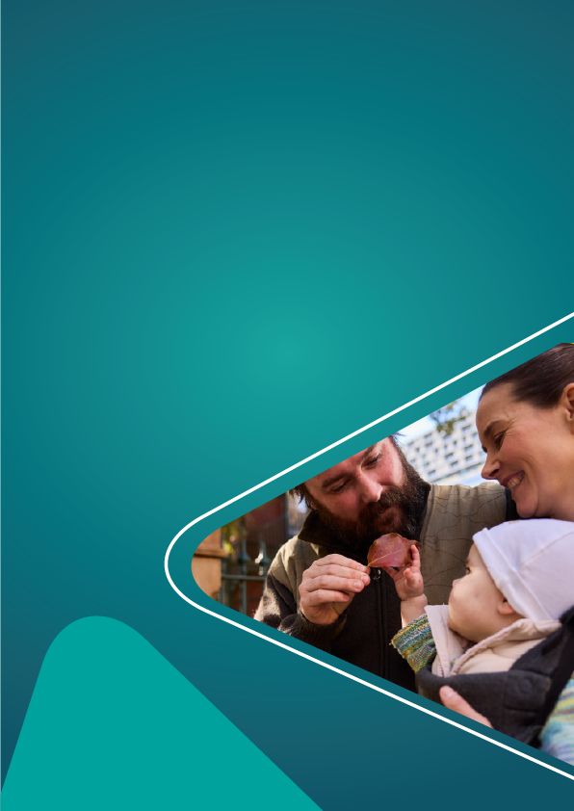


Frequently Asked Questions
Children and Family Support program
Last updated 26 June 2026
DSS3621.06.26

Why is the Australian Government making changes?
We know families are facing more complex challenges. The way we deliver supports requires a better, more coordinated response.
We have also heard that complex and duplicative grant requirements take service providers too long to complete and report on. This takes away from their ability to deliver services to the families and children who need support the most.
The government is committed to improving outcomes for children and their families and cutting red tape for community organisations.
The Children and Family Support (CaFS) Program aims to:
- strengthen the way we support children, their families, and the communities around them
- make grant arrangements and reporting easier and simpler for providers, so that they can spend more time delivering services to families
- Align funding and contracting to outcomes, allowing flexibility in service delivery to deliver meaningful outcomes for children and families.
- prioritise funding to organisations and supports which have shown to have the greatest benefit for families and children.
The program will also introduce a relational contracting approach to support stronger partnerships with service providers and improve outcomes for children and families.

When will we release the Grant Opportunity Guidelines for the CaFS Program?
We expect to release the GOGs and open submissions from September 2026.

Who is eligible to apply for the CaFS program?
The CaFS program will replace the following 5 programs:
- Children and Parenting Support
- Communities for Children – Facilitating Partners
- Family and Relationship Services
- Family Mental Health Support Services
- Specialised Family Violence Services
Through the consultation process we heard that an open and competitive grants process might disrupt trusted, long-established community relationships.
To ensure there is continuity for the families and children who access services, and to minimise disruption to existing service providers, submissions for the CaFS Program will generally be providers who currently deliver services under the 5 programs, through a “recommissioning” approach. Recommissioning means that we providers currently delivering services under the 5 programs CaFS will replace will be invited to reapply for a new grant.
A recommissioning approach will ensure there is continuity for the families and children who access services and minimise disruption to existing service providers.
Further information will be provided to eligible organisations shortly.
The design of the grant opportunity will also support transition to Aboriginal Community-Controlled Organisation (ACCO)-led delivery, particularly in areas where there is a high First Nations population and/or where there is evidence that an identified ACCO that has the capacity and capability to deliver services and could deliver that with the right support and transition plan. Time-limited funding will be available to support this transition.

What will the application process involve?
We will share more information on the recommissioning process and the shift to relational contracting soon. It will broadly involve:
- new GOGs published in September 2026
- an organisation submitting a short submission to demonstrate how their proposed activity aligns with the new program settings
- us using information we already know about these organisations to pre-populate submissions, where possible.
All providers will have to deliver services following the new program’s investment priorities. Investment priorities are outlined on the Children and Family Support Program webpage.
The recommissioning process will give existing providers an opportunity to refocus their activity in line with the investment priorities. In some cases, this may mean:
- adapting service type
- realigning service locations to areas with high levels of community need
- supporting transition to ACCO-led services.
The application process will be designed to be as streamlined and straightforward as possible, while allowing sufficient space for applicants to show the following without requiring unnecessary duplication:
- the range of services they may provide
- local knowledge
- community connections.
We don’t expect organisations will need the support of a third party to support writing a submission.

How will community need be identified?
In their submission, we will ask eligible organisations to show how their activities:
- align with the program’s 2 outcomes
- give consideration to the 4 investment priorities
- meet needs within the community.
We will publish a tool alongside the GOGs to help organisations understand community need in the areas they are delivering services. This tool will allow an organisation to enter their postcode and then see a snapshot of the ‘relative need’ of their community, including but not limited to:
- Socio-Economic Indexes for Areas
- Australian Early Development Census
- If that community has a high First Nations population
Organisations will be encouraged to provide additional evidence of local need in their submissions, recognising that population-level data may not always capture localised disadvantage.
Depending on the results of the recommissioning process, we will provide further advice to the government if we believe more action is needed to address service gaps or unmet needs.

How should providers show services are informed by what the local community needs?
Organisations should show how their proposed services respond to local community need and work with existing services, including through triage and referrals where needed. We encourage community-led approaches so activities reflect local priorities and deliver local solutions.
Submissions should also explain how proposed activities align with any existing community-led initiatives, partnerships, local strategies or shared focus areas.
In locations where the Australian Government has a formal partnership with a community, including through Empowered Communities or Stronger People, Stronger Places, organisations must engage the local decision-making body before lodging their submission.
Organisations should show how their proposed service connects to at least one priority in the formal partnership agreement and acknowledge that the local decision-making body’s view will inform the recommissioning process.

Will there be an opportunity to apply for additional funding?
The submission will include mandatory questions for eligible organisations to demonstrate how their current and any proposed new activities align with the 4 investment principles, that are achievable within current funding levels.
Organisations will also be able to apply for more funding where they can demonstrate how this would increase their impact under the new program settings. This could include new or expanded activities, or time-limited funding to support ACCO transition arrangements.

How will program impact be measured?
A focus of the program is measuring impact, so that the department can see where and how activities are making a difference, and to identify where a change in approach might be required.
Organisations funded under CaFS must be able to show how each activity is led by evidence and will achieve outcomes.
Evidence-led activities are informed by a clear understanding of what works, for whom, and in what circumstances. This may include drawing on research, program evaluations, practice expertise, community knowledge, client data and the lived experiences of children, families and communities. Evidence-led delivery also involves monitoring outcomes over time and using data, feedback and learning to refine activities so they remain responsive to community need and contribute to the CaFS program outcomes and investment priorities.
The Department will release a high-level draft Impact Placemat alongside the grant opportunity, which organisations may consider using to demonstrate how their activities will achieve outcomes.
DEX reporting, including client outcome reporting, will be adjusted over time to streamline reporting obligations and enhance data quality. This will support outcome measurement and quality improvement.

How will the program support improved outcomes for First Nations children?
One of the new program’s investment priorities is to uplift the number of ACCO delivered services, particularly in communities where there are significant numbers of First Nations children and families.
We will drive this through new contracting arrangements. These will encourage providers to enter into partnership arrangements with ACCOs for the delivery of services. In some cases, these will mandate transition to ACCOs as the lead organisation over time.
Targeted time limited funding will also be available to support providers to transition to new program arrangements. This could support the transition to ACCO-led delivery models.
All CaFS service providers must be able to deliver services that are respectful, culturally appropriate, and safe for First Nations children and their families.

What will a relational contracting approach look like?
Under the CaFS Program, grants will be delivered using a relational contracting approach. Visit the DSS Engage website to read about the Relational Contracting consultation.

Will the new program provide services for adults without dependent children?
No. We will work with organisations to refocus and realign their existing activities, where necessary.

Will reducing 5 programs to one mean you will be cutting services?
No. This reform is about cutting red tape, not cutting funding for services.
The extra funding for the new program is a 12% increase on the funding for the 5 programs being replaced by CaFS.
We expect this increase to support up to 26,000 extra children and their families each year. This means the program can reach up to 270,000 children and families each year.

If you have questions about the Children and Family Support Program, contact your Funding Arrangement Manager or email families@dss.gov.au

