POLIS: The Centre for Social Policy Research  ANU College of Arts & Social Sciences | POLIS WORKING PAPER  NO. ##




The costs of children in Australia estimated using financial stress
Ben Phillips, Maria Jahromi, Bruce Bradbury, Richard Webster and Matthew Gray

Working Paper No. ##/2024
DOI XXXX
POLIS: The Centre for Social Policy Research
Research School of Social Sciences
College of Arts & Social Sciences
The Australian National University
Front cover image:
Terry Ngamandarra Wilson, Gulach (detail), painting on bark, private collection © Terry Ngamandarra, licensed by Viscopy, 2016
Suggested citation: Phillips, B., Jahromi, M., Bradbury, B. Webster, R. & Gray, M. (2024), The costs of children in Australia estimated using financial stress (Working Paper No. ##), POLIS: The Centre for Social Policy Research, Australian National University.
Ben Phillips is an Associate Professor at POLIS: The Centre for Social Policy Research at the Australian National University. Maria Jahromi was, at the time of writing, a Senior Lecturer at POLIS: The Centre for Social Policy Research at the Australian National University. Bruce Bradbury is an Associate Professor at the Social Policy Research Centre, UNSW Sydney. Richard Webster is Senior Research Officer at POLIS: The Centre for Social Policy Research at the Australian National University. Matthew Gray is Professor and Director of POLIS: The Centre for Social Policy Research at the Australian National University
The costs of children in Australia estimated using financial stress
Ben Phillips, Maria Jahromi, Bruce Bradbury, Richard Webster and Matthew Gray
Abstract
Estimates of the costs of children are used in a wide range of economic and social policies. One important use is in the design of child support schemes and in setting the amount of child support payments that separated parents are required to pay or entitled to receive.
This paper provides new Australian estimates of the costs of children using a financial stress approach (a variant of the equivalent living standards approach) using data from the Household Income and Labour Dynamics in Australia (HILDA) Survey.

Acknowledgments
We would like to thank the Australian Government Department of Social Services (DSS) for its generous support of this study, and for helpful feedback and discussion throughout the life of this project.
Acronyms
ABS Australian Bureau of Statistics
HILDA Household Income and Labour Dynamics in Australia
Contents
Abstract ii
Acknowledgments ii
Acronyms iii
Tables v
Figures v
1 Introduction 1
2. Data and statistical methodology 3
3. Costs of children 8
Conclusion 22
References 23
Appendix A. Regression results 24
Appendix B. Equivalence scale estimates based on disposable household income using pooled HILDA data 28
Appendix C. Estimates based on the Survey of Income and Housing 2019-20 31

Tables
Table 1. Number of children In couple families of different ages and gross household income level, HILDA 2021 5
Table 2: Equivalence scale financial stress estimates for couple parent families by number and age of children and household income category, pooled estimates 2013 to 2021 14
Table 3. Equivalence scale financial stress stimates for couple parent families by number and age of children and household income category (disposable household income), 2013 to 2021, disposable household income approach 16
Table 4. Equivalence scale financial stress stimates for couple parent families by number and age of children and household income category (equivalised disposable household income), 2013 to 2021, disposable household income approach 18

Figures
Figure 1. Equivalence scale financial stress estimates for couple parent families by number of children, 2013 to 2022, gross household income approach 10
Figure 2. Equivalence scale financial stress estimates for couple parent families by number and of children , 2013 to 2022, gross household income approach 11
Figure 3. Equivalence scale financial stress estimates for couple parent families by number of children and household income category, Wave 21 (2021), gross household income approach 12
Figure 4. Equivalence scale financial stress estimates for couple parent families by number and age of children and household income category, pooled estimates 2013 to 2021, gross household income approach 15
Figure 5. Equivalence scale financial stress estimates for couple parent families by of children and household income category (disposable household income), pooled estimates 2013 to 2021, disposable household income approach 17
Figure 6. Average equivalence scales (all households)for couple parent families, pooled estimated 2013-2021, gross and disposable household income approaches 20
Figure 7. Average equivalence scales, lower-income households, by estimation approach 21
Figure 8. Average equivalence scales, middle-income households, by estimation approach 22

1 Introduction
Estimates of the costs of children are used in a wide range of economic and social policies. One important use is in the design of child support schemes and in setting the amount of child support payments that separated parents are required to pay or entitled to receive. This paper provides new estimates of the costs of children to help inform the work of the DSS Child Support Expert Panel.
In using the results reported in this paper it is important to bear in mind that there is no consensus as to how to define or measure the costs of children and there are several approaches that are used.
The different approaches to estimating the costs of children all have strengths and limitations and require the use of strong assumptions. Consequently, the different approaches can produce quite different estimates and there is no unambiguous ‘true cost’ of child (Gray and Stanton 2010). The US National Academy of Sciences Panel on Poverty and Family Assistance concluded that ‘although the empirical evidence helps determine the limits of what makes sense, there is no objective procedure for measuring the different needs for different family types’ (Citro and Michael, 1995, p. 161). It is thus important to draw upon a range of estimates of the costs of children using different approaches and data sources.
The literature on the costs of children has attempted to answer three broad questions (Browing 1992; Gray and Stanton 1999):
- The needs question—how much income does a family with children need, compared to a childless family, to attain a specific standard of living?
- The expenditure question— how much do parents spend on their children?
- The iso-welfare question: how much Income does a family with children require to have the same level of wellbeing (utility) as a family with no children?
There is some overlap between the needs question and the iso-welfare question. While the needs question is about the specific standard of living the iso-welfare question is about wellbeing more broadly defined (utility), in practice the iso-welfare question uses a consumption-based proxy for utility. which leads to some lack of distinctiveness from the needs questions in practice. From the perspective of the design of the Child Support Scheme the most relevant are the needs and Iso-welfare questions. In broad terms the empirical approaches to estimating the costs of children are:
- The budget standards approach: this approach involves defining a bundle of goods and services which are deemed necessary to meet the needs of a children and then costing this. This approach is generally used to answer the needs question.
- Various approaches based on observing either the actual expenditure patterns of households of different compositions, or other indicators of household well-being such as financial stress.
This paper provides new Australian estimates of the costs of children using the equivalent living standards approach. Various approaches are used to estimate the equivalent living standards concept of the costs of children all of which involve estimating the impact of children on the cost function to parents. The approaches differ in the assumptions they make about the impact of children on the cost function and how to equivalise the living standards. The main methods which have been used are the Engel and Iso-Prop methods, the Rothbart method, and Complete Demand System methods.
In essence the equivalent living standards approach involves estimating the amount of additional income a family with children require to obtain the same ‘standard of living’ as a couple without children. Using the Engel procedure as an example, the share of the family budget devoted to food is used as an indicator of living standards (Engel 1895). The central concept is simple: as family income falls, a family devotes a greater proportion of its total weekly spending to food. So, Engel suggested that the proportion of a family’s total spending that was devoted to food could be considered a reliable proxy for a family’s standard of living. Similarly, the ‘Rothbarth’ or ‘adult goods’ method, uses the level of household expenditure on goods consumed only by adults (adult clothes etc), as the living standard indicator in households with and without children.
Within the equivalent living standards approach a relatively new methodology that has been developed is to use financial stress, financial hardship or deprivation (rather than the proportion of expenditure to food (or other essentials)) as the well-being ‘measuring stick’ to compare the living standards for households of different sizes and compositions (see for example Breunig and Cobb-Clarke 2005; Breunig, Hasan and Hunter 2019).
The financial stress approach has both strengths and weaknesses. Strengths include the fact that financial stress questions are a direct measure of financial stress for the purpose of considering economic welfare (living standards) whereas the expenditure share is an indirect measure of welfare that for some households may have little do with welfare but rather be the result of their own preferences. It may also be that a family’s expenditure share is the function of the nature of parenting children rather than an indicator of financial wellbeing. In addition, in the current Australian context financial stress data is more readily available and up to date than household expenditure data.
Financial stress can be measured in several ways (for example, any stress, more than 3 forms of stress, any of the more extreme forms of financial stress) and there is no clear measure that is best suited to modelling the cost of children. Moreover, financial stress measures, at least for individual persons or families, may be the outcome of differing financial planning or literacy levels. For modelling at population level this may be less of an issue but where certain demographic groups are known to have different financial literacy or financial planning abilities the cost of children estimates may partly reflect those differences and not the genuine cost of children component.
Regardless of the approach taken to estimating the cost of children using the equivalent living standards approach (expenditure or financial stress) a useful feature of these estimates is that they are very flexible compared to the budget standards approach. They can provide very detailed costs for different family types whereas the budget standards approach requires very detailed and often strong judgements on the cost of children for each family type. Developing an estimate for each family type is time consuming so the economic approach offers a relatively simple way to estimate the cost of children for a wide range of family types be they low or middle or high income, families with different number of children or for children of different ages.

2. Data and statistical methodology
This section describes the data used to estimate the costs of children, some data related issues and the statistical methodology used.

Data
The costs of children are estimated using the Household Income and Labour Dynamics in Australia (HILDA) Survey. The HILDA survey is a nationally representative household-based longitudinal survey. HILDA started in 2001 and collects data annually from all people aged 15 years or older in each household. In wave 1 data was collected from 7,682 households and 13,969 individuals. All people living in households that participated in the survey in Wave 1 formed the basis of the panel from whom interviews are sought in each subsequent wave. The panel expands over time to include any new household members resulting from changes in who is living in the original households. The sample was topped-up in wave 11. The most recent wave of data that was available at the time this research was undertaken was collected 2022 (wave 22). In wave 22 data was collected from 7,117 households which had 17,199 persons living in them.
The HILDA survey asks respondents (aged 15 years or older) if they experienced a range of financial stresses. The specific question asked is “Since January [relevant year] did any of the following happen to you because of a shortage of money?” with the following list provided:
- Could not pay electricity, gas or telephone bills on time
- Could not pay the mortgage or rent on time
- Pawned or sold something
- Went without meals
- Was unable to heat home
- Asked for financial help from friends or family
- Asked for help from welfare / community organisations
In addition, HILDA survey includes the question “Suppose you had only week to raise $4,000 for an emergency. Which of the following best describes how hard it would be for you get that money?” with response options: I could easily raise the money; I could raise the money, but it would involve some sacrifices (e.g., reduced spending, selling a possession); I would have to do something drastic to raise the money (e.g., selling an important possession); or I don’t think I could rase the money.
The financial stress measure takes the value of one if at least one of these types of financial stress (including the ability to raise money in a crises) and zero otherwise. The measure is thus a simple ‘any stress’ measure. This measure does not place any greater weight on households who experience a greater number of financial stresses than households that experience a smaller number of financial stresses. This is essentially a judgement call and based on what one might expect to best correlate, across a wide range of income, with financial wellbeing. Were the measure of financial stress to only include the deeper forms of stress, such as going without meals, then such models would perform badly at discriminating between the cost of children for higher income households for whom these deeper forms of financial stress are extremely rare.
The sample is restricted to couples with and without dependent children. A dependent child is defined as a person being under 18-years of age. The sample is further restricted to adults who are less than 55-years of age but older than 20 years. Couples with any adult children and any couples living with other related or not related household members are excluded. Those aged 55-years and over are excluded from the modelling since cost of children approach attempts to compare the cost of a family with children with a reasonable counterfactual family without children – the difference being the cost of children. For example, a couple family without children who are retired and aged over 65 are not a realistic comparator group to families with children. Individuals with an age under 55 but with a partner aged over 55 are retained. the older partner is not retained. While it is possible to control for factors such as wealth, home ownership and age we expect that their inclusion in any modelling would likely bias results in a way that will be difficult to fully account for. Households with very low equivalised household incomes are excluded ($200 per week or less).
An alternative to using financial stress to estimate the equivalence scales is financial satisfaction. Respondents to the HILDA survey are asked to rate their financial satisfaction on a scale of 1 to 10. While conceptually a promising metric is only limited variation with most respondents, even people with substantial financial stress, rating their satisfaction as a 6, 7 or 8. A possible reason for this is that people compare themselves to their reference group which may be other low-income people in their neighbourhood. The regression results were broadly sensible across the whole population, but the models performed poorly in terms of fit and statistical significance for more detailed results such as the age of children or different income groups. Models are based on financial satisfaction are therefore not reported in this paper.

Estimation approach
As outlined in the introduction, the approach used to estimating the cost of children is to estimate the income required in households with and without children that will lead to them having the same living standards as measured by financial stress. The costs of children are expressed using equivalence scales which indicate how much additional income is needed to maintain living standards as the number of children increase compared to a couple family without children. An example can help illustrate the interpretation of the equivalence scales. If the reference family is a childless couple, then they have an equivalence scale of 1.00. If the equivalence scale for a couple with one child is 1.20, then this implies that a couple with one child needs 120 per cent of the income of the childless couple to enjoy the same standard of living. These equivalence scales can be converted to a dollar cost at a particular household income.
When estimating the amount of income needed to "equivalise" living standards the choice must be made as to which measure of income to use. The two broad choices are gross or disposable household income. Given that the primary purpose of this paper is to provide estimates of the costs of children to help inform whether changes need to be made to the child support formulae, the income measure used is gross household income. This is closer to the definition to the income measure used in the child support formula. Disposable household income is, arguably, a better measure of living standards as the measure deducts personal income tax payments. Given that are there are arguments for and against both gross and disposable household income both sets of results are reported in the paper. Anticipating one the conclusions of this paper, choice of income variable has relatively little impact on the estimated costs of children.
The number of couple families with children in the different age ranges in a single wave of the HILDA survey are relatively small (see

Table 1) and therefore the costs of children are estimated both using single waves of the HILDA survey and pooling waves of the HILDA survey which increases the sample size and results in smaller standard errors, even after taking into account the loss of sample efficiency from having the same individuals in multiple waves of the data. The estimates made using single waves of the HILDA survey also provides information on the extent to which there is any time trend in the estimated costs of children.

Table 1. Number of children In couple families of different ages and gross household income level, HILDA 2021
Number of children | Age of children
Number of children | 0-5 years | 6-12 years | 13-17 years | 0-17 years
 | Lower income
1 child | 192 | 50 | 37 | 279
2 children | 356 | 226 | 90 | 672
3 children | 192 | 186 | 78 | 456
4+ children | 115 | 139 | 53 | 307
 | Middle-income
1 child | 115 | 139 | 53 | 307
2 children | 505 | 349 | 128 | 982
3 children | 241 | 226 | 100 | 567
4+ children | 76 | 78 | 57 | 211
 | All households
1 child | 557 | 137 | 110 | 804
2 children | 1,270 | 958 | 412 | 2,640
3 children | 621 | 676 | 323 | 1,620
4+ children | 232 | 297 | 137 | 666
Source: HILDA Wave 21 (2021).

Statistical models estimated

Cross-sectional analysis over time
To estimate the equivalence scales using cross-sectional data (treating each wave of HILDA as a separate cross-section) a logit regression model is used with the dependent variable being whether the person experiences at least one type of financial stress and explanatory variables including household income and measures of the age of children variables. Equation (1) specifies the logistic regression model which is the basis for the equivalence scale calculation for children aged 0-17 years and separately for children of different ages:
$logit\left(\operatorname{Pr}\left({FS}_{i}=1\right)\right)= β_{0}+β_{1}ln\left(income_{i} \right)+β_{2}\ln\left(N_{Children{05}_{it}}\right)+β_{3}\ln\left(N_{Children{612}_{i}}\right)+β_{4}\ln\left(N_{Children{1317}_{i}}\right)+\sum_{a=1}^{k}{γ_{a}}X_{i}$) (1)
where ${FS}_{i}$ is a binary variable equal to 1 if the household experienced at least one type of financial stress out of eight possible types and 0 otherwise. $N_{Children{05}_{i}}$ is the number of children aged 0-5 years, ${N_{Children612}}_{i}$ is the number of children aged 6-12 years and $N_{Children{1317}_{i}}$ is the number of children aged 13 to 17 years. The number of children variables are expressed on a logarithmic scale (+1) to allow for economies of scale. $ln\left(income\right)$ is the natural logarithm of gross household income per week. $X_{1}$ to $X_{k}$ refer to k control variables. Control variables are selected based on the model fit via AIC and include adult age groups (age 18-24, age 25-34, age 35-44 as base category and age 45-59), tenure (home owner, home mortgage, renting as base category and living rent free), a dummy variable for gender of the respondent, labour force status (full-time employed as base category, part-time employed, unemployed, not in the labour force) and a series of dummy variable for state and territory of the adult and a further regional variable for capital city/rest of state.

Pooled data analysis using HILDA waves 13 (2013) to wave 21 (2021)
The models using the HILDA data pooled over wave 13 to wave 21 have similar specifications as Equation (1). The sample size for the pooled data analysis is about 41,500 (couples and couples with children), with most individuals appearing in more than one wave. Household income is adjusted for inflation and expressed in 2022 dollars.
The standard errors for the parameter calculations account for clustering generated by having repeated observations on individuals using the variables recommended in the HILDA documentation to overcome clustering issues for longitudinal data. While the pooling of data does significantly increase the sample size the estimated standard errors are increased once we account for the clustered nature of the HILDA longitudinal data.
Given the interest, from a child support perspective, as to whether the costs of children vary with household income, equivalence scales are estimated for different household types and for households at different points in the income distribution (low- and middle-income households).
Three regression models are estimated. The first is for all households and is used to estimate the overall equivalence scale for all households. The second model is for lower income families, and the third model is for middle-income level families. Income groups were based on splitting the sample into three equally sized populations (terciles) based on the sample. Equivalence scales were estimated for higher-income households. However, the variables capturing number of children by age were in a few cases not statistically significant. This is not entirely surprising given that relatively few higher income households experience financial stress. Given concerns about the robustness of the results for higher-income households the resulting equivalence scales for high-income households are not reported.
For the regression models using gross household income as the explanatory variable households are categorised into lower- and middle-income based on gross household income. For the regression models which use disposable household income, two approaches are used to categorise households into lower- and middle-income. The first is to use disposable household income and the second is to use equivalised disposable household income.

Equivalence Scale Calculations
The estimated coefficients from a simplified form of equation 1 (where age of children is not distinguished) are used to calculate the equivalence scales (ES) by equalising the predicted probability of financial stress of couples with different numbers of children. That is, for a couple with one child the natural logarithm of $N_{Children}$ is set equal to 2 (one child plus adding the constant 1)) and this predicted value is set equal to the predicted value for a couple without children (setting the natural logarithm of $N_{Children}$ equal to 1, i.e., zero children plus adding the constant 1).
${\hat{β}}_{0}+{\hat{β}}_{1}ln\left(income_1child\right)+{\hat{β}}_{2}×\ln\left(2\right)+\sum_{a=1}^{k}{γ_{a}}X_{i} ={\hat{β}}_{0}+{\hat{β}}_{1}ln\left(income_couple\right)+{\hat{β}}_{2}×\ln\left(1\right)+\sum_{a=1}^{k}{γ_{a}}X_{i}$
$${\hat{β}}_{1}ln\left(income_1child\right)+{\hat{β}}_{2}×\ln\left(2\right)= {\hat{β}}_{1}ln\left(income_couple\right)+{\hat{β}}_{2}×\ln\left(1\right)$$
$ln\left(income_1child\right)-ln\left(income_{couple}\right)=\ln\left(\frac{{income}_{1child}}{income_{couple}}\right)=-\frac{{\hat{β}}_{2}×\ln\left(2\right)}{{\hat{β}}_{1}}$
$ES=\frac{{income}_{1child}}{income_{couple}}=e^{\left(- \frac{{\hat{β}}_{2}×\ln\left(2\right)}{{\hat{β}}_{1}}\right)}$ (2)

All other control variables are held constant, so that we are comparing couples without kids to couples with one child that are otherwise identical in the socio-demographic aspects that are captured by our control variables.
The same approach is applied to the full version of Equation (1) except that the estimated coefficient ${\hat{β}}_{2}$on the number of children is replaced with the estimated coefficient that corresponds to the number of children of the age group that we are interested in, i.e., either ${\hat{β}}_{2}$, ${\hat{β}}_{3}$, ${\hat{β}}_{4}$ or ${\hat{β}}_{5}$. The number of children from other age groups is held constant.

Confidence intervals on the equivalence scale estimates
As outlined above, the equivalence scales are calculated from the parameters (coefficients) for income and the various children related variables estimated using regression models regression equations. The equivalence scales are a non-linear combination of these parameters. The parameters used for calculating the scales have standard errors associated with them. The calculation of the standard errors and confidence intervals is not straightforward since the equivalence scales are a non-linear combination of the regression coefficients for household income and the number and age of children from the underlying regression models. Calculating the standard errors for the non-linear combination of parameters (the equivalence scales) must account for the cross-correlation matrix between model parameters. To estimate the standard errors, the SAS macro nlest macro (non-linear estimate) is used.
It’s important to remember with the equivalence scale estimate that a ‘significant’ parameter estimate alone does not guarantee a small standard error for an equivalence scale estimate. A significant parameter suggests that the estimated impact of a variable is not equal to zero, but it may be that the standard error still allows reasonably large variation above zero which could lead to substantially different equivalence scales from random chance alone.
For the models which used pooled waves of HILDA data the standard errors for the estimated regression parameters need to be ‘robust’ standard errors that account for the clustering of the HILDA survey generated by the longitudinal nature of the pooled sample. That is, pooling doesn’t really increase the sample size as dramatically as it may appear as most people are in each of the pooled waves and will often give the same or at least strongly correlated financial stress responses in each wave.

Methodological limitations
The most important assumption made in this estimation is that our indicator of financial stress is a suitable indicator of well-being that is equally relevant across households of different composition. So, for example, if people were more likely to seek help from welfare organisations when they have children – simply because many welfare organisations only provide help to parents – then this would bias the estimates of the cost of children (upwards in this case). While we think such biases will be small, if they exist at all, there is no definitive test for comparability of the stress indicator across family types. More generally, some family types might respond to financial stress by restricting other areas of expenditure that are not included in the set of financial stress indicators. Our estimation approach assumes that the list of stress items includes items that are of salience for financial stress.
Similarly, if fertility Is influenced by financial stress, rather than the other way round, then the results will not be an accurate reflection of the costs of children.
Finally, previous research has shown that the relationship between financial stress indicators and income and family size is often noisy, with many other factors (such as personal organisational skills) intervening. To the extent to which these factors are independent of the relationships estimated, this imprecision is captured by our standard error estimates.

3. Costs of children
This section presents the estimates of the equivalence scales for couples with dependent children and thus the costs of children. Two sets of results are reported. The first set of estimates are the costs of children using each wave of HILDA from 2013 to 2022 as a separate cross-section. This provides information on the extent to which the costs of children are changing over this period. The second set of analysis pools the HILDA data for the period 2013 to 2021. The advantage of this approach is that it is substantially increases the number of observations on which the regression models are based which results in more precise and stable estimates. The pooled estimates are our preferred estimates using the HILDA Survey.

Costs of children over the period 2013 to 2022
This section reports the result of the costs of children for each wave of the HILDA survey from 2013 to 2022. This provides information on the extent to which the costs of children have changed over the last ten-years. As outlined above the costs of children expressed as equivalence scales for couple parent families for each year from 2013 to 2022 (Figure 1). The equivalence scale is set to the value of 1 for a couple only family and thus the equivalence scales reported in Figure 1 show how much additional income is required to equivalise living standards for couple parent families with children compared to a couple family with no dependent children.
While the estimated equivalence scales fluctuate, there is no evidence of any systematic trend in the costs of children over this period. This is consistent with the finding of range of estimates undertaken at different points of time that the costs of children as a proportion of household income only changes gradually.
The equivalence scales are much higher when estimated using the 2022 data than for any other year for all numbers of children. The increase is also very substantial compared to the previous year (2020/21). The reasons for the much higher costs of children using the 2022 wave of data are not clear and given the concerns about the 2022 results the 2022 data is not used in the estimates based on the data pooled across waves.
As a point of comparison, the values of the OECD modified equivalence scale which widely used for the purposes of adjusting household income for differences in household size and family composition are shown in the figure. The results show that for most years the average estimated equivalence scale is a little lower than the OECD modified scale. As an example, for the most common case of 2 children the equivalence scale ranges between just around 1.2 to just above 1.4. the OECD scale for a couple with two children is 2.1, or relative to a couple only 1.4.
The equivalence scales for number of children by age of child using gross household income for each year from 2013 to 2022 have high standard errors and consequently wide confidence interval (Figure 2).
Figure 1. Equivalence scale financial stress estimates for couple parent families by number of children, 2013 to 2022, gross household income approach
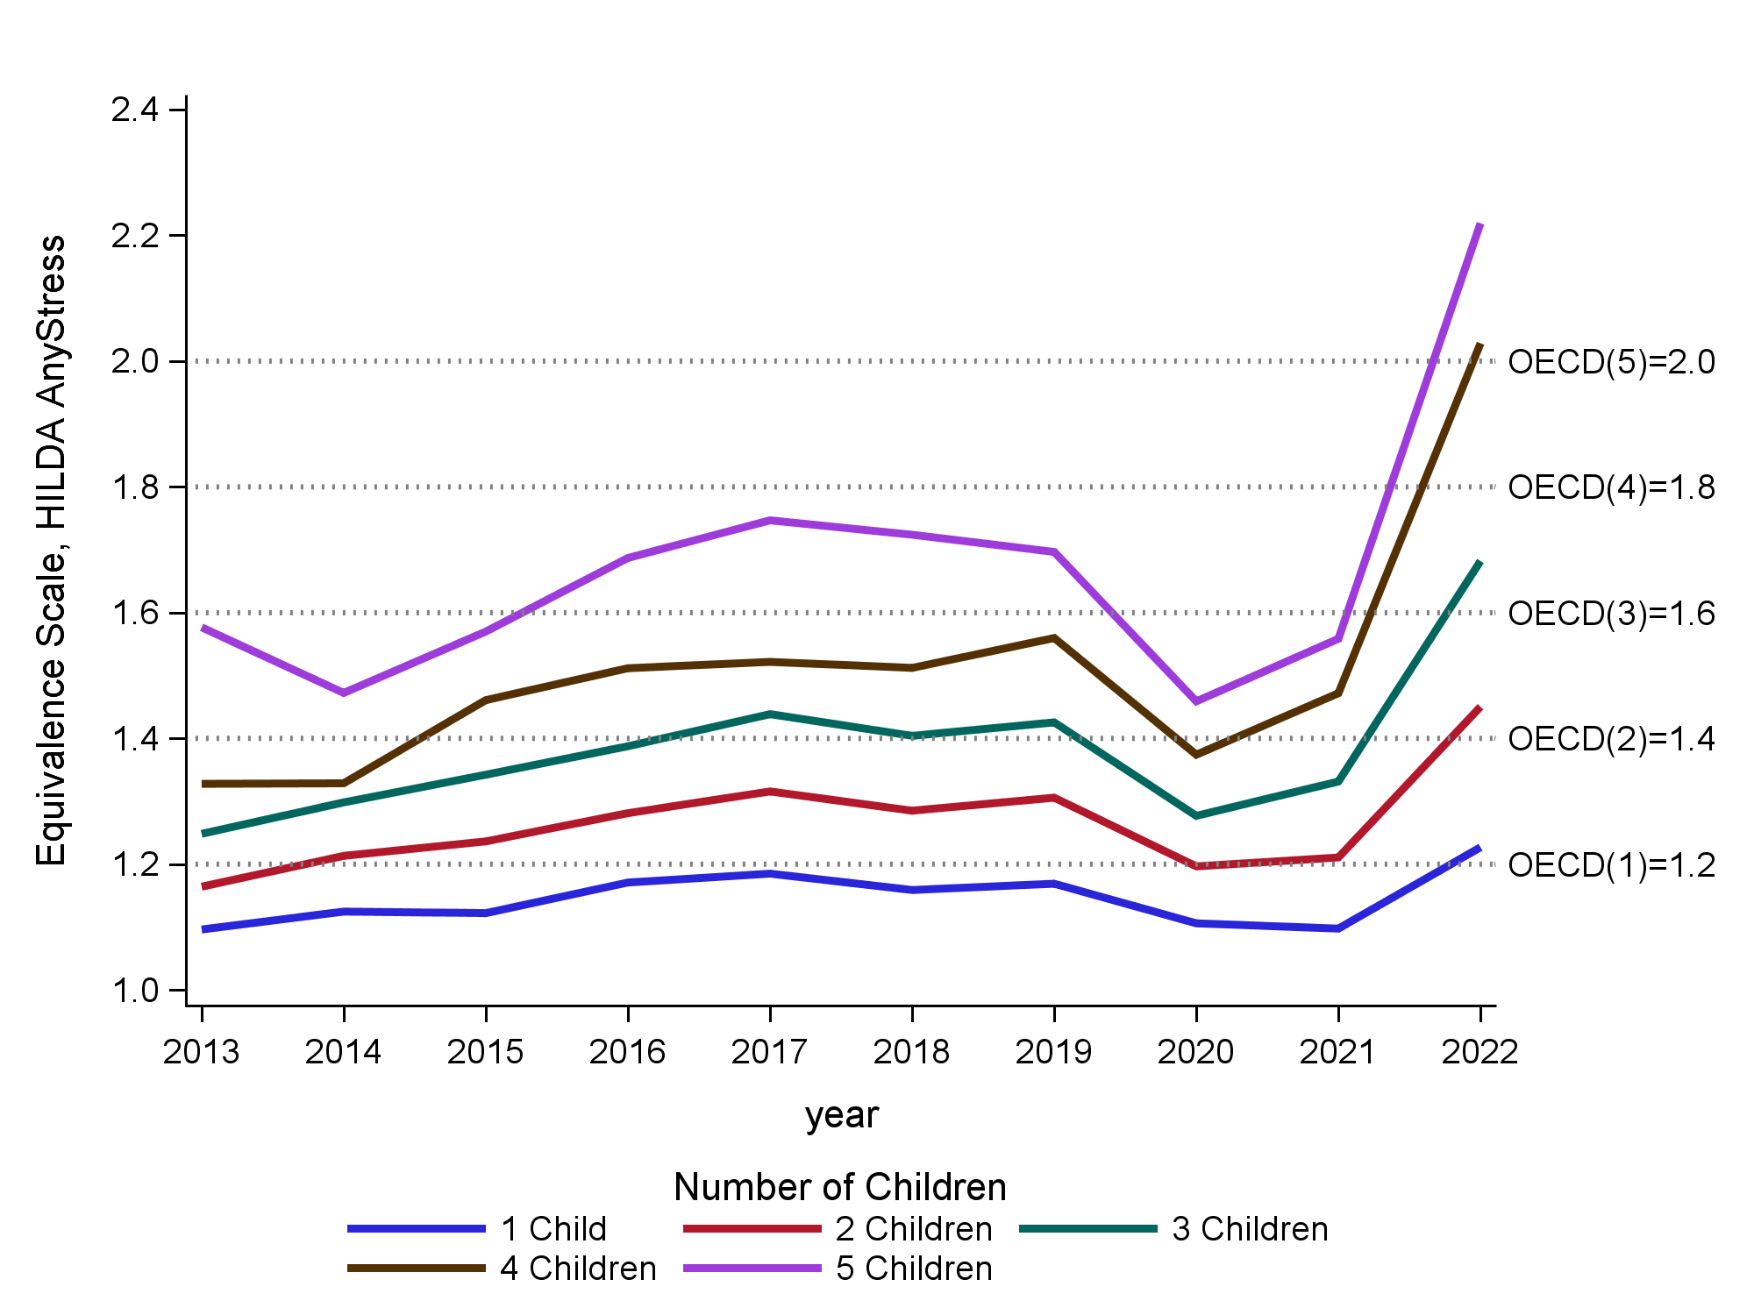
Notes: The income measure used is gross household income. Underlying regression models are unweighted.
Source: HILDA, Wave 13 (2013) to Wave 22 (2022).
Figure 2 shows the estimated equivalence scales for each children age group (0-5 years. 6-12 years and 13-17 years over the period 2013 to 2022. The trends are not all that clear although there is some evidence that younger children are getting more expensive and that older children less expensive. As expected, the equivalence scales increase as the number of children increase.
The equivalence scales for children 0-5 years are estimated to have increased very sharply from 2013 and remained higher until 2019 and then fallen back in 2020 and 2021 to about what they were in 2013 and 2014. For children aged 6-12 years the equivalence scales have increased since 2014. For children aged 13 to 17 years the trend was for falling equivalence scales until 2020, with an increase in 2021. All age groups are impacted through COVID with lower numbers through the peak years of COVID (2020 and 2021) but then a strong jump in 2022 (not shown In Figure 2) as we shift out of peak-COVID, although as noted above there are reasons to be cautious of the estimates for 2022.
Figure 2 Equivalence scale financial stress estimates for couple parent families by number and of children, 2013 to 2021, gross household income approach
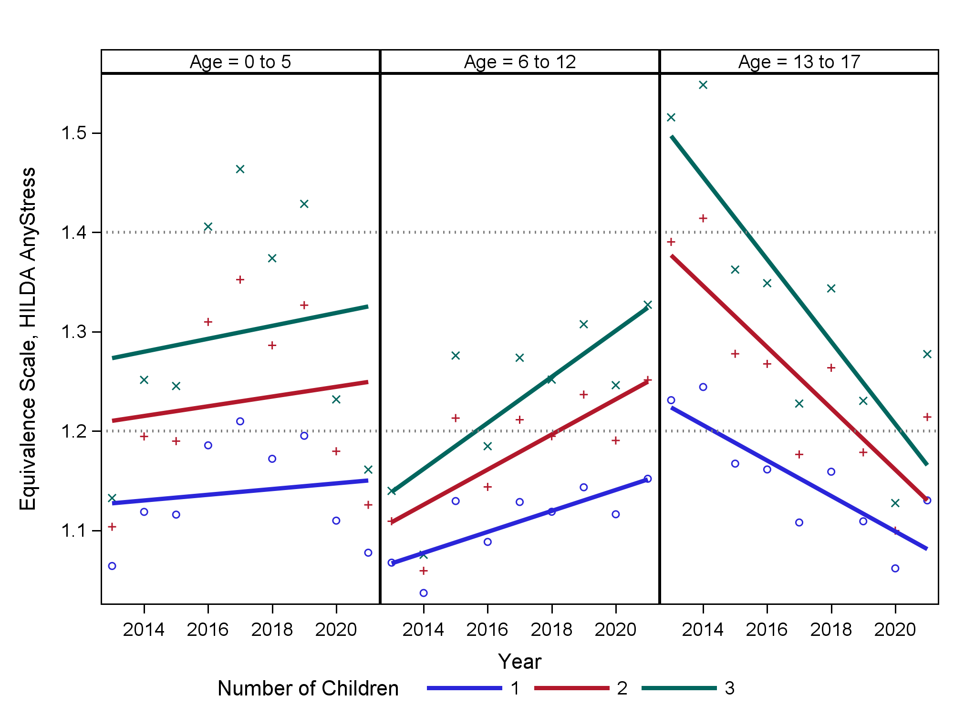
Notes: The income measure used is gross household income. Underlying regression models are unweighted.
Source: HILDA, Wave 13 (2013) to Wave 21 (2021).
Figure 3 shows the equivalence scales for number of children of different age groups by household income category derived from a regression model using only Wave 21 (2021) data. The figure shows the 95% confidence intervals. While the pattern of equivalence scales estimated generally make sense, the 95% confidence intervals are large, particularly for lower-income and middle-Income household models.

Figure 3 Equivalence scale financial stress estimates for couple parent families by number of children and household income category, Wave 21 (2021), gross household income approach
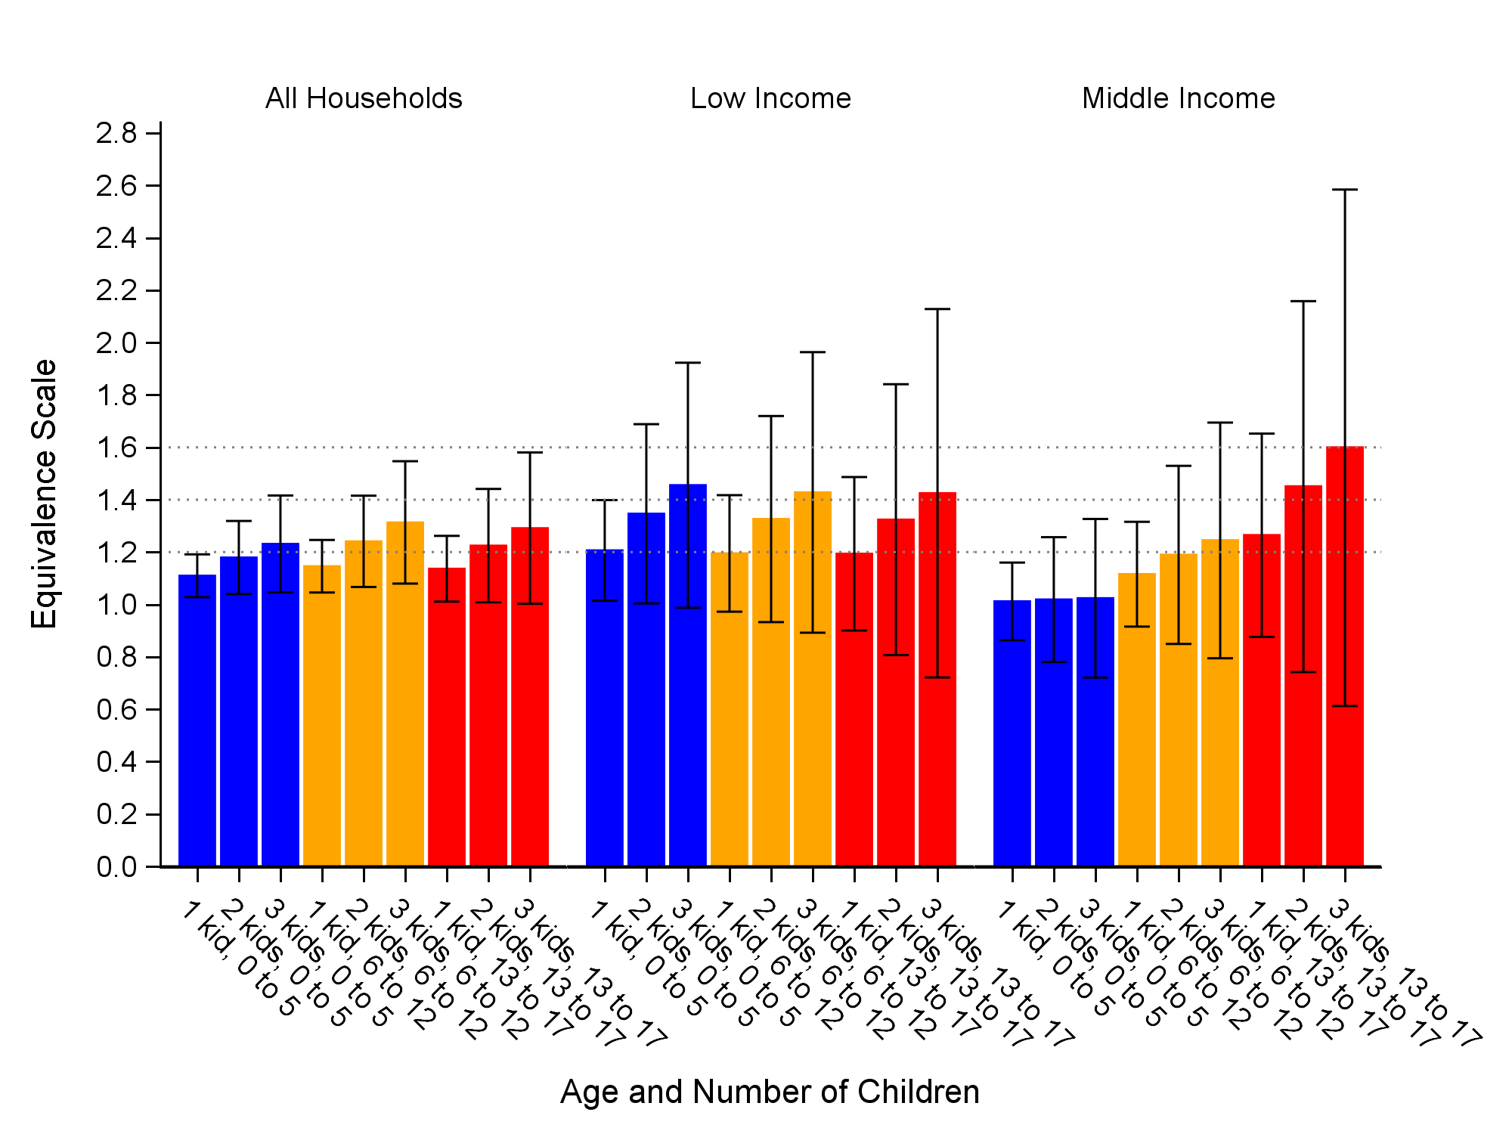
Notes: The income measure used in the underlying regression model is gross household income. Household are categorised as being low- or middle-Income based on gross household income. The whiskers show the 95% confidence intervals. Underlying regression models are unweighted.
Source Wave 21 (2021).
The equivalence scales estimated using disposable household income as the income measure are reported in Appendix B. The results indicate a similar story to the estimates based on gross household income, albeit with slightly lower equivalence scales for all households’ models. Results for low and middle income households do vary but disposable income version's standard errors are considerably lower, particularly for the middle income households model.

Pooled estimates
This section reports the estimated equivalence scales using the data from the HILDA survey pooled over waves 13 (2013) to 21 (2021). As noted above the pooled analysis does not include data for wave 22. The estimated equivalence scales, however, are not particularly sensitive to the exclusion of the 2022 data. The lack of any overall trend in the equivalence scales over time suggests that the data over the period 2013 to 2021 can be safely pooled. Given the high standard errors for some of the equivalence scales estimated by income the estimates based on the pooled data are preferred.

Gross household income approach
This section reports the results using gross household income. As outlined above this is our preferred approach to informing the costs of children from the perspective of the Child Support Scheme. The next section reports the results using disposable household income.
The estimated equivalence scales are reported in Table 2. Equivalence scales are estimated for all children 0-17 years, and separately for children aged 0-5 years, 6-12 years and 13-17 years. The estimates are also made for all households and for lower- and middle-income households. The estimation results of the underlying regression models are provided Appendix A.
Across households of all income levels, for couple families with one child aged 0 to 17 years the equivalence scale is 1.15 which means that the costs of the child is an additional 15% to the household income of a couple only family. Each additional child adds additional cost. The estimates exhibit some economies of scale when going from one to two-children, but not as additional children are added. With each additional child costing roughly the same as the previous child. This differs from what is generally found in the literature (Gray and Stanton 2009, Table 2) however it should be noted that due to compositional differences between small and large families (large families more likely to have older children on average) it is difficult to interpret economies of scale for the 0 to 17 year case.
Table 2 also shows that households with more children of the same age do tend to exhibit economies of scale. For example, for families with only children aged 0 to 5 years the first child’s equivalence scale is 1.16 (adding 16% to costs) whereas the second child adds a further 9 percentage points to costs (scale = 1.25) and third child aged 0 to 5 adds a further 11 percentage points (scale = 1.36). The small number of respondents with more than 3 children within specific age ranges means that it is not possible to reliably estimate the impact on costs beyond 3 children by within a specific age range (other than for the age range 0-17 years).
The costs of children, as percentage of household income, are higher for low-income households than for middle-level income households. This is consistent with the conclusion reached by the 2004-05 Ministerial Taskforce on Child Support. The estimates for all-households show that younger children (0-5 years) cost more than primary aged children (6 to 12 years) and that secondary aged children cost a similar amount to younger children (0-5 years). The literature generally suggests that the expenditure costs of children increase with age of child (excluding the foregone earnings costs of providing care for children) so the findings in this paper is a somewhat surprising result (Gray and Stanton, 2009).
Table 2 Equivalence scale financial stress estimates for couple parent families by number and age of children and household income category, pooled estimates 2013 to 2021
 | Low-income  ($200-$2,380 pw) | Middle-income  ($2,380-$3,605 pw) | All Households
 | Equivalence scales
 | Children 0 to 17 years
1 child | 1.23 | 1.09 | 1.15
2 children | 1.41 | 1.16 | 1.25
3 children | 1.58 | 1.24 | 1.36
4 children | 1.76 | 1.33 | 1.47
5 children | 1.99 | 1.41 | 1.60
 | Children 0-5 years
1 child | 1.33 | 1.08 | 1.16
2 children | 1.56 | 1.13 | 1.26
3 children | 1.76 | 1.16 | 1.34
 | Children 6 to 12 years
1 child | 1.19 | 1.08 | 1.10
2 children | 1.32 | 1.12 | 1.16
3 children | 1.42 | 1.16 | 1.21
 | Children 13 to 17 years
1 child | 1.11 | 1.15 | 1.16
2 children | 1.18 | 1.25 | 1.26
3 children | 1.24 | 1.32 | 1.33
Notes: The income measure used in the underlying regression model is gross household income. Household are categorised as being low- or middle-Income based on gross household income. Underlying regression models are unweighted.
Source HILDA, Wave 13 (2013) to Wave 21 (2021).
Figure 4 shows the equivalence scales and associated 95% confidence intervals for all households and for low and middle income households. The results indicate that the ‘all’ households model produces results with moderately low confidence intervals. The middle income household results have similar confidence intervals to 'all' households indicating we can be reasonably confident in the results for all and middle income households. The lower income households model has relatively large confidence intervals and caution should be taken in their use. For the all income households we do find that younger and older children are more expensive than children aged 6 to 12 years. For the middle Income households we find little difference between younger and middle aged children but that older children are more expensive than younger children. The 95% confidence intervals are marginally larger for the older aged children (13 to 17 years).
Figure 4 Equivalence scale financial stress estimates for couple parent families by number and age of children and household income category, pooled estimates 2013 to 2021, gross household income approach
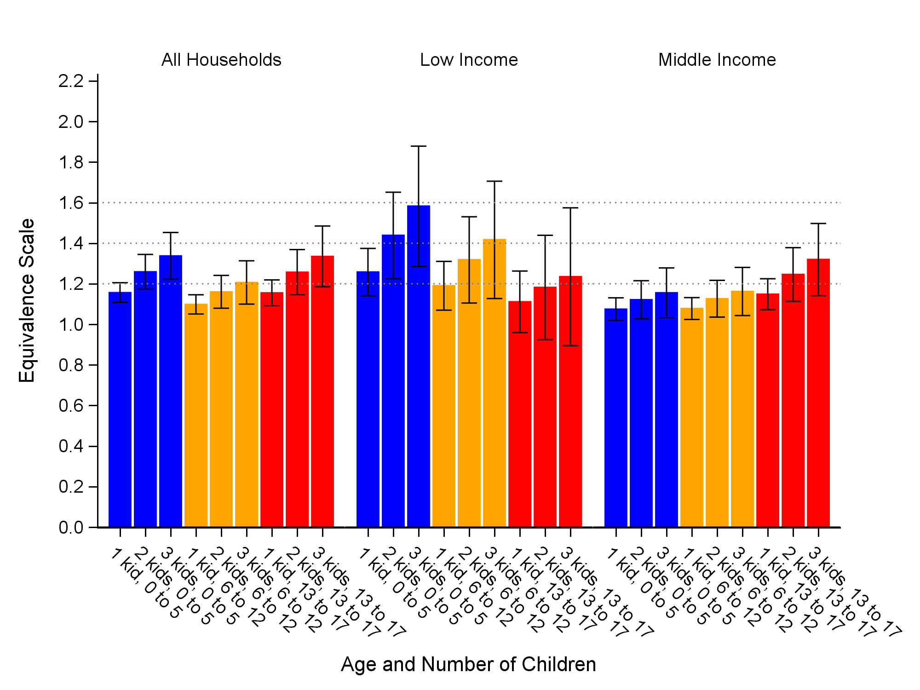
Notes: The income measure used in the underlying regression model is gross household income. Household are categorised as being low- or middle-Income based on gross household income. The whiskers show the 95% confidence intervals. Underlying regression models are unweighted.
Source HILDA, Wave 13 (2013) to Wave 21 (2021).

Disposable household income approach
As discussed above, the alternative income measure that can be used in the regression model is disposable household income (rather than gross household income). The equivalence scales that are derived from the underlying regression models which use disposable household income and with households categorised as being lower- or middle-income according to disposable household income.
The equivalence scales derived using disposable household income but with household income categories being based on disposable household income are reported in (Table 3) and those based on equivalised disposable household income are reported in (Table 4). The results In Table 3 (disposable Income) for the all household result show moderately lower equivalence scales than the gross Income based measure In Table 2. The results are generally similar for low and moderate income when comparing disposable and gross income.
Figure 5 shows the disposable income model results and standard errors (95 per cent confidence Intervals). The confidence Intervals are, like the equivalence scales estimates, reasonably like those of the gross Income model version. Figure 6 shows the results for the equivalence scales and related confidence Intervals for the disposable Income model where Income ranges are based on equivalised income. The confidence intervals are estimated to be narrower than those of the unweighted regression for disposable income.
Table 3 Equivalence scale financial stress stimates for couple parent families by number and age of children and household income category (disposable household income), 2013 to 2021, disposable household income approach
 | Low-income  ($200-$1,939 pw) | Middle-income  ($1,939-$2,779 pw) | All Households
 | Equivalence scales
 | Children 0 to 17 years
1 child | 1.23 | 1.08 | 1.13
2 children | 1.42 | 1.15 | 1.23
3 children | 1.61 | 1.23 | 1.33
4 children | 1.81 | 1.32 | 1.44
5 children | 2.08 | 1.39 | 1.56
 | Children 0-5 years
1 child | 1.24 | 1.07 | 1.14
2 children | 1.41 | 1.11 | 1.23
3 children | 1.55 | 1.14 | 1.30
 | Children 6 to 12 years
1 child | 1.20 | 1.09 | 1.10
2 children | 1.34 | 1.15 | 1.16
3 children | 1.44 | 1.19 | 1.21
 | Children 13 to 17 years
1 child | 1.17 | 1.12 | 1.15
2 children | 1.28 | 1.20 | 1.25
3 children | 1.36 | 1.27 | 1.33
Notes: The income measure used in the underlying regression model is disposable household income. Households are categorised as being low and middle income based on disposable household income. Unweighted data is used.
Source: HILDA, Wave 13 (2013) to Wave 21 (2021).
Figure 5 Equivalence scale financial stress estimates for couple parent families by of children and household income category (disposable household income), pooled estimates 2013 to 2021, disposable household income approach
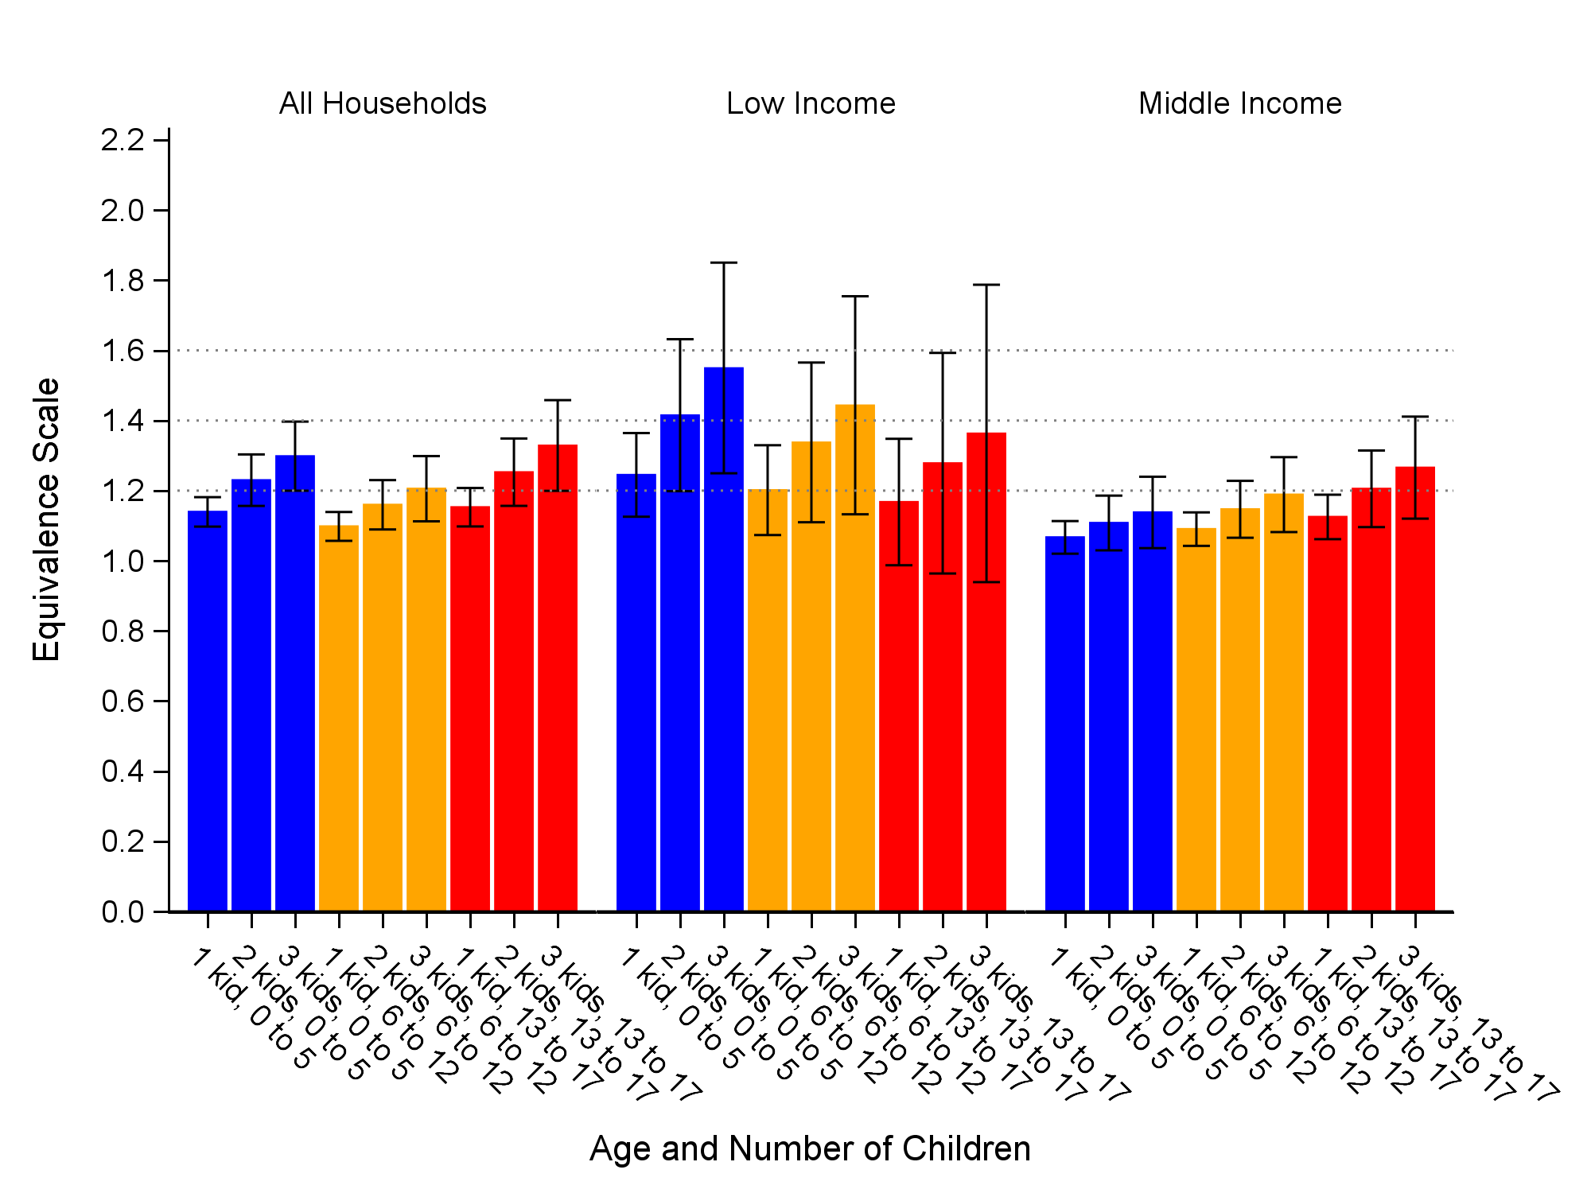
Notes: The income measure used in the underlying regression model is disposable household income. Household are categorised as being low- or middle-Income based on equivalised disposable household income. The whiskers show the 95% confidence intervals. Underlying regression models are unweighted.
Source HILDA, Wave 13 (2013) to Wave 21 (2021).

Table 4 Equivalence scale financial stress stimates for couple parent families by number and age of children and household income category (equivalised disposable household income), 2013 to 2021, disposable household income approach
 | Low-income^{(a)}  ($200-$1,020 pw) | Middle-income  ($1,020-$1,525 pw) | All Households
 | Equivalence scales
 | Children 0 to 17 years
1 child | 1.17 | 1.06 | 1.14
2 children | 1.30 | 1.12 | 1.23
3 children | 1.44 | 1.18 | 1.34
4 children | 1.58 | 1.26 | 1.45
5 children | 1.75 | 1.20 | 1.57
 | Children 0-5 years
1 child | 1.18 | 1.06 | 1.14
2 children | 1.30 | 1.09 | 1.23
3 children | 1.39 | 1.12 | 1.30
 | Children 6 to 12 years
1 child | 1.16 | 1.04 | 1.10
2 children | 1.26 | 1.06 | 1.16
3 children | 1.34 | 1.08 | 1.21
 | Children 13 to 17 years
1 child | 1.13 | 1.14 | 1.15
2 children | 1.21 | 1.23 | 1.25
3 children | 1.27 | 1.29 | 1.33
Notes: The income measure used in the underlying regression model is disposable household income. Households are categorised as being low and middle income based on equivalised disposable household income. (a) 6 to 12 year old parameter is statistically significant only at a 12% level only and should be considered unreliable. Unweighted data is used.
Source: HILDA, Wave 13 (2013) to Wave 2 (2021).
The equivalence scales are generally similar when weights are used in the regression model underlying the calculation of the equivalence scales (see Appendix B). The all households results are quite similar but there are some differences between the low and middle income results when comparing Table 4 and the weighted results in Appendix B. For low Income households the weighted results produce higher equivalence scales for younger and older children. It should be noted that standard errors are higher for the low and middle Income results and many of the differences are not statistically significant.

Figure 6 Equivalence scale financial stress estimates for couple parent families by of children and household income category (equivalised disposable household income), pooled estimates 2013 to 2021, disposable household income approach
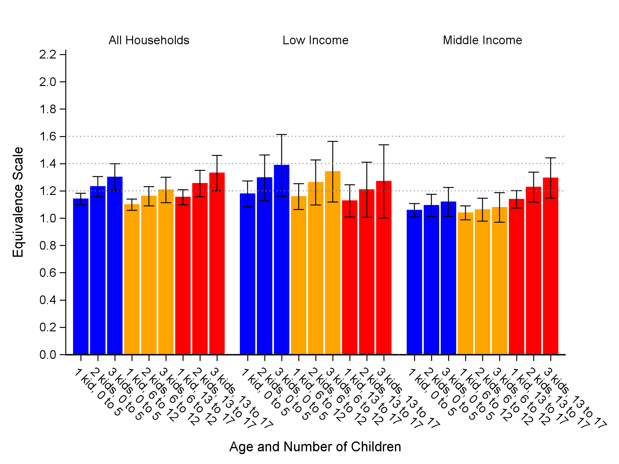
Notes: The income measure used in the underlying regression model is disposable household income. Household are categorised as being low- or middle-Income based on equivalised disposable household income. The whiskers show the 95% confidence intervals. Underlying regression models are unweighted.
Source: HILDA, Wave 13 (2013) to Wave 2 (2021).

Two alternative specifications to the log specification of the children were considered. The first alternative is including as explanatory variables the number of children and number of children squared which is a way of allowing for a non-linear relationship. The squared model Is a more flexible modelling approach to that taken earlier with the model being less restrictive regarding the form of economies of scale. The second is to capture the number and age of children using a set of dummy variables. For the first alternative, the squared model’s fit was not as tight (using Akaike Information Criterion) as the log specification. For the second alternative specification, many of the dummy variables are not statistically significant, particularly for models where the sample was restricted to different income groups and therefore the specification used in this paper is preferred. While these models are less restrictive with regard to the assumptions around economies of scale their results still suggested that economies of scale exist with the cost of children.

Summary of results and model selection
This section brings together the equivalence scales estimated using the gross household income approach and the disposable household income approach for one, two, three and four children. This allows an assessment to be made of the sensitivity of the resulting equivalence scales. The
Figure 7 shows the overall ‘average’ results across ages of children and household income category. The figure shows results for the disposable household income and the gross household income approaches. The equivalence scales estimated using gross household income and disposable household income similar with those based on gross income being slightly higher than those based on disposable income.
The estimated equivalence scales are lower than those implied by the standard OECD scale (OECD modified scale). For example, disposable household income version suggests that, on average, one child adds 13% to cost for a family. The OECD scale is a cost of 20% for one child. The difference between the financial stress approach estimates in this paper and those of the OECD scale only Increases with number of children. For example, the gross Income approach estimates the cost of children at 47 per cent of income whereas the OECD approach would estimate 80 per cent.
Figure 7 Average equivalence scales (all households)for couple parent families, pooled estimated 2013-2021, gross and disposable household income approaches
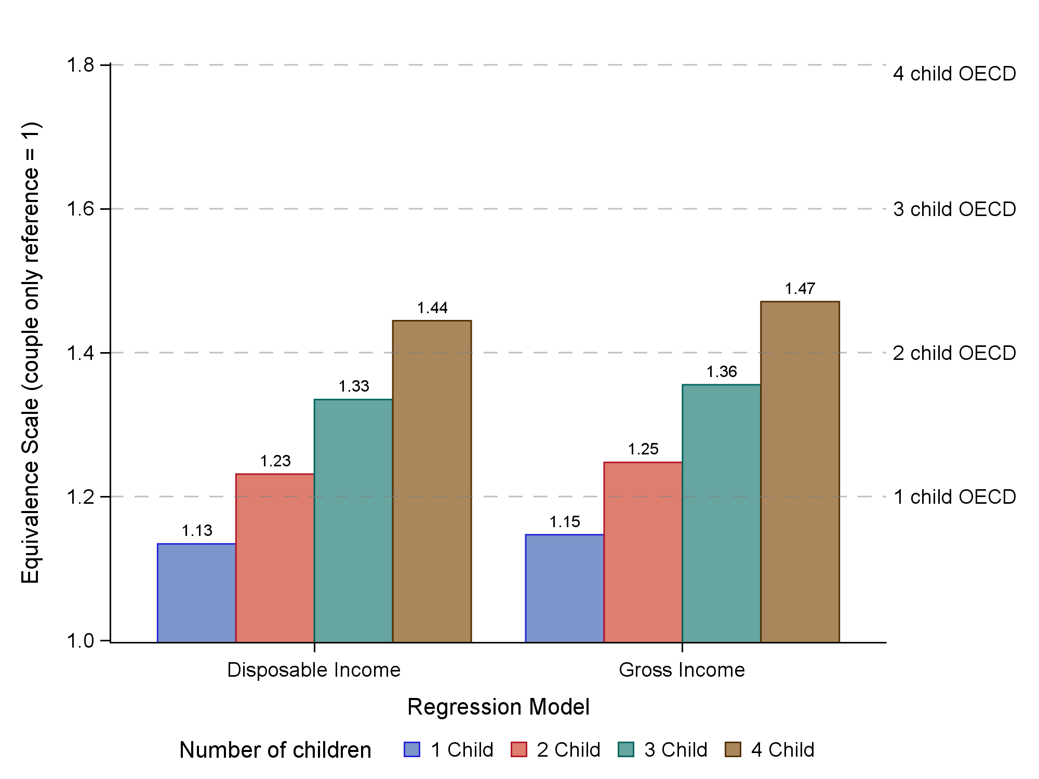
Notes: Underlying regression models are unweighted.
Source HILDA, Wave 13 (2013) to Wave 21 (2021).

Figure 8 shows the equivalence scales for lower-income families and Figure 8 for middle-income families. The estimates using gross household income are shown and two sets of estimates using disposable household income. The first categorises households as being lower- and middle-income based on disposable household income and the second based on equivalised disposable household income. There is little difference between the gross and disposable approach, however, the use of equivalising for income categories does lower the equivalence scales for disposable income.
The equivalence scales for lower-income families are considerably higher than those estimated for all families . The estimate equivalence scales for lower-income families are quite close to those implied by the OECD scale (except for the equivalised income category model). For middle-income families the estimated equivalence scales are considerably lower than those implied by the OECD scale. The finding is consistent with the general findings of the literature which is that the costs of children tend to fall as a percentage of income and income level increases.
It is important to keep in mind that due to averaging across different aged children these results don’t necessarily imply a lack of economies of scale as composition changes in age of children affects the results by number of children.
Figure 8 Average equivalence scales, lower-income households, by estimation approach
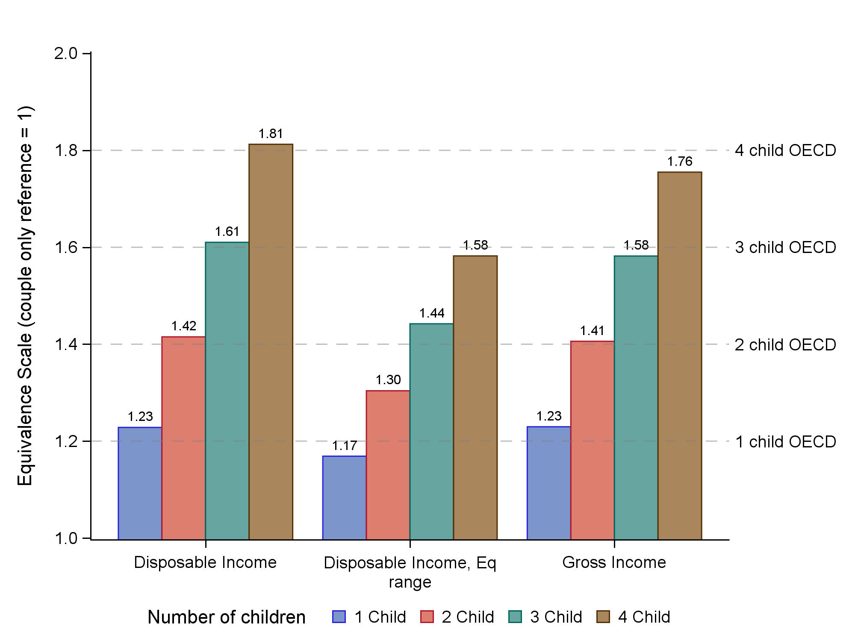
Notes: Underlying regression models are unweighted. The estimates labelled "disposable income" categorise households as being lower-income based in disposable income. The estimates labelled "disposable income, Eq range" categorise households as being lower-income based on equivalised disposable household income.
Source HILDA, Wave 13 (2013) to Wave 21 (2021).

Figure 9 Average equivalence scales, middle-income households, by estimation approach
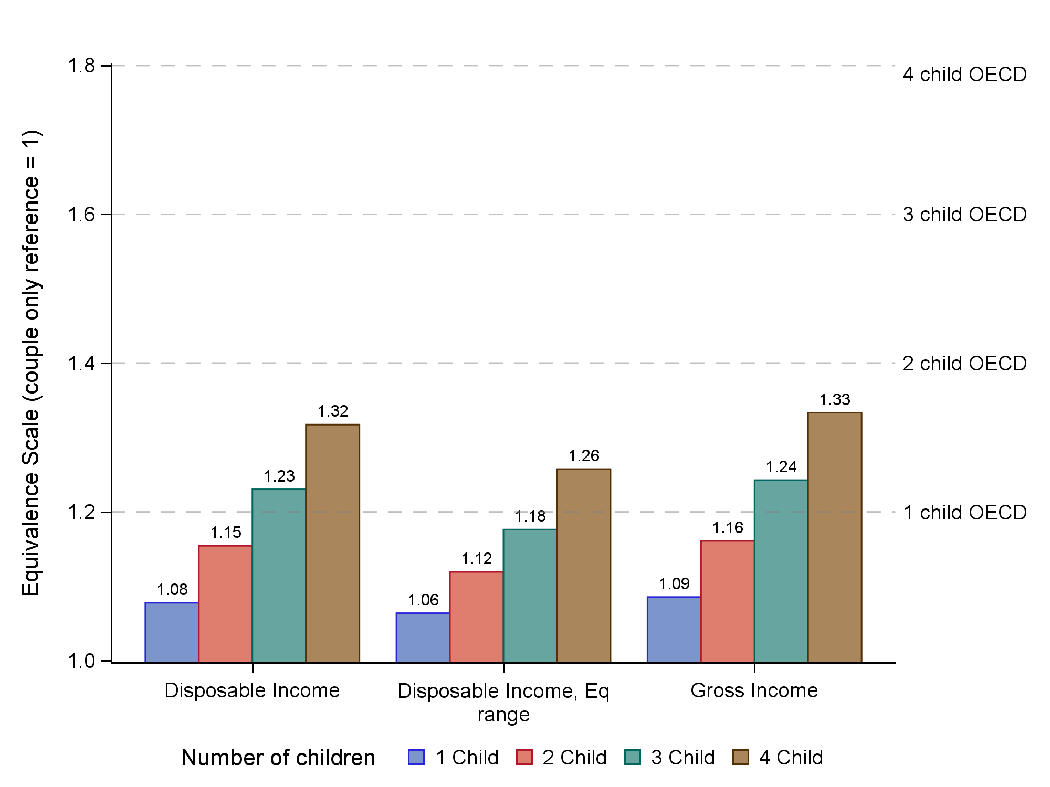
Notes: Underlying regression models are unweighted. The estimates labelled "disposable income" categorise households as being middle-income based in disposable income. The estimates labelled "disposable income, Eq range" categorise households as being middle-income based on equivalised disposable household income.
Source HILDA, Wave 13 (2013) to Wave 21 (2021).

Conclusion
This paper presents estimates of equivalence scales (costs of children) made using the financial stress method using data from the HILDA survey for the period 2013 to 2021. Several different variants on the financial stress method are presented. The resulting equivalence scales do not vary substantially on average according to the exact model estimated.
The key findings are:
- There is no clear evidence of changes in the costs of children over the period 2013 to 2021
- There are economies of scales with each additional child "costing" less than the previous child
- The costs of children (as a percentage of income) fall as income increases (noting that the estimates are produced separately for lower- and middle-income families, but not higher-income families)
- Somewhat at odds with the typical cost of children research is the finding that primary school aged children cost less than pre-school aged children (0 to 5) or high school aged children (13 to 17).
- The calculation of equivalence scales is sensitive to sample size and the use of single year samples from HILDA or the ABS SIH lead to large standard errors.
- Greater confidence in estimated equivalence scales is achieved through pooling waves In HILDA between 2013 and 2021. Splitting the pooled results into different Income groups also Increases standard errors and caution should be taken when Interpreting results for different Income groups.

References
Bradbury, B. (1989). Family size equivalence scales and survey evaluations of income and well-being. Journal of Social Policy, 18(3), 383–408.
Breunig, R. and Cobb-Clark, D. (2005). Understanding the factors associated with financial stress in Australian households. Australian Social Policy 2005, 13–64.
Breunig, R., Hassan, S., & Hunter, B. (2019). Financial stress and Indigenous Australians. Economic Record, 95(308), 34–57.
Browning, M. (1992). Children and household economic behavior. Journal of Economic Literature, 30(3), 1434–1475.
Citro, C., & Michael, R. (Eds.). (1995). Measuring poverty: A new approach. National Academy Press.
Engel, E. (1895). Die Lebenskosten belgischer Arbeiter-Familien früher und jetzt. International Statistical Bulletin, 9(5), 897–930.
Gray, M., & Stanton, D. (2010). Costs of children and equivalence scales: A review of methodological issues and Australian estimates. Australian Journal of Labour Economics, 13(1), 99–115.

Appendix A. Regression results
Table A1 Gross Income Model Results, HILDA Pooled 2013-2021
Variable | Parameter | Standard Error | P Value
 | All households
Intercept | 11.110 | 0.484 | <.0001
Log Income | -1.579 | 0.058 | <.0001
Log(Kid0_5) | 0.332 | 0.050 | <.0001
Log(Kid6_12) | 0.214 | 0.053 | <.0001
Log(Kid13_17) | 0.329 | 0.066 | <.0001
Own Outright | -1.171 | 0.181 | <.0001
Mortgage | -0.180 | 0.142 | 0.206
Rent | 0.684 | 0.142 | <.0001
Other | 0.892 | 0.550 | 0.105
Male | -0.130 | 0.014 | <.0001
 | Lower-income households
Intercept | 7.167 | 0.761 | <.0001
Log Income | -1.042 | 0.100 | <.0001
Log(Kid0_5) | 0.345 | 0.067 | <.0001
Log(Kid6_12) | 0.262 | 0.078 | 0.0008
Log(Kid13_17) | 0.159 | 0.105 | 0.1325
Own Outright | -0.993 | 0.230 | <.0001
Mortgage | -0.214 | 0.179 | 0.232
Rent | 0.768 | 0.175 | <.0001
Other | 0.613 | 0.679 | 0.367
Male | -0.118 | 0.019 | <.0001
 | Middle-income households
Intercept | 15.871 | 1.929 | <.0001
Log Income | -2.174 | 0.242 | <.0001
Log(Kid0_5) | 0.227 | 0.081 | 0.0051
Log(Kid6_12) | 0.236 | 0.080 | 0.0034
Log(Kid13_17) | 0.435 | 0.098 | <.0001
Own Outright | -1.310 | 0.251 | <.0001
Mortgage | -0.170 | 0.223 | 0.448
Rent | 0.575 | 0.228 | 0.0121
Other | 1.161 | 0.852 | 0.174
Male | -0.122 | 0.022 | <.0001
Source HILDA, Wave 13 (2013) to Wave 21 (2021).

Table A2 Disposable Income Model Results, HILDA Pooled 2013-2021
Variable | Parameter | Standard Error | P Value
 | All Households
Intercept | 12.518 | 0.559 | <.0001
Log Income | -1.807 | 0.071 | <.0001
Log(Kid0_5) | 0.340 | 0.050 | <.0001
Log(Kid6_12) | 0.244 | 0.053 | <.0001
Log(Kid13_17) | 0.370 | 0.066 | <.0001
Own Outright | -1.187 | 0.176 | <.0001
Mortgage | -0.199 | 0.136 | 0.145
Rent | 0.710 | 0.136 | <.0001
Other | 0.871 | 0.523 | 0.097
Male | -0.132 | 0.014 | <.0001
 | Lower-income Households
Intercept | 6.912 | 0.836 | <.0001
Log Income | -1.018 | 0.112 | <.0001
Log(Kid0_5) | 0.322 | 0.068 | <.0001
Log(Kid6_12) | 0.270 | 0.080 | 0.0008
Log(Kid13_17) | 0.228 | 0.115 | 0.0482
Own Outright | -1.048 | 0.226 | <.0001
Mortgage | -0.296 | 0.170 | 0.082
Rent | 0.717 | 0.170 | <.0001
Other | 0.853 | 0.663 | 0.199
Male | -0.115 | 0.019 | <.0001
 | Middle-income households
Intercept | 17.425 | 2.165 | <.0001
Log Income | -2.466 | 0.278 | <.0001
Log(Kid0_5) | 0.230 | 0.077 | 0.0029
Log(Kid6_12) | 0.308 | 0.079 | 0.0001
Log(Kid13_17) | 0.419 | 0.091 | <.0001
Own Outright | -1.099 | 0.205 | <.0001
Mortgage | 0.021 | 0.170 | 0.903
Rent | 0.845 | 0.170 | <.0001
Other | 0.149 | 0.627 | 0.812
Male | -0.133 | 0.022 | <.0001
Source HILDA, Wave 13 (2013) to Wave 21 (2021).

Table A3 Disposable Income Model Results (equivalised Income ranges), HILDA Pooled 2013-2021
Variable | Parameter | Standard Error | P Value
 | All households
Intercept | 12.486 | 0.560 | <.0001
Log Income | -1.803 | 0.071 | <.0001
Log(Kid0_5) | 0.341 | 0.050 | <.0001
Log(Kid6_12) | 0.244 | 0.053 | <.0001
Log(Kid13_17) | 0.371 | 0.066 | <.0001
Own Outright | -1.189 | 0.176 | <.0001
Mortgage | -0.200 | 0.136 | 0.144
Rent | 0.711 | 0.136 | <.0001
Other | 0.871 | 0.523 | 0.097
Male | -0.132 | 0.014 | <.0001
 | Lower-income Households
Intercept | 7.982 | 0.910 | <.0001
Log Income | -1.172 | 0.125 | <.0001
Log(Kid0_5) | 0.276 | 0.077 | 0.0004
Log(Kid6_12) | 0.248 | 0.078 | 0.0015
Log(Kid13_17) | 0.201 | 0.096 | 0.0361
Own Outright | -1.116 | 0.208 | <.0001
Mortgage | -0.331 | 0.149 | 0.027
Rent | 0.815 | 0.150 | <.0001
Other | 0.928 | 0.553 | 0.094
Male | -0.125 | 0.018 | <.0001
 | Middle-income Households
Intercept | 16.450 | 1.828 | <.0001
Log Income | -2.569 | 0.241 | <.0001
Log(Kid0_5) | 0.207 | 0.102 | 0.0419
Log(Kid6_12) | 0.140 | 0.105 | 0.1832
Log(Kid13_17) | 0.478 | 0.123 | 0.0001
Own Outright | 0.837 | 0.232 | 0.0003
Mortgage | 1.901 | 0.210 | <.0001
Rent | 2.597 | 0.204 | <.0001
Other | -7.301 | 0.801 | <.0001
Male | -0.137 | 0.023 | <.0001
Source HILDA, Wave 13 (2013) to Wave 21 (2021).

Table A4 Gross Income Model, HILDA 2021 Wave only
Variable | Parameter | Standard Error | P Value
 | All households
Intercept | 9.397 | 0.885 | <.0001
Log Income | -1.647 | 0.110 | <.0001
Log(Kid0_5) | 0.247 | 0.091 | 0.007
Log(Kid6_12) | 0.324 | 0.108 | 0.0029
Log(Kid13_17) | 0.304 | 0.136 | 0.0263
Own Outright | 1.191 | 0.258 | <.0001
Mortgage | 1.910 | 0.223 | <.0001
Rent | 2.786 | 0.212 | <.0001
Other | -8.046 | 0.806 | <.0001
Male | -0.102 | 0.033 | 0.0017
 | Lower-income households
Intercept | 7.922 | 1.546 | <.0001
Log Income | -1.180 | 0.209 | <.0001
Log(Kid0_5) | 0.319 | 0.136 | 0.0196
Log(Kid6_12) | 0.303 | 0.155 | 0.0516
Log(Kid13_17) | 0.301 | 0.214 | 0.1594
Own Outright | -0.902 | 0.214 | <.0001
Mortgage | 0.026 | 0.138 | 0.852
Rent | 0.827 | 0.116 | <.0001
Male | -0.122 | 0.045 | 0.007
 | Middle-income households
Intercept | 8.404 | 5.194 | 0.1067
Log Income | -1.543 | 0.652 | 0.0186
Log(Kid0_5) | 0.026 | 0.170 | 0.8783
Log(Kid6_12) | 0.244 | 0.199 | 0.223
Log(Kid13_17) | 0.522 | 0.256 | 0.0426
Own Outright | 1.489 | 0.343 | <.0001
Mortgage | 2.053 | 0.257 | <.0001
Rent | 2.886 | 0.259 | <.0001
Other | -9.101 | 0.823 | <.0001
Male | -0.082 | 0.060 | 0.1745
Source HILD Wave 21 (2021).

Appendix B. Equivalence scale estimates based on disposable household income using pooled HILDA data
Figure B1 Equivalence scale financial stress estimates for couple parent families by number of children using disposable household income, 2013 to 2022, disposable household income
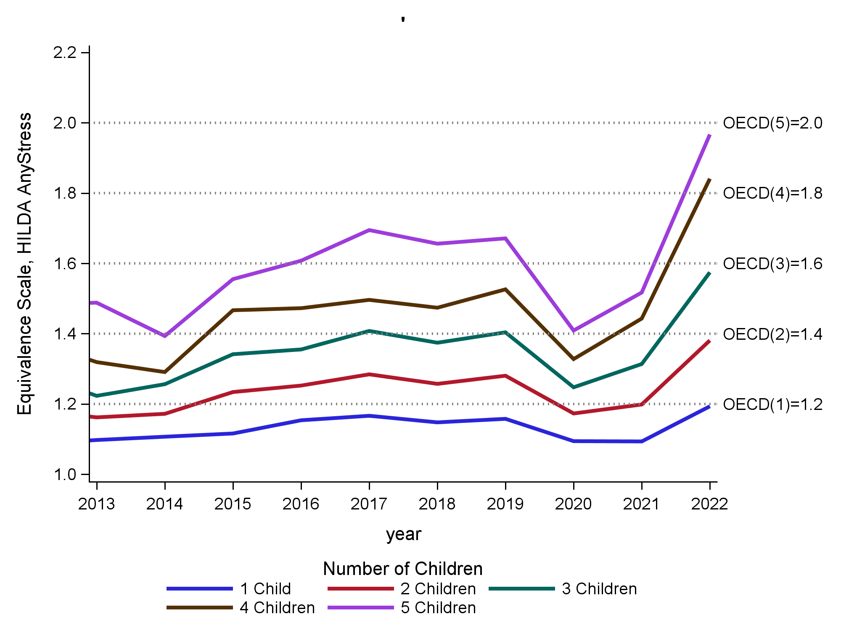
Source: HILDA, Wave 13 (2013) to Wave 22 (2022).
Figure B2 Equivalence scale financial stress estimates for couple parent families by number of children using disposable household income, 2021 HILDA Wave Only
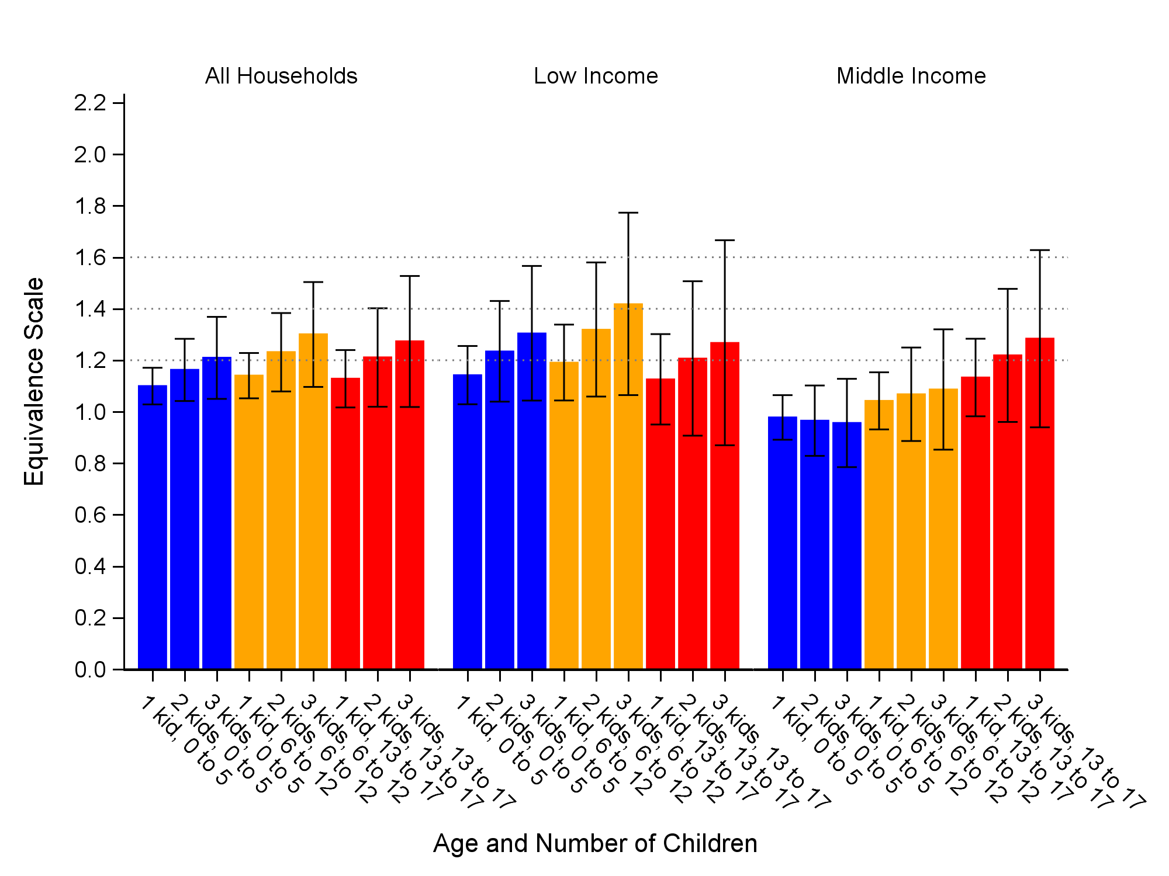
Table B1 Equivalence scale financial stress estimates for couple parent families by number and age of children, low and middle equivalised income groups, HILDA Survey, pooled estimates 2013 to 2021 (disposable household income approach), weighted data
 | Low-income  ($200-$1,025 pw) | Middle-income**  ($1,025-$1,527 pw) | All Households
 | Equivalence scales
 | Children 0 to 17 years
1 child | 1.23 | 1.08 | 1.16
2 children | 1.40 | 1.14 | 1.25
3 children | 1.57 | 1.20 | 1.35
4 children | 1.76 | 1.27 | 1.46
5 children | 2.02 | 1.27 | 1.59
 | Children 0-5 years
1 child | 1.26 | 1.09 | 1.18
2 children | 1.43 | 1.15 | 1.29
3 children | 1.58 | 1.19 | 1.38
 | Children 6 to 12 years
1 child | 1.12 | 1.05 | 1.08
2 children | 1.20 | 1.08 | 1.12
3 children | 1.26 | 1.10 | 1.16
 | Children 13 to 17 years
1 child | 1.26 | 1.11 | 1.16
2 children | 1.45 | 1.18 | 1.26
3 children | 1.59 | 1.23 | 1.34
Notes: Household are categories as being low- or middle-Income based on disposable household income. **6 to 12 year old parameter not significant for middle income and only significant at the 10% level for low income households. Weighted data is used.
Source: HILDA, Wave 13 (2013) to Wave 2 (2021).

Appendix C. Estimates based on the Survey of Income and Housing 2019-20
Results from the cross-sectional analysis using the 2019-20 Survey of Income and Housing are presented in this Appendix.
The econometric framework is like that used for the HILDA analysis except for a different set of control variables: a disability in the household flag, and a gender flag. Age of head of household was not included but only significant under a joint test at 10% level. Wealth not included. Including both wealth and tenure led to only wealth being significant. Wealth alone with income pushes up the equivalence scale but there is significant correlation between income and wealth so the preference was to go with just tenure.
The ABS Survey of Income and Housing is a nationally representative sample of Australian households for the 2019-20 financial year. The survey includes a very detailed range of income, wealth, and socioeconomic variables. The Survey of Income and Housing includes questions about 14 different forms of financial stress. The Survey of Income and Housing measures, while generally like those in HILDA, include a broader range of measures of financial stress than does HILDA. The additional measures in the Survey of Income and Housing in addition to those already listed for HILDA are:
- Went without dental treatment due to shortage of money;
- Could not pay registration or Insurance on time due to shortage of money;
- Could not pay home or contents Insurance on time due to shortage of money;
- Could not raise $2000 of emergency money; and
- Could not raise $500 of emergency money.
The measuring of financial stress for the analysis using the Survey of Income and Housing includes all the measures of financial stress except for the money management question (spend more than you earn) which is considered to be too susceptible to financial literacy or lack of money management skills than as a driver of the direct cost of children. Consistent with the analysis of the HILDA data a simple ‘any stress’ measure is used.
Similar restrictions are placed on the samples used in the modelling of the HILDA data and the Survey of Income and Housing data. The ABS Survey of Income and Housing has included questions of financial stress since 1998/99. Unfortunately, surveys prior to 2015/16 have limited data on the age of children in the confidentialised unit record data sets. These limits include broader age range than desired in this research and ‘top-coding’ on the number of children within age ranges to ‘2+ children). While potentially still of some value we considered this too limiting for this research.
Table C1 Equivalence scale financial stress estimates for couple parent families by number and age of children and household income category, 2019-20, gross household income approach
 | Low-income  ($200 to $960 | Middle-income  ($961 to $1,455) | All Households (Gross Income > $200pw)
 | Children 0 to 17 years
1 child | 1.16 | 1.16 | 1.18
2 children | 1.34 | 1.28 | 1.32
3 children | 1.56 | 1.42 | 1.49
4 children | 1.77 | 1.52 | 1.65
 | Children 0-5 years
1 child | 1.12 | 1.16 | 1.18
2 children | 1.19 | 1.26 | 1.29
3 children | 1.42 | 1.41 | 1.46
 | Children 6 to 12 years
1 child | 1.19 | 1.12 | 1.13
2 children | 1.32 | 1.19 | 1.21
3 children | 1.47 | 1.38 | 1.43
 | Children 13 to 17 years
1 child | 1.55 | 1.31 | 1.42
2 children | 2.00 | 1.54 | 1.75
3 children | 2.38 | 1.71 | 1.98
Notes: The ABS CURF microdata which has been used in this paper confidentialises the number of persons in a household to 6 which means that it is not possible to estimate the costs for five children using the CURF. The ABS datalab MURF can overcome this limitation.

Source: 2019-20 Survey of Income and Housing.

Table C2 Equivalence scales financial stress estimates for couple parent families by number of children and level of equivalised disposable household income, Survey of Income and Housing, 2019-20
 | Low-income ($200 to $960) | Middle-income ($960 to $1,455)
 | Children 0 to 17 years
1 child | 1.32 | 1.19
2 children | 1.61 | 1.37
3 children | 1.95 | 1.58
4 children | 2.35 | 1.79
 | Children 0-5 years
1 child | 1.31 | 1.17
2 children | 1.55 | 1.28
3 children | 1.99 | 1.54
 | Children 6 to 12 years
1 child | 1.29 | 1.21
2 children | 1.49 | 1.35
3 children | 1.96 | 1.57
 | Children 13 to 17 years
1 child | 1.44 | 1.33
2 children | 1.79 | 1.58
3 children | 2.30 | 1.91
Notes: The ABS CURF microdata which has been used in this paper confidentialises the number of persons in a household to 6 which means that it is not possible to estimate the costs for five children using the CUR. The ABS datalab MURF can overcome this limitation.
Source: 2019-20 Survey of Income and Housing.

Table C3 Equivalence scales financial stress estimates for couple parent families by number of children and level of gross household income (ranked by gross income), Survey of Income and Housing, 2019-20
Household Disposable income level
(equivalised household weekly income)
 | Low-income ($200 to $2110) | Middle-income ($2110 to $3,280)
 | Children 0 to 17 years
1 child | 1.17 | 1.19
2 children | 1.40 | 1.37
3 children | 1.66 | 1.56
4 children | 1.89 | 1.77
 | Children 0-5 years
1 child | 1.10 | 1.19
2 children | 1.16 | 1.32
3 children | 1.48 | 1.54
 | Children 6 to 12 years
1 child | 1.28 | 1.16
2 children | 1.48 | 1.27
3 children | 1.62 | 1.51
 | Children 13 to 17 years
1 child | 1.60 | 1.41
2 children | 2.11 | 1.73
3 children | 2.70 | 2.01
Notes: The ABS CURF microdata which has been used in this paper confidentialises the number of persons in a household to 6 which means that it is not possible to estimate the costs for five children using the CUR. The ABS datalab MURF can overcome this limitation.

Source: 2019-20 Survey of Income and Housing.

Figure C1 Equivalence Scales, Couples with children by income, Disposable Income, EQ Ranges, Survey of Income and Housing 2019-20,
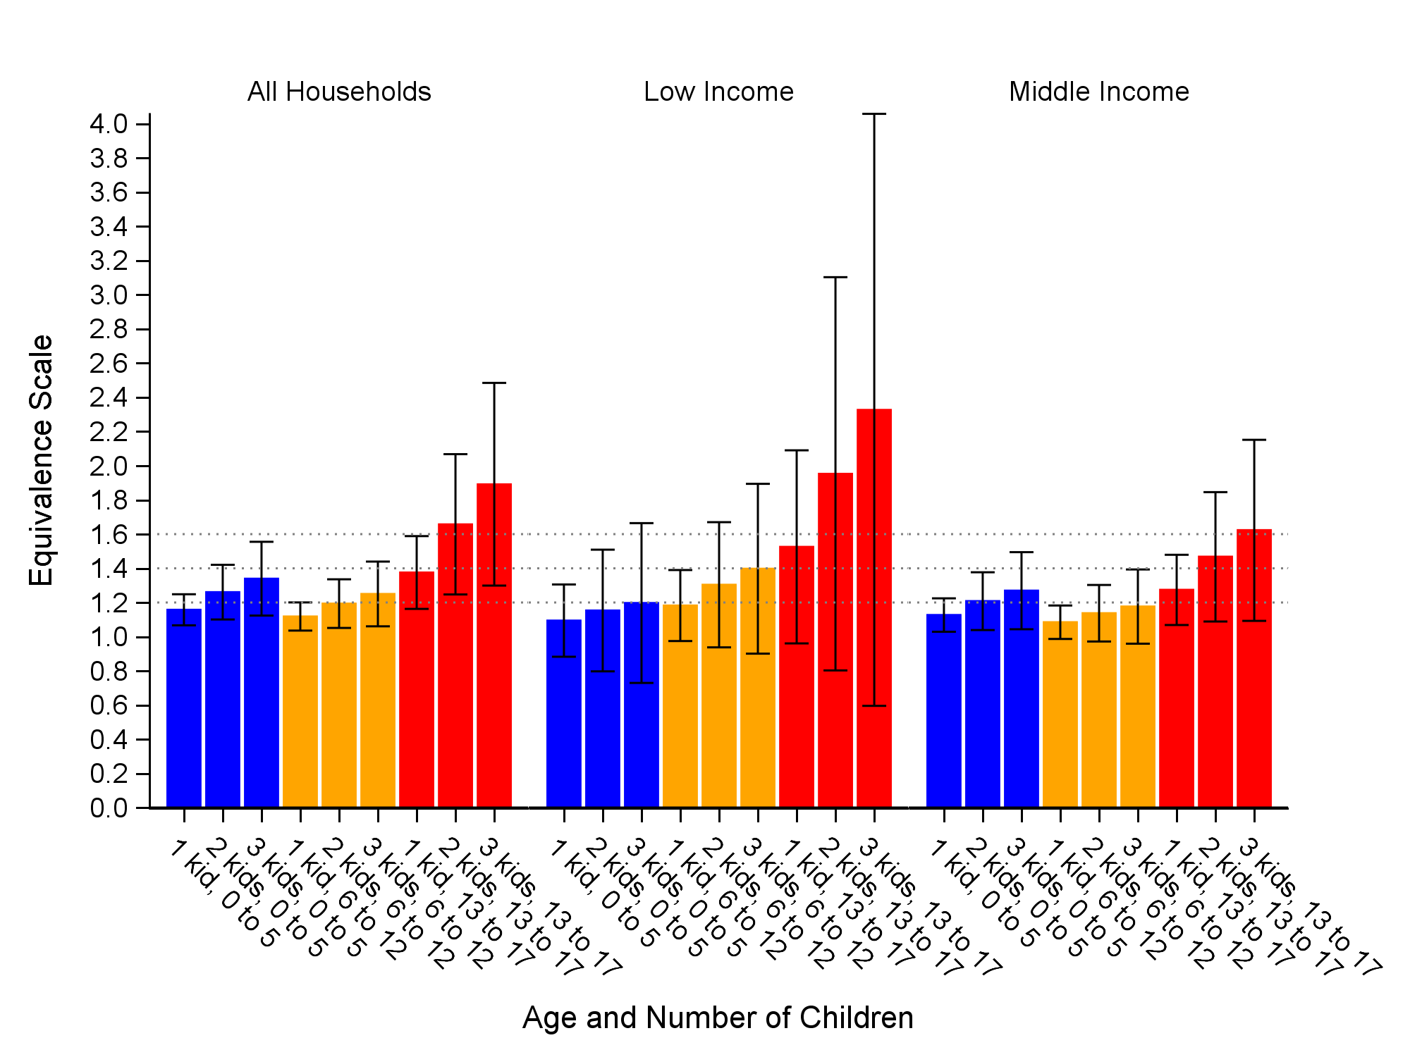
Notes: The "whiskers" indicate the 95% confidence intervals.
Source: Survey of Income and Housing 2019-20

Thus, suppose we had a couple without children who were spending $500 a week and devoting 30 per cent of this to food. And then we found an otherwise similar couple who had one child and were also spending 30 per cent of their total weekly expenditure upon food, but whose total weekly spending was $600 a week. Then Engel suggested that this would mean that the cost of the child was $100 a week ($600 minus $500).
This approach has similarities to the subjective well-being methods surveyed in Bradbury (1989) – though the indicators of hardship are now different.
Financial stress data Is available on a regular basis from several sources Including annually from the Household Income and Labour Dynamics In Australia (HILDA) survey and bi-annually from the ABS Survey of Income and Housing. In contrast expenditure data Is collected much less frequently with the most recent data being from the 2015-16 ABS Household Expenditure Survey.
Another potential data source is the Australian Bureau of Statistics (ABS) Survey of Income and Housing (2019-20). However, as will be shown in this paper the estimates based on the HILDA survey are more robust than those using the Survey of Income and Housing (2019-20). Estimates based on the Survey of Income and Housing are reported in Appendix C.
In waves 9-19 this question was whether the respondent could raise $3,000 for an emergency. From wave 20 the question was whether the respondent could raise $4,000 for an emergency.
There are also several other variables that are estimated that are ‘control’ variables, however, the parameter estimates for these are not needed for estimating the equivalence scales.
The OECD modified scale takes the value of one for a single adult household, the value of 1.5 for a couple only family and adds 0.3 for each child so it takes a value of 1.8 for a couple with one child, 2.1 for a couple with two children, 2.4 for a couple with three children, 2.7 for a couple with four children and 3.0 for a couple with five children. If we express these relative to a couple with no children, these scales are 1.2 for one child (=1.8/1.5), 1.4 for two children, and 1.6, 1.8 and 2.0 for three, four and five children respectively (to one decimal place). In Figure 1 the standard OECD modified equivalence scale Is expressed relative to a couple only household which takes the value 1 in order to allow a comparison with the financial stress-based estimates.
Caution should be taken in interpreting the 0-17 years children results regarding economies of scale as they also include composition change as families with more children are likely to have older children than families with fewer children.

