
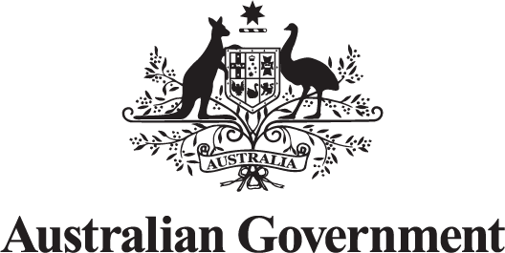

Australian Public Service Place-based Evaluation Guide

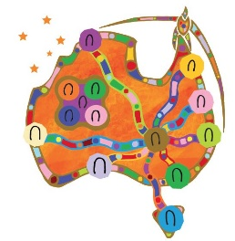
Acknowledgement of Country
The Australian Government acknowledges Aboriginal and Torres Strait Islander peoples throughout Australia and their continuing connection to land, water, culture and community. We pay our respects to the Elders both past and present.
Artwork: Reconciliation Journeys.
© Commonwealth of Australia 2026
ISBN: 978-1-921975-62-2
DSS product number: DSS3600.11.25
This publication is available for your use under a Creative Commons Attribution 4.0 International licence, with the exception of the Commonwealth Coat of Arms, Australian Government logo, photographs, images, third party materials, materials protected by a trademark, signatures and where otherwise stated. The full licence terms are available from creativecommons.org/licenses/by/4.0/legalcode.

Use of this material under a Creative Commons Attribution 4.0 International licence requires you to attribute the work (but not in any way that suggests that the Australian Government endorses you or your use of the work).
Material used ‘as supplied’
Provided you have not modified or transformed material in this publication in any way including, for example, by changing the text; calculating percentage changes; graphing or charting data; or deriving new statistics from published statistics – use the following attribution: Source: The Commonwealth of Australia.
Derivative material
If you have modified or transformed material in this publication or derived new material from those in this publication in any way, use the following attribution: Based on Commonwealth of Australia data.
Other material or rights in this publication
The terms under which the Coat of Arms can be used are set out on the Department of the Prime Minister and Cabinet website (see www.pmc.gov.au/government/commonwealth-coat-arms).
Cover image licensed by Envato.
Other uses
Inquiries regarding this licence or any other use of this document are welcome. Please contact: Branch Manager, Communication Services Branch, Department of Social Services. Phone: 1300 653 227. Email: communication@dss.gov.au

Contents
Introduction 4
What makes place-based evaluation different 5
Skills and understanding needed for place-based evaluation 10
Principles for leading practice 13
Putting the principles into practice 15
Appendix A – Additional resources 24
Appendix B – References 27
Appendix C – Figure descriptions 28

Introduction
Evaluation has an important role in the evidence-based policy cycle. Understanding what works, why and for whom can help to increase the effectiveness, efficiency and equity of government initiatives.
This Australian Public Service Place-based Evaluation Guide (the guide) is underpinned by a shift in how government works with communities, with a focus on listening, learning and acting collectively. It aims to help government employees generate and use robust evidence to help build a future where every child, family and community in Australia has the chance to share in our collective opportunities.
The guide should be used together with associated evaluation resources, including the Commonwealth Evaluation Policy and Toolkit. These resources set out principles and guidance for all Australian Government evaluations and should be used as the starting point for leading practice approaches.

Audience and purpose
This guide is designed for Australian Public Service (APS) staff involved in planning, commissioning, conducting or using evaluations of place-based work. It aims to build understanding of the unique features of place-based work and why these differences matter for evaluation.
It will help you identify what you need to do differently when planning and conducting a place-based evaluation and provides a principles-based approach to support leading practice.
This guide will help you:
- understand what makes evaluations of place-based work different from program evaluations
- understand the skills and knowledge you need for place-based evaluation
- explore a principles-based approach to support leading practice in place-based evaluation
- put the principles into practice.
Acknowledgments
The information in this guide is based on current Australian Government evaluation policy and existing placed-based evaluation tools and guidance. It has been developed and tested through consultation with a range of stakeholders, including government and non-government stakeholders involved in evaluating place-based work, the community sector and First Nations representatives. Thank you to everyone who contributed ideas or input.

What makes place-based evaluation different
Place-based work (or working in place) tailors support to specific communities by involving local people, communities and other stakeholders in designing and delivering solutions to support local priorities and needs. This work is highly relational, based on different forms of collaboration and governance that are unique to each community and place. In situations where multiple sites are involved in a place-based initiative, the characteristics of each community or place needs to be considered – both in terms of what is similar and what is different. This has important implications for evaluation and the learning systems needed to support continuous improvement, decision-making and accountability.
The characteristics often identified as being unique to place-based work include:
- initiatives that address long-term systemic changes like entrenched disadvantage, which cuts across different services and includes a broad range of stakeholders
- elevated community voices, through deliberately investing in collaborative relationships and aligning efforts to a community-led agenda for change
- initiatives that innovate and evolve continuously, through strategic learning from data and evidence.
The APS Guide to Working in Place [link] outlines different ways to work in place with communities and stakeholders, from place-focused approaches to formal partnerships with local leadership groups. Before using this guide, read the APS Guide to Working in Place to strengthen your understanding of place-based work and the different ways of working in place.
There are some unique features that make place-based evaluation different from traditional program evaluation. Each place has its own unique characteristics (history, priorities, perspectives, needs, strengths, resources, opportunities and community dynamics). This influences the type of initiatives required to meet the needs and goals of one or more site. Place-based work often aims to support long-term systems change, adding further complexity.
Evaluation planning and design takes time
The collaborative process and timelines involved in evaluating place-based work means it is usually necessary for evaluators to spend time in place (or places) to build relationships and understanding, which has implications for planning, resourcing and evaluation timeframes.
While early planning and collaboration are important for all evaluations, they are particularly important when evaluating place-based work. Ensuring sufficient time and flexibility to build relationships and work with communities is important for generating useful and meaningful findings.
Participatory planning, involving designing evaluations with people affected by the initiative, is also critical to ensure evaluation designs are fit-for-purpose and meet the needs of decision-makers and communities in specific contexts – there is no one-size-fits-all approach.
Multiple evaluation approaches
Different types of evaluation and evaluation approaches are needed for different place-based work at different times across the policy lifecycle. This will depend on:
- the diversity of different places and contexts
- the initiatives themselves (in one or more sites)
- the level of maturity of each place-based initiative (which can vary across sites).
Decisions about the type and timing of specific evaluation activities should be informed by:
- the context and characteristics of the specific place-based work
- the intended purpose and use of evaluation findings
- any timelines related to planned decision-making.
In First Nations contexts, First Nations approaches and principles for leading practice should be applied.
Iterative evaluation process
In place-based work the focus, actions, pace and people involved are dynamic and unfold as the initiative matures - particularly in the early stages. This means that planning and implementing a place-based evaluation is typically iterative, and remains responsive to emerging issues, changes and adaptations as the level of understanding about the situation increases.
This involves ongoing collaboration to shape and adapt all aspects of the evaluation from theories of change, key evaluation questions, types and sources of evidence, to how the process will be implemented, as well as focus areas for deep dives to reflect emerging issues.
Considerations for determining the type and timing of evaluations needed for single sites, or national place-based work made up of multiple sites at different stages of maturity include:
- build and plan for iterative evaluation design from the outset
- revise theories of change to reflect emerging issues and insights
- build in explicit cycles of learning
- pay attention to emerging unintended outcomes
- be responsive to the unique and changing context in place, with a learning-focussed approach
- conduct deep dive evaluations to understand emerging issues.
Multiple sites and diverse stakeholders
National place-based work often involves delivery across multiple sites with diverse stakeholders. This means that the contexts, intended outcomes and strategies used across different sites can vary in multiple ways, making it challenging to detect and understand patterns. Setting up a good performance monitoring system, with common ways to capture comparable data from the start can help to overcome some of these challenges. Careful consideration is needed to balance the benefits of standardised data collection (for comparability purposes) with more tailored data collection that reflects the diverse interests of stakeholders in local contexts.
Taking account of the differences between multiple sites may include:
- sites pursuing similar objectives but through different activities
- sites pursuing different objectives or priorities
- different evaluation purposes.
Place-based work often involves multiple and diverse stakeholders working together in different ways. Power dynamics, shared decision-making structures, and both local and initiative level governance arrangements guide who needs to be involved in the decisions about evaluations.
Good governance is essential for ensuring the right people are engaged at the right time, and in the right way. This is particularly important for evaluating national place-based initiatives with multiple sites.
Further detail is included in the section on Putting the principles into practice.
Challenges understanding effectiveness and impact
Understanding the effectiveness and impact of place-based work can be challenging for the dynamics and reasons outlined above. However, it is important for communities and decision-makers to know if an initiative is working and, if so, by how much.
Similar to each place-based initiative being tailored to specific needs, the best approach to evaluation for learning and demonstrating effectiveness and impact is also tailored (while adhering to Commonwealth Evaluation Policy principles). For place-based evaluation, this requires a balance of rigour and flexibility and strong partnerships to support this to occur in an integrated way as initiatives mature.
Rigour means being thorough. Rigour without rigidity is important to ensure:
- findings are credible and comparable across sites over time
- learning and scaling of effective practices can be shared
- accountability to funders (government and non-government) and stakeholders.
Flexibility means being adaptable. Flexibility is important to:
- ensure evaluations meet the needs of communities and funders (government and non-government)
- facilitate community ownership of evaluation so results are relevant and useful locally
- allow for iterative learning and adaptation, recognising contextual diversity across place
- build trust and capacity among local community members, who can interpret findings and incorporate contextual nuance.
Rigour provides the credibility needed for policy and funding decisions, while flexibility ensures relevance and ownership at the local level.
Answering causal questions
Impact questions ask whether an initiative caused a change to occur. Place-based work often involves complex change across the broader system with multiple actors and activities. This means different evaluation approaches and methods may be required to understand causal relationships in different contexts.
Understanding ‘causal contribution’ (did the initiative contribute to an improved outcome?) and ‘causal attribution’ (how much change in the outcome is attributable to the initiative?) is important. The evaluation should consider whether to focus on attribution, contribution or both, depending on what is needed.
Causal attribution asks if an initiative caused a change in outcomes by comparing observed results to those you would expect if the initiative had not been implemented. This is known as the ‘counterfactual’ (Better Evaluation 2025). A range of evaluation approaches and methods are used to make causal inferences using a counterfactual, including randomised trials, difference-in-differences or synthetic control modelling.
Other approaches and methods can be used to understand localised instances of impact and gain insight into causal relationships. Examples include contribution analysis, most significant change, outcome harvesting, social network analysis and outcome mapping.
It is often appropriate to combine several evaluation approaches and methods to fully evaluate place-based work. It is possible to use some of these approaches and methods after the initiative is implemented using data that is already collected.
While it can be difficult to establish causation, these questions are likely to be important to community and funders (government and non-government) and should be addressed wherever feasible. A range of evaluation approaches and methods can be used to understand causal relationships, including a combination of approaches and methods to support a full evaluation. It is important to document decisions for the focus and approach chosen and remain transparent about any limitations related to the assessment.
The multi-dimensional role of government
In place-based evaluation, government often has a multi-dimensional role to play. APS staff may be required to take on different roles at different times. For example, in some contexts staff may take on a more facilitative role in the design of an evaluation framework, with communities having a leadership role. In other situations, APS staff may lead or be the subject of a specific place-based evaluation while other staff indirectly support the process by managing administrative data for related services that could be used in the evaluation.
A useful characterisation recognises that APS staff may have 5 distinct roles to play:
- Commissioners of evaluation: as the individual or organisation that initiates, resources and oversees an evaluation project, defining its purpose, scope and approach.
- Evaluators: as the individual or team responsible for designing and delivering a place-based evaluation, either independently or in partnership with community and other stakeholders.
- Subject of evaluation (evaluand): as the individual or organisation representing the APS in a collaborative and/or partnership arrangements. This is particularly relevant to place-based partnerships where evaluations often focus on the actions of all partners/participants from a relational perspective.
- User of evaluation findings (funder/responder): as the individual or group who can use the evaluation findings to make decisions, change strategies, funding flows, or take action. This role may be shared with other funding partners, depending on who is involved.
- Evidence partners: as the individual or organisation responsible for performance monitoring and reporting, which generates administrative data and evidence that can inform an evaluation.
These multiple roles require careful consideration to ensure that evaluations are fit for purpose, robust, ethical and inclusive.
Good governance, with clearly defined roles and responsibilities, is essential for managing potential tensions or conflicts of interest. For example, where the Commonwealth is part of what is being evaluated (specifically in place-based partnerships), governance that provides structural independence and formal ways to manage conflict is essential.

Skills and understanding needed for place-based evaluation
Before commencing a place-based evaluation, APS staff should reflect on several foundational areas of understanding and practice to ensure they are prepared to work ethically, collaboratively and in a way that respects local contexts and communities.

Importance of self-awareness
Self-awareness is essential for building honest, trusting relationships with place-based partners. This is particularly important for APS staff working in community-led and First Nations contexts, as it involves shared decision making and relinquishing some power. Making our values explicit from the outset – rather than ignoring them – is important for preventing bias, ensuring transparency and building trusting relationships.
Being self-aware recognises that our values influence what gets measured, how data is interpreted and what defines success. As individuals, we have an important role and responsibility to show up in ways that establish and maintain respectful and positive interpersonal dynamics, which are key enablers of ethical, culturally safe and trauma-informed evaluation. A first step to changing how we show up as individuals is acknowledging that individual bias is inevitable and cannot be erased. The best way to reduce biases is to become aware of them.

Importance of place awareness
When designing or contributing to a place-based evaluation, it is critically important to develop an understanding of the place and community, including their history, priorities, perspectives, needs, strengths, resources and opportunities. This is necessary to implement policies, funding, support initiatives and evaluation approaches that respond to local conditions and needs.
Anyone involved in designing, delivering or reporting on place-based evaluations needs this information to build the knowledge and skills necessary to collaborate, partner and share power and decisions with communities.

Importance of cultural awareness
Cultural awareness involves being sensitive to the differences and similarities between cultures. Each place will have a diversity of community voices. APS staff involved in place-based evaluations must develop a deep understanding of the social, cultural and demographic context of the specific place. This includes recognising and respecting the diversity of population groups – such as First Nations communities, culturally and linguistically diverse communities, people with disability, LGBTIQ people and communities, and other groups with distinct needs and perspectives.
Everyone involved should build the knowledge and skills necessary to ensure evaluations are ethical, inclusive, equitable and locally relevant. Cultural awareness and capability must be viewed as a lifelong learning process to become more culturally informed. All staff involved in place-based evaluations should complete unconscious bias and cultural awareness training to begin this journey and commit to maintaining their own cultural capability as part of everyday practice.

First Nations approaches
There are distinct differences between a First Nations evaluation approach and more traditional western evaluation approaches. First Nations oral history is a living, complex knowledge system. It is essentially a 'living library', with insights passed down through storytelling, song, dance and art, and knowledge about Country.
First Nations knowledge prioritises context and history (experiences of community and aspirations), relationships (building relationships rather than an audit of lessons learnt), and respecting language, traditions and community perspectives (rather than comparing to an idea of best practice).
First Nations approaches create:
- time and space for reflection
- opportunity for generating discussion (yarning, storytelling and sharing, deep listening)
- engagement in ‘explicit’ thinking aloud.
A key feature of leading practice, exemplified by the Right Way Evaluation approach (Community First Development 2025), is that good evaluation takes time and must be embedded at all stages, from the first conversation through to maturity, and addresses potential Western biases (e.g. prioritising written evidence).
It is important to recognise that western approaches often do not reflect Indigenous worldviews that value oral traditions, spiritual knowledge and relational modes of understanding, knowing and being. It is important that APS staff spend time deeply listening, and refrain from rushing in or arriving at community with the solutions.
Under the National Agreement on Closing the Gap, Priority Reform 3 relates to transforming Government organisations. This requires mainstream Government agencies to embed and practice meaningful cultural safety. Priority Reform 4 relates to shared access to data and information at a regional level. This includes supporting First Nations communities to collect, use and interpret data to meet their own priorities (National Agreement on Closing the Gap 2020).
Increasing the number of community-led data and evaluation projects that support First Nations communities to make their own decisions about Closing the Gap creates greater opportunities for self-determination. It also helps to overcome challenges with researchers ‘owning’ data that may not align with Indigenous knowledge systems and protocols around who can speak, collect and use community knowledge and data.
APS staff must recognise that there is a trust deficit in some First Nations communities due to past and current treatment by all levels of government. Government officials may need to rebuild trust from the outset and this should be addressed with great sensitivity and respect.

Valuing the capability of stakeholders
It is important to be aware that many place-based stakeholders have existing evaluation skills, capabilities and resources that can be shared with others. Additional resources may be needed to ensure that all stakeholders can fully engage and have appropriate support to contribute to the evaluation governance, design and implementation, as well as support to find, access, improve and interpret data. Capability building may include training, mentoring, and using resources to build understanding of evaluation processes and roles. Resources may be needed for reasonable accommodations or adjustments to ensure accessibility and inclusive engagement. Monitoring and evaluation can also be seen as additional to a stakeholder’s primary work and resources may be needed to set up data infrastructure (e.g. data capture systems).

Principles for leading practice
Three sets of principles should guide the evaluation of place-based work:
- the overarching Commonwealth Evaluation Principles that guide the conduct of all evaluations in the Australian Government, as set out in the Commonwealth Evaluation Policy, which came into effect in 2021
- additional principles and approaches that are relevant to evaluating all place-based work
- principles that apply to all First Nations evaluations, which are often relevant for place-based work.
While there are overlaps and interconnections between the 3 sets of principles, they are set out separately to encourage consideration of how they apply in specific situations (from all evaluations to all place-based evaluations, to all First Nations evaluations). APS staff should thoroughly familiarise themselves with the requirements of each before commencing a place-based evaluation.

Principles for all evaluations
Consistent with the Commonwealth Evaluation Policy, all evaluations should be:
- fit for purpose
- useful
- robust, ethical and culturally appropriate
- credible
- transparent where appropriate.
Applying these principles requires judgement.
Agreeing on the evaluation’s purpose upfront will guide:
- the overarching evaluation framework or design
- the timing and type of evaluations required
- the approaches and methods needed to conduct specific evaluation activities.

Additional principles for evaluating place-based work
- Early engagement: involve all stakeholders early in the evaluation design process
- Two-way knowledge sharing and relationship building: value different perspectives, knowledges and approaches
- Flexibility: recognise the phased and emergent nature of place-based work
- Build local capacity: support the community to fully engage with data collection/use
- Commitment to continuous learning: help to understand what is or is not changing (and why)
- Strengths-based: frame key evaluation questions and findings in positive ways
- Trauma-informed: recognise the prevalence of trauma and being sensitive to its effects, with a focus on creating a safe environment for all participants to prevent re-traumatisation
- Inclusive, collaborative and reciprocal: ensure power differences are levelled so all participants involved in the evaluation can share information in reciprocal and respectful ways.

Principles for First Nations evaluations
- Centring First Nations people, perspectives, priorities and knowledge: recognise the strengths and diversity of First Nations people, communities, knowledges, histories and cultures.
- First Nations leadership: ensure First Nations people, perspectives, priorities and knowledge are centred in the evaluation design, data collection, analysis, reporting and sharing of findings.
- Cultural capability: ensure all people involved in the evaluation have the cultural awareness, skills, knowledge, behaviours and tools needed to support the evaluation in culturally appropriate ways.
- Cultural safety: factors contributing to cultural safety include a First Nations workforce, collaboration with Aboriginal Community Controlled Organisations (ACCOs), cultural education programs, and the involvement of community Elders in program planning. Communities may ask if evaluators speak their language and what language the evaluation will be conducted and reported in.
- Data Sovereignty: place-based evaluations should protect Indigenous intellectual property and knowledge, including financial and intellectual benefits generated.

Putting the principles into practice
Place-based evaluations are often assessing systems changes at a population or sub-population level. This can take longer than a traditional program evaluation. Sometimes 10 years or more, depending on the outcomes sought.
All place-based evaluations should develop a ‘Monitoring, Evaluation and Learning’ (MEL) Framework or similar. The Victorian Government MEL Toolkit provides guidance on setting up MEL from a First Nations lens, including the key phases of engaging, framing, sensemaking and communicating.
Figure 1 depicts common elements of leading practice in place-based evaluation and the relationship between them. It is important to note a key enabler that underpins leading practice for all place-based evaluation (as shown at the centre of the diagram) is a commitment to continuous learning.
It is also important to note the process to frame and scope the design of the evaluation is often repeated, consistent with the iterative evaluations, as the place-based work matures.
MEL frameworks place explicit value on the role of learning. Evaluation approaches that are inclusive and can adapt to findings as they emerge are critical to inform improvements to implementation and practices, community experience, investment decisions and community outcomes. Flexibility is particularly important to evaluation design, timing and delivery.
Figure 1: Common elements of leading practice
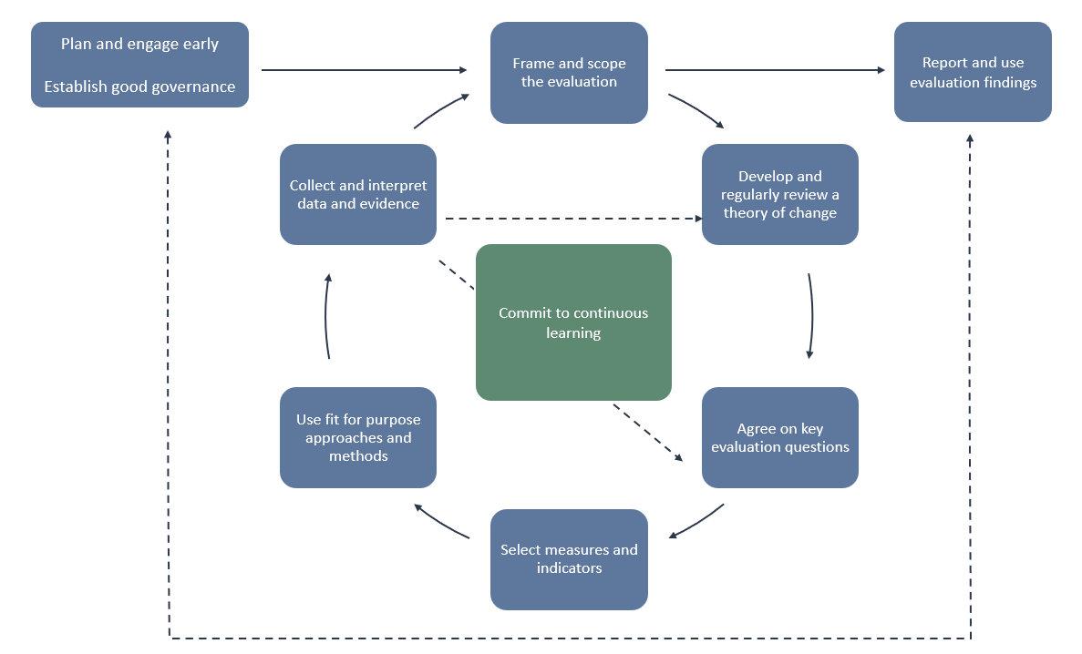
Figure 1 description
Common elements in the evaluation process that support leading practice are listed below, with links to supporting guidance and tools.
In addition to the enabler above (commit to continuous learning), many of these elements will be captured in the MEL Framework for the place-based evaluation:
- plan and engage early
- establish good governance
- frame and scope the evaluation
- develop and regularly review a theory of change
- agree on key evaluation questions
- select measures and indicators
- use fit for purpose approaches and methods
- collect and interpret data and evidence
- report and use evaluation findings.

Plan and engage early
Planning for monitoring, evaluation and learning should be part of the place-based initiative’s design - sometimes referred to as the ‘Understanding’ phase. Early planning creates depth in awareness and understanding by identifying stakeholders, developing partnerships and relationships, and clarifying the needs, challenges and aspirations of the people and places of focus, to ensure the initiative can address these. This stage can also establish how to capture the changes made through the work and enables ethics to be considered from the outset (including if formal ethics approval is required).
Early planning ensures the right people are involved in setting objectives, clarifying how success will be measured, and ways to adapt to emerging issues during implementation, monitoring and evaluation stages. This process also strengthens participation and shared ownership of the findings.

Establish good governance
Good evaluation governance is important for stakeholder engagement, collaborative learning and improved evaluation quality (Australian Centre for Evaluation 2025). Place-based work will often have existing supportive governance structures, which may have been established by the local community. These governance structures will inform the governance arrangements for the evaluation, including specific mechanisms (evaluation steering committee/technical working group/advisory group) to provide direction, facilitate transparency and agree on a shared agenda through collaborative decision-making.
Membership may differ depending on the type of place-based work but should include representatives from all partners and include the necessary expertise. Different stakeholders may need support or resources to participate effectively. Place-based partnerships should have independent or co-chaired evaluation governance structures, conflict-resolution protocols and transparency in membership.

Governance of evaluations in First Nations contexts
The governance of evaluations in First Nations contexts should include First Nations leadership. Some additional governance considerations that are particularly important for place-based work involving First Nations communities are detailed below.

Relationships and ethics
APS staff and external evaluators must recognise the centrality of relationships for place-based work. Ethical responsibility stems from understanding the deep connections First Nations people have with their ancestors, communities, culture, and Country. Engagement of First Nations people should occur from the outset to the dissemination and use of findings. Rushed or tokenistic negotiations or engagement can harm communities.

Self-determination and control
Place-based evaluation must be conducted using social justice principles, led by and with clear benefits for First Nations people. Priority should be given to known local evaluators and to including First Nations people as active members of the evaluation team. First Nations communities must have a say in the design, the methods used, who is consulted, and how information is collected, analysed, reported and used.

Two-way learning and capacity
Evaluators should approach the work as both learners and teachers, sharing knowledge about evaluation with communities and enabling local people to learn by doing (Cram 2018). This approach means funds are spent supporting local Indigenous evaluators, advisors, and workers and helps to ensure the validity of the findings (Cram 2018). Two-way learning builds capacity amongst non-Indigenous evaluators to better understand and incorporate First Nations evaluation perspectives into their work.

Respect and trust
Trust must be earned willingly through respectful engagement, transparency, and honesty (Grey et al 2018). Historically, Indigenous people have shared information that has been misused for academic purposes, leading to distrust of non-Indigenous researchers (Grey et al 2018). Evaluators must gain insight into the reality of the lived Indigenous experience, including strengths and aspirations, while also examining structural barriers.

Frame and scope the evaluation
To frame and scope the evaluation, you need to clarify:
- what is being evaluated
- the purpose of the evaluation
- the audience for the evaluation
- the resourcing and budget available for the evaluation.
Place-based evaluation should mirror the intent, including levels of participation, of the place-based initiative and bring stakeholders into developing the MEL framework and evaluation plans. This requires an understanding of the context of ‘place’ at multiple levels, including First Nations history, population movement and characteristics, cultural and geographic context.
First Nations viewpoints of MEL embed First Nations leadership and ownership, recognise the importance of culture and take a strengths-based approach that reflects the worldviews, knowledge and priorities of First Nations communities and partners. Further guidance on setting up MEL from First Nations viewpoints is contained in the Victorian Government MEL Toolkit.
As described previously, place-based evaluation is iterative. Stepped evaluation planning that results in phased evaluations is suited to initiatives aiming to make population level/system changes. This phased approach avoids developing a prescriptive evaluation framework too early, without considering early insights and emerging issues.
Evaluations should be fit for purpose. Place-based work addresses complex, interrelated and/or challenging issues. These evaluations typically require more resources than other forms of evaluation and should be proportional to the value, impact and strategic importance of the initiative.

Develop and regularly review a theory of change
Place-based work should be underpinned by an evidence-based theory of change (TOC). This should be developed with community stakeholders to map out how specific changes are expected to happen over time and document key assumptions. Place-based work is based on the idea that systemic changes in a local area will lead to long-term improvements for the whole community.
Place-based work is dynamic and the TOC should be regularly reviewed with input from key stakeholders to ensure emerging insights are captured. This may involve considering how change is occurring in one local area or across multiple sites. A place-based TOC often has an initial focus on shifting the ‘conditions for change’ – for example, power dynamics, decisions on resource allocation and different modes of service delivery – ahead of observing system and population level changes.
First Nations approaches to developing TOC include a wider and more holistic approach. For example, Story of Change is a circular approach that privileges First Nations’ perspectives, where each community is seen as an eco-system. The Story of Change creates shared outcomes measurements (Community First Development 2025).
Figure 2 shows a simplified generic TOC for place-based work that has been adapted by the Victorian Government (Victorian Government 2023, p. 18) from the Place-based Evaluation Framework (Clear Horizon 2018, p. 24).
This simplified TOC:
- provides a guide for strategic planning, measuring and evaluating the short, medium and long-term outcomes of the initiative
- shows the relationship between conditions for change (foundations and enabling conditions), mid-level impacts (systems changes), and impacts in place (population level changes)
- covers the 4 keys to unlock systems innovation: purpose, power, relationships and resource flows (Winhall and Leadbeater 2018).
Figure 2: Simplified Generic Theory of Change
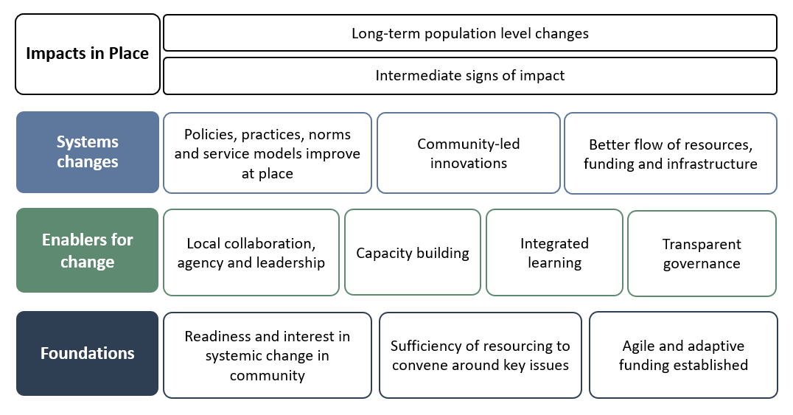
Figure 2 description
This approach provides a starting point to develop a tailored, context-specific TOC. A tailored TOC should be developed in partnership with stakeholders to represent community views on how change is expected to be achieved. This can support line of sight back to broader initiative-level information (for example, by using common organising principles across different sites), while also being responsive to the place and context for each site. This supports community defined and meaningful outcomes, measures and findings.
The TOC includes how foundations for change (e.g. community readiness, funding and resources) establish the enablers for change (e.g. types of relationships, training, established structures), needed to create changes at higher levels. These systems changes will be unique to each place, including changes to practices, innovation and shifts in resourcing flows. It may also document principles that will inform ways of working in the ‘place’ (Victorian Government 2023, p. 18).
The TOC should be regularly reviewed as more is learnt about how change is occurring. Population level impacts will not be observed for some time, but preceding these are early impacts on individuals, families or micro-communities that can be tested early and/or during implementation.
Figure 3 provides an annotated version of the Simplified Generic TOC showing how components can play out over time. This identifies possible focus areas for MEL (Victorian Government 2023, p. 19).
Figure 3: Annotated Theory of Change – with indicative time horizon
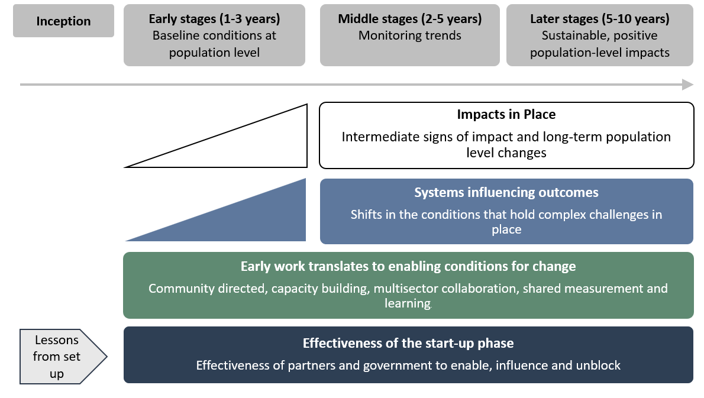
Figure 3 description
Agree on key evaluation questions
Key evaluation questions are the high-level questions that the evaluation is designed to answer. They should be developed early in the process, in partnership with stakeholders and documented in the MEL framework and evaluation plans. The scope, purpose and use of the evaluation, the theory of change, and the readiness of the ‘place/s’ for evaluation should inform the questions.
Depending on the purpose of the evaluation and the number of sites involved, there may be different questions for evaluations carried out at the community versus initiative level. Additionally, evaluation of each stage of implementation will also likely focus on different questions. For example, early-stage evaluation may focus on process or developmental questions and the enablers for change. This might include questions about the quality of relationships established under the partnership, capacity building initiatives, learning outcomes, or the level of satisfaction with governance and decision-making. Middle and later stage evaluation may focus on impact or economic evaluation questions and any intermediate signs of progress or population change.
The key evaluation questions should address issues important to communities and funders (both government and non-government) and focus on strengths (rather than deficits), demonstrating cultural respect. Different stakeholders may have varying perspectives on the key evaluation questions. Building genuine, respectful relationships from the outset, and allowing time for different perspectives to be shared in culturally safe ways helps to ensure evaluations are designed to address the right questions. Good evaluation governance includes deliberate and inclusive decision-making processes to work through these issues and ensure evaluations remain fit for purpose and findings are useful.
The Place-Based Evaluation Framework (Clear Horizon 2018) is a useful resource for considering evaluation questions.

Select measures and indicators
Deciding on the right measures and indicators is a key part of evaluation practice. They set the agreed parameters for what data is collected and what to focus on (Victorian Government 2023, p. 27). These are documented in the MEL framework or evaluation data matrix.
An indicator is a simple statistic or metric recorded over time to inform people of changing trends (Clear Horizon 2018, p. 54). Indicators should be based on a good understanding of how it is believed the changes will occur (the theory of change as supported by evidence) and what meaningful data is available or can be collected. In First Nations Communities, this may include the community dream, which is held by Elders, community members and youth (Community First Development 2025).
Some places develop their own indicators, while others may use existing indicators, to measure the overall goal of the place-based work. This recognises that place-based change is dynamic and involves many factors working together. In this context the selection of indicators will require analysis of intermediate outcomes (signs of progress) and consideration of root causes of change.
Establishing a reliable baseline and tracking signs of progress helps maintain community and stakeholder engagement. This may be required across all communities (or sites) for National or initiative level place-based work. Further guidance on indicators is contained in the Victorian Government MEL Toolkit (Victorian Government 2023) and the Place-based Evaluation Framework (Clear Horizon 2018).

Use fit for purpose evaluation approaches and methods
The selection of fit for purpose evaluation approaches and methods should be informed by the:
- local context and the number of sites
- initiative’s theory of change
- key evaluation questions
- views of stakeholders
- existing evidence
- needs of community and decision-makers.
It is important to ensure that the approaches and methods chosen are fit for purpose, robust, ethical and culturally appropriate. It is useful to document in the MEL Framework or evaluation plan the evaluation approaches that were explored but were deemed unsuitable.
There are a wide range of evaluation approaches and methods that may be used in evaluations of place-based work. The type of evaluation needed to support emergent decision making, continuous improvement and accountability will vary as the initiative matures. Some approaches and methods that may be used are described below.

Early stages (1 – 3 years) of designing and implementing place-based work
The iterative and emergent nature of the early stages could be supported by ‘developmental evaluation’. This provides a structured way to monitor, assess and provide timely feedback on place-based work while it is being developed and can inform improvements or changes.
It is useful in innovative, complex and uncertain contexts that can be found in place-based work as it uses real-time feedback to guide decision making and practice (Victorian Government 2023, p. 57). For more information on developmental evaluation, see the AIFS Practice Guide (Australian Institute of Family Studies 2018).

Middle stages (2 – 5 years)
It is likely that community leaders and decision-makers will be interested in assessing how well the initiative is being implemented (through ‘process evaluation’) and measuring systems changes and localised (intermediate) instances of impact.
Methods used could include outcome harvesting, most significant change, social network analysis, and contribution analysis among others.
While opportunities for ‘impact evaluation’ might be limited at this stage, in some cases this will be feasible. Examples include randomised trials, difference-in-differences and synthetic control modelling.

Later stages (5 – 10 years and beyond)
As an initiative matures and implementation becomes further advanced – the focus shifts to determining effectiveness in making population level changes (through ‘impact evaluation’) and cost-effectiveness (through ‘economic evaluation’). General guidance on approaches and methods is available from a range of sources however the UK’s Magenta Book is one good source (HM Treasury 2025).

First Nations approaches and methods
First Nations approaches and methods should be used at all stages, wherever possible, when working with First Nations communities. Methods that resonate with First Nations people are often participatory in nature meaning they engage stakeholders in meaningful ways. First Nations methods aim to strengthen connections between people and Country. These methods include yarning, storying and Dadirri. Yarning is a First Nations style of conversation and storytelling. Dadirri originates from the Ngan’gikurunggurr and Ngen’giwumirri languages of the Aboriginal peoples of the Daly River region, Australia, representing inner deep listening and quiet still awareness (Productivity Commission 2020). Storying involves making and remaking meaning through stories (Phillips and Bunda 2018).
Subject to the views of stakeholders, a combination of approaches and methods may be appropriate.

Collect and interpret data and evidence
All place-based work will have routine performance monitoring, which is part of funding administration. This data contributes to the evidence base for future evaluations. Additional data can also be collected to establish a baseline, track measures and indicators over long-periods of time, and answer the key evaluation questions.
Multiple data sources are needed to understand change processes through different lenses. Communities and local service providers commonly collect their own data to track progress and identify priorities. Data collected by communities and local service providers provides valuable insights that can explain what is changing or not changing (and why). Data collected by communities can be compiled by APS staff as part of performance monitoring at the community and initiative level.
There may be data limitations due to data collection capacity, small population sizes and concerns around privacy. Existing data may not align with specific locations and impact can be hidden through population movements (people moving in and out of an area). Alternate data sources and the availability of data may change over the life of the place-based work.
Under the National Agreement on Closing the Gap, Priority Reform 4 relates to shared access to data and information at a regional level, which includes governments providing access to the same data they use to make decisions (National Agreement on Closing the Gap 2020). The Framework for Governance of Indigenous Data contains guidelines for providing First Nations people with greater agency over how their data are governed within the APS, considering Indigenous Data Sovereignty (Commonwealth of Australia 2024).
Routinely generated government data that is produced as part of funding administration is also very useful and should be organised and stored for use in evaluation. Administrative data collected by all levels of government is often detailed and comprehensive, noting there can be limitations in data access and availability. It is particularly useful for tracking data over long periods of time, before and after a place-based initiative begins. Governments may be able to facilitate access to large administrative datasets. Guidance on government administrative data is available from the Australian Centre for Evaluation and the Community Data Toolkit [link].
The analysis and interpretation of results should be robust, unbiased, and anchored around the key evaluation questions established by the MEL framework. Further guidance is available in the Commonwealth Evaluation Toolkit.

Report and use evaluation findings
Evaluation findings should be used to support continuous improvement, decision-making and accountability. Findings need to be timely, usable and accessible. All findings should be substantiated with evidence and able to be defended. Reports should present findings in connection to key evaluation questions.
Local level interpretation of findings and associated recommendations is a key component of place-based work. Findings for place-based work should be collectively analysed in a culturally safe way using shared sense-making processes that are context appropriate. Sensemaking workshops can be used to reduce cultural assumptions and help stakeholders interpret findings. Validating findings with stakeholders can ensure the findings are contextually meaningful and useful.
There should be a strong focus on accountability to communities regarding the findings of evaluations, including a proactive approach to transparency and accessibility. Joint communication of findings is important in some place-based work. Findings should be shared in formats and languages that are accessible and meaningful to communities.

Appendix A – Additional resources
Whole-of-government evaluation requirements and guidance include:
- Commonwealth Evaluation Policy (2021) applies to all Commonwealth entities and companies subject to the Public Governance, Performance and Accountability Act 2013 (PGPA Act).
- Commonwealth Evaluation Toolkit (2021) designed to help Commonwealth entities and companies meet the requirements and policy intent of the Commonwealth Evaluation Policy. The Toolkit provides access to curated templates, tools and resources.
- Ethics in evaluation (2021) developed by the Australian Institute of Family Studies helps plan an evaluation, consider the ethical implications of what you intend to do, and reduce the risk of harm to people participating in the evaluation.
Whole-of-government commitments and frameworks include:
- Measuring What Matters Framework (2023) is Australia’s first national wellbeing framework. It tracks our progress towards a more healthy, secure, sustainable, cohesive and prosperous Australia.
- Toolkit for engaging with people with disability in evaluation (2025) created to support people with disability to be confident to engage in evaluations and ensure evaluations are accessible.
Tools and resources relevant for evaluating place-based work include:
- PLACE Resource Library (2025) developed by Partnerships for Local Action and Community Empowerment. The library provides access to a growing collection of tools and resources designed to support place-based approaches that can be used to inform evaluation of place-based approaches.
- Place-based Monitoring, Evaluation and Learning Toolkit (2023) developed by the Victorian Government to assist government officials and partners to progress place-based approaches.
- Place-based Evaluation Framework - a guide for evaluation of place-based approaches in Australia (2018) developed by Clear Horizon and commissioned by the Australian Government Department of Social Services, the Queensland Government Department of Communities, Disability Services and Seniors, and Logan Together.
- Toolkit for Evaluating Place-based Delivery Approaches (2018) developed by Clear Horizon as a companion to the Place-based Evaluation Framework (above).
- Evaluating Place-Based Approaches: a review of methods used (2023) summarises approaches to evaluating place-based approaches to inform the Youth Endowment Fund (YEF)'s evaluation of place-based approaches.
- Place-based approaches for community change: QCOSS’ guide and toolkit (2019) developed by the Queensland Council of Social Service to support people working on a place-based approach.
- Collaboration Health Assessment Tool (2017) developed by the Centre for Social Impact as an online diagnostic tool which helps to measure how collaborators are working together.
- Guide to Evaluating Collective Impact (2014) developed by the Collective Impact Forum as a practical handbook with a framework for approaching evaluation.
- A Practical Guide to Evaluating Systems Change in a Human Services System Context (2014) developed by the Center for Evaluation Innovation to provide guidance on systems change.
- MERIT (the Monitoring, Evaluation, Reporting and Improvement Tool) an online reporting system that simplifies and streamlines reporting across Australian Government Natural Resource Management.
Tools and resources relevant for First Nations contexts include:
- First Nations Partnership Playbook (2025) developed by the Australian Public Service Commission to provide practical guidance on working in partnership with Aboriginal and Torres Strait Islander peoples.
- Indigenous Evaluation Strategy (2020) developed by the Productivity Commission for Australian Government agencies to use when selecting, planning, conducting and using evaluations affecting Aboriginal and Torres Strait Islander peoples.
- Aboriginal and Torres Strait Islander Quality Appraisal Tool (2018) developed by the Centre of Research Excellence in Aboriginal Chronic Disease Knowledge Translation and Exchange (CREATE) to provide a set of 14 questions for appraising the quality of research in Australian settings through an Aboriginal and Torres Strait Islander lens.
- The ARPNet Dilly bag (2012) developed by the Aboriginal Research Practitioners’ Network (ARPNet) to guide participatory and other research tools for use by Aboriginal research practitioners.
- Indigenous evaluation (2025) resources are available on the Australian Centre for Evaluation website to support evaluations of policies and programs affecting Aboriginal and Torres Strait Islander people.
Examples of self-assessment tools, resources and training to build place and cultural awareness include:
- Australian Public Service Commission (APSC) Self-Assessment Tools incorporate cultural awareness as a competency, helping senior leaders to assess their ability to anticipate and manage cultural clashes.
- Indigenous Cultural Responsiveness Self-Reflection Tool developed by the Australian Institute for Teaching and School Leadership (AITSL) guides educators through a process of self-reflection on their attitudes, biases, and assumptions related to Aboriginal and Torres Strait Islander peoples.
- Cultural Competence Reflection Tool (CCRT) from the Centre for Culture, Ethnicity & Health (CEH) helps practitioners explore their cross-cultural skills, attitudes, and understanding.
- Aboriginal and Torres Strait Islander Cultural Awareness Self-Assessment Toolkit (CASAT) developed by ACTCOSS helps community service organisations assess and improve their services for Aboriginal and Torres Strait Islander clients and communities.
- APS Integrated Unconscious Bias Training Program helps APS employees gain confidence in identifying and addressing unconscious bias.

Examples of place-based evaluations are in the ACE Evaluation Library including:
- Australian Institute of Family Studies: Stronger Families in Australia Study
- Central Land Council (CLC): Evaluation of the Central Land Council’s Community Development and Governance Programmes
- Department of Education/Department of Health: Evaluation of Connected Beginnings (mid-term report 2023)
- Department of Employment and Workplace Relations: Local Jobs Program Evaluation
- Department of Employment and Workplace Relations: A strategy for evaluating Empowering YOUth Initiatives and Empowering YOUth Initiatives Consolidated Learnings Report
- Department of Home Affairs: Evaluation of the Settlement Engagement and Transition Support (SETS) Grants Program
- Department of Immigration and Multicultural Affairs: Synopsis Review of the COAG trial evaluations
- Department of Social Services: Evaluation of Cape York Welfare Reform
- Department of Social Services: Evaluation of the Escaping Violence Payment Place-Based Trial
- Hands Up Mallee: Hands Up Mallee Mid-Term Evaluation
- National Indigenous Australians Agency: Stronger Communities for Children (SCfC) Evaluation Report
- National Indigenous Australians Agency: Murdi Paaki Regional Assembly Lessons Learned
- Stronger Places, Stronger People (SPSP): SPSP Early Evidence Report of Community Led-Change

Appendix B – References
Australian Centre for Evaluation (2025) Evaluation governance, Australian Centre for Evaluation website.
Australian Institute of Family Studies (2018) Developmental evaluation, Australian Institute of Family Studies website.
Better Evaluation (2025) Compare results to the counterfactual, Better Evaluation website.
Clear Horizon (2018) Place-based Evaluation Framework, Australian Policy Online website.
Commonwealth of Australia (2024) Framework for Governance of Indigenous Data, National Indigenous Australians Agency website.
Community First Development (2025) Right Way Evaluation: Telling our own stories of change, Community First Development website.
Cram, F (2018) Conclusion: Lessons about Indigenous evaluation, In F. Cram, K. A. Tibbetts, & J. LaFrance (Eds.), Indigenous Evaluation. New Directions for Evaluation, 159, 121–133.
Grey K, Yamaguchi J, Williams E, David V, Foster D, Gibson J and Dunnett D (2018) The Strength of Indigenous Australian Evaluators and Indigenous Evaluation: A Snapshot of ‘Ways of Knowing and Doing’ Reflecting on the 2014 Darwin Conference of the Australasian Evaluation, In F. Cram, K. A. Tibbetts, & J. LaFrance (Eds.), Indigenous Evaluation. New Directions for Evaluation, 159, 79-95.
HM Treasury (2025) The Magenta Book. UK Government website.
Kowa (2025) What is UMEL?, Kowa website.
National Agreement on Closing the Gap (2020) National Agreement on Closing the Gap, National Agreement on Closing the Gap website.
Phillips L G and Bunda T (2018) Research Through, With and As Storying, Online Book.
Productivity Commission (2020) A Guide to Evaluation under the Indigenous Evaluation Strategy, Australian Government website.
Victorian Government (2023) Place-based approaches: Monitoring, Evaluation and Learning (MEL) toolkit, Victoria State Government website.
Winhall J and Leadbeater C (2018) A Green Paper of System Innovation, System Innovation website

Appendix C – Figure descriptions

Figure 1 description
Cycle diagram showing nine common elements of leading practice, its relationship and sequencing. Arrows in the diagram show that the cycle repeats through the second shape: frame and scope the evaluation.
- First shape, top left hand side: plan and engage early and establish good governance (as first steps)
- Second shape, top middle: frame and scope the evaluation
- Third shape, diagonal down right from second shape: develop and regularly review a theory of change
- Fourth shape, under third shape: agree on key evaluation questions
- Fifth shape, bottom middle: select measures and indicators
- Sixth shape, diagonal up left from fifth shape: use fit for purpose approaches and methods
- Seventh shape, diagonal down left from second shape and above sixth shape: collect and interpret data and evidence
- Eighth shape, top right hand side: report and use evaluation findings.
- Nineth shape, middle centre, inside the circle created by second, third, fourth, fifth, sixth and seventh shapes: Commit to continuous learning
Return to Figure 1

Figure 2 description
Four tiered process diagram showing a simplified generic Theory of Change, with short, medium and long term outcomes of the initiative:
- Top tier, 3 sections, top left hand side: Impacts in Place.
  - Top tier, top middle: Long-term population level changes
  - Top tier, under top middle: Intermediate signs of impact
- Second tier, 4 sections, from left to right: Systems changes.
  - Second tier, second from left to right: Policies, practices, norms and service models improve at place
  - Second tier, third from left to right: Community-led innovations
  - Second tier, fourth from left to right: Better flow of resources, funding and infrastructure
  - Third tier, 5 sections, from left to right :Enablers for change.
- Third tier, second from left to right: Local collaboration, agency and leadership
  - Third tier, third from left to right: Capacity building
  - Third tier, fourth from left to right: Integrated learning
  - Third tier, fifth from left to right: Transparent governance
- Fourth tier, 4 sections, from left to right: Foundations
  - Fourth tier, second from left to right: Readiness and interest in systemic change in community
  - Fourth tier, third from left to right: Sufficiency of resourcing to convene around key issues
  - Fourth tier, fourth from left to right: Agile and adaptive funding established
Return to Figure 2

Figure 3 description
Five tiered process diagram showing an annotated Theory of Change – with indicative time horizon (4 columns):
- Top tier, 4 sections, top left hand side: Inception
  - Top tier, second from left to right: Early stages (1-3 years), Baseline conditions at population level
  - Top tier, third from left to right: Middle stages (2-5 years), Monitoring trends
  - Top tier, fourth from left to right: Later stages (5-10 years), Sustainable, positive population-level impacts
- Second tier, 1 section, under third and fourth columns: Impacts in Place, Intermediate signs of impact and long-term population level changes
- Third tier, 1 section, under third and fourth columns: Systems influencing outcomes, Shifts in the conditions that hold complex challenges in place
- Fourth tier, 1 section, under second, third and fourth column: Early work translates to enabling conditions for change, Community directed, capacity building, multisector collaboration, shared measurement and learning.
- Fifth tier, 2 sections, under first column: Lessons from set up
  - Fifth tier, under second, third and fourth column: Effectiveness of the start-up phase, Effectiveness of partners and government to enable, influence and unblock
Return to Figure 3

The role of the understanding phase can be used together with “understanding, measurement, evaluation and learning”, or UMEL, which is particularly important in First Nations contexts. See Kowa (2025) for more information. This Strategy uses the more common ‘MEL’ acronym, but the importance of understanding is reflected in this early planning and engagement step.

