

DSS3619.05.26

Outcomes-Based Contracting

Factsheet: Introduction to Outcomes-Based Contracting
Outcomes-based contracting is an approach to commissioning services where contracts are structured around specific, measurable outcomes.
It focuses on the real-world changes a program achieves. Examples include:
- Families being reunited
- Getting and keeping a job
- Securing stable housing
- Reducing re-offending.
There are different kinds of outcomes-based contracts. They are sometimes referred to as payment by outcomes or by results. A social impact bond is one type of outcomes-based contract where private investors provide upfront funding to deliver a service.

Why use it
This approach can help achieve a range of policy objectives. It is often used where traditional funding approaches haven’t delivered impact or have failed to address entrenched disadvantage.

Outcomes-based contracting is:

Iterative and flexible, allows service providers to innovate and identify what works.

Able to focus on long term impact and reduce demand for acute services, by supporting measurable early intervention and prevention approaches.

Data driven, evidence-based, and able to learn about entrenched disadvantage.

A means to test new ways of working to deliver better, adaptive, services.

An opportunity to unlock capital and partner with other commissioners and philanthropy.

Able to align the efforts of diverse stakeholders around common outcomes.

An opportunity to share risk and provide more accountability of public funds.

What’s different about outcomes-based contracting
Outcomes-based contracting differs significantly to traditional funding approaches.
Component | Traditional funding approaches | Outcomes-based contracting
  What’s contracted? | Contract describes the service inputs and outputs (e.g. number of clients supported, or types of activities delivered) | Contract describes the measurable outcomes which are sought for defined cohorts (e.g. a reduction in welfare consumption)
  Service model | Program design is agreed upfront and can be hard to change service model once contract is in place. | Allows flexibility for service providers to deliver what is needed and learn, adapt and change approach to meet people’s needs
  Target cohort | Broad or flexible eligibility, with focus on responding to people that present to the service | Specific eligibility criteria for targeted cohorts of people experiencing disadvantage
  Reporting focus | Reporting on activities and outputs, often short-term (i.e. 6 monthly during service delivery). | Reporting on progress toward outcomes and long-term impact (i.e. 2 years after service finishes)
  Relationship between parties | Tends to be grounded on compliance, contract management and performance | Parties work together and share data and learnings, to achieve outcomes
  Payment terms | Payments made upfront or based on activities delivered | Both upfront and outcomes-based payments
  Performance reviews | Reviews are centred on outputs. Tends to use service provider data, with limited understanding of outcomes achieved | Reviews are centred on outcomes. Uses a mix of government and service provider data to understand outcomes achieved
  Financial benefit and risk allocation | Financial benefits and risks typically held by commissioner | Financial benefits and risks are shared between the commissioner and service provider (and investors for social impact bonds)

Outcomes Fund and outcomes-based contracting
The Australian Government has committed $100 million to establish the Commonwealth Outcomes Fund. The Outcomes Fund will provide opportunities for outcomes-based contracting projects by making payments to Governments (State and Territory) and service providers to address entrenched disadvantage.

Learn more
- Define who a service is for in Identifying a Target Cohort
- Identify indicators of real-world changes that align with your policy objectives in Defining Outcome Metrics
- Develop an approach to assessing impact in Understanding Outcome Measurement
- Determine how much to pay for an outcome in Pricing Outcomes
- Self-assess your readiness for outcomes-based contracting in the Readiness Checklist

Outcomes-Based Contracting
Factsheet: Identifying a Target Cohort

Outcomes-based contracting enables commissioners to focus on clearly defined groups within a population. This can ensure that services are directed towards people with the greatest need or those who are underserviced, whilst building evidence about what works to address disadvantage.
A well-defined target cohort ensures that:
- People who are directly impacted by the identified social problem are captured
- There is no ambiguity around who the service is for (and who it is not for)
- There is a clear process for identifying potential service users
- Outcomes can be measured fairly and consistently
- Commissioners can link improvements for the cohort to the funding that is provided
- Outcomes are priced fairly and sustainably.

Target cohorts
The target cohort refers to everyone that is eligible for, and can access, a service funded by an outcomes-based contract.

A target cohort is defined using eligibility criteria. Some examples include:

Demographic factors
- Age
- Gender
- Cultural background

Life stage or situation
- Leaving out of home care
- Exiting prison
- Experiencing homelessness

Service use
- Hospital admissions
- School attendance
- Welfare payments

Time since an event
- Received welfare payments for 13+ fortnights in the year immediately prior to enrolment

Assessed risk factors
- Assessed as at risk of homelessness
- Risk of school disengagement
- Reoffending likelihood

Able to meet program requirements
- Able to attend weekly program sessions
- Willing to participate

Defining eligibility criteria

How the eligibility criteria of a service are defined has implications for commissioners, service providers and service users. There are benefits and drawbacks with different approaches. Commissioners should consider the implications and define the criteria to suit the context and purpose of the service.

Breadth of eligibility criteria
The breadth of eligibility criteria refers to how wide or narrow your criteria are.
Criteria | Description | Implications | Example
Broad criteria | More people are potentially eligible for a service | More outcomes can be measured giving confidence that measured outcomes reflect true impact of service.  The cohort will have a wide spectrum of complexity. Some people may require high support needs, and other may require minimal support. This can make it harder to measure and understand the true costs and benefits of the service.  Incentives may arise to support those with lower needs and not support more ‘complex’ individuals where outcomes may require more effort and resources (i.e. cherry-picking). | Individuals aged 16-24 who received Youth Allowance
Narrow criteria | Fewer people are potentially eligible for a service | Enables focus on individuals with greatest need.  It can be easier to estimate the cost of achieving an outcome (and the benefits arising from the outcome) as the cohort will be less variable.  There is less risk of ‘cherry-picking’.  There may be effort and resources required to identify eligible people.  Fewer outcomes can be measured which can reduce reliability and confidence in results.  People may be excluded from a service who would benefit from support. | Individuals aged 16-24 who received Youth Allowance and presented to a homelessness service

Subjectivity of eligibility criteria
The subjectivity of eligibility criteria refers to how precise or generalised your criteria is.
Criteria | Description | Implications | Example
Subjective criteria | Relies on judgment or interpretation by service providers | Can capture emerging needs that are not reflected in datasets.  Offers flexibility to include people whose needs align with the intent of the service.  May be harder to verify eligibility and can increase risk of inconsistency or selection bias.  Can be difficult to communicate to referral partners.  May be unable to identify people in datasets so may be harder to evaluate or develop a counterfactual. | People underemployed or at risk of losing a job
Objective criteria | Fact-based and verifiable using data or documentation | Easy for referral partners and service providers to check and apply consistently.  More likely to be identifiable in datasets that can be used for evaluations or developing a counterfactual.  May exclude people in need from a service or reduce flexibility to support people in complex situations.  May require access to additional datasets to determine eligibility. | People employed less than 10 hours per week

Referral pathways
It’s important to consider how eligible people will be found and referred into a service, which may inform how you define eligibility criteria. You should ask yourself:
- Which organisations interact with the target cohort? For example, schools, hospitals, prisons, or non-government organisations may interact with the target cohort. You may need to consider additional strategies to find people if they do not regularly engage with other services.
- How will referring organisations identify eligible individuals? You will need to consider what information they will have access to confirm eligibility, and what guidance they will need to apply eligibility criteria consistently.

Case study: Foyer Central
Foyer Central provides young people who have been in out-of-home care in New South Wales with stable housing and strengths-based supports. It aims to build their capacity to access education, training and employment, and make positive decisions.
Eligible young people are referred by the NSW Department of Communities and Justice and non-government organisations. Some young people also self-refer.
Individuals must meet the following criteria:
- aged 18 to 22 years;
- has been in out-of-home care and exited care aged between 14 to 18 years;
- is homeless or at risk of homelessness;
- is assessed as motivated, willing and able to commit to the program; and
- not meet any exclusion criteria (e.g. no recent history of violent behaviour)
The service provider, Uniting, undertakes a comprehensive assessment of each referred young person to ensure they are eligible. Uniting also considers a range of factors to ensure that there is an appropriate mixture of residents at Foyer Central. An assessment panel comprising representatives from a mixture of organisations makes the final decision about whether a young person is eligible for enrolment.

Learn more
- Understand the basics of outcomes-based contracting in Introduction to outcomes-based contracting
- Identify indicators of real-world changes that align with your policy objectives in Defining Outcome Metrics
- Develop an approach to assessing impact in Understanding Outcome Measurement
- Determine how much to pay for an outcome in Pricing Outcomes
- Self-assess your readiness for outcomes-based contracting in the Readiness Checklist

Outcomes-Based Contracting

Factsheet: Defining Outcome Metrics

An outcome is a change for an individual as a result of a service or intervention. An outcome metric is the indicator selected to measure whether that outcome has been achieved.

How metrics are different with outcomes-based contracting
Outcome metrics used in outcomes-based contracting are distinctly different to key performance indicators used in traditional funding approaches.
Funding model | Traditional funding approaches | Outcomes-based contracting
Metric type | Key performance indicator (KPI). | Outcome metric.
Description | Tracks activities, outputs, or process milestones by reporting on “what was done to support people”. | Tracks meaningful outcomes (or progress toward outcomes) for service users by measuring “what changed for the people supported”.
Purpose | Used to monitor service delivery activities, budget adherence and compliance. | Used to assess impact of a service, support continuous learning, and align stakeholders’ efforts.
Examples | Number of participants served.  Number of sessions delivered.  % of funds spent and adherence to planned budget.  Submission of financial and activity reports on schedule.  Number of case managers employed to deliver the service. | Number of days spent in hospital.  Number of presentations to homelessness services.  % of service users who report improvements in wellbeing.  Number of job placements.  Amount of award wage income reported by service users.  % children reunified with their families.

Metric considerations

Alignment with policy objective
An outcome metric should clearly align with your policy objectives and allow commissioners to assess whether they are achieving this.

Broader monitoring and evaluation framework
Not all outcome metrics need to be linked to payments. You can develop a broader set of outcome metrics that can be used to inform adaptive service delivery and evaluate the impact of the service.

Data sources
Outcome metrics linked to payments should rely on existing data sources where possible so you can minimise investment into new data collection systems and processes. There are typically two different data sources that can be considered.
Data source | Advantages | Challenges
Government | May require lower level of verification.  Service provider resourcing effort is reduced.  Better suited to establishing counterfactuals and relative measurement approaches. | Access may be limited or delayed.  Requires greater commissioner resourcing.  Service providers need to collect additional data to match participants to dataset.  Often reliant on existing datasets.
Service provider (or service users) | Potential to be quicker and more direct.  Can capture broader set of outcomes not linked to use of government services (e.g. self-reported wellbeing).  Can more readily inform changes to service delivery on the ground. | Requires higher level of verification.  Subject to ‘survivorship bias’ or inaccuracy.  Creates additional administrative burden for service provider.  May impact relationship between provider and participants.  Unlikely to be able to establish robust counterfactual so better suited for absolute measurement approaches.

Objectivity
Outcome metrics linked to payments should rely on quantifiable and verifiable data rather than human judgement. This ensures there is minimal ambiguity in definition and measurement.

Perverse incentives
Linking payments to outcomes creates a financial incentive to achieve the outcomes. Therefore, it is important to ensure that these outcome metrics do not encourage service providers to behave in a way that is detrimental to service users and the objectives of the outcomes-based contract to maximise payments. For example, an outcome that can only be assessed as a ‘pass’ or ‘fail’ (e.g. an individual does or does not re-offend) can sometimes create perverse incentives.

Attribution
Attribution is about proving the additional impact of a service – i.e. the outcomes that can reasonably be credited to a service over and above what would have happened anyway. See the ‘Understanding Outcome Measurement’ factsheet for more information.

Outcome metrics that use government data
There are a wide range of outcome metrics that rely on government data sources.

Employment
Outcome Metric | Detail | Government
Income support payments | Dollars of income support paid | Commonwealth
Income support periods | Number of periods receiving income support | Commonwealth
Off welfare | Whether off benefits for at least x number of weeks | Commonwealth
Income | Dollars of (non-welfare) income | Commonwealth
Job placements | Number of job placements | Commonwealth
Job duration outcome | 12- or 26-week employment outcome achieved | Commonwealth

Housing
Outcome Metric | Detail | Government
Rent assistance payments | Dollars of rent assistance | Commonwealth
Homelessness support services | Number of presentations to specialist support services | State / Territory

Health
Outcome Metric | Detail | Government
Hospital bed days | Number of days in hospital | State / Territory
National weighted activity units | Relative cost of healthcare provision | State / Territory
Emergency department visits | Number of presentations to Emergency Department | State / Territory
Mortality | Incidence of death, or other morbidity events | State / Territory
MBS and PBS spending | Cost to Commonwealth based on schedule fees | Commonwealth

Justice
Outcome Metric | Detail | Government
Recidivism | Re-entry into custody | State / Territory
Charges | Number of charges | State / Territory
Proven offences | Number of proven offences, potentially by severity | State / Territory
Incarceration | Number of days in remand or serving custodial sentences, or total length of sentences awarded | State / Territory
Parole completions | Completion of parole period without violation | State / Territory

Learn more
- Clearly define who a service is for in Identifying a Target Cohort
- Develop an approach to assessing impact in Understanding Outcome Measurement
- Determine how much to pay for an outcome in Pricing Outcomes
- Self-assess your readiness for outcomes-based contracting in the Readiness Checklist

Outcomes-Based Contracting

Factsheet: Understanding Outcome Measurement

Outcome measurement is the process of assessing whether meaningful changes have occurred for an individual that received a service.

The importance of measurement
Outcome measurement is important to different stakeholders – such as service providers, communities and commissioners – for a variety of reasons. In the context of outcomes-based contracting, outcome measurement is central to determining whether the commissioner’s policy objectives have been achieved.
It’s important because it:
- assesses impact, by determining whether targeted outcomes and policy objectives have been achieved
- informs payments, so funding to service providers is linked to improvements in agreed outcome metrics
- supports adaptive service delivery, by providing feedback to adapt services to meet users’ needs over time
- provides deeper insight, by generating insight into what services are effective, and the value generated to support further investment.

Key concepts related to outcome measurement

Attribution
Attribution is about proving the additional impact of a service – i.e., the outcomes that can reasonably be credited to a service over and above what would have happened anyway.
A counterfactual is an estimate of what would have happened anyway. There are a range of approaches to estimating a counterfactual. Each has different benefits and limitations. Cost, complexity, robustness and ethics need to be considered with selecting an approach.
Approach | Overview
Assumption-based estimate | Using available data to inform assumptions about what would have happened anyway.
Individual’s pre-service experience | Each individual’s experience before participating in the service forms their own historic baseline.
Historical baseline for target cohort | Past outcomes for a similar population using historical data are analysed to set a baseline.
Matched control group | A comparison group is constructed based on the attributes of the individuals participating in the service.
Randomised control trial | Individuals are randomly allocated to participate in the service or to receive other services as usual.
Randomised control trials are considered the most reliable way to estimate the counterfactual.
Alternative approaches – like using an individual’s service experience or historical data for the target population – while not always as accurate, can offer a simpler and more cost-effective way to estimate what would have happened anyway.
When designing a contract, commissioners need to weigh up the benefits and limitations of each approach, to select the most appropriate.

Individual and cohort measurement
Outcomes can be assessed at an individual level, where each service user is assessed separately to determine whether they achieved an outcome (e.g., whether a child reunified with their parents after participating in the service for 18 months).
Outcomes at an individual level are typically then aggregated across all service users to assess the impact of the service (e.g., the number or proportion of children that are reunified with their families). This will inform the data sources that are used for measurement (see ‘Defining Outcome Metrics’ for more information).
Outcomes do not need to be assessed at an individual level and can instead be aggregated for all service users at a cohort level (e.g. the total number of presentations to specialist homelessness services by all service users).
For each metric, it is important to distinguish between measuring outcomes at an individual level and at a cohort level because it impacts how success is defined, what data needs to be collected and how payments are calculated.

Outcome verification
Outcome metrics linked to payments are typically verified to ensure credibility and transparency in measured outcomes. There are three options for verifying outcomes:
- Engaging an external organisation to independently review and certify measured outcomes and calculate payments. This is an additional cost for the commissioner but can provide greater confidence in the results
- Appointing the commissioner’s contract manager to review and verify measured outcomes and calculate payments in accordance with the outcomes-based contract
- Setting up the service provider to self-report measured outcomes and claim payments from the commissioner. This is less costly for the commissioner but can lead to lower confidence in the results.

Case study 1: Aspire Social Impact Bond

Overview
The Aspire Social Impact Bond aimed to provide people experiencing chronic homelessness in Adelaide with assistance with securing stable accommodation, job readiness training, and pathways to training, employment and life skills development.
The commissioner (the Government of South Australia) sought to explore a range of initiatives to promote innovation in the delivery of social and community services.

Outcome measurement
There were three outcome metrics linked to payments:
- Hospital bed days: the number of days spent in hospital bed over a three-year period
- Convictions: the number of convictions recorded in respect of offences over a three-year period
- Accommodation periods: the number of emergency accommodation periods accessed over a three-year period.
Each outcome metric was measured relative to a counterfactual. The counterfactual was initially determined using analysis of service usage rates for a historic group of people experiencing homelessness in metropolitan Adelaide. The counterfactual was subsequently updated during the life of the program to more fairly reflect the complexity and characteristics of the individuals entering the Aspire program. The revised counterfactual reflected Aspire participants’ average service usage over the two-year period prior to commencing the program.
Outcome metric | Counterfactual rate per person per year | Recorded rate per person per year | Initial target reduction | Actual reduction
Hospital bed days | 5.9 | 4.2 | 15 per cent | 29 per cent
Convictions | 1.2 | 0.8 | 15 per cent | 33 per cent
Accommodation periods | 1.1 | 0.3 | 50 per cent | 73 per cent
Other metrics used to inform ongoing service delivery were the number of participants housed, the number of participants maintaining their housing and the number of job placements. An evaluation was commissioned separately which measured a broad range of outcomes to better understand the effectiveness of the Aspire program and why it was effective.

Case study 2: Greater Manchester Refugee Integration Partnership

Overview
The Greater Manchester Refugee Integration Partnership aims to increase the self-sufficiency and integration of newly granted refugees, helping them to move into work, learn English, access housing and build links in their local communities.
The commissioner (the UK Home Office), through the Refugee Transitions Outcomes Fund, is seeking to encourage new partnerships and evaluate activities to better understand what works for refugees.

Outcome measurement
There were eight outcome metrics linked to payments:
- Intermediate employability outcome: undertaking volunteering or work experience alongside improvements on two further individualised employability targets
- Employment entry: entering employment or self-employment
- Employment sustained: sustaining employment or self-employment for three months
- Housing entry: entering safe and secure accommodation
- Housing sustained: sustaining housing for three months
- Integration plan: completing a person-centred individualised integration plan covering all areas relevant to their integration journey
- Six-month integration improvement: completed individualised integration plan, with improvement on two or more six-month progress targets
- Twelve-month integration improvement: completed individualised integration plan, with improvement on two or more 12-month progress targets.
These outcome metrics were not measured relative to a counterfactual for the purpose of determining payments.
The evaluation of the Refugee Transitions Outcomes Fund considers the impact of the initiative relative to a matched control group.

Learn more
- Understand the basics of outcomes-based contracting in Introduction to outcomes-based contracting
- Define who a service is for in Identifying a Target Cohort
- Identify indicators of real-world changes that align with your policy objectives in Defining Outcome Metrics
- Determine how much to pay for an outcome in Pricing Outcomes
- Self-assess your readiness for outcomes-based contracting in the Readiness Checklist

Outcomes-Based Contracting

Factsheet: Outcomes Payments
Outcomes payments are linked to the achievement of an agreed outcome, within an outcomes-based contract.
Choosing the right outcomes payment is important, because it:
- creates conditions to foster innovation in service delivery
- builds a healthy ecosystem of service providers by reflecting the true cost of delivering outcomes
- demonstrates value for money with prices reflecting benefits of the outcomes achieved
- aligns incentives and manages risk for commissioners, service providers and other stakeholders.

How funding is different
Funding under an outcomes-based contract is different to most traditional funding approaches across a range of dimensions.
Dimension | Traditional funding arrangements | Outcome based  contracting
Types of payment | Payments based on inputs or outputs. | A mixture of fixed and outcomes-based payments.
Payment timing | Regular payments paid in advance or based on completion of activity reports or milestones. | Fixed payments paid in advance, with outcome payments paid after achievement and verification of outcomes.
Price | Based on cost of service delivery. | Determined using a combination of cost to achieve outcomes and value of the outcomes.
Financial risk allocation | Lower financial risk for service providers as payments are fixed or volume-based. | Shared financial risk with service providers for proportion of funding contingent on achieving outcomes.
Funding sources | Typically one source of funding. | Can involve multiple funders including other commissioners (i.e. philanthropy).

Key concepts related to outcome pricing

Fixed funding
Fixed funding refers to the amount of funding under an outcomes-based contract that will be paid regardless of what outcomes are achieved. This funding is used to help cover the cost of service delivery until outcomes are achieved and paid on.

The amount of fixed funding also reflects the level of financial risk allocated to a service provider (and other stakeholders in some cases) and should be considered with reference to the policy objectives of the outcomes-based contract.
The amount of fixed funding can vary between having no fixed payments, to having a small proportion linked to outcomes (i.e. ~95% fixed payments).
Key considerations for determining this amount and, therefore, the financial risk allocated to the service provider include:
- Financial capacity of service providers: do service providers have the financial reserves to fund the service until the outcomes are achieved and paid on?
- Track record of the service: Has the service or a similar intervention model previously achieved the outcomes?

- The policy context: Is it appropriate to be shifting this amount of financial risk to service providers operating in this policy area?
- Ability to access external funding: Can service providers access funding from private investors or philanthropic funders to fund the service and share financial risk?

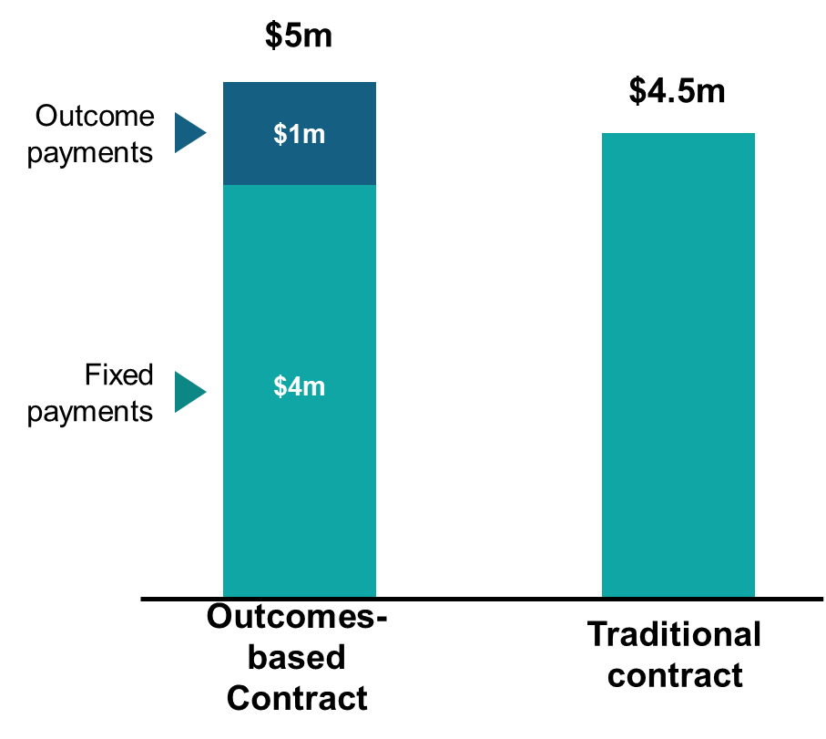

Price of an outcome
The price is the amount agreed by the service provider and commissioner for achievement of agreed outcomes. This is the level of funding that is ‘at risk’ if outcomes are not achieved.
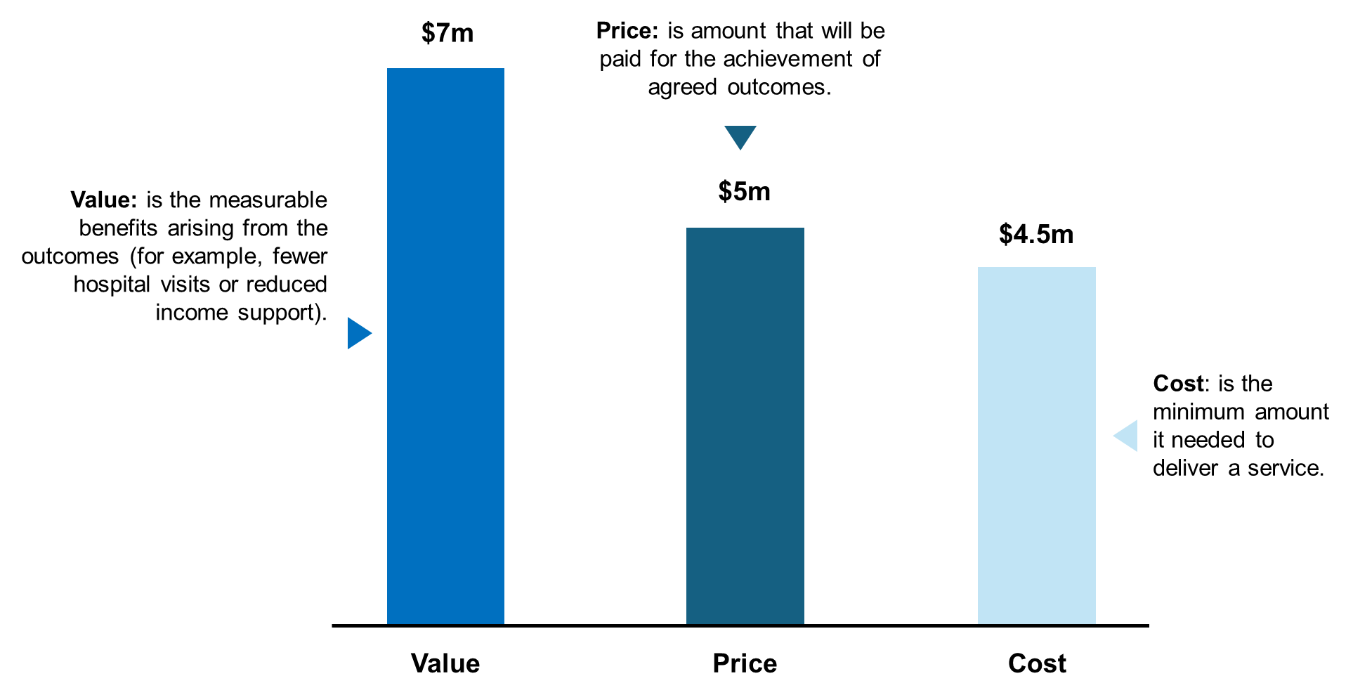
The price is different to the cost to achieve the outcome for the service provider and the value generated for the commissioner. The cost and the value are the bookends for determining the price of an outcome, with the price of an outcome usually being somewhere between.
In determining the price of outcomes, commissioners need to consider the minimum cost needed to deliver a service, without creating undue financial pressure or risks for service providers. Pricing should consider locational differences, for example remote locations may have higher costs. Commissioners should also recognise that different services providers or sectors may have key differences, for example smaller organisations may have higher relative administration costs or may be less able to bear risks than a larger organisation delivering programs nationally.
Additional considerations for determining price include:
- The level of certainty about whether the outcomes will be achieved, as service providers may require a higher price with more uncertainty
- The complexity and the characteristics of the target cohort, which impacts the level of support and amount of time required to achieve the outcomes and, therefore, the cost of the service
- The timing of payments, as longer-term outcome payments may require interim funding from a private investor or philanthropic funder, which may come with additional costs
- Whether outcomes would have happened anyway, as ideally the price should only reflect ‘additional’ outcomes that are achieved by the service provider.

Funding cap
The cap on funding (or funding envelope) refers to the maximum amount of funding available, which ensures that the commissioner does not pay more than the maximum amount it is prepared to pay for outcomes.
The cap is typically higher than the expected funding to be made available to the service provider as it allows service providers to outperform agreed performance targets, whilst ensuring that overall payments made to the service provider are not excessive.

Engaging the market on outcome pricing
There are two ways to engage the market in relation to outcome pricing:
- Commissioner set price: the commissioner defines the price it is willing to pay for a specified outcome and communicates this to the market (e.g., $5,000 per employment outcome sustained for 26 fortnights), which is typically closer to the value. Service providers can then propose pricing and a set of payment terms for their service based on this information and their estimated cost to achieve the outcomes.
- Provider proposed pricing: service providers propose pricing and payment terms based on the cost to achieve the outcomes, with some additional upside to reflect the financial risk taken on by the service provider (and other stakeholders) and the value to the outcome payer.

Case study: Many Rivers Payment by Outcomes Trial

Overview
The Many Rivers Payment by Outcomes (PBO) Trial aims to support unemployed or underemployed people into microenterprise development and self-employment.

Outcome measurement
There were two outcome metrics linked to payments:
- Business establishments: the number of businesses established by program participants
- Welfare payments: the amount of income support payments received by program participants over a three-year period (compared to the three years prior to participating in the program)
The business establishment metric was not measured relative to a counterfactual. Payments were provided at a fixed rate for each business established.
The welfare payment for each individual participant was measured relative to a counterfactual. This compared the amount of income support payments received by each participant in the three years before participating in the program, to the amount of income support received in the three years after participating in the program.

Pricing
The payment terms agreed by the commissioner (the Department of Social Services) and Many Rivers at the start of the PBO were as follows:
- Cap on funding: a maximum of $3.8 million was available under the contract.
- Proportion of fixed funding: around 40% of the expected funding ($1.3 million in total) was paid up front to support service delivery.
- Outcomes Payments: The remaining 60% was linked to outcomes payments ($2 million) split across two outcomes metrics. This included:
  - $4,500 was paid for every business established; and
  - $0.50 of every $1 of welfare savings recorded over three years, was paid to the service provider.

Learn more
- Understand the basics of outcomes-based contracting in Introduction to outcomes-based contracting
- Define who a service is for in Identifying a Target Cohort guidance
- Identify indicators of real-world changes in Defining Outcome Metrics guidance
- Develop an approach to assessing impact in Understanding Outcome Measurement guidance
- Self-assess your readiness for outcomes-based contracting in the Readiness Checklist

Outcomes-Based Contracting

Checklist: Are you ready to take the next step?
This checklist is designed to help you self-assess your readiness for outcomes-based contracting. It will highlight areas where you are well-prepared and identify aspects that may need further work before you begin your outcomes-based contracting journey.
Below the checklist, you’ll find instructions for interpreting your responses, additional guidance for each question, along with suggested next steps to help you strengthen your readiness.
This checklist is designed for print or reference purposes and is not an interactive form.

Policy objective
Question | Yes | No | Unsure
Is there a clearly defined policy objective that outcomes-based contracting will help you achieve?

Cohort identification
Question | Yes | No | Unsure
Have you defined your target cohort using well defined eligibility criteria?
Can service providers and referring organisations easily identify and enrol people from the target cohort?
Can your target cohort be identified within existing datasets?
Have you estimated the size of your target cohort?
Is your target cohort large enough to support your policy objectives and achieve meaningful results?

Outcome measurement
Question | Yes | No | Unsure
Have you identified outcome metrics that are aligned with your policy objectives?
Have you identified outcome metrics that are linked to payments (i.e., payment metrics)?
Are your payment metrics unambiguous and can be objectively determined?
Do you (or service providers) have access to existing data sources to measure your payment metrics?
Do your payment metrics create the right behaviours and avoid unintended consequences?
Do you have a clear method for determining how much impact is attributable to the service?

Outcome pricing
Question | Yes | No | Unsure
Do you have enough information to set fair and realistic prices for outcomes?
Do you have a view of the outcomes funding parameters (i.e., maximum funding, minimum funding, proportion of fixed funding)?
Have you considered how payments will reflect the additional impact created by the service (and not due to other existing services or external factors)?

Implementation
Question | Yes | No | Unsure
Does your organisation have the capabilities required to support outcomes-based contracting?
Do service providers have appetite for operating under an outcomes-based contracting approach?
Do services providers currently have, or could they develop the capacity to take on this approach?
Have you identified an appropriate process for engaging the market?
Have you decided whether you will be adopting standardised or bespoke payment terms for service providers?

Interpreting your completed checklist
If your checklist responses were:
‘Yes’, then you are likely ready to embark on your outcome-based contracting journey. See ‘where to next?’ for some practical next steps
‘Unsure’, then more information is needed to determine if you are ready for outcomes-based contracting. See guidance below and factsheets for more information
‘No’, then you are likely not ready and you may need to consider adjustments to ensure your policy objective is suitable for outcomes-based contracting.

Additional guidance for completing the checklist

Policy objective
Defining your policy objective is important because outcomes-based contracting works best when you have a clear long-term goal. This means you should be clear on what you want to achieve beyond the initial contract period.
See the ‘Introduction to Outcomes-Based Contracting’ factsheet for more information.

Cohort identification
Cohort identification is important in outcomes-based contracting because clearly defining who the service is for ensures that outcomes can be measured accurately, fairly attributed to the service and priced appropriately.
This means you should:
Use well defined eligibility criteria to define your target cohort
Check that:
  - Referring organisations are able to find the target cohort, and
  - Service providers are able to confirm eligibility when enrolling individuals
Be able to identify the target cohort in existing datasets if you are estimating a counterfactual (i.e., what would have happened without the service)
Understand the size and location of the target cohort as:
Too small or geographically dispersed cohorts result in operational challenges, and
  - Larger and geographically concentrated cohorts can generate more robust results and evidence, whilst potentially being more cost-effective.
See the ‘Cohort Identification’ factsheet for more information.

Outcome measurement
In the context of outcomes-based contracting, outcome measurement is important because it allows you to assess impact, determine payments, provide real-time results to enable adaptive service delivery and generate deeper insight about the efficacy of the service.
This means you should:
Define metrics that clearly indicate progress toward policy objectives
Define metrics that can be used to trigger payments and also form part of a broader monitoring and evaluation framework
Define payment metrics that:
  - Are meaningful for the impact you seek and easy to measure,
  - Use existing data sources where possible to avoid investment in new collection processes and systems (data availability and governance may constrain the scope of your measurement approach), and
  - Encourage positive behaviours and avoid perverse incentives (i.e., unintended harmful actions) from service providers
Consider how you might estimate what would have happened anyway (i.e., a counterfactual) to show additional impact of a service. This can be considered as part of the broader monitoring and evaluation framework. Consideration should be given to your policy objectives, cost, complexity, robustness and ethics.
See the ‘Outcome Metrics’ and ‘Understanding Outcome Measurement’ factsheets for more information.

Outcomes pricing
Pricing outcomes in outcomes-based contracting is important to ensure that incentives are aligned between commissioners and service providers, risk is appropriately shared and value for money is demonstrated for the commissioner.
This means you should:
Use the cost to achieve the outcomes and the value of benefits arising from the outcomes to inform the agreed price of outcomes
Define clear funding parameters, including:
  - The maximum and minimum funding, and
  - The proportion of fixed vs. outcome-based payments (this can be flexible but will require service providers to propose their own payment terms)
Ensure that payments reflect additional outcomes attributable to the service. This means that payments are tied to results that the service provider can realistically deliver, rather than outcomes influenced by external factors (e.g., other services, economic conditions, policy settings).
See the ‘Understanding Pricing of Outcomes’ factsheet for more information.

Implementation
Your outcomes-based contracting approach needs to be feasible to implement for it to be successful. This means you should consider:
Additional support within your organisation to support this approach (i.e. a senior champion)
New capabilities within your organisations to implement this approach (i.e. data, financial modelling, project management, contract design)
New capabilities and additional capacity service providers may require to take on this approach (e.g., financial risk management, data management, project management). You may need to consider capacity building for your sector
Supports service providers may need to manage the financial risk associated with the outcomes-based contract. You may need to consider having higher fixed payments or encouraging risk-sharing models (e.g., with investors or philanthropy) for service providers
Your approach for engaging the market or sector (e.g., expression of interest, time bound proposals, rolling proposals) that aligns with your objectives
Whether you will utilise standardized or bespoke payment terms as:
  - Standardised terms are faster to negotiate, help set clearer priorities, and enable broader learnings, and
  - Bespoke terms can be tailored but are slower to negotiate and limits learning and market development to a project-by-project basis.

Next steps
After completing the checklist, you may find there are areas to strengthen before starting outcomes-based contracting.
Here are some practical next steps:
- Start the conversation internally: share your checklist results with others in your organisation and discuss what needs to change or improve
- Connect with experts: Speak to a central government agency about outcomes-based contracting and engage external specialists to help build capability or advise on designing your initiative
- Explore trusted resources: UK Government Outcomes Lab; NSW Office of Social Impact Investment; Victorian Department of Treasury and Finance; Social Ventures Australia

