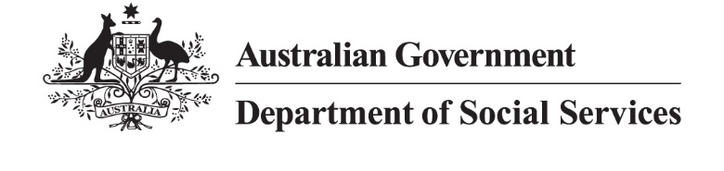

DSS XXXX.X.XX

Factsheet: Responsibilities of the Intercountry Adoption Community Under the National Protocol for Responding to Allegations of Illicit or Illegal Practices in Intercountry Adoption

What to do if you suspect illicit or illegal practices in your adoption
Your adoption should comply with legal and ethical standards. If you believe something was wrong or illegal, you have the right to raise concerns and seek support.

What counts as illicit or illegal practices?
- Falsified documents (birth certificates, consent forms).
- Lack of proper consent from birth parents.
- Financial incentives or trafficking.
- Breaches of the Hague Convention on Protection of Children and Co-operation in Respect of Intercountry Adoption or national laws.

Steps you can take
- Gather Information
  - Collect any documents or details related to the adoption.
  - Note what makes you suspect something was wrong or illegal.
  - Review the process outlined in the Protocol for responding to allegations of illicit or illegal practices in intercountry adoption found at: www.dss.gov.au/intercountry-adoption/.
- Report Your Concern
  - Contact your state or territory central authority (STCA) through which the adoption was facilitated. If you’re unsure which STCA facilitated the adoption, start with the STCA in your current state or territory, OR
  - Contact the Australian Central Authority (ACA) by submitting an enquiry through the ‘contact us’ form on the Intercountry Adoption Australia (IAA) website. Please note that concerns raised with the ACA may require close liaison with the relevant STCA and the overseas authority that facilitated the adoption.
  - If the concerns relate to the practices of the ACA or STCA, you may contact:
  - Commonwealth Ombudsman – 1800 362 072
  - State and Territory Ombudsmen:
Australian Capital Territory
New South Wales
Northern Territory
Queensland
South Australia
Tasmania
Victoria
Western Australia
  - Australian Federal Police – 13 14 44
- What Happens Next
  - A case worker will be assigned to your case to review records, contact relevant agencies, and conduct a thorough investigation while keeping you informed throughout the process.
  - Personal information will be managed in accordance with the Australian Privacy Principles and jurisdictional privacy laws.
  - At the conclusion of the investigation, you will receive details of the findings along with any recommended next steps.
Please note: Investigation timelines depend on case complexity, availability of information and response times from overseas authorities.

Support available

Intercountry Adoptee and Family Support Service (ICAFSS)
ICAFSS is a free national intercountry adoption-specific service, providing therapeutic support, counselling and information. Contact: 1800 422 377 or email icafss@rasa.org.au.

Jurisdictional Support Guide (JSG)
JSG contain details on how each STCA responds to reports of illicit or illegal practices, as well as information on available support services for adoptees and their families. Use links below to access the relevant JSG:
- Australian Capital Territory – not yet available
- New South Wales – not yet available
- Northern Territory – not yet available
- Queensland – not yet available
- South Australia
- Tasmania
- Victoria
- Western Australia

Community, peer and advocacy groups
There are several adoptee support groups run by individuals with lived experience of intercountry adoption. Information on local and community supports is available on the IAA Local and community support webpage.

