
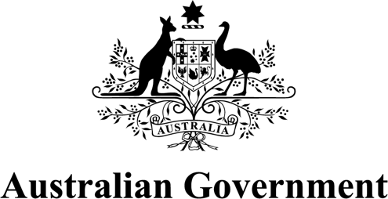
Early Years Strategy
2024-2034
Monitoring and Evaluation Framework
ISBN: 978-1-921975-45-5
Copyright notice


This document, Australian Government, Early Years Strategy 2024-2034, Monitoring and Evaluation Framework, is licensed under the Creative Commons Attribution 4.0 International Licence
Licence URL: https://creativecommons.org/licenses/by/4.0/legalcode
Please attribute: © Commonwealth of Australia (Department of Social Services) 2025
Notice:
- If you create a derivative of this document, the Department of Social Services requests the following notice be placed on your derivative: Based on Commonwealth of Australia (Department of Social Services) data.
- Inquiries regarding this licence or any other use of this document are welcome. Please contact: Branch Manager, Communication Services Branch, Department of Social Services. Phone: 1300 653 227. Email: communication@dss.gov.au
Notice identifying other material or rights in this publication:
- Australian Commonwealth Coat of Arms – not Licensed under Creative Commons, see https://www.pmc.gov.au/honours-and-symbols/commonwealth-coat-arms
- Certain images and photographs (as marked) – not licensed under Creative Commons.






Acknowledgement of Country
We acknowledge the Traditional Custodians of Country
throughout Australia and recognise their continued care
of and connection to land, water, culture and community.
We pay our respects to Aboriginal and Torres Strait Islander
cultures, and to Elders both past and present

Contents
Introduction 1
Early Years Strategy 1
Purpose of the Strategy 1
Monitoring and Evaluation Framework 2
Purpose of the Framework 2
Development of the Framework 3
Monitoring and Evaluation under the Framework 5
Overview 5
Guiding Principles for Monitoring and Evaluation 6
1. Early Years Strategy Principles 6
2. Best Practice Principles from the Commonwealth Evaluation Policy and Toolkit 9
Monitoring approach 11
Key monitoring questions 12
Data and information to be collated 12
Evaluation approach 16
Evaluation focus areas 16
Key evaluation questions 16
Designing and conducting the formal evaluation 19
Challenges for monitoring and evaluation 20
Governance of the Framework 21
Roles and responsibilities 21
Senior-level steering committee 21
Lead Government agency 21
Consultation mechanism with parents and carers 22
Appendices 23
Appendix A: Additional detail on key elements of the Strategy 23
Appendix B: Early Years Strategy Logic 24
Appendix C: Glossary of Key Terms 25

Introduction

Early Years Strategy

Purpose of the Strategy
The Early Years Strategy 2024-2034 (the Strategy) was launched in May 2024 and sets out the Australian Government’s vision to best support Australia’s children and their families in the early years.
The Strategy outlines how the Government will prioritise and support child-centred policy development and target investment in early years supports and services over the next decade.
It also provides a framework to drive and align the Government’s efforts in the early years, and to enhance cooperation and coordination of the Government’s early childhood policies, programs and services.
The Strategy includes 4 key elements – a vision, 5 principles, 8 outcomes and 4 priority focus areas. Together, these set out where the Government will direct its efforts, how it will work and what it seeks to achieve. Further detail on these can be found at Appendix A.
The Strategy is supported by an Evidence Summary, which outlines the research underpinning the Strategy, and a Consultation Report, which summarises what we heard during the consultation process to inform the Strategy.
The Strategy will be delivered through action plans to outline the practical steps the Government is taking to support young children and their families, in line with the Strategy’s 5 principles and 4 priority focus areas. The First Action Plan 2024 - 2027 (the First Action Plan) was released in December 2024 and covers the first implementation phase of the Strategy.
An Outcomes Framework was also released in December 2024 which sets out how the Government will measure the Strategy’s 8 outcomes. The Outcomes Framework will allow the Government to better understand how Australia’s young children and their families are faring across wellbeing domains and monitor trends and changes over time.
While the Strategy will guide the Government’s work in the early years, achieving the Strategy’s vision and outcomes requires collective action. This includes contributions from state, territory, local and Commonwealth governments, the early years system and workforce, the philanthropic sector, communities, and families.

Monitoring and Evaluation Framework

Purpose of the Framework
The Strategy commits to undertaking monitoring and evaluation to help track the progress and success of actions, measure change over time, and assess the overall effectiveness of the Strategy in achieving its vision and outcomes.
This Monitoring and Evaluation Framework (the Framework) sets out the Government’s overall approach to monitoring and evaluation over the 10-year life of the Strategy. It aims to assist those commissioning, planning and undertaking future monitoring and evaluation activities under the Strategy, by providing guidance on how the Strategy’s actions and outcomes will be monitored, as well as how the Strategy will be evaluated.
The Framework is also intended to assist those designing or delivering early years policies, programs and services that align with the Strategy, by providing guiding principles and a consistent approach to ensure any new activities can contribute to overarching monitoring and evaluation of the Strategy.
The Framework has been developed to allow enough flexibility to adapt and respond to evolving circumstances over the Strategy’s 10-year life, while still retaining an overarching focus on the long-term vision and outcomes the Strategy is seeking to achieve.
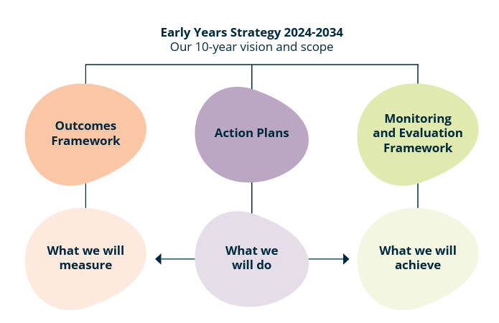
The Framework aims to ensure accountability and transparency for tracking progress under the Strategy, fostering continuous improvement and informing decision making. It sits alongside the Strategy, the Outcomes Framework and action plans, and will help inform future actions and evaluation of the Strategy.
Figure 1: Strategy implementation overview
Development of this Framework was an action in the First Action Plan (Action 4.5) and contributes to Priority Focus Area 4 of the Strategy – Strengthen accountability and coordination, particularly Priority Focus Area 4.1 which aims to strengthen data, research and evaluation in the early years. This includes capturing the views and lived experiences of children and families, building and sharing the evidence base around what works, and supporting a culture of evaluation and strong evaluation processes.
As with the Strategy, the Framework also supports accountability and coordination across the early years system. It is designed to ensure monitoring and evaluation activities complement, rather than duplicate, other strategies and frameworks that seek to improve outcomes for young children and families in Australia.
This includes:
- Safe and Supported: The National Framework for Protecting Australia’s Children 2021-2031.
- The National Plan to End Violence against Women and Children 2022-2032.
- The National Agreement on Closing the Gap (Closing the Gap).
- Australia’s Disability Strategy 2021-2031.
In line with Priority Focus Area 4 of the Strategy, the Government will continue to identify opportunities to strengthen monitoring and evaluation, including periodically reviewing the Framework over the life of the Strategy to see if any elements need to be adjusted based on emerging challenges and opportunities.

Development of the Framework
The Department of Social Services (DSS) developed this Framework with advice from the Australian Institute of Family Studies (AIFS) and feedback from other Government agencies. The AIFS advice focussed on identifying best practice approaches across 3 critical areas: guiding principles, monitoring and evaluation, and governance arrangements.
DSS also drew on key themes and findings from earlier consultations to inform development of the Strategy and the Outcomes Framework, including engagement with young children, families, the early childhood sector, academics and data experts.
This Framework builds on these previous consultations to ensure future monitoring and evaluation activities under the Strategy also embed the voices of children, families, kin and communities, in line with the Strategy’s 5 principles and 4 priority focus areas.



Monitoring and Evaluation under the Framework

Overview
The Government will lead the implementation of the Framework and monitoring and evaluation activities under the Strategy. In implementing the Framework, the Government will work collaboratively and partner with other early years system stakeholders as appropriate (see also Governance of the Framework).
Under the Framework, monitoring and evaluation will generate evidence to support accountability and transparency for progress under the Strategy, foster continuous improvement, and inform Government decision-making on early years policies, programs and services over the life of the Strategy and beyond.
Monitoring and evaluation will:
- Enhance community trust and confidence, by ensuring Government is transparent about progress and holds themselves to account for commitments under the Strategy.
- Highlight opportunities for learning and improvement by identifying where changes are needed to support the Strategy’s outcomes and vision.
- Support evidence-informed decision-making processes to inform early years policies, programs and services over the life of the Strategy and beyond.
Under the Framework, monitoring and evaluation will serve distinct but interconnected functions. Monitoring will track the implementation of actions in the action plans and progress towards the long-term outcomes, and will help to assess the effectiveness of the actions in achieving the Strategy’s goals. This monitoring activity will in turn support formal evaluation of the Strategy.
Evaluation will enable an in-depth assessment of whether the Strategy and its action plans have supported progress towards its goals, including the reasons for success or challenges and who benefitted the most or least. This will help to inform the Government’s future priorities and investments in the early years, beyond the life of the Strategy.
Monitoring will help set evaluation priorities by providing insights on implementation progress and outcomes achieved over the life of the Strategy. In turn, evaluation will rely on this data and information collected during monitoring to demonstrate evidence of the effectiveness and impact of the Strategy as a whole.
The Framework focusses on monitoring and evaluation of the Strategy as a whole, rather than on the specific programs or policies under it. However, it may also be used to inform monitoring and evaluation of broader early years policies, programs and services, including (but not limited to) those included in the Strategy’s action plans.
The Framework has 3 key elements:
- Principles to guide all monitoring and evaluation activities under the Strategy.
- The monitoring approach under the Strategy, including key monitoring questions and data and information to be collected.
- The evaluation approach under the Strategy, including key evaluation focus areas and questions, as well as considerations for designing and conducting an evaluation.

Guiding Principles for Monitoring and Evaluation
There are 2 sets of guiding principles that will apply to monitoring and evaluation under the Strategy: the Early Years Strategy Principles and Best Practice Principles from the Commonwealth Evaluation Policy and Toolkit. The principles are designed to guide the overall monitoring and evaluation of the Strategy itself but can also apply to monitoring and evaluation of individual actions under the Strategy.

1. Early Years Strategy Principles
The Strategy sets out 5 principles (Table 1). These principles reflect what the Government heard from families and communities during development of the Strategy about what is important and how the Government should work to support children and families in the early years. In particular, the principles are intended to guide how the Government will:
- Deliver the Strategy through action plans.
- Monitor and assess the progress of actions and outcomes over the life of the Strategy.
- Evaluate the overall impact and effectiveness of the Strategy in achieving its goals.
All 5 principles apply to both monitoring and evaluation. This Framework gives effect to the ‘evidence-informed’ principle by providing a structure and guidance for gathering data and evidence to inform improvements to the Strategy and its actions over time. The Framework also gives effect to other principles in the Strategy, such as ‘child- and family-centred’, by ensuring the perspectives and experiences of children and families are embedded in monitoring and evaluation activities, for example in the evaluation design, findings and recommendations.
Guidance on how these principles should apply in practice to monitoring and evaluation activities is provided in Table 1. In practice, these principles often intersect. For example, tracking progress on the outcome indicators for diverse groups of children and families over time exemplifies both ‘respect for diversity’ and a ‘strengths-based’ approach. This approach demonstrates ‘respect for diversity’ because it seeks to understand outcomes for diverse groups. It also demonstrates a ‘strengths-based’ approach because it makes it possible to highlight where groups have achieved positive progress over time, rather than focusing on deficits between groups at a particular point in time.
Table 1: Early Years Strategy principles applied to monitoring and evaluation activities
Principle | What should be done | How it should be done - examples
Child- and family-centred | Monitoring and evaluation should include the voices of children and families. | - Seek out, support engagement with, and listen to children and families in shaping monitoring and evaluation approaches. For example, seek input to shape the evaluation questions and design.  - Incorporate children and families’ perspectives in evaluation findings and recommendations. For example, by collecting data on wellbeing directly from children and families.  - Include children and families’ perspectives in monitoring outputs and reports, for example, through case studies or direct quotes.  - Implement governance arrangements that are inclusive of families with young children. For example, engaging a parent reference group in the design and preparation of evaluation or monitoring outputs.
Strengths-based | Monitoring and evaluation should recognise the strengths, abilities, knowledge and capacities of young children and their families. | - Apply strengths-based framing when presenting monitoring results, evaluation findings and recommendations.  - Use strengths-based indicators and measures to report on outcomes where possible. For example, presenting the proportion of children who are ‘developmentally on track’ rather than focusing on the proportion ‘not on track’.  - Provide contextual information or data in outputs and reports to explain wellbeing outcomes – especially when worsening – to avoid negative framing of families.
Respect for families and communities | Monitoring and evaluation should respect and value the roles that parents, caregivers, families, kin, educators, communities, language and culture play for children. | - Recognise and respect the roles that families, educators, and communities play. For example, highlighting their importance in reports and noting the key role of parents as first teachers, nurturers, and protectors.  - Respect and value the influence of language and culture on children’s wellbeing, including for Aboriginal and/or Torres Strait Islander people, by highlighting the relevant supporting measures and including other contextual data that captures these aspects.
Equitable, inclusive and respectful of diversity | Monitoring and evaluation should value all forms of diversity, including in relation to gender, culture, language, place and disability. | - Ensure active engagement with diverse groups to inform monitoring and evaluation activities, and ensure this engagement is culturally safe and respectful. This includes alignment with all Closing the Gap Priority Reforms.  - Establish governance arrangements that are culturally safe and inclusive. For example, involving representatives from diverse groups in reference groups or engaging with existing governance structures for different communities.  - Design inclusive outputs or reports, for example, that use plain English and a variety of formats suitable for different audiences, such as visually appealing versions for children.  - Report progress on wellbeing indicators for diverse groups over time, rather than making direct comparisons across groups that can result in deficit reporting for some groups.
Evidence-informed | Monitoring and evaluation should:  - build and continually draw on the latest available data, evidence and insights  - inform the design, development and review of supports and services for children and families. | - Remain flexible, incorporating new evidence and improved measures or data sources as they become available. For example, updating indicator measures when better or more timely data becomes available.  - Focus on generating useful learnings for service and community-level support, for example, by making reports and data available promptly to stakeholders and regularly seeking feedback on their utility.  - Implement transparent and robust cross-agency accountability. For example, by obtaining data from multiple agencies, regular public reporting, and strong evaluation processes.

Note: There may be limited circumstances where alignment with these principles is not possible. For example, administrative reporting requirements mandated under existing data systems or variations in data collection methods/sources may restrict the full application of these principles.

2. Best Practice Principles from the Commonwealth Evaluation Policy and Toolkit
In addition to the Strategy’s own principles, there are 5 overarching ‘best practice’ principles to guide evaluation activities, as outlined in the Commonwealth Evaluation Policy.
Table 2: Commonwealth evaluation principles
Principle | Description
Fit for purpose | - The choice to evaluate and the scale of effort and resources allocated to an evaluation should be proportional to the value, impact, strategic importance and risk profile of the program or activity.  - Methods should differentiate between evaluations to inform program administration and evaluations to inform policy decisions.
Useful | - Evaluations to inform program delivery should be designed for the purposes of continuous improvement and accountability against objectives.  - Evaluations for decision-making should be designed for the purpose of defining achievable outcomes, taking account of any pilots, prototyping or experience from other jurisdictions.  - A strong understanding of Government policy intent is required, both when evaluation is used as a monitoring tool and when it is an input to new program design.
Robust, ethical and culturally appropriate | - Evaluations should be well-designed, identify potential evaluator bias and take account of the impact of programs and evaluations on stakeholders.  - Robust data and evidence should provide performance insights and drive continuous improvement for programs in the delivery stage.  - Ethical and culturally appropriate approaches should be considered in all evaluation activities, including for the collection, assessment and use of information.
Credible | - Evaluations should be conducted by people who are technically and culturally capable.  - The collection and analysis of evidence should be undertaken in an impartial and systematic way, having regard to the perspectives of all relevant stakeholders.  - Evaluations should adhere to appropriate standards of integrity and independence.
Transparent where appropriate | - To be useful, evaluation findings should be transparent by default unless there are appropriate reasons for not releasing information publicly.  - To support continuous improvement, accountability and decision-making, evaluation findings should be provided to appropriate stakeholders.
Source: Adapted from The Treasury (2025).
The Commonwealth Evaluation Toolkit offers further advice and guidance on applying these principles to evaluation activities.

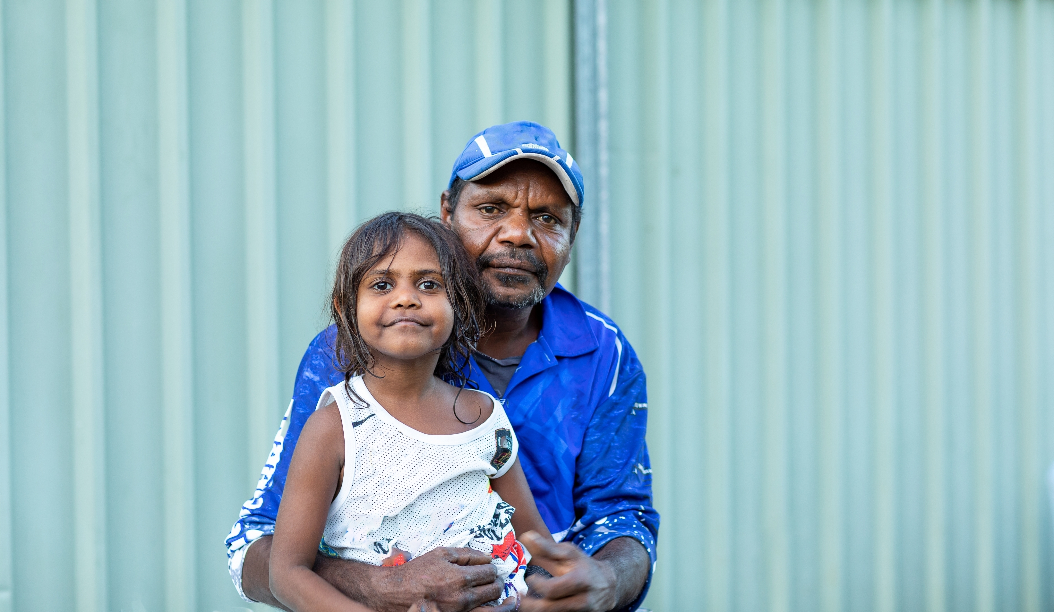
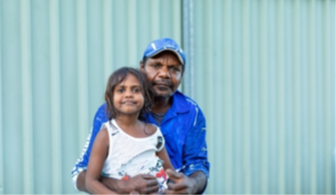

Monitoring approach
Under this Framework, the monitoring approach outlines how overall progress under the Strategy will be tracked by outlining key monitoring questions, and what data and information will need to be collated to answer these questions. This approach seeks to track progress under the Strategy as a whole; that is, the collective impact from actions across Government program and policy areas.
This approach may be refined as the Strategy progresses. To promote accountability and align with the principle of transparency, any monitoring outputs or reports will be published.

Key monitoring questions
Under the Strategy, monitoring activities will focus on answering the following key questions:
- Are actions in action plans appropriate: that is, how do the actions in the action plans map or contribute to the ‘what we will do’ statements for the priority focus areas, the intermediate outcomes and the long-term outcomes?
- Are actions in action plans being implemented as expected: that is, have all the actions in the action plans been implemented as intended according to the expected timelines?
- Has there been progress toward the Strategy’s long-term outcomes: that is, what progress has been made toward achieving the long-term outcomes to improve the lives of children, families and communities?
Monitoring the appropriateness and implementation of actions in an action plan, along with progress toward the long-term outcomes, will inform Government decision making on future early years policies, programs and services, as well as formal evaluation of the Strategy.

Data and information to be collated
To answer these monitoring questions, data and information will need to be collated on:
- Actions in the action plans.
- Long-term outcomes, as defined in the Outcomes Framework.

Actions in the action plans
Data or information on actions in the action plans will be collected from the policy or program areas responsible for actions (action holders). Relevant Government agencies with responsibility for actions should regularly review this data and information to assess the nature and extent of the implementation of actions, the appropriateness of the actions and the additional context outlined below.
Table 3: Data and information to be collated on actions
Category of data/information | Description
Nature and extent of implementation
Expected timeframes | Proposed timeframes for implementing the action, anticipated key outputs and short-term outcomes.
Current progress | Progress on implementation, including details of outputs delivered and short-term outcomes achieved.
Appropriateness of actions
Mapping to Strategy | How the action maps to ‘what we will do’ statements in the Strategy.
Contribution to intermediate outcomes | How the action will contribute to the Strategy’s ‘intermediate outcomes’ for a priority focus area.
Contribution to long-term outcomes | How the action will contribute to the Strategy’s long-term outcomes.
Additional information
Evaluation activity | Plans and reports on evaluation activity for an action (where available), and other data or information collected.
New initiative status | Whether the action is a new initiative under the Strategy.
Cooperation required | If substantial cooperation from state and territory governments or other stakeholders is needed.

Long-term outcomes
The Strategy includes 8 long-term outcomes (described in the Strategy simply as ‘outcomes’). These outcomes are designed to measure how children are faring, growing and developing, as well as assessing the wellbeing of families and the communities that support them. The long-term outcomes are the goals the Strategy seeks to achieve, and each contribute to the Strategy’s overarching vision that all children thrive in their early years.
The Outcomes Framework sets out how the Government will monitor these 8 long-term outcomes, including through relevant indicators, measures and data sources. The Outcomes Framework and indicators have been developed with an understanding of the limitations of existing data and measurement in the early years, and allows for the inclusion of better data over time as these data limitations are addressed and improved measures become available. Having best available, contemporary data is important to understanding if the lives of children, families and communities are improving under the Strategy.
The indicators, measures and data sources identified in the Outcomes Framework (and any improved data that becomes available over time) will be used to track progress toward these long-term outcomes. In addition to this, supplementary information to help with understanding progress may also be collated and reported, depending on the needs of the Strategy over time.
Monitoring the long-term outcomes will involve the collation of the following information from existing data collections/sources where available (or from other relevant or improved data sources when identified).
Table 4: Data and information to be collated for outcomes monitoring
Category of data/information | Description
Outcomes Framework measurement
Long-term outcome indicator/measures | Data will be collated on the indicator measures identified in the Outcomes Framework where available and disaggregated for priority groups where possible, including for Aboriginal and/or Torres Strait Islander people.
Assessment of progress | Progress will be assessed against the intended direction of change for each indicator measure (and separately for each priority group).
Supporting measures | Data for supporting measures will be collected as it becomes available.
Status updates on data development | Status updates will assess progress towards developing data sources for indicator measures currently identified as data gaps in the Outcomes Framework. The Government will monitor new data assets for application to address these gaps.
Supplementary information, as relevant throughout the Strategy
Contextual information | Key contextual data, such as economic, social or demographic data on factors known to affect the lives of families with young children or information relevant to specific focus areas for a report.
Lived/living experience | Data that reflects the views and lived experiences of children, parents, caregivers, kin and communities in relation to different outcome areas.

Where the measures and data sources have been identified, the Government should review available data at regular intervals to understand the progress being made under the Strategy. The Government will also regularly consider if the indicator measures are using the most robust and timely data.


Evaluation approach
A formal evaluation of the Strategy will be undertaken in the final 3 years of the Strategy. The Framework’s evaluation approach focuses on evaluating progress under the Strategy as a whole; that is, the collective impact from actions across Government program and policy areas. However, the Government also recognises the value and importance of ongoing evaluation and may consider additional evaluations during the life of the Strategy, as appropriate.
Under this Framework, the evaluation approach focusses on formal evaluation and outlines key focus areas, questions, and considerations for designing and conducting a formal evaluation.

Evaluation focus areas
The formal evaluation should cover the following key focus areas:
- Appropriateness: have the key elements of the Strategy – e.g. action plans, governance, principles, Outcomes Framework – supported achievement of the Strategy’s vision and outcomes?
- Implementation: have all aspects of the Strategy been implemented as intended? That is, in line with the actions in the action plans, priority focus areas and principles?
- Effectiveness: to what extent have the Strategy’s outcomes been achieved and/or to what degree have actions in the action plans led or contributed to the positive changes expected?
- Strategic Impact: what has been the overall impact of the Strategy, that is, the nature and extent of any broader, lasting changes resulting from the Strategy?
While the formal evaluation should cover these focus areas, its main purpose will be to understand the effectiveness and overall impact of the Strategy during its 10-year life. This will include understanding the drivers or barriers to success, and what works for families and children in the early years. The purpose will be to generate key learnings to inform the Government’s future priorities and investments in the early years beyond the life of the Strategy.

Key evaluation questions
Some broad evaluation questions are provided below that cover these focus areas. These questions are provided for guidance only and may need to be further refined ahead of the formal evaluation taking place, with additional sub-questions developed. This approach will enable engagement with key stakeholders on the final evaluation questions, including children and parents, and allow flexibility for additional questions to be included to respond to and address future issues as they arise.
Table 5: Key evaluation questions
Focus area | Key Questions
Appropriateness | - How appropriate were the various elements of the Strategy infrastructure in supporting achievement of the Strategy’s vision and outcomes (that is, the priority focus areas, actions and action plans, Outcomes Framework, Monitoring and Evaluation Framework, principles and governance arrangements)?  - How well did these elements drive collaboration across the early years system (including with states and territories and other non-government partners)?
Implementation | - To what extent were actions in the action plans implemented, and who were the target cohorts?  - What supported successful implementation, and what created challenges or barriers?  - To what degree were actions implemented in alignment with the Strategy’s principles and priority focus areas? For example, to what extent were the voices of children and families included?
Effectiveness | - How much progress was made toward achieving the intermediate outcomes for the priority focus areas?  - How well did actions in the action plans support progress for these intermediate outcomes?  - How much progress was made toward achieving the long-term outcomes to improve the lives of children, families and communities?  - Did progress vary across diverse groups, and if so, how?  - How well did the priority focus areas and actions in the action plans support progress for these long-term outcomes, including for diverse groups?  - Were there conditions or contextual factors that seemed to support or hinder progress toward the intermediate and long-term outcomes?
Strategic impact | - To what extent was the vision for the early years system, and for the lives of children, families and communities met?  - What lessons have been learned about ‘what works’ to support young children and their families?  - Were there any unanticipated outcomes (either positive or negative) arising from the Strategy or the actions undertaken under the Strategy?  - Based on learnings across the 10-year life of the Strategy, what should be the next steps for early years policy?

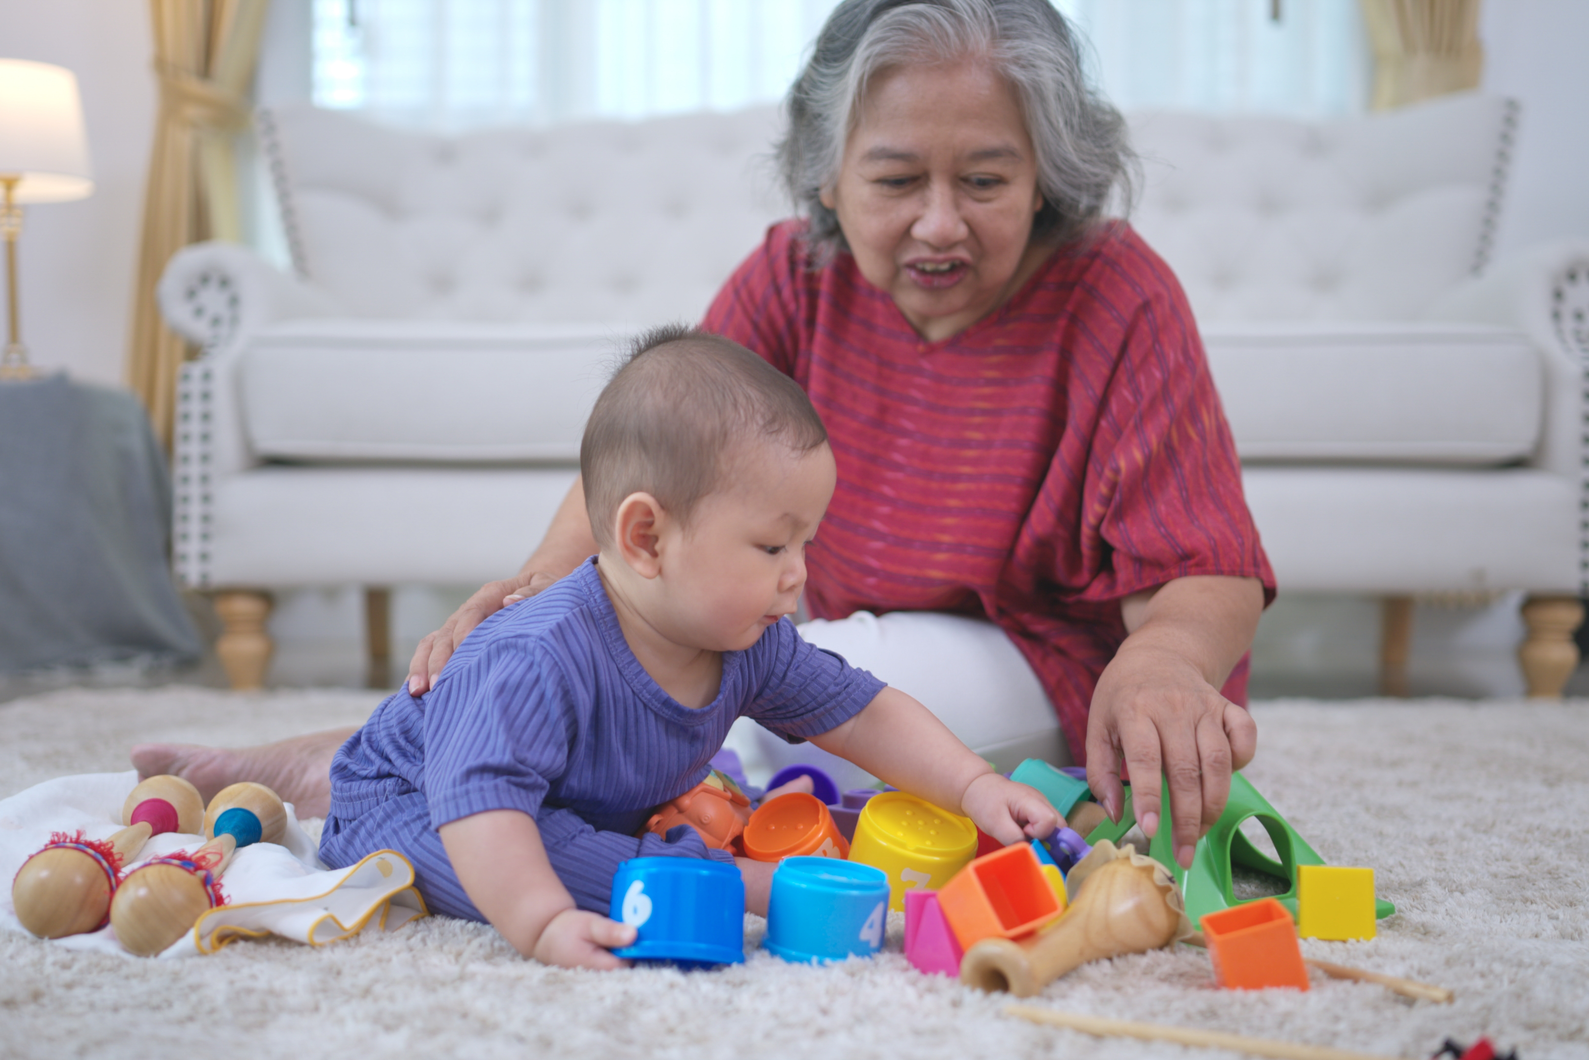

Designing and conducting the formal evaluation
In the planning phase, along with reviewing and refining key evaluation questions, the following considerations should inform the design and conduct of the formal evaluation of the Strategy.
First, the evaluation design will need to facilitate a strategic approach that supports transparent and robust cross-agency accountability arrangements. As the Strategy brings together actions from across Government, the evaluation will need to capture the collective effort and impact of the Strategy on the early years – even if the actions and information sources are from many different program and policy areas across portfolios. For example, the evaluation design will need to include a synthesis of evidence on the individual actions that sit under the Strategy, to understand their contribution to the collective impact of the Strategy as a whole (see below in relation to the minimum data and information required).
Second, the evaluation design needs to ensure the views of children and their parents/families are incorporated across the key evaluation phases, including:
- The design itself.
- Development and testing of findings and recommendations.
- Reporting of the final recommendations.
Third, the evaluation design needs to ensure the right data sources and perspectives are included. At a minimum, the evaluation would need to include data and information from:
- The monitoring of:
  - Actions in the action plans, including a synthesis of any action-level evaluation results to understand the contribution to collective impact (as noted above).
  - Long-term outcomes, as defined in the Outcomes Framework.
- Engagement with other key stakeholders; for example, early childhood experts, service providers and peak bodies, and state and territory governments.
Other sources of data and information could include:
- Administrative and survey data, including from sources identified in the Outcomes Framework.
- Engagement with families and children; for example, through surveys, focus groups or qualitative interviews.
- Additional information requests to action holders.
- Monitoring and evaluation of other overlapping or complementary plans, strategies or agreements.

Challenges for monitoring and evaluation
Due to the broad nature of the Strategy, there are some key challenges that may need to be addressed in future monitoring and evaluation activities. These may include, but are not limited to:
- Difficulties differentiating the effects of external factors, such as economic conditions, from those attributable to the Strategy itself, when tracking and assessing changes to the long-term outcomes.
  - This may be partly addressed by undertaking contribution analysis and collecting and assessing key economic, social and demographic data known to affect the wellbeing of children and families, alongside the data and information on the Strategy’s long-term outcomes.
- Lack of available data for measuring key outcomes in the early years. The Outcomes Framework identifies key data gaps and limitations for a subset of long-term outcomes in the Strategy. While data and information from action holders will help to assess how actions are contributing to the intermediate outcomes, data availability will also present challenges for measuring progress against these intermediate outcomes.
  - Both this Framework and the Outcomes Framework have been designed to allow for the inclusion of new data and improved measures as they become available over the life of the Strategy, to better understand the impact of the Strategy on children, families and communities.


Governance of the Framework
Monitoring and evaluation are key components of good governance. They generate evidence to drive accountability and transparency, foster continuous improvement, and inform decision-making. Evaluation also provides a mechanism to assess the appropriateness of the Strategy’s governance and accountability system, as highlighted in the key evaluation questions.
However, to ensure monitoring and evaluation activities are effective, these activities also need appropriate governance arrangements (including with the right governance groups involved that have clear roles and responsibilities).
To ensure governance arrangements for monitoring and evaluation are consistent with other aspects of Strategy implementation, the cross-Government senior-level steering committee overseeing the implementation of the Strategy will also oversee the implementation of this Framework. This committee will be supported by:
- A mechanism to consult with parents and carers on implementation of the Strategy, including monitoring and evaluation activities.
- A lead Government agency who will coordinate monitoring and evaluation activities across Commonwealth agencies and ensure robust cross-agency accountability for the Strategy.

Roles and responsibilities

Senior-level steering committee
This group will oversee implementation of this Framework and all monitoring and evaluation activities under the Strategy, including:
- Approving monitoring and evaluation plans and processes, such as the final design and approach to evaluation of the Strategy.
- Monitoring progress of the action plans and long-term outcomes as outlined in the Outcomes Framework.
- Considering and responding to evaluation findings and recommendations.
- Overseeing improvements to the Strategy and its actions over time.

Lead Government agency
A lead Government agency will support the senior-level steering committee in overseeing implementation of the Strategy, including monitoring and evaluation. It will work across the Government, including with the other governance groups, to coordinate monitoring and evaluation activities and ensure transparent and robust cross-agency accountability arrangements, data sharing and strong evaluation processes for the Strategy.

Consultation mechanism with parents and carers
In line with Priority Focus Area 1 of the Strategy, a consultation mechanism will be used to ensure the perspectives of parents and families are embedded in monitoring and evaluation activities under the Strategy, including:
- Providing input into the design of evaluations, including the development of questions and approaches.
- Offering advice on evaluation outcomes, recommendations, and monitoring outputs before they are finalised.
- Sharing reflections on evaluation findings and recommendations once finalised, which may be included as key messages in reports or communications directly to the Minister.

Appendices

Appendix A: Additional detail on key elements of the Strategy
The Strategy’s vision is for all children in Australia to thrive during their early years, and have the opportunity to reach their full potential, nurtured by empowered and connected families who are supported by strong communities.
Along with this vision, the Strategy also identifies 8 long-term outcomes (described in the Strategy simply as ‘outcomes’). These outcomes are designed to measure progress, focusing on how children are faring, growing and developing, as well as assessing the wellbeing of families and the communities that support them.
The Strategy has 4 priority focus areas for action, which contribute to 10 intermediate outcomes. These intermediate outcomes are the interim changes expected when the actions are implemented and provide the building blocks to achieve the Strategy’s vision and long-term outcomes.
The Strategy also sets out 5 principles to guide the Government in supporting children and families in the early years, especially through its action plans and Outcomes Framework.
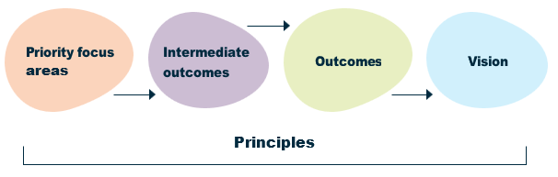
Figure 2: Key elements of the Strategy

The Strategy logic that outlines these key elements is provided on the next page.

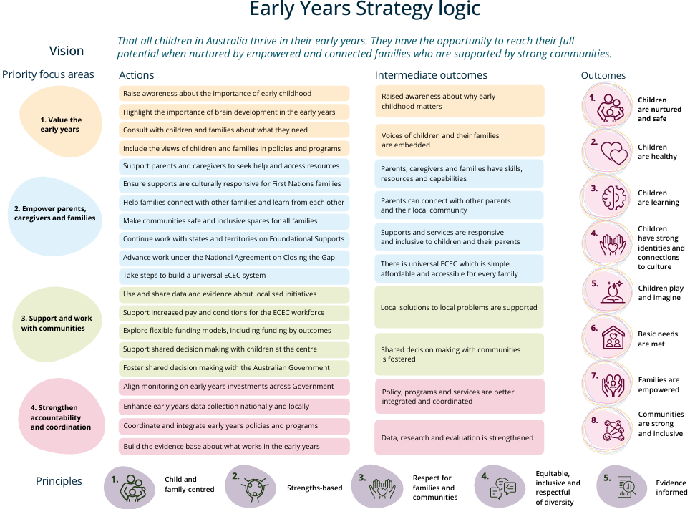
Appendix B: Early Years Strategy Logic

Appendix C: Glossary of Key Terms
Actions
The actions are the practical steps and activities the Government is taking to achieve the Strategy’s outcomes and vision. The actions align with the Strategy’s 4 priority focus areas and are included in the Strategy’s action plans.
Administrative data
Information collected primarily for administrative (not research) purposes, such as service usage, payments, or registration records.
Data source
The data collection(s) from which data are sourced to report against a measure.
Early years
Within the Strategy, the ‘early years’ refers to the period from pre-birth until 5 years of age.
Evaluation
The systematic, in-depth and objective assessment of the design, implementation or results of a strategy or program to determine its effectiveness and impact. It is conducted for purposes of continuous improvement, accountability and decision making.
Indicators
The concept(s) to be measured in the Strategy to identify change. The Strategy’s Outcomes Framework sets out the indicators that will be used to measure progress against the Strategy’s eight long-term outcomes.
Intermediate outcomes
The interim changes that are expected to occur as a result of the Strategy’s actions being implemented. They provide the desired building blocks to achieve the Strategy’s long-term outcomes and overall vision.
Long-term outcomes
Within the Strategy, the long-term outcomes are the desired changes for the wellbeing of children, families or communities, and the goals needed to achieve the Strategy’s vision. The Strategy’s Outcomes Framework sets out how these outcomes are defined and conceptualised and how they will be measured.
Measures
The measures set out how the indicators in the Outcomes Framework are to be calculated (also referred to as the computation rules) and where the data will come from to report against the measure (referred to as the data source).
Monitoring
The routine collection and analysis of data and information to track progress against the Strategy’s actions, outputs/short-term outcomes, intermediate outcomes, and long-term outcomes.
Outputs
Outputs are the tangible products or services that result from implementing an action/activity. Outputs are the immediate or direct results of actions, and they can be measured quantitatively or qualitatively.
Short-term outcomes
The most direct or immediate changes that are a result of the implementation of a Strategy’s action. These are not an end in themselves but a necessary step toward the desired end (intermediate or long-term outcomes).
Wellbeing
Wellbeing can be thought of as a child or young person having everything they need to thrive and reach their full potential. It encompasses all areas of life, which are linked and interdependent.



DSS 3618.05.26

