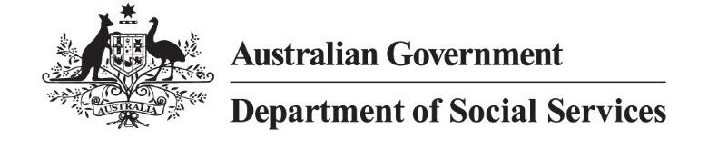

500 Workers Initiative
Jurisdictional high-level status as at 31 March 2026
Notes:
  - Data is as at 31 March 2026 and is subject to regular changes.
  - Due to individual jurisdictional contractual arrangements with service providers already in place, not all state and territory data is updated monthly.
  - States and territories have requirements to receive Commonwealth funding including annual reporting obligations to the Commonwealth under the Family, Domestic and Sexual Violence Responses 2021-30 Federation Funding Agreement.
  - Use of the word ‘commenced’ in the below table means workers who have started in their roles and are working with victim-survivors.
  - The 500 Workers Initiative has a phased approach, with 352.43 full-time equivalent (FTE) workers committed to by 30 June 2024, 462.61 FTE workers by 30 June 2025 and 500 FTE workers by 30 June 2026.

Jurisdiction | Commenced Workers | Commenced FTE | Next Steps
New South Wales (NSW) | 159 | 146.4 | The recruitment of new workers is progressing in line with NSW’s plan:  - NSW has awarded contracts to 82 service providers to deliver 148.4 FTE.  - 159 workers (146.4 FTE) are now delivering domestic, family and sexual violence services (DFSV) across NSW.  - The remaining 2024-25 quota have recruitment activity underway (2 FTE).  - NSW is working with service providers to support recruitment for the remaining 2 FTE.
Victoria | 105 | 99 | - Victoria has now recruited 105 new workers, equating to 99 FTE under two tranches.  - Tranche 1 is now complete with 65 people (total 59 FTE) recruited.  - The recruitment of new workers for tranche 2 is progressing in line with Victoria’s plan:  - 40 workers (total 40 FTE) have commenced.  - 3 positions have been advertised.  - The remaining position is in the planning phase.  - The filled roles include:  - 20 case managers at multicultural agencies. Collectively, they speak Mandarin, Cantonese, Tamil, Hindi, Urdu, Arabic, Ukrainian and Russian, as well as all speaking English.  - 3 workers employed at an Aboriginal Community Controlled Organisation.
Queensland | 131 | 112 | Queensland has now allocated all funding and FTE and has over-delivered on its target of 111.6 FTE, with funding allocated for a total of 113 FTE workers.
Western Australia (WA) | 50 | 50 | Western Australia has successfully completed its recruitment plan with 50 FTE employed across 13 organisations in metropolitan, regional and remote areas of the State.
South Australia | 49 | 36.8 | South Australia has now met its total target under the 500 Workers Initiative, with 36.8 FTE commenced, equivalent to 49 workers across 36 services.
Tasmania | 33 | 24.6 | Tasmania has now met its total 500 Workers Initiative target of 24.6 FTE commenced workers across 13 services.
Australian Capital Territory (ACT) | 8 | 7.6 | The ACT has delivered its total 500 Workers Initiative FTE target of 7.6 FTE.  - 4 workers (4.0 FTE) have commenced with Canberra Rape Crisis Centre.  - 2 workers (2.0 FTE) have commenced with YWCA.  - 1 worker (1.0 FTE) has commenced with Multicultural Hub.  - 1 worker (0.6 FTE) has commenced with Domestic Violence Crisis Service.
Northern Territory | 20 | 19.6 | Recruitment has increased with 20 commenced workers, including:  - 12 (11.6 FTE) Children’s safety workers  - 3 FTE non legal support workers, and  - 5 FTE co-responder pilot victim-survivor case manager
TOTAL | 555 | 496

Victoria’s project plan included 42 FTE in Tranche 2. Revised modelling based on available funding has resulted in Victoria allocating an additional two positions in the family violence sector, bringing the total for Tranche 2 to 44 FTE in 2025-26.

