

Appendix 4:
Increasing adequacy of JobSeeker and related Welfare payments: Modelling Policy Options by Australian National University



Increasing the adequacy of JobSeeker and related welfare payments: Modelling Policy Options
Ben Phillips

POLIS@ANU - The Centre for Social Policy Research
Research School of Social Sciences
College of Arts and Social Sciences
+61 2 6125 3500

polis.admin@anu.edu.au
The Australian National University
Canberra ACT 2600 Australia
www.anu.edu.au
TEQSA Provider ID: PRV12002 (Australian University)
CRICOS Provider Code: 00120C

About POLIS
The Centre for Social Research and Methods has been rebranded as POLIS: The Centre for Social Policy Research. As part of this change, the Centre for Aboriginal Economic Policy Research (CAEPR) has joined POLIS and is being renamed the Centre for Indigenous Policy Research.
POLIS – which draws from the Ancient Greek for the administrative centre of the City-State – is designed to provide a designated space at the ANU for discussion, debate and research on the formulation of social policy. The rebrand will allow POLIS to better capture and market the key work of the centre in providing research and expertise on social policy in response to community and federal and state/territory government needs and requirements.
POLIS delivers exceptionally robust data and evidence driven insights into the key challenges facing contemporary Australia. This provides the foundational cornerstones of informed social policy development amongst leading stakeholders within our modern policy: government, community groups, business representatives, and educators.
POLIS is home to seven research centres:
- Centre for Indigenous Policy Research
- Centre for Social Research
- Centre for Education, Equity and Development
- Centre for Crime and Social Justice
- Centre for Gambling Research
- Centre for Data, Analytics, and Evaluation
- Social Impact Hub

Working Paper No. 02/2026
DOI 10.25911/TKHF-9B25
ISBN: 978-0-6451893-7-7
For a complete list of POLIS publications see
https://csrm.cass.anu.edu.au/research/publications
POLIS: The Centre for Social Policy Research
Research School of Social Sciences
College of Arts & Social Sciences
The Australian National University
Front cover image:
Terry Ngamandarra Wilson, Gulach (detail), painting on bark, private collection © Terry Ngamandarra, licensed by Viscopy, 2016
Suggested citation:
Phillips, B. (2026), Increasing adequacy of JobSeeker and related payments: Modelling Policy Options (Working Paper No. 1 2026), POLIS: The Centre for Social Policy Research, Australian National University. https://doi.org/10.25911/TKHF-9B25
Ben Phillips is an Associate Professor at POLIS: The Centre for Social Policy Research at the Australian National University.

Increasing the adequacy of JobSeeker and related welfare payments: Modelling Policy Options
Ben Phillips

Abstract
The Economic Inclusion Advisory Committee recommends increasing the JobSeeker Payment for working age Australians from 67 to 90 per cent of the Age Pension. EIAC is concerned that the existing rate does not provide many recipients with an adequate safety net leaving many people with insufficient funds to meet their basic living expenses. This research models a number of policy options that increase the rate of JobSeeker and related payments. The modelling includes the full 90 per cent EIAC recommendation but also lower cost options including staging the required increases over a 4-year period and immediately increasing the rate for recipients who have a partial capacity to work. All options lead to substantial reductions in poverty for recipients and provide meaningful financial gains for groups in society that are known to be disadvantaged such as single parents, low income renters, and indigenous Australians.

Acknowledgments
I would like to thank the Australian Government Department of Social Services (DSS) for its generous support of this study. This research was commissioned and funded by DSS through the Economic Inclusion Advisory Committee in 2025. I would also like to thank Professor Jeff Borland and ACOSS for helpful comments on the paper. All errors and omissions remain with the author.

Contents
About POLIS ii
Abstract iii
Acknowledgments iv
Contents v
Tables vi
Figures vi
1. Introduction 8
2. Statistical Overview of JobSeeker and Related Payment Recipients 8
3. Methodology: Microsimulation Modelling using PolicyMod 17
Policy Modelling Options 18
4. Workforce Participation Impacts 34
5. Conclusions 41
6. References 43

Tables
Table 1. Age, Sex, Indigenous Status of JobSeeker and Related Payment Recipients, DSS 9
Table 2. Distributional and Cost Impacts of Staged JobSeeker Increase. 20
Table 3. Largest and Smallest SA3 Impact of 90 per cent of Age Pension rate for JobSeeker (2028), ANU PolicyMod 23
Table 4. Distributional and Cost Impacts of JobSeeker and related payments increase for PCTW recipients. 29
Table 5. Largest and Smallest SA3 Impact JobSeeker increase for partial capacity to work recipients (2025), ANU PolicyMod 31
Table 6. Change in EMTR for JobSeeker Recipients Only, ANU PolicyMod 40

Figures
Figure 1. JobSeeker and related payments and Disability Support Payment Numbers, ANU, DSS 10
Figure 2. JobSeeker/Youth Allowance by Partial Capacity to Work Status, DSS 11
Figure 3. Long Term Payment (>1 year) by PCTW Category 12
Figure 4. Very Long Term Payment (>5 year) by PCTW Category 13
Figure 5. Duration on JobSeeker and related payments 13
Figure 6. Very Long Term Duration by PCTW Category 14
Figure 7. Welfare Recipient rates of financial stress (3+ forms), HILDA release 24 16
Figure 8. Welfare Recipient After-Housing Poverty rates, HILDA release 24 17
Figure 9. Average Annual Gain by Australia SA3 regions 24
Figure 10. Average Annual Gain by Sydney SA3 regions 25
Figure 11. Average Annual Gain for Australian SA3 regions (2025), ANU PolicyMod 32
Figure 12. Average Annual Gain for Greater Sydney SA3 regions for Partial Capacity To Work JobSeeker Recipients, ANU PoliycMod 33
Figure 13. Average Annual Gain for Greater Melbourne SA3 regions 34
Figure 14. EMTR schedule for Single Rate JobSeeker, no rent, ANU PolicyMod 35
Figure 15. EMTR schedule for Single Rate JobSeeker, no rent, ANU PolicyMod 36
Figure 16. EMTR schedule for Single Rate JobSeeker current vs proposed EIAC policy, ANU PolicyMod 37
Figure 17. Distributional Analysis of EMTRs for working age population, ANU PolicyMod 38
Figure 18. Distributional of EMTRs for working age population by household Income Quintile, ANU PolicyMod 39
Figure 19. EMTR Distribution for JobSeeker and Related Payments recipients only by Policy, ANU PolicyMod 40

Introduction
The Australian social security system is broadly based around a means tested system of pensions and allowances and a family payments systems for parents to assist with the cost of raising children. For adult payments the pension system is more generous than allowances with payments such as the Age Pension and disability support payments designed for persons who have limited ability to work for reasons such as old age, disability or caring responsibilities. Allowances (mostly JobSeeker and Youth Allowance) are designed for recipients where the expectation is that payments will be of a short-term nature covering periods of unemployment or education.
As of January 2026 the Age Pension maximum entitlement for a single person is $1,178.70 per fortnight while the most common allowance (JobSeeker) is set at $793.60 per fortnight (or about 67 per cent of the Age Pension). At the start of 2000 JobSeeker (then Newstart Allowance) was around 89 per cent of the single rate of the Age Pension.
The relative reduction in the JobSeeker payment relates to the Age Pension (as per all pensions in Australia) being indexed to not just the Australian Bureau of Statistics’ (ABS) Consumer Price Index (CPI) but also wages and the ABS Pensioner and Beneficiary Living Cost Index (PBLCI). Beyond indexation differences, the Age Pension (single rate) received an increase in 2009 with the Harmer Review’s recommendation that the Age Pension (single rate) be substantially increased to better align with the couple rate (Harmer 2009).
While JobSeeker and related payments have been indexed this century in line with the ABS CPI the payment has fallen well below changes in living standards with wages and incomes in Australia increasing much more substantially this century.
Past (2023, 2024, 2025) Economic Inclusion Advisory Committee (EIAC) reports recommended substantial increases are necessary for JobSeeker and related payments. Each report suggests that to lower financial stress and improve adequacy of the JobSeeker Payment should be raised to 90 per cent of the Age Pension rate for singles to overcome the diminution of the payment this century.
The government through this period has responded with a $40 per fortnight increase to JobSeeker in the 2023 budget. In the absence of this increase JobSeeker would currently be around 64 per cent rather than the existing 67 per cent of the Age Pension. Both remain well short of EIAC’s preferred level set at 90 per cent of the single Age Pension rate.
The 90 per cent EIAC preferred rate would cost around $5 to $6 billion dollars annually from 2026-27. Following a request from EIAC this paper provides policy modelling, including the distributional impacts, of a range of options that lower this cost permanently or at least over the short term.
The two major options provided in this paper include a staged increase in the JobSeeker and related payments over the course of the forward estimates and a second approach where only those with a ‘partial capacity to work’ are provided an increase to their payment.

Statistical Overview of JobSeeker and Related Payment Recipients
The main argument for lower rates of payment for those on the JobSeeker and related payments (such as Youth Allowance student or unemployed, Parenting Payment Partnered, Special Benefit, or Abstudy) is that recipients are expected to be on these payments for shorter time periods (such as study or unemployment spells) and/or they are able to supplement their benefits more easily with part-time or casual work compared to those on pensions. This section provides a short statistical overview to better understand recipients of these payments.
The table below shows the age and sex and family distribution of JobSeeker and related payment recipients. The table shows that for the September quarter there are around 1.25 million recipients of which roughly 50 per cent (623,000) are male and the 50 per cent are female.
Recipients tend to be relatively young with around 30 per cent aged under 30, and a fairly even split in each 10-year category beyond that. Compared to the general population of adults 15 to 66 years the population skews towards younger persons. The gender distribution is little different to the rest of the population aged 15 to 66. 18 per cent of recipients are indigenous compared to just 3.4 per cent of the total population. Recipients are around twice as likely to be single than the total population aged 15 to 66.

Table 1. Age, Sex, Indigenous Status of JobSeeker and Related Payment Recipients, DSS
Category | Number (000s) | % of JS/related payment recipients | Population (15 to 66) years %
Age
<25 | 369 | 30 | 18
25 to 34 | 250 | 20 | 21
35 to 44 | 187 | 15 | 20
45 to 54 | 181 | 15 | 19
55+ | 259 | 21 | 22
Total | 1,246 | 100 | 100
Gender
Male | 623 | 50 | 49.4
Female | 623 | 50 | 50.6
Indigenous status
Indigenous | 184 | 15 | 3.4
Non-Indigenous | 1,062 | 85 | 96.6
Marital Status
Partnered/Married | 229 | 18 | 57.5
Single | 1,017 | 82 | 42.5
Figure 1 considers the number of JobSeeker recipients through time with a comparison with disability support pension (DSP). JobSeeker (and Youth Allowance – other) are driven heavily by economic factors and the economic cycle. Both DSP and JobSeeker type payments are impacted by policy change. DSP grew strongly (around 3.5 per cent per year - or more than 2 percentage points more than the general population) up until 2012. From 2013 tighter testing arrangements made getting onto the DSP payment more difficult. Resulting from this tightening of eligibility rules growth slowed substantially to the point that DSP numbers declined from 2012 until picking up again from around 2020 with moderately stronger growth than that of the Australian population.
Prior to 2012 the general demographic trend was towards larger DSP recipient numbers due to an ageing population. In addition, the increasing Age Pension age, particularly for women added to JobSeeker recipient numbers. People who previously may have shifted onto the DSP payment it can be reasonably suggested instead shifted onto the less generous JobSeeker payment. Figure 1 does show increased recipient numbers beyond 2012. Caution should be taken here though as JobSeeker and Youth Allowance (other) recipient numbers are driven heavily by economic forces particularly labour market conditions and the related unemployment rate. There are also other drivers such as the Gillard government acceleration of the shift from Parenting Payment Single to JobSeeker for single parents of younger children in 2013. During COVID JobSeeker numbers doubled as the unemployment rate increased substantially and eligibility rules were loosened. Beyond the COVID period, numbers for JobSeeker returned roughly to pre-COVID times.
Figure 1. JobSeeker and related payments and Disability Support Payment Numbers, ANU, DSS
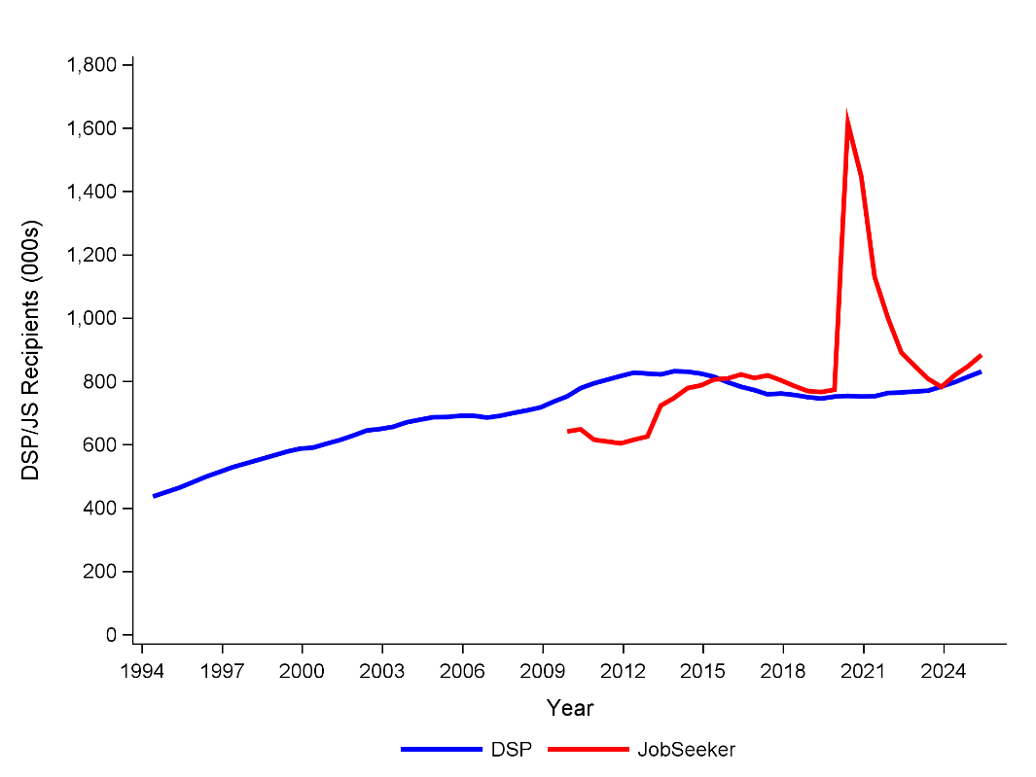
The main points of relevance for this research from Figure 1 is that JobSeeker numbers have been pushed higher by various policy shifts in recent decades including changes in policy to single parents and disability support (both increased JobSeeker numbers) but other factors such as a relatively strong labour market have constrained growth in recipient numbers.
The next section of this statistical summary is to better understand the partial capacity to work (PCTW) element of the JobSeeker and related payments. An element of the policy modelling shown in this paper is to consider a policy option to increase JobSeeker and related payments for those recipients with a partial capacity to work. These payments have different policies for individuals deemed to have a partial capacity to work. Some of these recipients deemed to have only a partial capacity to work receive a (modestly) higher payment but they also have less demanding job search requirements to maintain their payment. The policy option explored in more detail later in this paper considers the impact and cost of increasing their payment more substantially and in proportion to the work incapacity.
Existing policy for JobSeeker recipients is that persons with capacity to work of less than 15 hours per week receive a slightly higher rate of payment (in line with those with a dependent or older recipients with at least 9 months of continuous payment receipt). This rate is $849.90 compared to the base rate of $793.60 per fortnight. Some other JobSeeker recipients are also classed as ‘partial capacity to work’ recipients where their capacity to work is defined as less than 30 hours per week. These recipients with between 15 and 29 hours of work capacity don’t receive additional payments but they are subject to lighter payment conditions around mutual obligation requirements.
Figure 2 shows the trend in PCTW groups. The number of persons defined as ‘0-14 hours’ is very small at fewer than 10,000 recipients. A much more substantial population are those defined as capable of working between 15 and 22 hours per week (currently around 290,000 recipients. This group has increased substantially since 2012-13 increasing from around 75,000 on average through the 2012-13 financial year. Those with between 23 and 29 hours of work capacity has been relatively stable with around 68,000 over the past financial year (2024-25 on average). Those with no PCTW have declined from around 650,000 to around 580,000 recipients. In summary, most JobSeeker and related recipients remain non-PCTW but the number of PCTW recipients is increasing. The numbers covered by the higher JobSeeker rate is very small at less than 10,000 recipients.

Figure 2. JobSeeker/Youth Allowance by Partial Capacity to Work Status, DSS

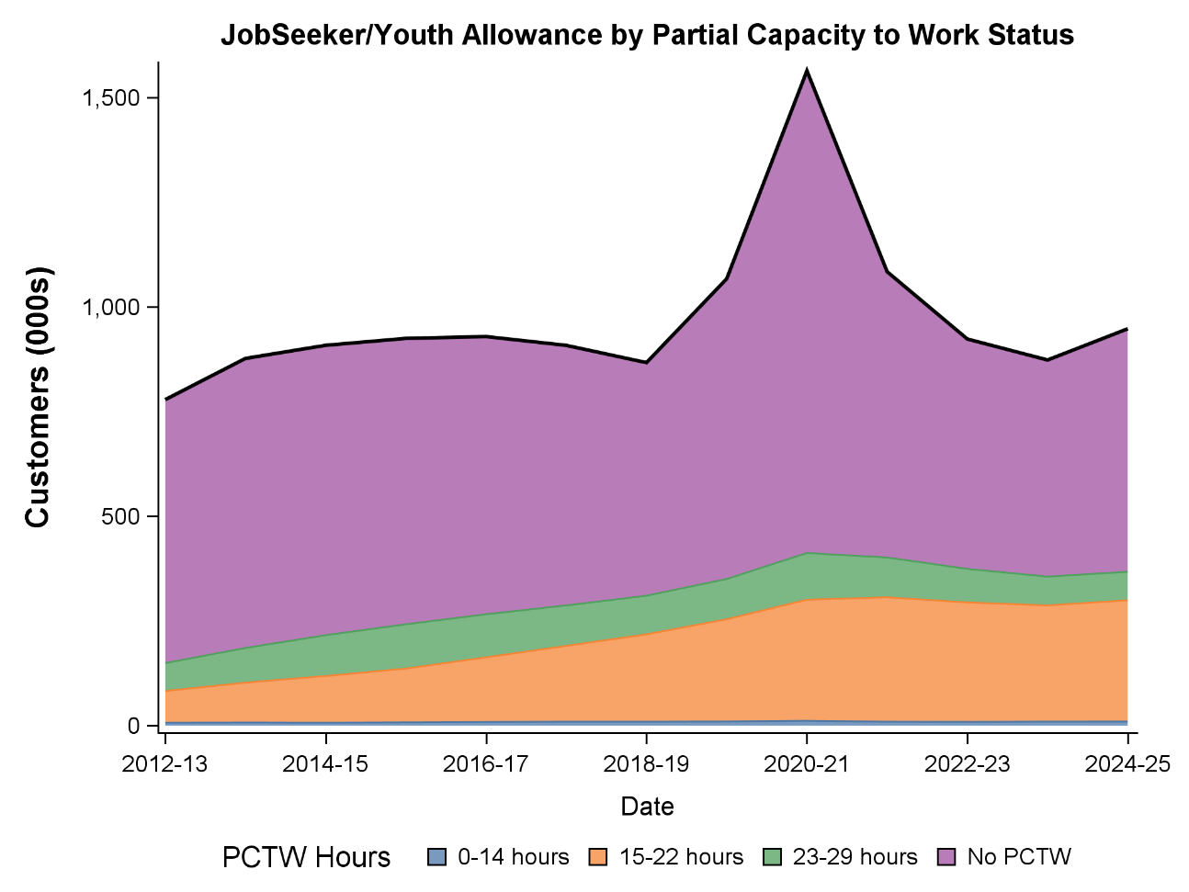
The increasing rate of individuals with partial capacity to work calls into question the assumption that JobSeeker (and related payments) recipients have (or should have) short spells on the payment before quickly finding employment and shifting off the payment. Figure 3 considers the share of recipients who have spent more than one year on welfare payments by PCTW grouping. Clearly, PCTW recipients are much more likely to be on payments for longer than a year than is the case for those not PCTW. Even so, those who are not PCTW for most financial years comprise a population with at least 50% of recipients on payment for more than one year. Those with the highest rate of long term payment use are those judged to have a PCTW of 15 to 22 hours – those who currently only receive the base payment of JobSeeker. Typically, (and currently) over 80 per cent of these customers have been on payment for more than one year. A similar story holds for those on payment for more than 5 years (Figure 4). Those with PCTW of 15 to 22 hours around 50 per cent are on payment for 5 or more years. Around 20 per cent of non-PCTW recipients are on payment for more than 5 years. While the shares for those staying on payment for over 1 year are relatively stable the shares persisting for over 5 years on payment are increasing particularly those defined in the 15 to 22 hour category of PCTW.

Figure 3. Long Term Payment (>1 year) by PCTW Category
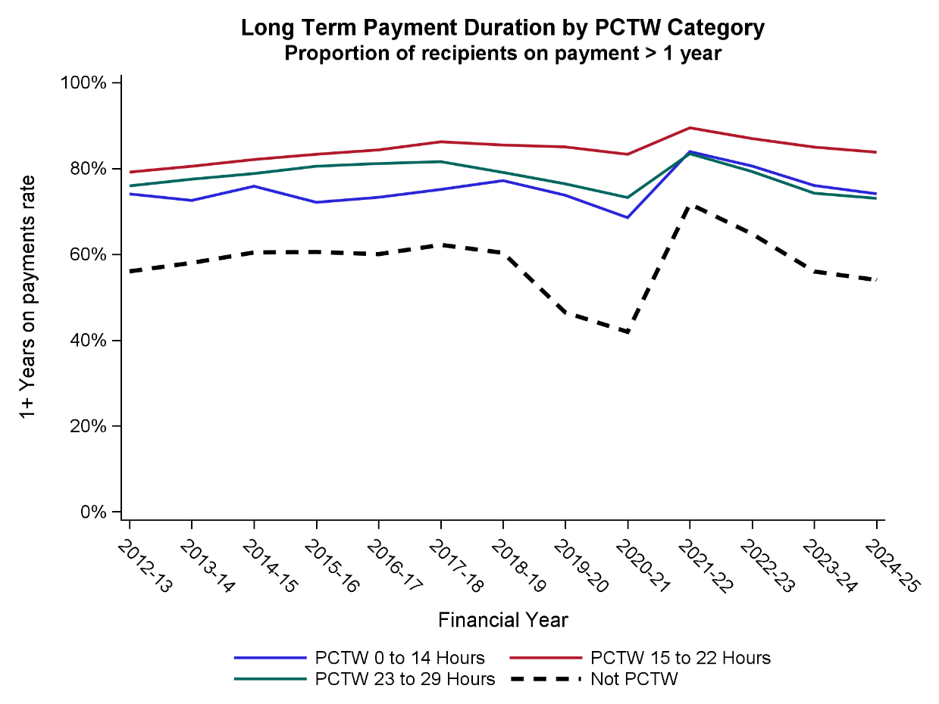

Figure 4. Very Long Term Payment (>5 year) by PCTW Category
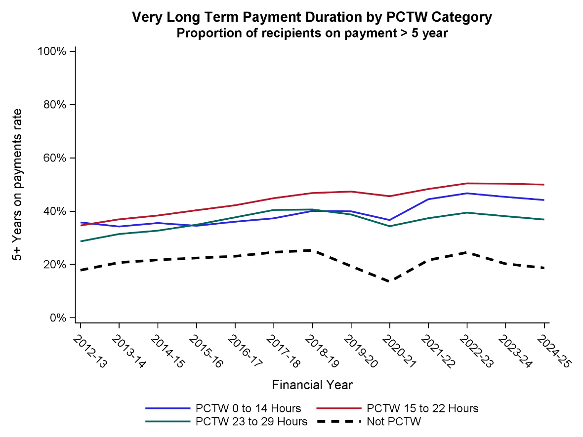
Figure 5. Duration on JobSeeker and related payments
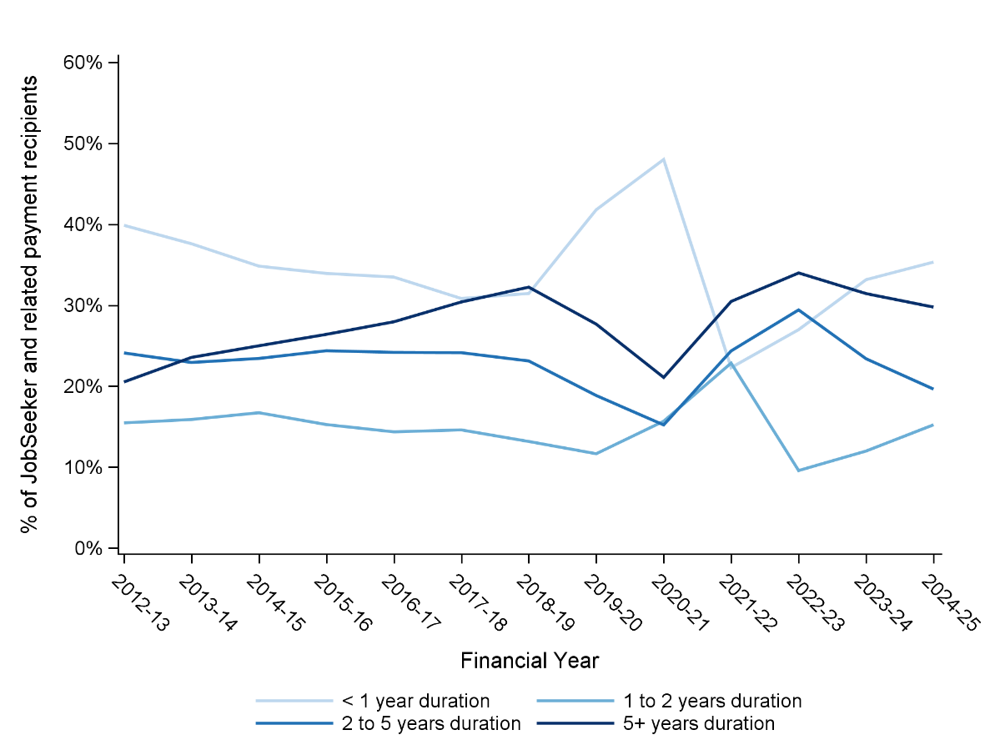
Figure 5 shows that there has been a modest downward trend in JobSeeker and related payment recipients on the payment for less than one year but an upward trend in recipients on the payment for more than 5 years. Covid years (roughly 2020 to 2022) show considerable variation that potentially relate more to differences in welfare populations during that time due to unusual economic conditions and changes in recipient conditions such as the relaxation of mutual obligation conditions.
The trend is towards a population that is more likely to remain on payments for longer durations and more likely to have some work limitations (partial capacity to work). Very few recipients (<10,000) have a limitation below 15 hours which currently entitles recipients to a moderately higher payment. There is a large (around 290,000 persons) and increasing share with a limitation of 15 to 22 hours which is just above the DSP limit of 15 hours per week. The persons with partial capacity to work also tend to have longer durations on payments than those with full capacity to work.
These summary findings provide some explanation around why it would seem that many recipients are remaining on payments for a very long time and many also have limited capacity to work. For these reasons there should be concern that too many JobSeeker and related recipients are (for whatever reason) not finding employment and leaving welfare payments but are staying on payments often for periods of time for which the JobSeeker payment is not designed to adequately cover basic costs. Rather, JobSeeker is designed as a stopgap measure that covers some basic expenses for a short period of time only for recipients who are expected to quickly move on from welfare to work.

Figure 6. Very Long Term Duration by PCTW Category
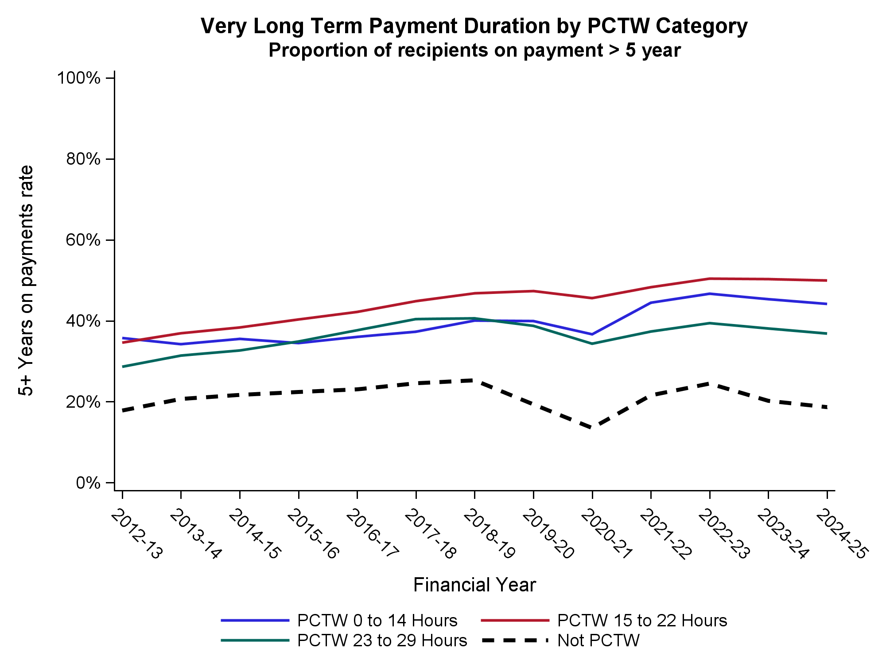
This next section considers the financial stress position of JobSeeker and related payment recipients. These payments have relatively low entitlements compared to pensions such as the Age Pension or the DSP and have tight means testing and eligibility arrangements. As such it is useful to understand the current financial stress position and to consider how that position may have changed given changes in underlying composition and relative rate of payment.
Financial stress measures from the HILDA (Household, Income and Labour Dynamics in Australia) Survey—such as indicators of being unable to pay bills or rent/mortgage on time, skipping meals, going without heating, pawning items, or seeking financial help from family, friends, or welfare organizations—are very useful because they capture the lived experience of economic hardship in real time, reflecting actual difficulties in making ends meet rather than relying solely on income thresholds or metrics alone. While income-based poverty measures (like relative income poverty lines) provide a standardized, objective benchmark for low resources and are useful for tracking inequality and eligibility for support, they can miss key realities: households with similar incomes may face vastly different pressures due to variations in essential expenditure (e.g., high rent, medical expenses, or debt repayments), family size dynamics, or differences in wealth. Financial stress indicators complement and potentially improve upon income and poverty metrics alone by highlighting material deprivation and financial strain that persist even among those above poverty lines. This multidimensional approach takes a broader and direct perspective on financial disadvantage allowing more effective policy targeting.
The HILDA survey is a nationally representative household-based longitudinal survey. HILDA started in 2001 and collects data annually from people aged 15 years or older in each household. In wave 1, data was collected from 7,682 households and 13,969 individuals. All people living in households that participated in the survey in Wave 1 formed the basis of the panel from whom interviews are sought in each subsequent wave. The panel expands over time to include any new household members resulting from changes in who is living in the original household. The sample was topped-up in wave 11. The most recent wave of data that was available at the time this research was undertaken was collected in 2024 (wave 24). In wave 24 data comprised 17,178 responding persons aged 15 years and over from 9,513 households.
The HILDA survey asks respondents (aged 15 years or older) if they experienced a range of financial stresses. The specific question asked is “Since January [relevant year] did any of the following happen to you because of a shortage of money?” with the following list provided:
- Could not pay electricity, gas or telephone bills on time
- Could not pay the mortgage or rent on time
- Pawned or sold something
- Went without meals
- Was unable to heat home
- Asked for financial help from friends or family
- Asked for help from welfare / community organisations.
In addition, HILDA survey includes the question “Suppose you had only one week to raise $4,000 for an emergency. Which of the following best describes how hard it would be for you get that money?” with response options: I could easily raise the money; I could raise the money, but it would involve some sacrifices (e.g., reduced spending, selling a possession); I would have to do something drastic to raise the money (e.g., selling an important possession); or I don’t think I could raise the money. For this research only the latter two options were considered as a response indicating financial stress. The financial stress measure taken in this research is whether or not a person had at least 3 financial stress reponses (including the ability to raise money in a crisis) and zero otherwise.
Figure 7 shows the long run trends in financial stress for welfare recipients using the HILDA longitudinal survey (2001 to 2024 data). Since 2001 the data clearly shows that the rate of stress is greatest amongst working age welfare payments, in particular, the JobSeeker and Parenting Payment Single payments. Current rates of stress suggest that these two payments have rates of stress of 45 and 50 per cent respectively, considerably higher than the population wide average of 10 per cent. Rates of stress for JobSeeker recipients have increased dramatically since COVID (2020 and 2021) but the number of recipients increased dramatically and it may be the case that the new recipients are not representative (possibly having lower rates of financial stress) of the usual JobSeeker population. It was also the case that the rate of the JobSeeker payment was increased substantially through this period, particularly early and mid-2020. Current rates of financial stress (3+ forms) for JobSeeker recipients is similar to early this century which is in contrast to non-welfare recipients who have lower rates of financial stress (13.6 per cent in 2001 compared to 10 per cent in 2024).

Figure 7. Welfare Recipient rates of financial stress (3+ forms), HILDA release 24
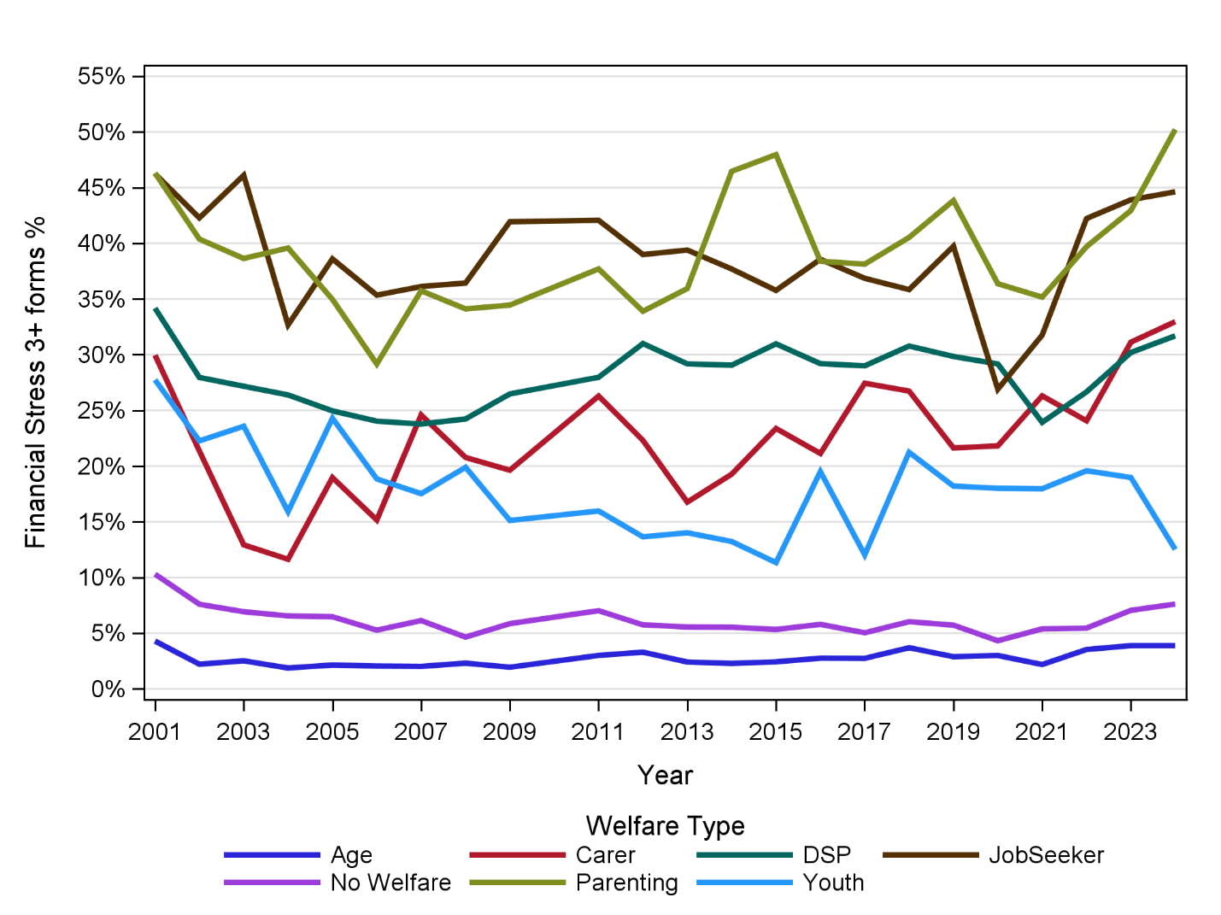
Figure 8 provides a poverty lens on financial disadvantage for the major welfare recipient types. The overall trend for poverty (not shown) has been steady with 12.3% in 2001 and 12.2% in 2024. Poverty was at its lowest in 2013 at 10 per cent.
Rates for JobSeeker have increased from 34.5% to 36.2%. The highest rate of poverty in HILDA by welfare type is for parenting payment recipients (39.2 per cent) and DSP (37.8%). Over time each of parenting payment, JobSeeker and DSP have had the highest poverty rates. Compared to non-welfare recipients, poverty rates are around 5 to 7 times higher for working age welfare recipients.

Figure 8. Welfare Recipient After-Housing Poverty rates, HILDA release 24

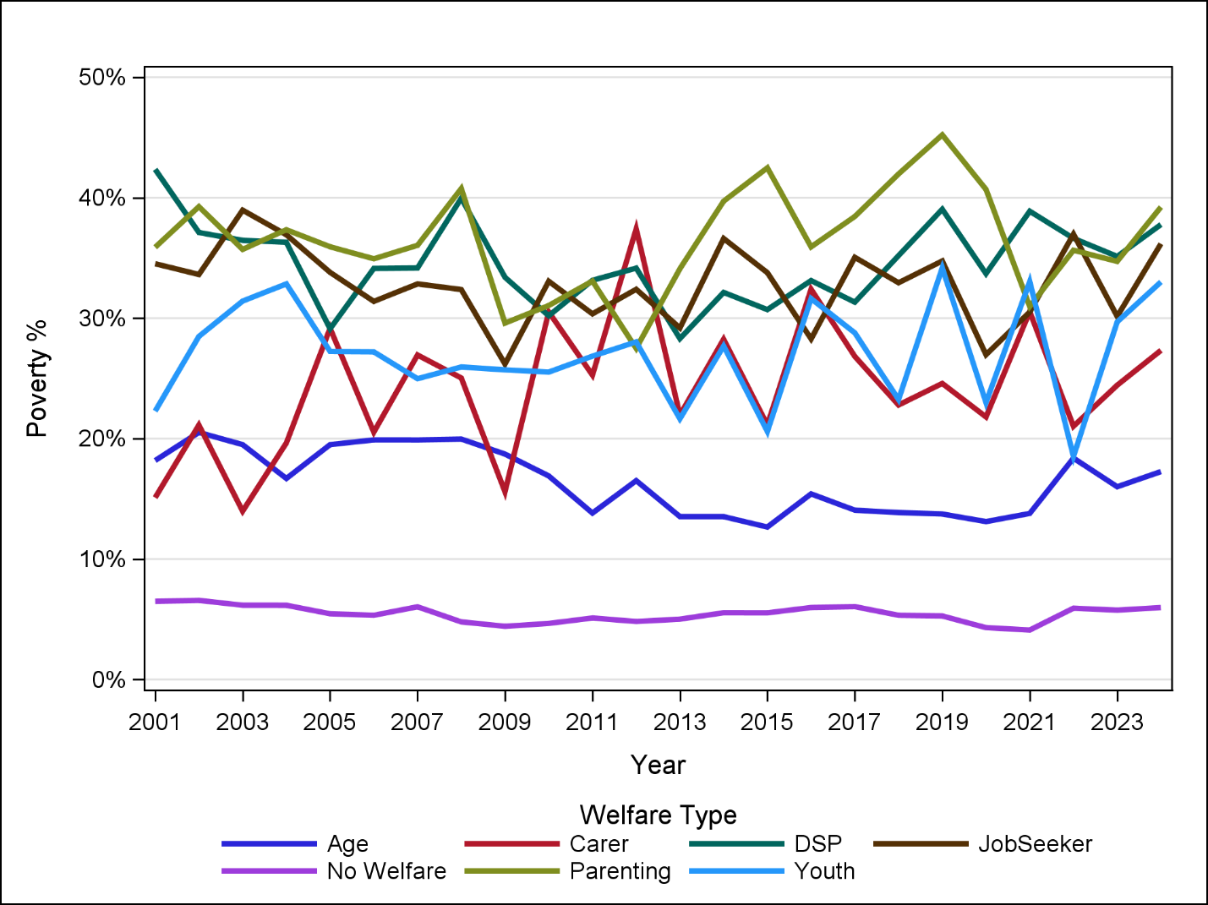

Methodology: Microsimulation Modelling using PolicyMod
For modelling the current policy world and a range of alternative policies we employ the ANU PolicyMod model of the Australian Tax and Transfer System. PolicyMod is based on the ABS Survey of Income and Housing but updates that survey with the latest tax and welfare policies and makes a number of important updates to most dollar values in the survey such as incomes, rent paid, investment returns and changes in wealth. PolicyMod also updates the survey weights to align with the population of Australian tax, welfare and general population and labour force of today rather than those that applied in the original survey. The model is calibrated to a broad range of the latest official welfare, personal income tax and demographic data. This means that the PolicyMod model’s base population for the most recent years align with detailed data on most welfare payments, such as JobSeeker and the Age Pension, in addition to the distribution of tax payers in the latest available taxation statistics.
The modelling using PolicyMod is based on the current 2025-26 base population using the current personal income tax and welfare policy settings for individuals and families. This paper proposes several variations to those policy settings with the main goal of lowering poverty in Australia and improving living standards of those persons at most financial disadvantage in Australia.
PolicyMod compared the disposable income outcomes compared to the base model data for existing policies. The differences are then tabulated by a range of household types to better understand not only the overall costs but the distribution of that impact on different household types. The modelling here is undertaken over the forward estimates (2025-26 to 2028-29).

Policy Modelling Options
The Economic Inclusion Advisory Committee (EIAC) is interested in assessing the cost and distributional impact of two broad options for a more generous JobSeeker payment. EIAC’s position for the first 3 reports has been that the payment should be increased to 90 per cent of the Age Pension. In this modelling two separate options are modelled. The first is to stage the increases in the payment over the forward estimates while the second, from a longer term perspective a lower cost option, is to only increase the payment for those recipients with a partial capacity to work. Both options over the forward estimate lower the cost relative to an immediate increase in the JobSeeker rate to 90 per cent of the Age Pension.
The analysis provides the cost for each year over the forward estimates. In the case of the staged increase the final year (2028/29) is effectively the full or permanent impact of the full 90 per cent policy. The ‘forward estimates’ start from 2025/26 financial year to line up with estimates provided by DSS. Realistically, any policy change relating to the 2026 Budget would not start until the 2026/27 financial year.

Staged Increase in JobSeeker and Related Payments
This section models the implications of an increase in JobSeeker to 90 per cent of the Age Pension (with related working age payments (including Parenting Payment Single being raised to the full Age Pension) being raised commensurately) in four stages:
75% of the Age Pension on 20 September in Year 1
80% of the Age Pension on 20 September in Year 2
85% of the Age Pension on 20 September in Year 3
90% of the Age Pension on 20 September in Year 4.
All years represent an increase on the current JobSeeker base rate payment which is around 67 per cent of the Age Pension, substantially lower than at the start of the century (89 per cent).
Table 2 below shows the distributional impact of increasing JobSeeker and related payments in a staged manner. The impact in year 1 (2025/26) is $2.2 billion due to the modest increase in the JobSeeker payment and a more substantial gain for those on Parenting Payment Single. The base JobSeeker rate is increased from around $793 (current policy) to $873.60 per fortnight representing a roughly 10 per cent increase in the base payment. Other payments are increased in line with this per cent increase.
The overall after-housing poverty rate is reduced by 0.37 percentage points (from 13.15 per cent to 12.79 per cent) or around 103,300 persons in 2025/26. The poverty rate for JobSeeker and related payment recipients drops a little more substantially from 36.6 per cent to 35.5 per cent. The average poverty gap lowers from an average annual figure for households with a JobSeeker or related payment from $5,336 pa to $4,780 pa – a reduction of 10.4 per cent compared to current policy in 2025/26. Of the poverty reduction there are around 12,000 fewer JobSeeker Payment recipients and 17,400 fewer Parenting Payment Single recipients. The poverty rate of households containing Parenting Payment Single recipients drop from 40.9 per cent to 33.9 per cent.
Average gains from the first stage of the JobSeeker increase are heavily directed towards low income households with gains of $289 and $522 per year respectively for income quintile 1 and quintile 2. For the top two income quintiles the gains are trivially small.
An alternative view on living standards is to consider a financial stressed based metric where a household’s financial stress risk is assessed based on a logistic regression of their predicted probability of having any financial stress in the ABS Survey of Income and Housing (the base data set for PolicyMod). This approach is a broader perspective on financial living standards since it takes into account household income, wealth, region, family type, housing tenure, age of the household head, disability status, gender and education status.
Based on the logistic regression model for each household in PolicyMod a probability of ‘any financial stress’ is given. These probabilities are ranked from lowest to highest. The highest ranked households have the greatest chance of having financial stress while the lowest ranked households have the least chance of financial stress. These results are then flipped so that the lowest quintile for living standards are those households with the highest ranking for financial stress probabilities. Conversely, those defined in the top quintile for living standards are those ranked in the bottom 20 per cent for financial stress probability.
The distribution of gains is more heavily distributed towards the lowest ‘living standard’ group (quintile 1) with gains of $739 per year compared to almost no impact for the top 60 per cent of the living standard distribution (quintile 3 to quintile 5).
For household type the largest gains in 2025/26 go to single parents (+$1,062 per year) largely thanks to the large proportion of single parent families who gain from the increase in Parenting Payment Single.
The largest gains by tenure are for renter households with average gains of $441 per year. The other major tenure types (mortgagors and outright owners) both have small gains of $101 and $76 respectively per year.

Table 2. Distributional and Cost Impacts of Staged JobSeeker Increase.
 | 2025 | 2026 | 2027 | 2028
Fiscal Cost $B | 2.2 | 4.0 | 5.7 | 7.4
Poverty Rate (Base) % | 13.15 | 13.14 | 13.18 | 13.32
Poverty Rate (New) % | 12.79 | 12.37 | 12.20 | 12.24
Change in poverty numbers (persons) | 103,345 | 220,898 | 288,271 | 319,890
Poverty Rate (Allowances, Base) % | 36.6 | 36.1 | 36.4 | 36.2
Poverty Rate (Allowances, New) % | 35.5 | 32.5 | 28.8 | 25.4
Change in poverty numbers (persons) | 12,000^ | 39,580 | 84,329 | 123,801
Average Poverty Gap (Allowances, Base) $pa | -5,336 | -5,445 | -5,631 | -5,858
Average Poverty Gap (Allowances, New) $pa | -4,780 | -4,377 | -4,014 | -3,695
Poverty Rate (PPS, Base) % | 40.9 | 40.6 | 41.0 | 42.3
Poverty Rate (PPS, New) % | 33.9 | 24.7 | 24.5 | 27.3
Change in poverty numbers (persons) | 17,396 | 46,055 | 46,535 | 41,483
Average Poverty Gap (PPS, Base) $pa | -4,131 | -4,187 | -4,392 | -4,692
Average Poverty Gap (PPS, New) $pa | -2,951 | -2,557 | -2,636 | -2,850
Average Gains ($pa)
Income Q1 | 289 | 522 | 747 | 997
Income Q2 | 458 | 798 | 1084 | 1396
Income Q3 | 149 | 263 | 384 | 454
Income Q4 | 79 | 133 | 188 | 234
Income Q5 | 13 | 22 | 34 | 42
Living Standard Q1 | 739 | 1313 | 1820 | 2362
Living Standard Q2 | 142 | 253 | 343 | 425
Living Standard Q3 | 47 | 79 | 140 | 183
Living Standard Q4 | 28 | 47 | 71 | 93
Living Standard Q5 | 73 | 124 | 179 | 213
Couple, Children | 47 | 81 | 144 | 221
Couple only | 21 | 40 | 66 | 128
Lone Person | 109 | 218 | 336 | 442
Other | 546 | 985 | 1456 | 1880
single Parent | 1062 | 1690 | 1873 | 1943
Own Outright | 76 | 141 | 202 | 272
Mortgagor | 101 | 170 | 236 | 299
Renter | 441 | 780 | 1097 | 1398
Other | 261 | 439 | 560 | 720
< 25 (age of head of household) | 583 | 953 | 1456 | 1576
25 to 34 | 204 | 330 | 431 | 522
35 to 44 | 261 | 428 | 513 | 634
45 to 54 | 257 | 429 | 590 | 738
55 to 64 | 248 | 531 | 842 | 1170
65+ | 66 | 121 | 181 | 259
PIT funding (% point increase) | 0.18 | 0.32 | 0.43 | 0.53

Source: ANU PolicyMod, ^ caution should be taken with a small sample size. The number of people removed from poverty is substantially larger than the number of persons on the JobSeeker or Parenting Payment due to most people (including children) in the household not on payments.
The largest gains of any age group would be younger Australians with households headed by persons aged less than 25 gaining $583 per year, substantially larger than the next highest gain of $261 per year for those aged 35 to 44 years. Gains are particularly large for the youngest cohort (<25 years) at the household level due to their relative greater numbers and likelihood for multiple recipients in a given household.
The percentage point increases in personal income tax to fund the proposed policy change in 2025/26 is 0.18 per cent. This would mean that the 30 per cent tax rate would be increased to 30.18 per cent and all other rates for personal income tax (including Medicare) would be raised by 0.18 percentage points. Other alternatives for funding would be lower spending elsewhere in welfare or other areas of spending or debt finance. It is likely that some reductions in spending could be derived from lower costs elsewhere in government associated with better mental and physical health and other potential cost savings as described in the most recent EIAC report (Mandala 2025). Exact costings on such savings are generally not included in official budget costings, however. It is likely such savings would only partially fund the proposed increases in JobSeeker and related payments with an annual cost of $7.4B in 2028/29.
The impacts described in Table 1 are generally roughly in line with the change in total expenditure which increased through the forward estimates (2025/26 to 2028/29). For reasons of brevity only the final and long-term impact in 2028/29 will be discussed in detail.
By 2028/29 the increase in the JobSeeker and related payments is complete with the JobSeeker payment raised to 90 per cent of the Age Pension. The full cost is estimated to be $7.4 billion in the final forward estimate year. The reduction in total poverty rate for all persons is 1.08 percentage points equivalent to a reduction in the number of persons in poverty of around 320,000. The rate of poverty for households including at least one person receiving JobSeeker or other related payments is lowered from around 36.2 per cent to 25.4 per cent. The rate of poverty for those on single parent payment lowers from the current policy’s 42.3 per cent to 27.3 per cent. The overall poverty gap for JobSeeker and related payment recipients lowers from an estimated $5,858 to $3,695 per year (37 per cent lower) – implying an average reduction in the poverty gap of $2,163 per year.
In 2028/29 the financial gains are again heavily targeted toward lower income families with average annual gains of $997 and $1,396 for quintiles 1 and 2 respectively. The gains for middle income (quintile 3) are $454 while the gains for higher income households are trivially small. Again, for living standard quintiles the gains are substantially tilted toward those with the lowest living standards. The gains for the lowest living standard households are the highest amongst all groups with average annual gains of $2,362 compared to minimal gains for middle and higher living standard households.
The largest gains go to single parent families ($1943 per year) while other households (mostly group households) gain $1880. Gains for singles are less substantial at $442 while couple families receive very modest gains.
The gains are most substantial for renter households with gains of $1,398 per year by 2028/29. The gains for mortgagors are $299 per year while those who own outright are $272 per year.
The gains are heavily tilted toward younger Australians with average annual gains of $1,576 for households headed by a person under 25. The next largest gain is for households headed by persons aged 55 to 64 with annual gains of $1,170 per year. Naturally, households headed by persons over 65 have very limited gains as working age payments are limited to persons aged under 67.
The full 90 per cent of Age Pension EIAC recommendation would be implemented by 2028/29 at a cost of $7.4 billion in that year. Offsetting that cost increase via an increase in personal income taxation would require an average increase across all personal income taxation rates of 0.53 percentage points. As an example, the 30 per cent rate would need to increase to 30.53 per cent.
From a distributional perspective the main households to gain would be low income and low living standard households. This is as expected as the JobSeeker and related payments almost exclusively are directed toward low income households with limited income and other resources. The gains are felt most strongly by single parents, group households, renters and both the very young and older adults.
The modelling undertaken here for the staged increased does include an estimated additional 31,000 JobSeeker and related payment recipients as a result of higher income cut out points that would occur due to the higher rate of inflation. The modelling does not attempt to account for any behavioural changes that may flow from higher rates of payment. The payment maximum rate for JobSeeker even at the 90 per cent of the Age Pension rate remains a very modest payment and would increase their position in the income distribution (on an equivalised income basis) from about the 6th percentile to the 10th percentile. Such a gain while of some financial benefit to these recipients is unlikely to drive large behaviour change regarding hours worked particularly with the existing requirements around welfare to work obligations to remain on the payment and the asset and liquid asset tests that do limit who can access such payments.

Regional Impacts of lifting JobSeeker and related payments to 90 per cent of Age Pension
Table 2 results can be calculated on regional basis (SA3) using the ANU PolicyMod regional version. The same underlying data and policy simulations are used, however, a reweighting process is applied to obtain weights for each SA3 of which the model calculates around 330 separate weights for each 330 SA3s.The weights are calculated to shift the original PolicyMod weights for Australia to a SA3 basis such that instead of the Australia weights (which add up to the population of Australia – around 27.5 million in 2025) to add up to the population of each SA3. The reweighting process alters these weights so they also align with detailed ABS Census socioeconomic and demographic targets along with DSS administration totals for a range of welfare payments including JobSeeker and the Age Pension.
Increasing the rate of JobSeeker and related payments to 90 per cent of the Age Pension rate (as per the final year of the staged JobSeeker increase in 2028/29) would have a substantial financial impact on remote Australia. Easily the most substantial impacts are felt in remote and very remote SA3s with the largest impact felt in what are mostly indigenous populations. For example, Daly-Tiwi-West Arnhem SA3 has the largest annual average household gain of $3,124, closely followed by East Arnhem at $3,054. A range of other remote areas in NT, QLD and WA follow with only Playford in Adelaide making the top 10 impact list with an average gain of $1,130. These results reflect the relatively high rate of recipients in these more remote regions of Australia.
The least impact regions (SA3s) are high income regions in Sydney such as Ku-ring-gai, North Sydney-Mosman and Manly. 8 out of the 10 least impacted regions are in Sydney.

Table 3. Largest and Smallest SA3 Impact of 90 per cent of Age Pension rate for JobSeeker (2028), ANU PolicyMod
Rank |  |  | State/Region | SA3 Name | $ impact
 |  | Largest Impact SA3s
1 |  |  | Rest of NT | Daly - Tiwi - West Arnhem | $3,124
2 |  |  | Rest of NT | East Arnhem | $3,054
3 |  |  | Rest of NT | Katherine | $2,196
4 |  |  | Rest of Qld | Far North | $1,636
5 |  |  | Rest of NT | Alice Springs | $1,516
6 |  |  | Rest of WA | Kimberley | $1,406
7 |  |  | Rest of SA | Outback - North and East | $1,262
8 |  |  | Greater Adelaide | Playford | $1,130
9 |  |  | Rest of NSW | Bourke - Cobar - Coonamble | $1,115
10 |  |  | Rest of Qld | Outback - North | $1,058
 |  | Smallest impact SA3s
1 |  |  | Greater Sydney | Ku-ring-gai | $96
2 |  |  | Greater Sydney | North Sydney - Mosman | $105
3 |  |  | Greater Sydney | Manly | $111
4 |  |  | Greater Perth | Cottesloe - Claremont | $117
5 |  |  | Greater Sydney | Pittwater | $124
6 |  |  | Greater Sydney | Chatswood - Lane Cove | $130
7 |  |  | Greater Sydney | Baulkham Hills | $138
8 |  |  | Australian Capital Territory | South Canberra | $143
9 |  |  | Greater Sydney | Warringah | $148
10 |  |  | Greater Sydney | Eastern Suburbs - North | $149
Figure 9 shows the pronounced regional impact in Australia from increasing JobSeeker. The largest gains are in regional but particularly remote parts of Australia while major cities and agricultural areas in the east of Australia and south west tend to have smaller impacts.

Figure 9. Average Annual Gain by Australia SA3 regions
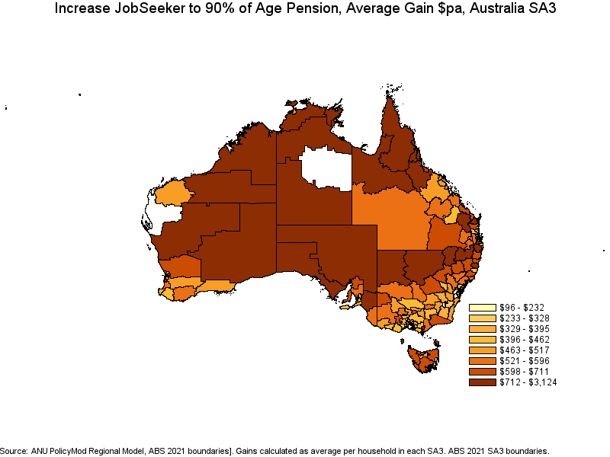
The gains in Sydney are most pronounced in lower income and lower socioeconomic regions in the south-west of the city (Figure 10). The largest gains in Sydney would be in Mount Druitt ($956 and ranked 12 out of 328 SA3s modelled) and second is Fairfield at $905 per year. Both are situated in south west Sydney. As per Table 2 the smallest gains are those mostly situation around the inner parts of Sydney and the harbour and the inner north of Sydney. These regions have very few payment recipients relative to their population.

Figure 10. Average Annual Gain by Sydney SA3 regions
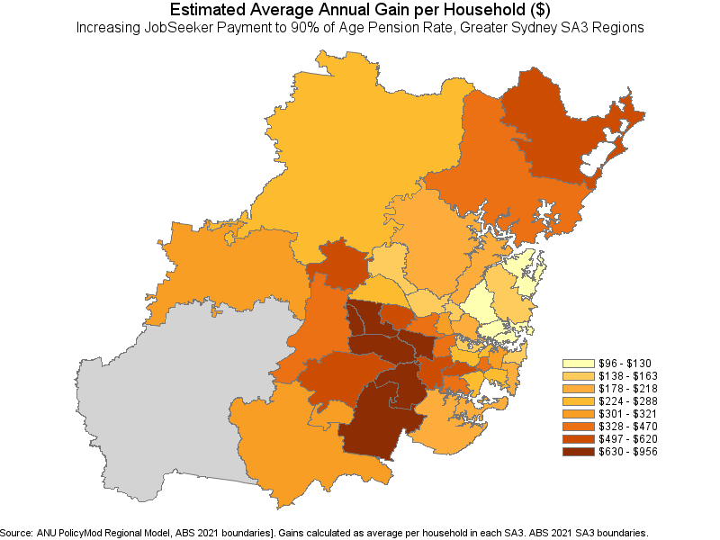
Similarly, Melbourne’s SA3s with the smallest gains are in higher income and more centrally located regions while the largest gains are in lower income areas and those generally further out in the suburbs, particularly the north-west of Melbourne. The largest Melbourne gains are in Brimbank and Tullarmarine-Broadmeadows with gains of $761 and $718per year respectively.

Figure 10. Average Annual Gain by Melbourne SA3 regions
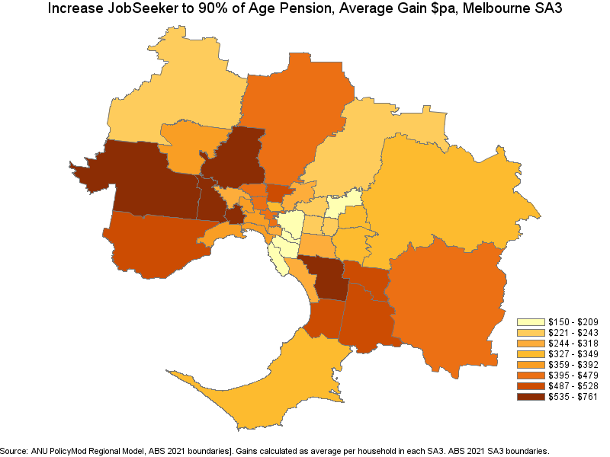
Other regions of note in capital cities with large impacts are Springwood-Kingston (South-west Brisbane and ranked 13 out of 328 SA3s), Salisbury in Adelaide (ranked 21) and Caboolture (ranked 24) and Browns Plains and Beaudesert in Brisbane ranked 32 and 33 respectively.
Overall from a regional perspective, increasing the JobSeeker and related payments substantially lifts income in remote regions of Australia. Within capital cities the gains are most substantial in more outer suburbs while inner and higher income regions gain little from increases in JobSeeker (on average).

Higher Rates of Payment for Partial Capacity to Work Recipients
The current arrangement for partial capacity to work recipients is that those with capacity of less than 15 hours get a small additional payment each fortnight recognizing the additional challenges and costs associated with poor health and disability. This group is very small with less than 10,000 recipients. A much larger group of recipients also have partial capacity to work albeit a larger number of hours per week. In this section a more substantial additional benefit is modelled for all existing recipients with partial capacity to work recognizing that it is likely that most people with partial capacity to work (not just those judged to have less than 15 hours per week capacity) have additional costs and face greater limitations in both working and finding suitable employment.
Modelled in this section is a proposal to lift the rate of payment to EIAC’s 90 per cent of the Age Pension rate for those with PCTW of less than 15 hours. Those with PCTW of between 15 and 22 hours their payment would increase to 80 per cent of the Age Pension rate and those with a PCTW between 23 and 29 would receive the benefit received by the current cohort of PCTW recipients (less than 15 hours). Those with no PCTW would continue to receive the existing rate of JobSeeker or their related payment.
The scaling of the payment increase is designed to better reflect the greater challenges in working and finding employment that PCTW recipients face. The additional payments continue to provide the incentive to work with payments that are lower than the Age Pension (and the disability support pension) but do provide some additional assistance particularly to those with greater need as reflected in their capacity to work.
EIAC has outlined their reasons for why JobSeeker should be raised to 90 per cent of the Age Pension. Given government priorities and fiscal challenges this option provides the government with a lower cost alternative, or interim measure, focusing on those recipients with the greatest need.
The modelling here does not attempt to model the increase in recipient numbers due to a higher income threshold. The numbers involved would be expected to be exceptionally small likely substantially less than half of the 31,000 identified in the full 90 per cent case modelled in the previous section. It is also considered that the regression model that should be adequate for the full population may be less appropriate for the PCTW cohort. This should not impact the main findings of this section as the numbers involved are trivially low. The modelling also does not attempt to model behavioural change.
Table 4 provides the costing and distributional results for increasing the JobSeeker and related payments for those with a partial capacity to work. The focus here will mostly be the 2025/26 results as, unlike the staged modelling earlier, the 2025/26 result is the permanent result as all policy change takes place immediately rather than over the 4 years of the forward estimates.
The policy change costs $2.5 billion in 2025/26 with a modest increase for each year thereafter. The total cost over the forward estimates is $10.6 billion. The cost would be increased moderately were the payments also increased in line with expected wage growth as per the staged JobSeeker modelling just described. This modelling will only focus on the more immediate interest in an increase in the JobSeeker rate for those persons on the JobSeeker and related payments. This policy option is substantially less expensive (half the cost) than that staged increase over the forwards which was estimated to cost $19.4 billion over the forward estimates and over the long run around 38 per cent of the cost of the staged increase model where the full 90 per cent of the Age Pension rate applies.
The poverty rate in 2025/26 lowers very modestly by 0.29 of a percentage point across all households. The poverty rate lowers more substantially for those recipients of the JobSeeker payment (and related payments) – down from 36.6 per cent to 31.7 per cent. Their poverty gap also lowers by a substantial 17.6 per cent.
Income gains are most substantial for the lowest income quintiles with quintile 1 gaining of $432 per year on average per household. Income quintile 2 has a similar impact while gains are substantially lower for middle and higher income households.
By living standards again it’s the case that the lowest living standard households gain the most with quintile 1 households gaining $823 per year on average in 2025/26. Gains diminish as living standards increase with gains of only $107 for middle living standard households (quintile 3) and $37 for quintile 5 (highest living standards).
With PCTW not being modelled for Parenting Payment Single the gains for single parent families is substantially lower. The largest gains are for ‘other’ households which are mostly group households. There tends to be a limited impact on lone persons and couple only families as a large share of these families are older households who do not qualify for JobSeeker or related payments.
The largest gains by tenure type are for renters with average annual gains per household of $398 per year, substantially higher than home owners (around $140 per year).
The largest gains by age of head of household are different to the staged JobSeeker increase modelling with older households, particularly those aged 55 to 64 the most likely to gain $444 per year). This relates to young single parents mostly missing out now (due to those on Parenting Payment Single not impacted by this policy change) and older recipients more likely to have a partial capacity to work as a JobSeeker recipient.
The required rate of increase of personal income tax to fund this policy is around 0.2 percentage point increase across all taxpayers. That would imply, for example, that a person with a top marginal tax rate of 30 per cent that rate would need to increase to 30.2 per cent.
The PCTW policy provides broadly similar (relative to investment) results to the staged JobSeeker policy in year 1. Beyond year 1 the staged policy has a larger impact which relates to a more substantial investment as the staged policy fully matures to the EIAC recommended 90 per cent rate of the Age Pension for JobSeeker recipients. The PCTW policy is more heavily directed toward JobSeekers while the staged approach applies to both JobSeekers and those on Parenting Payment Single. The PCTW policy is directed slightly more toward lower income and lower living standard households relative to the staged increase policy. Both policies have impacts (relative to their investment) that are quite similar, both impacting typically very low and mostly disadvantaged households and their impacts are largely proportional to the expenditure for a given year. Clearly, by 2028 the staged increase has a larger dollar investment relative to the PCTW policy and therefore more substantially lowers poverty rates and poverty gaps in total and across most demographic groups consisered.

Table 4. Distributional and Cost Impacts of JobSeeker and related payments increase for PCTW recipients.
 | 2025 | 2026 | 2027 | 2028
Fiscal Cost $B | 2.5 | 2.6 | 2.7 | 2.8
Poverty Rate (Base) % | 13.15 | 13.14 | 13.18 | 13.32
Poverty Rate (New) % | 12.86 | 12.85 | 12.89 | 13.05
Change in poverty numbers (persons) | 82,869 | 84,249 | 83,699 | 79,484
Poverty Rate (Allowances, Base) % | 36.6 | 36.1 | 36.4 | 36.2
Poverty Rate (Allowances, New) % | 31.7 | 31.2 | 31.7 | 31.8
Change in poverty numbers (persons) | 52,244 | 52,503 | 50,197 | 47,286
Average Poverty Gap (Allowances, Base) $pa | -5,336 | -5,445 | -5,631 | -5,858
Average Poverty Gap (Allowances, New) $pa | -4,397 | -4,480 | -4,629 | -4,825
Poverty Rate (PPS, Base) % | 40.9 | 40.6 | 41.0 | 42.3
Poverty Rate (PPS, New) % | 40.9 | 40.6 | 41.0 | 42.3
Change in poverty numbers (persons) | 0 | 0 | 0 | 0
Average Poverty Gap (PPS, Base) $pa | -4,131 | -4,187 | -4,392 | -4,692
Average Poverty Gap (PPS, New) $pa | -4,131 | -4,187 | -4,392 | -4,692
Average Gains ($pa)
Income Q1 | 432 | 444 | 453 | 456
Income Q2 | 450 | 465 | 475 | 482
Income Q3 | 155 | 158 | 160 | 163
Income Q4 | 53 | 55 | 56 | 57
Income Q5 | 7 | 7 | 7 | 7
Living Standard Q1 | 823 | 854 | 872 | 884
Living Standard Q2 | 127 | 129 | 140 | 144
Living Standard Q3 | 107 | 109 | 106 | 110
Living Standard Q4 | 57 | 57 | 58 | 55
Living Standard Q5 | 37 | 38 | 38 | 39
Couple, Children | 291 | 300 | 306 | 306
Couple only | 176 | 179 | 183 | 186
Lone Person | 100 | 104 | 106 | 108
Other | 440 | 450 | 458 | 465
single Parent | 45 | 48 | 49 | 48
Own Outright | 140 | 142 | 144 | 143
Mortgagor | 141 | 145 | 148 | 149
Renter | 398 | 412 | 422 | 431
Other | 239 | 247 | 251 | 255
< 25 (age of head of household) | 212 | 221 | 226 | 232
25 to 34 | 218 | 222 | 227 | 231
35 to 44 | 239 | 250 | 256 | 260
45 to 54 | 230 | 237 | 243 | 243
55 to 64 | 444 | 461 | 472 | 484
65+ | 92 | 94 | 96 | 98
PIT funding (% point increase) | 0.20 | 0.21 | 0.20 | 0.20

Source: ANU PolicyMod

Regional Impacts of lifting JobSeeker and related payments for partial capacity to work recipients in 2025
Increasing the rate of JobSeeker and related payments for partial capacity to work recipients would have a substantial financial impact on remote Australia. Easily the most substantial impacts are felt in remote and very remote SA3s with the largest impact felt in what are mostly indigenous populations. For example, East Arnhem SA3 has the largest annual average household gain of $1,031, closely followed by Daly-Tiwi-West Arnhem at $1,017. A range of other remote areas in NT, QLD and WA follow with only Fairfield in Greater Sydney and Playford in Adelaide making the top 10 impact list with an average gain of $487 each. These results reflect the relatively high rate of recipients in these more remote regions of Australia.
The least impact regions (SA3s) are high income regions in Perth (Cottesloe-Claremont) and in Sydney such as Ku-ring-gai, Pittwater, Chatswood-Lane. Compared to the staged modelling the PCTW policy has a more evenly shared distribution of low SA3 impact regions across the capital cities.

Table 5. Largest and Smallest SA3 Impact JobSeeker increase for partial capacity to work recipients (2025), ANU PolicyMod
Rank | State/Region | SA3 Name | $ impact
Largest Impact SA3s
1 | Rest of NT | East Arnhem | $1,031
2 | Rest of NT | Daly - Tiwi - West Arnhem | $1,017
3 | Rest of NT | Katherine | $656
4 | Rest of Qld | Far North | $533
5 | Greater Sydney | Fairfield | $487
6 | Greater Adelaide | Playford | $487
7 | Rest of SA | Outback - North and East | $464
8 | Rest of NT | Alice Springs | $455
9 | Rest of NSW | Bourke - Cobar - Coonamble | $433
10 | Rest of SA | Mid North | $433
Smallest impact SA3s
1 | Greater Perth | Cottesloe - Claremont | $35
2 | Greater Sydney | Ku-ring-gai | $38
3 | Greater Sydney | Pittwater | $46
4 | Greater Sydney | Chatswood - Lane Cove | $52
5 | Greater Brisbane | Kenmore - Brookfield - Moggill | $52
6 | Australian Capital Territory | Molonglo | $53
7 | Greater Melbourne | Stonnington - East | $55
8 | Greater Melbourne | Bayside | $56
9 | Australian Capital Territory | South Canberra | $57
10 | Greater Melbourne | Boroondara | $57
The mapped results below are similar to those produced for the staged increase modelling. The overall gains are considerably smaller on average though as the policy relating to PCTW is considerably cheaper.
For the whole of Australia, the impacts are again felt most strongly for the remote parts of Australia with high indigenous population rates (Figure 11). The differential between the highest and lowest impact SA3s is very substantial with $1,031 (average household gain per year) for Arnhem Land compared to just $35 for Cottesloe-Claremont.

Figure 11. Average Annual Gain for Australian SA3 regions (2025), ANU PolicyMod

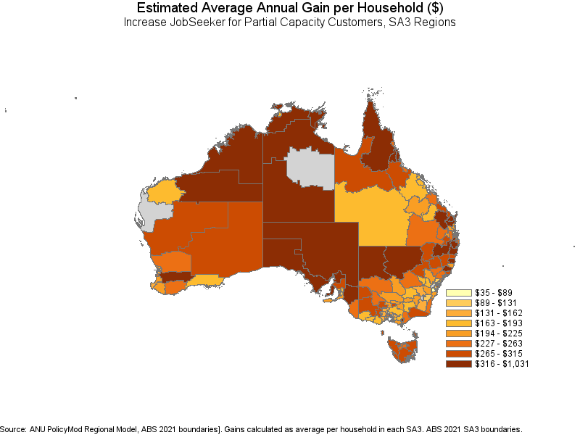
For Sydney, again the results show a strong relationship with regions known for lower income and lower socioeconomic status gaining the most. The south west region of Sydney gains the most with gains of up to $487 per year per household (Fairfield) while the very high income regions around inner and the inner-north have the lowest gains, as low as $38 per year (Kur-ing-gai).

Figure 12. Average Annual Gain for Greater Sydney SA3 regions for Partial Capacity To Work JobSeeker Recipients, ANU PoliycMod

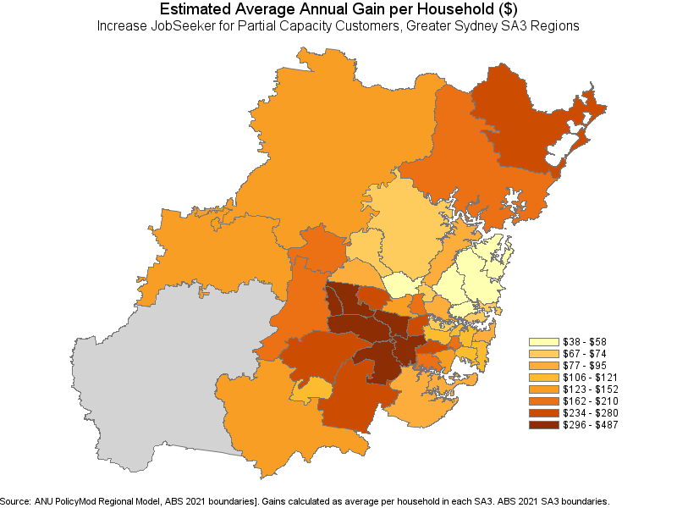
Figure 13 shows a similar relative impact as per the staged modelling (albeit lower) with inner Melbourne SA3 gaining very little but more substantial gains in the outer north-west and south-eastern SA3s. The overall gains are fairly similar between Sydney and Melbourne with the exception that Sydney tends to have a moderately larger impact for a few lower income/socioeconomic SA3s compared to Melbourne.

Figure 13. Average Annual Gain for Greater Melbourne SA3 regions

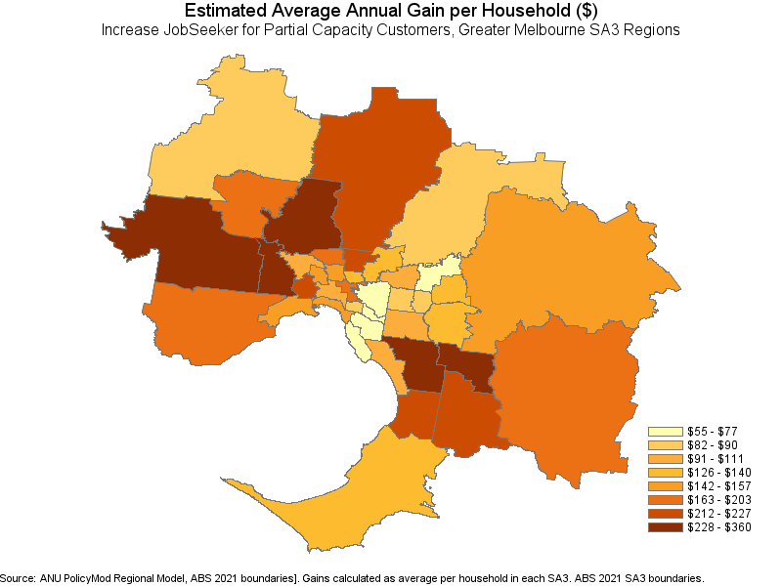

Workforce Participation Impacts
This section considers the impact of raising the JobSeeker rate from the current base rate of around $793 pf to around $1048 pf (or 90 per cent of the Age Pension) on workforce incentives. The analysis will consider the EMTR (effective marginal tax rate) schedules of the current rate and the proposed rate from both hypothetical and distributional perspectives. The analysis will not attempt to formally model the behavior change or the broader economic impacts of such policy change.
The EMTR analysis is a useful starting point for understanding what the impact may be on the incentives to increase paid employment that JobSeeker payment recipients face now and how that changes. The hypothetical EMTR is a useful perspective on the incentives faced by a single recipient while the distributional EMTR approach provides a guide to the actual EMTRs faced by recipients. The two provide different results for a number of reasons but the most important is that the distributional EMTR analysis is based on actual survey responses so should be a better representation of how EMTRs would be affected by the proposed policy change. An example, it may be the case that the hypothetical EMTR analysis identifies that over a certain income range there are very high (or low) EMTRs but it may be that the distributional analysis demonstrates that very few people belong to that income range.
Figure 14 shows the EMTR schedule for a single person on the JobSeeker payment with no rental costs. The chart shows the impact on disposable income for income increments of $1000 per year from $0 of private income up to $100,000. Initially the recipients pay no tax on private income or lose any JobSeeker payment. Once their income rises above $150pf they lose 50 cents in the dollar of that gain in lost JobSeeker and beyond $250 pf they lose 60 cents in the dollar. As a result, they lose either 50 or 60 per cent over low income levels. Once their private income rises above the $8,000 pa they also start paying personal income tax (although assisted through changing BENTO and LITO offsets). Their EMTR peaks at around 79 per cent with a contribution from tax of around 19 per cent and from JobSeeker of 60 per cent. When JobSeeker cuts out the rate briefly lowers to around 19 per cent before heading up to 33.5 per cent over most of the remaining income increments.
These EMTR’s represent substantial disincentives over a relatively wide range of income. In shifting from the maximum JobSeeker payment ($802pf including around $9 of energy supplement) to a full time minimum wage job ($948pw) the recipient shifts from a disposable income of $22,343 to $43,256 leading to a EMTR of 54.7 per cent. This implies that on average, working full time (38 hours at a minimum wage of $24.95ph or $49,296pa) they are only better off by $22,342.
Figure 14. EMTR schedule for Single Rate JobSeeker, no rent, ANU PolicyMod
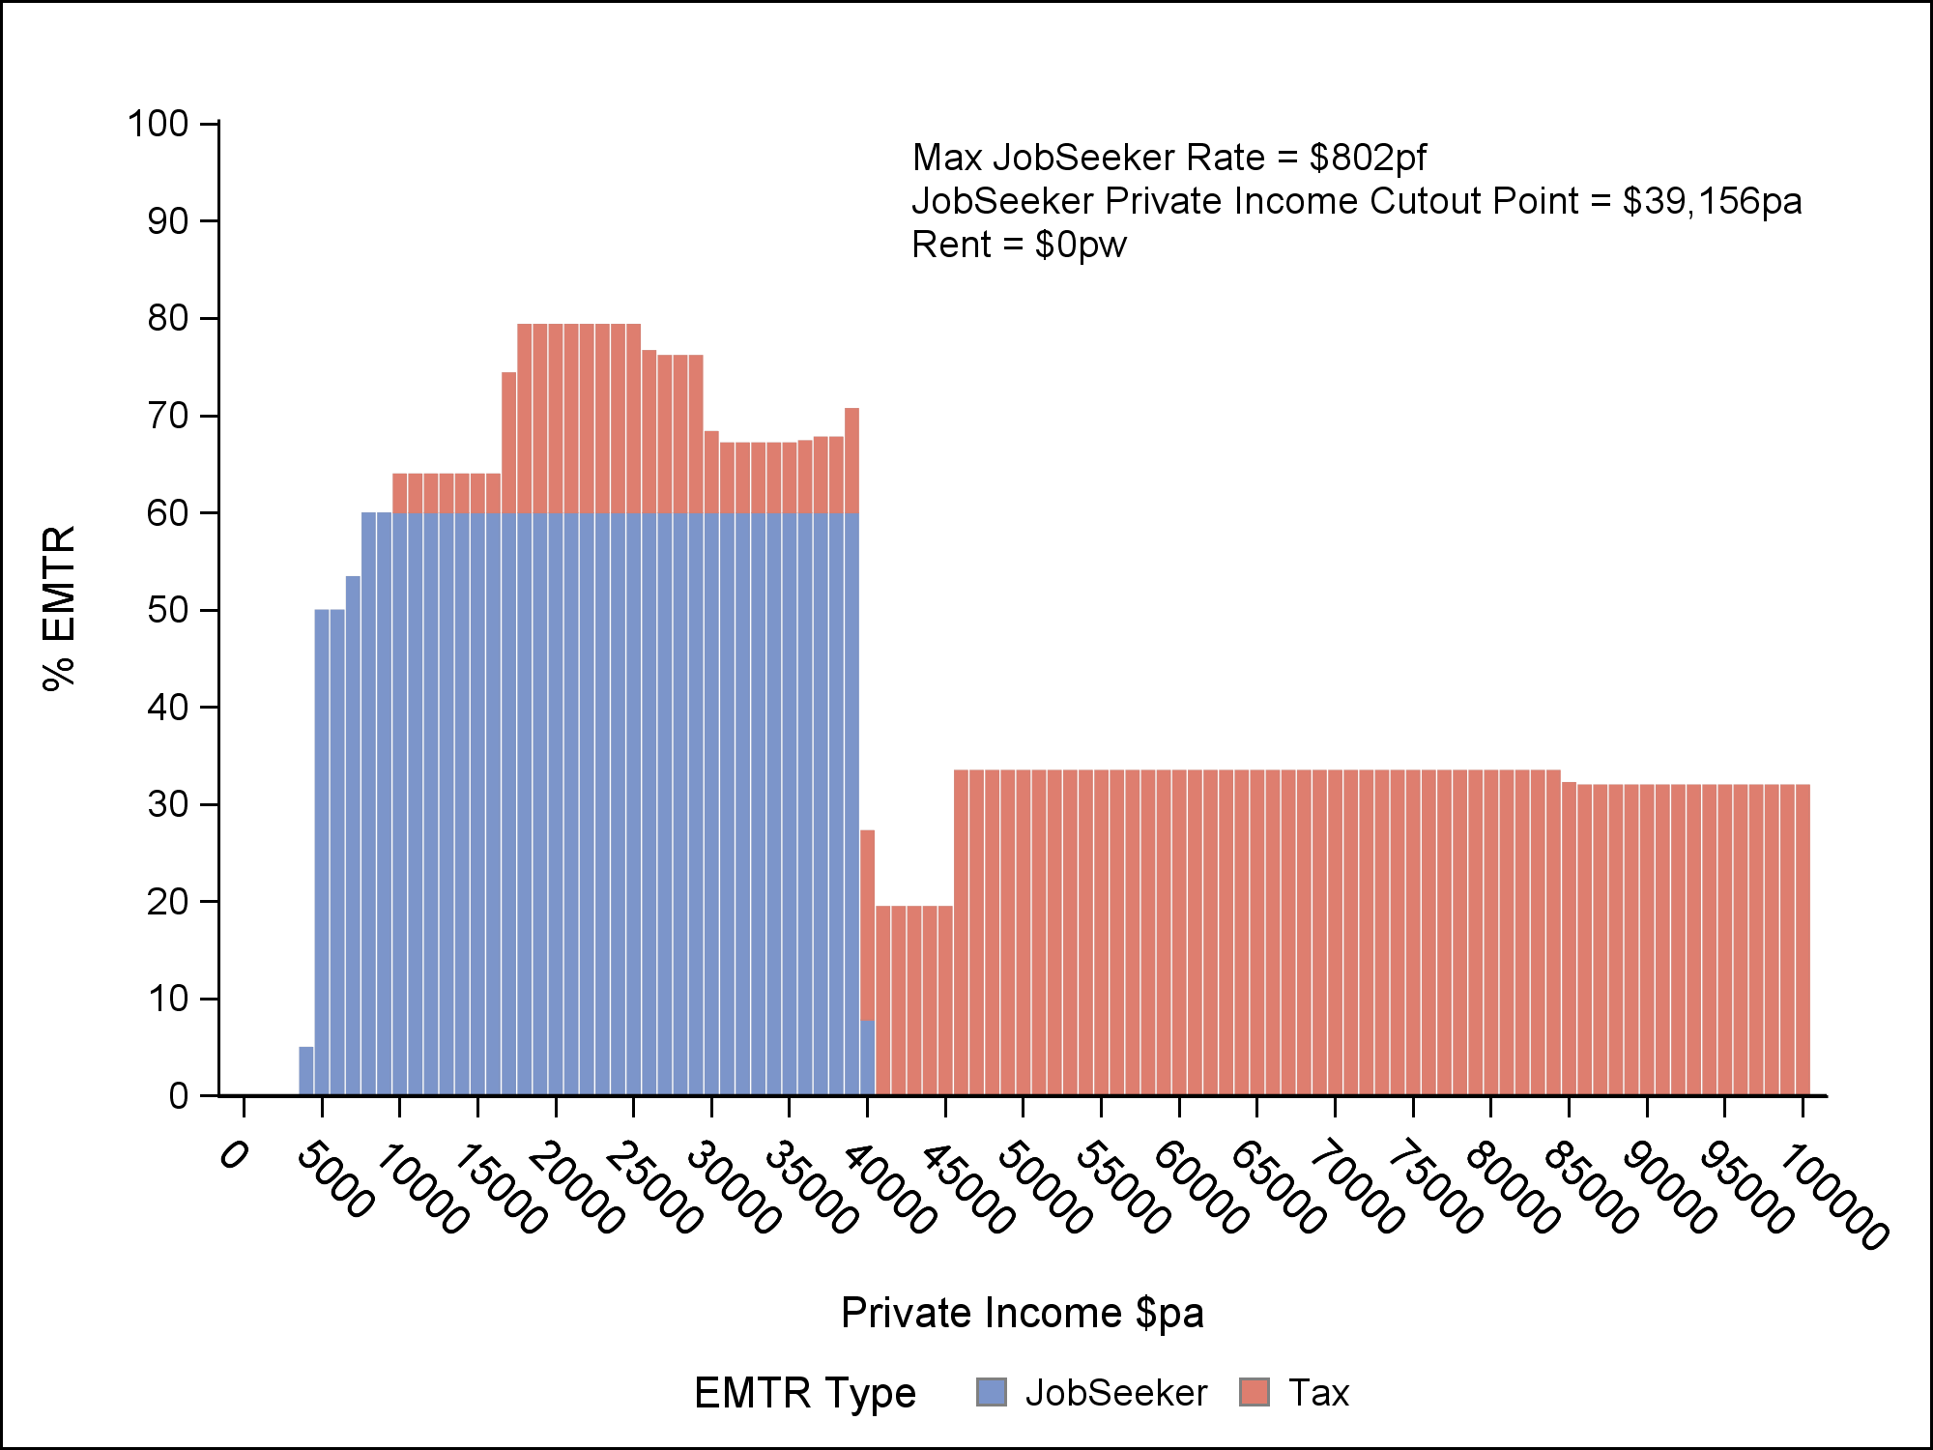

EIAC’s preferred JobSeeker model is to raise the rate to 90 per cent of the Age Pension or around $1,057 pf including energy supplement. Figure 15 shows a similar pattern in EMTR distribution for this higher rate except that that the high EMTRs continue up until JobSeeker cuts out at around $50,000 per year.
Figure 15. EMTR schedule for Single Rate JobSeeker, no rent, ANU PolicyMod
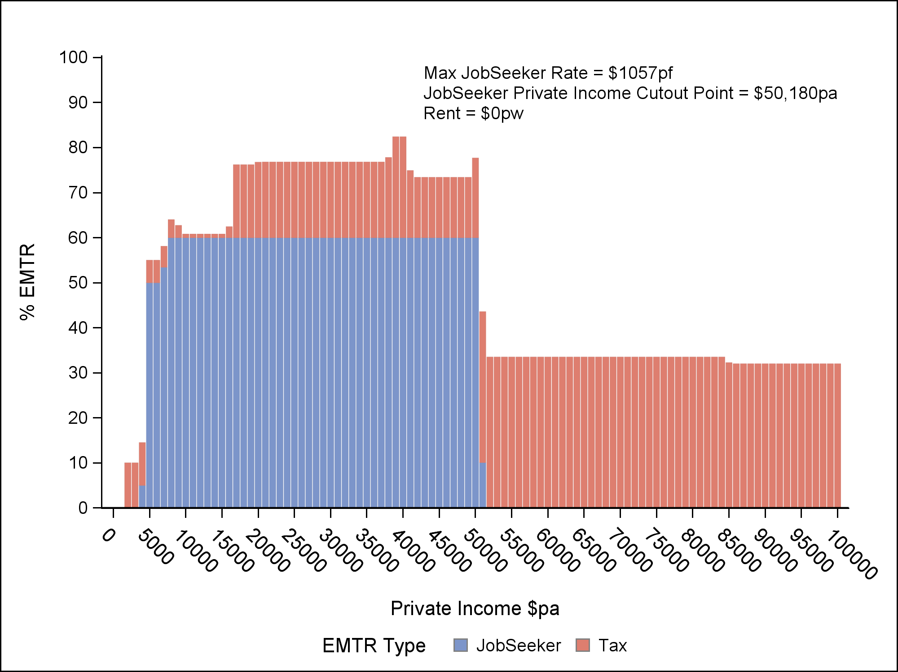
Shifting from a JobSeeker payment on the higher EIAC proposed rate to a minimum wage (FT) leaves the recipient with a slightly higher disposable income ($43,680pa) but due to a higher initial JobSeeker rate ($27,471pa) the overall EMTR is higher at 67.1 per cent.
Figure 16 compares the EMTR schedules for the current and proposed policies. The EIAC policy has a higher EMTR rates for private incomes between around $30,000 per year and $50,000. The main driver of this difference is that the EIAC JobSeeker rate continues to taper away (at 60 cents in the dollar) for incomes beyond the current cut out point (around $39,000 per year). There are other less substantial differences driven by differences in personal income taxation EMTRs as private income interacts with medicare levy, and tax offsets (Bento and LITO).
The JobSeeker rate is, by design, lower than that set for permanent welfare payments such as the Age Pension. A lower rate is designed (at least in theory) to recognize the trade-off between adequacy and work incentives. The JobSeeker payment is tilted more towards work incentives rather than adequacy when compared to pensions such as DSP or the Age Pension. With that said, the existing payment does have a sharp taper rate (50 per cent initially rising quickly to 60 per cent).
Increasing the payment to the 90 per cent of the Age Pension would shift the JobSeeker payment more towards adequacy over work incentives. Previous EIAC work suggests that the payment is too heavily weighted towards the work incentives side of the trade-off and not enough toward the adequacy side. Further to this, it has been argued, and demonstrated, that inadequate payments are themselves a barrier to work (Mandala 2025).
The hypothetical EMTR work in the figures above likely overstate the dimensions of the incentives problems in the real world. For other payments such as the Age Pension or family payments it is the case that increasing the generosity of the payment or lightening means testing (such as lowering taper rates) will automatically lead to a larger pool of recipients. With JobSeeker there are a range of additional eligibility criteria such as liquid assets test and job search/welfare to work requirements that in reality do substantially limit the expansion of the pool of recipients.
While the EMTRs in the earlier figures are those faced by recipients a distributional analysis can shed light on the more challenging issue of eligibility and how many recipients may actually be impacted. The results below are based on an increase in the number of days worked by 1 full day (8 hours). For most people who are employed this is based on their current hourly wage. For those not working, the hourly rate is based on an imputed value given their age, gender and education status. The EMTRs are based only on the working age population (18 to 66 years – under the Age Pension age). Some persons are not included who are not expected to work or have substantial limitations for work such as full-time students and those on a disability or carer pension.

Figure 16. EMTR schedule for Single Rate JobSeeker current vs proposed EIAC policy, ANU PolicyMod
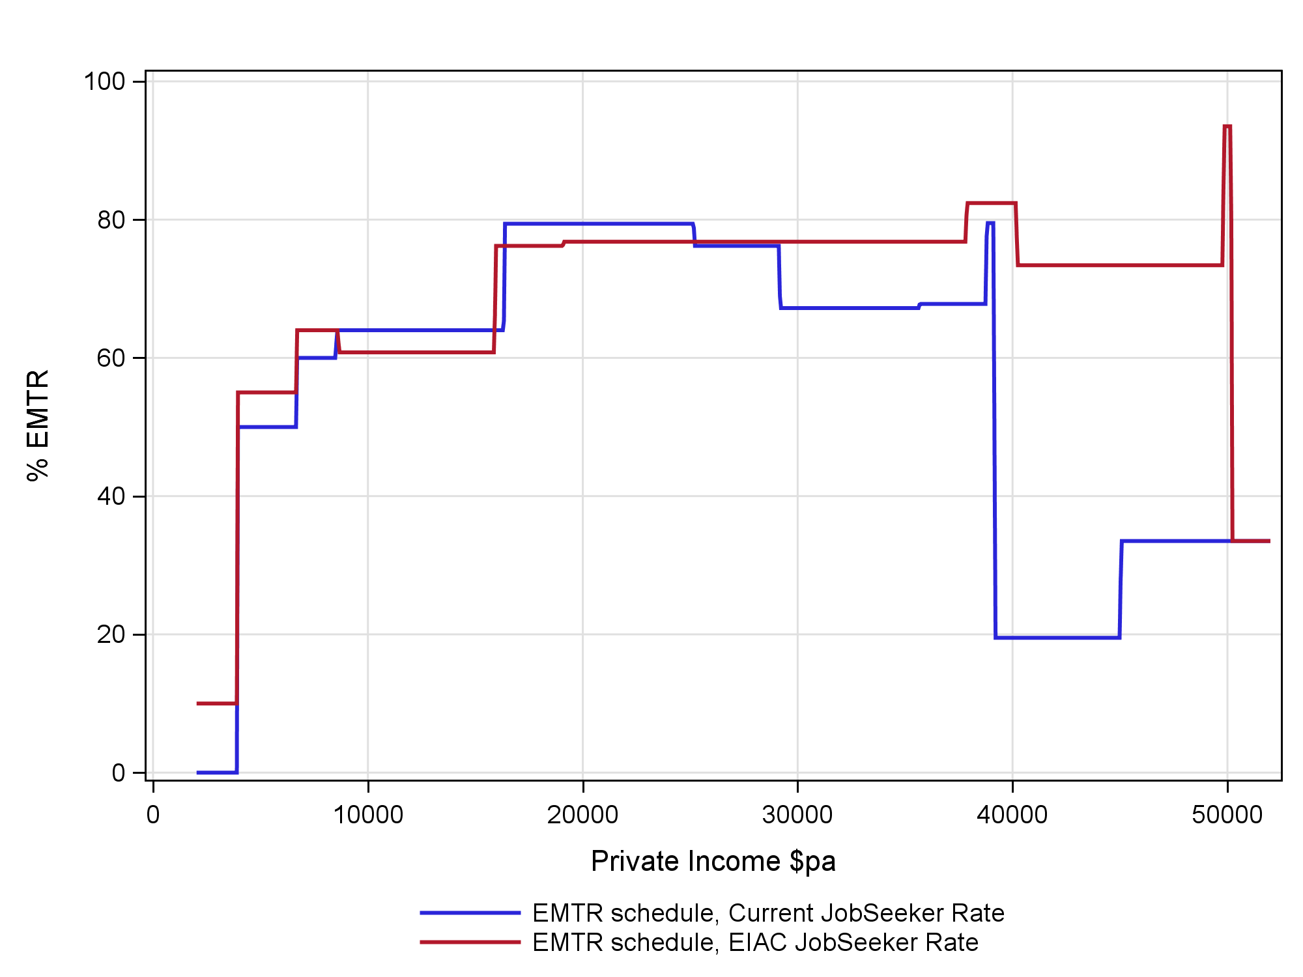
Figure 16 does suggest quite substantial increases in EMTRs over a substantial range of private income. One may expect that there would be many people with a private income of between $30,000 and $50,000 per year. The distributional modelling, however, does take account of the realities of the JobSeeker which include strict welfare-to-work, eligibility and asset testing which the hypothetical modelling ignores. Figure 17 shows that the distribution of EMTR’s for the higher job rate is not greatly impacted by the higher rate of JobSeeker in the same way that the hypothetical modelling suggests could be the case.

Figure 17. Distributional Analysis of EMTRs for working age population, ANU PolicyMod

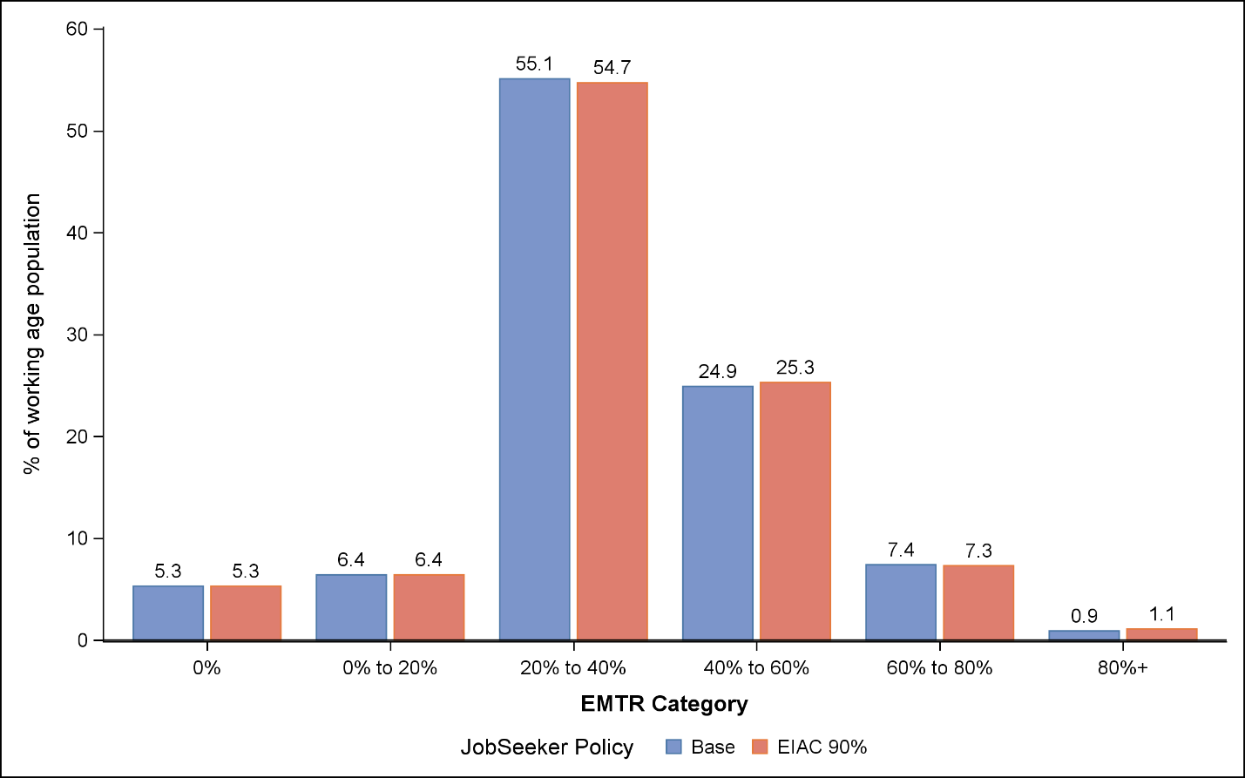
Figure 17 shows that across the working age population (18 to 66 years of age, but excluding full-time students and some welfare recipients such as those on DSP and Carer Payment) the impact of the higher rate of JobSeeker is quite small. EMTRs are divided into categories of EMTR rates. The higher rate of JobSeeker policy does not alter the share of persons in the two lowest EMTR categories, slightly reduces the share in the ‘20% to 40%’ category but moderately increases the share of persons in the higher categories. Most substantially, the ‘40% to 60%’ category share increases from 24.9 per cent to 25.3 per cent.
Not surprisingly, JobSeeker increases are directed most heavily toward low and very low income households. Figure 18 shows the changes in the distribution of EMTRs by the income quintile of the household. The changes are very modest for middle and higher income households. For lower income households there is a slight reduction for the lowest income quintile households (quintile 1) and a modest increase for income quintile 2.

Figure 18. Distributional of EMTRs for working age population by household Income Quintile, ANU PolicyMod
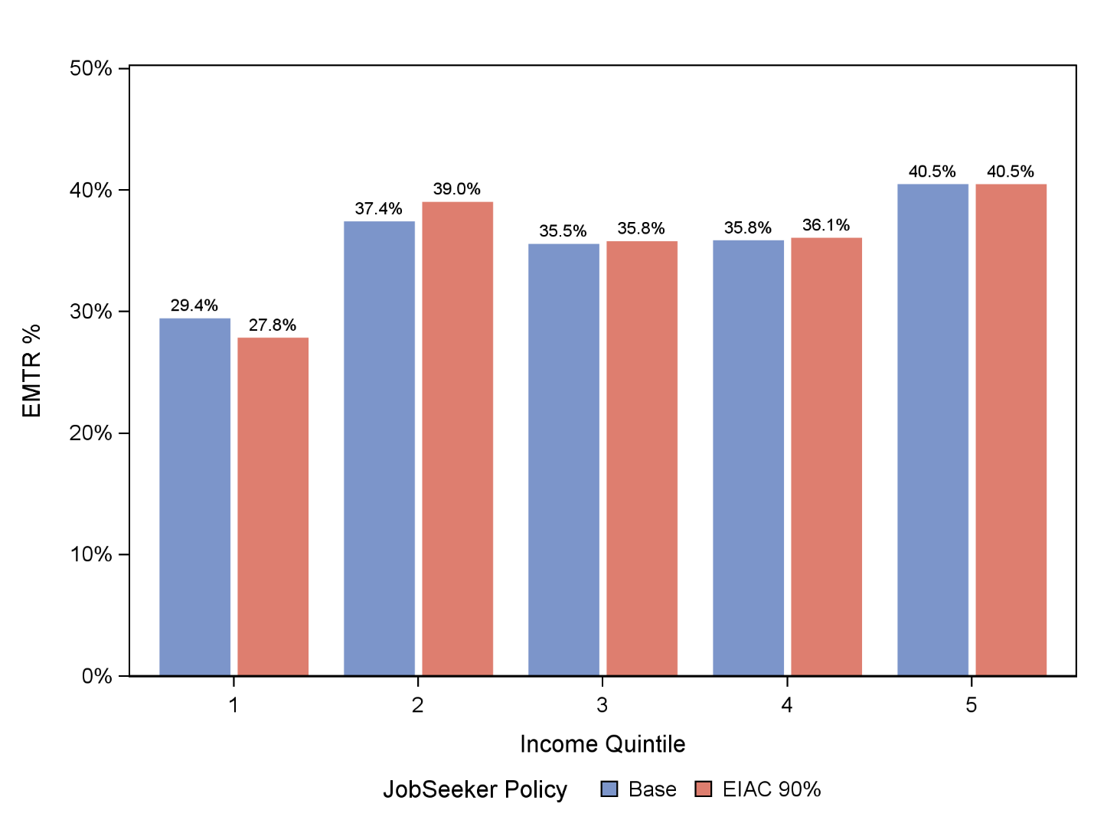
The analysis above considers the working age population (with some selection). The entire working population is much more substantial than the JobSeeker (and related payments) population. Considering only the JobSeeker and related payment recipients in the base year their average EMTR increases from 44 per cent (existing policy) to 46.4 per cent under the new higher JobSeeker rate. Expanding the population to include the small number of additional recipients under the EAIC higher rate proposal the average EMTR increases to 47 per cent.
Figure 18 is based on the assumption of a '1-day' increment to work. An alternative is to increment by $1. The preferred method is the 1-day increment as that better represents realistic labour supply decisions relative to a $1 increment in income per week. When the analysis is re-done but using the $1 increment the general story does not alter greatly, however, it is the case that EMTR’s on average are a little lower across all household income levels (by quintile) but particularly so for quintile 1 where the average rate lowers to around 15 per cent rather than in high 20s as per the current analysis in Figure 18. The reason for this is that a full extra day of work is more likely to put low income workers into an income range where personal income tax is paid and similarly they are also more likely to shift into (or have greater share of their income impacted) means testing for welfare payments.

The table below shows the per cent change and number of recipients by the change in their EMTR from the new policy. The table reflects the full population under the EIAC higher JobSeeker rate proposal. Around 84 per cent of recipients would have a change in EMTR of less than 5 percentage points (positive or negative). Within that around 583,000 recipients would have a modest increase in EMTR of more than 0 per cent but less than 5 per cent – around a half of all recipients within this population. Around 8.2 per cent are estimated to have a substantial increase in their EMTR by more than 10 per cent.

Table 6. Change in EMTR for JobSeeker Recipients Only, ANU PolicyMod
% Change in EMTR | Number of persons | % of population
<-5% | 18,000 | 1.6%
-5% to 0% | 148,000 | 12.7%
No change | 246,000 | 21.2%
0% to 5% | 583,000 | 50.2%
5% to 10% | 71,000 | 6.1%
10%+ | 95,000 | 8.2%

Figure 19. EMTR Distribution for JobSeeker and Related Payments recipients only by Policy, ANU PolicyMod
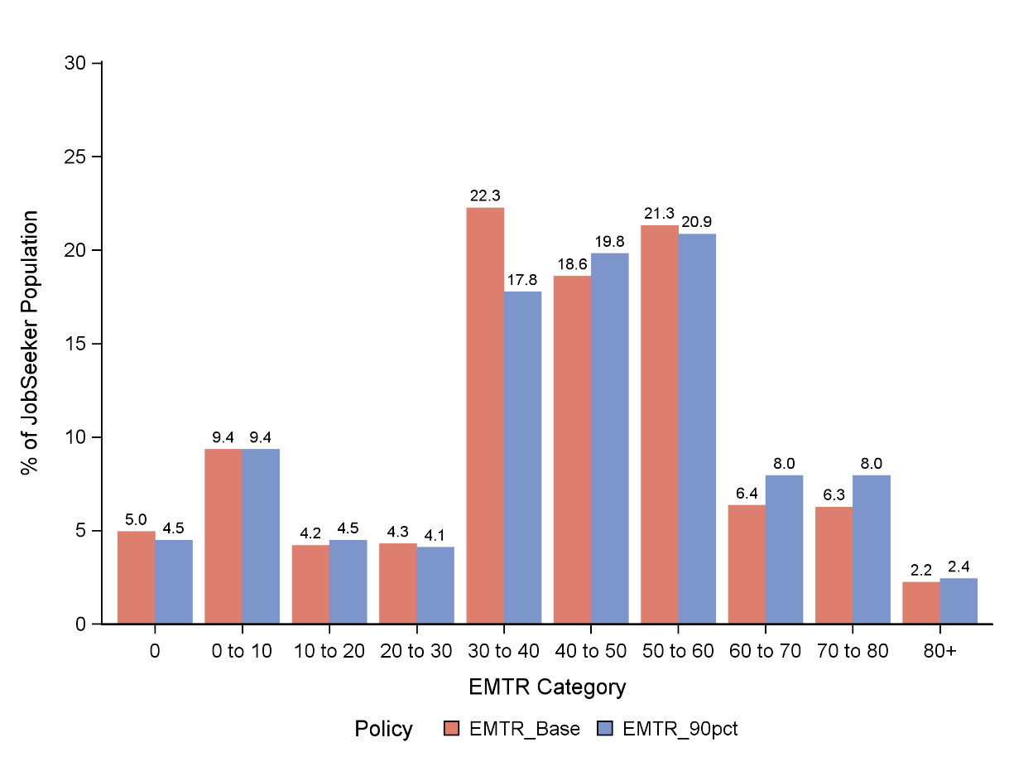

Figure 19 shows the distribution of EMTRs (with 10 percentage point categories) for the current policy compared to the higher rate of JobSeeker proposed by EIAC. The estimates relate only to those recipients who either currently receive the JobSeeker and related payments or are estimated to receive those payments were the EAIC proposal adopted (a slightly larger cohort). The figure shows the share of recipients in the 30 to 40 per cent category falls from 22.3 per cent to 17.8 per cent. The loss here is gained in higher EMTR categories with the largest gains in the 60 to 80 per cent ranges. Figure 19 again demonstrates that for those on the JobSeeker payments and those likely to shift onto JobSeeker with a higher rate there will be an impact with moderately higher EMTR rates for some.
The overall finding from the EMTR analysis is that the hypothetical modelling does show that for those people on JobSeeker and do manage to increase their employment hours over a reasonably substantial income range they do face higher EMTRs and therefore less incentive to work. The distributional analysis shows a substantially different result incorporating the reality that many JobSeekers do not currently work, or only have very limited incomes and at the margin, further increases in private income do not greatly alter their EMTRs. Around 5 in 6 JobSeeker recipients face only a small increase or decrease in their EMTR (but tilted more toward a small increase) while around 1 in 12 (8.2 per cent) would face a significantly higher EMTR under the higher JobSeeker rate.

5. Conclusions
The modelling in this paper has considered two possible options for EIAC to consider. Each of EIAC’s three reports (2023 to 2025) has recommended a substantial increase to the JobSeeker and related payments. The options modelled in this paper provide two options that are considerably cheaper over the forward estimates than the 90 per cent of the Age Pension that EIAC supports. In the case of the staged increase the cost is substantially lower over earlier years but increases to parity in the final year (2028/29) with earlier EIAC recommendations. The second modelled option, increasing payments for those with PCTW, is again, substantially lower cost to government but that cost remains lower for all years through the forward estimates and beyond.
The options modelled are a pragmatic response to broader concerns around budget constraints for the Federal Government and offer the government cheaper options that still have a substantial impact on a vulnerable cohort of welfare recipients.
The introductory material showed that JobSeeker recipients have high rates of poverty and financial stress and relative to most other welfare payments they are in a difficult financial position. In theory, JobSeeker recipients would only be on the payment for a short period and move back to work or study but the research here does show that a large share of recipients either have limited capacity to work and/or remain on the payment for a long period of time. The evidence here shows that recipients are not easily moving off payment.
The JobSeeker payment’s intent is to provide a limited but adequate payment but only for a limited period of time as recipients move between jobs. The evidence provided here is that recipients are very often on payments for much longer than what the payment is designed for and that the majority of recipients are in challenging financial position.
The research here shows that recipients are increasingly on the payment for longer periods of time and that increasingly recipients have a partial capacity to work. The options provided offer the government cheaper options that are shown to substantially improve the financial welfare of a significant number of very low income persons. Both options modelled have a lower cost and also a lower financial impact relative to the full EIAC recommended position of JobSeeker and related payments increasing to 90 per cent of the Age Pension. The staged approach converges on the EIAC position by 2018/29.
The research shows that the two options broadly benefit low income, low living standard, renters, single parents, remote Australia, outer suburban capital city regions and particularly the very young and the older cohort of recipients.
The partial capacity to work only option provides a less expensive policy option that while not providing the full assistance that EAIC recommends does provide substantial assistance to a sub group of JobSeeker recipients who are known to have substantial employment limitations and are often on the payment for several years.
The full recommended JobSeeker increase reduces poverty of JobSeeker and related payment households by around one half and removes around 321,000 persons from poverty. The poverty gap also lowers by 37 per cent for households with JobSeeker recipients.
From a regional perspective the gains are particularly substantial for remote Australia with some regions (such as the Tiwi Islands and Arnhem lands) average households gain of over $3,000 per year. Gains are less substantial in capital city regions.
Hypothetical modelling shows that for those people who are on JobSeeker and do manage to increase their employment hours face higher EMTRs and therefore a lower incentive to work over a reasonably substantial income range they do face higher EMTR. The distributional analysis shows a substantially different result incorporating the reality that many JobSeekers do not currently work, or only have very limited incomes and at the margin, further increases in private income do not greatly alter their EMTRs. The small increase in work disincentives should be compared to the substantial increase in adequacy of the JobSeeker payment.
While the policy options modelled are not as substantial as the preferred model as stated in each EIAC report (increase JobSeeker to 90 per cent of the Age Pension) the modelled options still provide substantial support to a cohort of welfare recipients who are shown to be significantly disadvantaged compared to the rest of Australia and most other welfare recipients. In the case of the staged policy, by 2028 the policy matches the preferred EIAC position on JobSeeker, while the PCTW policy continues to only benefit a sub-group of JobSeeker and related payment recipients, albeit a particualrly disadvantaged group.

6. References
ABS (2021) Survey of Income and Housing, Australian Bureau of Statistics.
ABS (2021) 2021 Census – Demographic Counts [TableBuilder], ABS website, accessed 13 February 2026.
ABS (2025) National, State and Territory Population, September 2025.
DSS (2026) DSS Benefit and Payment Recipient Demographics - Quarterly Data, updated 13/2/2026
Harmer, J. (2009) Pension Review Report. Canberra: Department of Families, Housing, Community Services and Indigenous Affairs (FAHCSIA), Commonwealth of Australia.
Economic Inclusion Advisory Committee. (2023) Interim Economic Inclusion Advisory Committee 2023-24 Report Report to Government. Canberra. Department of Social Services, Australian Government. https://www.dss.gov.au/system/files/resources/eiac_report_8.06.23_0.pdf
Economic Inclusion Advisory Committee. (2024). Economic Inclusion Advisory Committee 2024 Report to Government. Canberra: Department of Social Services, Australian Government. https://www.dss.gov.au/system/files/resources/13404-eiac-report-dv-08-app-orig_0.pdf
Economic Inclusion Advisory Committee. (2025). Economic Inclusion Advisory Committee 2025 Report to Government. Canberra: Department of Social Services, Australian Government. https://www.dss.gov.au/system/files/documents/2025-04/economic-inclusion-advisory-committee-2025-report.pdf
Mandala (2024) The Social Dividend an Actuarial Case for Higher Income Support, Report for the Economic Inclusion Advisory Committee, December 2024.
Melbourne Institute of Applied Economic and Social Research. (2026) Household, Income and Labour Dynamics in Australia (HILDA) Survey, Waves 1 to 24. Melbourne: The University of Melbourne.
Phillips (2024) Work Incentives in Australia: The distribution of effective marginal tax rates for working age Australians in 2023, Australian Journal of Social Issues.

This work was supported and funded by the Economic Inclusion Advisory Committee. The DSS secretariat provided substantial assistance through the provision of administration data.
Table 1 population relates to the aggregate of ABSTUDY (Living Allowance), ABSTUDY (non-Living Allowance), JobSeeker Payment, Parenting Payment Partnered, Special Benefit, Youth Allowance (other), Youth Allowance (student and apprentice) recipients from the September quarter 2025 DSS Quarterly Demographics report published on data.gov.au
ABS Census (2021)
Comparison of DSS Quarterly Benefit and Payment Recipient Demographics and ABS Demographic Statistics for latest available data between 2020 and 2025.
Figure 4 is based on monthly DSS data while earlier data in Table 1 uses quarterly DSS data.
In waves 9-19 this question was whether the respondent could raise $3,000 for an emergency. From wave 20 the question was whether the respondent could raise $4,000 for an emergency.
Poverty based on the HILDA data set was based on the half-median measure for disposable income. Income was adjusted by the OECD equivalence scale where the first adult in a household is weighted with a 1, subsequent adults 0.5 and children 0.3. Children are aged under 15 years.
For more detail on the ANU PolicyMod microsimulation model of the Australian tax and transfer system see the model documentation (Phillips 2023).
From 2026/27 onwards parenting payment single Is increased to the age pension but does not exceed the age pension thereafter.
The poverty rate is based on a half-median of equivalised household income. Equivalising is based on the modified OECD equivalence scale. Households with Incomes in the bottom 2 per cent (standard ABS practice) of the Income distribution are excluded from poverty but are excluded from poverty but Included in the base population. Poverty rates are based on a persons-based calculation within households defined as in poverty.
The overall cost over the forward estimates Is $19.4 billion. This cost is higher than that estimated by the Department of Social Services (DSS). There are 3 major drivers of the higher cost in the ANU modelling. The ANU modelling assumes costs over all quarters of the forward estimates while DSS misses most of one quarter. ANU's modelling estimates a larger increase in parenting payment recipients resulting from a higher income cut-out point. DSS estimates around 327,000 parenting payment single recipients while ANU estimates just over 351,000 by 2028/29. There are also expected to be differences in estimates from a survey-based microsimulation model and the DSS modelling based on administration data.
For more detail on the regional modelling methodology used in PolicyMod see the documentation in Phillips (2023).
For more detail on the methodology used see Phillips (2024)
A similar finding is estimated where the income quintiles from the base world calculation are used for the policy simulation world (EIAC) rather than allowing income quintiles to be policy specific. A slight difference is that the small changes in quintile 1 and quintile 2 are reversed with quintile 1 Increasingly marginally and quintile 2 lowering marginally. Fixing the quintiles for both the current policy (base) and alternative policy (EIAC 90%) to be those of the base removes some small compositional change as some household in this analysis do move between quintiles.

