

GUIDE: Capturing case study photos
Connecting Communities: Share your story
A captivating image can make a big impact. To support your story of success, we’ve developed a short guide to help you get the best result from a mobile phone.
Email CommunityCaseStudies@dss.gov.au if you need any advice or help with this guide.

Subject
We want people to be the focus of our stories. If they consent to have their photo shared with us for use, please take a portrait photo of them.
If possible, please:
- take the photo with them looking directly at the camera
- frame the photo so we can see their face
- be sure they are the focus and take up space in the photo
- make sure photo depicts an authentic version of them. For example please don’t use filters that alter their features. They also don’t have to dress up for the photo unless it is what they prefer, or it is relevant to the case study.
Here is an example:
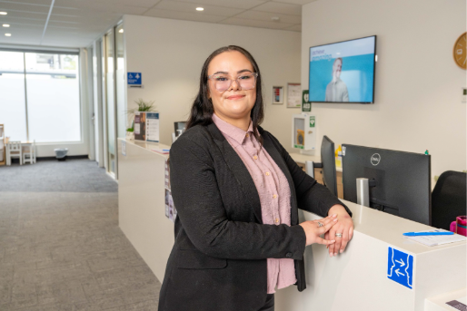

Lighting
Good lighting is important and makes the biggest difference.
The best time to take your photo is in early morning or late afternoon. The light is softer and avoids glare. Use natural light where possible.
If the sun is too strong, try:
- Moving slightly left/right to avoid direct glare.
- Standing in light shade.
- Waiting a minute or two if clouds are moving.
Try to avoid:
- Very bright patches on the sign (over-exposed areas).
- Heavy shadows falling across any branding.
If you have a small LED light, you can use it to gently brighten the front of the sign or a person’s face.

Framing and composition
This means what is in your shot and how you hold your phone.
For good framing and composition:
- Hold your phone at eye level or slightly above.
- Keep the phone straight, not tilted up or down, so the subject doesn’t appear distorted.
- Check the background for clutter. Move a little if needed.
Use the rule of thirds: imagine your phone screen divided into a grid. Try to place the main subject (the person or activity) off-centre along one of the lines.
For photos of people:
- Use ‘Portrait Mode’ (if your phone has it) to gently blur the background and highlight the person.
- Make sure the person is well-lit and facing the light, not with the sun behind them.
- Take the shot from slightly above eye level for a natural, friendly angle.

Here is an example of a good outdoor portrait.
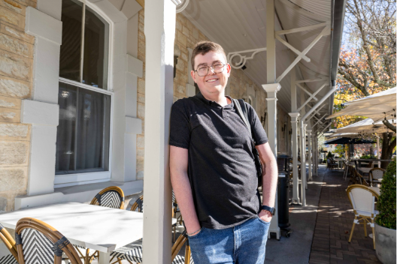
Ensure you have consent if including a person in your photos. A consent form is on the website Connecting Communities: Share your story | Department of Social Services

Steadiness and sharpness
Steadiness and sharpness ensure the photo is clear in focus and detail.
To take a clear photo:
- Hold the phone with both hands.
- If possible, rest your elbow against something to stay steady.
- Tap the screen on the subject before taking the photo to help your phone focus correctly.

Editing
This is an easy, optional touch up of your photo. Before sending, you can do a quick check in your Photos app:
- Increase brightness slightly if needed.
- Adjust warmth or colour if the image looks too cool/blue.
- Avoid heavy filters. Natural images are best.

Submitting your photos
Send your photos, with consent forms, to: CommunityCaseStudies@dss.gov.au.

