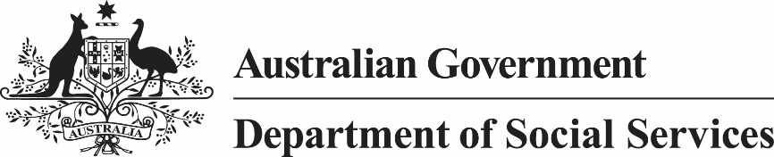

NRAS approved participants

Victoria

As at 1 February 2026

Melbourne
Approved participant | Dwelling location
Questus Funds Management Ltd  www.questus.com.au/  info@questus.com.au  08 6184 8000
  Brunswick
  North Melbourne

Regional Victoria
Approved participant | Dwelling location
Questus Funds Management Ltd  www.questus.com.au/  info@questus.com.au  08 6184 8000
  Belmont

