DSS3611.01.26

Our Ways – Strong Ways – Our Voices
National Aboriginal and Torres Strait Islander Plan to End Family, Domestic and Sexual Violence 2026-2036

What is Our Ways – Strong Ways – Our Voices?
Our Ways – Strong Ways – Our Voices: National Aboriginal and Torres Strait Islander Plan to End Family, Domestic and Sexual Violence 2026-2036 (Our Ways – Strong Ways – Our Voices) is a plan developed by Aboriginal and Torres Strait Islander peoples in partnership with the Australian, state and territory governments. It is the first plan of its kind.
This plan:
- sits alongside the National Plan to End Violence Against Women and Children 2022-2032 (the National Plan)
- builds on the Aboriginal and Torres Strait Islander Action Plan 2023-2025
- focuses on stopping family, domestic and sexual violence before it happens, helping early, responding when it does happen, and supporting recovery and healing
- centres Aboriginal and Torres Strait Islander voices and self-determination, growing community-led action in healing and prevention.

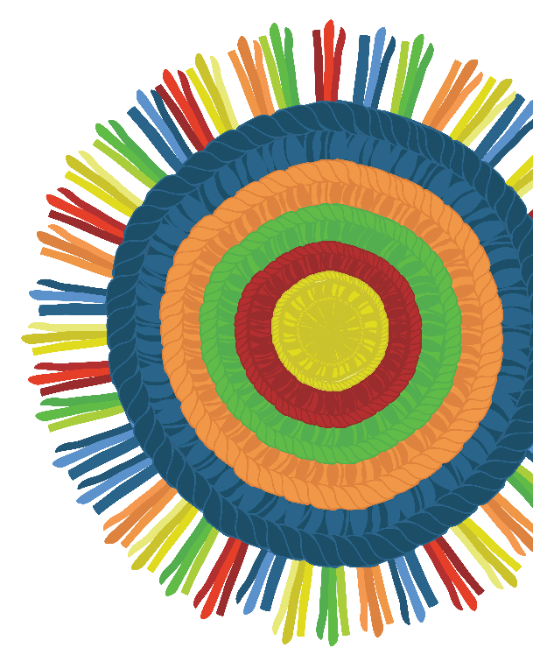
5 threads woven together
Our Ways – Strong Ways – Our Voices has 5 important threads that show what we need to do. Each one is strong on its own, but when they are woven together they create a fabric of safety and healing.
- Voice, agency and self-determination: Aboriginal and Torres Strait Islander voices, leadership and wisdom shape every decision.
- Aboriginal and Torres Strait Islander-led solutions that are strengths-based, preventive and healing: Support honours First Nations story and culture, weaving trauma-responsive, community-led approaches that bind Aboriginal and Torres Strait Islander people in strength.
- Reforming the institutions and systems that impact safety: Reform systems like justice, health, housing, education and child protection to strengthen supports.
- Strengthening evidence, research and data, embedding Indigenous Data Sovereignty: Aboriginal and Torres Strait Islander ownership of data and stories means the research woven into work is ethical, trustworthy, culturally sensitive and fit for communities.
- Breaking the cycle through strengthened housing and financial security: Safe housing and fair and equal opportunities help women and children stay safe and strong.

Why we need a dedicated plan
Our Ways – Strong Ways – Our Voices values the strength, leadership, culture and wisdom of Aboriginal and Torres Strait Islander peoples. It makes safety, healing and wellbeing a national priority and supports communities to lead change.

We need this plan because:
- everyone deserves a future free from family, domestic and sexual violence
- Aboriginal and Torres Strait Islander women are 27 times more likely to be hospitalised due to family violence and 7 times more likely to be homicide victims
- Aboriginal and Torres Strait Islander communities need responses that respect culture, lived experience and self-determination.
Strong family and kinship ties mean that when violence happens against Aboriginal and Torres Strait Islander women, children and families, it affects many people. Colonisation, racism, unfair systems and trauma passed through generations have made things worse. Today, unfair systems still cause harm.
Family, domestic and sexual violence is not a problem Aboriginal and Torres Strait Islander peoples can or should solve in isolation.
We need a plan that meets the real needs of Aboriginal and Torres Strait Islander women, children and families. This includes addressing the drivers and risk factors that can escalate family violence, like poverty, homelessness, drug and alcohol use, gambling and experiencing mental health issues. Equally important is ensuring access to culturally safe, community-led services for victim-survivors.
This includes strengthening the Aboriginal Community Controlled Organisation (ACCO) sector to provide support and deliver effective interventions for people using violence against Aboriginal and Torres Strait Islander peoples.
To make real change, we need solutions that:
- acknowledge the past and the unfair systems that cause family violence, sexual violence and other forms of abuse
- focus on healing and bringing back cultural strength, not just fixing problems in a crisis
- put Aboriginal and Torres Strait Islander voices and leadership first so they can lead decisions about policies, programs and services
- respond to the barriers to safety and justice, like fear of children being taken away, lack of culturally safe services, and living far away from help
- use long-term strategies and build on strengths like culture, kinship and connection to Country.

How the plan helps community
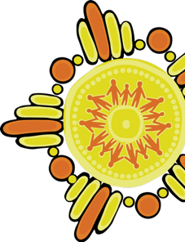
Our Ways – Strong Ways – Our Voices is a 10-year plan for lasting change. Instead of adding more to existing services, it calls for systems to change. The plan focuses on bringing together responses across family violence services, health, housing, justice, education and child protection services.
The plan is a shared commitment:
- solutions sit with Aboriginal and Torres Strait Islander peoples
- all governments and services will walk alongside Aboriginal and Torres Strait Islander peoples, working in true partnership.

How change will happen
Real change needs a long-term plan led by Aboriginal and Torres Strait Islander voices.
We will work together to create lasting change by:
- building on what works and developing an Action Plan that strengthens and aligns governments approach to supporting Aboriginal and Torres Strait Islander women, children and families, consistent with the Our Ways – Strong Ways – Our Voices commitments
- setting out clear steps for communities, governments and services
- updating the Action Plan regularly to meet community needs.

How we got here
Aboriginal and Torres Strait Islander peoples have called for action that respects their history, culture and lived experiences for a long time – but systems have not always supported them in a culturally safe way.

Community-led consultation
The Our Ways Steering Committee led the development of the plan in partnership with the Australian Government Department of Social Services, supported by SNAICC, the national voice for Aboriginal and Torres Strait Islander children.
A 24-member Steering Committee guided this work:
- 12 non-government Aboriginal and Torres Strait Islander representatives (the First Nations Caucus Group)
- 2 Commonwealth representatives
- 8 State and Territory representatives
- the Domestic, Family and Sexual Violence Commissioner
- the Aboriginal and Torres Strait Islander Social Justice Commissioner.
More than 80 organisations, advisory bodies and 47 ACCOs contributed their voices to the plan. Women and children with lived experience also shared their stories. Consultations included:
- 14 sessions with ACCOs (online and in person)
- 9 online sessions with non-Indigenous services
- 14 online sessions with individuals or specific organisations
- 9 online consultations with cross-government agencies
- 6 conference sessions with 997 participants
- 6 Knowledge Circles with 71 women with lived experience
- 52 written submissions (including 13 from ACCOs).
These conversations shaped the recommendations for Our Ways – Strong Ways – Our Voices, making sure the plan reflects what Aboriginal and Torres Strait Islander communities need.

Get support
- In an emergency, call 000. For crisis support or suicide intervention services, call 13 11 14 for Lifeline Australia.
- Feeling worried or no good? Connect with 13YARN Aboriginal & Torres Strait Islander Crisis Supporters on 13 92 76, available 24/7 from any mobile or pay phone, or visit 13yarn.org.au. No shame, no judgement, safe place to yarn.
- If you or someone you know is experiencing, or at risk of experiencing, domestic, family or sexual violence, call 1800RESPECT on 1800 737 732, text 0458 737 732 or visit 1800respect.org.au for online chat and video call services. 1800RESPECT is a free and confidential service, available 24 hours a day, 7 days a week.

More information
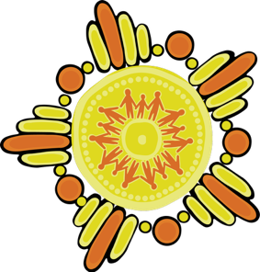
To find out how Our Ways – Strong Ways – Our Voices supports safer communities and will reduce violence against women and children, visit dss.gov.au/our-ways-strong-ways-our-voices.

Australian Institute of Health and Welfare (AIHW), Family, domestic and sexual violence, Aboriginal and Torres Strait Islander people, AIHW, 2025, accessed 28 August 2025.
S Bricknell and H Miles, Homicide of Aboriginal and Torres Strait Islander women, Statistical Bulletin 46, Australian Institute of Criminology, 2024; Our Watch, Changing the picture.

