
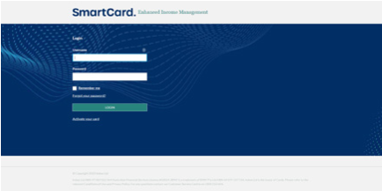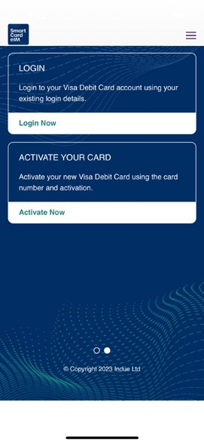
How to use the SmartCard eIM app and online account
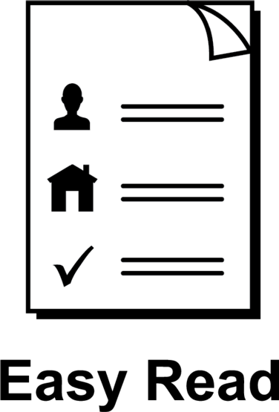

About this guide
 | This guide is from Services Australia.
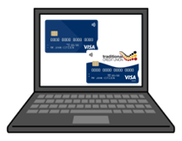 | You can read more information about this on our SmartCard web page www.servicesaustralia.gov.au/smartcard
 | This guide is written in a way that is easy  to understand.
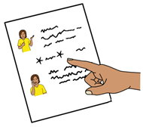 | We add a star before and after *hard words*.  Then we explain what the words mean.
 | You can ask someone to help you read and understand this guide.
 | Contact information is at the end of this guide.

Use the SmartCard *eIM* app or online account to manage payments
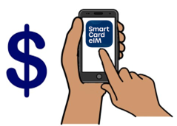 | The letters eIM mean  *enhanced Income Management*.  Enhanced Income Management means  - some money you get from Centrelink goes  to your enhanced Income Management account
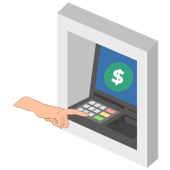 | - some money goes to your bank account.
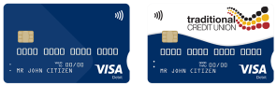 | People on enhanced Income Management  have an enhanced Income Management account and SmartCard.
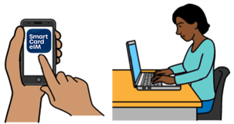 | You can manage your payments using the SmartCard eIM app or online account.
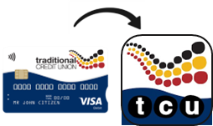 | People with a Traditional Credit Union SmartCard can use the TCU SmartCard eIM app.
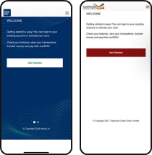 | The apps and online accounts look different but they work the same.
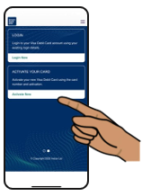 | This guide shows the SmartCard eIM app and online account.

How to get the SmartCard eIM app
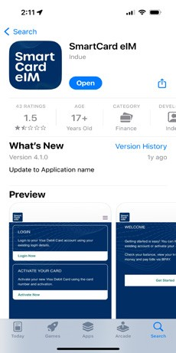   | Search for the SmartCard eIM app in the App Store or Google Play.
 | Download the app to your phone.

How to access your online account
 | Use the SmartCard online account on  your computer.
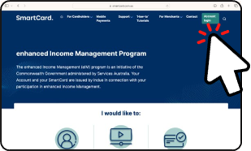 | Go to the SmartCard online web page www.smartcard.com.au
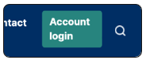 | Click on Account login in the top right corner.
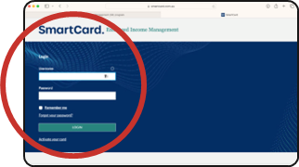 | Log in using your username and password.

What you can see in the SmartCard eIM app and online account
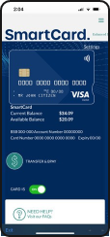 | When you log in to your account you can see  your SmartCard details.
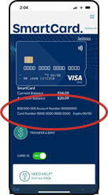 | You can see  - your SmartCard number, BSB and  account number
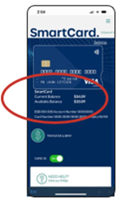 | - your *available balance*  - available balance means how much money you can spend
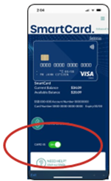 | - if the card is ON or OFF.
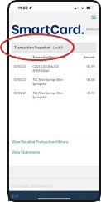 | You can choose to see  - the last 5 payments to and from your account  or
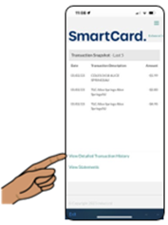 | - all past payments to and from your account  - click on View Detailed Transaction History
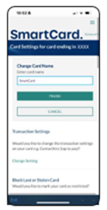 | In Card Settings you can  - change the name of your SmartCard
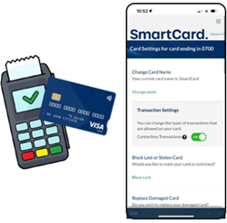 | - turn *tap to pay* ON or OFF  - tap to pay means you tap your card when you pay at a store instead of using a PIN
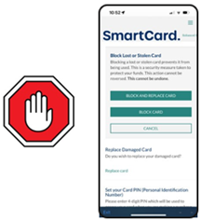 | - block a lost or stolen card
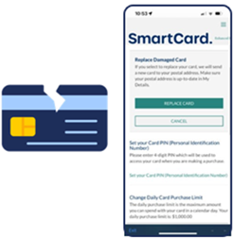 | - replace a damaged card.
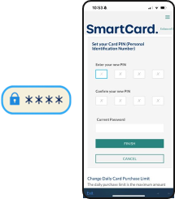 | In Card Settings you can also  - change your SmartCard PIN
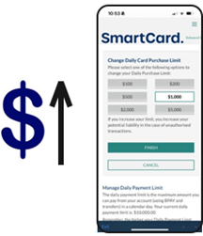 | - change the *daily card limit*  - this is the most amount of money you can spend each day
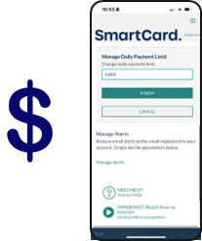 | - manage the *daily payment limit*  - this is the most amount of money you can pay to other accounts each day
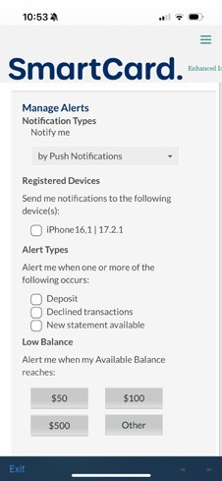     | - choose the messages you want to get  - for example, a message to let you know  if you do not have much money left in  your account.

 | More information and support
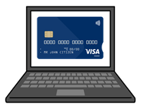 | You can find more information on the SmartCard web page  www.servicesaustralia.gov.au/smartcard
 | Call 1800 252 604  Tell us if you need an interpreter.
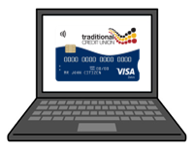 | If you have a TCU SmartCard go to the  TCU SmartCard web page  www.tcu.com.au/smartcard
 | Call 1800 828 232
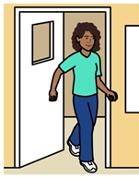 | Visit a Services Australia service centre or  TCU branch.

Easy Read Australia created this Easy Read document in March 2025 using Picture Communication Symbols (PCS). PCS and Boardmaker are trademarks of Tobii Dynavox LLC. All rights reserved. Used with permission.
You must ask for permission to use the images in this document. For more information, please visit Easy Read Australia www.easyreadaust.com.au

