
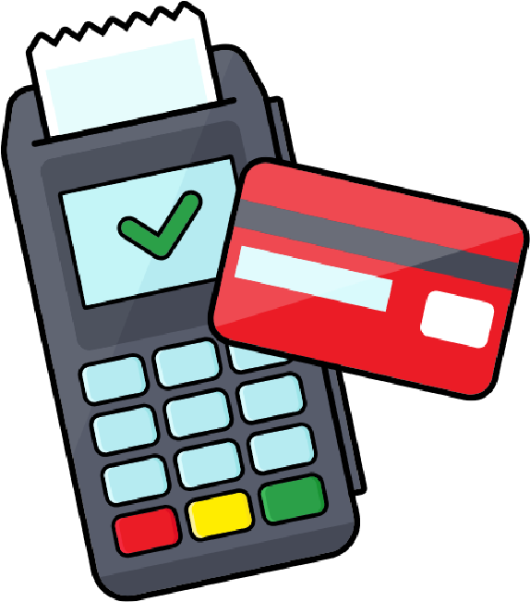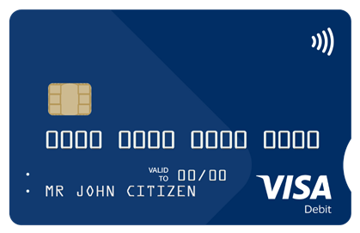
How to turn tap to pay on or off
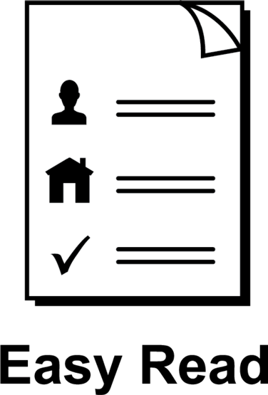

About this guide
 | This guide is from Services Australia.
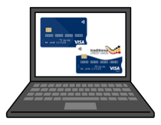 | You can read more information about this on our SmartCard web page www.servicesaustralia.gov.au/smartcard
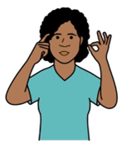 | This guide is written in a way that is easy  to understand.
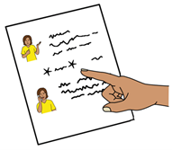 | We add a star before and after *hard words*.  Then we explain what the words mean.
 | You can ask someone to help you read and understand this guide.
 | Contact information is at the end of this guide.

Use the app or online account to manage payments
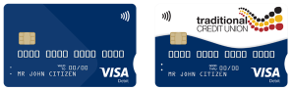 | People on *enhanced Income Management*  have an enhanced Income Management account and SmartCard.
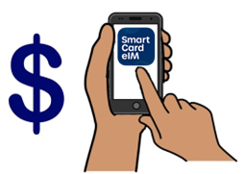 | Enhanced Income Management means  - some money you get from Centrelink goes  to your enhanced Income Management account
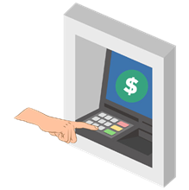 | - some money goes to your bank account.
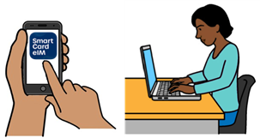 | You can manage your payments using the SmartCard *eIM* app or online account.  The letters eIM mean  enhanced Income Management.
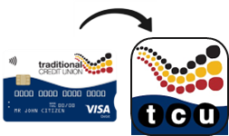 | People with a Traditional Credit Union SmartCard can use the TCU SmartCard eIM app.
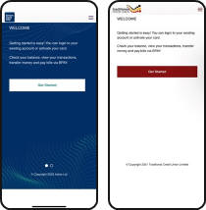 | The apps and online accounts look different but  they work the same.
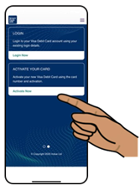 | This guide shows the SmartCard eIM app.
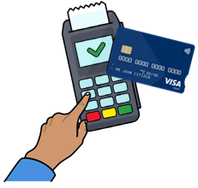 | You can use *tap to pay* with your SmartCard.  Tap to pay means you tap your card when you pay  at a store instead of using a PIN.
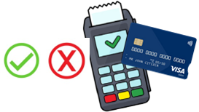 | You can turn tap to pay on or off in the  SmartCard eIM app.
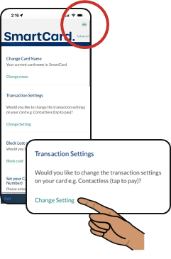 | Log in to your SmartCard eIM app and go to Settings in the top right corner.  In Transaction Settings, click on  Change Setting.
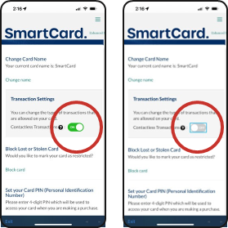 | Use the setting to turn tap to pay ON or OFF.
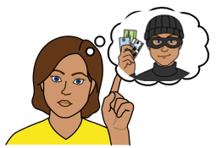 | If someone has your SmartCard and tap to pay  is turned on, they can spend the money in your account without needing your PIN.
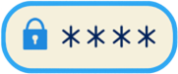 | You must keep your SmartCard safe at all times  to protect your money.

 | More information and support
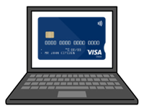 | You can find more information on the  SmartCard web page www.servicesaustralia.gov.au/smartcard
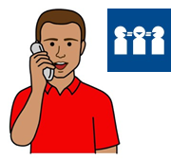 | Call 1800 252 604  Tell us if you need an interpreter.
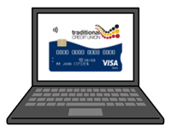 | If you have a TCU SmartCard go to the  TCU SmartCard web page  www.tcu.com.au/smartcard
 | Call 1800 828 232
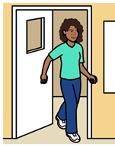 | Visit a Services Australia service centre or  TCU branch.

Easy Read Australia created this Easy Read document in March 2025 using Picture Communication Symbols (PCS). PCS and Boardmaker are trademarks of Tobii Dynavox LLC. All rights reserved. Used with permission.
You must ask for permission to use the images in this document.
For more information, please visit Easy Read Australia www.easyreadaust.com.au

