
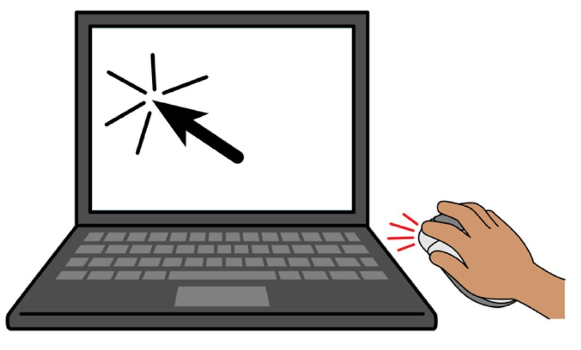
How to make internet banking payments
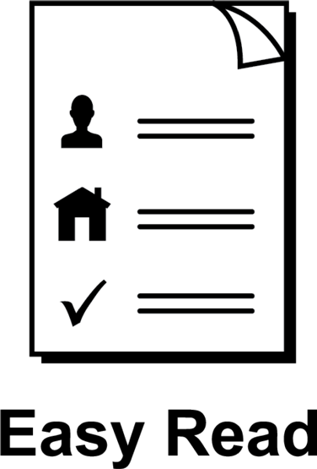

About this guide
 | This guide is from Services Australia.
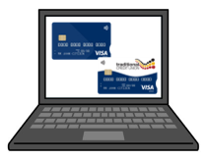 | You can read more information about this on our SmartCard web page www.servicesaustralia.gov.au/smartcard
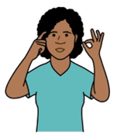 | This guide is written in a way that is easy to understand.
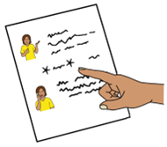 | We add a star before and after *hard words*.  Then we explain what the words mean.
 | You can ask someone to help you read and understand this guide.
 | Contact information is at the end of this guide.

About
*enhanced Income Management*
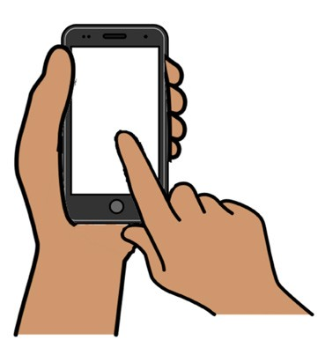  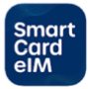   | Enhanced Income Management or eIM means  - some money you get from Centrelink goes  to your enhanced Income Management account
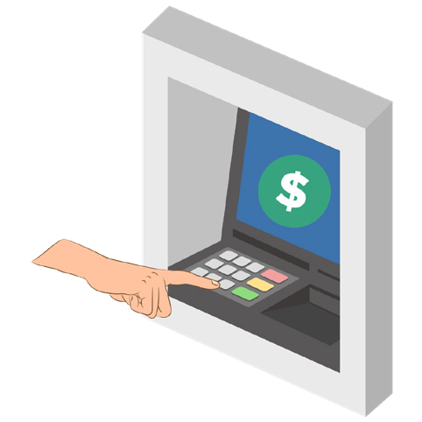 | ● some money goes to your bank account.
  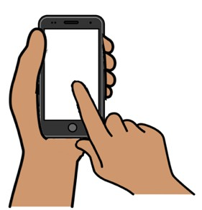   | If you are on enhanced Income Management you can use the SmartCard eIM app or online account.
  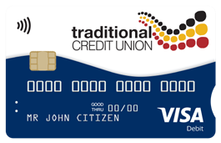   | People with a Traditional Credit Union SmartCard can use the TCU SmartCard eIM app.
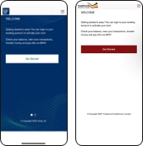 | The apps and online accounts look different but they work the same.
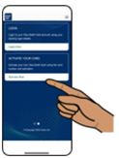 | This guide shows the SmartCard eIM app.

About *internet banking* payments
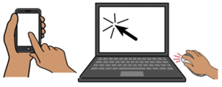 | Internet banking means you use the internet on your mobile phone or computer to transfer money and pay bills online.
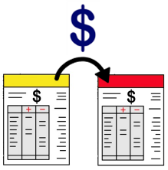 | Internet banking payments can be  - transferring money to another  enhanced Income Management account
 | - *BPAY*  - this means a way to pay bills online
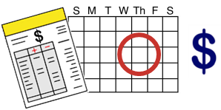 | - *direct debit*  - this means you tell someone to take money on the due date from your bank account.

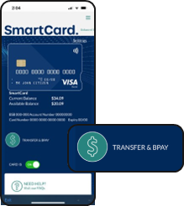 | How to transfer money  There is a Transfer option in the SmartCard  eIM app.
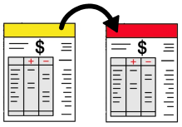 | You can transfer money to other  enhanced Income Management accounts.
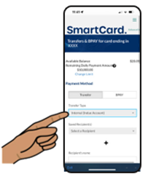 | Click on Internal to transfer money to someone with the same BSB number as you.
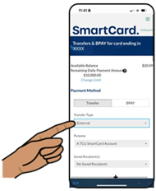 | Click on External to transfer money to someone with a different BSB number to you.
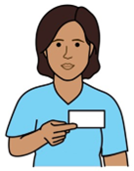 | You must put in  - the other person’s name, BSB and  account number
 | - how much money you want to transfer.
 | Check the details are right.  If the details are wrong you might not be able  to get your money back.
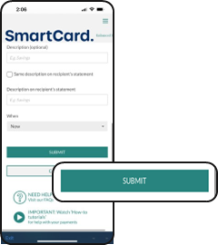 | When you are finished click on Submit and  the money will go to the person you want to transfer it to.
 | Call the SmartCard eIM hotline to send money to an account that is not an enhanced Income Management account.  Call 1800 252 604

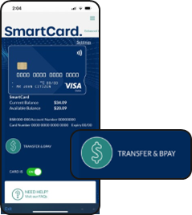 | How to make payments with BPAY  There is a BPAY option in the SmartCard eIM app.
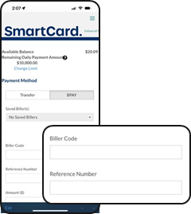 | Put in  - the *biller code*  - this means a number to identify the business  - a *reference number*  - this means a number for the business to identify you
 | - how much you want to pay.
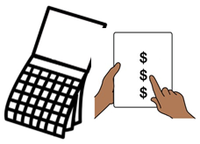 | Choose if you want the payment to be made now, later or *recurring*.  Recurring means you pay the biller more  than once.
 | If you choose to pay later or make recurring payments, you need to put in the payment dates.
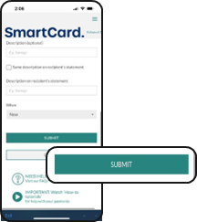 | When you are finished, click on Submit and  your payment will go to the BPAY business.
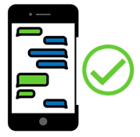 | You will get a message when the payment has been made.

How to set up a direct debit
    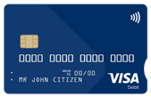 | Contact the bank or business you are paying and give them your enhanced Income Management BSB and account number.
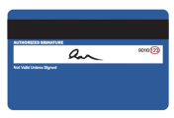 | You can find your enhanced Income Management BSB and account number  - on the back of your SmartCard
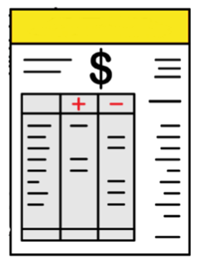 | - on your bank statement
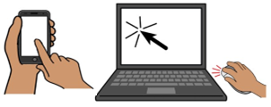 | - on the SmartCard eIM app or online account.
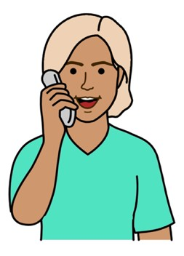 | You can contact the SmartCard eIM hotline.  Call 1800 252 604
 | You can contact TCU if you have a  TCU SmartCard.  Call 1800 828 232
 | If you already pay direct debits, you can  ask those businesses to take the payments from your enhanced Income Management account.
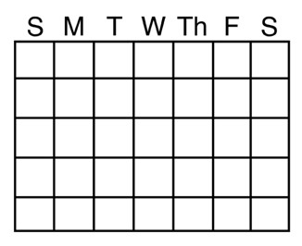    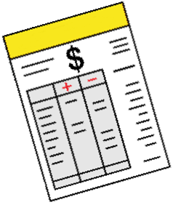 | When the businesses update their records  the direct debits will start to come out of your enhanced Income Management account.

 | More information and support
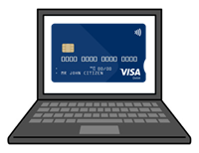 | You can find more information on the  SmartCard web page  www.servicesaustralia.gov.au/smartcard
 | Call 1800 252 604  Tell us if you need an interpreter.
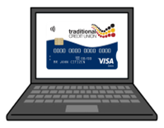 | If you have a TCU SmartCard go to the  TCU SmartCard web page  www.tcu.com.au/smartcard
 | Call 1800 828 232
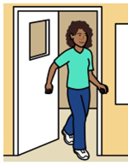 | Visit a Services Australia service centre or  TCU branch.

Easy Read Australia created this Easy Read document in March 2025 using Picture Communication Symbols (PCS). PCS and Boardmaker are trademarks of Tobii Dynavox LLC. All rights reserved. Used with permission.
You must ask for permission to use the images in this document. For more information, please visit Easy Read Australia www.easyreadaust.com.au

