
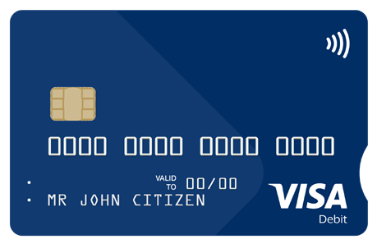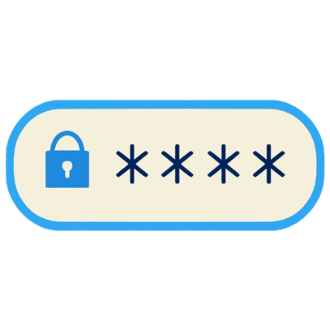

How to keep your money and SmartCard safe
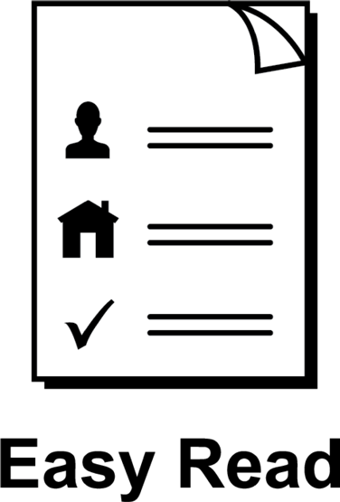

About this guide
 | This guide is from Services Australia.
  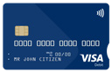  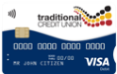 | You can read more information about this on our SmartCard web page www.servicesaustralia.gov.au/smartcard
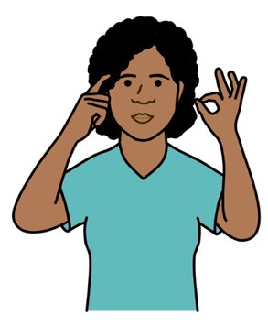 | This guide is written in a way that is easy to understand.
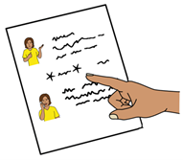 | We add a star before and after *hard words*.  Then we explain what the words mean.
 | You can ask someone to help you read and understand this guide.
 | Contact information is at the end of this guide.

About your SmartCard
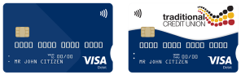 | People on *enhanced Income Management*  have a SmartCard.
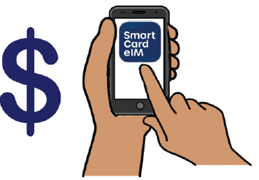 | Enhanced Income Management means  - some money you get from Centrelink goes  to your enhanced Income Management account
 | - some money goes to your bank account
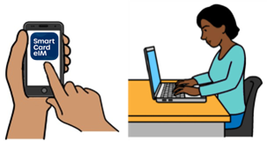 | You can manage your money using the  SmartCard *eIM* app or online account.  The letters eIM mean  enhanced Income Management.
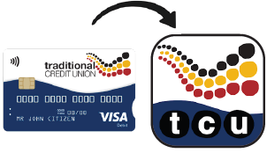 | People with a Traditional Credit Union SmartCard use the TCU SmartCard eIM app or online account.

How to keep your money and SmartCard safe

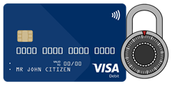 | There are lots of ways to keep your money and SmartCard safe.
 | For example  - do not give your SmartCard to anyone,  including family and friends
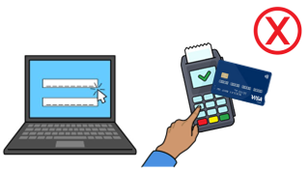 | - do not share your password or PIN with anyone
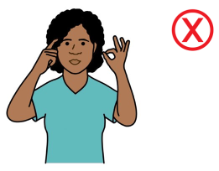 | - do not set a password or PIN that someone could easily guess
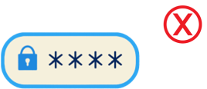 | - do not let anyone see your PIN
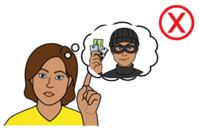 | - do not leave your SmartCard in a place  someone could take it
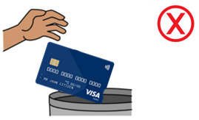 | - do not throw your SmartCard away.
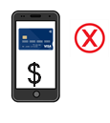 | If you add your SmartCard to your *digital wallet* keep your phone safe and do not share it  with anyone.
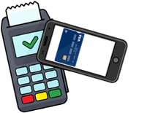 | A digital wallet is a way to pay for things using  your phone.
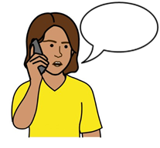 | Tell us straight away if  - your SmartCard is lost, stolen or damaged
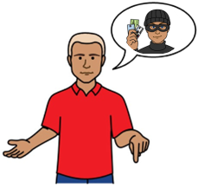 | - someone knows your online account password  or SmartCard PIN
 | - you use a digital wallet and have lost your phone
 | - you notice a payment you did not make.
 | You can contact TCU if you have a  TCU SmartCard.  Call 1800 828 232
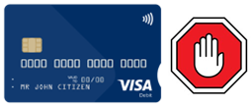 | You can also log in to your online account to  - turn off or block your SmartCard if it is lost or stolen
   | - set up messages so you know if you  do not have much money in your account
  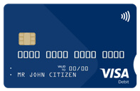   | - turn *tap to pay* off  - tap to pay means you tap your card when you pay at a store instead of using a PIN
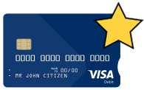 | - order a new SmartCard

 | More information and support
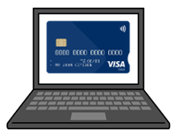 | You can find more information on the  SmartCard web page  www.servicesaustralia.gov.au/smartcard
   | Call 1800 252 604  Tell us if you need an interpreter.
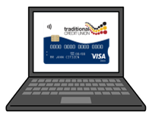 | If you have a TCU SmartCard go to the  TCU SmartCard web page  www.tcu.com.au/smartcard
 | Call 1800 828 232
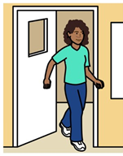 | Visit a Services Australia service centre or  TCU branch.

Easy Read Australia created this Easy Read document in March 2025 using Picture Communication Symbols (PCS). PCS and Boardmaker are trademarks of Tobii Dynavox LLC. All rights reserved. Used with permission.
You must ask for permission to use the images in this document. For more information, please visit Easy Read Australia www.easyreadaust.com.au

