


How to check your account balance
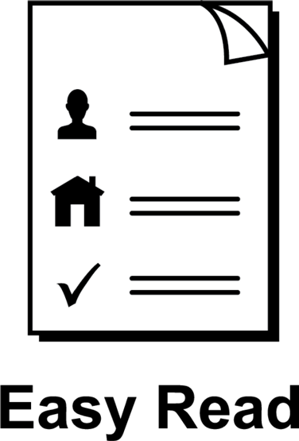

About this guide
 | This guide is from Services Australia.
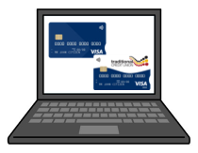 | You can read more information about this on our SmartCard web page www.servicesaustralia.gov.au/smartcard
 | This guide is written in a way that is easy to understand.
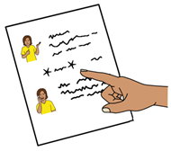 | We add a star before and after *hard words*. Then we explain what the words mean.
 | You can ask someone to help you read and understand this guide.
 | Contact information is at the end of this guide.

How to check your *account balance*
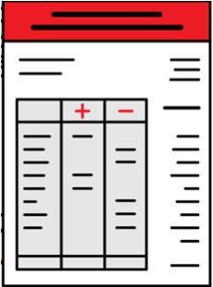   | Account balance means how much money you have in your bank account.
 | There are different ways to check your  account balance if you are on  *enhanced Income Management*.
  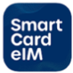   | Enhanced Income Management means  - some money you get from Centrelink goes  to your enhanced Income Management account
 | - some money goes to your bank account.
 | You can check your balance using the  SmartCard *eIM* app or online account.  The letters eIM mean  enhanced Income Management.
  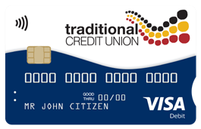   | People with a Traditional Credit Union SmartCard can use the TCU SmartCard eIM app.
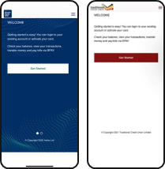 | The apps and online accounts look different but they work the same.
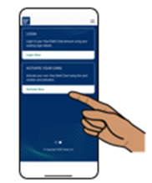 | This guide shows the SmartCard eIM app.
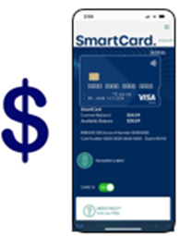 | Open your SmartCard eIM app to see your  - SmartCard and account *available balance*  - available balance means how much money you can spend  - SmartCard and account *current balance*  - current balance means how much money you have before payments are approved.
 | There are a lot of other ways you can check  your balance.
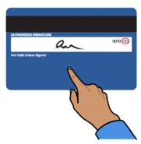 | You can  - use the SMS option on the back of your SmartCard
 | - use any Westpac, Commonwealth, ANZ, NAB ATM or other ATMs that do not charge fees
 | - call 1800 252 604 and choose the balance checking option  - you will need the Card ID and *CVV* number
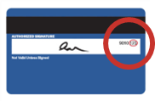 | CVV means the three numbers on the back of your card.
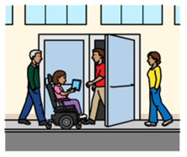 | - visit a service centre.
 | If you have a TCU SmartCard you can  - call 1800 828 232
 | ● visit one of their branches.

 | More information and support
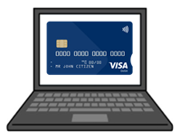 | You can find more information on the  SmartCard web page  www.servicesaustralia.gov.au/smartcard
 | Call 1800 252 604  Tell us if you need an interpreter.
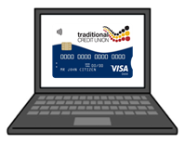 | If you have a TCU SmartCard go to the  TCU SmartCard web page  www.tcu.com.au/smartcard
 | Call 1800 828 232
 | Visit a Services Australia service centre or  TCU branch.

Easy Read Australia created this Easy Read document in March 2025 using Picture Communication Symbols (PCS). PCS and Boardmaker are trademarks of Tobii Dynavox LLC. All rights reserved. Used with permission.
You must ask for permission to use the images in this document. For more information, please visit Easy Read Australia www.easyreadaust.com.au

