
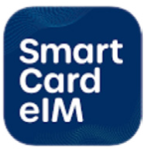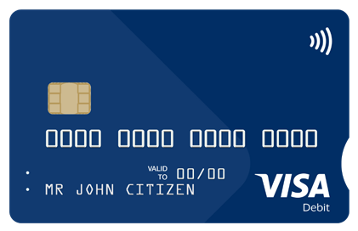
How to activate your SmartCard
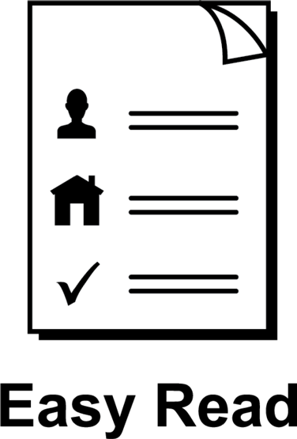

About this guide
 | This guide is from Services Australia.
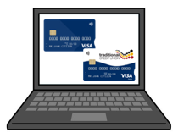 | You can read more information about this on our SmartCard web page www.servicesaustralia.gov.au/smartcard
 | This guide is written in a way that is easy to understand.
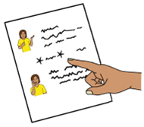 | We add a star before and after *hard words*.  Then we explain what the words mean.
 | You can ask someone to help you read and understand this guide.
 | Contact information is at the end of this guide.

You must *activate* your SmartCard that has your name on it
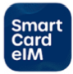 | Activate means you turn on your SmartCard so you can start to use it.
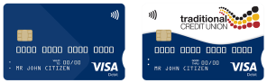 | People on *enhanced Income Management* have an enhanced Income Management account and SmartCard.
  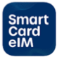   | Enhanced Income Management means  - some money you get from Centrelink goes to your enhanced Income Management account
 | - some money goes to your bank account.
     | You can manage your payments using the SmartCard *eIM* app or online account.  The letters eIM mean enhanced Income Management.
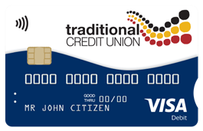 | People with a Traditional Credit Union SmartCard can use the TCU SmartCard eIM app.
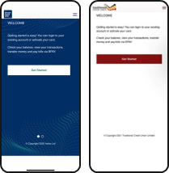 | The apps and online accounts look different but they work the same.
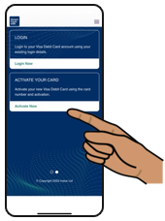 | This guide shows the SmartCard eIM app.

How to activate your SmartCard when you get it in the mail
 | This guide shows you how to use the SmartCard eIM app if you already have an online account.
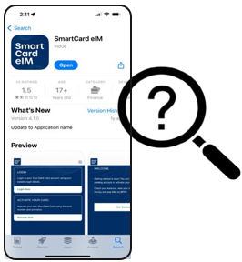 | Search for and download the SmartCard eIM app from the App Store or Google Play.
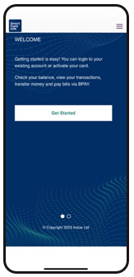 | Open the app and log in using your online account details.
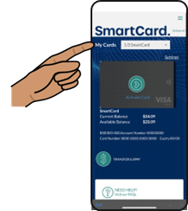 | On the home screen, find the SmartCard you want to activate from the My Cards list.
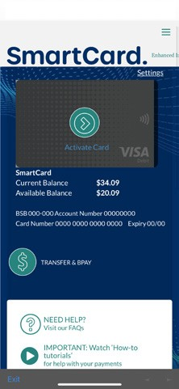 | Look for the SmartCard that has a green arrow over the card image.  Click on Activate Card.
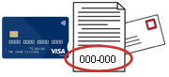 | Now you will need your SmartCard and activation code you got in the mail.
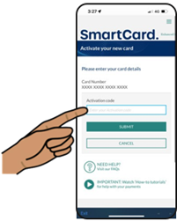 | On the Activate your card page, enter the activation code from your letter.
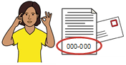 | Enter the activation code exactly as it is written on the letter.
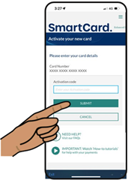 | Click on Submit.
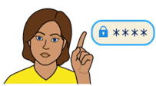 | Set your PIN for your SmartCard.
 | Choose a PIN that is hard for others to guess.
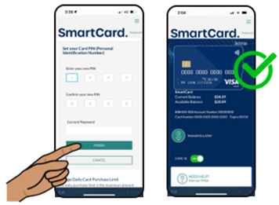 | Confirm your new PIN by entering it again.  Click on the green button to activate the card.

 | More information and support
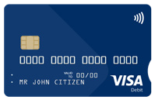 | You can find more information on the SmartCard web page  www.servicesaustralia.gov.au/smartcard
 | Call 1800 252 604  Tell us if you need an interpreter.
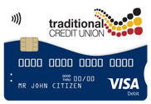 | If you have a TCU SmartCard go to the  TCU SmartCard web page  www.tcu.com.au/smartcard
 | Call 1800 828 232
 | Visit a Services Australia service centre or TCU branch.

Easy Read Australia created this Easy Read document in March 2025 using Picture Communication Symbols (PCS). PCS and Boardmaker are trademarks of Tobii Dynavox LLC. All rights reserved. Used with permission.
You must ask for permission to use the images in this document. For more information, please visit Easy Read Australia www.easyreadaust.com.au

