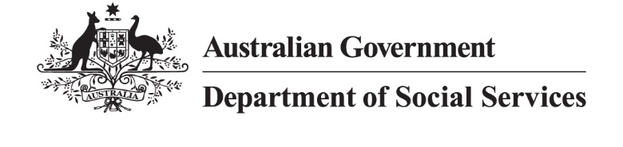

DSS XXXX.X.XX

Connecting Communities: Share your story guide
We want to hear real stories that show the impact services and programs have on real people. These stories will help to raise awareness of the good work the sector is doing in the community and help providers learn from each other’s successes.

Key considerations
Before you submit a story, please think about the following:

Please take a first-person approach
We want to hear about how the program or service is making a difference to people. Please focus on how your organisation has made a positive impact on the life of an individual or family. This could include how someone’s life has improved with your support, a small moment in their day, or how your organisation works behind the scenes.
Here is an example of a first-person writing style:
‘When I first joined the program, I wasn’t sure I would be able to do it. Now I’m a team leader and people look to me for ideas.’

Show why your service is valuable to the community
Stories should help to build awareness of services and programs in your local community. Please make sure the stories are true and accurate and reflect how your services benefit people. If you can, include photos or videos, quotes and a snapshot version (100 words max) for social media channels.

Choosing story participants
When writing the story, always put the participant at the centre and be accurate about their story and experience. Understand that representation of diversity is important. Select your story based on the people who receive your support, and the ways you have helped them.

Make sure your story is accessible and inclusive
When writing a story, use a tone of voice which is accessible, clear and supportive. Use plain language and keep to a reading level of grade 7-9.
Consider how your story will be read by diverse audiences including people with disability, people from culturally and linguistically diverse backgrounds, and First Nations communities.
Use a mix of pictures, videos and include alt text to explain the images for screen reader users
Use inclusive language
Use diverse and authentic representation in visuals and content.
The Australian Government Style Manual (Style Manual) has developed a Quick guide: plain language to help your audience understand your message. The Style Manual also includes information on writing accessible and inclusive content.
Format and language
- Try and keep your case study between 400-650 words.
- Use plain language with short sentences.
- Keep it supportive and people-focused.
- Include photos, videos or other visuals if you have them.
- Make sure your story and any images reflect the diversity of the people you support.
- If someone can be identified in your story or images, please get written consent.

Gain consent in writing
Make sure that anyone who can be identified in your story and photos has agreed to share their details or image. Please fill out the permission to publish section at the end of the Connecting Communities: Share your story template and attach the signed consent form.

Story sample
Here is an example of a finished story written with a first-person perspective.

Mission Australia story
I arrived in Australia after fleeing the war in Lebanon and losing my husband. I needed a new place to call home and the opportunity to rebuild my life after loss.
I settled into temporary accommodation, found a community to connect with and as time passed, I slowly regained a sense of stability. It wasn’t until my last lease was close to ending that I came face to face with the possibility of homelessness. I had tried to secure accommodation on my own but had been unsuccessful. I felt hopeless and scared.
Then I reached out to Mission Australia. Their Emergency Relief service, funded by the Department of Social Services (DSS), listened to what I was experiencing. They supported me emotionally and helped me understand the practical steps I could take. They encouraged me to seek advocacy from my local MP and guided me through each stage of the process.
The guidance came at a time when I truly needed it. With their help (Mission Australia), I’ve been able to move forward and rebuild my life with a stronger sense of confidence and stability. The guidance I received changed everything. I now have a safe place to live, and I feel supported.’
Securing housing for low income earners can be challenging. With help from the Emergency Relief service, Sara found a new home in only 10 days.
Many people across Australia face housing stress and the risk of homelessness [STATISTICS: 71% of low income households experience housing stress; 127,000 people are projected to face homelessness in 2025; 33% worry about losing their home].
Find out more about the DSS-funded [insert program name] at [insert link here].

We are here to help
Email CommunityCaseStudies@dss.gov.au if you’d like some advice or to share feedback about our Connecting Communities pilot. We’d love to hear what guides and tools would help.

