Your service guarantee



 | The Australian Government Department of Social Services wrote this.  We say DSS for short.
 | The Service Guarantee is about Inclusive Employment Australia providers.  When you see the word we it means Inclusive Employment Australia providers.
 | We wrote this in an easy to read way.  We use pictures to explain some ideas.
 | We have some words in bold.  This means the letters are thicker and darker.  These are important words.
 | This is an Easy Read summary of another document.
 | You can ask for help to read this document.  You can ask  - A friend  - Family members  - A support person.
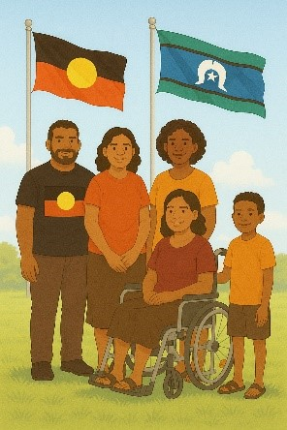 | We recognise Aboriginal and Torres Strait Islander people as the Traditional Owners of the land we live on.
 | They were the first people to live on and use the  - Land  - Waters.

Contents

About Inclusive Employment Australia | 5
Your provider will | 6
Before you find a job | 10
Job support | 14
Your responsibilities | 16
Help for making phone calls | 18
What happens to your information | 19
If you are not happy with the  support | 21

About Inclusive Employment Australia

 | This tells you what to expect when working with a provider for Inclusive Employment Australia.
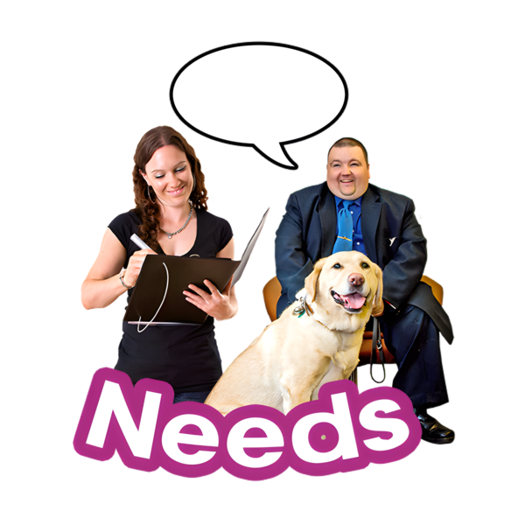 | We need to make sure the employment support we give you is  - What you need
 | - Supporting you to take part in a good way
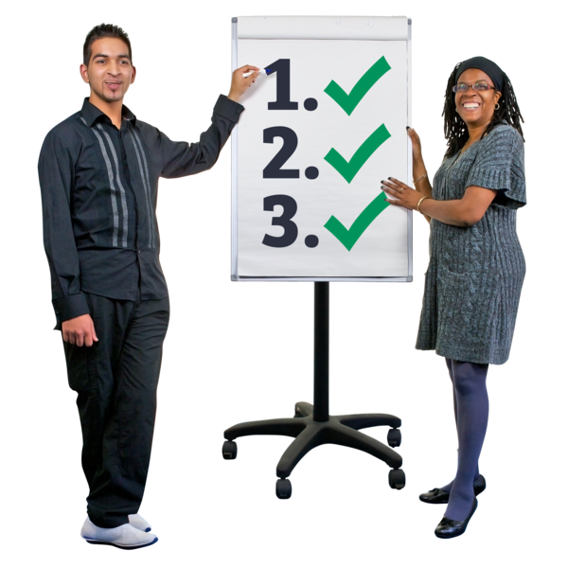 | - What you can do.

Your provider will

 | Your provider will  - Treat you fairly
 | - Treat you with respect
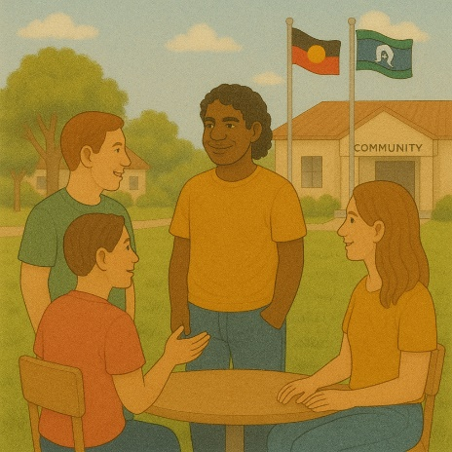 | - Be culturally safe  Culturally safe means respecting peoples  - Rights  - Cultures  - Traditions.  This helps people feel safe to be themselves.

 | - Support you to look for work
 | - Help you build skills to work
 | - Explain how they can support you
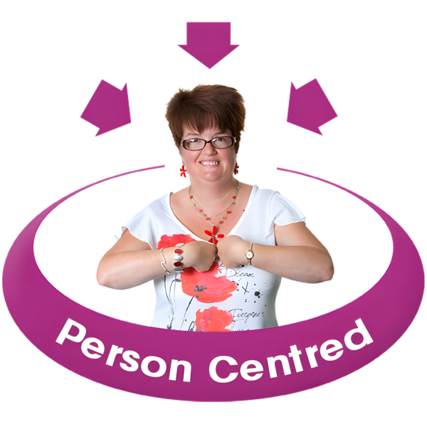 | - Be person centred  Person centred means treating people  - With respect  - Like they need.  It looks different for each person.
 | - Explain your rights  Rights are rules about treating everyone  - Fair  - Equal.
 | - Explain your responsibilities  Responsibilities are the things that you need to do.
 | - Build a good relationship with you
 | - Communicate with you in the way you need.
 | You can have an interpreter if it is needed.  Interpreters are people who  - Speak your language  - Help you understand what someone is saying.

Before you find a job

 | Everyone will need different supports from their provider.  We will work with you to know what supports you need.
 | There are lots of things we can support you with.  Before you get a job we can help with things like
 | - Writing a resume  A resume is about your  - Work experience  - Skills.
 | - Looking for jobs
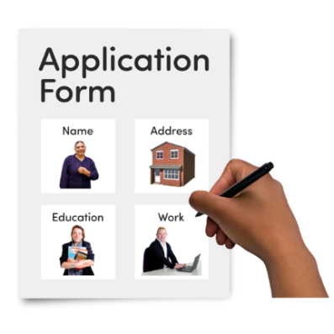 | - Filling out job applications  Applications are forms you fill out to say you want to work at a job.
 | - Practising interviews  Interviews are when you talk about your skills and experience about a job.
 | - Taking part in programs and services to help build your work skills
 | - Learning more by doing  - Training  - Education
 | - Taking part in activities run by  - The government  - Other organisations
 | - Helping you get support from allied health professionals  This might be to support you with  - Your disability  - An injury  - Health issues
 | Talk to your provider about what you need.
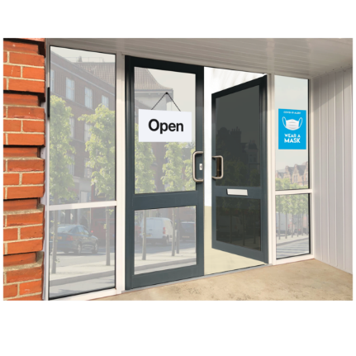 | Help you set up a business and be the boss.
 | You can have a support person to help you do any of these things.

Job support
 | There are lots of things we can support you with.  We can help with
 | - Knowing your rights at work
 | - Working with employers that need workers with your skills  An employer is someone who pays someone to do work for them.
 | - Supporting you to talk to employers
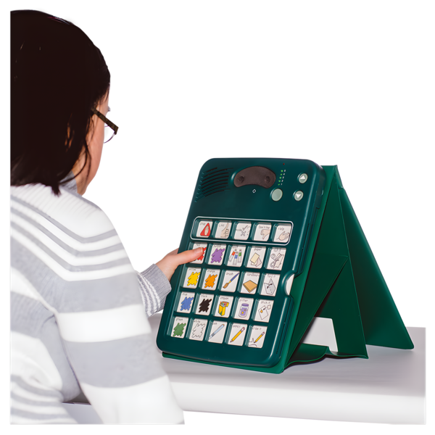 | - Support different ways of communicating
 | - Supporting you to keep your job
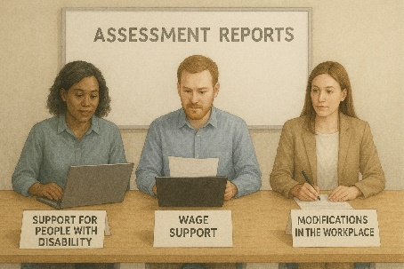 | - Being able to get funding for  - Assessments at work  - Changes to the workplace.  Funding is money from the government to take part.  The funding is called Employment Assistance Fund.

Your responsibilities
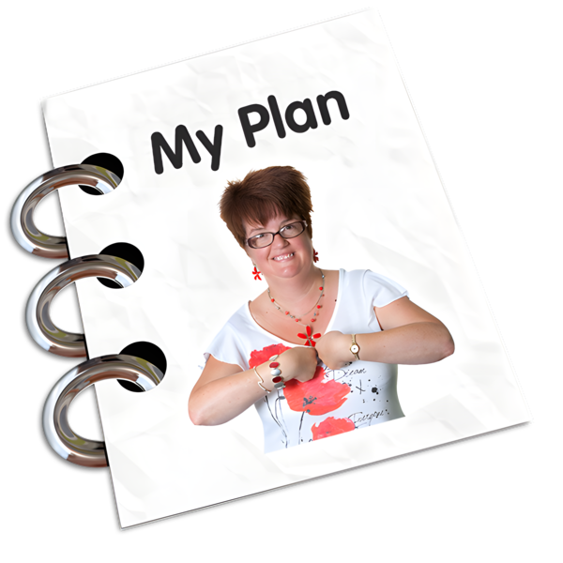 | You will need to  - Work with your provider to make a Job Plan.  A Job Plan says all the activities you have to do to find and keep a job.
 | - Taking part in activities in your Job Plan
 | - Going to appointments with your provider
 | - Telling your provider if you will miss your appointment
 | - Telling your provider if something in your life has changed.
 | If you do not  - Go to appointments  - Do the activities in your Job Plan  Your Centrelink money might be less or stopped.
You need to tell your provider if you have a good reason to not go.

You need to tell them before you miss any appointments.

Help for making phone calls
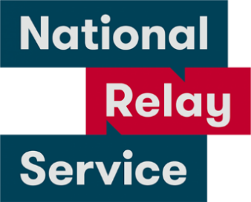 | If you are  - Deaf or hard of hearing  - Find it hard to speak on phones  You can call the National Relay Service.
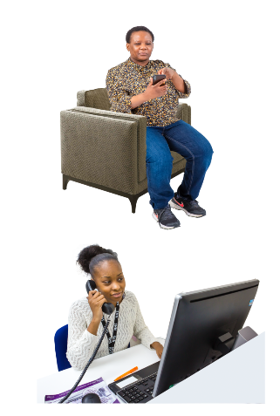 | - TTY Talk and Listen  Call 1800 555 677  Then ask for 1800 880 052
 | - Speak and Listen  Call 1800 555 727  Then ask for 1800 880 052
If you speak a language other than English you can call the Translating and Interpreting Service.

13 14 50

What happens to your information
 | There are rules we need to follow to keep your personal information safe.
 | Personal information is information like  - Your name
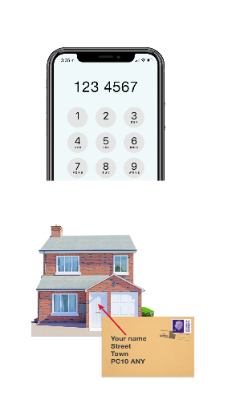 | - Your phone number  - Your address
 | It is information to tell people apart.
 | We will not share your personal information unless  - You say it is okay  - The law says we have to.
 | Laws are rules for how we live.
 | You can change your mind about what personal information we are allowed to share.  You need to tell us if you have changed your mind.
 | You can read more about keeping your information safe.  This website is not in Easy Read.  www.oaic.gov.au/

If you are not happy with the support
You need to tell us if you are not getting the right support.

We will

- Listen to you
- Try and work with you to make it right.
 | You can call the Complaints Resolution Referral Service if you  - Can not talk to us  - Want to make a complaint.  Complaints are when you tell someone they have not done a good job.  Everyone has the right to make a complaint.
 | You can talk to the Complaints Resolution Referral Service.  You can call them.  1800 880 052.
 | You can send them an email.  crrs@glresolution.au
 | You can go to the website to read more about these rules.  It is in Easy Read.  www.dss.gov.au/disability-advocacy/resource/national-standards-disability-services

Images in this Easy Read must not be used or copied without permission.

