Your service guarantee

National Panel of Assessors
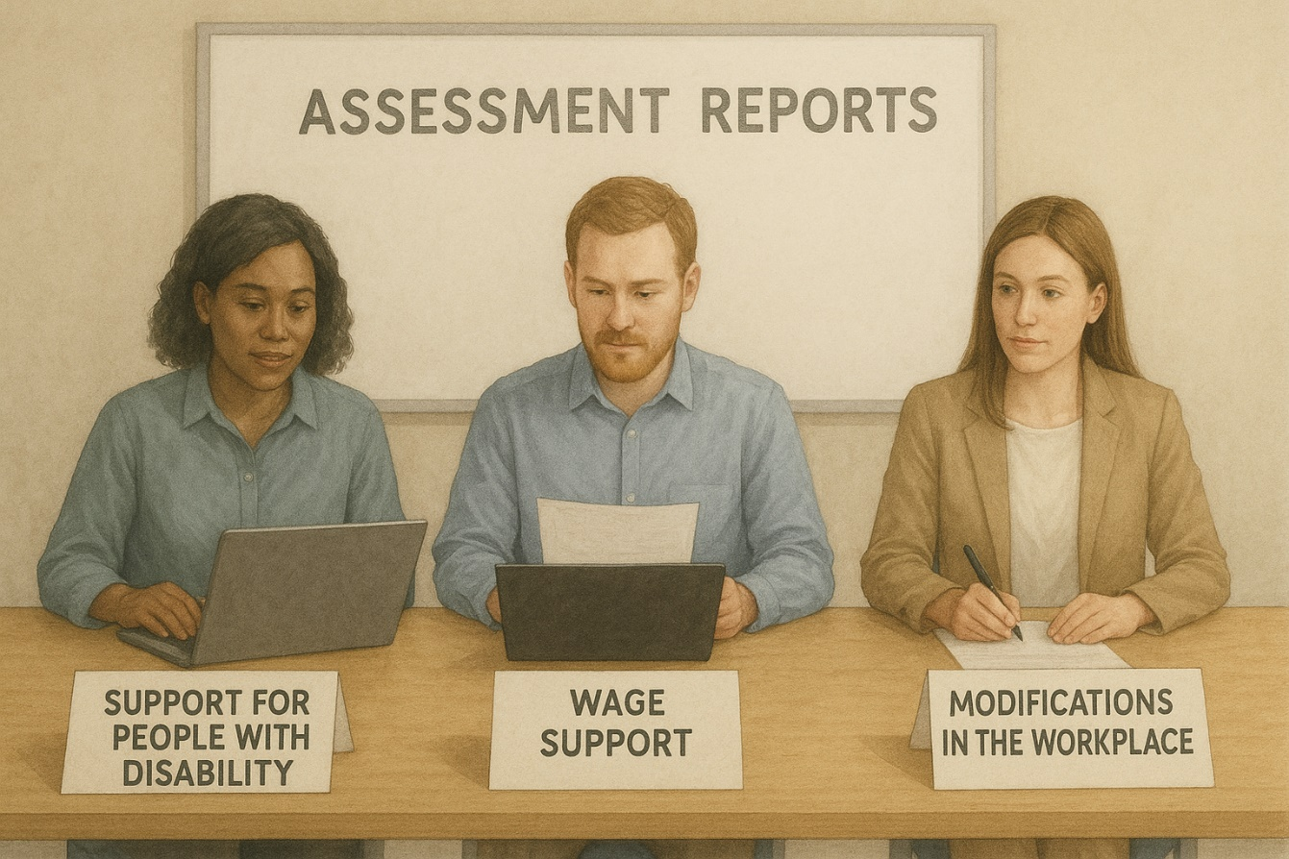

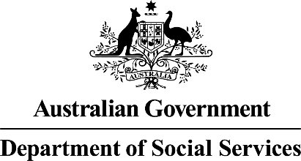 | The Australian Government Department of Social Services wrote this.  We say DSS for short.
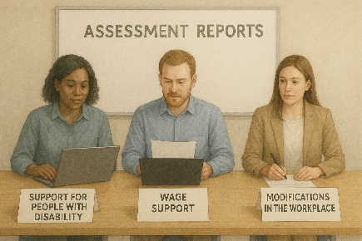 | The Service Guarantee is about National Panel of Assessors.  We call it NPA for short.  When you see the word we it means NPA.
 | We wrote this in an easy to read way.  We use pictures to explain some ideas.
 | We have some words in bold.  This means the letters are thicker and darker.  These are important words.
 | This is an Easy Read summary of another document.
 | You can ask for help to read this document.  You can ask  - A friend  - Family members  - A support person.
 | We recognise Aboriginal and Torres Strait Islander people as the Traditional Owners of the land we live on.
 | They were the first people to live on and use the  - Land  - Waters.

Contents

About the National Panel of Assessors | 5
What can you expect | 9
What are your responsibilities | 14
Help for making phone calls | 15
What happens to your information | 16
If you are not happy about your assessment | 18

About the National Panel of Assessors

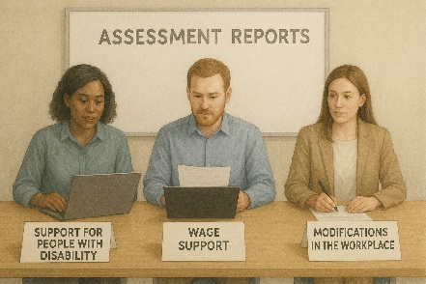 | The Australian Government set up the Disability Employment NPA.
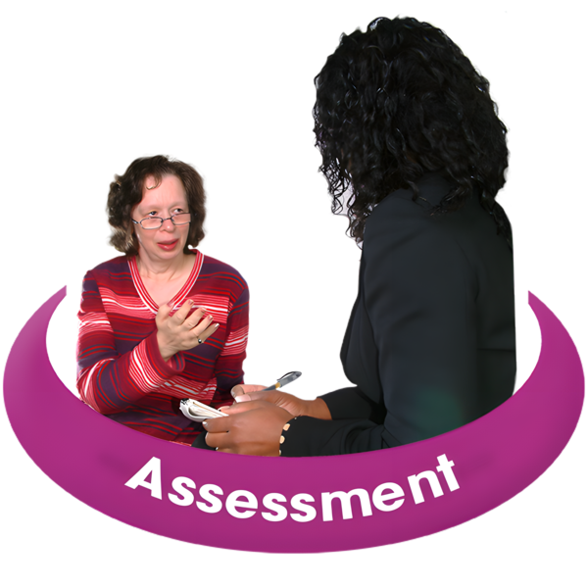 | We support people with disability to get assessments to support their needs in the workplace.  Assessments help us work out what support you need.
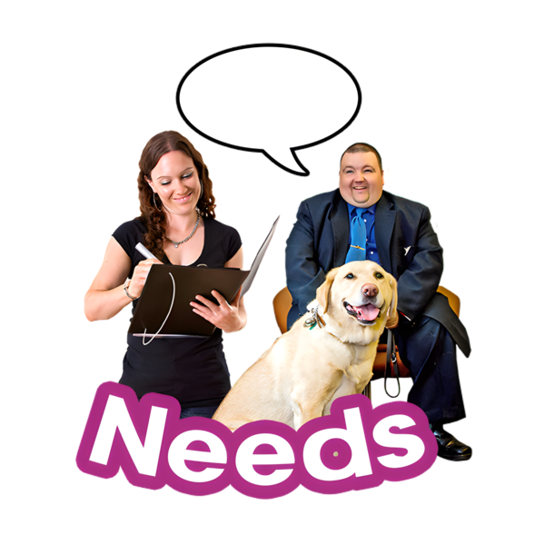 | NPA providers  - Work with lots of different people to make sure people with disability have the right supports
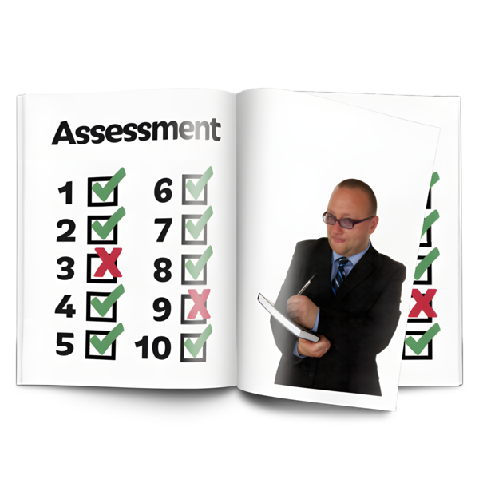 | - Do assessments.
 | We work with  - People with disability
 | - Employers  An employer is someone who pays someone to do work for them.
 | - Employment services providers.  They support people to find a job.
 | We will explain  - Why the assessments are important
 | - What needs to happen to do the assessments.
 | We will make sure the support they give you  - Keeps your information safe
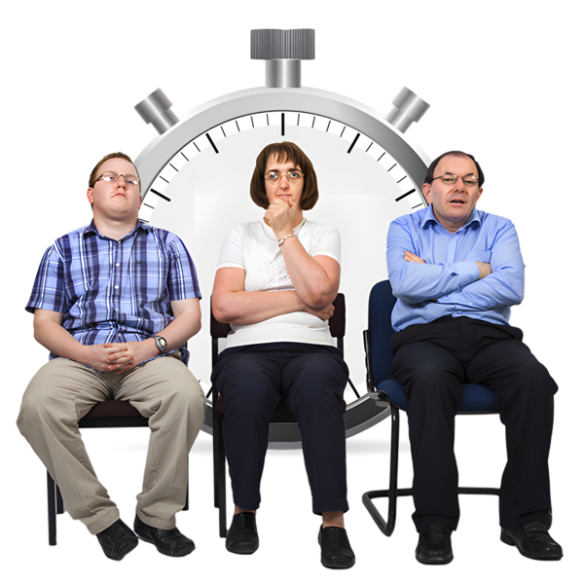 | - Gives you enough time to make decisions
 | - Treats you with respect
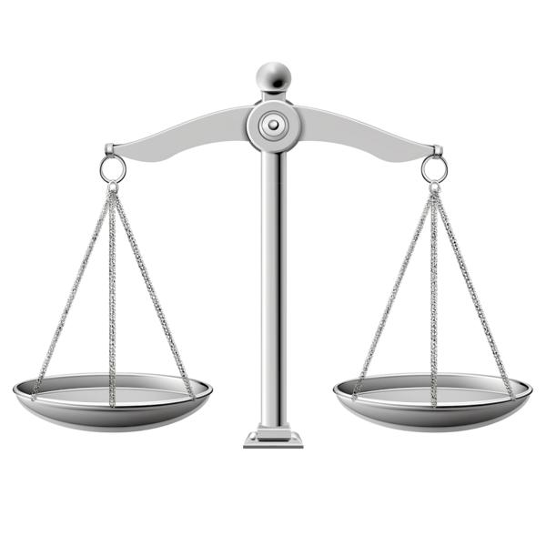 | - Is fair.
 | We will work hard to make sure all the information shared is up to date.
 | We will write an independent assessment report.  Independent means separate to other people.

What can you expect

There are different assessments that NPA can do.
The assessments support people with disability.
 | There are different assessments.
 | 1. Ongoing Support Assessments  These assessments support a person with disability to keep a job.
 | 2. Supported Wage System assessments  These assessments decide how much to pay a person with disability for doing a job.
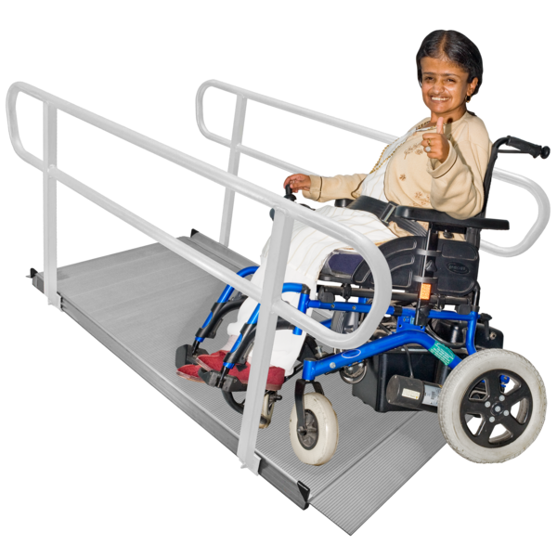 | 3. Workplace Modifications Services assessments.  These assessments can help make reasonable adjustments in the workplace for people with disability.
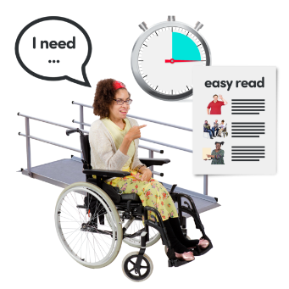 | Reasonable adjustments mean things that make it easier for people with disability to do their job.
 | Before any assessments we will talk with  - You
 | - Your employer
 | - Employment support providers.
 | We will explain  - Why assessments need to happen  - How they will happen.
 | A NPA provider will organise a time to  - Meet you  - Do the assessment.
A NPA provider will agree to what is needed to do the assessment.
Like
- Going to your workplace
 | - Making sure your workplace is safe
 | - Having an interpreter if it is needed.  Interpreters are people who  - Speak your language  - Help you understand what someone is saying.
 | NPA providers can answer your questions about the assessments.
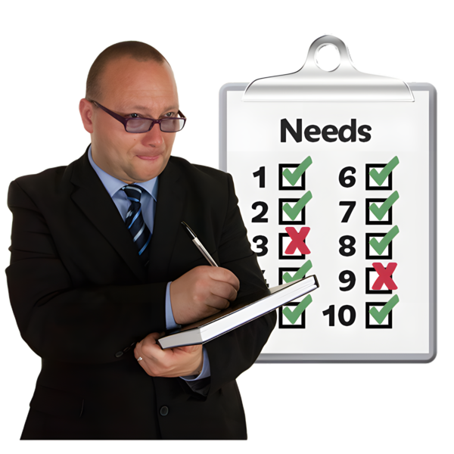 | All the information you give NPA providers will help them understand  - What support you need  - How to get ready to do the assessment.
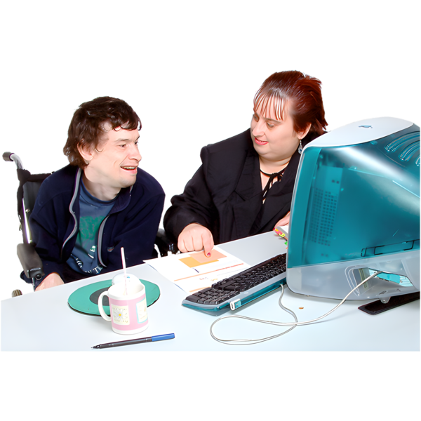 | When NPA providers do the assessments they will talk to you about things  - You do at work  - That might be hard for you to do.
 | NPA providers will write everything down.  This will help them write a report.
 | When NPA providers are doing the assessments you will be respected.
 | NPA providers will follow the rules to keep information safe.

What are your responsibilities

 | Responsibilities are the things that you need to do.  NPA providers need you to tell them true information.  This is so they can write a good report to support you.
 | NPA providers need to organise a new time if you miss your assessment.
 | NPA providers need  - You  - Your employer  - Your provider  To let them know if you need to change your assessment time.
 | This will help them plan a new time to do the assessment.

Help for making phone calls

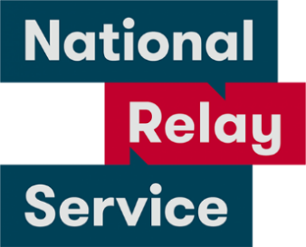 | If you are  - Deaf or hard of hearing  - Find it hard to speak on phones  You can call the National Relay Service.
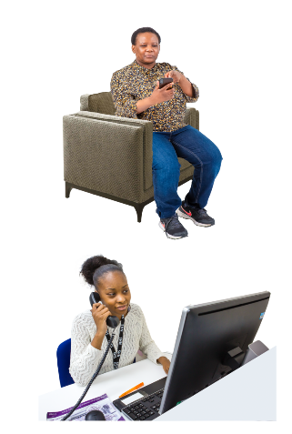 | - TTY Talk and Listen  Call 1800 555 677  Then ask for 1800 880 052
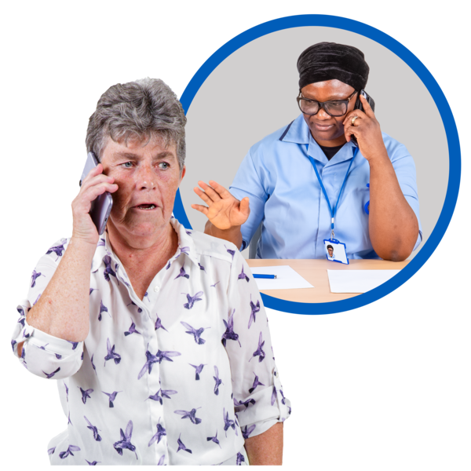 | - Speak and Listen  Call 1800 555 727  Then ask for 1800 880 052
If you speak a language other than English you can call the Translating and Interpreting Service.
13 14 50

What happens to your information

 | NPA providers will collect personal information to do the assessments.
 | Personal information is information like  - Your name
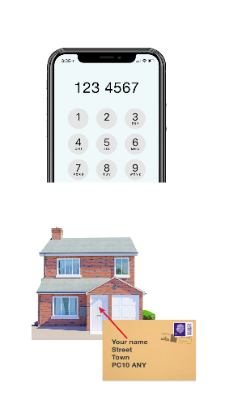 | - Your phone number  - Your address
 | It is information so they can tell people apart.
 | NPA providers need to follow rules to keep your information safe.  They will not share your personal information unless  - You say it is okay  - The law says they have to.  Laws are rules for how we live.
 | You can change your mind about NPA providers being allowed to share your information.  You need to tell them if you have changed your mind.
 | You can read more about keeping your information safe.  This website is not in Easy Read.  www.oaic.gov.au/

If you are not happy about your assessment

 | You need to tell the NPA provider if you are not getting the right support  They will  - Listen to you  - Work with you to make it right.
 | You can call the Complaints Resolution Referral Service if you  - Can not talk to NPA provider  - Want to make a complaint.  Complaints are when you tell someone they have not done a good job.  Everyone has the right to make a complaint.
 | You can talk the Complaints Resolution Referral Service.  You can call them.  1800 880 052.
 | You can send them an email.  crrs@glresolution.au
 | You can go to the website to read more about these rules.  It is in Easy Read.  www.dss.gov.au/disability-advocacy/resource/national-standards-disability-services
Images in this Easy Read must not be used or copied without permission.

