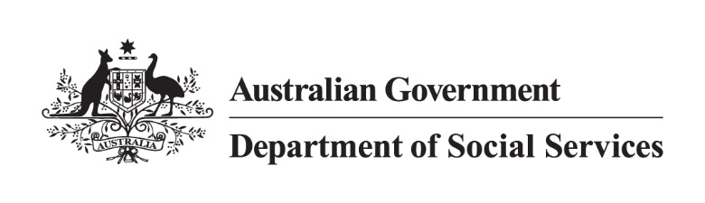

National Rental Affordability Scheme
Quarterly Performance Report
As at 31 December 2025

Copyright notice


This document [National Rental Affordability Scheme Quarterly Performance Report] is licensed under the Creative Commons Attribution 4.0 International Licence
Licence URL: https://creativecommons.org/licenses/by/4.0/legalcode
Please attribute: © Commonwealth of Australia (Department of Social Services)
Notice:
- If you create a derivative of this document, the Department of Social Services requests the following notice be placed on your derivative: Based on Commonwealth of Australia (Department of Social Services) data.
- Inquiries regarding this licence or any other use of this document are welcome. Please contact: Branch Manager, Communication Services Branch, Department of Social Services. Phone: 1300 653 227. Email: communication@dss.gov.au
Notice identifying other material or rights in this publication:
- Australian Commonwealth Coat of Arms – not Licensed under Creative Commons, see https://www.pmc.gov.au/honours-and-symbols/commonwealth-coat-arms
- Certain images and photographs (as marked) – not licensed under Creative Commons.

Performance summary
The National Rental Affordability Scheme (NRAS) is an Australian Government initiative, working in partnership with the states and territories. NRAS approved participants are eligible to receive a National Rental Incentive, comprising Commonwealth and state or territory contributions for each approved home rented to eligible low and moderate income households at a rate that is at least 20 per cent below the prevailing market rates, for up to 10 years.
Report Definitions
In this report:
Active allocations means dwellings tenanted or available for rent.
Provisional allocations means dwellings not yet delivered.
Total allocations means the total number of active allocations and provisional allocations.
Type means the type of NRAS home.
Size means the number of bedrooms in the NRAS home.
NRAS Year means the period 1 May to 30 April each year.
Key Allocation Data
- All data in this report is current at 31 December 2025
- Number of active allocations: 4,528
- Number of provisional allocations: 63
- Total allocations: 4,591
- Number of ceased allocations: 31,973
- Number of approved participants: 28
- Number of approved participants who have allocations in multiple jurisdictions: 3
- Number of for profit/other approved participants: 8
- Number of approved participants who are endorsed charities: 20
*Data is subject to daily variation because dwelling details can change
Disclaimer
The Department of Social Services (DSS) has made this Report available for the purpose of disseminating information about the National Rental Affordability Scheme (NRAS). It draws on information and data provided by a variety of individuals and organisations, including from approved participants of NRAS. As such, DSS accepts no responsibility for the accuracy or completeness of the Report or any of its contents. Additionally, the Commonwealth disclaims all liability to any person in respect of anything, and of the consequences of anything, done or omitted to be done by any such person in reliance, whether wholly or partially, upon the Report or any information presented within it. Reference in the Report to any organisation, including an approved participant, does not constitute any endorsement of that organisation or any associated organisation, product or service.

1: Incentive status by state/territory
State | Active allocations | National % | Provisional allocations | National % | Total allocations | National %
NSW | 2,007 | 43.72% | 1 | 0.02% | 2,008 | 43.74%
Vic. | 35 | 0.76% | 1 | 0.02% | 36 | 0.78%
WA | 1,477 | 32.17% | 61 | 1.33% | 1,538 | 33.50%
SA | 2 | 0.04% | 0 | 0.00% | 2 | 0.04%
Tas. | 596 | 12.98% | 0 | 0.00% | 596 | 12.98%
ACT | 361 | 7.86% | 0 | 0.00% | 361 | 7.86%
NT | 50 | 1.09% | 0 | 0.00% | 50 | 1.09%
Total | 4,528 | 98.63% | 63 | 1.37% | 4,591 | 100.00%

2: NRAS quarterly summary
NRAS Summary | Dec Qtr. 2024 | Mar Qtr. 2025 | June Qtr. 2025 | Sep Qtr. 2025 | Dec Qtr. 2025
Active allocations | 8,424 | 6,351 | 5,571 | 4,771 | 4,528
Provisional allocations | 165 | 124 | 95 | 94 | 63
Total | 8,589 | 6,475 | 5,666 | 4,865 | 4,591

3a: Total allocations ceased by calendar year by state as at 31 December 2025
State | 2018 | 2019 | 2020 | 2021 | 2022 | 2023 | 2024 | 2025 | Total
NSW | 67 | 431 | 271 | 380 | 457 | 605 | 1,140 | 1,186 | 4,537
Vic. | 95 | 286 | 96 | 261 | 1,296 | 1,356 | 2,146 | 459 | 5,995
Qld. | 5 | 181 | 323 | 1,079 | 2,692 | 2,497 | 2,835 | 599 | 10,211
WA | 0 | 50 | 131 | 266 | 352 | 1,110 | 917 | 820 | 3,646
SA | 24 | 179 | 262 | 515 | 517 | 806 | 1,079 | 240 | 3,622
Tas. | 7 | 59 | 128 | 135 | 145 | 25 | 321 | 98 | 918
ACT | 0 | 32 | 157 | 393 | 746 | 93 | 542 | 60 | 2,023
NT | 0 | 0 | 0 | 12 | 150 | 125 | 198 | 536 | 1,021
Total | 198 | 1,218 | 1,368 | 3,041 | 6,355 | 6,617 | 9,178 | 3,998 | 31,973

3b: Total allocations ceasing by Quarter from 1 January 2026
State | Mar Qtr. 2026 | Jun Qtr. 2026 | Total
NSW | 565 | 1,443 | 2,008
Vic. | 0 | 36 | 36
WA | 305 | 1,233 | 1,538
SA | 0 | 2 | 2
Tas. | 120 | 476 | 596
ACT | 0 | 361 | 361
NT | 0 | 50 | 50
Total | 990 | 3,601 | 4,591
Note: All remaining allocations end in 2026

4: Total allocations remaining nationally by quarter as at 31 December 2025
State | Dec Qtr. 2025 | Mar Qtr. 2026
NSW | 2,008 | 1,443
Vic. | 36 | 36
WA | 1,538 | 1,233
SA | 2 | 2
Tas. | 596 | 476
ACT | 361 | 361
NT | 50 | 50
QLD | 0 | 0
Total | 4,591 | 3,601

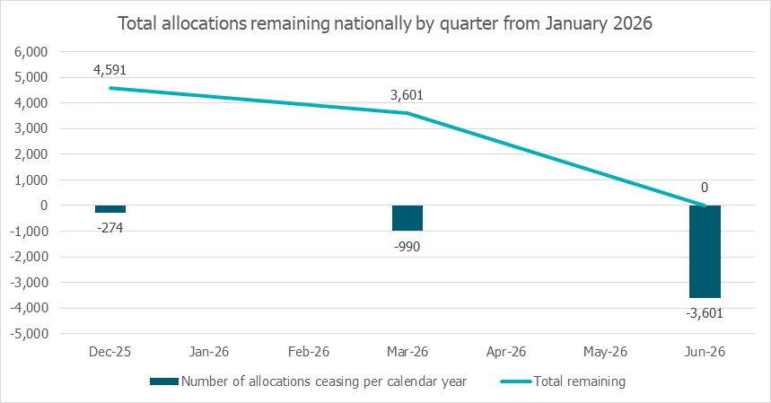

5: Allocations by ABS Remoteness by State/Territory
State | Major Cities | Inner Regional | Outer Regional | Remote | Very Remote | Total
NSW | 1,792 | 209 | 7 | 0 | 0 | 2,008
Vic. | 36 | 0 | 0 | 0 | 0 | 36
WA | 1,350 | 128 | 27 | 23 | 10 | 1,538
SA | 2 | 0 | 0 | 0 | 0 | 2
Tas. | 0 | 596 | 0 | 0 | 0 | 596
ACT | 361 | 0 | 0 | 0 | 0 | 361
NT | 0 | 0 | 50 | 0 | 0 | 50
Total/  % | 3,541  77.13% | 933  20.32% | 84  1.83% | 23  0.50% | 10  0.22% | 4,591  100%

6: Charitable status by State/Territory
6a: Endorsed Charities
State | Active allocations | Provisional allocations | Total allocations
NSW | 1,052 | 1 | 1,053
Vic. | 0 | 0 | 0
WA | 405 | 0 | 405
SA | 0 | 0 | 0
Tas. | 596 | 0 | 596
ACT | 361 | 0 | 361
NT | 50 | 0 | 50
Total | 2,464 | 1 | 2,465
6b: For Profit/Other
State | Active allocations | Provisional allocations | Total allocations
NSW | 955 | 0 | 955
Vic. | 35 | 1 | 36
WA | 1,072 | 61 | 1,133
SA | 2 | 0 | 2
Tas. | 0 | 0 | 0
ACT | 0 | 0 | 0
NT | 0 | 0 | 0
Total | 2,064 | 62 | 2,126

7: Type of dwellings by State/Territory
State | Apartment | Apartment | Boarding House | Boarding House | House | House | Studio | Studio | Townhouse | Townhouse | Total
State | Active allocations | Provisional allocations | Active allocations | Provisional allocations | Active allocations | Provisional allocations | Active allocations | Provisional allocations | Active allocations | Provisional allocations | Total
NSW | 1,098 | 0 | 0 | 0 | 187 | 0 | 424 | 0 | 298 | 1 | 2,008
Vic. | 30 | 1 | 0 | 0 | 0 | 0 | 0 | 0 | 5 | 0 | 36
WA | 728 | 28 | 0 | 0 | 164 | 6 | 240 | 0 | 345 | 27 | 1,538
SA | 0 | 0 | 0 | 0 | 1 | 0 | 0 | 0 | 1 | 0 | 2
Tas. | 0 | 0 | 0 | 0 | 20 | 0 | 550 | 0 | 26 | 0 | 596
ACT | 35 | 0 | 0 | 0 | 9 | 0 | 317 | 0 | 0 | 0 | 361
NT | 50 | 0 | 0 | 0 | 0 | 0 | 0 | 0 | 0 | 0 | 50
Total | 1,941 | 29 | 0 | 0 | 381 | 6 | 1,531 | 0 | 675 | 28 | 4,591

8: Size of dwellings by State/Territory
State | Studio  (0 bedroom) | 1 Bedroom | 2 Bedrooms | 3 Bedrooms | 4 Bedrooms | 5 or more Bedrooms | Total allocations
NSW | 428 | 512 | 717 | 256 | 95 | 0 | 2,008
Vic. | 0 | 27 | 9 | 0 | 0 | 0 | 36
WA | 232 | 484 | 556 | 250 | 16 | 0 | 1,538
SA | 0 | 0 | 0 | 2 | 0 | 0 | 2
Tas. | 550 | 0 | 28 | 18 | 0 | 0 | 596
ACT | 317 | 0 | 0 | 9 | 0 | 35 | 361
NT | 0 | 34 | 8 | 8 | 0 | 0 | 50
Total | 1,527 | 1,057 | 1,318 | 543 | 111 | 35 | 4,591

9: Allocations Ceasing from 1 January 2026 to 30 June 2026 by approved participant and State/Territory
Approved participant | 2026
1.NSW | 2,008
Aboriginal Housing Company Limited | 32
Argyle Community Housing Ltd | 25
Australian Affordable Housing Securities Limited | 264
Baptistcare Community Housing Limited | 20
BlueCHP Limited | 49
Bridge Housing Limited | 237
Central Park Students Pty Ltd | 340
City West Housing Pty Ltd | 93
Community Housing Limited | 15
Evolve Housing Limited | 161
Hume Community Housing Association Company Limited | 183
Link Wentworth Housing Limited | 59
National Affordable Housing Consortium Ltd | 26
National Housing Group Pty Ltd | 212
St George Community Housing Limited | 133
The North Coast Community Housing Company Ltd | 20
The Trustee for C.K.S.Unit Trust | 78
Zinkohl Pty Ltd | 61
2.Vic. | 36
Questus Funds Management Ltd | 36
3.WA | 1,538
Australian Affordable Housing Securities Limited | 385
Evolution Housing Pty Ltd | 19
Foundation Housing Ltd | 30
Housing Choices Western Australia Limited | 133
Questus Funds Management Ltd | 729
The University of Western Australia | 242
4.SA | 2
The Trustee for Affordable Housing Management Trust | 2
5.Tas. | 596
Community Housing Limited | 46
University of Tasmania | 550
6.ACT | 361
Community Housing Canberra Ltd | 9
University of Canberra | 352
7.NT | 50
Venture Housing Company Limited | 50
Grand Total | 4,591

10: Allocations Ceasing from 1 January 2026 to 30 June 2026 by suburb
Suburb | 2026
1. NSW | 2,008
ABERGLASSLYN | 6
ARMIDALE | 5
ASHFIELD | 9
AUBURN | 2
BANKSTOWN | 22
BASS HILL | 4
BOORAGUL | 19
BOURKELANDS | 4
BUNGARRIBEE | 65
CALALA | 7
CAMBRIDGE PARK | 1
CAMERON PARK | 2
CAMPBELLTOWN | 56
CANLEY HEIGHTS | 1
CARSS PARK | 2
CHIPPENDALE | 250
CHISHOLM | 2
CLIFTLEIGH | 2
DENHAM COURT | 1
FAIRFIELD | 60
FLETCHER | 20
GILLIESTON HEIGHTS | 13
GLEBE | 158
GLENMORE PARK | 3
GOONELLABAH | 5
GOULBURN | 24
GRANVILLE | 2
GREGORY HILLS | 1
GRIFFITH | 7
GUILDFORD | 77
HAMLYN TERRACE | 20
HARRIS PARK | 10
HEDDON GRETA | 1
HILLVUE | 1
HORNSBY | 2
JORDAN SPRINGS | 3
KENDALL | 4
KINGSWOOD | 14
KIRRAWEE | 3
KOORINGAL | 7
KOOTINGAL | 2
LEICHARDT | 2
LISMORE | 20
MAITLAND | 4
MAYS HILL | 40
MENAI | 12
MERRYLANDS | 15
MIRANDA | 3
MOORE CREEK | 9
MORISSET | 4
MOUNT HUTTON | 25
MULLUMBIMBY | 20
NORTH TAMWORTH | 8
ORANGE | 1
OXLEY PARK | 22
PARRAMATTA | 52
PEAKHURST | 33
PENRITH | 169
PORT MACQUARIE | 92
PUNCHBOWL | 4
QUAKERS HILL | 1
RAYMOND TERRACE | 5
REDFERN | 122
RIVERSTONE | 2
ROUSE HILL | 44
RUTHERFORD | 4
RYDE | 1
SHORTLAND | 2
ST MARYS | 39
SUTHERLAND | 46
THORNTON | 17
TWEED HEADS | 77
ULTIMO | 26
WADALBA | 2
WARNERVALE | 4
WARWICK FARM | 13
WENTWORTHVILLE | 66
WESTMEAD | 8
WOONGARRAH | 4
ZETLAND | 93
2. Vic. | 36
BELMONT | 16
BRUNSWICK | 4
NORTH MELBOURNE | 16
3. WA | 1,538
ALKIMOS | 1
ARMADALE | 8
ASHBY | 97
ATWELL | 15
BALDIVIS | 44
BALGA | 2
BANKSIA GROVE | 3
BAYSWATER | 5
BECKENHAM | 11
BEELIAR | 23
BELMONT | 2
BERESFORD | 26
BERTRAM | 4
BOYANUP | 8
BRABHAM | 2
BROOME | 8
BUNBURY | 1
BURSWOOD | 8
BUSSELTON | 7
BUTLER | 4
BYFORD | 20
CAMILLO | 1
CANNING VALE | 5
CANNINGTON | 68
CARINE | 1
CARLISLE | 1
CARNARVON | 15
CAVERSHAM | 29
CLARKSON | 1
COMO | 1
COODANUP | 101
COOLBELLUP | 11
CORAL BAY | 10
CRAWLEY | 242
DARDANUP | 14
DAYTON | 28
DONNYBROOK | 12
DUNCRAIG | 1
DUNSBOROUGH | 40
DWELLINGUP | 10
EAST CANNINGTON | 19
EAST PERTH | 17
ELLENBROOK | 56
EMBLETON | 1
FALCON | 3
FERNDALE | 1
GEOGRAPHE | 1
GERALDTON | 1
GLEN IRIS | 32
GOSNELLS | 36
HAMILTON HILL | 12
HAMMOND PARK | 1
HIGHGATE | 1
HOCKING | 17
INNALOO | 1
JOONDALUP | 1
KELMSCOTT | 2
KEWDALE | 19
KOONDOOLA | 2
LANDSDALE | 8
LATHLAIN | 26
LEEDERVILLE | 1
LYNWOOD | 1
MADDINGTON | 38
MADELEY | 25
MANDURAH | 33
MAYLANDS | 2
MEDINA | 14
MELVILLE | 3
MIDLAND | 28
NOLLAMARA | 16
NORTH FREMANTLE | 14
ORELIA | 5
PERTH | 73
REDCLIFFE | 6
RIDGEWOOD | 4
RIVERTON | 1
RIVERVALE | 1
ROCKINGHAM | 36
SEVILLE GROVE | 7
SPEARWOOD | 3
SUCCESS | 20
THORNLIE | 10
WAIKIKI | 9
WELLARD | 24
WEST BUSSELTON | 1
WEST PERTH | 1
WHITE GUM VALLEY | 12
WILLAGEE | 2
YANCHEP | 1
4. SA | 2
MARDEN | 1
PROSPECT | 1
5.Tas. | 596
BRIDGEWATER | 20
HOBART | 430
INVERMAY | 120
RAVENSWOOD | 26
6. ACT | 361
BRUCE | 352
LAWSON | 9
7. NT | 50
JOHNSTON | 8
NIGHTCLIFF | 42
Grand Total | 4,591

