Independent evaluation of 1800RESPECT
0BDepartment of Social Services
Final Report
June 2025


Acknowledgements

We also acknowledge the talent and artistry of Emma Walke, who designed the artwork for our acknowledgment of Aboriginal and Torres Strait Islander peoples. The design shows a story of connection to country and people, representing the breadth of work we do with Aboriginal and Torres Strait Islander communities across Australia. The colours represent the land, and the lines in between represent the water that connects us all.
---------------------------------------------------------------------------------------------------------------------------------------------
This work was completed with the assistance of the Ending Gender-Based Violence Group at the Australian Government Department of Social Services.
We would also like to thank the past service users and many key informants from Telstra Health, 1800RESPECT subcontracted organisations and the broader service system who participated in the evaluation. We thank them for their time and insights and trust that their views are adequately represented in this report.
ARTD consultancy team
Stephanie Quail, Alexandra Lorigan, Imogen Williams, Natalie Martino, Natalie Janzen, Tracee Kresin, Leah Carrol, Theebana Tharmakumar, Paula Shaw, Andrew Hawkins
ARTD associates
Auntie Julie Smith, Peter Ninnes, Greta Waring
Content warning
This document contains reference to domestic, family and sexual violence (DFSV). Some readers may find this content distressing. If you or someone you know needs support, please consider seeking support from a trusted individual or professional service. If you, a child, or another person is in immediate danger, call 000.
Contents
Summary v
Snapshot vi
Executive Summary vii
Report 15
1. Program and policy context 16
1.1 The policy context 16
1.2 1800RESPECT 18
2. The evaluation 30
2.1 Purpose 30
2.2 Methods 32
2.3 Confidence in the findings and limitations 35
3. How effective is 1800RESPECT in delivering an accessible service? 38
3.1 What is the awareness and understanding of 1800RESPECT in the community? 38
3.2 How accessible is the service? 45
4. How effective is 1800RESPECT in delivering a service that is responsive to service user needs? 60
4.1 What are the needs of 1800RESPECT service users? 60
4.2 How well does 1800RESPECT meet the needs of service users? 62
4.3 To what extent does 1800RESPECT support service users to navigate the broader service system through the provision of connected and coordinated support? 77
5. To what extent is 1800RESPECT efficiently delivering a value for money service? 84
5.1 How is the current Performance Management Framework supporting the efficiency of the service? 85
5.2 What are the key cost drivers under the current service delivery arrangements? 89
5.3 Are the core elements of the service delivery arrangements, including the PMF, achieving intended value for money? 91
6. Conclusion 93
6.1 Conclusions 93
6.2 Opportunities for continuous improvement 93
Appendices 96
Appendix 1. Supplementary tables and figures 97
A1.1. Population survey 97
A1.2. Service data 120
Appendix 2. Performance Management Framework 123
Connect with us 125
Abbreviations, acronyms and common terms
AIHW | Australian Institute of Health and Welfare
ANAO | Australian National Audit Office
CALD | Culturally and linguistically diverse
CASP | Caller Access and Support Plan
CRM | Customer Relationship Management system
DSS | Department of Social Services (The department)
DFSV | Domestic, family and sexual violence
GAD | generalised anxiety disorder
KPI | Key Performance Indicator
LGBTIQA+ | Lesbian, Gay, Bisexual, Transgender, Intersex, Queer, Asexual
MDD | major depressive disorder
MHS | Medibank Health Solutions Telehealth Pty Ltd
NPS | Net Promoter Score
NRS | National Relay Service
PMF | Performance Management Framework
PTSD | post-traumatic stress disorder
QDA | qualitative data analysis
RDVSA | Rape and Domestic Violence Services Australia
SAUD | severe alcohol use disorder
SHI | System Health Indicator
SHS | Specialist Homelessness Services
SMS | Short Message Service
SPM | Strategic Performance Measures

Summary
A graphic snapshot of the project and the Executive Summary.

Snapshot

What we did
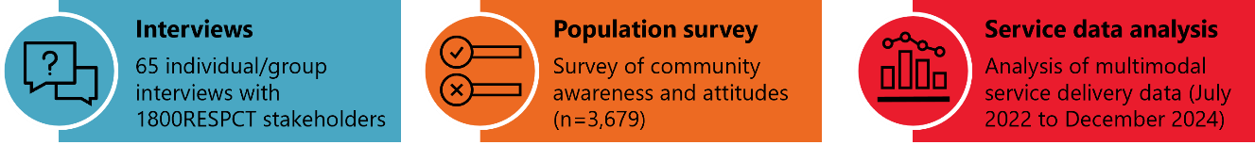

What we found
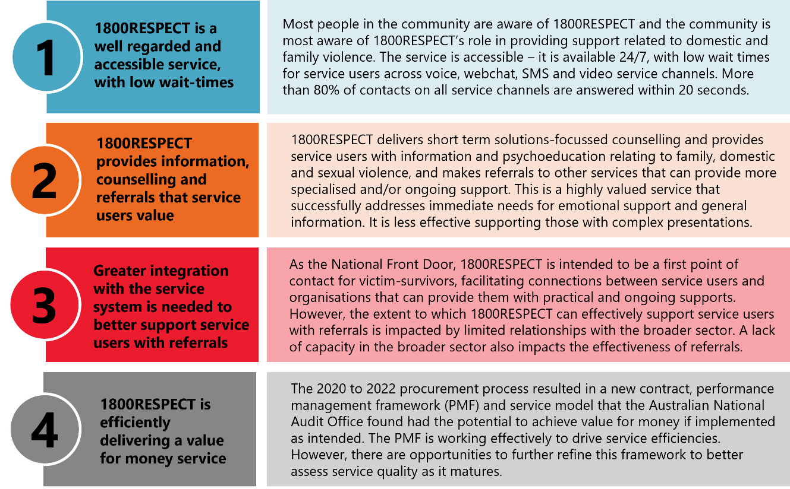

What we recommend
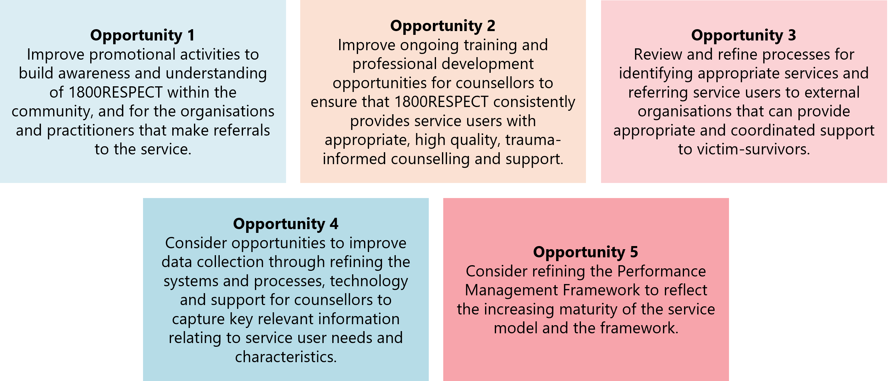

Executive Summary
1800RESPECT is a national service that provides counselling, information and support to people experiencing or at risk of domestic, family and sexual violence (DFSV), including sexual harassment and workplace sexual harassment. The service is also available to the people and professionals who support them. 1800RESPECT provides free, 24/7 support, nationwide.
Following a procurement process over 2020 to 2022, 1800RESPECT is delivered by Telstra Health and subcontracted organisations (currently 54 Reasons, Marninwarntikura Women’s Resource Centre, Lifeline and Safe Steps Family Violence Response Centre).0F The subcontracted organisations work as Counsellors and Senior Counsellors alongside Telstra Health Counsellors and Senior Counsellors, providing counselling and supervision, as well as subject matter expertise to the 1800RESPECT Service.
People seeking information or support from a counsellor can access 1800RESPECT through a range of service channels (phone, online chat) as well as through 2 new service channels introduced as part of the new service model (SMS, video call). People can also access information on the 1800RESPECT website and through the Daisy and Sunny digital applications.
The Department of Social Services (the department) funds 1800RESPECT through a contract-based funding model, including a Performance Management Framework (PMF), that was developed as part of the 2020 to 2022 procurement process. The Australian National Audit Office (ANAO) audited this procurement process and found that the new funding contract and service model had the potential to deliver value to government, if the contract and PMF were able to be fully implemented and drive the service and cost efficiencies as intended.

What we did
The department engaged ARTD Consultants to conduct an independent evaluation of 1800RESPECT between July 2024 and June 2025. The evaluation focuses on the period from when Telstra Health started delivering 1800RESPECT on 1 July 2022 until 31 March 2025. The evaluation does not directly examine implementation of the service under previous models and previous service providers.

Given the recent evaluation of 1800RESPECT conducted by the University of New South Wales in 2020, our evaluation intended to:
- fill gaps in knowledge (rather than duplicating existing research)
- understand the extent to which 1800RESPECT is achieving its strategic outcomes and value for money
- provide practical recommendations that support continuous improvement in service delivery.
We consulted widely as part of this evaluation. We conducted 65 individual/group interviews with 1800RESPECT staff, service providers, sector peaks, lived experience groups and service users, and collected 3,679 survey responses from the Australian community, of which 312 survey respondents (9%) had used 1800RESPECT in the past 3 years. We also analysed multimodal service data relating to the access and delivery of 1800RESPECT and reviewed key documents relating to the service, including the PMF, regular service reporting, prior evaluations of the service and audit reports.
We were able to implement most data collection and analysis methods as intended. We are confident in our answers to the key evaluation questions.

What we found
1800RESPECT is delivering a highly accessible service. People looking for counselling, information and referral support relating to DFSV, including sexual harassment, are able to speak to a highly qualified counsellor 24 hours a day, 7 days a week. More than 80% of contacts across multiple channels (phone, online chat, SMS, video calls) are answered within 20 seconds.
The short-term solutions-focused counselling, information and referral support 1800RESPECT provides is generally well received and appears to meet the needs of most service users, particularly those who are looking for general information and counselling supports. However, people with complex presentations and people from underrepresented cohorts are not able to consistently experience a service that meets their needs, highlighting the need to improve the ability of the service to appropriately engage with these cohorts, and the critical importance of ensuring the service is successful at referring service users to specialised support services.
The new contract, PMF and service model are working as intended to drive efficiencies in service delivery. The PMF places a high value on the timeliness of access to the service, which is effective in delivering low wait times for service users. As this service model and framework matures, opportunities to incorporate service user input and assessment of the usefulness of referrals and referral information could support 1800RESPECT to continue to deliver a high-quality and accessible service.

How effective is 1800RESPECT in achieving its outcomes to deliver a high-quality service that is accessible and responsive to service user needs?
- There is broad, but not comprehensive community awareness of 1800RESPECT. Around half (55%) of the population survey respondents had heard of 1800RESPECT. People with disability were more likely to have heard of 1800RESPECT than people without a disability. In contrast, people from culturally and linguistically diverse (CALD) backgrounds were less likely to have heard of 1800RESPECT than people from non-CALD backgrounds. The community is most aware of 1800RESPECT’s role in providing support relating to domestic and family violence, but less frequently described the service’s role in providing support relating to sexual violence and sexual harassment, and workplace sexual harassment. When provided with a description of 1800RESPECT, those who had not previously used the service reported feeling that 1800RESPECT appeared to be a safe (78%) and accessible service (73%).
- 1800RESPECT delivers a responsive service with low wait times for service users: more than 80% of contacts across all service channels were answered within 20 seconds. The proportion of contacts that are answered within 20 seconds has increased over the current contract period.
- Service users can access 1800RESPECT when they need it, including outside business hours. Service users predominantly access the service through the phone line (84% of all contacts). Use of the phone line peaks in the afternoon and drops off after 8 pm. Use of the online chat and SMS service channels are highest outside of business hours, with peaks in activity between 8 and 10 pm. These different patterns of demand suggests that the quieter and more discreet access that online chat and SMS channels provide may be valuable for service users looking for support overnight or where there may be others in the household around.
- 1800RESPECT delivers high volume short-term solutions-focused counselling, and provides service users with information about DFSV (including sexual harassment) and referrals to other services that can provide more specialised and/or ongoing support. The service is not intended to provide intensive ongoing counselling or case management. Generally, service users were satisfied with the support they received from 1800RESPECT and appreciated the skills, knowledge and trauma-informed approach of the counsellors. However, some service users felt the counsellors they engaged with required more training to be able to understand their circumstances and provide person-centred support. Service users generally found the counselling support they received more useful and appropriate than the practical advice offered, such as steps to take to access additional support to address their needs and referrals to other services.
- It is unclear to what extent 1800RESPECT is meeting the needs of people with complex presentations. Service users with complex needs (individuals who present with multiple, interconnected needs) require tailored, multi-faceted approaches to counselling and support. 1800RESPECT’s trauma-informed, person-centred approach to supporting these service users recognises that while 1800RESPECT will always be available to these service users for counselling and/or support if needed, connecting them to state and territory-based services that can provide medium to long-term support is the best way to meet their needs. The evaluation has limited data to assess the effectiveness of this policy in supporting service users with complex needs to transition to medium to long-term supports as these service users are not always able to be identified in the system. Additionally, as there are limitations with regard to recording referrals, and there is no data currently available to understand satisfaction with support or uptake of referrals, it is difficult to assess the extent to which the referrals made align with or have successfully addressed service user needs. Staff reported mixed levels of confidence in supporting service users with complex needs, which may suggest variability in the extent to which service users with complex needs are being connected to services that meet their needs.
- As part of the new service model delivered by Telstra Health, 1800RESPECT has introduced 2 new service channels (SMS and video call). In response to Recommendation 54 of the Respect@Work report, focused on uplifting and promoting 1800RESPECT’s capability to support those affected by workplace sexual harassment.1F Telstra Health has taken a staged approach to introducing these service channels and the promotion of its role in supporting people affected by workplace sexual harassment to ensure 1800RESPECT is adequately resourced to respond to increased service user uptake and is able to provide appropriate support and referrals. During the evaluation period, some elements of service delivery were not yet fully implemented, including Senior Counsellor support over video call and broader promotion of 1800RESPECT’s capability to provide support relating to workplace sexual harassment. However, these elements of service delivery have resulted in significant changes internally. Video call and SMS uptake has reportedly increased substantially since the evaluation period, and contacts related to workplace sexual harassment are expected to increase as broader promotion rolls out in 2025 and 26.
- As the ‘National Front Door’ (a service that is accessible to people affected by DFSV across Australia and is intended to act as a first point of contact), 1800RESPECT is intended to effectively facilitate connections between service users and organisations in the broader service system, where victim-survivors are then able to access connected and coordinated supports. 1800RESPECT provides service users with trauma-informed support,2F through information, referrals and short-term solutions-focused counselling. However, more could be done to improve the extent to which the support 1800RESPECT provides is connected and coordinated with the broader service system including: building awareness of the purpose and scope of 1800RESPECT within the sector, building stronger referral pathways and relationships between 1800RESPECT and key jurisdictional service providers, making greater use of warm referrals, and ensuring that the service directory is up to date and easy to access for 1800RESPECT staff and sector stakeholders.
In conclusion, 1800RESPECT has successfully delivered a service model that ensures people across Australia can obtain short-term, solutions-focused counselling and support where, when and how they need it. In the context of a high-volume, national service, the service model and delivery is broadly appropriate to meet the needs of most service users. The service can further mature by ensuring that, as the National Front Door, it is well connected to the broader service system through improved knowledge of and stronger referral pathways to external services that are better placed to meet more complex and specialised needs.

To what extent is 1800RESPECT efficiently delivering a value for money service?
Overall, 1800RESPECT is delivering a value for money service, as a result of successfully implementing key elements of the contract and service model developed through the 2020 to2022 procurement process.
- The PMF is working as intended to drive a service that is efficiently able to meet service demand in a timely manner. The overall efficiency of the service delivered requires a balance between the efficient use of resources, the service quality that can be provided, the accessibility of the service, and how well the service can respond to projected and unexpected demand for the service. The PMF is working well to ensure that service users can access support in a timely manner when they contact 1800RESPECT. There is a potential for the strong emphasis on timeliness metrics in the PMF to create incentives through overstaffing, including having more staff rostered on or available for a shift than are needed to avoid the potential penalty associated with not being able to meet targets relating to the timeliness of answering service user contacts. However, as the PMF is designed with checks and balances, other elements of the PMF such as how the daily payment rates are calculated limit the impact of potential inefficiencies. We found that balancing the domains of efficiency has been well managed with no evidence found of an increase in one element of efficiency at the expense of another.
- According to the department, the key factor that drives how much it costs the government to deliver 1800RESPECT is service user demand and the number of contacts the service receives. Delivering a service that can provide the same level of support to an increasing number of service users costs more. Under the previous grant-based contract, 1800RESPECT was funded under a cost-per-contact model, where there was a set unit price for each call or online counselling session, regardless of its duration. This meant that the cost to the government would continue to increase linearly as service demand and access to the service increased. Given the projections that demand for the service would continue to increase over time, this model was considered to drive costs for government in an unsustainable way. The current service delivery arrangements were designed to ensure that growth in service user demand and access to the service does not drive cost for government in an unsustainable way. This means that although contact volume remains the key cost driver for the government and the total cost to government will increase as service user demand for and access to the service increases, these costs do not scale linearly as the cost to the government of a having counsellor available to deliver the service (i.e. the marginal unit cost) decreases as the volume of support delivered increases.
- Service user demand is also a key cost driver for Telstra Health. As contact volume increases it costs Telstra Health more to deliver support to meet this demand. However, the service payment Telstra Health receives also increases with the volume of contacts and support delivered. From Telstra Health’s perspective, there were several additional key factors that drive Telstra Health’s costs in delivering the service, including elements of frontline staffing related costs such as those relating to staff turnover, ongoing staff training and support and staff wellbeing, as well as the resourcing costs associated with some of the non-service delivery aspects of 1800RESPECT such as stakeholder engagement, additional data analysis and reporting requirements.

Opportunities for continuous improvement
Based on the evaluation findings, and the perspectives of staff, service users and key stakeholders, we have identified key potential opportunities for the continuous improvement of the service.
- Improve promotional activities to build awareness and understanding of 1800RESPECT within the community and for the organisations and practitioners that make referrals to the service. In addition to broad promotion of the service, targeted promotion relating to the elements of 1800RESPECT’s remit that were less well known, such as sexual violence, including sexual harassment, and workplace sexual harassment, could help more victim-survivors become aware that 1800RESPECT can support them. In particular, the lower levels of awareness of 1800RESPECT among people from CALD backgrounds, and the very small proportion of contacts made from service users who speak a language other than English, indicate an opportunity to increase awareness and understanding of 1800RESPECT in CALD communities through targeted, culturally appropriate promotion of the service. Professionals in organisations that are not explicitly in the DFSV sector but are likely to come into contact with victim-survivors, such as GPs, lawyers, settlement services and religious institutions, play an important role in referring people who may need support to 1800RESPECT. There is an opportunity to deliver more targeted promotion of the service to these organisations to ensure that those referring people to 1800RESPECT understand its remit and the nature of the support the service is able to provide to service users.

- Improve ongoing training and professional development opportunities for counsellors, to ensure that 1800RESPECT consistently provides service users with appropriate, high quality, trauma-informed counselling and support. 1800RESPECT counsellors provide support to a broad range of individuals, from diverse backgrounds, and with different needs and sensitivities. To ensure that service users, regardless of their background or presenting circumstances, are able to consistently receive high-quality, trauma-informed and culturally safe support, counsellors require a high level of ongoing training and professional development. This includes continuing to focus on: specialised DFSV training; training on emerging research and approaches; training to better support people seeking information and referrals for sexual harassment, including workplace sexual harassment; training to provide more culturally responsive and inclusive support to underrepresented cohorts; and training relating to relevant services and legislation in different jurisdictions.
- Review and refine processes for identifying appropriate services and referring service users to external organisations that can provide appropriate and coordinated support to victim-survivors. To ensure that 1800RESPECT is contributing to building the capacity of the sector to provide victim-survivors with connected and coordinated supports, it is critical that 1800RESPECT is able to effectively connect service users with other organisations that can provide them with support outside the remit of 1800RESPECT. This requires counsellors to identify appropriate services to refer service users to, given their consent and depending on their needs, location and other personal circumstances or characteristics, and the processes that the service uses to facilitate these connections. Investing more time and resources into developing sector relationships, as well as refining the processes used by counsellors to identify suitable services for referrals, and developing approaches to assessing whether the counsellors are making accurate and appropriate referrals to services, could allow 1800RESPECT to more effectively guide service users through the broader service system. Given the barriers service users can face when attempting to access services to which they have been provided a cold referral, opportunities to facilitate connections in a way that minimises the frequency that service users are required to re-tell their story could support service users to more effectively continue their support journey.
- Consider opportunities to improve data collection through refining the systems and processes, technology and support for counsellors to capture key relevant information relating to service user needs and characteristics. There is very limited information available relating to the needs, characteristics and experiences of service users. Additionally, information relating to the referrals counsellors provide to service users is frequently not captured in the 1800RESPECT customer relationship management (CRM) system. To ensure that 1800RESPECT delivers a high-quality, appropriate service that meets the needs of service users, it is important to have a greater understanding of who is accessing the service, their characteristics, needs, and the types of support services they are referred to. Telstra Health should continue their efforts to refine the CRM used by counsellors and to better support the quality and completeness of appropriate data recorded as part of service delivery. Telstra Health should also consider reviewing the processes and guidance related to when and how information relating to service users’ needs, circumstances and support preferences can be collected in a trauma-informed way. For example, we suggest considering 2 processes – one for light-touch interactions, or where the service user does not wish to disclose or have their personal information recorded, and a second process for more in-depth contacts where service users may be more comfortable providing information about their needs and circumstances that could allow the counsellor collecting information to better tailor the support and referrals they provide. Improving data collection processes relating to service user needs and characteristics could help support continued improvements to the quality and efficiency of the service by allowing a clearer understanding of who the service is reaching and how it is responding to address service user needs.
- Consider refining the PMF to reflect the increasing maturity of the service model and the framework. The PMF is working effectively to drive service efficiencies. The PMF has a strong emphasis on timeliness metrics (as is appropriate for a service where service users may be in acute crisis when they contact the service), and the service’s performance against these metrics across the implementation period demonstrates the effectiveness of assessing and tracking indicators to drive service delivery towards intended outcomes. There is an opportunity, as the service matures, for further refining the PMF through integrating safe mechanisms for service user feedback into the quality assessment processes. This would provide more robust quality measurements and help identify opportunities for greater efficiency in service delivery that do not compromise the effectiveness of the service.

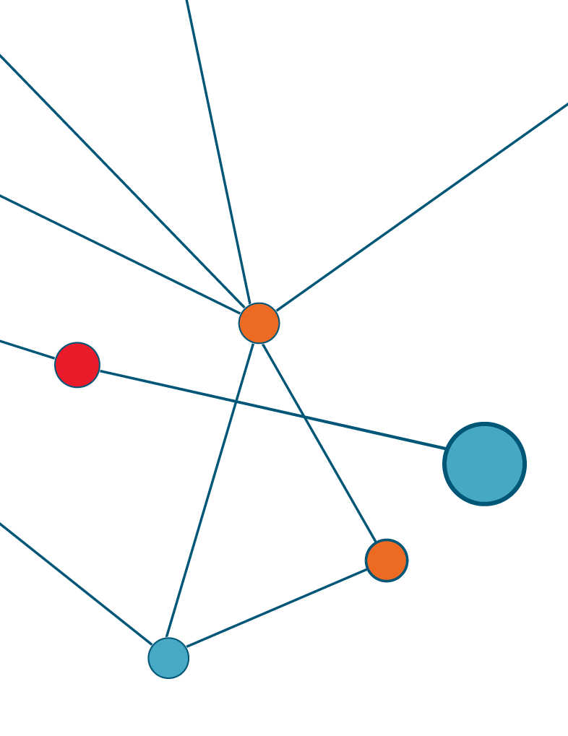

Report
Detailed analysis against the Key Evaluation Questions.

Program and policy context

The policy context

Domestic, family and sexual violence
Domestic and family violence (DFV) is a pervasive and complex social issue that has serious consequences for victim-survivors. DFV encompasses a broad range of behaviours that exert power and control through violence or threats of violence not only in intimate partner relationships, but also in relationships with children, elders, across kin relationships and in care giving relationships. This includes behaviour that is physically, sexually, emotionally, psychologically or economically abusive. It also includes behaviours that are threatening, coercive, or in any way control or dominate a person so that they feel fear for the safety or wellbeing of themselves or another person. It also includes behaviour that causes a child to hear or witness, or otherwise be exposed to the effects of the above behaviour.3F
The National Plan to End Violence against Women and Children 2022–2032 (the National Plan) defines sexual violence as sexual activity that happens where consent is not freely given or obtained, where consent is withdrawn or where the person is unable to consent due to their age or other factors. Sexual violence involves forcing, coercing or manipulating someone into sexual activity.4F This includes touching, abuse, assault, rape, harassment, intimidation and forced participation in pornography. Non-physical forms of sexual violence include unwanted sexualised comments, intrusive questions, and sexual harassment.5F Modern slavery, such as forced marriage, servitude and trafficking can also involve sexual violence.6F

The National Plan to End Violence against Women and Children

The National Plan to Reduce Violence against Women and their Children 2010–2022
The National Plan to Reduce Violence against Women and their Children 2010–2022 was Australia's first comprehensive policy framework to coordinate Commonwealth, state and territory government action to address violence against women. It focused on the 2 main types of violence experienced by women – domestic and family violence and sexual assault – and aimed to achieve a ‘significant and sustained reduction in violence against women and their children.’ The National Plan focused on 6 national outcomes:
- Communities are safe and free from violence: Promoting community-wide attitudes and behaviours that support respectful relationships and prevent violence.
- Relationships are respectful: Encouraging respectful relationships, particularly among younger people, to prevent the development of violent behaviours.
- Indigenous communities are strengthened: Addressing the unique issues and higher rates of violence faced by Aboriginal and Torres Strait Islander women and children.
- Services meet the needs of women and their children experiencing violence: Enhancing service delivery for women and children to ensure they receive the support they need.
- Justice responses are effective: Ensuring that the justice system holds people using violence accountable and provides justice and protection for victim-survivors.
- Perpetrators stop their violence and are held to account: Focusing on changing the behaviour of people who use violence and enhancing intervention programs.

The National Plan to End Violence against Women and Children 2022–2032
The second plan, the National Plan to End Violence against Women and Children 2022–2032, was released in October 2022. It builds upon lessons learned from the previous National Plan and recognises there is more work to do.
The National Plan highlights how all parts of society, including governments, businesses and workplaces, media, schools and educational institutions, the DFSV sector, communities and all individuals, must work together to achieve the shared vision of ending gender-based violence in one generation.
The scope of the second National Plan is broader than the first, reflecting the evolving understanding and language around gender-based violence.
The key objectives under each of the 4 domains of the National Plan – prevention, early intervention, response, and recovery and healing – will be implemented through 2 Action Plans, each spanning 5 years.
The First Action Plan 2023–2027 outlines the initial scope of activities, areas for action and responsibility with respect to outcomes. Action 4 under the First Action Plan is ‘Build the capacity of services and systems that support victim-survivors to provide trauma-informed, connected and coordinated responses that support long-term recovery, health and wellbeing.’ 1800RESPECT is part of the Commonwealth Government’s contribution to this Action as part of its role is to connect people to relevant services within the broader service system.
To address the high rates of violence Aboriginal and Torres Strait Islander women and children experience, a dedicated Aboriginal and Torres Strait Islander Action Plan 2023–2025 has been developed, which will work alongside the First Action Plan and be aligned to the National Agreement on Closing the Gap.7F

1800RESPECT
1800RESPECT is Australia’s national DFSV counselling, information and support service. It is free, confidential and available 24 hours a day, 7 days a week.
1800RESPECT was established in 2010 as a foundational service under the National Plan 2010–2022, designed to achieve National Outcome 4 (see Section 1.1.2), and remains a core component of the second National Plan.

The history of 1800RESPECT
Figure 1 below outlines the evolution of 1800RESPECT from when it was launched on
1 October 2010 to present. We then explain this in more detail in the sections below the figure.

Figure 1: Evolution of 1800RESPECT
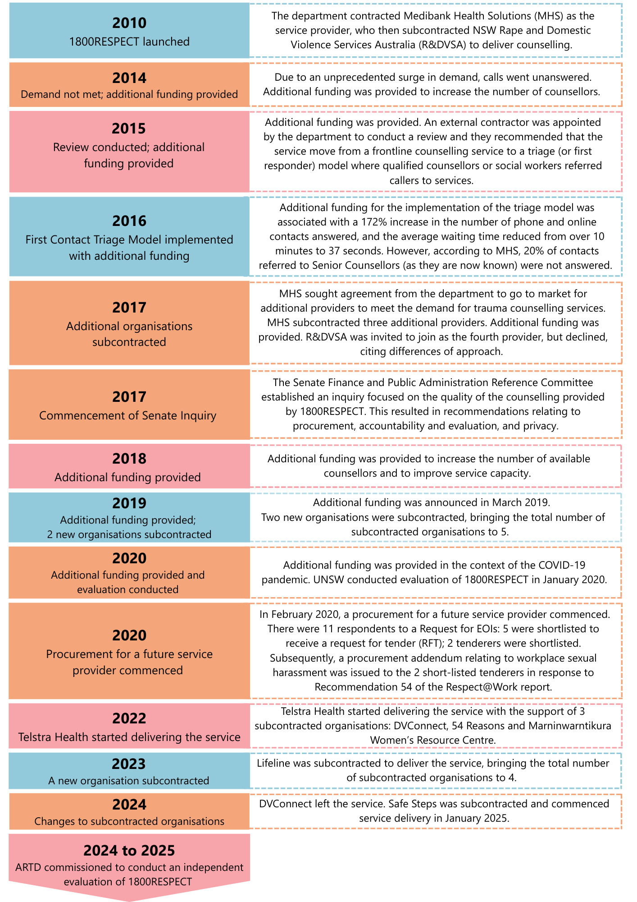
Source: Adapted from the ANAO Performance Audit of the Procurement of 1800RESPECT (2022).

The initial 1800RESPECT service model (2010–16)
In 2010, the Australian Government Department of Families, Housing, Community Services and Indigenous Affairs (FaHCSIA), now known as the Department of Social Services, contracted Medibank Health Solutions Telehealth Pty Ltd (MHS) to operate 1800RESPECT. The delivery of the service was contracted through a series of multi-year grant agreements from 8 July 2010 to 30 June 2022. Under these agreements, funding was provided for each contact made to 1800RESPECT.
Over time, calls to the 1800RESPECT line grew substantially. As demand for the service began to exceed capacity, many calls went unanswered. In September 2015, as part of the Australian Government’s Women’s Safety Package, $5 million was allocated to 1800RESPECT to respond to the growing demand for the service. As part of the new funding, an independent review of the service was undertaken by KPMG in 2015 and 16. The review recommended that 1800RESPECT implement a First Response triage model to ensure all calls were answered quickly and service users got the help they needed, when they needed it.
A First Response model was introduced on 16 August 2016, with services subcontracted to Rape and Domestic Violence Services Australia (RDVSA). This model involved the use of a prime provider, MHS, which provided a First Response, such as needs assessment, information, referral and some counselling; and, where needed, referred service users to RDVSA for more intensive trauma counselling.

1800RESPECT Senate Inquiry (2017)
The Senate Inquiry into 1800RESPECT was launched in 2017 to examine the operation and effectiveness of Australia’s national telephone and online counselling service for people affected by DFSV. The inquiry was initiated in response to concerns over changes to the service's operating model, specifically the decision to outsource frontline counselling services to a single provider, MHS, instead of multiple specialist organisations.
The inquiry highlighted concerns about the new model's impact on service quality, the need for improved governance, and better integration with specialist services. It recommended increased funding, enhanced accountability and ensuring that highly qualified, specialised counsellors are available to meet the needs of people affected by violence. It also outlined recommendations for strengthening 1800RESPECT’s operations, emphasising a need for a model that prioritises specialist, trauma-informed care and better coordination with broader support services.
As a result of the Senate Inquiry into 1800RESPECT, several changes were made to improve the service:
- Restoration of specialist services: The service model was adjusted to reintegrate specialist counsellors with expertise in DFSV by subcontracting DVConnect (Queensland), Women’s Safety Services (South Australia) and Safe Steps Family Violence Response Centre (Victoria) to deliver trauma-informed counselling. This aimed to ensure that service users received more knowledgeable and trauma-informed support.
- Increased funding: Additional funding was allocated to enhance the service’s capacity and quality, addressing concerns about under-resourcing.
- Improved governance and oversight: Enhanced governance structures were implemented to ensure better oversight and accountability in the management of 1800RESPECT. This included improved contract management and transparency.
- Enhanced coordination: Efforts were made to improve coordination between 1800RESPECT and other support services to ensure a more integrated response for people affected by violence.

Independent evaluation of 1800RESPECT (2020)
In 2019, the University of New South Wales (UNSW) was commissioned by the department to undertake an independent evaluation of 1800RESPECT. The evaluation was conducted by the Social Policy Research Centre (SPRC) and Gendered Violence Research Network (GVRN) at UNSW and covered the period from October 2018 to May 2019. It was completed and made publicly available in 2020.
The evaluation examined the service’s effectiveness, funding arrangements, work-from-home practices, prevention of vicarious trauma, and staff qualifications and training. The report provided insights into the service's strengths and areas for improvement, including its effectiveness in delivering high-quality counselling, challenges in managing repeat service users with complex needs, and issues related to funding arrangements, as noted by the Senate Inquiry in 2017, and staff support.
The evaluation reported that 1800RESPECT was generally considered effective in delivering high-quality, accessible and responsive counselling services, and was fulfilling its brief specified by National Outcome 4 of the National Plan. The service also had improved call answering rates and reduced wait times.
However, the service faced challenges in managing repeat service users with complex needs, who require strategies beyond the single-session model that was used at that time. The evaluation also raised concerns about the transparency and sustainability of the funding model, which was based on a cost-per-contact basis; and highlighted issues for monitoring of staff wellbeing, particularly for counsellors employed under work-from-home arrangements.
Recommendations were made to ensure and enhance consistent access to supervision and support and to improve training and professional development. There was also an identified need for better integration and coordination with state, territory and local services for fit for purpose referral pathways.
Many of the issues identified in the UNSW evaluation contributed to the design and process for procuring a new service provider (see ‘Auditor-General Report No. 15 2022–23 Performance Audit: Procurement of 1800RESPECT (2022)’ below).

Respect@Work: National Inquiry into Sexual Harassment in Australian Workplaces (2020)
The Respect@Work: National Inquiry into Sexual Harassment in Australian Workplaces was a comprehensive inquiry conducted by the Australian Human Rights Commission (AHRC), led by Sex Discrimination Commissioner, Kate Jenkins. The inquiry was initiated in 2018 in response to widespread recognition that sexual harassment in Australian workplaces was a significant and pervasive problem. The final report was released on 8 April 2021.
Recommendation 54 from the Inquiry was: ‘The Australian Government promote the 1800RESPECT hotline and ensure it is adequately resourced to expand its services to provide appropriate psychological support and referral to people affected by workplace sexual harassment, and collect and maintain de-identified and disaggregated data on contacts regarding workplace sexual harassment.’
While workplace sexual harassment has always been within the remit of 1800RESPECT, recommendation 54 resulted in the Australian Government providing additional, one-off funding to the service. This funding was to enable improved promotion and specialised training for 1800RESPECT staff to ensure that people experiencing workplace sexual harassment are aware of the support 1800RESPECT provides and can receive appropriate counselling, information and referral support relevant to their needs and circumstances.
We note that our evaluation assesses the extent to which the service is accessible to and appropriate for people experiencing DFSV, including workplace sexual harassment.

Auditor-General Report No. 15 2022–23 Performance Audit: Procurement of 1800RESPECT (2022)
The Australian National Audit Office (ANAO) undertook a performance audit to assess the effectiveness of the department’s 2-stage procurement process (between 2020 to 2022) to select a service provider to deliver the 1800RESPECT service using a new contract-based approach to funding. The report assessed whether the procurement achieved value for money, complied with Commonwealth Procurement Rules and if the transition to the new provider was effectively managed. It also evaluated the administrative arrangements and performance monitoring systems established for the new contract.
An ANAO Performance Audit of the Procurement of 1800RESPECT, published in March 2023, found that the negotiations and design of the new contract were undertaken to achieve value for money – particularly by linking service provider performance to financial and commercial consequences.

The audit found that the procurement was effective and has the potential to achieve value for money. There are 5 key features of the new service delivery arrangement whose benefits need to be realised for 1800RESPECT to deliver the intended value for money:
- A new funding model: The funding of 1800RESPECT has changed from a cost-per-contact model to one based on payment for the length of time support is provided. It has introduced an hourly rate that changes in line with demand levels. The department also pays for counsellors logged on and available to deliver services. This system is intended to encourage efficiency and effective responses to service users. The contract also includes provisions for adjusting the contract if significant policy or legislative changes impact service delivery.
- Performance linked payments: The new arrangement introduced a Performance Management Framework (PMF) with strategic performance measures and key performance indicators to monitor performance. This framework links performance to financial and non-financial consequences for the service provider. The framework also outlines that part of the fees that can be lost for not achieving performance indicators can be earned back through performance against strategic measures.
- Economies of scale: The new arrangement includes a fee structure designed to deliver economies of scale as demand grows, where the marginal unit cost of each counsellor hour falls in line with decreasing hourly rates charged.
- Risk allocation: The new arrangement assigns risk and accountability to the service provider (Telstra Health) to ensure the right number of counsellors are available at agreed times. Telstra Health absorbs additional costs if demand exceeds their rostered counsellor hours (subject to agreed limits) – noting that there are checks and balances in the PMF.
- Enhanced service requirements: The new arrangement has introduced expanded service channels (SMS, video call) in addition to existing service channels (phone call, online chat) to promote accessibility. It also mandates high-quality training and support for counsellors. The new arrangement specifies governance arrangements with increased transparency and oversight compared with previous arrangements. The department now has direct access to the provider’s clinical governance team.
The audit also found the procurement process complied with Commonwealth Procurement Rules and the department applied lessons learned from previous reviews and evaluations to design the procurement process and negotiate a contract with improved performance measures and a revised funding model. The transition between service providers was appropriately managed, ensuring continuity of service. Fit-for-purpose administrative arrangements were established, including a contract management manual and governance framework. ANAO commenced the performance audit in 2022 and this was finalised in March 2023. As such, some aspects of the contract and PMF were in the process of being implemented at the time of the ANAO’s performance audit. This meant that at the time of the ANAO performance audit, the completeness and accuracy of data provided by Telstra Health could not be assured. Since this time, additional reporting has been provided to the ANAO, providing assurance of the reliability of performance reporting and the integrity of the contract management process.

The current 1800RESPECT service model
In January 2022, Telstra Health signed a 5-year contract with the department to deliver 1800RESPECT. However, it did not officially start delivering services until 1 July 2022, following a transition period with MHS.

Strategic outcomes
The delivery of 1800RESPECT is underpinned by 6 strategic outcomes as a service that:
- acts as a National Front Door (a service that is accessible to people affected by DFSV across Australia and is intended to act as a first point of contact) and a key source of information and a voice for people experiencing or at risk of DFSV
- supports service users to make decisions and plans to ensure their safety and manage risks
- informs and empowers service users through tools, reference material and trauma-informed education and advice
- can meet demand which may be unpredictable
- meets the needs of service users and improves support to underrepresented cohorts8F
- offers high quality and improves the wellbeing and knowledge of service users and the Australian community, and delivers value to the Commonwealth.

Target cohort
1800RESPECT is designed to provide support for:
- people experiencing or at risk of DFSV (including sexual harassment and workplace sexual harassment)
- people supporting someone experiencing, or at risk of experiencing, DFSV (including sexual harassment and workplace sexual harassment)
- professionals supporting someone experiencing, or at risk of experiencing DFSV (including sexual harassment and workplace sexual harassment).

Service model
People can access information, resources and external service provider information on the 1800RESPECT website and through the digital applications, Daisy and Sunny. They can also speak to a counsellor via the following channels:
- phone call
- online chat
- SMS
- video call.
Counsellors provide free and confidential support aligned to service user needs, which may include:
- Counselling delivered by qualified counsellors who provide trauma-informed and person-centred counselling support. Counsellors are guided by service users and work alongside them to find strategies to support their safety and wellbeing, including facilitating connections to Senior Counsellors for specialised support if required.
- Information about DFSV (including sexual harassment and workplace sexual harassment).
- Cold and warm referrals to other services that can provide more specialised and/or ongoing support.9F
Service user safety, risk and needs are assessed through an initial intake assessment undertaken at the start of a person’s contact with the service. The 1800RESPECT Counsellor will then deliver support appropriate to these needs, as outlined in the delivery model below.
Figure 2: 1800RESPECT delivery model
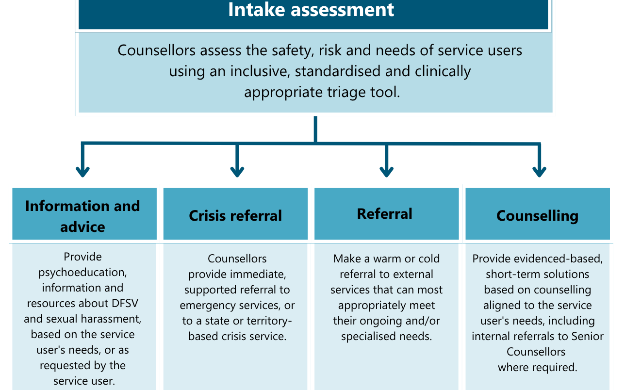
Source: 1800RESPECT contract.
The support provided by 1800RESPECT is guided by the service principles, which are designed to ensure that 1800RESPECT delivers a safe, trauma-informed, person-centred, inclusive and connected service (see Figure 3 below).
Figure 3: 1800RESPECT service principles
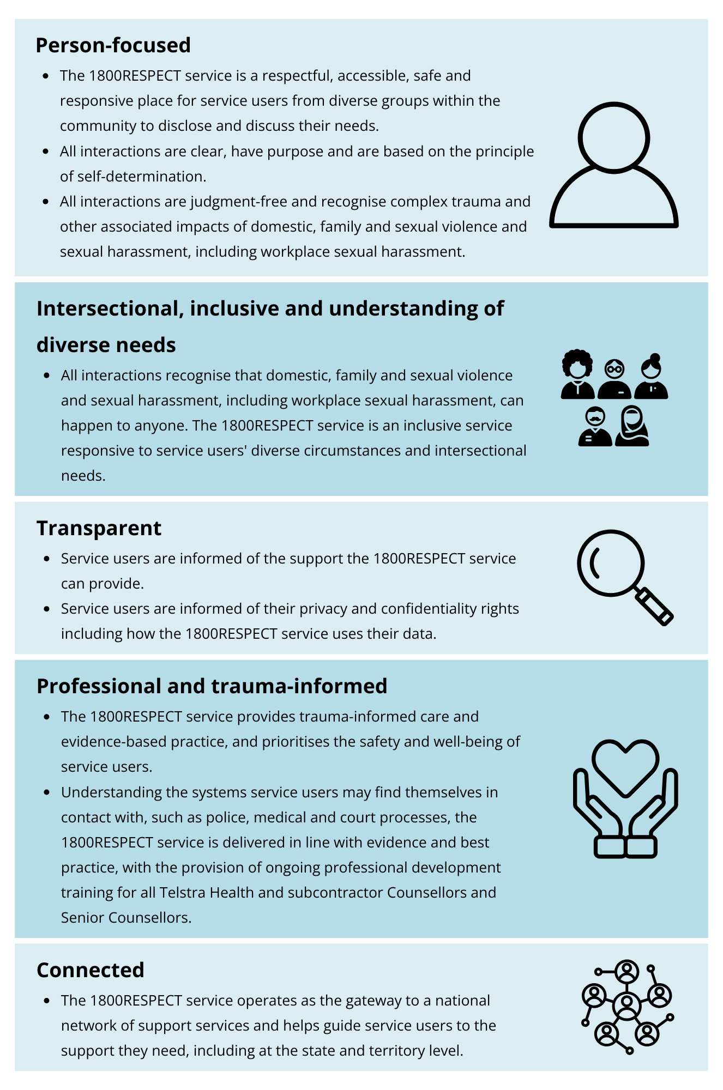
Source: 1800RESPECT contract.
Support is also underpinned by the 1800RESPECT Clinical Governance Framework, which includes theoretical and evidence-based standards, processes and protocols to ensure delivery of high-quality outcomes for all service users, including through clinical risk and incident management.

Counsellor qualifications and training
To ensure support is delivered in line with the service principles and 1800RESPECT Clinical Governance Framework, 1800RESPECT Counsellors and Senior Counsellors are required to:
- meet minimum qualifications and registrations relevant to their role and the level of support provided to service users, which includes minimum relevant tertiary qualifications (such as social work) and counselling experience
- undertake comprehensive, evidence-based induction training and ongoing professional development, support, supervision and coaching on topics including, but not limited to:
- trauma-informed support and practice
- crisis identification and management, including referral
- domestic and family violence
- sexual violence, including sexual harassment and workplace sexual harassment
- intersectionality and underrepresented cohorts
- responding to service users with complex presentations
- systems relevant to service users accessing 1800RESPECT, such as police, medical and court processes
- vicarious trauma and self-care
- counselling approaches
- short-term, solutions-based counselling.

Governance
Telstra Health is the primary service provider. Telstra Health also provides IT infrastructure and leadership to facilitate the service and monitor and manage demand. It subcontracts specialist organisations10F to help deliver the service, including:
- 54 Reasons (previously Save the Children Australia)
- Marninwarntikura Women’s Resource Centre
- Lifeline Australia
- Safe Steps Family Violence Response Centre.
The ways in which subcontracted organisations contribute to service design and delivery vary. Some organisations are providing specialist advice under the 1800RESPECT Clinical Governance Framework, while others are simply providing additional counselling support.
All counsellors operate under 1800RESPECT so service users are not aware which organisation a counsellor is employed by.

Funding model
1800RESPECT was originally funded by the Australian Government through a series of multi-year grant agreements from 8 July 2010 to 30 June 2022. Under these arrangements, funding was provided for each contact made to 1800RESPECT.
As part of the 2020 to 2022 procurement process, the funding model was changed from cost-per-contact to payment for the length of time support is provided (see Section 1.2.1). As explained, the new PMF was introduced to formalise this model. The PMF employs a 3-tiered approach to monitor and incentivise service performance through complementary measurement systems, including:
- Strategic Performance Measures (SPMs)
- Key Performance Indicators (KPIs)
- System Health Indicators (SHIs).
This integrated framework creates a layered accountability system where KPIs drive immediate operational performance, SPMs encourage strategic value creation, and SHIs provide monitoring without penalty to identify emerging issues (see Chapter 5 for more detail).

The evaluation

Purpose
The department engaged ARTD to conduct an independent evaluation of 1800RESPECT from July 2024 to June 2025. The purpose of this evaluation is to consider the extent to which 1800RESPECT is achieving its strategic outcomes. We aimed to fill gaps in knowledge and provide practical recommendations that support continuous improvement in 1800RESPECT service delivery.
In doing so, our evaluation provides evidence of 1800RESPECT’s progress towards:
- The Australian Government’s contribution to Action 4 under the First Action Plan 2023–2027, under the National Plan to End Violence against Women and Children 2022−2032: ‘Build the capacity of services and systems that support victim-survivors to provide trauma-informed, connected and coordinated responses that support long-term recovery, health and wellbeing.’
- The department’s response to the Auditor-General Report No.15 2022–23 Performance Audit Procurement of 1800RESPECT, where the department agreed to ‘develop an evaluation strategy and plan to assess the performance of 1800RESPECT in line with its objectives and the performance management framework. The evaluation strategy should have regard to the relevant recommendations of the evaluation of the first National Plan and the relevant targets and indicators of the second National Plan.’

Scope
Given the recent evaluation of 1800RESPECT,11F and other existing research relating to the service, this evaluation builds on prior knowledge of the delivery and impact of 1800RESPECT through a focussed assessment of the impact of the current funding arrangements and changes to the service model.
Our evaluation focuses on the period from when Telstra Health started delivering 1800RESPECT on 1 July 2022 until 31 March 2025.12F We focussed on assessing the current model using previous reviews and the contract as a reference. Our evaluation does not directly examine implementation of the service under previous models and previous service providers.
1800RESPECT’s clinical model, including its approach to service user support, and policies and procedures for ensuring quality and safety of clinical care for service users, and the extent to which the service model is aligned with best practice, is outside of the scope of this evaluation.

Key Evaluation Questions
This evaluation responds to the Key Evaluation Questions in Table 1. The table also provides a reference to the relevant sections of the report where these questions have been answered.
Table 1: Key Evaluation Questions
Key Evaluation Questions and sub-questions | Section
KEQ1: How effective is 1800RESPECT in achieving its outcomes to deliver a high-quality service that is accessible and responsive to service user needs? | 3, 4
1a) What is the extent of community awareness and confidence in 1800RESPECT and the support it provides (including among people who have historically been underrepresented in 1800RESPECT service data)? | 3.1
1b) To what extent does 1800RESPECT provide services that are accessible to all people affected by DFSV including people who have historically been underrepresented in 1800RESPECT service data? | 3.2
1c) To what extent does 1800RESPECT provide services that are appropriate to all people affected by DFSV including people who have historically been underrepresented in 1800RESPECT service data? | 4
1d) How does 1800RESPECT support service users with complex needs (e.g. complex trauma)? | 4.2.4
1e) As the ‘National Front Door’, to what extent does 1800RESPECT support service users to navigate the broader service system through the provision of trauma-informed, connected and coordinated support? | 4.3
1f) How has the addition of new service channels, and the expansion of 1800RESPECT’s remit to include workplace sexual harassment, impacted service delivery? | 3.1.3, 3.2.1, 4.1
KEQ 2: To what extent is 1800RESPECT efficiently delivering a value for money service? | 5
2a) How is the current 1800RESPECT performance management framework supporting the efficiency of the service? | 5.1
2b) What are the key cost drivers under the current service delivery arrangements? | 5.2
2c) What opportunities exist for continuous improvement? | 6.2

Methods
We have used a mixed methods design for the evaluation incorporating qualitative and quantitative data collection and analysis. We sought ethical approval for the evaluation from the Human Research Ethics Committee (HREC), Bellberry Limited (Application ID: 2024-10-1337-A-2) and this was approved on 3 March 2025.
We have synthesised data across all sources to triangulate findings. Each method is described below.

Literature scan and document review
We reviewed a range of background documents provided by the department to inform our understanding of the 1800RESPECT service model and its history. These documents included:
- contract and PMF
- prior UNSW evaluation
- ANAO performance audit
- Senate inquiry documentation
- past reviews of 1800RESPECT.
We also conducted a brief scan of relevant literature and policy documents to help contextualise and support key findings in this report. A systematic review of the support service literature was not in scope of this evaluation.

Qualitative methods
Interviews were carried out with a range of stakeholders. Stakeholder groups and sample sizes are described in Table 2. A lived experience researcher conducted interviews with service users.
Table 2: Overview of stakeholders interviewed
Stakeholder group | Role | Sample size | Delivery mode
Department staff | 1800RESPECT policy and governance staff | n=2 interviewees | Written responses (n=2)
Telstra Health Directors/Managers | Telstra Health management staff including operations, strategy, finance, risk, clinical expertise and commercial management | n=13 interviewees | Semi-structured interviews and focus groups (n=5)
Team leaders | Telstra Health and subcontracted organisation call centre management staff including contact centre and clinical management | n=10 interviewees | Semi-structured interviews and focus groups (n=4)
Front line staff | Telstra Health and subcontracted organisation Counsellors, Senior Counsellors and Clinical Support Specialists | n=20 interviewees | Semi-structured interviews (n=19)
Peak bodies, lived experience panels and advocacy groups | Organisations representing underrepresented cohorts and people with lived experience of DFSV and peak bodies representing these cohorts | n=41 interviewees | Semi-structured interviews and focus groups (n=13)
External service providers | DFSV, housing, legal and health services including services for underrepresented cohorts | n=20 interviewees | Semi-structured interviews and focus groups (n=12)
Past service users | Past 1800RESPECT service users | n=8 interviewees | Semi-structured interviews (n=8)

Interview data analysis
Interviews and focus groups were recorded, transcribed and analysed by theme using a grounded theory approach to thematic analysis. The evaluation team collaboratively developed a coding framework based on the evaluation questions and sub-questions to identify key themes and findings. This was then programmed into NVivo, a qualitative data analysis (QDA) software that allows us to categorise sections of transcripts into different codes to enable systematic qualitative analysis.
Emerging themes from the analysis were regularly discussed among the evaluation team to ensure consistent interpretation and enable further exploration of key themes in the interviews and focus groups.

Quantitative methods

1800RESPECT service data analysis
Telstra Health provided the evaluation team with reporting extracts containing de-identified monthly aggregate data relating to all service user contacts for the period from July 2022 to December 2024 for all Counsellor and Senior Counsellor service channels. These reports related to:
- telephony metrics
- access and service level
- cold and warm referrals
- service user demographics
- service user presenting needs
- service user complaints and compliments
- audited calls with a focus on adherence to the PMF
- audited calls with a focus on the achievement of appropriate outcomes.
We conducted descriptive analysis to examine service use and patterns of service delivery over the evaluation period.
Data relating to access and use of the 1800RESPECT website, as well as the Sunny and Daisy applications, were not included in this analysis.

Performance Management Framework reporting data analysis
We received aggregated reporting data of several metrics of the PMF, including Key Performance Indicators (KPIs), Strategic Performance Measurements (SPMs) and System Health Indicators (SHIs). Data for KPIs and SHIs were aggregated monthly, and SPMs were aggregated 6-monthly.
The final extract of the PMF reporting we analysed excluded the implementation period at the start of Telstra Health’s service delivery: 1 July 2022 to 28 February 2023. The implementation period gave Telstra Health time to work up to full implementation prior to the PMF coming into effect.
Our analysis covered from 1 March 2023 to 31 December 2024, with several exceptions. First, KPI-03 data covered a service delivery period of November 2023 to December 2024 and KPI-08 data covered a service delivery period of February 2024 to December 2024. Second, given the 6-monthly aggregation of data, the final extracts of the SPM data covered a service delivery period of January 2023 to December 2024.
Of note, several PMF metrics were not included in the data extract for various reasons: KPI-06 (no data), KPI-07 (no data), SHI-03 (performance band and APS only visible to Commonwealth and service provider) and SPM-05 (has not been implemented – no data).
We analysed the available data by looking at the performance band (A, B, C, D) and the APS score of each metric across the service delivery period to identify trends in performance and determine if the PMF is effectively driving intended behaviours and outcomes in the service provider.

Population survey
We conducted a nation-wide population survey through a subcontracted market research company, Market Metrics. The purpose of this survey was to understand community awareness of and attitudes toward 1800RESPECT and the support it provides in a large national sample. The survey included some basic demographic questions, including age, gender, transgender identity, sexual orientation, state or territory of residence, area/location (i.e., major city, regional, rural), Aboriginal and Torres Strait Islander identity, culturally and linguistically diverse background13F and disability identity. These questions were used to help us meet our target sample sizes for different demographic groups (see Appendix A1.1). Market Metrics used their databases and partner databases to allow targeted recruitment of these demographic groups. The online survey was open from 5 February 2025 to 20 March 2025. There were 3,679 total survey respondents.
We conducted descriptive analysis of each of the questions across the whole sample and then broke these down by variables of interest such as demographics and previous use of 1800RESPECT. Where sample sizes were sufficient, we followed up descriptive analysis of responses with inferential statistics (chi-square test and/or Fisher’s exact test) to examine differences in awareness and attitudes toward 1800RESPECT between groups of interest. Only group differences that reached statistical significance (p < 0.05) were included in this report. We also conducted text-mining analysis of open-text survey responses to identify common themes and phrases.

Confidence in the findings and limitations
We were able to implement most of the planned data collection and analysis methods as intended and had sufficient data to confidently answer the Key Evaluation Questions. However, there were some limitations to the data:
- We interviewed a smaller sample of service providers than intended. This was largely due to the lack of connections 1800RESPECT had with external service providers – many providers did not respond to our request, or responded saying that they did not know enough about the service to comment. While this has limited our ability to interview service providers, we feel that this reflects broader evaluation findings relating to 1800RESPECT’s connection and relationships within the service system.
- We interviewed a smaller sample of service users than intended. Our key recruitment mechanism involved working with longer-term support services to invite participants so that only service users who were known to be previous users of 1800RESPECT assessed as being suitably low-risk to participate in an interview, would be invited to participate. The approach assured the safety of participants but yielded low numbers of interviewees. However, other data sources contributed to our understanding of service user experiences including data from service users who completed the population survey. In addition, more lived experience panels were engaged than originally planned. These panels are comprised of people with lived experience of DFSV that are convened by peak and advocacy agencies to help support the inclusion of lived experience voices in sector related consultations. While not all panel members had direct experience of using 1800RESPECT, all were able to provide insights as to the needs, concerns, risks and barriers to accessing support that confront those affected by DFSV. Our understanding of service user experiences was further augmented by analysis of compliments and complaints data from the 1800RESPECT website. We also collected substantial anecdotal feedback about service user experiences from interviews with external service providers and peak bodies.
- Analysis of the service data was limited by the quality and completeness of data captured by counsellors in Telstra Health’s Customer Relationship Management (CRM) system during the delivery of the service (see Opportunity 4 in Section 6.2 for suggested improvements to data collection). Some information, such as the demographic characteristics of service users, is infrequently recorded as this data is not routinely collected by counsellors due to considerations about collecting information relating to service users in a trauma-informed manner. As a result, this data is only recorded when it is proactively disclosed by the service user as part of their engagement with 1800RESPECT. For some other data captured in the Telstra Health CRM, such as referrals made, the quality and completeness are impacted by issues with data entry processes, resulting in information not always being captured for all contacts.
- In addition, the data able to be collected by a service of this type (a support service where service users can opt to remain anonymous) includes very limited insights into outcomes for service users. The methodological and ethical challenges associated with collecting and examining data on the impact of support services such as 1800RESPECT are well known.14F For example, service users may be reluctant to compromise their anonymity. This is particularly salient in the context of the nature of support that service users receive from 1800RESPECT. Nevertheless, it is possible to collect a range of demographic and other data, such as presenting issues, without compromising a service user’s anonymity and there is an opportunity for this element of the service design to be improved (see Section 6.2). These concerns, however, have meant that the service data 1800RESPECT collects is for only a relatively small proportion of all service users, and that 1800RESPECT does not collect direct service user feedback about the effectiveness of the service beyond complaints and compliments submissions. As a result, the extent to which this evaluation is able to directly assess how effectively the service is able to meet the needs of service users more broadly is limited.
- Our estimates of 1800RESPECT access and attitudes of past 1800RESPECT service users through the population survey are based on self-reported prior use of 1800RESPECT. As a result, we are unable to verify that these individuals had in fact accessed 1800RESPECT within the indicated time period. Although there are known difficulties with using broad based online-recruitment approaches to examine experiences of DFSV and/or use of DFSV services,15F the design of the survey (in which participation was not driven by reported use of the service, and there was no additional benefit to the respondent for reporting service use) minimises this potential limitation. As a result, we feel confident that the estimates of 1800RESPCT service use reflect the rates of use of the service within the community.

How effective is 1800RESPECT in delivering an accessible service?
Chapter 3 examines the extent to which 1800RESPECT is achieving its outcomes to deliver
a high-quality service that is known in the community and accessible to all people affected
by DFSV.
KEQ 1: How effective is 1800RESPECT in achieving its outcomes to deliver a high-quality service that is accessible and responsive to service user needs?
- 1a. What is the extent of community awareness and confidence in 1800RESPECT and the support that it provides (including among people who have historically been underrepresented in 1800RESPECT service data)?
- 1b. To what extent does 1800RESPECT provide services that are accessible to all people affected by DFSV including people who have been historically underrepresented in 1800RESPECT service data?
- 1f. How has the addition of new service channels, and the expansion of 1800RESPECT’s remit to include workplace sexual harassment impacted service delivery?

What is the awareness and understanding of 1800RESPECT in the community?
1800RESPECT is intended to be the National Front Door – a service that is accessible to people affected by DFSV across Australia and is intended to act as a first point of contact – providing service users with counselling, information and support relating to their individual circumstances. For 1800RESPECT to effectively fulfil this role, it is critical that the broader community, including those who are not seeking to access supports relating to DFSV, is aware of the service and understands the types of support it provides.

1800RESPECT is well known in the community and within a range of diverse groups, but there are opportunities to increase awareness
To understand community attitudes towards 1800RESPECT, we conducted a large survey of the Australian population (N=3,679). This found that there was a broad – although not comprehensive – awareness of 1800RESPECT within the community, with around half of all survey respondents having previously heard about 1800RESPECT (55%) (see Figure 4). This is consistent with what peak bodies, advocacy groups, service providers and service users reported: while all had heard of 1800RESPECT, some service users reported that they had only found out about 1800RESPECT when they needed support, and some advocates said they only really became aware of the service when they became involved in the sector. Service providers generally told us that awareness among those they supported ranged from about half to most.
Figure 4: Community awareness of 1800RESPECT
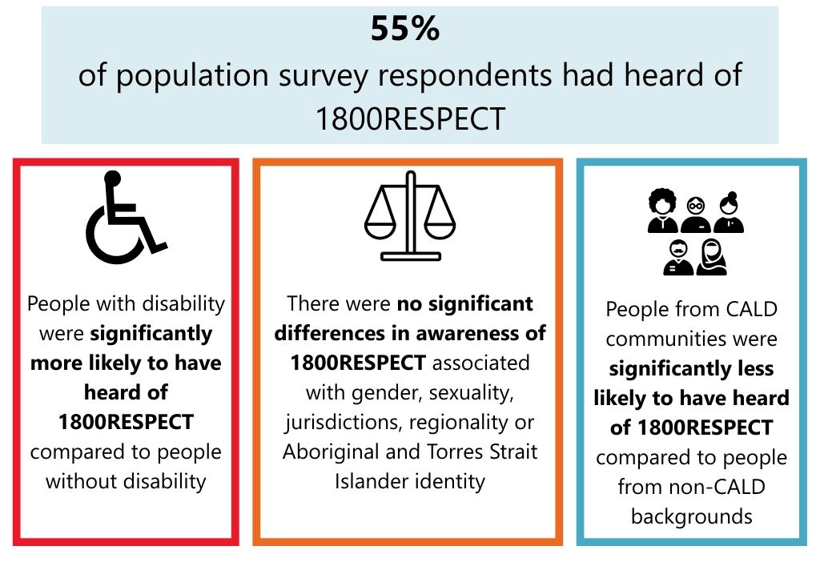
Source: Population survey – January to March 2025.
Among survey respondents, awareness of 1800RESPECT was similar across a range of groups. There were no significant differences in awareness driven by gender, jurisdiction, regionality, or Aboriginal and Torres Strait Islander identity.
However, service provider and sector interviewees reported that regional and rural areas had lower levels of awareness than metropolitan areas. Given these perceptions were not borne out in the survey results, where there were no differences in awareness based on geography, this may indicate that this historical disparity has reduced and that awareness raising of the service in areas of historically low awareness has been effective.
In the survey, people with disability were significantly more likely to have heard of 1800RESPECT (60%) compared to people without disability (54%).16F This higher level of awareness may reflect targeted promotion for people with disability, the existence of the Sunny app and/or the fact that people with disability are more likely to access health services.17F It may also reflect longer-term impacts of the Disability Referral Pathways Project that was developed as a result of targeted research relating to the awareness, inclusivity and accessibility of 1800RESPECT for people with disability and delivered between 2017–2019 under the previous service provider.18F
In contrast, people from CALD backgrounds were less likely to have heard of 1800RESPECT (42%) than people who did not come from a CALD background (58%). This is unsurprising given lower awareness of health services among CALD populations in Australia.19F While 1800RESPECT has worked with the Harmony Alliance to develop posters targeted to people from CALD backgrounds, this indicates that there is potential to increase promotion of the service and engagement with CALD communities. Some interviewees suggested that improving awareness among CALD communities required further engagement with stakeholders from CALD communities who were not working in DFSV organisations. For example:
- engaging with faith-based and other community-based organisations – as these are key places people from CALD backgrounds typically go for support
- building relationships with peak bodies, such as the Australian National Imams Council, that sit outside of the DFSV sector
- engaging with settlement services.
While interviewees noted that 1800RESPECT is widely promoted across various channels – including in the media, in service provider and peak body communications, and in physical locations – Telstra Health staff were the only interviewees who mentioned social media. This may suggest there is an opportunity to increase promotion through social media. Other suggestions from interviewees included:
- increasing 1800RESPECT’s presence in geographically hard-to-reach communities
- including more diverse representation in the promotion of the service and service offerings to make it clear that 1800RESPECT is inclusive and culturally appropriate for people from underrepresented cohorts
- building stronger relationships with peak bodies and other key sector stakeholders (discussed further in Section 4.3).

1800RESPECT’s role in providing support relating to domestic and family violence is well understood, but sexual harassment (including workplace sexual harassment) is a lesser-known part of 1800RESPECT’s remit
There is generally good understanding in the community that 1800RESPECT provides support relating to domestic violence. When asked to describe the type of support 1800RESPECT can help people with, the most common words survey respondents used were ‘domestic’ and ‘violence’, and people most commonly used the phrases ‘domestic violence’ or ‘family violence’ when describing 1800RESPECT (Figure 5). However, ‘mental health’ was the third most common phrase used by respondents to describe 1800RESPECT – suggesting that there may be some confusion between 1800RESPECT and other similar support services (particularly telephone helplines) in the community.
Figure 5: Community descriptions of 1800RESPECT
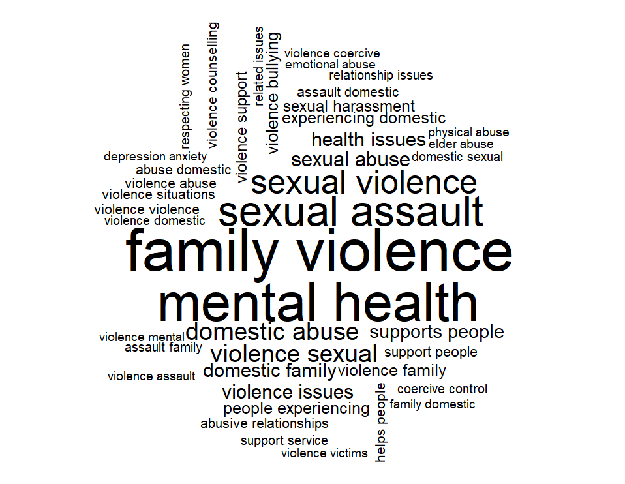
Source: Population survey – January to March 2025.
There is also lower awareness of other aspects of 1800RESPECT’s remit among survey respondents. People less commonly referred to sexual violence or sexual abuse than domestic or family violence when describing the types of issues 1800RESPECT can provide support with. Fewer than 1% (n=87) of respondents referenced sexual harassment and only 2 respondents referenced ‘workplace sexual harassment’ when describing what 1800RESPECT can help with.
This is unsurprising given workplace sexual harassment was only emphasised as part of 1800RESPECT’s remit in Recommendation 54 of the Respect@Work report, which was released in March 2020 and said:20F
‘The Australian Government promote the 1800RESPECT hotline and ensure it is adequately resourced to expand its services to provide appropriate psychological support and referral to people affected by workplace sexual harassment, and collect and maintain de-identified and disaggregated data on contacts regarding workplace sexual harassment.’21F
Plans to action this recommendation commenced in 2022 under the new 1800RESPECT contract. Since this time, Telstra Health has prioritised the following activities in preparation for increased promotion:
- counsellor training and professional development
- updates to the service directory – the list of services that people experiencing DFSV can access for support beyond 1800RESPECT, presented online and managed by Telstra Health
- updates to policies and procedures
- digital content uplift, including web pages and routine communications.
Broader promotion of this area of the service’s remit is prioritised for 2025 and 26.

The community generally felt that 1800RESPECT provides a safe and accessible service
1800RESPECT aims to deliver a respectful, accessible, safe and responsive service to people from diverse groups within the community. To understand the extent to which the community felt 1800RESPECT upheld these principles, we asked population survey respondents about their attitudes. All respondents – including those who had and had not heard of 1800RESPECT prior to the survey – were shown a brief description of 1800RESPECT provided by the department and Telstra Health and asked about their perspectives of the service based on this description of the service and what they already know about 1800RESPECT (if relevant).
The population survey found that the community held positive attitudes towards 1800RESPECT, broadly reporting that it was a safe and accessible service. Figure 6 shows that nearly 4 in 5 (79%) respondents reported that they would feel very or totally safe using 1800RESPECT if they needed, and nearly three-quarters (74%) of respondents felt very or totally confident they would be able to access the service if needed. Community attitudes about the relevance of 1800RESPECT were lower – 51% felt that 1800RESPECT would provide relevant information. However, this is not unexpected given that many in the community may not think the service 1800RESPECT provides is relevant if they are not currently experiencing and/or supporting someone with DFSV or sexual harassment.
Figure 6: Community perceptions of the safety, accessibility and relevance of 1800RESPECT
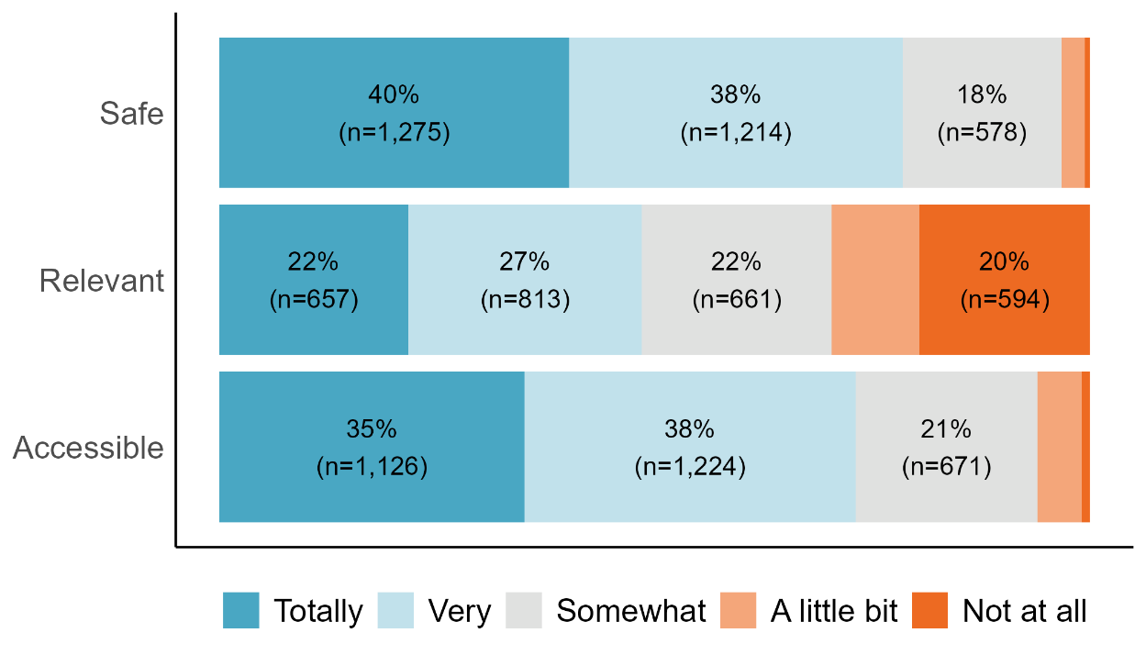
Source: Population survey – January to March 2025. Note: Only respondents who had not used 1800RESPECT are included in this analysis. Labels for values <15% are not shown.
When asked if they would recommend 1800RESPECT to someone in need of support, using the Bain & Co. Net Promoter Score (NPS) methodology,22F 70% of respondents were categorised as promoters, 15% were passive and 15% were detractors (see Figure 7). This resulted in a NPS score of 55, which indicates that more people are likely to promote the service than not. In Australia and New Zealand, NPS scores above 30 are considered good, and scores above 80 are considered excellent. This indicates that for people who have not accessed the service, the general marketing of 1800RESPECT is working well at promoting the service as somewhere that community members would feel comfortable referring others to for support.
Figure 7: Community NPS scores for 1800RESPECT
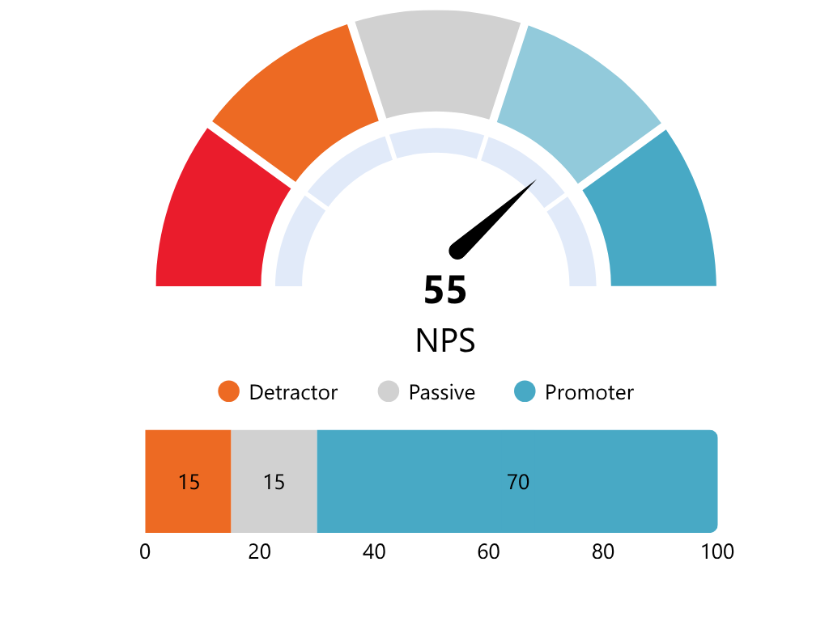
Source: Population survey – January to March 2025. Note: Only respondents who had not used 1800RESPECT are included in this analysis. Net Promoter Score is calculated as the proportion of promoters minus the proportion of detractors. NPS scores can range from -100 to +100. Scores above 0 are positive, indicating there are more promoters than detractors. Scores above 30 are considered good, and scores above 80 are considered excellent.

Some underrepresented cohorts had different perspectives on the safety, relevance and accessibility of 1800RESPECT
Although perceptions of 1800RESPECT as a safe, relevant and accessible service were high across the community, there were some statistically significant differences in reported perceptions between different underrepresented cohorts.23F These perceptions were based on a brief description of the support provided by 1800RESPECT and its approach to providing this support that was included in the survey.

Safety
- People with disability were less likely to report that they felt safe using 1800RESPECT (69% totally or very safe) compared to people without disability (78% totally or very safe). Nevertheless, this still reflects a high level of perceived safety of the service for all respondents.

Relevance
- People in rural and remote areas were more likely to report that 1800RESPECT offers a service that is relevant to them (57% totally or very relevant), compared to respondents from major cities or regional towns (46% totally or very relevant).
- Younger people were more likely to report that 1800RESPECT was relevant to them than older respondents. Fifty-three percent of respondents aged 18 to 35 thought 1800RESPECT could provide them with support that is totally or very relevant to them, compared to 42% of respondents aged 55 and over.
- People from CALD backgrounds were more likely to think that 1800RESPECT provided a service that was relevant to them (52% totally or very relevant) than people from non-CALD backgrounds (47% totally or very relevant).

Accessibility
- People with disability were less likely than other respondents to be confident that they would be able to access 1800RESPECT if they needed to.
- People from CALD backgrounds were less likely to feel confident that they could access 1800RESPECT if they needed to (66% totally or very confident in ability to access, compared to 73% for people from non-CALD backgrounds).

Confidence
Some interviewees representing underrepresented cohorts reported low confidence in the service among their cohort due to:
- inconsistent experiences of support among service users
- a lack of perceived cultural appropriateness and safety
- historic mistrust of services among LGBTQIA+ and Aboriginal and Torres Strait Islander communities.

How accessible is the service?
1800RESPECT delivers a national service that is confidential, free of charge, operates 24/7 and has low wait times. As 1800RESPECT has evolved, different channels have been introduced to improve accessibility for people with different communication and access needs (see Figure 8 below). Overall, interviewees from all stakeholder groups were highly positive about the range of channels and ease with which people could contact 1800RESPECT.
Figure 8: 1800RESPECT access channels
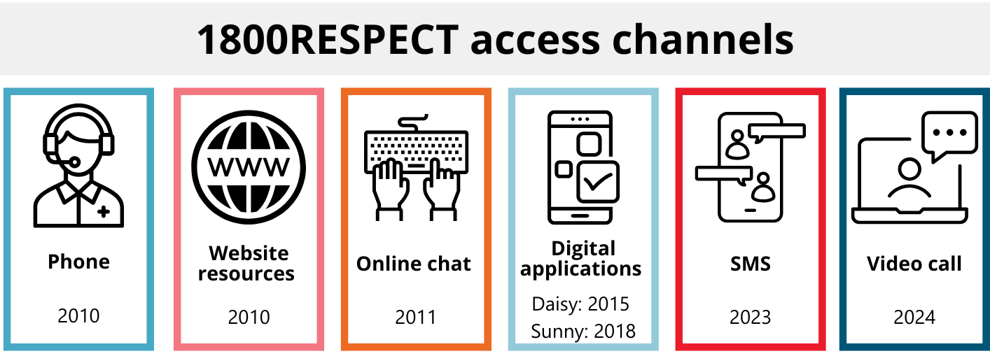

The range of access channels cater to people with different needs and preferences
Throughout the evaluation period, 1800RESPECT answered 847,058 contacts from service users across Australia over phone, online chat, SMS and video call service channels. The number of contacts that were answered by counsellors for each channel is shown in Figure 9. The number of contacts answered by each service channel across the delivery of the service is also shown in Figure 9.
Figure 9: Number of contacts answered by counsellors by channel
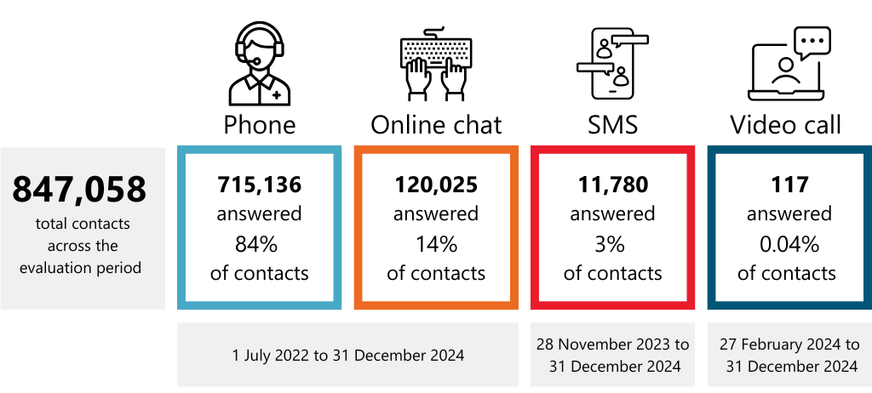
Source: 1800RESPECT service data – Service level (1 July 2022 to 31 December 2024). Note: SMS and video call service channels were introduced as part of planned changes to the service model to improve accessibility. The proportion of contacts were calculated based on the total number of contacts answered during the period that service channel was active. As a result these percentages do not sum to 100.
Figure 10: Access to 1800RESPECT by service channel across the evaluation period
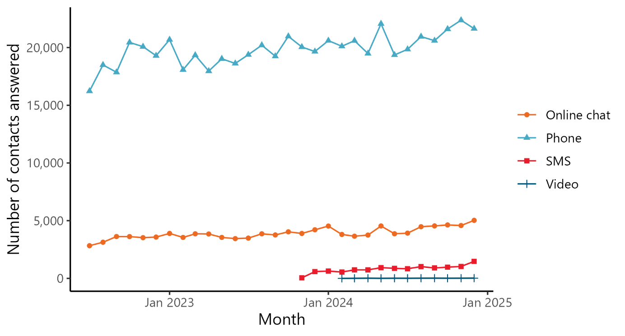
Source: 1800RESPECT service data – Service level (1 July 2022 to 31 December 2024). Note: SMS and video call service channels were introduced as part of planned changes to the service model to improve accessibility.
The most established channels were most commonly used to access the service. Phone call is by far the most commonly used channel (84% of all contacts), followed by online chat (14% of all contacts, see Figure 9 above). This was followed by the newer channels: SMS and video call. For SMS, 11,303 contacts were answered between when the channel was introduced on 28 November 23 and 31 December 24 (3% of contacts in that period). The data shows that online chat usage has remained relatively stable with the introduction of SMS, which suggests that the introduction of this channel is important for improving accessibility of the service as it is attracting people who otherwise may not have contacted 1800RESPECT. Interviewees across all stakeholder groups were also highly positive about the introduction of the 24/7 SMS channel. They thought it was key to improving access for younger people (18+), people with different access or communication needs and people who are in a situation in which it is not safe/appropriate to speak on the phone or online chat.
Between 27 February 2024, when the on-demand video call channel was introduced, and 31 December 2024, 117 contacts were answered via video call (0.04% of contacts in that period). Low usage over this period is unsurprising as it was initially only made available during business hours (9 am to 5 pm, Monday to Friday, excluding national public holidays) and minimally promoted. This was deliberate to ensure both the department and Telstra Health could monitor and gain insights into the technical and operational aspects that were needed to support counsellors and service users to use this new service channel in a clinically safe way.

In late 2024, the department and Telstra Health agreed to begin a staged expansion of the operating hours and promotion of the video call channel, working towards 24/7 operation by 1 July 2025. While video call channel data beyond 31 December 2024 is out of scope of this evaluation, the department has reported a substantial increase in usage of this channel since the expansion of video hours to 9 am to midnight from 4 February 2025 and then to 7 days a week from 1 April 2025. Telstra Health has also provided anecdotal feedback that some new video call service users have mentioned the promotional material launched during these expansion phases encouraged them to contact the service. Counsellors we interviewed commented that this channel would be suited to isolated people, such as older people and those living in rural and remote areas, as it simulates face-to-face support, and for people with disability or people from CALD backgrounds who may benefit from non-verbal communication techniques.
Population survey respondents were asked which channels they would use to access 1800RESPECT if they needed information and support. This included channels through which they could speak to a counsellor (phone line, online chat, SMS and video call) and channels for accessing information (1800RESPECT website and digital applications) (see Figure 11 below).
Figure 11: Community preferences for accessing 1800RESPECT by channel type
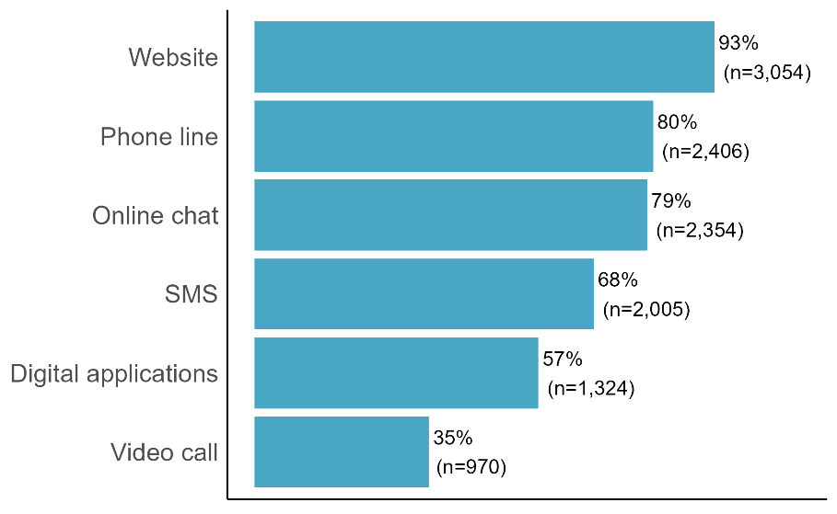
Source: Population survey – January to March 2025.
The website was the most commonly selected channel among population survey respondents. Aligned to service usage data, phone line and online chat were the next most commonly selected channels, followed by SMS. The digital applications and video call were the least commonly selected channels; however, these were still selected by a substantial proportion of respondents (57% and 35%, respectively). These results suggest there is potential for the use of the online chat and SMS channels to increase given strong community preferences for accessing the service in these manners. Although video call was the least preferred method of access, this channel can be valuable in meeting the accessibility needs and preferences of certain types of service users, as discussed above.

1800RESPECT delivers a responsive service with low wait-times for service users
A core element of the PMF between the department and Telstra Health is ensuring the responsiveness of 1800RESPECT. Service levels are measured according to the proportion of contacts that are answered within 20 seconds. 1800RESPECT’s service level target is for 80% of contacts across phone calls, online chat, SMS and video calls to be answered within 20 seconds.
The service level has improved over time across all channels, and the service is now consistently reaching its target service level (see Figure 12). The service level for contacts transferred to Senior Counsellors was also consistently at or above 80%, indicating that service users were able to access senior counselling support in a timely manner when Counsellors make these transfers. The service users we interviewed were all highly positive about the low wait times they experienced when contacting the service. This is a substantial difference from 2016 when, according to the ANAO report, average wait times to speak to a Counsellor were 10 minutes and 20% of internal referral calls to Senior Counsellors were not answered at all. This is also an improvement from the 37 second average wait time reported in the 2017 Senate Inquiry.
Figure 12: Service level for Counsellors and Senior Counsellors by service channel across the evaluation period
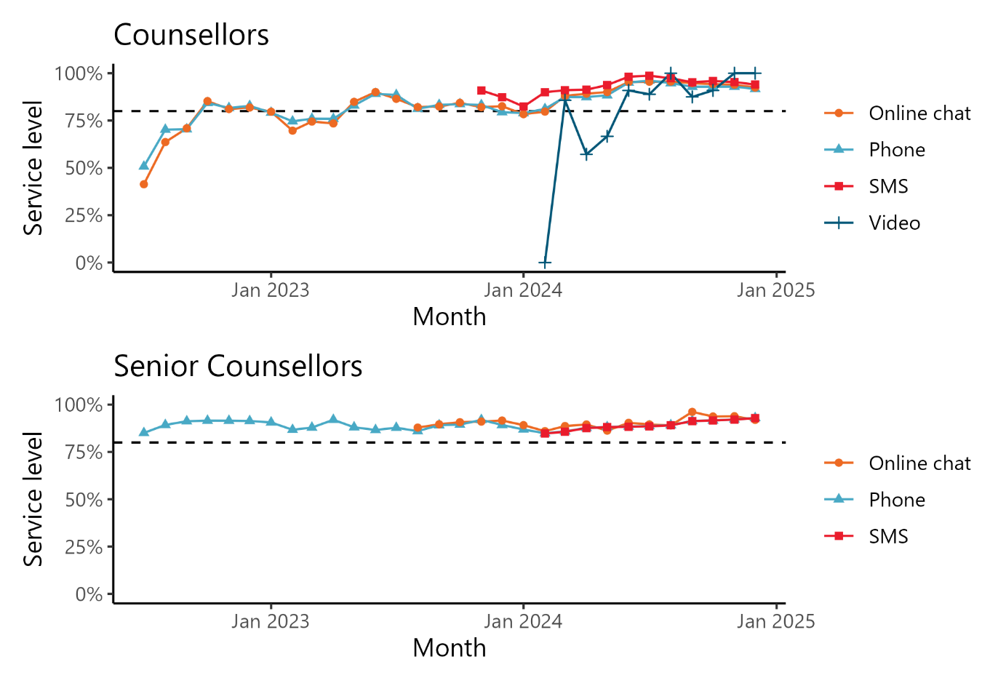
Source: 1800RESPECT service data – Service level (1 July 2022 to 31 December 2024). Note: SMS and video call service channels were introduced as part of planned changes to the service model to improve accessibility. There is no video call data available for Senior Counsellors as their services were not offered on the video call channel during the evaluation period. Recent expansions to the video call channel has seen Senior Counsellor services made available for the channel. The dashed line represents the target service level of 80% of contacts answered within 20 seconds.
The changes in the service model since Telstra Health was contracted were intended, in part, to support the responsiveness of the service and to make greater use of the supports that counsellors are able to provide service users. The strengthened service model for 1800RESPECT was introduced when Telstra Health was engaged as the service provider in July 2022. Under the strengthened model, Counsellors provide a greater range of support for service users, including safety, risks and need assessments, information, counselling and referrals. Service users are transferred to a Senior Counsellor where there is an identified clinical need, for example, where a service user needs more intensive, therapeutic support.
This change was made to introduce a ‘tell-it-once’ approach, which minimises the need for service users to repeat their story to multiple people and reduces the risk of re-traumatisation when they are seeking support. It was also intended to give Senior Counsellors greater capacity to support users with more in-depth needs, and to ensure the role of Counsellors better aligns to their qualifications and skills.
As an outcome of this change, the amount of time Counsellors spend with service users has increased, and transfers to Senior Counsellors have decreased (as observed in Figure 13). This was an expected consequence of Counsellors being able to provide enhanced and broader support to service users.
Figure 13: Proportion of contacts referred to Senior Counsellors across the evaluation period
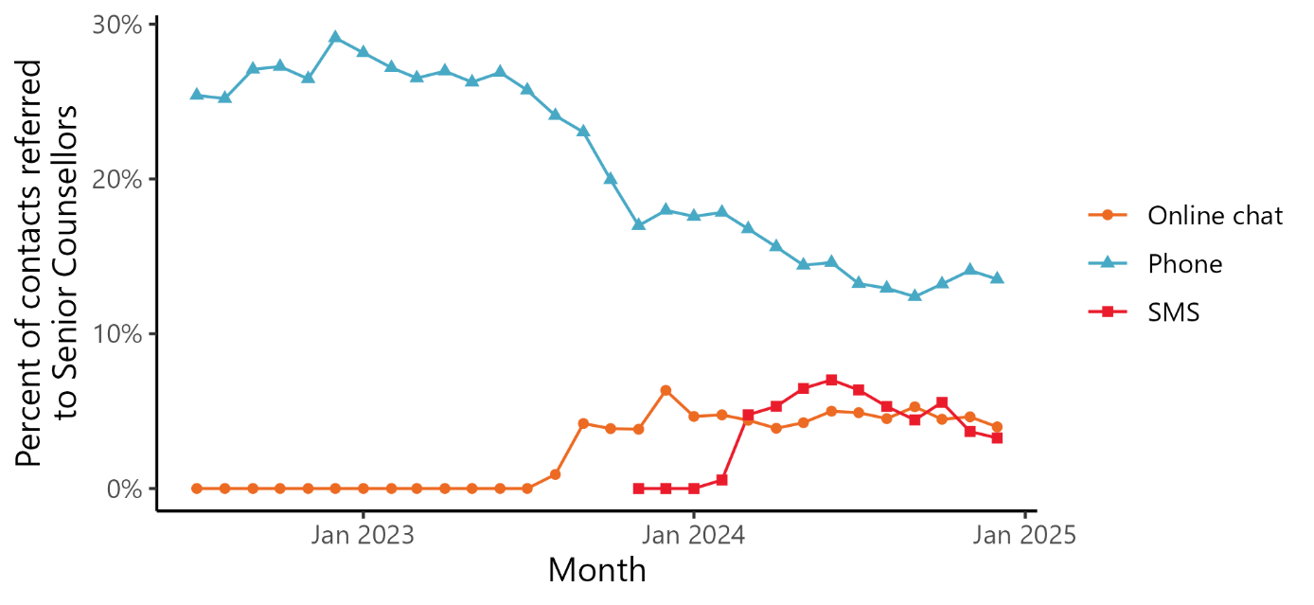
Source: 1800RESPECT service data (1 July 2022 to 31 December 2024).

Service users can access 1800RESPECT when they need it, including outside of business hours
External stakeholder interviewees frequently noted that a unique aspect of 1800RESPECT, particularly when compared to some jurisdictional DFSV support services, is that it delivers a service that can be accessed 24 hours a day, 7 days a week. Service users who left compliments on the 1800RESPECT website also highly appreciated that the service was available 24 hours a day, 7 days a week and open in periods when other services were not available.
Examining the average number of contacts made across the day illustrates the pattern of outside of business hours service usage. Figure 14 shows that across phone calls, online chat and SMS service channels, contacts begin ramping up from 8 am. For phone calls, contacts peak around noon and remain high throughout business hours. Contacts drop off slightly but remain steady from 5 to 10 pm, after which they steadily decline until 5 am. In contrast, for the online chat and SMS service channels contacts peak between 8 and 10 pm. Stakeholders suggested that these different patterns of demand suggests that the quieter and more discreet access that online chat and SMS channels provide may be valuable for service users looking for support overnight or where there may be more likely to be at home with other people. The service level and the proportion of referrals made to Senior Counsellors remained relatively steady, indicating that accessibility to the service was consistent regardless of the time of day that service users accessed it.
Figure 14: Average access to 1800RESPECT phone calls by time of day
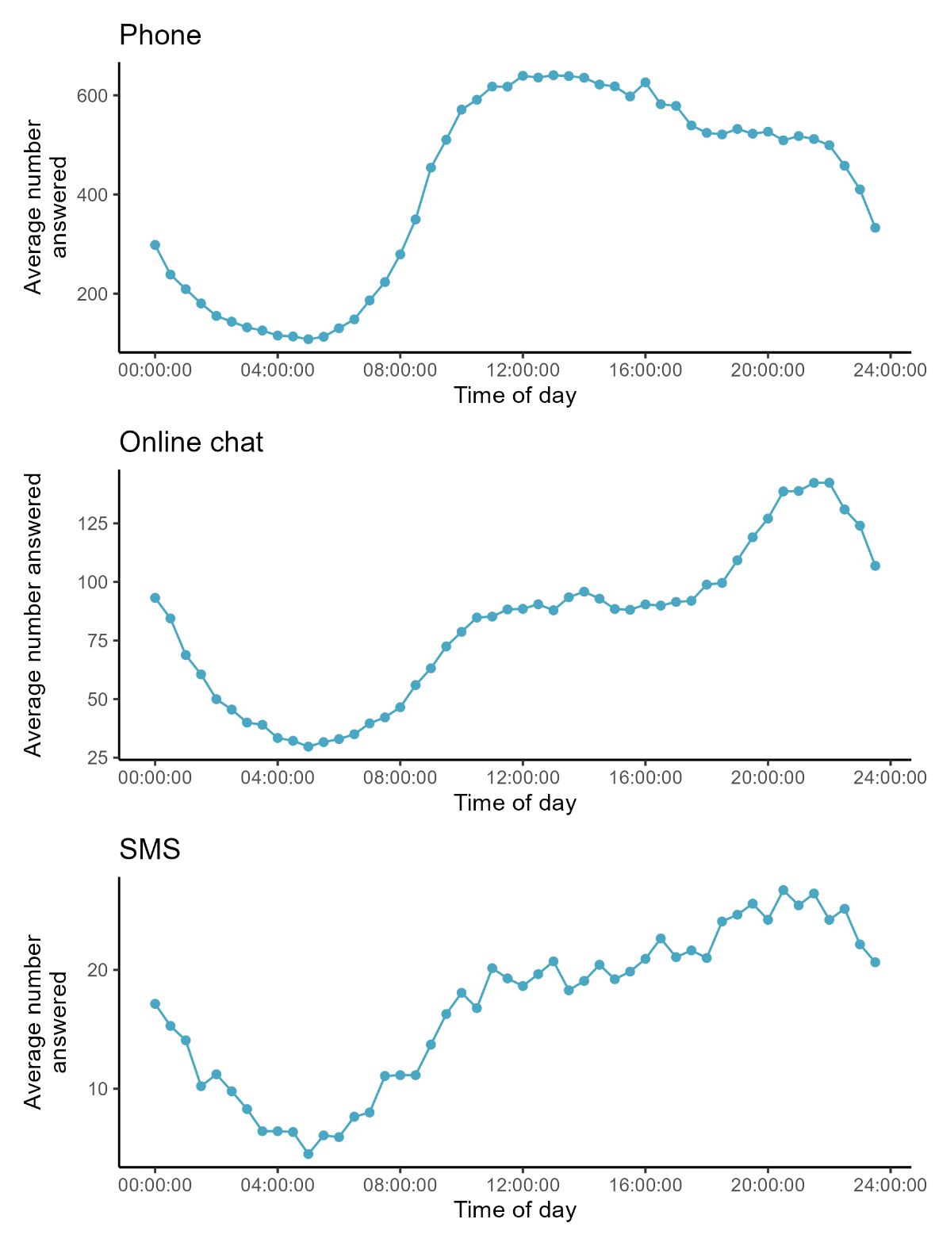
Source: 1800RESPECT service data (1 July 2022 to 31 December 2024). Note: Video calls have not been included in this analysis due to the smaller number of contacts to the service channel over the evaluation period.

1800RESPECT is used by service users in all jurisdictions
The number and proportion of contacts from each jurisdiction is shown in Table 3. Consistent with the last evaluation,24F the proportion of contacts in each jurisdiction aligns with the size of its population – jurisdictions with more residents have higher usage, while states with fewer residents have lower usage.
Table 3: Contacts to 1800RESPECT, by jurisdiction
State/Territory | Number of contacts | % of contacts | % of Aus. population
NSW | 161,554 | 29% | 31%
VIC | 144,262 | 26% | 26%
QLD | 118,317 | 21% | 21%
WA | 48,214 | 9% | 11%
SA | 47,641 | 9% | 7%
ACT | 11,515 | 2% | 2%
TAS | 11,355 | 2% | 2%
NT | 3,965 | 1% | 1%
Source: 1800RESPECT service data (1 July 2022 to 31 December 2024). Australian Bureau of Statistics (September 2024), National, state and territory population, ABS website, accessed 10 April 2025. Note: Contacts where location was not provided, or the service user was from an ‘other’ location have been excluded from this analysis.

There are additional considerations required for ensuring access to 1800RESPECT for underrepresented cohorts
While 1800RESPECT is a highly response service, our analysis of historic service user data has identified that some groups within the Australian community do not contact 1800RESPECT at the rates expected given the prevalence of DFSV in the community.
The ANAO performance audit noted that a need for better targeting of the service to underrepresented cohorts was identified as an issue, and that changes to the 1800RESPECT contract (informed by expert advice, the 2017 Senate Inquiry, and the Department’s experience of the service delivered between 2010 and 2020) were intended to address this. In addition to the introduction of SMS and video calls, key activities being undertaken to increase the accessibility of the service for underrepresented cohorts include:
- a stakeholder engagement plan, which sets out how Telstra Health will engage with key stakeholders, including people from underrepresented cohorts, in delivery of the service
- the Underrepresented Cohorts Strategy 2022–2027, which aims to identify and address barriers to access for underrepresented cohorts of service users, and ensure 1800RESPECT provides an inclusive, accessible and culturally supportive service
- a stakeholder panel including people working with or advocating for underrepresented cohorts, which provides advice to support the service to remain up-to-date with clinical and industry best practice, as well as to provide direction and recommendations to support development, implementation and ongoing review of all areas of the 1800RESPECT service.
1800RESPECT also has the following features and tools to make the service and website accessible to people in need of support:
- Translation and languages for people from CALD backgrounds:
- The 1800RESPECT website has information in 30 languages.
- People who would like to speak to a counsellor in a language other than English can use the Translating and Interpreting Service (TIS National).
- Interpreting services for Aboriginal and Torres Strait Islander people:
- 1800RESPECT includes interpreting services in its service directory. The Aboriginal Interpreting WA service provides registered, trained and supported interpreters in over 40 WA Aboriginal languages. The Aboriginal Interpreter Service in the Northern Territory (NT) provides interpreting services for most of the widely spoken Aboriginal languages in the NT.
- 1800RESPECT continues to seek opportunities to offer the service in other Aboriginal and Torres Strait Islander languages.
- Accessibility features for people with disability:
- The 1800RESPECT website text can be read using a screen reader.
- People who find it difficult to hear or speak, can contact 1800RESPECT through the National Relay Service (NRS).
- 1800RESPECT is accredited with the Communication Access Symbol, awarded by Scope, meaning that the service is accessible to people with communication difficulties.
- The 1800RESPECT Sunny app has been developed by people with disability, for people with disability, who are affected by DFSV. Sunny supports people with disability to tell their story, understand what has happened to them, know their rights, and find supports.

Service reach
As noted in the UNSW evaluation of 1800RESPECT, it is challenging to assess the extent to which the service is reaching individuals from underrepresented cohorts, as counsellors do not routinely collect information relating to the demographics of service users. This information is only recorded if it is disclosed by service users as part of their engagement, consistent with Telstra Health’s trauma-informed approach. Data presented in this section should, therefore, be interpreted with caution as it is incomplete and may be misleading. Reported demographic information is shown in Table 4.
Table 4: Reported access to 1800RESPECT for underrepresented cohorts
Underrepresented cohort | No. contacts recorded | % of contacts recorded
Disability | 5,428 | 0.98%
LGBTIQA+ | 3,139 | 0.57%
Culturally diverse | 2,773 | 0.5%
Linguistically diverse | 1,764 | 0.32%
Aboriginal and Torres Strait Islander | 449 | 0.08%
Source: 1800RESPECT service data (1 July 2022 to 31 December 2024).
Language translation: Over the evaluation period, 1,595 contacts were translated through TIS – fewer than the number of contacts that were recorded as being related to a service user from a culturally diverse background. This indicates that counsellors do not just use the culturally diverse category to record when a service user accesses 1800RESPECT in a language other than English. However, it is not clear the definition that counsellors use when they note that a service user is from a culturally diverse background. The most common languages that service users accessing translation services speak is shown in Table 5.
Table 5: Language of service users accessing translation services
Language | N | %
Mandarin | 311 | 19%
Arabic | 171 | 11%
Farsi | 120 | 8%
Spanish | 115 | 7%
Vietnamese | 109 | 7%
Thai | 99 | 6%
Hindi | 88 | 6%
Punjabi | 78 | 5%
Cantonese | 44 | 3%
Dari | 40 | 3%
All other languages other than English | 420 | 25%
Total | 1,595 | 100%
Source: 1800RESPECT service data (1 July 2022 to 31 December 2024). Note: Only 10 most frequently accessed languages are shown in this analysis.
The non-English language pages that are most commonly viewed by 1800RESPECT website users (Table 6) differs from the most common languages of service users accessing the service through interpreter services. This suggests that different options for accessing information through 1800RESPECT may allow the service to more effectively reach service users of different cultural backgrounds, and with different preferences for accessing 1800RESPECT.
Table 6: Most commonly viewed non-English language website pages
Language | Total Views
Thai | 84,015
Hindi | 65,730
Tagalog | 58,002
Portuguese | 31,835
Khmer | 29,861
Spanish | 24,058
Farsi | 21,480
Arabic | 16,038
Bengali | 15,280
Tetum | 14,706
Source: 1800RESPECT website analytics data (1 Jul 2023 to 31 March 2025). Note: Only the top 10 most frequently viewed languages are shown in this analysis. In September 2024 several fixes were made to language pages with YouTube links, which has likely skewed the number of views for some less-frequented language pages.
Gender: Sixty per cent of contacts did not provide information about their gender. Of the contacts where information relating to gender was provided, the vast majority of service users were women. Men made up around one-in-ten contacts, and there were small numbers of trans and gender diverse service users (see Table 7).

Table 7: Reported access to 1800RESPECT, by gender
Gender | No. contact recorded | % of contacts recorded
Female | 193,042 | 88.01%
Male | 25,191 | 11.48%
Trans Female | 361 | 0.16%
Non-binary or Gender Queer | 352 | 0.16%
Trans Male | 262 | 0.12%
Prefer not to self-describe | 105 | 0.05%
Prefer not to say | 26 | 0.01%
Sistergirl | 5 | <0.01%
Brotherboy | 1 | <0.01%
Total | 219,345 | 100%
Missing | 335,352
Source: 1800RESPECT service data (1 July 2022 to 31 December 2024). Note: Contacts where gender was not provided have been excluded from this analysis.
In the absence of representative demographic data collected over time, it can be challenging to understand the extent to which efforts to promote the access of the service by underrepresented cohorts are having their intended impacts. To estimate the reach of the service, and to better understand patterns of access amongst key groups, we asked population survey respondents if they had used 1800RESPECT in the past 3 years. Using broad online recruitment strategies to examine experiences relating to DFSV can be problematic25F and we are unable to verify whether those who reported having used 1800RESPECT were genuine service users. Nevertheless, there is no incentive for participants to misreport their use of the service.
Overall, we found that 9% of survey respondents (n=312) reported using 1800RESPECT in the past 3 years. However, the reported rate of accessing 1800RESPECT differed across key underrepresented cohorts:
- Younger people were more likely to have accessed 1800RESPECT than older people. Fourteen per cent of people aged 18 to 34 had reported using 1800RESPECT, compared to 3% of those 55 and older.
- Aboriginal and Torres Strait Islander people were more likely to have accessed 1800RESPECT (21%) than non-Aboriginal and Torres Strait Islander people (7%).
- People with disability were more likely to have accessed 1800RESPECT (13%) compared to people without disability (8%).
- People from rural, and remote areas were more likely to have accessed 1800RESPECT (13%) than people living in metropolitan areas or regional towns (8%).
Although differences in sample sizes for different underrepresented cohorts impacts the confidence with which we can estimate rates of access to 1800RESPECT between cohorts, these findings represent an early emerging trend that 1800RESPECT is having more success in reaching key cohorts of the population than is reflected in the service data.

Suggestions from interviewees to improve the accessibility of the service
While peak bodies, advocacy groups and service providers were positive about the measures undertaken to ensure accessibility of 1800RESPECT, they generally felt that increased promotion of these features was needed, including:
- the different access channels, acknowledging that promotion of video call is increasing
- features designed to ensure accessibility for people with disability and people from CALD backgrounds
- the service’s approach to privacy, confidentiality and mandatory reporting, considering that a key barrier to access reported by many interviewees was service users’ concerns about what will happen to their information when they contact the service.
Many service providers and service users also commented on the accessibility of the website, noting that it seemed dated, was difficult to navigate, and that more could be done to make it more inviting and inclusive of underrepresented cohorts. The department has advised that a planned digital uplift of the website and apps is about to commence.
A number of peak bodies, advocacy groups and service users we interviewed also suggested that having the option to speak to a counsellor or peer worker26F from an underrepresented cohort would go a long way in supporting people from these cohorts to feel comfortable and safe to access the service. While it is acknowledged that service users can currently include their own peer worker (if they have one) when they contact the service, advocacy groups suggested that, if requested by the service user, a peer worker could be provided by 1800RESPECT to join the call to bridge the gap between counsellors and service users. However, 1800RESPECT is not designed to facilitate requests to speak to specific counsellors and the service only employs qualified counsellors. Some interviewees noted that the qualifications to work for 1800RESPECT prevents people from these cohorts being employed as they face greater barriers to education and training.
Other suggestions from interviewees to improve accessibility for specific underrepresented cohorts included:
- people from CALD backgrounds:
- additional measures to build trust in the service and service system
- automated translation of the service directory
- people with disability:
- asking about access and communication needs at the start of the contact
- Aboriginal and Torres Strait Islander people:
- ensuring the initiation of contact is culturally sensitive and informed
- older people:
- ensuring the 1800RESPECT phone number is written out in number form in promotion and resources.

How effective is 1800RESPECT in delivering a service that is responsive to service user needs?
Chapter 4 examines the extent to which 1800RESPECT is delivering a service that is responsive to service user needs.
KEQ 1: How effective is 1800RESPECT in achieving its outcomes to deliver a high-quality service that is accessible and responsive to service user needs?
- 1c. To what extent does 1800RESPECT provide services that are appropriate to all people affected by DFSV including people who have historically been underrepresented in 1800RESPECT service data?
- 1d. How does 1800RESPECT support service users with complex presentations (e.g. complex trauma)?
- 1e. As the National Front Door, to what extent does 1800RESPECT support service users to navigate the broader service system through the provision of trauma-informed, connected, and coordinated support?
- 1f. How has the addition of new service channels, and the expansion of 1800RESPECT’s remit to include workplace sexual harassment impacted service delivery?

What are the needs of 1800RESPECT service users?
1800RESPECT is designed to provide support for people experiencing or at risk of DFSV, including sexual harassment and workplace sexual harassment, and the people and professionals who support them.

Most service users who contact 1800RESPECT are those that have experienced or are at risk of domestic and family violence
Counsellors are able to document different categories of service users who contact 1800RESPECT. However, Telstra Health’s trauma-informed and person-centred approach means counsellors only document this data if service users volunteer the information. For this reason, this data is documented for roughly a third (34%) of contacts from 1 July 2022 to 31 December 2024. Of these contacts, the vast majority (85%) were made by people who had experienced domestic and family violence, and around one in 10 (9%) were made by people who had experienced sexual assault27F (see Table 8, below). Bystanders, organisations, and people who use violence made up small proportions of identifiable 1800RESPECT contacts.
Table 8: Service user category
Service User | N of contacts | % of contacts
Person who has experienced domestic and/or family violence | 167,394 | 85%
Person who has experienced sexual assault | 17,573 | 9%
Bystander | 7,733 | 4%
Organisation | 1,890 | 1%
Person who has experienced workplace sexual harassment | 1,618 | 1%
Person who uses violence | 1,456 | 1%
Employer | 154 | 0%
Total | 197,818 | 100%
Missing | 356,879
Source: 1800RESPECT service data (1 July 2022 to 31 December 2024). Note: Contacts where service user type was not known or not provided have been excluded from this analysis.
The rate of contacts from people who have experienced sexual assault is lower (9% of contacts with service user category recorded) than would be anticipated based on rates of sexual assault in the community (14%).28F The proportion of contacts from people who have experienced workplace sexual harassment is also low (1% of contacts with service user category recorded). This is consistent with counsellor reports that they very rarely support anyone who has experienced workplace sexual harassment. Telstra Health has advised that the direct promotion of workplace sexual harassment as part of 1800RESPECT’s remit (in response to Recommendation 54 of the Respect@Work report) has not, as yet, had a substantial impact on service delivery (see Section 3.1.2). Contacts related to workplace sexual harassment) are expected to increase as promotion increases in 2025 and 26.

Service users have most commonly experienced emotional abuse, verbal abuse and/or coercive control
When service users engage with the service, Counsellors conduct an initial safety, risk and needs assessment to identify relevant factors relating to their presenting circumstances. Of the 39 presenting issues included in the intake assessment, emotional abuse was the most commonly reported experience. This was followed by experiences of verbal abuse or coercive control (see Figure 15 below).
Figure 15: Most common reported presenting issue reported by service users
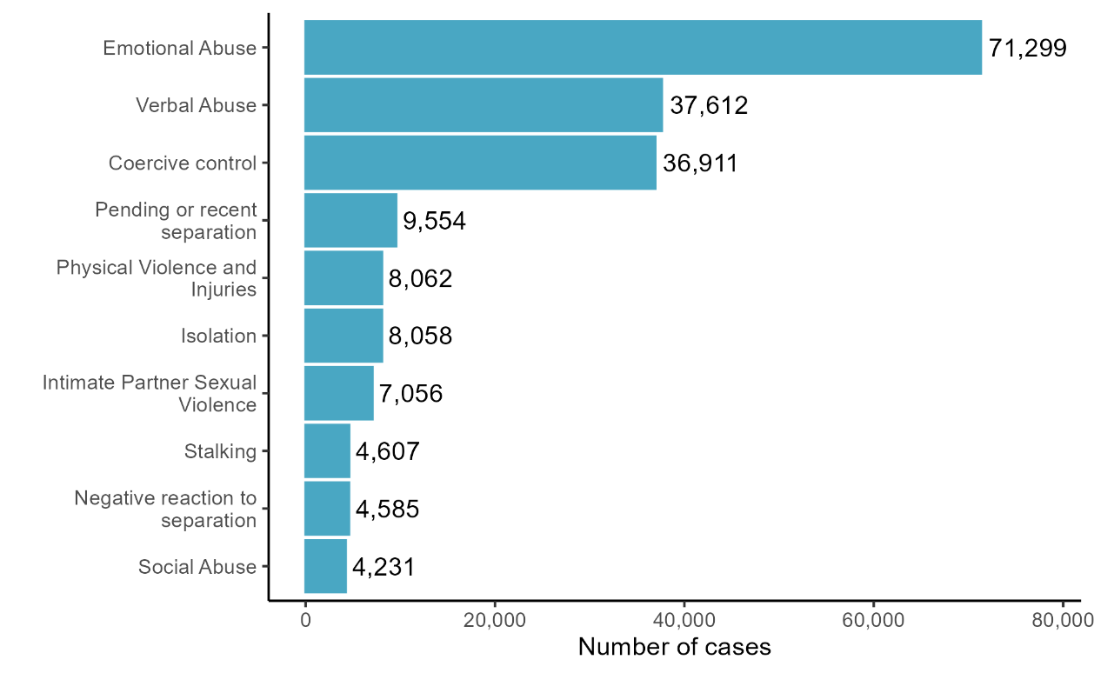
Source: 1800RESPECT service data (1 July 2022 to 31 December 2024). Note: Only the 10 most commonly reported risks are shown in this analysis.
Although the service user’s presenting issues are recorded by counsellors as part of their engagement with the service, 1800RESPECT does not currently collect information relating to the type of information and/or support that service users were seeking by engaging with the service. There is an opportunity to collect additional information relating to the types of supports service users are seeking such as information, referrals, psychoeducation and counselling.

How well does 1800RESPECT meet the needs of service users?
To understand the extent to which the service is able to meet the needs of service users, we examined:
- Telstra Health’s internal audit data
- compliments and complaints data from the 1800RESPECT website
- data from population survey respondents who said they had used 1800RESPECT
- interview data.
Telstra Health’s internal quality assurance processes include examining the proportion of contacts that resulted in appropriate outcomes. Appropriate outcomes were considered those that were specific to the identified needs of the service user. The examination of this data showed that the appropriateness of the referrals varied depending on the service channel used and the level of support the service user received. Contacts were more likely to result in appropriate outcomes being reached in video or phone calls compared to online chat or SMS. This is likely because service users use different channels in different ways. For example, we suggest that a service user may be seeking more transactional information via SMS or they might use SMS to test their comfort levels with accessing support, whereas someone contacting via phone or video call may be more ready to access support and more likely to be seeking an in-depth discussion. While the processes for assessing safety and risk are the same on all channels, some counsellors reported that it can be more challenging to decipher the language used and the service user’s emotional state over online chat and SMS than on phone and video calls.
Population survey respondents who had used 1800RESPECT within the past 3 years were highly positive about the safety, relevance and accessibility of 1800RESPECT, with over two-thirds of these respondents reporting that they felt 1800RESPECT was totally or very safe, relevant and accessible (see Figure 16).
Figure 16: Perceptions of 1800RESPECT's safety, relevance and accessibility
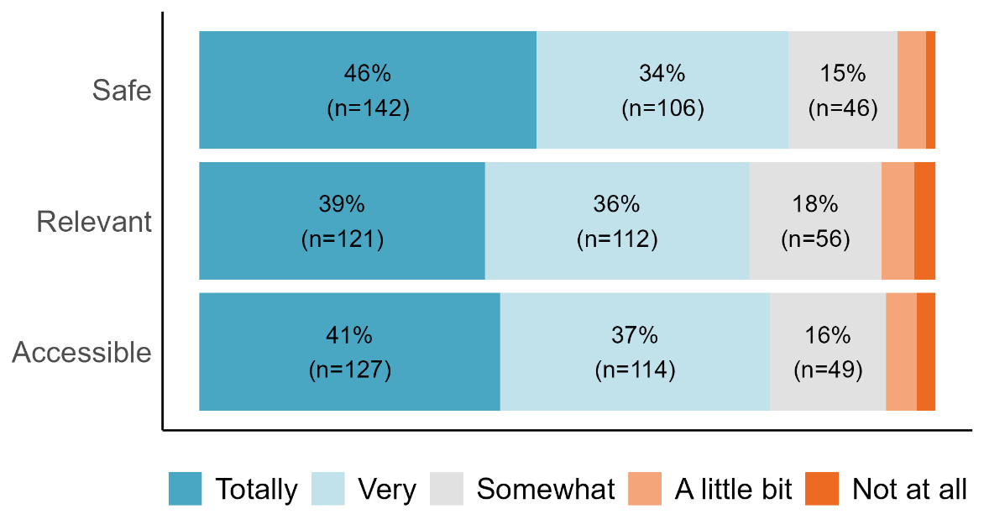
Source: Population survey – January to March 2025. Note: Only respondents who had reported using 1800RESPECT within the past 3 years are included in this analysis. Labels for <10% are not shown in this figure.
Respondents who had reported using 1800RESPECT in the past 3 years were asked – based on their experience of the service – how likely they would be to recommend the service to a friend or family member if they needed support. Figure 17 shows that in response to this NPS question, 62% of respondents were categorised as promoters, 17% as passive, and 21% as detractors. This resulted in a NPS score of 41. As scores over 30 are considered good, this suggests current approaches are generally working well, but that there is still potential to improve the service user experience. Given the challenges of identifying relevant and appropriate benchmarks for NPS scores for 1800RESPECT, tracking this measure to identify if there are changes in service user satisfaction over time could be helpful in understanding how service delivery or external factors impact how well 1800RESPECT is meeting the needs of service users.
Figure 17: Service user satisfaction ratings for 1800RESPECT
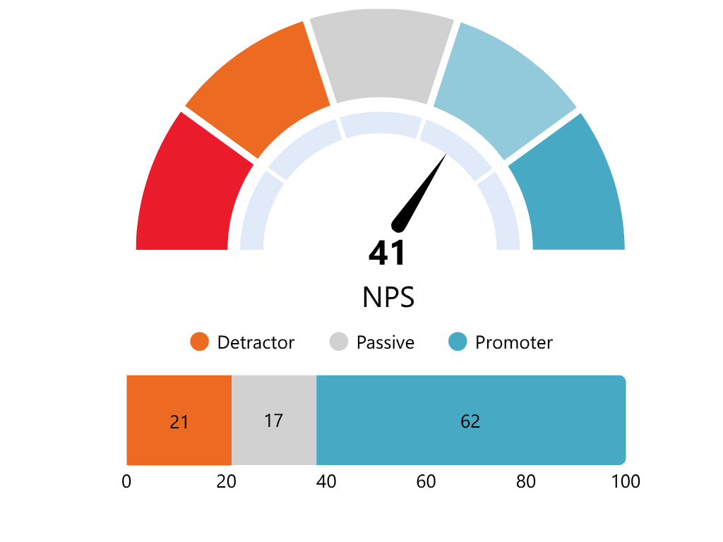
Source: Population survey – January to March 2025. Note: Only respondents who had reported using 1800RESPECT within the past 3 years are included in this analysis. NPS is calculated as the proportion of promoters minus the proportion of detractors. NPS scores can range from -100 to +100. Scores above 0 are positive, indicating there are more promoters than detractors. Scores above 30 are considered good, and scores above 80 are considered excellent.
Due to ethical considerations, we did not ask respondents who had used 1800RESPECT to provide any additional feedback to explain their rating of 1800RESPECT in the NPS score. However, service user feedback collected through interviews and the ‘Compliments and Complaints’ portal on the 1800RESPECT website support us to understand what is driving positive or negative service user experiences (discussed in detail throughout the rest of Section 4.2)

Highly qualified counsellors deliver counselling, information and support aligned to most service users’ needs
1800RESPECT Counsellors and Senior Counsellors are highly qualified and undertake comprehensive, evidence-based induction training and ongoing professional development, support and coaching (see Section 1.2 for more detail). While it is outside the scope of this evaluation to assess the extent to which the counselling and support provided by 1800RESPECT is aligned to clinical best practice, service users were highly positive about the counsellors with whom they engaged. Service users who left a compliment on the 1800RESPECT website valued the trauma-informed approach counsellors took.
[I] appreciated that I didn't tip toe around the situation and was factual and clear on what is occurring and what needs to be done for me to get to a better place. (Service user, Compliment)
Service users we spoke to were also highly positive about the manner of the counsellor with whom they spoke. They felt the counsellors were kind, caring, non-judgemental and listened to them without rushing them; and those that had called the service multiple times noted that their experience with different counsellors had been consistently positive.
It was like a little light house … and it was being able to call like someone neutral, someone professional, someone with that knowledge to get responses that were actually helpful. (Service user, Interview)
---------------------------------------------------------------------------------------------------------------------------------------------
Women don’t know where to go or who to talk to because [the people using violence] have isolated us for so long, but 1800RESPECT gives you the time of day and they don’t make it feel like you were at fault. (Service user, Interview)
However, some service users submitted complaints to the portal on the 1800RESPECT website about the support they received from counsellors.29F These related to service users feeling that the counsellor they engaged with did not have the knowledge or training to appropriately respond to their situation and provide advice, psychoeducation and referrals in a trauma-informed way. The prior evaluation of 1800RESPECT found that 1800RESPECT staff felt less confident in responding to sexual violence, financial abuse, technology-facilitated abuse and neglect, compared to the physical and emotional aspects of violence. This evaluation has also found that, despite additional professional development and training specific to responding to sexual violence and some other less frequently reported forms of abuse, many counsellors still indicated they felt less confident responding to these concerns.
Nevertheless, most service users we spoke to felt that regardless of how helpful the counsellors were, they were comforted in knowing they could speak to a counsellor if ever they needed to talk to someone, their circumstances had changed, they reached a new point in their journey or they had hit a roadblock in accessing other services.
It helped me, I think, just to get off the phone and then keep functioning. Keep going. Keep managing this like insanely stressful, traumatic situation. And it was that little safety net that was always there, no matter how hectic things got. (Service user, Interview)
---------------------------------------------------------------------------------------------------------------------------------------------
I felt validated and safer after calling [1800RESPECT] … The existence of it helps leaps and bounds because it really challenges those unhelpful thoughts that were happening … if 1800RESPECT didn’t exist, the barriers [to getting help] would have been higher … This won’t fix all my problems but it is a safe home base to go back to. If I didn’t have that, my situation would have been a lot worse. (Service user, Interview)
---------------------------------------------------------------------------------------------------------------------------------------------
Do you know how much help it is to be able to call someone in the middle of the night? I could not sleep, and I can call you, talk through the issues, and then be able to cope better during the day. I am so grateful for the overnight service. (Service user, Compliment)
---------------------------------------------------------------------------------------------------------------------------------------------
Having the support available while waiting for my turn on the waitlist has been so valuable. I am a different person because this service is available 24/7. (Service user, Compliment)

Counsellors make referrals to a range of external services for emergency or crisis support, specialist advice and ongoing support
If counsellors assess that a service user requires emergency or crisis support, ongoing support, or specialist advice (e.g. legal or financial) at any stage of the interaction, they are able to connect service users to external services by providing them with a service’s contact number for them to call (‘cold referral’) or by transferring them directly to a staff member of another service while they are still on the line (‘warm referral’).30F Telstra Health has noted that there are challenges with their customer relationship management (CRM) which mean that not all referrals that are made are recorded by counsellors in this system. As a result, the number of referrals reported in the data is an underrepresentation of the true number of referrals. However the broad trends observed in the data are likely to be reflective of patterns of referrals made overall. Telstra Health has noted that this is being addressed through refinements to data collection processes, which were not in place during the time period of our evaluation. After these refinements were introduced the number of recorded interactions made per interaction has increased from an average of 0.3 referrals per contact to on average 0.8 referrals per contact. Between 1 July 2022 and 31 December 2024, 1800RESPECT has provided referrals to 2,569 unique services – this has increased since Telstra Health assumed the contract for 1800RESPECT service delivery (see Figure 18).
Figure 18: Number of unique service providers to which 1800RESPECT made referrals
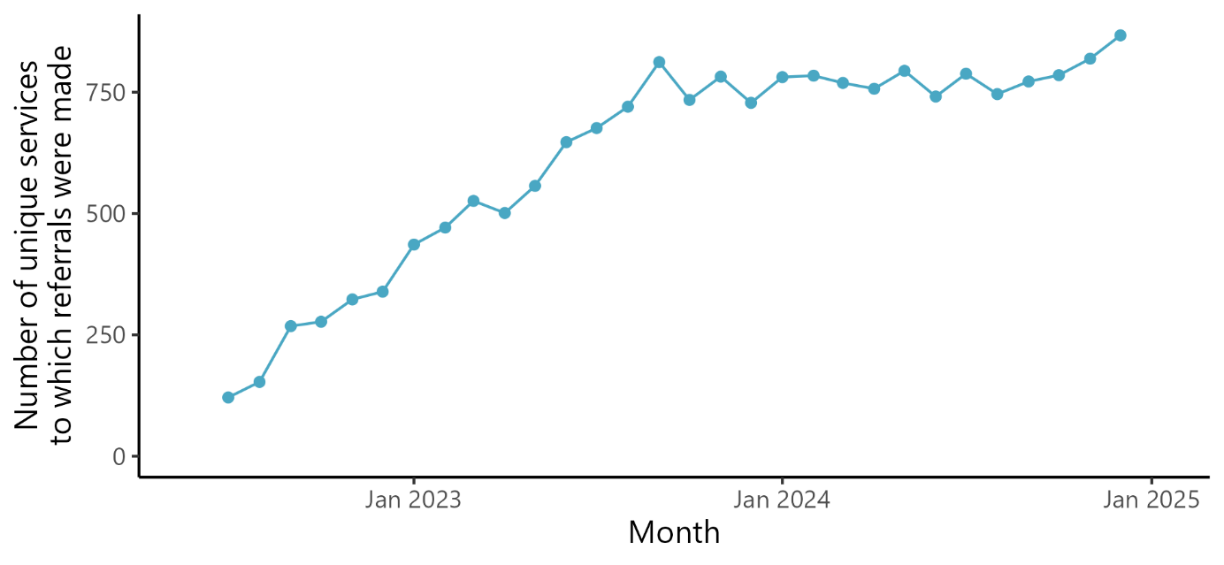
Source: 1800RESPECT service data (1 July 2022 to 31 December 2024).
Over the evaluation period, cold referrals were made to 2,569 unique service providers, including a range of national, state and local organisations providing a range of services. Table 9 shows that cold referrals are most commonly made to other services providing DFSV support (42% of all cold referrals), legal support (14% of all cold referrals) or to police services (11% of all cold referrals).
Table 9: Services to which cold referrals were most commonly made
Service name | N cold referrals | % of cold referrals
DVConnect: Womensline and Pets in Crisis Program (Queensland) | 7,017 | 6%
Safe Steps (Victoria) | 5,982 | 5%
NSW Domestic Violence Line | 5,901 | 5%
Uniting Escaping Violence Payment (EVP) | 2,330 | 2%
Police Queensland | 1,945 | 2%
Police Victoria | 1,937 | 2%
Police NSW: Domestic and Family Violence | 1,815 | 2%
Women’s Domestic Violence Helpline WA | 1,787 | 2%
Mensline Australia | 1,730 | 1%
Women’s Legal Service Victoria | 1,656 | 1%
Source: 1800RESPECT service data (1 July 2022 to 31 December 2024). Note: Only the 10 services to which cold referrals were most commonly made are shown in this analysis. Until August 2024, DV Connect was a subcontracted organisation of 1800RESPECT. Counsellor familiarity with the service may explain the relatively higher rates of referral to this service.
Warm referrals were made substantially less frequently and to a smaller number of organisations compared to cold referrals. It is important to note that facilitating a warm referral will not always be possible as 1800RESPECT is a 24/7 service and many of the services to which they refer are not; and not all service users will want or need a warm referral. Warm referrals were made to 160 service providers across the evaluation period (see Table 10). These were overwhelmingly made to other state crisis services (83% of all warm referrals), but were also made to other local services (11% of all warm referrals) and state emergency services (4% of all warm referrals).
Table 10: Services to which warm referrals were most commonly made
Service name | N warm referrals | % of warm referrals
DVConnect: Womensline and Pets in Crisis Program (Queensland) | 246 | 30%
Safe Steps (Victoria) | 127 | 16%
NSW Domestic Violence Line | 115 | 14%
Women’s Safety Services SA: Domestic Violence Crisis Line | 48 | 6%
Women’s Domestic Violence Helpline WA | 22 | 3%
Police Victoria | 9 | 1%
Police Queensland | 8 | 1%
ACT Domestic Violence Crisis Service | 7 | 1%
Qld Homeless Hotline | 7 | 1%
1300 MH CALL: Qld Mental health access line | 6 | 1%
Source: 1800RESPECT service data (1 July 2022 to 31 December 2024). Note: Only the 10 services where warm referrals were most commonly made to are shown in this analysis.
Service data shows that cold referrals increased steadily from when Telstra Health began delivering 1800RESPECT until 2024, when they began to decline (see Figure 19). Warm referrals have remained consistently low. This is consistent with what interviewees told us – all 1800RESPECT staff we spoke to reported that they very rarely do warm referrals. This is likely due to the fact that not all service users will want or require a warm referral, the operational/technological limitations that hinder warm referrals (e.g. not all services are available to receive referrals outside of standard business hours; warm referrals can require counsellors to stay online and on hold for long periods of time with the service user), and the lack of direct referral pathways to external services (see Section 4.3). Counsellors reported that to make warm referrals, they call the service’s general phone line and wait on hold (sometimes for hours) until they can transfer the service user. For this reason, they reported they only facilitate warm referrals when a service user is unable to contact a service on their own.
Figure 19: Proportion of contacts that resulted in warm or cold referrals across the evaluation period
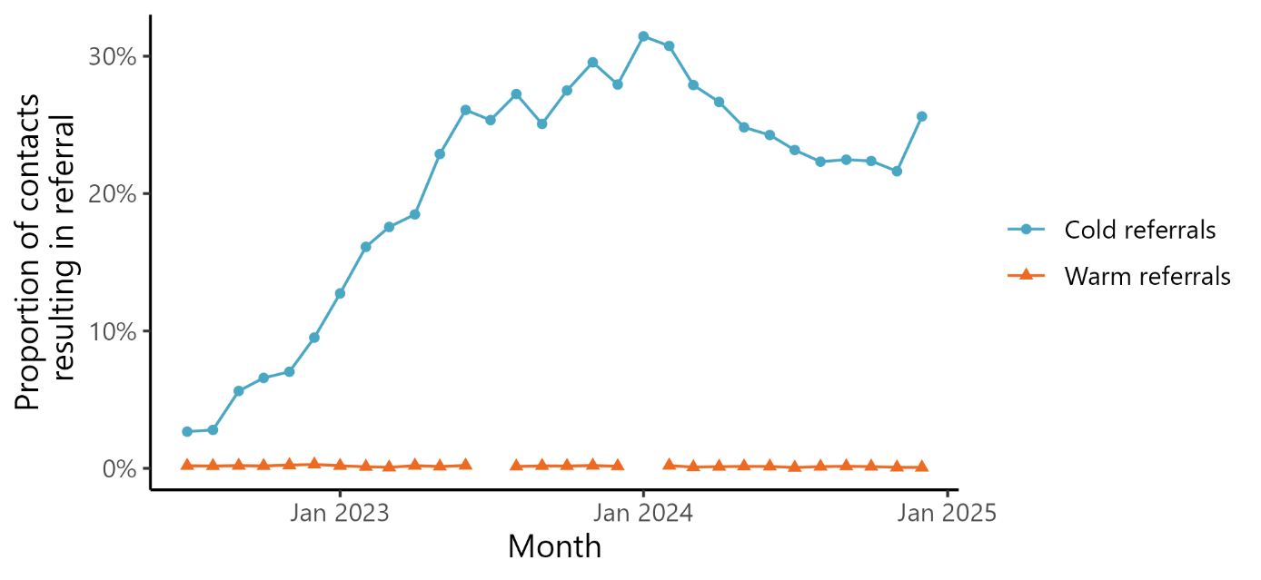
Source: 1800RESPECT service data (1 July 2022 to 31 December 2024).
Service providers and peak bodies who had received anecdotal feedback about 1800RESPECT from service users had mixed views about the service’s approach to referrals. Some service providers and peak bodies felt that cold referrals provided victim-survivors with agency and control in how they receive support. Others were concerned that cold referrals were not always trauma-informed as they require service users to repeat their story and to initiate further action.
All the service users we spoke to had received cold referrals to external service providers
(2 were also provided with warm referrals). While some felt these referrals were useful, others reported that they had either not been eligible for the service or that the service could not provide what they needed. This led to most service users feeling that the counselling support (i.e. being able to talk to someone who was caring and understood their situation) was more useful than the information, advice and/or referrals they received – either because the counsellor was not able to provide enough advice about their particular situation or the referrals were not appropriate for them. External stakeholders we interviewed also regularly told us that 1800RESPECT was providing service users with cold referrals to services for which they were not eligible, that were at capacity, were not in the same geographic area, or did not provide the support they were seeking.
[The counsellor was] very good but didn’t really provide a path forward … [The counsellor] was empathetic but didn’t provide a solution … They were just a listening service, so I wouldn’t have called them if I had known it was just a listening service. (Service user)
---------------------------------------------------------------------------------------------------------------------------------------------
If I was looking for immediate regulating and emotional support, 1800RESPECT would have been great, but I didn’t need this. They listen and hold space and give advice; they serve that role well. But I needed actionable guidance about where I can go and what those people can do for me. (Service user, Interview)
---------------------------------------------------------------------------------------------------------------------------------------------
I did not feel supported by the counsellor in making a safety plan around the violence I am experiencing. I needed specific options and none were provided. (Service user, Complaint)
---------------------------------------------------------------------------------------------------------------------------------------------
I had an online chat where the counsellor gave me an inappropriate phone number/referral, and did not provide any advice around my issues. (Service user, Complaint)
Peak bodies and service providers noted several implications of providing inappropriate referrals, including:
- service users having to take ‘extra steps’ in seeking support and having to repeat their story, which can lead to overwhelm, distress and re-traumatisation
- a missed or delayed opportunity for intervention and increased risk to service users
- additional burden being placed on the broader service system, as external service providers often end up supporting service users to connect to more appropriate services (for which they are not resourced).
Inappropriate referrals also have the potential to cause secondary victimisation, which is the additional harm and sense of betrayal experienced by victim-survivors when they receive inappropriate service responses.31F Secondary victimisation impacts help-seeking behaviours of victim-survivors and can reduce the likelihood of the person seeking support in the future.32F
We've also had referrals at times where we firmly believe that the referral should have been made to the police or to another emergency service, and instead, it's been made to us, which places an undue burden on our service. (Service provider, Interview)
Many sector stakeholders felt the service should be offering more warm referrals and follow-up contact as they considered this to be key to supporting service users to navigate the complex service system. Of the 10 service users we spoke to, 2 had received a warm referral and greatly appreciated this. All other service users we spoke to would have appreciated if this had been offered to them. This was largely because it would have prevented them from having to repeatedly tell their story, remember which service did what, and from having to make several phone calls when they were already overwhelmed. Some also said they would have liked a follow-up call because the services to which they had been referred by the counsellor were not appropriate, so they had to contact 1800RESPECT again for another referral.33F However, Telstra Health’s clinical position is that outbound calls can carry risks to safety for service users.
When they transferred me directly that was really helpful. It felt like it is one less thing I have to do when I have so little executive function, but it felt like a whole new conversation from the start … If they had asked ‘would you like me to give [the service I was being referred to] some notes?’, I would have definitely said ‘yes’, but this was not presented as an option. (Service user, Interview)
---------------------------------------------------------------------------------------------------------------------------------------------
Follow-up is so important. Someone could have called to check up on me, or used an alternative number to call [if it wasn’t safe to do so], like contacting my adult daughter. (Service user, Interview)
This suggests there is a need to work with services to establish stronger referral pathways (see Section 4.3.2).

1800RESPECT can be less appropriate for people from underrepresented cohorts and those who require more specialised supports
Due to the limited demographic data collected, we are unable to examine the types of referrals made and the extent to which appropriate outcomes were achieved for service users from underrepresented cohorts. Analysis of the types of services to which cold referrals are made found that 1800RESPECT is making referrals to specialist services supporting different underrepresented cohorts (see Table 11). Given the disproportionately high rates of DFSV within underrepresented cohorts,34F the relatively small proportion of referrals made to specialist support services suggests that more could be done to connect service users from these groups to organisations that may be better placed to provide them with support.
Table 11: Referrals made to organisations supporting underrepresented cohorts
Service type | N cold referrals | % of cold referrals
Men’s DFSV support services | 3,593 | 3%
CALD support services (multicultural, refugee, migrants) | 1,965 | 2%
Aboriginal and Torres Strait Islander services | 760 | 1%
Disability services | 756 | 1%
Youth services | 555 | <1%
LGBTQIA+ services | 357 | <1%
Seniors services | 333 | <1%
Source: 1800RESPECT service data (1 July 2022 to 31 December 2024).
Some interviewees across all stakeholder groups reported that while counsellors take a trauma-informed approach to engaging with all service users, and that approach is broadly appropriate for all, people from underrepresented cohorts do not consistently experience an appropriate service that meets their needs. Some service providers and peak bodies shared anecdotal feedback from service users that the counsellor’s approach had not been culturally safe or that the counsellor did not understand the nuances of their situation. For example, one Aboriginal service user reported feeling like the service ‘wasn’t meant for them’, and a CALD peak body reported that sometimes women were being asked about their residence or their visa status in a way which was experienced as interrogative rather than supportive. One LGBTQIA+ service provider reported that their clients had been repeatedly misgendered by 1800RESPECT staff or had felt that their experiences as gay men were not taken seriously. Some service users from underrepresented cohorts also left complaints on the 1800RESPECT website about the appropriateness of the counsellor’s approach.
We want to get to the point where you say, ‘Well, what was so good about that support?’ [and a service user says] it was culturally appropriate. The right questions were asked. There was a deep recognition of the kinds of, you know, struggles that I have. An appreciation of what the structural barriers are and appreciation of how racism can really impact on the choices that I feel I can make in the access to services. That's an example of a really good response. I do hear some of these, but unfortunately more often than not, and more recently, the feedback I'm getting is that [1800RESPECT is] falling short. (Peak body, Interview)
---------------------------------------------------------------------------------------------------------------------------------------------
Some advocacy group members and service users we interviewed also reported receiving referrals to services for which they were not eligible or that did not meet their specialised needs. This resulted in them having to call 1800RESPECT back to seek alternative suggestions.
Interviewees felt like this was largely due to counsellors not consistently:
- having a strong understanding of intersectionality and the unique needs of underrepresented cohorts
- asking enough questions to determine whether a service user was from an underrepresented cohort
- knowing enough about services that support underrepresented cohorts, or not having strong enough referral pathways to these services.
While interviewees did not expect counsellors to know about every form of intersectionality or the specific needs of each cohort, they felt that further training for counsellors in delivering a culturally responsive and inclusive approach to support, and stronger referral pathways to specialised services, would help ensure that underrepresented cohorts had a more consistently positive and safe experience of the service. To ensure service users were being referred to the right services, some interviewees suggested that 1800RESPECT could consult peak bodies for underrepresented cohorts about how to appropriately ask about people’s gender, access needs, and communication and support preferences, such as whether it is important for them to receive support from an Aboriginal and Torres Strait Islander or CALD organisation.
Many interviewees also suggested that having the option to speak to a counsellor or peer worker from an underrepresented cohort would help to ensure people from these cohorts receive appropriate support. This was seen as particularly important for Aboriginal and Torres Strait Islander people. While 1800RESPECT subcontracts an Aboriginal organisation to deliver the service,35F this does not mean that Aboriginal and Torres Strait Islander counsellors are able to respond to Aboriginal and Torres Strait Islander service users. Currently, all counsellors operate under 1800RESPECT, and service users are not able to request to speak to a counsellor from a particular organisation.
Interviewees also had some comments and suggestions about how 1800RESPECT could better support particular cohorts:
- Aboriginal and Torres Strait Islander people:36F
- There is an opportunity for counsellors to be more aware of the different ways in which trauma manifests for Aboriginal and Torres Strait Islander people, and the language they use to describe DFSV, such as ‘He was being cheeky.’
- As a government funded service, more effort is needed to build trust with Aboriginal and Torres Strait Islander communities, including more visibility of 1800RESPECT’s engagement with Aboriginal and Torres Strait Islander communities and Elders.
- The average length of a service user interaction may not be adequate for the rapport building required to build trust.
- First Nation’s lore and cultural frameworks could be better understood and integrated into 1800RESPECT’s practice frameworks.
- People from CALD backgrounds:
- Language is critical. An alternative translation service to the Translating and Interpreting Service (TIS) would support the use of more trauma-informed language around DFSV. For example, one counsellor described an instance where ‘in the middle of the call, the interpreter started to tell the woman off for repeating herself and calling the service again.’
- There is an opportunity for counsellors to develop a greater understanding around issues that are more likely to affect CALD communities, such as forced marriage, slavery and religious abuse, and the role racism plays in accessing services.
- People with disability:
- Many people with disability have multiple disabilities and experience multiple intersecting forms of discrimination. A greater awareness among counsellors of how this intersectionality can impact the types of violence people with disability experience, and the types of support and services they need, would be beneficial. For example, people with disability regularly experience forced institutionalisation, denial of legal capacity, withholding of medications and forced sterilisation, abortion and contraception.
- LGBTQIA+ communities:
- There is an opportunity for counsellors to develop a greater understanding of the gendered nature of DFSV and how this impacts LGBTQIA+ people’s experience of services. For example, understanding the impact it has on people when they or their partner are misgendered, and ensuring that people feel like they are taken seriously even though they do not identify as a woman.

Service users with complex needs often require more or different support than what 1800RESPECT alone can provide
A service user with complex needs usually presents with multiple, interconnected and overlapping needs that require a tailored, multi-faceted approach to counselling and support.
Many individuals accessing 1800RESPECT may bring with them resilience shaped by lived experiences of trauma. Others may be less resilient. Their ways of engaging with the service may reflect efforts to stay safe or regain control in the context of previous harm. They may also face intersectional vulnerabilities, where factors like gender, race, disability, sexual orientation and other personal circumstances influence their experiences and support needs.37F
These service users’ needs may include mental health issues, addiction, socioeconomic circumstances, family or relational dynamics, and cultural or systemic barriers. Although 1800RESPECT is not intended to be a mental health support service, mental health-related needs were frequently identified in service users’ risk and needs assessment. This is consistent with the literature that has identified multiple links between mental health and other complex needs of DFSV victim-survivors and people who use violence. For example, the Australian Child Maltreatment Study (2021)38F reported that almost half (48%) the respondents who had experienced child maltreatment and were victim-survivors of DFSV met the criteria for a mental health issue, including lifetime major depressive disorder (MDD), severe alcohol use disorder (SAUD), post-traumatic stress disorder (PTSD) and generalised anxiety disorder (GAD). Additionally, the Australian Institute of Health and Welfare (AIHW) reported that of the 2023 to 2024 Specialist Homelessness Services (SHS) clients over 10 years of age, almost half (45%) have experienced DFSV and have a mental health issue.39F
1800RESPECT’s approach to supporting service users with complex needs is grounded in the principles of trauma informed, person centred and solutions-focused framework (see box below).

Approach to supporting people with complex needs40F
Where the counsellor assesses that a service user has diverse, complex or chronic needs, including mental health issues, a personalised care plan is developed and tailored to identify and capture the individual’s needs.
The personalised care plan allows the service user to receive consistent support and referral information. The service is only able to develop this plan if a service user provides identifying information.
This approach recognises that while 1800RESPECT remains available to service users with complex needs for counselling and/or support, connecting individuals with ongoing, state and territory-based services will be more effective in meeting their medium to long term support needs.
We had limited access to data to assess the effectiveness of supporting service users with complex needs. This is due to a number of reasons, including:
- service users with complex needs may not disclose personal identifying information, which is needed to develop and use a personalised care plan, impacting on the ability to examine if the referrals made align with these service users’ needs
- the service does not collect data on service user satisfaction with the support provided, including satisfaction with the quality and appropriateness of referrals
- for ethical reasons, we were unable to speak to service users with complex needs as part of the evaluation to understand their experiences and outcomes of the support they received.
However, comments from 1800RESPECT staff suggested that while some counsellors felt well equipped to manage service users with complex needs, others did not. This, combined with the lack of warm referrals and direct referral pathways (see Section 4.2.2 and 4.3.2), may suggest that the extent to which service users with complex needs are being connected to services that meet their needs is varied. This is consistent with findings from the prior evaluation of 1800RESPECT, which found that many 1800RESPECT staff felt that the service was less effective for service users with highly complex needs, including mental health issues.
This finding also suggests that the implementation of 1800RESPECT’s policy for supporting service users with complex needs should continue to be prioritised in staff training and coaching.

To what extent does 1800RESPECT support service users to navigate the broader service system through the provision of connected and coordinated support?
Many victim-survivors experience a fragmented support system,41F and underrepresented cohorts experience additional barriers to accessing services. Service systems can place unrealistic expectations on women with complex trauma and intersecting needs to understand and navigate the formal and informal process governing each service.42F Integrated, connected and coordinated responses are known to improve safety for victim-survivors and minimise barriers to accessing services for underrepresented cohorts.43F
Integrated approaches in Australia emphasise case coordination, information sharing and a collaborative multi-agency framework to enhance safety for victim-survivors. 44F These approaches typically involve police as a lead or partner agency, inclusion of housing and accommodation services, and multi-agency risk assessment and safety planning.45F Effective collaboration is crucial for integrated approaches to succeed. This involves understanding how different parts of the service system function and building trust with other services over time.46F
The National Plan to End Violence against Women and Children 2022–32 emphasises the need for a person-centred, interconnected and coordinated service system, stating:47F
A person-centred service system requires minimum standards to ensure quality and consistency. Under a person-centred system approach, services are aware of each other, and referral pathways are clearly established. This upholds victim-survivors’ confidentiality and limits the number of times they must retell their story. A person-centred service system is timely, safe, inclusive, tailored and accessible, and it delivers integrated specialised services that reinforce the need to work together to end gender-based violence.48F
Action 4 of the First Action Plan under the National Plan states that the Commonwealth’s contribution (to the Plan) is to: ‘Build the capacity of services and systems that support victim-survivors to provide trauma-informed, connected and coordinated responses that support long-term recovery, health and wellbeing.’49F
As the National Front Door, 1800RESPECT is designed to be a first point of reference for victim-survivors – a service they can access anytime, anywhere for counselling, information and support designed to help them navigate the broader service system (see Section 4.2 for more information about the effectiveness of the counselling, information and support). However, the extent to which 1800RESPECT is able to effectively provide connected and coordinated support appears to be limited by 2 key factors:
- the capacity of the broader service system
- 1800RESPECT’s relationships with and connections to the broader service system.

1800RESPECT’s ability to provide connected and coordinated support is constrained by the capacity of the broader service system
To assess 1800RESPECT’s role in supporting service users to navigate the broader service system, it is important to understand the current state of the system.
Services responding to DFSV are broad and span multiple sectors. In general, these services can be categorised into ‘specialist’ and ‘mainstream’ services.50F It has been well-documented that, particularly since the COVID-19 pandemic, these services are facing significant challenges, including a resource constrained environment, workforce issues and rising demand.51F
This was reiterated by external stakeholders, many of whom spoke about challenges such as the:
- capacity of the service system to take on new clients
- lack of available resources and services, particularly for refuges and in relation to affordable housing options
- limited DFSV specialist workforce
- increased demand for services due to increased awareness of DFSV
- uncoordinated funding models and legislation at the national and jurisdictional level.
Interviewees also widely acknowledged that these constraints on the broader service system impact 1800RESPECT’s ability to effectively support service users to navigate through it. For example, if 1800RESPECT is referring service users to services that are at capacity and unable to provide support, service users may feel as though 1800RESPECT has not adequately connected them to appropriate supports. However, in general, interviewees still felt there was more 1800RESPECT could be doing to connect to the sector.

1800RESPECT’s lack of relationships with the broader service system impacts its ability to provide connected and coordinated support
1800RESPECT has a stakeholder engagement plan to guide engagement with the sector. This involves attending conferences, joining relevant DFSV-related forums, engaging with the 1800RESPECT Stakeholder Panel on key issues or areas of development for the service, and meeting with DFSV related organisations to share insights and explore collaboration opportunities. Additionally, 1800RESPECT manages stakeholder enquiries regarding the use of 1800RESPECT merchandise and brand elements to promote the service.
However, interviews with sector stakeholders suggest that while they see 1800RESPECT as an essential and valuable part of the service system, further engagement is required to integrate it into the sector.
It feels like [1800RESPECT] sort of floats above us because it doesn’t connect to us as service providers. (Service provider, Interview)
---------------------------------------------------------------------------------------------------------------------------------------------
I think that it is an important front door. I'm not sure that the doors into the other parts of the house are working very well. (Peak body, Interview)
Given service providers and peak bodies regularly refer clients to 1800RESPECT, there is an appetite from the sector to know more about 1800RESPECT, develop relationships and referral pathways, and share knowledge to support more connected and coordinated support for victim-survivors. However, most service providers described having no (or limited) relationship, communication channels or established ‘ways of working’ with 1800RESPECT.
I don't feel like there's very good communication. It still feels to me that it operates almost outside of the sector… I would like to see it be the beating heart of our national movement …
As a sector, I think we're recognising that interconnectedness is absolutely vital to our success. (Service provider, Interview)
---------------------------------------------------------------------------------------------------------------------------------------------
It was quite difficult to get contact [with 1800RESPECT] and it was only that we were at a conference ... I ran into somebody that was from 1800RESPECT, she actually gave me the contact person to contact so we could escalate a particular issue. (Service provider, Interview)
According to sector stakeholders, this has had a number of ramifications, all of which have ultimately restricted the ability of 1800RESPECT and the broader service system to provide connected and coordinated support for victim-survivors;
- The sector does not have a clear understanding of what 1800RESPECT offers, which has led to some service providers being hesitant in referring their clients, and others referring clients that are potentially not appropriate for the type of support provided by 1800RESPECT.
- In the absence of established relationships with 1800RESPECT, inconsistent client experiences with the service and stories about 1800RESPECT in the news have eroded the confidence of some service providers and, ultimately, prevented them from referring their clients.
- The lack of communication, combined with inappropriate referrals to their services and the limitations of the service directory on the 1800RESPECT website, has led to some service providers feeling as though 1800RESPECT has limited knowledge of the service landscape, and a lack of consideration for the burden inappropriate referrals place on their already constrained resources. Issues with the service directory have also limited the ability of service users to connect to appropriate services. This is the case whether they are seeking to connect either on their own (through the website) or through the support of the 1800RESPECT counsellors. Many 1800RESPECT counsellors interviewed for this evaluation advised they had resorted to googling services or creating their own lists of services to manage gaps in the service directory. These approaches introduce an element of risk as these counsellor-created resources have not undergone Telstra Health’s vetting processes.
- Limited direct referral pathways, including pathways for referring service users directly to a staff member at an external service, between 1800RESPECT and external service providers mean that service users are having to navigate a complex and uncoordinated system to access the services they need on their own.

Limited sector understanding of what 1800RESPECT offers
While external stakeholders we interviewed were aware that 1800RESPECT is a national domestic, family and sexual violence service, they were less clear about the specifics of what 1800RESPECT could offer – namely, whether it was designed to help people enter the service system or navigate through it, and/or whether it was designed to provide counselling. For example, some referred to it as the ‘National Front Door’, acting as a conduit or bridge to other services and helping service users navigate a complex service system. Others thought it was merely a starting point for service users to seek support.
Many external stakeholders also thought 1800RESPECT’s primary role was to provide counselling; however, while some described it as crisis counselling, others reported people using the service in an ongoing way while they waited to see a private counsellor or psychologist. A number of service providers also said they provide their clients with the 1800RESPECT number to call over the weekend or after hours in case they need someone to talk to when their services were unavailable.
However, some service providers we spoke to reported that they did not feel confident in recommending the service to the people they support because they did not know enough about 1800RESPECT’s clinical governance and risk assessment processes, privacy and confidentiality policies, and its accessibility and appropriateness for different types of service users such as people from CALD backgrounds.
I wouldn't call [1800RESPECT] the front door. I would call them the after-hours backup. There is no understanding of how 1800RESPECT works, what information they maintain, or what kind of service a woman can expect when calling them. This lack of understanding makes it difficult to inform clients about what to expect from 1800RESPECT. (Service provider, Interview)
This suggests that more specific and targeted promotion of the service to peak bodies, service providers and other professionals who make referrals to 1800RESPECT may be needed to improve clarity on the scope of the service and ensure appropriate referrals to 1800RESPECT.

Limited sector confidence in the support offered by 1800RESPECT
Some service providers and peak bodies reported that they were hesitant to refer victim-survivors to 1800RESPECT because they had heard stories of inconsistent experiences with the service and concerning stories about 1800RESPECT in the news. In the absence of any communication with 1800RESPECT, this had led some service providers to form a view that the service was not nuanced enough in the support it provided – for example, some people thought it was not able to provide a safe and appropriate response to people who had experienced sexual violence; others were concerned that the service does not understand the complexities of different jurisdictions’ legislative frameworks. This results in victim-survivors, who may potentially benefit from accessing 1800RESPECT, not being referred to the service for support. Similarly, some service providers (and 1800RESPECT counsellors) felt as though counsellors did not have a comprehensive enough understanding of what external services could offer, or enough knowledge of local services to effectively support service users to navigate the service system in their local area or jurisdiction. This perception stemmed from service providers having received inappropriate referrals, which placed additional burden on them to connect people to more appropriate services (for which they were not resourced). Some providers also believed information about their service available in the service directory on the 1800RESPECT website was incorrect.
[Our service does not provide housing, but] I have received an influx of calls for housing with the clients saying they were told to call us by 1800RESPECT, up to 10 a day sometimes. Also, on Friday whilst I was at [location] they had a walk in for housing and they said they were told by 1800RESPECT to attend the office for supports. The team told me they had been getting more walk ins for housing redirected by them too … (Service provider, Interview)
External stakeholders we interviewed felt the service directory could be a valuable resource for the sector and help build trust in 1800RESPECT as a credible and relevant resource; however, there were currently too many issues with its usability and accuracy. Service providers regularly reported that the service directory had out of date or incorrect information about their service, duplicate listings and no information about service capacity (i.e. the service’s ability to take on new clients). While some had attempted to contact 1800RESPECT to update their listing, most were unsure of who or how to contact 1800RESPECT.
Stakeholders expressed similar concerns relating to the accuracy of the service directory as part of the previous evaluation of 1800RESPECT. There is information available on the 1800RESPECT website for service providers about how to get in contact regarding the service directory (through a dedicated email) and Telstra Health has continued its efforts to improve the service directory. Nevertheless, it is evident from interviews with service providers that they are not aware of available mechanisms for making contact with 1800RESPECT and that challenges in keeping the service directory up to date remain.
1800RESPECT counsellors we interviewed also regularly commented on the usability and accuracy of the internal service directory used by staff.
[The service directory is] incredibly difficult to use. You put in a suburb, and you'll get all these services from a different state. You put in family violence, and you get all this stuff about Veterans Affairs. (1800RESPECT counsellor, Interview)
This not only serves as a barrier to service users connecting to services they need but has also resulted in counsellors creating their own lists of services or googling services while they are supporting service users. While this practice is intended to support service users, it undermines the existing Telstra Health process for ensuring the safety and quality of services included in the service directory and may be leading to service users receiving referrals to services that are not trauma-informed or appropriate.

Limited direct referral pathways
The lack of relationships between 1800RESPECT and other services in the sector has also resulted in there being limited direct referral pathways between 1800RESPECT and the services needed by service users. This means that 1800RESPECT relies predominantly on providing service users with contact details for other services (cold referrals), rather than a direct transfer to a staff member at these services (warm referrals) (see Section 4.2.2).
It is important to note that facilitating a warm referral will not always be possible as 1800RESPECT is a 24/7 service and many of the services to which they refer are not; and not all service users will want or need a warm referral. However, the National Plan recognises that established referral pathways are required to maintain victim-survivors’ confidentiality and limit the number of times they must retell their story.52F This was echoed by service users we spoke to, who noted that having the option of a warm referral would have avoided them having to repeatedly tell their story, remember which service did what, and from having to make several phone calls when they were already distressed and overwhelmed. This was also supported by service providers, many of whom felt working with 1800RESPECT to establish more direct referral pathways would help to provide more coordinated support for service users and reduce the number of inappropriate referrals to their services.
We would be very interested in working with 1800RESPECT to, you know, understand what the referrals are and the calls that are coming through to them and how could we facilitate 1800RESPECT referring back through to us or any of the other services. (Service provider, Interview)
Overall, while it is not feasible for 1800RESPECT to have relationships with all local services in every jurisdiction, these findings suggest there is more 1800RESPECT can do to connect to the broader service system to more effectively fulfil its role as the National Front Door. Stakeholders suggested:
- having more of a physical presence in each jurisdiction, such as visiting services and attending interagency meetings, acknowledging that 1800RESPECT already attends conferences
- working with key jurisdictional services to establish referral pathways
- consultation with the sector on staff training and service offerings
- sharing 1800RESPECT’s insights and knowledge gained through being a national service to inform policy.
Stakeholders also suggested conducting periodic checks of the service directory and providing services with a contact to report any changes or issues with their listing, and establishing a feedback process for services. 1800RESPECT already has these processes in place. However, stakeholders were not always aware of these processes and how to address issues or share feedback about the listing of their service on the service directory. Conducting more frequent checks of the service directory, and more proactive communication with services about how to contact 1800RESPECT relating to their service’s listing, could help address these issues and support connections between 1800RESPECT and the broader service system.

To what extent is 1800RESPECT efficiently delivering a value for money service?
KEQ 2: To what extent is 1800RESPECT efficiently delivering a value for money service?
- 2a. How is the current 1800RESPECT performance management framework supporting the efficiency of the service?
- 2b. What are the key cost drivers under the current service delivery arrangements?
It is clear that 1800RESPECT is delivering a service that is valued by service users (see Section 4.2). Interviewees consistently spoke of the value of 1800RESPECT – for people accessing the service and the sector more broadly.
In response to emerging concerns about the sustainability of the previous grant-based funding model and the lack of contractual mechanisms to enforce performance, the department conducted a procurement process in 2020 to 2022 to change the funding arrangements for 1800RESPECT to a contract-based model. Officials from non-corporate Commonwealth entities are required to undertake procurements in accordance with the Commonwealth Procurement Rules and, in particular, achieve value for money. The ANAO conducted a performance audit of this procurement process to assess the extent to which this process is ‘likely to deliver a service that can meet increasing demand and provide the highest quality support within the projected cost’.
This review found that 1800RESPECT had the potential to achieve value for money, if the new PMF, contract and service model are fully implemented, stating:
The department’s 2020 to 2022 procurement of counselling and support services provided through 1800RESPECT was effective and has the potential to achieve value for money when the performance management framework is fully implemented and an evaluation strategy and plan are developed.
The department’s 2020 to 2022 tender process to procure a new 1800RESPECT service provider was effective and has the potential to achieve value for money. The department applied the lessons learned from reviews, evaluations and a 2017 Senate Inquiry on the Delivery of National Outcome 4 of the National Plan to Reduce Violence Against Women and Their Children (2017 Senate Inquiry) to design a two-stage procurement process and negotiate a contract that incorporates a revised funding model and additional performance measures. The procurement was compliant with the Commonwealth Procurement Rules (CPRs). The contract negotiations and design were undertaken for the purpose of achieving value for money, and the contract links performance to financial and commercial consequences.
In line with the conclusions of the ANAO performance audit, to understand the extent to which 1800RESPECT is efficiently delivering a value for money service, we have examined:
- how changes to the contracting and service delivery model for 1800RESPECT were intended to drive a more efficient use of available resources
- the extent to which these key elements have been implemented as intended, and whether this has resulted in the desired efficiencies.
Overall, 1800RESPECT is efficiently delivering a value for money service as evidenced by the design and operation of the PMF. The PMF has clear metrics and financial incentives that effectively prioritise a service that responds to contacts in a timely manner, which is critical for a service such as 1800RESPECT where service users may be in acute crisis when they contact the service. However, we found that there are several opportunities to adjust the PMF to further improve the ways that the efficiency and quality of the service are assessed. The PMF is working well to ensure that service users can access support in a timely manner when they contact 1800RESPECT. There is a potential for the strong emphasis on timeliness metrics in the PMF to create incentives through overstaffing, including having more staff rostered on or available for a shift than are needed to avoid the potential penalty associated with not being able to meet targets relating to the timeliness of answering service user contacts. However, as the PMF is designed with checks and balances in place, other elements, such as how the daily payment rates are calculated, limit the impact of potential inefficiencies. We found that balancing the domains of efficiency has been well managed with no evidence found of an increase in one element of efficiency at the expense of another.

How is the current performance management framework supporting the efficiency of the service?
As part of the 2020 to 2022 procurement process, a new contractual arrangement was put in place which included a PMF. It replaced the previous grant-based agreement, which was found to be unsustainable and had been criticised for a lack of accountability, and limited mechanisms for contractual enforcement of performance.
The PMF aims to align service performance with the strategic outcomes of the service – using a range of performance measures linked to a balanced range of commercial consequences outlined in the contract with Telstra Health. The contract also outlines a comprehensive governance framework for the PMF.
The PMF employs a three-tiered approach to monitor and incentivise service performance through complementary measurement systems. This includes a mix of financial indicators (Key Performance Indicators (KPIs), and Strategic Performance Indicators (SPMs)) and non-financial incentives (Strategic Health Indicators (SHIs)) that attempt to quantify the performance of the service. These measures, and their relationships to each other, are shown in Figure 20.
Figure 20: Summary of the PMF performance measures
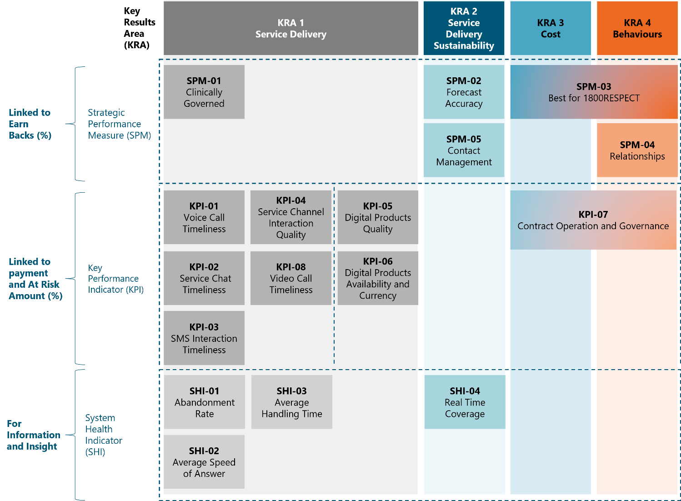
Source: 1800RESPECT PMF.
SPMs assess Telstra Health’s contributions in delivering long term effective, efficient and cost-conscious services as a strategic partner to the Department. The SPMs provide a mechanism for Telstra Health to ‘earn back’ up to 50% of lost At-Risk Amounts through demonstrated excellence in strategic areas. These are assessed every six months and include:
- clinical governance implementation (SPM-01)
- forecast accuracy across multiple timeframes (SPM-02)
- prioritisation of 1800RESPECT interests (SPM-03)
- stakeholder relationship management (SPM-04)
- contact management (SPM-05).
KPIs assess Telstra Health’s performance in direct service delivery to meet service user needs. The KPIs function as the primary financial lever in the PMF, directly affecting monthly payments through an ‘At-Risk Amount’ mechanism that withholds 7% of fees subject to performance. These indicators are assessed monthly and focus on:
- Timeliness KPIs (KPI-01, 02, 03, 08): These account for 75% of the At-Risk Amount and measure responsiveness across all service channels (phone, online chat, SMS, and video), requiring 80% of contacts to be answered within 20 seconds.
- Quality KPI (KPI-04): Representing 25% of the At-Risk Amount, this assesses interaction quality through the Approved Interaction Quality Management Tool with a 90% target.
- Operational KPIs (KPI-05, 06, 07): Evaluated separately for the Other Services Fee, these measure digital product quality, availability and contract governance.
SHIs function as early warning systems for significant changes in service user engagement and service delivery. There are no financial consequences associated with these indicators. The SHIs are reviewed every month and they track:
- abandonment rates (SHI-01)
- average speed of answer (SHI-02)
- average handling time (SHI-03)
- real-time coverage compliance (SHI-04).
This integrated framework creates a layered accountability system where KPIs drive immediate operational performance, SPMs encourage strategic value creation, and SHIs provide monitoring without penalty to identify emerging issues. It important to note that poor performance on any indicator, regardless of financial or non-financial consequences, can trigger a remediation plan, and will factor into the department’s considerations regarding contract extension.

The PMF is working to drive a service that is efficiently able to meet service demand in a timely manner
The PMF has worked as intended to ensure that 1800RESPECT delivers a service where those who contact the service can be connected to support in a timely manner. Over the implementation period, 84.73% of contacts were answered within 20 seconds – exceeding the target for 80% of contacts to be answered within 20 seconds. The PMF’s allocation of 75% of the At-Risk Amount to timeliness ensures this performance dimension receives appropriate organisational focus. The PMF’s graduated hourly rate structure also incentivises Telstra Health to maintain sufficient staffing levels to meet varying demand patterns. The proportion of contacts that are answered within the target 20 second timeframe has increased across the implementation period and, at the end of 2024, was exceeding the KPI target of 80% of contacts answered within 20 seconds (see Section 3.2.2). This indicates that the PMF, and the weighting of indicators assessing the timeliness of service user access to the service, is working well to drive this intended outcome.
In addition to being an important element of service delivery, the timeliness of service user access to 1800RESPECT can be clearly and objectively measured. However, service quality (which represents 25% of the At-Risk Amount) and some of the SPMs can be more challenging to assess. These challenges include:
- Absence of service user voice: The PMF assesses KPI-04 (Interaction Quality) through internal quality assessment tools. However, the Approved Interaction Quality Management Tool does not appear to incorporate direct service user feedback, creating a significant blind spot in quality assessment. While there are ways to safely capture user perspectives, these have not been integrated into the formal measurement framework. This means the extent to which 1800RESPECT is delivering a service that meets the needs of service users is currently difficult to assess and track through the PMF.
- Understanding the appropriateness of referrals: The referrals counsellors make are a critical aspect of the support 1800RESPECT provides to service users. The ability for 1800RESPECT to appropriately refer and transition service users to state and territory- based services was intended to be assessed through SPM-05 (Contact management). However, reporting against this SPM has not taken place due to challenges in assessing the appropriateness of referrals. As a result, the appropriateness of referrals is not assessed and tracked through the PMF as was initially intended.
The PMF's fundamental design principles align well with promoting service efficiency, but targeted refinements could significantly enhance its effectiveness in balancing accessibility, quality, and cost-effectiveness while maintaining the essential support capabilities of 1800RESPECT.
Overall, the PMF is working as intended to drive service efficiency. However, as the service matures, refinements to the framework could further enhance the efficient delivery of the service through introducing opportunities for incorporating service user feedback. Currently there is an absence of service user voice in the PMF. The lack of direct service user feedback creates a significant blind spot in the ability of the PMF to assess the quality of the service. Refining the PMF through integrating safe mechanisms for service user feedback into the quality assessment process would provide more robust quality measurement and help identify efficiency opportunities that do not compromise effectiveness. The Department and Telstra Health should consider if approaches to collecting service user feedback used for other similar support services could be safely introduced in the context of 1800RESPECT. 53F The types of service user outcomes assessed should be informed by research into the types of outcomes most important for service users accessing support services or helplines.54F

What are the key cost drivers under the current service delivery arrangements?
Given the commercially sensitive nature of financial data associated with Telstra Health’s delivery of 1800RESPECT, our understanding of the key cost drivers of the service is informed by interviews with key staff from the department and Telstra Health. To understand the key factors that determine the costs of running the service, it is important to separately consider the factors that drive the cost to the government, and factors that drive costs to the service provider associated with delivering the service.

The key cost driver for the government is contact volume
According to the department, the key factor that drives how much it costs the government to deliver 1800RESPECT is service user demand and the number of contacts the service receives. As awareness of and demand for the service increases, the number of service users contacting 1800RESPECT has continued to increase. Delivering a service that can provide the same level of support to an increasing number of service users costs more. This continued increase in contact volume is a long-standing trend which was noted in the previous evaluation of 1800RESPECT and in the ANAO performance audit.
The way service user demand drives costs for the government, and the potential opportunities for managing costs in the context of increased contact volumes was an important consideration during the development of the current 1800RESPECT contract and service delivery arrangements. Under the previous grant-based contract, 1800RESPECT was funded under a cost-per-contact model, where there was a set unit price for each call or online counselling session, regardless of its duration. This meant that the cost to the government would continue to increase linearly as service demand and access to the service increased. Given the projections that demand for the service would continue to increase over time, this model was considered to drive costs for government in an unsustainable way.
The current service delivery arrangements were designed to ensure that growth in service user demand and access to the service does not drive cost for government in an unsustainable way. The contract’s funding model is designed to acknowledge and encourage efficiencies in service delivery as contact volume increases. It includes:
- A graduated hourly rate structure, in which the amount it costs the government for a counsellor to be available to deliver support decreases as the volume of support provided by the service increases.
- The use of forecasted demand level to determine the extent to which rostered and available counsellor hours are billed. There is a robust process to determine the extent to which rostered and available counsellor hours are billed, which includes forecasts of demand level and engagement with independent contact centre SMEs. This provides an additional set of checks and balances to limit potential for the costs associated with excess staffing to drive up costs for the department.
This means that although contact volume remains the key cost driver for the government and the total cost to government will increase as service user demand for and access to the service increases, these costs do not scale linearly as the cost to the government of a having counsellor available to deliver the service (i.e. the marginal unit cost) decreases as the volume of support delivered increases.

There are some additional factors that drive Telstra Health's costs of delivering 1800RESPECT
The key cost driver for both the government and Telstra Health is service user demand. As contact volume increases it costs Telstra Health more to deliver support to meet this demand. However, the service payment Telstra Health receives also increases with the volume of contacts and support delivered.
From Telstra Health’s perspective, there were several additional key factors that drive Telstra Health’s costs in delivering the service. These include:
- Frontline personnel costs: Telstra Health identified that the biggest cost driver is frontline staff including not just direct wages but several less transparent costs such as:
- Recruitment expenses, associated with staff turnover driven by the nature of the work counsellors are engaged in.
- Remote working infrastructure costs and technical support requirements associated with ensuring that the remote workforce is able to connect to the contact lines and remain connected.
- Vicarious trauma management, such as workers compensations, the delivery of support programs and employee access programs.
- Resourcing associated with non-direct service delivery requirements:
- Stakeholder engagement.
- Responding to media and community enquiries.
- Additional data and reporting requests such as those related to audits, inquiries and evaluation.
The anticipated costs associated with delivering the service were considered by Telstra Health and the department when entering into the 1800RESPECT contract. These key factors associated with Telstra Health’s internal operating costs of service were not unanticipated. No previously unknown or additional key factors driving the cost of Telstra Health’s delivery of the service have been identified by the evaluation.

Are the core elements of the service delivery arrangements, including the PMF, achieving intended value for money?
The current funding model, PMF and contract with Telstra Health were designed to deliver value for money. In its audit of the 2020 to 2022 tender and procurement process, the ANAO concluded that the procurement and contracting process undertaken to engage Telstra Health as the service provider for 1800RESPECT was effective and had the potential to achieve value for money if the PMF and other key elements of the model are fully implemented.
To assess whether 1800RESPECT is delivering a value for money service, we examined the extent to which these elements have been implemented as intended and if the potential value for money has been realised.

1800RESPECT has successfully implemented key elements of the new contract and service model and is delivering a value for money service
The evaluation has found that 1800RESPECT is delivering a value for money service as a result of successfully implementing key elements of the contract and service model developed through the 2020 to 2022 tender and procurement process. The potential value for money that each key element of the new contract and service model was intended to delivery, and the evidence of implementation and impact are outlined in Table 12.
Table 12: The extent to which key elements of the new contract and service model have delivered value for money
Element | Potential for value for money | Evidence of implementation and impact
A contract-based funding model | - In contrast to the previous model of grant-based funding, the contract-based funding model results in payments that are based on an hourly rate that changes in response to demand levels. | - The contract-based funding model has been implemented as intended.  - This model appears to be encouraging efficient responses to service users, as the payment structure does not incentivise shorter, more frequent contacts. This also allows 1800RESPECT to not have set KPIs for counsellors relating to the duration of contact.
Key enhancements to service delivery | - The revised service model includes improvements such as new service channels, enhanced training for staff, enhanced governance arrangements, a secure IT platform and frequent service user management processes. | - Most of the planned service enhancements have been implemented as planned and are having the intended impact on the service.  - However, there is potential for some elements of enhanced service delivery (improved counsellor training, use of warm referrals) to be improved to increase the value of the service that is delivered.
A Performance Management Framework (PMF) | - All key measures of 1800RESPECT are measured, and payments are linked to meeting agreed performance targets. | - Following an initial implementation period, at-risk payments were determined by performance against set KPIs. Telstra Health was able to ‘earn back’ a proportion of lost payments through demonstration of providing value to the department as a delivery partner (as assessed through the SPMs).  - There have been observed improvements in the service level and the proportion of KPIs and SPMs met over the evaluation period.

Conclusion
KEQ 2c: What opportunities exist for continuous improvement?

Conclusions
1800RESPECT is delivering a highly accessible service. People looking for counselling, information, support and referrals relating to DFSV (including sexual harassment) are able to speak to a qualified counsellor 24 hours a day, 7 days a week. More than 80% of contacts across multiple channels are answered within 20 seconds.
The short-term solutions-focused counselling, information and referrals 1800RESPECT provides is generally well received and appears to meet the needs of most service users, particularly those who are looking for general information and counselling supports. However, people with complex presentations and people from underrepresented cohorts are not able to consistently experience a service that meets their needs, highlighting the need to improve the ability of the service to appropriately support these service users, and the critical importance of ensuring the service is successful at referring people to specialised support services.
The new contract, Performance Management Framework (PMF) and service model are working as intended to drive efficiencies in service delivery. The PMF places a high value on the timeliness of access to the service, which is effective in delivering low wait times for service users. As this service model and PMF matures, opportunities to incorporate service user input and assessment of the usefulness of referrals could support 1800RESPECT to continue to deliver a high-quality and accessible service.

Opportunities for continuous improvement
Based on the evaluation findings and the perspectives of staff, service users and key stakeholders, we have identified 5 key potential opportunities for the continuous improvement of the service:
- Improve promotional activities to build awareness and understanding of 1800RESPECT within the community, and for the organisations and practitioners that make referrals to the service. In addition to broad promotion of the service, targeted promotion relating to the elements of 1800RESPECT’s remit that were less well known (e.g. sexual violence, including sexual harassment, and workplace sexual harassment) could help more victim-survivors become aware that 1800RESPECT can support them. In particular, the lower levels of awareness of 1800RESPECT among people from CALD backgrounds, and the very small proportion of contacts made from service users who speak a language other than English, indicate an opportunity to increase awareness and understanding of 1800RESPECT in CALD communities through targeted, culturally appropriate promotion of the service. Professionals in organisations that are not explicitly in the DFSV sector but are likely to come into contact with victim-survivors, such as GPs, lawyers, settlement services and religious institutions, play an important role in referring people who may need support to 1800RESPECT. There is an opportunity to deliver more specific targeted promotion of the service to these organisations to ensure that those referring people to 1800RESPECT understand the remit of 1800RESPECT and the nature of the support the service is able to provide to service users.
- Improve ongoing training and professional development opportunities for counsellors to ensure that 1800RESPECT consistently provides service users with appropriate, high quality, trauma-informed counselling and support. 1800RESPECT counsellors provide support to a broad range of individuals from diverse backgrounds and with different needs and sensitivities. To ensure that service users, regardless of their background or presenting circumstances are able to consistently receive high-quality, trauma-informed and culturally safe support, counsellors require a high level of ongoing training and professional development. This includes continuing the focus on specialised DFSV training; training on emerging research and approaches; training to better support people seeking information and referrals for sexual harassment, including workplace sexual harassment; training to provide more culturally responsive and inclusive support to underrepresented cohorts; and training relating to relevant services and legislation in different jurisdictions.
- Review and refine processes for identifying appropriate services and referring service users to external organisations that can provide appropriate and coordinated support to victim-survivors. To ensure that 1800RESPECT is contributing to building the capacity of the sector to provide victim-survivors with connected and coordinated supports, it is critical that 1800RESPECT is able to effectively connect service users with other organisations that can provide them with support outside the remit of 1800RESPECT. This requires counsellors to be able to identify appropriate services to refer service users to, given their consent and depending on their needs, location and other personal circumstances or characteristics, and the processes that the service uses to facilitate these connections. Investing more time and resources into developing sector relationships, as well as refining the processes used by counsellors to identify suitable services for referrals, and developing approaches to assessing whether the counsellors are making accurate and appropriate referrals to services, could allow 1800RESPECT to more effectively guide service users through the broader service system. Given the barriers service users can face when attempting to access services to which they have been provided a cold referral, opportunities to facilitate connections in a way that minimises the frequency that service users are required to re-tell their story could support service users to more effectively continue their support journey.
- Consider opportunities to improve data collection through refining the systems and processes, technology and support for counsellors to capture key relevant information relating to service user needs and characteristics. There is very limited information available relating to the needs, characteristics and experiences of service users. Additionally, information relating to the referrals counsellors provide to service users is frequently not captured by counsellors in the 1800RESPECT CRM. To ensure that 1800RESPECT delivers a high-quality, appropriate service that meets the needs of service users, it is important to have a greater understanding of who is accessing the service, their characteristics, needs, and the types of support services they are referred to. Telstra Health should continue their efforts to refine the CRM used by counsellors, to better support the quality and completeness of appropriate data recorded as part of service delivery. Telstra Health should also consider reviewing the processes and guidance related to when and how information relating to service users’ needs, circumstances and support preferences can be collected in a trauma-informed way. For example, we suggest that Telstra Health considers 2 processes – one for light-touch interactions, or where the service user does not wish to disclose or have personal information recorded, and a second process for more in-depth contacts where service users may be more comfortable providing information about their needs and circumstances that could allow the counsellor collecting information to better tailor the support and referrals they provide. Improving data collection processes relating to service user needs and characteristics could help support continued improvements to the quality and efficiency of the service, by allowing a clearer understanding of who the service is reaching and how it is responding to address service user needs.
- Consider refining the PMF to reflect the increasing maturity of the service model and the framework. The PMF is working effectively to drive service efficiencies. The PMF has a strong emphasis on timeliness metrics (as is appropriate for a service where service users may be in acute crisis when they contact the service) and the service’s performance against these metrics across the implementation period demonstrate the effectiveness of assessing and tracking indicators to drive service delivery towards intended outcomes. There is an opportunity, as the service matures, to further refine the PMF through integrating safe mechanisms for service user feedback into the quality assessment processes. This would provide more robust quality measurements and help identify opportunities for greater efficiency in service delivery that do not compromise effectiveness.

Appendices
- Supplementary tables and figures
  - Population survey
- Survey quotas and responses
Table A1: Target and actual population survey sample
Target demographic | Quota (n) | Quota (%) | Responses (n) | Response (%)
ACT resident | 500 | 11.8% | 500 | 13.6%
NSW resident | 500 | 11.8% | 500 | 13.6%
NT resident | 385 | 9.1% | 168 | 4.6%
Queensland resident | 500 | 11.8% | 500 | 13.6%
SA resident | 500 | 11.8% | 500 | 13.6%
Tasmania resident | 500 | 11.8% | 500 | 13.6%
Victoria resident | 500 | 11.8% | 500 | 13.6%
WA resident | 500 | 11.8% | 500 | 13.6%
Aboriginal and/or Torres Strait Islander people (nationally) | 385 | 9.1% | 308 | 8.4%
People from culturally and linguistically diverse backgrounds (nationally) | 385 | 9.1% | 704 | 19.1%
People who identify as having a disability (nationally) | 385 | 9.1% | 527 | 14.3%
Female respondents (nationally) | 3,685 | 87% | 3,249 | 88.3%
Male respondents (nationally) | 380 | 9% | 418 | 11.4%
Transgender identity (nationally) | 170 | 4.0% | 34 | 0.9%

- Survey instrument

Introduction
Thank you for agreeing and providing your consent to complete this survey.
As we said in that information sheet it is entirely up to you if you want to be part of this evaluation by filling out this survey.
If you do say yes, you can change your mind at any time without giving a reason, up until you submit the survey. Once you submit the survey, we won’t be able to delete it because the survey is anonymous, so we won't be able to tell which one is yours.

Q1
Before today, have you heard of 1800RESPECT?
- Yes
- No
- Unsure

Q2_a
What types of issues do you think 1800RESPECT supports people with?
[short open text]
[if Q1 == Yes]

Q2_b
If you or someone you know was experiencing domestic, family or sexual violence, would you know where to go for outside support?
- Yes
- No
- Unsure
[if Q1 == No or Unsure]

Demographics
Before we move onto our next set of questions, we want to know a little bit more about who you are.

Q3
What was your age on your last birthday?
- Under 18
- 18 to 24
- 25 to 34
- 35 to 44
- 45 to 54
- 55 to 64
- 65 to 74
- 75+
- Prefer not to say
[if under 18 – END]

Q4
How do you describe your gender?
- Man or male
- Woman or female
- Non-binary
- I use a different term
- Prefer not to say

Q5
Do you identify as transgender?
- Yes
- No
- Prefer not to say

Q6
How do you describe your sexual orientation?
- Straight (heterosexual)
- Gay or lesbian
- Bisexual
- I use a different term
- Don’t know
- Prefer not to answer
Q7
What state or territory do you live in?
- NSW
- Victoria
- Queensland
- ACT
- Tasmania
- Western Australia
- Northern Territory
- South Australia
- Another Australian territory
- Prefer not to say

Q8
Which of the following best describes the area where you currently live?
- Major city (e.g. Sydney, Melbourne, Brisbane)
- Regional town (e.g. Ballarat, Toowoomba, Albury)
- Rural area
- Remote area
- I’m not sure
- Prefer not to say
Q9
Are you Aboriginal or Torres Strait Islander?
- Yes – Aboriginal
- Yes – Torres Strait Islander
- Yes – Aboriginal and Torres Strait Islander
- No
- Prefer not to say

Q10
Do you speak a language other than English at home?
- Yes
- No
- Prefer not to say

Q11
How would you describe your cultural/ ethnic background? (e.g. Australian, Chinese, Indian, Greek)
[open text]
Q12
Do you identify as having a disability?
- Yes
- No
- Prefer not to say

What is 1800RESPECT?
To help you answer the next questions we have a short description of the 1800RESPECT service.
1800RESPECT is the national domestic, family and sexual violence counselling, information and support service. It is delivered by Telstra Health on behalf of the Australian Government.
1800RESPECT is funded by the Australian Government through the Department of Social services to provide support for:
- people experiencing or at risk of domestic, family and sexual violence (including sexual harassment and workplace sexual harassment)
- people supporting someone experiencing, or at risk of experiencing, domestic, family and sexual violence (including sexual harassment and workplace sexual harassment)
- professionals supporting someone experiencing, or at risk of experiencing domestic, family and sexual violence (including sexual harassment and workplace sexual harassment).
1800RESPECT is a confidential service available 24 hours a day, 7 days a week. It provides:
- counselling delivered by counsellors who are guided by service users and work alongside them to find strategies to support their safety and wellbeing.
- information on domestic, family and sexual violence (including sexual harassment and workplace sexual harassment)
- referrals to other support services that can provide help.
1800RESPECT offers a range of ways people can access information and support. These are:
- website resources
- digital applications (Sunny and Daisy)
- phone line
- online chat
- SMS
- video call.
1800RESPECT has the following features and tools to make the service and website accessible to people in need of support.

Translation and languages:
- The 1800RESPECT website has information in 30 languages.
- People who would like to speak to a counsellor in a language other than English can use the Translating and Interpreting Service (TIS National).

Features for people with disability:
- The 1800RESPECT website text can be read using a screen reader.
- People who find it difficult to hear or speak, can contact 1800RESPECT through the National Relay Service (NRS).
- 1800RESPECT is accredited with the Communication Access Symbol, awarded by Scope. This means that the service is accessible to people with communication difficulties.
- 1800RESPECT Sunny App has been developed by people with disability, for people with disability, who are affected by domestic, family and sexual violence.
Our next questions are about what you think about 1800RESPECT, based on what you know about the service from this description and what you already knew about 1800RESPECT.
If Q1 == ‘Yes’
Our next questions are about what you think about 1800RESPECT, based on what you know about the service from this description.
If Q1 == ‘No’ or ‘Unsure’

Q13_a
If you needed to access information and support, to what extent would you feel safe using 1800RESPECT?
- Totally safe
- Very safe
- Somewhat safe
- A little bit safe
- Not at all safe
- Unsure/ Do not know
- Prefer not to say

Q13_b
How relevant do you believe the information and/or support that 1800RESPECT provides would be for you?
- Totally relevant
- Very relevant
- Somewhat relevant
- A little bit relevant
- Not at all relevant
- Unsure/Do not know
- Prefer not to say
Q13_c
How confident do you feel that you could access 1800RESPECT if you needed information and support through one or more of the channels they offer?
- Totally confident
- Very confident
- Somewhat confident
- A little bit confident
- Not at all confident
- Unsure/ Do not know
- Prefer not to say
We want to understand what ways people would want to access 1800RESPECT, if they needed information or support.

Q14_a
If I needed to access 1800RESPECT for information or support, I would use the website.
- Yes
- No
- Unsure

Q14_b
If I needed to access 1800RESPECT for information or support, I would use the online chat.
- Yes
- No
- Unsure

Q14_c
If I needed to access 1800RESPECT for information or support, I would use the phone line.
- Yes
- No
- Unsure

Q14_d
If I needed to access 1800RESPECT for information or support, I would use the SMS service.
- Yes
- No
- Unsure

Q14_e
If I needed to access 1800RESPECT for information or support, I would use the video call service.
- Yes
- No
- Unsure

Q14_f
If I needed to access 1800RESPECT for information or support, I would use the digital applications (Sunny and Daisy).
- Yes
- No
- Unsure

Use of 1800RESPECT
Many people access 1800RESPECT for information and support for themselves, a friend or family member, or as a professional.
We would like to know if you have used the1800RESPECT service. This question is optional, and you do not have answer if you don’t want to.
We won’t ask any questions about why, when or what you accessed 1800RESPECT for.

Q15
Have you used the 1800RESPECT service in the past 3 years?
- Yes
- No
- Prefer not to say
[optional]
[able to finish survey from here]

Q16
Based on [your experience/ what you know about 1800RESPECT, on a scale of 0 to 10 how likely would you be to recommend 1800RESPECT to someone who needed information or support about family, domestic and sexual violence (including sexual harassment and workplace sexual harassment)?
- 0 – Not likely at all
- 1
- …
- 9
- 10 – Very likely
[optional]
[if Q16 == ‘Yes,’ ‘based on your experience of 1800RESPECT,’ if Q16 == ‘No’ or ‘Prefer not to say,’ ‘based on what you know about 1800RESPECT’]

END

Thank you
Thank you for taking the time to complete this survey.
Answering these questions might have brought up some unexpected feelings. If you feel you need some additional support, consider talking to someone you usually go to for support like a friend, family member, counsellor or support worker.
1800RESPECT remains available to support anyone affected by domestic, family, or sexual violence. Call 1800 737 732, text 0458 737 732, or access online chat and video call at www.1800respect.org.au. You may also like to contact the following support services, which are staffed by trained counsellors and mental health professionals.
- Description of 1800RESPECT
As part of the population survey, respondents were shown a brief description of 1800RESPECT before being asked about their perceptions of the safety, accessibility, and confidence in the service.
What is 1800RESPECT?
To help you answer the next questions we have a short description of the 1800RESPECT service.
1800RESPECT is the national domestic, family and sexual violence counselling, information and support service. It is delivered by Telstra Health on behalf of the Australian Government.
1800RESPECT is funded by the Australian Government through the Department of Social Services to provide support for:
- people experiencing or at risk of domestic, family and sexual violence (including sexual harassment and workplace sexual harassment)
- people supporting someone experiencing, or at risk of experiencing, domestic, family and sexual violence (including sexual harassment and workplace sexual harassment)
- professionals supporting someone experiencing, or at risk of experiencing, domestic, family and sexual violence (including sexual harassment and workplace sexual harassment).
1800RESPECT is a confidential service available 24 hours a day, 7 days a week. It provides:
- counselling delivered by counsellors who are guided by service users and work alongside them to find strategies to support their safety and wellbeing.
- information on domestic, family and sexual violence (including sexual harassment and workplace sexual harassment)
- referrals to other support services that can provide help.
1800RESPECT offers a range of ways people can access information and support. These are:
- website resources
- digital applications (Sunny and Daisy)
- phone line
- online chat
- SMS
- video call.
1800RESPECT has the following features and tools to make the service and website accessible to people in need of support.

Translation and languages:
- The 1800RESPECT website has information in 30 languages.
- People who would like to speak to a counsellor in a language other than English can use the Translating and Interpreting Service (TIS National).
Features for people with disability:
- The 1800RESPECT website text can be read using a screen reader.
- People who find it difficult to hear or speak, can contact 1800RESPECT through the National Relay Service (NRS).
- 1800RESPECT is accredited with the Communication Access Symbol, awarded by Scope. This means that the service is accessible to people with communication difficulties.
The 1800RESPECT Sunny app has been developed by people with disability, for people with disability, who are affected by domestic, family and sexual violence.
- Key tables

Awareness of 1800RESPECT
Table A2: Awareness of 1800RESPECT
Response | N | %
Yes | 2,008 | 55%
No | 1,378 | 37%
Unsure | 293 | 8%
Total | 3,679 | 100%
Source: Population survey – January to March 2025.
Table A3: Awareness of 1800RESPECT by gender
Response | Yes N | Yes % | No N | No% | Unsure N | Unsure % | N | %
Man or male | 220 | 53% | 169 | 40% | 29 | 7% | 418 | 100%
Woman or female | 1,783 | 55% | 1203 | 37% | 263 | 8% | 3,249 | 100%
Non-binary | 4 | 44% | 5 | 56% | 0 | 0% | 9 | 100%
I use a different term | 1 | 100% | 0 | 0% | 0 | 0% | 1 | 100%
Prefer not to say | 0 | 0% | 1 | 50% | 1 | 50% | 2 | 100%
Total | 2,008 | 55% | 1,378 | 37% | 293 | 8% | 3,679 | 100%
Source: Population survey – January to March 2025.
Table A4: Awareness of 1800REPECT by transgender identity
Response | Yes N | Yes % | No N | No% | Unsure N | Unsure % | N | %
Yes | 23 | 68% | 9 | 26% | 2 | 6% | 34 | 100%
No | 1981 | 55% | 1365 | 38% | 285 | 8% | 3631 | 100%
Prefer not to say | 4 | 29% | 4 | 29% | 6 | 43% | 14 | 100%
Total | 2,008 | 55% | 1,378 | 37% | 293 | 8% | 3,679 | 100%
Source: Population survey – January to March 2025.
Table A5: Awareness of 1800RESPECT by jurisdiction
Response | Yes N | Yes % | No N | No% | Unsure N | Unsure % | N | %
NSW | 262 | 52% | 202 | 40% | 36 | 7% | 500 | 100%
Victoria | 284 | 57% | 188 | 38% | 28 | 6% | 500 | 100%
Queensland | 262 | 52% | 203 | 41% | 35 | 7% | 500 | 100%
ACT | 297 | 59% | 168 | 34% | 35 | 7% | 500 | 100%
Tasmania | 311 | 62% | 154 | 31% | 35 | 7% | 500 | 100%
Western Australia | 235 | 47% | 211 | 42% | 54 | 11% | 500 | 100%
Northern Territory | 91 | 54% | 58 | 35% | 19 | 11% | 168 | 100%
South Australia | 261 | 52% | 188 | 38% | 51 | 10% | 500 | 100%
Another Australian territory | 5 | 62% | 3 | 38% | 0 | 0% | 8 | 100%
Prefer not to say | 0 | 0% | 3 | 100% | 0 | 0% | 3 | 100%
Total | 2,008 | 55% | 1,378 | 37% | 293 | 8% | 3,679 | 100%
Source: Population survey – January to March 2025.
Table A6: Awareness of 1800REPSECT by regionality
Response | Yes  N | Yes  % | No  N | No  % | Unsure N | Unsure % | N | %
Major city (e.g. Sydney, Melbourne, Brisbane) | 1,320 | 55% | 894 | 37% | 179 | 7% | 2,393 | 100%
Regional town (e g Ballarat, Toowoomba, Albury) | 410 | 55% | 275 | 37% | 60 | 8% | 745 | 100%
Rural area | 217 | 53% | 155 | 38% | 39 | 9% | 411 | 100%
Remote area | 41 | 58% | 25 | 35% | 5 | 7% | 71 | 100%
I’m not sure | 15 | 32% | 25 | 53% | 7 | 15% | 47 | 100%
Prefer not to say | 5 | 42% | 4 | 33% | 3 | 25% | 12 | 100%
Total | 2,008 | 55% | 1378 | 37% | 293 | 8% | 3,679 | 100%
Source: Population survey – January to March 2025.
Table A 7: Awareness of 1800RESPECT by Aboriginal and Torres Strait Islander identity
Response | Yes N | Yes % | No N | No% | Unsure N | Unsure % | N | %
No | 1,816 | 54% | 1,270 | 38% | 264 | 8% | 3,350 | 100%
Prefer not to say | 3 | 14% | 11 | 52% | 7 | 33% | 21 | 100%
Yes – Aboriginal and/or Torres Strait Islander | 189 | 61% | 97 | 31% | 22 | 7% | 308 | 100%
Total | 2,008 | 55% | 1,378 | 37% | 293 | 8% | 3,679 | 100%
Source: Population survey – January to March 2025.
Table A8: Awareness of 1800RESPECT by CALD background
Response | Yes N | Yes % | No N | No% | Unsure N | Unsure % | N | %
Yes | 299 | 42% | 354 | 50% | 51 | 7% | 704 | 100%
No | 1,707 | 58% | 1,016 | 34% | 234 | 8% | 2,957 | 100%
Prefer not to say | 2 | 11% | 8 | 44% | 8 | 44% | 18 | 100%
Total | 2,008 | 55% | 1,378 | 37% | 293 | 8% | 3,679 | 100%
Source: Population survey – January to March 2025.
Table A9: Awareness of 1800RESPECT by disability status
Response | Yes N | Yes % | No N | No% | Unsure N | Unsure % | N | %
Yes | 315 | 60% | 153 | 29% | 59 | 11% | 527 | 100%
No | 1,675 | 54% | 1,211 | 39% | 223 | 7% | 3109 | 100%
Prefer not to say | 18 | 42% | 14 | 33% | 11 | 26% | 43 | 100%
Total | 2,008 | 55% | 1,378 | 37% | 293 | 8% | 3679 | 100%
Source: Population survey – January to March 2025.

Understanding of 1800RESPECT
Table A10: Most commonly used phrases to describe 1800RESPECT
bigram | n
Domestic violence | 881
Family violence | 143
Mental health | 126
Sexual assault | 91
Sexual violence | 66
Domestic abuse | 41
Violence sexual | 41
Sexual abuse | 30
Health issues | 29
Domestic family | 27
Source: Population survey – January to March 2025.
Table A11: Occurrence of key phrases
Phrase | N
Domestic violence | 932
Sexual violence | 65
Family violence | 145
Sexual harassment | 87
Workplace sexual harassment | 2
Source: Population survey – January to March 2025.

Preferences for accessing 1800RESPECT
Table A12: Preferences for accessing 1800RESPECT service channels
Channel | Yes % | No N | No% | Unsure N | Unsure % | N | % | Yes %
Digital applications | 1,324 | 36% | 989 | 27% | 1,366 | 37% | 3,679 | 100%
Online chat | 2,354 | 64% | 619 | 17% | 706 | 19% | 3,679 | 100%
Phone line | 2,406 | 65% | 587 | 16% | 686 | 19% | 3,679 | 100%
SMS | 2,005 | 54% | 925 | 25% | 749 | 20% | 3,679 | 100%
Video call | 970 | 26% | 1,790 | 49% | 919 | 25% | 3,679 | 100%
Website | 3,054 | 83% | 238 | 6% | 387 | 11% | 3,679 | 100%
Total | 12,113 | 55% | 5,148 | 23% | 4,813 | 22% | 22,074 | 100%
Source: Population survey – January to March 2025.

Use of 1800RESPECT
Table A13: Reported prior use of 1800RESPECT
Prior use of 1800RESPECT | N | %
Yes | 312 | 9%
No | 3,269 | 90%
Prefer not to say | 46 | 1%
Total | 3,679 | 100%
Missing | 35
Source: Population survey – January to March 2025.

- Statistical analysis of group differences
Table A14: Statistical analysis of group differences
Question | Demographic comparison | Test | Result | Notes/limitations
Q1 – Have you previously heard of 1800RESPECT? | Age | Pearson's Chi-squared test | Chi^2 = 102.3, df = 12, p < 0.001 | ‘Prefer not to say’ responses removed
Q1 – Have you previously heard of 1800RESPECT? | Gender | Pearson's Chi-squared test  Fisher’s exact test | Chi^2 = 4.9, df = 6, p > 0.05  Fisher’s p > 0.05 | ‘Prefer not to say’ responses removed  Some cells had expected n <5, so run with Fisher’s exact test
Q1 – Have you previously heard of 1800RESPECT? | Transgender identity | Pearson's Chi-squared test  Fisher’s exact test | Chi^2 = 2.3, df = 2, p > 0.05  Fisher’s p > 0.05 | ‘Prefer not to say’ responses removed  Some cells had expected n <5, so run with Fisher’s exact test
Q1 – Have you previously heard of 1800RESPECT? | Sexual orientation | Pearson's Chi-squared test | Chi^2 = 11.4, df = 8, p > 0.05 | ‘Prefer not to say’ responses removed  Some cells had expected n <5  Fisher’s exact test could not be run given size of computation (i.e., table much larger than 2x2)
Q1 – Have you previously heard of 1800RESPECT? | State and Territory | Pearson's Chi-squared test | Chi^2 = 45.1, df = 16, p < 0.001 | ‘Prefer not to say’ responses removed  Some cells had expected n <5  Fisher’s exact test could not be run given size of computation (i.e., table much larger than 2x2)
Q1 – Have you previously heard of 1800RESPECT? | Area/location | Pearson's Chi-squared test | Chi^2 = 11.3, df = 8, p > 0.05 | ‘Prefer not to say’ responses removed  Some cells had expected n <5  Fisher’s exact test could not be run given size of computation (i.e., table much larger than 2x2)
Q1 – Have you previously heard of 1800RESPECT? | Aboriginal and/or Torres Strait Islander | Pearson's Chi-squared test | Chi^2 = 5.7, df = 2, p > 0.05 | ‘Prefer not to say’ responses removed
Q1 – Have you previously heard of 1800RESPECT? | Culturally and linguistically diverse | Pearson's Chi-squared test | Chi^2 = 54.5, df = 2, p < 0.001 | ‘Prefer not to say’ responses removed
Q1 – Have you previously heard of 1800RESPECT? | Disability status | Pearson's Chi-squared test | Chi^2 = 24.6, df = 2, p < 0.001 | ‘Prefer not to say’ responses removed
Q13a – Safe using 1800RESPECT? | Age | Pearson's Chi-squared test | Chi^2 = 42.2, df = 36, p > 0.05 | ‘Prefer not to say’ responses removed  Some cells had expected n <5  Fisher’s exact test could not be run given size of computation (i.e., table much larger than 2x2)
Q13a – Safe using 1800RESPECT? | Gender | Pearson's Chi-squared test | Chi^2 = 5.9, df = 18, p > 0.05 | ‘Prefer not to say’ responses removed  Some cells had expected n <5  Fisher’s exact test could not be run given size of computation (i.e., table much larger than 2x2)
Q13a – Safe using 1800RESPECT? | Transgender identity | Pearson's Chi-squared test | Chi^2 = 3.4, df = 6, p > 0.05 | ‘Prefer not to say’ responses removed  Some cells had expected n <5  Fisher’s exact test could not be run given size of computation (i.e., table much larger than 2x2)
Q13a – Safe using 1800RESPECT? | Sexual orientation | Pearson's Chi-squared test | Chi^2 = 61.7, df = 24, p < 0.001 | ‘Prefer not to say’ responses removed  Some cells had expected n <5  Fisher’s exact test could not be run given size of computation (i.e., table much larger than 2x2)
Q13a – Safe using 1800RESPECT? | State and territory | Pearson's Chi-squared test | Chi^2 = 62.4, df = 48, p > 0.05 | ‘Prefer not to say’ responses removed  Some cells had expected n <5  Fisher’s exact test could not be run given size of computation (i.e., table much larger than 2x2)
Q13a – Safe using 1800RESPECT? | Area/location | Pearson's Chi-squared test | Chi^2 = 34.2, df = 24, p > 0.05 | ‘Prefer not to say’ responses removed  Some cells had expected n <5  Fisher’s exact test could not be run given size of computation (i.e., table much larger than 2x2)
Q13a – Safe using 1800RESPECT? | Aboriginal and/or Torres Strait Islander | Pearson's Chi-squared test | Chi^2 = 5.8, df = 6, p > 0.05 | ‘Prefer not to say’ responses removed  Some cells had expected n <5  Fisher’s exact test could not be run given size of computation (i.e., table much larger than 2x2)
Q13a – Safe using 1800RESPECT? | Culturally and linguistically diverse | Pearson's Chi-squared test | Chi^2 = 6.0, df = 6, p > 0.05 | ‘Prefer not to say’ responses removed  Some cells had expected n <5  Fisher’s exact test could not be run given size of computation (i.e., table much larger than 2x2)
Q13a – Safe using 1800RESPECT? | Disability status | Pearson's Chi-squared test | Chi^2 = 35.2, df = 6, p < 0.001 | ‘Prefer not to say’ responses removed  Some cells had expected n <5  Fisher’s exact test could not be run given size of computation (i.e., table much larger than 2x2)
Q13b – Relevance of 1800RESPECT? | Age | Pearson's Chi-squared test | Chi^2 = 217.4, df = 36, p < 0.001 | ‘Prefer not to say’ responses removed  Some cells had expected n <5  Fisher’s exact test could not be run given size of computation (i.e., table much larger than 2x2)
Q13b – Relevance of 1800RESPECT? | Gender | Pearson's Chi-squared test | Chi^2 = 16.2, df = 18, p > 0.05 | ‘Prefer not to say’ responses removed  Some cells had expected n <5  Fisher’s exact test could not be run given size of computation (i.e., table much larger than 2x2)
Q13b – Relevance of 1800RESPECT? | Transgender identity | Pearson's Chi-squared test | Chi^2 = 10.6, df = 6, p > 0.05 | ‘Prefer not to say’ responses removed  Some cells had expected n <5  Fisher’s exact test could not be run given size of computation (i.e., table much larger than 2x2)
Q13b – Relevance of 1800RESPECT? | Sexual orientation | Pearson's Chi-squared test | Chi^2 = 59.3, df = 24, p < 0.001 | ‘Prefer not to say’ responses removed  Some cells had expected n <5  Fisher’s exact test could not be run given size of computation (i.e., table much larger than 2x2)
Q13b – Relevance of 1800RESPECT? | State and Territory | Pearson's Chi-squared test | Chi^2 = 80.1, df = 48, p < 0.01 | ‘Prefer not to say’ responses removed  Some cells had expected n <5  Fisher’s exact test could not be run given size of computation (i.e., table much larger than 2x2)
Q13b – Relevance of 1800RESPECT? | Area/location | Pearson's Chi-squared test | Chi^2 = 54.0, df = 24, p < 0.001 | ‘Prefer not to say’ responses removed  Some cells had expected n <5  Fisher’s exact test could not be run given size of computation (i.e., table much larger than 2x2)
Q13b – Relevance of 1800RESPECT? | Aboriginal and/or Torres Strait Islander | Pearson's Chi-squared test | Chi^2 = 29.4, df = 6, p < 0.001 | ‘Prefer not to say’ responses removed  Some cells had expected n <5  Fisher’s exact test could not be run given size of computation (i.e., table much larger than 2x2)
Q13b – Relevance of 1800RESPECT? | Culturally and linguistically diverse | Pearson's Chi-squared test | Chi^2 = 18.0, df = 6, p < 0.01 | ‘Prefer not to say’ responses removed  Some cells had expected n <5  Fisher’s exact test could not be run given size of computation (i.e., table much larger than 2x2)
Q13b – Relevance of 1800RESPECT? | Disability status | Pearson's Chi-squared test | Chi^2 = 3.9, df = 6, p > 0.05 | ‘Prefer not to say’ responses removed  Some cells had expected n <5  Fisher’s exact test could not be run given size of computation (i.e., table much larger than 2x2)
Q13c – Confidence in 1800RESPECT? | Age | Pearson's Chi-squared test | Chi^2 = 25.3, df = 36, p > 0.05 | ‘Prefer not to say’ responses removed  Some cells had expected n <5  Fisher’s exact test could not be run given size of computation (i.e., table much larger than 2x2)
Q13c – Confidence in 1800RESPECT? | Gender | Pearson's Chi-squared test | Chi^2 = 14.9, df = 18, p > 0.05 | ‘Prefer not to say’ responses removed  Some cells had expected n <5  Fisher’s exact test could not be run given size of computation (i.e., table much larger than 2x2)
Q13c – Confidence in 1800RESPECT? | Transgender identity | Pearson's Chi-squared test  Fisher’s exact test | Chi^2 = 8.9, df = 6, p > 0.05  Fisher’s p > 0.05 | ‘Prefer not to say’ responses removed  Some cells had expected n <5
Q13c – Confidence in 1800RESPECT? | Sexual orientation | Pearson's Chi-squared test | Chi^2 = 156.9, df = 24, p < 0.001 | ‘Prefer not to say’ responses removed  Some cells had expected n <5  Fisher’s exact test could not be run given size of computation (i.e., table much larger than 2x2)
Q13c – Confidence in 1800RESPECT? | State and Territory | Pearson's Chi-squared test | Chi^2 = 59.2, df = 48, p > 0.05 | ‘Prefer not to say’ responses removed  Some cells had expected n <5  Fisher’s exact test could not be run given size of computation (i.e., table much larger than 2x2)
Q13c – Confidence in 1800RESPECT? | Area/location | Pearson's Chi-squared test | Chi^2 = 32.5, df = 24, p > 0.05 | ‘Prefer not to say’ responses removed  Some cells had expected n <5  Fisher’s exact test could not be run given size of computation (i.e., table much larger than 2x2)
Q13c – Confidence in 1800RESPECT? | Aboriginal and/or Torres Strait Islander | Pearson's Chi-squared test | Chi^2 = 3.7, df = 6, p > 0.05 | ‘Prefer not to say’ responses removed  Some cells had expected n <5  Fisher’s exact test could not be run given size of computation (i.e., table much larger than 2x2)
Q13c – Confidence in 1800RESPECT? | Culturally and linguistically diverse | Pearson's Chi-squared test | Chi^2 = 19.0, df = 6, p < 0.01 | ‘Prefer not to say’ responses removed  Some cells had expected n <5  Fisher’s exact test could not be run given size of computation (i.e., table much larger than 2x2)
Q13c – Confidence in 1800RESPECT? | Disability status | Pearson's Chi-squared test | Chi^2 = 23.8, df = 6, p < 0.001 | ‘Prefer not to say’ responses removed  Some cells had expected n <5  Fisher’s exact test could not be run given size of computation (i.e., table much larger than 2x2)
Q13a – If you needed to access information and support, to what extent would you feel safe using 1800RESPECT? | Previous users of 1800RESPECT (Q15) | Pearson's Chi-squared test | Chi^2 = 18.2, df = 6, p < 0.01 | ‘Prefer not to say’ responses removed  Some cells had expected n <5  Fisher’s exact test could not be run given size of computation (i.e., table much larger than 2x2)
Q13b – How relevant do you believe the information and/or support that 1800RESPECT provides would be for you? | Previous users of 1800RESPECT (Q15) | Pearson's Chi-squared test | Chi^2 = 125.4, df = 6, p < 0.001 | ‘Prefer not to say’ responses removed  Some cells had expected n <5  Fisher’s exact test could not be run given size of computation (i.e., table much larger than 2x2)
Q13c - How confident do you feel that you could access 1800RESPECT if you needed information and support through one or more of the channels they offer? | Q15 - Previous use of 1800RESPECT | Pearson's Chi-squared test | Chi^2 = 22.9, df = 6, p < 0.001 | ‘Prefer not to say’ responses removed  Some cells had expected n <5  Fisher’s exact test could not be run given size of computation (i.e., table much larger than 2x2)
Q15 - Previous use of 1800RESPECT | Age | Pearson's Chi-squared test | Chi^2 = 106.9, df = 6, p < 0.001 | ‘Prefer not to say’ responses removed  Some cells had expected n <5  Fisher’s exact test could not be run given size of computation (i.e., table much larger than 2x2)
Q15 - Previous use of 1800RESPECT | Gender | Pearson's Chi-squared test  Fisher’s exact test | Chi^2 = 14.6, df = 3, p < 0.01  Fisher’s p < 0.05 | ‘Prefer not to say’ responses removed
Q15 - Previous use of 1800RESPECT | Transgender identity | Pearson's Chi-squared test  Fisher’s exact test | Chi^2 = 24.5, df = 1, p < 0.001  Fisher’s p < 0.001 | ‘Prefer not to say’ responses removed
Q15 - Previous use of 1800RESPECT | Sexual orientation | Pearson's Chi-squared test  Fisher’s exact test | Chi^2 = 5.4, df = 4, p > 0.05  Fisher’s p > 0.05 | ‘Prefer not to say’ responses removed
Q15 - Previous use of 1800RESPECT | State and Territory | Pearson's Chi-squared test | Chi^2 = 22.2, df = 8, p < 0.01 | ‘Prefer not to say’ responses removed  Some cells had expected n <5  Fisher’s exact test could not be run given size of computation (i.e., table much larger than 2x2)
Q15 - Previous use of 1800RESPECT | Area/location | Pearson's Chi-squared test  Fisher’s exact test | Chi^2 = 32.4, df = 4, p < 0.001  Fisher’s p < 0.001 | ‘Prefer not to say’ responses removed
Q15 - Previous use of 1800RESPECT | Aboriginal and/or Torres Strait Islander | Pearson's Chi-squared test  Fisher’s exact test | Chi^2 = 71.5, df = 1, p < 0.001  Fisher’s p < 0.001 | ‘Prefer not to say’ responses removed
Q15 - Previous use of 1800RESPECT | Culturally and linguistically diverse | Pearson's Chi-squared test  Fisher’s exact test | Chi^2 = 3.4, df = 1, p > 0.05  Fisher’s p > 0.05 | ‘Prefer not to say’ responses removed
Q15 - Previous use of 1800RESPECT | Disability status | Pearson's Chi-squared test  Fisher’s exact test | Chi^2 = 18.5, df = 1, p < 0.001  Fisher’s p < 0.001 | ‘Prefer not to say’ responses removed

  - Service data
- Referrals
Table A15: Types of supports cold referrals were made for
Type of support | N referral | % of referrals
DFSV support (women, families, education) | 49,514 | 42
Legal support (lawyers, court advocacy programs) | 17,172 | 14
Emergency services and relief (police, ambulance, child protection, food services) | 13,313 | 11
Counselling | 9,173 | 8
Housing and homelessness | 7,812 | 7
Financial assistance (aid, counselling) | 7,739 | 7
Men’s DFSV support | 3,593 | 3
Mental health | 3,343 | 3
CALD support (multicultural, refugee, migrants) | 1,965 | 2
Health | 1,565 | 1
Aboriginal | 760 | 1
Disability | 756 | 1
Other | 628 | 1
Youth | 555 | 0
LGBTQIA+ | 357 | 0
Seniors | 333 | 0
Drug and alcohol | 169 | 0
Workplace sexual harassment | 148 | 0
Gambling | 22 | 0
Source: 1800RESPECT service data (1 July 2022 to 31 December 2024). Note: Type of support was coded based on the main type of support the organisation a referral was made to provided.

Table A16: Types of services warm referrals were made to
Service type | N warm referrals | % of warm referrals
State crisis services (e.g. other DFSV services) | 667 | 83
State local services (housing, health, etc) | 91 | 11
State emergency services (e.g. police) | 30 | 4
National services | 10 | 1
National specialist services | 7 | 1
Source: 1800RESPECT service data (1 July 2022 to 31 December 2024). Note: Service type was coded based on the nature of the organisation referred to.
Table A17: Types of supports warm referrals were made for
Type of support | N warm referrals | % of warm referrals
DFSV support (Women, families, education) | 641 | 80
Emergency services and relief (police, ambulance, child protection) | 37 | 5
Housing and homelessness | 35 | 4
Legal support (legal aid, court advocacy programs) | 27 | 3
Mental health | 15 | 2
Counselling | 10 | 1
Men’s DFSV support | 8 | 1
CALD support | 7 | 1
Financial assistance | 7 | 1
Youth | 7 | 1
Aboriginal | 5 | 1
Health | 5 | 1
LGBTIQA+ | 1 | 0
Source: 1800RESPECT service data (1 July 2022 to 31 December 2024). Note: Type of support was coded based on the main type of support the organisation a referral was made to provided.

- Service delivery
Table A18: Adherence to practice framework by service channel and counsellor type
Channel | Average practice group score
FR Online chat | 80%
FR SMS | 81%
FR Video | 93%
FR Phone | 82%
SC Online chat | 97%
SC SMS | 97%
SC Phone | 96%
Source: 1800RESPECT service data (1 July 2022 to 31 December 2024).
Table A19: Outcomes achieved for Counsellors
Channel | Average proportion of contacts with achieved outcomes
FR Online chat | 66%
FR SMS | 67%
FR Video | 85%
FR Phone | 74%
Source: 1800RESPECT service data (1 July 2022 to 31 December 2024).
Table A 20: Outcomes achieved for Senior Counsellors
Channel | Average proportion of contacts with achieved outcomes
SC Online chat | 73%
SC SMS | 79%
SC Phone | 88%
Source: 1800RESPECT service data (1 July 2022 to 31 December 2024).

- Performance Management Framework
  - Strategic Performance Measures (SPMs)
Purpose: To assess Telstra Health’s contribution to the strategic partnership with the department in delivering long-term cost effective services.
Reporting frequency: 6 monthly.
Cost of non-compliance: Reduction in strategic performance payment that can be earned back.
Table A21: SPMs
Measure | Target
SPM-01: Clinically governed | 5 clinically governed performance attributes assessed as ‘Good’
SPM-02: Forecast accuracy | 16 or more of the 18 workforce forecasts within the review period were within the expected tolerances
SPM-03: Best for 1800RESPECT | 6 of the 1800RESPECT performance attributes assessed as ‘Satisfactory’
SPM-04: Relationships | 6 relationship performance attributes assessed as ‘Good’
SPM-05: Contact Management | The ratio of total call, online chat and SMS contacts per unique user are less than, or equal to 3
  - Key Performance Indicators (KPIs)
Purpose: To assess the delivery of direct services to meet client and the department’s requirements.
Reporting frequency: Monthly.
Cost of non-compliance: Reduction in performance payment.

Table A22: KPIs
Measure | Target
KPI-01 Phone Call Timeliness | 80% within 20 seconds
KPI-02: Online Chat Timeliness | 80% within 20 seconds
KPI-03: SMS Interaction Timeliness | 80% within 20 seconds
KPI-04: Interaction Quality | Minimum 90% of all contacts
KPI-05: 1800RESPECT Digital Products Quality | Minimum 90% for new content on digital products
KPI-06: 1800RESPECT Digital Products Availability and Currency | Digital products unavailable for <3 hours and 90% of broken links resolved within one business day and 100% within 2 business days
KPI-07: Contract Operation and Governance | 6 contract operations and governance performance attributes assessed as ‘Good’
KPI-08: Video Call Timeliness | 80% within 20 seconds
  - System Health Indicators (SHIs)
Purpose: To identify any underlying issues with service delivery.
Reporting frequency: Monthly.
Cost of non-compliance: Nil.
Table A23: SHIs
Measure | Target
SHI-01 Abandonment Rate | All service channel abandonment rates less than or equal to 5%
SHI-02: Average Speed of Answer | All channels average speed of answer less than or equal to 15 seconds
SHI-03: Average Handling Time | No target
SHI-04: Real Time Coverage | Actual logged counsellor hours meet the approved coverage plan (the forecast) in at least 80% of service intervals

Connect with us
artd.com.au | (02) 9373 9900


DVConnect was also subcontracted to deliver services under the new contract from January 2022 to August 2024.
Sexual harassment (including workplace sexual harassment) has always been captured under the support 1800RESPECT provides to people affected by sexual violence.
Trauma-informed practice is an approach that is holistic, empowering, strengths-focused, collaborative and reflective. It promotes physical, emotional, spiritual and cultural safety.
Family Violence Protection Act 2008 (Vic) s 5.
Australian Institute of Health and Welfare (AIHW), 2025, Sexual violence.
Ibid.
Department of Social Services, 2022, National Plan to End Violence against Women and Children 2022–2032, Australian Government.
Joint Council on Closing the Gap, 2020, National Agreement on Closing the Gap.
1800RESPECT classifies the following groups as underrepresented cohorts based on historic underrepresentation within 1800RESPECT service data compared with expected level of contact based on DFSV prevalence rates within the community: First Nations; LGBTQIA+; people from culturally and linguistically diverse backgrounds; people with disability; people in rural, regional and remote locations; older people; younger people (18+); men.
Cold referrals are when counsellors connect service users to external services by providing them with a service’s contact number for them to call. Warm referrals are when counsellors transfer service users directly to a staff member of another service while they are still on the line.
DVConnect was subcontracted to deliver services under the new contract from January 2022 to August 2024.
Smyth, C., Cortis, N., Cama, E. Giuntoli, G., Breckenridge, J., & valentine, k., 2020, Evaluation of 1800RESPECT – Final Report, Sydney, Social Policy Research Centre, UNSW Sydney.
Some data was only available up to December 2024; this is noted under the relevant tables.
The Australian Institute of Health and Welfare (AIHW) culturally and linguistically diverse Australians Glossary states: ‘There are a number of ways to define culturally and linguistically diverse people. Cultural and linguistic diversity can encompass a range of aspects including a person’s country of birth, their ancestry, where their parents were born, what language/s they speak, and their religious affiliation. Generally, people who were born overseas, have a parent born overseas and/or who speak a variety of languages are considered to be in the CALD population.’
Almedia, N,Trevithick E, Hieltjes-Rigamonti, E., (2024), A review into the evidence base and impact of Helplines.
Giles, F. C., McKenzie, M., Kyei-Nimakoh, M., Satyen, L., Tarzia, L., & Hegarty, K., 2025, Management of imposter participants when conducting online research with victim-survivors and perpetrators of violence, Methodological Innovations, 0(0).
We only report on group differences that were found to be statistically significant (p < 0.05).
Fortune, N., Madden, R. H., & Clifton, S., 2021, Health and access to health services for people with disability in Australia: Data and data gaps, International Journal of Environmental Research and Public Health, 18(21), 11705.
Women with Disabilities Australia, 2016, Improving Service Responses for Women with Disability Experiencing Violence: 1800RESPECT, Final Report.
Al-Abdulrazzaq, D., Chater, A., Radwan, N., Ashrafi, R., & Al-Qerem, W., 2022, Barriers to accessing health services among culturally and linguistically diverse (CALD) populations in Australia: A scoping review, BMC Public Health, 22, 256.
Sexual harassment (including workplace sexual harassment) was included in 1800RESPECT’s remit prior to the Respect@Work report; however, it was captured under sexual violence rather than explicitly called out.
Australian Human Rights Commission, 2020, Respect@Work: National Inquiry into Sexual Harassment in Australian Workplaces, p. 51.
Net Promoter Score (NPS) is a metric used to measure customer loyalty and satisfaction. It is calculated by asking customers a single question: ’On a scale from 0 to 10, how likely are you to recommend this product/company to a friend or colleague?’ Based on their responses, customers are categorised into 3 groups: Promoters (9 to 10), Passives (7 to 8) and Detractors (0 to 6). The NPS is derived by subtracting the percentage of Detractors from the percentage of Promoters, resulting in a score that can range from -100 to 100, where higher scores indicate greater customer loyalty and satisfaction.
We only report on group differences that were found to be statistically significant (p < .05).
Smyth, C., Cortis, N., Cama, E. Giuntoli, G., Breckenridge, J., & valentine, k., 2020, Evaluation of 1800RESPECT – Final Report, Sydney: Social Policy Research Centre, UNSW Sydney.
Giles, F. C., McKenzie, M., Kyei-Nimakoh, M., Satyen, L., Tarzia, L., & Hegarty, K., 2025, Management of imposter participants when conducting online research with victim-survivors and perpetrators of violence, Methodological Innovations, 0(0).
A peer worker is someone who draws on their own personal lived experience of domestic, family and/or sexual violence to others. Peer workers may have received some training, but do not have formal qualifications such as social workers.
This is only for service users where service user type has been recorded.
According to the 2021–22 Australian Bureau of Statistics (ABS) Personal Safety Survey (PSS), 14% of the Australian population had reported experiencing sexual violence (including sexual assault and threat) since the age of 15. See AIHW, 2025, FDSV summary.
A very small number of complaints were submitted related to the service. There were 687 complaints made over the period that 1800RESPECT answered 874,058 contacts from service users, meaning less than 0.08% of contacts resulted in a complaint.
Under the current model for providing warm referrals, this is only possible for service users accessing the service through the telephone line.
Australia’s National Research Organisation for Women’s Safety (ANROWS). (2020). Working across sectors to meet the needs of clients experiencing domestic and family violence. Sydney: ANROWS.
Ibid.
There is no limit to the amount of times someone can contact 1800RESPECT.
The AIHW reports on the prevalence of DFSV within underrepresented cohorts at AIHW, 2025, Domestic, family and sexual violence – population groups.
A stakeholder mentioned to ARTD that no Aboriginal or Torres Strait Islander counsellors were employed by this organisation at the time of our evaluation but we could not verify this information.
Telstra Health has developed an 8-week intensive cultural humility training program for staff; however, this has not yet been delivered due to scheduling challenges.
Telstra Health provided a detailed overview of their definition of and approach to supporting complex service users.
Mathews, B, Pacella, R, Scott, J.G, Finkelhor, D, Meinck, F, Higgins, D.J, Erskine, H.E, Thomas, H.J, Lawrence, D.M, Haslam, D.M, Malacova, E. and Dunne, M.P., 2023, ‘The prevalence of child maltreatment in Australia: findings from a national survey,’ The Medical Journal of Australia, 218: 26-32.
AIHW, 2025, Specialist homelessness services annual report 2023–24.
Telstra Health provided a detailed overview of their definition of and approach to supporting complex service users.
First Action Plan 2023−2027.
Salter, M., Conroy, E., Dragiewicz, M., Burke, J., Ussher, J., Middleton, W., Noack-Lundberg, K., 2020, ‘A deep wound under my heart’: Constructions of complex trauma and implications for women’s wellbeing and safety from violence (Research report, 12/2020), Sydney, ANROWS.
Ibid., p. 5.
ANROWS, (2020), Working across sectors to meet the needs of clients experiencing domestic and family violence, Sydney, ANROWS.
Ibid.
Ibid.
Department of Social Services, 2022, National Plan to End Violence against Women and Children 2022−2032.
Department of Social Services, 2022, National Plan to End Violence against Women and Children 2022−2032.
First Action Plan 2023−2027, Action 4.
AIHW, 2025, Family, domestic and sexual violence – Services responding to FDSV.
Australian Council of Social Services, 2023, At the Precipice: Australia’s Community Sector through the cost-of-living crisis, Findings from the Australian Community Sector Survey.
Department of Social Services, 2022, National Plan to End Violence against Women and Children 2022–2032.
Hawkins, A., Odgers, J., Reeves, A., & McCoy, A., 2020, Evaluating telephone and online psychological support and referral, Evaluation Journal of Australasia, 20(3), 157-175. Original work published 2020.
Curll, S., Mazzer, K., & Rickwood, D. (2024). The development of a core outcome set for crisis helplines: A three-panel Delphi study. Journal of Affective Disorders Reports, 16, 100763.

