Disability Employment Pilots: Tourism Local Navigators Pilot
Department of Social Services
Outcomes Evaluation Report
February 2025


Acknowledgements

We also acknowledge the talent and artistry of Emma Walke, who designed the artwork for our acknowledgment of Aboriginal and Torres Strait Islander peoples. The design shows a story of connection to country and people, representing the breadth of work we do with Aboriginal and Torres Strait Islander communities across Australia. The colours represent the land, and the lines in between represent the water that connects us all.

This work was completed with the assistance of the Employer Engagement Team in the Disability Employment Policy Branch of the Department of Social Services.
We would also like to thank the many key informants from the Tourism Local Navigator Pilot providers. We thank them for their time and insights and trust that their views are adequately represented in this report.
ARTD consultancy team
Stephanie Quail, Emily Habgood, Moya Johansson, Kerry Hart, Leah Carroll, Tracee Kresin, Georgia Clift, Maia Grange, Amanda Taylor-Short, Greta Westermann, Gerard Atkinson, Jade Maloney.

Contents
Summary i
Snapshot ii
Executive Summary iii
Report 1
1. Program and policy context 2
1.1 The policy context 2
1.2 The Disability Employment Tourism Local Navigator Pilot 4
2. The evaluation 9
2.1 Purpose 9
2.2 Methods 11
2.3 Confidence in the findings 14
3. Appropriateness 15
3.1 To what extent does the design of the TLNP address the identified needs of pilot participants? 15
3.2 To what extent did providers’ tailored pilot models address the needs of local TSMEs and the goals of the pilot? 18
4. Implementation 21
4.1 What was delivered as part of the pilot? 21
4.2 What were the enablers and barriers to the pilot? 26
5. Effectiveness 31
5.1 What progress was made towards achieving the outcomes of the pilot? 31
5.2 Who experienced which outcomes, in what ways, and under which circumstances? 39
5.3 A case study – exploring the Tourism Taster program in Cairns, Queensland 44
6. Sustainability 52
6.1 What outcomes are likely to continue? 52
7. Efficiency 55
7.1 Was the pilot implemented within budget? 55
7.2 Does the current funding model provide value for money? 55
8. Learnings for future initiatives 62
8.1 What are the conditions for success? 62
8.2 What has been learned from the pilot about overcoming barriers? 62
8.3 What are the opportunities for future initiatives? 64
Appendices 66

Abbreviations, acronyms and common terms
TLNP | Tourism Local Navigator Pilot
SMEs | Small-to-medium enterprises
TSMEs | Small-to-medium enterprises in the tourism industry
DSS | Department of Social Services
AWP | Activity Work Plans
FAM | Funding Arrangement Manager
DES | Disability Employment Services
ESO | Expert Service Organisation
SA4s | Statistical area 4s
BCR | Benefit-cost ratio
QCA | Qualitative Comparative Analysis
CBA | Cost-benefit analysis

Summary
A graphic snapshot of the project and the Executive Summary.

Snapshot

What we did
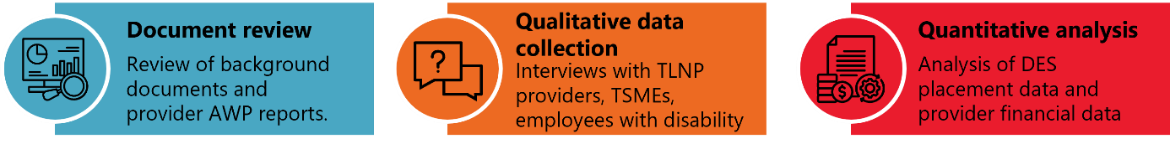

What we found
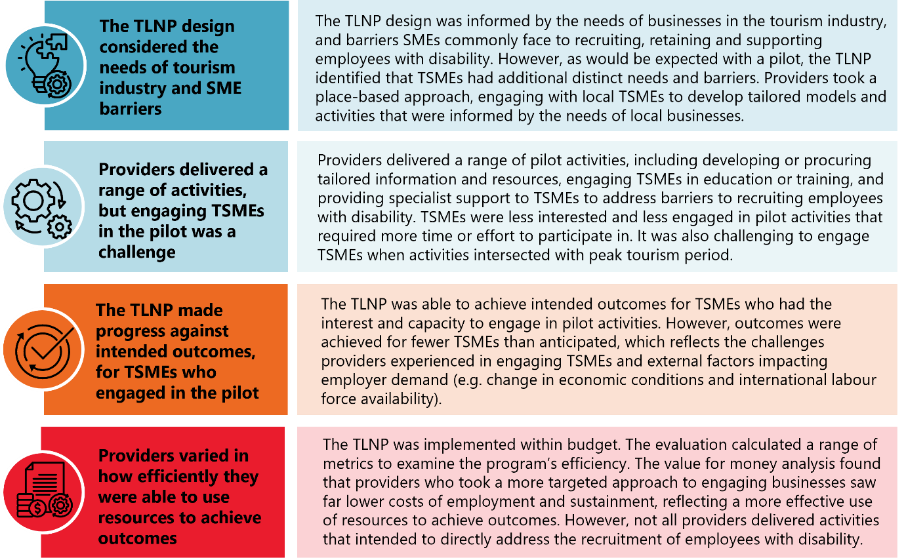

Opportunities
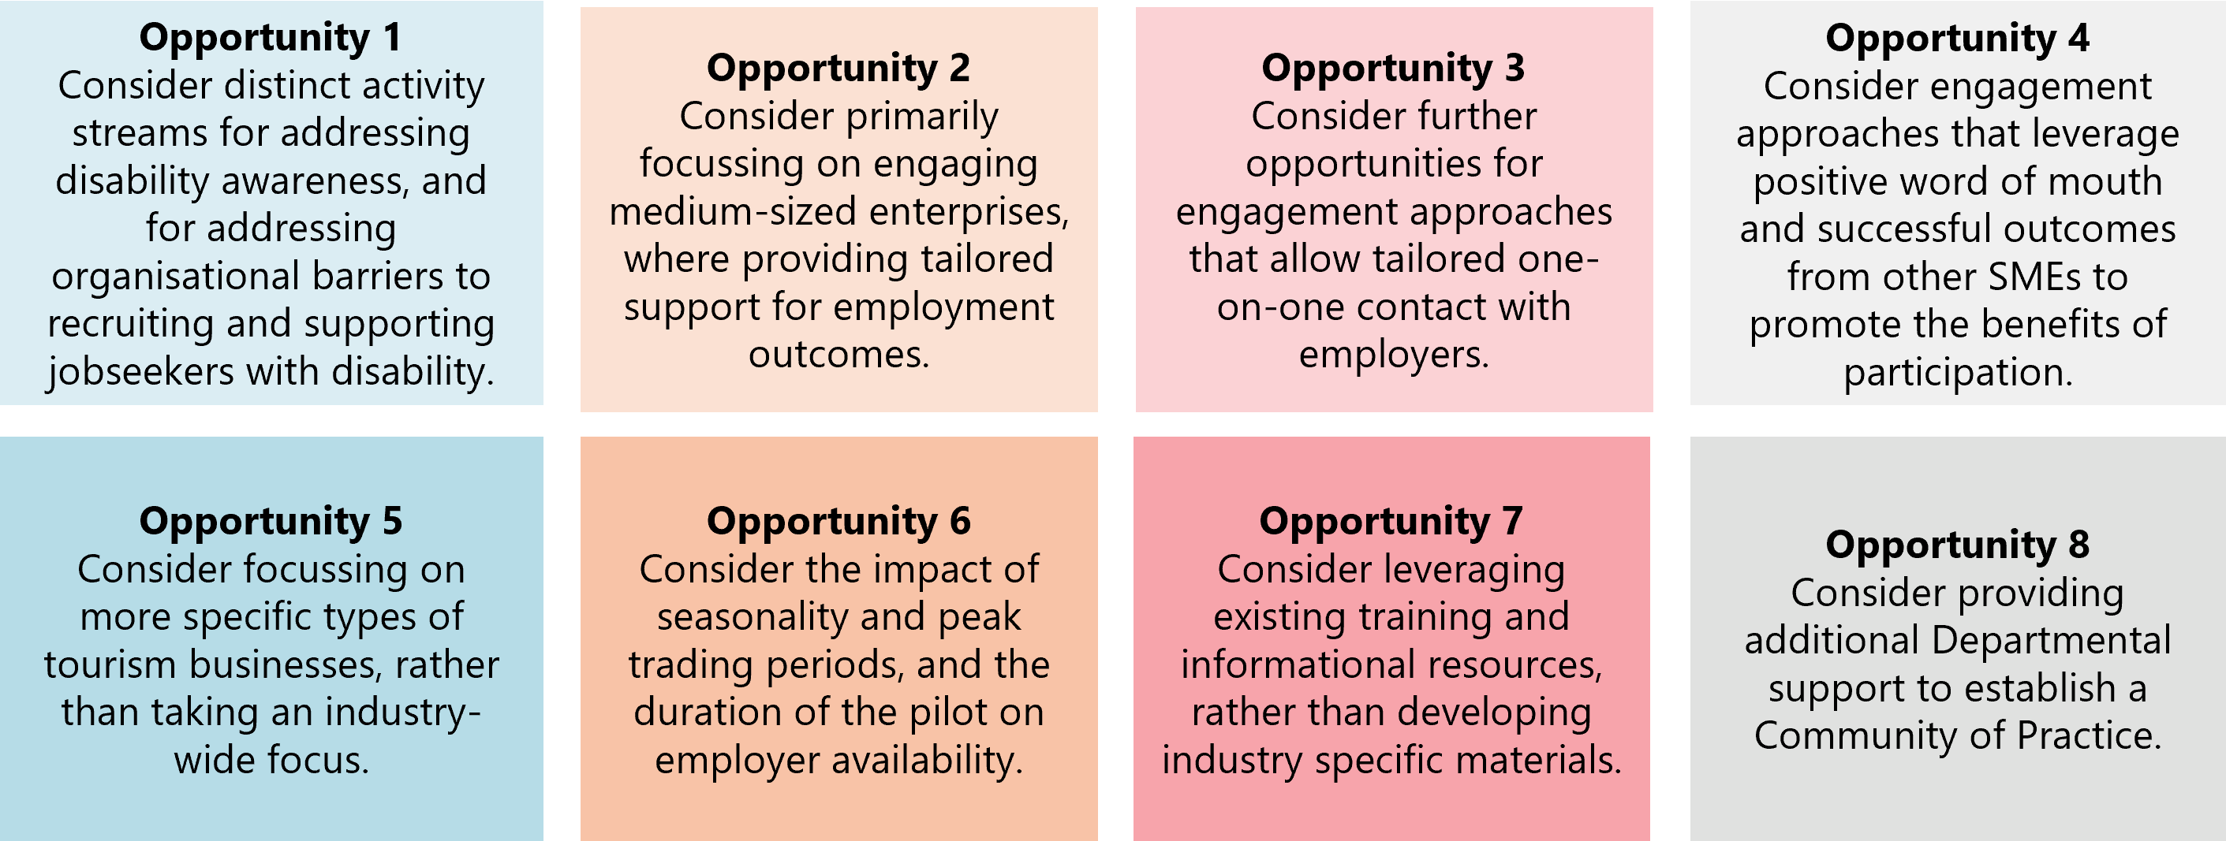

Executive Summary

The Tourism Local Navigator Pilot
The Tourism Local Navigator Pilot (TLNP) was a one-year national pilot focused on helping small-to-medium enterprises (SMEs) in the tourism industry (TSMEs) address barriers to recruiting and retaining employees and jobseekers with disability. The TLNP was funded from July 2023. The pilot was led by the Department of Social Services (DSS), and delivered in partnership with Austrade, who used their experience and existing networks to identify and engage stakeholders. There were 12 providers funded to engage local “Navigators” with knowledge of the local market and existing networks to facilitate engagement with TSMEs. The grant opportunity guidelines gave providers broad scope to identify and tailor eligible pilot activities to best suit the needs of TSMEs in their regions. Navigators were intended to act as a bridge between disability employment providers (including Disability Employment Services [DESs]) and local businesses in the community. The pilot covered 5 states, and 16 service areas in a mixture of urban and regional locations with established tourism industries that were experiencing workforce shortages as a result of the COVID-19 pandemic.

What we did
The DSS engaged ARTD Consultants to conduct an evaluation of the TLNP between September 2023 and November 2024.
The evaluation draws on:
- a review of key background documents, including TLNP grant opportunity guidelines, provider applications, and navigator location assessment criteria
- a review of TLNP provider Activity Work Plans (AWP), quarterly AWP reports, and final grant reports submitted by each provider to DSS as part of their funding agreement
- online and face-to-face interviews with TLNP Navigators and provider staff (N = 37, 12/ 12 providers)
- online and face-to-face interviews with TSMEs who participated in pilot activities (N = 14, 6/ 12 providers)
- online and face-to-face interviews with people with disability who were employed at a TSME as a result of the pilot (N = 12, 3/ 12 providers)
- online interviews with other key stakeholders (Austrade: N =1, at two timepoints, DSS Funding Arrangement Managers [FAMs]: N = 3, at the interim)
- analysis of DES placement data relating to placements into tourism industry roles in TLNP sites and non-pilot regions
- analysis of provider financial data submitted by each provider to DSS as part of their funding agreement and DSS financial data relating to the administration of the pilot.
The evaluation team was able to implement most data collection and analysis methods as intended and have sufficient data to answer the key evaluation questions. However, we were not able to interview TSMEs and/or people with disability at all sites, reflecting the lower than anticipated reach of the pilot. This, along with the differences in the quality of data collected and reported on by providers as part of quarterly AWP reporting and in their final reports, limit our ability to report on the outcomes of the pilot. In particular, our ability to report on the sustainment of employment is likely less reliable as not all providers were able to collect and report on data relating to the employment outcomes of people with disability placed into tourism roles as a result of the pilot. The consistency of the outcomes data and the ability to put a dollar value on all outcomes also impacted the value for money analysis.

What we found

Appropriateness
The TLNP design was informed by the needs of businesses in the tourism industry, and barriers SMEs commonly face to recruiting, retaining and supporting employees with disability. Key elements of the pilot design directly addressed these identified needs and known barriers including: a lack of time and/or capability, confusion on how or where to seek support, and preferences to use local networks. However, given this was a pilot, which would be expected to uncover greater understanding of TSME-specific needs, additional distinct needs and barriers emerged. These included:
- a greater need for TSME staff to be ‘all-rounders’ than in other types of SMEs
- less flexibility to tailor roles to be suitable for people with disability than larger tourism organisations
- less potential benefit from economies of scale than in larger tourism organisations, as many TSMEs were only looking to fill one or two positions at a time
- less regular/ more seasonal patterns of when businesses are looking to recruit new staff compared to other types of SMEs.
Providers took a place-based approach engaging with local TSMEs to develop tailored pilot models and activities that were informed by the needs of local businesses, which is consistent with recent research on the evidence base for employment supports. However, given the short timeframe available to engage TSMEs and develop a tailored model, providers were unable to make substantial alterations from their initial proposals.
Consistent with the guidelines, provider models included a range of pilot activities promoting the pilot, developing or procuring tailored information or resources, engaging TSMEs in education or training, and providing specialised support to TSMEs to identify job expectations and address barriers to recruiting, retaining and supporting employees with disability. While consistent with the guidelines, 4/ 12 providers did not focus on Navigators working directly with TSMEs to collaboratively address barriers to employing people with disability. This impacted how the TLNP could address one of its intended outcomes: to increase the number of people with disability employed in the tourism industry.
The TLNP tailored models and pilot activities met the business needs of some TSMEs – particularly those who were looking for new employees and/or were struggling to find new staff. However, provider staff reported that changes in economic conditions, seasonality in workforce needs, and increased availability of international workers during the course of the pilot impacted the business needs of many TSMEs in their regions, which resulted in lower than anticipated demand for the pilot.

Implementation
Generally, providers found that TSMEs were less interested and less engaged in pilot activities that required more time or effort to participate in. Additionally, only 8/ 12 providers planned to deliver higher engagement activities that directly aimed to achieve employment outcomes for people with disability.
Providers identified a range of barriers and enablers to implementation. The key enablers to pilot implementation included:
- The skills and experience of the Navigators
- The presence of strong existing relationships between TSMEs within the pilot site.
The key barriers to pilot implementation included:
- Changes in local conditions – including economic conditions, the job market, and TSME’s immediate business needs
- TSME’s perceptions of the benefits of the time-cost of engaging with the pilot
- Lower than anticipated disability confidence among TSMEs, and the persistence of stigma in the community
- Nature of roles available in TSMEs, and the limited ability to adapt roles to be more suitable for employees with disability given the greater need for staff who can be ‘all-rounders’.
The delivery of the TLNP started as planned and on time. However, providers experienced difficulties engaging TSMEs because when they were ready to promote the pilot to TSMEs it was peak tourism season. Many providers had to pause communication with TSMEs during this period. In response, DSS gave providers an option of a three-month extension to the pilot, which 8/ 12 took up.
Following feedback from providers regarding challenges engaging smaller enterprises, DSS expanded the definition of SME used to determine pilot eligibility, from <99 employees to <199 employees to help address some of the challenges providers experienced engaging TSMEs.
Additionally, providers reported changing the focus of their communication, information and/or training delivered to TSMEs, changing the mode of pilot activity delivery, as well as the timing and intensity of planned activities to better engage TSMEs. The adaptions providers made were generally similar across providers – reflecting broad rather than regionally-specific TSME needs and challenges.

Effectiveness
The TLNP was able to achieve intended outcomes for TSMEs who had the interest and capacity to engage in pilot activities. However, outcomes were achieved for fewer TSMEs than anticipated, which reflects the challenges providers experienced in engaging TSMEs and external factors impacting employer demand (e.g. change in economic conditions and international labour force availability).
Providers reported that employers who engaged with information and/or training delivered by TLNP providers knew more about their current capacity to employ people with disability, what they could do to increase their capacity, and where to go to access more information about employing people with disability. Indications from provider reports and TSME interviews are that this has yet to be translated into increased confidence and capability in recruiting and supporting people with disability in some TSMEs, and few TSMEs had begun applying their learnings at the conclusion of the pilot.
The extent to which providers facilitated improved connections between TSMEs and expert support organisations (ESOs) varied based on the extent to which their activities focused on this outcome. Some TSMEs had new or improved connections with ESOs as a result of the pilot.
Half of the TSMEs who were interviewed (across 4 of the sites) reported being more interested in employing people with disability as a result of the pilot but many noted that other factors (e.g. changing economic conditions, seasonal fluctuations in workforce demand, increasing return of international workers) influenced their employment demand.
In total, providers reported that, as a result of pilot activities, 221 people with disability interviewed for roles in TSMEs, resulting in 149 people with disability employed in TSMEs. However, these outcomes varied notably across providers: 10 of 12 providers achieved employment outcomes, with the number of people with disability employed ranging from 1 to 43 per provider. Providers also noted that their ability to achieve employment outcomes relied on the engagement of ESOs with the pilot, and some providers reported that some local DESs were not interested or willing to engage with the Navigator. When comparing statistical area 4 (SA4s) where the TLNP was delivered to non-pilot SA4s, there is no statistically significant differences in DES placements into roles in the tourism industry over the duration of the pilot. However, in the last quarter of available data (reflecting the final quarter of pilot delivery) there was a greater increase in the number of DES placements into tourism roles found in TLNP SA4s compared to non-pilot regions. This may reflect the time taken for employment outcomes to be achieved in pilot sites.

Sustainability
Providers and some TSMEs interviewed reported that TSMEs are likely to continue to use their increased awareness and understanding of the benefits of employing people with disability, including the resources developed and distributed by the Navigators, as well as more inclusive approaches to recruitment processes that some TSMEs have implemented. Some TSMEs reported highly valuing the support Navigators provided in building connections and relationships with ESOs, but given nearly half of the providers (5 of 12) anecdotally reported that many TSMEs in their region had poor experiences and relationships with ESOs prior to the pilot it is unclear the extent to which these connections will be sustained after the pilot support is concluded.
Providers, TSMEs, and people with disability reported that people with disability who were employed in TSMEs as a result of the pilot have developed skills and/or experience that can support their current and future employment, including employment in the tourism industry. Providers reported that 31 people with disability who were employed in TSMEs as a result of the pilot were still in those roles at the conclusion of the pilot, a sustainment rate of 21%. However, this may be an underrepresentation of the true number of people with disability who achieved sustained employment outcomes because not all providers remained in contact with TSMEs after facilitating connections to ESOs. Additionally, as employment in the tourism industry is strongly driven by seasonal demands, the achievement of a sustained employment outcome is likely to be highly dependent on when a person was employed relative to the seasonal cycle, the type of job and the nature of the role.

Efficiency
The TLNP was implemented within budget. The optional 3-month extension allowed most providers to expend their funding (except one provider which reported an underspend). In financial reporting to DSS five providers reported spending more than their funding amount as part of their acquittal process. The amounts varied significantly between providers (from 1.4% to 80% of the grant amount) and while it is likely that this extra amount was drawn from their own funding, due to the differences between organisations in terms of their accounting practices, it is difficult to infer whether this overspend was a function of underbudgeting on the part of providers or accounted for as part of program delivery.
The evaluation calculated a range of metrics related to the program’s economy, efficiency and effectiveness.
- Economy: DSS administration costs represented 17% of total program costs; while this is higher than available benchmarks for established government programs, this is to be expected for a pilot.
- Efficiency: There was wide variation between providers in costs to reach and engage TSMEs reflecting the different approaches taken by providers and different definitions of reach and engagement in provider data. Providers that took a more targeted approach to engaging businesses had higher costs of reach but progressively lower costs of engagement.
- Effectiveness:
- This analysis focussed on employment outcomes, but the pilot also targeted employer capability outcomes.
- Providers that took a more targeted approach to engaging businesses saw far lower costs of employment and sustainment. The overall cost per employment outcome sustained was $40,050 for the three providers that recorded these outcomes. This is a lower-bound estimate as some filled vacancies may become sustained vacancies over time and because of limitations in provider data on sustained employment outcomes. However, this is within range for employment programs referenced in recent research, especially those based on tailored in-person support (though this research does not represent a benchmark but a reference point from 10 programs).
- A cost-benefit analysis (CBA) for the pilot was developed but not included as part of the final analysis for several reasons, including that not all providers directly targeted employment outcomes, difficulties in capturing employment outcomes and sustained outcomes within the time period of the evaluation, and the inability to monetise key outcomes of the program, such as improvements in employer capability. For future programs, identification and monetisation of outcomes in the design phase through ex-ante CBA approaches, and validation of this through systematic collection of outcomes data by grantees may enable this analysis; however, there will likely be limitations to this given the difficulty of monetising some employment related benefits, such as wellbeing.
- Equity: Equity is an important consideration in value for money assessments. Recent research on the costs and benefits of employment services indicates participant need is an important influence on costs. However, there is not data on the needs of employees with disability reached through the pilot to identify if this also influenced costs.

Opportunities for the future
Based on the above findings, we have identified a number of potential opportunities for the design and delivery of future pilot initiatives or that could inform the new Specialist Disability Employment Program or align with the New Disability Employment Centre of Excellence.
For pilots or programs considering engaging SMEs:
- Consider distinct activity streams for addressing fundamental disability awareness, and organisational barriers to recruiting and supporting jobseekers with disability. Providers consistently reported that there was a lower level of disability awareness and confidence among employers than they expected. There is a clear need for information, education and training to improve the foundational disability awareness of employers, consistent with recommendations made in the Mid-term Review of the DES Program. However, these employers will take longer and require more intensive work to engage, compared to employers who have a sufficient existing level of understanding and interest in employing people with disability. Separating these two distinct streams of support that SMEs require could enable providers directly targeting employment outcomes to work more with employers to identify and address their needs, which is in scope for providers of the new Specialist Disability Employment Program and which recent research suggests is effective. This could support providers to more effectively use resources in promoting and engaging SMEs in relevant activities. However, this would require a level of local knowledge about existing SME capacity.
- Consider primarily focussing on engaging medium-sized enterprises, where providing tailored support for employment outcomes. As addressed through the expansion of the definition of SME in the pilot, providers consistently found that although some small enterprises were open to the opportunities of hiring people with disability (particularly where the employer had a personal connection to disability), the constraints of their organisation size (e.g. how regularly they were looking to hire new staff, their ability to tailor position descriptions) limited the extent to which activities aiming to increase the employment of people with disability were able to achieve their intended outcomes in smaller enterprises. This should not be to the exclusion of smaller enterprises that are seeking to employ people with disability.
- Consider further opportunities for engagement approaches that allow tailored one-on-one contact with employers. Providers that focussed on engaging fewer TSMEs with a higher intensity approach had more success and were more efficient than providers who focussed on reaching a higher number of TSMEs with a communications approach that prioritised broad and bulk communications.
- Consider engagement approaches that leverage positive word of mouth and successful outcomes from other SMEs to promote the benefits of participation. TSMEs found positive word of mouth and examples of other organisations benefiting from the pilot compelling. Consider taking a two-stage approach to engagement – where providers initially work with employers that are most responsive and interested in engaging in activities at initial contact (e.g. aligns with their corporate values, already highly value the importance of employing people with disability due to their personal experiences, highly motivated to hire new staff), then use their experiences to promote the pilot to employers that may have initially been more hesitant to participate.
For pilots or programs considering engaging tourism businesses:
- Consider focussing on more specific types of tourism businesses, rather than taking an industry-wide focus. The tourism industry includes a large range of businesses that support the visitor economy. The broad range of businesses made it challenging for Navigators to identify and to effectively engage all types of eligible businesses, as their business needs and potential ability to adjust roles differed substantially across different types of tourism businesses.
- Consider the impact of seasonality and peak trading periods, and the duration of the pilot on employer availability. Allowing for more of an establishment phase ahead of peak tourism season could help to avoid the clash experienced in rollout of the TLNP that delayed employer engagement.
For future pilot programs delivered by multiple providers:
- Consider leveraging existing training and informational resources, rather than developing industry-specific materials. Providers reported spending a substantial proportion of the pilot duration engaging local TSMEs about their needs, and tailoring their pilot model, activities, and resources to meet their needs. However, the identified needs of TSMEs and their required resources did not appear to substantially differ across the regions. As intended in the role of the Disability Employment Centre of Excellence, leveraging existing training and resource materials would allow providers to spend more time engaging and delivering pilot activities to SMEs, particularly in pilot programs where multiple providers are engaged as part of service delivery.
- Consider providing additional DSS support to establish a Community of Practice. It was intended that a Community of Practice (supported by DSS but organised and run by providers) would meet regularly throughout the delivery of the pilot. Although this group initially met as intended, for most of the implementation period it wasn’t active. As providers reported experiencing many similar challenges in the design and implementation stages of the pilot, an active community of practice may have helped providers to more effectively identify and address common problems. Including Community of Practice participation as a required activity for providers in the grant opportunity guidelines, as well as additional support from DSS in establishing and maintaining this group, may have helped ensure it met as intended.

Report
Detailed analysis against the key evaluation questions.

Program and policy context

The policy context
The United Nations Convention on the Rights of Persons with Disability set out the rights of people with disability to workplaces that are ‘open, inclusive, and accessible’ and to ‘equal opportunity to career development and advancement. In many countries around the world, there are legislative provisions to ensure equitable access to employment for people with disability. Nevertheless, global research indicates that there are numerous ‘roadblocks’ that continue to exist for people with disability in the workplace.
In Australia, the workforce participation rate of people with disability has persistently lagged behind the general population. Within the working-age population, only 56% of people with disability are employed, as compared to 82% of people not living with disability. Additionally, people with disability are more likely to experience underemployment relative to their capacity, skills, and qualifications. People with disability report working fewer hours than they may otherwise want or being looked over for opportunities for career advancement when compared to their co-workers not living with disability.
The economic impact of this gap negatively affects the health, wellbeing and prosperity of people with disability (and their carers and support workers)3F. Moreover, businesses are economically impacted through the lost opportunities in innovation and engagement that can accrue from meaningful engagement of people with disability4F. The persistence of this gap is especially prominent given the historically low unemployment rate in Australia.

Employ my Ability
To help address the challenges faced by people with disability, The Australian Government set out the Australian Disability Strategy 2021-2031 as a national framework to continue to improve the lives of people with disability in Australia over the next 10 years.
Within this, the Department of Social Services (DSS) launched Employ My Ability – the Disability Employment Strategy (the Strategy), which outlines a vision of an Australian workforce with an ‘inclusive workplace cultures where people with disability thrive in their careers’. The strategy recognises the need for a systems approach to change and includes 4 priority areas:
- Lifting employer engagement, capability and demand
- Building employment skills, experience and confidence of your people with disability
- Improving systems and services for job seekers and employers
- Changing community attitudes.
Under Australia’s Disability Strategy 2021-2031, governments have established Targeted Action Plans to make headway in achieving outcomes in specific areas of the Strategy. The Employment Targeted Action Plan5F sets out key actions to improve paid employment outcomes for people with disability.
A key action under the objective to increase employment of people with disability was to connect people to work in areas of skills shortage through the Australian Government partnering with industry to trial pilot programs that connect Disability Employment Services (DES) participants to jobs in sectors that are experiencing skills shortages.

Post-COVID recovery of the tourism industry
The COVID-19 pandemic had an extreme impact on the tourism industry, both as a result of restrictions on business activities to mitigate the pandemic, as well as restrictions on travel and immigration that reduced the market for tourism as well as the workforce to deliver tourism activities. This was especially felt in regional and remote Australia.
One of the priorities outlined in the THRIVE 2030 strategy is to grow a secure and resilient workforce for the visitor economy. A key action under this priority was to increase workforce participation from under-participating cohorts, including people with disability, by supporting people with disability with employment opportunities in the visitor economy, including through a pilot program to facilitate people with disability into the visitor economy workforce. This action was the genesis of the Disability Employment Tourism Local Navigator pilot (TLNP).

The Disability Employment Tourism Local Navigator Pilot
The TLNP was a one-year national pilot focused on helping small-to-medium enterprise (SME) in the tourism industry (TSMEs) address barriers to recruiting and retaining employees and jobseekers with disability. The TLNP was funded from July 2023.

Design and delivery model
The pilot was led by the Department of Social Services (DSS), and delivered in partnership with Austrade, who used their experience and existing networks to identify and engage stakeholders.
The TLNP funded service providers in each site to engage local “Navigators” with knowledge of the local market and existing networks to facilitate engagement with TSMEs. The grant opportunity guidelines gave providers broad scope to identify and tailor eligible pilot activities to best suit the needs of TSMEs in their regions. The Navigator was intended to act as a bridge between disability employment providers (including DES) and local businesses in the community.

Target cohort
The TLNP targeted SMEs in the tourism industry (TSMEs), in a mixture of urban and regional locations with established tourism industries that were experiencing workforce shortages as a result of the COVID-19 pandemic.

Locations
DSS identified the priority locations for the TLNP pilot by assessing each potential service area against a range of relevant criteria. These included whether a service area:
- had an entrepreneurship facilitator, and the related network of existing support that could be leveraged through the TLNP
- had an employment facilitator, and the related network of existing support that could be leveraged through the TLNP
- had a local jobs plan, with visitor economy jobs as a priority
- had a high number of tourism SMEs
- had a high number of vacancies in tourism-related occupations, which indicated unfilled jobs and employer demand
- had a high number of DES users
- had a high number of income support recipients with partial capacity or temporarily reduced capacity to work.
Through this process, service areas that had both the demand for employees by TSMEs and sufficient numbers of people with disability who may be able to fill these vacancies were selected as priority regions for the delivery of the TLNP.
The TLNP was delivered across 16 service areas (Figure 1).
Figure 1: TLNP provider service areas
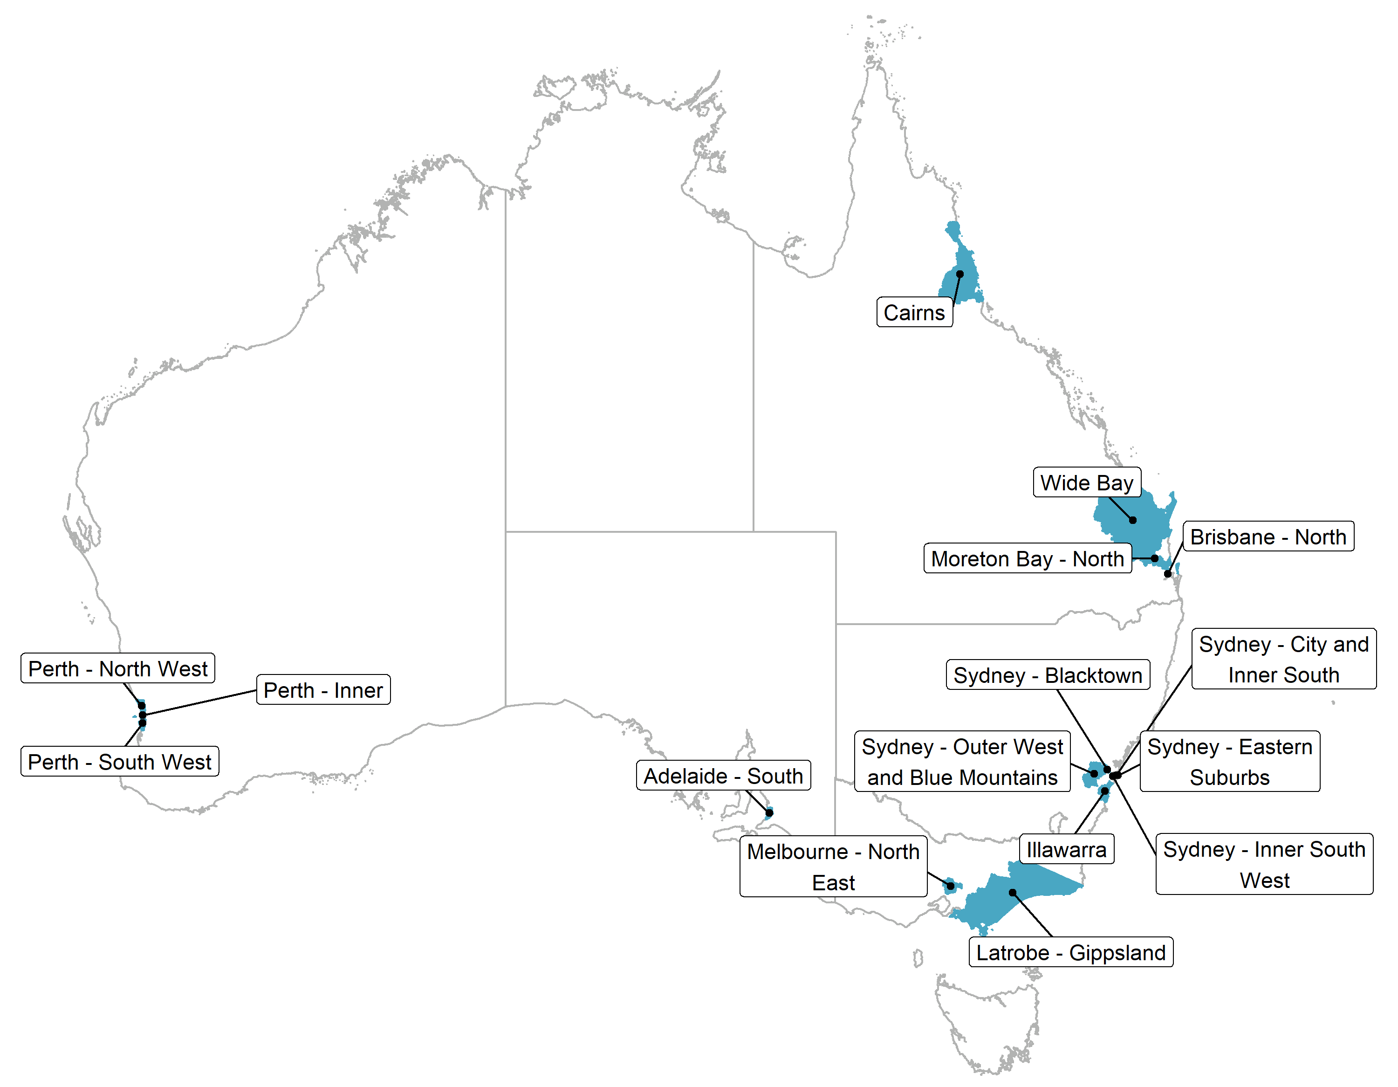
The twelve successful providers and the service areas they deliver the pilot in are shown in Table 1.
Most regions only had a single provider delivering the TLNP; however, in two SA4s there were two providers delivering the TLNP:
- Adelaide South: Julia Farr Association and SYC
- Latrobe – Gippsland: Interact Australia Limited and Management Governance Australia.
Three providers delivered the TLNP across multiple SA4s:
- Hospitality Disability Network WA: Perth – Inner, Perth – North West, Perth – South West
- HELP Enterprises: Brisbane – North, Brisbane – Inner City, Wide Bay
- Disability Services Australia: Sydney – Blacktown, Sydney – City and Inner South, Sydney – Eastern Suburbs, Sydney – Inner South West.

Table 1: TLNP providers and service areas
Provider | Service Area (as per grant agreement)
Interact Australia Limited (Victoria) | Latrobe − Gippsland
Hospitality Disability Network WA Incorporated | Perth − Inner  Perth − North West  Perth − South West
Epic Employment Service Incorporated | Cairns
Julia Farr Association Incorporated | Adelaide − South
Management Governance Australia Proprietary Limited | Latrobe − Gippsland
Project Etico Australia Limited | Sydney − Outer West and Blue Mountains
Eastern Volunteer Resource Centre Incorporated. | Melbourne − North East
ON-Q Human Resources Limited (trading as BUSYAbility) | Moreton Bay − North
SYC Limited | Adelaide − South
HELP Enterprises Limited | Brisbane – North and Inner City7F  Wide bay and Sunshine Coast
Disability Services Australia Limited | Sydney – Blacktown  Sydney – City & Inner South  Sydney – Eastern Suburbs  Sydney – Inner South West
The Disability Trust | Illawarra
There was substantial variability in the characteristics of the regions across the selected pilot sites. The pilot sites included both large metropolitan cities, and regional areas with smaller towns. The specific features of the local tourism industry differed across sites, as did the scale and connectivity of existing local TSME networks. The characteristics of the TLNP providers and the Navigators they employed also differed across sites. See Appendix 2.2 for a summary of the key characteristics of each site and provider.

Intended outcomes
The grant opportunity guidelines for funded providers stated that the intended outcomes of the TLNP were:
- Building TSME’s capability, disability confidence and workplace accessibility through industry tailored approaches and resources
- Reforming workplace culture and employment practices
- Connecting tourism businesses to existing disability resources, supports and specialist information
- Sustainable job creation for people with disability looking to participate in the labour market through workplace preparedness and targeted on the job training and supports.

Funding
The total allocated funding for the project was $3.3 million.

Program logic
A program logic model was developed to describe how the outcomes of the program were expected to be achieved (see Figure 2 below). The logic model is read from left to right. On the left side of the logic, the program has more control while at the right it has less control, as external factors have more influence.

Figure 2: TLNP program logic
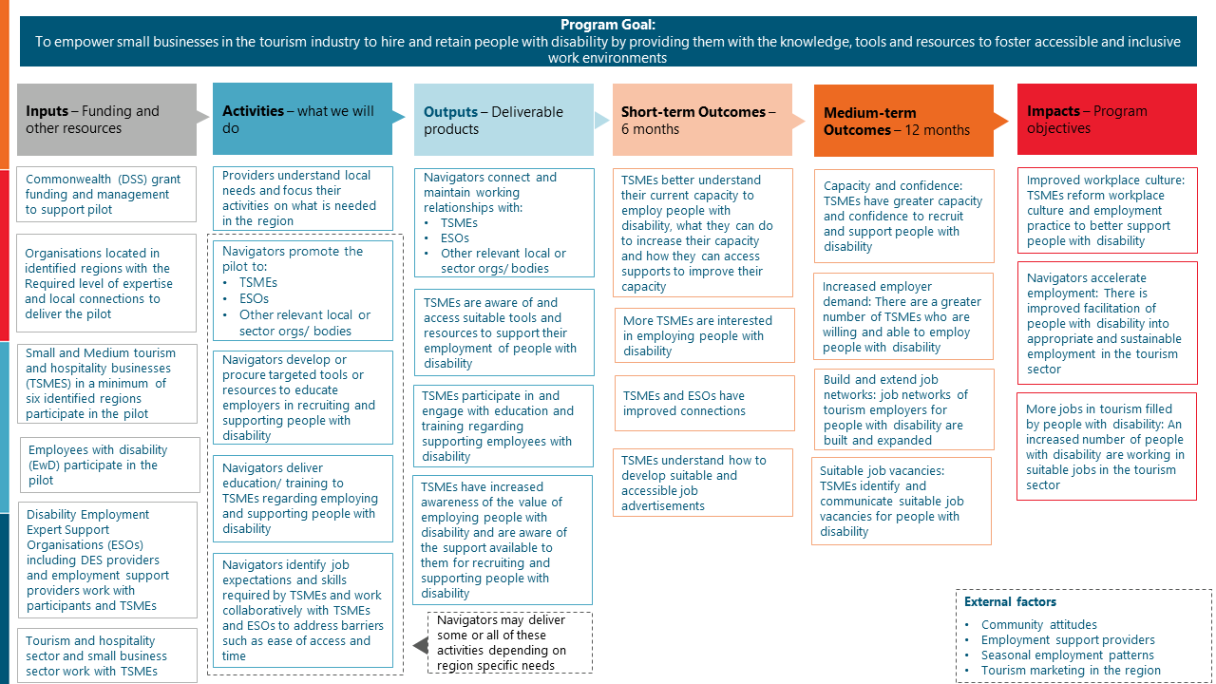

The evaluation

Purpose
The evaluation team was engaged at the inception of the TLNP to enable robust monitoring and evaluation of the pilot through establishing a baseline and benchmarking, reviewing pilot implementation, assessing outcomes, and providing timely input to future policy and program design.

Key evaluation questions
The key evaluation questions, and the evaluation reports they have been addressed in are shown in Table 2.
Table 2: Key evaluation questions
Question domains | Key evaluation question | Baseline evaluation | Interim evaluation | Final evaluation
Appropriateness | 1. To what extent does the TLNP address the identified needs of the pilot participant and the goals of the pilot? | Yes | Yes | Yes
Appropriateness | 1.1 How were the needs of businesses understood and used to inform pilot activities? | Yes | Yes | Yes
Implementation | 2. What was delivered as part of the pilot? | Yes | Yes | Yes
Implementation | 2.1 Was it delivered as planned and on time? | No | No | Yes
Implementation | 2.2. To what extent did planned activities need to be adapted to the needs of regions? | Yes | Yes | Yes
Implementation | 2.3 What were the enablers and barriers to the pilot? | No | No | Yes
Effectiveness | 3. What progress was made towards achieving the outcomes of the pilot? | Yes | Yes | Yes
Effectiveness | 3.1 Who experienced which outcomes, in what ways, and under which circumstances? | No | Yes | yes
Effectiveness | 3.2 What were the characteristics of employers who valued the contribution and benefits of employing people with disability? | No | Yes | Yes
Effectiveness | 3.3 What unanticipated positive or negative outcomes also occurred? | No | Yes | Yes
Sustainability | 6. What outcomes for employers and people with disability are likely to continue? | No | No | Yes
Sustainability | 6.1 What changes that employers have made are likely to continue? | No | No | Yes
Sustainability | 6.2 To what extent is the pilot likely to result in increased employment for people with disability? | No | No | Yes
Efficiency | 4. Was the pilot implemented within budget? | No | Yes | Yes
Efficiency | 4.1 Were there any differences in delivery between pilot sites? | No | Yes | Yes
Efficiency | 4.2 Did any sites require additional attention (i.e. extra support from DSS)? | No | No | Yes
Efficiency | 5. Does the current funding model provide value for money? | No | No | Yes
Efficiency | 5.1 What was learned about how different pilot sites used different resources and activities to produce outcomes? | No | No | Yes
Scalability | 7. What are the conditions for success? | No | Yes | Yes
Scalability | 8. What has been learned from the pilot regarding overcoming barriers? | No | Yes | Yes
Scalability | 9. What has been learned from the pilot that can be used to inform future initiatives? | No | Yes | Yes

Methods
We have addressed the evaluation questions using a mixed-methods approach that draws on multiple sources of information to answer evaluation questions. The methods used to answer the key evaluation questions are outlined below.

Document review

Document analysis and literature scan
We reviewed a range of background documents provided by DSS relating to the design and delivery of the TLNP. These documents included:
- TLNP Grant Opportunity Guidelines
- Provider applications for the TLNP
- TLNP Activity Work Plans (AWP)
- Navigator locations assessment matrix

Review of TLNP provider AWP reports
We reviewed all AWPs that each provider submitted to DSS, as required under their funding agreement.
Emerging themes regarding activities and anticipated outcomes were used to inform the development of the revised TLNP program logic, and each provider’s AWP was used to tailor provider interview guides.
Provider AWP reports were used to map intended and delivered program activities, and outcomes achieved to the activities and outcomes as outlined in the TLNP program logic.
We also reviewed the final grant reports submitted by each provider to DSS, as required under their funding arrangement. Evidence submitted by providers (in the report, or as supplementary appendices) was used to inform assessment of outcomes achieved by each provider and was the key source of evidence for the value-for-money analyses.

Qualitative methods

Interviews with TLNP staff and stakeholders
We conducted interviews with TLNP staff and stakeholders, to understand the implementation, impact and sustainability of the pilot (Table 3).
Table 3: Interviews with TLNP staff and stakeholders
Stakeholder group | Sample | Timing | Notes
TLNP Navigators and provider staff | - Navigators: N = 12  - Other provider staff: N = 25  - 12/12 providers | Final interviews  - Cohort 1* (Providers A – D): July – August 2024  - Cohort 2* (Providers E – L): September – October 2024.  Post AWP interviews  - September 2023  - December 2023  - March 2024 | - Interviews with Navigators and provider staff conducted after each AWP submission over pilot delivery  - Reached target number and provider coverage.
TSMEs | - N = 14  - 6 / 12 providers | - Cohort 1 (Providers A – D): July – August 2024  - Cohort 2 (Providers E – L): September – October 2024. | - Did not reach overall target (60 TSMEs because of level of TSME engagement in the pilot.  - Only reached target coverage (5 TSMES per provider) for one provider.
Employees with disability | - N = 12  - 3 / 12 providers | - Cohort 1 (Providers A – D): July – August 2024  - Cohort 2 (Providers E – L): September – October 2024. | - Did not reach overall target (72 employees with disability) because of lower engagement of people with disability in the pilot  - Only reached target coverage (6 per provider) at one provider.
Austrade | - N = 1 | - May 2024 | - A representative from Austrade was interviewed as part of the interim evaluation regarding how the TLNP was designed and how it aligns with broader objectives and strategies.
DSS Funding Arrangement Managers (FAMs) | - N = 3 | - March – April 2024 | - FAMs were interviewed as part of the interim evaluation regarding provider implementation of the pilot.
Note: * Data collection with providers took place in 2 cohorts, depending on the end date of the pilot at each site. Cohort 1 consisted of 4 providers who did not take up DSS’ offer of an extension, and pilot delivery concluded in June 2024. Cohort 2 consisted of 8 providers who took up the option for a three-month extension, and pilot delivery concluded in September 2024.

Quantitative methods

DES placement data analysis
The DES Employment Data includes information about DES placements for people with disability at the SA4 level. There is no Australia New Zealand Industry Code (ANZIC) for tourism; however, a Tourism Industry Indicator was created by data analysts in the Jobs and Skills team in DSS that flags roles that are likely to be in the tourism industry. This allowed for information relating to when a placement was made, the type of industry (e.g. tourism industry, non-tourism industry) and location (TLNP SA4, non-pilot SA4) to be examined at baseline and during the implementation of the pilot.
The relevant metrics to benchmark the employment of people with disability in the tourism sector prior to and post implementation of the TLNP included:
- number of DES tourism sector placements as a proportion of total working age population, by quarter, for TLNP and non-pilot SA4s
- proportion of all DES placements that were made into the tourism sector, for TLNP and non-pilot SA4s.
To examine the causal impact of the TLNP on placement of people with disability into roles in the tourism sector, we conducted a difference-in-difference regression. This approach compares the changes in outcomes over time between the treatment group (SA4s where the TLNP was delivered) and a control group (SA4s where the TLNP was not delivered). This approach helps control for time-invariant differences between groups (e.g. differences in baseline levels of DES placements into tourism roles) and common trends (e.g. seasonal fluctuations in the number of DES placements into tourism roles), isolating the impact of the pilot from other external factors.

Economic analysis
The value for money analysis is structured by the work of Barr and Christie, which classifies metrics related to Economy, Efficiency, Effectiveness and Equity by quality (Monetary, Quantitative or Qualitative) and measurement type (Benchmark, Comparative, or Stand-alone).
Input data and metrics for the analysis came from DSS budget and spending data, including data on internal resourcing (staff levels and full-time equivalent loading), along with spending on grants and reported actual outcomes as budgeted and reported by providers as part of AWPs.
As financial reporting data differed between providers, it was not possible to identify the level of “in-kind” support provided as part of project delivery in aggregate. However, it is assumed that where a cost overrun relative to the grant was made, that this shortfall represented in-kind support from the provider.
A cost-benefit analysis (CBA) for the pilot was developed but not included as part of the final analysis for several reasons, including that not all providers directly targeted employment outcomes, difficulties in capturing employment outcomes and sustained outcomes within the time period of the evaluation, and the inability to monetise key outcomes of the program, such as improvements in employer capability.

Confidence in the findings
We were able to implement most of the planned data collection and analysis methods as intended and have sufficient data to answer the key evaluation questions.
However, we were not able to interview TSMEs and/or people with disability at all TLNP pilot sites, reflecting the lower than anticipated reach of the pilot, so we did not reach the target numbers of interviewees for these cohorts. This, along with the differences in the quality of data collected and reported on by providers as part of regular quarterly AWP reporting and in the final provider reports, limit our ability to report on the outcomes of the pilot. In particular, our ability to report on the sustainment of employment is likely less reliable as not all providers were able to collect and report on data relating to the employment outcomes of people with disability placed into tourism roles as a result of the pilot.
The consistency of the outcomes data available also impacted the value for money analysis.

Appropriateness
This chapter examines the extent to which the design of the TLNP was appropriate.
 | Key evaluation question
Appropriateness | 1. To what extent does the TLNP address the identified needs of the pilot participants and the goals of the pilot?  1.1 How were the needs of businesses understood and used to inform pilot activities?

To what extent does the design of the TLNP address the identified needs of pilot participants?
The tourism industry was identified as the target sector for this pilot due to the skills shortages the sector was experiencing following the COVID-19 pandemic, and the alignment with broader government strategy to support a more diverse visitor economy workforce outlined in the THRIVE 2030 strategy. The business need and projected industry workforce needs addressed by the TLNP are shown in Table 4.
Table 4: Tourism industry needs addressed by the TLNP
Industry need | Reason for need | Addressed through TLNP by:
Current business need: more available workers to address acute shortages | As a result of the COVID-19 pandemic, and associated travel restrictions, tourism businesses that typically relied on short-term holiday workers were not able to fill roles using their previously available worker options. | The TLNP Navigators expanding the job networks of TSMEs through supporting connections between TSMEs and ESOs, and working collaboratively to address barriers to the organisation employing people with disability.
Projected industry needs: a more sustainable local source of employees | The National Skills Commission predicted a strong future workforce demand for many businesses within the tourism sector and, as outlined in the THRIVE 2030 strategy, there is an opportunity to diversify the tourism workforce through increasing workforce participation from under-participating cohorts (including people with disability). | Building knowledge and skills of TSMEs to support their ability to recruit, employ and retain employees with disability beyond the duration of the pilot.  Employing people with disability can reduce the burden of staff turnover for businesses, as people with disability are an available domestic source of employees who are likely to stay with businesses on a longer-term basis.
Note: Current industry need was identified through interviews with Austrade representatives. Projected industry needs outlined in THRIVE 2030: The Re-Imagined Visitor Economy. A national strategy for Australia’s visitor economy recovery and return to sustainable growth, 2022 to 2030.
As the vast majority (around 95%) of tourism businesses are categorised as small operations, employing 20 or fewer employees, and previous research has found that SMEs experience barriers to recruiting, retaining and progressing employees and jobseekers with disability, the pilot was designed to target and support these businesses to hire and retain people with disability through providing TSMEs with the knowledge, skills and resources they need to address known barriers to SMEs employing people with disability. The features of TLNP design that address known barriers to employing people experienced by SMEs is shown in Table 5.
Table 5: TSME barriers to employing people with disability addressed through the TLNP
Barriers experienced by SMEs | Addressed through TLNP by
A lack of time and/or capability to recruit people with disability | Reducing the time burden for TSMEs interested in building their capability to employ people with disability through helping them to navigate processes involved in developing an accessible and inclusive workplace and employing jobseekers with disability.
Confusion on how or where to seek support | Supporting TSMEs to understand where and how to access available supports, through connecting TSMEs to existing disability resources and supports, as well as through delivering educational resources and/or training tailored to the tourism industry and SME needs.
Preferences to use local networks to source employees. | Working collaboratively with TSMEs and ESOs to address barriers to employing people with disability and building local job networks, so that TSMEs have expanded local networks they can draw on to source employees.
Note: These key barriers experienced by SMEs are reported in ComCare, Employer Mobilisation Final Research Report, 2018.
Although the needs of the tourism industry and the barriers experienced by SMEs were used to inform the design of the TLNP, given this was a pilot, which would be expected to uncover greater understanding of TSME-specific needs, additional distinct needs and barriers emerged (see Section 3.2).

How was the TLNP tailored to address the needs of local businesses?
As the tourism industry consists of a diverse range of businesses, the characteristics and needs of tourism businesses are likely to differ across regions, and a ‘one-size-fits-all’ model would be unlikely to meet the needs of TSMEs in smaller regional locations as well as TSMEs operating in large metropolitan cities. The TLNP design process allowed for each provider to tailor the types and focus of activities they deliver, so pilot activities can address the needs and barriers identified by TSMEs in their region. As intended, all providers reported undertaking engagement activities to understand the needs of TSMEs in their region. There were two broad approaches to engagement that providers took to understand the needs of local TSMEs.
- Direct one-one-one engagement with local TSMEs: Navigators directly reaching out to local TSMES (either through industry events, social media, or cold-calling) to discuss the pilot and the needs of their business. This approach allowed Navigators to directly understand the specific needs to TSMEs in their region. However, Navigators found this engagement approach was often very time intensive and that it took longer to identify broader trends regarding TSME needs in their region.
- Engagement with sector organisations/ bodies: Navigators engaging with business councils, relevant industry associations or sector bodies to promote the pilot and understand the needs of their members. Engaging with appropriate and relevant associations gave providers a greater understanding, and greater reach than would be possible through spending similar amounts of time on direct engagement. However, many providers found that there was a disconnect between the needs identified by these associations and the needs expressed by TSMEs on the ground. Some Navigators found that industry leaders reported there was a high need for the pilot, but when they later engaged with local TSMEs they commonly expressed that they were not currently looking to employ new staff. This may reflect the changing context that the pilot was being delivered in, or differences in need between larger tourism businesses and the TSMEs that were eligible to participate in the pilot.
In line with the grant opportunity guidelines, providers tailored their service model and planned pilot activities after engaging with local TSMEs to identify local needs. Providers reported using their understanding of local TSME needs to inform:
- the focus and content of educational and training materials
- the expected level of disability understanding and awareness of pilot participants
- the mode of delivery for intended pilot activities.
The extent to which providers tailored the design of their intended model in response to identified local needs is less clear. As part of the grant application process, providers outlined their tailored model and proposed pilot activities. Given the relatively short duration of the pilot (12 months), some providers noted that it was challenging to use their understanding of local needs to substantially alter their proposed pilot model – as providers needed to progress on the delivery of other pilot activities in parallel to engaging TSMEs.

To what extent did providers’ tailored pilot models address the needs of local TSMEs and the goals of the pilot?
As a result of the flexible design process, providers delivered different activities. The number of providers delivering each type of pilot activity is shown in Figure 3. All providers planned to promote the pilot and develop tools and resources. Most providers also planned to deliver education and training as part of their model.
Figure 3: The types of pilot activities included in the providers tailored models
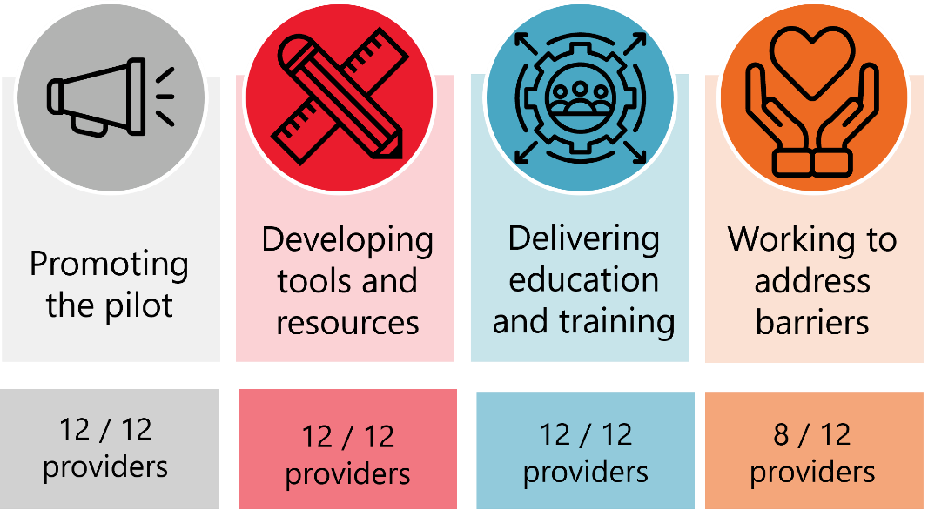
Source: Provider AWP reports.
The tailored models developed by providers had less of a focus on the Navigators acting as a “bridge” between TSMEs and ESOs than was anticipated. 4 of the 12 providers did not plan to directly support TSMEs to address their organisational barriers to employing and supporting jobseekers with disability. As a result, this tailoring process (although in line with grant opportunity guidelines) impacted the extent to which the pilot is likely to make progress towards sustainable job creation for people with disability looking to participate in the labour market through workplace preparedness and targeted on the job training and supports.
A range of specific TSME needs emerged through the pilot including:
- a greater need for TSME staff to be ‘all-rounders’ than in other types of SMEs
- less flexibility to tailor roles to be suitable for people with disability than larger tourism organisations
- less potential benefit from the economies of scale than in larger tourism organisations, as many TSMEs were only looking to fill one or two positions at a time
- less regular/ more seasonal patterns of when businesses are looking to recruit new staff compared to other types of SMEs.
Providers attempted to address some of these needs through tailoring the focus and content of the pilot activities they delivered. However, these TSME specific needs meant that many employers did not feel that the potential benefits for their organisation outweighed the time-cost associated with engaging or participating in the pilot. Most of the TSMEs who were interviewed as part of the evaluation reported that the pilot and the activities delivered by the Navigator aligned with their current business needs – their business was interested in hiring new employees and/or was struggling to find new employees. Most TSMEs who were interviewed felt that the pilot activities met their needs regarding recruitment. However, one TSME interviewed noted that TLNP activities would not be as suitable for businesses that were only looking to hire one new employee, as the time investment for the employer would be too much.
Provider staff consistently reported that there was a lower need for the TLNP in their region than anticipated. Some reasons for local TSMEs having a lower current business need (i.e. workforce shortages) that could be addressed through the TLNP included:
- Seasonal fluctuations in workforce demands: Providers found that TSME need for new workers fluctuated across the year driven by peak tourism periods in their region. Many TSMEs may have future needs for workers that could be supported by the TLNP, but this did not align with the timing of engagement and/or planned periods of pilot activities.
- Changing economic conditions impacting the tourism industry: Providers reported that many TSMEs were impacted by inflation and increasing cost-of-living pressures impacting the tourism industry, due to decreased demand/ spending.
- Increasing return of international workers following the lifting of COVID-19 travel restrictions: At the time the TLNP was designed the tourism industry was still experiencing the impact of COVID-19 travel restrictions on international worker numbers. This had begun to change by the time the pilot was implemented, and providers reported TSMEs found this less of an issue.

Implementation
This chapter examines what has been delivered across services providers, as well as how pilot activities have been adapted to meet specific regional needs.
 | Key evaluation question
Implementation | 2. What was delivered as part of the pilot?  2.1 Was it delivered as planned and on time?  2.2. To what extent did planned activities need to be adapted to the needs of regions?  2.3 What were the enablers and barriers of the pilot?

What was delivered as part of the pilot?
As noted in Chapter 3, not all providers focused on delivering all activities within the pilot guidelines. Examples of activities delivered under each pilot activity type, and the number of providers that delivered each type of activity is shown in Table 6. The number of providers that delivered pilot activity types differs from the number of providers than intended to deliver these activities as part of their tailored pilot model (reported in chapter 3) as some did not undertake some of their planned activities.
Table 6: Types of activities delivered as part of the TLNP
Activity type | Delivered by | Examples of activities
Promoted the pilot to TSMEs, ESOs, and/or other relevant sector organisations and bodies | 12/ 12 providers | - Created area specific branding of the pilot.  - Direct engagement and conversations with these groups by the Navigator.  - Engaged with local media regarding new stories reporting on the pilot.  - Used social media (e.g. Facebook, LinkedIn) to promote the pilot to provider networks.  - Attended expos in tourism and hospitality to promote the pilot to SMEs.  - Engaged/ partnered with local councils (e.g. to deliver info sessions at council event or included information about the pilot in the council newsletter).
Developed or procured targeted tools and resources to educate employers in recruiting and supporting people with disability | 12/ 12 providers | - Developing new tools and resources, for example developing industry specific online toolkits, or employer resource packs.  - Tailoring or adapting existing tools or resources to include more specific details relevant to employers in the tourism and hospitality industries.  - Engaging another provider to deliver disability awareness training for TSMEs.
Engaged TSMEs with education and training regarding supporting employees with disability | 11 / 12 providers | - Delivering educational panels or online webinars.  - Delivering disability awareness, workforce planning, or diversity in recruitment workshops or training (online or face-to-face).  - Providing tailored one-on-one training and support to businesses.
Identified job expectations and skills required by TSMEs and worked collaboratively with TSMEs and ESOs to address barriers to employment such as ease of access and time. | 6/ 12 providers | - Engaging with TSMEs to understand their specific business needs and engaging with ESOs to understand the skills of jobseekers with disability.  - Using a ‘reverse-marketing’ approach to promote candidates to TSMEs that are well matched to the roles and the skills their business needs.
Source: Provider AWPs and final reports.
Providers typically reported taking a staged approach to their delivery of pilot activities: first promoting the pilot more broadly, then engaging potential pilot participants with more information about the pilot and the potential benefits participating in pilot activities and/or employing people with disability could have for their business. After identifying businesses that were interested and available in learning more about employing and supporting employees with disability, providers engaged TSMEs in information and/or training. All but one provider reported delivering these types of activities. The one provider who did not engage TSMEs in information and training activities had intended but was not able to deliver these types of activities. Finally, providers supported some TSMEs with interest and current needs with business-specific supports to address barriers to employing people with disability. Although 8 of 12 providers planned to deliver these activities, only 6 of 12 reported delivering these activities in their final reports to DSS.
The overall reach of the TLNP, as reported in provider final reports submitted to DSS, is shown in Figure 4. Generally, providers found that TSMEs were less interested and less engaged in pilot activities that required more time or effort to participate in.
Figure 4: Reach of TLNP activities, across all providers
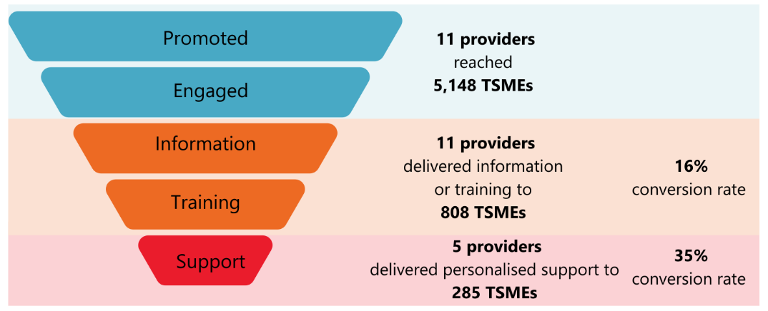
Source: Provider final reports. Note: Reach is across all providers that reported data against relevant activities. One provider did not report any reach data in their final report, and as such is not included in this analysis.
There were notable differences in the number of TSMEs that each provider was able to reach in different types of pilot activities (see Table 7). Some providers had a strong focus on promoting the pilot through high reach approaches such as email, newsletters or social media (e.g. Provider L which reported reaching 2,500+ TSMEs through newsletter or social media campaigns), whereas other providers had a greater focus on in-person promotion and reached a smaller number of TSMEs over the duration of the pilot.
The number of TSMEs reached in initial promotional activities did not always translate into higher levels of engagement with information and/or training activities. Some providers had greater success in translating promotion to engagement with the pilot.
For example, Provider E reached 115 TSMEs in promotion and initial engagement activities, which resulted in 68 TMEs participating in information and/or training (59% conversion rate). While one provider interviewed reported that they found that around 5% of the businesses they promoted the pilot to expressed interest in engaging with the pilot.
Additionally, 2 of the 8 providers that had planned to deliver activities providing personalised support to TSMEs to address barriers to employment for people with disability, were not able to do so at the conclusion of the pilot. One of these providers noted that they were unable to deliver this type of activity as TSMEs they engaged with advised that they were not currently hiring employees, or they were hesitant to employ people with disability and as a result were not ready to engage with this type of activity.

Table 7: Reach of TLNP activities, by provider
Provider | Businesses reached | Businesses received information or training | Businesses received personalised support
Provider A* | 300 | 35 (12% converted) | 8 (23% converted)
Provider B* | 80 | 80 (100% converted) | 0 (0% converted)
Provider C* | 115 | 68 (59% converted) | 0 (0% converted)
Provider D | 88 | 66 (75% converted) | 66 (100% converted)
Provider E* | 2500 | 100 (4% converted) | 10 (10% converted)
Provider F* | 512 | 127 (25% converted) | 32 (25% converted)
Provider G | 106 | 106 (100% converted) | 0 (0% converted)
Provider H | 138 | 6 (4% converted) | 0 (0% converted)
Provider I* | 121 | 38 (31% converted) | 0 (0% converted)
Provider J | 1019 | 13 (1% converted) | 0 (0% converted)
Provider K* | 0 | 0 (0% converted)** | 0 (0% converted)
Provider L* | 169 | 169 (100% converted) | 169 100% converted)
Total | 5148 | 808 (16% converted) | 285 (35% converted)
Source: Provider final reports. Note: As providers were able to deliver and report on different activities, the nature of each activity was coded as reach, information and training, or personalised support. As reporting of reach differed across providers, this may be an undercount of true pilot reach. Given differences in reporting approaches across providers, some providers reported that they had delivered activities but did not include specific data relating to reach. Where no information is available, reach is recorded as zero. * indicates providers that planned to deliver personalised support to TSMEs as part of their tailored model. **Provider K had intended to, but was not able to deliver education and training activities with TSMEs.

Was the pilot delivered as intended? To what extent did planned activities need to be adapted to the needs of regions?
The TLNP was delivered broadly as intended. However, some adaptations were made as a result of challenges providers experienced with engaging TSMEs during pilot delivery. Key changes in the delivery of the TLNP during implementation included:
- DSS changing the eligibility criteria regarding number of employees: in response to feedback from providers regarding challenges engaging TSMEs, the definition of a SME for the purpose of eligibility in the pilot was changed by DSS from <99 employees to <199 employees.
- Providers changing the focus of communication, information and/or training: In response to lower than anticipated levels of disability awareness in the community and within TSMEs, many providers reported tailoring the focus of the activities they delivered to have a greater focus on foundational disability awareness. Some providers felt that it was not appropriate to work with TSMEs to address barriers to employing people with disability without first ensuring that there was an appropriate baseline level of disability confidence with the organisation.
- Providers changing the mode for engagement and/or training with TSMEs: In response to many providers experiencing challenges in engaging TSMEs in planned activities, or lower than anticipated participation in pilot activities, some providers reported changing their mode of engagement and/or delivery of pilot activities to better suit the preferences and needs of local TSMEs.
- Providers changing the timing and intensity of planned activities and engagement approaches in response to TSME capacity (e.g. reducing engagement during peak tourism periods, shifting engagement to times of day were TSMEs had greater availability to engage in non-core business activities).
Few of these adaptations made were in response to regionally specific factors. Providers reported facing similar challenges in the delivery of TLNP, and similar adaptations to address these challenges were implemented across sites.
Providers who delivered the TLNP in sites covering large geographical areas reported that TSMEs in different regions within their site had different needs and experiences (for example, not all TSMEs viewed their needs as the same and were not willing to travel to attend training in person), and that they tailored their approach and activities to meet these different needs (e.g. switched to offer both in person training for TSMEs in more connected areas and online for more diverse areas).
Given the diversity of sites the TLNP was delivered in, the absence of regionally specific adaptations made during pilot implementation reported by providers was unexpected. This could reflect:
- The opportunity for providers to develop tailored local models allowed regionally specific needs to be addressed during the design phase
- The substantial challenges providers experienced in the initial engagement with TSMEs overshadowing less salient regionally specific needs and/or challenges.
Additionally, it was intended that a Community of Practice (supported by DSS but organised and run by providers) would meet regularly throughout the delivery of the pilot. Although this group initially met as intended, for most of the implementation period the Community of Practice wasn’t active.

Was the pilot delivered on time?
The delivery of the TLNP started on time, in July 2023. However, providers noted that it took time for the pilot to be established. Many providers found that by the time they completed the recruitment process for their Navigator/s, tailored the pilot model to address their local needs, and were ready to engage TSMEs and deliver education and training activities, many providers did not have the time or interest in engaging with the Navigator as they were in the lead up to a peak tourism period (the Christmas/ summer holiday period) and had very limited ability to engage in any activities not related to their core business. Many providers reported feeling a loss in momentum, as pilot activities had to be put on hold over this peak period just as the Navigator and the pilot was beginning to settle into implementation. One provider noted that if the pilot had started in January rather than September, they may have had more success in reaching TSMEs as the timing of the delivery of pilot activities would have been less impacted by the peak tourism period.
DSS acknowledged that these widely experienced delays in the initial delivery period of the pilot were likely to impact the extent to which many providers would be able to deliver the pilot as intended. As a result, DSS gave all providers the option to take up a three-month extension to the pilot and 8 of 12 providers took up the extension.

What were the enablers and barriers to the pilot?
Providers identified a range of barriers and enablers to implementation. The key enablers of pilot implantation included:
- The skills and experience of the Navigators
- The presence of strong existing relationships between TSMEs within the pilot site.
The key barriers to pilot implementation included:
- Changes in local conditions – including economic conditions, the job market, and TSMEs immediate business needs
- TSME’s perceptions of the benefits of the time-cost of engaging with the pilot
- Lower than anticipated disability confidence, and the persistence of stigma.
To better understand how the reported enablers and barriers can be leveraged or managed in future initiatives, these have been analysed using the Consolidated Framework for Implementation Research, which identifies five domains and related constructs associated with successful initiative implementation.
Table 8: Enablers and barriers relating to the pilot initiative
Enabler | Barrier
Innovation adaptability: How the innovation can be modified, tailored or refined to fit local context or needs  - Adaptability was a key feature of the TLNP design, allowing providers to tailor local models to address local TSME needs.  - Most providers reported that the ability to adapt to create training, deliver Individual/bespoke engagement by connecting with local DESs, troubleshoot concerns raised and linking to resources was a key feature. Being able to provide end to end support to TSMEs resulted in higher engagement with the pilot. | N/A

Table 9: Enablers and barriers relating to TLNP’s outer setting
Enabler | Barrier
Partnerships & Connections: Providers are networked with external entities  - Many providers found engaging or partnering/collaborating with local councils/LGAs (for example running information sessions at council events or including information about pilot in council newsletter) resulted in perceived increased confidence or credibility from the TSMEs.  - Partnering with capacity building providers (that are not DESs) to increase TSME reach.  - Many providers collaborated with DESs (the pilot has shown the benefits of working together).  Local conditions: Economic, environmental, political and/or technological conditions  - Pilot sites were selected based on anticipated need (high numbers of tourism businesses) and potential opportunity (high numbers of people with disability seeking employment).  - Providers who hired well connected Navigators or researched the needs of the local businesses resulted in improved abilities to identify potential TSMEs and improved engagement.  - Providers understanding needs of the TSME communities improved pilot outcomes, for example ensuring events were held after hours to increase attendance. | Partnerships & Connections: Providers are networked with external entities  - DESs not experienced with partnering/collaborating with providers, difficulty trusting that the providers were not going to replace them or poach their clients. DESs are already relatively competitive, and providers were seen as additional competitor instead of partner.  - Nearly half of the providers (5 of 12) reported that poor previous experiences with DES providers impacted TSMEs willingness to engage with the providers and the pilot.  Local conditions: Economic, environmental, political and/or technological conditions  - With changes in the employee market and economic conditions, many TSMEs were not experiencing high workforce demand at the time of the pilot.  - Changes in travel restrictions/ availability of workers during the pilot, resulted in less demand than anticipated.  - Providers in sites where other similar state or local initiatives were already being delivered found it harder to engage eligible TSMEs with the TLNP, as SMEs did not have the capacity to engage with more than one program, pilot, or external provider at a time.  Local attitudes: Sociocultural values and beliefs encourage or discourage implementation and delivery  - Lower levels of disability awareness than anticipated within TSMEs.  - Persistence of stigma relating to people with disability in the community.

Table 10: Enablers and barriers relating to TLNP’s inner setting
Enabler | Barrier
Relational connections: Formal and informal relationships and networks within and across provider regions.  - Some providers had existing high connectivity and existing networks between TSMEs, this led to increased engagement with TSMEs.  Culture: Shared values, beliefs and norms across provider regions.  - Some TSMEs had organisational values aligned to inclusivity, this resulted in readiness and higher uptake of the pilot activities which was more likely to result in employment. | Relative priority: Implementing and delivering the innovation is important compared to other initiative  - TSMEs experience many competing demands impacting their ability to engage with the pilot activities.  Available resources: Resources available to implement and deliver the pilot  - While a known possible barrier for TSMEs, having limited time available to engage in business development activities, remained a barrier. Smaller TSMEs were impacted most as they tended to be shorter staffed, had less time available and less funds to hire new staff compared to larger TSMEs who were more likely to have dedicated HR staff.  - Given the time constraints TSMEs experience, TSMEs that had less acute business needs that could be addressed by the TLNP did not feel that the potential benefits for their organisation outweighed the time-cost associated with engaging with the Navigator and/or participating in pilot activities.  Culture: Shared values, beliefs and norms across provider regions.  - Providers reported TSMEs having lower than anticipated disability confidence.  Compatibility: How the TLNP fits with workflows, systems and processes  - The timing of the pilot, and the intended timeframes of implementing pilot activities was not compatible with providers existing workflows. All providers reported that the peak seasons and high demand periods were not compatible with the timing of the TLNP activities. The timeframe impacted their ability to sufficiently engage TSMEs, combat stigma and raise awareness.

Table 11: Enablers and barriers relating to the TLNP’s individuals
Enabler | Barrier
Implementation leads: Individuals who lead efforts to implement the pilot  - The skills, experiences and personal attributes of the Navigator supported successful engagement with TSMEs. For example, Navigators with a strong reputation or previous close ties to the community or being a person with disability and willing to talk about their experiences increased trust with TSMEs.  Opinion leaders: Individuals with informal influence on the attitudes and behaviours of others  - TSMEs who participated and experienced positive outcomes for their organisation as part of the pilot were able to promote the pilot to other TSMEs in their network. | Individual characteristics:  - Many TSMEs had lower motivation to engage with the pilot than anticipated, and providers found it challenging to address TSME motivation through pilot activities.  - Community members, including some employers, had stigmatising perceptions of people with disability.

Table 12: Enablers and barriers relating to the TLNP’s implementation process
Enabler | Barrier
Adapting: Modifying the pilot for optimal fit and integration into work processes  - DSS and providers adapted pilot delivery and eligibility criteria in response to emerging challenges. | Emerging – innovation recipients: Attraction of recipients to participate in the pilot  - Providers found it more challenging than anticipated to engage TSMEs (both in discussion about the pilot, and in pilot activity participation).  Reflecting and evaluating – implementation: Collection and discussion of implementation process and success of implementation  - A community of practice was planned, but did not meet throughout implementation as intended. As a result, many providers who were experiencing similar challenges were not able to share reflections and strategies to address these barriers more effectively.

Effectiveness
This chapter examines the evidence of the progress the pilot has made towards achieving its intended outcomes for SMEs and employees with disability.
 | Key evaluation question
Effectiveness | 3. What progress was made towards achieving the outcomes of the pilot?  3.1 Who experienced which outcomes, in what ways, and under which circumstances?  3.2 What were the characteristics of employers who valued the contribution and benefits of employing people with disability?  3.3 What unanticipated positive or negative outcomes also occurred?

What progress was made towards achieving the outcomes of the pilot?
The TLNP was intended to achieve outcomes relating to employer capability and confidence, employer demand, employer job networks, and suitable job vacancies. Across all outcomes, the extent to which the pilot was able to achieve its intended outcomes was impacted by:
- The number of providers delivering activities related to that domain
- The reach of pilot activities delivered, and number of TSMEs that were engaged
- The length of time that providers were able to deliver relevant pilot activities.

Improving employer capability and confidence to recruit and support employees with disability
10/ 12 providers reported that TSMEs who engaged with a Navigator had increased their knowledge about employing people with disability and knew more about the supports available to TSMEs who employ people with disability.
Table 13: Impact of the pilot on employer capacity and confidence, by provider
Provider | Outcome observed | Strength of evidence | Magnitude of outcome
Provider A | Yes | Report + survey | - 100% of survey respondents - all agree or strongly agree
Provider B | Yes | Report only + TSME interviews | - 3/4 TSMEs interviewed reported increased capacity. The other TSME reported they already had this capacity prior to engaging the pilot
Provider C | Yes | Report + survey | - 83% of survey respondents (N = 20/24)
Provider D | Yes | Report + survey + TSME interview | - Survey referenced but not provided  - 1 TSME interviewed reported increased capacity and understanding of where to access supports
Provider E | Yes | Report only | - No specifics
Provider F | Yes | Report + survey | - 100% of TSME participants (14/14)
Provider G | Outcome not observed | - | -
Provider H | Outcome not observed | - | -
Provider I | Yes | Report only | - No specifics
Provider J | Yes | Report + survey | - 42 have used new resources
Provider K * | Yes | Report only | - No specifics
Provider L | Yes | Report + survey | - 66% (N = 76) increased understanding
Summary | 10 / 12 providers | 1 / 10 strong evidence  6/ 10 moderate evidence  3/10 weak evidence | Range: 66% - 100% of participants
Source: Provider final reports, TSME interviews. Note: Weak evidence = 1 data source, Moderate evidence = 2 data sources, Strong evidence = 3 data sources. * Provider K was the only provider that reported that they were not able to engage TSMEs in education and training as planned in their tailored model.
There was less evidence that the improved awareness and access to information has translated into improved capability and confidence in employing people with disability. Some sites reported that TSMEs who engaged with the Navigator were more confident in employing people with disability. However, only a few sites reported that TSMEs who had engaged with the pilot had made changes to their onboarding processes to better facilitate the employment of people with disability and a few sites reported that some participating TSMEs had made workplace adjustments to support the employment of people with disability.

Increasing employer demand for employing jobseekers with disability
There is some evidence that the pilot has contributed to changes in TSME attitudes and demand for employing jobseekers with disability.
10/ 12 providers reported that there have been changes in the perceptions around employing people with disability within TSMEs in their region. Some also reported that participating TSMEs had increased levels of organisational readiness and willingness to employ people with disability.
Table 14: Impact of the pilot on employer demand for employees with disability, by provider
Provider | Outcome observed | Strength of evidence | Magnitude of outcome
Provider A | Yes | Report only | -
Provider B | Yes | Report only + TSME interviews | - 2/4 TSMEs interviewed report that they are more interested in employing people with disability as a result of the pilot. 2/4 TSMEs interviewed reported that their organisation already was interested in employing people with disability prior to the pilot
Provider C | Yes | Report only | -
Provider D | Yes | Report + survey + TSME interview | - * survey referred to but not attached  - TSME interviewed reported that their organisation already employed people with disability
Provider E | Yes | Report only + TSME interviews | - 2/2 TSMEs interviewed reported that they were more interested in employing people with disability
Provider F | Yes | Report + survey | - 85.7% of businesses engaged and measured pre- and post- project had shifted to the next or further stages of readiness. Average increase of 7.3 points in business readiness  - Significant movement of businesses from HESITANT or INTERESTED, to VERY INTERESTED in employing jobseekers with disability - a 42% increase in the number of participating businesses who are VERY INTERESTED. Including a change in the percentage of businesses HESITANT to provide employment for people with disabilities from 21% to 0%
Provider G | Yes | Report only | - At least 15 businesses have expressed a long-term commitment to inclusive hiring, with at least 5 (mainly medium to large employers) now integrating disability inclusion into their recruitment and training policies
Provider H | Outcome not observed | - | -
Provider I | Yes | Report only | - No specifics
Provider J | Yes | Report only + TSME interview | - TSME interviewed reported they had already hired people with disability before the pilot
Provider K | Outcome not observed | - | -
Provider L | Yes | Report + survey | - A combined 16% of confidence growth across the 2 disability inclusion workplace accessibility measures ‘I believe that people with disability will integrate well and bring a positive impact into my workforce + The qualifications, skills & abilities of applicants with disabilities match my business’s requirements’ demonstrate a better understanding of capability of, and belief in the value of hiring people with disability
Summary | 10 / 12 providers | 1/10 providers with strong evidence  5 / 10 providers with moderate evidence  4/ 10 providers with weak evidence | Due to different tools used to assess change across providers, range of outcomes cannot be presented.
Source: Provider final reports, TSME interviews. Note: Weak evidence = 1 data source, Moderate evidence = 2 data sources, Strong evidence = 3 data sources.
Providers noted that TSMEs had lower than anticipated openness to employing jobseekers with disability, and addressing these attitudes was challenging. However, providers and TSMEs noted that their willingness and ability to bring on new staff was typically influenced by factors outside of the control of the pilot (e.g. time of year relative to peak season, economic factors impacting tourism demand). Additionally, some providers noted that some TSMEs they engaged with were open to employing people with disability, but the employers did not feel like they could currently translate this interest into changes in recruitment process as a result of business specific factors (e.g. small businesses not always looking for new staff, need for staff to be “all rounders” in the context of a small business). Despite these perspectives, some Navigators reported that through providing information and engaging with TSMEs they were able to successfully change the attitudes of employers towards recruiting employees with disability.
We received a firm ‘no’ at first time of asking as the organisation had a perception that an employee with disability was a high risk. Our Navigator left a copy of our ‘Inclusive Employer Field Guide’ and sent a follow up email inviting a call at any time. Some weeks later we received a call from with details of vacancies having read through the guide and considered the support they could receive if they were to recruit an employee with disability.
– Final AWP, Provider L

Expanding employer job networks
Most providers that focused on this were able to facilitate connections between ESOs, TSMEs and jobseekers with disability. Of the 6 providers that reported delivering activities directly connecting TSMEs and ESOs, 4 were able to strengthen local employer job networks. Additionally, 3 providers who did not directly deliver activities seeking to facilitate connections between TSMEs and ESOs found that these connections were developed as a result of the pilot. TSMEs interviewed reported that the support with recruitment and facilitating connections to jobseekers with disability was the most valuable aspect of the pilot. The number of connections facilitated at sites that undertook this work (as reported by providers in their final reports) was modest and given poor experiences and relationships with ESOs prior to the pilot reported by many TSMES, the extent to which these connections will continue in the absence of Navigator facilitation was unclear.
Table 15: Impact of the pilot on employer job networks, by provider
Provider | Outcome observed | Strength of evidence | Magnitude of outcome
Provider A | Outcome not observed | - | -
Provider B* | Yes | Report only | Jobseekers from 11 ESOs met.
Provider C* | Yes | Report only | Navigator connected with 12 DES providers, 6 forwarded candidates
Provider D | Outcome not observed | - | -
Provider E* | Yes | Report only | 6 ESOs provided connections to TSMEs
Provider F | Yes | Report only | 16 ESOs engaged with the pilot
Provider G | Yes | Report only | 2+ ESOs engaged with the pilot
Provider H | Outcome not observed | - | -
Provider I* | Yes | Report only | One TSME employed 2 people with disability from one DES provider.
Provider J | Yes | Report only | No specifics
Provider K* | Outcome not observed | - | -
Provider L* | Outcome not observed | - | -
Summary | 7/ 12 providers | 7 / 7 providers with weak evidence | Range: 1 – 16 ESOs connected with TSMEs
Source: Provider final reports. Note: Weak evidence = 1 data source, Moderate evidence = 2 data sources, Strong evidence = 3 data sources. * indicates providers that delivered activities to work collaboratively with TSMEs to identify and address barriers to employing and supporting employees with disability.
Providers frequently reported that a barrier to successfully facilitating connections between TSMEs and ESOs was a lack of engagement or interest in engaging with the Navigator from other ESOs. Some providers that were a DES noted that other DESs were wary of engaging with the Navigator and/or facilitating connections between their clients and TSMEs due to a lack of understanding of the pilot, and a concern that the Navigator would ‘poach’ their clients. Another provider noted that ESOs they attempted to engage informed the Navigator that they had their own internal processes and were not interested in external support. One provider, that was also a DES, noted that they successfully mitigated these potential concerns from other local DESs by developing and using distinct and separate branding for the pilot – to enforce the feeling of separation from their organisation’s activities as a DES – and through engaging equally with all interested local DESs regarding facilitating placements. The Navigator at this provider also reported taking a ‘reverse-marketing’ approach, where they would meet jobseekers from local DESs so that they were able to match and promote specific jobseekers to roles and skills TSMEs were looking for. The ability of the Navigator to invest additional time into identifying, matching, and promoting jobseekers to TSME vacancies (including identifying where modifications to the role description could reduce barriers to employment for people with disability) resulted in positive outcomes for the DES, the TSME, and the jobseeker.

Increasing the number of suitable job vacancies for jobseekers with disability
Across all sites, providers reported that 221 people with disability interviewed for roles as a result of the pilot, resulting in 149 people with disability employed in TSMEs. TSMEs interviewed spoke about adjusting role descriptions and recruitment processes to better support jobseekers and/or current employees with disability because of the pilot.
Employees with disability who were employed in TSMEs because of the pilot reported that their roles matched their interest and skills, and that they felt supported by their employer.
‘And when I come here, it's a very nice environment. I like being right here. A very, you know, friendly sort of people. Yeah, I like the location. Is not far from my home. Yeah, you know, so it really fits well with me. So amazing. Yeah, it works well for me.
- Employee, Interview
There was notable variation between providers in the employment outcomes achieved as a result of the pilot (Table 16). The number of people with disability who interviewed at TSMEs at each site ranged from 1 to 70, resulting in 1 to 43 people with disability employed in TSMEs as a result of the pilot. 6 providers reported delivering activities to work collaboratively with TSMEs to address barriers to employment for people with disability, however employment outcomes were also seen by providers who did not directly work with TSMEs. Providers who did not directly connect TSMEs and ESOs had less visibility over potential employment outcomes in TSMEs. As a result, this employment outcomes may reflect an undercount of the true number of people with disability who interviewed, and who were employed in a TSME.
Table 16: Employment outcomes achieved for people with disability, by provider
Provider | Participants interviewed | Participants employed
Provider A | 14 | 14 (100% conversion)
Provider B* | 40 | 23 (58% conversion)
Provider C* | 2 | 0 (0% conversion)
Provider D | 51 | 43 (84% conversion)
Provider E* | 3 | 3 (100% conversion)
Provider F | 1 | 1 (100% conversion)
Provider G | 70 | 37 (53% conversion)
Provider H | 2 | 2 (100% conversion)
Provider I* | 2 | 2 (100% conversion)
Provider J | 25 | 13 (52% conversion)
Provider K* | 11 | 11 (100% conversion)
Provider L* | 0 | 0 (0% conversion)
Total | 221 | 149 (67% conversion)
Source: Provider final report. Note: Provider L stated that they did not see employment for people with disability as an outcome of their tailored pilot model. * indicates providers that delivered activities to work collaboratively with TSMEs to identify and address barriers to employing and supporting employees with disability.
At the conclusion of pilot delivery there were no clear differences in the changes in DES placements into tourism roles3 comparing SA4s where the TLNP was being delivered, to non-pilot SA4s (Figure 5). TLNP and non-pilot SA4s had similar patterns of DES placements into tourism industry roles in the 12 months prior to the pilot starting (baseline) and across most of pilot delivery. A difference-in-difference regression found that there was no significant different in the change from baseline to pilot implementation between TLNP and non-TLNP SA4s in the number of DES placements into tourism roles as a proportion of the working age population. (treatment x time: β =−0.000007, SE = 0.00002, p > .05). However, there was a slightly larger increase in DES placements into tourism industry roles in TLNP SA4s compared to non-pilot SA4s in the last quarter of available data. This may reflect the time taken for employment outcomes to be achieved in pilot sites.
Figure 5: Change in the number of DES placements into tourism industry roles as a proportion of working age population, in TLNP SA4s compared to non-pilot SA4s
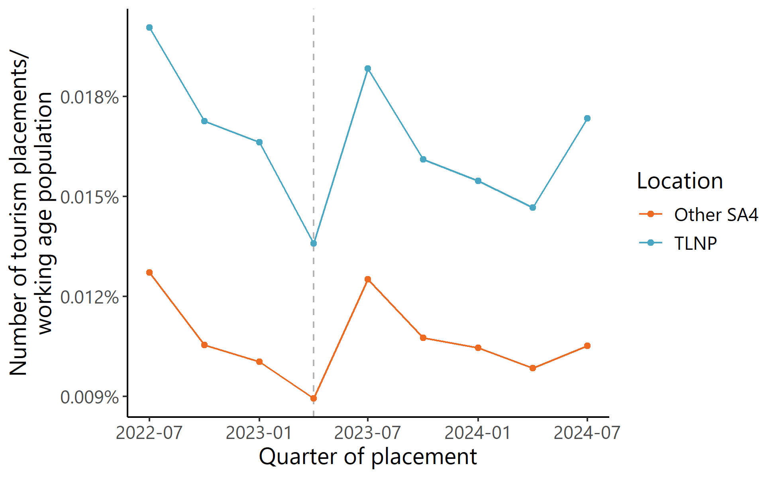
Source: DES Employment data, July 2022 – September 2024.

Who experienced which outcomes, in what ways, and under which circumstances?
Although the pilot has made progress towards achieving its intended outcomes across all outcome domains, this progress was not consistent across all sites, or by all TSMEs within pilot regions.

What were the characteristics of employers that achieved positive outcomes?
Providers noted that a wide variety of TSMEs in their regions met the eligibility criteria for the pilot, and that within this group there was substantial variability between TSMEs in their interest in participating in pilot activities, and the extent to which the pilot was able to achieve intended outcomes with these employers.
Given the greater than anticipated challenges providers faced in engaging TSMEs, it is difficult to clearly determine the characteristics associated with greater pilot success (e.g. employers implementing changes to recruitment processes, interviewing and/or hiring employees with disability) within the cohort of TSMEs that engaged with pilot activities. Key features of TSMEs where pilot activities appeared to have greater impact include:
- Organisation size: Providers reported that medium, rather than smaller sized organisations were more likely to engage with the pilot and were more likely to implement training or recruitment changes or hire a jobseeker with disability. This was due to the greater level of flexibility in these organisation – both in the amount of time/ staffing available to engage with non-core business activities, and in the ability to tailor roles to meet the skills and abilities of jobseekers with disability.
- Organisational values: TSMEs that viewed social inclusion or diversity as a key value for their organisation were more open to the benefits of employing people with disability, and more open to embed new learnings from the pilot through adapting organisational processes regarding recruiting, employing and supporting employees with disability. Providers also reported that organisations where employers had a direct personal experience with disability were more open to the benefits of employing people with disability and valued the potential outcomes of the pilot.
- Acute workforce needs: Providers, and some TSMEs interviewed reported that the pilot was more engaging and effective for businesses that had current workforce demand that they were not able to meet through their usual methods. One TSME interviewed noted that pilot activities were effective for their business because they were looking to hire multiple roles, but for businesses who were not looking to hire, or only had one vacant position the pilot activities would have less of an impact.
- TSMEs that engaged in business-to-business, rather than customer facing, activities: Providers generally found that businesses with high proportions of customer facing roles were more hesitant about employing people with disability. Navigators commonly reported that hospitality businesses were the least responsive to the pilot, as employers reported that they needed staff who could be all-rounders, and there was less flexibility to tailor roles to be suitable for people with disability. Providers also reported that hospitality employers had misconceptions about disability, and the types of roles that were/ weren’t suitable for people with disability. In contrast, one provider reported that they had most success engaging TSMEs that provided auxiliary services to tourism and hospitality businesses (e.g. a farm that supplies herbs and organic flowers to hospitality businesses, entertainment companies), with these types of businesses more open to employing people with disability than hospitality businesses.

What were the characteristics of providers and tailored pilot models that were more successful in achieving positive outcomes?
The extent to which the pilot was able to achieve its intended outcomes varied across providers and the different tailored pilot models they delivered. Key features of providers and tailored pilot models that appeared to have a greater positive impact included:
- Communication approach: Navigators taking a tailored approach to communication and engagement with TSMEs. Persistent and proactive.
"Success comes down to that person's passion. I didn't know [Navigator] beforehand and introduced herself out of nowhere. A lot of the success came from her passion and openness to share. She is knowledgeable without being pushy and too regimented or making it too difficult. Her response time was very good. That tailor made approach. She was an advocate for both parties is what I think made it work."
- TSME, Interview.
- Understanding of TSME needs: Understanding the business needs, focus on solving problems/ providing value to the business in the opening pilot activities.
“Well, I usually would go, I want to meet with them. I want to understand their business, sometimes go for a tour of the business. That gives me a good understanding and if they need to add in support, I'll bring them in, train them, so you can still get on with your job.” – Navigator, Interview.
- Active approach to facilitating connections between TSMEs, ESOs and jobseekers with disability: Using a ‘reverse-marketing’ approach to promote TSMEs with suitable vacancies to ESOs, and/or to promote jobseekers with disability to TSMEs with vacancies that are aligned with their skills and interests.
“[The Navigator] and I spoke in detail, looking at what I am interested in. She very quickly got a sense of what I was looking for. And she is a genius – because straight away she messaged me about this job.” - Employee, Interview.
- Strong local relationships and connections: Having strong and positive relationships with local ESOs. Leveraging existing connections and relationships between local TSMEs to promote the pilot, and to drive interest and engagement in pilot activities.
“We're connecting with some of the business owners and employers and they're connecting with other employers, I just think, you know, the connections that we have, and are able to build with people. To have that collaboration made a bigger pool of participants to be able to work with.” – Navigator, Interview.

What were the characteristics of pilot sites that were more successful in achieving positive outcomes?
To further examine the conditions associated with pilot sites achieving positive outcomes, we conducted a Qualitative Comparative Analysis (QCA). The QCA technique tests whether there are certain factors, or sets of factors, that are likely to lead to positive outcomes. See Appendix A2.1.1 for more detailed methodology and supplementary findings.
For this analysis, the positive outcome that was examined (the extent to which providers were assessed as achieving success with the pilot) was determined by:
- The extent to which the provider viewed that the pilot was a success in their region
- The extent to which TSMEs engaged with the pilot
- The extent to which employment outcomes were achieved for people with disability.
To understand what factors were associated with successful pilot delivery, we identified a small number of provider-level conditions that were important and potentially associated with pilot success. The selection of these factors was informed by a thematic analysis of interviews with providers, AWP reporting and provider final reports, as well as theoretically important conditions identified in discussion with key stakeholders.
The provider level conditions that were tested as part of the QCA were:
- Metro or regional location of the pilot site
- Size of the region the site covers
- Existing TSME network connectivity of the pilot site
- Whether the provider was a DES
- Whether the Navigator had a SME or business background
- Whether the Navigator had a background in disability services.
It is important to note that due to the constraints of the QCA methodology, not all theoretically important conditions were able to be tested as part of this analysis.
After coding the extent to which these conditions were observed at each provider, we were able to analyse the necessary and sufficient conditions associated with pilot success.
- Necessary conditions are always present when ‘positive outcomes’ occur but are also sometimes present when ‘less positive outcomes’ occur. This means that a ‘successful outcome’ cannot occur without the necessary condition being present. However, a less positive outcome can still occur, even if the necessary condition is present.
- Sufficient conditions are present where positive outcomes occur but are never present where less positive outcomes occur. This means that we can reasonably predict the type of outcome (positive or less positive) that will occur when this condition is present.
Using the recommended consistency threshold of 0.9, our analysis of the data identified no significant necessary conditions. This means that there is no single condition or combination of conditions that is present in all sites that achieve the most success, and that pilot success can be achieved through multiple pathways.
Using the recommended consistency threshold of 0.9, the analysis of sufficient conditions (things that can be seen in highly successful sites, but never in less successful sites), one significant sufficient set of conditions was identified:
- Being located in a regional area and having high pre-existing TSME network connectivity.
Where both of these conditions are present, it is highly likely that the site will have a positive outcome, however positive outcomes can occur in the absence of these conditions. As such, these conditions make up one, but not the only path to positive outcomes for the pilot.

What unanticipated positive or negative outcomes also occurred?
Providers and TSMEs reported several unanticipated positive outcomes that occurred as a result of the pilot. These included:
- Providers finding TSMEs engaging with pilot activities to make their businesses more disability inclusive to better support current employees with disability.
- Providers finding that there was interest in employing people with disability and/or participating in pilot activities from businesses that were not eligible to participate in the TLNP (e.g. above the threshold for a SME, not a tourism business).
- Providers and TSMEs finding that there was some increased positive regard from the community towards participating TSMEs as a result of their openness to create a more inclusive workforce.
- Participating TSMEs using their raised awareness of disability to provide a better service to customers/ guests with disability.
- Increased connections between TSMEs participating in the pilot, and the positive impact of word of mouth.
‘One of the outcomes I think we achieved is local employers working together, where they normally wouldn’t do that… We’ll do a social media post, and other employers would reach out to that employer and go “Great job! Well done!” The word of mouth piece is really key in this space.’ – Program Staff, Interview
There were no unobserved unanticipated negative outcomes as a result of the pilot.

A case study – exploring the Tourism Taster program in Cairns, Queensland
Epic Employment services delivered the pilot in Cairns, Queensland – promoting the pilot as the Tourism Taster Program.
This case study explores the experience of the provider in delivering the pilot in this location.

Community insights: A profile of Cairns
Cairns, Gimuy-walubarra Yidi, is a city in Far North Queensland, Australia. It is a major tourist destination, providing access to 2 UNESCO World Heritage sites: the Daintree Rainforest and the Great Barrier Reef.
Figure 6: Location of Cairns
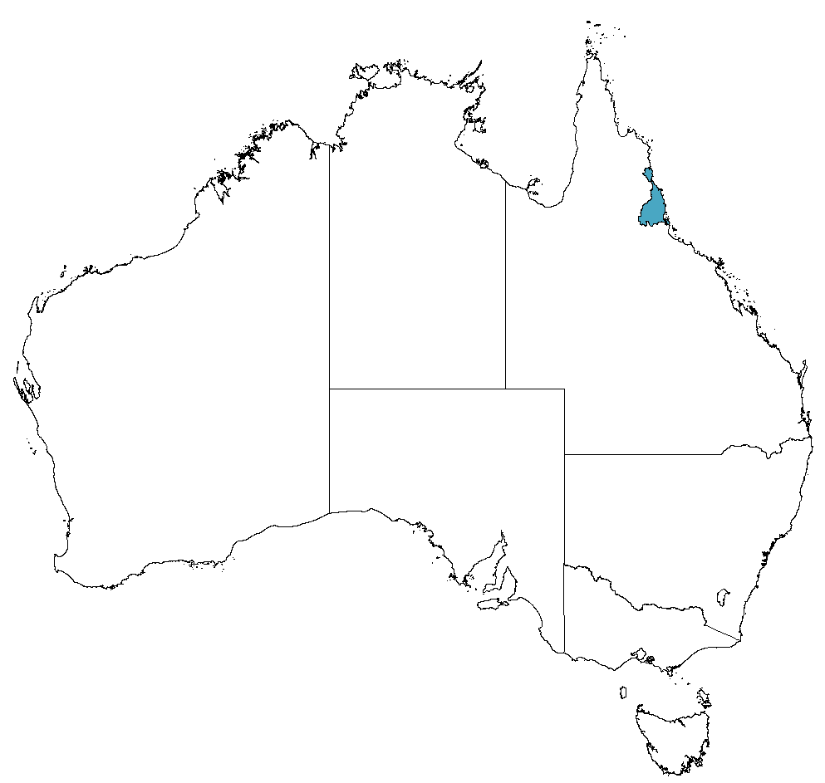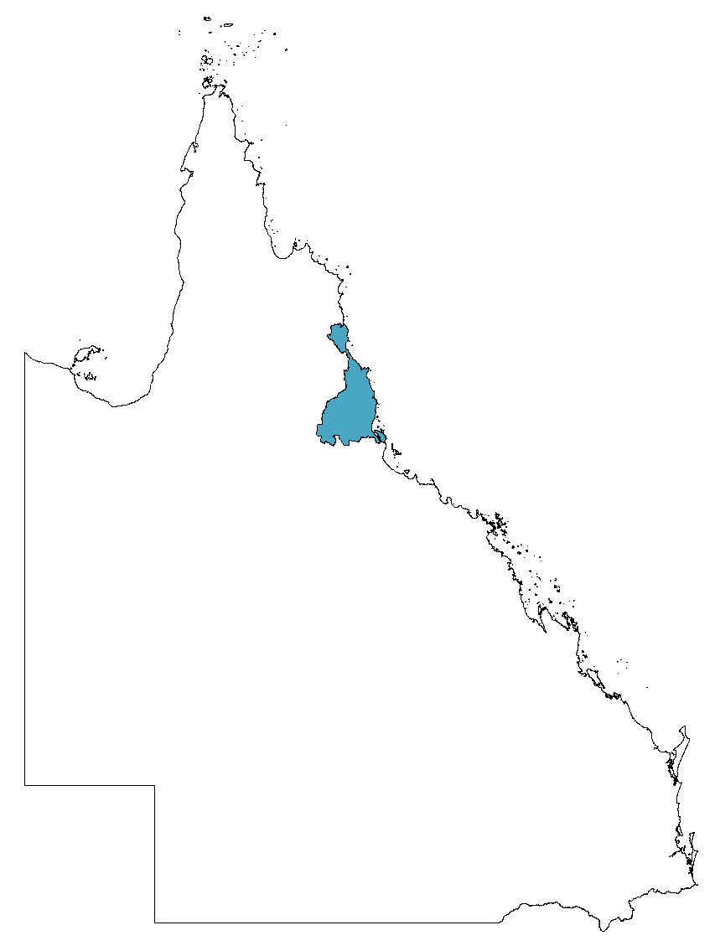
Most businesses operating in the region are small and medium sized. As at 30 June 2023, the number of businesses in Cairns with 1-4 employees was 6,465, with 5-19 employees was 2,667 and with 20 or more employees was 708.
The estimated population of Cairns as at 30 June 2023 was 265,366 people. In the Cairns LGA there are more than 28,000 residents living with disability and over 10,000 locals require daily assistance due to disability. At March 2024, 3.54% of Queensland employees disclosed that they lived with disability. At the time pilot sites were selected, DSS identified that there were 3,642 DES participants and 1,532 Workforce Australia Services Participants, demonstrating that there is clear opportunity for the pilot in the region.
Tourism is the main economic driver in the region and is also the number one source of employment. The region’s tourism sector provides accommodation, entertainment, activities and experiences to 2.4 million visitors per year, generating 24,000 jobs [one in 5 of the region’s jobs] and contributing $3.1 billion to the economy.
This made the Cairns region an appropriate area to deliver the Tourism Taster program.

What did the Tourism Taster Program deliver?
The Tourism Taster program delivered several activities during the 12-month pilot period.
Marketing and promotion of the program
- The program branding as the Tourism Taster Pilot was developed and used to promote the program within the Cairns Regions.
- The Navigator promoted the pilot to employers in the region through engaging employers directly in discussions, as well as through broader scale promotional events such as a forum with over 80 attendees including SMEs, DESs and community organisations.
Figure 7: Program branding developed to market the TLNP as Tourism Taster

Connecting with TSMEs and ESOs
- The Navigator achieved successful contact with 70% of the identified TSMEs in Cairns and promoted disability awareness and guidance during this contact.
- The Navigator connected with local ESOs to conduct meet and greets with jobseekers with disability, and to identify individuals that may be a good fit for current vacancies within TSMEs.
Providing disability awareness training and guidance
- Disability awareness training and guidance was provided to 25 employers including outlining the benefits of hiring employees with disability. This also included working with employers to help them to create more inclusive workplace culture and employment practices.
- Disability awareness training and guidance was also provided to the 80 attendees including (SMEs, DESs and community organisations) who attended the Tourism Taster promotional forum.
Placing employees with disability into roles with the TSMEs
- The Navigator identified, prepared, and connected people with disability to appropriate employment roles with the employers within the project period.
- The Navigator provided ongoing post-placement support to all employees placed into employment to ensure support successful employment outcomes.
Maintaining ongoing relationships with TSMEs and ESOs
- Created ongoing relationships and networks with local TSMEs, and attended relevant career fairs to further promote employment for people with disability to TSMEs within the Cairns region.
- Established ongoing relationships with local DESs and ESOs whose participants were successfully placed in employment in TSMEs because of the pilot.

What worked well and what was challenging?
Key success factors for the delivery of the pilot included:
Domain | Enabler
Outer setting | Local conditions: Economic, environmental, political and/or technological conditions  - Efforts by the Navigator to understand the business needs of each TSME appeared to improve their ability to connect. By knowing the business, the Navigator was able to improve chances of their engagement with each TSME by offering suggestions as to what tasks within each TSME a person with disability might be able to be employed to do.
Inner setting | Available resources and access to information: Resources developed, or training provided to assist implementation and deliver the pilot  - There was strong branding and marketing support for the development of the Tourism Taster program from within the service provider. Staff felt this was central to providing the Navigator with the credibility required to establish relationships and build trust with DESs within the community.  - Some employers who had previously engaged with another disability employment program and had undertaken training through it, felt this made them better ready and able to participate in the program and felt better prepared to adjust roles to facilitate people with differing needs.  Culture: Shared values, beliefs and norms across provider regions.  - Those employers who were organisationally ready to participate in the program and had previously had a workplace inclusion culture in place for employing people with disability were better placed to engage with the program.  Relational connections: Formal and informal relationships and networks within and across provider regions.  - Strong and ongoing engagement by the Navigator with the community was central to the pilot success. The Navigator belonged to multiple networking groups, joined local associations, attended local conventions, held monthly meetings with NDIS providers, and created employer events.  - Ongoing efforts of engagement by the Navigator with the employers was important to develop trusting relationships. Employers reported that the Navigator was proactive about presenting potential candidates – working to find the right candidate for the role, matching skills, interests and abilities of people with disability to appropriate roles. They also appreciated that the Navigator was available to provide continued support post-employment of employees.  - The collaboration between several Disability Employment Service Providers and the Navigator helped to match participants into roles with employers.
Individuals | Implementation leads: Individuals who lead efforts to implement the pilot  - The personality and skillset of the Navigator is important to create connections with employers and employees with disability. In particular, a combination of disability, tourism and recruitment experience contributed to the Navigator’s success in engaging employers. Employers appreciated the personable, passionate and persistent approach the Navigator took towards promoting the pilot and jobseekers with disability.  - The personal network of the Navigator, including connections to many local employment services and employers, allowed the Navigator to better identify good matches for available roles and have a bigger pool of candidates to draw from than any individual employment provider.  - Employers appreciated that the Navigator had really taken the time to understand the skills, abilities and barriers of people with disability, and to understand the specific needs of the employer to suggest good employment matches.
Implementation process | Engaging/readiness:  - Employers with staffing shortages were more willing to engage with the pilot. Where there was an identified business need for staff employers were more likely to engage with the program. Employers reported that the program was a good opportunity to recruit staff where they felt unable to compete with larger organisations who could offer employee sign-on bonuses or better pay.  - Employers who had an organisational value or ethos of equality and inclusion aligned well with the aims of the program and seemed more willing to engage.  Where the existing recruitment policy and procedures of an employer aligns well with the purpose and goals of program there appeared to be greater engagement.
Key challenges included that:
- Some employers were initially overwhelmed and hesitant about adjusting their workplace to be more accessible. Some felt setting up their workplace environment in a way that would accommodate a wide range of disabilities and provide the individualised support that might be required to support employment for people with disability was initially overwhelming. The Navigator overcame this challenge through tailored one-on-one engagement and advising employers of the existence of JobAccess to help facilitate their employment of people with disabilities.
- Small to medium sized employers can often require employees to perform a broad range of tasks due to their small size. They may not be able to hire employees into narrowly scoped roles like larger organisations can. This presents a unique employment challenge for small to medium sized employers. When structuring job descriptions and employing people with disabilities, employer expectations may need to be modified. The Navigator addressed this challenge by encouraging employers to accept employees who meet only some of the job criteria.
- Employers felt that without information specific to the disability of the person looking to be employed made it difficult for them to effectively and safely place them in employment within their organisation. This information is only available to employers when participants give authority for this information to be shared (by completing an Authority to Gain & Release Information form). Where participants gave authority to do so, Navigators were able to assist in providing this information, however it could be a barrier to engaging prior to this stage.
- Some employers had strong perceptions that they were unable to facilitate job-share and/ or part-time roles and to facilitate support for employees with disability due to organisational needs and lack of time available.

What was achieved?
Employment outcomes included 23 employees who were offered employment, 20 who accepted placements and 14 who are still in employment as at August 2024.
For employees | For employers
Employees who were placed into employment through the Tourism Taster program across several employers reported the following outcomes.  - Obtained jobs aligned with experience and interests  - Increased work hours and shifts compared to previous casual roles  - Felt supported and satisfied in their new role  - 14 successfully maintained paid employment  - Gained a sense of independence through employment  - Used newly acquired skills and qualifications in inclusive work settings  - Experienced unexpected workplace positivity, inclusivity and team support  - Work locations that are close to home  - Contribute to the community instead of feeling ‘idle’  - Increased social interaction compared to previous roles. | Employers who placed employees with disabilities through the Tourism Taster program reported the following outcomes.  - Filled staff shortages  - Better staff retention rates  - More inclusive recruitment practices and a more diverse workplace  - Easier integration of employees with disabilities into their workforce than anticipated  - Increased awareness and readiness for disability-inclusive practices  - Amended job advertisements and onboarding processes to support disability inclusive practices  - More flexible position descriptions and job requirements  - Positive impact on workplace culture and morale  - Increase in potential employees with disabilities approaching the employer for employment  - Improved public relations through improved organisational branding, including social responsibility.

The journey for employees
The pilot program in Cairns successfully placed several employees into new positions. Below are brief vignettes of four of these employees.
Employee A
The Navigator proposed a new role to an employee with a disability, which aligned with their passion and experience. When the employee learnt about the job, they felt it was a great opportunity. The employee transitioned seamlessly from job discovery to employment and appreciated the support they received from the Navigator during the recruitment and interview process. In their new role, they earn income doing what they love in a nature setting that satisfies their enjoyment for the outdoors. The employee feels accepted by their manager and colleagues, describing the job as 'stress-free'. They have received recognition and praise from their local community for their participation in this role.
Employee B
The employee was linked to the Navigator after four unsuccessful months trying to find employment with another employment service who suggested unsuitable roles. The employee felt the Navigator took time to understand the employee's needs and aspirations. Appreciating the Navigator's efficient approach and industry knowledge, the employee was quickly matched with a role aligned to their skill set. This personalised attention led to a swift and satisfying job placement in the employee's field.
Employee C
The Navigator collaborated with the employee's provider to alert them to a new job opportunity. The process moved quickly, with less than a week between the job alert and an interview with this employer. They were offered a position with the employer, which they found to be a good fit. This was because they could leverage their experience and enjoyment of the role. Since starting the job, they have appreciated the flexible work environment that allows for adjustments to meet their individual needs. While the Navigator's specific role in expediting the recruitment process was unclear, the employee notes this as their first experience of receiving significant support in securing employment.
Employee D
After negative experiences in hospitality, the employee engaged with an employment services provider and the Navigator, who understood their desire to change sectors. Previous jobs had often failed to accommodate their physical needs or effectively support them. Through the program, the Navigator helped place the employee in a job that used their previous experience. Since starting the new role, the employee has been expanding their skill set. They feel respected and heard for the first time in a workplace. Now comfortable in their position, they are ready to increase their hours and are working with their employer to make this happen.

Lessons learned
Tourism Taster program staff, participating employers and employees with disability shared insights gained from their involvement in the program.
- Use 'reverse marketing' to establish relationships with TSMEs by addressing their support needs first before pitching the program to them.
- Incorporate regular check-ins to monitor employee wellbeing and progress.
- Offer flexible support levels to employees at participating employers.
- Improve clarity about involvement expectations when disseminating pilot information to employers.
- Ensure Navigators thoroughly explain disability-specific information to assess employee-role requirements and suitability.

Sustainability
This chapter examines the extent to which the outcomes achieved by the TLNP are likely to continue after the conclusion of the pilot.
 | Key evaluation question
Sustainability | 6. What outcomes for employers and people with disability are likely to continue?  6.1. What changes that employers have made are likely to continue?  6.2 To what extent is the pilot likely to result in increased employment for people with disability?

What outcomes are likely to continue?
As the pilot was intended to be a 12-month initiative, pilot activities were designed such that Navigators support TSMEs to build their knowledge and access tools and resources to hire and retain jobseekers with disability in a way that can be sustained when the support of the Navigator concludes at the end of the pilot period. Although funding for the pilot, and the Navigator role itself has concluded, the majority of providers (9 of 12 providers) noted that pilot activities will continue to have some impact for TSMEs and people with disability who engaged with the TLNP. However, given the duration of the pilot and the timing of the final evaluation the extent to which long-term outcomes have been achieved and/or are likely to be sustained are not examined in this report.

What changes that employers have made are likely to continue?
TSMEs who engaged with and participated in pilot activities made a range of changes because of the TLNP (see Section 5.1). However, the extent to which these changes are likely to be sustained, and the observed outcomes maintained after the end of the pilot varied across outcome domains.
Most provider staff felt that TSMEs improved capability and confidence would be likely to continue after the end of the pilot through:
- Continuing to be able to access and use tailored resources developed as part of the pilot
- Improved awareness and understanding of employing people with disability.
Some provider staff and TSMEs reported that the increased employer demand to recruit, retain and support jobseekers with disability would be sustained because of:
- Changes in TSME recruitment processes made a result of the pilot
- Changes in perception of employees with disability, including decreased stigma.
We used to approach the interviews with specificity – we need people for X hours a week etc. In the past we would say we will find someone else. But now we are more flexible in our approach and may split the job between people. The lean field of prospective employees has forced us to rethink how we do our business. We are more flexible in roles and positions. My attitude in going into an interview with new employees is to see what they can do and how we can work this into our business.
- TSME. Interview
Most providers noted that participating TSMEs had expanded job networks, through developing connections with the providers themselves and/or developing connections with local ESOs. Providers felt that where these connections had been developed during the pilot, they would continue after the pilot has ended and without the active support of the Navigator. However, as many TSMEs reported that they had poor experiences with DESs in the past and noted that the additional support provided by the Navigator was critical to their positive experiences of engagement with ESOs, the extent to which these connections will be sustained after the conclusion of the pilot is unclear.
"If we just had [local DES] we wouldn't have had any of the applicants. [TLNP] and [the Navigator] was the connection to employees."
- TSME, Interview

What outcomes for people with disability are likely to continue?
People with disability who were employed at a TSME as a result of the pilot reported that they had developed skills and experience that will be helpful to them (either in their current roles, or in future work in the tourism industry). Some employees with disability reported that they were now working in a role and/or industry that they had experience in and enjoy, and are looking to continue working in the tourism industry. One person with disability who was employed in a TSME because of the pilot reported that they felt that they no longer needed support to do their job well.
Some people with disability will continue to be employed in the tourism industry, after the conclusion of the pilot. Of the 149 people with disability that were employed in a TSME because of the pilot, 31 were reported by providers having a sustained employment outcome (i.e. that they were still employed in a TSME) at the conclusion of the pilot. Although 10 of 12 providers reported achieving employment outcomes for people with disability because of the pilot, only 3 providers reported that these employees had sustained their employment in these roles at the conclusion of the pilot. Some providers noted that they were aware of people with disability who were employed but were not sustained by the end of the pilot. However, many providers noted that as their pilot model did not involve continued engagement/ support for TSMEs or employees with disability after placement in employment that they were unable to report on sustainment outcomes as they were no longer connected to TSMEs to know whether any employment outcomes were sustained. The findings relating to sustainment outcomes should be interpreted with caution, as not all providers were able to collect and report on data relating to the employment outcomes of people with disability placed into tourism roles as a result of the pilot. This impacts the reliability of these measures. Additionally, as employment in the tourism industry is strongly driven by seasonal demands, the achievement of a sustained employment outcome is likely to be highly dependent on when a person was employed relative to the seasonal cycle, the type of job and the nature of the role. However, the evaluation was not able to account for these factors with the data collected and reported on by providers for this pilot.
Table 17: Employment outcomes achieved for people with disability, by provider
Provider | Participants employed | Participants sustained
Provider A | 14 | 0 (0% sustained)
Provider B* | 23 | 14 (61% sustained)
Provider C* | 0 | 0 (0% sustained)
Provider D | 43 | 14 (33% sustained)
Provider E* | 3 | 0 (0% sustained)
Provider F | 1 | 0 (0% sustained)
Provider G | 37 | 0 (0% sustained)
Provider H | 2 | 0 (0% sustained)
Provider I* | 2 | 0 (0% sustained)
Provider J | 13 | 0 (0% sustained)
Provider K* | 11 | 3 (27% sustained)
Provider L* | 0 | 0 (0% sustained)
Total | 149 | 31 (21% sustained)
Source: Provider final reports. Note: Sustainment of employment outcomes was defined in provider final reporting as an employee that was still in employment at the end of the pilot period* indicates providers that delivered activities to directly target employment outcomes for people with disability.

Efficiency
This chapter examines the extent to which the TLNP efficiently used available resources.
 | Key evaluation question
Efficiency | 4. Was the pilot implemented within budget?  4.1 Were there any differences in delivery between pilot sites?  4.2 Did any sites require additional attention (i.e. extra support from DSS)?  5. Does the current funding model provide value for money?  5.1 What was learned about how different pilot sites used different resources and activities to produce outcomes?
To understand the extent to which the TLNP efficiently used available resources, we have examined:
- how the resources were used to achieve the intended outcomes of the pilot
- the extent to which the use and impact of these resources reflects value for money.

Was the pilot implemented within budget?
The TLNP was implemented within budget. The optional 3-month extension to funding allowed most providers to expend their funding, except one provider with an underspend of about 10%.
Six providers acquitted funds exactly (or near exactly), a further 2 reported a small (less than 3%) overspend, and three providers reported a significant overspend to the grant amount (over 10%). One of these providers (Provider A) reported spending over 80% more than the grant amount to deliver the program. It is understood that the additional costs were borne by the providers, and that their reporting as part of the acquittal process aimed to demonstrate the additional financial investment by the provider to ensure delivery of the pilot to the requirements of the grant. It is also not clear whether providers who acquitted funds exactly may have had extra spending not accounted for in their acquittal which was not reported.

Does the current funding model provide value for money?
The value for money analysis is structured by the work of Barr and Christie ,which classifies metrics related to Economy, Efficiency, Effectiveness and Equity by quality (Monetary, Quantitative or Qualitative) and measurement type (Benchmark, Comparative, or Stand-alone). Limitations of the data used in the analysis are identified below.

Economy
The DSS administrative/ service delivery ratio (DSS costs compared to provider funding) was 0.20, meaning for every $1 spent by DSS on provider delivery of the program, a further $0.20 is spent on DSS administration and overheads. It is difficult to benchmark this as the only available data is for established programs. The Australian National Audit Office report into the efficiency of the Australia Council for the Arts’ administration of grants found that the average value for this metric across 14 government agencies (Commonwealth and State) was around $0.03 for established programs.
Table 18: Indicators of the economy of program delivery
Indicator | Description | Value
1 | DSS Administrative/Service Delivery Ratio | 0.20

Efficiency
The efficiency of program delivery can be broken down into two sets of metrics: administrative efficiency, which considers the efficiency of managing the disbursement of funds on program activities; and operational efficiency, which focuses on the activities and outputs generated by funding the program.

Administrative efficiency
For these metrics, we observe that DSS’ administrative costs comprised 16.78% of the overall spending on the program. As noted above, available benchmarks consider administrative spending in the context of established programs and vary based on the size and nature of the grant type.
For the DSS administrative costs per provider, it was not possible to calculate the actual time spent by DSS on a provider-by-provider basis, so the average value was used. FAMs who were interviewed noted that some providers needed more administrative support than others (e.g. providers who were newer to working with government funding).
For both these metrics, we note that if the program proceeded beyond pilot to a more mature stage, these costs (and the associated metrics) would be expected to decrease.
Table 19: Indicators of the administrative efficiency of program delivery
Indicator | Description | Value
3 | DSS Administrative costs as percentage of total spending | 16.78%
2 | DSS Administrative costs per provider | $53,225

Operational efficiency
There was wide variation between providers in costs to reach and engage TSMEs reflecting the different approaches taken by providers as well as different definitions of reach and engagement. One provider did not report on reach and only 11 reported on engagement, and variation in the cost per business engaged was largely driven by a select set of providers that had poor conversion from reach to engagement. Providers that look a more targeted approach to engaging businesses had higher costs of reach but progressively lower costs of engagement.
The cost per business engaged ($4,709) indicates that the amount spent to engage a business with the pilot was somewhat higher than anticipated, as for a program of this scale and scope it would be expected that this value would be closer to what is reported for the cost to each business.
Table 20: Indicators of the operational efficiency of program delivery
 | Metric | Value | Mean | Median | Range | Std deviation
6 | Cost per business reached | $739 | $2,084 | $2,003 | $5,734 | $1,689
7 | Cost per business engaged | $4,709 | $9,182 | $4,594 | $43,763 | $12,737

Effectiveness

Cost per outcome
In assessing costs per outcome, we have focused on employment outcomes, but the pilot also had broader outcomes in building TSME capability which cannot be readily monetised beyond engagement metrics. Additionally, we have only considered the costs for DSS and providers in this analysis. There would be additional costs for DESs/ ESOs associated with employment outcomes, however these were considered out of scope of this analysis and have not been included.
- The cost per business engaged and creating vacancies: This was estimated to be $6,385 – using the data available from 5 providers and appropriation program costs for these providers.
- The cost per identified vacancy created: This was estimated to be $15,462 based on the 11 providers for which this data was available. This is high considering that the net economic benefit of filling the vacancy would have to exceed the additional cost of filling the identified vacancy above what it would cost to fill this position from the open market. There was again substantial variation between providers and three providers (Provider J, Provider G, and Provider B) reported costs per vacancy identified below $10,000.
- The cost per vacancy filled: This was estimated to be $22,934 for the 10 providers with this data available.
- The cost per vacancy sustained ($40,058) for the three providers that recorded these outcomes is a lower-bound estimate as some filled vacancies may become sustained vacancies over time and because of limitations in provider data on sustained employment outcomes. However, the amount spent to achieve a sustained employment outcome for a person with disability is within the range seen for other employment programs referenced in recent research on costs and benefits of employment services ($6,100 - $79,600), especially those based on tailored in-person support (though this research does not represent a benchmark but a reference point from 10 programs). One provider (Provider B) outperformed others by a significant margin, at a cost of $21,756 per sustained vacancy. While this is still somewhat high and above expected benefits that would accrue to Government, it does underscore that this provider’s model of reach and engagement was ultimately more cost-efficient, and that a focus on relationships with businesses and targeting support to maximise sustainment produces improved economic efficiency.
Table 21: Indicators of the cost per outcome of program delivery
 | Metric | Value | Mean | Median | Range | Std deviation
8 | Cost per business engaged and creating vacancies | $6,385 | $17,185 | $10,552 | $34,362 | $14,695
9 | Cost per identified vacancy created | $15,462 | $84,489 | $38,409 | $333,974 | $101,581
10 | Cost per vacancy filled | $22,934 | $79,077 | $29,678 | $330,684 | $102,807
11 | Cost per vacancy sustained | $40,058 | $66,452 | $36,765 | $119,077 | $64,852

Cost benefit analysis
A cost-benefit analysis (CBA) for the pilot was developed but not included as part of the final analysis. This is due to a number of reasons:
- Providers reported different goals in terms of their activities: while an overarching objective of the program was to increase the number of people with disability in sustained employment, not all providers directly targeted employment outcomes as part of their activities, instead focusing on building the capacity and confidence of TSMEs to employ people with disability. This means that a CBA with a target outcome variable of sustained employment would not capture some of the key intended pilot outcomes.
- There were difficulties in capturing employment outcomes within the time period of the evaluation, which coincided with the completion of the funding period of the program. For employment to be considered “sustained” typically requires a longer period between initial employment and data capture (between 3-12 months depending on the applied definition). With some participants only starting employment close to the end of the funding period, any sustainment outcome could not be measured. Therefore, the benefits of the program would be underestimated. As some providers were not able to collect and/or did not record this data, this would further mean these benefits were underrepresented.
- Key outcomes of the program targeted by providers are resistant to monetisation in a CBA model. For example, improvements in employer capability and confidence cannot be readily translated to economic benefits, in large part because these changes can only be monetised once an employer has had the opportunity to translate capability to measurable actions, which takes place over a much longer timeline. Other important outcomes for employers and employees, such as improvements in social connectedness and mental wellbeing are difficult to reliably measure in economic terms.
This resulted in an estimate of the ratio of benefits to costs that did not adequately reflect the model of the program or its outcomes as reported elsewhere in the evaluation.
For future program design and evaluation, there are opportunities to build in data collection approaches that may enable a robust CBA model to be developed. Key to this is the identification and monetisation of outcomes in the design phase of a program, and development of an “ex-ante” CBA model that considers the anticipated benefits of the program relative to the expected costs. Such a model can inform design decisions, and can also be validated during and at completion of the program by systematically collecting data as part of standard reporting. For example, for a program such as TLNP a measurement framework to support a robust CBA may incorporate:
- Number of employees placed
- The length of employment
- The hourly wage of each employee
- The costs of supports for that employee in their role
- Changes in Government support payments for that employee resulting from employment (such as reduced welfare payments and/or changes to NDIS budget allocations)
Due to the ethical and practical considerations around collecting and accessing such data, consideration o should be given to whether the investment required by DSS and providers to systematically capture this information during a program is proportionate to the scale of the program itself; for example, while changes in support payments can be derived from existing Commonwealth databases, the resources required to access and analyse information from these databases and link this with participant data captured as part of the program may be disproportionate to the size of the program.

Equity
Equity is also an important consideration is value for money assessment. Recent cost analysis of employment support programs indicates differences in costs are influenced by participant need. However, there is not available data on participant level of need for this pilot.
The only data on equity we have for the pilot is on regional versus metropolitan investment. The ratio of regional ($988,964) to metropolitan ($2,816,147) investment in the pilot was 0.35. This is below the benchmark of 0.44 based on population distribution between Metropolitan and non-Metropolitan areas as defined by the Australian Bureau of Statistics. One consideration for future programs, particularly at the procurement stage, is how costs for regional providers are likely to be higher where a program model requires significant face-to-face engagement (such as for Navigator engagement with employers), as travel costs and time is higher to achieve coverage of regional areas.

Learnings for future initiatives
This chapter outlines what has been learned from the delivery of the pilot, and key opportunities for the delivery of future pilots or programs.
 | Key evaluation question
Scalability | 7. What are the conditions for success?  8. What has been learned from the pilot regarding overcoming barriers?  9. What has been learned from the pilot that can be used to inform future rollout?

What are the conditions for success?
The TLNP had most success where:
- employer motivation to achieve the potential pilot outcomes outweighed the perceived opportunity-cost of taking time away from core business to participate (e.g. where the business was seeking to fill more than one vacancy by engaging with the Navigator)
- there were strong pre-existing industry-specific relationships and connections between employers eligible to participate.
- the Navigator had strong local knowledge, was able to easily build rapport and connections, and could understand the specific business needs of employers.
- The tailored pilot model emphasised a lower volume, proactive and tailored approach to promoting and engaging eligible employers in pilot activities.

What has been learned from the pilot about overcoming barriers?
As discussed in Section 1.2, the design of the TLNP was intended to address known barriers to SME’s recruiting, retaining and supporting jobseekers with disability. The extent to which the pilot activities delivered by providers were able to successfully address these barriers can be used in future pilots or the Specialist Disability Employment Program.
Barrier | Successfully addressed? | Notes
a lack of time and/or capability to recruit people with disability | Partially | The Navigator role reduced the time burden associated with SMEs recruiting people with disability, through answering employer questions, connection employers to relevant resources and to local ESOs.  Although this reduced the time involved for employers, there is still some time cost involved in both engaging with the Navigator, participating in pilot activities and engaging with ESOs regarding recruiting jobseekers with disability. For TSMEs who were less motivated by acute workforce pressures (e.g. didn’t need to hire new staff or had small numbers of vacancies needing to be filled), the potential benefit of participating in the pilot did not outweigh the time cost of engaging with the pilot – even if it was lower than if they were navigating this process alone.
confusion on how or where to seek support | Yes | The Navigator role was effective in connecting TSMEs to resources and/or training about what is required and supports available to employers seeking to recruit and retain jobseekers with disability.
preferences to use local networks to source employees. | Partially | The Navigator role had some success in expanding the job networks of TSMEs through facilitating connections between employers and local ESOs.  However, these connections were not always able to be built as intended as:  - Some ESOs were not open to engaging with the Navigator – due to either a lack of understanding of the pilot, concerns about providers ‘poaching’ clients, or existing internal processes.  - Many TSMEs had prior poor experiences with local DESs, and as a result were hesitant about hiring jobseekers with disability through a DES as a result of this.

What are the opportunities for future initiatives?
Based on the above findings, we have identified a number of potential opportunities for the design and delivery of future pilot initiatives or that could inform the new Specialist Disability Employment Program or align with the New Disability Employment Centre of Excellence.
For pilots or programs considering engaging SMEs:
- Consider distinct activity streams for addressing fundamental disability awareness, and organisational barriers to recruiting and supporting jobseekers with disability. Providers consistently reported that there was a lower level of disability awareness and confidence among employers than they expected. There is a clear need for information, education and training to improve the foundational disability awareness of employers, consistent with recommendations made in the Mid-term Review of the DES Program. However, these employers will take longer and require more intensive work to engage, compared to employers who have a sufficient existing level of understanding and interest in employing people with disability. Separating these two distinct streams of support that SMEs require could enable providers directly targeting employment outcomes to work more with employers to identify and address their needs, which is in scope for providers of the new Specialist Disability Employment Program and which recent research suggests is effective. This could support providers to more effectively use resources in promoting and engaging SMEs in relevant activities. However, this would require a level of local knowledge about existing SME capacity.
- Consider primarily focussing on engaging medium-sized enterprises, where providing tailored support for employment outcomes. As addressed through the expansion of the definition of SME in the pilot, providers consistently found that although some small enterprises were open to the opportunities of hiring people with disability (particularly where the employer had a personal connection to disability), the constraints of their organisation size (e.g. how regularly they were looking to hire new staff, their ability to tailor position descriptions) limited the extent to which activities aiming to increase the employment of people with disability were able to achieve their intended outcomes in smaller enterprises. This should not be to the exclusion of smaller enterprises that are seeking to employ people with disability.
- Consider further opportunities for engagement approaches that allow tailored one-on-one contact with employers. Providers that focussed on engaging fewer TSMEs with a higher intensity approach had more success and were more efficient than providers who focussed on reaching a higher number of TSMEs with a communications approach that prioritised broad and bulk communications.
- Consider engagement approaches that leverage positive word of mouth and successful outcomes from other SMEs to promote the benefits of participation. TSMEs found positive word of mouth and examples of other organisations benefiting from the pilot compelling. Consider taking a two-stage approach to engagement – where providers initially work with employers that are most responsive and interested in engaging in activities at initial contact (e.g. aligns with their corporate values, already highly value the importance of employing people with disability due to their personal experiences, highly motivated to hire new staff), then use their experiences to promote the pilot to employers that may have initially been more hesitant to participate.
For pilots or programs considering engaging tourism businesses:
- Consider focussing on more specific types of tourism businesses, rather than taking an industry-wide focus. The tourism industry includes a large range of businesses that support the visitor economy. The broad range of businesses made it challenging for Navigators to identify and to effectively engage all types of eligible businesses, as their business needs and potential ability to adjust roles differed substantially across different types of tourism businesses.
- Consider the impact of seasonality and peak trading periods, and the duration of the pilot on employer availability. Allowing for more of an establishment phase ahead of peak tourism season could help to avoid the clash experienced in rollout of the TLNP that delayed employer engagement.
For future pilot programs delivered by multiple providers:
- Consider leveraging existing training and informational resources, rather than developing industry-specific materials. Providers reported spending a substantial proportion of the pilot duration engaging local TSMEs about their needs, and tailoring their pilot model, activities, and resources to meet their needs. However, the identified needs of TSMEs and their required resources did not appear to substantially differ across the regions. As intended in the role of the Disability Employment Centre of Excellence, leveraging existing training and resource materials would allow providers to spend more time engaging and delivering pilot activities to SMEs, particularly in pilot programs where multiple providers are engaged as part of service delivery.
- Consider providing additional DSS support to establish a Community of Practice. It was intended that a Community of Practice (supported by DSS but organised and run by providers) would meet regularly throughout the delivery of the pilot. Although this group initially met as intended, for most of the implementation period it wasn’t active. As providers reported experiencing many similar challenges in the design and implementation stages of the pilot, an active community of practice may have helped providers to more effectively identify and address common problems. Including Community of Practice participation as a required activity for providers in the grant opportunity guidelines, as well as additional support from DSS in establishing and maintaining this group, may have helped ensure it met as intended.

Appendices

Appendix 1. Data collection tools

A1.1. Round 3 Provider interview guide
- [quick recap of our understanding of how the pilot is running at the provider.]
- Quick description of key features of model
- Success factors
- Barriers
- Since we last spoke, have you made any adaptations to how you have been delivering the pilot in your area?
- [please describe]
- Why did you make these changes?
- Did these changes have the impact you expected?
- [if yes, how so? If no, why not?]
- What, if any, outcomes have you seen as a result of the pilot?
- [prompt: PL outcomes]
- What evidence do you have for this? [refer to AWP – check, is this evidence included in/ as appendix to AWP]
- Is this in line with what you expected?
- Are there any regions or stakeholder groups that have been more, or less, responsive to the pilot?
- Since we last spoke, have you experienced any unexpected positive or negative consequences or outcomes as a result of the pilot’s implementation?
- [quick recap of external factors flagged in previous interviews]
- Have these factors impacted the pilot in the way/ to the extent you anticipated?
- Are there any additional external factors that have impacted the pilot?
- [if yes, how so?]
- Thinking about your experience delivering the pilot so far, how do you think it could be improved?
- [prompts: design, delivery, duration, DSS support]

- Can you tell me a bit about the support your organisation has received from the Department (e.g. FAMS, the policy team, the Community Grants Hub) across the delivery of the pilot?
- What, if any, did you find most helpful?
- What, if any, additional support would you have liked?
- Any final comments – anything that we haven’t touched on today that you would like to discuss?

A1.2. Program stakeholder interview guide
- Can you tell me a bit about your role and your involvement with the pilot?
- Can you tell me a bit about your understanding of the pilot?
- How has it been implemented?
- What has been effective? What has been challenging?
- Based on your role and perspective, what outcomes have you seen from the pilot?
- Have you experienced any unexpected or unintended consequences of the pilot?
- Based on your experience, is there anything about the pilot that you think could have been improved?
- Is there anything that we haven’t touched on today that you want to discuss, or think that it is important for the evaluation to know?

A1.3. Representatives from tourism SMEs Interview Guide
Initial Participation
- How did your organization first learn about the pilot [/ name of the pilot]?
- What motivated your organization to participate in this pilot?
- Were there specific goals or objectives you hoped to achieve through participation?
- Did any particular aspects of the pilot resonate with your values?
Interactions with Navigators
- Can you describe your interactions and experiences with the Navigator(s)?
- Were there specific tools, resources, or support mechanisms provided by the Navigator(s) that you found particularly beneficial?
- How did they support you in your role?
- Were there any areas where you felt the Navigator could have provided more or different support?
Recruitment and Onboarding
- How did the pilot [/ name of the pilot] influence or assist in your recruitment and onboarding processes for employees with disability?
- How did the pilot [/ name of the pilot] address any concerns or gaps you previously had in recruiting employees with disability?
- Were there specific challenges or successes you experienced in this area?
- Can you share any specific feedback regarding the process?
- Has your business employed any people with disability as a direct result of the support you received from the Navigator?
Training and Development
- What was your experience with the training and development aspects of the pilot [/ name of the pilot]?
- Were there specific training modules or content areas that stood out in terms of their effectiveness?
- How relevant and impactful did you find the education and training sessions facilitated by the Navigator(s)?
- Has this impacted your broader people practices in any way? – have you made any changes in general?
Benefits to SMEs
- Can you discuss any tangible benefits or positive outcomes your business has experienced as a result of participating in the pilot [/ name of the pilot]?
- Has there been a noticeable change in workplace culture or team dynamics?
- Has there been any unexpected benefits or learnings?
Challenges and Feedback

- Were there any challenges or barriers your business faced during the implementation of the pilot [/ name of the pilot]?
- Were there any specific aspects of the pilot that required more time or resources than anticipated?
- How were these challenges addressed, and what support was provided?
- How would you evaluate the responsiveness and effectiveness of the support provided during challenging moments?
Looking Forward:
- Based on your experience, would you consider continuing involvement or participation in initiatives like the pilot [/ name of the pilot] in the future?
- What recommendations or suggestions do you have for the improvement of the pilot [/ name of the pilot] or similar initiatives?

A1.4. Employee Interview guide
Working in the tourism sector
- How did you find out about this job?
- What made you think you would like this kind of job?
- Have you worked in a similar job before?
- Have you worked in tourism before?
Understanding your thoughts about the pilot
- Have you heard of the Tourism Local Navigator Pilot/name of the pilot at site?
- Yes
- No
- If no, have you had any involvement with a navigator [name of navigator] who works for the Tourism Local Navigator Pilot?
- If no, explain the pilot here.
- What do you know about the pilot/your local Navigator?
- If unsure, explain the pilot and the provider’s connection to it, and how this is linked to their employment. *It is unsure at this point how much awareness employees will have of the TLNP and the Navigators. The interviewer may need to talk the employee through the pilot and how it works. The interviewer may also need to explain what a Navigator is.
- What involvement with your Navigator have you had? [note: use the phrasing the employee uses to describe the pilot when you refer to the pilot [/name of the pilot] from this point on]
- What was it like to work together with your local Navigator? What did you do together?
- What parts of the pilot or your experience with your local Navigator did you find most useful or helpful?
- Were there parts of the pilot that you did not find useful or helpful?
Meeting your needs and goals
- How well did you feel your individual needs and goals were supported as a [insert role] by [insert employer]?
- How, if at all, did [employer name] help you to achieve your goals in your job?
- Did you have enough help to do your job? For example, have you had any training in new skills that you need?
- Were there moments where you felt that your support needs to work weren’t being met by [your employer] If so, can you tell me about this?
- Were there any moments where you thought, ‘this isn’t really what I need?’ If you did, can you share anything about that?
Offering support
- Have you received any help through TLNP? If so, was that help right for what you needed?
- How easy was it for you to get help?
- Were there any specific tools or information you wish had been available to you?
Employing people with disability
- Do you think that the pilot [/name of the pilot] has helped tourism businesses employ people with disability? If so, in what way?
Creating a good place to work
- Do you think [name of employer] is a good place to work?
- Is working at [name of employer] different to any of the places that you have worked before? Can you provide any specific examples of why it is different?
- Do you feel more or less safe at this workplace?
- Do you feel like people at [employer] listen to you and respect you?
Communicating about jobs
- Do you know how your employer worked out which jobs would be a good fit for someone with a disability?
- How do [your employer] let people know these roles are available for people with disability? Do you think they may be doing this more, or in a different way, since the beginning of this pilot?
Getting help from other providers
- Did you get help from a DES provider, or from an NDIS provider of Workforce Australia to get or keep this job? Can you tell us about any support you received?

Appendix 2. Technical appendix

A2.1. Supplementary methodology

A2.1.1. QCA
QCA uses an analysis framework based on Boolean algebra and a branch of mathematics called set-theory. For this evaluation, the methodology applied was:
- defining appropriate positive outcome(s) and conditions,
- determining appropriate conditions,
- calibrating data,
- creating a raw data matrix,
- analysing necessary conditions,
- analysing sufficient conditions,
- presenting results, and
- interpreting results.

Defining positive outcomes
QCAs involve identifying factors that contribute to positive outcomes from any particular intervention. A first step in conducting a QCA is, therefore, defining what is understood to be a positive outcome. The Evaluation team defined a positive outcome for pilot success as: the pilot was viewed by providers as a success in the region, high numbers of businesses were engaged with the program, and employment outcomes for people with disability were achieved.

Determining appropriate conditions
Where possible these coded as present or absent (e.g. if a provider was a DES or not), but for some conditions this approach was not possible. Other criteria were coded using a four point scale to assess the extent to which this condition was present or relevant for each site.

Necessary conditions
The analysis of necessity examines all possible combinations of causal conditions to assess which condition (or combination of conditions) are present when pilot sites achieve positive outcomes. To identify which of the many potential causal conditions are considered most necessary three measures are used:
- Consistency: How often this causal condition is present when a positive outcome is observed. Scores closer to one indicate that this condition is consistently seen in positive outcomes.
- Relevance of necessity: How relevant or trivial the causal condition is. A condition is considered trivial if it is very common and seen almost all the time regardless of outcome. Scores closer to one indicate that this condition is highly relevant.
- Raw coverage: How often a positive outcome is observed when a casual condition is present (e.g. what proportion of cases have a positive outcome when a causal condition is present). A high raw coverage score means that the causal condition is present in most cases where a positive outcome occurs. Scores closer to one indicate that this condition is highly relevant.

Sufficient conditions
As with the analysis of necessary conditions, there are three measures to determine which of the many potential conditions or combinations of conditions are considered sufficient to explain the outcome observed:
- Consistency: The same as in the analysis of necessity – how often a positive outcome occurs when this condition is present.
- PRI: The degree to which a condition is associated exclusively with positive outcomes (that is, when this condition is present, there is never a negative outcome).
- Raw coverage: How much of the positive outcome is explained by a condition. For a condition is more important for a positive outcome the more it covers.

A2.2. Supplementary tables and figures

A2.2.1. Provider characteristics
Table 22: Key characteristics of providers
Provider | State | Metro or regional | Size of region | Tourism Primary industry | TSME network connectivity | Provider a DES? | Navigator background - SME/business | Navigator background - Disability
Provider A | VIC | Regional | Large | A little | None | Yes | No | No
Provider B | QLD | Regional | Small | Substantial | Substantial | Yes | Yes | No
Provider C | QLD | Regional | Small | Substantial | Some | Yes | No | No
Provider D | NSW | Regional | Large | Moderate | Some | Yes | Yes | Yes
Provider E | VIC | Metro and Regional | Large | Moderate | Some | No | Yes | Yes
Provider F | SA | Metro and Regional | Small | Moderate | Substantial | Yes | No | Yes
Provider G | NSW | Regional | Small | Substantial | Substantial | No | Yes | Yes
Provider H | VIC | Regional | Small | Moderate | None | No | Yes | No
Provider I | SA | Metro and Regional | Small | Moderate | A little | No | Yes | Yes
Provider J | WA | Metro and Regional | Large | Moderate | Some | Yes | Yes | Yes
Provider K | NSW | Metro | Small | A little | None | Yes | No | Yes
Provider L | QLD | Metro | Small | Moderate | None | Yes | No | Yes

Table 23: Planned and completed activities delivered by providers - Providers understand local needs and focus their activities on what is needed in the region
Provider | Planned | Completed
Provider A | Y | Y
Provider B | Y | Y
Provider C | Y | Y
Provider D | Y | Y
Provider E | Y | Y
Provider F | Y | Y
Provider G | Y | Y
Provider H | Y | Y
Provider I | Y | Y
Provider J | Y | Y
Provider K | Y | Y
Provider L | Y | Y

Table 24: Planned and completed activities delivered by providers - Navigators promote the pilot to TSMEs, ESOs, Other relevant sector orgs/ bodies
Provider | Planned | Completed
Provider A | Y | Y
Provider B | Y | Y
Provider C | Y | Y
Provider D | Y | Y
Provider E | Y | Y
Provider F | Y | Y
Provider G | Y | Y
Provider H | Y | Y
Provider I | Y | Y
Provider J | Y | Y
Provider K | Y | Y
Provider L | Y | Y

Table 25: Planned and completed activities delivered by providers - Navigators develop or procure targeted tools and resources to educate employers in recruiting and supporting people with a disability
Provider | Planned | Completed
Provider A | Y | Y
Provider B | Y | Y
Provider C | Y | Y
Provider D | Y | Y
Provider E | Y | Y
Provider F | Y | Y
Provider G | Y | Y
Provider H | Y | Y
Provider I | Y | Y
Provider J | Y | Y
Provider K | Y | Y
Provider L | Y | Y

Table 26: Planned and completed activities delivered by providers - TSMEs participate in and engage with education and training regarding supporting employees with disability
Provider | Planned | Completed
Provider A | Y | Y
Provider B | Y | Y
Provider C | Y | Y
Provider D | Y | Y
Provider E | Y | Y
Provider F | Y | Y
Provider G | Y | Y
Provider H | Y | Y
Provider I | Y | Y
Provider J | Y | Y
Provider K | Y | N
Provider L | Y | Y

Table 27: Planned and completed activities delivered by providers - Navigators identify job expectations and skills required by TSMEs and work collaboratively with TSMES and ESOs to address barriers such as ease of access and time
Provider | Planned | Completed
Provider A | Y | N
Provider B | Y | Y
Provider C | Y | Y
Provider D | N | N
Provider E | Y | Y
Provider F | Y | N
Provider G | N | N
Provider H | N | N
Provider I | Y | Y
Provider J | N | N
Provider K | Y | Y
Provider L | Y | Y

A2.2.2. Outcomes
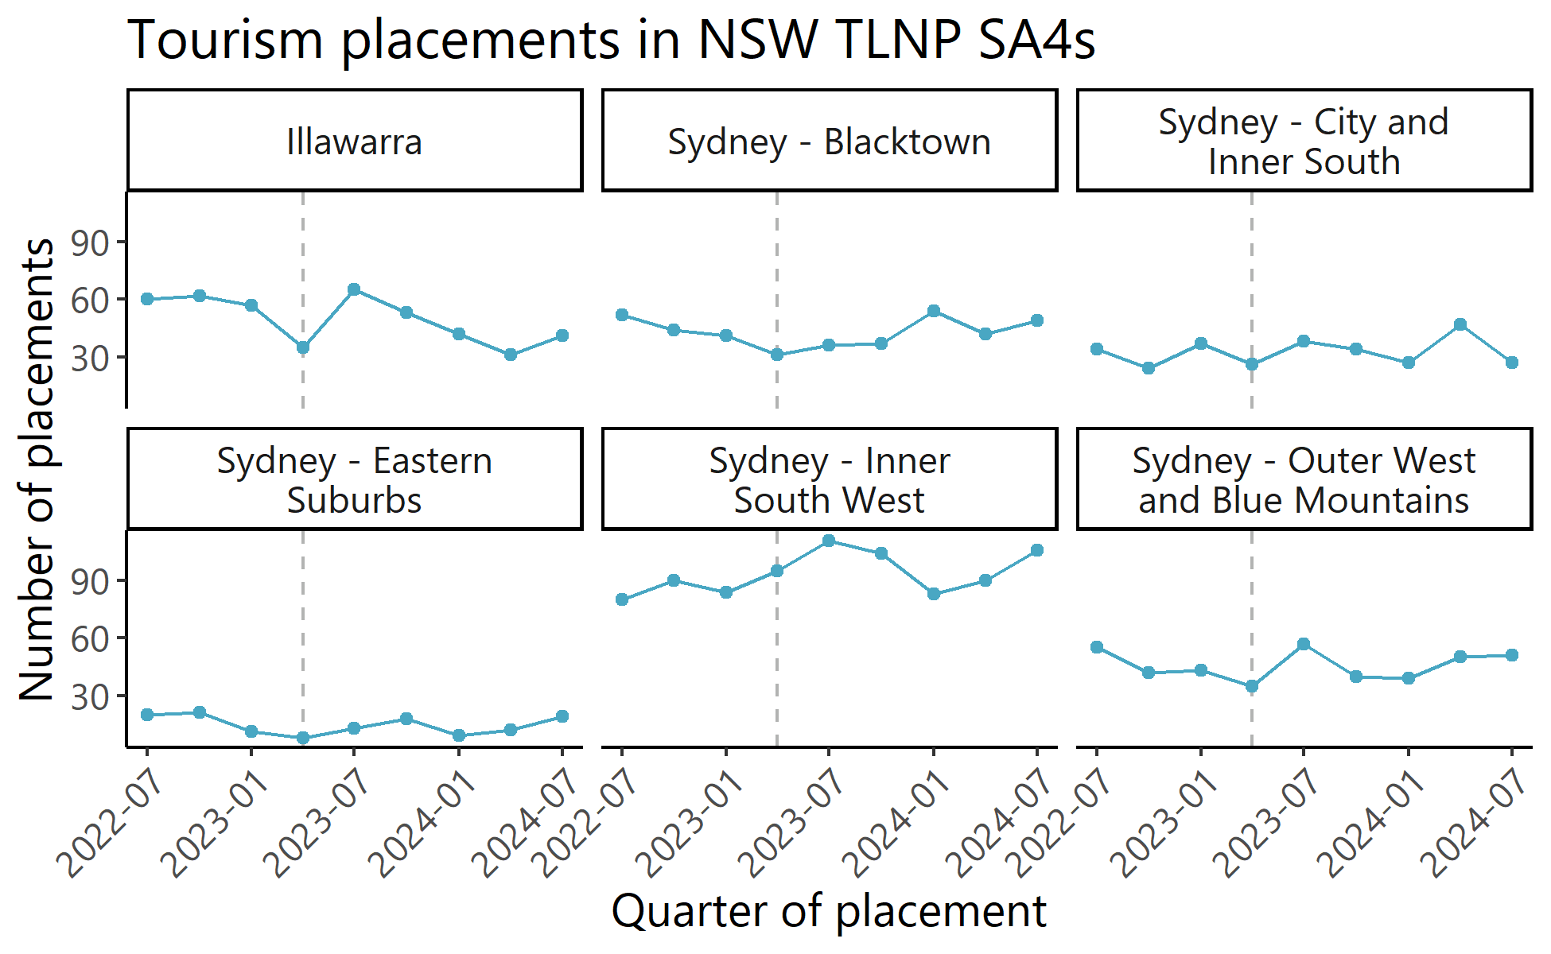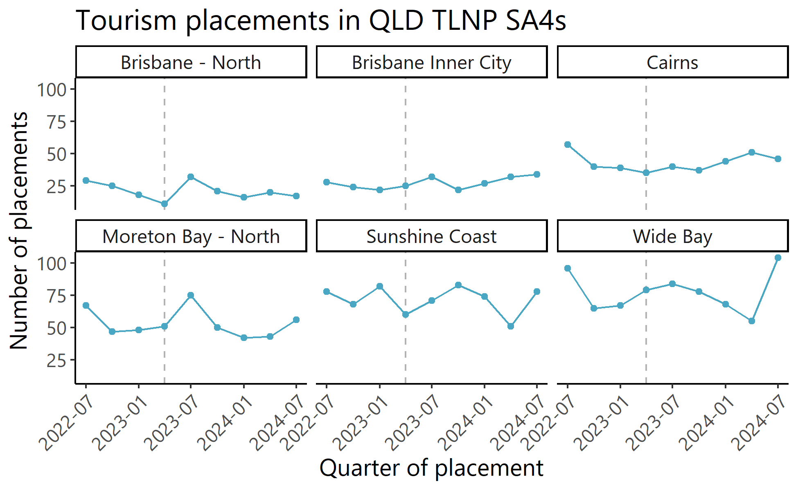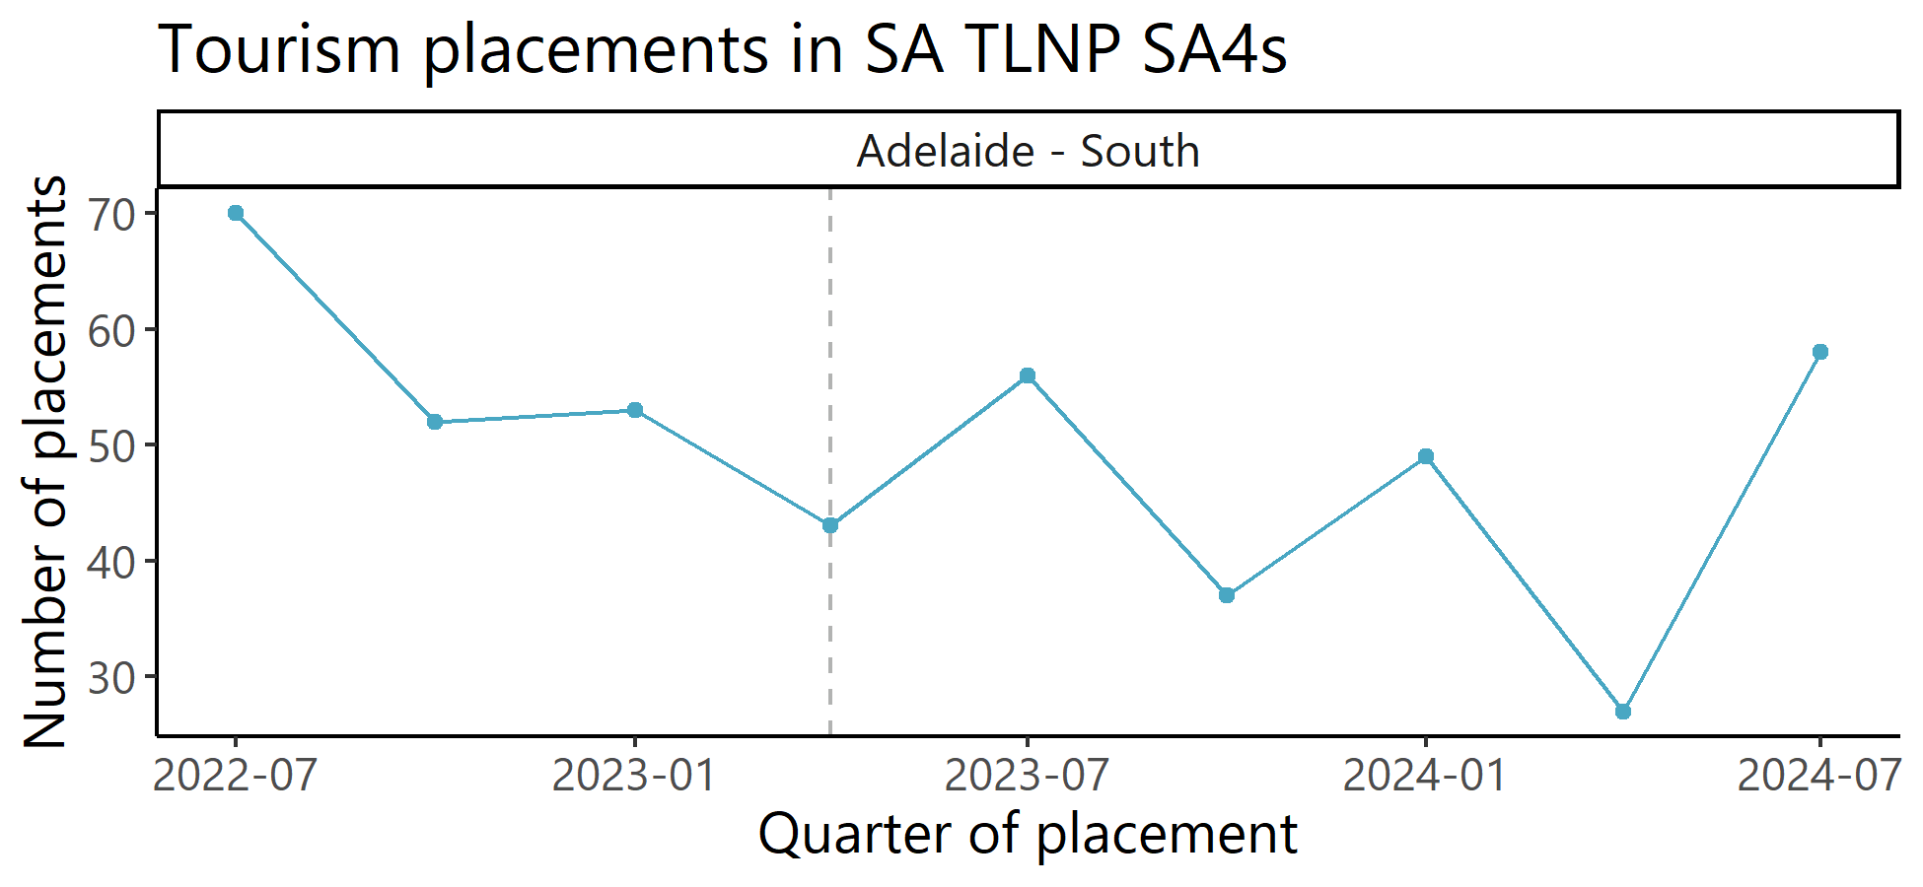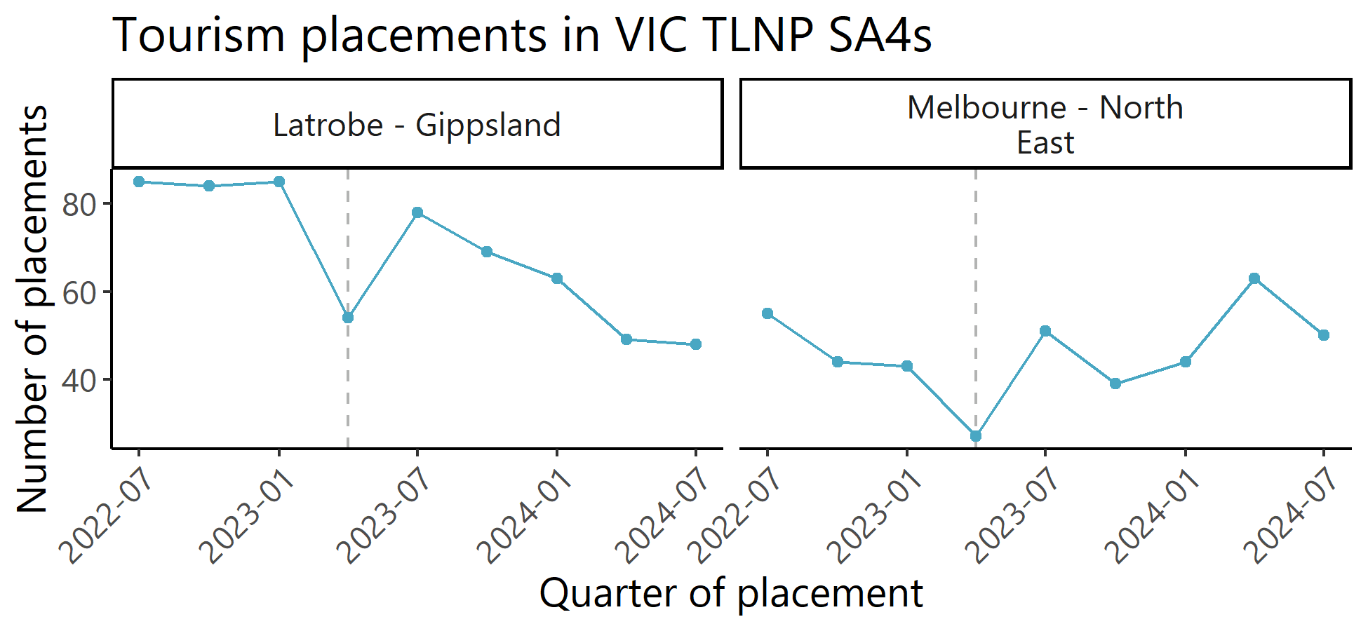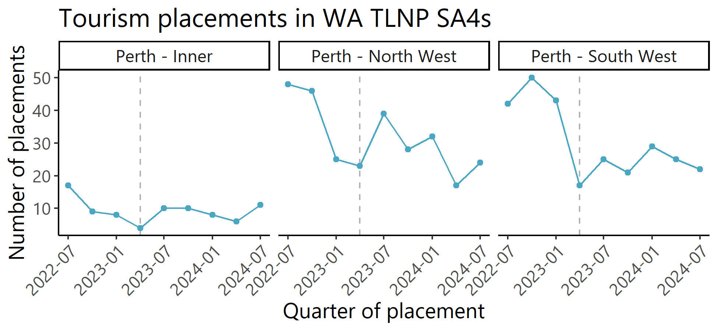


Connect with us
artd.com.au | (02) 9373 9900


Paul Ramsay Foundation, “Understanding the benefits, costs and funding flows to tailored jobseeker supports”, November 2024
International Recommendations for Tourism Statistics (2008) Department of Economic and Social Affairs, Statistics Division, United Nations.
The language ‘people with disability’ is chosen for several reasons, primarily to emphasise the personhood and humanity of individuals who have disabilities. This is also consistent with the language the Department of Social Services uses. However, it is recognised that members of the disability community may choose to identify as ‘disabled’.
Refer to Article 27 of the United Nations Convention on the Rights of Persons with Disabilities, 2006.
Refer to the ‘Disability, Ageing and Carers, Australia: Summary of Findings 2022’, Australian Bureau of Statistics.
Keogh, 2023
Aichner, T. (2021). The economic argument for hiring people with disabilities. Humanities and Social Sciences Communications, 8(1), 1-4.
Refer to p. 4 of the Australian Government Employ My Ability.
Employment Targeted Action Plan https://www.disabilitygateway.gov.au/sites/default/files/documents/2021-12/1896-tap-employment-accessible.pdf
THRIVE 2030: The Re-Imagined Visitor Economy. A national strategy for Australia’s visitor economy recovery and return to sustainable growth, 2022 to 2030.
Brisbane – Inner City was added as a service area for HELP Enterprises through a grant variation.
Barr, J and Christie, A. Better Value for Money, An organising framework for management and measurement of VFM indicators. itad. Available online: http://www.itad.com/wp-content/uploads/2014/11/Itad-VFM-paper-v21.pdf
THRIVE 2030: The Re-Imagined Visitor Economy. A national strategy for Australia’s visitor economy recovery and return to sustainable growth, 2022 to 2030.
Department of Employment and Workplace Relations, 2007 Are People With Disability at Risk at Work? A Review of the Evidence pp. 1-70 SafeWork Australia
Tourism businesses in Australia: June 2018 to June 2023. Austrade (2024).
ComCare, Employer Mobilisation Final Research Report, 2018.
https://cfirguide.org/
There is no ANZIC code for tourism, however a Tourism Industry Indicator was created by the Jobs & Skills Australia team that flags roles that are likely to be in the tourism industry.
Data by region. (2024). Data by region | Australian Bureau of Statistics. https://dbr.abs.gov.au/region.html?lyr=sa4&rgn=306
Data by region. (2024). Data by region | Australian Bureau of Statistics. https://dbr.abs.gov.au/region.html?lyr=sa4&rgn=306
Disability and Inclusion Plan 2024-2026. (2024). Cairns Regional Council. *Appears to be LGA-based report.
https://www.forgov.qld.gov.au/pay-benefits-and-policy/state-of-the-sector-report/our-diversity/people-living-with-disability
Tourism. (2023, January 24). Cairns Convention Centre. https://www.cairnsconvention.com.au/cairns/key-industries/tourism/
Key industries. (2023, January 24). Cairns Convention Centre. https://www.cairnsconvention.com.au/cairns/key-industries/
Barr, J and Christie, A. Better Value for Money, An organising framework for management and measurement of VFM indicators. itad. Available online: http://www.itad.com/wp-content/uploads/2014/11/Itad-VFM-paper-v21.pdf
Paul Ramsay Foundation, “Understanding the benefits, costs and funding flows to tailored jobseeker supports”, November 2024
Noting that there is not a consistent definition of an “engaged” business across provider reports; we have taken it to mean a substantial interaction with the provider to engage in activities that may prepare that business to identify and fill vacancies, such as participation in training and/or planning.
Data reported by providers on the numbers of interviews completed were used as a proxy for identified vacancies. This may be a slight overestimation if more than one participant was interviewed for a single position, though the model of matching vacancies to potential candidates makes the likelihood of this small in practice.
Although only 6 of 12 providers reported delivering activities directly relating to collaboratively engaging with TSMEs and ESOs to address barriers to employing people with disability all providers were asked to report on employment outcomes as part of their final reporting to DSS. Some providers did not directly target this outcome but were still able to report on employment outcomes achieved indirectly through their pilot activities.
Note that the definition of sustained employment varies.
Paul Ramsay Foundation, “Understanding the benefits, costs and funding flows to tailored jobseeker supports”, November 2024
Paul Ramsay Foundation, “Understanding the benefits, costs and funding flows to tailored jobseeker supports”, November 2024
This benchmark is also consistent with Australian Bureau of Statistics data on the distribution of tourism expenditure and Gross Value Added.
International Recommendations for Tourism Statistics 2008. Department of Economic and Social Affairs, Statistics Division. United Nations.

