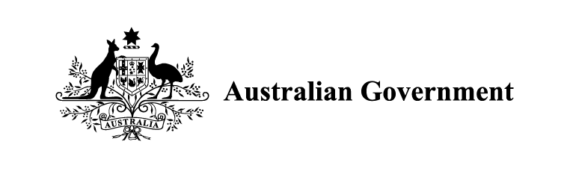

National Plan to End Violence against Women and Children 2022-2032

Table of Contents

Governance Arrangements: Core 2
Organisations 3
Governance Arrangements: Support 6
Stakeholder Expertise 6
Evidence, Monitoring and Reporting 6

Governance Arrangements: Core
The Minister for Social Services is responsible for the National Plan to End Violence against Women and Children 2022-2032 (the National Plan).
Reporting to the Minister are:
- Women and Women’s Safety Ministerial Council
    - This decision-making body consists of representatives from all jurisdictions and is
co-chaired by the Minister for Women and the Minister for Social Services.
- Commonwealth National Plan Implementation Committee
    - This Commonwealth body is chaired by a Deputy Secretary from the Department of Social Services and Senior Executives from the Office for Women.
- Domestic, Family and Sexual Violence Commission
    - This is a national independent agency responsible for providing strategic policy advice and developing consistent frameworks to measure progress of the National Plan.
- Domestic, Family and Sexual Violence Advisory Council
    - This council provides independent advice and is chaired by the Minister for Social Services.
The Women and Women’s Safety Senior Officials group (co-chaired by Senior Executives from the Office for Women and the Department of Social Services) reports to the:
- Women and Women’s Safety Ministerial Council
- Commonwealth National Plan Implementation Committee.
The Commonwealth Ending Gender-based Violence Inter-Departmental Committee (chaired by Senior Executives from the Office for Women, Department of the Prime Minister and Cabinet) reports to the Commonwealth National Plan Implementation Committee.

Organisations

Women and Women’s Safety Ministerial Council (WWSMC)
This is a decision-making body that has oversight of the women’s safety environment, driving cross-jurisdictional efforts and ensuring activities achieve intended outcomes. Reports into National Cabinet on their ending-gender based priority and consists of Commonwealth, state and territory ministers responsible for women and women’s safety.
Chair: Co-chaired by the Minister for Women and the Minister for Social Services.
Ex-officio member: DFSV Commissioner
Membership: All jurisdictions.

Women and Women’s Safety Senior Officials
This is decision-making body responsible for policy advice to support the National Plan consisting of senior jurisdictional representatives from departments and agencies.
Chair: Co-chaired by Senior Executives from the Office for Women and the Department of Social Services.
Membership: All jurisdictions.

Commonwealth National Plan Implementation Committee
This Commonwealth body directs work and priorities across Commonwealth government agencies, focused on collaboration and delivery of the National Plan.
Chair: Chaired by a Deputy Secretary from the Department of Social Services, with Senior Executives from the Office for Women as Deputy Chair.
Membership: Relevant Commonwealth agencies.

Commonwealth Ending Gender-based Violence Inter-Departmental Committee
This group consists of Commonwealth government executives supporting FDSV policy development and initiatives.
Chair: Chaired by Senior Executives from the Office for Women.
Membership: Executives from relevant Commonwealth agencies.

Domestic, Family and Sexual Violence Commission (The Commission)
The Commission is an independent agency responsible for providing strategic policy advice to governments, developing consistent frameworks to measure progress and impact of the National Plan, and providing a yearly report to the Australian Parliament.
The Commission also amplifies the voices of people with lived experience of domestic, family and sexual violence by convening the Lived Experience Advisory Council. The Lived Experience Advisory Council undertakes engagement with people with lived and living experience of domestic, family and sexual violence to influence policy and service development.

Domestic, Family and Sexual Violence Advisory Council
This is an independent council providing advice to the Minister for Social Services on effective delivery of the National Plan to drive down rates of violence. The Council will provide advice on new and emerging evidence, progress, and national system and service delivery implementation.
Chair: Minister for Social Services.
Membership: Minister for Social Services and up to 10 independent subject matter experts. The Advisory Council will also be supported by ex-officio members including Senior Executives from the Department of Social Services and the Office for Women, the DFSV Commissioner, the eSafety Commissioner, Australia’s National Research Organisation for Women’s Safety (ANROWS), and a member of the National Aboriginal and Torres Strait Islander Peak Body to address Domestic, Family and Sexual Violence.

Governance Arrangements: Support
A range of critical expertise and evidence is also required to support and inform effective governance functions and delivery of the National Plan.

Stakeholder Expertise

National Women’s Alliance
The National Women’s Alliances play a key role in ensuring women’s voices are central in the policy development and decision-making process.

National Organisations
These are key national organisations delivering national responses to DFSV and key outcomes to support the National Plan. These include ANROWS and Our Watch.

National Peak Bodies
These are organisations representing members and communities working with government to inform policy and delivery. This includes the new National Aboriginal and Torres Strait Islander Peak Body to address Domestic, Family and Sexual Violence.

Evidence, Monitoring and Reporting

National Evidence Technical Working Group
These are subject matter experts focused on guiding Commonwealth-led family and domestic violence data initiatives, until at least the end of the First Action Plan 2023–2027.
Chair: Australian Institute of Health and Welfare.
Membership: Commonwealth, state and territory representatives.

ANROWS
Australia’s National Research Organisation for Women’s Safety (ANROWS) delivers research and associated reports, research synthesis papers, tools and resources across all priority areas of the National Plan.

Reporting and Evaluation
Reporting that informs our assessment of the National Plan is underpinned by such key products as the Activities Addendum update, the National Plan’s Outcomes Framework, and Impact Evaluations.

