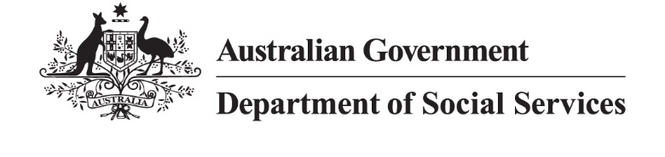

Connecting Communities: Share your story consent form – for adults

Who we are
We are the Australian Government Department of Social Services (DSS).
We work in partnership with other government agencies and organisations to improve the economic and social wellbeing of individuals, families and vulnerable members of Australian communities.

Why we are seeking your consent
We are seeking your consent to collect, use and disclose your personal information to help us explain and promote government policies, programs, services, events and activities.
This might include your personal information being used or disclosed:
  In printed products  (e.g. annual reports, brochures, booklets, fact sheets, banners, newspapers or magazines) | 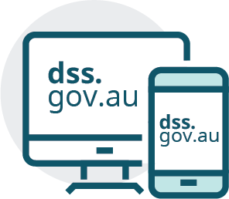  In digital products  (e.g. the internet, on our website at dss.gov.au, in presentations) |   On television and radio  (e.g. advertisements, news, notices etc.)
  On social media  (e.g. Facebook, Instagram, X, LinkedIn, YouTube) |   To other parties  (e.g. other government agencies, contractors, media outlets) |   To Members of Parliament to promote DSS work (but not for political purposes)

Important note: As digital products may be viewed online, your personal information may be accessed by people in other countries.

Your personal information
For the purposes of the promotion, your personal information may include:
- your photo (image), and/or
- a digital, video or audio recording of you, and/or
- information which can be assumed from your image, such as your gender, age, hair or clothing worn, religion, race or ethnicity, sexual orientation, disability and/or illness
- your first and last name, and/or
- your general location (e.g. your city or state/territory), and/or
- your personal experience with a government program or service.
We will not share your personal contact details or address without your permission. However, we may use this information to contact you to check your ongoing consent for your personal information to be used.

Why do we need your personal information?
We are collecting your personal information to promote case studies showing the value of services and programs funded by DSS. Your information will be supplied to us by service providers.

How long will we use your personal information?
We may use and disclose your personal information for a continuous period of 2 years and no longer than 6 years unless otherwise agreed (for example, as part of a contract). If we want to continue to use your personal information after 2 years, we will contact you to seek consent again.
You can contact us at any time to withdraw your consent. However, it may not always be possible for us to retrieve or delete your personal information once it is published.

Who owns the copyright?
The Australian Government owns copyright of any promotional material it produces. If you receive a copy of material containing your personal information, you may not publish it without permission from DSS.

More information
Please refer to our Privacy Policy for more information on how we protect and store your information. Our Privacy Policy also contains information on how you may seek access or correction to your personal information or complain about our handling of your personal information.

Contact us
- Email: complaints@dss.gov.au
Telephone: 1800 634 035
Post: DSS Feedback, GPO Box 9820, Canberra ACT 2601

Consent
Please fill in the following details:
I,
of (address)
phone number
Email
Type yes or no in the Yes/No column below to acknowledge and give consent that I:
Consent Statement | Yes/No
Have read (or someone has read to me) the information in this document and understand it.
Consent to my personal information being used and disclosed by DSS (and contractors or providers working on DSS’s behalf), the Australian Government and Members of Parliament for the promotional purposes described in this form.
Acknowledge I will not be able to publish the written, photo, video or audio material containing my personal information without permission from the Australian Government.
Acknowledge I can withdraw my consent at any time by contacting DSS using the contact details listed above (subject to contractual requirements if this is a paid appearance).
Acknowledge that if I withdraw consent that my personal information will no longer be used or disclosed but that already printed or online materials may not be able to be removed.
Acknowledge that I may be contacted in the future to check my ongoing consent for DSS to use and disclose my personal information.
Please fill in the following details:
Type your name in the signature field below to confirm you’ve read and agree to this consent form
Signature:
Date:
(If signed by another person on behalf of the individual)
Name:
Relationship to individual (i.e. power of attorney, nominee, carer/guardian):
Signature:
Date:

