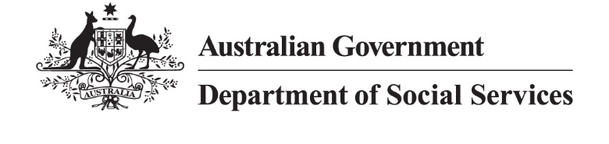
DSS 3597.11.25

Young people aged 22 to 29

2024 Priority Investment Approach projections

The Priority Investment Approach provides a
long-term view of how all Australians are predicted
to use the social security system over their lifetime.
The following analysis focuses on the 3.1 million young people aged 22-29 at 30 June 2024. Within this cohort:
- 89% (1.4 million) of men and 93%
(1.4 million) of women had attained Year 12 or higher
- 5% (146,000) identified as First Nations Australians
- 13% (392,000) received income support (IS).
Of the young people receiving income support, 157,000 received JobSeeker Payment (JSP) and 65,000 received Disability Support Pension (DSP).

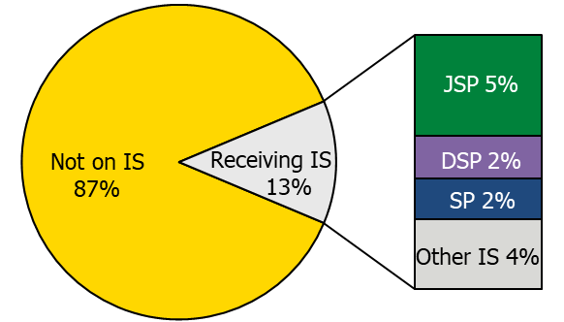
Figure 1: Income support payments received by young people aged 22-29.
Young people receiving JSP are projected to spend 15.3 years receiving income support prior to Age Pension age, compared to 31.3 years for those receiving DSP. Young people accessing student payments (SP) are projected to spend only 5 years on income support prior to Age Pension age. Completing Year 12 and gaining a higher level of educational attainment is associated with less time on income support in the future.

Support for young people with a mental health condition
Young people with a mental health condition that
restricts their ability to work may receive DSP or JSP.
At 30 June 2024, 28% of young people receiving JSP and 44% of young people receiving DSP had a mental health condition.
Figure 2 shows an increase in overall numbers of young people with a mental health condition on income support payments over the past 10 years. There has been a 39% rise in young people with a mental health condition receiving DSP and, excluding the COVID years (2020-22), a 19% increase in young people with a mental health condition receiving JSP. Of the young people receiving these payments, there were more men than women with a mental health condition: 63% of DSP recipients and 55% of JSP recipients.
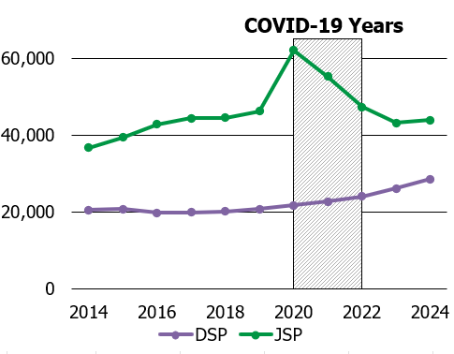
Figure 2: Number of DSP and JSP recipients aged
22-29 with a mental health condition.

How are young people with a mental health condition predicted to use income support in the future?
This section compares projected use of income support payments by looking at the 73,000 young people with a mental health condition who were receiving either JSP or DSP.

JobSeeker Payment
44,000 young people receiving JSP had a mental health condition at 30 June 2024. On average, they are projected to spend 18.8 years receiving income support payments before they reach Age Pension age, including an average of 7.5 years on JSP, and 8.5 years receiving DSP.
For those on JSP, this is 6.1 years longer than young people without a medical condition on JSP (12.7 years), and 11.5 years longer than those who were not receiving income support (7.3 years).
Figure 3 shows in 10 years’ time, while 50% will not be on income support, 22% are projected to receive JSP, 18% are projected to receive DSP and 10% are projected to receive other forms of income support (7% Parenting Payment, 3% Carer Payment).
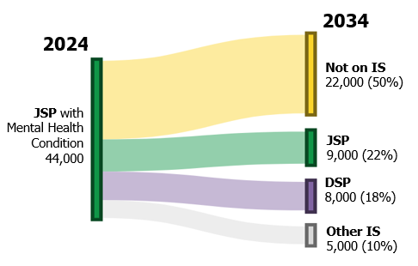
Figure 3: Projected payment use in 10 years’ time for young people with a mental health condition receiving JSP

Disability Support Pension
29,000 young people receiving DSP had a mental health condition at 30 June 2024. They are projected to spend an average of 30.1 years receiving income support. This is 11.3 years longer than those with
a mental health condition who were receiving JSP at 30 June 2024 (18.8 years).
Figure 4 shows in 10 years’ time, 80% of young people with a mental health condition receiving DSP are projected to still be receiving DSP, while 19%
are projected to no longer be on income support.
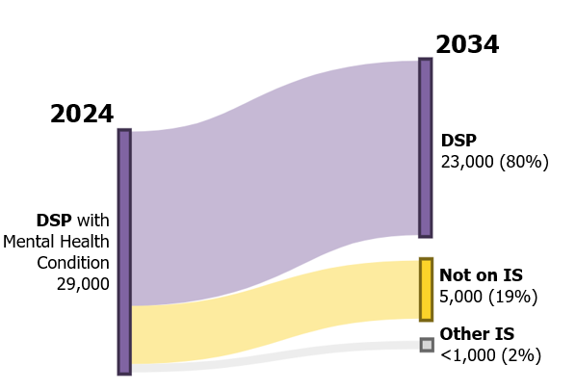
Figure 4: Projected payment use in 10 years' time for young people with a mental health condition receiving DSP.

Note: These figures are from the Priority Investment Approach 2024 model and will not match official or published recipient data due to different data extraction rules and extraction timing. For official figures please refer to the DSS Benefit and Payment Recipients Demographics reports or DSS Income Support Recipients – Monthly Time Series published on data.gov.au.
This only includes psychological or psychiatric conditions identified as a person’s primary medical condition following assessment for payment eligibility and is therefore likely to be an underrepresentation of the number of recipients with a mental health condition.
To be eligible for Disability Support Pension, a person must be assessed as being unable to work (or be reskilled to work) for 15 hours or more per week, for at least the next two years, due to their impairment.
This includes people with a partial or full capacity to work. For JSP, a person who is assessed as being unable to work for at least 30 hours per week, whether due to a physical, intellectual or psychiatric impairment, within the next 2 years is referred to as having a partial capacity to work.
Of this group, 61% (27,000) had a partial capacity to work.

