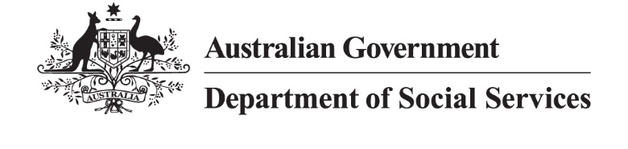
DSS 3596.11.25

Women aged 45 to 54

2024 Priority Investment Approach projections
The Priority Investment Approach provides a long-term view of how all Australians are predicted to use the social security system over their lifetime.
The following analysis focuses on the 1.68 million women aged 45-54 at 30 June 2024. Within this cohort:
- 35% (596,000) were single
- 3% (55,000) identified as First Nations Australians
- 14% (232,000) were receiving income support (IS).
Of those women receiving income support, 73,000 were on Disability Support Pension (DSP), 72,000 were on JobSeeker Payment (JSP), and 51,000 received Carer Payment (CP).
Over the next 10 years, women aged 45-54 receiving income support are projected to receive a working age payment (primarily JSP) for 1.8 times longer (2 years) than women aged 25-34 receiving income support (1.1 years). They are also projected to receive CP for 2.1 times longer (1.8 years) than women aged 25-34 (0.9 years).
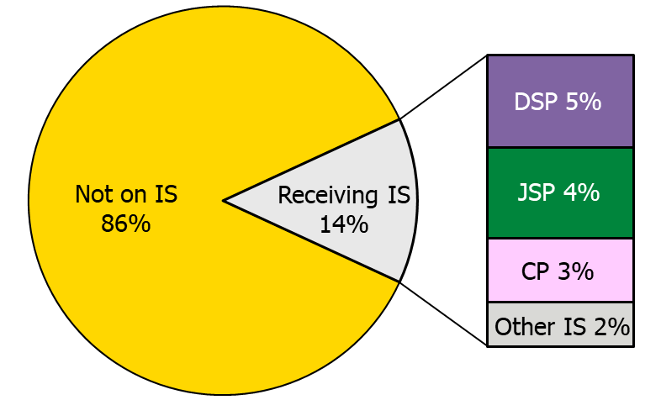
Figure 1: Income support payments received by women aged 45-54 at 30 June 2024.

What payments are women aged 45-54 predicted to receive in 10 years’ time?
1.45 million women aged 45-54 were not receiving income support at 30 June 2024, and projections show 92% of this cohort will not be on income support in 2034.
Of the 8% who are projected to receive
a payment in 2034, 4% will be on JSP,
2% will be on DSP, and 2% will receive CP.
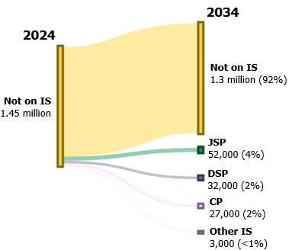
Figure 2: Projected payment use in 10 years’ time for women aged 45-54 not receiving income support.

How do outcomes differ for those with caring responsibilities or a reduced capacity to work?
This section looks at projected use of income support payments for the 51,000 women aged 45-54 who were receiving CP at 30 June 2024 and for the 37,000 women in this age group who were receiving JSP with a partial capacity to work.

Carer Payment
Of the 51,000 women aged 45-54 who received CP at 30 June 2024:
- 45% were caring for their child
- 23% were caring for a partner or spouse
- 20% were caring for a parent.
Figure 3 shows the predicted use of payments for this group in 10 years’ time. In 2034, 53% are projected to receive CP, 24% are projected to be not receiving income support, 13% are projected to receive JSP, and 10% are projected to receive DSP.
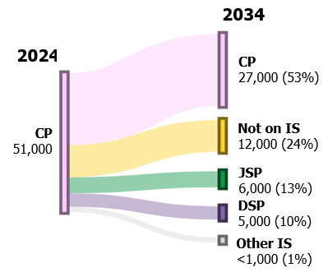
Figure 3: Projected payment use in 10 years’ time for women aged 45-54 receiving CP.

JobSeeker Payment
Of the 72,000 women aged 45-54 receiving JSP at 30 June 2024, 52% had a partial capacity to work. Over the next
10 years, women with a partial capacity to work are projected to spend 1.9 years longer on income support (7.7 years) than those with full capacity to work (5.8 years).
Figure 4 shows 33% of women receiving JSP with a partial capacity to work are projected to receive DSP in 2034 – more than twice the percentage of women with full capacity to work (15%). In 10 years’ time, 45% of women on JSP with full capacity to work will not be on income support, compared to only 28% of women with a partial capacity to work. Regardless of capacity to work, around one third are projected to be receiving JSP in 10 years’ time.
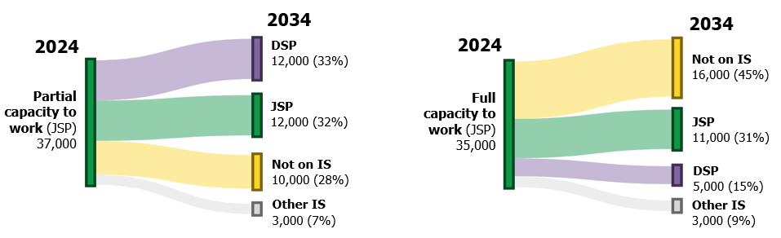
Figure 4: Projected payment use in 10 years’ time for women on JSP with a partial capacity to work compared with those with full capacity to work.

Note: These figures are from the Priority Investment Approach 2024 model and will not match official or published recipient data due to different data extraction rules and extraction timing. For official figures please refer to the DSS Benefit and Payment Recipients Demographics reports or DSS Income Support Recipients – Monthly Time Series published on data.gov.au.
A person who is unable to work for at least 30 hours per week, whether due to a physical, intellectual or psychiatric impairment, is referred to as having a partial capacity to work. A person who is able to work for at least 30 hours per week within 2 years is referred to as having full capacity to work.

