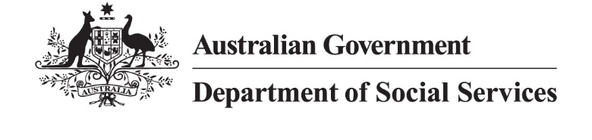
DSS 3595.11.25

Single Parents aged 30 to 45

2024 Priority Investment Approach projections
The Priority Investment Approach provides a long-term view of how
all Australians are predicted to use the social security system over their lifetime.
The following analysis focuses on the cohort of single parents
aged 30-45 at 30 June 2024. Within this cohort:
- 75% (474,000) were women
- 13% (80,000) identified as First Nations Australians
- 32% (204,000) live in the lowest 20% of socio-economic areas
- 50% (315,000) received income support (IS).
Of the single parents receiving income support, 187,000 received Parenting Payment (Single) (PPS) and 61,000 received JobSeeker Payment (JSP).
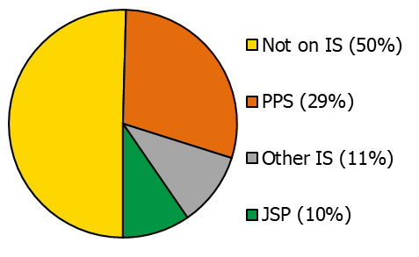
Figure 1: Income support payments received by single parents at 30 June 2024.

First Nations single parents
Of single parents aged 30-45, a greater proportion of those identifying as First Nations Australians had their first child at a younger age. Figure 2 shows 45% had their first child before age 23. By comparison, more non-First Nations single parents had their first child in their late 20s, with 23% having their first child before age 23.
Over the next 10 years, First Nations single parents are projected to spend on average 6.4 years receiving income support payments, compared to 3.9 years for non-First Nations single parents.
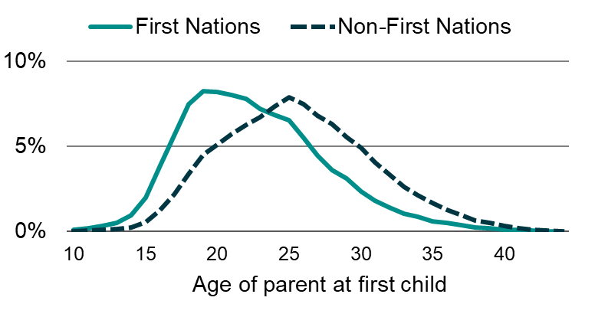
Figure 2: Age of single parents when they had their first child by First Nations status.

How have projections changed post-PPS policy change?
On 20 September 2023, eligibility for PPS was extended to include those with a youngest child up to age 14. Previously, eligibility ended when the youngest child turned 8.

Better support for single parents
This section compares projected use of income support payments by looking at 2022 model projections made prior to the PPS policy change and projections from the 2024 model after the policy change.
Figure 3 shows the positive effect of this policy change for single parents at 30 June 2024. The dotted green line represents the extent to which JSP provided support for single parents and their older children prior to this change. While the total number of single parents receiving payments has changed minimally, the change in overall composition shows greater use of PPS to better meet individual needs.
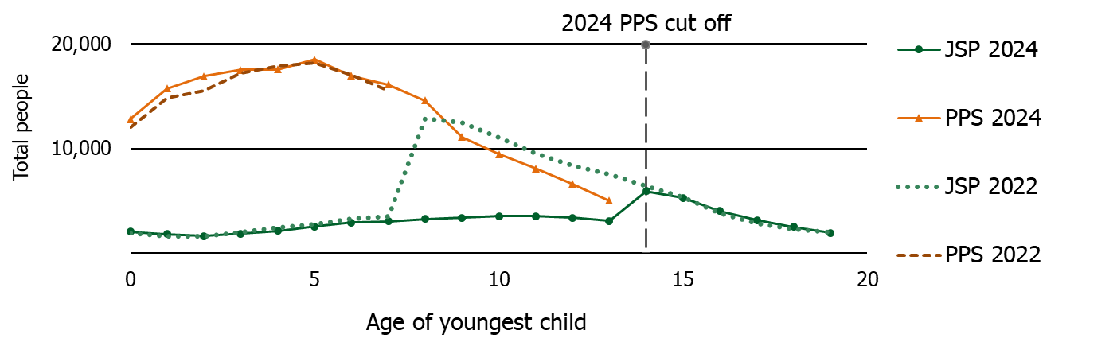
Figure 3: Number of single parents receiving JSP and PPS by age of youngest child.

Youngest child aged 0-7
Single parents aged 30-45 with a youngest child aged 0-7 are projected to receive income support payments for 4.6 of the next 10 years, compared to 3.9 in 2022. Figure 4 shows single parents are primarily projected to receive PPS, rather than JSP, following the expansion of eligibility to those with children aged between 8 and 14.

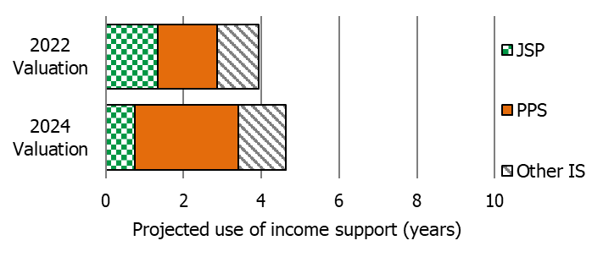
Figure 4: Change in projected use of JSP and PPS for single parents with a youngest child aged 0-7.

Youngest child aged 8-14
Single parents aged 30-45 with a youngest child aged 8-14 are projected to receive income support payments for 3.8 of the next 10 years, compared to 3.1 in 2022. Figure 5 shows single parents are now projected to receive more PPS and less JSP to better support their needs.

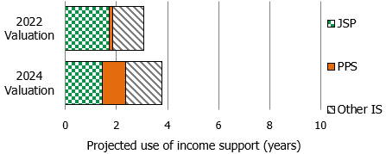
Figure 5: Change in projected use of JSP and PPS for single parents with a youngest child aged 8-14.

‘Single parents’ includes all single people who have a child aged 19 or under. These single parents may or may not be the principal carer of the child under their care. A parent is the natural or adoptive parent or guardian of the child, or the child’s parent or guardian where the child is the product of that person’s previous or current relationship (whether that be a same-sex or opposite sex relationship).
Note: These figures are from the Priority Investment Approach 2024 model and will not match official or published recipient data due to different data extraction rules and extraction timing. For official figures please refer to the DSS Benefit and Payment Recipients Demographics reports or DSS Income Support Recipients – Monthly Time Series published on data.gov.au.

