Australian Priority Investment Approach to Welfare
30 June 2024 Valuation Report

© Commonwealth of Australia 2025
ISSN: 2653-4525 (online)
This publication is available for your use under a Creative Commons Attribution 4.0 International licence, with the exception of the Commonwealth Coat of Arms, the Australian Government Actuary logo, photographs, images, third party materials, materials protected by a trademark, signatures and where otherwise stated. The full licence terms are available from creativecommons.org/licenses/by/4.0/legalcode.

Use of material from the Australian Government Actuary under a Creative Commons Attribution 4.0 International licence requires you to attribute the work (but not in any way that suggests that the Australian Government Actuary endorses you or your use of the work).
Material sourced from the Australian Government Actuary, used ‘as supplied’.
Provided you have not modified or transformed material from the Australian Government Actuary in any way including, for example, by changing the Australian Government Actuary’s text; calculating percentage changes; graphing or charting data; or deriving new statistics from statistics published by the Australian Government Actuary – then the Australian Government Actuary prefers the following attribution:
Source: The Commonwealth of Australia.
Derivative material
If you have modified or transformed material from the Australian Government Actuary, or derived new material from those of the Australian Government Actuary in any way, then the Australian Government Actuary prefers the following attribution:
Based on Commonwealth of Australia data.
Use of the Coat of Arms
The terms under which the Coat of Arms can be used are set out on the Department of the Prime Minister and Cabinet website
(see www.pmc.gov.au/government/commonwealth-coat-arms).
Other uses
Inquiries regarding this licence and any other use of this document are welcome at:
Publications enquiries
The Australian Government Actuary
The Treasury Building
Langton Crescent
Parkes ACT 2600
Email: aga@aga.gov.au

Introduction
This document presents a summary of insights from the 30 June 2024 actuarial valuation of the Australian social security system. The actuarial valuation is part of the Australian Priority Investment Approach to Welfare (the Approach), implemented by the Department of Social Services. The Approach uses actuarial analysis to support a better understanding of how Australians use the social security system, both at the population level and for various groups within the population. This is the fifth such valuation carried out with the assistance of the office of the Australian Government Actuary.
This report continues the reporting style that the 2022 report instigated, with a greater focus on presenting an overview of insights at different life stages. The overview of each life stage is necessarily brief for the purposes of this report but gives an indication of the sorts of insights that are possible when applying an actuarial modelling approach to social security payment data and experience. Further insights can be gained in specific areas through more granular analysis of the valuation results, sensitivity testing and testing the effect of varying assumptions.
The valuation is based on the concept of a Lifetime Cost, which is the expected net present value of all future in-scope payments made in respect of the model population over their lifetimes. The model population includes both the entire resident Australian population, and all people living overseas receiving social security payments, on 30 June 2024.
The actuarial model projects the future possible interactions of those in the model population with the social security system. Detailed data is required for this projection. The data is provided by the Department of Social Services in the form of a longitudinal dataset covering social security payment use in Australia. Together with a range of other supplementary datasets, it enables projections of future transitions into and out of the social security payment population, transfers within the social security system, and the type and amount of social security payments made. For this valuation, updates to two important data sources were incorporated into the valuation process – the 2021 Census and the 2020–22 Australian Life (Mortality) Tables. Another significant change from the 2022 valuation was to recognise that employment and use of social security payments has moved closer to a post-COVID setting. As a result, the valuation is based on post-COVID experience wherever possible, meaning that the historical experience used to simulate future experience is now based on more recent data.
The total Lifetime Cost for the model population on 30 June 2024 is estimated to be $6,843 billion, which equates to $251,000 per person in the model population. Various economic, demographic and policy factors contribute to the Lifetime Cost, as well as changes in social security payment use over the two-year period between valuations. These factors include the effect of higher inflation, an increase in the number of Age Pension and Disability Support Pension (DSP) recipients, and the increases in payment rates and expansion of eligibility criteria for specific payments.
The major contributor to the Lifetime Cost remains the Age Pension ($3.9 trillion, or 58% of the total). The significant influence of the Age Pension is due to [1] the large number of people currently receiving the Age Pension; [2] the large number of people who will receive the Age Pension in the future; [3] the relatively high payment rates; and [4] the long duration for which payments are received (17 years, on average).
The next largest contributor is DSP ($899 billion, or 13% of the total). This assumes a continuation of DSP use at current levels, both in terms of new recipients and length of time existing recipients spend on payment, including those who choose to remain on DSP when they reach Age Pension age. Whilst it is too early to tell whether future numbers of new DSP recipients will remain at current levels, I believe this assumption is prudent given the experience of other forms of disability support, in life insurance, and in the community. Other income support payments and supplementary family payments are also significant contributors to the total Lifetime Cost.
Various individual characteristics are correlated with higher social security payment use in the future. Women are generally expected to have a higher Lifetime Cost for family and parenting payments, and for the Age Pension. Age is an influential factor in the use of most social security payments, in particular for DSP where, for example, the age of onset of disability has a bearing on the future duration of support.
The duration of support is reflected in the Lifetime Cost. For those who currently receive an income support payment, they are also more likely to spend time on income support in the future. This is particularly the case for people receiving Carer Payment and DSP. For DSP, the combination of existing recipients remaining on payment into Age Pension age and higher numbers of new entrants in recent years adds significantly to the Lifetime Cost and as such, emerging experience should be monitored carefully.
It is important to note that the estimate of the Lifetime Cost is subject to various sources of uncertainty. For example, how changes in mortality emerge over time can have a significant impact on future social security payment usage, notably the Age Pension. Improvements in life expectancy contribute to longer duration on payments. Changes in assumed indexation rates such as Average Weekly Earnings (AWE) directly impact the size of payments made, and assumptions about future Consumer Price Index (CPI) have a significant effect on supplementary payment categories. Changes in the unemployment rate affect the number of people both entering and exiting the social security system. This predominantly impacts working age and family payments, with flow-on impact to other payments. In addition, the behaviour and response of people receiving social security payments currently, and in the future, may also change over time in response to changes in policy and/or economic conditions.
This valuation takes a long-term view of expected social security payment usage based on the post-COVID environment. The degree to which the remaining effects of COVID continue to be felt remains uncertain and highlights the benefit of long-term modelling as a means of informing government responses to unexpected events.
The overall purpose of an actuarial approach to modelling, through the Priority Investment Approach, is to gain insights into the dynamics of the social security system. There are many factors that contribute to the results, including demographic, economic, social and policy changes. These can all change over time. The impact of all such changes should be considered in future valuations as part of an iterative process to implement, monitor, and adjust the modelling approach over time. Understanding the long-term impacts of changes, for example as measured by the Lifetime Cost and other metrics produced by the modelling, can help inform how the social security system is managed to ensure it remains fit for purpose.
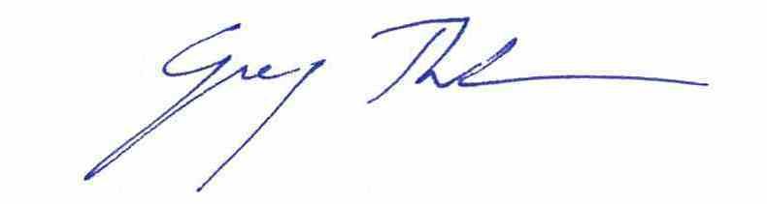
Guy Thorburn FIAA
Australian Government Actuary
November 2025

Contents
2024 Valuation of the Social Security System: Summary of findings 1
1 Childhood (under 18) 8
2 Young adults (18 to 21) 11
3 Transition to work (22 to 25) 14
4 Working age (26 to 44) 18
5 Older working age (45 to 66) 21
6 Age Pension age (67 and over) 25
7 People with children 28
8 People receiving payments to support caring 33
9 People receiving Disability Support Pension 37
Reflections and looking ahead 40
Appendix A: General Glossary 41
Appendix B: Payment Glossary 43
Technical note 45

2024 Valuation of the Social Security System: Summary of findings
The 2024 valuation provides insights into how the Australian population is likely to access social security payments over their lifetime.
The social security system provides a range of targeted support to assist people according to their needs at each stage of their lives. For vulnerable Australians, it provides a safety net for when they are unable to support themselves through work.
This valuation uses data as at 30 June 2024 to project how the Australian population will interact with the social security system in the future. Insights from the projections can assist in identifying vulnerable groups and opportunities to provide targeted support at critical points in people’s lives.
Descriptions of social security payments used throughout this report are consistent with payment settings in place as at 30 June 2024.
More than half of all Australians have accessed a social security payment at some point in their lives.
Around 28% of Australians accessed a social security payment in 2023–24, primarily through the Age Pension, employment support, and family support. A further 25% have accessed a social security payment in the past 22 years, many of whom have recently accessed JobSeeker Payment. Post COVID-19, the number of people accessing JobSeeker Payment has continued to decrease.
1 in 6 of the 19.8 million Australians not currently receiving a social security payment are expected to start receiving a payment over the next five years.
Most people projected to start receiving a social security payment are expected to receive either student payments, working age payments, supplementary family payments, or the Age Pension.
All Australians, including those who have not yet accessed the social security system, are expected to access a social security payment, on average, for 19.1 years of their future lifetime. The expected average total time on payment for a new recipient varies significantly between payment types.
In 2023–24, people new to student or working age payments are expected to access those particular payments for an average total of 2 and 4 years, respectively.
In contrast, a new recipient of Disability Support Pension (DSP) is expected to remain on payment for more than 23 years, and a person new to Age Pension is expected to remain on payment for 17 years on average.
About the Approach
The results presented in this report are based on an actuarial valuation as at 30 June 2024. This is the ninth in a series of valuations produced since the establishment of the Australian Priority Investment Approach to Welfare in 2015.
The Approach uses actuarial analysis to support a better understanding of the social security system, both at the population level and for various groups within the population.
The actuarial model projects how the Australian population will interact with the social security system across their lifetime. A customised longitudinal administrative dataset is used to project future transitions into, out of, and within the social security system.
Analysis of demographic characteristics and projected patterns of payment usage can provide insight into vulnerable groups and critical transition points. This informs policies and initiatives designed to intervene early to support people at risk of long-term disadvantage.
On 30 June 2024, the Lifetime Cost for the social security system is estimated at $6.843 trillion. For 27.3 million Australians, that is an average of $251,000 per person.
The 2024 valuation reflects a renewed outlook since the 2022 valuation, using post-COVID social security payment data and the 2021 Census to create a new baseline for understanding payment use. The new baseline provides an estimated Lifetime Cost that is higher than previous estimates, due to the use of more recent data to inform projections.
The largest contributor to Lifetime Cost is the Age Pension ($3.9 trillion), which makes up more than half of the total. Other major costs include DSP ($899 billion, or 13% of the total) and supplementary family payments, comprising Family Tax Benefit (FTB) and other family payments ($610 billion, or 9% of the total).
The new baseline Lifetime Cost is estimated using a combination of economic and demographic trends, patterns of social security payment usage, and policy changes.
The 2024 valuation results reflect higher payment rates through payment indexation to keep pace with the higher cost-of-living, as well as population growth of more than 1 million Australians over the previous two years. There have been two additional years of payment indexation since the 2022 valuation, during which time Consumer Price Index (CPI) inflation peaked at 7.8% in 2022–23. Projected wage growth and CPI inflation affected the largest social security payments, including Age Pension and DSP. This has led to higher projected payment rates in the future. The slightly lower long-term unemployment rate forecast had only a minimal effect on Lifetime Cost.
Other contributing factors include an upward trend in the number of people accessing payments such as DSP, the Age Pension and Child Care Subsidy, and new Government policies that expanded eligibility and increased rates for certain payments. DSP is the second highest payment contributing to Lifetime Cost, partly because some DSP recipients remain on the payment after Age Pension age. Higher rates of new entrants onto DSP in recent years also added to the estimated Lifetime Cost. The Lifetime Cost is reduced slightly by the decreasing trend in use of student payments and Family Tax Benefit.

The key new Government policy changes introduced since the 2022 valuation are now reflected in the 2024 valuation. They are as follows:
Commonwealth Rent Assistance (CRA): The maximum rates for CRA increased by 15% from 20 September 2023.
Parenting Payment Single (PPS): From 20 September 2023, PPS recipients could receive the payment until their youngest child turned 14 years of age. Previously, eligibility ended when the youngest child turned 8 years old.
Working age and student payments: On 20 September 2023, the base rate for some working age and student payments increased by $40.
JobSeeker Payment (JSP): From 20 September 2023, single JSP recipients aged 55 to 59 without children, who receive payment for at least 9 continuous months, receive the higher single rate.
Parental Leave Pay (PLP): The number of weeks a couple or single parent can receive PLP entitlements increased from 20 weeks in 2023–24 to 22 weeks in 2024–25. This will further increase to 24 weeks in 2025–26, and 26 weeks from 1 July 2026 onwards.
Child Care Subsidy (CCS): On 1 July 2023, the CCS rebate amount for the base rate was increased for all income levels, and the maximum income level was increased from $350,000 to $500,000.
Drivers of social security payment use
The payment eligibility rules directly influence the level of social security payment use. For example, increasing the Age Pension age reduces Age Pension usage, as people younger than the eligibility age cannot access an Age Pension.
Demographic characteristics, such as age and gender, are correlated with usage. For example, historically, women have had lower superannuation and financial assets at Age Pension age. This, combined with greater longevity, means on average they access Age Pension for a longer period than men.
Changes in the unemployment rate affect the number of people both transitioning into and out of the social security system. Working age payments and family payments are the main payment categories directly affected, with flow-on effects to other payments.
Future improvements in mortality, and therefore life expectancy, can have a significant impact on usage, most notably for Age Pension.

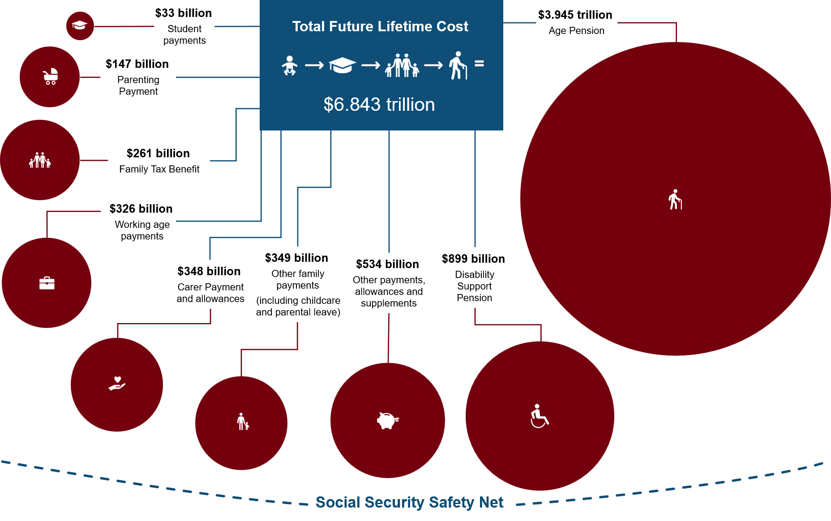
For many Australians, the social security system provides the support they need as they transition through each life stage from study to employment, partnering, having children and retirement.
Children aged under 18 generally interact with the social security system through the experience of their parents. For some, growing up in a household where a parent or guardian has received income support increases the likelihood they will receive income support themselves in the future. Children aged 15 years who spent more than 50% of their childhood with a parent(s) receiving income support are projected to be 1.5 times more likely to receive income support payments themselves before Age Pension age, compared to 15-year-olds whose parent(s) did not receive income support.
Age 18 to 21 is a transitional period between study and work for many young adults. A relatively small proportion access social security payments in this age group, mainly through student or working age payments. Young adults receiving working age payments are projected to spend 2.3 times (9.9 years) longer receiving income support prior to Age Pension age, on average, compared to those receiving student payments.
Age 22 to 25 is a time of growing independence for many young people. From age 22, the parental income test no longer applies, and young people looking for work become eligible for JobSeeker Payment. Young people previously on Youth Allowance (Other) who continue on to receive JobSeeker Payment from age 22 are projected to spend on average 8 more years on income support during their working life, than people who had been receiving a student payment.
Age 26 to 44 is typically a period of greater self-reliance when people of working age have established themselves in the workforce and can access support if their circumstances change. However, people with a physical, intellectual or psychiatric impairment, such as those receiving JobSeeker Payment with a partial capacity to work, are a particularly vulnerable group. Among those without children, people on JobSeeker Payment with a partial capacity to work are projected to receive income support for 5 years longer prior to Age Pension age, than people receiving JobSeeker Payment with full capacity to work.
Between the ages of 45 and 66, current use of JobSeeker Payment is associated with a greater likelihood of using income support in the future, particularly for those with a partial capacity to work. Women aged 45 to 66 who are currently on JobSeeker Payment with a partial capacity to work have the highest probability of moving onto Age Pension at the eligibility age.
The extent of interaction with the social security system at Age Pension age is closely related to the length of income support use during a person’s working life. On 1 July 2023, the Age Pension eligibility age increased to 67, and for many Australians this is the age they retire from full time work. The Age Pension is the primary income support payment for those unable to fully finance their retirement through superannuation and other savings. Around 2.6 million Australians accessed the Age Pension on 30 June 2024. Age Pension is projected to form approximately 58% of the total future Lifetime Cost for the current Australian population.
For people with disability and those receiving payments to support parenting or caring responsibilities, the social security system may provide financial assistance.
People with children may be able to access multiple social security payments depending on their needs. On 30 June 2024, 13% of parents (including guardians) were receiving an income support payment. A further 25% received a supplementary family payment (such as FTB, Child Care Subsidy and Parental Leave Pay) in 2023–24. People receiving Parenting Payment are expected to use income support for 3.6 of the next 5 years, while parents who are not on income support are expected to use income support for only 0.2 of the next 5 years.

There were 690,000 Australians receiving a payment to support caring on 30 June 2024. Older carers are projected to spend more time on income support than younger carers. People receiving Carer Payment in their 50s are expected to spend 4.4 of the next 5 years on income support, compared to only 3.7 years for people receiving Carer Payment aged under 20.
On 30 June 2024, 796,000 Australians were receiving DSP. Often, DSP provides income support over the long-term, with 89% of people currently below Age Pension age receiving DSP projected to stay on DSP until they reach Age Pension age or for the remainder of their life.
This report provides an analysis of current trends and future predicted use of the social security system. The analysis examines key life stages, including:
- Childhood (under 18)
- Young adults (18 to 21)
- Transition to work (22 to 25)
- Working age (26 to 44)
- Older working age (45 to 66)
- Age Pension age (67 and over).
In addition, the report provides an in-depth focus on the following three groups:
- People with children
- People receiving payments to support caring
- People receiving Disability Support Pension.

How Australians use the social security system
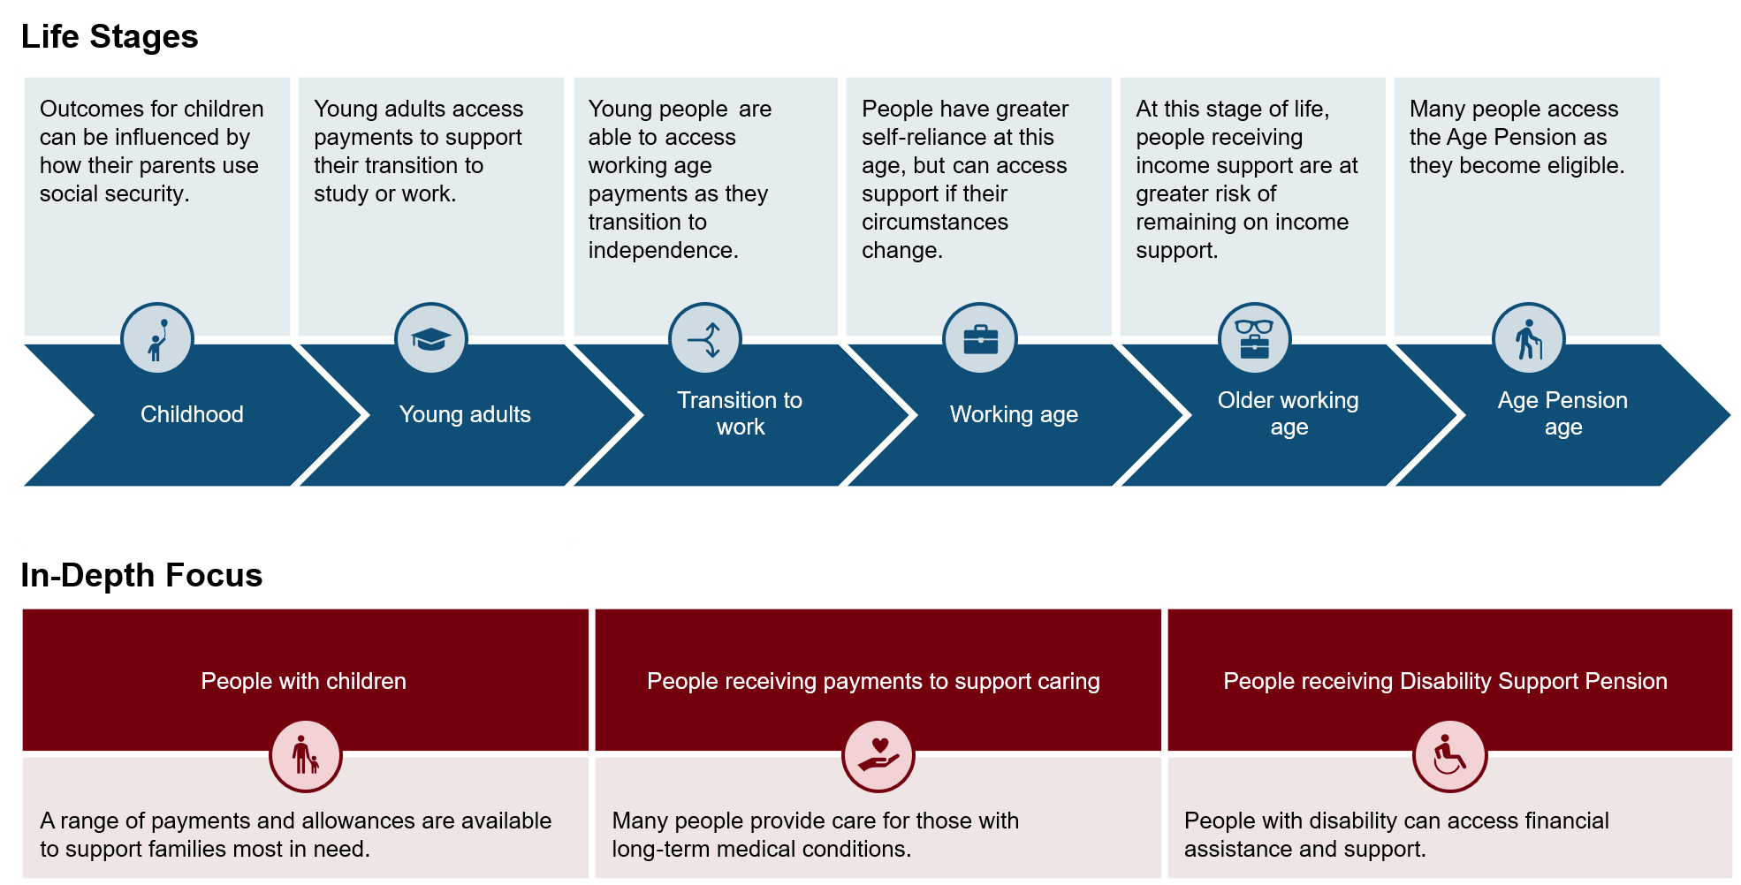

Childhood (under 18)
Children aged under 18 generally interact with the social security system through the experience of their parents. A parent’s income support use is associated with the child’s future use of income support.
There were 5.8 million children in Australia on 30 June 2024, making up 21% of the total Australian population.

Australian population
Most children under 18 do not directly receive social security payments, and only a small number receive income support.
1.1% of children under age 18 received a social security payment during the 2023–24 financial year. Only 0.4% were receiving an income support payment on 30 June 2024.
There is an association between the proportion of time spent growing up in a household where a parent(s) received income support and the child’s future use of income support.
Almost half of all children aged 15 on 30 June 2024 (163,000) grew up in a household with a parent(s) who received income support payments. As shown in Figure 1.1, 17% of children had a parent(s) who received income support payments for more than half of their childhood.
            - Number of children aged 15 at 30 June 2024
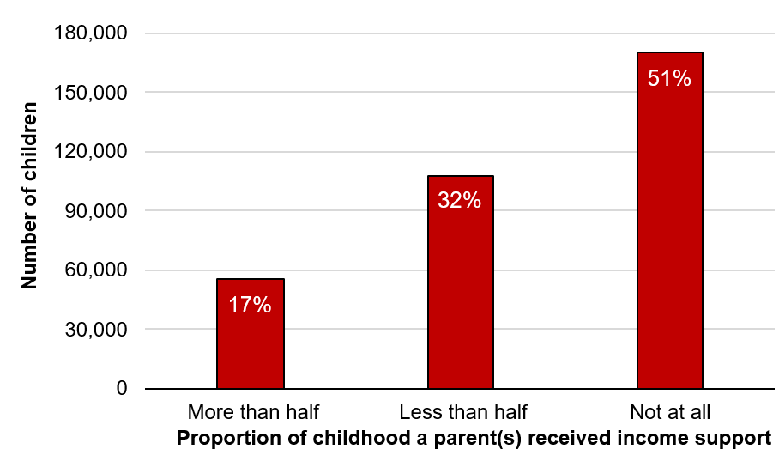
Children who spent more than half of their childhood in a household with a parent(s) receiving income support are 1.5 times more likely to receive income support themselves, compared to children whose parent(s) did not receive income support. They are also more likely to receive this support earlier in life.
As shown in Figure 1.2, 52% of children aged 15 who spent more than half of their childhood in a household with a parent(s) receiving income support are projected to access income support for the first time before age 22. A further 20% are projected to access income support for the first time after age 22 and before Age Pension age. The remaining 27% are not predicted to use income support prior to Age Pension age. In contrast, 50% of children aged 15 who did not grow up in a household with a parent(s) receiving income support are not projected to access income support before Age Pension age. Those projected to access income support tend to do so at an older age, with 37% projected to first use income support after age 22.
            - Projected age of first income support use for children aged 15 at 30 June 2024
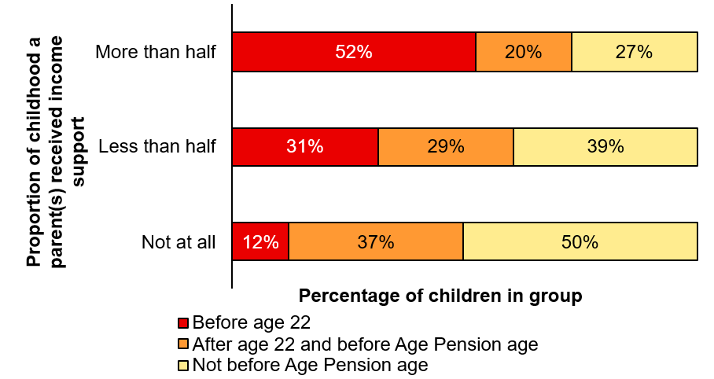
Children who grew up in a household with a parent(s) receiving income support are projected to spend longer receiving income support than children whose parent(s) did not receive income support. This is even more pronounced for those who also identify as First Nations.
Figure 1.3 shows children aged 15 who spent more than half of their childhood in a household with a parent(s) receiving income support are projected to spend 10.9 years on average on income support later in their lives. This is 3.1 times (7.3 years) longer than those whose parent(s) did not receive income support (3.5 years).
First Nations children aged 15 who spent more than half of their childhood with a parent(s) receiving income support are projected to spend 19.8 years on average on income support prior to Age Pension age. This is 2.4 times (11.5 years) longer than non-First Nations children whose parent(s) received income support for more than half their childhood, and 5.8 times (16.3 years) longer than non-First Nations children aged 15 whose parent(s) did not receive income support (3.4 years).
            - Projected average time receiving income support before Age Pension age for children aged 15 at 30 June 2024
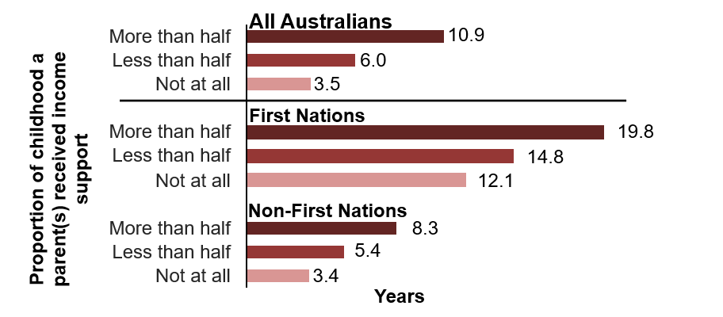
Children who grew up in a household with a parent(s) receiving income support and who live in disadvantaged areas of Australia are projected to spend more time receiving income support. Figure 1.4 shows children who spent more than half of their childhood with a parent(s) receiving income support and who reside in the most disadvantaged (lowest 20%) areas are projected to spend a much greater amount of time receiving income support (14.2 years) than those living in the most advantaged (highest 20%) areas (5.4 years). By contrast, children whose parent(s) did not receive income support and who reside in the most disadvantaged areas are projected to spend only slightly more time receiving income support (3.6 years) than children who reside in the most advantaged areas and whose parent(s) did not receive income support (3.4 years).
Children experiencing both forms of disadvantage – growing up in a household with a parent(s) receiving income support for more than half of their childhood and living in the most disadvantaged areas of Australia – are projected to spend 4.2 times (10.8 years) longer receiving income support (14.2 years) than children whose parent(s) did not receive income support living in the most advantaged areas of Australia (3.4 years).
            - Average projected time receiving income support before Age Pension age (in years)

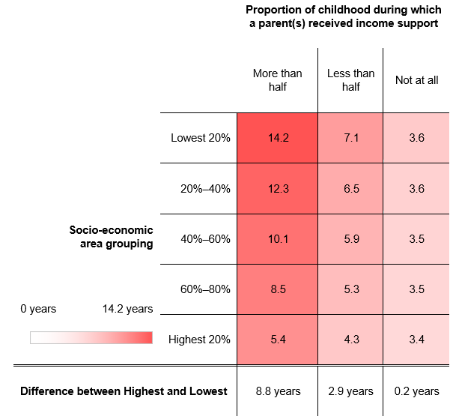

Young adults (18 to 21)
Many young adults transition to further study or employment between the ages of 18 and 21. Those on income support mainly receive student or working age payments.
There were 1.34 million people aged 18 to 21 on 30 June 2024, making up 5% of the Australian population.

Australian population
15% of young people received an income support payment on 30 June 2024.
As Figure 2.1 shows, most were receiving either student payments (Youth Allowance Student and ABSTUDY) or working age payments (Youth Allowance Other or Apprentice). Only 6% of young people received a student payment on 30 June 2024, compared with 8% on 30 June 2022.
            - Composition of income support use for people aged 18 to 21 at 30 June 2024
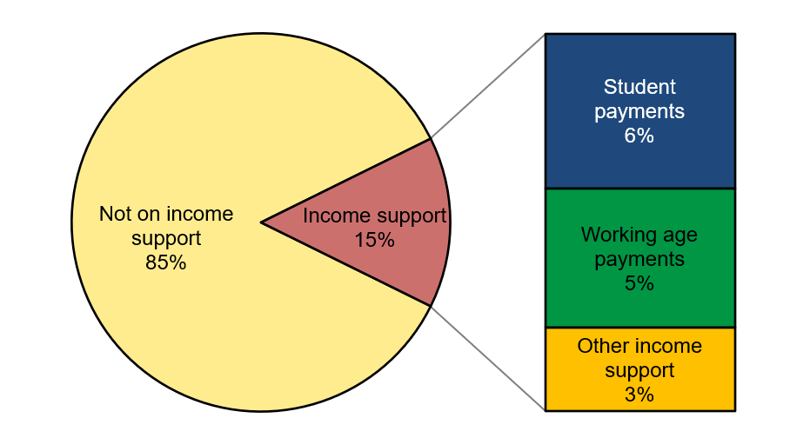
Of approximately 81,000 people aged 18 to 21 on student payments:
- 68,000 (84%) were in higher education,
- 8,000 (10%) were in Vocational Education and Training (VET), and
- 4,000 (5%) were in school.
Most young adults receiving other forms of income support (43,000) were receiving DSP (65%), or Parenting Payment (27%). These groups are considered further in the In-Depth Focus section later in this report.
Young adults who spent more than half of their childhood with a parent(s) receiving income support are 6.5 times more likely to receive income support themselves, compared to those whose parent(s) did not receive income support.
Figure 2.2 shows 60% of young adults who spent more than half of their childhood in a household with a parent(s) receiving income support started to receive income support themselves by 30 June 2024. By contrast, only 9% of young adults who grew up in a household where their parent(s) did not receive income support began receiving income support themselves by 30 June 2024.
            - Proportion of people aged 18 to 21 who received income support by 30 June 2024
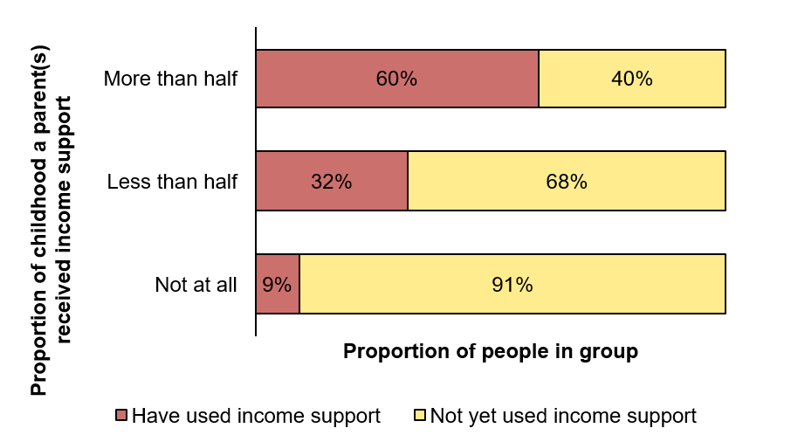
Young people aged 18 to 21 who have not completed Year 12 and who spent more than half their childhood in a household with a parent(s) who received income support are projected to spend longer on income support than those who have completed Year 12. This is even more pronounced for women.
Figure 2.3 shows young adults who have not completed Year 12, and who spent more than half their childhood in a household with a parent(s) receiving income support are projected to spend longer on income support over their working lives than those who have completed Year 12 (8.6 years longer for women, and 5.7 years longer for men).
            - Projected time on income support before Age Pension age for people aged 18 to 21 by educational attainment
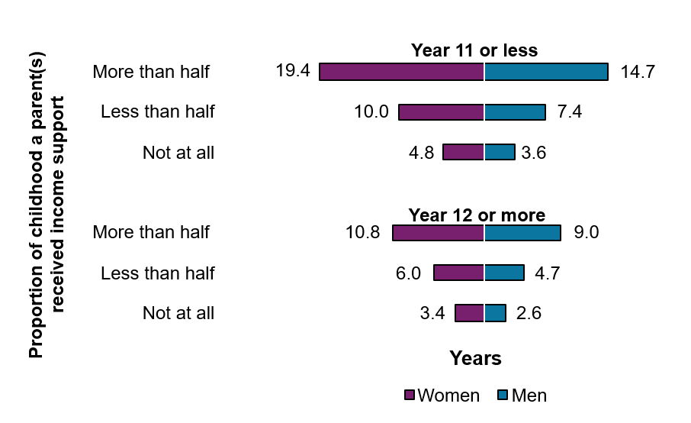
There is an association between an increased level of educational attainment and spending less time on income support over the long-term.
Figure 2.4 shows young adults receiving working age payments on 30 June 2024 are projected to spend 2.3 times (9.9 years) longer on income support before Age Pension age than those receiving student payments. This highlights the benefit studying payments can provide in supporting young people to gain the qualifications they need to make a successful transition to employment. Over their working lives, young adults receiving working age payments are projected to spend 13.6 years longer on income support on average, compared to those not on income support.
            - Average projected time receiving income support before Age Pension age for people aged 18 to 21 at 30 June 2024
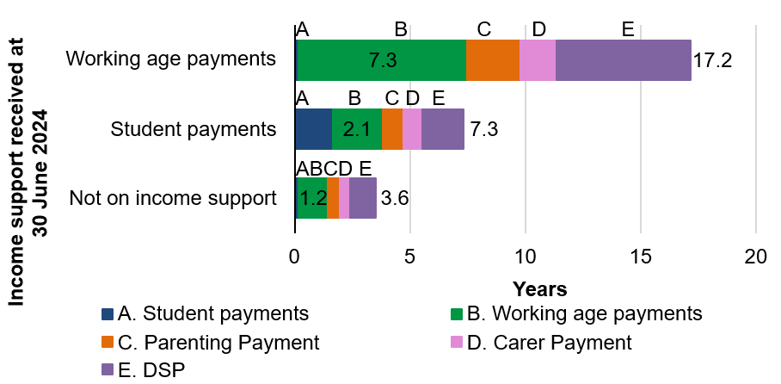
Figure 2.5 shows young adults on working age payments on 30 June 2024 have the highest average projected Lifetime Cost before Age Pension age ($375,000), as they are projected to spend longer receiving income support on average, than people receiving student payments or not currently receiving income support.
            - Average projected Lifetime Cost for people aged 18 to 21
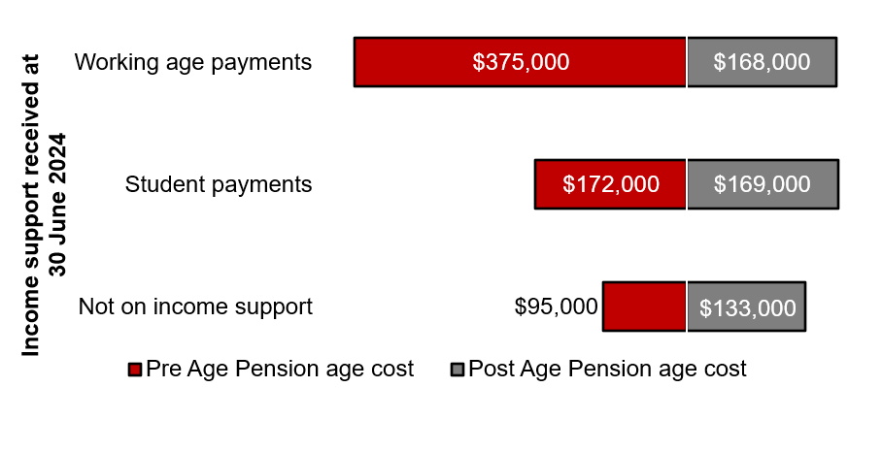

Transition to work (22 to 25)
Age 22 to 25 is a time of growing independence for many young people. From age 22, the parental income test no longer applies, and young people become eligible to apply for JobSeeker Payment. There were 1.49 million people aged 22 to 25 on 30 June 2024, making up 5% of the Australian population.

Australian population
14% of people aged 22 to 25 received income support on 30 June 2024.
Figure 3.1 shows 14% of the Australian population aged 22 to 25 received some form of income support. Only 3% received a student payment, down from 5% on 30 June 2022; while 6% received JobSeeker Payment and 5% received other income support payments. Most people on other income support payments were receiving Parenting Payment or DSP. These groups are considered further in the In-Depth Focus section later in this report.

            - Composition of income support use for people aged 22 to 25 at 30 June 2024
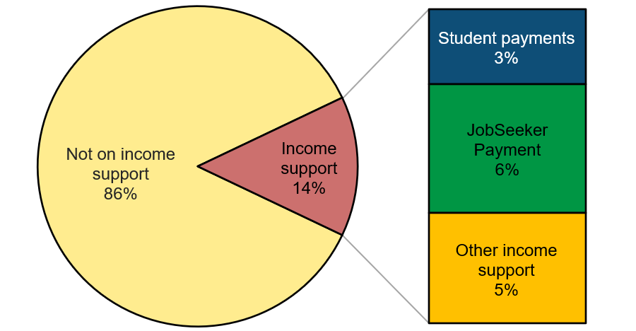
For people aged 22 to 25 who grew up in a household where a parent(s) received income support, there is a greater likelihood they will receive income support themselves.
As shown in Figure 3.2, those aged 22 to 25 who spent more than half of their childhood with a parent(s) receiving income support were 3.5 times more likely to have received income support themselves (83%) than those whose parents did not receive income support (24%).
            - Proportion of people aged 22 to 25 who have received income support by 30 June 2024
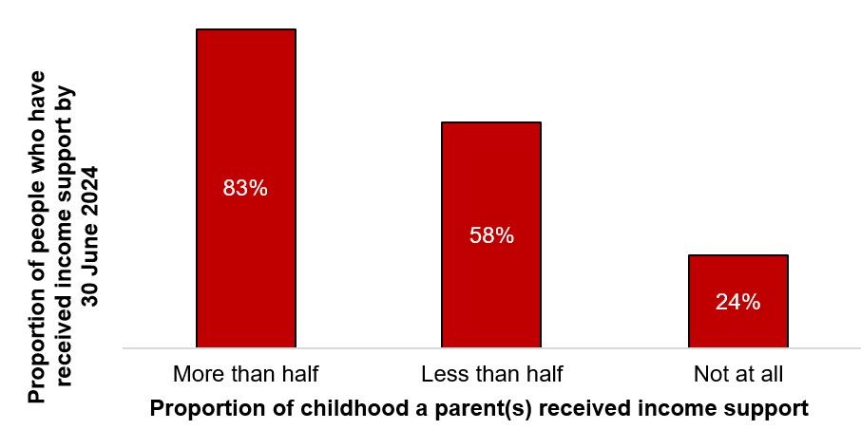
Over their entire working lives, people aged 22 to 25 on JobSeeker Payment are projected to spend 4.1 times (5.1 years) longer receiving working age payments than those receiving student payments.
Figure 3.3 shows those receiving JobSeeker Payment are projected to spend 2.8 times (9.6 years) longer receiving income support on average (14.8 years) than those receiving student payments (5.2 years).
            - Average projected time receiving income support before Age Pension age for people aged 22 to 25
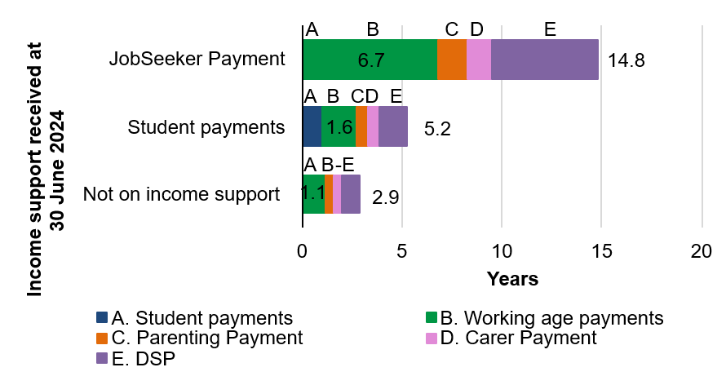
There is a positive association between completing Year 12 and spending less time on income support in the future.
People aged 22 to 25 who did not finish Year 12 are projected to receive income support for 2.1 times (4.7 years) longer on average before Age Pension age than those who did complete Year 12. Achieving a higher level of education can make an even greater difference. Figure 3.4 shows those who have not completed Year 12 are also projected to spend 2.9 times (6.1 years) longer on income support before Age Pension age than those who have completed higher education.
            - Average projected time receiving income support before Age Pension age for people aged 22 to 25
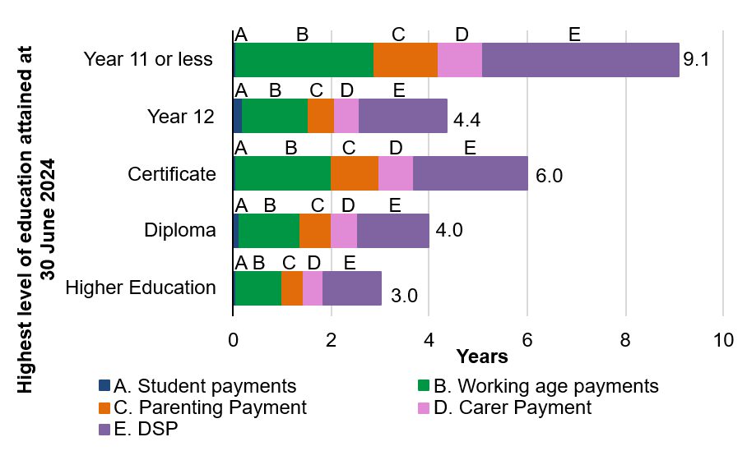
50% of people on JobSeeker Payment were previously receiving Youth Allowance (Other), compared to 13% who previously received student payments.
Figure 3.5 shows over one-third of people receiving JobSeeker Payment did not receive income support immediately prior to receiving JobSeeker Payment.
            - Previous income support payment for people on JobSeeker Payment aged 22 to 25 at 30 June 2024
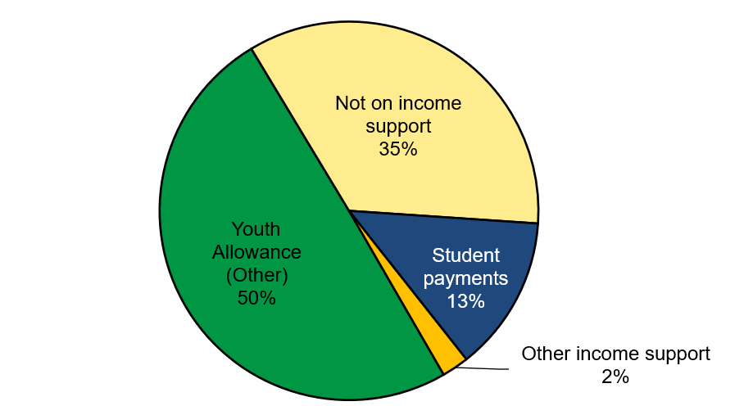
For people receiving JobSeeker Payment, previous receipt of a social security payment affects their future projected time receiving income support. In particular, those previously receiving Youth Allowance (Other) are projected to use income support for longer.
Figure 3.6 shows those previously receiving Youth Allowance (Other) are projected to receive income support for 8 years longer prior to Age Pension age, than those who were previously receiving a student payment before they began receiving JobSeeker Payment. The projected time receiving income support before Age Pension age is 1.5 years lower for those who had received a student payment prior to commencing JobSeeker Payment than for those who were not on income support before they began receiving JobSeeker Payment.
            - Average projected time receiving income support before Age Pension age for people aged 22 to 25 on JobSeeker Payment at 30 June 2024
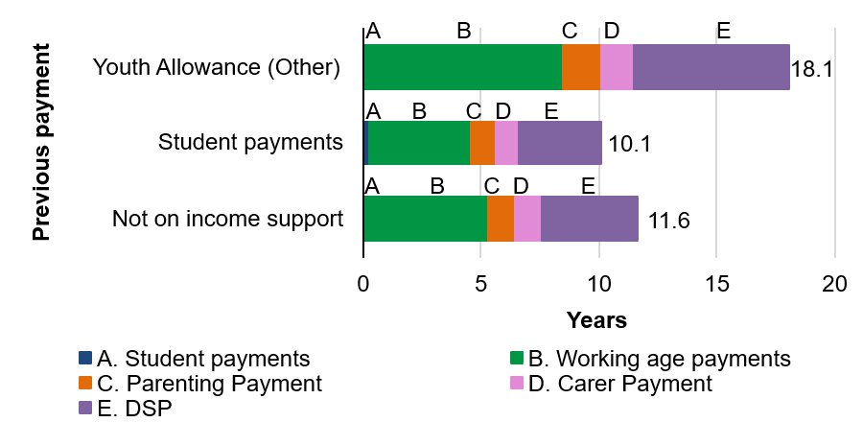
The capacity to work is a measure of physical, intellectual, or psychiatric impairment, and is an important factor when projecting future interactions with the social security system. People who have a partial capacity to work are projected to spend more time on income support before Age Pension age than those who have full capacity.
22% of people aged 22 to 25 who received JobSeeker Payment on 30 June 2024 had a partial capacity to work. As shown in Figure 3.7, partial capacity to work is associated with a longer projected time on income support prior to Age Pension age (19.6 years), as this group is also projected to receive DSP for a longer period later in their lives. People in this age group receiving JobSeeker Payment with a partial capacity to work are projected to spend 9.7 years on DSP, compared to 4 years for those with full capacity to work.
            - Average projected time receiving income support before Age Pension age for people aged 22 to 25 on JobSeeker Payment at 30 June 2024
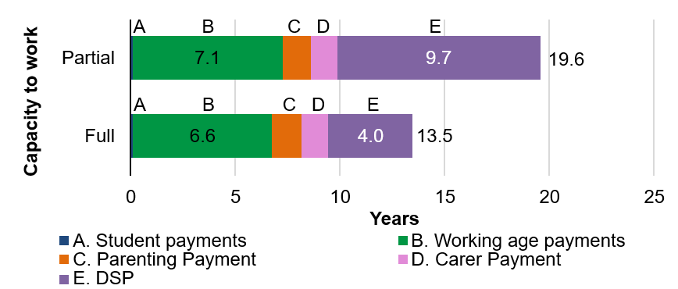
This longer projected time on income support prior to Age Pension age is also reflected in the Lifetime Cost (Figure 3.8). People receiving JobSeeker Payment with a partial capacity to work are projected to have an average Lifetime Cost before Age Pension age that is $129,000 higher than those with full capacity to work.
            - Average projected Lifetime Cost for people aged 22 to 25 on JobSeeker Payment at 30 June 2024
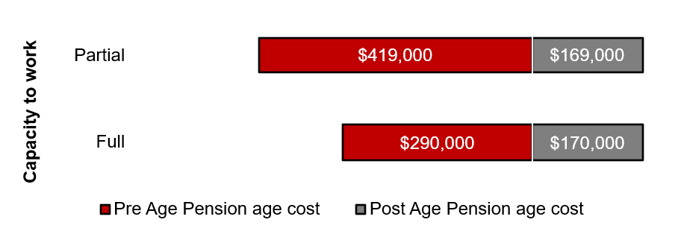

Working age (26 to 44)
Age 26 to 44 is typically a period of greater self-reliance as people of working age have established themselves in the workforce.
There were 7.5 million people aged 26 to 44 on 30 June 2024, making up 28% of the Australian population. Within this age range, 52% of Australians had children, and 48% did not have children.

Australian population
Of the people without children, 58% were single and 42% were partnered. Around 10% of people without children received income support. Of those without children receiving income support, 95% were single.
The remainder of this section focuses on people aged 26 to 44 without children who are either not receiving income support or only receiving JobSeeker Payment (Figure 4.1). All others aged 26 to 44 are considered as part of the In-Depth Focus section later in this report (including the sections on People with children, People receiving payments to support caring, and People receiving Disability Support Pension).
            - Composition of income support use for people aged 26 to 44 at 30 June 2024
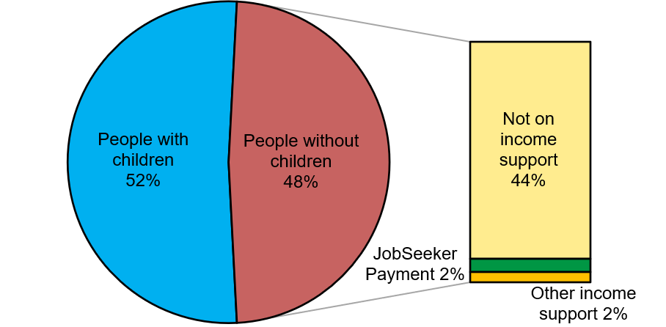
38% of people aged 26 to 44 without children who were receiving JobSeeker Payment had a partial capacity to work. This group spent 1.1 years longer on JobSeeker Payment than those with full capacity over the previous 5 years on average.
Figure 4.2 shows people without children aged 26 to 44 receiving JobSeeker Payment with a partial capacity to work received income support for 4 years out of the previous 5 years on average. This is 1.2 years longer than those with full work capacity (2.8 years). People without children and not receiving income support on 30 June 2024 received working age payments for only 0.2 of the previous 5 years on average.
            - Average time receiving income support over the previous 5 years for people aged 26 to 44 without children
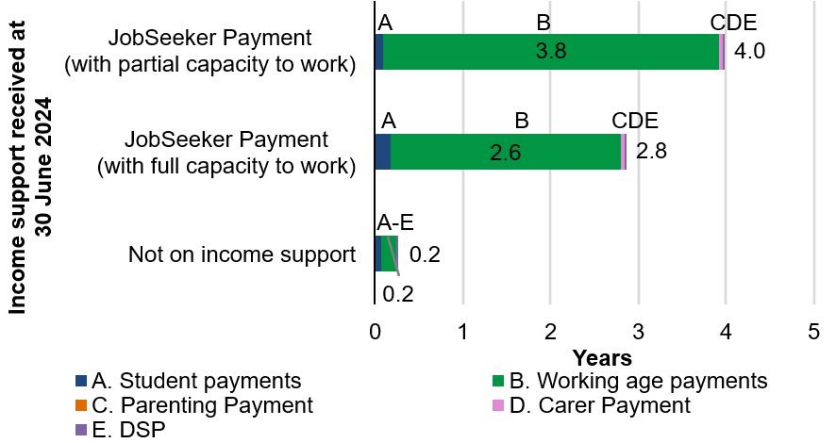
People without children who were receiving JobSeeker Payment with a partial capacity to work are projected to spend 5 years longer on income support before Age Pension age, than those with full capacity to work.
Figure 4.3 highlights the vulnerability of those with a partial capacity to work. People without children who were receiving JobSeeker Payment with a partial capacity to work are projected to spend 17.6 years on income support on average. This is 5 years longer than those with full capacity to work, and reflects greater future use of DSP. Those not receiving income support have the lowest average projected time on income support before Age Pension age (2.3 years).
            - Average projected time receiving income support before Age Pension age for people aged 26 to 44 without children
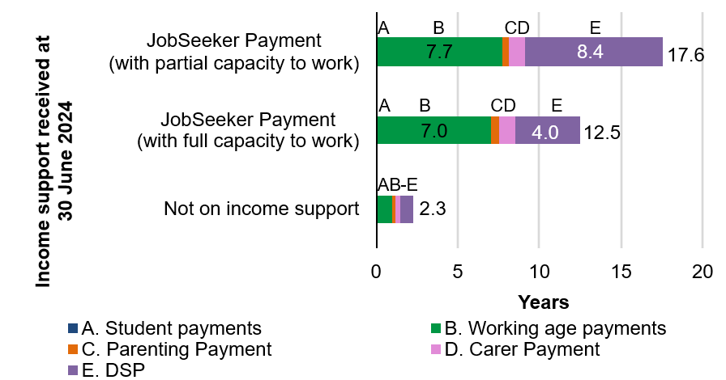
The longer projected time on income support for those receiving JobSeeker Payment with a partial capacity to work is also reflected in the Lifetime Cost (Figure 4.4). People without children who were receiving JobSeeker Payment with a partial capacity to work are projected to have an average Lifetime Cost before Age Pension age that is $113,000 higher than those with full capacity to work, and almost 6.3 times ($304,000) higher than people who did not receive income support.

            - Average projected Lifetime Cost for people aged 26 to 44 without children
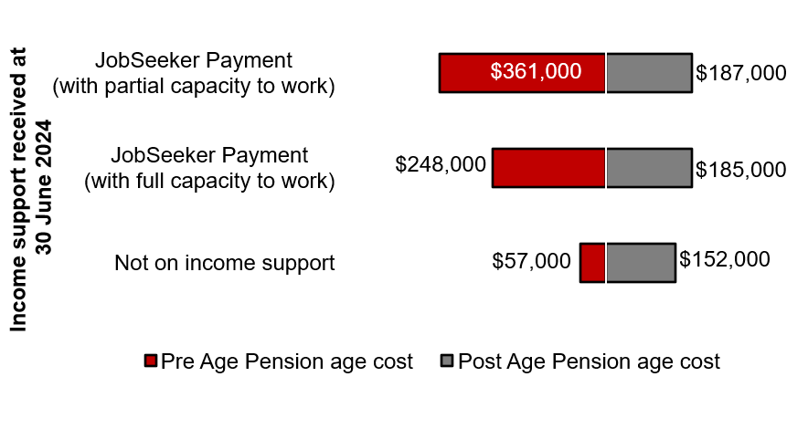
Single people without children are projected to spend a larger proportion of their working life before Age Pension age receiving income support, compared to partnered people without children.
For single people without children aged 26 to 44, the socio-economic area
in which they live has a greater effect on their projected time receiving
income support than for partnered people without children in the same age group. As Figure 4.5 shows, single people without children in the most disadvantaged socio-economic areas (lowest 20%) are projected to spend 18% of their working life before Age Pension age receiving income support, compared to 8% for those in the most advantaged socio-economic areas (highest 20%). Partnered people without children in the lowest 20% of socio-economic areas are projected to spend 6% of their working life before Age Pension age on income support, compared to 4% for those in the highest 20% of socio-economic areas.
            - Projected percentage of time receiving income support before Age Pension age for people aged 26 to 44 without children
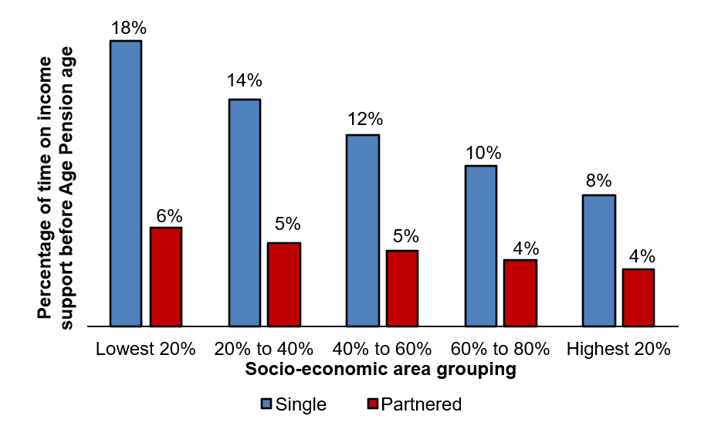

Older working age (45 to 66)
For many Australians in this age group, the length of time on JobSeeker Payment is associated with a greater likelihood of continuing to receive income support in the future, which then flows onto Age Pension. This is particularly the case for women and people with a partial capacity to work.
There were 6.9 million people aged 45 to 66 on 30 June 2024, making up 25% of the Australian population.

Australian population
15% of people aged 45 to 66 received income support on 30 June 2024. Women comprised 56% of people receiving income support in this age group.
Of those people receiving income support, more than half were aged 55 to 66 (Figure 5.1). A greater number of people in this age group receive DSP and Carer Payment, compared to those aged 45 to 54. People receiving DSP and Carer Payment are considered as part of the In-Depth Focus section later in this report.
            - Composition of income support use for people aged 45 to 66 at 30 June 2024
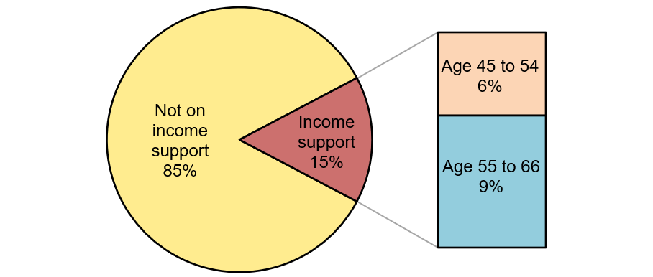
55% of people aged 45 to 66 who received JobSeeker Payment on
30 June 2024 had a partial capacity to work.
Among people aged 45 to 66 receiving JobSeeker Payment (Figure 5.2), 51% of those aged 45 to 54 and 58% of those aged 55 to 66 had a partial capacity to work.
            - Work capacity of people aged 45 to 66 receiving JobSeeker Payment at 30 June 2024
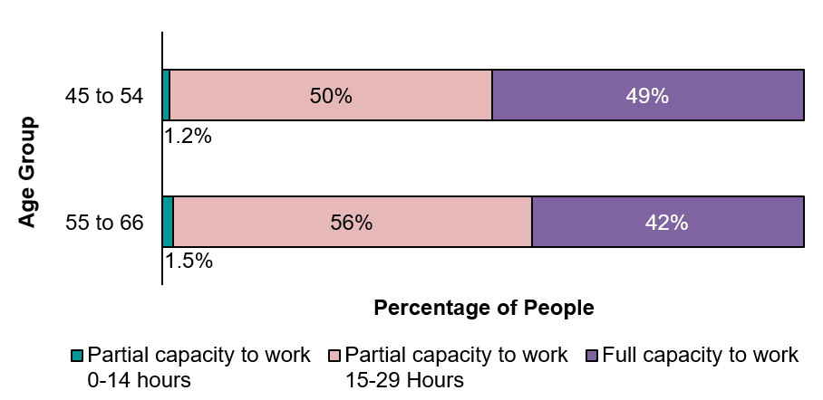
People on JobSeeker Payment with a partial capacity to work spent longer on income support over the previous 5 years than those with full capacity to work.
Figure 5.3 shows people aged 45 to 66 on JobSeeker Payment with a partial capacity to work spent on average 4 of the previous 5 years on income support, compared to 3 of the previous 5 years for those on JobSeeker Payment with full capacity. The most common payment received over the last 5 years was JobSeeker Payment. Those not receiving an income support payment had received almost no income support over the preceding 5 years.
Generally, women on JobSeeker Payment spent slightly longer on income support than men. Women with a partial capacity to work spent an average of 4.1 years on income support compared to 3.9 years for men. Women with a full capacity to work spent an average of 3.1 years on income support over the previous 5 years, compared to 2.8 years for men.
            - Average time receiving income support over the previous
5 years for people aged 45 to 66
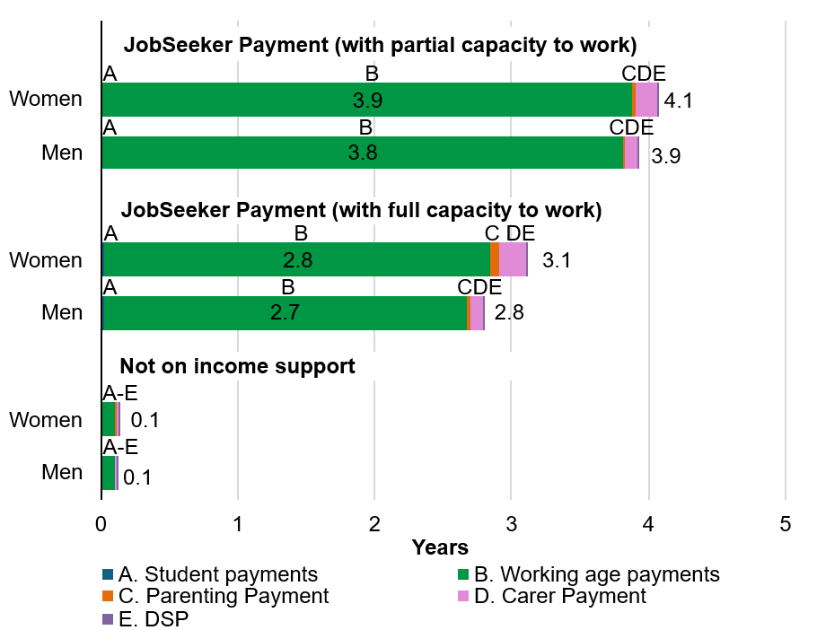
People aged 45 to 66 receiving JobSeeker Payment on 30 June 2024 are projected to spend longer on income support over the next 5 years than those not on income support.
In the next 5 years, people receiving JobSeeker Payment with a partial capacity to work are projected to spend an average of 4.3 years on income support, compared to 3.5 years for those with full capacity to work and 0.3 years for those not on income support (Figure 5.4).

Women and men are projected to spend a similar amount of time receiving income support over the next 5 years, while women are projected to spend slightly longer on Age Pension. This is largely due to differences in life expectancy between men and women.
            - Average projected time receiving income support over the next 5 years for people aged 45 to 66
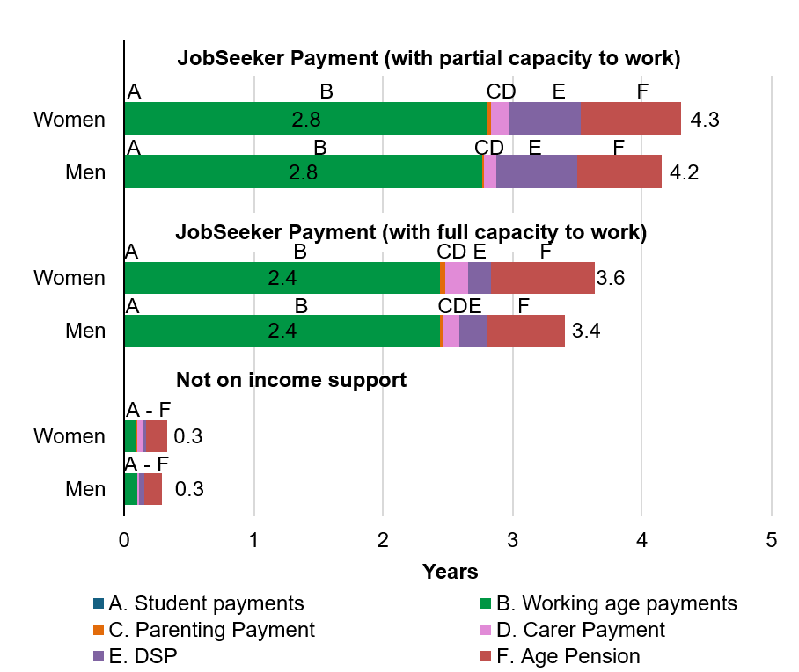
People aged 45 to 66 receiving JobSeeker Payment with a partial capacity to work on 30 June 2024 are projected to have a higher Lifetime Cost before Age Pension age than those with full capacity to work and those not on income support.
As shown in Figure 5.5, women on JobSeeker Payment with a partial capacity to work are projected to have an average Lifetime Cost before Age Pension age that is $27,000 higher than women with full capacity. For men on JobSeeker Payment with a partial capacity to work, the Lifetime Cost before Age Pension age is $26,000 higher than for those with full capacity. While both women and men are projected to have a similar average Lifetime Cost before Age Pension age, women have a higher average Lifetime Cost after Age Pension age due to longer life expectancy and associated use of Age Pension.
            - Average projected Lifetime Cost for people aged 45 to 66
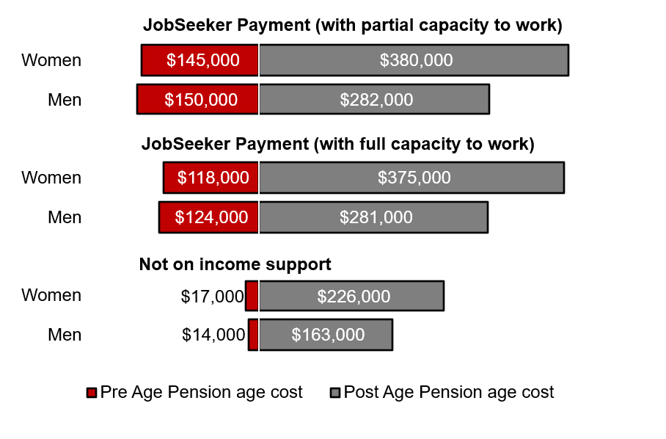
People receiving JobSeeker Payment with a partial capacity to work have the highest probability of entering Age Pension when they reach eligibility age. More than 10% of this group are projected to receive DSP instead of the Age Pension at eligibility age.
Over 80% of women aged 45 to 66 currently receiving JobSeeker Payment who have a partial capacity to work are projected to receive either Age Pension, DSP or another income support payment at Age Pension age (Figure 5.6). Of women in this age group, at least 11% are projected to receive DSP at Age Pension age.
By contrast, men aged 45 to 66 receiving JobSeeker Payment with a partial capacity to work have more than a 70% likelihood of receiving Age Pension, DSP or another income support payment (mostly Carer Payment) at Age Pension age. At least 12% of this group are projected to receive DSP rather than the Age Pension at Age Pension age.
In comparison, people aged 45 to 66 who are not on income support are much less likely to receive one of these payments at Age Pension age, with only 29% of men and 35% of women projected to receive an income support payment.
            - Probability of receiving an income support payment at Age Pension age for people aged 45 to 66 by capacity to work
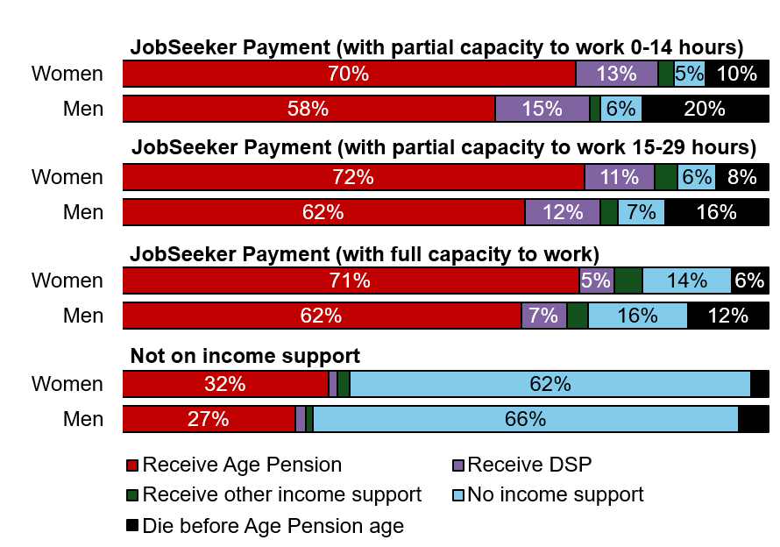
* People not receiving Age Pension at eligibility age may choose to access the Age Pension later in life
.

Age Pension age (67 and over)
The Age Pension is the primary social security payment for those unable to fully or partially finance their retirement through superannuation and other savings. The extent of interaction with the social security system at Age Pension age is closely related to the length of income support use during a person’s working life.
Since 1 July 2023, the Age Pension eligibility age has been 67 years.
There were 4.2 million people at or above Age Pension age on 30 June 2024, making up 15% of the Australian population.

Australian population
On 30 June 2024, 2.6 million of the 4.2 million people at or above Age Pension age received the Age Pension.
Of the 2.6 million people receiving Age Pension, 1.7 million (40%) were eligible for the maximum rate and 0.9 million (22%) for a partial rate. As shown in Figure 6.1, a further 130,000 (3%) people received other income support, including DSP or Carer Payment.
            - Composition of income support use for people aged 67 and above at 30 June 2024
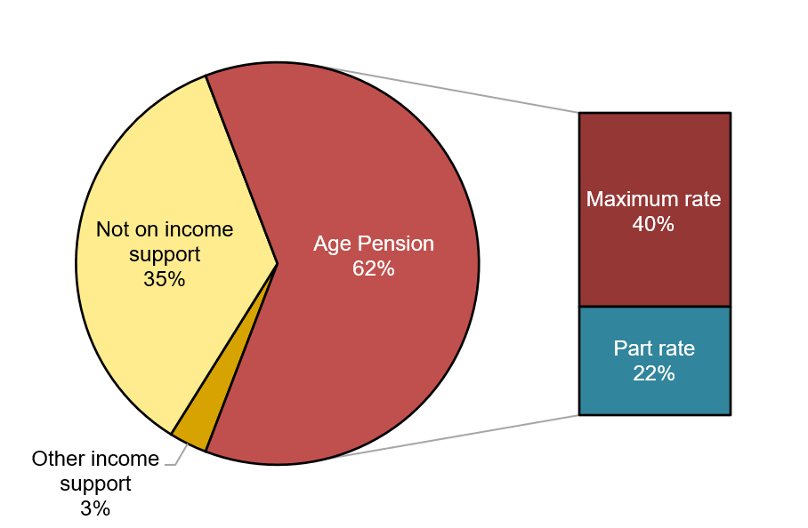
Use of income support at Age Pension age is closely related to the length of time income support has been used during a person’s working life.
In 2023–24, 159,000 people reached Age Pension age, and 49,000 (31%) began receiving Age Pension. 70% of those aged 67 years on 30 June 2024 are projected to receive Age Pension at some point during their lives. As shown in Figure 6.2, this group spent an average of 2.1 years on an income support payment in the previous 5 years before receiving Age Pension, and over half of this time was spent in receipt of a working age payment. In comparison, those who did not begin receiving Age Pension when they reached Age Pension age spent only 0.5 years on income support in the past 5 years.
            - Average time on income support over the previous 5 years for people who reached Age Pension age in 2023–24
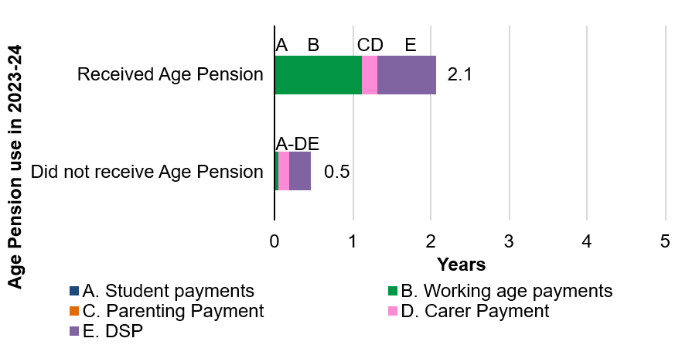
Single people are 1.7 times more likely to access Age Pension when they reach Age Pension age, compared to those with a partner.
Of the 159,000 people who reached Age Pension age during 2023–24, 43% of people who were single and 25% of people who had a partner started to receive Age Pension. The higher proportion of single people accessing Age Pension reflects greater use of income support in the years leading up to Age Pension age. As shown in Figure 6.3, single people spent an average of 1.7 years on income support over the previous 5 years, and over half of this time was spent receiving DSP.
            - Average time on income support over the previous 5 years for people who reached Age Pension age in 2023–24
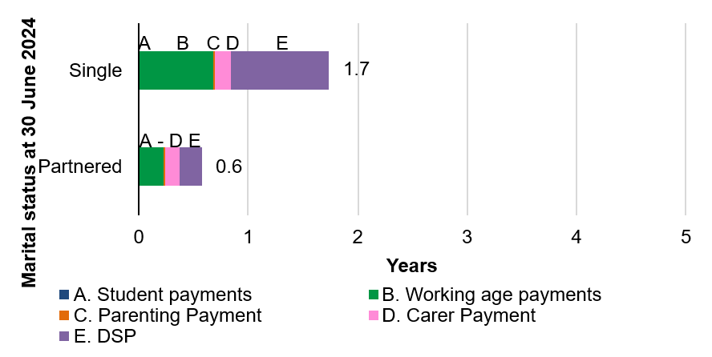
Women are 1.2 times more likely to access Age Pension when they reach Age Pension age, compared to men.
Of the 159,000 people who reached Age Pension age during 2023–24, 28% of men and 33% of women accessed Age Pension. As shown in Figure 6.4, women spent an average of 1.1 years on income support in the previous 5 years, which is 0.2 years longer than men.
            - Average time on income support over the previous 5 years for people who reached Age Pension age in 2023–24
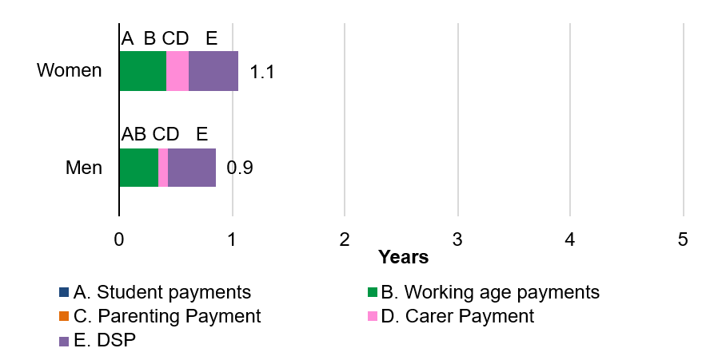
The number of people receiving Age Pension is expected to increase over time as the population ages. However, the proportion of people accessing Age Pension is projected to decline as the superannuation system matures.
As Australia’s population ages, the number of people reaching Age Pension age and accessing Age Pension is projected to increase by more than 50% by 2060 (Figure 6.5). However, as the superannuation system continues to mature over the next few decades, a higher proportion of Australians are expected to self-finance their own retirement with an increased accumulated superannuation balance. This means the proportion of people receiving Age Pension in the total eligible population is projected to decline from 62% to 54% by 2060. Almost all people who receive Age Pension are projected to remain on the payment for the rest of their life.
            - Projected number, and proportion of people at Age Pension age and older, receiving Age Pension
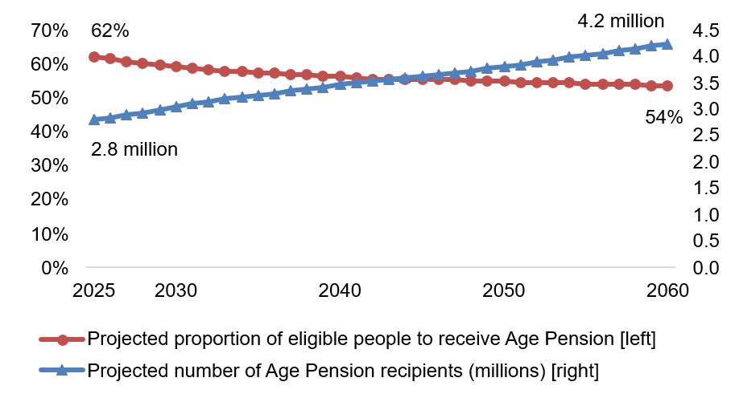
* Projections of Age Pension use do not include the impact of migration.

People with children
Parents can access different social security payments depending on their eligibility and needs. Parenting Payment is the main income support available to assist when a parent is a child’s main carer. Parental Leave Pay is available to help care for a newborn or newly adopted child. Child Care Subsidy is available to assist with childcare fees. Family Tax Benefit (FTB) is a supplementary payment available to help with the cost of raising children.
The definition of a child in this section is up to and including age 19.
This definition is based on when a parent is eligible for certain payments according to the age of the child. For example, a parent can continue to claim
FTB Part A up to and including when their child is aged 19.
There were 6.2 million parents with children aged 19 or under in Australia on 30 June 2024, making up 23% of the population.

Australian population
13% of parents in Australia were receiving income support on 30 June 2024. An additional 25% of parents received a supplementary family payment during 2023–24.
Most parents receiving income support were receiving either Parenting Payment or a working age payment such as JobSeeker Payment. On 30 June 2024, Parenting Payment was available until the youngest child was aged 14 if the parent was single (prior to 20 September 2023, eligibility ended when the youngest child was aged 8), or aged 6 if the parent was partnered. Many parents who were previously ineligible due to their child’s age received a working age payment instead.
Figure 7.1 shows the changed composition resulting from this expansion of eligibility, with 6% of people receiving Parenting Payment and 3% on working age payments, compared to 5% on Parenting Payment and 5% on working age payments on 30 June 2022. A further 2% of parents received Carer Payment and another 2% received DSP. People receiving DSP and Carer Payment are considered in separate parts of the In-Depth Focus section.
Of the 13% of parents receiving income support, just over two-thirds also received at least one supplementary family payment (such as FTB) in 2023–24.
The remaining 62% of parents did not use income support or supplementary family payments during 2023–‍24 (Figure 7.1).
Only one parent can claim Parenting Payment and/or supplementary family payments on behalf of the family. Women comprise 93% of parents receiving Parenting Payment, 60% of parents receiving other income support payments, and 82% of those receiving supplementary family payments only. The majority of parents who were not receiving income support or a supplementary family payment were men (61%).
            - Composition of social security payment use for parents at 30 June 2024
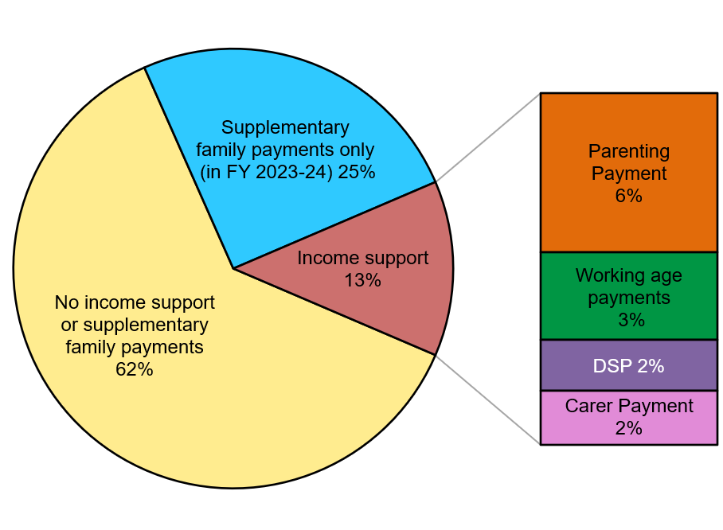
First Nations parents who had their first child before age 22 were 6.7 times more likely to receive income support than non-First Nations parents who had their first child at an older age.
Figure 7.2 shows parents who had their children at an earlier age are more likely to receive an income support payment, particularly First Nations parents. Around two-thirds (68%) of First Nations parents who had their first child before age 22 were receiving income support on 30 June 2024. Only 10% of non-First Nations parents who had their first child at an older age were receiving income support on 30 June 2024.
            - Percentage of parents receiving income support based on First Nations status and age when first child was born or adopted
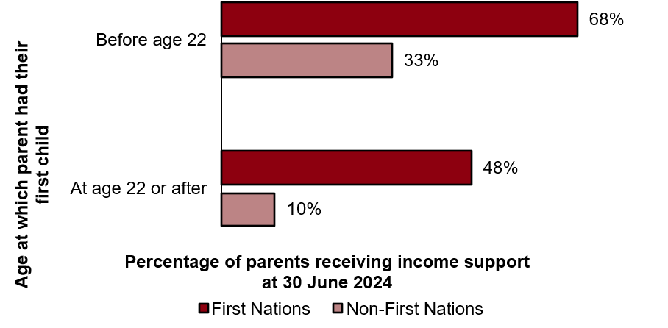
Parents receiving income support payments were 2.3 times more likely to live in the lowest 20% of socio-economic areas compared to parents who did not receive income support.
Two-thirds (66%) of parents receiving income support live in the lowest 40% of socio-economic areas, highlighting the level of disadvantage faced by this group (Figure 7.3). In contrast, those not receiving income support are more evenly spread across the various socio-economic area groupings.
            - Socio-economic area of parents by use of income support
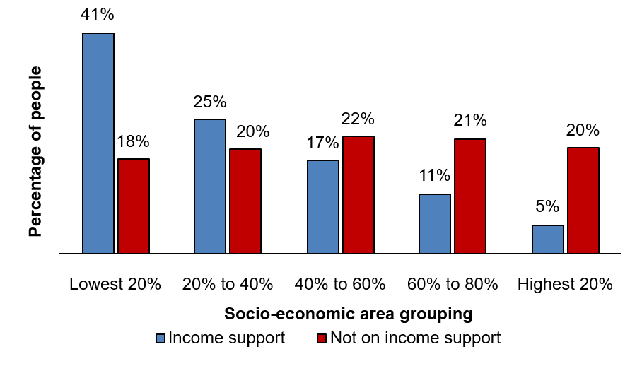
Parents receiving Parenting Payment on 30 June 2024 had been receiving income support on average for 3.8 of the previous 5 years.
By comparison, parents who did not receive income support had been receiving income support for 0.2 of the previous 5 years on average (Figure 7.4).
            - Average time receiving income support over the previous 5 years for people with children
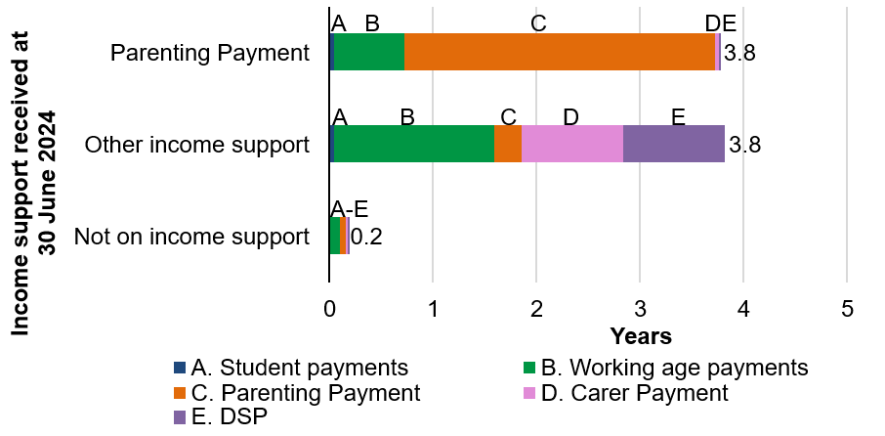
Parents receiving Parenting Payment are projected to spend 3.6 years on income support over the next 5 years. They are projected to receive Parenting Payment for 3 of those years.
Figure 7.5 shows parents receiving other income support payments are projected to receive income support for 4 of the next 5 years. A large proportion of this time will be spent receiving Carer Payment or DSP. Parents who did not receive income support are projected to spend only 0.2 of the next 5 years on income support.
            - Average projected time receiving income support over the next 5 years for people with children
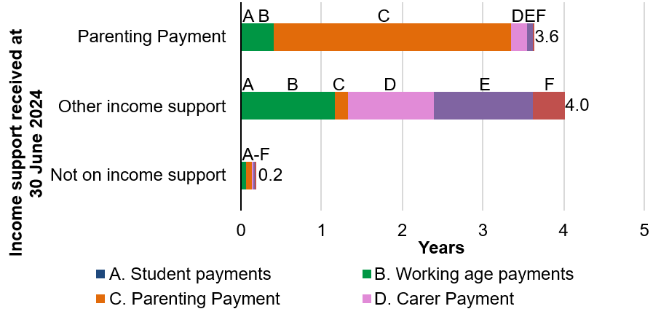
First Nations parents who had their first child before age 22 are expected to use income support for 6.2 times (2.7 years) longer than non-First Nations parents who had their first child at an older age.
First Nations parents who had their first child before age 22 are expected
to spend 3.2 of the next 5 years receiving income support on average (Figure 7.6). In contrast, non-First Nations parents who had their first child
at an older age are expected to receive income support for 0.5 of the next 5 years on average.
            - Average projected time on income support over the next 5 years based on First Nations status and age when first child was born or adopted
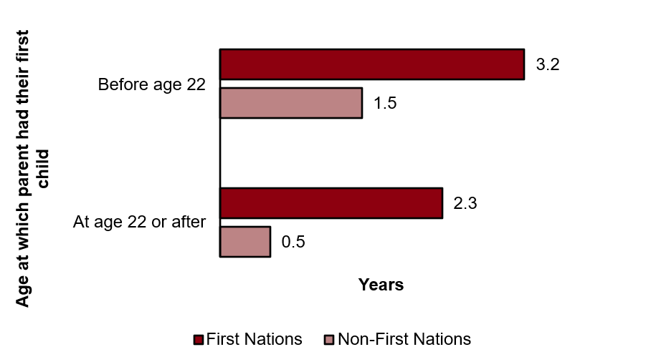
Parents receiving Parenting Payment are projected to have a Lifetime Cost before Age Pension age that is 8.2 times ($410,000) higher than those not receiving income support.
Parents receiving parenting payment have an expected Lifetime Cost
before Age Pension age of $467,000 (Figure 7.7). While this is 1.4 times ($140,000) higher than parents on other income support payments, the difference is largely due to the lower average age of parents receiving Parenting Payment (35 years compared to 47 years for parents receiving other income support payments).
            - Average projected Lifetime Cost for parents at 30 June 2024
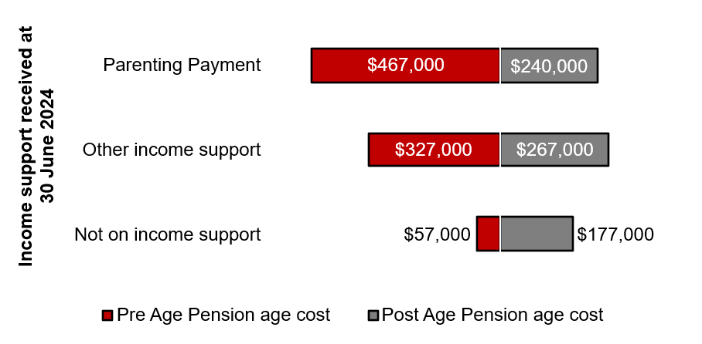

People receiving payments to support caring
Many Australians receive payments to help support them to care for someone with disability, a medical condition, or who is frail due to age.
There were around 690,000 people receiving a payment to support caring on 30 June 2024, making up 3% of the Australian population.

Australian population
There were 313,000 people receiving Carer Payment and a further 377,000 receiving a supplementary carer payment only on 30 June 2024. Overall, 77% of people receiving a payment to support caring were women.
Carer Payment is an income support payment available to people who provide constant care. The requirement to be providing constant care, together with assets and income test limits, means not all carers are eligible for this payment. The number of people who received Carer Payment increased by 3% (9,000) between 30 June 2022 and 30 June 2024.
Among those eligible for payments to support caring on 30 June 2024, 45% received Carer Payment and 55% received a supplementary carer payment only (Figure 8.1). Supplementary carer payments, such as Carer Allowance, are a support available to a wider range of people including those who are not eligible for Carer Payment. Carer Allowance, the main payment in this group, does not have an assets test and has less restrictive income tests and care requirements. It is also paid to recipients according to the number of eligible people in their care.
Note people receiving Carer Payment can also receive supplementary carer payments, and many people receiving supplementary carer payments are also receiving some form of income support other than Carer Payment.
            - Composition of social security payment use for people receiving payments to support caring at 30 June 2024
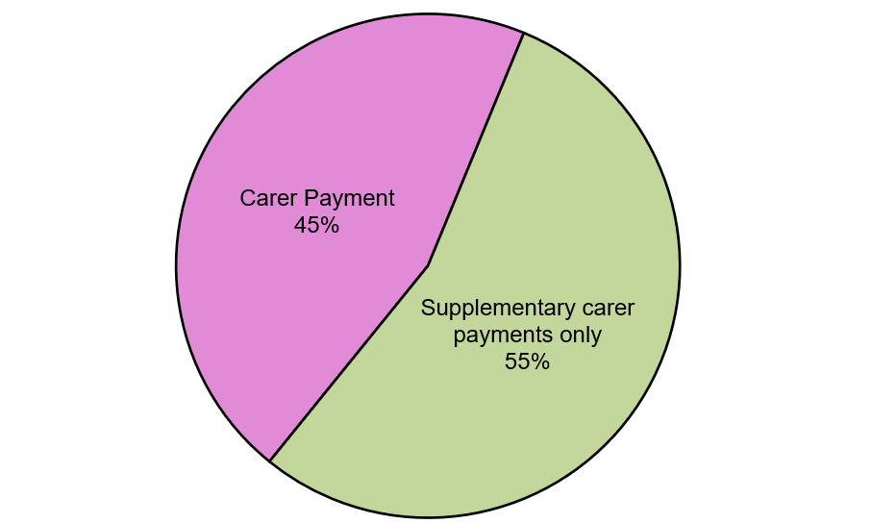
People receiving payments to support caring tend to live in lower socio-economic locations. Around a third of people receiving this support live in the lowest 20% of socio-economic areas.
Figure 8.2 shows the majority of people receiving Carer Payment live in more disadvantaged socio-economic locations. Some 41% of people receiving Carer Payment live in the lowest 20% of socio-economic areas. Due to the less restrictive income test and no assets test on Carer Allowance, people receiving supplementary carer payments only are more evenly spread across socio-economic areas. A smaller proportion (27%) of people receiving a supplementary carer payment only live in the lowest 20% of socio-economic areas.
            - Socio-economic area of people receiving payments to support caring
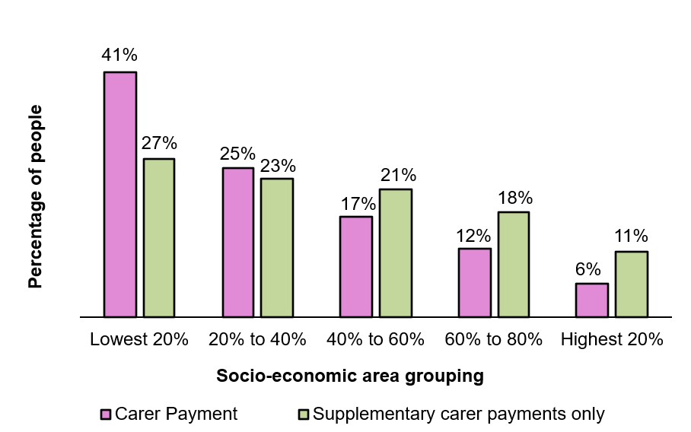
A person’s age and relationship to the person they are caring for affects the extent of future income support use.
Figure 8.3 shows the different types of caring relationships for people receiving Carer Payment at different ages. Younger carers are often the child of the person they are caring for (48% of people receiving Carer Payment in their 20s). People receiving Carer Payment in their 30s and 40s tend to be the parent of the person they are caring for (46% of people receiving Carer Payment in their 30s and 45% of people in their 40s). People receiving Carer Payment aged 50 or older tend to be the partner of the person they are caring for (31% of people in their 50s and 54% of people in their 60s).
            - Relationship of people receiving Carer Payment to the person they are caring for at 30 June 2024
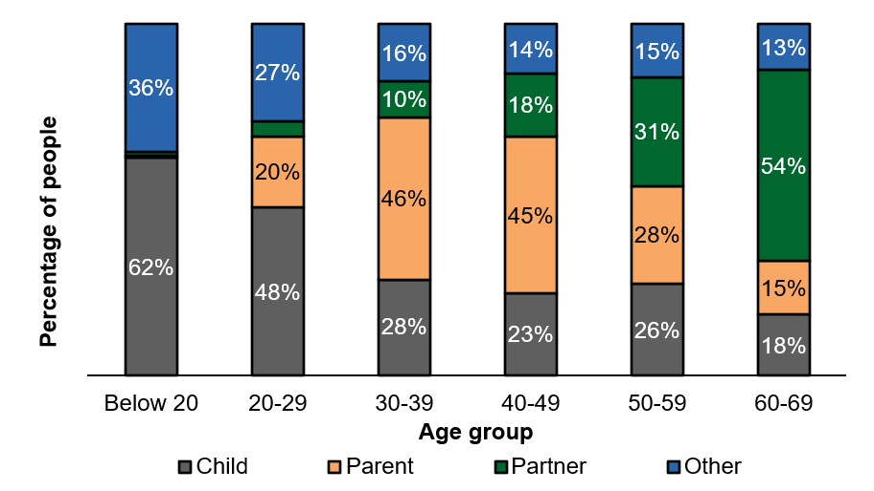
People on Carer Payment aged 20 and above have received income support for approximately 4 or more of the previous 5 years on average.
Past income support usage is a strong predictor of future income support use for people receiving Carer Payment. For all age groups from 20–29 through to 60–69, people on Carer Payment have received income support for between 3.9 and 4.4 years over the previous 5 years. However, Figure 8.4 shows people in older age groups have received Carer Payment for a longer period of time (1.3 years longer than those in their 20s).
            - Average time on income support over the previous 5 years for people receiving Carer Payment at 30 June 2024
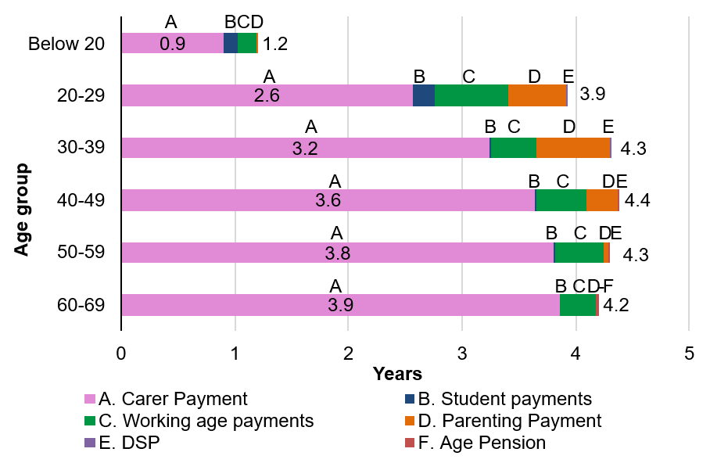
Over the next 5 years, older carers are projected to spend more time receiving income support than younger carers.
Older people receiving Carer Payment generally remain on the payment longer, and are more likely to use other forms of income support in the future. Those aged in their 50s are projected to spend 4.4 of the next 5 years receiving income support, whereas those aged under 20 are projected to receive income support for 3.7 of the next 5 years (Figure 8.5).
            - Average projected time on income support over the next 5 years for people receiving Carer Payment ‌at‍‍ 30 June 2024
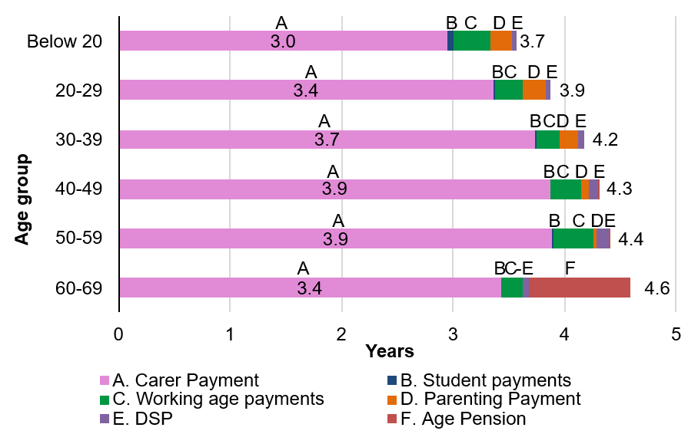
People receiving Carer Payment aged in their 30s are projected to have the highest Lifetime Cost before Age Pension age. They are also projected to have a higher average Lifetime Cost than those not receiving Carer Payment.
The projected average Lifetime Cost for people receiving Carer Payment is significantly higher than their peers (Figure 8.6). People in their 30s are projected to have a Lifetime Cost before Age Pension age that is $471,000 higher than other Australians in their age group. The higher projected average Lifetime Cost for younger age groups reflects the length of time they are expected to need to access Carer Payment prior to Age Pension age.
Overall, the average Lifetime Cost for all people receiving Carer Payment is around 2 to 3 times higher than for those not receiving Carer Payment. This is largely due to higher use of Carer Payment before Age Pension age.
            - Average projected Lifetime Cost for people receiving Carer Payment, compared to all other Australians at 30 June 2024
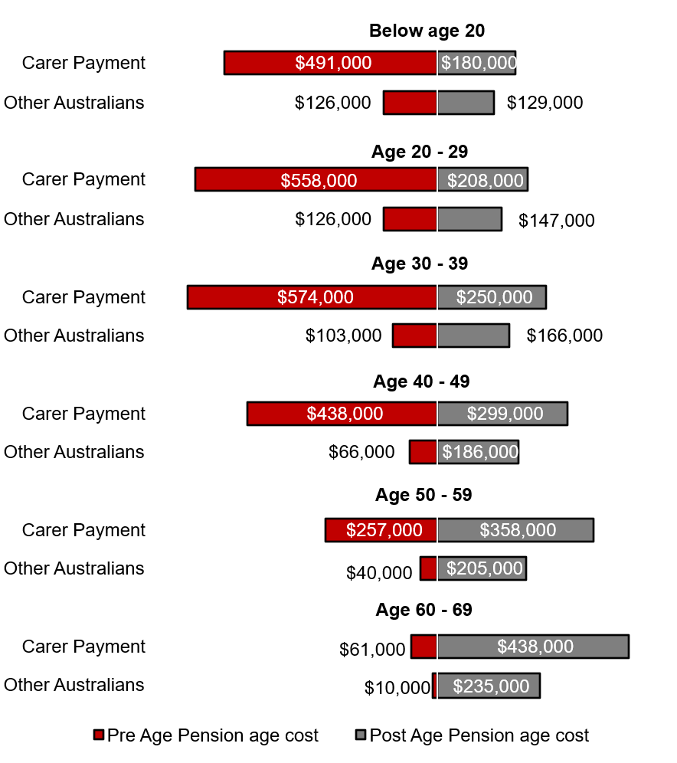
Note: All other Australians includes anyone not receiving Carer Payment. This includes people receiving supplementary carer payments only.

People receiving Disability Support Pension
Disability Support Pension (DSP) provides financial support to people with a physical, intellectual or psychiatric condition that is likely to persist for at least 2 years and stops them from working 15 or more hours per week.
There were 796,000 people with disability receiving DSP on 30 June 2024, making up 3% of the Australian population.

Australian population
Of the 796,000 people receiving DSP on 30 June 2024, only 8% were new to the payment during 2023–24.
The majority of people receiving DSP (92%) were receiving the payment a year earlier and are expected to remain on payment for the long term (Figure 9.1). The proportion of people who were new recipients of DSP has increased from 6% to 8% between 30 June 2022 and 30 June 2024.
This has contributed to an overall increase of 5% (38,000) in numbers of DSP recipients, both existing and new, between 30 June 2022 and 30 June 2024. Most of this increase is due to larger numbers of people in the 16 to 25 and 65 and over age groups receiving DSP.
            - People receiving DSP at 30 June 2024
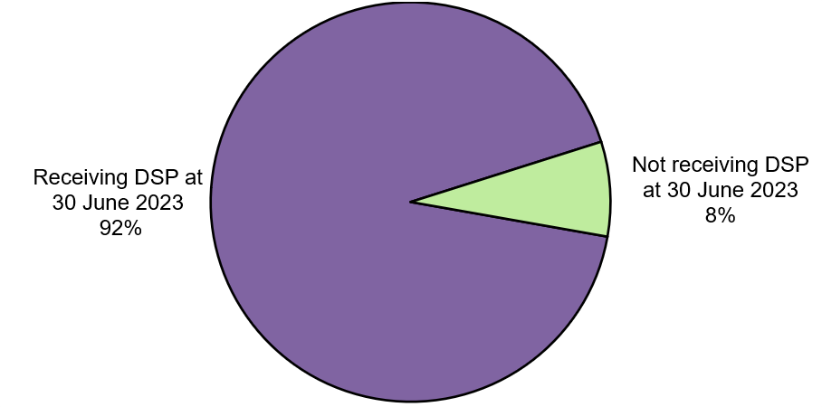
45% of the 61,000 new DSP recipients on 30 June 2024 were receiving JobSeeker Payment a year earlier. 35% were receiving JobSeeker Payment with a partial capacity to work.
The large proportion of new DSP recipients with a partial capacity to work indicates many people receiving DSP had limitations to their work capacity prior to commencing DSP. Figure 9.2 shows 50% of new DSP recipients were not receiving any income support a year earlier.
            - Income support payments received by new DSP recipients a year earlier, at 30 June 2023
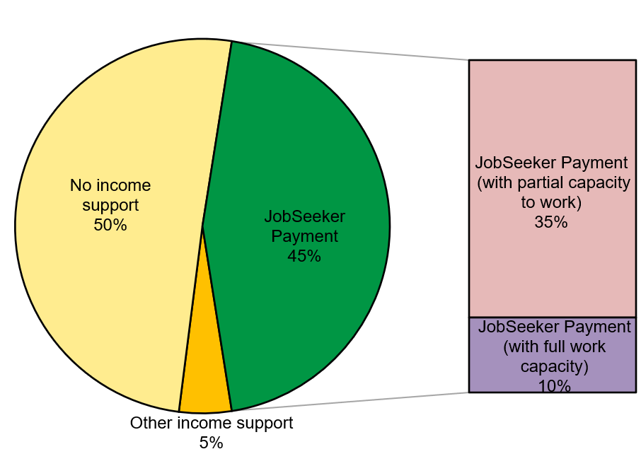
New DSP recipients who were previously on JobSeeker Payment with a partial capacity to work received income support for 1.4 years longer than new DSP recipients who had been on JobSeeker Payment with full capacity to work.
People receiving JobSeeker Payment with a partial capacity to work prior to commencing DSP received income support for 3.8 of the 5 years to 30 June 2023 on average (Figure 9.3). By comparison, new DSP recipients who were previously receiving JobSeeker Payment and had full work capacity prior to beginning DSP received income support for 2.4 years over the 5 years to 30 June 2023.
Existing DSP recipients received income support for 4.6 of the 5 years to 30 June 2023, indicating that a large proportion of this group have been receiving DSP for an extended period of time.
            - Average time on income support over the 5 years to 30 June 2023 for people on DSP at 30 June 2024
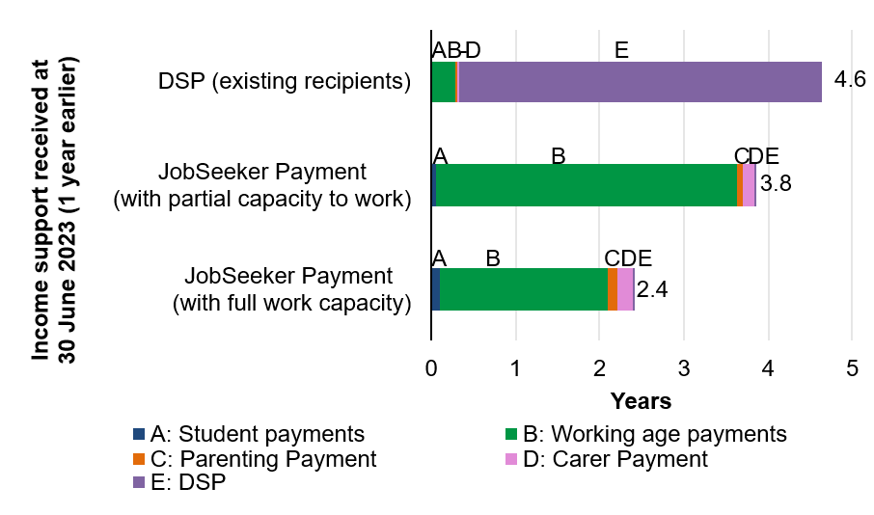
People receiving DSP are projected to receive income support for 4.6 of the next 5 years. Similarly, people on JobSeeker Payment with a partial capacity to work are predicted to spend 4 of the next 5 years on income support.
Most people on DSP are not predicted to leave the payment in the next 5 years. While there is potential for some people on JobSeeker Payment with a partial capacity to work to recover and stop receiving the payment, many are predicted to continue using both this payment and DSP over the next 5 years (Figure 9.4).
            - Average projected time on income support over the next 5 years
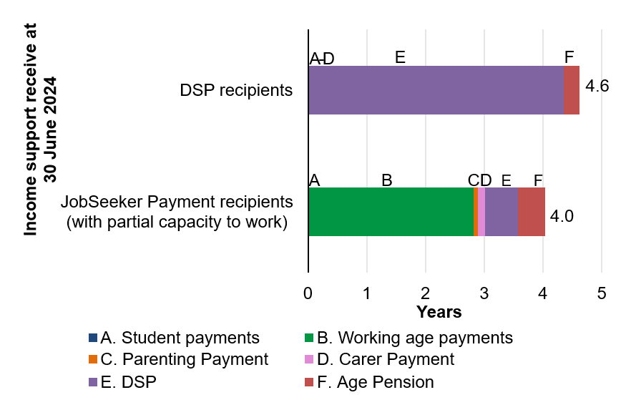
People receiving DSP on 30 June 2024 have a 33% higher ($76,000) Lifetime Cost before Age Pension age than those on JobSeeker Payment with a partial capacity to work.
DSP has a higher payment rate than working age payments. As DSP recipients are projected to spend more time on DSP before Age Pension age, they are expected to have a higher Lifetime Cost (Figure 9.5). At Age Pension age, DSP recipients have a slightly lower ($35,000) projected average Lifetime Cost than those receiving JobSeeker Payment with a partial capacity to work. As both groups are projected to receive either DSP or Age Pension, each with the same payment rate, the lower Lifetime Cost after Age Pension age for DSP recipients is largely due to lower life expectancy.
            - Average projected Lifetime Cost for people receiving DSP or JobSeeker Payment with a partial capacity to work
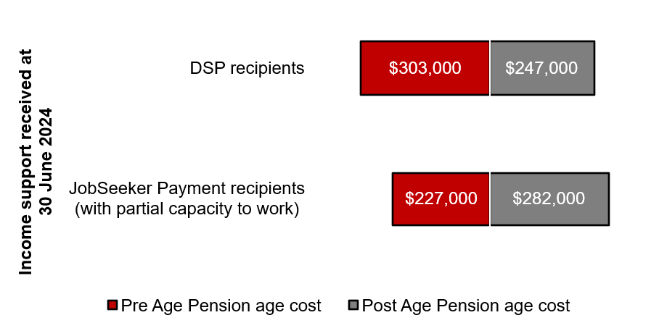
89% of people currently receiving DSP are projected to stay on DSP until they reach Age Pension age or for the remainder of their life. The long-term nature of the payment is reflected in the projected Lifetime Cost for this group.
While many DSP recipients move onto the Age Pension, some choose to remain on DSP even after Age Pension age. In 2023–24, there were 81,000 people on DSP above the eligibility age for Age Pension, making up 10% of the total number of DSP recipients.

Reflections and looking ahead
The 2024 valuation captures a number of key changes in payment eligibility and use since the 2022 valuation. As economic recovery continued post-COVID, the number of people receiving JobSeeker Payment fell by around 70,000 people between 30 June 2022 and 30 June 2024.
Over this time, new patterns of payment use emerged, including greater numbers of people accessing DSP – particularly young adults and people of Age Pension age – and an increase in use of Carer Payment. The expansion of Parenting Payment Single to those with children under 14 (previously 8) saw more people accessing this payment who, prior to the change, might otherwise have begun using JobSeeker Payment once their child turned 8. Changing patterns of use can also be seen in a decrease in the number of people accessing student payments. While the effects of population ageing and other factors can be seen in an increased number of people accessing Age Pension, longer-term the overall proportion of recipients will decline as the Superannuation system matures.
Cost-of-living relief measures legislated since the 2022 valuation have provided support through increases to the base rate of working age and student payments; an extended higher rate of payment for single people receiving JobSeeker Payment long-term to 55+ (previously 60+); increases in support for parents through Child Care Subsidy and Parental Leave Pay; and an increased maximum rate of Commonwealth Rent Assistance.
While the Lifetime Cost naturally reflects a larger Australian population in 2024 than 2022, current and projected rates of payments have increased with indexation across all payment types to maintain their real value. This has been driven by wage growth and high inflation over the period between the two valuations, with CPI peaking at 7.8% during that time. Together with cost-of-living relief measures, changes in payment rates, eligibility and patterns of use have contributed to the overall Lifetime Cost. Looking ahead, changes in the broader economic outlook will remain a key factor influencing future valuations.

Appendix A: General Glossary

Australian population
The Australian population refers to the 27.3 million individual person records used in the model. This model population represents the resident population together with people living overseas receiving social security payments.

Duration on payment
The number of years an individual has received a particular payment. Duration is only included for income support payments.

Income support
Income support is the primary form of financial assistance for people who are unable, or not expected, to fully support themselves. Income support refers to the following social security payment categories: student payments, working age payments, Parenting Payment, Carer Payment, Disability Support Pension, and Age Pension.

First Nations status
First Nations status refers to whether a person identifies as Aboriginal or Torres Strait Islander. First Nations status is based on self-reported information provided to Centrelink in the first instance. Where a person has not interacted with Centrelink, their First Nations status is based on information from the ABS Census.

Lifetime Cost
The net present value of all future in-scope social security payments. It is calculated for every Australian.

Net Present Value
The sum of the present value of incoming and outgoing cash flows over a period of time.

Other supplementary payments
Other supplementary payments include any supplementary payments not specifically related to the cost of raising families (supplementary family) or for caring (supplementary carer). An example is Rent Assistance.

Parent
A parent is the natural or adoptive parent or guardian of the child, or the child’s parent or guardian where the child is the product of that person’s previous or current relationship (whether that be a same-sex or opposite sex relationship).

Partial capacity to work
A person who is unable to work for at least 30 hours per week, whether due to a physical, intellectual or psychiatric impairment, is referred to as having a partial capacity to work. A person who is assessed as being able to work for at least 30 hours per week within 2 years with intervention or has not been assessed for partial capacity to work is referred to as having full capacity to work.

SEIFA
Socio-Economic Indexes for Areas. A product developed by the Australian Bureau of Statistics that ranks areas in Australia according to relative socio-economic advantage and disadvantage.

Social security payments
The social security system provides targeted financial assistance to support people who are unable to fully support themselves. In this report, social security payments refers to both income support payments and supplementary payments.

Student payments
Student payments include payments provided to students to assist them with living costs while undertaking their studies. Payments in this category include Austudy, ABSTUDY and Youth Allowance (Student).

Supplementary payments
Supplementary payments include any payments that are not an income support payment. Examples of payments in this group include supplementary family payments (such as Family Tax Benefit, Child Care Subsidy), supplementary carer payments (such as Carer Allowance) and other supplementary payments (such as Rent Assistance).

Supplementary carer payment
Supplementary carer payments include any payments provided to assist carers other than Carer Payment. Carer Allowance is the largest payment in this category.

Supplementary family payments
Supplementary family payments refer to any supplementary payments provided to assist families. The main payments are Family Tax Benefit, Child Care Subsidy, and Parental Leave Pay.

Working age payments
Income support payments to assist working age people who are temporarily unable to support themselves through work. Working age payments mainly consist of JobSeeker Payment for people aged 22 and above, and Youth Allowance (Other) for people aged 16 to 21. Other payments in this category include Special Benefit, and apprenticeship related payments such as Youth Allowance (Apprentice).

Appendix B: Payment Glossary

Income support payments

ABSTUDY (Living Allowance)
ABSTUDY (Living Allowance) is a payment made to First Nations students and apprentices to help with living costs while studying or training.

Age Pension
Age Pension is an income support payment that helps provide an adequate standard of living to senior Australians with low means and supplements the income of those with moderate means.

Austudy
Austudy is a payment made to full-time students and Australian apprentices who are aged 25 years and older.

Carer Payment
Carer Payment provides income support to people who, because of the demands of their caring role, are unable to support themselves through substantial paid employment.

Disability Support Pension
Disability Support Pension provides support to people with a permanent physical, intellectual or psychiatric impairment. The person must also be assessed as being unable to work (or be re-skilled to work) for 15 hours or more per week, for at least the next two years, due to their impairment.

JobSeeker Payment
JobSeeker Payment is the main income support payment for people aged between 22 years and Age Pension age, who have capacity to work now or in the near future. JobSeeker Payment is available to people who are looking for work, who temporarily cannot work or study due to an injury or illness, or bereaved partners in the period immediately following the death of their partner, subject to meeting eligibility requirements.

Parenting Payment
Parenting Payment provides income support for parents or guardians to help with the cost of raising children. Parenting Payment Partnered is an income support payment for partnered parents with a youngest child under 6 years of age. Parenting Payment Single is an income support payment for single parents with a child under 14 years of age (from 20 September 2023).

Special Benefit
Special Benefit is an income support payment for people who are in severe financial hardship due to circumstances beyond their control and who are ineligible for any other income support payment.

Youth Allowance (Other)
Youth Allowance (Other) is the primary income support payment for young people aged 16‒21 years who are seeking or preparing for paid employment. Some 15-year-olds may also receive assistance. To qualify for Youth Allowance (Other) a person must be unemployed, aged under 22, looking for work or combining part‐time study with job search, or undertaking any other approved activity, or temporarily incapacitated for work or study.

Youth Allowance (Student)
Youth Allowance (Student) is a payment for full‐time students.

Youth Allowance (Apprentice)
Youth Allowance (Apprentice) is a payment for Australian apprentices.

Supplementary payments

Carer Allowance
Carer Allowance is an income supplement available to people who provide daily care and attention in a private home to a person with disability or a severe medical condition.

Commonwealth Rent Assistance
Rent Assistance is a non-taxable income supplement paid to eligible income support and Family Tax Benefit customers who rent in the private rental market or community housing.

Family Tax Benefit (FTB)
FTB is the main family assistance payment for families with children, made up of FTB Part A and FTB Part B. FTB is available by fortnightly instalments or as a lump sum after the end of the financial year.

Parental Leave Pay
Parental Leave Pay (previously known as Paid Parental Leave and Dad and Partner Pay) provides financial support to primary carers to allow them to take time off work, care for their child, enhance the health and development of mothers and children, and encourage women’s workforce participation.

Child Care Subsidy
Child Care Subsidy aims to assist families with the cost of approved childcare to support their workforce participation, and to meet the early childhood education needs of children. The Department of Education is responsible for the legislation underpinning Child Care Subsidy.

Technical note

Rounding
Total numbers may not exactly match the sum of individual parts because of rounding.

Comparisons
The calculation for “times longer” is the average number of years receiving income support payments for a particular group divided by the average number of years receiving income support payments for a comparison group.

Parental income support use
The calculation for “Proportion of childhood during which a parent(s) received income support” is the proportion of the person’s childhood up to age 15 when their parent(s) received income support. If the person had more than one parent in a year, income support use is averaged across all parents for that year. These calculations are based on the available data from 2002.

2021 Census
The 2024 valuation has been updated to reflect the 2021 Census. The 2022 valuation was based on the 2016 Census. The updated Census captures changes in the Australian population, reflecting an ageing population, lower fertility and partnering rates and a higher percentage of the population identifying as First Nations.

Official numbers
This report uses data from the Priority Investment Approach 2024 actuarial model. The numbers will not match official or published recipient data due to different data extraction rules and timing.
For official figures please refer to the DSS Benefit and Payment Recipients Demographics reports or DSS Income Support Recipients – Monthly Time Series published on data.gov.au.

