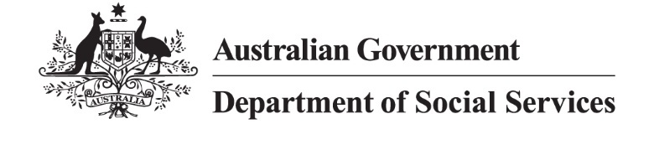

Census Action Plan 2025 –26

Our purpose:
The Department of Social Services is actively delivering on our purpose to improve the economic and social wellbeing of individuals, families and vulnerable members of Australian communities. Our 2025 APS Employee Census results indicate that we are an engaged workforce, who strongly believe in delivering on our agency’s purpose.

Our values – what guides us?
- Curiosity
- Contestability
- Courage
- Collaboration

Our successes

Employee engagement
Our employees are involved and motivated. Our staff believe in what our agency does and want to help reach our goals to deliver for the Australian community. Staff come up with new ideas and put in extra effort at work. Teams work well together to get things done. Leaders support staff and help them do their best.

Wellbeing
Our staff and our work are important. Managers care about the health and wellbeing of their employees. Our employees treat each other with respect and help create a workplace where everyone feels included as we work together to achieve our goals. Staff are happy with how we talk about wellbeing at work and the different ways to get involved in wellbeing activities so they can deliver for Australian communities.

Our areas of focus

Lead strategic social policy
Our employees are proud to deliver on our important purpose to assist the Australian people. Our staff want their opinions heard and respected, and their work, experience and career goals valued. Staff want to feel supported to lead innovative thinking.

Drive delivery
Our employees are dedicated to achieving meaningful outcomes that positively impact members of Australian communities.
Staff feel we could get better at working together to deliver on these outcomes.

Embed supportive systems
Our employees are always working to improve and achieve our outcomes. Staff want to feel safe and well in our workplace. Our staff believe we can support new and creative thinking to enhance productivity by fostering innovation and embracing technology.

Collaborate meaningfully
Effective change management ensures staff can successfully adapt to new ways of working and deliver on our priorities.
Our employees feel that we can improve the way we manage and communicate change.

Our commitment to action

Lead strategic social policy
Build capability through mobility and investment in staff development to ensure we have the capability and capacity to deliver on our goals.
Support leaders at all levels to connect their day-to-day work with strategic priorities and encourage time for experimentation and innovation.
Review our capabilities in line with the results of the Capability Review to ensure ministerial priorities are met.

Drive delivery
Take an outcome focused approach, using data to support continuous improvement to ensure that our policies meet the needs of the Australian people.
Create a delivery focused stream to assist with prioritisation and evaluation of our policies and service delivery.
Work together to deliver by encouraging information sharing and partnership across the department and broader agencies to achieve our outcome and purpose.

Embed supportive systems
Refine and develop strategies and frameworks with practical actions that acknowledge and support staff wellbeing, diversity and workforce planning so we reflect the community we serve.
Continue to invest in technology and systems to improve our operations and enhance the experience of our employees and enable them to deliver our outcomes.
Review our governance and decision-making structures to make our work more efficient and effective.

Collaborate meaningfully
Equip leaders to guide their teams through change, fostering open and effective communication to ensure we deliver on our outcomes for Australian communities.
Recognise and celebrate improvement and create feedback opportunities for staff to find better ways of working to achieve our goals.
Consult staff as early as possible when there are changes in the workplace.

