Information for school leavers with disability
Fact Sheet


 | The Australian Government Department of Social Services wrote this.  We say DSS for short.  When you see the word we it means DSS.
 | We wrote this in an easy to read way.  We use pictures to explain some ideas.
 | We have some words in bold.  This means the letters are thicker and darker.  These are important words.
 | This is an Easy Read summary of another document.  This means it has the most important ideas.
 | We can answer any questions by email.  Email us NationalCustomerServiceLine@dewr.gov.au
 | You can ask for help to read this document.  You can ask  - A friend  - Family members  - A support person.
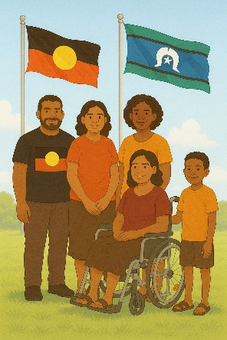 | We recognise Aboriginal and Torres Strait Islander people as the Traditional Owners of the land we live on.
 | They were the first people to live on and use the  - Land  - Waters.

Contents

Disability Employment Programs | 5
Eligible School Leavers | 7
How Inclusive Employment Australia providers can help | 12
Other programs to help young people | 15
Contact us | 19

Disability Employment Programs

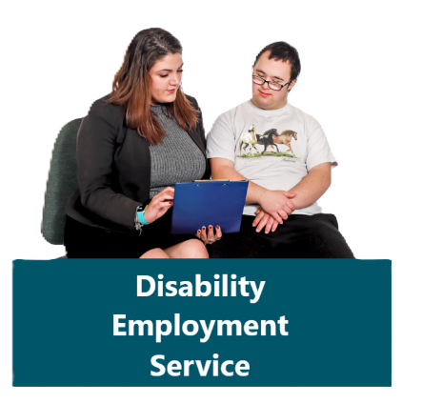 | Inclusive Employment Australia is a program that helps people with disability  - Get a job  - Keep a job.  We call it program for short.
This program gives Eligible School Leavers extra support when they

- Leave school
- Start work.

We call them school leavers for short.
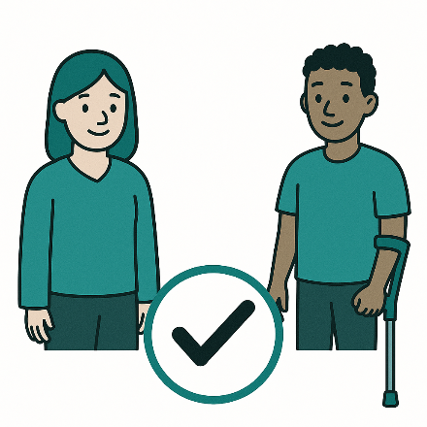 | Eligible means you can  - Get something  Or  - Join something.
 | A school leaver is a person with a disability that wants to transition from school to work.
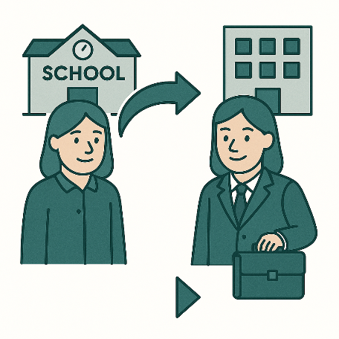 | Transition means to change from one thing to another.

Eligible School Leavers

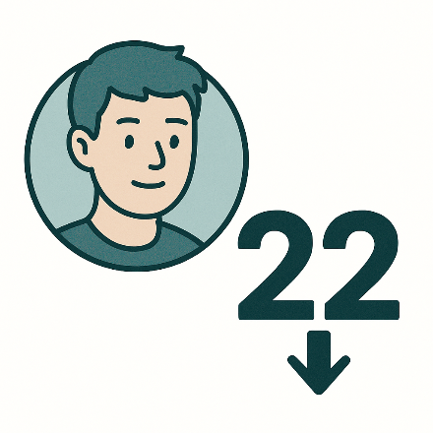 | A school leaver is a person who  - Is under 22 years old
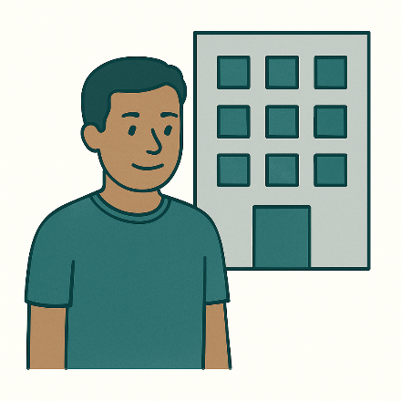 | - Is old enough to work
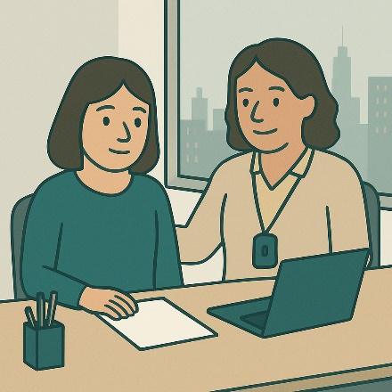 | - Needs support to start work after leaving school
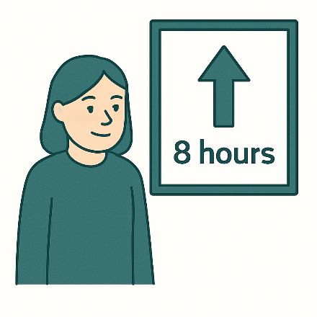 | - Can work more than 8 hours in a week
 | - Has a significant disability.  A person with a significant disability means that they have barriers when they  - Get a job  - Start a job.
 | A barrier is something that stops you from doing what you  - Want  - Need.
 | A school leaver may be a person who is  - In their last year of school
 | - Leaving work experience or training at school  Work experience or training at school means learning skills that will help you work
 | - In a work program  A work program is when a person with a disability gets extra support to  - Leave school  - Start work.  This is sometimes called a transition program.
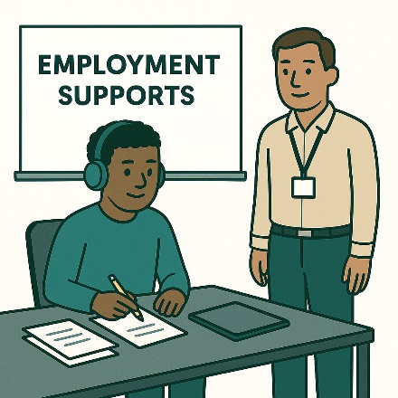 | - Leaving School Leaver Employment Supports  School Leaver Employment Supports is a NDIS program.  It helps young people with a disability go from school to work.
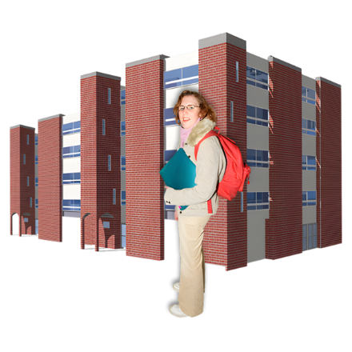 | Most of the time a school leaver will finish school after year 12.  A school leaver can choose to leave school early.  If their parents and school agree.
 | A school leaver will have a disability that makes it hard to  - Move
 | - Communicate  Communicate means doing things like talking and writing.
 | - Do things you do in your job
 | - How much work you can do
 | - Do Self care  Self care means looking after yourself.  Like doing exercise or brushing your teeth
 | - Make your own choices.

How Inclusive Employment Australia providers can help

 | An Inclusive Employment Australia provider can help school leavers to  - Get ready to work
 | - Learn new work skills
 | - Find the right job
 | - Write a resume  A resume is a list of jobs you have done or what work skills you have.  It can also be called a CV.
 | - Write job applications  A job application means you give a work place your resume and write about yourself.
 | - Get ready for a job interview.  A job interview is when you talk to someone to see if you are the right person to work there.
 | You can read more about Inclusive Employment Australia provider on our website.  www.dss.gov.au/information-participants.  This is not Easy Read.
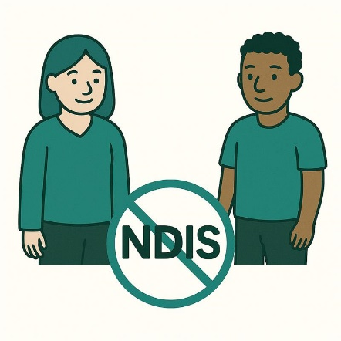 | A school leaver does not need to get NDIS to be in the Inclusive Employment Australia program.
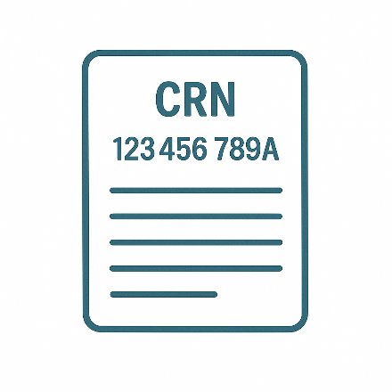 | A school leaver needs to have their own Centrelink Customer Reference Number.  We call this a CRN for short.  A CRN is given to you by Centrelink.  You need a CRN to get money from Centrelink.

Other programs to help young people

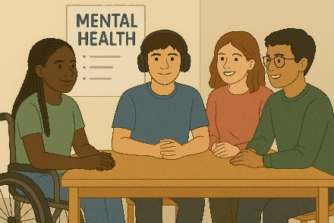 | There are other programs that support young people with disability to work like  - Mental health support  Mental health means how you  - Think  - Feel.
You can read more about this on our website.

www.dss.gov.au/mental-health-support#center

This is not Easy Read.
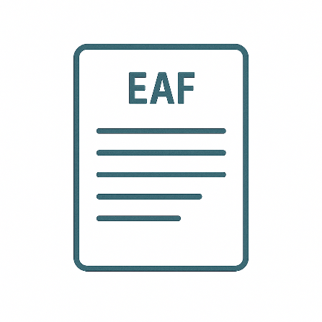 | - The Job Access and Employment Assistance Fund  We call this EAF for short.
 | EAF can pay for things at work that can support you.  This might be  - Assistive technology  - Auslan interpreters.
 | Assistive technology can be things to help you  - Speak  - Move  - See  - Hear.
 | Auslan is Australian sign language.
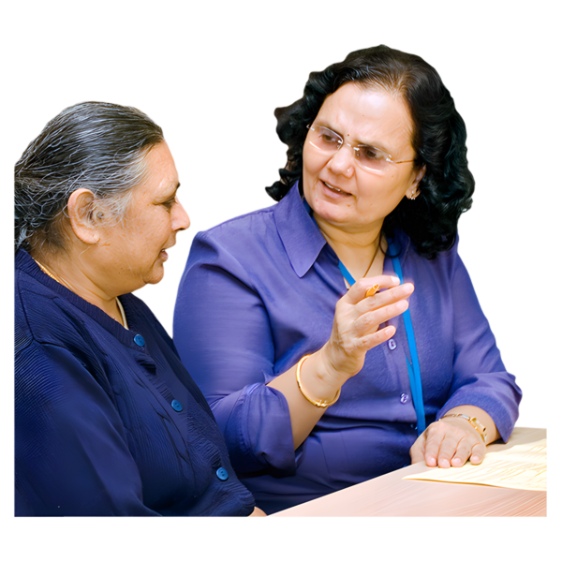 | Interpreters help change words from one language to another like Auslan.
You can read more about what supports EAF has on the website.

www.jobaccess.gov.au/i-am-a-person-with-disability/looking-applying-job/government-services-help-you/funding-workplace-changes/what-eaf

This is not Easy Read.
- School Leaver Employment Support.

You can read more about it on our website.

www.ndis.gov.au/providers/working-provider/delivering-capacity-building-employment-assistance#employment-for-school-leavers

This is not Easy Read.
 | A school leaver might be able to get extra money if they get money from Centrelink already.
You can read more about the extra money on the website.

www.servicesaustralia.gov.au/youth-disability-supplement

This is not Easy Read.

Contact us

 | You can contact us if you need more information.
 | You can send us an email to  NationalCustomerServiceLine@dewr.gov.au
 | You can call us on  1800 805 260

Images in this Easy Read must not be used or copied without permission

