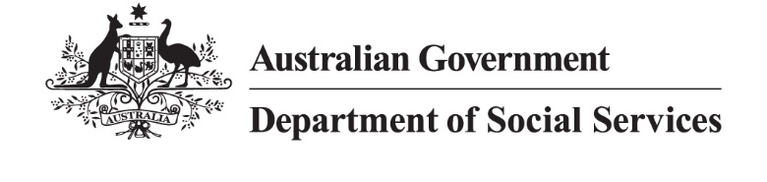

Code of Conduct made by the Disability Services and Inclusion (Code of Conduct) Rules 2023 under the Disability Services and Inclusion Act 2023
The Code of Conduct (Code) is a mandatory set of guidelines that must be followed by anyone providing disability services funded by the Commonwealth.
As part of the Disability Services and Inclusion Framework, the Code promotes the health, safety and wellbeing of people with disability.
The Code sets out acceptable, appropriate and ethical conduct for providers and employees who are delivering disability services funded by the Commonwealth.
The Code requires employees and providers delivering supports and services to:
- act with respect for the individual rights of people with disability to freedom of expression, self-determination and decision-making, in accordance with applicable laws and conventions;
- respect the privacy of people with disability;
- provide the eligible activity in a safe and competent manner, with care and skill;
- act with integrity, honesty and transparency;
- promptly take steps to raise and act on concerns about matters that may have an impact on the quality and safety of the provision of the eligible activity to people with disability;
- take all reasonable steps to prevent and respond to all forms of violence against, and exploitation, neglect and abuse of, people with disability; and
- take all reasonable steps to prevent and respond to sexual misconduct.

