Inclusive Employment Australia

Finding careers for people with a disability

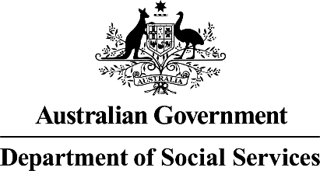 | The Australian Government Department of Social Services wrote this.  We say DSS for short.  When you see the word we it means DSS.
 | We wrote this in an easy to read way.  We use pictures to explain some ideas.
 | We have some words in bold.  This means the letters are thicker and darker.  These are important words.


 | We can answer any questions by phone.  You can call the DES transition line on  1800 227 337
 | You can ask for help to read this document.  You can ask  - Your provider  - Family members  - A support person.
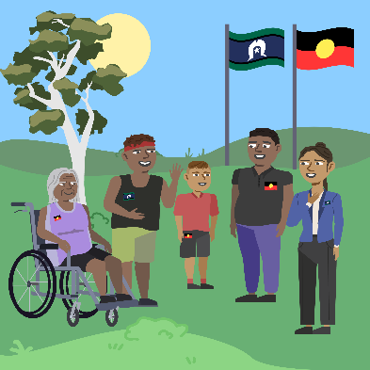 | We recognise Aboriginal and Torres Strait Islander people as the Traditional Owners of the land we live on.
 | They were the first people to live on and use the  - Land  - Waters.

Contents

About Inclusive Employment Australia | 5
Changing from the old program | 8
What I need to do | 9
Your information | 11
Contact us | 13

About Inclusive Employment Australia

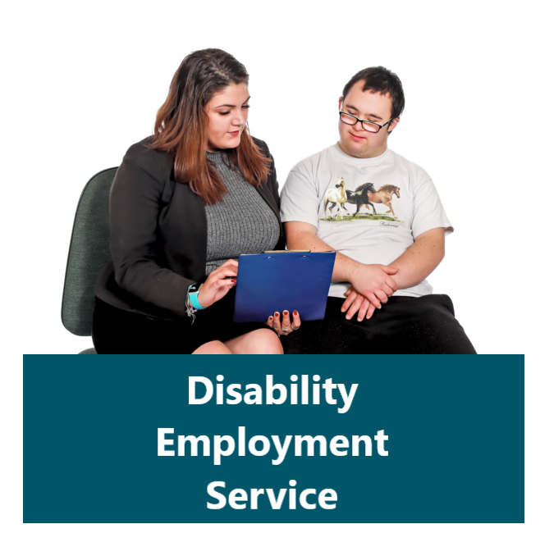 | The Australian Government is changing from Disability Employment Services to Inclusive Employment Australia.  We call it DES for short.
 | Inclusive Employment Australia is a new program to better support you to get a job.  It will start on 1 November 2025.
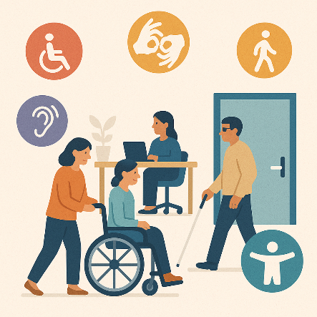 | Providers will help you find a job that is right for you.
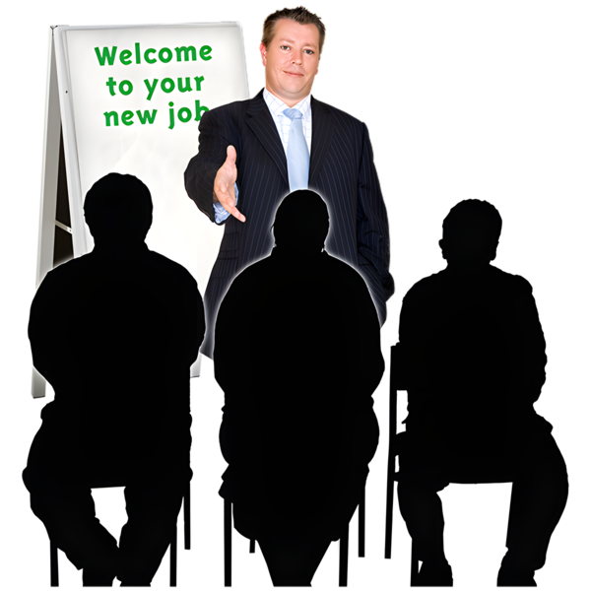 | The way people get a job is different for everyone.
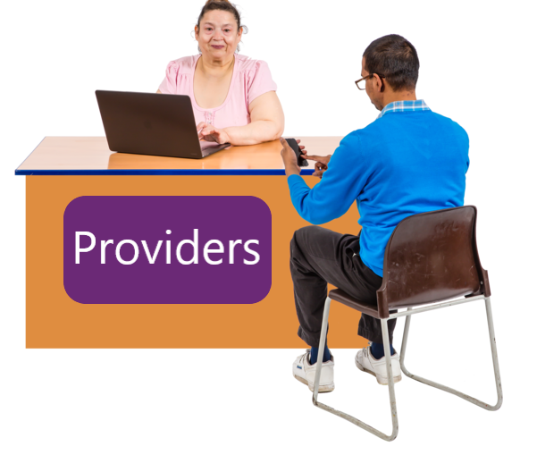 | There will be lots of providers in the program.  They will offer services designed for your needs and circumstances.
 | Your provider will  - Take time to understand what you need
 | - Make services that work for you
 | - Change services if needed.
 | Your provider will help you  - Get ready for work  - Find a job you love.
 | You can join Inclusive Employment Australia if you have a  - Disability  - Injury  - Long term health condition
 | You do not need to be on an income support payment.  Income support payment is money you get from Centrelink.

Changing from the old program

 | We will work with providers to help you get ready for the new program.
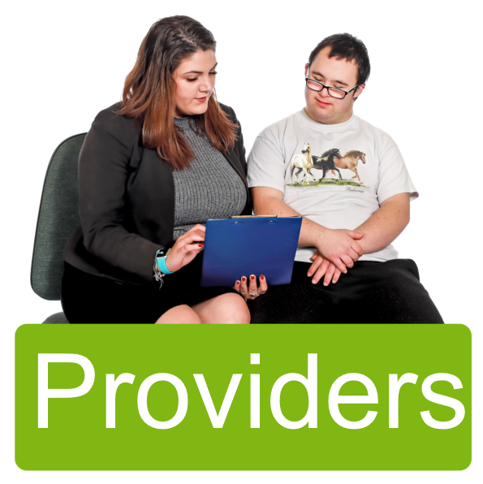 | Some providers may not keep going in the new program.  Some people may need to change providers in November 2025.
 | We will tell you if you need to change providers.

What I need to do
 | You do not need to do anything yet.
 | Keep doing your agreed activities like  - Applying for jobs
 | - Going to job interviews
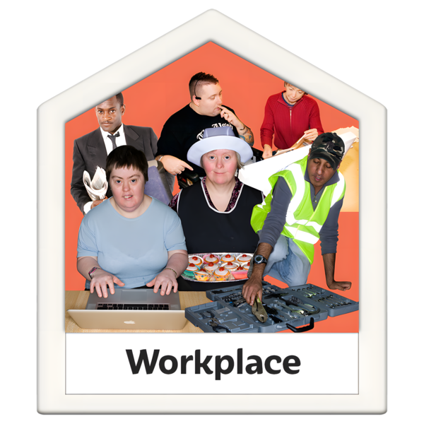 | - Going to work
 | - Keep doing your study or training
 | - Meeting with your provider.

Your information

 | It is important to keep your information up to date by speaking to your provider.  This will help providers to support you with the right services.
You can tell us if you do not want providers to look at your information.

This might change things for you.

Like

- You might not be able to take part in Inclusive Employment Australia
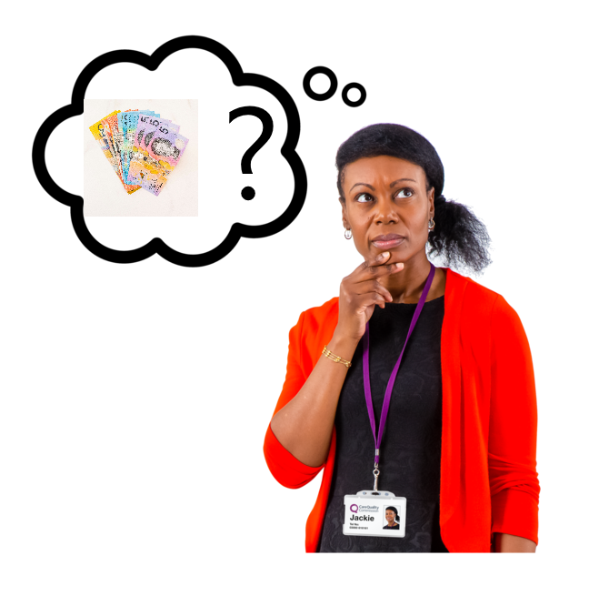 | - It might change the money you get from Centrelink.
 | You can read about Inclusive Employment Australia on our website.  www.dss.gov.au/information-participants  It is not Easy Read.
 | You can find the department’s privacy policy at www.dss.gov.au/privacy-policy

Contact us

 | You can contact us if you need more information.
 | You can call us on  1800 227 337
You can look at our website

https://www.dss.gov.au/information-participants

Images in this Easy Read must not be used or copied without permission.

