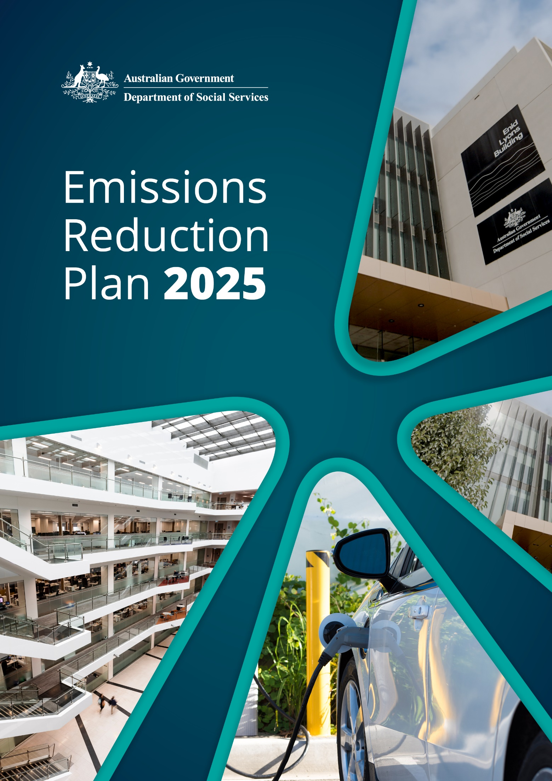

|  |  |
| --- | --- |
| Information | Details |
| Purpose: | The goal of this Emissions Reduction Plan is to provide a pathway for the department to meet net zero emission targets through reduction activities. |
| Category: | Corporate |
| Applicable to: | All staff, including contractors, consultants and visitors. |
| Relevant Authority: | [Net Zero in Government Operations Strategy and Roadmap](https://www.finance.gov.au/government/climate-action-government-operations/aps-net-zero-emissions-2030) describes the approach for implementing the Australian Government’s commitment to achieve net zero emissions from government operations by 2030 as included in Australia’s [Nationally Determined Contribution Communication 2022](https://unfccc.int/sites/default/files/NDC/2022-06/NDC%202022%20Update%20Letter%20to%20UNFCCC.pdf) under the Paris Agreement. |
| Related Documents: | [Net Zero in Government Operations Annual Progress Report](https://www.finance.gov.au/government/climate-action-government-operations/commonwealth-emission-reporting/net-zero-government-operations-annual-progress-report)  [Department of Social Services Corporate Plan](https://www.dss.gov.au/corporate-plans)  [Department of Social Services Annual Report](https://www.dss.gov.au/about-the-department/publications-articles/corporate-publications/annual-reports) |
| Approved by: | Michael Lye  Secretary  Department of Social Services |
| Review Date: | August 2026 |
| Owner: | Property Services; Finance and Information Services Group |
| First Issued: | August 2024 |
| Document Change Control: | August 2024 – Property Services Section (baseline emissions amended)  August 2025 – Annual Update |

## Acknowledgement of Country

The department acknowledges the Traditional Owners and Custodians of Country throughout Australia and acknowledges their continuing connection to land, waters, and community. We pay our respects to the people, the cultures, and the Elders past and present.

Table of contents

Acknowledgement of Country 3

Accountable Authority sign off 5

Introduction 5

Commitment to achieving net zero 5

Emissions Reduction Plan 6

Purpose 6

Net zero greenhouse gas emissions 6

Scope 6

Governance and reporting 7

Department of Social Services operational context 8

Baseline emissions 9

Engagement 9

Emissions reduction targets 9

Priorities and actions 10

Net zero energy and buildings 10

Net zero fleet 12

Net zero ICT 12

Net zero procurement 13

Net zero travel 13

People, culture, and capability 14

Owner/contact officer 14

More information 14

## Accountable Authority sign off

### Introduction

Climate change will continue to have significant effects on the environment, society and economy, with impacts felt across the Australian Government’s operations. The Department of Social Services (the department) acknowledges that human behaviours, pollution and consumption patterns have both immediate and future impacts on the climate and environment, and that as a Commonwealth entity it is part of our role to mitigate and manage these impacts on our community.

This declaration establishes our position and commitments to reduce emissions.

The department supports the environmental, social and economic benefits of addressing climate change immediately. We see an opportunity to demonstrate leadership in emissions reduction.

### Commitment to achieving net zero

The department is committed to achieving the government’s net zero emissions by 2030 target. The department is following the APS Net Zero 2030 target in full, as per the Net Zero in Government Operations Strategy (the Strategy). We acknowledge the central role of government in driving a successful climate response. Hence, we declare that we are committed to reducing operational emissions, through the implementation of mitigation and adaptation strategies.

Our overall objectives align with the Strategy to reduce our operational emissions.

This Emissions Reduction Plan (the plan) describes the priorities and actions the department is taking to reduce our operational emissions and contribute to the APS Net Zero 2030 target.

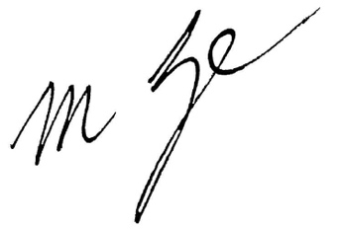

**Michael Lye**  
Secretary

## Emissions Reduction Plan

### Purpose

The department is responsible for managing and implementing emissions reduction initiatives set by the government’s [Strategy](https://www.finance.gov.au/government/climate-action-government-operations/aps-net-zero-emissions-2030) developed by Department of Finance. The Strategy sets out the government’s approach to achieving net zero greenhouse gas emissions from its operations by 2030 and the reinstatement of public emissions reporting.

The goal of this Emissions Reduction Plan is to provide a pathway for the department to contribute to the achievement of the APS Net Zero 2030 target through emissions reduction activities. This plan encompasses existing and new priorities and actions within the department to reduce emissions.

This plan has been completed in accordance with the [Strategy](https://www.finance.gov.au/sites/default/files/2023-11/Net_Zero_Government_Operations_Strategy.pdf), associated guidance and reporting standards for annual emissions reporting.

### Net zero greenhouse gas emissions

APS Net Zero 2030 is the target set by the government to achieve net zero greenhouse gas emissions from government operations by the year 2030. It includes scope 1 and scope 2 emissions from activities in Australia and its territories, as described in the Strategy. The APS Net Zero 2030 target applies at the aggregate level to non-corporate Commonwealth entities and generally covers the entirety of the entity’s organisation. From an organisational perspective, this means minimising the greenhouse gas emissions that are within our control.

**Scope 1 emissions** – reflect emissions from sources owned or controlled by government, including the stationary combustion of fuels (boilers, generators), and transportation (vehicle fleet).

**Scope 2 emissions** – are indirect emissions which occur because of the activities that generate electricity, which is consumed by an entity, but is generated outside that entity’s boundaries. They are physically produced by the burning of fossil fuels by the generator of the electricity.

### Scope

**Inclusions**

Emissions reduction activities will align with the Strategy, with the initial focus on scope 1 and scope 2 greenhouse gas emissions. Future reviews will consider additional inclusions to align with the Strategy and organisational activities, including the consideration for scope 3.

**Exclusions**

Activities by Commonwealth entities that take place outside of Australia or its territories, including international air and marine travel, are not included in Australia’s Nationally Determined Contribution and are not included in the APS Net Zero 2030 target or subject to the Strategy. Entities that undertake these activities will act as appropriate to reduce their emissions in the relevant local context as an aspirational goal for the government to demonstrate leadership and advance Australia’s climate diplomacy objectives.

### Governance and reporting

This plan will be updated annually, with a summary to be incorporated into our annual report. Progress against actions identified within this plan, and any additional measures adopted, will be included in our annual reports. This, combined with annual emissions reporting, will be used as a measure of the department’s progress towards reducing its emissions.

As part of the Net Zero in Government Operations Annual Progress Report, the Department of Finance will aggregate these measures to provide Whole-of-Australian-Government (WoAG) emissions reporting.

Future iterations of this plan will align with the offset strategy and Commonwealth Climate Disclosure requirements that are currently under-development by the Climate Action in Government Operations within Department of Finance.

The department has appointed the Chief Operating Officer (COO) to be the Chief Sustainability Officer (CSO). The role of the CSO is to:

* champion the Strategy and related initiatives that support climate action in government operations.
* represent the department in the CSO network.

**Governance diagram**

**Audit and Risk Committee**

Provides independent assurance and advice to the Secretary and EMG on the design and operation of the department’s risk, control and compliance framework, including its external accountability responsibilities.

**Net Zero Working Group**

**(Chaired by BM Financial Management and Property Services)**

Officer-level working group responsible for the department’s Emissions Reduction Plan and Emissions Reporting.

**DSS Financial Management and Property Services Branch**

Responsible for developing and maintaining the department’s Emissions Reduction Plan and including Emissions Reporting in the Annual Report.

**Chief Sustainability Officer (CSO)**

**(Chief Operating Officer)**

Responsible for championing the department’s Net Zero by 2030 Emissions Reduction Plan.

Note: The COO is also the department’s appointed Chief Risk Officer, responsible for overseeing the department’s Risk Management Framework and governance arrangements.

**Executive Management Group (EMG)**

**(Chaired by Secretary)**

Oversees the department’s overall strategic direction, priorities, management, and performance.

Responsible for signing the department’s Emissions Reduction Plan, ensuring commitment to the net zero outcomes.

### Department of Social Services operational context

As at 30 June 2025, the department operates across all Australian states and territories, with an annual staffing level around 3,000 personnel. The department has staff located in 18 sites across Australia of which 10 properties are leased directly. Leasing and facilities management activities are managed under the whole-of-government Property Services Coordinated Procurement Arrangements.

The department has staff located in 8 properties which are sub-leased from other government departments under Memorandum of Understanding (MoU) agreements. The department does not have operational control of MoU properties.

The Domestic, Family and Sexual Violence Commission, National Commission for Aboriginal and Torres Strait Islander Children and Young People and staff from 5 other MoU agreements are located within the department’s tenancies.

The department operates a small fleet of 23 leased vehicles to support the delivery of services across all Australian states and territories, of which 12 are Low Emission Vehicles, including 11 Battery Electric Vehicles and 1 Plug-in Hybrid Electric Vehicle.

The provision of information and communications technology services including infrastructure, support, and maintenance of equipment, is provided by Services Australia under a shared services arrangement.

All procurement is undertaken in accordance with the Commonwealth Procurement Rules. For the full financial year 2024-25, the department entered into 307 contracts with a total estimated value of $536 million.

All departmental travel is undertaken utilising the whole-of-government Travel Arrangements which includes travel management services, domestic and international air travel services, domestic accommodation, domestic vehicle rental services and travel and procurement payment services.

For the full financial year 2024-25, the department undertook 4,128 domestic and international trips.

On 13 May 2025, the Department of the Prime Minister and Cabinet released Administrative Arrangements Orders (AAOs) regarding Machinery of Government changes that affect the department. As per the AAOs, housing, rental and homelessness functions have been transferred to Department of the Treasury and disability functions (except Disability Employment Services) have been transferred to the Department of Health, Disability and Ageing. These changes have not yet been reflected in this version of the Plan.

### Baseline emissions

Baseline emissions are a record of greenhouse gasses that have been produced in the past and were produced prior to the introduction of any strategies to reduce emissions. The baseline emissions from financial year 2022-23 are the reference point against which emissions reduction actions can be measured.

At this stage, the APS Net Zero 2030 target includes scope 1 and scope 2 emissions. Decisions on scope 3 will be made in the future as further data becomes available. The baseline emissions for this plan will focus on those emissions.

|  |  |
| --- | --- |
| Baseline year | Financial year 2022-23 |
| Scope 1 emissions | 18.79 tCO2-e |
| Scope 2 emissions | 1,474.23 tCO2-e |
| Total emissions | 1,493.02 tCO2-e |

Time series show historical emissions trends and track the effects of emission reduction strategies. Efforts will be made to calculate the time series using the same methods and data sources in all years. However, as emissions measurements, data collection methods, methodological refinements and reporting requirements are expected to be continually added and improved upon, strategies to ensure time-series consistency are being implemented from the outset. Key to ensuring confidence in time-series consistency will be the diligent documenting of approaches to emissions estimated, including methodologies and data sources, in the Net Zero in Government Operations Annual Progress Reports.

### Engagement

In the development of this plan the department has engaged with:

* Climate Action in Government Operations – to ensure that this plan aligns with the Net Zero in Government Operations Strategy and the Commonwealth Climate Disclosure requirements.
* Financial Management and Property Services Branch – to discuss net zero energy, buildings, fleet, procurement and travel.
* Chief Information Officer Branch – to discuss net zero ICT.
* Corporate Communications and Media Relations Branch – to discuss people, culture and capability.

### Emissions reduction targets

The department is following the APS Net Zero 2030 target in full, as per the Strategy. The target covers the entirety of our entity’s operations within Australia for scope 1 and scope 2 emissions, as described in the Strategy.

## Priorities and actions

For the department to contribute to the achievement of the APS Net Zero 2030 target, targeted action on existing emissions reduction measures and the introduction of further or new measures is required. These actions are summarised in the following points, with further detail provided below:

* Procuring renewable electricity
* Improving building performance
* Transitioning the fleet passenger vehicles to low emission vehicles
* Embedding sustainability into future procurement activity
* Encouraging low-emission sources of travel
* People, culture, and capability uplift.

### Net zero energy and buildings

Under the procurement of energy and management of buildings, the department will:

|  |  |
| --- | --- |
| Action by the department | Status  2024-25 progress update |
| Electricity procurement  Procure renewable energy through participating in the WoAG renewable electricity procurement, when available. | **Ongoing**  The department was not required to participate in the WoAG renewable energy procurement for Western Australia due to the department’s electricity meters being on the building’s embedded electricity network.  The department purchased 100% GreenPower (effective from March 2025) in 1 contract extension. |
| Commonwealth National Lease (CNL)  From 1 January 2025, incorporate additional environmental sustainability and emission reduction elements into the CNL template to negotiate with landlords. | **Ongoing**  The department incorporated additional sustainability considerations into 1 new lease. |
| Green lease schedule (GLS)  From 1 January 2025, review new leases over 1,000m2 and 4 years duration to include the relevant version of the GLS. | **Ongoing**  The department included a GLS in 1 new lease. |
| EV charging  From 1 January 2025, review allocated parking facilities with a fleet vehicle to support electric vehicle charging where possible. | **Achieved**  The department incorporated an EV charging plan into the Property Management Plan. The department’s landlords installed EV charging stations in 2 buildings.  The department will continue to work with landlords to install charging stations within leased premises carparking. |
| NABERS ratings  From 1 July 2025, ensure new leases over 1,000 m2 and 4 years duration are working towards and can maintain a 5.5 star or higher base building and tenancy NABERS energy rating. | **Underway**  The department included a 5.5 star NABERS target in 1 new lease. |
| GBCA Green Star ratings  From 1 July 2026, contracts for the purchase or construction of office spaces with a value greater than $15 million must obtain a GBCA 4-star Green Star rating (minimum) using the climate positive pathway and 6-star NABERS energy rating. | **Not commenced**  The department did not undertake any procurements that met the value threshold. |
| Electrification  From 1 July 2026, review contracts for the purchase or construction of office space to ensure they include all-electric where available[1]. | **Not commenced** |
| Energy efficiency measures   * Consider the use of energy efficient lighting solutions including sensor lights and LED. * Consider conducting audits of operational use of buildings and operation of plant and equipment by building management systems (BMS) to identify BMS tuning opportunities and resource consumption reduction. * Reduce power consumption by using technology that automatically switches off when left on and unattended. * Using heating/cooling air conditioning timers in meeting rooms and breakout areas. | **Ongoing**  The department worked with our landlord to install energy efficient lighting in 1 new fitout. |
| Minimise environmental impacts   * Minimise use of hazardous waste materials. * Target premium Water Efficiency Labelling and Standards (WELS) rating where possible. | **Ongoing**  The department incorporated the Environmentally Sustainable Procurement Policy principles into the Property fitout brief. |
| Reducing landfill   * Promote waste management practices. * Provide recycling bins in every site and provide organic waste bins, where possible. * Support a circular economy through reuse, repair, refurbishment and recycled content use, where possible. | **Ongoing**  The department strengthened its property fitout brief requirements for waste management.  The department introduced an organic waste service in 1 more site. |

### Net zero fleet

Under the leasing of fleet vehicles, the department will ensure the procurement and sourcing of motor vehicles is consistent with the *Commonwealth Fleet Vehicle Selection Policy*[2].

|  |  |
| --- | --- |
| Action by the department | Status  2024-25 progress update |
| By 1 July 2023, transition 25% of new passenger vehicle orders to low emission vehicles. | **Achieved** |
| By 1 July 2024, transition 50% of new passenger vehicle orders to low emission vehicles. | **Achieved** |
| By 1 July 2025, transition 75% of new passenger vehicle orders to low emission vehicles. | **Achieved** |

### Net zero ICT

Services Australia provides ICT services and equipment under a shared services arrangement. The department will work in partnership with Services Australia to ensure data centres are located in energy efficient premises and wherever possible participate in the whole-of-government digital marketplace panel.

|  |  |
| --- | --- |
| Action by the department | Status  2024-25 progress update |
| Continue to work in partnership with Services Australia to ensure new data facilities, that are sourced outside the whole-of-government panel arrangement, are required to achieve, and maintain 5 stars NABERS rating or equivalent environmental rating, such as a Power Usage Effectiveness of 1.4 or less. | **Ongoing**  Services Australia confirmed the data facilities already meet the minimum standards. |
| Continue using new technology that allows staff to ‘wake up’ PCs that have been switched off to install software updates. | **Ongoing** |

### Net zero procurement

Under the procurement guidelines the department will:

|  |  |
| --- | --- |
| Action by the department | Status  2024-25 progress update |
| Commit to supporting training and guidance, including the government’s Sustainable Procurement Guide[3] to be embedded into the department’s procurement process, training, and templates, by 1 January 2025. | **Ongoing**  The department considers the Department of Climate Change, Energy, the Environment and Water, Environmentally Sustainable Procurement Policy and the Sustainable Procurement Guide when undertaking procurement.  Environmentally Sustainable Procurement training courses are available on the department’s online Learning Management System. |
| Purchase 100% recycled content paper for internal printers, photocopiers, and multifunction devices. | **Ongoing** |
| Only where all options associated with emissions avoidance and reduction have been exhausted should residual emissions be addressed through the purchase of offsets, when available. | **Not commenced** |

### Net zero travel

The department will:

|  |  |
| --- | --- |
| Action by the department | Status  2024-25 progress update |
| Ensure the travel policy is updated to enable and encourage low-emission sources of transport, such as trains or other land-based transport. | **Achieved** |
| Work with staff responsible for booking travel to ensure they consider energy ratings in the Online Booking Tool once available under the whole-of-government arrangements. | **Ongoing** |

### People, culture, and capability

The department will develop a communication plan to support all staff, including contractors and consultants, to contribute to improving the department’s environmental performance by:

|  |  |
| --- | --- |
| Action by the department | Status  2024-25 progress update |
| Appoint a Chief Sustainability Officer | **Achieved** |
| Communicate the Emissions Reduction Plan | **Achieved**  The department communicated the Emissions Reduction Plan through multiple channels including the Secretary’s update, COO all staff message, intranet and internet. |
| Support and promote APS Academy advice, guidance, tools, case studies and training programs, when available. | **Underway**  The department promoted the Net Zero Foundations and Net Zero Buildings courses to relevant Property Services staff.  The department promoted the Environmentally Sustainable Procurement e-learning course to relevant staff. |
| Promote employee engagement and staff-led initiatives such as WoAG Environmental Contact Officer network (ECONet), when available. | **Not commenced** |
| Update intranet pages to promote:   * Fostering a culture of environmental responsibility. * Thinking before printing. * The importance of shutting down equipment. * Effective use of blinds to optimise air conditioner and heating system efficiency. | **Achieved** |
| Participate in Earth Hour each year. | **Ongoing**  The department participated in Earth Hour 2025. |

## Owner/contact officer

Chief Sustainability Officer, Chief Operating Officer, Corporate

## More information

For more information, please contact Property Services, in the Financial Management and Property Services Branch by email [netzero@dss.gov.au](mailto:netzero@dss.gov.au).

1. This includes building heating, cooling and water heating but excludes backup generation, subject to the 2026-27 [Net Zero in Government Operations Strategy](https://www.finance.gov.au/government/climate-action-government-operations/aps-net-zero-emissions-2030) review.
2. [Commonwealth Fleet Vehicle Selection Policy | Department of Finance](https://www.finance.gov.au/government/procurement/vehicle-leasing-fleet-management/commonwealth-fleet-vehicle-selection-policy)
3. [Sustainable Procurement Guide - DCCEEW](https://www.dcceew.gov.au/environment/protection/waste/sustainable-procurement/sustainable-procurement-guide)