
Institute for Social Science Research
17 June 2021

Try, Test and Learn Evaluation


This report was commissioned by the Department of Social Services as part of the Australian Government’s commitment to explore new or innovative approaches to assist some of the most vulnerable in society onto a path towards stable, sustainable independence.

Authors
The evaluation was undertaken by the Institute for Social Science Research, The University of Queensland, and the Melbourne Institute, The University of Melbourne.
Janeen Baxter (Evaluation Lead)
Jenny Povey (Evaluation Program Manager) Sarah-Ann Burger
Stephanie Cook Yi-Ping Tseng Cain Polidano Guyonne Kalb Abdullah Mamun Shabbir Ahmad Martin O’Flaherty Jeff Borland Stefanie Plage Melindy Bellotti
Elizabeth Kennedy Wojtek Tomaszewski Mark Western

Contact
Institute for Social Science Research The University of Queensland
80 Meiers Road Long Pocket Precinct Queensland 4068 Australia
Business: +61 7 3346 7471 Email: issr@uq.edu.au

Acknowledgements
The TTL Evaluation Team thanks all of those who assisted in the preparation of this report, including staff members of the Australian Government Department of Social Services. The authors thank the TTL clients and service providers who took the time to speak with us and share their rich and thoughtful feedback. We also acknowledge the contributions of the following colleagues who contributed their time and expertise to various aspects of the evaluation: Alexandra Gramotnev, Laura Simpson Reeves, Sarah Ball, Anne Schirmann, Fran Donoso Rivas, Heidi Hoffman, Asma Zulfiqar, Kora Uhlmann, Russell McKay, Chris Ambrey, Charley Pedde, Rumaana Suleman and Emma Earl.

Disclaimer
The opinions, comments or analysis expressed in this document are those of the author or authors and do not necessarily represent the views of the Department or the Minister for Families and Social Services, and cannot be taken in any way as expressions of government policy.

Contents

Glossary of terms and acronyms vi
Executive summary viii
- Background to the establishment of the TTL Fund 2
  - The Australian Priority Investment Approach to Welfare 2
  - Try, Test and Learn Fund 3
- Evaluation design 6
  - Theory of change 6
  - Research questions 6
  - Research methods and data collection 7
  - Limitations 8
- Effectiveness 12
  - Overall TTL Fund 13
  - Young Parents 23
  - Young Students 28
  - Young Carers 32
  - At-risk Young People (tranche 1) 37
  - At-risk Young People (tranche 2) 41
  - Migrants and Refugees 46
  - Older Unemployed People 52
  - Other 57
  - Working Age Carers 62
- Efficiency 64
  - How cost-effective were the TTL projects in the TTL Fund? 66
  - Cost-benefit comparisons for TTL projects by priority group 70
- Appropriateness 76
  - How appropriate was the development of the TTL projects in the TTL Fund? 77
  - How appropriate was the department’s implementation of the TTL Fund? 81
  - How appropriate was the data quality implementation, DEX training and support provided by the department? 82
  - What impact did the TTL Fund have on the service provider community? 83
- Lessons learned about promising approaches for future investment 86
  - Did the TTL Fund meet its stated objectives? 86
  - To what extent does the evidence suggest that the TTL projects have helped to have a more cost- effective, sustainable welfare system for those who need it? 88
  - Are there indications that lend confidence to the underlying theory of change, program logic and assumptions? 89
  - Conclusion 89
Appendices 92

    - Background of the TTL Fund 96

    - Evaluation design 107

    - Technical methodology 116

    - Effectiveness 130

    - Efficiency 194

    - Data collection tools 208
    - References 216

Figures
Figure: 1 TTL Fund implementation structure 4
Figure: 2 Data sources 7
Figure: 3 Levels of service-user involvement 80
Figure: 4 Three groups of clients at varying stages of work-readiness 87

Glossary of terms and acronyms

Any employment income while on income support refers to an outcome measure used in the impact analysis to assess whether a person received any income from employment while on income support in a 3-month period.
Baseline SCORE is defined as the earliest recorded DEX SCORE, up to 28 days before or after either the first session or client commencement.
Capacity is defined as having non-vocational barriers addressed to participate in work or study, such as stable housing, transport or childcare.
Client commencement is defined as the first session that a TTL client attends at the TTL project that is not an intake/assessment session, except where the metadata documents indicate a different choice would be appropriate.
Comparison group refers to a group of people who did not participate in any TTL project who had similar personal traits as the TTL clients at the time of client commencement.
Educational participation or attainment refers to TTL clients’ participation in education or training (i.e. enrolled, remained engaged, or completed an educational program).
Employer demand-led approach to work placements refers to employers’ needs being identified first and then TTL clients matched based on their assessed vocational interests and capabilities.
Employment income earned while on income support refers to an outcome measure used in the impact analysis to assess the amount of income earned from employment while in receipt of income support in a 3-month period.
Follow-up SCORE is defined as the last recorded SCORE up to 28 days before the last recorded session in DEX.
Generic vocational training refers to training that is broad or non-specific to a particular vocation,
role or industry, such as general business skills that can be used in a number of vocations.
Generic work placement refers to work experience opportunities that do not have a direct pathway into long-term work opportunities. These opportunities are focused on the experience rather than placing TTL clients into work placements that have the potential to become long-term employment placements.
Health and wellbeing refers to mental, physical, or social and emotional wellbeing, which supports a person’s ability to participate in social and economic life, as reported by TTL clients or service providers in interviews.
Impact analysis refers to the quantitative analysis that measured the impact of projects by examining TTL clients’ outcomes compared over time to people with similar characteristics and circumstances who did not participate in any TTL project (the comparison group). This tested whether any changes in TTL clients’ outcomes were due to participating in the projects, rather than external factors.
Income support unrelated to study refers to an outcome measure used in the impact analysis to assess whether a person was in receipt of income support payments that were not student-related income support.
JobSeeker Payment – From 20 March 2020, 7 payments were merged into JobSeeker Payment including Newstart Allowance, Wife Pension, Widow B Pension, Sickness Allowance, Bereavement Allowance, Partner Allowance and Widow Allowance. JobSeeker Payment is now the main working-age payment for people aged from 22 years to Age Pension age who have capacity to work, now or in the near future. Although these payment types were in use during the TTL Fund implementation, the report refers to JobSeeker Payment throughout.
New study commencement occurs where a client is recorded as having started a new course of study at any time between the start and end of a given quarter. All levels of courses are captured,

including secondary education, certificates and university study.
Non-vocational barrier is defined as any barrier that is not related to vocational skills, knowledge or experience, such as language difficulties, caring responsibilities or homelessness, that impacts on an individual’s capacity to work or study.
Number of days on any income support refers to an outcome measure used in the impact analysis to assess the number of days a person received income support payments in a 3-month period.
Mental health issues includes a wide range of conditions from anxiety and depression to psychotic disorders.
Pre-post analysis examines change of an outcome between 2 time points.
Project implementation is defined as the start of the project (once the Activity Work Plan is finalised with the department) and includes activities such as recruitment.
Project participation measures whether clients who commenced a TTL project continue to receive those services over time.
Skills refers to competencies required to participate in work or study, such as job-specific knowledge or job search skills.
Student income support refers to an outcome measure used in the impact analysis to assess whether a person was in receipt of student- related income support payments.
Sustainable welfare system is defined as a social, ecological and economic system that has the capacity to continue indefinitely without compromising the ability of future generations to meet their own needs.
Vocational barrier is defined as a lack of skills, knowledge or experience required for work or study, and includes job search skills and preparing a resume or for an interview.
Workforce participation is defined as a TTL client becoming employed or increasing work hours, and can include casual, part-time or full-time employment.
Work-ready refers to having the skills, capacity and/or health and wellbeing to be able to participate in work.

Acronyms
ABS Australian Bureau of Statistics
AWP Activity Work Plan
CBA Cost-benefit analysis
DEX Data Exchange
DOMINO Data Over Multiple Individual Occurrences
DSS Department of Social Services
FAM Funding Arrangement Manager
IS Income Support
ISSR Institute for Social Science Research
PIA Priority Investment Approach
PIR Post-Implementation Review
SCORE Standard Client Outcomes Reporting system
TTL Try, Test and Learn
UoM University of Melbourne
UQ University of Queensland
VET Vocational Education and Training


Ex

Executive summary

A Priority Investment Approach (PIA), and appropriate early intervention, may enable identified at-risk groups to build skills and capacity, to take opportunities to participate in the labour market and live independently of welfare.
The Try, Test and Learn (TTL) Fund was established in 2016 and was informed by the PIA. The objective of the TTL Fund was to generate new insights and empirical evidence into what works to reduce long-term welfare dependence by trialling a number of new or innovative approaches to support at- risk groups identified by the PIA to inform policy and program development.
Overall, the evaluation evidence indicates that the TTL Fund was an appropriate model to trial new approaches and generate insights into how people can be supported to have better lives and independence from the welfare system. While there is limited evidence of the impact of TTL in the short term, it is expected to be an effective and efficient investment to assist the identified at-risk groups to build capacity to overcome non- vocational barriers, improve their wellbeing, develop the skills required to participate in work or study, and move onto a path towards stable, sustainable independence in the long term.
The TTL Fund was informed by the PIA — a recommendation of the 2015 review of Australia’s welfare system, A New System for Better Employment and Social Outcomes, led by Patrick McClure. The 2016–17 Budget allocated $96.1 million to the TTL Fund over 4 years to implement and test the effectiveness of new service responses for identified groups, where targeted investment may improve life outcomes through independence from welfare. A key aspect of the TTL Fund was developing a sound evidence base to support the design, implementation and measurement of outcomes for the overall TTL Fund and new service responses, referred to as TTL projects, for identified groups.
Seven priority groups were identified, informed by the PIA, and project development and grant applications for projects were sought in 2 tranches. Initially, tranche 1 focused on Young Carers, Young Parents and Young Students, while tranche 2 focused on Migrants and Refugees, Older Unemployed People, At-risk Young People, Working Age Carers, and an 8th group, ‘Other’, which covered clients who belonged in more than one of the primary priority groups, or had specific circumstances. Subsequently, 4 projects targeting At-risk Young People were included in tranche 1. Fifty-two projects were funded across the 8 priority groups.
In March 2018, the Australian Government Department of Social Services (the department) commissioned the Institute for Social Science Research (ISSR) at The University of Queensland (UQ), in association with the Melbourne Institute: Applied Economic and Social Research at The University of Melbourne (UoM) (collectively the TTL Evaluation Team), to evaluate whether the TTL Fund achieved its intended objectives.
The TTL Evaluation used a mixed methods research design, embedding qualitative methods within a quasi-experimental design. The

evaluation drew on administrative records¹ to examine the impact of TTL projects by comparing TTL clients’ outcomes to the outcomes of people with similar characteristics who did not participate in any TTL project, called the comparison group (impact analysis). It also incorporated data reported by service providers through the department’s Data Exchange (DEX) platform² and TTL Client Survey data³ to examine changes in TTL clients’ outcomes between 2 time points (pre-post analysis). TTL projects’ quarterly Activity Work Plan (AWP) progress reports and qualitative data from semi-structured group interviews with service providers from all projects, and interviews with 230 TTL clients from 36 projects, provided context and client-reported outcomes. In total, 5,201 clients were recruited across the Fund (as recorded in DEX), 5,108 started the projects, and impact analyses were conducted for 3,379 TTL clients across 34 projects with sufficient data over a 6-month period. Cost-benefit analyses (CBAs) were conducted using project costs, and the benefits were estimated using the simulated differences in the life-time costs for the 34 projects included in the impact analyses.
This report evaluates the effectiveness, efficiency and appropriateness of the TTL Fund to meet its objective to inform future policies on the basis of the Fund’s achievements, strengths and limitations. The report combines project-level outcomes to identify and report learnings for each priority group. Findings are presented at the Fund and priority group level.
Limitations
A strength of the TTL Evaluation was the ability to test the impact of TTL projects on clients’ outcomes compared to people who have similar characteristics as TTL clients, but who were not involved in TTL over the same period (comparison group). This allowed for the analyses to disentangle changes associated with the project from changes that may have occurred anyway, for example, changes that may have occurred due to
individual or societal circumstances. However, there are some key limitations to the evaluation that need to be taken into consideration when reviewing the results.
The impact analyses were restricted to administrative data (DOMINO); therefore, these could only include changes in income support receipt and employment income while on income support as outcomes.
To measure broader outcomes such as changes in health and wellbeing, skills, capacity, or education and qualification attainment, the impact analyses were complemented by additional quantitative and qualitative data. However, these outcomes could not be measured against the comparison group as the impact analyses could. Therefore, it was not possible to test whether the outcomes observed would have occurred outside of TTL. Further, the impact on these outcomes could not be reliably estimated using these data sources due to the small sample size and self-selecting nature of the TTL clients who answered the TTL Client Survey, or participated in the client interviews, or for whom there are DEX SCORE data. Changes in the outcomes using these data sources need to be interpreted with caution, as only a small proportion of clients completed the TTL Client Survey and DEX SCORE at 2 timepoints and these clients may not be representative of all TTL clients.
Changes in education were estimated using the proxy measure of an increase in student income support receipt. This may not reflect all educational participation, such as apprenticeships or traineeships. It also did not allow for the detection of educational engagement such as subject completion, and it limited the analysis to individuals observed in the DOMINO data, which excluded TTL clients under 16.
The impact analyses were input into the CBA. As such, all limitations of the quantitative impact analyses are transferred to these analyses.
Particularly, due to limited availability of data, the

¹ Data over Multiple Individual Occurrences (DOMINO) is a curated income support receipt database compiled from the department’s administrative datasets.
² The Data Exchange is the program performance reporting solution developed by the department. In addition to standard reporting into DEX, TTL service providers are required to collect additional data called DEX Standard Client Outcomes Reporting (SCORE) measures ³ The TTL Client Survey was to be completed at, at least, 2 time points. At baseline (or first survey), data were collected from 690 (14%) TTL clients from 34 projects. Seventy-nine (2%) clients completed a follow-up survey. The number of projects is not reported for data privacy reasons.

CBA focused on employment and income support outcomes. It was not possible to fully assess projects with a main focus on improving education, skills, capacity, and/or health and wellbeing using administrative data.
In addition, the change in employment income while on income support could not be used in predicting the lifetime welfare cost in the scenario with and without participation in TTL, so that the predicted welfare cost savings are likely underestimated for those TTL projects that experienced an increase in the probability of clients earning income from employment while on income support. Further, employment income reporting is only available while clients are on income support. Once clients move off income support, it is unclear where they go; it is optimistically assumed that they exit due to employment income.
Similarly, although student income support receipt was observed, this only informed whether a TTL client participated in education. The data do not provide information on the area of study or whether the TTL client partly or fully completed the course, or did not complete any part of the course. Therefore, while the investment in the human capital of these students will likely have a flow-on effect to employment, it is too early to assess the impact this will have.
Some tranche 2 projects had to significantly change their design, or experienced significant impacts on their implementation, due to COVID-
19. While the impact analyses prevents either the TTL clients or the comparison group being favoured/penalised because of different exposure to macroeconomic conditions (e.g. job loss due to COVID-19) or other national trends, such as policy changes (e.g. JobKeeper), these analyses could not control for the variable impact on project implementation and dilution or cessation of services during COVID-19 restrictions which affected some geographic areas more than others. Some projects had to adjust, or pause implementation completely, during the COVID-19 restrictions. This posed challenges for the evaluation because it was difficult to identify what
types of services clients received and make judgements about the effectiveness of the project overall. Extensions were granted to some projects to allow them to be completed, but COVID-19 restrictions still had 2 main impacts. First, it reduced the time available to tranche 2 projects to show impacts compared to tranche 1 projects, and second, some projects could not deliver their original design and instead had to adjust their project to fit the restrictions. This may have limited the impact these projects could have had on their clients and thus what could be observed in the analyses.
Lastly, the short observation period for the TTL clients, especially for tranche 2 projects, limited insights into the possible longer-term impacts and costs and benefits of TTL projects. These limitations indicate room for further research.

How effective was the TTL Fund?
The TTL Fund aimed to trial new or innovative approaches to assist some of the most vulnerable in society onto a path towards stable, sustainable independence. This section evaluates how well the TTL Fund assisted the target populations to improve their skills and capacity to participate in social and economic life and live independently of welfare in the long term.
How representative are the participants in the TTL projects of the at-risk groups as identified under the PIA?
To understand the implications of the findings for future policy, it is important to examine whether TTL client characteristics reflect those identified by the PIA model as being at risk of long-term welfare dependence. TTL clients’ characteristics were compared to all income support recipients in DOMINO who met the priority group eligibility criteria; specifically, income support receipt at client commencement ⁴ and the age group relevant to the priority group. To determine how disadvantaged the recruited clients were compared to the average income support recipient, additional measures were examined, such as income support history, attainment of secondary school completion or post-secondary

⁴ Client commencement is defined as the first session that a TTL client attends at the TTL project that is not an intake/assessment session, except where the metadata documents indicate a different choice would be appropriate.

qualifications, and the relative socio-economic disadvantage of the area in which a person resides.

Overall, the TTL clients partly resembled the at- risk groups identified by the PIA modelling.
Eligibility criteria could be broadened to reflect the true spectrum of at-risk clients and to align more closely with what is practical and implementable.
The eligibility criteria could be reconsidered for the reasons presented below.
- Two-thirds⁵ of all clients resembled the at-risk groups the TTL Fund aimed to support, when taking factors indicative of being at risk of future welfare dependency into consideration, such as family or personal income support history. However, it should be noted that half of the clients recruited to participate in the TTL projects were not on income support at client commencement and/or were outside the target age, thus were not representative of the at-risk groups identified by the PIA modelling. This highlights that the PIA modelling may not capture all who are at risk of long-term welfare dependency.
- Half of the TTL projects recruited clients who were on average experiencing less disadvantage than the average income support recipient who met the eligibility criteria. Therefore, it is unclear whether the effectiveness of some of the projects is translatable to very disadvantaged groups based on the available evidence. While not in scope for this evaluation, separate actuarial analyses could be undertaken on groups of income support recipients who differ in terms of their levels of relative disadvantage to determine the difference in lifetime welfare dependence cost estimates for these groups.
- Only 13 projects specified income support receipt as a criterion for their project. Instead, most focused more broadly on clients at risk of long-term welfare dependence, indicating that the broader priority group eligibility criteria that
were informed by the PIA modelling were not always implemented in practice.
- TTL projects that targeted clients aged 16–24 years found recruiting clients according to the age criteria challenging as it often did not reflect the age of the individuals ready for, or most interested in, the project. This was notable for Young Parents and At-risk Young People projects. This indicates that the eligibility criteria for some service models could consider the life course stage of the clients to ensure services are suitable.
- TTL service providers reported they were not readily able to identify whether individuals were on income support, making it challenging to implement this criterion in practice. Further, if services were not given a jobactive code, then individuals on income support needed to receive these services over and above other mutual obligations that they needed to fulfil, which was identified as a strain on the client and impacted recruitment.
- Lastly, implementing the eligibility criteria in practice may have led to people at risk of long- term welfare dependency missing out on the opportunity to participate in the TTL projects. For example, projects delivering services in certain catchment areas (such as rural locations) found there was a limited sample that fit the specific criteria (e.g. age), despite there being a demand for their services in that community.
To what extent does the evidence suggest that TTL projects have helped increase the skills and capacity of individuals to participate in social and economic life and live independently of welfare?
Drawing from key outcomes measured in the impact analyses, and from client- and service provider-reported outcomes, improvements were assessed by examining workforce and educational participation, skills and capacity outcomes (see Glossary of terms).

⁵ This proportion may be underestimated for 2 reasons. First, 21% of all clients could not be matched to DOMINO. While this indicates those who were unmatched were not on income support, there may be other reasons such as using pseudonyms for safety reasons, data entry error by services or because these clients were too young to have their own income support history. Second, family history was not calculated for TTL clients under the age of 16 because these clients would not have the outcomes in the administrative data needed to measure impact.

The evaluation found that the TTL projects broadly provided services to clients who were in one of 3 work transition phases: work-ready; developing work readiness; or those with limited capacity to work due to experiencing non- vocational barriers⁶. Projects were mostly tailored to these 3 groups, although in some instances, projects needed to adapt their design during implementation to meet clients’ emerging needs.
Overall, projects providing services to work-ready clients showed early signs of having a positive impact on clients’ outcomes. More time is required to examine the longer-term impacts for those clients developing work readiness or who have limited capacity to work due to experiencing non-vocational barriers.

There was suggestive evidence that some TTL projects achieved early outcomes for clients.
  - Overall, at the Fund level, about half of all TTL clients reported increased workforce or educational participation, and two-thirds reported increased skills, based on suggestive evidence from DEX SCORE pre-post analyses. At least half reported improvements in capacity, based on suggestive evidence from the client interviews⁷. Similarly, suggestive evidence was found in other data sources such as the TTL Client Survey and AWP reports completed by service providers. These results need to be interpreted with caution due to the small sample size and self-selecting nature of the TTL clients who answered the TTL Client Survey, or participated in the client interviews, or for whom there are DEX SCORE data. Medium- and long- term outcomes of TTL clients could be assessed with follow-up surveys, interviews and linked administrative data.

Some TTL projects showed early signs of having a positive impact on developing clients’ work readiness.
  - Service models of intensive case management and individualised support could be
implemented for clients facing higher non- vocational barriers. While the initial cost of service delivery is higher, this cost could be offset by savings in reductions in long-term welfare reliance. Intensive case management and individualised support approaches helped to increase skills and capacity to work or study based on suggestive findings from the TTL client interviews. Impact analyses were conducted on 6 projects from the At-risk Young People (tranche 2) and Other priority groups. Only 3 projects were effective in the short term — 2 projects increased study-related income support and one had clients who on average were more likely to be earning while on income support relative to the comparison group.
- Projects seeking to improve outcomes for clients with higher vocational barriers to employment could begin with more basic skills such as soft skills and career guidance. These projects may not immediately move clients into employment, but the vocational support can improve their skills, and be an important first step on the path to work. Impact analyses were conducted on 2 At-risk Young People (tranche 2) projects and the results showed that neither project was effective in decreasing income support relative to the comparison group in the short term.
- Generic vocational training could be incorporated into service requirements for clients facing higher non-vocational barriers. While generic vocational training did not increase employment in the short term, suggestive evidence from the client interviews showed it helped to improve clients’ skills and capacity on the pathway to work. Impact analyses were conducted on 10 projects from the Young Carers, At-risk Young People (tranche 2), Migrants and Refugees, Older Unemployed People and Other priority groups, and the results showed that these projects were not effective in decreasing income support relative to the comparison group in the short term.

⁶ Work-ready clients broadly require work experience and information on jobs. Clients developing work-readiness require skills and knowledge to overcome vocational barriers to work. Clients with limited capacity to work require support to overcome non-vocational barriers to work or study.
⁷ TTL clients were asked in the interview what changed for them since participating in the TTL project. Not all outcomes may have been raised as is usual in semi-structured interviews. Therefore, it is unclear whether those clients who did not discuss these outcomes experienced improvements, or not. Those who specifically noted improvements are reported.

  - Personalised support projects addressing non- vocational barriers may lead to improved educational engagement and attainment and increased skills, knowledge and capacity based on suggestive findings from the TTL client interviews. Impact analyses were conducted on 2 Young Students projects and the results showed that neither project was effective in decreasing income support or increasing student income support relative to the comparison group in the short term. Follow-up surveys, interviews and linked administrative data could be used to assess the long-term impact of personalised support projects that address non- vocational barriers.

Some TTL projects providing services to work- ready clients showed early signs of having a positive impact on clients’ workforce participation outcomes.
  - Employer demand-led approaches to work placements could be incorporated in service requirements for relatively work-ready clients from any priority group. The employer demand- led approach to work placements was effective in decreasing income support and led to more sustainable employment for work-ready Young Parents. An impact analysis was conducted on one Young Parents project.
  - Targeted vocational training, complemented with pathways into jobs, could be incorporated in service requirements for relatively work-ready clients from any priority group. Targeted vocational training, together with a pathway into a job (work experience or placements that led to job offers) using that training, was effective in decreasing income support. Impact analyses were conducted on 7 projects from the At-risk Young People (tranches 1 and 2), Migrants and Refugees and Older Unemployed People priority groups and all 7 were effective. Six projects were effective in decreasing income support. One project was not effective in decreasing income support, but this project had clients who on average were more likely to be earning while on income support relative to the comparison group.
  - Generic placements were not effective at decreasing income support and increasing
employment in the short term. An impact analysis was conducted on one Young Parents project. However, suggestive findings from the TTL client interviews showed that this project helped to improve skills and capacity on the pathway to work. Follow-up surveys, interviews and linked administrative data could be used to assess the long-term impact of generic placements.

Some TTL projects supporting clients preparing for work showed early signs of having a positive impact on clients’ educational participation outcomes.
- Individualised mentoring approaches could be incorporated into service requirements for clients who are ready to study. An individualised mentoring approach involves mentoring/coaching by project staff tailored for the individual, complemented with peer mentoring/support. This approach led to increases in educational participation, skills and capacity based on suggestive findings from the TTL client interviews. Impact analyses were conducted on 5 projects (from the Young Parents and Young Carers priority groups) and the results showed that 2 projects were effective. The rate of study-related income support receipt increased for one project, and both projects had clients who on average were more likely to be earning while on income support relative to the comparison group.
Overall, these findings suggest that screening is important to ensure clients are matched to the project that is tailored to their specific life stage and work transition phase. Providing a range of projects that focus on the various stages across the continuum of work readiness ensures that those who are work-ready are provided direct pathways into employment and that the most vulnerable clients are provided the support they need to address non-vocational barriers to increase their capacity to work or study. The findings also showed that projects and priority groups providing services to the most work-ready clients were most able to be assessed in the short term. More time is required to examine the longer-term impacts for those clients developing work readiness or who have limited capacity to

work. The medium- and long-term impacts for projects could be monitored using cross-agency linked administrative data supplemented by surveys and interviews. Particular attention could be paid to developing measures to assess education, skills and capacity.
To what extent does the evidence suggest that the TTL projects have helped to improve the health and wellbeing of individuals at risk of welfare dependence?
Drawing on client interview data, improvements were assessed by examining clients’ self-reported physical, mental and social-emotional wellbeing outcomes.

There was suggestive evidence that TTL clients improved their health and wellbeing and access to support networks.
  - Two-thirds of all TTL clients interviewed (n=230) reported an increase in health and wellbeing. This was higher for the 11 projects with a health and wellbeing objective (76% — 42 of 55 clients from the 9 projects with client data). The long- term impact of increased health and wellbeing on workforce and educational participation could be monitored with follow-up surveys or interviews.
Did the TTL projects meet their stated objectives?
The TTL projects’ objectives (as described in the AWPs) were categorised into 5 key objectives⁸ that aligned with the 5 overarching evaluation outcomes. These objectives were assessed against the relevant integrated findings to determine whether TTL projects met their stated objectives.
Overall, 13 out of 19 projects met their objective to increase workforce participation and 5 out of 16 met their objective to improve educational capacity. These 2 objectives were able to be assessed by the impact analyses.
  - There was suggestive evidence that most projects met their objective to increase skills (21 out of 26 projects), capacity (4 out of 6 projects) and health and wellbeing (5 out of 11 projects).
- It is too early to assess whether projects in the early stages of implementation met their stated objectives. Other projects struggled to recruit clients, which could mean that differences in TTL clients relative to a comparison group are less apparent due to the smaller sample. Further, some service providers reported that clients had more complex needs and non-vocational barriers than anticipated; these needed to be addressed first, meaning projects may not move clients into employment in the short term.
- It is important to take into account that the length of evaluation period is very short. The outputs, aimed at building skills and capacities in line with human capital and job search theory, may mainly generate observable impacts after the time period of the evaluation.

How efficient was the TTL Fund?
The CBA shows that, across the TTL Fund, there were some projects that achieved early successes and are expected to decrease the lifetime welfare costs of clients. Due to data availability, the focus of the CBA has been on the benefits arising from a reduction in income support receipt. However, for most projects, it is too early to judge whether they are expected to return savings and assist in creating a more cost-effective welfare system.
This is due to short observation periods after commencing the project for several TTL projects, combined with many projects having a primary focus on improving health and education.
Although improved health and education are expected to reduce income support receipt in the medium to long term by increasing employment, this takes some time. The available data did not allow an estimation of the effects of TTL projects on health or education directly. Thus, to observe any impact arising from these projects, there is a need to wait for the flow-on effects from health and education on employment and income support to eventuate. The medium- and long-term outcomes of these projects could be assessed using linked administrative data.

⁸ The 5 overarching objectives align with the 5 primary outcomes used to measure effectiveness and include, improved: workforce participation, educational participation, skills, capacity, and health and wellbeing. Some projects have more than one objective.

How cost-effective were the TTL projects?

A decrease in average lifetime welfare costs was expected for clients of 15 of 34 projects.
  - Three projects expected to return welfare cost savings of over $20,000 per client (2 of these projects had costs per client less than these savings, and thus had a net saving after allowing for the cost of the TTL project), and 12 projects expected to return savings of under $10,000 per client.
    - The 3 projects with the highest expected decrease in lifetime welfare costs also were estimated to have the highest increase in tax paid over a 5-year period (between $4,664 and $7,423).
  - Migrants and Refugees and At-risk Young People (tranche 1) expected to have the largest average decrease in lifetime welfare costs.
Six projects were expected to increase the average lifetime welfare costs of their clients by
$10,000 to $15,000, and the remaining 15 projects expected to increase by less than $10,000 per client. In many cases, these increases could be due to the observation period being too short for an impact on income support to have eventuated.
  - Young Students are expected to have the largest increase in lifetime welfare costs, but the analyses were limited by a lack of information on education outcomes. As a result, the impacts on education could not be monetised, and the impacts on employment and income support will take time before they eventuate and enable the benefits of these projects to be determined.
In 5 of the 34 projects, a significant increase in earnings from employment while on income support was observed. Two of these were also in the top 3 projects in terms of lifetime welfare cost savings, indicating that a project that decreases the probability of income support is also more likely to increase earnings while on income support. However, for 2 projects that led to increased earnings while on income support, there was no decrease in the probability of income support receipt, and no expected welfare cost savings. The reasons for inconsistent outcome results between the expected welfare
costs and employment earnings could be investigated further.

Scaling up projects to achieve similar impacts and efficiency as observed in the TTL trials is likely to be challenging for 2 reasons:
- Successful projects often had a bespoke nature, so by definition, making such projects available to a broader group of clients without losing the reason why it was successful is a challenge.
- Costs per client have been considerably higher than anticipated for the projects that had difficulties recruiting clients, so when rolling out to a larger number of clients, the need for larger availability needs to be carefully considered.

How appropriate were the TTL Fund processes?
The TTL Fund intended to operate in a different way to standard government funding processes, and was driven by an outcomes-based approach to designing and implementing policy responses.
Drawing on service providers’ self-reported experiences in group interviews, departmental document review and evaluators’ assessment of processes, appropriateness considers the processes of the TTL Fund to facilitate the generation of new insights and empirical evidence into what works to reduce long-term welfare dependence. Specifically, project development, Fund implementation and data quality processes are evaluated. The impact of the TTL Fund on the service provider community is also examined.

Overall, the TTL Fund provided an appropriate opportunity to develop and test new services to support those at risk of welfare dependence and generate evidence of what works, for whom.
Service providers were enthusiastic about the new way of working with the department, the opportunity to bring their ideas, and the alternative approach to investing in services that reduce the need for income support for some groups.

How appropriate was the development of the TTL projects in the TTL Fund?
Generally, it has been more usual for government to seek applications from the sector to deliver a particular program or service, whereas the TTL Fund invited a broad range of stakeholders to generate ideas and collaboratively co-design and develop proposals.
In tranche 1, co-design was employed to generate and develop ideas, and once selected, develop full proposals, grant opportunity guidelines and applications. For tranche 2, co-development with the department happened after a proposal had been selected and was designed to support robust planning of projects and inform the development of suitable grant agreements.
The appeal of the ‘try, test and learn’ model enhanced the reach of the TTL Fund by attracting diverse stakeholders and proposals. While an evaluation of the extent to which projects were new or innovative was out of scope of the evaluation, the number and diversity of funded projects provided the opportunity to gain insights into what works for whom, and contributed to building a substantial evidence base for future policy design — not only concerning what works, but importantly, what may not work. Project designs that proved less effective still contributed important lessons, including a better understanding of the needs of those most at risk of long-term welfare dependence.
The co-design and co-development models offered an appropriate framework for developing projects and, by harnessing the collective expertise of all relevant stakeholders, enhanced the ability to generate relevant evidence.
However, crucial elements include:
- Engaging all relevant parties necessary for development and implementation is important to ensure that the feasibility and appropriateness of proposed intervention components are considered in project design. This includes subject matter experts, those with relevant knowledge and authority for logistical or practical components of project implementation, and evaluation experts to ensure projects are developed (and
implemented) in such a way that would strengthen capability for robust evaluation.
- With considered planning, engaging service- users as equal partners throughout the design process could augment innovative solutions, the relevance of evidence and the suitability of project design. Although individuals with lived experience were consulted by TTL service providers to varying degrees, to understand needs or verify aspects of the proposed ideas, this could be strengthened during project design to create innovative solutions and to ensure projects are fit for purpose.
How appropriate was the department’s implementation of the TTL Fund?
Sustained communication and flexible deadlines were required to offset process delays and could have ensured projects had sufficient time to prepare project implementation, including the time required to be evaluation ready.
Preparing project tools (such as the Activity Work Plans, program logics and theory of change) maintained an outcomes focus to project planning and was strengthened by the support of the external consultants. It is unclear, though, whether service providers revisited the projects’ program logics or theory of change during project implementation, despite changes to service delivery, as almost no service providers discussed this in the interviews.
Continuity of management support (particularly through Funding Arrangement Managers) supported the flexibility and responsiveness that the TTL Fund endeavoured to achieve. However, handover processes could be improved to mitigate challenges associated with departmental staff movement.
Reporting tools could be reviewed to ensure utility and quality of data is maintained, while meeting all stakeholders’ needs, including the department, service providers and clients.
How appropriate was the data quality implementation, DEX training and support provided by the department?

Overall, the data quality implementation processes were resource intensive, and while

some improvements (such as the DEX–DOMINO match rate) were evident, further consideration is needed as to how to efficiently ensure high- quality data that are fit for purpose can be achieved.
Understanding the data needs and planning data quality processes should be a fundamental part of project development. Considerable efforts were made during the implementation of the TTL Fund to mitigate data quality issues, but potentially at great cost to the department. While retrospective data quality controls improved the data quality, better planning and training prior to implementation is important.
Data quality was improved by provision of bespoke, in-person (or real-time) training and support for using DEX. However, not all service providers had access to this and some felt the DEX Helpdesk was not always able to support their specific needs. Given the unique requirements of the TTL Fund, having a dedicated departmental staff member knowledgeable of TTL and DEX could support upskilling providers from the start, and could mitigate the need for retrospective actions to resolve data quality.
What impact did the TTL Fund have on the service provider community?
Shared learning opportunities could be further explored, allowing the service provider community to benefit from the collective learnings generated by the TTL Fund. Achieving a sustainable welfare system is underpinned by a service provider community that is supported to deliver evidence-based practices. Having access to evidence and opportunities to share learnings is necessary to actuate best practice, and further enhance knowledge generation — a benefit for service providers, the department and service- users.

What are the lessons learned?
The TTL evaluation assessed the effectiveness, efficiency and appropriateness of the TTL Fund to inform future policies on the basis of the Fund’s achievements, strengths and limitations.
Importantly, it is worth noting that that the TTL Fund was focused on building individual
capabilities to improve health, wellbeing, education and employment outcomes rather than redesigning institutions such as schools, communities or organisations to provide better supports and services. There may be some flow- on effects to these institutions, such as greater awareness of the needs of some individuals facing complex circumstances, but these outcomes will be unintended and are not directly measured by current data systems.
Did the TTL Fund meet its stated objectives?
The TTL Fund met its stated objective to generate new insights and empirical evidence into what works to reduce long-term welfare dependence by trialling a number of new approaches to inform policy and program development. This is what was learned from these trials.
  - Identifying and recruiting at-risk individuals in practice was challenging. This highlights the need for support and additional planning time to ensure that the size of the eligible client group will be sufficient and that there are viable mechanisms for ensuring that at-risk individuals can be recruited. Future initiatives may consider building systems that allow linked administrative data to better support projects to identify and recruit participants.
  - The co-design of projects by service providers and end-users (at-risk clients) is good in theory, but in practice, it appears that the needs of some clients were not properly incorporated into the program design. Future funding initiatives could encourage project teams to collaborate with providers who have prior experience with the target group and engage end-users more effectively in the design of the project.
  - Future initiatives could provide stronger evidence of effectiveness with better advance planning to ensure that all projects are ready to commence service delivery before the commencement of an evaluation, incorporate the data collection in their project design and costings, and ensure that an effective evaluation strategy has been designed in advance.
  - The diversity and number of projects that were funded is a good starting point to build a

foundation for the evidence base. With ongoing monitoring and evaluation (using robust measures), further evidence of what works (and what does not work) will emerge. Future policy can then draw on these initial promising insights to expand and test on a larger scale.
    - A tailored approach offering the right supports at the right time to address the non-vocational barriers faced by the at-risk groups was successful, especially when services worked closely with employers. However, this bespoke design may make scaling-up challenging.
    - Cross-agency ownership or at least support of future initiatives like the TTL Fund could be established earlier to ensure there is access to the data needed to monitor and evaluate the effectiveness of the projects it funds. Data- sharing arrangements need to be in place before implementing future initiatives like the TTL Fund. Further, future initiatives could consider incorporating standardised measures that are mandatory (tied to funding) for projects undergoing pilot testing. Additional financial resources could be made available to rigorously test these measures where existing valid instruments are not available to ensure they are measuring the same construct at different time points and across subgroups.
    - The evaluation capability within the TTL project teams was limited. Future initiatives could consider making it mandatory for projects funded by the department that have not been evaluated to include team members who have experience and expertise in evaluation, or engage external evaluation experts.
To what extent does the evidence suggest that the TTL projects have helped to have a more cost-effective, sustainable welfare system for those who need it?
There are TTL projects with sufficient evidence of short-term impact who have the potential to contribute to a sustainable welfare system in the short term, but these projects are focused only on at-risk individuals who are work-ready. The evaluation has identified 15 TTL projects across the Fund that have the potential to decrease the lifetime costs of specific at-risk groups and contribute to a sustainable welfare system. These
projects had some key features that are important for future policy and program development:
- tailored to the specific client group
- clients were work-ready
- adopted a demand-led approach to work
- provided targeted vocational training together with pathways to work
- provided support during and after clients transitioned to work
- offered paid work experiences or traineeships.
While these projects may have relatively immediate impacts, this does not negate the value of projects that were more focused on developing clients’ skills and knowledge to overcome vocational barriers to work, or supporting clients to overcome non-vocational barriers to work.
These less work-ready clients need more time and more intensive and tailored support to translate additional education or better health and wellbeing into outcomes that can be measured by the available data. While they may not have immediate effects, building non-vocational skills is a valuable first step toward study/work participation.
  - One of the most important contributions the TTL Fund made was to fund projects that supported 2 additional groups — those who have limited capacity to work (due to experiencing non-vocational barriers) and those who are developing their work readiness. While these individuals may take longer to contribute to a sustainable welfare system (e.g. paying tax), research shows that without intensive support these individuals do not have the capacity to focus on job readiness skills (Kemp & Neale 2005). They are less likely to benefit from traditional labour market programs and may even fail to comply with mutual obligation requirements (Danziger & Seefeldt 2002; Goldberg 2002). There may be long-term impacts on both the social and economic sustainability of the welfare system if no tailor- made programs are available for these groups. Understanding the circumstances of the individuals at risk and the extent to which they are ready to work (capacity) is important when assessing the social sustainability of the TTL projects.

    - There was suggestive evidence that the TTL projects increased capacity, and health and wellbeing. Overall, 54% and 68% of the clients interviewed (n=230) improved their capacity, or health and wellbeing, respectively. These results are based on qualitative data and not generalisable; however, if these projects have indeed improved the health and wellbeing of the broader at-risk groups, we may expect to see an impact on employment once enough time has passed for any flow-on effects on employment to be realised.
Are there indications that lend confidence to the underlying theory of change, program logic and assumptions?
    - There are indications that the theory of change, program logic and assumptions underlying the evaluation were appropriate and, for some projects, relatively immediate impacts have been observed. However, the evaluation revealed there was an additional theory, capability theory (Sen 1985; 1999), that was important to understand the third group of clients who had limited capacity to work due to high non-vocational barriers to work or study.

Conclusion
The TTL Fund was an innovative approach to trialling what works to reduce long-term welfare dependence, producing valuable insights into how services might be designed to support selected priority groups. The innovation was evident in the co-design and co-development approach, the aim to intervene early to invest in long-term outcomes, and the use of a range of different types of data, including large-scale administrative data from income support payments, to evaluate outcomes. Without an initiative of this kind, there is a risk that policies and services aimed at supporting individuals to move off welfare will continue with a ‘business as usual approach’ that maintains the status quo, rather than attempting to invest in building capacity across all social groups. Moreover, it is important in a rapidly changing world that new approaches are trialled and evaluated to ensure that policies and services are well-suited to current social, political and economic contexts.
There are a number of learnings based on the evidence to improve the TTL approach going forward, such as delineating clear goals for the Fund, improving implementation processes, improving data systems to support evaluation, and cross-agency ownership of TTL. Standard labour market programs and a work-first approach (emphasising rapid employment placement) do not seem sufficient to help all groups to enter employment.
Further, it is apparent that non-vocational barriers need to be addressed in order for workforce participation goals to be achieved.
In future iterations of TTL, it is important that data needs are considered early, with strategies to ensure appropriate numbers of clients are recruited, suitable administrative and other data are available, and sufficient time is allowed from commencement of a project for outcomes to be observed. Although not all TTL projects achieved outcomes in time for reporting in the current evaluation timeframe, there may be additional insights available with a longer timeframe. This evaluation concludes that the TTL Fund represents an appropriate, effective and efficient investment into the at-risk groups.


Try, Test and Learn Evaluation 1

Background to the establishment of the TTL Fund

Background to the establishment of the TTL Fund

In 2013, the Commonwealth Government commissioned a review of the Australian welfare system, led by Patrick McClure. The McClure report (2015) concluded that the Australian welfare system was complex, inconsistent and incoherent. It recommended that much greater attention be directed to employment, incentives to work and appropriate payment rates. The report provided detailed recommendations under 4 main categories:
- a simpler and sustainable income support system
- strengthening individual and family capability
- engaging with employers
- building community capacity.
To strengthen individual and family capability, the McClure report (2015) recommended early investment to prevent lifetime disadvantage, following New Zealand’s social investment approach.
The McClure report also recommended that a ‘test and learn funding pool should be available to fund and evaluate trials of new interventions’ (p. 27). The report described a process of investing in groups with the largest lifetime liability of dependence on the income support system, followed by evaluation leading to an evidence base to support future investments.
This approach invests resources upfront to support people most at risk of poor outcomes later in life by building capability and pathways to workforce participation. This reduces future liability associated with vulnerable groups at risk of long-term dependence on income support by ‘preventing social problems, [and] breaking the cycle of intergenerational disadvantage’ (McClure et al. 2015, p. 121).

The Australian Priority Investment Approach to Welfare
In May 2015, the Commonwealth Government announced its intention to implement the Australian Priority Investment Approach (PIA) to Welfare based on recommendations of the 2015 review of Australia’s welfare system, A New System for Better Employment and Social Outcomes, led by Patrick McClure. The Australian Government Department of Social Services (the department) established an Investment Approach Taskforce to implement the Australian PIA to Welfare, with the aim of reducing welfare dependence and improving the lifetime wellbeing of people and families in Australia. Guided by evidence that employment positively impacts on individual wellbeing, the Australian PIA specifically aims to inform policy settings and interventions that effectively assist individuals with the capacity to participate in paid work. The specific objectives included investing in tailored policy settings and interventions for those at risk of long-term welfare dependency.
The department commissioned annual actuarial valuations of the Commonwealth’s social security and income support systems, undertaken from 2015 onwards. The actuarial valuations identified the lifetime liabilities (costs) of the Australian welfare system for the Australian population, and identified subgroups at greater risk of long-term welfare dependence (referred to as at-risk groups). The PIA is underpinned by an actuarial model that projects interactions with the welfare system for each individual over the remainder of their lives, based on their personal history and characteristics, and past patterns of long-term welfare users who share similar characteristics to the individuals for whom the projections are being undertaken. Lifetime liabilities are revalued after targeted investments are made to determine whether there is a return on investments for these individuals compared to a

comparison group who did not receive targeted investments. This information is imperative in making evidence-based decisions regarding future policy settings and interventions for these groups.
The results from the initial valuations identified at-risk groups of interest. This work informed the selection by the department of 7 priority groups at risk of long-term welfare dependence. A summary of each priority group is presented in Appendix A-1.

Try, Test and Learn Fund
The Try, Test and Learn (TTL) Fund was established in 2016 and was informed by the PIA. The TTL budget allocation comprised $79.6 million for the delivery and evaluation of policy responses and $16 million for other implementation costs, including information and communication technology and data analytics, stakeholder consultation, proposal assessments and improved public data access.
The objective of the TTL Fund was to generate new insights and empirical evidence into what works to reduce long-term welfare dependence by trialling a number of new or innovative approaches to support at-risk groups identified by the PIA to inform policy and program development. The TTL Fund has two key aims that focussed on change at the individual level rather than systemic change. The first aim was to increase the skills and capacity of these at-risk
groups to enable them to participate in social and economic life and live independently of welfare. The second aim was to improve the health and wellbeing of these at-risk groups.
The TTL Fund was guided by the following principles:
- new ideas, innovative approaches, experimentation and flexibility
- accessibility, collaboration, co-development (including with members of the priority groups) and user-focused design
- a focus on outcomes and responsiveness to evaluation, data and stakeholders.
Following announcement of the TTL Fund, the department undertook a consultation process to inform the Fund design and implementation.
Project development and grant applications for projects targeting the priority groups were released in 2 tranches. Initially, tranche 1 focused on Young Carers, Young Parents and Young Students, while tranche 2 focused on Working Age Carers, Working Age Migrants and Refugees, Older Unemployed People, At-risk Young People and an ‘Other’ group, which included projects that focused on clients who fit into more than one of the primary priority groups, or had specific circumstances. Subsequently, 4 projects targeting At-risk Young People were included in tranche 1. Figure: 1 summarises the TTL Fund tranches, priority groups and projects. For a description of the 52 TTL projects, see Appendix A-2.

Figure: 1 TTL Fund implementation structure
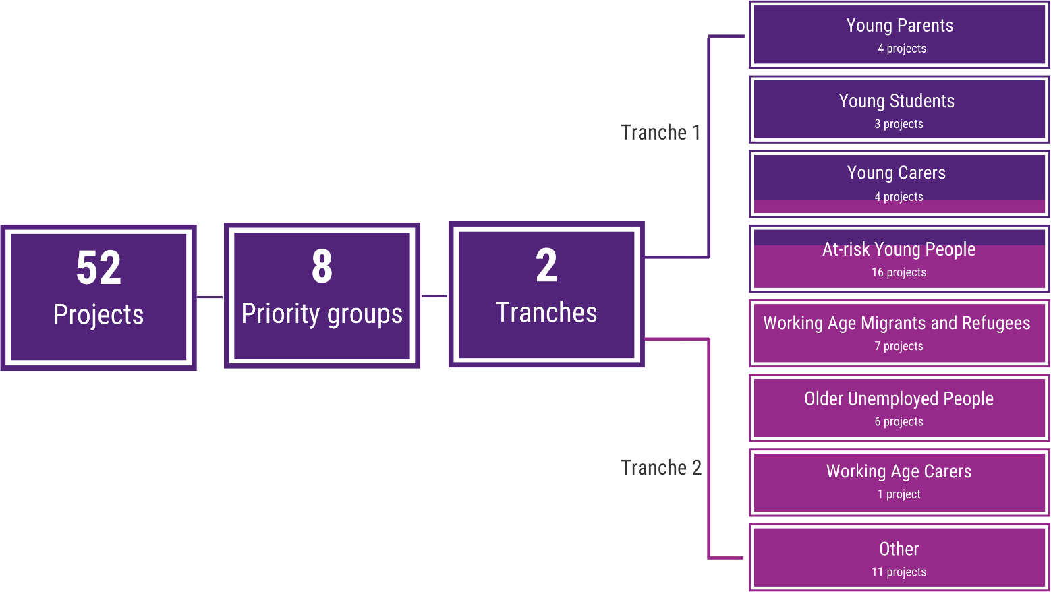
Note: The 52 TTL projects in the 8 priority groups were implemented in 2 tranches. Four projects targeting At-risk Young People were included in tranche 1 as these projects were initially designed for the Young Students priority group and later recategorised. One Young Carer project was implemented in tranche 2



Evaluation approach

Evaluation design
In March 2018, the department commissioned the Institute for Social Science Research (ISSR) at The University of Queensland (UQ), in association with the Melbourne Institute: Applied Economic and Social Research at The University of Melbourne (UoM), to undertake a process and outcomes evaluation to assess the effectiveness of the TTL Fund in achieving its intended outcomes.
The aim of the TTL evaluation is to produce evidence about the effectiveness of the TTL Fund in reducing long-term welfare dependence. The objectives of the evaluation are:
- to examine the extent to which the TTL Fund has met its stated policy objectives, and in the process, determine the TTL Fund’s outcomes, both intended and unintended
- to review the implementation of the TTL Fund and to examine the extent to which projects funded under the TTL Fund have met their stated objectives in order to assess what works, for whom, when and in what circumstance.

Theory of change
A theory of change explains the underlying assumptions of a program, and specifies the mechanism of change. A common way of presenting a theory of change is through program logic diagrams, which highlight assumed causal linkages between elements within the program and outcomes achieved. The aim of the program logic is to identify what is most necessary to produce the intended outcomes.
The theory of change underpinning the TTL Fund draws on human capital, job search, life course and ecological systems theories. These explain how individuals develop, or fail to develop, capabilities such as job skills or knowledge. In brief, the capabilities an individual develops over their life course depend on the resources available to the individual and the context in which the individual lives. (See Appendix B for theory of change and program logic.)

Research questions
The evaluation examines the effectiveness, efficiency and appropriateness of the TTL Fund and TTL projects by answering the following key research questions.
Effectiveness: What works, for whom?
- How representative are the participants in the TTL projects of the at-risk groups as identified under the PIA?
- To what extent does the evidence suggest that the TTL projects have helped increase the skills and capacity of individuals to participate in social and economic life and live independently of welfare?
- To what extent does the evidence suggest that the TTL projects have helped to improve the health and wellbeing of individuals at risk of welfare dependence?
- Did the TTL Fund and cohorts meet their stated objectives?
Efficiency: Cost-benefit?
- How cost-effective were the TTL projects?
Appropriateness: Processes support objectives?
- How appropriate was the development of the TTL projects in the TTL Fund?
- How appropriate was the department’s implementation of the TTL Fund?
- How appropriate was the data quality implementation, DEX training and support provided by the department?
- What impact did the TTL Fund have on the service provider community and government processes?
Overall: Lessons learned
- What are the lessons learned about promising approaches for future investment?
- Did the TTL Fund meet its stated objectives?
- To what extent does the evidence suggest that the TTL projects have helped to have a more cost- effective, sustainable welfare system for those who need it?
- Are there indications that lend confidence to the underlying theory of change, program logic and assumptions?

Research methods and data collection
To answer the research questions, the TTL Evaluation uses a mixed methods research design, embedding qualitative methods within a quasi- experimental design. The evaluation incorporates multiple forms of data and methods of analysis to ensure the evaluation is comprehensive. (See Appendix B-3 and C-2 for full description of data sources and methodologies for each part of the evaluation.) Integration of different kinds of data (Figure: 2) and analysis strengthens the insights, and was achieved by drawing on the findings from a number of measures used to determine the effectiveness, efficiency and appropriateness of the TTL Fund (detailed in Appendix C-1).
To evaluate effectiveness, impacts of the TTL projects on income support and employment income measures were examined by comparing outcomes for TTL clients to people with similar characteristics and circumstances who did not participate in any TTL project (comparison group) over time (impact analyses). TTL service providers also reported on the number of clients who moved into employment or education in their Activity Work Plan (AWP) reports. Findings from the qualitative interviews with TTL clients provided insights into outcomes for clients not captured in the quantitative data, including self- reported improvement of skills, capacity, and health and wellbeing. Pre-post analysis of data collected by TTL projects was used to examine changes in TTL clients’ circumstances and goals (see DEX SCORE in Appendix B-3-2). The TTL clients’ characteristics were compared to people in the population identified in the PIA as being at risk of long-term welfare dependence to determine the representativeness of TTL clients.
A CBA was conducted to evaluate the efficiency of the TTL Fund. The analysis compared average cost per participant, including TTL-related costs to the department, and the change in outcomes for clients as determined in the effectiveness analysis (benefits) by priority group, with information at the project level aiding interpretation of the results.
Findings from the thematic analysis of data from group interviews with TTL service providers and TTL Fund documentation provided insights into the appropriateness of the processes of the TTL Fund for achieving its objectives.
Figure: 2 Data sources
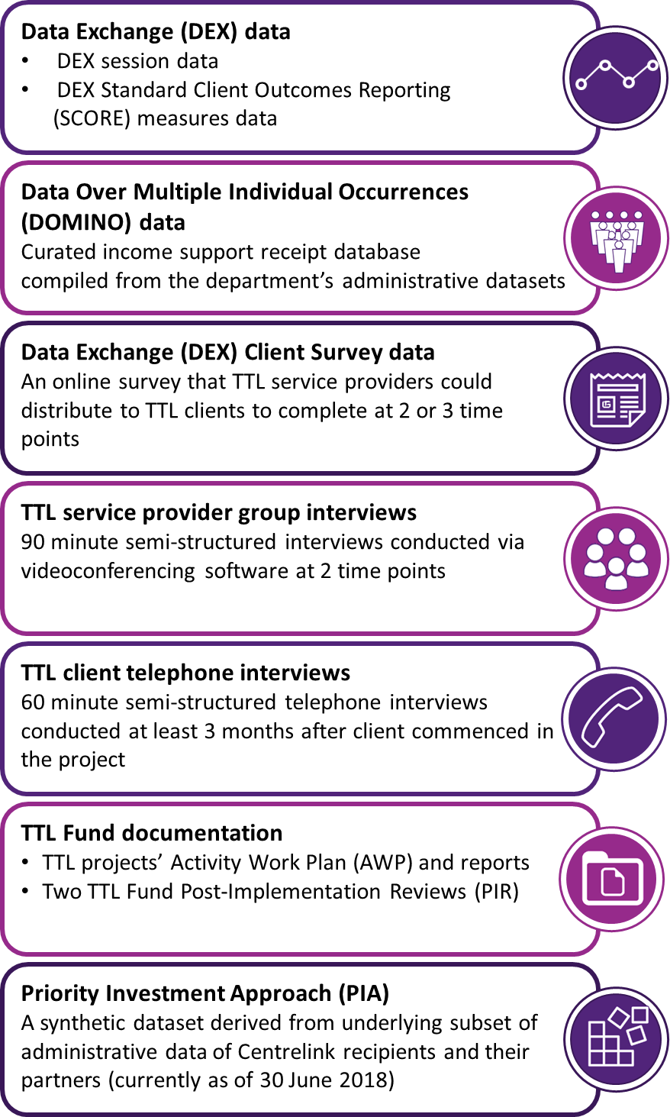
Note: Full description of data sources available in Appendix B-3

Limitations
Some key limitations to the evaluation should be taken into consideration when reviewing the results.
To measure the impacts of the TTL projects, TTL clients’ outcomes were compared to people with similar characteristics and circumstances who did not participate in any TTL project, that is, a comparison group from the DOMINO population (see Figure: 2). This was to test whether any changes in TTL clients’ outcomes were due to participating in the projects. This methodology is considered best practice for the type of evaluation needed for TTL and with the data that were available. However, there are limitations and these results must be interpreted with caution.
It is possible clients who were recruited to TTL differed from the comparison group in ways that could not be observed, but could impact on client outcomes. The creation of the comparison group was limited by the variables available in the dataset, and being able to find individuals with similar characteristics in the administrative dataset (DOMINO) who did not take part in a TTL project. The possibility that clients who were recruited to TTL were different to their comparators in ways that cannot be observed in administrative data, but were likely to also impact on outcomes, cannot be ruled out (e.g. mental health issues and personality traits). Although psychological condition was used as a matching characteristic, this includes a wide range of conditions from anxiety and depression to psychotic disorders. It is not possible to verify that the matching produced a truly comparable sample, and the credibility of the assumptions underpinning conclusions of the impact analyses may vary from project to project depending on the types of clients recruited. The TTL client and comparison groups were tested for similarities on characteristics after the matching process, and characteristics that differed significantly between the two groups were controlled for to try and address this issue. Sensitivity tests conducted at the project level suggest that the results are robust to the inclusion of extra controls (such as mental health identifiers) that are not perfectly measured but may be correlated to personal traits
that are not in the data. This provides some confidence that the results are not completely driven by controls that are not in the data, but the possibility cannot be ruled out.
Impact analyses restricted to DOMINO limited insights into the possible impacts of the TTL projects. Impact analyses were only able to observe changes in income support receipt and employment income as outcomes. Changes in health and wellbeing, skills, capacity, or education and qualification attainment were not directly available in the DOMINO data and could not be reliably estimated using other data sources. DEX SCORE and client survey data provided suggestive evidence of these types of impact, however this was limited to a small proportion of clients (that were unlikely to be representative) with data at 2 time points. Changes in education were estimated using the proxy measure of an increase in student income support receipt. This may not reflect all educational participation, such as apprenticeships or traineeships. It also did not allow for the detection of educational engagement such as subject completion, and it limited the analysis to individuals observed in the DOMINO data, which excluded TTL clients under 16. Education qualification attainment is likely to have the greatest longer term impact on outcomes for TTL clients, thus the limitations on how education qualification attainment could be measured are problematic. Due to this lack of data availability, the efficiency analysis in Chapter 4 has a strong focus on employment and income support outcomes. Further, employment income reporting is only available while clients are on income support. Once clients move off income support, it is unclear where they go; it is optimistically assumed that they exit due to employment income.
The impact analyses were not able to properly measure intensity of treatment. Completion rates and intensity (e.g. number of sessions, time in different types of sessions) are important outcomes that provide contextual information to help in the interpretation of the results. The data available for the evaluation was not reliable.
Although outcomes were tracked longitudinally in the data, there was no consistent way in DEX of recording the level of service delivery (e.g. hours

of service received), the intensity of treatment or client completion of the project over time. There were inconsistencies in how service providers recorded both the sessions and the services being delivered in the sessions. Thus, relative rates of service delivery, project completion or the impact that completion may have had on outcomes could not be measured.

Some tranche 2 projects had to significantly change their design, or experienced significant impacts on their implementation, due to COVID-
19. The impact analyses prevents neither the TTL clients nor the comparison group being favoured/penalised because of different exposure to macroeconomic conditions (e.g. job loss due to COVID-19) or other national trends, such as policy changes (e.g. JobKeeper), these analyses could not control for the variable impact on project implementation and dilution or cessation of services during COVID-19 restrictions which affected some geographic areas more than others. Some projects had to adjust, or pause implementation completely, during the COVID-19 restrictions. This posed challenges for the evaluation because it was difficult to identify what types of services clients received and make judgements about the effectiveness of the project overall. Extensions were granted to some projects to allow them to be completed, but COVID-19 restrictions still had 2 main impacts. First, it reduced the time available to tranche 2 projects to show impacts compared to tranche 1 projects, and second, some projects could not deliver their original design and instead had to adjust their project to fit the restrictions. This may have limited the impact these projects could have had on their clients and thus what could be observed in the analyses.
The short observation period for the TTL clients, especially for tranche 2 projects, limited insights into the possible longer term impacts of TTL projects. The data available for the impact analyses ranged from 6 to 24 months post- commencement. To measure the long-term outcomes of these projects, even 24 months is a fairly short duration. A short observation period leaves insufficient time for employment outcomes to eventuate for less work-ready groups such as young parents with young children, and for flow-
on effects from additional education or improved health and wellbeing to occur. The variation in the duration of the observation window made comparisons of the cost-benefit ratio across projects problematic. In addition, some projects were still delivering services after the analysis cut- off date of 30 June 2020, which makes it unlikely these projects can be adequately assessed.
The sample size and self-selecting nature of the TTL clients who answered the DEX SCORE and TTL Client Survey limited the use of this data in the evaluation. DEX SCORE and DEX Client Survey data were unlikely to be representative of all TTL clients and were only available for a small proportion of TTL clients. Furthermore, the validity of the DEX SCORE and TTL Client Survey instruments has not been previously established. The DEX SCORE was also measured in different ways in the various projects. Measurement errors (and inconsistencies) may have limited the comparability of results across projects and the ability to detect change. If errors or differences in the exact measures used were systematically related to client or project characteristics, this may lead to bias in estimates. As well as a lack of validity, there was no uniform application of the DEX SCORE instruments, which made comparisons of SCORE results across projects difficult.
Analysing the TTL Client Survey data, it was difficult to identify which was the pre and which was the post survey. The time point was indicated by one variable where TTL clients self-identified what stage of the project they were in (beginning, middle or end). This was prone to error, with some TTL clients having completed multiple surveys at one time point. Self-reporting the stage of the project introduced further error, where some TTL clients had completed an endpoint survey before a middle or beginning survey, making it difficult to ascertain which survey was pre and which was post. Finally, the TTL Client Survey did not include non-TTL participants, which means comparison against similar income support clients who did not participate in the program was not possible. Such a comparison is important to help rule out other trends in the environment (such as labour market or policy changes) that may have impacted pre-post changes in TTL Client Survey indicators.

The self-selecting nature of the sample for the qualitative client interviews was a limitation. The qualitative client interviews are a rich source of information, and provide insights to the experiences and impacts for clients. However, the interviews only represent a small proportion of TTL clients, and capture a particular moment in time, thus limiting insights about longer term outcomes. It is also possible that the TTL clients who agreed to participate in interviews differed from those who did not, and, although considerable efforts were made to reach clients who dropped out and accommodate all clients (e.g. allowing for written interviews, or calling out of business hours), it was difficult to access those who had dropped out of the projects for the interviews. Therefore, the experiences for those clients who did not continue in the projects is unknown.
The CBA could not distinguish between set-up and ongoing costs of projects due to insufficient information. The CBA relied on the impact analyses to calculate the benefits, and so shares the limitations of these analyses. In addition, the available information about the projects and departmental costs was not sufficiently detailed to allow separation of set-up and ongoing costs. This impacts on what can be said about the estimated future costs of these projects.
The change in income from employment while on income support could not be used in predicting the lifetime welfare cost in the scenario with and without participation in TTL, so that the predicted welfare cost savings are likely to be underestimated for those TTL projects that
experienced an increase in the probability of participants earning income from employment while on income support.
The TTL Fund focussed on individual rather than systemic change. An alternative or simultaneous focus could have been placed on reshaping institutions, such as schools, communities, government or non-government organisations to build awareness of the challenges faced by long- term welfare recipients and to change institutional structures to provide alternative support systems. Such an approach would likely require legal changes to policy frameworks and coordination across multiple government agencies to implement and trial. It would also require different data to measure outcomes including both data on individual outcomes but also on organisational change.



Effectiveness

Effectiveness
The TTL projects vary in their overarching objectives, project designs and scope, and are directed at different client groups, even within priority groups. They share, however, an ambition to use innovative approaches to support priority groups at high risk of long-term welfare dependency to participate in the labour market and improve their overall wellbeing.
This section evaluates how well the TTL projects have assisted the target populations to improve their skills and capacity to participate in social and economic life and live independently of welfare in the long term. Analysis of administrative data (DEX and DOMINO), quarterly progress reporting (AWP reports) and interviews were used to examine the impact of the TTL projects and changes in the TTL clients’ lives. Improvements were assessed via a combination of work and educational participation outcomes, skills and capacity outcomes, and health and wellbeing (see Appendix C-1 for a description of measures).
Findings are presented at the Fund level and for each priority group. The At-risk Young People group is split into tranche 1 and tranche 2 because some clients in this group were initially categorised as Young Students in tranche 1, and later recategorised as At-risk Young People.
Therefore, the eligibility criteria for At-risk Young People cannot be strictly applied to this group.
The evaluation presents the findings separately to accommodate this difference.

The evaluation examined 5 overarching outcomes to test the effectiveness of the projects. Workforce participation was measured by conducting impact analyses examining income support and employment income while on income support. Educational participation was measured using student income support as a proxy. These outcomes were measured quarterly from the time of client commencement, which varied from project to project based on commencement data.
Skills to support work or education; capacity (overcoming non-vocational barriers); and health and wellbeing drew on client- and service provider-reported information to provide insights at a particular point in time (cross-sectional data). Workforce and educational participation are also complemented by these qualitative data. (See Figure C-1 for information on client-reported outcome measures and Appendix D for summaries of outcomes by priority group.)

Overall TTL Fund
An analysis of the PIA data shows that in 2014–15, the average estimated future lifetime costs per person for priority groups ranged from $306,000 for the At-risk Young People priority group to
$547,000 for the Young Parents priority group. The TTL projects were intended to support individuals and families from the identified at-risk priority groups to live independently of welfare, improve their wellbeing and maintain a safety net for individuals who require it.
This section examines the effectiveness of the 52 TTL projects at the Fund level. Findings were synthesised across data sources to identify project-level characteristics that contributed to the impact projects had on TTL client outcomes. However, it is important to note that any differences in impacts across projects is just ‘suggestive’ of the relative impacts because of differences in nature and circumstances of clients that the projects served. To do this would require greater standardisation of clients across projects to generate a single priority group benchmark against which all projects in the priority group could be compared. Similarly, when describing relative project success in outcomes examined, the TTL Evaluation Team cannot make definitive claims about what services were responsible for the different outcomes. In practice, projects comprise bundles of services and differences in
outcomes cannot be attributed to any one service.
This evaluation is not able to make any definitive statements about the relative effectiveness across projects because outcomes are not compared across a common counterfactual scenario.
Nevertheless, a number of project-level characteristics such as: project type (ongoing, fixed, or ongoing and fixed); main session type; use of screening tools; experience working with the priority group; use of mentors; and new versus existing projects that were adapted were examined. There were no observed patterns across these project-level characteristics. The findings were synthesised according to the
indicative evidence that differences in impacts reflected the service delivery approach taken.
At a glance, the results indicate:

Overall, the TTL clients partly resembled the at- risk groups identified by the PIA modelling.
Eligibility criteria could be broadened to reflect the true spectrum of at-risk clients and to align more closely with what is practical and implementable.
- Taking other factors into consideration, such as family or personal income support history, showed that two-thirds⁹ of TTL clients were likely to be at high risk of future welfare dependency and therefore resembled the at- risk groups the TTL Fund aimed to support. However, it needs to be noted that half of the clients recruited to participate in the TTL projects were not on income support at client commencement and/or were outside the target age, thus were not representative of the at-risk groups identified by the PIA modelling.
- Half of the TTL projects (for which there is data) recruited clients who were on average experiencing less disadvantage than the average income support recipient who met the eligibility criteria. Therefore, it is unclear whether the effectiveness of some projects is translatable to more disadvantaged communities based on the available evidence.
- Only 13 projects specified income support receipt as a criterion for their project. Instead, most focused more broadly on clients at risk of long-term welfare dependence, indicating that the broader priority group eligibility criteria that were informed by the PIA modelling were not always implemented in practice.
- TTL projects that targeted clients aged 16–24 years found recruiting clients according to the age criteria challenging as it often did not reflect the age of the individuals ready for, or most interested, in the project. This was notable for Young Parents and At-risk Young People projects. This indicates that the eligibility criteria for some service models

⁹ This proportion is underestimated for 2 reasons. First, 21% of all clients could not be matched to DOMINO. Second, family history was not calculated for TTL clients under the age of 16 because these clients would not have the outcomes in the administrative data needed to measure impact.

could consider the life course stage of the clients to ensure services are suitable.
  - TTL service providers reported they were not readily able to identify whether individuals were on income support, making it challenging to implement this criterion in practice. Further, if services were not given a jobactive code, then individuals on income support needed to receive these services over and above other mutual obligations that they needed to fulfil, which was identified as a strain on the client and impacted recruitment.
  - Lastly, implementing the eligibility criteria in practice may have led to people at risk of long- term welfare dependency missing out on the opportunity to participate in the TTL projects. For example, projects delivering services in certain catchment areas (such as rural locations) found there was a limited sample that fit the specific criteria (e.g. age), despite there being a demand for their services in that community.
There are indications that some TTL projects achieved early successes to improve 5 overarching outcomes for clients.
  - At least half of the TTL clients reportedly increased workforce or educational participation (for the remainder of clients, no increase was reported or data was not available).
  - At least two-thirds of TTL clients reportedly increased skills that may support them to participate in work or study (the remaining one-third comprised clients where no increase was reported or where data was not available).
  - There are some indications of improvement in the reported capacity of TTL clients to participate in work/study, though the data are limited. One of the areas clients identified as improved was their caring responsibilities, which clients had reported as a barrier to work or study.
  - There is suggestive evidence that TTL clients improved their health and wellbeing and access to support networks.
- TTL clients differed in their level of capacity to work, and had a number of vocational and non- vocational barriers to overcome.
Matching the appropriate service delivery with the extent to which clients’ non-vocational barriers were addressed provided one plausible explanation of why some TTL projects showed early success compared to others. It should be noted that such findings are indicative. A meta- synthesis of the findings presents the effectiveness of the TTL projects in the Fund by service delivery approach.
- For relatively work-ready TTL clients, an employer demand-led approach to work placements was effective in decreasing income support and led to more sustainable employment. Service providers know what type of clients are going to benefit from projects that provide direct pathways into work, and so target that type of client for their project.
- Generic placements were not effective at decreasing income support and increasing employment in the short term, but helped to improve skills and capacity on the pathway to work.
- For relatively work-ready TTL clients, a project that provided targeted vocational training, together with a pathway into a job (work experience or placements that led to job offers) using that training, was effective in decreasing income support.
- Generic vocational training was not effective at decreasing income support and increasing employment in the short term, but helped to improve skills and capacity on the pathway to work.
- An individualised mentoring approach led to increases in education participation, skills and capacity.
- Personalised support programs addressing non-vocational barriers may lead to improved educational engagement and attainment and increased skills, knowledge and capacity.
- Projects seeking to improve outcomes for clients with higher vocational barriers to

employment need to begin with more basic skills such as soft skills and career guidance. Those projects may not immediately move clients into employment, but the vocational support can improve their skills, and be an important first step on the path to work.
  - Vocational support integrated with services to address non-vocational barriers was effective in increasing the skills and capacity of clients to prepare them for workforce participation.
  - Addressing non-vocational barriers through intensive case management and individualised support helped increase skills and the capacity to work or study. These barriers are often complex and require intensive case management and individualised support before clients can start working on vocational barriers or consider participating in work. This does not diminish the value of such projects — instead, addressing non-vocational barriers is a starting point rather than an ending point.

TTL Fund background
There were 52 projects funded across the 8 priority groups.
The TTL projects were primarily directed at:
- providing employment opportunities through work placements
- education participation and attainment
- providing vocational training with/without work experience
- providing vocational support
- providing non-vocational support.
(See Appendix A-2 for summaries of each project.)
In total, 5,201 clients were recruited across the Fund (as recorded in DEX), 5,108 started the projects, and impact analyses were conducted for 3,379 TTL clients across 34 projects. (See Table C-2 for projects included in impact analyses.)

    - How representative are the participants in the TTL projects of the at-risk groups as identified under the PIA?
To assess whether TTL clients were representative of the at-risk groups identified by the PIA, income support receipt and the age group determined by the priority group definitions were examined.

Overall, the TTL clients partly resembled the at- risk groups as identified by the PIA modelling. Eligibility criteria could be broadened to reflect the true spectrum of at-risk clients and to align more closely with what is practical and implementable.
Taking other factors into consideration, such as family or personal income support history, showed that two-thirds of TTL clients were likely to be at high risk of future welfare dependency and therefore resembled the at risk-groups the TTL Fund aimed to support. However, it needs to be noted that half of the clients recruited to participate in the TTL projects were not on income support at client commencement and/or were outside the target age, thus were not representative of the at-risk groups identified by the PIA modelling. Since half of the TTL projects recruited clients who were on average experiencing less disadvantage than the at-risk groups identified in the PIA modelling, it is unclear whether the effectiveness of some of the projects is translatable to more disadvantaged communities based on the available evidence.
Overall, 54% of clients were not representative of the at-risk groups in terms of income support receipt or being in a specific age group. This figure is predominantly driven by 34% who were not in receipt of income support at the time of commencing in the TTL projects. On average, TTL clients spent 222 days less on income support in the 2 years prior to client commencement compared with the average income support recipient identified in the PIA. This difference varied across priority groups, from 101 for Young Parents to 422 for Young Carers.
For some priority groups (Young Carers, Young Students and At-risk Young People – tranche 2), the TTL clients were, on average, younger, thus less likely to be on income support in their own

right. Similarly, newly arrived migrants are not able to access income support for the first 12 months, and consequently are not recorded in the DOMINO data.
Although the broad criteria for most priority groups included income support receipt, only 13 projects specified this as a criterion for their specific project. Instead, most focused on other circumstances that may make clients at risk of long-term welfare dependence. Examining family history on income support shows that many TTL clients came from families who had been on income support for at least 12 months in the past 2 years. It can be argued that such clients are within scope, as research has shown that young people are almost twice as likely to need welfare if their parents have a history of receiving welfare (Cobb-Clark et al. 2017). Taking these clients into consideration reduced the number of clients who were not representative to 44%. Further, if the proportion of TTL Fund clients who were not on income support at client commencement were examined but who had received income support for at least 12 months in the 2 years prior, the number of clients who were not representative reduced further to 38%. This highlights the need to consider broadening the eligibility criteria simulated in the PIA to reflect the true spectrum of those at risk of long-term welfare dependence, and accurately revalue the lifetime liabilities after receiving targeted investment.
Nevertheless, identifying and recruiting at-risk groups can be challenging. Firstly, implementing the eligibility criteria in practice can be difficult and time-consuming for projects, particularly identifying clients on income support. Most service providers may not have had access to relevant information or data necessary to identify those who are on income support. For example, Young Carers projects struggled to identify young carers without using administrative data like Centrelink to locate and recruit them. For those groups with mutual obligations, utilising organisations such as jobactive providers to refer clients could mitigate this. However, many service providers who tried this approach reported that building these relationships took considerable effort, often with little to no return. This was exacerbated when TTL projects were not
considered registered services. Support to access jobactive codes could be provided to ensure services are a viable option for referrers for those at-risk groups that have mutual obligations.
However, for other at-risk groups such as Young Carers, alternative ways to identify and recruit these at-risk groups needs to be considered.
Service providers from 29 TTL projects reported in the interviews that they experienced additional recruitment challenges relating to project-level eligibility criteria. First, the catchment areas selected (such as rural locations) had a limited sample from which to recruit. Though services may be required in these areas, the need to reach target numbers may have been at odds with the level of demand. Second, where there were many potential clients who met the criteria, service providers found that some of these potential clients did not have the capacity to work due to mental or physical limitations, thus the project was unsuitable for them at that point in time.
While a few projects incorporated services to support these limitations, other projects referred clients to organisations that could support these clients, with the proviso that they could reapply for the project once they had the capacity to work. Third, almost all of the projects targeting individuals aged 16–24 years found recruiting clients according to the age criteria challenging. Providers reported that the target age did not reflect the age of the individuals most interested in the project: Young Parents projects found older parents were more interested in participating in the project; Young Students and At-risk Young People (tranche 1) projects struggled to find participants 18 years and older. These projects had a lot of interest from people aged under 16. These findings suggest that the target age range was not always fit for purpose and that projects need to be afforded the flexibility to adjust the age criteria based on the needs of the clients.
Fourth, translating the eligibility criteria into recruitment material was challenging. Older unemployed people often had more complicated financial lives (with partners earning higher amounts, or being able to pull from their super) that could make such language a deterrent and difficult for clients to self-assess. Likewise, translating the eligibility criteria of students who

are ‘at risk of moving to an extended period of unemployment benefits’ was difficult to implement in practice. Lastly, service providers felt ethically challenged to help people who were vulnerable and in crisis, as described below:
I had a parent come to me with a 14-year-old that dropped out of school, trying to get her back into school […] You can’t wait 12 months for the girl to turn 15 [to be eligible for the project]. We’ve got to get her back to school. (SP, #12)
Half of the TTL projects (for which there is data) recruited clients who were on average experiencing less disadvantage than the at-risk group identified in the PIA. Therefore, it is unclear whether the effectiveness of some projects is translatable to more disadvantaged communities based on the available evidence.
Examining 4 additional disadvantage indicators showed that 17 of the 34 projects with data had clients who were on average living in more advantaged circumstances relative to the average income support recipient identified in the PIA. Service providers reported that the most vulnerable and disadvantaged individuals either had complex needs that required additional time and attention, or these complex needs created non-vocational barriers that impacted their capacity to work. This links back to the recruitment struggles some projects experienced, and that they were not prepared for the level of non-vocational barriers clients presented with.
    - To what extent does the evidence suggest that TTL projects have helped increase the skills and capacity of individuals to participate in social and economic life and live independently of welfare?
At least half of TTL clients reportedly increased workforce or educational participation (as reported in DEX SCORE).
The evidence from various data sources suggests an increase in work/study participation (excluding the impact analyses, which do not have specific variables measuring workforce or educational participation). The results from DEX SCORE pre- post analyses (Figure D-4) showed an
improvement in clients’ employment (63%) and training (59%) outcomes. TTL clients interviewed (n=230) also specifically reported an increase in work (23%) and education (37%) participation. TTL clients were asked what changed and not all outcomes may have been discussed during the interview, therefore it is unclear whether they experienced improvements or not. Client reports in interviews were further supported by a subset of service providers, who reported an increase in work (32% across 31 TTL projects) and study participation (22% across 23 TTL projects) in their AWP reports.

At least two-thirds of TTL clients reportedly increased skills that may support them to participate in work or study.
DEX SCORE results indicated that 65% of clients improved their skills outcomes. Seventy-four per cent of clients interviewed also reported improvements in skills. These were predominantly soft skills (34%) and job search skills (36%) for clients interviewed. TTL clients mentioned applying these skills to their continued job search efforts:
The biggest change was getting job-ready and getting the experience and being able to have something to talk about in interviews now. I feel like it’s definitely something that […] has really helped. (client, #9)
The remaining clients may not have discussed these outcomes in the client interviews, therefore it is unclear whether they experienced improvements or not.

There are some indications of improvement in the capacity of TTL clients to participate in work/study, though the data are limited.
Client interviews were the only source of data on clients’ capacity. Fifty-four per cent of the TTL clients reported an improvement in their capacity to participate in work or study. TTL clients differed in terms of capacity to work and had a number of vocational and non-vocational barriers to work or study participation. The most prevalent vocational barriers for TTL clients were: a lack of work experience (48%), the cost of items for work (38%), education (34%) and transport (32%). The most prevalent non-vocational barriers were:

mental health (34%), housing (25%), physical health/disability (24%) and caring responsibilities (19%) (Figure D-1).
Matching the appropriate service delivery with the extent to which clients’ non-vocational barriers were addressed provides one plausible explanation of why some TTL projects showed early success compared to others. A meta- synthesis of the findings presents the effectiveness of the TTL projects in the Fund by service delivery approach.
For relatively work-ready TTL clients, an employer demand-led approach to work placements was effective in decreasing income support and led to more sustainable employment. This finding is consistent with the employer demand-led models used in the US and UK to support disadvantaged jobseekers (Sissons & Green 2017; Fletcher 2004) and recently in Australia to support Indigenous jobseekers (Vocational Training and Education Centres). This employer demand-led approach to work placements was incorporated in projects in the Young Parents (1 project) and Other (1 project) priority groups. Strong evidence supports the use of this approach with Young Parents, but there is insufficient data to support the use of this approach with the Other priority group.
The employer demand-led placements involved service providers acting like a broker, where the needs of the employer were identified first and were matched to suitable TTL clients based on their assessed vocational interests and capabilities. But barriers to attaining ongoing employment, such as mental health issues, must be addressed first. Clients in the employer demand-led projects (In-School Parent Employment Services) were 23 percentage points less likely to be on income support in the last month post-commencement of the project compared to the comparison group (Figure D-5). While only qualitative data exists, there are positive signs that Demand-led Education to Employment in Care has also been achieving employment outcomes.

Generic placements were not effective at decreasing income support and increasing employment in the short term, but helped to
improve skills and capacity on the pathway to work. It is possible that exposure to a work environment may develop general skills, such as time management and interpersonal skills, as well as networks that may lead to more favourable outcomes in the longer term. The generic placement approach was incorporated in a project in the Young Parents (1 project) priority group.
This project was not effective in the short term. Train and Care clients were 15 percentage points more likely to be on income support 18 months post-commencement relative to the comparison group (Figure D-5).
For relatively work-ready TTL clients, a project that provided targeted vocational training, together with a pathway into a job (work experience or placements that led to job offers) using that training, was effective in decreasing income support. This targeted vocational training approach was incorporated in projects in the At- risk Young People (tranche 1 — 2 projects), At-risk Young People (tranche 2 — 1 project), Migrants and Refugees (3 projects) and Older Unemployed People (1 project) priority groups. All of these projects were effective.
Projects that offered their clients intensive training in industry-specific skills directly related to job opportunities, together with a pathway into a job, had fairly immediate impacts on skills and receipt of income support payments if those clients were already relatively work-ready. To be job-ready, clients need support to address complex needs such as mental health, homelessness or caring responsibilities that may have impacted their capacity to work (a non- vocational barrier). Until these clients have these supports in place, they will have limited capacity to work. Clients who participated in targeted vocational training projects with a direct pathway into a job (Build and Grow, My Maintenance Crew, Meeting the Youth Gap, Employer-led Refugee Employment project and the Work Work project) were between 7 and 36 percentage points less likely to be on income support payments in the last month post-commencement compared to the comparison group (see Figure D-24, Figure D-31, Figure D-38 and Figure D-45). Build and Grow, the Employer-led Refugee Employment project and the Work Work project were established projects

that were being trialled on a different target group, while My Maintenance Crew and Meeting the Youth Gap were new initiatives. These findings suggest that the success of these projects cannot be attributed to how well-established these projects were. In addition to these 5 projects, there were 2 other projects that used this approach (targeted vocational training). The Women’s Employment into Action project was not effective in decreasing income support, but these clients had reduced days on income support (-8 days) relative to the comparison group (see Figure D-41). The UpCycLinc project was the only project that used this approach to have clients who were on average 9 percentage points more likely to be on income support payments in the last month post-commencement compared to the comparison group. However, these clients were also 23 percentage points more likely to be earning an income while on income support relative to the comparison group 12 months post- commencement (see Figure D-38 and Figure
D-40).
Generic vocational training was not effective at decreasing income support and increasing employment in the short term, but helped to improve skills and capacity on the pathway to work. The generic vocational training approach was incorporated in projects in the Young Carers (1 project), At-risk Young People (tranche 2 — 4 projects), Migrants and Refugees (1 project), Older Unemployed People (6 projects) and Other (3 projects) priority groups. Impact analyses were conducted on 10 of the 14 projects. None of these projects were effective in the short term.
Projects with this approach included Skills for Micro-enterprise, Dunn & Lewis F3style, Leadership, Engagement and Development, RIDE, Brighton Integrated Community Engagement, Multicultural Enterprise Development, Next Steps, Sisters Support Business Together, Career Skills for New Jobs, Reach, Train and Employ, Building Bridges for Mature Jobseekers, IMPACT Club, Online Business Lift-Off and I Am Ready. Clients who participated in generic vocational training, including business training, general skills training, job search and job skills training, were between 5 and 18 percentage points more likely to be on income support payments in the last month post-
commencement compared to the comparison group (see Figure D-31, Figure D-38 and Figure D-45). Only 6 of the 10 projects that had impact
analyses had significant results for this outcome. It may take longer to see employment outcomes for clients in these projects.
An individualised mentoring approach led to increases in education participation, skills and capacity. This individualised mentoring approach was incorporated in projects in the Young Parents (2 projects) and Young Carers (3 projects) priority groups. Impact analyses were conducted on 4 of the 5 projects. Only 2 of these projects were effective.
Projects with this approach included Career Readiness for Young Parents, Supporting Expecting & Parenting Teens, Carer Achievement Pathway, Data-driven Job Opportunities and Young Carer School Accreditation project.
Clients who were provided with individualised mentoring from the Career Readiness for Young Parents and Carer Achievement Pathway projects were between 7 and 8 percentage points more likely to be earning while on income support payments in the last month post-commencement compared to the comparison group (see Figure
D-7 and Figure D-21). The rate of study-related income support receipt increased by 17 percentage points for the Carer Achievement Pathway project, relative to the comparison group (see Figure D-20).
Personalised support programs addressing non- vocational barriers may lead to improved educational engagement and attainment and increased skills, knowledge and capacity. This personalised support approach was incorporated in projects in the Young Students (2 projects — Support for VET Students and Rewire the Brain) priority group. Impact analyses were conducted on both TTL projects and the results showed that both projects were not effective in the short term.
Projects offering personalised support to the Young Students priority group found that income support unrelated to study significantly increased, while study-related income support significantly decreased. These results seem to suggest that these clients are moving from study-related

income support to income support unrelated to study relative to the comparison group. There is also no increase in income while on income support, which is what you would hope to see as these clients start entering the workforce after studying. This priority group also had the highest percentage of clients report mental health as a barrier (65%), which may have impacted their outcomes. The impact analyses were unable to show educational engagement through subject achievement and educational attainment as outcomes, which are much better measures of educational engagement (the main aim of these projects). There was some limited evidence of educational participation through client qualitative and AWP report data. For Support for VET Students, all 6 clients interviewed reported an increase in educational participation or attainment outcomes, and the service providers reported a 47% increase in educational participation (AWP report). Rewire the Brain only had one out of 7 clients report an increase in educational participation or attainment in the client interview. It is likely to take time to observe what flow-on effects these projects have for TTL clients.
Projects seeking to improve outcomes for clients with higher vocational barriers to employment need to begin with more basic skills such as soft skills and career guidance. These projects may not immediately move clients into employment, but the vocational support can improve their skills, and be an important first step on the path to engagement with work. This approach was not effective with At-risk Young People (tranche 1) in the short term.
Young people have specific vocational barriers, such as poor understanding of vocational options available to them, the workings of the job market or workplace etiquette, which are all associated with a lack of work experience.
The findings show that At-risk Young People (tranche 1) projects (Mentoring 2 Work and Y4Y Youth Force) were less likely to have immediate impacts on income support outcomes. The At-risk Young People (tranche 1) clients had complex needs and non-vocational barriers such as mental health problems, contact with the justice system
and risk-taking behaviours, which may be impacting their capacity to work and hence impacting the immediate outcomes for these clients.

Vocational support integrated with services to address non-vocational barriers was effective in increasing the skills and capacity of clients to prepare them for workforce participation.
This individualised mentoring approach was incorporated in 2 projects for the Migrants and Refugees priority group (Sonder Employment Solutions and The Australian Way). Only 1 project had an impact analysis. This project was effective for migrants and refugees. In the last month post- commencement, these clients were more likely to have reduced the number of days on income support (-10 days, Figure D-41) than the comparison group.
Addressing non-vocational barriers through intensive case management and individualised support helped increase skills and the capacity to work or study. This approach was incorporated in projects in the At-risk Young People (tranche 2 — 3 projects) and Other (3 projects) priority groups. Only 3 of these projects were effective in the short term.
Projects with this approach included Your Job Your Way, Dependence to Independence, Lead with Culture, Community Voices, Getting Ready for Take Off and Warra Warra Kanyi.
For 2 projects (Community Voices and Warra Warra Kanyi) the rate of study-related income support receipt increased by 2 to 4 percentage points for these projects, relative to the comparison group (see Figure D-53). Clients in the Your Job Your Way project were 17 percentage points more likely to be earning while on income support payments in the last month post- commencement compared to the comparison group (see Figure D-33).
These barriers were often complex and required intensive case management and individualised support before clients could overcome vocational barriers or consider participating in work or study. This does not diminish the value of such projects
— rather, addressing non-vocational barriers is a

starting point rather than an ending point. These findings were relevant across the priority groups.
    - To what extent does the evidence suggest that the TTL projects have helped to improve the health and wellbeing of individuals at risk of welfare dependence?

Limited available evidence suggests that the TTL projects improved clients’ health and wellbeing and access to support networks.
Two-thirds of all TTL clients interviewed (n=230), reported an increase in health and wellbeing (68%). In the TTL Client Survey, clients who had indicated room for improvement at baseline reported improvements in their mental health (31%) and physical health (38%). Clients also reported improved access to support networks, specifically vocational support (53%) and social support (44%) (Figure D-3).
Thirty-four per cent of clients reported mental health as a barrier in the survey, and 37% expressed mental health concerns in the interviews. Many projects found that their clients required support to improve their health and wellbeing more broadly. Some projects adapted their services to support these clients, while others referred clients to additional support services.
Despite the clear need for support to improve health and wellbeing for at-risk clients, only 11 projects included this as an objective. Seventy-six per cent (42 of 55) of clients from 11 projects (9 had client data) saw improved health and wellbeing. Looking at patterns across all projects in the TTL Fund, there were 14 projects with 80% or higher client health and wellbeing outcomes across 6 of the 8 priority groups. Six of the 14 projects had an objective of improving health and wellbeing (In-School Parent Employment Services, Rewire the Brain, Build and Grow, Community Voices, Dependence to Independence and Next Steps), mostly achieving this through individualised mentoring or the delivery of emotional and wellbeing skills (e.g. Next Steps or Build and Grow), incorporated alongside vocational training. The remaining projects all focused strongly on addressing non-vocational barriers, and often also included ongoing social
contact through the delivery of vocational training (Train and Care, I Am Ready, Work Work, RIDE, Demand-led Education to Employment in Care, Career Readiness for Young Parents, Mentoring 2 Work, Brighton Integrated Community Engagement). Three out of the 4 Young Parents projects had 80% or more of their clients report increased health and wellbeing, indicating that this group may particularly benefit from mentoring and social support. As one young parent stated, they experienced:
[A] relief of feeling disconnected to people, relief of anxiety, because I had anxiety of just talking around people […] It was a big relief just to get in contact and connect with people and just to do something with myself […] I think the biggest thing for me was that I connected with other people, and I haven’t done that for a long time. (client, #3)
Most TTL clients interviewed who reported increased health and wellbeing also reported increased skills and/or capacity (85%), and some explicitly spoke about how their other achievements in the project had flow-on effects to their health and wellbeing.
    - Did the TTL projects meet their stated objectives?
The objectives of the TTL projects focused primarily on improving educational participation, building soft skills and preparing clients to be work-ready to increase workforce participation. To increase work readiness, these projects focused first on providing practical skills training and work experience to increase knowledge, skills and abilities to increase work productivity and capacity (human capital theory). Second, they focused on soft skills and developing job search skills to provide better information about opportunities and how to improve search efforts (job search theory). Third, these projects acknowledged the importance of addressing non- vocational barriers to employment such as mental health, trauma, housing, physical health/disability, childcare, low levels of English language proficiency, and knowledge of workplace culture.
Overall, 13 out of 19 projects met their objective to increase workforce participation and 5 out of

16 met their objective to improve educational capacity. These 2 objectives were able to be assessed by the impact analyses. There is also suggestive evidence that most projects met their objective to increase skills (21 out of 26 projects), capacity (4 out of 6 projects) and health and wellbeing (5 out of 11 projects). It is too early to assess these outcomes for projects in the early phase of implementation. Some projects also struggled to recruit clients, which could mean that differences in TTL clients relative to a comparison group are harder to see in the impact analyses due to the smaller sample. Further, some service providers reported that clients had more complex needs and non-vocational barriers than anticipated: these needed to be addressed first, meaning projects may not move clients into employment in the short term.
It is important to take into account that the length of evaluation period is very short relative to what would usually be interpreted as long term (e.g. 5– 10 years post project completion). The outputs, aimed at building skills and capacities, in line with human capital and job search theory, may mainly generate observable impacts after the time period of the evaluation.

Young Parents
Having a child young can disrupt education and increase the barriers to finding and keeping a job (Kalb, Le & Leung 2015). This can lead to long- term welfare dependency and poorer life outcomes for mothers and their children (Jeon, Kalb & Vu 2011). Research also shows that generational influences play a significant role in the cycle of welfare dependency (Australian Human Rights Commission 2017). An analysis of the PIA data shows that in 2014–15, approximately 4,370 young parents aged 18 and under were receiving Parenting Payment, and it shows that if nothing changes for these young parents, around 70% will be receiving income support in 10 years and around 40% in 20 years. The average future lifetime cost of young parents was estimated at $547,000 per person. The Young Parents priority group is defined as parents under 25, who claimed Parenting Payment when they were aged under 19 and who are still receiving income support.
This section examines the effectiveness of the Young Parents projects.
At a glance, the results indicate:
- The young parents recruited to the TTL projects are mostly consistent with the priority group eligibility criteria.
- Young parents in the TTL projects are less disadvantaged than those identified in PIA.
- An employer demand-led approach to work placements, which links employers with real jobs to suitable clients, is more effective and leads to more sustainable employment than generic placements.
- Addressing vocational barriers prior to work placements is an important ingredient for success.
- Service providers with experience working with disadvantaged groups are better able to deal with their non-vocational barriers.
- All objectives were met, except for one project that was unable to meet the education participation objective and another the workforce participation objective.

TTL projects background
There were 4 projects funded under the Young Parents priority group. Young Parents face a range of barriers to work and/or study (Figure D-10) as reported in the TTL Client Survey; the main ones are a lack of work experience (65%); cost of items for work (49%), caring responsibilities (37%) and mental health (37%).
The dominance of work experience as a barrier reflects the fact that many Young Parents in their early 20s have had continuous caring responsibilities since leaving school.
The 4 Young Parents projects differed in their objectives. In-School Parent Employment Services and Train and Care focused mainly on providing employment opportunities to young parents through work placements. In contrast, Career Readiness for Young Parents and Supporting Expecting & Parenting Teens focused on providing individualised support (through case managers and mentors respectively) to address immediate childcare or health needs and to develop plans for a future return to work. (See Table A-1 for project summaries.) The differences in project objectives reflect different life stages of clients in Career Readiness for Young Parents and Supporting Expecting & Parenting Teens (33% and 44% of clients respectively are pregnant or have a child under 1 year) compared to clients in Train and Care, and In-School Parent Employment Services (11% and 15% respectively). (See Table D-1 for projects’ objectives.)
In total, 672 clients were recruited for this priority group (as reported in DEX), and impact analyses were run for 496 TTL clients in 4 projects. A high proportion of clients that could not be matched were under 16. Except for age, statistical analysis of differences between those who could and could not be linked to DOMINO showed minor differences between the 2 groups. This provides some surety that the omission of those that could not be matched did not severely bias the sample. See Appendix C-2-2-3 (sample definition) for a discussion of this analysis. Project details and all figures and tables are presented in Appendix D-2.

    - How representative are the participants in the TTL projects of the at-risk groups as identified under the PIA?

The young parents recruited to the TTL projects are mostly consistent with the priority group eligibility criteria.
The Young Parents priority group targeted people who were under 25 who claimed Parenting Payment when they were aged under 19 and were still receiving an income support payment. The characteristics of TTL clients were generally consistent with the intended Young Parents priority group, although 11% were 25 or older and 13% were not receiving income support at client commencement. Most of the older clients were from In-School Parent Employment Services.
Service provider interviews suggested that recruitment of young parents under 25 was difficult because they were often still caring for young children, which limited their capacity to participate in TTL and return to work in the short term. It may be more beneficial for future projects working with young parents to consider designing service delivery to provide varying types of support based on the life course stage of the young parent and the age of the children.
This is supported by qualitative evidence that suggests that meeting caring needs was an important motivator for participation in Train and Care:
At the beginning of the program, I think 110% that’s what attracts them to the training camp program, because it’s free childcare and they can find this and they can pay for that. (SP, #3)
Childcare is fully paid for as long as you have your subsidy. Yeah, it’s paid for, for the three days. If you end up with work, which I have, they then follow it on for another six months. (client, #3)

Young parents in the TTL projects are less disadvantaged than the young parents identified by the PIA.
Although the recruitment of Young Parents was mostly consistent with the eligibility criteria, on average they possessed traits at client commencement that made them less disadvantaged than the average income support
recipient who met the eligibility criteria. Compared to the average person who met the criteria, young parents in the projects had spent fewer days on income support (530 vs 617), and were more likely to have completed a Year 12 qualification (vocational certificate, diploma or bachelor degree) (43% vs 33%). They were also less likely to be Indigenous (18% vs 31%) and less likely to have had their first child while school- aged (53% vs 89%). The pressing caring responsibilities of many young parents under 25 may have meant that only those with adequate resources/support were able to participate in the project.
For the impact analysis, excluding those under 18 and those 25 or over did not fundamentally change the main findings. TTL clients were very similar to the priority group average on factors related to family history and living arrangements.
Figure D-10 shows that almost two-thirds (65%) of Young Parents see a lack of work experience as a barrier to economic participation. For many Young Parents who experienced teenage pregnancies, especially those who have several children, caring responsibilities are likely to have been their main activity since leaving school. Consistent with this, Young Parents also report access to childcare (34%) and caring responsibilities (37%) as barriers to economic participation.
    - To what extent does the evidence suggest that the TTL projects have helped increase the skills and capacity of individuals to participate in social and economic life and live independently of welfare?

An employer demand-led approach to work placements is more effective and leads to more sustainable employment than generic placements.
Two projects in the Young Parents priority group offered work placements with a view to improving employment outcomes. The first, In-School Parent Employment Services, adopted an employer demand-led approach. The second, Train and Care, adopted a generic work placement approach. There was suggestive evidence in support of the employer demand-led approach that emphasised the quality of the employer–

client match over job placements that are focused more on providing on-the-job work experience opportunities for jobseeker clients (generic work placement).
It is estimated that clients in the employer demand-led project (In-School Parent Employment Services) were 23 percentage points less likely to be on income support 18 months post-commencement compared to the comparison group. In comparison, clients in the generic work placement project (Train and Care) were 15 percentage points more likely to be on income support 18 months post-commencement relative to the comparison group (Figure D-5).
Employer demand-led placements involve service providers acting like a broker, where the needs of the employer are identified first and are then matched to suitable TTL clients based on their assessed vocational interests and capabilities, but with any barriers to attaining ongoing employment, such as mental health issues and skill gaps, addressed first. Typically, these models also involve ongoing support and mentoring to help smooth the transition to work. Such a model has been used widely in the US and UK to support disadvantaged jobseekers (Sissons & Green 2017; Fletcher 2004) and recently in Australia to support Indigenous job seekers (Vocational Training and Education Centres).
Addressing vocational and non-vocational barriers prior to work placements is an important ingredient for success. Young parents have specific vocational barriers to employment that stems from a lack of work experience (as reported by 65% of clients). Services (and service providers) need to be sympathetic to the specific barriers of young parents, especially a poor understanding of vocational options available to them, the workings of the job market and workplace etiquette. Our results suggest that dealing with these barriers before placements begin is an important ingredient for success, including prior to any work placement. In the case of In-School Parent Employment Services, vocational barriers were addressed by giving Young Parents career counselling before matching them to employers, and they were also provided with job-specific training to prepare them for their work placements. To help ensure success of the
placement, clients received ongoing mentoring to help iron out any issues that the client may have faced, including misunderstandings about job requirements.
For the generic work placement project (Train and Care), an initial failure to address vocational and non-vocational barriers of TTL clients prior to work placements may have limited the chances of sustainable employment in the first 18 months post-commencement.
Participants are securing multiple interviews but failing to get past that first interview. We have attributed this to a combination of inexperience and nervousness. (AWP, #3)
Although they changed their service delivery to address these barriers once they realised the importance of this issue, it takes time to overcome these barriers and see an impact on employment and income support. Their initial failure to address non-vocational barriers as a priority may be related to a lack of experience dealing with disadvantaged populations.
At the start we didn’t think about providing referrals for local community groups [...] We didn’t realise the socioeconomic of that cohort and the poverty was going to be such a big factor. (AWP, #3)
A broader implication is that service providers with experience in dealing with disadvantaged people may be better equipped to meet clients’ non-vocational needs.
Associated with the paid work placement, Train and Care participants were more likely to receive employment income while on income support, relative to the comparison group (Figure D-7).
However, on placement completion at 9 months post-commencement, the rates of employment income among clients fell and became no different to the comparison group by 18 months post-commencement. At 18 months, the rate of income support reliance was significantly higher than the comparison group (Figure D-5 – Figure D-7). This is likely to be because the generic work placement did not lead to sustainable employment, but clients were likely to have ceased other job search activities during the placement.

Among the projects that provided individualised support for a future return to work, only the one that also emphasises work readiness skills (Career Readiness for Young Parents) is estimated to be associated with improvements in outcomes in DOMINO. This project is estimated to have a 7 percentage point increase in income support related to study up to 15 months post- commencement, and a small increase in employment while on income support at 18 months (Figure D-6; Figure D-7).
    - To what extent does the evidence suggest that the TTL projects have helped to improve the health and wellbeing of individuals at risk of welfare dependence?

The client interviews indicated that TTL projects were effective in increasing social and emotional wellbeing for young parents.
Although there were no administrative data on health and wellbeing, there is qualitative information available on 25 out of 672 clients. Of the young parents who were interviewed, most reported improvements in health and wellbeing. Overall, 76% (19 out of 25) reported increased social and emotional wellbeing, including increased self-confidence and a sense of belonging. As these clients testify:
[W]hen I signed up with them I had to do this questionnaire that it was about my emotions and mental health and how I was feeling […] Now that I’ve been in job for a bit, they’ve got me do it again and they compare. So, your emotions, your general wellbeing and how you’re feeling, and it’s improved. (client, #2)
Wouldn’t say a word. I was as quiet as anything, didn’t want to say anything, and I just sat in the back of the corner because I have anxiety issues. And basically [mentor’s] just been working with me constant. Getting my confidence out and making me realise that I am a better person than what I actually think I am. (client, #1)
A third of clients interviewed reported an improvement in mental health (8/25), which relative to the 37% who report that mental health is a barrier to living independently from income
support in the TTL Client Survey, is a substantial proportion. These included the changes illustrated above, but also more subtle personal growth in the capacity to recognise self-worth and relate to others, as this Train and Care client testimonial reported against the AWP indicates:
Before starting this course I felt scared and nervous about doing the course as I struggled to communicate and trust other people. I also struggled with knowing my worth. I didn’t think that I could do good things for myself as I felt selfish if I put myself first but I now understand that bettering myself will not only help me but it will help my children. (AWP, #3)
    - Did the TTL projects meet their stated objectives?

All objectives were met, except for one project that was unable to meet the education participation objective and another the workforce participation objective.
Based on the available evidence and relevant objectives of the different projects, In-School Parent Employment Services appears to have met its objectives to provide employment opportunities through work placements and increase client skills. There is suggestive evidence that it also met its objective to increase client health and wellbeing, based on client and stakeholder qualitative interviews.
Career Readiness for Young Parents was successful in increasing skills and capacity through individualised support to address immediate needs to facilitate the development of plans for a return to work. This was also effective in providing employment opportunities.
Train and Care did not achieve its primary objective to place clients into work, but there was qualitative evidence for achieving outcomes in skills, as well as social and emotional wellbeing, which was not an objective of the project. For Supporting Expecting & Parenting Teens, despite suggestive evidence of positive health and wellbeing outcomes from the client interviews, there is insufficient data to conclude whether its objectives to prepare clients for a future return to education and/or employment was achieved. This is not surprising given that, according to life

course and human capital theory, the achievement of medium- to long-term objectives will likely only become observable after the time frame covered by the currently available data sources. This is particularly pertinent given that Supporting Expecting & Parenting Teens was explicitly engaging clients who were pregnant or with newborn babies and still in school, for whom a return to education or employment was a longer-term aspiration.

Young Students
Dropping out before completing school results in risks of poorer health outcomes, unstable employment and a decrease in lifetime earnings (Leigh & Ryan 2008; Oreopoulos 2003, cited in Dulfer, Rice & Clarke 2017). According to the OECD (2016), the negative long-term consequences of joblessness are likely to be greatest for young people who remain not in employment, education or training (NEET) for long periods.
An analysis of the PIA data shows that while most people who receive student payments exit income support within 5 years, there are some who are at risk of long-term welfare dependency. Between 2003 and 2017, there were 13,400 vocational and university students who started receiving a student payment aged 17–19, and then experienced a period of long-term dependence on unemployment payments.
The analysis shows that if nothing changes for these former young students, around 45% who moved directly to unemployment payments will be receiving income support payments in 10 years, and more than one-third in 20 years.
This section examines the effectiveness of the Young Students projects.
At a glance, the results indicate:
- TTL clients in the Young Students priority group were generally consistent with the PIA criteria in terms of age (<25 years old). However, this priority group was not consistently related to the income support criteria. At a project level, not all projects required clients to be income support recipients at client commencement.
- Young Students in the TTL projects were generally less disadvantaged than the average income support recipient that meets the eligibility criteria identified by PIA for this priority group.
- Personalised support programs addressing non-vocational barriers may lead to improved educational engagement and attainment and increased skills, knowledge and capacity.
- Young students have complex needs, and improvements in non-vocational barriers have not yet translated into employment or independence from welfare outcomes.
- Qualitative evidence suggests that young students improved their health and wellbeing.
- Limited data from 2 projects in this priority group indicated they were meeting their stated objectives to improve educational capacity.
TTL projects background
There were 3 projects funded under the Young Students priority group. All 3 projects (Support for VET Students; Rewire the Brain and Strengthening Students’ Resilience) had educational participation and attainment as their primary objective, with Support for VET Students also focusing on workforce participation and Rewire the Brain on health and wellbeing as additional objectives. (See Table A-2 for project summaries.)
Although some data were collected by the department and Strengthening Students’ Resilience project, these data were not within the scope of this evaluation. For the purpose of this evaluation, the Young Students priority group only includes 2 projects (Support for VET Students and Rewire the Brain).
In total, 759 clients were recruited for this priority group (as recorded in DEX), and impact analyses were run for 571 TTL clients in 2 projects. Project details and all figures and tables are presented in Appendix D-3.

    - How representative are the participants in the TTL projects of the at-risk groups as identified under the PIA?

The clients in the Young Students priority group were generally consistent with the PIA criteria in terms of age (<25 years old). However, this priority group was not consistently related to the income support criteria. At a project level, not all projects required clients to be income support recipients at client commencement.
The Young Students priority group targeted people who were under 25 who had moved, or were at risk of moving, from study (post-

secondary or tertiary, and had been in receipt or were receiving a student payment) to an extended period on unemployment benefits. TTL clients in the Young Students priority group were generally consistent with the PIA criteria in terms of age (<25 years old). However, they were not consistent in terms of the income support criteria. Although overall, one in 3 clients were on income support, only 7% were on student income support at client commencement. In addition, educational status was unknown for one-third of the clients.
At a project level, Rewire the Brain eligibility criteria were modified so not all clients were required to be in receipt of a student income support payment.
Compared to the priority group, Young Students TTL clients were more likely to be younger than 20 years (67% vs 33%); less likely to be on youth allowance (32% vs 48%); and less likely to be on income support for the same proportion of time as people identified in the population that match the PIA criteria (proportion of time >=75% on income support in the last 2 years: 29% vs 61%).
It may have been easier to identify and recruit young students while they were still engaged in education. To do this, relationships between service providers and educational institutions need to be supported to ensure access. Once clients disengage from education, they are less able to be identified.

Young Students in the TTL projects were generally less disadvantaged than the average income support recipient that meets the eligibility criteria identified by PIA for this priority group.
Although the recruitment of Young Students was mostly consistent with the eligibility criteria in terms of age (<25 years old), on average they possessed traits at client commencement that made them less disadvantaged than the average income support recipient who met the eligibility criteria. Compared to the average person who met the criteria, young students in the projects had spent fewer days on income support (281 vs 572), they were less likely to have a qualification less than Year 12 (24% vs 28%), less likely to live in a more disadvantaged area (32% vs 38%), and slightly more likely to live in a region with a high
unemployment rate (61% vs 58%) (Table D-14). They were also less likely to be Indigenous (13% vs 28%) and more likely to have unknown educational attainment status (32% vs <1%) due to being younger.
Figure D-17 shows these young people had complex needs at the commencement of their participation in the projects. At the time of commencing the projects, the top 3 barriers to work/study participation as reported in the TTL Client Survey were mental health (reported as a barrier by 65% of clients in the TTL Client Survey), work experience (reported by 53% of clients) and cost of items for work (reported by 50% of clients).
    - To what extent does the evidence suggest that the TTL projects have helped increase the skills and capacity of individuals to participate in social and economic life and live independently of welfare?
Personalised support programs addressing non- vocational barriers may lead to improved educational engagement and attainment and increased skills, knowledge and capacity. More than one-third of TTL clients in this priority group who had pre- and post-DEX scores reported changes to training and knowledge as a result of participating in the TTL project. TTL service providers were required to collect data through DEX SCORE measures at the beginning (baseline) and end of a TTL client’s participation in the TTL project (follow-up). Figure D-18 presents the proportion of Young Students TTL clients that improved. Improvement is defined as having recorded a more favourable SCORE measurement at the follow-up than at baseline. See Appendix C- 2-3 for detail on DEX SCORE analysis. Data from the client and stakeholder interviews, AWP reports and project evaluation reports for Support for VET Students suggested increased engagement, attendance and attainment in education for TTL clients. For instance, service providers for Support for VET Students indicated in their final AWP report that 82% of their clients had achieved either study goals (retention or attainment of VET program) or work participation as a result of participating in the TTL project (AWP, #5). According to information from the final

AWP report, at least 47% had enrolled in formal education or training and 27% were employed (AWP, #5). Service providers for Rewire the Brain stated in their project evaluation report that 90% of clients were engaged in either education or employment 3 months after the project.
The impact analyses showed that study-related income support declined significantly for clients in the 2 projects (Figure D-13) relative to the comparison group. Further, income support receipt increased (Figure D-12), suggesting that clients may have moved from studying to unemployment. However, there were only a small proportion of young students in the 2 projects who were receiving study-related income support at client commencement, which may inflate these results.
Around 45% of all Young Students clients reported improvements in their circumstances across all 5 domains. The largest reported change was in improved knowledge (67 percentage points), which supports the other evidence that educational engagement increased. Support for VET Students service providers reported that 47% of their clients had achieved improvements in education. Young students reported improved educational skills, such as goal-setting, as evidenced by the following quote:
Oh yeah, definitely. I’ve never been into goalsetting and planning and stuff. I know it’s a thing, like smart goals and stuff, but they sort of force you to persist with it and keep you on top of it, which is only the reason why it actually is happening, these goals. Because if they weren’t there, then I wouldn’t really be as persistent with it as I normally would have. (client, #6)
The main elements underpinning improvements for clients in this priority group may be (i) flexible delivery of a student-centred program, offering services outside of usual business hours and at out-of-office locations convenient for clients; (ii) client empowerment by early interventions addressing mental health needs or referral to other services; (iii) mentor assistance and personalised plans with study (academic and engagement), goal setting, time management and assistance with capacity; and (iv) social
connections, extended hours, functional activities and the provision of snacks that assisted client engagement and led to positive interactions with others with shared experiences. As this client from Support for VET Students disclosed:
[…] the most important thing is how sociable, being able to contact my support person is […] I can just be myself and be able to send texts whenever and not having to work on a scheduled time […] It makes me feel like the worker actually cares about me […] they’re able to see me as a person and I’m able to see them as a person as well as someone who’s there to help. (client, #5)

Young students have complex needs, and improvements in non-vocational barriers have not yet translated into employment or independence from welfare outcomes.
Results from the quantitative impact analyses suggested that improvements in knowledge, capacity and behaviours observed through the qualitative data have not translated into improvements in earnings, employment and independence from welfare. The impact analyses for Support for VET Students and Rewire the Brain showed that the rate of income support receipt unrelated to study for TTL clients compared to a comparison group had increased significantly in the last month post-commencement for both TTL projects (20 percentage points and 8 percentage points), and student income support declined significantly (Figure D-12, Figure D-13), as discussed above. The average number of days TTL clients received income support in a 3-month period, relative to a comparison group, increased significantly for both projects (Figure D-15). The amount of employment income TTL clients earned in a 3-month period, relative to the comparison group, decreased for clients from Rewire the Brain. The increasing trend in employment income for clients in Rewire the Brain, from -$586 to
-$173 relative to the comparison group, 15 months post-commencement, is promising, but overall, the impact analyses indicated continued reliance on income support (Figure D-16).
There were some limited data that suggested improvements in employment had been seen for this priority group, with DEX SCORE data indicating

improvement in employment (51 percentage points), and Support for VET Students stating in its AWP report that 27% of its clients had gained employment.
    - To what extent does the evidence suggest that the TTL projects have helped to improve the health and wellbeing of individuals at risk of welfare dependence?

Qualitative evidence suggests that young students improved their health and wellbeing.
The young people in this priority group have complex needs, as evidenced by the fact that two- thirds have mental health issues, half of them have no work experience and more than 2 in 5 reported having no family or friends (see Figure
D-17). Clients from Rewire the Brain spoke positively about engaging in ‘brain training’ exercises that had been specifically selected for them, based on their needs. Clients also spoke about improvements in mental health, wellbeing and confidence from participating in this project. As one client from Rewire the Brain described:
Mainly just my ability to focus and concentrate from the […] training games and also my confidence in going to new workplace environments […] And with my ADHD and stuff I just couldn’t keep up with the other employees and my confidence was awful. I ended up quitting that job just because I couldn’t handle it. But now I have the confidence to go work anywhere. I know I’m capable and […] I wouldn’t be like that without the […] course. (client, #6)
Evidence from the AWP reports and the service provider group interviews indicated that TTL service providers took a proactive interest in the mental health and wellbeing of the young students and explicitly included activities to address mental health in their project designs.
SCORE results showed a positive change in mental health for TTL clients in 2 projects, and in behaviours (51 percentage points). Further, 40% of clients (based on self-reports from 353 clients from the Rewire the Brain project) had improved mental health. Improvements in health and wellbeing were particularly noteworthy for this
priority group, as poor mental health was the most common barrier to work/study participation.
    - Did the TTL projects meet their stated objectives?

Limited data from 2 projects in this priority group indicated they were meeting their stated objectives to improve educational capacity.
This is based on qualitative data from clients, AWP reports from service providers and DEX SCORE data. There was no evidence supporting this from the impact analyses. Both projects assisted the clients who came into the projects to reduce multiple risk factors. Most clients interviewed reported increased capacity to participate in social and economic life as a result of increased skills acquired during the projects. It is possible that improvement of clients’ complex needs will provide a foundation to improve their health and wellbeing, and in turn their capacity to engage in education and employment. However, for the time available for observation, and based on the limited sample of young students on student support payments, TTL clients seem to move from study-related income support on to income support unrelated to study, suggesting unemployment.

Young Carers
An analysis of the PIA data shows that in 2014–15, approximately 11,200 young carers aged 24 and under were receiving Carer Payment (the number has trebled in the last decade), and the analysis shows that if nothing changes for these young carers, over 60% will be receiving income support in 10 years and around 50% in 20 years. The average future lifetime cost of this group was estimated at $464,000 per person. The Young Carers priority group is defined as people aged under 25 who are eligible for Carer Payment, or are at risk of claiming Carer Payment, due to caring responsibilities for a person with a disability or medical condition.
This section examines the effectiveness of the Young Carers projects.
At a glance, the results indicate:
- The young carers recruited to the TTL projects were consistent with priority group eligibility criteria, although the criteria were modified for this priority group.
- The Young Carers clients were broadly representative of the priority group but were younger and less likely to be on income support at the commencement of the projects.
- An individualised mentoring approach led to increases in education participation, skills and capacity.
- Project design needed to be appropriate for the life course stage of the carer and have suitable outcomes for young carers.
- There is some evidence of improved health and wellbeing outcomes due to support from mentors and opportunities for increased social interaction.
- All projects met their objectives except for 2 projects with an education objective.

TTL projects background
There were 4 projects in the Young Carers priority group, with 3 primarily focused on increasing human capital in the pre- employment stages of the life course, namely access to support services, educational participation and attainment and work skills and planning. (See Table A-3 for project summaries.)
In total, 203 TTL clients were recruited in this priority group, as reported in DEX, of whom 66 appear in the impact analyses. A high proportion of clients could not be matched in the DOMINO data or were not eligible for impact analyses as they were under 18 years of age, not receiving income support in their own right and hence not in the DOMINO data. In the Young Carer School Accreditation project, 85% of clients were under 16 years of age, and in the Skills for Micro-enterprise project, there were only 19 clients with DEX– DOMINO matched data (below our defined cut-off sample size of a minimum of 20 clients for impact analyses using DEX–DOMINO matched data).
Moreover, none of the projects in this priority group reached their target sample sizes, the impact analyses are based on small sample sizes, and evidence from the qualitative analyses provide key insights but they are not representative of all clients and stakeholders. Project details and all figures and tables are presented in Appendix D-4.
    - How representative are the participants in the TTL projects of the at-risk groups as identified under the PIA?

The young carers recruited to the TTL projects were consistent with priority group eligibility criteria, although the criteria were modified at the project level.
The Young Carers priority group targeted people under 25 who were eligible for Carer Payment, or were at risk of claiming Carer Payment, because they were undertaking the care of a person with a disability or medical condition. TTL clients in the

Young Carers priority group were broadly consistent with the PIA criteria in terms of age. Originally, the eligibility criteria included being in receipt of Carers Payment. However, service providers noted in their interviews that they dropped the eligibility criteria requiring that clients be in receipt of Carer Payment, which was approved by the department. Two-thirds of the clients were not in receipt of income support at client commencement, with significant variations across projects. Eligibility for Carer Payment requires that no more than 25 hours per week is spent away from caring on other activities such as study or employment. This rule may have been a barrier to client participation in the TTL projects, as carers may not want to risk compromising their Carer Payment.
Compared to the at-risk group identified in the PIA, the TTL young carers were more likely to be younger than 20 years (76% vs 29%). Overall, 92% of clients were within the target age (<25 years). It is also interesting that 67% of the Young Carers clients were women, with one project recruiting 95% women. This is likely reflective of the gendered nature of care work (ABS, 2020; Australian Human Rights Commission 2018).
Dropping the Carer Payment eligibility criteria may explain why the age of participants was younger than the priority group criteria. There is an emerging consensus that around 10% of children and young people are young carers in Australia, UK and other advanced countries, which far exceeds the initial estimates (Nap et al. 2020; Warren & Edwards 2017). This is further substantiated in the 2016 Longitudinal Study of Australian Children (LSAC), which found at least one in 10 Australians aged 14–15 years self- reported providing care for a household member. Many of these young people are not officially defined as carers and are not receiving Carer Payment. There is a lack of awareness and visibility of young carers, including those who are not officially defined as such, by policy-makers and service providers.

Young Carers in the TTL projects were generally less disadvantaged than the average income support recipient that meets the eligibility criteria identified by PIA for this priority group.
Although the recruitment of Young Carers was mostly consistent with the modified eligibility criteria, on average they possessed traits at client commencement that made them less disadvantaged than the average income support recipient who met the eligibility criteria.
Compared to the average person who met the criteria, young carers in the projects had spent fewer days on income support (170 vs 592), they were less likely to have a qualification less than Year 12 (7% vs 28%), less likely to live in a more disadvantaged area (30% vs 45%), and less likely to live in a region with a high unemployment rate (55% vs 64%) (Table D-14). They were also more likely to have unknown educational attainment status (62% vs 18%), likely due to their age, than those identified by PIA.
Data from the client interviews indicated that the main barriers to study and work faced by these young people are their caring responsibilities, which impact their ability to engage in education, jobseeking and employment. Additionally, the evidence indicates that mental health problems, including feelings of being ‘overwhelmed’ by the conditions of those in their care, were a major barrier.
    - To what extent does the evidence suggest that the TTL projects have helped increase the skills and capacity of individuals to participate in social and economic life and live independently of welfare?

An individualised mentoring approach led to increases in education participation, skills and capacity.
There is some evidence of improved capacity to engage in education and training among clients in this priority group. For example, receipt of study- related income support for Carer Achievement Pathway increased 17 percentage points 12 months post-commencement relative to the comparison group, indicating improvement in engagement in education (Figure D-20). Results from the impact analyses show that the rate of income support receipt between TTL clients and the comparison group for 2 projects (Carer Achievement Pathway and Data-driven Job Opportunities) was not significantly different over

time, indicating no reduction in welfare support for the TTL clients (Figure D-19). For the Carer Achievement Pathway project, the rate of employment income increased by 7 percentage points 12 months post-commencement, though the amount of employment income earned in a 3- month period was negative (Figure D-21). This may indicate that the young carers compromised work hours to prioritise caring responsibilities.
According to information provided in the AWP reports for Carer Achievement Pathway, Data- driven Job Opportunities and Skills for Micro- enterprise, 21–29% found employment and 4– 39% had enrolled in formal education or training. Finishing education is important because those who do not finish are at increased risk of staying on income support, according to the valuation PIA analyses. The results suggest that an individualised approach, combined with training workshops and a strong focus on setting goals in education, working with mentors to assist with job applications and interview preparation, was successful.
For all 3 projects that included client interviews (Carer Achievement Pathway, Data-driven Job Opportunities and Skills for Micro-enterprise), clients spoke about the value of mentoring for their level of engagement and achievement of outcomes. Clients in Carer Achievement Pathway spoke positively about the project incorporating an initial goal-setting activity and described how the mentors assisted them to reach these goals.
… just help build my confidence and skills in terms of resume writing, cover letters, applying. Just everything to do with just job seeking. (client, #26)
In Carer Achievement Pathway and Data-driven Job Opportunities projects, clients spoke about the project service provider acting as advocates for them as carers, and the impact that these responsibilities have on them in accessing educational settings and in the workplace.
… the big thing for a lot of people, especially in their more serious carer role, was that understanding of when finding work […] that
this person is a carer, they have these certain additional, I guess, needs as an employee. (client, #28)
As most projects were focused on building skills and capacity to engage in and complete education, and only one was focused on workforce attainment, these are not surprising results. It may be that there has been insufficient time to observe longer term employment outcomes for projects focused on building skills in pre-employment stages of the life course. It is speculated that successful engagement with employment is more likely once other barriers, such as those to education, skills and capacity, are removed.

Project design needed to be appropriate for the life course and have suitable outcomes for Young Carers.
Young carers face a number of non-vocational barriers to work/study participation. Projects that were designed with these barriers in mind, such as Carer Achievement Pathway, which included goals to build capacity and refer to support services (see project description in Table A-3), showed stronger results from the impact analyses for education outcomes than those that did not. For example, Data-driven Job Opportunities planned to develop and use augmented intelligence and data analytics to match young carers to an available job that was aligned to their interests, along with training and individual support. However, along with a lack of access to data¹⁰, the project found its young clients required more support to overcome non- vocational barriers prior to being matched with a job. Subsequently, the project predominantly delivered individual support to young carers to overcome non-vocational barriers.
In terms of the underlying theories and the complex needs of this group, job search skills may be less important for this group than developing basic human capital skills and providing social support. Job search support is likely to be more effective after non-vocational barriers are improved.

¹⁰ Initial design relied on data from Services Australia (formerly Department of Human Resources) to create phenotypes for the augmented intelligence.

As many of the clients in these projects were younger than the PIA priority group criteria, focusing on building engagement in foundation- level education may be more important than would be the case if the clients were older and had already attained these skills. Job search support, such as the design of the Data-driven Job Opportunities project, may be more useful for older clients who are ready to enter the workforce. Consideration must therefore be given to life course stage as an important criterion when designing projects.
Situations where education and labour market organisations are not cognisant of the responsibilities of carers are likely to provide additional barriers to clients achieving outcomes. For example, the Young Carer School Accreditation project was co-designed in a school setting and engaged clients by the creation of social connections, fun and interactive activities. While it reported 86% of its clients had achieved education outcomes, there was a perceived lack of awareness and flexibility in schools towards young carers according to the service provider interview. This indicates that it is important to build a better understanding in organisations, such as schools, of the responsibilities and constraints faced by young carers. This view is evidenced by the following comment from one young carer.
Because of my care responsibilities, I was taking care of my mum, so I didn’t attend school that much. And the school just keep on contacting me, ‘Why you’re not coming to school?’ […] TAFE was like my last options. […] [CAP service provider] talked to the TAFEs about my situation, financial situation. […] Because I was eligible for their free course. (client, #26)
    - To what extent does the evidence suggest that the TTL projects have helped to improve the health and wellbeing of individuals at risk of welfare dependence?

There is some evidence of improved health and wellbeing outcomes due to support from mentors and opportunities for increased social interaction.
The clients in the Young Carer priority group have complex social, economic and wellbeing needs. In client interviews, many described disrupted education due to caring responsibilities or having to juggle work and education and the impact this had on overall wellbeing. Additionally, many faced financial hardships and insufficient family support. Improving their capacity and skills to engage in education requires attention to these multifaceted needs to create the conditions and circumstances that enable them to engage in activities to improve their participation in social and economic life.
Data from interviews with 9 clients across all 4 projects indicated improved social and emotional wellbeing outcomes, and fewer than 5 clients reported improved physical health. Clients spoke about their mentor helping them to feel happier, and about the value of referrals for additional help with mental health problems. As this Carer Achievement Pathway client testified:
It really helps you out. If there’s anything wrong that you need, they’ll help you. [The mentor] helps me, like if I feel sad or anything she’ll advise me to go speak to someone and they offer that to us. (client, #26)
There is also evidence that participation in the projects led to increased social interaction and social support, which was well received by the clients. They appreciated meeting other carers with shared experiences, which improved their confidence and wellbeing, and in some cases, led to new friendships. Clients from one project (Skills for Micro-enterprise) described an online and face-to-face mode delivery of content as useful.
Clients from 2 projects (Skills for Micro-enterprise and Data-driven Job Opportunities) also liked the pedagogical approach, which brought carers together, either face-to-face or virtually.
Moreover, there is also evidence of flow-on improvements to other family members of improvements in wellbeing for clients.
… through doing the course myself, I’m a lot happier with the person I am, which has had a flow-on effect to my family. (client, #28)

Clients from Carer Achievement Pathway indicated that they would have liked more time and access to mentors.
    - Did the TTL projects meet their stated objectives?

Projects broadly met their objectives except for 2 projects with an education objective.
Relying on client qualitative interviews, most clients from projects with a skills objective (14 out of 18 clients, from 203 total clients) reported increasing their skills. The Carer Achievement Pathway project also improved educational engagement, as indicated by the results for study- related income support, which likely led to increased skills.
Data-driven Job Opportunities also aimed to increase workforce participation and education in addition to skills, but no evidence supports it having met the education objective. There is some limited evidence that it increased workforce participation based on AWP reports and client qualitative interviews. There is also some indication of improvement in employment outcomes at 6 months post-commencement.
There is too little evidence to assess whether the Young Carer School Accreditation project met its education objective, with only its AWP report data to assess.
The results suggest that, overall, the projects met their stated objectives to improve skills and workforce participation, but were forced to change the design of their projects to address the complex needs of their clients.

At-risk Young People (tranche 1)
The At-risk Young People priority group was defined in the original public material as: At-risk people aged 16–21 and receiving income support. Given the 4 TTL projects that were added to this priority group were originally designed according to the Young Students criteria, the age range for these 4 tranche 1 projects differs from the At-risk Young People criteria and includes clients under 25 years.
This section examines the effectiveness of the At- risk Young People (tranche 1) projects.
At a glance, the results indicate:
- Clients recruited to the At-risk Young People (tranche 1) priority group were not consistent with eligibility criteria. This mainly related to the income support criteria at a project level, as most projects did not require clients to be income support recipients.
- Clients of the At-risk Young People (tranche 1) priority group were less disadvantaged than the intended At-risk Young People in the priority group.
- For relatively work-ready TTL clients, a project that provides primarily vocational training, together with a pathway into a job using that training, can have a relatively immediate impact in decreasing income support receipt.
- Projects seeking to improve outcomes for clients with higher vocational barriers to employment need to begin with more basic skills such as soft skills and career guidance. Those projects may not immediately move clients into employment, but can improve their skills, and be an important first step on the path to work.
- Qualitative evidence suggests that the projects improved clients’ health and wellbeing.
- Two projects met their objective of increasing workforce participation. There is suggestive evidence that all projects met their objective of improving clients’ skills.

TTL projects background
There were 4 projects funded under the At-risk Young People tranche 1 priority group. Initially, TTL projects in the Young Students priority group were subdivided into projects targeting ‘current students’ and ‘unemployed former students’. Once the priority groups for tranche 2 were confirmed, 4 TTL Young Students projects that were grouped as ‘unemployed former students’ were reclassified as At-risk Young People, a priority group identified for tranche 2. Therefore, tranche 1 included projects from the At-risk Young People priority group.
All projects in the At-risk Young People (tranche 1) priority group were primarily directed at building job readiness, job search skills and labour market networks, with the ultimate objective to improve workforce participation.
The focus of 3 projects was on providing clients with practical skills training and work experience; and the other project paired young people with a volunteer mature mentor to guide and support them through the process of seeking work. (See Table A-4 for project summaries.)
In total, 794 clients were recruited for this priority group (as recorded in DEX), and impact analyses were run for 518 TTL clients in 4 projects. Project details and all figures and tables are presented in Appendix D-5.

    - How representative are the participants in the TTL projects of the at-risk groups as identified under the PIA?

Clients recruited to the At-risk Young People (tranche 1) priority group were not consistent with eligibility criteria. This mainly related to the income support criteria at a project level, as most projects did not require clients to be income support recipients.
The At-risk Young People (tranche 1) priority group targeted people aged 16–24 who had disengaged from education and were at risk of long-term unemployment. The target clients in general were not limited to income support

recipients, except for the Mentoring 2 Work project.
At the time of client commencement, 82% of clients were aged between 16 and 24 years. Most clients either had no income (47%) or had government payments as their main source of income (46%). Of those who were on income support, almost all were on JobSeeker (formally NewStart¹¹) or Youth Allowance. The comparatively low proportion on income support is a major difference from the original definition of this priority group in the PIA by the department.
However, there are large variations across projects; for example, all clients in Mentoring 2 Work were on income support, but only 16% of Build and Grow clients were on income support.

Clients of the At-risk Young People (tranche 1) priority group were less disadvantaged than the at-risk group identified in the PIA.
The At-risk Young People (tranche 1) priority group clients were predominantly male, Australian-born, with English as their primary language, and 12% of clients identified as Indigenous. Overall, the At-risk Young People (tranche 1) priority group clients had shorter total time on income support in the past 2 years (less than 192 vs 414 days) than the matched population of JobSeeker and Youth Allowance recipients.
The top 4 barriers to work/study participation identified in the TTL Client Survey (Figure D-29) were: work experience (69%); cost of items for work (45%); education or skills needed (42%); and transport (42%). Clients of 2 projects had characteristics consistent with high barriers to employment — Mentoring 2 Work clients with longer histories of income support (456 days), and My Maintenance Crew, with a higher proportion of clients who ever recorded psychological conditions, intellectual disability or acquired brain injury. As this My Maintenance Crew service provider corroborated in the qualitative interview:
[A]nxiety has been a key issue. A lot of the young people, especially those that are coming
through their disability employment services pathway […] their mental health and their anxiety really is probably the biggest key. (SP, #11)
    - To what extent does the evidence suggest that the TTL projects have helped increase the skills and capacity of individuals to participate in social and economic life and live independently of welfare?

For relatively work-ready TTL clients, a project that provides primarily vocational training, together with a pathway into a job using that training, can have a relatively immediate impact.
Projects that offered their clients intensive training in industry-specific skills directly related to job opportunities had fairly immediate impacts on skills and receipt of income support payments if those clients were already relatively work-ready. This included the removal of vocational and non- vocational barriers, as noted by a My Maintenance Crew service provider:
The most successful participants are those that have already taken steps to address some of the barriers that have prevented ongoing employment and stability such as finding stable housing, accepting support to address AOD issues or acknowledging their social isolation. (AWP, #11)
Hence, this project was intended for relatively work-ready clients and was most successful for those clients.
Build and Grow and My Maintenance Crew provided training for (respectively) working in construction and maintenance services. Build and Grow clients were significantly younger (79% under 18), with a very small proportion on any type of income support (16%), and 45% living in the lowest quartile of regions for rate of unemployment. Although clients in My Maintenance Crew were more disadvantaged on average, after 4 weeks of initial internship, resources were concentrated on those clients who

¹¹ Newstart Allowance ceased on 20 March 2020 and was replaced by the JobSeeker Payment, which is now the main working age payment for people aged from 22 years to Age Pension age who have capacity to work now or in the near future. We refer to JobSeeker Payment in the report.

were more work-ready by offering them paid employment for up to 12 months.
They’re the unpaid interns. They come in for four weeks and work three days a week. We do some employability skill development, whether that be around communication or resilience or just what it means to turn up to work on time, punctuality, maintaining work with other people around you, as well as doing some really hands-on stuff […] Then those that have done really well and shown a genuine interest and ability will then be offered employment, and that’s where we’ve employed 21 of those young people, and then they’re employees. (SP, #11)
By the last month post-commencement, clients of these projects were significantly less likely to be in receipt of income support and received lower average amounts than the comparison groups (Figure D-24). As well, all interviewed clients from these projects believed that their skills had increased — mainly through improved professional networks, job-specific skills and apprenticeships/traineeships. However, there was no significant impact on work participation while on income support for either project at the end of the evaluation period.

Projects seeking to improve outcomes for clients with higher vocational barriers to employment need to begin with more basic work-ready skills such as soft skills and career guidance. Those projects may not immediately move clients into employment, but can improve their skills, and be an important first step on the path to work.
Projects that offer training and ongoing support for work readiness and career choices, targeted at clients with higher barriers to employment, can improve skills and engagement with work, but are less likely to have immediate impacts on receipt of income support payments. All clients in Mentoring 2 Work were on income support, and there is evidence from interviews with the service providers of a high incidence of mental health issues. Y4Y Youth Force targeted youth with high barriers to employment and risk factors such as out of home care, contact with the justice system and risk-taking behaviours. By the last month
post-commencement, for one of these projects
there was no significant impact on income support receipt, and for the other project, a negative impact (Figure D-24). But it seems likely that these projects did move their clients further along the pathway to work. For example, 8 out of 12 clients interviewed from these projects believed that their skills and capacity to overcome non- vocational barriers had improved — mainly from improved soft skills, jobseeking skills and career aspirations, as this Y4Y Youth Force client quote illustrates:
We learned about professionalism and time management, and we did some mock interviews as well, which was really good, to get feedback of how to interact in interviews. So that was really helpful too. (client, #9)
Projects that offered work experience to their clients through ‘gigs’ or social enterprises (Y4Y Youth Force and My Maintenance Crew) had a significant positive impact on employment and earnings (8 to 15 percentage points) during the time of participation in the project (Figure D-26, Figure D-28). Specifically, these projects leveraged peer supports, for example, by integrating project alumni into the delivery of the services to new cohorts, and mixed cohorts with different ages or levels of complexities in their lives. These strategies aimed to build social connections among clients that would outlast the duration of the project, while concurrently fostering a sense of belonging and ownership.

All projects exhibited what is known as a lock-in effect.
During the period in which clients were participating in activities associated with the project, their likelihood of receiving income support and the amount of payment was higher than the comparison group. This can be attributed to clients devoting their effort to activities in the project and therefore reducing their job search activities. The main evidence in support of lock-in effects (Table D-9) is correlation between the length of time for which negative effects occurred for clients in each project and the length of their involvement with projects; and that clients with higher numbers of sessions exhibited stronger lock-in effects. Lock-in should not be interpreted as an adverse consequence of a project, since the

objective is for clients to participate fully in the activities a project offers in order to benefit from the opportunity to improve their skills.
    - To what extent does the evidence suggest that the TTL projects have helped to improve the health and wellbeing of individuals at risk of welfare dependence?

Qualitative evidence suggests that the projects improved clients’ health and wellbeing.
Participation in projects translated into improved social and emotional wellbeing for 18 out of 25 clients, with 4 additionally reporting improved physical health. While these were often not primary objectives of these TTL projects, they incorporated activities and strategies to address health barriers to employment. For example,
[T]here were some really key wellbeing outcomes that were very visible from the start of the program to the end […] With the resilience toolbox, the outcomes that we really are looking for are around about self- awareness, self-regulation, self-management, around about feeling more confident to be able to go for interviews, confident in themselves to step out of their comfort zone, management of anxiety. (SP, #9)
In particular, TTL projects offered means to reflect and develop coping strategies when facing rejections as part of the job search process, and offered visualisation tools and group sessions led by psychologists. While these were generally welcomed by clients, some commented that these activities could be confronting for young adults with a mental health history, and more one-on- one sessions would have been useful to complement group activities.
    - Did the TTL projects meet their stated objectives?

Two projects seemed to meet their objective of increasing workforce participation. There is suggestive evidence that all projects met their objective of improving clients’ skills.
All 4 projects in the At-risk Young People (tranche 1) priority group had both improving skills and
workforce participation as their primary objectives.
Qualitative analyses based on clients’ self- assessments and service providers’ perceptions (qualitative interviews and improvement in DEX SCOREs) suggest that all projects met their primary objective of improving clients’ skills.
As well, impact analyses show that Build and Grow and My Maintenance Crew met the objective of increasing workforce participation, as their clients’ rates of income support receipt were significantly lower than the comparison group 18 months post- commencement.
Whether the objective of increasing workforce participation was met for Mentoring 2 Work and Y4Y Youth Force is unclear. Both projects targeted clients with high employment barriers where longer term service provision is likely to be required to assist the clients into work. However, for both projects, the outcomes clearly show improving trends in the last month post- commencement. It is important to take into account that the length of evaluation period is very short relative to what would usually be interpreted as the long term, and the outputs aimed at building skills and capacities, in line with human capital and job search theory, may mainly generate observable impacts after the time period of the evaluation.

At-risk Young People (tranche 2)
The At-risk Young People (tranche 2) priority group targeted at-risk people aged 16–21 and receiving income support. The needs and barriers to employment for members of this group are highly varied and include labour market participation, cultural connectedness and educational attainment issues. Indicators of vulnerability include disengagement from education, experience of severe family breakdown, history of abuse, drug and alcohol use, family instability including living in out-of- home care, and experiences with the juvenile justice system (Campo & Commerford 2016; Dixon 2007; Unruh, Povenmire-Kirk & Yamamoto 2009). An analysis of the PIA data shows that as at 30 June 2017, there were around 109,000 young people receiving Youth Allowance or Disability Support Pension with mental health as the primary condition. Fifty-four per cent were male, 38% lived in inner or outer regional areas and 16% were Indigenous. The PIA analysis shows that if nothing changes, 42% will be receiving income support payments in 10 years. The average future lifetime cost of this group was estimated at
$306,000 per person.
The clients in the At-risk Young People (tranche 2) priority group faced serious barriers to labour market participation, and disengagement from cultural and education activities. The targeted unemployed young people were on the verge of social exclusion and needed mentorship and support to cope with these barriers.
This section examines the effectiveness of the At- risk Young People (tranche 2) projects.
At a glance, the results indicate:
- The young people recruited to the At-risk Young People (tranche 2) projects were mostly consistent with the priority group eligibility criteria.
- Clients of the At-risk Young People (tranche 2) priority group were more disadvantaged than the intended At-risk Young People in the priority group.
- A project that provided targeted vocational training, with intensive support together with a pathway into a job using that training, was more effective than generic training with no direct employment pathways, for relatively work-ready TTL clients.
- For relatively work-ready TTL clients, a project that provided targeted vocational training, with intensive support together with a pathway into a job using that training, was effective in decreasing income support receipt.
- Generic vocational training was less effective in the short term but helped to improve skills on the pathway to work.
- Project design needed to be appropriate for the life course stage, and clients identified the importance of a mentor and personalised support to address non-vocational barriers.
- Addressing non-vocational barriers through intensive case management and individualised support helped increase skills and the capacity to work.
- Qualitative evidence suggests that the projects improved clients’ health and wellbeing.
- Most projects showed some evidence of meeting at least one of their objectives.

TTL projects background
There were 12 projects funded under the At- risk Young People (tranche 2) priority group. These projects aimed to reduce the educational and employment barriers through personal employment skills development, capacity building, cultural connectedness, increased educational outcomes, and improved health and wellbeing of the clients, thereby improving their job readiness and equipping them to successfully participate in the labour market. (See Table A-5 for project summaries.)
There is limited data for The Opportunity Account and Care Plays projects. At the end of the evaluation period, The Opportunity Account was in Discovery Phase and the courses offered by Care Plays had not yet begun. It is too early to include these projects in the evaluation.
In total, 886 clients were recruited for this priority group (as recorded in DEX), and impact analyses were run for 497 TTL clients in 8 projects. Project details and all figures and tables are presented in Appendix D-6.

    - How representative are the participants in the TTL projects of the at-risk groups as identified under the PIA?

The young people recruited to the At-risk Young People (tranche 2) projects were mostly consistent with the priority group eligibility criteria.
The At-risk Young People (tranche 2) priority group targeted at-risk people aged 16–21 and receiving income support. The majority of the At- risk Young People (tranche 2) clients (about 90%) were aged between 16 and 21 years and 56% were on any income support at the time of the client commencement.

Clients of the At-risk Young People (tranche 2) priority group were more disadvantaged than the intended At-risk Young People in the priority group.
A comparison of the At-risk Young People (tranche 2) clients with the average income support
recipient who meets the eligibility criteria showed that, on average, the At-risk Young People (tranche 2) clients were more disadvantaged.
While they had spent fewer days on income support (188 vs 244), they were more likely to have a qualification less than Year 12 (28% vs 23%), more likely to live in a more disadvantaged area (45% vs 31%), and more likely to live in a region with a high unemployment rate (51% vs 38%) (Table D-12).
At-risk-Young People (tranche 2) clients were broadly consistent with the average income support recipient who meets the eligibility criteria, except for several characteristics. TTL clients were more likely to be younger (40% under 18 vs 11%). They were also more likely to identify as Indigenous (36% vs 13%). Over 60% of the TTL clients were on income support, but they were less likely to be in receipt of study-related income support (11% vs 47%).
At-risk Young People (tranche 2) clients had both vocational and non-vocational barriers. The top 4 barriers to work and study participation reported by At-risk Young People (tranche 2) clients were a lack of work experience (36%), mental health issues (33%), a lack of career guidance (33%) and educational challenges (32%) (Figure D-36).
Qualitative interviews with clients provided further insights and indicated the presence of multiple dimensions of social disadvantage in individuals’ lives. These included childhood trauma or neglect, anxiety or depression, domestic and family violence, housing and food instability, contact with the youth justice system, absence of positive role models and risk-taking behaviours. Service providers differed in how aware they were of these issues, and how prepared they were to respond to these when delivering their services. This points to the importance of understanding the clients who take part in the TTL projects.

    - To what extent does the evidence suggest that the TTL projects have helped increase the skills and capacity of individuals to participate in social and economic life and live independently of welfare?

Addressing non-vocational barriers (e.g. health and wellbeing) through intensive case management and individualised support helped increase skills and the capacity to work.
Your Job Your Way employed an intensive case management model using a strengths-based, trauma-informed approach to work with pre- existing jobactive clients. Clients were allocated both a pathways coach and an employment mentor. The results from the impact analyses indicated that their clients were 17 percentage points more likely to be receiving an employment income while on income support 12 months’ post- commencement, relative to a comparison group (Figure D-33). They were also likely to be earning more income ($758 more in a 3-month period) while on income support relative to the comparison group (Figure D-35).
Dependence to Independence used peer-to-peer mentoring, life skills training and group counselling sessions to improve the health and wellbeing of its clients (primary objective). The results from the impact analyses indicated that its clients were 8 percentage points more likely to be on income support and spent 10 days more on income support relative to the comparison group, 6 months post-commencement. Six months is a short evaluation period and it may be too soon to see the impacts of participation in this project.
Lead with Culture used connecting with culture to build capacity to address non-vocational barriers to work/study participation. The results from the impact analyses indicated that at 9 months post- commencement, TTL clients were earning less money ($316 less in a 3-month period) while on income support relative to the comparison group (Figure D-35).
Non-vocational barriers are complex and require intensive case management and individualised support before clients can start working on vocational barriers or consider participating in work. This does not diminish the value of such
projects — this is an important first step on the path to work.

For relatively work-ready TTL clients, a project that provided targeted vocational training, with intensive support together with a pathway into a job using that training, was effective in decreasing income support receipt.
Meeting the Youth Gap trains Indigenous young people from remote communities as youth workers, who are then employed by the TTL project. The results from the impact analyses indicated that at 6 months post-commencement, its clients were 9 percentage points less likely to be on income support unrelated to study, spent 7 days less on income support, and were 27 percentage points more likely to be employed while on income support relative to the comparison group (Figure D-31, Figure D-33, Figure D-34).

Generic vocational training was less effective in the short term, but helped to improve skills and capacity on the pathway to work.
RIDE engaged the clients through BMX-riding in vocational and non-vocational training to improve their educational and employment outcomes, but provided no direct pathways into work. The results from the impact analyses indicated that clients were 18 percentage points more likely to be on income support unrelated to study and spent 20 days more on income support relative to the comparison group, 12 months post- commencement (Figure D-31, Figure D-34). There is suggestive evidence that clients improved their skills (6 out of 6 client interviews) and 30% were employed (AWP).
Brighton Integrated Community Engagement provided a job-readiness program with work experience placements and links to training opportunities, but no direct pathways into work. Although the results from the impact analyses were insignificant (Figure D-31), there is suggestive evidence that clients improved their skills (6 out of 6 client interviews), and 18% were employed and 25% were studying (AWP).
Leadership, Engagement and Development offered Certificate I and II vocational training, the option to try different trades before picking one,

and tailored support. The results from the impact analyses indicated that at 9 months post- commencement, its clients were 17 percentage points more likely to be on income support unrelated to study, 5 percentage points less likely to be on study-related income support, and spent 15 days more on income support relative to the comparison group (Figure D-31, Figure D-32, Figure D-34). There is suggestive evidence that clients improved their skills (7 out of 8 client interviews) and capacity (7 out of 7 client interviews), and 55% were employed (AWP report).
Dunn & Lewis F3style offered a Certificate II and work experience in 2 areas — a pop-up restaurant or an online directory — and offered job placements at local businesses and individual support. The results from the impact analyses indicated that at 9 months post-commencement, their clients were 10 percentage points more likely to be on income support unrelated to study, spent 12 days more on income support, and earned less money while on income support ($413 less in a 3-month period) relative to the comparison group (Figure D-31, Figure D-34, Figure D-35). There is suggestive evidence that clients improved their skills (5 out of 6 client interviews) and 33% were employed (AWP). Dunn & Lewis F3style also assisted clients with their
non-vocational barriers and building capacity:
We do a lot of one-on-one support. We will link them in with other support services, like a youth worker. There’s been a couple that we’ve tried to refer into homelessness services and mental health services and even going to doctors appointments and things like that to try and get young people mental health plans. (SP, #13)

Project design needed to be appropriate for the life course and clients identified the importance of a mentor and personalised support to address non-vocational barriers.
TTL service providers discussed the presence of multiple non-vocational barriers for their clients, and their strategies for addressing them, at length during the interviews and AWP reports. At times, they stated that their clients’ personal circumstances were more severe than catered for
in their original project designs. Clients enrolled in these projects spoke about engaging in TTL project activities aimed at preparing them for future workforce participation including: identifying career aspirations and education and employment options, developing skills for jobseeking and applying for jobs, and identifying any mental health barriers. Clients identified the importance of a mentor and personalised support, particularly when they were not work-ready or similar.
    - To what extent does the evidence suggest that the TTL projects have helped to improve the health and wellbeing of individuals at risk of welfare dependence?

Qualitative evidence suggests that the projects improved clients’ health and wellbeing.
Two-thirds (43 out of 54) of the clients interviewed from 9 projects in the At-risk Young People (tranche 2) priority group reported improvements in their health and wellbeing. Only one project with client interview data — Dependence to Independence — focused on improving health and wellbeing. All the clients interviewed from this project reported improved health and wellbeing.
Of the 54 TTL clients interviewed, 32 mentioned improvements in their social and emotional wellbeing, including confidence, self-worth, physical health and uptake of mental health services. Clients of Dependence to Independence, spoke positively and candidly about the 2 main project activities: support groups and camp.
Support groups were held weekly and led by a counsellor. Activities included goal-setting and check-ins on their progress. Clients spoke about the benefits of having a network and support when they needed it, extending beyond face-to- face contact into online delivery during COVID-19 restrictions.
[W]e sit in a circle and one thing that helps me is that I was sitting next to my support adult […] You can hold their hands or they just put their arm on your shoulder or your back […] They won’t leave you. They’ll just wait there until you’ve calmed down […] You can just sit there and just be with someone. (client, #23)

Clients spoke also very positively about attending camps, particularly around meeting people with shared experiences, and continuing the support networks after the camp.
Improvements in social and emotional wellbeing were not limited to Dependence to Independence.
The big thing I’ve learned too is it’s okay to want to try and be superhuman at all times, but, at the end of the day, it will come back to how tired your make [your] body. An old expression, ‘Your body can any only take so much’. (client, #21)
Many of the young clients associated the experiences of support and connection during project activities with greater capacity for help- seeking and wellbeing-focused behaviours.
    - Did the TTL projects meet their stated objectives?

Most projects showed some evidence of meeting at least one of their objectives.
Based on the evidence integrated from various data sources, most projects met at least one of their objectives. Where the quantitative information was limited, the client qualitative data provided further insights about the achievement of stated objectives.
Overall, Your Job Your Way met its objective to increase workforce participation, based on impact analyses, client interviews and AWP report data. Lead with Culture and Dunn & Lewis F3style did not meet their objective to increase workforce participation, but there is qualitative data that suggests Lead with Culture did meet its objective to build capacity. There was too little data to assess The Opportunity Account on its capacity objective. There is also suggestive evidence that most projects (Brighton Integrated Community Engagement, RIDE, Explore, Discover and Empower) met their objective to increase skills.
Meeting the Youth Gap could not be assessed directly on skills as no client interviews were conducted for this project; however, this project was effective in decreasing income support receipt and increasing employment.
Of the 5 projects with an objective to improve educational capacity, there is suggestive evidence
that the Leadership, Engagement and Development project met this. There was too little data to assess Support to Skills or Care Plays on any of their objectives.
One of the 2 projects with a health and wellbeing objective met this objective (Dependence to Independence) based on the client interview data, while there was too little data to assess Support to Skills. Similarly, Explore, Discover and Empower only had 3 months of data, hence was excluded from the impact analysis.
The areas in which improvements were identified included skills development (e.g. job readiness), increased capacity, improved health and social and emotional wellbeing. These outcomes indicate TTL clients were enhancing their capacity to participate in social and economic life and their health and wellbeing. Given the non-vocational barriers of this group, these improvements are a positive achievement.
The analysis suggests that investing in at-risk young people through well-designed interventions explicitly focused on workforce participation or building the relevant skills base may pay off with higher earnings, which in turn may result in less reliance on income support over the longer run.
Continuation of tailor-made workforce participation and skills enhancement projects would help to address work and skills barriers in the long term.

Migrants and Refugees
Refugees and humanitarian entrants have below average employment rates in Australia (Flanagan 2007; Liebig 2006), with high levels of unemployment evident even among skilled refugees (Colic-Peisker & Tilbury 2007). Most migrants (other than humanitarian migrants) do not have immediate access to income support payments when they first arrive in Australia, with most being required to serve the 104-week Newly Arrived Residents Waiting Period for income support payments. An analysis of the PIA data shows that as at 30 June 2017, there were 299,400 working-age Australians from migrant and refugee backgrounds on working-age payments. The analysis shows that if nothing changes, 56% will be receiving income support payments in 10 years, and 52% in 20 years. The average future lifetime cost of this group was estimated at $340,000 per person.
This section examines the effectiveness of the Migrants and Refugees projects.
At a glance, the results indicate:
- The TTL clients recruited to the Migrants and Refugees projects were mostly consistent with the priority group eligibility criteria.
- Migrants and refugees recruited to the priority group were living in more disadvantaged circumstances compared to the at-risk people identified in the PIA.
- Targeted vocational training complemented by paid traineeships/work experiences and ongoing vocational support was found to have a relatively immediate impact in decreasing income support receipt and increasing the skills and capacity of migrants and refugees who were work-ready.
- Generic vocational training (not tailored for this priority group and with no direct employment pathways) was found to be ineffective for migrants and refugees.
- Vocational support integrated with services to address non-vocational barriers was effective in increasing the skills and capacity of disadvantaged migrants and refugees to prepare them for workforce participation.
- Addressing non-vocational barriers in the design or screening for migrants and refugees who have addressed their non-vocational barriers is an important first step prior to matching clients to employment opportunities.
- Qualitative evidence suggests that migrants and refugees improved their health and wellbeing.
- Four projects met their objective to increase workforce participation and one did not meet this objective. One project met its objectives to increase skills and address non-vocational barriers to work/study, while another project was unable to meet this objective.
TTL projects background
There were 7 projects funded under the Migrants and Refugees priority group, primarily focused on building job readiness to increase workforce participation. To increase job readiness, these projects focused on providing practical skills training and work experience to increase knowledge, skills and abilities to increase work productivity and capacity (human capital theory). Second, they focused on developing job search skills to provide better information about opportunities and how to improve search efforts (job search theory).
In addition, these projects acknowledged the importance of addressing non-vocational barriers to employment such as mental health, trauma, childcare, low levels of English language proficiency, and knowledge of local workplace culture protocols. (See Table A-6 for project summaries.)
In total, 698 clients were recruited for this priority group (as recorded in DEX), and impact analyses were run for 494 TTL clients in 5 projects. Statistical analysis of differences between those who could and could not be linked to DOMINO showed minor differences between the two groups. This provides some surety that the omission of those who could not be matched has not severely biased the sample. See Appendix C-2-2-3 (sample definition) for a discussion of this analysis. Project details and all figures and tables are presented in Appendix D-7.

    - How representative are the participants in the TTL projects of the at-risk groups as identified under the PIA?

The TTL clients recruited to the Migrants and Refugees projects were mostly consistent with the priority group eligibility criteria as identified by PIA. However, at a project level, not all projects required clients to be income support recipients.
The Migrants and Refugees priority group targeted people who were migrants or refugees aged 16–64 years and in receipt of a working-age payment. TTL clients in this priority group met the eligibility criteria, with the exception of 19% of TTL clients who were not receiving a working-age payment (excludes study-related income support) at the time of commencing the TTL project.
Additional sensitivity analyses showed that excluding the clients who were not on income support at client commencement did not change the impact analysis findings.

Migrants and refugees in the TTL projects were more disadvantaged than the average income support recipient that meets the eligibility criteria identified by PIA for this priority group.
A comparison of the Migrants and Refugees clients with the average income support recipient who meets the eligibility criteria showed that, on average, the Migrants and Refugees clients were more disadvantaged. While they had spent fewer days on income support (455 vs 563), they were more likely to have a qualification less than Year 12 (30% vs 18%), more likely to live in a more disadvantaged area (59% vs 36%), and more likely to live in a region with a high unemployment rate (97% vs 36%) (Table D-14). A higher proportion were also more likely to be born in a non-English speaking country (98% vs 77%), be younger (25% vs 11% under 25), and have newly arrived (39% vs 5% arrived in the past 5 years).
Examining the barriers to work or study participation, these clients were experiencing both vocational and non-vocational barriers that are common to this group. The top 3 barriers to work/study participation identified in the TTL Client Survey were: a lack of work experience (62%); language or communication difficulties
(47%); and a lack of education or skills needed (42%) (see Figure D-43). The clients provided further insights during the interviews, explaining that even when they had work experience from their country of origin, they still struggled to secure employment in Australia.
Clients also described that they were unable to attend school in their country, and achieving education or skills through the projects was something they felt proud of. A service provider from A Bridge to Regional Employment and Opportunities explained how language or communication difficulties impacted on work participation, with employment recruitment processes requiring a minimum level of English to apply, hence addressing this non-vocational barrier was considered an important first step.
    - To what extent does the evidence suggest that the TTL projects have helped increase the skills and capacity of individuals to participate in social and economic life and live independently of welfare?

Targeted vocational training complemented by paid traineeships/work experiences and ongoing vocational support was found to have a relatively immediate impact in decreasing income support receipt and increasing the skills and capacity of migrants and refugees who were work-ready.
The evidence shows that, while there were 3 projects (Employer-led Refugee Employment, UpCycLinc and Women’s Employment into Action) that provided targeted vocational training and ongoing vocational support, strong positive outcomes were seen for migrants and refugees who participated in the 2 projects (Employer-led Refugee Employment and Women’s Employment into Action) that provided paid traineeships or work experiences that led to direct employment pathways. These 2 projects also screened clients to ensure they were work-ready, which contributed to the positive outcomes observed.
However, if all projects focused on work-ready clients, the most vulnerable clients would not receive the support they need to address their non-vocational barriers. Screening is important to ensure clients are matched to the project that is tailored to their specific life stage and work

transition phase. Having a range of projects targeting the various phases clients are in, in terms of being work-ready, would be the most optimal solution.
Overall, the impact analyses results supported the efficacy of these projects in increasing clients’ workforce participation. The Employer-led Refugee Employment project provided pre- employment training, a paid work experience in a supermarket, and coaching. Clients were screened for job readiness and non-vocational barriers, specifically for English proficiency, skills sets, attitude, and availability to work if they had caring responsibilities. Even though these clients were screened, they were still more disadvantaged compared to the other projects in this priority group and compared to those identified in the PIA (Table D-14). In the previous 2 years, these clients had on average received income support for 514 days, 69% were living in disadvantaged areas, and 35% had a qualification less than Year 12. The service providers explained their rationale for screening:
[O]ur position is we don’t want to set people up to fail. They’ve already been traumatised enough and gone through enough rejection. So if we tell them, ‘Yeah, you’ll be fine. We’re going to put you into this program. You’ve got a chance,’ when their English isn’t good, then we’re setting them up to fail. (SP, #32)
The results showed, that in the last months post- commencement, participating in the project had a very strong positive impact on clients’ short-term and longer term outcomes. Clients were significantly less likely to be in receipt of income support (-36 percentage points, Figure D-38), have fewer days on income support (-29 days, Figure
D-41) and be more likely to be earning while on income support than the comparison group ($2,646 on average at 15 months, Figure D-42). Service providers reported (AWP, #32) that at least 89% of their clients were employed and 2% studying. The qualitative interviews supported these findings: all TTL clients interviewed (7 out of 7) reported an increase in their skills and workforce participation. These clients also reported increased capacity (6 out of 7) and improved health and wellbeing (5 out of 7). The
clients described how they didn’t know how to get an interview or prepare for one, and that the paid work experience provided the opportunity, not only to connect with the Australian culture and practise speaking English, but also to show they were hard-working and could do the job well if given a chance.
[T]hey gave me 10 hours permanent part-time after [the training] […] I am working, I hard work [...] So, they extended my hours […] I’m working around 20 hours. (client, #32)
UpCycLinc offered hands-on skills training (e.g. carpentry) to contribute to a social enterprise, and once clients developed the competency they needed and were work-ready, they were offered a traineeship through another funded project.
[F]ocusing too much on employment outcomes we inadvertently ended up excluding many participants who were not yet in a position to look for work […] For example […] young women in the community who had new babies or young families. They had limited English and had stopped attending English classes to care for their children. (SP, #35)
In the last month post-commencement, clients from the UpCycLinc project were more likely to be in receipt of income support (9 percentage points, see Figure D-38), have more days on income support (8 days, Figure D-41), be more likely to be receiving any income while on income support (23 percentage points, Figure D-40), and more likely to be earning while on income support than the comparison group ($3,010 on average in quarter 4, Figure D-42). Service providers reported (AWP, #35) that at least 17% of their clients were employed and 10% studying. There were no clients interviewed for this project. While these results are mixed, the increase in employment and earnings while on income support is only evident in the last few months post-commencement, which is likely when these clients started their paid traineeship. A decrease in income support and days on income support may only be observed after the traineeship ends and they start to enter the workforce.
The Women’s Employment into Action project provided culturally appropriate accredited

training, pre-vocational non-accredited training and individualised support to complete appropriate Certificate III qualifications for work in the aged and disability care sector, and included a short placement. The additional training and support included mentoring, English language support, free childcare, resume and interview assistance and transport assistance. This project deliberately targeted women with family responsibilities who were not serviced by existing programs in the community due to these responsibilities. These migrants and refugees were more disadvantaged compared to those identified in the PIA (Table D-14). In the previous 2 years, these clients had on average received income support for 423 days, 59% were living in disadvantaged areas, and 35% had a qualification less than Year 12. In addition, one-fifth of these TTL clients had a psychological or intellectual condition. In the last month post-commencement, these clients were significantly more likely to reduce the number of days on income support (-8 days, Figure D-41) than the comparison group.
Service providers reported (AWP, #33) that at least 26% of their clients were employed and 28% studying.
TTL clients interviewed from the Women’s Employment into Action project reported an increase in their skills (5 out of 8), increased health and wellbeing (4 out of 8), increased jobseeking (3 out of 8), and increased job readiness (3 out of 8). While only 2 of the 8 clients interviewed had moved into full- or part-time employment at the time of the interviews, the importance of being able to work and live independently was evident in the quote below:
I am totally living by myself […] doing this job [community support worker]. I always wanted to be earning independent, I wanted to earn my own […] I was having […] a lot of problem with my family and with my husband [domestic and family violence] […] I was struggling to get a job […] nobody was accepting me or giving me an opportunity. (client, #33)
Service providers reflected on some of the challenges and reported that, in addition to needing to tailor the strategies they used to accommodate the diversity of levels and needs,
they also found they had to address the attitudes of some cultural groups who did not see ‘working as a carer in someone’s house […] as a noble job’, and were inclined to hide what they were doing from their community (AWP, #33). These challenges may also have impacted on the results observed, but they point to the importance of tailoring training to clients’ circumstances.

Generic vocational training (not tailored for this priority group and with no direct employment pathways) was found to be ineffective for migrants and refugees.
The Multicultural Enterprise Development project provided vocational (e.g. business) training and vocational support for one group of clients and support to others to start their own business.
These clients were predominantly women with children, facing long-term unemployment. These migrants and refugees were considerably less disadvantaged compared to the other projects in this priority group and compared to those identified in the PIA (Table D-14). In the previous 2 years, these clients had on average received income support for 325 days, 24% were living in disadvantaged areas, and 14% had a qualification less than Year 12.
Even though these migrants and refugees were less disadvantaged, literacy levels and language proficiency still made delivering the training course challenging, as this service provider recounted:
The lecturer has found it challenging to deliver the business component to the mixed levels of students since the workbook was developed for Certificate III or Certificate II students with high literacy skills. (AWP, #37)
In addition, there were clients who needed interpreters during the training, which added to the challenges. The other component (stream 2) seemed to have been effective in that the majority of clients developed business plans.
In the last month post-commencement, these TTL clients were more likely to be in receipt of income support (10 percentage points, Figure D-38) and have more days on income support (6 days, Figure D-41) than the comparison group.

Vocational support integrated with services to address non-vocational barriers was effective in increasing the skills and capacity of disadvantaged migrants and refugees to prepare them for workforce participation.
The evidence shows that when the outputs are adapted for the target group, the results are more effective. As this service provider recounted:
[W]e had to be very adapting, but also very creative, but understanding. I think because we have a very diverse workforce and when you have, I think, the understanding experience of migrants and refugees, you can explain things a lot easier. (SP, #34)
Vocational support delivered in an integrated way with mental health services had a positive impact on client outcomes (Sonder Employment Solutions). Clients in this project were very disadvantaged compared to the other projects in this priority group, and compared to those identified in the PIA (Table D-14). In the previous 2 years, these clients had on average received income support for 516 days, 68% were living in disadvantaged areas, and 25% had a qualification less than Year 12. In the last month post- commencement, these clients were significantly more likely to reduce the number of days on income support (-10 days, Figure D-41) relative to the comparison group. Service providers reported (AWP, #34) that at least 37% of their clients were employed and 15% were studying. TTL clients interviewed reported an increase in their skills (7 out of 8), increased workforce participation (3 out of 8), increased health and wellbeing (2 out of 8), and increased capacity (2 out of 8).
[A]fter [the] program my life changed because of the job […] financially […] my mental [health]. When you don’t have job, you’re all the time […] in the stress […] Now, I’m so confident […] I’m so happy. (client, #33)
Evidence from The Australian Way project (AWP reports and service provider interview) suggests that information on how to write a resume and prepare for an interview was useful in developing job search skills. There were no other data sources to triangulate these findings.

Addressing non-vocational barriers in the design or screening for migrants and refugees who have addressed their non-vocational barriers is an important first step prior to matching clients to employment opportunities.
There is strong evidence that projects that focus on addressing non-vocational barriers in the design, or where they screen for migrants and refugees who have addressed their non-vocational barriers before being matched to employment opportunities, have better outcomes.
However, when a project underestimated the complex needs of these clients, and non- vocational barriers were not addressed prior to matching clients to employment opportunities, objectives were not met. This points to the importance of knowing the circumstances of the target group. A Bridge to Regional Employment and Opportunities project explained that it had underestimated the amount of work required to prepare both the client and employer prior to matching clients. It found that many of its clients were experiencing complex issues that were out of scope or beyond the capability of the project. There were no other data sources to triangulate these findings or interrogate this further.
    - To what extent does the evidence suggest that the TTL projects have helped to improve the health and wellbeing of individuals at risk of welfare dependence?

Qualitative evidence suggests that migrant and refugees improved their health and wellbeing.
Increased social and emotional wellbeing was achieved irrespective of whether this was a primary objective of the projects targeting migrants and refugees. Projects that had strong positive impacts on skills development and workforce participation had better social and emotional outcomes than those that focused on vocational and non-vocational barriers alone.
However, based on the premise that non- vocational barriers can negatively impact on work readiness, one can expect to see improved social and emotional wellbeing in these migrants and refugees over a longer period of time once they are work-ready and participate in the workforce.

Of the Migrants and Refugees clients who were interviewed, 48% (11 out of 23) reported increased social and emotional wellbeing, which included increased self-confidence and increased sense of belonging, as this quote illustrates:
Before going to Sonder, I thought, ‘I’m not getting a job [...] I have done my education [overseas] and people are not recognising me’ [...] So I got rejected […] I feel I’m good for nothing. But [participating in this project made] me feel confident […] I have a hope now. (client, #34)
Similarly, a provider stated:
[A] key part of employability is competence and confidence, and we found a number of people with high levels of competence, but low levels of confidence. (SP, #37)
Sonder Employment Solutions was the only project that aimed to support migrant and refugees to overcome non-vocational barriers by identifying and supporting unrecognised or undiagnosed mental health problems to assist with a smooth transition into the workplace.
However, only 2 of the project’s 8 clients interviewed reported increased social and emotional wellbeing compared to 9 of the 15 clients from the other 2 projects. It would be expected that social and emotional wellbeing will increase once clients address their non-vocational barriers and start participating in the workforce.
    - Did the TTL projects meet their stated objectives?

Four projects met their objective to increase workforce participation and one did not meet this objective. One project met its objectives to increase skills and address non-vocational barriers to work/study, while another project was unable to meet this objective.
Based on the available evidence and relevant objectives of the different projects, 4 of the 5 projects (Employer-led Refugee Employment project, Women’s Employment into Action, Sonder Employment Solutions and UpCycLinc) that aimed to provide employment opportunities met their objectives. The project that did not (A Bridge to Regional Employment and Opportunities) started 6 months later than the
others and had limited data, but the qualitative data from service providers suggests that the project underestimated the complex needs of the migrants and refugees in the project, and non- vocational needs were not met prior to matching clients with work opportunities. There was also no evidence to suggest this project met its objective of increasing capacity. Sonder Employment Solutions also had an objective to increase health and wellbeing, which does not appear to have been met. This could be because clients found it too difficult to engage with the mental health support available:
Because another staff, they told me, ‘If you like to talk about yourself, about your life, what happened with you, a bad thing, we are here to listen to you’ […] but when I remember what happened with me, I just start to cry. Very hard for me. Yeah, I prefer to just stop that […] I talked twice, then I stopped. (client, #34)
The main objective of The Australian Way and the Multicultural Enterprise Development Project was to increase the skills of migrants and refugees and thereby address vocational barriers to work participation. While there is limited evidence available, the data collected from service providers suggests that The Australian Way met its stated objective of providing newly arrived migrants and refugees with the skills they need.
The limited evidence available for the Multicultural Enterprise Development Project suggests that the skills objective was not met, mainly because the training course was not tailored for migrants and refugees and the literacy levels were inappropriate.

Older Unemployed People
Many older Australians want to work but experience difficulties finding a job (Encel & Studencki 2004). The evidence from the PIA data analysis showed that 74% of the priority group will be receiving income support payments in 20 years if nothing changes. The TTL projects sought to support unemployed people aged 50 years and over and receiving JobSeeker Payment (formally NewStart¹²) to improve their skills and capacity to live independently of welfare in the long term.
This section examines the effectiveness of the Older Unemployed People projects.
At a glance, the results indicate:
- Half of TTL clients recruited to the Older Unemployed People projects met the priority group eligibility criteria, with most of those who were ineligible falling outside the requirement to be in receipt of JobSeeker Payment.
- Older unemployed TTL clients were generally more advantaged than the PIA priority group, although this was driven predominantly by Next Steps clients.
- Vocational training based in workplaces experienced in working with people with trauma histories, coupled with paid work experience, can increase skills and workforce participation for clients experiencing disadvantage but who have capacity to engage in the project.
- An emphasis on career coaching and job search skills can result in increased skills, but may not decrease welfare dependency in the short term.
- Practical skills training to start small businesses can improve skills in the short term, but evidence is limited.
- Re-skilling older unemployed people for jobs in the aged and disability care sector showed early increases in educational engagement.
- Incorporating strategies to improve clients’ health and wellbeing in the project design, or providing one-on-one support, can lead to better health and wellbeing outcomes for clients.
- All objectives were met, except one project that was unable to meet the education participation objective and another the workforce participation objective.
TTL projects background
There were 6 projects funded under the Older Unemployed People priority group, primarily focused on increasing TTL clients’ skills, with one focused on education and one on increasing employment opportunities. Next Steps, which had a primary objective of skills, also aimed to increase health and wellbeing. Two of the skills-focused projects were targeted to support women living in, or at risk of entering, social housing or homeless shelters. (See Table A-7 for project summaries.)
In total, 581 clients were recruited for this priority group (as recorded in DEX), and impact analyses were run for 420 TTL clients in 4 projects.
Statistical analysis of differences between those who could and could not be linked to DOMINO, revealed older unemployed TTL clients included in the impact analyses had completed more sessions on average, but were otherwise similar to those excluded from the analysis. Project details and all figures and tables are presented in Appendix D-8.

    - How representative are the participants in the TTL projects of the at-risk groups as identified under the PIA?

Half of TTL clients recruited to the Older Unemployed People projects met the priority group eligibility criteria, with most of those who were ineligible falling outside the requirement to be in receipt of JobSeeker Payment.

¹² Newstart Allowance ceased on 20 March 2020 and was replaced by the JobSeeker Payment, which is now the main working age payment for people aged from 22 years to Age Pension age who have capacity to work now or in the near future. We refer to JobSeeker Payment in the report.

The Older Unemployed People priority group targeted people who were aged 50 or over and receiving JobSeeker Payments. Almost all TTL clients met the age criteria of the priority group, but only half met the criteria of being on JobSeeker Payment (with an additional 9% on a different payment type). Most of the clients not on JobSeeker Payment were Next Steps TTL clients.

Older unemployed TTL clients were generally more advantaged than the older unemployed people identified by the PIA, although this was driven predominantly by Next Steps clients.
The characteristics of TTL clients were broadly consistent with those of the priority group identified in the PIA except for being less likely to have a medical condition (excluding psychological and intellectual conditions; 35% vs 62%) and more likely to be a home owner (39% vs 29%). This appears to be driven by Next Steps TTL clients, who were experiencing less disadvantage and comprised 63% of TTL clients recruited to this priority group. This evidence indicates Next Steps TTL clients as a group are potentially in a better position to re-enter the workforce than the PIA group.
However, the TTL clients from the other projects in the priority group were similarly disadvantaged to the PIA group. Additionally, TTL clients from Sisters Support Business Together and Work Work were much less likely to be home owners (9% vs 29%) and more likely to have a psychological or intellectual condition than the PIA group (54% vs 29%).
When investigating the barriers to work/study participation reported by TTL clients, the most common were the cost of items for work (33%), mental health (32%) and transport (30%) (Figure D-50). Illustrating the impact of the cost of items for work, one TTL client stated that:
[W]ith that laptop now, I can send and receive documents whenever I want. I can work on my website. It’s the catalyst. If I didn’t have that laptop, this wouldn’t be happening. And if it wasn’t for the [TTL Project], I wouldn’t have been able to afford to buy myself a laptop. I was stuck with that. (client, #40)
    - To what extent does the evidence suggest that the TTL projects have helped increase the skills and capacity of individuals to participate in social and economic life and live independently of welfare?
Overall, the evidence suggests that the TTL projects supported older unemployed people to increase their skills to participate in work, but translating this into employment outcomes takes time. Employability (i.e. a lack of knowledge and skills required for today’s jobs) is increasingly understood as one explanation for unemployment, particularly for older people who, it is argued, ‘have skills and experience that suited industry needs in previous decades’ (Bowman et al. 2016). Greater skills transferability is being expected for workers, and as a result, ‘employment, earnings and job quality reductions are typically more pronounced for less-educated workers’ (Brand 2015).
There is evidence from the TTL evaluation that building older peoples’ knowledge, skills and abilities (human capital theory) or improving their ability to seek work (job search skills theory) helped older unemployed Australians to increase their skills. This is evidenced by 28 of the 36 clients interviewed (from a total of 581 clients) reporting improved skills to participate in work, including improved job search skills, job readiness, professional networks and practical skills to start their own businesses. This is complemented by DEX SCORE data, which showed 73% of TTL clients in this priority group reported improved skills.
However, only one project (Work Work) showed a consistent positive impact on clients’ employment outcomes in the short term (discussed below), highlighting that translating these skills into employment takes time, particularly for clients experiencing disadvantage.

Vocational training in workplaces experienced in working with people with trauma histories, coupled with paid work experience, can increase skills and workforce participation for clients experiencing disadvantage but who have capacity to engage in the project.
The Work Work project provided vocational training and paid work experience to women who

were either homeless or at risk of homelessness. It was the only project in this priority group matching clients to employment after the work experience component. Work Work’s training was job-specific, with 16 weeks as kitchen assistants, as well as accredited training in vocational and hospitality skills. The project was underpinned by a trauma-informed approach to support clients in the workplace, and was most suited to clients who had ‘the time, energy, and resilience to tackle the program’ (SP, #39). The Work Work project was an existing program, with the TTL Fund providing the opportunity to test scalability.
This approach saw a strong positive impact on clients’ independence as they were less reliant on income support than those who did not participate in TTL, evidenced by the decrease in the rate on income support unrelated to study (- 21 percentage points at 9 months post- commencement, Figure D-45). There was also a significant decrease in total days on income support relative to the comparison group (-18 days at 9 months post-commencement, Figure
D-48). There was a large but temporary increase in the rate of employment income while on income support in the first 6 months of participating in the project, relative to the comparison group (40 percentage points 3 months post-commencement and 55 percentage points at 6 months post- commencement, Figure D-47). This became insignificant at 9 months post-commencement, possibly owing to clients completing the paid work experience portion of the project and potentially moving off income support into employment.
Clients are still included in the impact analysis once they move off income support, so while some reduction in the sample size occurred across the 9 months of the analysis (e.g. because of differing client commencement dates), it is unlikely to explain this result. Forty-two per cent of Work Work TTL clients obtained employment according to AWP reports.
TTL clients spoke positively of the supportive yet challenging work environment and how it helped them learn new skills (5 out of 7 clients). The paid work experience, lasting 4 months (although flexible to extensions), was mentioned as a key catalyst for change. Structure and supports were in place, such as corporate mentorship as well as
staff working to place women in suitable jobs that fit their needs and circumstances once they completed the 4 months paid work experience.
These short-term successes are linked primarily to the paid work experience (TTL clients received an average of 52 sessions) and the design elements mentioned above, as well as TTL clients being ready to tackle the project. Whether these TTL clients will be matched to, and remain in, paid employment over time is uncertain, as only 9 months of data were available. These results are very promising, and human capital theory supports this view in that it is based on the premise that building skills and knowledge in people results in long-term productivity gains.

An emphasis on career coaching and job search skills can result in increased skills but may not decrease welfare dependency in the short term.
Drawing on job search theory, 3 projects — Next Steps, Career Skills for New Jobs and Building Bridges for Mature Jobseekers — focused on providing career support by building job search skills and networking opportunities with potential employers to support older unemployed people find and maintain work.
In the qualitative interviews, almost all clients from the 2 projects with data reported increased job search skills (5 out of 6 and 7 out of 7, respectively), particularly receiving support to prepare resumes and practising for job interviews. Some clients reported getting more interviews, or advancing further in the selection process for a job as a result.
You went in there feeling [bad] and no one’s going to hire me, and when you come out after the first day you’re flying. ‘Hey, I am good after all.’ People have just got to get over my age. (client, #42)
These skills are valuable for preparing people to move back into the workforce, but the effects on independence from welfare were not immediately apparent. Next Steps, which provided support to less disadvantaged clients (and had 15 months of data), did see small but significant short-term increases (5–6 percentage points) in the rate of clients receiving employment income while on income support relative to the comparison group

(Figure D-47). However, this was not significant at 12 and 15 months post-commencement. In their AWP reports, 52% of TTL clients were reported to have been employed. The qualitative interviews revealed that this employment was on a temporary, casual or part-time basis (fewer than 5 TTL clients discussed employment during their interview).
Apart from the short-term impact on employment income for Next Steps, across the 3 projects, clients tended to have higher rates of income support unrelated to study (Figure D-45), and/or have a reduction in their employment income while on income support relative to the comparison groups (Figure D-47 and Figure D-49). For Next Steps, which had a high proportion of clients not on income support (53%), the increase in income support unrelated to study could be due to project staff linking clients who need support to benefits. When the impact analysis was run only on Next Steps clients who met the eligibility criteria (sensitivity analysis), there was no significant increase in income support unrelated to study, lending support to this explanation.
Meanwhile, the significant reduction in the amount of employment income (average decrease between $1,717 and $3,105) while on income support seen for Career Skills for New Jobs and Building Bridges for Mature Jobseekers clients relative to the comparison group could be attributed to a form of ‘lock-in effect’. This is where TTL clients are dedicating their time to the activities offered by the project, such as increasing their skills, rather than obtaining other forms of income.

Practical skills training to start small businesses can improve skills in the short-term, however, evidence is limited.
For the Sisters Support Business Together project, the aim was to increase job readiness and skills to assist TTL clients to move towards financial independence. This project focused on women in, or at risk of entering, social housing.
There was high variability in the existing skills level of TTL clients who took part, and some had experienced significant personal trauma. The project did adapt to both these learnings:
[S]uccess in the program is variable for the Sisters, because what we’re wanting is, what does the Sister want to improve, change, adapt, overcome? So, once we know what they want, we can help them to achieve that, and that’s success. (SP, #40)
From the client qualitative interviews, however, those who got the most out of the project were those with an existing set of skills that translated into a feasible business idea. However, almost all TTL clients interviewed reported an increase in their skills (7 out of 8), and human capital theory suggests increased skills will lead to long-term benefits.

Re-skilling older unemployed people for jobs in the aged and disability care sector shows early increases in educational engagement.
Reach, Train and Employ focused on providing TTL clients with a free, supported study experience for a Certificate III in Individual Support through RMIT University.
All TTL clients interviewed (7 in total) reported engaging in education. TTL clients referenced the excellent staff and supportive environment as key mechanisms for being engaged in learning, despite having to shift to online learning due to COVID-19 restrictions. It was early on for this project when these data were collected, but they seem to suggest a positive impact.
    - To what extent does the evidence suggest that the TTL projects have helped increase health and wellbeing?

Incorporating strategies to improve clients’ health and wellbeing in the projects’ design, or providing one-on-one support, can lead to better outcomes for clients.
Involuntary job loss can take a significant toll on a person’s health and wellbeing (Gallo et al. 2006; Moore et al. 2017). This in turn can impact on the ability or capacity to re-engage with the job market. Re-engagement in work at an older age also offers mental and psychological benefits (Axelrad, Malul & Luski 2018). Addressing health and wellbeing is important to support people to return to work.

Mental health was listed by one-third of TTL clients (32%) as a barrier to work/study, and 11 of 36 TTL clients reported mental health concerns in the qualitative interviews. A similar percentage (27%) of TTL clients had a psychological or intellectual medical condition at the time they entered the projects.
Overall, 22 of the 36 clients interviewed reported increased health and wellbeing, 17 of which were participating in one of 3 projects — Next Steps, Work Work and Career Skills for New Jobs. While only one project (Next Steps) included improved health and wellbeing as a primary objective, Work Work took a trauma-informed approach to its activities and clients. Meanwhile, Career Skills for New Jobs TTL clients reported in qualitative interviews how important the one-on-one time and the bond created with their career counsellor were in increasing their confidence. Clients reported increased self-confidence, a sense of belonging, generally feeling happier and a decrease in negative activities such as behaviours, routines or thought processes. The latter is supported by the change in DEX SCORE, with 69% of clients reporting improved behaviours.
Improved social and emotional wellbeing is important for increasing job readiness and increasing resilience for continued job searching, according to service providers.
    - Have the TTL projects met their objectives?

All objectives were met, except one project that was unable to meet the education participation objective and another the workforce participation objective.
There is strong evidence that Work Work increased TTL clients’ skills and in turn their workforce participation. Next Steps showed some significant increases in employment income which, taken together with AWP reported outcomes and client interview data, is moderate evidence they increased TTL clients’ skills. While only qualitative data exists, there is some suggestive evidence that Next Steps helped to improve TTL clients’ health and wellbeing as well.
The other 2 projects with skills objectives, Sisters Support Business Together and Career Skills for
New Jobs, show increased skills for TTL clients based on qualitative information, which provided some suggestive evidence for having met this objective. However, there was no other corroborating information. For Career Skills for New Jobs, these increased skills did not translate into positive income support outcomes, and in fact showed negative impacts on employment- related outcomes. AWP reports indicate that very few TTL clients (under 10% respectively) from these projects had achieved employment.
Therefore, while suggestive evidence exists that these projects met their objectives of skills, there is no supporting evidence, such as seeing an effect of increased skills on employment outcomes, to strengthen this.
For Reach, Train and Employ, which had an objective of education, there is some suggestive evidence that it met its objective based on qualitative data, but this data was collected early on in the project. The project was to deliver a
year-long education course, and as such there was too little data to state whether this project met its objective.
The only project with an objective of increasing workforce participation, Building Bridges for Mature Jobseekers, had less data sources than the other projects. Relying on the impact analyses alone, it was not successful in meeting its objective of workforce participation in the short term. However, this should be interpreted with caution, as there is only 6 months of data to analyse and no qualitative interview data to provide additional insights into the project’s outcomes.

Other
The available evidence supports the efficacy of projects in the Other priority group in improving clients’ participation in education, and highlights the importance of sustained individual engagement between clients and mentors in achieving gains in education and health and wellbeing. Apparent detrimental effects on employment participation and earnings in the short term observed for some projects should be considered in light of the projects’ focus on education as a pathway to longer term workforce participation, and highlights the need for longer term follow-up of outcomes and stronger evaluation designs to address methodological limitations.
This section examines the effectiveness of the Other projects.
At a glance, the results indicate:
- There was no fixed eligibility criteria for the Other priority group, but they resembled the At-risk Young People priority group. Fifty-seven per cent were on income support at client commencement.
- Overall, the clients in the Other projects can be considered to be disadvantaged when compared to the At-risk Young People in the PIA.
- Addressing non-vocational barriers through ongoing individual support from mentors with strong client relationships helped to improve educational participation and capacity.
- Targeted vocational training increased a range of client outcomes in the short term, including workforce participation, for work-ready TTL clients, based on limited evidence.
- Non-targeted vocational training increased client skills and capacity, but did not show any impact on welfare dependency in the short term.
- Qualitative evidence suggests that three- quarters of the clients from projects in the Other priority group improved their health and wellbeing.
- Most projects showed some evidence of meeting their objectives.
TTL projects background
There were 11 projects funded as Other, as they did not target a defined PIA priority group.
These projects were highly diverse with respect to their target clients, geographic location and intervention approach. Of the projects with available data to assess TTL client outcomes, most focused on education, skills, or health and wellbeing, with a lesser emphasis on short-term employment outcomes. These projects’ TTL client groups were aimed at people experiencing unique disadvantages and barriers, such as disability, being in the corrections system, being a child of someone in the corrections system, or living in a remote Indigenous community. (See Table A-8 for project summaries.)
In total, 550 clients were recruited for this priority group (as recorded in DEX), and impact analyses were run for 274 TTL clients in 5 projects. Statistical analysis of differences between those who could and could not be linked to DOMINO indicated that those aged under 18 or living in outer regional or remote areas were less likely to be included in the analysis (due to data availability). There were also important differences between the projects, with clients from I Am Ready and Community Voices most likely to be included in analysis, whereas clients from Getting Ready for Take Off, Online Business Lift-Off and Warra Warra Kanyi were substantially less likely to be included in the analysis. Project details and all figures and tables are presented in Appendix D- 9.

    - What are the characteristics of clients in the Other projects?

There were no fixed eligibility criteria for the Other priority group, but they resembled the At- risk Young People priority group. Fifty-seven per cent were on income support at client commencement.
Clients in the Other projects included a higher proportion of Indigenous clients (17%) than the Australian population, and approximately half

were receiving income support (57%). They had a diverse age range (with clients from under 18 to over 55), although they were predominantly younger, with a median age of 20. Close to a quarter of TTL clients in this group (21%) were born in non-English speaking countries.

Overall, the clients in the Other projects can be considered to be disadvantaged when compared to the At-risk Young People in PIA.
These projects were aimed at very vulnerable and disadvantaged groups. Three of the 5 projects had clients who were on average more disadvantaged than the average income support recipient who met the eligibility criteria for the At-risk Young People priority group (Table D-18).
Clients in the Other projects were most likely to identify transport (46%), financial costs associated with entering employment (44%) and work experience (41%) as the primary barriers to workforce participation (Figure D-58).
    - To what extent does the evidence suggest that the TTL projects have helped increase the skills and capacity of individuals to participate in social and economic life and live independently of welfare?

Addressing non-vocational barriers through ongoing individual support from mentors with strong client relationships helped to improve educational participation and capacity.
There is preliminary evidence that the client- centred support or mentoring approach common to these projects was effective in improving educational outcomes. Evidence from client interviews highlighted the role played by mentors with close client relationships in providing advocacy and support to address a diverse range of challenges specific to individual clients.
The first few times were a lot of coffee and her getting to know me […] the school said, ‘She’s failing. It’s getting really bad,’ because I wasn’t showing up to school at that time […] your teacher just does not have time to sit there and go, ‘You’re off task. Get your butt back into gear’. Whereas [the first mentor] did that. And I think it’s easier when it’s someone you respect so highly as well. (client, #45)
Overall, impact analyses results supported the efficacy of these projects in increasing clients’ participation in education. For instance, projects targeting youth with incarcerated parents, remote Indigenous youth and a diverse group of at-risk people (Community Voices, Getting Ready for Take Off, Warra Warra Kanyi) contributed to increases of 2 to 11 percentage points in rates of study-related income support and 3 to 11 percentage points in new educational commencements relative to the comparison group (Figure D-53, Figure D-57). These effects were found in the 6 months post-commencement for clients from Getting Ready for Take Off and Warra Warra Kanyi projects, and emerged at 9 months post-commencement for the Community Voices project. Both Community Voices (66%) and Getting Ready for Take Off (68%) reported two- thirds of their clients engaging or remaining engaged in education (AWP). Notably, sensitivity analyses suggested that beneficial effects on educational participation were found primarily among younger clients (aged up to 25 compared to over 25 in the case of Community Voices (Table D-19), over 18 compared to the main impact analyses in the case of Warra Warra Kanyi) (Table D-20).
The counterpoint to the success of the Other projects in increasing educational participation was the lack of beneficial outcomes related to employment and earnings (and in some cases, apparent reductions in employment and earnings). Warra Warra Kanyi and I Am Ready were found to lead to short-term reductions in the probability of any employment or the amount of earnings (while on income support) (Figure D-54, Figure D-56). On the other hand, some limited decreases of 4 to 5 percentage points in the rate of income support unrelated to study, relative to the comparison group, were seen. However, this effect was confined to the 3-month period immediately after commencing participation (Getting Ready for Take Off and Warra Warra Kanyi) (Figure D-52). While no decreases in non- study income support were seen for Community Voices, it reported that 48% of its clients were employed (AWP). Overall, considered in light of the projects’ primary focus on education and skills, and evidence of success in increasing

educational participation, the limited effects on employment-related outcomes may be viewed in a less negative light. Note also that this may reflect short-term ‘lock in’ effects associated with project participation, found across a number of priority groups.
An exception to the general pattern of beneficial effects on educational outcomes relative to the comparison group was a project focusing on secondary students in Year 11 with a disability (I Am Ready). For this project, no effects were found in relation to education, and detrimental effects were found in relation to employment and earnings while on income support It is, however, important to note that the clients are school-aged, and consequently increased participation in education (measured by new study commencements or increased rate of study- related income support) may not represent a desirable outcome in the short term. As clients were in Term 2 of Year 11 at client commencement and followed for a year in the impact analysis, increased education participation could indicate exiting high school before Year 12 graduation. Other measures of education engagement such as improved grades or attendance could not be observed. Furthermore, the I Am Ready project recruited secondary students with disabilities such as autism spectrum disorder or anxiety disorders, and the available administrative data is insufficient to properly match clients to a comparison group in this regard. This suggests that the comparison group analysis likely suffers from a negative bias in this case, which would make the project appear to have worse outcomes than is actually the case. All 6 TTL clients interviewed from this project did report increased skills, which was the primary objective of the project.
There was a lot of shyness in the room. I think it took three classes to get half of us out of our bubbles. (client, #51)
The qualitative client interview data also shows improvements for clients in capacity, predominantly career aspirations, as their non- vocational barriers were addressed (no client qualitative data was available for Warra Warra Kanyi). This included Finding Strengths, whose
focus was on addressing non-vocational barriers. For this project, there was very limited data, and it was collected quite early on in the project delivery phase, but it indicates some small initial successes in client capacity.
The Coach Project, Giving it a Go and the Ability School Engagement Partnership experienced significant delays to delivering their intervention due to COVID-19, and no information regarding the impact on TTL clients was available for the latter 2 projects. The Coach Project reported some initial successes in employment (18% employed) in its AWP, although service providers commented on the impact COVID-19 had on TTL clients maintaining these jobs.

Targeted vocational training increased a range of client outcomes in the short term, including workforce participation, for work-ready TTL clients, based on limited evidence.
TTL clients participating in the Demand-led Education to Employment in Care project reported increased engagement in education, skills and capacity. Client and service provider interviews indicate that most TTL clients were achieving employment, although it should be strongly noted that the service provider used stringent selection criteria for clients accepted into the project, as well as the limitations associated with using solely interview data.
These results were drawn from the qualitative client interviews with 7 TTL clients participating in this project. All reported increased engagement in education and increased skills, while most also stated they experienced increased capacity (5 out of 7) and increased health and wellbeing (6 out of 7). Service providers stated that they made sure clients were work-ready when recruited (having police and working with children checks, driver licence and the motivation to change and obtain this career). This stringent selection process resulted in only a small number of clients being recruited to the project, who were likely well prepared to benefit from the project.
And therefore while we may have had a 150, 200 expressions of interest, we only ended up accepting 10 people into the program. (SP, #50)

Clients spoke positively about the way the training was delivered and the support offered, such as helping them with job search skills and linking them with employers. They felt very prepared for working in carer positions, and the work experience offered through the project was an opportunity to build connections to lead to employment. The service provider stated that for its first cohort, ‘six remain in employment [out of 9]’ (SP, #50).

Generic vocational training increased client skills and capacity, but did not show any impact on welfare dependency in the short term.
The available evidence did not suggest any improvement (reduction) in welfare dependency outcomes for clients in the Online Business Lift-Off project, which provided non-targeted vocational online business training to a mix of adult carers and older unemployed people. In fact, the results indicated a substantial decrease in earnings while on income support 6 months post- commencement relative to the comparison group. It is, however, important to note that only 6 months of data were available in this instance, which is unlikely to be long enough to see these outcomes. This decrease could indicate TTL clients were focusing on building their businesses rather than pursuing other sources of income in the short term (a ‘lock-in’ effect, as this was the activity supported by the project). The course was also described by clients as quite intensive, although stakeholders modified it from 6 to 3 months and estimated 6–10 hours workload required per week. This suggests that clients may remain on income support in the short term in order to allow them to participate in the course provided by the project. Evidence from client interviews supported this interpretation.
Approximately half of the clients interviewed indicated that they were in the process of getting their business up and running, leveraging their existing skills and interests as well as what they had learned in the project. One client stated, in regard to their business:
[P]eople I speak to […] the feedback I’m getting is I sound passionate, confident, have a purpose and I have hope for the future. I’m […] in ore [sic] that this is actually happening and
that I am really capable of pulling this off. (client, #49)
All clients who were interviewed for the Online Business Lift-Off project reported increased skills (7 clients) and close to half reported increased capacity.
The IMPACT Club project, which also delivered non-targeted vocational training, experienced significant delays in delivering its intervention due to COVID-19, so no information regarding the impact on TTL clients was available.
    - To what extent does the evidence suggest that the TTL projects have helped increase health and wellbeing?

Qualitative evidence suggests that three-quarters of the clients from projects in the Other priority group improved their health and wellbeing.
Three-quarters (27 out of 36) of the clients interviewed from 6 projects in the Other priority group reported improvements in their health and wellbeing. Community Voices was the only project focused on improving health and wellbeing that we have client interview data for. All the clients interviewed from this project reported improved mental health. Most also reported improved social and emotional wellbeing, and again highlighted the role of the mentor in supporting clients.
And then I went through a really, really difficult phase [...] a few months back. It got really bad and she was just like, ‘Look, I know what’s going on in your head right now. If you need me, call me. Don’t do anything stupid. Just call me. I’ll come pick you up, we’ll sort it out, but let me help you’ […] If it was from anyone else, I probably wouldn’t have listened […] But, I don’t know, when you see someone so dedicated to their job, it changes. (client, #17)
Given the nature of the available evidence, it is, however, important to stress that this conclusion must remain tentative.
    - Did the TTL projects meet their objectives?

Most projects showed some evidence of meeting their objectives.

Three projects met their objective to increase workforce participation, 2 out of 4 projects met their objective for educational participation/attainment, 3 out of 4 projects met their skills objectives, 2 projects showed some evidence they met their capacity objective, and 1 out of 3 projects met their objective to increase health and wellbeing. For those with no client outcomes data, this could not be assessed (Giving it a Go, Ability School Engagement Partnership and IMPACT Club), and Finding Strengths and The Coach Project had too little data to draw any conclusions.
Strong evidence exists for Community Voices and Getting Ready for Take Off having achieved their primary short-term objectives. No evidence exists to assess Warra Warra Kanyi on its health and wellbeing impacts, but given its positive impacts on education and holistic design, it seems plausible that TTL clients engaging with the project may have flow-on effects of increased health and wellbeing. I Am Ready showed no impact analysis results to support its objective being met, but the client qualitative data and AWP reports seem to indicate progress towards meeting the objective, and as noted above, the comparison group analysis for this project is likely to be biased due to lack of available data on client disabilities to find a comparison group with similar characteristics.
Online Business Lift-Off was successful at increasing skills, based on client interview data, although flow-on effects were not seen (it also had a short follow-up duration). Demand-led Education to Employment in Care showed some evidence that it was achieving its objective of workforce participation, based on client and stakeholder interviews. As available follow-up time for these projects was relatively short (at most 12 months), it is unclear whether there are any longer term beneficial effects on employment or wellbeing associated with participation in these project.

Working Age Carers
Working age carers are particularly vulnerable to the risk of long-term welfare dependency. Carers face several barriers in accessing employment.
Due to their caring responsibilities, they have limited time available to work. Over time, their lack of work experience can become an additional barrier to work.
An analysis of the PIA data shows that as at 30 June 2017 there were 221,700 working age (16–64 years) carers. The analysis shows that if nothing changes, 80% will be receiving income support payments in 10 years, and 73% in 20 years. The average future lifetime cost of this group was estimated at $461,000 per person.
Carers Connect to Education and Employment was the only project targeting working-age carers, a combined effort from 4 key service providers. The aim of the project was to help working age carers into accredited education and training, setting them on pathways in the aged care and disability care sectors. There is limited data available for this project, other than a stakeholder interview and baseline barriers to work/study identified by the TTL client survey. The majority of TTL clients started the TTL project less than 3 months before 30 June 2020 (which was the evaluation end date). The service providers indicated that there had been a delay in starting due to COVID-19 restrictions. In describing the characteristics of the TTL clients, service providers stated that financial concerns were often the largest barrier to carers engaging in further education. There was also a lack of confidence, as well as indirect barriers such as being the only person in the family with a driver licence. This overlapped with previous literature as well as what TTL clients identified as the top barriers to them participating in work/study — their caring responsibilities (78%), cost of items for work (53%) and work experience (50%).
As it was too early for outcomes to be assessed, what can be observed is that there was a high level of interest from potential TTL clients, particularly once they became aware that training targeted a diverse range of employment opportunities in the care industry — not only becoming a support worker.
    - How representative are the participants in the TTL project of the at-risk group as identified under the PIA?
This priority group is defined as carers aged 16 to 64 years who are on a Carer Payment. Examining the characteristics of the TTL clients with the working age carers in PIA, the results show that they had fewer days on income support in the last 2 years (356 days vs 674 days) and were less likely to live in more disadvantaged areas (10% vs 39%). They were, however, more likely to live in areas with higher unemployment rates. TTL clients were less likely to be identified as a carer (received a Carer Payment in the past 20 years as observed in DOMINO) (87% vs 100%), be receiving income support at client commencement (58% vs 100%), or have an ‘other’ medical condition (18% vs 36%) than working age carers in PIA.
They were also more likely to be partnered (65% vs 50%) and be a home owner (38% vs 29%).
These results suggest that the TTL clients in this project appear to be more advantaged (predominantly based on income support receipt) than the PIA group (working age carers). The service provider used a variety of methods to recruit potential clients, reaching out to their existing networks with a barriers survey, phone calls and direct marketing. They discovered through their own barriers survey (which drew over 400 responses) that carers were often very time poor:
[O]ne of the things that we found out was that more than 65% of carers are working in excess of 45 hours a week on just caring. So, it’s very time consuming what they do. [I]t’s almost a matter of timing […] [w]hen is the right time for people to transition. (SP, #30)
They also received permission from the department to include clients whose carer had passed away up to 6 months before enrolling in the project. The time-consuming nature of caring may have resulted in clients who were in a more stable situation being interested in participating in the project. In addition, an unknown number of clients whose carer had passed away were included, which may mean they were not on income support at the stage they joined the project.



Efficiency

Efficiency
One of the long-term aims of the TTL Fund is to ensure a more sustainable, cost-effective welfare system for those who need it (Figure B-1). This chapter addresses the question ‘How cost- effective were the TTL interventions?’
At a glance the results indicate:

Although some of the projects achieved early successes, for most projects, it is too early to judge whether they assisted in creating a more cost-effective welfare system.
- For the subpopulation of work-ready priority group clients, a number of projects achieved good results, and continuing this type of project would likely reduce welfare costs into the future.

Projects that were most successful in reducing simulated lifetime welfare costs were tailored to the specific client group that they intended to serve.
- Substantial improvements in employment for disadvantaged populations occur when the specific barriers that face a project’s clients are accounted for, and the project works closely with employers.

Costs per client range between $317 and
$105,300. Costs per client tend to be high for those projects that had difficulty recruiting clients, and that had not succeeded in reaching their target number of clients.
- A potential disadvantage of project-based funding vs client-based funding is that the direct link between the number of clients and amount of funding disappears. Ensuring that the actual number of clients is close to the targeted number can help keep costs down, so knowledge of the potential demand for services by a project is essential.

In 15 of the 34 projects for which lifetime welfare costs were simulated, a decrease in lifetime welfare costs was projected:
- 3 projects are expected to return savings of over $20,000 per client (2 of these projects had lower costs per client) and 12 projects are
expected to return savings of under $10,000 per client.
- The 3 projects with the highest expected decrease in lifetime welfare costs also were estimated to have the highest (potential) increase in tax paid over a 5-year period (between $4,664 and $7,423).
- Migrants and Refugees and At-risk Young People (tranche 1) projects expected to have the largest decrease in lifetime welfare cost (likely due to relative work readiness of migrants and refugees and projects being tailored to the clients). However, at most 9.5% of overall simulated welfare cost was saved for any project (usually less than 3%).
- 6 projects expected to increase their lifetime welfare costs by $10,000 to $15,000 per client, and the remaining 15 projects expected to increase by less than $10,000 per client.
- Young Students projects expected to have the largest increase in lifetime welfare costs. While the investment in the human capital of these students will likely have a flow-on effect to employment, it is too early to assess the impact this will have. Similarly, the flow-on effect from the improved health and wellbeing on employment will take time.

In 5 of the 34 projects for which a simulation was carried out, a significant increase in earnings from employment while on income support was estimated in the impact analyses:
- 2 of these were for the top 3 projects in terms of lifetime welfare cost savings, but also 2 for projects without welfare cost savings.

Scaling up projects to achieve similar impacts and efficiency as observed in the TTL trials is likely to be challenging for 2 reasons:
- Successful projects often had a bespoke nature, so by definition, making such projects available to a broader group of clients without losing the reason why it was successful is a challenge.
- Costs per client have been considerably higher than anticipated for the projects that had difficulties recruiting clients, so when rolling out to a larger number of clients, the need for

larger availability needs to be carefully considered.

Limitations
The impact analyses provided input into the efficiency analysis. All limitations of the quantitative impact analyses are therefore transferred to the efficiency analysis. As well, due to limited availability of data on education participation, the efficiency analysis focuses on employment and income support outcomes. (Although student income support receipt was observed, this only informs whether a TTL client participated in education. The data do not provide information on the area of study or whether the TTL client partly or fully completed the course, or did not complete any part of the course.)
  - As a result, projects and priority groups that serve the most work-ready clients and have employment as their primary objective can be assessed well.
  - It is not possible to assess projects with a main focus on improving education, capacity, and health and wellbeing using administrative data, but there is suggestive evidence of improvements in skills, capacity, and health and wellbeing for most projects (74%, 54% and 68% of 230 interviewed clients) as measured through client interview data.
A short observation period left insufficient time for employment outcomes to eventuate for less work-ready groups such as young parents with young children, and for flow-on effects from additional education or improved health to occur.

Possible solutions to broaden the scope of evaluation:
  - Seeking data linkages to add information on education and health (including child health for Young Parents priority group), for example, National VET Provider Collection (VETPC) for information on study progression and completion, and Medicare records for health information. DOMINO only indicates whether they are studying, but not what they are studying, nor whether they completed and gained a higher qualification.
- Following up with TTL clients in 2 to 4 years so employment outcomes have time to eventuate.

Background to the approach
The detailed methodology underlying the analyses is presented in Appendix E. The results are reported for the TTL Fund and by priority group, including only those projects that had sufficient data to carry out the quantitative impact analysis based on DOMINO data (see Table C-2). The results from the impact analyses are used as input into the PIA model to simulate lifetime costs under a base case scenario of no TTL participation, as well as the lifetime costs when incorporating the estimated impacts on student and non-student income support receipt for the clients in the TTL projects. Aside from TTL participation and the associated impact on income support receipt, the person in the base case scenario is exactly the same as the person in the reform scenario as far as PIA is concerned.
The PIA modelling does not include information on the amount of income tax paid by individuals, so the PIA simulation outcomes were complemented with a ‘best’ case scenario for additional tax received by the government to provide an upper bound for benefits arising from TTL clients’ employment (with a lower bound of zero additional benefits in terms of additional tax received).
In addition to information on whether any income support is received, impact estimates in Chapter 3 also include whether the TTL client earned any employment income while on income support. This information could not be used in the PIA simulation, but this is reported in the tables with results, and in the sections below (if significant) to indicate that there are further benefits to be expected for the relevant TTL project.
The results from PIA form the basis for the cost- benefit comparison. However, as it has been impossible to quantitatively assess other important outcomes such as improvements in health and wellbeing, and additional education attainment, the analysis is also complemented by using qualitative data where possible. The qualitative data provide an indication of whether the quantitative cost-benefit assessment under- or over-estimated the costs relative to the benefits generated by the projects.

How cost-effective were the TTL projects in the TTL Fund?
In the following subsections, the observed costs for all projects are briefly discussed first, then the simulated benefits for all projects based on the PIA¹³ and the calculation of some other benefits (such as the expected change in tax paid), before discussing the cost-benefit comparisons across the TTL Fund. Section 4.2 reports on the project cost- benefit comparisons by priority group.
    - Project costs and DSS administration costs for all TTL projects in the Fund
Using information on actual expenditure up to 30 June 2020, costs per client are found to range between $317 and $105,300. The second lowest and second highest costs are $3,308 and $82,305, respectively. The extremely high costs per client for some projects appear due to a much smaller actual number of clients recruited than the target number.¹⁴ The project with the extremely low cost per client is very different from all the other projects, in that the intervention worked via messages through an app and required no personal contact with clients. This project can therefore reach a large number of clients at low cost. ¹⁵ About one-third of projects (16 out of 52) cost less than $10,000 per client, while 11 projects cost over $25,000 per client, and half are in between.
The AWPs for the TTL projects contain information on the funding granted to each of the projects.
This was complemented by acquittal information that also includes co-development funding, so that all costs are included. From this information, combined with the number of clients, the average project cost per client is computed. The budgeted cost per client can be computed using the information in the approved AWPs, as well as the actual cost per client based on the actual number of clients assisted up to 30 June 2020 and the actual expenditure up to 30 June 2020. The actual
number of clients is observed through the entries made into the DEX system. For the projects where no DEX information was collected, the target number of clients was used instead. Information received from the department regarding the allocated amounts of funding by financial year for each project was used; these amounts include co- development funding, variations and rollovers.
The amount of funding that was allocated up to 30 June 2020 is used to match the period over which the TTL clients were observed in the evaluation.
Appendix E contains more detail on the approach.
The expenses encountered by the department in running and administering the projects (the non- grant costs) have only been reported separately for TTL under departmental expenses and departmental capital in Commonwealth of Australia (2016). Therefore the information provided in 2016 was used, assuming the total amount has not changed. The total number of project financial years up to 30 June 2020 were counted, before dividing the total non-grant costs by this total number of project financial years to compute the non-grant costs per financial year that a project was active to find a cost of $157,356 per project per financial year. Details of the calculation are provided in Appendix E. As long as a similar or larger number of projects continue so that similar or better economies of scale apply, this is considered be an upper bound of the cost.
Table E-5 reports the numbers from the AWP, DEX and the acquittal information, and adds the costs to the department per client under the above assumptions, leading to the total estimated costs per client.
    - Project benefits based on PIA: simulated differences in lifetime costs for all TTL projects in the TTL Fund
In 15 of the 34 projects for which a PIA simulation was carried out, a decrease in lifetime welfare costs was projected, with 3 projects expected to return savings of over $20,000 per client and 12 projects expected to return savings of under

¹³ We acknowledge the contributions of Ben Cherian, who has greatly assisted us with understanding the PIA modelling, and has run the simulations for the TTL clients who participated in the relevant projects.
¹⁴ This cost is based on the number of participants reported in DEX as at 30 June 2020, so if these numbers are not up to date, the cost per client reported here is an overestimate.
¹⁵ For this project, we have used the target number of clients in the per client cost calculation as no DEX information with the actual number of clients is available. The low cost is therefore based on the assumption that this project achieved this target number.

$10,000 per client. All other projects reported an increase in welfare costs, with 6 projects expected to increase between $10,000 and $15,000 per client, and the remaining projects expected to increase by less than $10,000. These increases and decreases are driven by the estimated impact of the project on the probability to be on income support at the end of the latest observed quarter (as reported in Chapter 3). An increased probability of receiving income support leads to an increase in the simulated lifetime welfare cost. With only one exception, the directions and relative sizes of the welfare cost changes within a 5-year period are the same as for the lifetime welfare cost changes. Of the 8 priority groups for which simulations could be done, 4 groups reported decreases in lifetime welfare costs.
Consistent with the relatively large impacts on the probability of receiving income support by the end of the observation period (as reported in Chapter 3), the largest average decrease was simulated for Migrants and Refugees and At-risk Young People (tranche 1), while the largest average increase in welfare costs was simulated for Young Students. In 5 of the 34 projects, a significant increase in earnings from employment while on income support was observed, with 2 of these for the top 3 projects in terms of lifetime welfare cost savings, further reinforcing the expected welfare cost savings. However, 2 projects with an expected welfare cost increase were also estimated to have an increase in earnings, one of them substantial, so the 2 types of outcomes are not perfectly correlated. The increase in earnings from employment while on income support could be a first step towards exiting from income support. It would therefore be of interest to check in one or 2 years time whether there has been an increase in the probability of exiting income support for these 2 projects.
The impacts for specific priority groups are discussed in detail in Section 4.2.
Detailed simulated lifetime costs under the 2 alternative scenarios are reported in Table E-5 (by project) and in Table E-3 (by priority group). Five- year welfare costs are also reported. These 5-year estimates provide an idea of how long it might take for returns to the projects to equal the investment when positive lifetime welfare cost
changes are estimated. Changes in employment income while on income support are excluded when estimating these future lifetime welfare costs. This is consistent with the PIA modelling used by the department, but likely underestimates projected savings as estimated changes in employment income while on income support tend to be correlated with the estimated change in the probability of being on income support, and would thus reinforce projected savings. The magnitude of this underestimate is difficult to quantify, without incorporating it as part of the PIA model (which is not possible at present).
Similarly, the use of impact estimates for being on income support at one point in time for the PIA simulations, rather than a measure aggregated over time, ignores the potential information contained in, for example, the number of days on income support within a certain period of time.
Including additional information in the PIA modelling could potentially improve the accuracy of predicted lifetime welfare costs.
On the other hand, as in the interpretation of the cost-benefit results, a reduction in lifetime welfare costs cannot be assumed to be solely due to clients gaining employment, and attributing all welfare savings to outcomes achieved by the projects could be an overestimation. For example, income support exits that occur due to employment or to failed Centrelink reporting requirements both count towards project welfare savings. However, the overestimation of welfare savings should be minimal because the comparison groups are likely to experience the same outcome measurement issues.
Standard deviations are not reported with the simulated welfare costs and welfare cost changes. Applying the simulated standard deviations, none of the simulated welfare cost changes would be statistically significant. This is not surprising given the long-term nature (and associated uncertainty) of the simulated costs, and the considerable differences in welfare costs that the different possible pathways would imply.
These PIA simulation results are extrapolated from the estimated impacts on the probability of receiving student and non-student income support, which are observed up to 2 years after

commencing the project, but they do not include the impacts that the projects may have had on education, health and wellbeing, or earnings while on income support. This means that the changes in lifetime welfare costs simulated by the PIA are completely driven by the changes in the probability of receiving student and non-student income support. All limitations that apply to these quantitative impact analyses therefore also apply to the efficiency analyses.
Despite the limitations mentioned before, the PIA provides the best available approach to quantifying longer term benefits. It has the advantage that it is based on the same administrative data (DOMINO) as is used in the effectiveness evaluation, and it includes the full population of current and former income support recipients. Information on this population is available for several years, which allows the model to estimate the probability of future income support conditional on current circumstances. This provides the best possible, solid foundation for extrapolating TTL’s short-term impacts into longer term impacts. Although the evaluation team did not have direct access to the PIA model and could therefore not validate the modelling themselves, the PIA model has been subject to several validation exercises since it was developed in 2015 (e.g. see PwC 2019).
A further advantage is that most TTL clients can be found in the data used as input in the PIA, and for the clients that cannot be found, similar people can be selected instead¹⁶. Selecting clients with the same characteristics as clients who couldn’t be found in PIA shouldn’t make any different to the simulated net benefits because the implicit assumption is that every client within a TTL project experiences the project average benefits, regardless of their characteristics (more detail on this is provided in Appendix E-1-2). As a result, it is relatively straightforward to select the appropriate group of individuals for a simulation of lifetime welfare costs. The starting point for the PIA simulation is the TTL client’s circumstances before entering TTL. For the base case, the usual PIA simulation is run to obtain expected lifetime
welfare costs, while for the alternative scenario, the transition probabilities for income support in the PIA model are adjusted for the first year of simulated transitions to reflect the estimated impacts of participation in the projects on income support receipt (see Appendix E-1-2 for more detail).
    - Additional benefits for all TTL projects in the TTL Fund
Although the PIA simulation accounts for changes in student income support, this only allows for whether a TTL client participated in education.
Our data do not provide information on the area of study or whether the TTL client partly or fully completed the course, or did not complete any part of the course. As a result, the impact from the TTL projects on education cannot be assessed quantitatively. Therefore, any education outcomes arising from the projects are not observed and cannot be included in the CBA. Similarly, there is no administrative data on health, so it also cannot be included in the CBA. As there is no quantitative data on health and education at all, it is not possible to use results from the literature to extrapolate limited evidence from this study, as at least some evidence needs to be observed to facilitate this approach. These other impacts are therefore only considered using qualitative information, where possible, in the discussions in the next sections, when comparing costs and benefits.
Another potential benefit arising from the TTL projects is the (extra) amount of tax TTL clients are expected to pay if they succeed in obtaining (and maintaining) employment. The PIA simulation accounts for all income support and family payments provided to the TTL clients, but it does not allow for changes in tax and Medicare levy paid (tax paid, in short) by the client.
Therefore, the amount of tax paid is estimated separately. This estimation starts from the information on the estimated change in probability of receiving any income support for each of the projects, and a few assumptions. To calculate an upper bound for these additional

¹⁶ Six per cent of TTL clients who were included in the impact analyses could not be found in the PIA and instead people with the same characteristics as these clients at commencement were used in the analysis. Therefore, the treatment group includes a small number of individuals who were not clients who received treatment.

benefits, it is assumed that TTL clients who leave income support obtain a full-time job work 40 hours per week at $20 per hour (which is just over the minimum wage), and are taxed as a single person. In addition to this optimistic assumption, a 2% indexation of tax paid and a 6% annual discounting rate is assumed (as in the PIA model)¹⁷ to find an expected increase in tax paid of $22,177 over a 5-year period (assuming that the TTL client remains off welfare for the full 5 years). When a significant decrease in the probability of receiving any income support is estimated, the above expected increase in tax paid for someone who has remained off welfare for the full 5 years was multiplied by the percentage point decrease to obtain the expected change in tax paid over the next 5 years. A lower bound estimate for additional benefits from tax payments is $0. More details are provided in Appendix E.
    - Cost-benefit comparisons for all TTL projects in the TTL Fund
The effectiveness analyses discussed in Chapter 3 have a strong focus on employment-related outcomes, so that the priority groups and projects that service the most work-ready clients are most likely to perform well. This is because the other outcomes such as education, health and wellbeing could not be measured by the available administrative data, only through the AWP reports and qualitative client interview data that were available. Although the client-reported outcomes provided suggestive evidence of improvements in skills, capacity, and health and wellbeing for most projects in the TTL Fund (74%, 54% and 68% of the 230 interviewed clients noted improvements in skills, capacity, and health and wellbeing, respectively), the number of interviewed clients per project is too small (and respondents are not randomly selected) to draw a firm conclusion on the basis of this evidence. Therefore, no firm conclusions can be drawn with regard to the projects’ impacts on skills, capacity, and health and wellbeing on the basis of this evidence.
Furthermore, the relatively short observation period of between 3 months and 2 years has meant that any flow-on effects from improved
health, wellbeing and education on employment may not have eventuated yet.
As a result, the insights from the CBA are most relevant for those projects where employment was the main objective, and the targeted clients were relatively ready for work. Nevertheless, some of the projects also showed that they could achieve improvements in employment for disadvantaged populations when accounting for the specific barriers that their clients face, and when working closely with employers (In-School Parent Employment Services, Work Work and Employer-led Refugee Employment project). Two of these projects have expected lifetime welfare cost savings per client that are more than the cost per client, as well as increased earnings from employment while on income support (In-School Parent Employment Services and Employer-led Refugee Employment projects). However, so far, even for these successful projects is the amount of projected savings no more than at most 9.5% of overall lifetime welfare costs, and usually much less, around 3% or less, as so far only a small proportion of clients has benefitted. This means that the overall lifetime welfare cost (to the Government) remains high on average.
Nevertheless, for the clients who achieve reduced dependence on income support and increased employment income, it can change their lives.
In order to do justice to the projects that had improved health and wellbeing, self-confidence and education as their primary objectives, good- quality data covering these domains on a substantial number of clients would be required; for example, VETPC for information on study progression and completion, and Medicare records for health information. From DOMINO, it is only known whether some TTL clients were studying, but not what they were studying, and whether they completed and gained a higher qualification.
Alternatively, the clients who participated in these projects could continue to be followed up for 2 to 4 years to observe the employment outcomes that could be expected to arise in the long run if

¹⁷ We assume that the minimum wage and the income tax thresholds both increase with inflation so that the tax paid remains the same in real terms, and increases 2% in nominal terms.

health, education and self-confidence have improved as a result of the project.
Although some of the projects have achieved early successes, for most projects, it is too early to judge whether they assisted in creating a more cost-effective welfare system, especially for the projects in tranche 2, for which less than one year of data is available, and for the projects targeting priority groups who are less work-ready. More time is needed to determine whether, overall, the TTL Fund can be considered cost-effective, but for the subpopulation of work-ready priority group clients, a number of projects have achieved good results, and continuing such types of projects would likely reduce welfare costs into the future.
For the projects that were successful, the question is whether they could be scaled up to benefit a larger number of clients. To answer this question, there are 2 key considerations to keep in mind.
First, the evidence suggests that the projects that were successful were tailored to the specific client groups that they intended to serve. Service providers who understood the clients they were targeting were more likely to have the right supports in place and offer the right services at the right time.
In addition, projects need to understand the needs of the local businesses and employers that may provide opportunities for their clients. This bespoke nature makes scaling up complicated, as more general services rolled out to large numbers of clients are less likely to address the specific issues of very disadvantaged groups. Scaling up while keeping a bespoke design could start from an evidence-based program, where the mechanism of change and core components that need to be preserved are broadly understood, and then use targeting of demand and participants to prioritise where to implement. If the populations or settings differ in pertinent ways, some participatory co-design to tailor elements of programs to new populations or settings might then be undertaken (e.g. customise elements of the delivery or implementation), while preserving the core components. This kind of approach is used in health promotion with evidence-based programs that cannot simply be rolled out.
Although more costly to implement initially, such
an approach may achieve better returns longer term than poor implementation at scale, without targeting and customisation. See Hagen et al. (2012) for a detailed overview of this approach and some case studies in a youth mental health setting.
Second, examining the actual costs per client shows that these costs increase substantially (compared to the budgeted costs per client) for the projects that were struggling to find or reach their priority groups. When funding is provided to a project to reach and help a specified target number of clients, but an insufficient number of clients from this priority group are present in the service provider’s region, or potential clients do not know about the project or are not interested in participating, the cost to the service provider may not be much less than if they had reached their targeted number of clients. In addition, fixed costs per participant and per outcome are highest for innovative projects early on in the implementation, and are expected to reduce dramatically as the caseload and number of outcomes increase to full operational capacity.
Higher average cost per client will make it more difficult to achieve sufficiently high benefits to offset the costs completely, although much of course depends on how, for example, an improvement in health (which can have enormous value for the individual and their family) is valued. Before scaling up a project, there needs to be strong evidence for the level of demand for the services of a specific project in a region, and recruitment should be facilitated by referral agencies to ensure potential clients can be identified and reached.

Cost-benefit comparisons for TTL projects by priority group
    - Young Parents
Overall, Young Parents clients have seen slightly reduced expected lifetime welfare costs on average. All 4 projects in the Young Parents priority group have been included in the CBA. For 2 of the projects, welfare cost savings are predicted, while the other 2 show a small increase in predicted welfare costs. Not surprisingly, In-

School Parent Employment Services, the demand- led work placements project that showed the largest estimated reduction of receiving non- student income support in the impact analysis, is observed with the largest expected savings of over
$33,000 per client, nearly 3 times the cost per client. The expected savings per client within the first 5 years are nearly sufficient to offset the cost per client, especially when taking into account the potential additional tax paid of just over $5,000 by the average client over a 5-year period. This project was also reported to significantly increase earnings while on income support for its participants, which is likely to further reduce the expected welfare costs. Career Readiness for Young Parents is estimated to have a more modest decrease in welfare costs of about half the cost per client, and although not significant, this project also shows some additional earnings while on income support. The other 2 projects show a small decline in earnings while on income support, which is consistent with the simulated increase in lifetime welfare cost. However, it should be mentioned that Train and Care showed an increase in earnings while on income support for the time that the project was active. This could have compensated for some of the relatively high costs of the project (around $24,000 per client).
Including the qualitative findings in our consideration, Supporting Expecting & Parenting Teens AWP reports mention a relatively high proportion of clients who were in education (42%). This indicates an engagement with education, which could lead to improved labour market outcomes down the track, especially considering that its clients tend to have younger children than the clients in the other projects, and may therefore be less work-ready. Given the relatively low cost of this project at around
$10,000 per client, an improvement in labour market outcomes would quickly repay itself. The qualitative client-reported outcomes for 25 clients in this priority group also indicated improvements in health and wellbeing, skills and capacity across all 4 projects.
    - Young Students

This priority group had the largest average increase in expected lifetime welfare costs. Only
2 of the 3 projects in the Young Students priority group — Support for VET Students and Rewire the Brain — could be included in the PIA simulations, and thus the CBA. Given the focus on education for both projects, it is too early to determine impacts for these TTL clients using the current data. For both projects, an increase in welfare costs is predicted. This is due to the estimated negative impacts of the projects on non-student income support: that is, an increase in the probability of non-student income support is estimated in the effectiveness analysis. This increase in current income support receipt leads to an increase in expected future income support dependence in the PIA model, and thus increases expected lifetime welfare costs. Both projects also showed a decrease in earnings while on income support (which was significant for Rewire the Brain).
In terms of qualitative results, AWP report outcomes for Support for VET Students indicated a substantial number of clients in education (47%). Both projects indicated improvements in client- reported outcomes on health and wellbeing, skills and capacity (which can be expected to decrease income support receipt in the longer term). The costs per client were quite modest for both projects ($6,000–$7,000), so only a modest improvement in health or education outcomes is necessary to pay for the investment. However, the available administrative data do not report what education course is taken, and which components have been completed. As a result, these outcomes could not be included in the impact analyses of Chapter 3, and The TTL Evaluation Team cannot make any predictions regarding future welfare costs savings or additional tax payments received on the basis of the information that is available.
While the investment in the human capital of these students will likely have a flow-on effect to employment, it is too early to assess the impact this will have. Similarly, the flow-on effect from the improved health and wellbeing on employment will take time. Given the young age of these clients, it would be important to investigate their outcomes again in a few more years from now to allow sufficient time for the impacts on health and wellbeing, and on

education, to have a flow-on effect on employment.
    - Young Carers
None of the projects in this priority group reported any expected lifetime welfare costs savings, nor is there any indication of increased earnings while on income support. Of the 4 projects in the Young Carers priority group, only 2 projects (with a combined 68 clients) could be included in the PIA simulations. The 2 projects that were included were quite expensive at just over $30,000 and $40,000 per client. Again, this relatively high cost seems at least partly due to a shortfall of clients. The projects reported difficulties in reaching the intended target group, and this is particularly evident for Carer Achievement Pathway, which remained at 20% of its intended number of clients. Like Young Parents with young children, Young Carers are likely to be less work-ready because they have substantial caring responsibilities, which make the pursuit of employment difficult or even impossible. Two factors complicate the provision of replacement care. While it is essential to facilitate participation in education or employment, it is expensive. In addition, carers are very committed to those they care for and are often reluctant to opt for replacement care, which they believe may not be of the desired quality, or may expose their loved ones to risk of harm.
    - At-risk Young People (tranche 1)
On average, the projects in this priority group performed second best in terms of benefits from the projects for their clients. PIA simulation results were available for all 4 projects in the At- risk Young People (tranche 1) priority group. This priority group did well in terms of lifetime welfare cost savings, with 3 of the projects showing a decrease in lifetime welfare costs, although for Mentoring 2 Work, the decrease was small and only appears to occur after the first 5 years. Again, the welfare cost savings were driven by the estimated impact of the project on income support receipt, with larger savings for the projects with larger reductions in the probability of welfare receipt. The costs per client were just under the lifetime welfare cost savings of $6,200 and additional tax paid of up to $2,600 (over a 5-
year period) for the Build and Grow project, which cost $6,500 per client. The other projects were more expensive per client and would need other benefits to exceed the costs per client. This is especially so for My Maintenance Crew, which is expected to generate over $13,000 in decreased welfare costs and up to $3,800 in expected additional tax paid over a 5-year period, but comes at a cost per client of nearly $45,000. The high costs appear due to the much smaller number of clients than was anticipated.
Only Y4Y Youth Force clients were not expected to see reduced lifetime welfare costs, but this group was estimated to have a substantial increase in earnings of $205 per fortnight while on income support. This may have been at least partly due to some former clients (who had performed well) being offered a part-time job for 30 hours per week as a ‘navigator’ to help new clients in the project. This increase in earnings can be expected to reduce the welfare costs, and this reduction could not be accounted for in the PIA simulation.
This priority group also reported strong employment outcomes through its AWP reports (30% for Mentoring 2 Work, to 46% for My Maintenance Crew). All projects had positive client-reported outcomes on skills, health and wellbeing, and capacity.
    - At-risk Young People (tranche 2)
Overall, the projects in this priority group performed relatively poorly, with a small overall increase in lifetime welfare costs. In this large priority group of 12 projects, PIA simulations were carried out for 8 projects. Compared to the At-risk Young People (tranche 1) projects, the tranche 2 projects had less time to see improved outcomes eventuate, and targeted a different group of clients, who were slightly younger (under 21 rather than under 24) and did not need to be a former student. Of the 8 projects included in the PIA simulation, 4 projects were observed with a simulated decrease in lifetime welfare costs.
These are again the projects that are estimated to have the largest reduction in the probability of welfare receipt. The projects with the highest reduction in welfare costs are also the projects that were estimated to have the larger increase in earnings from employment while on income

support, which would have reinforced the lifetime welfare cost savings. However, for none of the projects in this priority group does the lifetime welfare cost savings and additional tax paid exceed much more than half of the costs per client, so that substantial other savings would need to be made to break even.
As for the other priority groups, the client- reported outcomes indicate improvements in skills, capacity, and health and wellbeing. As for Young Students, improved education is expected to be the most important outcome to be achieved from the TTL projects for this priority group.
However, as discussed in Section 4.2.2, the available data do not report what education course is taken, and which components have been completed, so that such outcomes cannot be included in the CBA.
    - Migrants and Refugees

Overall, the projects in this priority group were expected to have the largest decrease on average in lifetime welfare costs of all 8 priority groups.
This priority group of 7 projects reported results from the PIA simulation for 5 projects. This priority group appears by far the most successful in generating reductions in lifetime welfare costs, and the Employer-led Refugee Employment project was the stand-out performer in this regard. At a relatively low cost of $7,600 per client, it returned this nearly 6-fold in savings and additional tax paid, and this good result is likely to be reinforced by a large increase in average earnings from employment while on income support. The increase of over just $400 per fortnight on average is certain to further reduce income support payments. This result further confirms the efficacy of employer-led programs and strong pre-employment support in leading to sustainable employment, and as a result reduced welfare costs.
Two other projects showed a reduction in lifetime welfare costs, with Sonder Employment Solutions being relatively close to breakeven when comparing this reduction with the per client costs. Again, the projects with expected lifetime welfare cost savings were the projects that were estimated to have a reduction in the probability of income support receipt. A 4th project, UpCycLinc,
although not reporting a welfare cost saving, is estimated to have very substantial additional earnings of $463 per fortnight while on income support.
For this group, there is even more limited evidence from the client-reported outcomes than for other groups, as only 3 of the 5 projects participated in the client interviews.
    - Older Unemployed People
Overall, the projects in this priority group performed quite poorly, with on average the second-largest increase in expected lifetime welfare costs. Nevertheless, the third most successful project in terms of estimated lifetime welfare cost savings is found in this group, the Work Work project. Its savings are nearly 80% of the per-client cost of this project, and this is complemented by an expected upper bound of
$4,700 in additional tax paid, bringing the total benefits even closer to the per client cost. This project targeted a very disadvantaged group of women who were homeless or at risk of homelessness, but who were motivated to participate in the project. Strong support, especially with regard to mental health, was part of the project, and is likely to have been key to its success. However, only 9 months of data after commencement in the project were available, so the sustainability of the employment obtained has not yet been tested.
PIA simulations were carried out for 4 of the 6 projects in the Older Unemployed People priority group. Only one other project, Career Skills for New Jobs, was estimated to produce modest welfare cost savings, but these fell well short of the high project cost of just over $50,000 per client. Again, this high cost seems due to the shortfall in clients participating in the project; less than a third of the targeted sample size was achieved. In addition, the clients on this project were estimated to face a substantial reduction in earnings from employment while on income support, further widening the gap between costs and benefits. This large reduction could be due to the lock-in effect of the project, as clients could only be followed for 6 months after commencing the project.

All projects reported improvements in skills, and health and wellbeing in the client-reported outcomes.
    - Other
For this mixed group of 11 projects, only 5 projects could be included in the PIA simulations. Three of these were successful in reducing the lifetime welfare costs somewhat, with only the I Am Ready project close to having sufficient savings to offset the cost of the project. This could be because the other 4 projects were all in a relatively early stage, so that outcomes could only be assessed at 6–9 months after commencement of participation in the project, which may not be sufficient to observe improved outcomes in relation to employment. The I Am Ready project had a slightly longer time to achieve results at one year, and was estimated to have a reduction in the probability of receiving income support (although this was not significant), leading to the expected welfare cost savings.
One of the projects where clients may experience improved employment outcomes at a later stage was Community Voices. This project reported a large proportion of clients in education (66%), which in due course, if this translates into an improved labour market position, may cover the
$9,000 costs per client that are not yet covered by the simulated welfare cost savings. Similar to most other projects in the TTL Fund, these 5 projects have reported improvements in skills, capacity, and health and wellbeing in the client-reported outcomes.



Appropriateness

Appropriateness

The TTL Fund intended to operate in a different way to standard government funding processes, and was driven by an outcomes-based approach to designing and implementing policy responses.
Appropriateness considers the processes of the TTL Fund to facilitate the generation of new insights and empirical evidence into what works to reduce long-term welfare dependence.
Specifically, project development, Fund implementation and data quality processes are evaluated. The impact of the TTL Fund on the service provider community is also examined.
At a glance the results indicate:
The appeal of the ‘try, test and learn’ model enhanced the reach of the TTL Fund by attracting diverse stakeholders and proposals. While an examination of the extent to which projects were new or innovative was out of scope of the evaluation, the number and diversity of funded projects bolstered the ability to gain insights of what works for whom, and contribute to building a substantial evidence base for future policy design.
The co-design and co-development models offered an appropriate framework for developing projects and, by harnessing the collective expertise of all relevant stakeholders, enhanced the ability to generate relevant evidence.
However, crucial elements include:
- Engaging all relevant parties necessary for development and implementation is important to ensure that the feasibility and appropriateness of proposed intervention components are considered in project design. This includes subject matter experts, those with relevant knowledge and authority for logistical or practical components of project implementation, and evaluation experts to ensure projects are developed (and implemented) in such a way that would strengthen capability for robust evaluation.
- Consulting individuals with lived experience to understand needs or verify aspects of the
proposed ideas supported user-focused design. However, with considered planning, engaging service-users as equal partners (i.e. as co- designers) throughout the design process could augment innovative solutions and the relevance of evidence.
Preparing project tools (such as the AWPs, program logics and theory of change) maintained an outcomes focus to project planning, and was strengthened by the support of the external consultants. It is unclear, though, whether service providers revisited the projects’ program logics or theory of change during project implementation, despite changes to service delivery.
Continuity of management support (particularly through Funding Arrangement Managers) supported the flexibility and responsiveness that the TTL Fund endeavoured to achieve. However, handover processes could be improved to mitigate departmental staff movement.
Reporting tools could be reviewed to ensure utility and quality of data, while meeting all stakeholders’ needs, including the department, service providers and clients.
Understanding data needs and planning data quality processes should be a fundamental part of project development. Considerable efforts were made during the implementation of the TTL Fund to mitigate data quality issues, but potentially at great cost to the department.
Shared learning opportunities could be further explored, allowing the service provider community to benefit from the collective learnings generated by the TTL Fund. Achieving a sustainable welfare system is underpinned by a service provider community that is supported to deliver evidence-based practices. Having access to evidence and opportunities to share learnings is necessary to actuate best practice, and further enhance knowledge generation — a benefit for service providers, the department and service- users.

How appropriate was the development of the TTL projects in the TTL Fund?
The TTL Fund was underpinned by a desire to engender new and forward thinking on how people can be supported to have better lives and independence from the welfare system (PIR1).
Generally, it has been more usual for government to seek applications from the sector to deliver a particular program or service, whereas the TTL Fund invited a broad range of stakeholders to generate ideas and collaboratively co-design and develop proposals.
There were differences in the co-design (tranche 1) and co-development (tranche 2) processes. In tranche 1, co-design was employed to generate and develop ideas, and once selected, develop full proposals, grant opportunity guidelines and applications (PIR2). For tranche 2, co-development with the department happened after a proposal had been selected and was designed to support robust planning of projects and inform the development of suitable grant agreements (PIR2).

The appeal of the ‘try, test and learn’ model enhanced the reach of the TTL Fund by attracting diverse stakeholders and proposals, strengthening the opportunity to gain new insights.
The ideas generation¹⁸ process in tranche 1, although resource intensive, was successful in engaging, and receiving submissions from, a variety of stakeholders, with almost 400 proposals submitted (PIR1, 46), providing a range of ideas for consideration for each priority group. Service providers from both tranches were galvanised by the ethos of TTL and the unique opportunity to trial their ideas.
[W]e always had this idea to try […] and Try, Test and Learn sort of became a perfect place to do just that. (SP, #17)
Well, here’s an opportunity to actually initiate something […] with enough open slather as opposed to the very traditional grant funding
situation […] So that’s what drew me to it straight away. (SP, #16)
Further, the 52 projects funded by the TTL Fund varied in their overarching objectives, project designs, geographic spread and scope, and serviced different client groups. This diversity provided the ability to gain new insights and generate new evidence of what works for whom.

Co-design and co-development enabled sharing expertise and establishing mutual understanding, where all stakeholders were viewed as equal partners and contributors, thus facilitating relevant evidence generation.
Co-design has the advantage of harnessing the collective expertise of all relevant stakeholders, in equal partnership, to design a new service, ‘making full use of each other’s knowledge, resources and contributions, to achieve better outcomes’ (Ward et al. 2018). In interviews, TTL service providers felt the department was receptive to and acknowledged service provider expertise, ‘there was a real openness to our presence there as kind of experts, subject matter experts’ (SP, #26). This meant that the knowledge of service providers, either in relation to the priority group or in relation to the service area (e.g. transitions to employment), was drawn on for project design. The majority of service providers felt the time and space created to share ideas with the department and other stakeholders (particularly tranche 1), clarify expectations and ensure mutual understanding among all parties involved in the TTL Fund implementation was worth the investment of resources (though it is unclear whether this would be true for those who were not funded). The process was also valuable for developing relationships between service providers and the department, which enabled ongoing open communication and support throughout project implementation.
There were some learnings to improve the co- design and co-development implementation, much of which was captured in the PIR1 following the co-design in tranche 1. Some TTL service providers felt unsure about what they were

¹⁸ The ideas generation included an open submission of ideas via the engage.dss portal and a Policy Hack: a one day workshop designed to provide an opportunity for stakeholders to work with the department and each other to deliberate and discuss new project ideas that might be further developed and funded under the TTL Fund.

expected to bring to the process, or commented on unsatisfactory communication (‘to-ing and fro- ing’) during this phase. Others expressed a desire for more open-endedness to the co-design and co- development to give service providers greater ownership over decision-making on costing, locations or partners for collaborations.
As previously described, co-design in tranche 1 included generating and developing ideas into project proposals, whereas most proposals in tranche 2 were more comprehensive and the co- development process focused on refining projects. As such, the extent to which proposed projects were shaped through co-development varied.
Regardless, inviting and drawing on the collective expertise of service providers and the department, and establishing mutual understanding of both parties’ needs and expectations, enhanced the possibility for generating applicable evidence for future policy decisions.
There is mixed evidence about the extent to which projects were innovative, however the number and diversity of projects provides an opportunity to generate extensive evidence of what works for whom.
Almost all service providers described their project as being new for their organisation(s) to varying degrees. Some providers that were already working with the priority group prior to TTL recognised a gap in services for their existing clients and developed their project to meet those needs. Others modified their existing models or services to be trialled with a new client group. At least 4 projects noted that their TTL project was an existing service that was extended to new locations, but otherwise were models the service provider was already delivering. A small number of projects aimed to design and build completely new products, such as virtual reality games or apps.
Based on service providers’ descriptions (interviews and AWPs) of their project, or how their idea was devised, most projects fulfilled the criteria¹⁹ outlined in the tranche 2 project
guidelines to assess the extent to which a project was innovative. However, without an assessment of each project against existing programs (e.g. examining literature), which is out of scope of this evaluation, it is unclear whether the individual projects were novel. This uncertainty, along with it being too soon to measure long-term impacts, makes it challenging to explore any patterns in the relevance of evidence generated by TTL projects, by their level of innovation, at this point.
However, the number and diversity of projects, including the variable levels of innovation, may contribute to building a substantial evidence base for the department to draw on for future policy design — not only concerning what works for whom, but importantly, what may not work.
Project designs that prove less effective still contribute important lessons, including a better understanding of the needs of those most at risk of long-term welfare dependence.
Two key factors emerged as necessary for appropriate project design. Firstly, having all relevant parties engaged in the co-design and co-development process and secondly, understanding the needs, particularly unmet needs, of the priority groups.

Co-design and co-development require that all parties necessary for the development and implementation of the projects are engaged to ensure that the feasibility of implementation and appropriateness of possible intervention components are considered in the project design. This includes subject matter experts, those with relevant knowledge and authority for logistical or practical components of project implementation, and evaluation experts.
Interviews with service providers revealed this was mostly achieved. Where relevant decision- makers or representatives from different departments were present, their insights contributed to shaping project design. TTL service providers whose project ideas were in the early phases of development particularly appreciated co-design and co-development as an opportunity to map out program details (e.g. outcomes, sites

¹⁹ To determine the extent to which a project was innovative, proposals were assessed by considering whether: the service fills a gap in existing service offerings; is trialling new approaches, such as technologies, and/or engaging end users in a new way or in new locations; or provides new and useful policy evidence for the government about ‘what works’.

and recruitment) with input from the department, at times resulting in scaling back unrealistic project designs.
However, there were occasions where projects would have benefited from representation from departments with knowledge of other policy areas to ensure proposed activities were feasible. For example, service providers from the Young Carers projects felt they would have benefited from having representatives from other departments such as Services Australia (formerly the Department of Human Services) or ‘people from the disability carers section’ to ‘support the bigger picture’, given that ‘carer policy does cover across a range of different sections and departments’ (SP, #28). ‘Whether that was [TTL] reps having information, or even just having someone from the carers section involved in those conversations’ (SP, #28).
Similarly, projects would have benefited from someone knowledgeable about the feasibility of relying on, for example, Services Australia or ParentsNext providers to facilitate recruitment. A number of projects reported challenges with getting referrals from jobactive providers or getting a jobactive code, which impeded recruitment. As discussed in Chapters 3 and 4, recruitment struggles impacted on the client outcomes that were observed, and on the cost- effectiveness of the projects. These projects may have benefited from knowing during the design phase whether this was a feasible strategy, or having someone with authority to facilitate access engaged in the design phase.
Lastly, engaging external evaluation experts early in the project design would ensure projects are developed (and implemented) in such a way that would strengthen capability for robust evaluation and allow for much stronger evidence of effectiveness to be collected. Incorporating evaluation planning in the project design would ensure projects incorporate the outcome measures and data required to understand what works to reduce long-term welfare dependence. The benefits of this include:
- designing systems for data collection from projects and for training those implementing the projects on how to collect and report data
- putting in place arrangements for administrative data needed to be used in the evaluations
- time for evaluators to work with the funded projects so that implementation can be done in a way that allowed the highest quality evaluation possible.

Consulting people with lived experience coupled with the flexibility of the TTL Fund supported user-focused design. However, more engagement could be encouraged to augment innovation and the relevance of insights.
Input from individuals from the priority group was mostly achieved through consultation where people with lived experience are invited to provide feedback about products and services developed (see Figure: 3) to understand their needs or test ideas.
In tranche 1, efforts were made to include individuals from the priority group in the ideas generation and co-design. While valuable for ‘tossing around ideas’ (SP, #28), of those who could recall, half (n=6) felt they would have appreciated more involvement to support project design rather than simply ‘a validation’ (SP, #27) of their proposal.
I think it’s a stretch to say that they helped design it. They just commented, ‘That sounds good. We’d use that service’. (SP, #2)
Approximately one-third of projects from both tranches consulted potential clients to inform their design, to varying degrees. This was mostly actuated by service providers proactively seeking input from clients outside of the formal TTL processes, or prior to submitting a proposal. This ranged from hosting focus groups with potential clients to identify needs, to informal conversations with existing clients. When priority group members were consulted as part of the project design, service providers reported their understanding of the groups’ needs was enhanced, or helped to confirm or modify service delivery based on those needs. As an example, projects included access to transport for clients as part of the service delivery to enable participation in the TTL project activities. Others revisited the

modalities and timing in which workshops to clients would be delivered.
Where potential service-users did not contribute to the project design in the early stages of the TTL Fund implementation, TTL service providers attributed this to logistical challenges (e.g. short notice for co-development workshops) rather than a lack of interest in their expertise.
During project implementation, almost all service providers reported adapting or making changes to their services to respond to learnings of clients’ needs. This was viewed as ‘inevitable’ and, as one service provider noted:
In terms of a try, test, learn type model, it’s definitely the right thing to do. To conceive of something and put it out there and see if it works. It’s also the right thing to do to change it when you have new information. (SP, #28)
While the flexibility afforded by TTL was viewed as a strength, arguably some challenges that arose during the project implementation may have been addressed by involving clients earlier in the design phase. For example, at least one project that had not worked with the priority group prior to TTL, and initially struggled with recruitment, recognised that:
[I]f we’d had a larger number of carers in the room with the design phase [and asked] ‘Well, how do you do that?’ then we would have known a lot more about how to communicate directly with them around the opportunity. (SP, #27)
While consultation was a suitable approach to understand the needs of the target group, or corroborate services were fit for purpose, seeking involvement or feedback after an agenda has already been set inhibits service-users from being involved in defining the problem and designing solutions (Roper, Grey & Cadogan 2018). True co- design engages service-users as equal partners throughout the design process (see Figure: 3) ‘with the aim to involve users as “experts of their experiences”’ (Timo et al. 2017). It enables service-users to contribute to new ideas ‘that transcend information sourced from traditional market research techniques’ and broaden approaches traditionally led by ‘expert views’
(Timo et al. 2017). Nearly all TTL service providers deliberately took participant needs into account when designing their projects (n=47), often based on knowledge gained from work with the priority group prior to the TTL Fund (n=36). However, although careful consideration is required to implement appropriately, there may have been a missed opportunity under a try, test and learn model to harness the input from people with lived experiences to create innovative solutions.
Figure: 3 Levels of service-user involvement
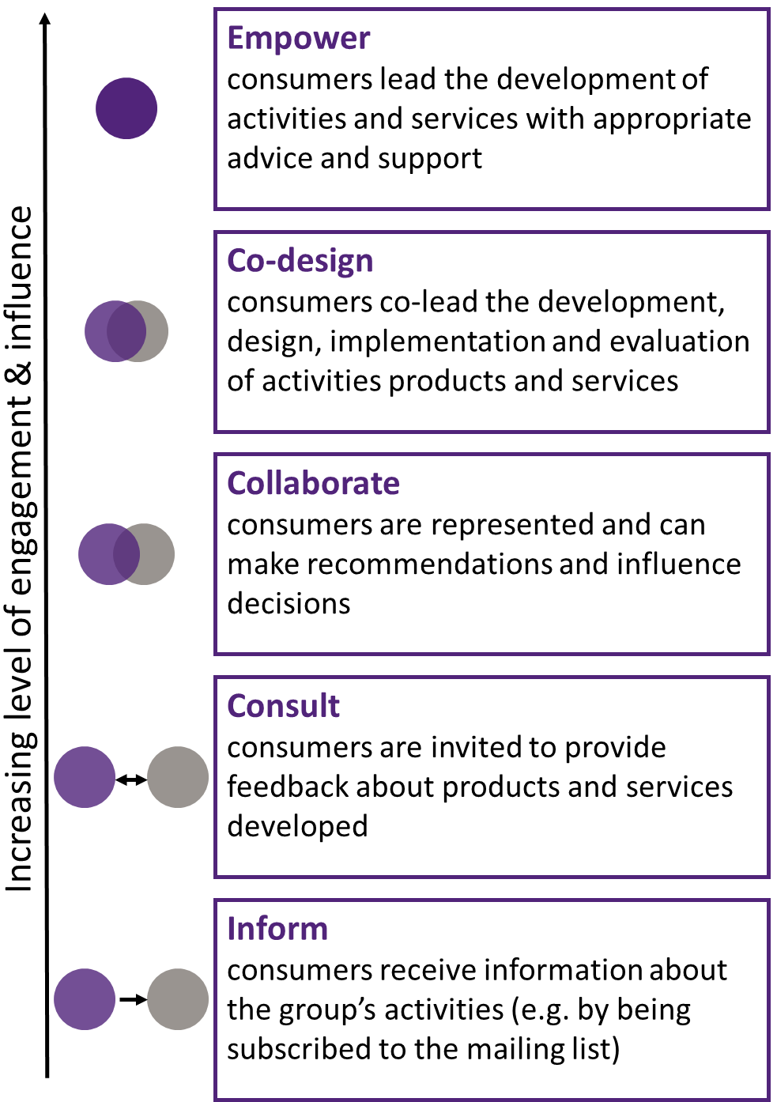
Source: Agency for Clinical Innovation, 2019 Figure: 3 presents the range of participation levels.
Higher levels such as co-design are realised when project development engages service-users in equal partnership and values their knowledge and expertise.
Overall, co-design or co-development are productive ways to formulate and develop new projects or services, but can be resource intensive and require sufficient time to examine all aspects of the design.

How appropriate was the department’s implementation of the TTL Fund?
While many of the TTL Fund implementation processes necessarily abided by traditional government practices, such as setting up funding agreements and AWPs, central to the TTL Fund is flexibility, as well as a focus on outcomes and responsiveness to data and stakeholders.
Sustained communication and flexible deadlines were required to offset process delays. All tranche 2 service providers felt the timeframes during the initial stages of the projects were unrealistic and were a source of frustration.
Specifically, infrequent communication and delays during the grants process were reportedly followed by short notification for attending co- development workshops or expected project commencement. This purportedly impacted on project development and project implementation respectively, as providers had little time to prepare. Given some of the processes were new to the department, delays were to be expected.
However, unlike traditional funding processes, TTL projects were potentially more invested given their involvement with co-design and co- development, therefore continued communication or providing informal updates during these phases may have helped manage expectations and keep providers engaged.
Further, flexibility of deadlines when delays occurred could have ensured projects had sufficient time to prepare and implement their projects as intended. As discussed in Limitations (Section 2.4), these delays also impacted on the evaluation of the client outcomes for some projects. This flexibility would also allow better preparation for evaluation, as discussed in Section 5.1.
Continuity of support was necessary for the flexibility and responsiveness that the TTL Fund endeavoured to achieve. Despite the initial challenges, the majority of service providers reflected positively on the communication with the department during project implementation. Having a single point of contact in the Funding Arrangement Manager (FAM), who was
knowledgeable of the projects, was key for ongoing communication, providing advice for adapting services and directing service providers to additional resources. However, many service providers reported high turnover of the FAMs, which impacted on continuity and delayed decisions needed for project delivery. Having processes in place to facilitate smooth handovers could mitigate the expected reorganisation of departmental staff. This could include informing providers of changes prior to their occurrence and ensuring new staff are fully apprised of the specific decisions, activities and status of the projects.

Preparation of required project documentation supported an outcomes focus to project development, and employing external consultants to support the process was considered a strength.
Preparation of required project documentation, such as the AWP, program logic and theory of change, supported projects to thoroughly plan their ideas and maintain an outcomes focus.
Although some service providers found the preparation time-consuming and at times laborious, many noted that it ‘gave us a clear scope as to what we would be able to commit to’ (SP, #42), and ‘it’s actually the nexus and allows us to map out the how-to of the project that we’re going to implement’ (SP, #52). The external consultants were considered a strength of the process by most service providers, not only to support projects, particularly those with less experience of developing such documentation, but possibly to also alleviate pressure from time- poor departmental staff.
That said, while service providers were required to report against the AWPs on a quarterly basis, it is unclear whether they revisited their project’s program logic or theory of change during project implementation. Almost no service providers explicitly referred to re-examining these tools, even when changes to service delivery were made. However, it is possible these documents were incorporated into individual project evaluations.

Reporting tools could be reviewed to ensure utility and quality of data, while meeting all

stakeholders’ needs, including the department, service providers and clients. Overall, TTL service providers acknowledged the value of the reporting required as part of the TTL Fund, however commented on the impact on resourcing. This was particularly unexpected (and under-resourced) for projects that were unfamiliar with government processes, and smaller organisations with limited capacity. Although reporting requirements were stipulated in the funding agreements, advising organisations of the possible extent early in the process would support appropriate planning and budgeting.
A common theme in the service provider interview data was the desire to capture and report on progress and outcomes specific to the unique project. In some respects, reporting against the AWPs allowed for this, and a large proportion of the service providers felt these were suitable for collating information and were easy to use. However, the AWP reporting is a paper- based, open-ended reporting tool, and having FAMs monitor the completion of the AWP reports, often going through numerous rounds of checks, was resource-intensive for both the service providers and department. Further, it does not serve as a tool for standardised data in its current format.
In contrast, the data captured in DEX has the potential of providing standardised measures for high-level monitoring and evaluation. However, providers felt that the DEX reporting processes were too rigid and templates not suitable for every program. Despite many projects reporting they were collecting their own data to build evidence, few reported using DEX data for their own evaluation or monitoring purposes, and vice versa. This duplication was further exacerbated by challenges arising from making their own reporting systems compatible with reporting via DEX.
There is a clear need for considering the user- friendliness of reporting and reporting tools, particularly for diverse programs, against the need for robust standardised data collection for monitoring, evaluation and building an evidence base. There is an opportunity to consider streamlining and combining elements of the 2
reporting mechanisms to serve both purposes. For example, digitising the AWP reporting with some close-ended questions could provide standardised evidence for quick review while maintaining bespoke sections for service providers to include project-specific context. Similarly, the department has already built in some flexibility to the DEX reporting, such as allowing customisation of 'service types' and project specific categories, or SCORE language/domains to suit cohorts and match the specific goals of each project (Department of Social Services internal document). However, the impacts on the utility of this data for evaluation purposes should be considered before further customisation is actioned. Lastly, the department could explore the reporting mechanisms service providers already use, and capitalise on repurposing these systems, or ensuring compatibility so that data can easily be shared between systems.

How appropriate was the data quality implementation, DEX training and support provided by the department?
Collecting high-quality data is fundamental for monitoring, evaluation and building an evidence base.
Understanding the data needs and planning data quality processes should be a fundamental part of project development, and requires buy-in from all parties from the start. Considerable efforts were made during the implementation of the TTL Fund to meet data needs, which somewhat mitigated data quality issues, but potentially at great cost to the department. For example, efforts made to follow up with individual service providers to improve human error in transcribing data into DEX was generally successful, as evidenced by the improved DEX–DOMINO match rate. Similarly, the implementation of a metadata library was appropriate for contextualising DEX data provided by service providers to support data quality and interpretability of the data. However, not all projects provided this information, which meant that the nuances in the data, and hence the data quality for some projects, is unknown.
Further, following up with projects in this manner

was particularly resource intensive. More efficient mechanisms for capturing this information may be required to ensure data quality is enhanced in a scalable way.
The development and implementation of the TTL Client Survey occurred after the commencement of the TTL Fund, delaying data collection. Further, service providers expressed challenges with implementing the TTL Client Survey, citing unawareness of the need to distribute the survey, limited client interest or survey fatigue, or ethical concerns about distributing the survey to at-risk groups, particularly those who are less trusting of sharing their information. The result is evident in the lower number of responses, particularly for pre-post evaluation (2% of TTL clients), which significantly limited the data available to evaluate the effectiveness of the TTL projects, particularly shorter term outcomes for clients, and where the survey was the main data source. To ensure usability of the data, the survey could be mandated and collected systematically in the same way providers collect session data. Likewise, the response rates for the mandatory SCORE measures near the end of the intervention could be tied to financial milestones to incentivise the collection of this data to enable the department to build an evidence base.
Provision of bespoke, in-person (or real-time) training and support for using DEX improved data quality. However, not all service providers had access to this and some felt the DEX Helpdesk was not always able to support their specific needs.
Given the unique requirements of the TTL Fund, having a dedicated departmental staff member knowledgeable of TTL and DEX could support upskilling providers from the start, and could mitigate the need for retrospective actions to resolve data quality.
Overall, the data quality implementation processes were resource intensive, and while some improvements (such as the DEX–DOMINO match rate) are evident, further consideration is needed as to how to efficiently ensure high- quality data that are fit-for-purpose can be achieved. The need for retrospective data quality improvement could be mitigated by having the tools, processes, and necessary training in place
prior to implementation, and ensuring it is appropriately resourced.

What impact did the TTL Fund have on the service provider community?
As outlined in the program logic, achieving a sustainable welfare system is underpinned by a service provider community that is supported to deliver evidence-based practices.
All service providers were committed to using and building an evidence base to inform practice. Most were collecting and utilising data to inform their service delivery, including formal and informal feedback from clients. The evidence collection and evaluation were facilitated by the TTL Fund partly through the evaluation requirements, and at least 7 projects specifically noted improved internal monitoring and evaluation capacity (though this is likely higher given latent learning for projects with an external evaluator).
The reporting wouldn’t happen [without TTL Fund]. [Previously], my reporting, most of it’s been in my head. (SP, #46)
It may be important to clarify with service providers when evaluation is a contractual obligation though, and consideration may need to be given to budget allocations, as a few service providers raised concerns about unforeseen budgeting for evaluation.
Service providers proactively developed partnerships to strengthen service delivery. TTL service providers’ strong desire to better support TTL clients saw them proactively build relationships with partners and other service providers to support service delivery. Almost all TTL service providers mentioned developing new, or strengthening existing, relationships since commencing their TTL journey, leading to: innovation, help with recruitment, links with industry or prospective employers/education providers, additional funds, referrals to provide a more holistic approach, and assistance with future endeavours. The most challenging relationships to build and sustain were with referral agencies, particularly jobactive providers. There may be an

opportunity for the department to broker these relationships, which are key to service delivery for future projects.
Opportunities for shared learning could be explored, allowing the service provider community to benefit from the collective learnings generated by the TTL Fund. There was a desire for further partnership development, particularly with other TTL projects, to share successes and learnings from both design and implementation. As such, there is an opportunity for the TTL Fund to continue creating opportunities for relationship-building and knowledge-sharing beyond the co-design and co- development phase. This would afford service providers the opportunity to benefit from the collective learnings across the TTL Fund to which they have contributed. Having access to evidence and opportunities to share learnings is necessary to actuate best practice, and further enhance knowledge generation: a benefit for service providers, the department and service-users.

Overall, the TTL Fund provided the opportunity to develop and test new services to support those at risk of welfare dependence and generate evidence of what works, for whom.
Providers were genuinely enthusiastic about the new way of working with the department, the opportunity to bring their ideas, and the alternative and more innovative approach to investing in services that reduce the need for income support for some groups.
[TTL Fund] is such a revolution in how you use income support to enable people to operate at their optimum. (SP, #46)



Lessons learned

Lessons learned about promising approaches for future investment

The TTL evaluation assessed the effectiveness, efficiency and appropriateness of the TTL Fund to inform future policies on the basis of the Fund’s achievements, strengths and limitations.
Importantly, it is worth noting that that the TTL Fund was focused on building individual capabilities to improve health, wellbeing, education and employment outcomes rather than redesigning institutions such as schools, communities or organisations to provide better supports and services. There may be some flow- on effects to these institutions, such as greater awareness of the needs of some individuals facing complex circumstances, but these outcomes will be unintended and are not directly measured by current data systems.

Did the TTL Fund meet its stated objectives?
The TTL Fund met its stated objective to generate new insights and empirical evidence into what works to reduce long-term welfare dependence by trialling new approaches to inform policy and program development. This section presents the lessons learned from these trials.
Identifying and recruiting at-risk individuals for the projects was challenging. This highlights the need for support and additional planning time to ensure that the size of eligible client groups will be sufficient and that there are viable mechanisms for ensuring that at-risk individuals can be recruited. Future initiatives may consider building systems that allow linked administrative data to better support projects to identify and recruit participants. This may include the department contacting participants on behalf of the projects or providing advice to potential projects about the feasibility of identifying in-scope participants in their target areas.

The co-design of projects by service providers and end-users (at-risk clients) is good in theory, but in practice it appears that the needs of some clients were not properly incorporated into the
project design. There were some TTL projects that did not know or understand the circumstances of their clients at the time of the co-design process and this impacted on the effectiveness of these projects. Future funding initiatives could encourage project teams to collaborate with providers who have prior experience with the target group and engage end-users more effectively in the design of the project.
Future initiatives could provide stronger evidence of effectiveness with better advance planning to ensure that projects are ready to commence service delivery before the commencement of an evaluation, incorporate data collection in their project design and costings, and ensure that an effective evaluation strategy has been designed in advance. Several highly innovative project designs could not be effectively evaluated due to delays in service delivery associated with ongoing project development. An example of this was Data-driven Job Opportunities, which aimed to use augmented intelligence and data analytics to match young carers to an available job. Additionally, projects with a properly designed evaluation strategy in place prior to commencement would be able to provide much stronger evidence of effectiveness. This entails a number of considerations, including selection of appropriate outcome measures and, potentially, adjustments to project delivery to facilitate evaluation. There were many instances where relatively minor modifications to project delivery could have facilitated much stronger inferences regarding project effectiveness, and involving evaluators in the design of projects prior to commencement would assist with this. Projects need to be informed about the additional data they need to collect for costing purposes and to ensure they do not overburden their clients.
Stronger project planning with these goals in mind would provide more robust evidence, ensuring that policy-makers have the best information available to guide future decisions.

The diversity and number of projects that were funded is a good starting point to build a foundation for the evidence base. With ongoing monitoring and evaluation (using robust measures), further evidence of what works (and what does not work) will emerge. Future policy can then draw on these initial promising insights to expand and test on a larger scale.
A tailored approach, offering the right supports at the right time to address the non-vocational barriers faced by the at-risk groups, was successful, especially when services worked closely with employers. However, this bespoke
design may make scaling-up challenging. The evidence gathered from the TTL projects revealed 3 groups of clients who needed different types of support in order to take advantage of the opportunities presented to them. These were individuals who were work-ready, were developing work readiness, or had less capacity to work due to high non-vocational barriers to work/study (See Figure: 4). Project design will be most effective when taking into account which group best characterises their clients.

Figure: 4 Three groups of clients at varying stages of work-readiness
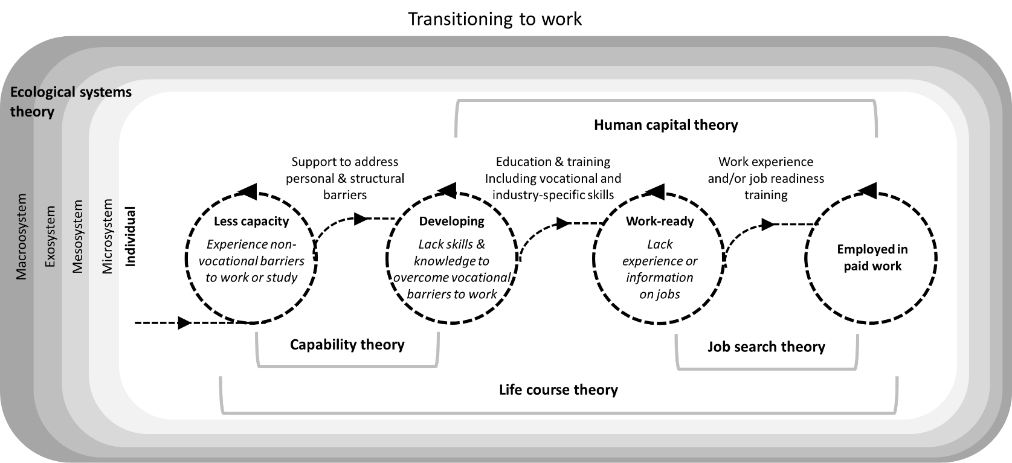
Note: Three groups of clients were identified at different stages of transitioning to work based on the types and levels of support required to take advantage of the opportunities presented to them. These included clients who were work- ready, developing work readiness, or had less capacity. The level of work readiness for each group is characterised by the type of barriers to work, for example clients with less capacity experience non-vocational barriers. The type of support required to facilitate transitioning to the next stage of work readiness is presented, for example clients with less capacity require support to address personal and structural barriers in order to transition to developing work readiness. The theory of change underpinning the processes at each stage are presented.

Cross-agency ownership or at least support of future initiatives like the TTL Fund is important and could be established earlier to ensure there is access to the data needed to monitor and evaluate the effectiveness of the projects it funds. Data-sharing arrangements need to be in place before implementing future initiatives like
the TTL Fund. Further, future initiatives could consider incorporating standardised measures that are mandatory (tied to funding) for projects undergoing pilot testing. Additional financial resources could be made available to rigorously test these measures where existing valid instruments are not available to ensure they are

measuring the same construct at different time points and across subgroups.
The evaluation readiness of the TTL projects was limited, and future evaluations will need to ensure projects have team members with evaluation capability or engage external evaluation experts. Achieving a sustainable welfare system is underpinned by a service provider community that is supported to deliver evidence-based interventions. Future initiatives may consider making it mandatory for projects funded by the department that have not been evaluated to include team members who have experience and expertise in evaluation or engage evaluation partners. This is important to ensure that the projects are designed and implemented in a way that supports strong evaluation.
Specifically, individual theories of change and program logics need to be developed and funded at the design phase and not retrofitted later by evaluators. In addition, overarching evaluations need to invest time in developing the evaluation framework prior to conceptualisation of the projects. The overarching evaluators need to work alongside the projects as they are co-designed to ensure the theory of change and program logic align with the overarching evaluation.
Alternatively, an overarching evaluation framework could be provided to projects during their design phase.

To what extent does the evidence suggest that the TTL projects have helped to have a more cost-effective, sustainable welfare system for those who need it?
There are TTL projects with sufficient evidence of short-term impact who have the potential to contribute to a sustainable welfare system in the short term, but these projects are focused only on at-risk individuals who are work-ready.
For a social system to be sustainable, it needs to be socially and economically sustainable. The TTL evaluation has helped to identify 15 TTL projects across the Fund that have the potential to decrease the lifetime costs of specific at-risk
groups and contribute to a sustainable welfare system. These projects had some key features that are important for future policy and program development:
- tailored to the specific client group
- clients were work-ready
- adopted a demand-led approach to work
- provided targeted vocational training together with pathways to work
- provided support during and after clients transitioned to work
- offered paid work experiences or traineeships.
While these projects may have relatively immediate impacts, this does not negate the value of projects that were more focused on developing clients’ skills and knowledge to overcome vocational barriers to work, or supporting clients to overcome non-vocational barriers to work.
These less work-ready clients need more time and more intensive and tailored support to translate additional education or better health and wellbeing into outcomes that can be measured by the available data. While they may not have immediate effects, building non-vocational skills is a valuable first step toward study/work participation.
There is suggestive evidence that the TTL Fund achieved other outcomes that could have flow-on effects on employment in the long term and contribute to a sustainable welfare system.
Overall, 74% of the clients interviewed (n=230) improved their skills. Sixteen TTL projects offered access to education/vocational training to all or some clients. Eighteen TTL projects offered work experiences or placements and 6 of these were paid work experiences. Better outcomes were achieved for projects that offered paid work experiences with a pathway into work. Ten TTL projects provided job search skills, which included resume writing and interviewing skills.
One of the most important contributions the TTL Fund made was to fund projects that supported 2 additional groups — those who have less capacity to work and those who are developing their work readiness. While these individuals may take longer to contribute to a sustainable welfare

system, there will be long-run economic and social costs if they are not supported.
Examining the evidence across the TTL Fund to determine whether the TTL projects contributed to a socially sustainable welfare system that promotes wellbeing and builds capacity, there was suggestive evidence that the TTL projects increased capacity, and health and wellbeing.
Overall, 54% and 68% of the clients interviewed (n=230) improved their capacity, or health and wellbeing, respectively. These results are based on qualitative data and not generalisable; however, if these projects have indeed improved the health and wellbeing of the broader at-risk groups, we may expect to see an impact on employment once enough time has passed for any flow-on effects on employment to be realised. Understanding the circumstances of the individuals at risk and the extent to which they are ready to work (capacity) is important when assessing the social sustainability of the TTL projects. Research shows that without intensive support these individuals do not have the capacity to focus on job readiness skills (Kemp & Neale 2005). They are less likely to benefit from traditional labour market programs and may even fail to comply with mutual obligation requirements (Danziger & Seefeldt 2002; Goldberg 2002), and this may have long- term impacts on both the social and economic sustainability of the welfare system if no tailor- made programs are available for these groups.

Are there indications that lend confidence to the underlying theory of change, program logic and assumptions?

There are indications that the underlying theory of change, program logic and assumptions were appropriate, and for some projects, relatively immediate impacts have been observed.
The results presented in the Effectiveness (3) and Appropriateness (5) chapters indicate broad support for the theories of change, as indicated by evidence of improvements for all of these outcomes. Specifically, human capital and job search theories were appropriate in preparing
these at-risk groups for work (developing work readiness). However, without providing direct pathways into a job, and support during this transition when the clients are work-ready, it is unlikely that these clients will move on to sustainable employment.
The evaluation revealed there was an additional theory, capability theory (Sen 1985; 1999), that was important to understand the third group of clients who had limited capacity to work due to high non-vocational barriers to work/study (see Figure: 4). These barriers were often complex and required intensive case management and individualised support before clients could overcome vocational barriers or consider participating in work/study. This does not diminish the value of such projects — rather, addressing non-vocational barriers is a starting point rather than an ending point.
In some cases, the results are suggestive rather than conclusive, either because the data are limited or because there has been limited time to observe outcomes from the projects.

Conclusion
The TTL Fund was an innovative approach to trialling what works to reduce long-term welfare dependence, producing valuable insights into how services might be designed to support selected priority groups. The innovation is evident in the co-design and do-development approach, the aim to intervene early to invest in long-term outcomes, and the use of a range of different types of data, including large-scale administrative data from income support payments, to evaluate outcomes. Without an initiative of this kind, there is a risk that policies and services aimed at supporting individuals to move off welfare will continue with a ‘business as usual approach’ that maintains the status quo rather than attempting to invest in building capacity across all social groups. Moreover, it is important in a rapidly changing world that new approaches are trialled and evaluated to ensure that policies and services are well-suited to current social, political and economic contexts.
There are a number of learnings based on the evidence to improve the TTL approach going

forward, such as delineating clear goals for the Fund, improving implementation processes, improving data systems to support evaluation, and cross-agency ownership of TTL. Standard labour market programs and a work-first approach (emphasising rapid employment placement) do not seem sufficient to help all groups to enter employment.
Further, it is apparent that non-vocational barriers need to be addressed in order for workforce participation goals to be achieved.
In future iterations of TTL, it is important that data needs are considered early with strategies to ensure appropriate numbers of clients are recruited, suitable administrative and other data are available, and sufficient time is allowed from commencement of a project for outcomes to be observed. Although not all TTL projects achieved outcomes in time for reporting in the current evaluation timeframe, there may be additional insights available with a longer timeframe. This evaluation concludes that the TTL Fund represents an appropriate, effective and efficient investment into the at-risk groups.



Appendices

Appendices

List of Appendices

Background of the TTL Fund 96
 Priority group summaries 96
 TTL projects 98

Evaluation design 107
 Theory of change 107
 Program logic 108
 Data sources 111

Technical methodology 116
 Methodology overview and measures 116
 Methods 117

Effectiveness 130
 TTL Fund 130
 Young Parents 133
 Young Students 140
 Young Carers 147
 At-risk Young People (tranche 1) 152
 At-risk Young People (tranche 2) 159
 Migrants and Refugees 169
 Older Unemployed People 176
 Other 183
 Working Age Carers 192

Efficiency 194
 Analytical approach for the economic evaluation 194

Data collection tools 208
 Activity Work Plan report – additional questions 208
 TTL service provider group interview topic guide – time point 1 209
 TTL service provider group interview topic guide – time point 2 211
 TTL client interview topic guide 214
 TTL Client Survey 215


References 216

Figures
Figure B-1 Program logic 110
Figure B-2 DEX SCORE domains, by outcome 112

Figure B-3 Likert scale used for each DEX SCORE outcome 113
Figure C-1 Client-reported outcome measures 126
Figure D-1 TTL clients’ self-reported vocational and non-vocational barriers on TTL Client Survey items 130
Figure D-2 TTL clients’ self-reported improvement on TTL Client Survey items – overall 131
Figure D-3 TTL clients’ self-reported improvement on TTL Client Survey items – only clients indicating room for improvement at baseline 131
Figure D-4 TTL clients’ change in circumstances and goals on DEX SCORE measures 132
Figure D-5 Income support unrelated to study – Young Parents 135
Figure D-6 Student income support receipt – Young Parents 136
Figure D-7 Any employment income receipt while on income support – Young Parents 136
Figure D-8 Days on income support – Young Parents 137
Figure D-9 Amount of employment income while on income support – Young Parents 137
Figure D-10 TTL clients’ self-reported vocational and non-vocational barriers on TTL Client Survey items – Young Parents 138
Figure D-11 TTL clients’ change in circumstances and goals on DEX SCORE measures – Young Parents 139
Figure D-12 Income support unrelated to study –Young Students 142
Figure D-13 Student income support receipt – Young Students 142
Figure D-14 Any employment income receipt while on income support – Young Students 143
Figure D-15 Days on income support – Young Students 143
Figure D-16 Amount of employment income while on income support – Young Students 144
Figure D-17 TTL clients’ self-reported vocational and non-vocational barriers on TTL Client Survey items – Young Students 145
Figure D-18 TTL clients’ change in circumstances and goals on DEX SCORE measures – Young Students 146
Figure D-19 Income support unrelated to study – Young Carers 149
Figure D-20 Student income support receipt – Young Carers 149
Figure D-21 Any employment income receipt while on income support – Young Carers 150
Figure D-22 Days on income support – Young Carers 150
Figure D-23 Amount of employment income support while on income support – Young Carers 151
Figure D-24 Income support unrelated to study – At-risk Young People (tranche 1) 154
Figure D-25 Student income support receipt – At-risk Young People (tranche 1) 154
Figure D-26 Any employment income receipt while on income support – At-risk Young People (tranche 1)
. 155
Figure D-27 Days on income support – At-risk Young People (tranche 1) 155
Figure D-28 Amount of employment income while on income support – At-risk Young People (tranche 1)
. 156
Figure D-29 TTL clients’ self-reported vocational and non-vocational barriers on TTL Client Survey items –
At-risk Young People (tranche 1) 157
Figure D-30 TTL clients’ change in circumstances and goals on DEX SCORE measures – At-risk Young People (tranche 1) 158
Figure D-31 Income support unrelated to study – At-risk Young People (tranche 2) 162
Figure D-32 Student income support receipt – At-risk Young People (tranche 2) 163
Figure D-33 Any employment income while on income support – At-risk Young People (tranche 2) 164

Figure D-34 Days on income support – At-risk Young People (tranche 2) 165
Figure D-35 Amount of employment income while on income support – At-risk Young People (tranche 2)
. 166
Figure D-36 TTL clients’ self-reported vocational and non-vocational barriers on TTL Client Survey items –
At-risk Young People (tranche 2) 167
Figure D-37 TTL clients’ change in circumstances and goals on DEX SCORE measures – At-risk Young People (tranche 2) 168
Figure D-38 Income support unrelated to study – Migrants and Refugees 171
Figure D-39 Student income support receipt – Migrants and Refugees 172
Figure D-40 Any employment income while on income support – Migrants and Refugees 172
Figure D-41 Days on income support – Migrants and Refugees 173
Figure D-42 Amount of employment income while on income support – Migrants and Refugees 173
Figure D-43 TTL clients’ self-reported vocational and non-vocational barriers on TTL Client Survey items – Migrants and Refugees 174
Figure D-44 TTL clients’ change in circumstances and goals on DEX SCORE measures – Migrants and Refugees 175
Figure D-45 Income support unrelated to study – Older Unemployed People 178
Figure D-46 Student income support receipt – Older Unemployed People 179
Figure D-47 Any employment income while on income support – Older Unemployed People 179
Figure D-48 Days on income support – Older Unemployed People 180
Figure D-49 Amount of employment income while on income support– Older Unemployed People 180
Figure D-50 TTL clients’ self-reported vocational and non-vocational barriers on TTL Client Survey items – Older Unemployed People 181
Figure D-51 TTL clients’ change in circumstances and goals on DEX SCORE measures – Older Unemployed People 182
Figure D-52 Income support unrelated to study – Other 185
Figure D-53 Student income support receipt – Other 186
Figure D-54 Any employment income while on income support – Other 186
Figure D-55 Days on income support – Other 187
Figure D-56 Amount of employment income while on income support – Other 187
Figure D-57 New study commencement – Other 188
Figure D-58 TTL clients’ self-reported vocational and non-vocational barriers on TTL Client Survey items – Other 190
Figure D-59 TTL clients’ change in circumstances and goals on DEX SCORE measures – Other 191
Figure D-60 TTL clients’ self-reported vocational and non-vocational barriers on TTL Client Survey items – Working Age Carers 193
Tables
Table A-1 Young Parents project descriptions 98
Table A-2 Young Students project descriptions 99
Table A-3 Young Carers project descriptions 99

Table A-4 At-risk Young People (tranche 1) project descriptions 100
Table A-5 At-risk Young People (tranche 2) project descriptions 101
Table A-6 Migrants and Refugees project descriptions 103
Table A-7 Older Unemployed People project descriptions 104
Table A-8 Other project descriptions 105
Table A-9 Working Age Carers project description 106
Table C-1 Outcome measures for impact analyses 123
Table C-2 Data sources included in analyses by TTL project 127
Table D-1 Project objectives and service delivery recorded in DEX - Young Parents 133
Table D-2 Disadvantage indicators – Young Parents 134
Table D-3 Project objectives and service delivery recorded in DEX - Young Students 140
Table D-4 Disadvantage variables – Young Students 140
Table D-5 Project objectives and service delivery recorded in DEX - Young Carers 147
Table D-6 Disadvantage variables – Young Carers 147
Table D-7 Project objectives and service delivery recorded in DEX - At-risk Young People (tranche 1) 152
Table D-8 Disadvantage variables – At-risk Young People (tranche 1) 152
Table D-9 Mentoring 2 Work impact estimates for clients who attended higher number of sessions (greater than median) 156
Table D-10 Build and Grow impact estimates by age 157
Table D-11 Project objectives and service delivery recorded in DEX - At-risk Young People (tranche 2) 159
Table D-12 Disadvantage variables – At-risk Young People (tranche 2) 160
Table D-13 Project objectives and service delivery recorded in DEX - Migrants and Refugees 169
Table D-14 Disadvantage variables – Migrants and Refugees 170
Table D-15 Project objectives and service delivery recorded in DEX - Older Unemployed People 176
Table D-16 Disadvantage variables – Older Unemployed People 177
Table D-17 Project objectives and service delivery recorded in DEX - Other 183
Table D-18 Disadvantage variables – Other 184
Table D-19 Community Voices impact estimates for clients who were aged 25 and under, and over 25 189
Table D-20 Warra Warra Kanyi impact estimates for clients aged 18 and over 189
Table D-21 Project objectives and service delivery recorded in DEX - Working Age Carers 192
Table D-22 Disadvantage variables – Working Age Carers 192
Table E-1 Payment class definitions including relevant payment types 197
Table E-2 Baseline and treatment transition probabilities by payment class as defined in Table E-1 198
Table E-3 Simulated welfare costs changes by priority group 198
Table E-4 Expenditures on the Investment Approach to Welfare as reported in budget statements 201
Table E-5 Estimated costs and benefits by project 202


– Background of the TTL Fund

Priority group summaries
A summary of each priority group is presented.
 Young Parents
Having a child young can disrupt education and increase the barriers to finding and keeping a job (Kalb, Le & Leung 2015). This can lead to long- term welfare dependency and poorer life outcomes for mothers and their children (Jeon, Kalb & Vu 2011). Research also shows that generational influences play a significant role in the cycle of welfare dependency (Australian Human Rights Commission 2017). An analysis of the PIA data shows that in 2014–15, approximately 4,370 young parents aged 18 and under were receiving Parenting Payment, and the analysis shows that if nothing changes for these young parents, around 70% will be receiving income support in 10 years and around 40% in 20 years. The average future lifetime cost of young parents was estimated at $547,000 per person.
The Young Parents priority group eligibility criteria included people aged under 25 who claimed Parenting Payment when they were aged under 19 and were still receiving an income support payment.
 Young Students
People who obtain higher levels of education are more likely to be employed (Australian Institute of Health & Welfare 2017). Dropping out before completing school results in risks of poorer health outcomes, unstable employment and a decrease in lifetime earnings (Leigh & Ryan 2008; Oreopoulos 2003, cited in Dulfer, Rice & Clarke 2017). Risk factors for school dropout range from individual circumstances such as disability, family responsibilities, attitudes and behaviour, to family background and family attitudes towards education (Hammond et al. 2007).
An analysis of the PIA data shows that while most people who receive student payments exit income support within 5 years, there are some who are at risk of long-term welfare dependency. Since 2003, there have been 13,400 vocational and university
students who started receiving a student payment aged 17 to 19, and then experienced a period of long-term dependence on unemployment payments. Of these former students, 6,600 received an unemployment payment in 2014–15. Around three-quarters did not complete their study or training before moving to an unemployment payment. The analysis shows that if nothing changes for these former students, around 45% who moved directly to unemployment payments will be receiving income support payments in 10 years and more than one- third in 20 years. The average future lifetime cost of students who move directly to an unemployment payment for a period of long-term dependence was estimated at $304,000 per person. For students who fail to complete their study or training, the average future lifetime cost was estimated at $318,000 per person. The Young Students priority group eligibility criteria included people aged under 25 who have moved, or are at risk of moving, from study (post-secondary or tertiary, and have been in receipt or receiving a student payment) to an extended period on an unemployment payment.
 Young Carers
An analysis of the PIA data shows that in 2014–15, approximately 11,200 young carers aged 24 and under were receiving Carer Payment (the number has trebled in the last decade), and the analysis shows that if nothing changes for these young carers, over 60% will be receiving income support in 10 years and around 50% in 20 years. The average future lifetime cost of this group was estimated at $464,000 per person. The Young Carers priority group eligibility criteria included young people aged under 25 who are eligible for Carer Payment, or are at risk of claiming Carer Payment, because they are undertaking the care of a person with a disability or medical condition.
 At-risk Young People
This priority group is defined as young people aged 16 to 21 receiving Youth Allowance (Other) or Disability Support Pension (with a mental health condition). Originally, the 4 At-risk Young

People projects in tranche 1 were designed according to the Young Students criteria, thus the age range for these 4 tranche 1 projects reflect the Young Students projects of people aged 16 to
25. The needs and barriers to employment for members of this group are highly varied and they may have a number of indicators of vulnerability. These factors can often interact with each other (Department of Health 2004), and can include disengagement from education, experience of severe family breakdown, history of abuse, drug and alcohol misuse, family instability including living in out-of-home care, and experiences with the juvenile justice system (Campo & Commerford 2016; Dixon 2007; Unruh, Povenmire-Kirk &
Yamamoto 2009).
An analysis of the PIA data shows that as at 30 June 2017, there were around 109,000 young people receiving Youth Allowance or Disability Support Pension with mental health as the primary condition (7%). Fifty-four per cent are male, 38% live in inner or outer regional areas, and 16% are Indigenous. The analysis shows that if nothing changes, 42% will be receiving income support payments in 10 years and 33% in 20 years. The average future lifetime cost of this group was estimated at $306,000 per person.
 Migrants and Refugees
Refugees and humanitarian entrants have below average employment rates in Australia (Flanagan 2007; Liebig 2006), with high levels of unemployment evident even among skilled refugees (Colic-Peisker & Tilbury 2007). Barriers to employment include such factors as limited proficiency in English, lack of work experience in Australia, lack of understanding of Australian workplaces, discrimination, lack of employment support, and the impacts of the entrants’ pre- arrival experiences (Refugee Council of Australia 2010). Humanitarian entrants are generally entitled to income support without having to serve any waiting periods, including the Newly Arrived Residents Waiting Period. Most migrants (other than humanitarian migrants) do not have immediate access to income support payments
when they first arrive in Australia, with most being required to serve the 104-week Newly Arrived Residents Waiting Period for income support payments and a 10-year qualifying residency period for Age Pension and Disability Support Pension. An analysis of the PIA data shows that as at 30 June 2017, there were 299,400 working-age Australians from migrant and refugee backgrounds on working-age payments. Sixty-five per cent were female, 85% lived in major cities, and 78% had a non-English speaking background. The analysis shows that if nothing changes, 56% will be receiving income support payments in 10 years, and 52% in 20 years. The average future lifetime cost of this group was estimated at
$340,000 per person. The Migrants and Refugees TTL priority group eligibility criteria included migrants and refugees aged 16 to 64 years who are in receipt of working-age payments.
 Older Unemployed People
Many older Australians want to work but find it difficult to get work (Encel & Studencki 2004). An analysis of the PIA data shows that as at 30 June 2017, there were around 251,400 people aged 50 or over receiving Newstart Allowance (now JobSeeker Payment). Fifty-three per cent were female, 35% lived in inner and outer regional areas, and two-thirds were between the ages of 50 and 59. The analysis shows that if nothing changes, 75% will be receiving income support payments in 10 years and 74% in 20 years. The average future lifetime cost of this group was estimated at $320,000 per person. The Older Unemployed People priority group eligibility criteria included JobSeeker Payment (formally Newstart Allowance²⁰) recipients aged 50 or over.
 Working Age Carers
Carers face several barriers to accessing employment. Due to their caring responsibilities, they have limited time available to work. Over time, their lack of work experience can become an additional barrier to work. Carers have indicated that they need more flexibility in support services and ‘carer-friendly’ workplaces (Cass et al. 2009). An analysis of the PIA data shows that as at 30

²⁰ Newstart Allowance ceased on 20 March 2020 and was replaced by the JobSeeker Payment, which is now the main working age payment for people aged from 22 years to Age Pension age who have capacity to work now or in the near future. We refer to JobSeeker Payment in the report.

June 2017, there were around 221,700 working- age (16–64) carers. The analysis shows that if nothing changes, 80% will be receiving income support payments in 10 years, and 73% in 20 years. The average future lifetime cost of this group was estimated at $461,000 per person. The Working Age Carer priority group eligibility criteria included carers aged 16 to 64 years who are in receipt of a Carer Payment.

TTL projects
Table A-1 to Table A-9 provide descriptions of the TTL projects in each priority group. For the purpose of the evaluation, one TTL project (Community Voices) was reclassified into the Other priority group based on its clients’ characteristics being dissimilar to the At-risk Young People priority group definition, which would skew priority group level analyses. Further project details are included by priority group in Appendix D.

Table A-1 Young Parents project descriptions

TTL project | Project description
1. Career Readiness for Young Parents | The project supports young parents under 25 to improve job readiness through intensive case management that focuses on non-vocational barriers to employment (e.g. mental health, housing stability, childcare and transport assistance). Services offered include peer support and group training, advocacy, mental health services, childcare and work experience. The project supplements ParentsNext and jobactive providers in addressing broader barriers to job readiness training and employment for  young parents on income support.
2. In-School Parent Employment Services | The project aims to increase employment of young parents under 25 by integrating personalised, demand-led employment services in regional primary schools. The project works with local employers to identify job opportunities, match participants to these positions, and provide training and other support to ensure clients are job- ready. The project provides vocational and pre-vocational support including career guidance, resume writing and warm referrals to other agencies including ParentsNext,  Centrelink and jobactive providers.
3. Train and Care | The project aims to help parents under the age of 25 transition to work. It delivers 6 to 9 months of practical training, including hands-on learning and work trials with employers sourced through the organisation’s networks. The project provides childcare (paid for by the project) to enable participation in practical training. The curriculum was developed specifically to address limited work experience, low  confidence and other barriers for the participants.
4. Supporting Expecting & Parenting Teens | Mentors based in 12 hubs in 5 regions around Australia work intensively with young parents and expecting parents to support them to achieve their goals by using a parent-centred pathway plan. The plan helps participants address barriers to education, training and workforce participation. Mentors connect participants to services including health, housing, education and training, childcare and employment. The project also includes a national online directory of information on support  services.

Table A-2 Young Students project descriptions

TTL project | Project description
5. Support for VET Students | The project aims to help students aged between 17 and 24 to remain engaged with education to complete their studies through a coordinated and individualised suite of support services. Depending on level of need, these support services range from low intensity focused on study sessions to high intensity support, focused on mental wellbeing. Support services may include mentoring, employment readiness assessment and support, and non-vocational assistance to address social and other issues that might impede engagement with vocational and education training.
6. Rewire the Brain | The project targets young people who have been exposed to trauma that impacts the young person’s executive functioning skills. It aims to increase participants’ ability to remain engaged or re-engage in education and to obtain and sustain employment through improving their cognitive function, social and emotional skills, mental control and self-regulation. Each participant is assessed to identify their particular needs and a personalised plan is developed. The plan’s activities differ between the 2 locations,  and results of the 2 different approaches will be compared through evaluation.
7. Strengthening Students’ Resilience | The project comprises 2 trials that use behavioural insights. Both aim to increase the educational outcomes and retention of students at tertiary institutions in NSW, with the long-term goal of getting better employment outcomes. One trial (led by BETA) will test a smartphone app and the other (led by BIT) will trial study supporter nudge texts. BETA’s goal setting app aims to improve students’ sense of belonging, connectedness and participation at university, and improve their ability to plan and organise their work. BIT’s study supporter nudge texts evolved from research that found that some students do not have good learning strategies, are socially isolated and don’t have supportive networks. This project aims to build those networks  through SMS text nudges.

Table A-3 Young Carers project descriptions

TTL project | Project description
26. Carer Achievement Pathway | This project aims to increase young carers’ readiness for employment or education. The project assists young carers to plan beyond their caring roles. Activities include coaching, coordinated referrals and peer networking. An online portal assists  participants to navigate and access support services.
27. Skills for Micro- enterprise | This project seeks to increase young carers’ readiness for participation in employment through developing skills and experience for creating and running small businesses. It does this by providing coaching, mentoring, peer support, employer contacts and an incubator program to help young carers set goals for gaining employment or developing a business idea. The provider has also developed an online platform that is able to facilitate delivery of some training modules, mentoring and peer support  networks and forums.
28. Data-driven Job Opportunities | The project uses Chandler Macleod’s relationships with business and government to identify job opportunities that are aligned to participants’ interests and capabilities. Matching of participants with opportunities and employers is supported by an online platform using data analytics and augmented intelligence. Job coaches use the platform to match carers with jobs aligned with their skills and goals. The data on  outcomes is analysed through the augmented intelligence platform to improve future

matches. Other activities include targeted pre-employment training and individualised
services, and 6 months post-job placement support.
29. Young Carer School Accreditation project | The program (18 months long) aims to improve young carers’ retention and engagement in education through specific and individualised support, and change the school environment to create more awareness of young carers by engaging with  teachers, parents and all students in workshops.

Table A-4 At-risk Young People (tranche 1) project descriptions

TTL project | Project description
8. Mentoring 2 Work | This project pairs young people at risk of long-term unemployment with a volunteer mature mentor, who is employed or has strong business and workplace connections, to guide and support them through the employment process (job search, job readiness, job placement and sustaining work). Mentoring is provided both through group sessions and one-on-one mentoring over a 6-month period.
9. Y4Y Youth Force | The project assists young people to develop skills and build a work portfolio that allows them to connect with longer term employment and/or stimulate an interest in undertaking more formal education in a particular field. Young people are provided with training, peer-to-peer networks, externally employed mentors and other expert resources (such as youth workers) to help with barriers to workforce participation. The range of training includes barista courses, IT skills, customer service and additional specialist training by request (e.g. administration work and gardening). The service provider is working with established connections in the community and new enterprises and individuals to identify job tasks for participants to do with the support of mentors. Participants are connected to task-based ‘mini’ experiences of work and  the task-based (gig) economy.
10. Build and Grow | This is an 8-week practical training course to help young people find work in the civil construction industry. The project is delivered by qualified tradespeople in a simulated work environment, with youth development workers mentoring participants and referring them to support services where appropriate. The trial is based on an existing program model centred around formwork, steel fixing, carpentry, bricklaying, concreting and welding, and will test the replication and expansion of this model to a second site, and an expansion to other industries, such as commercial and residential  construction and landscaping.
11. My Maintenance Crew | A social enterprise that offers participants employment in construction, landscaping, and event clean-up and maintenance services. Participants are paid to attend TAFE once a week to achieve a Certificate II accreditation in construction pathways, receive personal development opportunities, mentoring and counselling, and undergo a 4- week (3 days a week) internship that focuses on pre-employment and employability skills (time management, professionalism) and technical skills (OH&S). Participants then work on a project together to practise practical and teamwork skills. Participants are offered transport to the project site, paid above award wages, and are provided with uniforms and lunch. On completion of the internship, participants are offered the  opportunity to interview for either a traineeship or casual employment.

Table A-5 At-risk Young People (tranche 2) project descriptions

TTL project | Project description
12. Lead with Culture | Lead with Culture aims to reconnect young Indigenous people with their culture, building a sense of identity, purpose and meaning. The project will test whether connection to culture, with support for health, education and lifestyle concerns and the support of an Indigenous mentor, will lead to increased employment outcomes. Participants will undergo a 4-step process structured around a series of workshops to improve their cultural connectedness and help them into employment and training. The project will: build trust and rapport with participants; connect them to counsellors, mentors and other supports; build the foundations for belonging and empowerment through goal-setting with mentors and supports; and engage participants in training, education, employment and building pathways to  empowerment.
13. Dunn & Lewis F3style | This project supports at-risk young people to develop work and life skills and assists them in building self-confidence and capacity to engage in meaningful employment. It provides training in life skills and job search skills as well as setting up vocational training in participants’ chosen industries. Participants receive mentoring and are encouraged to undertake work experience at the Dunn & Lewis centre and with  other local employers.
14. Your Job Your Way | Your Job Your Way targets long-term unemployed young people at risk of social exclusion and permanent detachment from the labour market. The model is designed to build participants’ capabilities in the context of employment and assist them to gain and retain employment. The model complements jobactive services by delivering intensive, concurrent services and supports to a high-needs cohort that is not catered for in other labour market programs. A dual support team works collaboratively with the young person using a strengths-based, trauma-informed, best-practice model of employment services, including employer engagement and  community connections.
16. Brighton Integrated Community Engagement | The project will assist young people by providing tailored support for them to participate in volunteer placements with Bridgewater Police and Community Youth Club (PCYC). Participants will engage in 4 to 6 months supervised volunteer activities at Bridgewater PCYC and in local primary schools. The project will improve job readiness by addressing motivational barriers to engaging in education and employment, providing work experience, and providing individually tailored training,  such as driving practice and resume writing.
18. RIDE | This project provides workshops to unemployed young people who have serious barriers to gaining employment or re-entering education, including young people who have had experience with the youth justice system. Participants are offered a fun, physically and mentally challenging activity, BMX riding, as a tool to involve them in the workshops. Participants are engaged in 2 sessions per week for 15 weeks, and in addition to BMX riding, are offered training in team building, work health and safety, goal-setting, job search techniques, financial literacy, vocational pathways, socially appropriate behaviour, nutrition and cooking, communication and conflict  resolution, mental health strategies and time management.
19. Leadership, Engagement and Development | This project is a ‘try a trade’ training course designed to give participants experience in different trades, acquire nationally accredited training, and receive tailored case management support. Participants have the opportunity to try out different trades such as hospitality, conservation, land management and construction as part of a  Certificate I in leadership. They are then able to complete a Certificate II in their

chosen industry. This training approach will be accompanied by literacy and numeracy support, mentoring, counselling, mental health support, transport and
food.
20. Meeting the Youth Gap | The project is trialling new ways to support at-risk Indigenous youth and decrease unemployment in remote communities in Central Australia by promoting the employment of, and intensively supporting, 20–30 participants as youth workers. Participants receive regular, paid, on-the-job training and work experience supervised by youth program managers. They also receive training in subjects including introduction to youth work, financial literacy, managing mental health issues, and alcohol and drug misuse. The youth program managers also mentor  participants and link them with other training and employment opportunities.
21. Support to Skills | The project aims to increase apprenticeship completion rates and create a skilled, resilient young workforce positioned for financial independence through enhancing the mental wellbeing of apprentices employed by small businesses in the ACT and parts of regional New South Wales. The project will also work with those small  businesses to ensure that as employers they are equipped to provide a mentally healthy workplace.
22. Explore, Discover and Empower | This project aims to provide pathway options to disengaged and at-risk young people through trade taster courses in various industries using an existing, under-utilised Australian Technical College. The project also proposes to establish a Learning Hub at a local shopping centre to engage and recruit young people and to deliver digital,  creative industry, trade taster courses.
23. Dependence to Independence | A project that provides peer-to-peer support to at-risk young people through monthly group counselling workshops, weekly support groups and mentoring. In  these workshops, participants will develop personal and leadership skills through a range of activities, including life skills training, group counselling and other activities.
24. The Opportunity Account | The Opportunity Account is designing and trialling a digital platform/intervention that uses behavioural drivers and incentives to encourage young people in the Cape York region, together with other members of their communities, to take up available opportunities to improve their circumstances.  The project is undertaking an intensive co-design phase that will include local community engagement, and user research and testing to determine the behaviours that will be incentivised, and the behavioural drivers and rewards that will be used to encourage those behaviours.  Participants will register their goals, targets and behaviours and find ways to improve their employability and build their financial capability in practical and easy ways.  Participants also have access to existing Cape York Institute Opportunity Products (case management services) through the O-Hubs (Cape York Institute facilities).
25. Care Plays | This project is developing immersive virtual reality games to attract young Indigenous jobseekers into the human services sector. It also provides vocational skills training that will prepare participants for entry level jobs in the sector. Participants will be  supported for the first 3 months of employment and employers will be supported to understand the cultural needs of the employees.

Table A-6 Migrants and Refugees project descriptions

TTL projects | Project description
31. The Australian Way | Our HR Company is working with Amplifier Agency to develop an app that will help refugees and humanitarian entrants understand Australian workplace culture and expectations and provide jobseeking support. The material will be in English and translated into 4 other languages and align with the employment orientation component of the Humanitarian Settlement Program. The app will also include messages and prompts regarding such commitments as Centrelink appointments, and encourage English-class attendance. The app content will also be produced in hard  copy.
32. Employer-led Refugee Employment project | This project is an employer-led, culturally customised employment program that aims to help vulnerable migrants and refugees build their skills and capability for work in the Woolworths Group. Participants receive mentoring, work-readiness training and work experience. Woolworths Group managers receive cultural awareness training to assist  participants’ transition to work.
33. Women’s Employment into Action | This project is being developed to support culturally and linguistically diverse refugee women in South Australia through accredited training to access employment opportunities in aged care and disability care in metropolitan and regional areas in  South Australia.
34. Sonder Employment Solutions | This project delivers a modified and culturally appropriate version of the Individual Placement and Support model of vocational assistance, which integrates individualised employment and vocational support with mental health services, to assist migrants and refugees gain employment. Employment specialists are trained in mental health first aid to identify signs or symptoms of unrecognised mental health problems or undiagnosed mental health conditions, and coordinate employment support with mental health services and any other services received by participants.
35. UpCycLinc | Migrants and refugees work in a social enterprise to upcycle, refurbish and repurpose discarded household and commercial goods, such as furniture and textiles, and make unique items. The workshop provides participants with an opportunity to practise existing work skills and learn new work skills in a supported workplace environment. Support at the workshop includes access to tools and equipment, supervision by qualified tradespeople, and product development and design help. The project provides a shop front and website for marketing and sales, as well as using other online  sales platforms.
36. A Bridge to Regional Employment and Opportunities | AMES Australia is working to link recently arrived migrants and refugees living in Melbourne, who are having difficulty finding work and are willing to relocate to regional areas, with employers with vacancies in the Grampians and Loddon Mallee regions. This will deliver employment and associated benefits to the participants and their families, and deliver economic and social benefits to the receiving towns and regions.

37. Multicultural Enterprise Development Project | This project provides 2 streams of enterprise development support for people from refugee and migrant backgrounds in both the north and south regions of metropolitan Perth:  Stream 1 — Collective enterprise incubator that provides culturally competent business training and individualised support to build participants’ skills, knowledge and confidence while they gain work experience in a collective enterprise.  Stream 2 — Individual enterprise accelerator facilitates access to a culturally competent version of New Business Assistance with NEIS training and assistance to help  participants who want to start their own business.

Table A-7 Older Unemployed People project descriptions

TTL project | Project description
38. Next Steps | This project improves older jobseekers’ chances of finding and keeping a job through a combination of training, mentoring and transformational coaching to improve their job search skills and emotional wellbeing. The project delivers positive mental health tools and techniques alongside effective job search skills training in group workshops, one-on-one coaching sessions and networking events with local employers.
39. Work Work | This is an existing food service/catering company that upskills vulnerable mature- aged women in the hospitality industry. Women complete 16 weeks of paid on-the- job training as kitchen assistants in Two Good kitchens, and then complete 6 months of paid work placement with a Two Good industry partner, primarily in the hospitality  and aged care industries.
40. Sisters Support Business Together | This project provides women aged 50 and over, who are either living in social housing or are at-risk of entering social housing, with the practical skills to start small businesses. It helps them to build the necessary knowledge and confidence for increased likelihood of moving to financial independence. Participants are provided with seed funding, mentoring and training in business, finance management and  marketing.
41. Reach, Train and Employ | This project aims to re-skill older jobseekers for aged care and disability services sector work through work experience and a formal Certificate III in Individual Support through RMIT University. Tailored training with wraparound support and financial capability support where required helps to prepare participants for the often-  casualised nature of employment in this sector.
42. Career Skills for New Jobs | This project is supporting mature-aged jobseekers to re-enter and stay in the workforce by equipping them with the skills and confidence they need to self- manage their own careers, with the assistance of career practitioners and an online career management tool. The project also seeks to engage employers to understand their challenges with recruiting and retaining older jobseekers.
43. Building Bridges for Mature Jobseekers | This project was developed out of an ideas exchange in Burnie, Tasmania. It connects older unemployed people with local job opportunities by building networks and increasing communication between employers, job service providers, mentors, the community more broadly and older jobseekers. Mentors assist in bridging the gap  between jobseekers and employers, and the value of older workers is being promoted to employers and the community.

Table A-8 Other project descriptions

TTL project | Project description
17. Community Voices | This project is establishing 2 community choirs: one in Logan, Queensland, and the other in the Mersey Valley, Tasmania. Choirs comprise general community members and at-risk young people. Other disadvantaged people are also welcome to participate (young parents, migrants and refugees, carers, and older unemployed people). Participants are encouraged to form networks that support them towards increased engagement in employment and education, and they are provided with strengths-based case management and employment supports. The choirs have weekly rehearsals. In the breaks, all choir members are supplied with supper.  Participants have the opportunity to create ‘wish lists’, where they can ask other choir members for something that could help them find employment, for example, work experience or assistance in writing their resume. Outside of rehearsals, participants will also have access to face-to-face strengths-based case management  and employment support.
44. The Coach Project | COACH provides participants with intensive tailored support through coaching and mentoring, to address immediate barriers to remaining in or increasing employment. The project is underpinned by a model that focuses on 6 key domains and can be  customised to the individual or a target group.
45. Getting Ready for Take Off | Getting Ready for Take Off supports young people aged between 13 and 25 who have, or have had, a parent or guardian in prison, to improve their employability and overcome cycles of disadvantage. A life coach who has had similar life experiences will work one-on-one with each participant to develop an individualised employment or training plan based on their personal barriers and strengths, and will support them to reach their goals; for example, by enrolling in vocational training with financial assistance from the project, or receiving literacy and numeracy training. Young people will also participate in group workshops that will develop interpersonal skills  such as self-esteem, and also skills in problem-solving and decision-making.
46. Giving it a Go | This project will support Disability Support Pension recipients with a musculoskeletal primary medical condition who are able to return to work. It will test whether different information packages and support mechanisms that are built on behavioural insights can support participants to make the transition to employment,  and re-engage with education and the wider community.
47. Finding Strengths | This project uses evidence-based testing to assess for and treat learning difficulties in offenders on parole or community correction orders to improve their employment and education outcomes. Participants are assessed for learning difficulties, and if they have a profile of learning difficulties, participants are then supported to understand its interaction with other issues, provided with a project officer as a single contact point between their teachers, therapy specialists and mentors, and  provided with treatment and guidance on how to manage their learning difficulties.
48. Warra Warra Kanyi | This project aims to improve the health and wellbeing of Indigenous people, aged between 12 and 35 years and living in 2 remote Warlpiri communities, to assist them to become more resilient, engaged and productive. The project will test whether higher levels of social and emotional wellbeing will lead to improved education and  employment outcomes.
49. Online Business Lift-Off | This project supports older carers and older unemployed people in Victoria to develop the skills and confidence to set up an online business or to work for an online business as an alternative to traditional employment. Ongoing support is  provided through online mentoring and coaching.

50. Demand-led Education to Employment in Care | This is a demand-led, holistic approach to training and placing people into employment in the disability care and aged care sectors. The project targets 19–35 year olds who are at risk of long-term welfare dependence. The project provides end- to-end support for participants and selected employers, including recruitment of both project participants and employers, curriculum design, training and mentoring, job placement and other ongoing support as required. The project is to be delivered in New South Wales, with the first cohort in Western Sydney, and later cohorts in  areas with an adequate mix of employer demand and potential participants.
51. I Am Ready | This project aims to increase the employment aspirations of students with learning barriers, as well as their parents, schools and potential employers. The project provides support to later-year high school students with disability and other undiagnosed learning barriers, assisting them to achieve their employment goals by providing them with the knowledge, skills and opportunities to find work, or continue  in vocational education and training.
52. Ability School Engagement Partnership | This project targets high school students in south-east Queensland who are not attending school regularly. It aims to encourage them to re-engage with school and society to improve their educational outcomes, and their longer term work trajectory. Through a randomised control trial, the project is testing an approach to responding to a high number of unexplained school absences; working with the students, their parent/carer, the school and police to understand the reasons why the young person is not attending school and the consequences of truancy for all  parties, and to develop an action plan for the students.
53.IMPACT Club | This project aims to help disadvantaged young people to develop the skills, behaviours and attitudes necessary to enter education, employment or enterprise pathways and to make a positive contribution to their communities. It uses a youth- led, service-learning approach, with participants identifying and undertaking practical  projects with learning outcomes that will benefit their community.
Notes: Community Voices was reclassified by the evaluation team from the At-risk Young People (tranche 2) priority group to the Other group as this project recruited migrants and refugees, and older unemployed people, in addition to at-risk young people, and thus had a diverse sample that was substantially different from the rest of the projects in the At-risk Young People (tranche 2) priority group.
Table A-9 Working Age Carers project description

TTL project | Project description
30. Carers Connect to Education and Employment | This project assists working-age carers into accredited education and training, setting them on pathways in the aged care and disability care sectors. It helps carers identify their needs and goals, and provides them with mentoring and support while participants undertake training that aligns with their goals.


– Evaluation design

Theory of change
A theory of change explains the underlying assumptions of a program, and specifies the mechanism of change. A common way of presenting a theory of change is through program logic diagrams, which highlight assumed causal linkages between elements within the program and outcomes achieved. The aim of the program logic is to identify what is most necessary to produce the intended outcomes.
The TTL Fund was informed by the Australian PIA to Welfare, as discussed in Section 1.1. The PIA provided a framework to identify the at-risk groups. This approach aimed to ‘inform policy settings and interventions that help individuals with capacity to work, to do so’ (Australian Government, 2016). This includes: ceasing policy settings or interventions that are ineffective in reducing lifetime costs of welfare for particular groups; introducing policy settings or interventions that encourage self-reliance for particular groups; investing in tailored policy settings and interventions for those at risk of long- term welfare dependency.
A key contribution of this approach was to identify at-risk groups by quantifying the lifetime costs of groups of people with similar characteristics and assessing whether more effective policy settings or effective interventions could reduce the lifetime welfare cost of these groups.
The theory of change developed for the evaluation of the TTL Fund draws on human capital, job search, life course and ecological systems theories. These explain how individuals develop, or fail to develop, capabilities such as job skills or knowledge. In brief, the capabilities an individual develops over their life course depend on the resources available to the individual and the context in which the individual lives.
Becker’s (1993) human capital theory describes how knowledge, skills and abilities increase people’s long-term work productivity and capacity, which contribute to better job
opportunities, higher wages and greater economic self-sufficiency. The representation of human capital theory within the TTL theory of change asserts that individuals have skills, abilities and attributes that make them productive in the workplace, and interventions aim to increase these skills and capacity.
People can increase their knowledge, skills and abilities in a variety of ways through formal schooling to improve their overall knowledge, vocational training to improve their work skills, medical care to improve their health and physical abilities, on-the-job training and work experience to improve work skills, and other means. All these activities have immediate money, time or opportunity (e.g. reduced work time or work productivity) costs, but yield long-term productivity improvements. Becker’s key insight was that these qualities of the activities made them akin to business capital, and as such, they could be studied and analysed using standard investment tools. Most people will choose appropriate investments in knowledge, skills and abilities that balance the costs and benefits of acquiring these characteristics. However, some people may face barriers, such as a lack of funds or borrowing opportunities to pay for the investments, or may make poor initial decisions because of incomplete information, a failure to appreciate future outcomes or other life circumstances (Mullainathan & Shafir 2013). In these circumstances, TTL activities may provide schooling, training, health care, work experience or other productivity-enhancing activities.
Job search theory (see, e.g. Mortensen 1986) starts from the premise that people have some information about the general types of job opportunities that are available, but they lack information about specific jobs. People acquire this information through a job search process, during which job offers are made sequentially. As each job offer comes in, people must decide whether to accept that job (and reduce their efforts towards or stop subsequent search) or reject the job and continue their search. High

search costs, barriers to search, a lack of information about job opportunities, poor opportunities and low productivity can all lead to increased joblessness and longer periods of unemployment. Many programs are based on providing more and better job information, improving search activities and lowering search barriers. The relevance of this theory for the TTL Fund is that people have imperfect information about job opportunities, which TTL activities aim to improve by providing better information about opportunities, and so improve search efforts.
Life course theory suggests that an individual’s life is influenced by time, context, transitions and links with significant others, and that interventions should be tailored accordingly. Life course theory considers human development through 2 primary lenses (Elder, Johnson & Crosnoe 2003). The first is the ‘long view’ of human development — emphasising that events and actions may have long-term effects on the lives of the actors involved and others that depend on them (including intergenerationally). Included here is the recognition that the meaning and impact of an event may depend fundamentally on when it occurs within the life course. For example, parenthood may have different consequences for a teenage parent than for an older parent with an established work and family environment. Second, life course theory highlights the importance of the meso- and macro-level context — the network, neighbourhood and societal environment in which the actor is located. Context encompasses, for example, technological change, major events such as recessions, local economic or social circumstances, and network characteristics. Life course theory therefore views individual trajectories (sequences of states that an individual experiences over time) as the product of lifelong (and potentially intergenerational) development, embedded within larger local or historical contexts. Within this framework, people plan and act to improve their lives, conditional on the constraints that they encounter.
The TTL theory of change incorporates life course theory by acknowledging the importance of designing priority group-specific interventions that may take different forms at different points in the individual’s life stage, and differ in different
locations. The TTL Fund is also based on the premise that an early intervention can lead to a change in outcomes over the life course.
Bronfenbrenner’s (1979) ecological systems theory suggests that an individual’s environment plays a key role in human development.
Individuals live in environments composed of multiple overlapping contexts and settings that are related and influence each other.
Bronfenbrenner identifies 5 ecological system levels, embedded within each other: the individual (private environment), the microsystem (the systems that most immediately impact a person’s life, e.g. family, work, school, neighbourhood), the mesosystem (interactions between microsystems, e.g. linkage between home and school), the exosystem (linkages between 2 or more settings,
e.g. a child’s interaction at home may reflect parental experience with the welfare system or unemployment), the macrosystem (cultural patterns and values, and political and economic institutions), and the chronosystem (time dimension, both in terms of life course and historical time). Their nested structure demonstrates the synergies among the systems, as well as the effect on the individual.

Program logic
The TTL program logic, represented in Figure B-1, illustrates the sequence of indicators required to achieve the TTL Fund’s outcomes and goals. These indicators are used as measurement guidelines for the process and outcomes evaluation. It sets out the hierarchy and direction of inputs, activities and intended outputs and outcomes, including the links to the higher level goal of the Australian welfare system and the key foundational theories informing the program logic.
The program logic presents the evaluation process at 5 levels:
- inputs — the resources required to implement the activities
- activities — eligibility criteria for each priority group and examples of activities undertaken by TTL projects targeted at each priority group

- outputs — the tangible products of the activities that are within the control of each specific TTL project to deliver
- immediate outcomes — the changes occurring in the short term that result from the delivery of outputs that will occur through the ongoing implementation of the TTL Fund
- long-term outcomes — the changes that result from the immediate outcomes that are expected to be achieved by the TTL Fund over the long term.
The program logic describes the indicators of the overarching TTL Fund process, and the outcomes of both the Fund and the 52 individual TTL projects at a priority group level. Each indicator presented in Figure B-1 is referenced in the text by the corresponding number in the respective box.
The evaluation assessed whether there were effective processes and sufficient resources to implement the Fund and individual TTL projects. For example, stakeholder and community consultation (60), co-design or co-development workshops (62) and data quality training and support (63) are necessary to design and implement the TTL projects. Similarly, government management and leadership (66), including support from FAMs, is required for delivery of the TTL Fund. These are the inputs required to implement the TTL Fund.
With the inputs in place, the TTL projects aim to improve wellbeing, work capacity and participation for their target population. In the program logic, the TTL projects are categorised by the priority group they set out to target (50–57). The projects deliver a range of services or activities, the most common being case management, referrals, mentoring/peer support, as well as training. Some also aim to develop soft/social skills (such as increased self- confidence), while others involve work experience or employment services. The tangible products of these activities are the outputs (34–49), for example, clients having a plan to mitigate non- vocational barriers (47). The TTL projects propose these outputs will lead to improvements in individual capabilities in a variety of ways, for example, improving their mental and physical
health (7, 8), increasing educational participation and attainment (11) and increasing workforce participation (9). These immediate outcomes of the TTL Fund and TTL projects will lead to the realisation of the long-term outcomes of ‘increased health and wellbeing’ (2) and ‘increased skills and capacity to participate in social and economic life and to live independently of welfare’ (3).
The underlying theories inform the hypothesised process of change. For example, job search theory informs the development of activities that aim to increase participants’ knowledge of job opportunities, build job networks, increase their effectiveness of job search, and facilitate and reduce barriers to job search. The goal of these activities is to connect participants to appropriate jobs. The process of realising effective opportunities through appropriate pathways is informed by elements of life course theory and the ecological approach, and depends on the capabilities (effective opportunities) individuals have, which themselves depend on capital or resources and the available opportunity structure (or context).
A key element of the TTL Fund is the focus on the creation of systems through which innovation can be identified, monitored and evaluated. Through support provided by the department, the TTL Fund aims to increase TTL service provider capacity to monitor and evaluate (49), and this in turn enables the design and use of monitoring systems, infrastructure and ultimately data for decision-making. This also affects the capacity of the sector to design, deliver and assess outcomes- based services (25) that are cost-effective (28).
Ultimately these effects contribute to the third long-term outcome: ‘a more sustainable, cost- effective welfare system for those who need it’. Achievement of the 3 TTL Fund long-term outcomes collectively supports the achievement of the TTL Fund goal for ‘a modern welfare system that supports individuals and families in Australian communities to live independently of welfare, improving their lifetime wellbeing, while maintaining a sustainable welfare safety net for those unable to fully support themselves’.

Figure B-1 Program logic
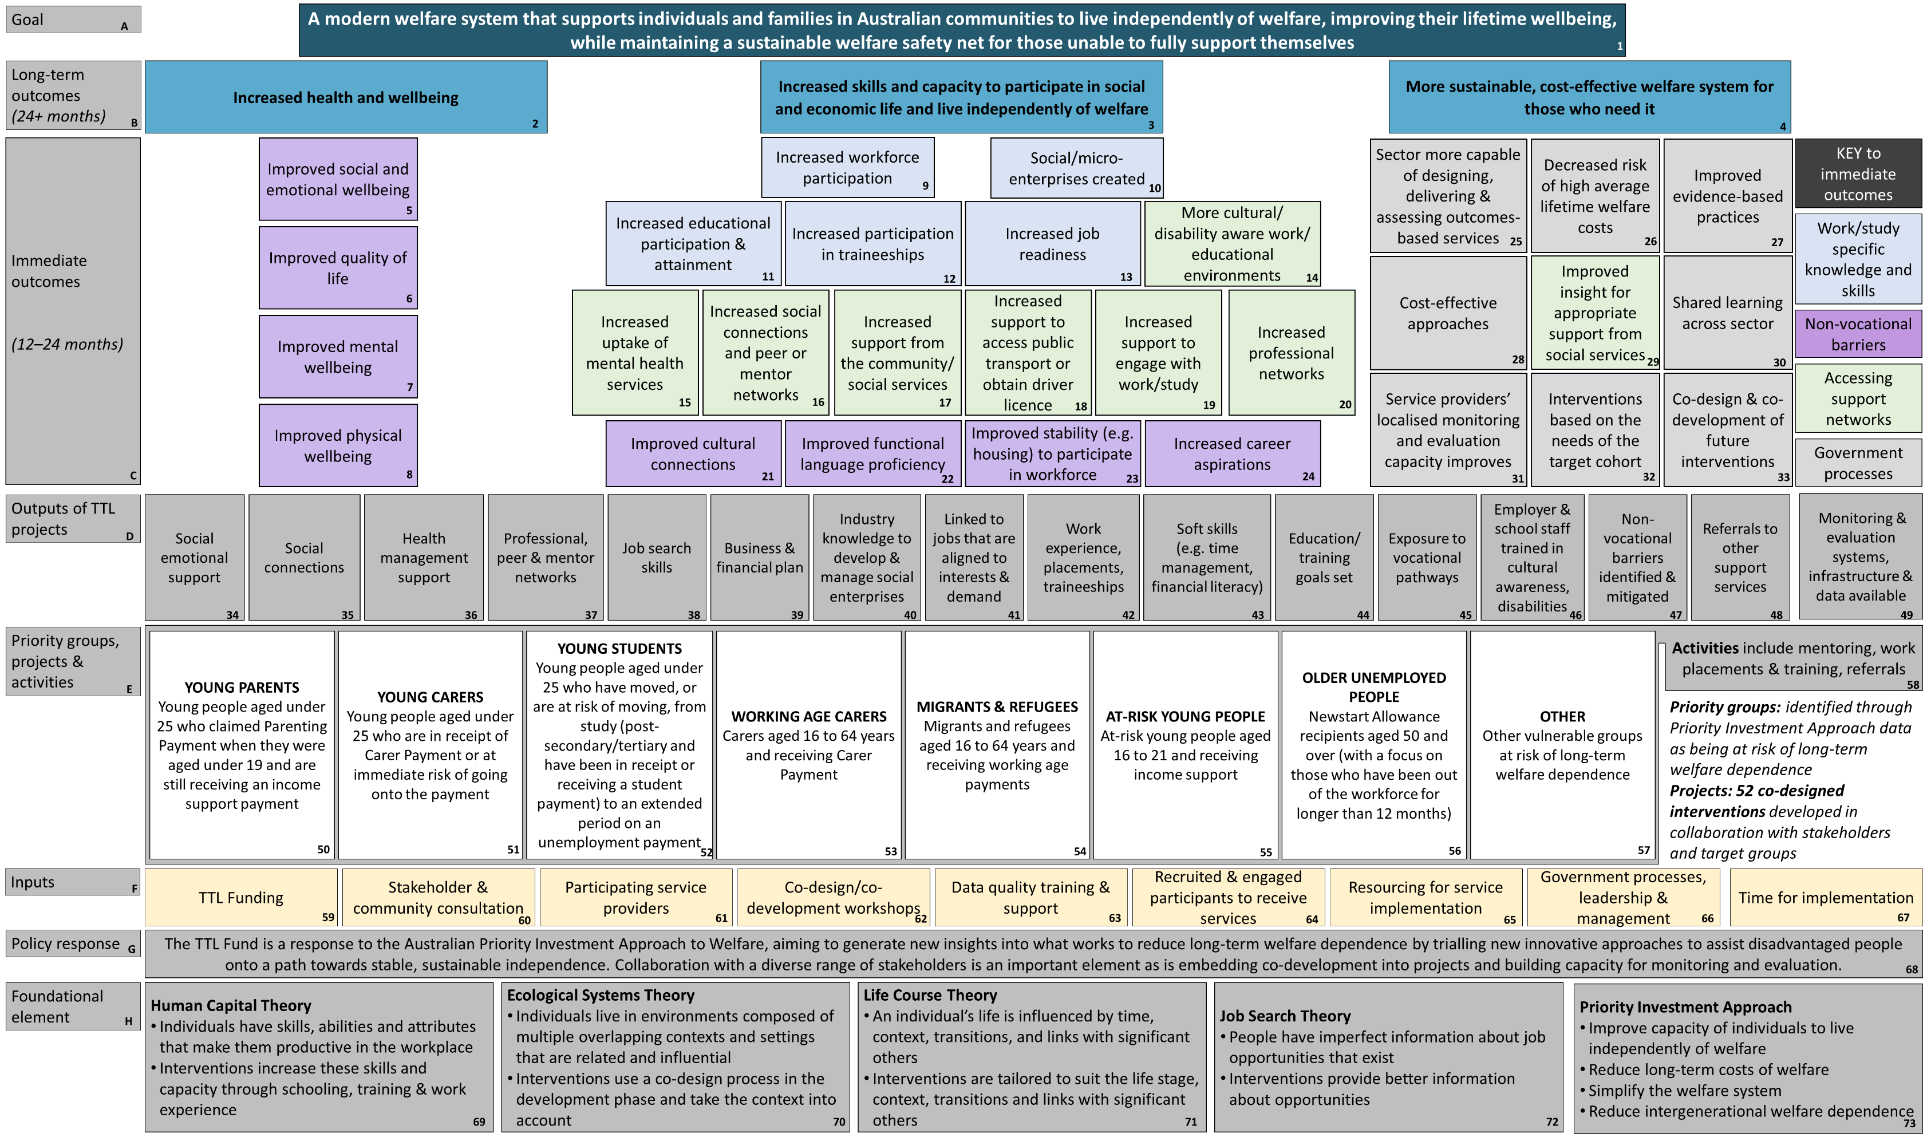

Data sources
 Data over Multiple Individual Occurrences
Data over Multiple Individual Occurrences (DOMINO) is a curated income support receipt database compiled from the department’s administrative datasets. DOMINO data are used to construct matched comparison groups for each project for the impact analyses, and incorporate data on client demographics, income support, residential location, education, family history, housing situation and family relationships.
DOMINO data used for this report cover the period up to the end of June 2020. Construction of measures for the impact analyses is discussed in detail below in Appendix D.
 Data Exchange data
All data reporting for TTL projects occurs through the web-based portal Data Exchange (DEX) via https://dex.dss.gov.au/. This portal has undergone a number of changes and updates since the introduction of TTL. Traditional grant programs are required to enter their data every 6 months.
However, TTL projects in tranche 1 were encouraged to enter their data monthly for monitoring and evaluation, and tranche 2 TTL projects were required to report monthly. The types of information that are reported in DEX by TTL service providers are demographic characteristics, main source of income and session information (time and type of activity or service undertaken). TTL clients’ DEX data were linked to the DOMINO data using a de-identified client identifier.
Two primary sources of data from within the DEX system are used to capture client circumstances and outcomes: DEX Standard Client/Community Outcomes Reporting (SCORE) data and the TTL Client Survey data.

DEX Standard Client Outcomes Reporting (SCORE) system
In addition to standard reporting into DEX, TTL service providers are required to collect additional data through DEX SCORE measures DEX SCORE data have been available since the inception of the TTL Fund (with some exceptions such as
changes made between tranche 1 and 2 where the Employment and Education SCORE measures were separated), and comprise a series of Likert- scale type responses (see Figure B-3) that represent the client’s situation as favourable/unfavourable in broad terms, across a series of 21 separate domains such as ‘employment’ or ‘mental health’. There are 4 types of outcomes measured through DEX SCORE: Circumstances SCORE; Goal SCORE; Community SCORE; and Satisfaction SCORE. Each of these DEX SCORE measures is entered at the beginning and end of a TTL client’s participation in a TTL project by the TTL service provider, with the exception of the Satisfaction and Community SCORE, which is only entered at the end. In practice, however, client data is often not captured, or is captured at other times when service providers are able.
The Circumstances SCORE is used to report changes in a TTL client’s circumstances, such as education, that impact on their independence, participation and wellbeing. It should be noted that SCORE does not collect information on the education levels and types of skills training of the TTL client, but rather how their education and skills training impacts on their ability to work or study as perceived by the TTL client. The Employment and Education SCORE measures were separated only after tranche 1 projects had started.
The Goal SCORE is used to report progress in achieving specific individual goals that need to be achieved as a pre-condition to improve client circumstances.
The Community SCORE is used to report progress in achieving specific group, organisational or community goals that support the environment for improved TTL client circumstances.
The Satisfaction SCORE is used to report changes in clients’ satisfaction with services, and is measured at the end of service delivery.
As a minimum, TTL clients or service providers are required to report on 7 of the 24 available SCORE domains (see Figure B-2). These domains represent outcomes that are most closely linked to the goals of the TTL Fund. TTL service providers are, however, encouraged to enter information on

any domain that is relevant to their project. As such, collection of these data may occur in a number of different modalities depending on the service provider and client needs. For instance, although SCORE is primarily collected by asking clients to select a response, it is also possible for service providers to rate clients based on their observations of the client. Similarly, in some instances, service providers may use a more detailed measure for separate
evaluation/program management purposes (for example, the Kessler-10 measure of symptoms of depression and anxiety) and subsequently, translate these responses back to the SCORE response categories. The SCORE outcomes are reported using a 5-point Likert scale that is intended to have a consistent interpretation across all domains within each outcome. The intended interpretation for each SCORE outcome is shown in Figure B-3.

Figure B-2 DEX SCORE domains, by outcome
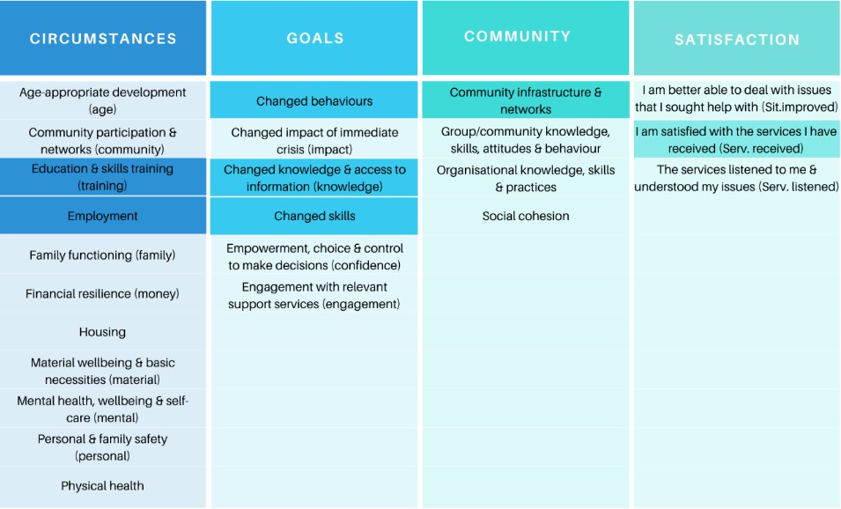
Notes: Domains that TTL projects are required to report against are a darker shade (e.g. Employment). The terms in brackets for each domain indicate the abbreviated text that is used to represent the domains in the figures.

Figure B-3 Likert scale used for each DEX SCORE outcome
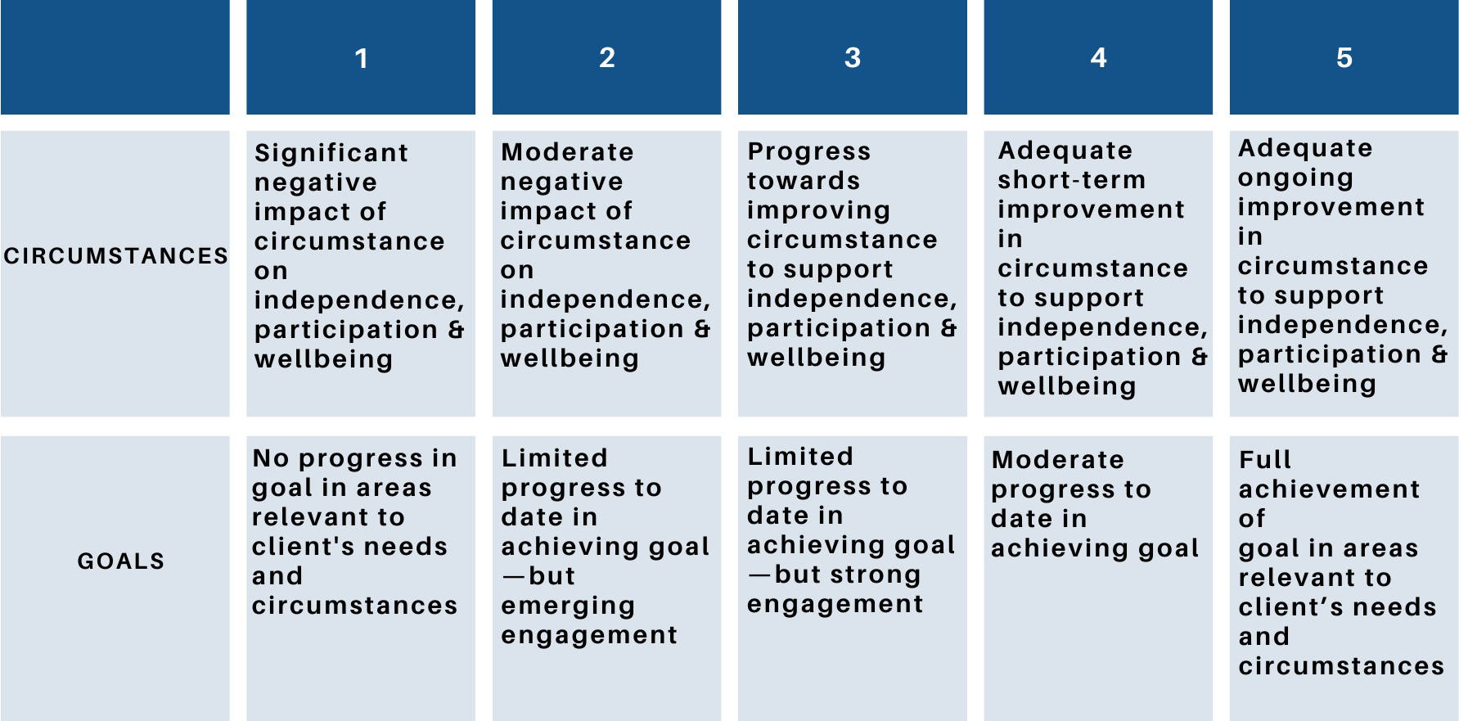
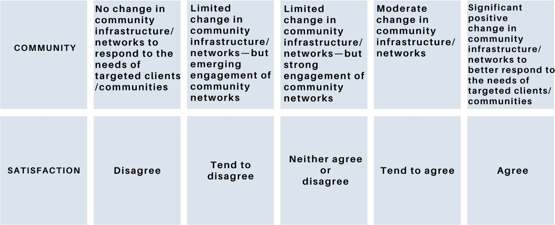

TTL Client Survey data
The second source of client outcomes data from the DEX system is the TTL Client Survey. The Client Survey was intended to capture a broader range of barriers and outcomes than what can be observed in SCORE or elsewhere in the administrative data, and is collected through an online survey embedded in the DEX platform. The survey is primarily completed directly by the client when visiting the service provider, although where necessary, service providers can assist clients to complete the survey. The survey was to be administered at the start of clients’ participation (baseline) and near the end (follow-up), with the
option to administer it a third time in the middle of clients’ participation in the project. Nineteen items identifying strengths and barriers experienced by clients form the basis of reporting, each of which is scored on a Likert scale from ‘Strongly Agree’ to ‘Strongly Disagree’. (See Appendix F-5 for TTL Client Survey items.)
 Semi-structured interviews
Client interviews were conducted to provide insight into clients’ experience with the TTL projects and how that experience affected their current situation. The interviews were conducted as semi-structured telephone interviews of approximately 60 minutes duration towards the

end of a client’s involvement in the TTL project (or after a minimum of 3 months of participation in an intervention — whichever came first). (See Appendix F-4 for interview topic guide.) A total of 230 clients were interviewed between February 2019 and June 2020 from the 36 projects that had delivered services to clients for at least 3 months prior to the interview. Clients were recruited via the TTL service providers, who distributed information about the interview, designed by the TTL Evaluation Team, to all clients. Clients could opt-in to participate in the interviews by contacting the Evaluation Team directly, or by liaising via the service providers. All clients received the participant information prior to the interview, and had the opportunity to ask questions before providing explicit consent to participate either verbally or in writing and to be audio-recorded.
The TTL service provider interviews were semi- structured group interviews via Zoom (a communications software package) of approximately 90 minutes with key project personnel. Each TTL project had a group interview, with the number of participants in each interview ranging from 2 to 16. In addition to staff from the service provider organisation, the interviews included other key stakeholders involved in the TTL project, such as consortia members, research partners, partner organisations, external evaluators, and staff from site locations such as mentors or facilitators. In this report, these participants are referred to as ‘TTL service providers’. These interviews provide insights into TTL service provider experiences with the TTL Fund and the lessons learned from the implementation of the TTL projects. The first interview was undertaken once TTL projects were recruiting and enrolling clients (time point 1), while the second interview was undertaken 9 to 12 months after the first interview (time point 2). The time point 1 group interviews focused on gathering TTL service providers’ perspectives of the initial design and planning phase (including co- design or co-development), working with the department, participant recruitment, implementation of project activities, DEX reporting and evaluation training (see Appendix F- 1 for interview topic guide). Time point 2 group
interviews focused on participant engagement with project activities (e.g. work placements or mentoring), achievement of project outputs (e.g. professional, peer and mentor networks, or soft skills), early outcomes (e.g. work or study participation), monitoring and evaluation, DEX reporting and lessons learned (see Appendix F-3 for interview topic guide). Only one interview was conducted with 13 projects who were in the early phases of project implementation during the evaluation. The interview was a hybrid of the time point 1 and 2 interview guides. Interviews were conducted between September 2018 and June 2020.
 Reporting against the Activity Work Plan
The AWP is used by TTL service providers to set a clear scope and timelines for activities to deliver on the outcomes under their TTL project grant agreement. The AWP also includes key performance indicators, risk management, budgets and engagement with stakeholders. In addition to the initial work of setting up the AWP, TTL projects produced AWP reports every quarter for the duration of the TTL project, and answered questions that were used in the TTL Evaluation.
The analyses included data from 7 questions included at the end of the AWP reports. The 7th question was added in July 2019, 12 months after the commencement of the first TTL projects from tranche 1. See Appendix F-1 for AWP report additional questions.
 Post-implementation reviews
Two post-implementation reviews (PIR1 and PIR2) were conducted. The PIR1 was conducted by an external contractor (GD Executive Consulting) in mid-2017. It drew on feedback from interviews and surveys with a range of stakeholders involved in the design, development and implementation of the TTL Fund. These stakeholders included the Australian PIA to Welfare Interdepartmental Committee members, Internal Reference Group members, Expert Advisory Panel members, idea proponents, Policy Hack participants, co- development participants, consultants used during the different processes and departmental staff. The PIR1 was designed to identify the lessons learned from the implementation of the TTL Fund. The review covered the design of the

TTL Fund, the generation of ideas (including the Policy Hack), review and checking of eligibility of ideas, shortlisting of ideas for co-design, and the co-design process.
The PIR2 was prepared by Silverstone Edge in February 2020. The department invited providers of both tranche 1 and tranche 2 projects to attend a roundtable to explore lessons learned from establishing TTL Fund projects. The roundtable aimed to draw out insights from a small group of TTL Fund grant recipients on such topics as the application processes, co-development, project implementation, reporting and monitoring, and other engagement with the department.
Additionally, the department prepared an internal document (Department of Social Services internal document) capturing processes and lessons learned for data quality, particularly successful adaptations, challenges and recommendations for improving DEX data quality.
 Priority Investment Approach
The PIA data is an annual longitudinal dataset derived from administrative data of Centrelink recipients and their partners. It contains information from 2001 onwards and includes details relating to entitlements to benefits, payment information and demographic information.
The dataset was developed following the 2015–16 federal budget to project lifetime welfare costs associated with different groups, with the view to identifying groups at risk of long-term welfare dependence.

.


– Technical methodology

Methodology overview and measures
The TTL Evaluation used a mixed methods research design, embedding qualitative methods within a quasi-experimental design. It incorporated multiple forms of data (see Appendix B-3) and methods of analysis (Appendix C-2) to evaluate the effectiveness, efficiency and appropriateness of the TTL Fund.
 Effectiveness measures

Representativeness of TTL clients of at-risk groups:
    - TTL clients’ characteristics compared to the at- risk groups identified in the PIA
Extent to which TTL projects helped increase the skills and capacity of individuals, evaluated by examining 4 overarching outcomes. Workforce participation drew on impact analyses examining income support and employment income while on income support. Educational participation used student income support as a proxy. Skills to support work or education and capacity to overcome non-vocational barriers drew on client- and service provider-reported information to provide insights at a particular point in time.
Workforce and educational participation were also complemented by these qualitative data. The measures include:
    - The impact of TTL projects on clients’ workforce and educational participation outcomes (impact analysis): Difference in TTL clients’ income support receipt and employment income from people with similar characteristics and circumstances who did not participate in any TTL project (‘comparison group’) over time (see Table C-1 for description of items)
    - Change in clients’ circumstances and goals, and satisfaction with service (pre-post): Change in the average DEX SCORE for mandatory measures

Stakeholder-reported client outcomes:
      - TTL clients’ self-reported outcomes in interviews (see Figure C-1)
      - Number of clients who were employed or entered education after completing the core component of the project, as reported by TTL service providers in AWP reports
    - Clients’ self-reported changes: as reported in TTL Client Survey

Extent to which TTL projects helped increase the health and wellbeing of individuals:
    - TTL clients’ self-reported outcomes in interviews (see Figure C-1)

Projects met stated objectives:
    - TTL projects’ primary objective(s) assessed against the triangulated outcomes evidence
 Efficiency measures
Cost-benefit analysis (CBA): Average costs and benefits by project, using information at the project level to aid interpretation of the results. Qualitative information on health and education outcomes provided context to CBA.

Average cost per participant by project based on:
      - The actual expenditures and number of participants per project (as reported in DEX) up to 30 June 2020
      - The TTL-related costs reported in the portfolio budget statements (and portfolio additional estimates statements) for the relevant years

Average benefit per participant based on:
      - Impact estimates on the probability of income support receipt, which were translated to benefits using PIA to estimate changes in lifetime welfare costs
 Appropriateness measures
Extent to which TTL Fund processes facilitated achieving Fund’s objectives and met the department and service providers’ needs, assessed by service providers’ self-reported experiences in group interviews, departmental document review and evaluators’ assessment of processes.

 Ethical clearance
The evaluation underwent full ethics review by The University of Queensland’s Human Research Ethics Committee (HREC B) and was found to comply with the provisions contained in the National Statement on Ethical Conduct in Human Research and with the regulations governing experimentation on humans (Reference number: 2018000871).

Methods
 Representativeness of TTL clients of at- risk groups
Whether TTL client characteristics reflect those of the priority group is important to be able to understand the implications of the findings for future policy. In general, if TTL client characteristics reflect those of the priority groups, then it might be reasonably expected that the lessons learned from TTL apply to the priority group more generally. However, if they are very different, then it would suggest that the applicability of the findings is limited to certain subgroups only, and would also possibly point to problems/difficulties faced in recruitment.
To examine how representative the TTL clients within each priority groups were of the average income support recipients that met the eligibility criteria of that priority group, target populations were first constructed in DOMINO for each priority group. This was done by identifying all income support recipients in DOMINO who met the priority group eligibility criteria as of 15 March 2018. Attempts were made to operationalise priority group eligibility criteria as closely as possible given the available data, but note that in several instances no clear indicators or definitions were available. In particular, there was no definition of ‘at risk’, so the comparison population for At-risk Young People was defined only by age and income support receipt at client commencement. Similarly, for the Young Students priority group, there was no definition of ‘at risk’ or how long an ‘extended period on an unemployment payment’ would be.
Consequently, the target population for each priority group was operationalised using current
receipt of Youth Allowance (other) or working age payment for a period of at least 6 consecutive months as at 15 March 2018, in addition to other age and previous study criteria. Additionally, it was only possible to identify carers by receipt of a Carer Payment, not those who were eligible or ‘at risk’ of receiving one, so that criteria was used as well as the age criteria to create the comparison population for the Young Carers priority group.
Against the average characteristics of the target population, the average characteristics of the clients recruited was compared to the priority group, linked to DOMINO and eligible for analysis (i.e. had a treatment start date and had not participated in multiple projects) at the time of their recruitment. Comparisons were made against key variables, including those related to eligibility criteria and characteristics that were particular to the priority group.
To assess the representativeness of the clients in the projects across the TTL Fund, the priority group definitions as described above were used. Additional analyses used personal or family income support history to accommodate clients who may have been identified as being ‘at-risk’.
To estimate the average level of disadvantage experienced by TTL clients, compared to the average income support recipient who met the eligibility criteria 4 indicators were derived. These include the total days on income support in the last 2 years calculated as the total days on income support unrelated to study across the 2-year period ending at their treatment start date. The highest level of education calculated as the percentage of TTL clients who had less than a Year 12 education level at the time of their treatment start date. The Index of Relative Socio-Economic Disadvantage, which is an ABS measure that quantifies the relative disadvantage of an area using broad criteria such as income, qualifications and low-skill occupation rates. The unemployment rate was taken from the ABS at the SA4 level, meaning that each individual had, as a region statistic, the unemployment rate from the SA4 that they lived in. The median unemployment rate from all SA4s in Australia was used to divide SA4 regions into high and low unemployment areas. It was then possible to estimate the percentage of

clients in each project who lived in high unemployment SA4 regions.
In addition to these disadvantage indicators, outcomes were also compared across measures such as income support history, attainment of secondary school completion or post-secondary qualifications, Indigenous status, if they had their first child while school-aged, housing tenure and partner status. These additional variables were priority group specific and only presented where sample size was sufficient to protect privacy.
Results from this analysis are discussed in detail at the Fund level (Section 3.1) and at the priority group level (Sections 3.2–3.10).
 Impact analyses
A key part of the mixed methods approach is the quantitative analysis that measures the project impacts on key outcomes, measured in administrative income support data (DOMINO). Impact analysis was conducted for projects that were large enough to generate statistically robust estimates. Statistically viable projects were those with at least 20 clients who were observed for at least 2 quarters after the time of commencement. Projects that did not have at least 20 client observations in the first 2 quarters were not included in the impact analysis because such small samples were not likely to produce robust estimates. Compared to other quantitative approaches used in TTL, such as changes in DEX SCORES, the impact analysis has 3 major advantages.
First, because before-and-after changes in outcomes are measured through DOMINO, the impact analysis covers most TTL clients.
Specifically, 79% of TTL clients from projects that were included in the impact analysis were included in the analysis. This contrasts with other quantitative approaches that have relied on clients completing before and after surveys, where less than 10% of clients were represented in the data. Second, the impact analysis was implemented in a consistent way across projects, which allowed for outcomes to be more readily compared across projects. Third, the impact analysis generated impact estimates that disentangled changes associated with the project
from changes that may have occurred anyway, for example, changes that may have occurred due to individual circumstances. This was achieved by comparing post-commencement outcomes of TTL clients against outcomes of people over the same period who had similar traits as TTL clients, but who were not involved in TTL (comparison group).
 Introduction to the comparison group approach
In any impact evaluation, the key is estimating client outcomes if they were not involved in the project, or ‘counterfactual’ outcomes, against which observed outcomes are compared to measure the project effects. The gold standard, which is commonly used in medical trials, is to randomise project allocation or randomise the opportunity for project participation (intention to treat design). Under these approaches, randomisation ensures that there are no differences between the 2 groups that may affect outcomes, so that simple mean differences in outcomes reflect the causal effects of the project allocation/project opportunities.
In TTL and other projects where participation is based on self-selection, impact analysis involves the construction of a comparison group from non- participants. This is a balancing act. On the one hand, the comparison group should be chosen to be as close as possible to TTL clients on factors that affect outcomes, so that their outcomes should, on average, reflect the counterfactual outcomes of TTL clients — the case under randomisation. For this reason, approaches that construct a matched comparison group are called ‘quasi-experimental’ methods. On the other hand, despite the large number of observations in DOMINO, finding people who are the same across all factors that are likely to affect outcomes is too restrictive and would mean that clients without a ‘statistical twin’ would be omitted from the analysis.
To deal with this issue, a 2-step approach was used. In the first step, comparison groups of people were constructed who did not participate in TTL, but who had the same select traits as TTL clients (exact matching). These select traits were those that are most important in influencing outcomes of interest, including criteria for

admission to the project (e.g. gender, age, current income support status, income support history, payment type, caring responsibilities, study status, past education, migrant and refugee status, family history and local employment opportunities). In practice, the choice of which, and how many, variables to exact match was restricted to combinations for which there was at least one statistical twin for each TTL client to avoid excluding any TTL client from the analysis.
In the second stage, a regression model of outcomes using the TTL clients and the matched comparison group was run. The variables on the right-hand-side of the regression equation, or explanatory variables, include a binary measure of membership of the client or comparison group along with all other variables that may influence outcomes that ‘soak up’ the residual differences between the 2 groups. These other variables vary from project to project, but include a rich list of variables, including family history information that may reflect family stability and financial independence (e.g. mother’s income support history, number of partners of mother between 6 and 15, whether mother has a mental health condition); past education attainment and recent study; own reported health conditions while on income support; relationship status; country of birth; recent history of employment income while on income support; housing arrangements; regional disadvantage and participation in non-TTL programs while on income support (from DEX).
Determining which variables to use in the exact matching and regression analysis were guided by the theory of change, drawing on human capital, job search, life course and ecological systems theories that explain how resources and individual circumstances influence individual capabilities over a life course.
While the impact analyses prevents either the TTL clients or the comparison group being favoured/penalised because of different exposure to macroeconomic conditions (e.g. job loss due to COVID-19) or other national trends, such as policy changes (e.g. JobKeeper), these analyses could not control for the variable impact on project implementation and dilution or cessation of services during COVID-19 restrictions which affected some geographic areas more than others.
COVID-19 restrictions had 2 main impacts. First, it reduced the time available to tranche 2 projects to show impacts compared to tranche 1 projects, and second, some projects could not deliver their original design and instead had to adjust their project to fit the restrictions. This may have limited the impact these projects could have had on their clients and thus what could be observed in the analyses.
The estimated regression coefficient on the membership identifier represents the average effect of TTL on the project clients. Such a complementary use of exact matching and regression has been shown to be an effective combination in similar large sample settings (see,
e.g. Glazerman, Levy & Myers 2003; Abadie & Imbens 2006). It is important to stress that the estimated average project impact applies only to clients in the analysis, and caution should be exercised in using the results to compare across projects or priority groups. Any comparison of results across projects within a priority group should be considered only as ‘suggestive’ of the relative impacts of different projects.
 Data construction and implementation
Data used in the impact analysis involved the linking of individual TTL clients, via a unique client number, to individual records within DOMINO between 1 January 2016 and 30 June 2020. We allowed the linkage to extend beyond the period of analysis (1 July 2018 to 30 June 2020) to maximise the chances of finding a match, including for people who were no longer on income support during their time in TTL. Overall, 79% of TTL clients were linked to DOMINO, or 4,090 out of 5,201 clients in DEX (see Table C-2 for projects included in impact analyses).
In total, the matched dataset contains information on over 1 million individual recipients of income support between 1 January 2016 and 30 June 2020. Such a large dataset is computationally intractable. To deal with this issue, for each project we chose ‘like regions’, measured at Australian Bureau of Statistics (ABS) Statistical Area 2 (SA2) level, from which to draw matched comparison groups. We chose SA2 geographic regions (typically containing around 10,000

people) because they represent communities that interact together socially and economically and are the smallest area that ABS data is available for. This means it is the finest level for which a ‘like region’ can be derived.
For a given project, the selected like regions did not include SA2s where the project clients resided to minimise differences between clients and matched comparison groups that were not observed in the data. In general, while people who volunteer (or agree) to be part of social interventions like TTL may have very similar characteristics to those who do not on things we can observe (such as education, age, caring responsibilities), they are often quite different on characteristics that cannot be observed, such as interpersonal skills (trust, openness to new experiences and agreeableness) that can also affect outcomes. Thus, within regions, those who did and did not participate in TTL are likely to be different in ways that we cannot control for, which is why we did not draw comparison of groups from within the same regions. Choosing like, but different, regions does not totally avoid this problem, but by allowing the comparison group to be drawn from a pool of people with a mixture of unobserved traits, it may reduce it.
To choose like regions for each project, we used coarsened exact matching, an approach that chooses regions that meet criteria stipulated by the researcher. These are regions that have characteristics, such as unemployment rate, socio- economic composition (ABS index of relative
socio-economic disadvantage), ABS remoteness structure, that are within defined bounds of the regions where the TTL clients are from.
Another key aspect of the data infrastructure was reshaping the data to ensure that the period over which TTL clients and the matched comparison groups were compared was the same. This prevents either the TTL clients or the comparison group being favoured/penalised because of different exposure to macroeconomic conditions or other national trends, such as policy changes. To achieve this, we set the starting point from which TTL outcomes would be observed as the date of client commencement in TTL. This was defined by the date of the client’s first session
that was not an intake/assessment session, except where the metadata documents indicated a different choice would be appropriate.
Information/referral sessions that occurred prior to intake/assessment were assumed to be general information sessions about the project and were not part of the service. Once the commencement date was set, then the time-varying variables (outcomes and variables used in matching) for the client were defined monthly from the commencement date. For those who were not TTL clients, time-varying information was generated monthly as of the 15th of each month. This created a monthly longitudinal image of potential recruits over 24 months and the exact matching (described above) selected, for each TTL client, comparators who had the same characteristics (on selected variables) in the month of TTL commencement.
As described above, outcomes were generated on a quarterly basis from the time of commencement. Because TTL projects were rolled out at different times, the post-commencement timeframe over which outcomes could be observed varied. For some projects, the rollout occurred late, which only allowed for estimation of impacts over one or 2 quarters post- commencement. As well as a varying post- commencement observation window (within the maximum 2-year window), because project recruitment within a project occurred over time, there were fewer post-commencement outcome quarters observed for people who were recruited later rather than earlier to a project. This has 2 implications. First, it meant that longer term impacts were generated from fewer observations, and hence became less statistically robust. To address this problem, we restricted the estimation of impacts to quarters for which there were at least 20 client observations. Second, the shorter observation window of those recruited later meant that the composition of the client group varied from quarter to quarter, which may have implications if the characteristics of the clients varied systematically over time because of changes in the recruiting strategy (e.g. they became less discerning in who they recruited over time to meet participation targets). For each project, we estimated alternative models to test

the sensitivity of results to this scenario (see Section C-2-2-3 for details).
Although we tracked outcomes longitudinally in the data, there was no consistent way in DEX of recording the level of service delivery (e.g. hours of services received) or client completion of the project over time. Thus, we could not measure the relative rates of service delivery, project completion or the impact that completion may have had on outcomes.
The types of outcomes used in the impact analysis were those from DOMINO that directly related to income support. These are a binary measure of income support at the end of the quarter — receipt unrelated to study and income support related to study — and a continuous measure of the number of days on any income support within the quarter. Measures of employment are only available while clients remain on income support. These are a binary measure of any employment income earned over the quarter and total employment income ($) over the quarter. These outcomes are summarised in Table C-1 below.
Income support unrelated to study includes the following payment types: JobSeeker Payment (formerly Bereavement Allowance, Newstart Allowance, Partner Allowance, Sickness Allowance, Widow Allowance, Wife Pension and Widow B Pension), Age Pension, Carer Payment, Disability Support Pension, Exceptional Circumstances Payment, Farm Family Restart Scheme, Mature Age Allowance, Mature Age Partner Allowance, Newstart Mature Age Allowance, Parental Leave Pay, Parenting Payment Partnered, Parenting Payment Single, Special Benefit, Wife Pension DSP, Youth Allowance (other). Income support associated with study includes the following: ABSTUDY (schooling), ABSTUDY (secondary/tertiary — CEPS), ABSTUDY (secondary/tertiary), Austudy, Youth Allowance, Youth Allowance (student) and Youth Training Allowance.
In undertaking the analysis, we omitted those who were under 16, who were outside the TTL eligibility age, except for clients from Young Parents and Young Students priority groups.
 Sensitivity tests
In any impact analysis, there are always limitations of the analysis that cannot be avoided or decisions that are made that may involve trade- offs. In such cases, it is prudent to test how sensitive the findings are to these parameters before making conclusions about effectiveness. In the impact analysis, the key parameters that could affect the results included issues related to the sample definition (sample of analysis construction, sample restrictions due to outliers, and compositional changes in the sample over time) and those related to the choice of control variables.
From the sensitivity tests conducted (described below), our conclusion is that the results of the impact analysis (Chapter 3) are generally robust.
Sample definition
As discussed above, a limitation of the impact analysis was that not all TTL clients could be included in the analysis. Of the 5,201 TTL clients, 4,090 are included in sample of analysis, or 79%. Of the 1,111 clients who were not included, the main reason was that clients (from DEX) could not be linked to DOMINO data (967). The remaining reasons include no individual client commencement date available from DEX (92), synthetic identifier (used in the linking) was missing (28), and clients participated in multiple TTL projects (24). The extent to which exclusion of around 20% of TTL participants skews the results and findings depends on whether the characteristics of those who were excluded differed from those that were not. To test this, for each priority group, we ran statistical tests (logistic regressions) for differences in the characteristics of clients in DEX who were included in the sample of analysis against those who were excluded. The characteristics examined include education, employment, living arrangements, age, gender, Indigenous status and regional measures. Across all priority groups, we found few statistical differences in characteristics between those included and excluded, except for age. Across priority groups that recruited young people, the sample of analysis had a lower representation of clients under 16. Under age 16, TTL clients would not typically receive income support that was

independent from their parents, which meant that they would not appear in DOMINO. Age aside, the similarity of characteristics of clients in and out of the sample of analysis provided comfort that the exclusion of some TTL clients did not skew our findings.
Further sample restrictions were made because of peculiarities in the data or the clients (outliers).
Examples include a small number of male Young Parents clients who were excluded because important controls for caring responsibilities could not be derived from relationship tables (an issue peculiar to many males), and clients under 18 who, except for Young Parents and Young Students, were outside the eligibility criteria. In these cases, we ran analysis with and without the outliers to test the sensitivity to their exclusion. In the main, the numbers excluded were small and their exclusions made no substantive difference to the results.
As discussed above, a side effect of ongoing recruitment over time within a fixed 2-year window is that the time that clients can be observed post-commencement varies, with late recruits observed over fewer quarters than early recruits. This means that any longitudinal impact measured from the time of client commencement may not just reflect the impacts of the projects over time, but also changes in the composition of the client recruits. To test the sensitivity of our results to this scenario, for each project, we ran alternative impact analysis where we restricted the sample to those who were observed in each of the quarters analysed post-commencement (early recruits). Without exception, results from these alternative analyses were consistent with the main results reported in Chapter 3.
Selection of control variables
As discussed in Section C-2-2, key to producing estimates that reflect ‘causal’ impacts of the projects, and not just differences in the outcomes of clients and their matched comparison group, is the choice of variables in the exact matching and subsequent regression analysis. This was informed by theory of change, but in practice, we were
limited by the richness of the controls that were available in the data. When using quasi- experimental approaches, there is no way to be sure that all differences between clients and the matched comparison group have been adjusted for. This means that estimated impacts should not be interpreted as causal.
Although causal interpretation cannot be used, we tested for evidence of potential bias by generating results with different levels and types of controls in the regression analysis, including results with no controls (just differences in outcomes between the treated and exact matched sample) to get a sense of how sensitive the results were to the addition of extra controls. Except for a handful of projects (discussed in Chapter 3), the nature of results, but not necessarily the magnitude of results, were unchanged after the introduction of variables in the regression analysis once a finely defined exact matched comparison group was established. The implication is that in all but a handful of cases, the data was rich enough to draw from the large sample of non-participants comparators that were alike on the most important factors that explain outcomes (besides participation). Thus, this gives us comfort that in most cases, the results are not heavily biased by insufficient controls.

Table C-1 Outcome measures for impact analyses

Outcome label | Description of outcome | Description of impact measure
Income support unrelated to study | Whether a person was in receipt of income support payments, that is, not student-related income support (yes or no) | Difference between the percentage of TTL clients on non-student income support relative to the comparison group, measured at the end of a given quarter
Student income support | Whether a person was in receipt of student-related income support payments (yes or no) | Difference between the percentage of TTL clients on student income support relative to the comparison group, measured at the end of a given quarter
Any employment income while on income support | Whether a person received any income from employment while on income support in a 3-month period (yes or no) | Difference between the percentage of TTL clients who received any employment income relative to the comparison group, measured at the end of a given quarter
Number of days on any income support | The number of days a person received income support payments in a 3-month period | Difference in the average number of days TTL clients received income support in a 3-month period, relative to the comparison group, measured at the end of a given quarter
Employment income earned while on income support | The amount of income earned from employment while in receipt of income support in a 3-month period | Difference in the amount of employment income TTL clients earned (A$) in a 3-month period, relative to the comparison group, measured at the end of a given quarter

 DEX SCORE analyses
To evaluate changes in clients’ circumstance and goals, the percentage of people who reported improvements on DEX SCORE measures were assessed. TTL service providers were required to collect DEX SCORE data for at least 7 measures at the beginning (baseline) and end of a TTL client’s participation in the TTL project (follow-up), with the exception of the satisfaction SCORE, which was only collected at the end. The change in the average SCORE measures from baseline to follow- up was calculated and the percentage of TTL clients’ that improved are presented (see Figure B-2 for mandatory items).
For ease of interpretation, improvement in SCORE outcomes for clients with both a ‘baseline’ SCORE and a ‘follow-up’ SCORE are reported, separated by at least 7 days, for instances where there are at least 20 clients with available pre-post data of this kind. Improvement is defined simply as having recorded a more favourable SCORE measurement
at the follow-up than at baseline. The baseline SCORE is defined as the earliest recorded DEX SCORE, up to 28 days before or after (56-day window) either the first session or commencement of service, excluding an intake/assessment session. The 28-day restriction is intended to support clarification of the meaning of the DEX SCORE responses. The alternative approach would be to take the earliest recorded DEX SCORE as the ‘baseline’, regardless of time elapsed between the first session and the DEX SCORE date; however, this would create interpretation difficulties, as a small number of the earliest DEX SCOREs are dated much later than the first session. The follow-up is measured as the last recorded DEX SCORE within 28 days of the last recorded session in DEX (the timing of which may vary across projects and clients). Improvement was only reported for cases where both a baseline and the follow-up SCORE were available. As with the 28-day window, the requirement for a 7-day gap between baseline and follow-up SCOREs was

imposed to aid interpretation, specifically to ensure that there was time for the intervention to occur in the interim. Note that the majority of cases had substantially longer gaps between baseline and follow-up SCORE dates. A combination of ongoing delivery of project services and lack of follow-up meant that the percentage of clients for whom improvement could be observed in SCORE measures was often low.
There are several challenges in interpreting the DEX SCOREs. Therefore, these measures should be interpreted as providing general insights into the circumstances or challenges TTL clients face at the start of a project, client satisfaction with service provision, and some progress of TTL clients. It is not advised to use SCORE measures to form judgements about the project effectiveness, including relative effectiveness across projects, for the following reasons:
- The available SCORE measures are, in many cases, based on a limited subgroup and may not be representative of the experiences of all TTL clients in the project.
- The SCORE measures are recorded at different times, which limits comparability across projects with distinct SCORE collection times.
- There is an absence of information on who recorded the SCORE measures (client or service provider).
- DEX protocol defines responses for goals domains in terms of ‘making progress’, but there are no guidelines on how to measure progress and it is likely to be interpreted differently.
 TTL Client Survey analyses
As the TTL Client Survey was only implemented much later (February 2019), the available data are much more restricted in comparison to the SCORE data, with many programs having already completed or commenced service delivery before the TTL Client Survey became available. In particular, there are only a very small number of clients with multiple TTL Client Survey completions that could form the basis for
measurement of change, and consequently we report improvement on Client Survey items only at the TTL Fund level, and not at the level of individual programs or priority groups.
At the TTL Fund level, we report improvement on these items for clients with multiple survey completions, including instances where there was an available ‘baseline’ response (completed either when the client was ‘Near the start’ of program participation or ‘Near middle’) and a ‘follow-up’ response (completed either ‘Near middle’ if the baseline is ‘Near the start’, or ‘Near end’). Similar to the SCORE analysis, improvement was defined simply as recording a more favourable response at the ‘follow-up’ completion in comparison to the ‘baseline’ completion.
We also report analysis of barriers experienced by clients at baseline at the TTL Fund, priority group and program levels. For this purpose, we utilised the earliest recorded Client Survey completion for each client, excluding instances where the earliest client survey was completed ‘Near end’ of program participation. Clients are defined as experiencing a given barrier where they respond either ‘Strongly Agree’ or ‘Agree’ to negatively worded items (i.e. items where the issue ‘makes it hard to work or study’), or ‘Strongly Disagree’ or ‘Disagree’ to positively worded items (e.g. ‘I am someone who can be successful at work or study’).
 Qualitative data analyses
Audio-recordings from the group interviews with TTL service providers and client interviews were transcribed, and all identifiable information removed.
The qualitative data were analysed using the Framework Approach to thematic analysis. Data from the group interviews with TTL service providers at 2 time points (where relevant²¹), and the 7 open questions from the AWP reports, were analysed together using NVivo12, a computer software program for analysing qualitative data. Client interview data were analysed separately using the same analytical methods.

²¹ Only one interview was conducted with 13 projects who were in the early phases of project implementation during the evaluation.

Coding frameworks were developed for staff and client data respectively, to ensure consistency among the coders. Data were analysed thematically, guided by the evaluation objectives and questions, and structured along the topics covered in the interview guides. Classification sheets were used to organise the data along attributes of the projects, for example, priority group or location, and project elements, such as inclusion of a mentor in the project.
 Client reported outcomes
Client-reported outcomes were assessed through thematic analysis of the coded TTL client interview
data. The resulting outcomes that emerged from the analysed data were categorised in 5 overarching outcomes defined by the long-term outcomes in the program logic. Figure C-1 presents the 5 overarching outcomes, and the coded sub-outcomes included in each overarching outcome.
 Cost-benefit analyses – economic evaluation
Details of the CBA analyses and results are in Appendix E.

Figure C-1 Client-reported outcome measures
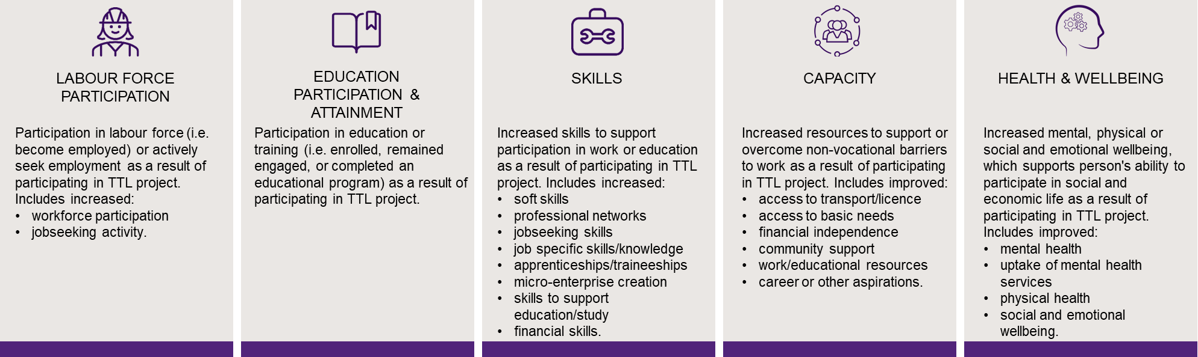
Notes: Client interviews were analysed by inductively coding client-reported outcomes. The themes, or sub-outcomes, were grouped into 5 overarching outcomes informed by the program logic

 Data sources for analyses by TTL project
Table C-2 indicates which data were available and included in the analyses for each project.
Table C-2 Data sources included in analyses by TTL project

Project number | Priority group | Tranche | Project | Impact analyses & CBA | DEX  data | Service provider interviews | Client interviews | DEX SCORE (PG  level) | TTL  Client Survey (PG  level) | AWP  report Q7
1 | Young Parents | T1 | Career Readiness for Young Parents | * | * | * | * | * | * | *
2 | Young Parents | T1 | In-School Parent Employment Services | * | * | * | * | * | * | *
3 | Young Parents | T1 | Train and Care | * | * | * | * | * |  | *
4 | Young Parents | T1 | Supporting Expecting & Parenting Teens | * | * | * | * | * | * | *
5 | Young Students | T1 | Support for VET Students | * | * | * | * | * | * | *
6 | Young Students | T1 | Rewire the Brain | * | * | * | * | * | *
7 | Young Students | T1 | Strengthening Students’ Resilience |  |  | *
8 | At-risk Young People | T1 | Mentoring 2 Work | * | * | * | * | * | * | *
9 | At-risk Young People | T1 | Y4Y Youth Force | * | * | * | * | * | * | *
10 | At-risk Young People | T1 | Build and Grow | * | * | * | * | * | * | *
11 | At-risk Young People | T1 | My Maintenance Crew | * | * | * | * | * | * | *
12 | At-risk Young People | T2 | Lead with Culture | * | * | * | * |  | * | *
13 | At-risk Young People | T2 | Dunn & Lewis F3style | * | * | * | * | * | * | *
14 | At-risk Young People | T2 | Your Job Your Way | * | * | * | * | * | * | *
16 | At-risk Young People | T2 | Brighton Integrated Community Engagement | * | * | * | * |  |  | *
18 | At-risk Young People | T2 | RIDE | * | * | * | * | * | * | *
19 | At-risk Young People | T2 | Leadership, Engagement and Development | * | * | * | * | * | * | *
20 | At-risk Young People | T2 | Meeting the Youth Gap | * | * | * (1) |  | * | *
21 | At-risk Young People | T2 | Support to Skills |  | * | * | * | * | *
22 | At-risk Young People | T2 | Explore, Discover and Empower |  | * | * | * |  | * | *
23 | At-risk Young People | T2 | Dependence to Independence | * | * | * | * |  | *
24 | At-risk Young People | T2 | The Opportunity Account |  |  | *

Project number | Priority group | Tranche | Project | Impact analyses  & CBA | DEX  data | Service provider  interviews | Client interviews | DEX SCORE (PG  level) | TTL  Client Survey (PG  level) | AWP  report  Q7
25 | At-risk Young People | T2 | Care Plays |  |  | * (1)
26 | Young Carers | T1 | Carer Achievement Pathway | * | * | * | * |  |  | *
27 | Young Carers | T1 | Skills for Micro-enterprise |  | * | * | * |  |  | *
28 | Young Carers | T1 | Data-driven Job Opportunities | * | * | * | * |  |  | *
29 | Young Carers | T2 | Young Carer School Accreditation project |  | * | * (1) |  |  |  | *
30 | Working Age Carers | T2 | Carers Connect to Education and Employment |  | * | * (1) |  |  | *
31 | Migrants and Refugees | T2 | The Australian Way |  |  | * (1)
32 | Migrants and Refugees | T2 | Employer-led Refugee Employment project | * | * | * | * | * |  | *
33 | Migrants and Refugees | T2 | Women's Employment Into Action | * | * | * | * | * | * | *
34 | Migrants and Refugees | T2 | Sonder Employment Solutions | * | * | * | * | * | * | *
35 | Migrants and Refugees | T2 | UpCycLinc | * | * | * (1) |  | * | * | *
36 | Migrants and Refugees | T2 | A Bridge to Regional Employment and Opportunities |  |  | * (1)
37 | Migrants and Refugees | T2 | Multicultural Enterprise Development Project | * | * | * (1) |  | * | * | *
38 | Older Unemployed People | T2 | Next Steps | * | * | * | * | * | * | *
39 | Older Unemployed People | T2 | Work Work | * | * | * | * | * | * | *
40 | Older Unemployed People | T2 | Sisters Support Business Together |  | * | * | * |  | * | *
41 | Older Unemployed People | T2 | Reach, Train and Employ |  | * | * | * |  | *
42 | Older Unemployed People | T2 | Career Skills for New Jobs | * | * | * | * | * | * | *
43 | Older Unemployed People | T2 | Building Bridges for Mature Jobseekers | * | * | * (1) |  | *
17 | Other | T2 | Community Voices | * | * | * | * | * | * | *
44 | Other | T2 | The Coach Project |  | * | * (1) |  |  |  | *
45 | Other | T2 | Getting Ready for Take Off | * | * | * | * |  | * | *
46 | Other | T2 | Giving it a Go |  |  | *
47 | Other | T2 | Finding Strengths |  | * | * | *
48 | Other | T2 | Warra Warra Kanyi | * | * | * (1) |  |  | *
49 | Other | T2 | Online Business Lift-Off | * | * | * | * | * | *

Project number | Priority group | Tranche | Project | Impact analyses  & CBA | DEX  data | Service provider  interviews | Client interviews | DEX SCORE (PG  level) | TTL  Client Survey (PG  level) | AWP  report  Q7
50 | Other | T2 | Demand-led Education to Employment in Care |  | * | * | * | *
51 | Other | T2 | I Am Ready | * | * | * | * |  |  | *
52 | Other | T2 | Ability School Engagement Partnership |  |  | * (1)
53 | Other | T2 | IMPACT Club |  | * | * (1)
Notes: 1. Impact analyses and CBA – * indicates the 34 projects that had sufficient data (i.e. at least 20 clients who were observed for at least 2 quarters after commencement up until 30 June 2020) to be included in the impact analyses and CBA. 2. DEX data – * indicates the projects that had data in DEX. 3. Service provider interviews – *indicates the projects that had service provider interview data; *(1) indicates the 13 projects that had only one hybrid group interview. All other projects had group interviews at 2 time points. 4. Client interviews – * indicates the projects that had client interview data. 5. DEX SCORE (PG level) – * indicates the projects that had data included in the priority group level analyses of the pre-post DEX SCORE analyses. 6. TTL Client Survey (PG level) – * indicates the projects that had baseline data included in the analyses of TTL clients’ barriers at the priority group level. AWP report Q7 – * indicates the projects that reported against question 7 in the AWP reports (see Appendix F-1)


  - TTL Fund

– Effectiveness

 TTL clients’ self-reported barriers
TTL clients were invited to complete the TTL Client Survey, one near the start of project participation (baseline) and a second survey toward the end (follow-up). See Appendix C-2-4 for further details on TTL Client Survey analysis. Figure D-1 shows TTL clients’ self-reported vocational and non-vocational barriers as reported on the TTL Client Survey at baseline. Figure D-2 shows clients’ self-reported improvement in client survey items, for all clients with baseline and follow-up (pre-post) data. Figure D-3 shows clients’ self- reported improvement for clients with pre-post data and who indicated room for improvement at baseline (pre-).
Figure D-1 TTL clients’ self-reported vocational and non-vocational barriers on TTL Client Survey items
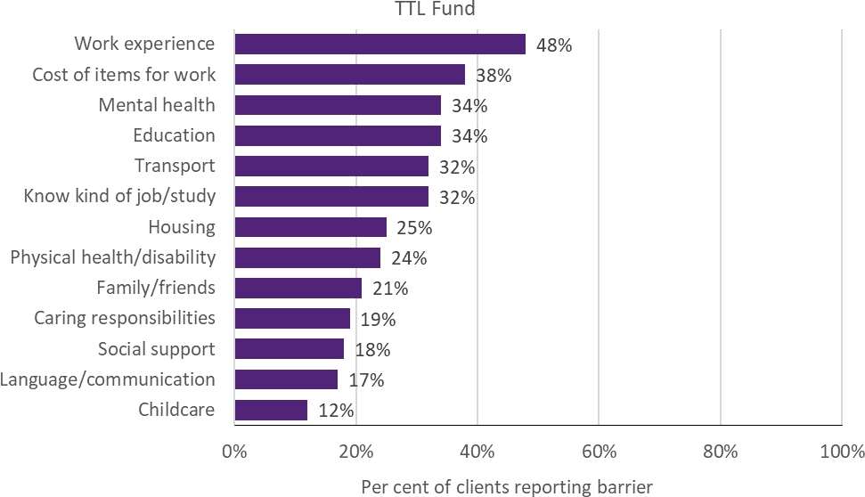
Notes: Data are from TTL Client Survey at baseline (first survey not near the end of participation). Collected from 14% (n=690) of TTL Fund clients across 34 out of 52 projects

Figure D-2 TTL clients’ self-reported improvement on TTL Client Survey items – overall
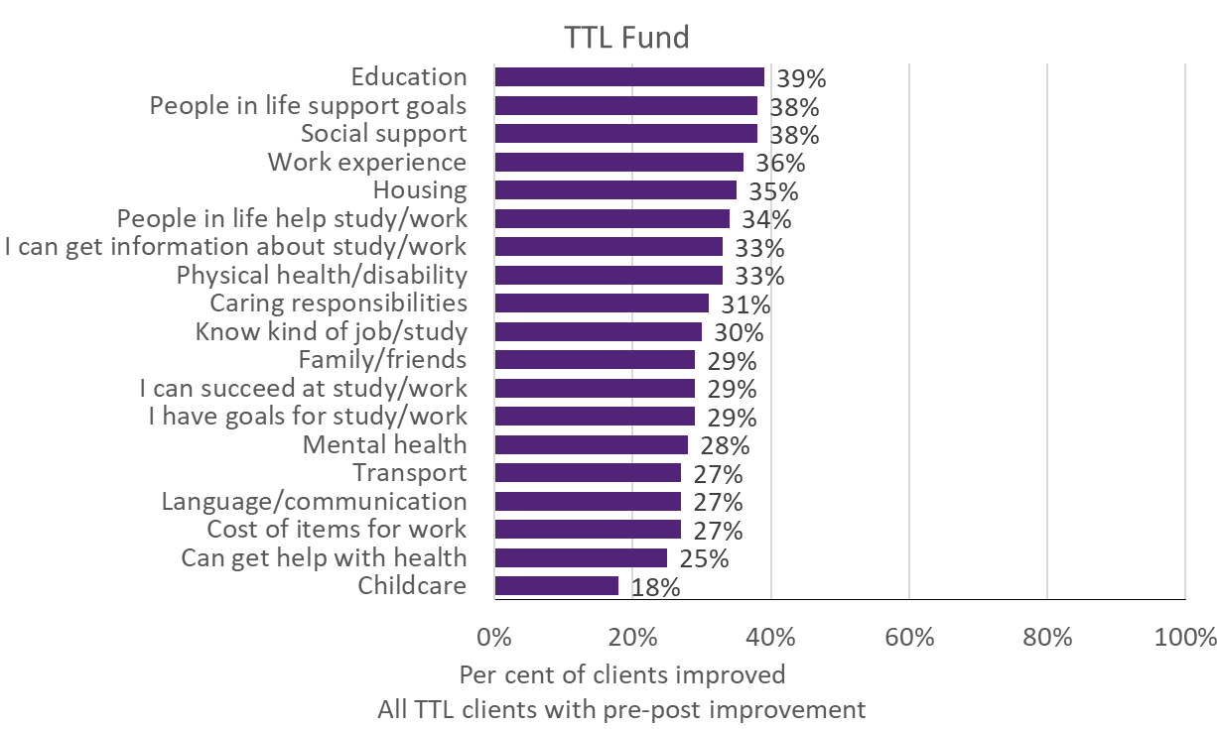
Notes: Data are from TTL Client Survey. Collected from 2% (n=79) of the TTL Fund clients with pre-post data. Number of projects not reported for data privacy reasons
Figure D-3 TTL clients’ self-reported improvement on TTL Client Survey items – only clients indicating room for improvement at baseline
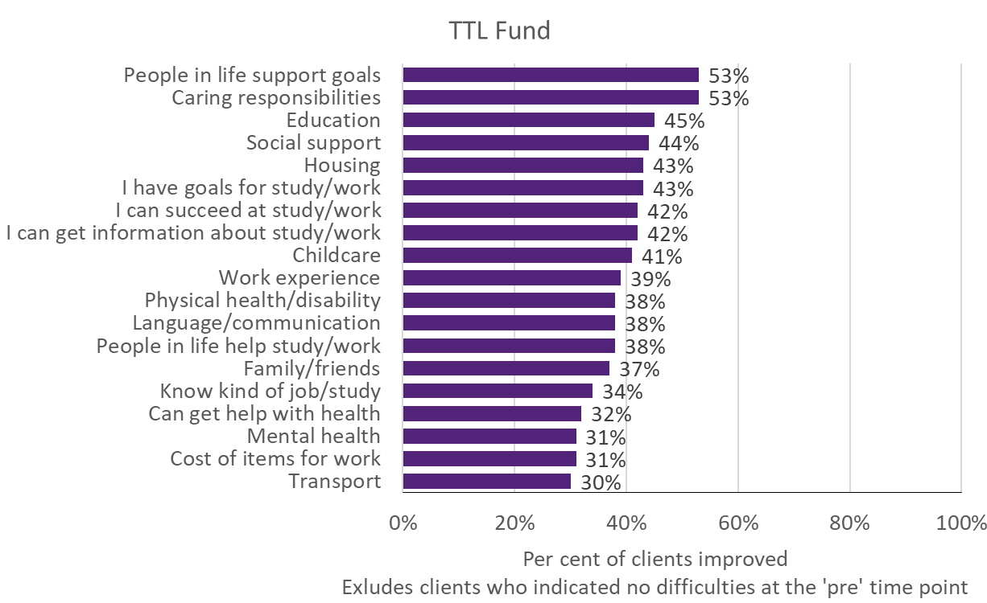
Notes: Data are from TTL Client Survey. Collected from 1% (n=72) of the TTL Fund clients with pre-post data, and reported room for improvement at baseline (pre-). Number of projects not reported for data privacy reasons

 TTL clients’ change in circumstances and goals
TTL service providers were required to collect data through DEX SCORE measures at the beginning (baseline) and end of a TTL client’s participation in the TTL project (follow-up). Improvement in SCORE outcomes for clients with both a baseline (pre) SCORE and a follow-up (post) SCORE, separated by at least 7 days, are reported for instances where there are at least 20 clients with available pre-post data of this kind. Improvement is defined as having recorded a more favourable SCORE measurement at the follow-up than at baseline. See Appendix C-2-3 for detail on DEX SCORE analysis. Figure D-4 presents the proportion of TTL clients that improved at the TTL Fund level.
Figure D-4 TTL clients’ change in circumstances and goals on DEX SCORE measures
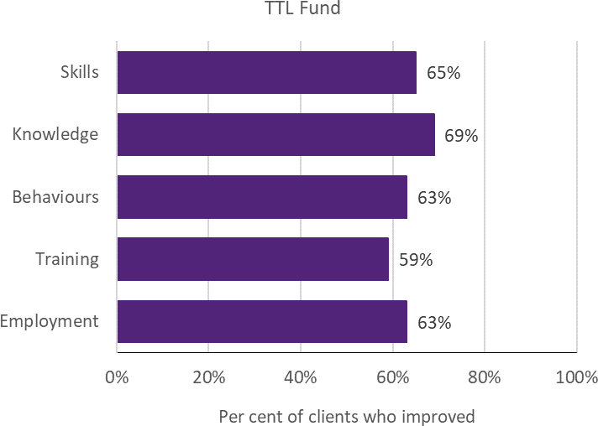

Notes: DEX SCORE data were collected for 28 out of 52 projects. Eleven per cent (n=546) of TTL Fund clients were observed with baseline and follow-up data. The fund data was dominated by 4 projects, with just over half of the TTL clients coming from Build and Grow, Rewire the Brain, Mentoring 2 Work and Support for VET Students

Young Parents
 Project level details
Priority group eligibility criteria: The Young Parents TTL projects broadly sought to provide support to people aged under 25 who claimed Parenting Payment when they were aged under 19 and were still receiving an income support payment.
Table D-1 provides details of the 4 Young Parents projects, including the projects’ primary objective(s), and the number of clients and main service type recorded in DEX.
Table D-1 Project objectives and service delivery recorded in DEX - Young Parents

TTL project | Project start date | Primary objective | Number of clients in DEX | Main service type delivered
1. Career Readiness for Young Parents | 15-Feb-18 | Skills & Capacity | 85 | Mentoring/peer support
2. In-School Parent Employment Services | 19-Mar-18 | Workforce participation, Skills &  Health and wellbeing | 87 | Facilitate employment  pathways
3. Train and Care | 15-Feb-18 | Workforce participation  & Skills | 73 | Education and skill  building
4. Supporting  Expecting & Parenting Teens | 01-Mar-18 | Health and wellbeing | 427 | Mentoring/peer support
Notes: Project start date is defined as the start of the project after the contract is signed. Primary objective is categorised according to project objective detailed in AWPs. Number of clients in DEX are to 30 June 2020; includes clients who may have participated in more than one TTL project. Main service type delivered is based on the most frequently recorded DEX session service type for each TTL project
 TTL clients’ level of disadvantage
Table D-2 presents the 4 indicators used to estimate the average level of disadvantage experienced by TTL clients, compared to the average income support recipient who met the eligibility criteria. These are presented by project, priority group and PIA level. (See Appendix C-2-1 for description of analyses.)

Table D-2 Disadvantage indicators – Young Parents

 | 1. Career Readiness for Young Parents | 2. In-School Parent Employmen t Services | 3. Train and Care | 4. Supporting Expecting & Parenting Teens | Priority group | Ave. IS  recipi ent
Total number of days on income support in last 2 years (mean) | 585 | 535 | 674 | 469 | 517 | 618
Highest level of education  (less than Year 12) | 36% | 33% | 51% | 38% | 39% | 51%
Index of Relative Socio- economic Disadvantage (bottom 20%) | 41% | 60% | 43% | 52% | 51% | 42%
Unemployment rate SA4 (high) | ≈ 100% | 37% | 37% | 42% | 57% | 58%
Notes: Data are from DOMINO. Total days on income support in the last 2 years was calculated as the total days on income support unrelated to study across the 2-year period ending at their treatment start date. Highest level of education is presented as the percentage of TTL clients who had less than a Year 12 education level at the time of their treatment start date. Index of Relative Socio-Economic Disadvantage is an ABS measure that quantifies the relative disadvantage of an area using broad criteria such as income, qualifications and low-skill occupation rates. The ABS unemployment rate was used to divide all SA4 regions into high and low, based on the median value
 Summary of overarching outcomes

This section summarises the results for the 4 overarching outcomes used to measure the extent to which TTL projects helped to increase the skills and capacity of individuals to participate in social and economic life and live independently of welfare from the various data sources.
Workforce participation: Using receipt of income support unrelated to study as a measure of workforce participation showed that 2 of the 4 projects had significant impacts on the rate of income support receipt unrelated to study 18 months after client commencement (Figure D-5): in one project, the TTL clients were 23 percentage points less likely than the comparison group to be on income support unrelated to study; in contrast the TTL clients for one of the projects were 15 percentage points more likely than the comparison group to be on income support unrelated to study 18 months after client commencement. Half (49%) of Young Parents clients with pre-post DEX SCORE data (6% of Young Parents clients) reported positive changes to employment (Figure D-11). In the AWP reports, TTL service providers from all 4 TTL projects reported that on average 27% of clients
increased workforce participation in their AWP reports. This was supported by 9 of the 25 clients who were interviewed (36%) reporting increased workforce participation (including actively seeking work).
Educational participation: Using student income support receipt as a proxy measure of educational participation showed that TTL clients from 2 projects had significant reductions in the rate of student income receipt 18 months after client commencement, but the impacts were small — less than 1.5 percentage points less compared to the comparison group (Figure D-6). The results from the DEX SCORE pre-post analysis showed 45% of clients reported improvements in training (Figure D-11); and according to the AWP reports for 3 TTL projects, on average 30% of clients participated in education or training. That said, 18 of the 25 clients interviewed (72%) reported educational participation or attainment.
Skills to participate in work or study: Of the Young Parents clients with pre-post DEX SCORE data (6% of Young Parents), 41% reported an increase in their skills (Figure D-11). This was

supported by 18 of the 25 clients interviewed (72%) specifically reporting increased skills, particularly improved soft skills (n=11; 44%), jobseeking skills (n=10; 40%) and skills to support education or study (n=6; 24%). The TTL Client Survey showed that, of the Young Parents clients who responded (10%), 65% reported work experience as their biggest vocational barrier (Figure D-10).
Capacity: TTL client interviews were the only source of data to examine clients’ improved capacity. Twenty-two of the 25 clients

 Impact analysis
Figure D-5 – Figure D-9 are results from the impact analyses for projects for Young Parents. The bars represent average quarterly post- commencement outcomes of TTL clients relative to their comparison group. The number of quarters that outcomes are measured over varies
interviewed (88%) reported increased capacity to overcome non-vocational barriers, including improved career aspirations (n=12; 48%), access to work or educational resources (n=9; 36%), community support (n=8; 32%), and access to transport or support to get driver licence (n=6; 24%). The Young Parents clients who responded to the TTL Client Survey (10%) reported a number of non-vocational barriers, including the cost of items for work (49%), mental health (37%), caring responsibilities (37%), transport (35%) and childcare (34%) (Figure D-10).
by project, depending on their being at least 20 client observations for robust estimation of impacts. Where results are not statistically significant, this means that it cannot be certain that the impact of a project (for the given outcome and quarter) are different from zero. (See Appendix C-2-2 for details of the impact analyses.).

Figure D-5 Income support unrelated to study – Young Parents
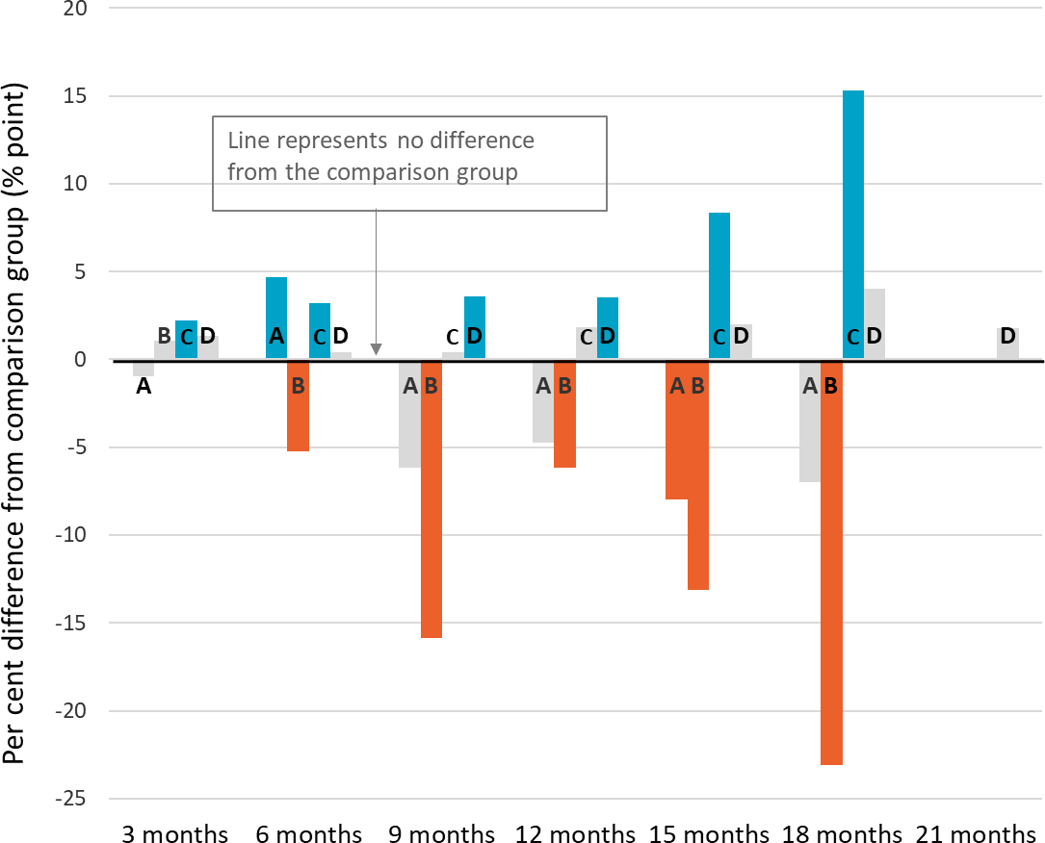
A – Career Readiness for Young Parents
B – In-School Parent Employment Services
C – Train and Care
D – Supporting Expecting & Parenting Teens

Significant increase Significant decrease
No significant difference

Notes: Difference between TTL clients’ outcomes compared to the comparison group at the end of each quarter. Impact analyses were run for 496 Young Parents clients; 78% of those who commenced the project as recorded in DEX

Figure D-6 Student income support receipt – Young Parents

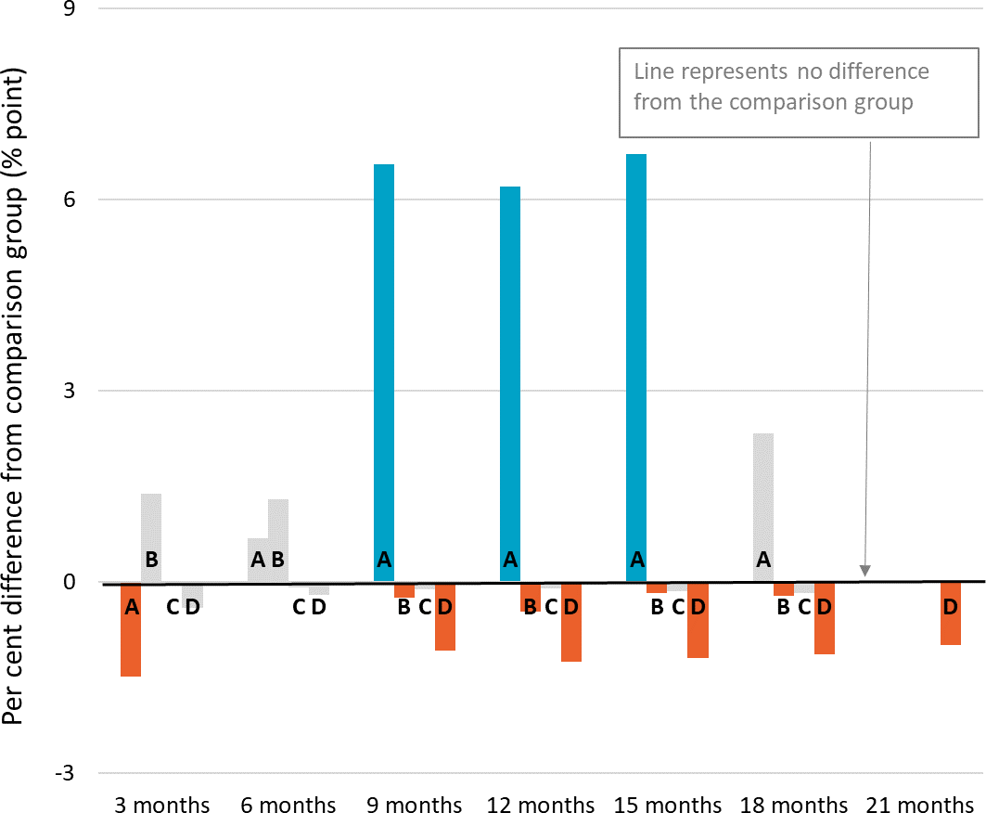
A – Career Readiness for Young Parents
B – In-School Parent Employment Services
C – Train and Care
D – Supporting Expecting & Parenting Teens

Significant increase Significant decrease
No significant difference

Notes: Difference between TTL clients’ outcomes compared to the comparison group at the end of each quarter. Impact analyses were run for 496 Young Parents clients; 78% of those who commenced the project as recorded in DEX
Figure D-7 Any employment income receipt while on income support – Young Parents

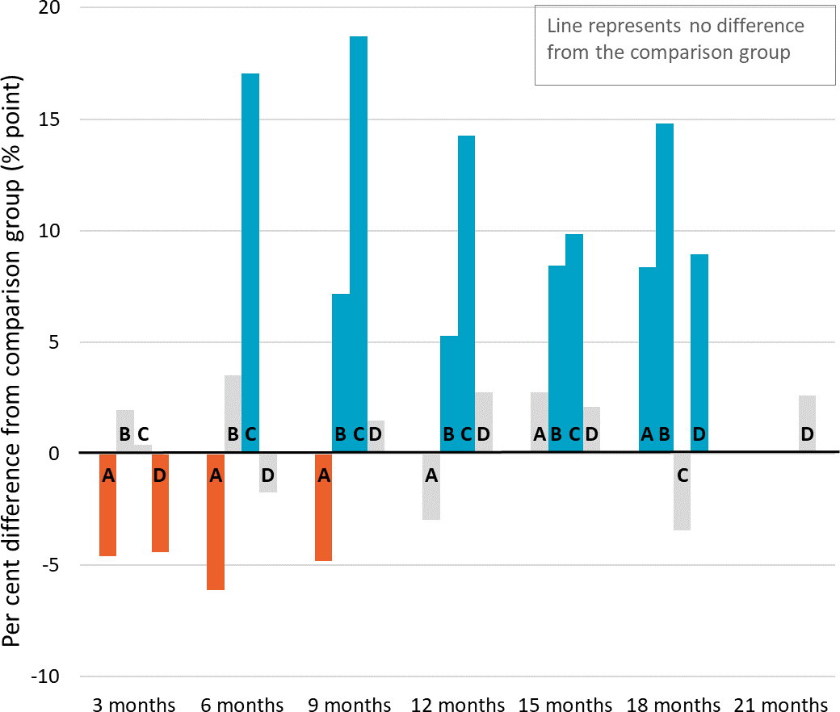
A – Career Readiness for Young Parents
B – In-School Parent Employment Services
C – Train and Care
D – Supporting Expecting & Parenting Teens

Significant increase Significant decrease
No significant difference

Notes: Difference between TTL clients’ outcomes in the quarter compared to the comparison group. Impact analyses were run for 496 Young Parents clients; 78% of those who commenced the project as recorded in DEX

Figure D-8 Days on income support – Young Parents

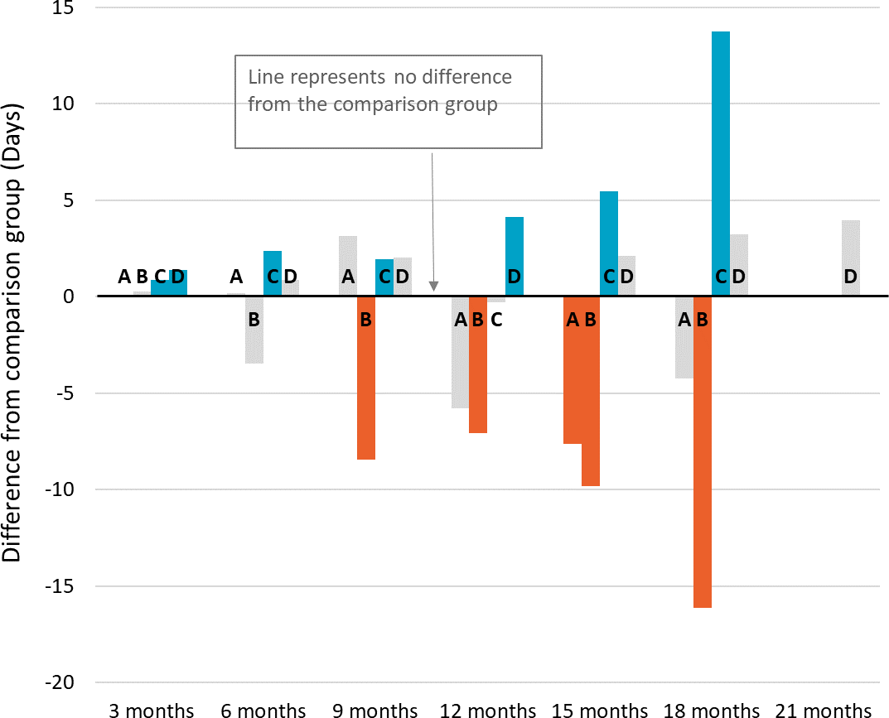
A – Career Readiness for Young Parents
B – In-School Parent Employment Services
C – Train and Care
D – Supporting Expecting & Parenting Teens

Significant increase Significant decrease
No significant difference

Notes: Difference between TTL clients’ outcomes in the quarter compared to the comparison group. Impact analyses were run for 496 Young Parents clients; 78% of those who commenced the project as recorded in DEX
Figure D-9 Amount of employment income while on income support – Young Parents

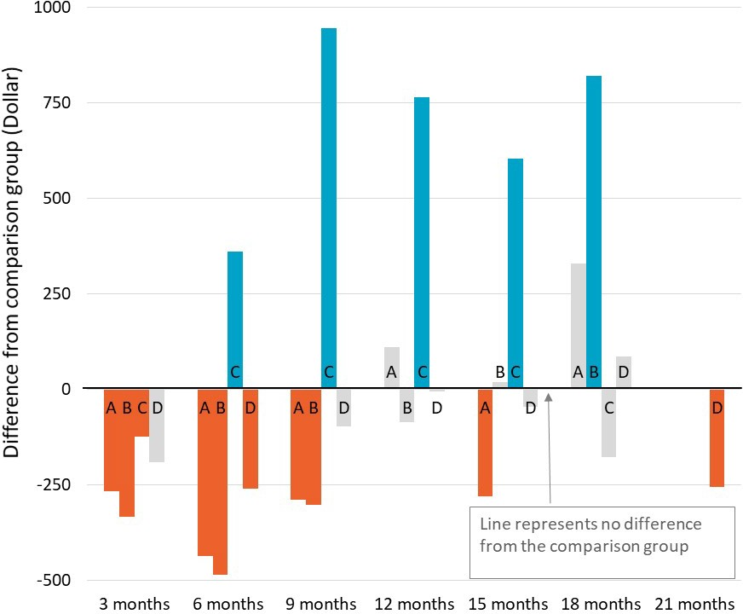
A – Career Readiness for Young Parents
B – In-School Parent Employment Services
C – Train and Care
D – Supporting Expecting & Parenting Teens

Significant increase Significant decrease
No significant difference

Notes: Difference between TTL clients’ outcomes in the quarter compared to the comparison group. Impact analyses were run for 496 Young Parents clients; 78% of those who commenced the project as recorded in DEX

 TTL clients’ self-reported barriers
Figure D-10 presents the self-reported barriers experienced by Young Parents clients as reported in the TTL Client Survey at the beginning (baseline) of a TTL client’s participation in the TTL project. Clients are defined as experiencing a given barrier where they respond either ‘Strongly Agree’ or ‘Agree’ to negatively worded items (i.e. items where the issue ‘makes it hard to work or study’). See Appendix C-2-4 for further details on TTL Client Survey analysis.
Figure D-10 TTL clients’ self-reported vocational and non-vocational barriers on TTL Client Survey items – Young Parents
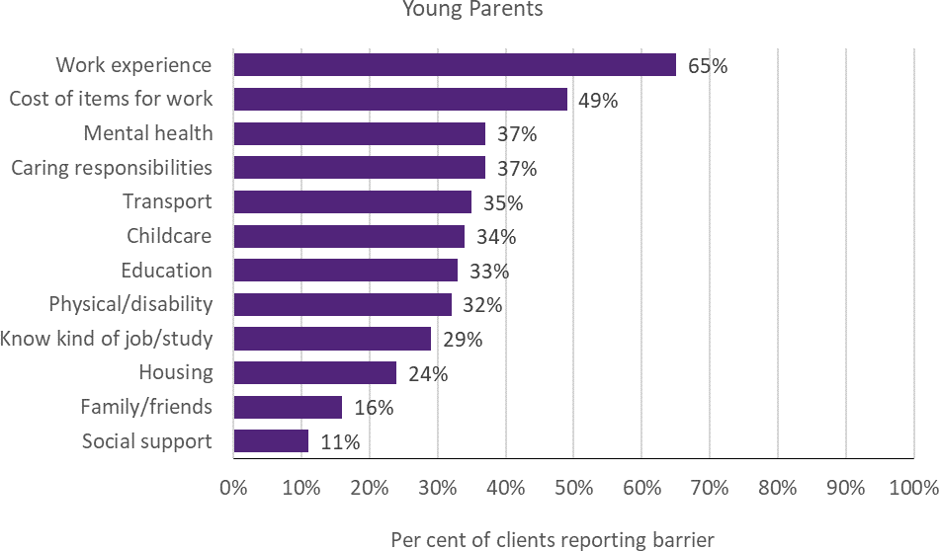
Notes: Data are from the TTL Client Survey at baseline (first survey not near the end of participation). Collected from 10% of Young Parents TTL clients across 3 of the 4 projects
 TTL clients’ change in circumstances and goals
TTL service providers were required to collect data through DEX SCORE measures at the beginning (baseline) and end of a TTL client’s participation in the TTL project (follow-up). Figure D-11 presents the proportion of Young Parents TTL clients who improved. Improvement is defined as having recorded a more favourable SCORE measurement at the follow-up than at baseline. (See Appendix C-2-3 for detail on DEX SCORE analysis.)

Figure D-11 TTL clients’ change in circumstances and goals on DEX SCORE measures – Young Parents
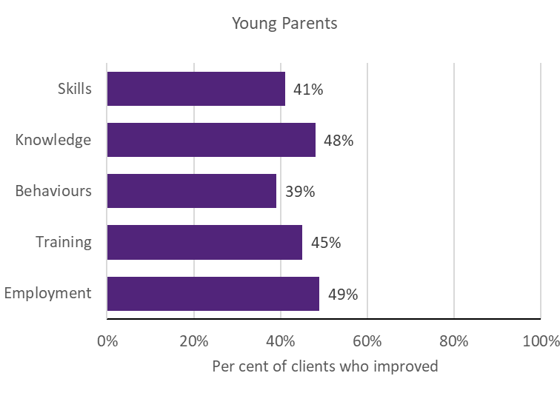
Notes: Improvement in SCORE outcomes for clients with both a baseline (pre) SCORE and a follow-up (post) SCORE, separated by at least 7 days, are reported for instances where there are at least 20 clients with available pre-post data of this kind. SCORE data were collected for all 4 projects. Six per cent of Young Parents TTL clients were observed with baseline and follow-up data. The priority group data was dominated by Supporting Expecting & Parenting Teens

Young Students
 Project level details
Priority group eligibility criteria: People aged under 25 who have moved, or are at risk of moving, from study (post-secondary or tertiary, and have been in receipt or receiving a student payment) to an extended period on an unemployment payment.
Table D-3 provides details of the 3 Young Students projects, including the projects’ primary objective(s), and the number of clients and main service type recorded in DEX.
Table D-3 Project objectives and service delivery recorded in DEX - Young Students

TTL project | Project start date | Primary objective | Number of clients in DEX | Main service type delivered
5. Support for VET  Students | 15-Feb-18 | Workforce participation &  Educational participation | 406 | Advocacy/support
6. Rewire the Brain | 01-Jun-18 | Educational participation &  Health and wellbeing | 353 | Education and skill  building
7. Strengthening  Students’ Resilience | 07-May-18 | Educational participation | N/A | N/A
Notes: Project start date is defined as the start of the project after the contract is signed. Primary objective is categorised according to project objective detailed in AWPs. Number of clients in DEX are to 30 June 2020; includes clients who may have participated in more than one TTL project. Main service type delivered is based on the most frequently recorded DEX session service type for each TTL project
 TTL clients’ level of disadvantage
Table D-4 presents the 4 indicators used to estimate the average level of disadvantage experienced by TTL clients, compared to the average income support recipient who met the eligibility criteria. These are presented by project, priority group and PIA level. (See Appendix C-2-1 for description of analyses.)
Table D-4 Disadvantage variables – Young Students

5. Support for VET  Students |  | 6. Rewire the  Brain | Priority Group | Ave. IS recipient
Total number of days on income support in last 2 years (mean) | 259 | 312 | 281 | 572
Highest level of education  (less than Year 12) | 25% | 23% | 24% | 28%
Index of Relative Socio- economic Disadvantage  (bottom 20%) | 35% | 23% | 32% | 38%
Unemployment rate SA4  (high) | 66% | 54% | 61% | 58%
Notes: Data are from DOMINO. Total days on income support in the last 2 years was calculated as the total days on income support unrelated to study across the 2-year period ending at their treatment start date. Highest level of education is presented as the percentage of TTL clients who had less than a Year 12 education level at the time of their treatment start date (note: there were a lot of missing data for this variable). Index of Relative Socio-Economic Disadvantage is an ABS measure that quantifies the relative disadvantage of an area using broad criteria such as income, qualifications and low-skill occupation rates. The ABS unemployment rate was used to divide all SA4 regions into high and low, based on the median value

 Summary of overarching outcomes
This section summarises the results for the 4 overarching outcomes used to measure the extent to which TTL projects helped to increase the skills and capacity of individuals to participate in social and economic life and live independently of welfare from the various data sources.
Workforce participation: Using receipt of income support unrelated to study as a measure of workforce participation showed that both projects for which there are data had a significant increase in the rate of income support receipt unrelated to study in the 15 or 24 months, respectively, after client commencement (Figure D-12). TTL service providers from 1 TTL project reported 27% of clients engaged in work in their AWP reports. Similarly, 2 of the 13 clients interviewed reported increased workforce participation. Of the TTL clients with pre-post DEX SCORE data (21%), 51% reported improvement in employment outcomes (Figure D-18).
Educational participation: Using student income support receipt as a proxy measure of educational participation showed that 1 of the 2 projects for which there are data had significant reductions in the rate of student income support receipt 15 months after client commencement (Figure D-13). For the other, although initially there was a reduction in the rate of student income support, this became insignificant at 24 months after client commencement. The results from DEX SCORE pre-post analyses (for 21% of
 Impact analysis
Figure D-12 – Figure D-16 are results from the impact analysis for projects for Young Students. The bars represent average quarterly post- commencement outcomes of TTL clients relative to their comparison group. The number of quarters that outcomes are measured over varies

clients with data) showed an improvement in clients’ training (46%) outcomes (Figure D-18). Seven of the 13 (53%) Young Students clients interviewed also specifically reported an increase in educational participation. This was further supported by service providers from 1 TTL project, who reported an increase in educational participation (47%) in their AWP reports.
Skills to participate in work or study: The results from DEX SCORE pre-post analyses (for 21% of clients with data) showed an improvement in clients’ skills outcomes (46%) (Figure D-18).
Similarly, 6 of the 13 clients (46%) interviewed reported increased skills, including soft skills (n=3) and skills to support study and education (n=2). The most prevalent vocational barriers for Young Students clients who responded to the TTL Client Survey (11%) include: a lack of work experience (53%) and a lack of education (41%) (Figure D-17).
Capacity: Client interviews were the only source of data to measure clients’ capacity. Six of the 13 Young Students clients (46%) reported an improvement in their capacity to participate in work or study. The most prevalent non- vocational barriers for those who responded to the TTL Client Survey (11%) include: mental health (65%), cost of items for work (50%), transport (43%), housing (37%), lack of social support (35%) and physical health/disability (23%) (Figure D-17).
by project, depending on their being at least 20 client observations for robust estimation of impacts. Where results are not statistically significant, this means that we cannot be certain that the impact of a project (for the given outcome and quarter) are different from zero. (See Appendix C-2-2 for details of the impact analyses.)

Figure D-12 Income support unrelated to study –Young Students

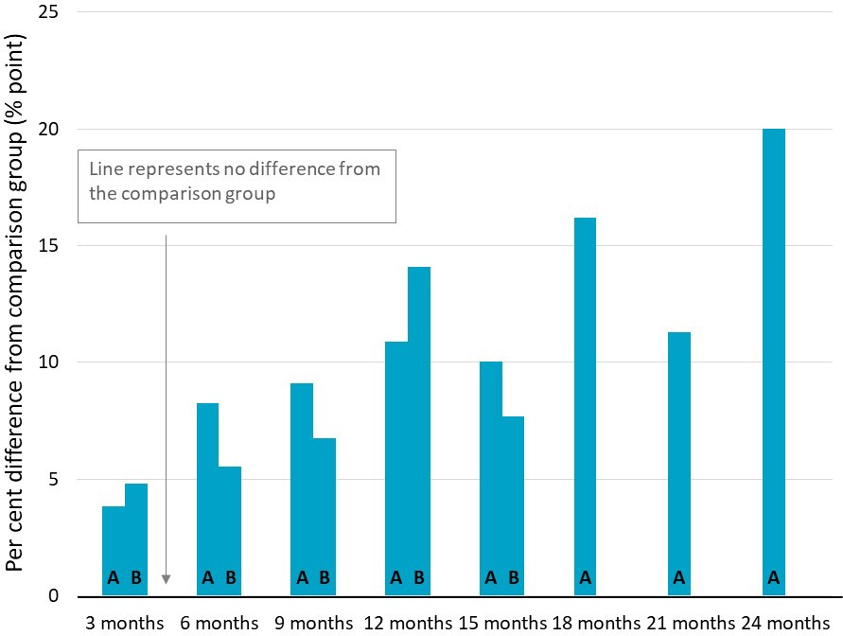
A – Support for VET Students
B – Rewire the Brain
Significant increase Significant decrease
No significant difference

Notes: Difference between TTL clients’ outcomes compared to the comparison group at the end of each quarter. Impact analyses were run for 571 Young Students clients; 75% of those who commenced the project as recorded in DEX
Figure D-13 Student income support receipt – Young Students

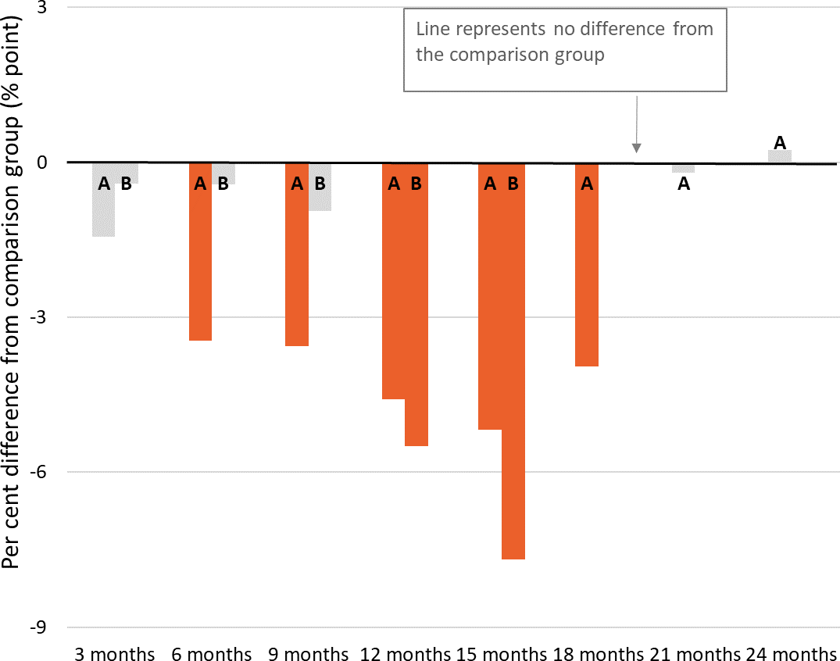
A – Support for VET Students
B – Rewire the Brain
Significant increase Significant decrease
No significant difference

Notes: Difference between TTL clients’ outcomes compared to the comparison group at the end of each quarter. Impact analyses were run for 571 Young Students clients; 75% of those who commenced the project as recorded in DEX

Figure D-14 Any employment income receipt while on income support – Young Students

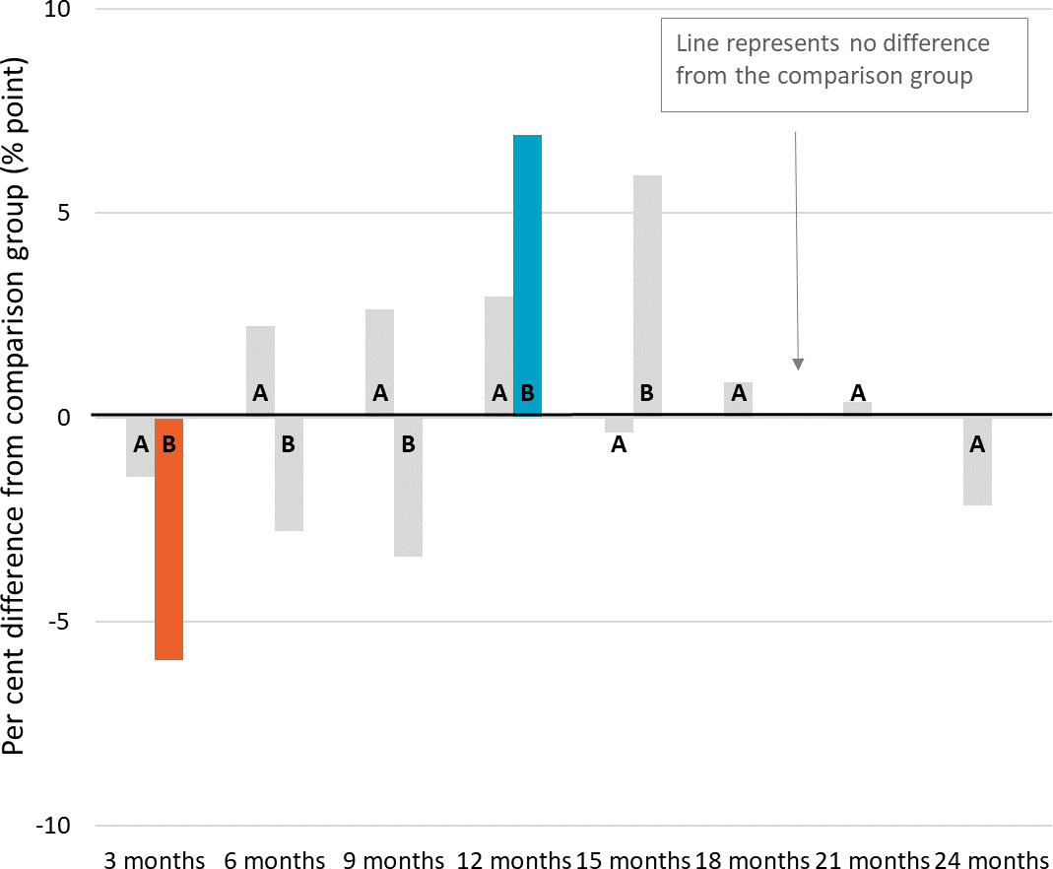
A – Support for VET Students
B – Rewire the Brain
Significant increase Significant decrease
No significant difference

Notes: Difference between TTL clients’ outcomes in the quarter compared to the comparison group. Impact analyses were run for 571 Young Students clients; 75% of those who commenced the project as recorded in DEX
Figure D-15 Days on income support – Young Students

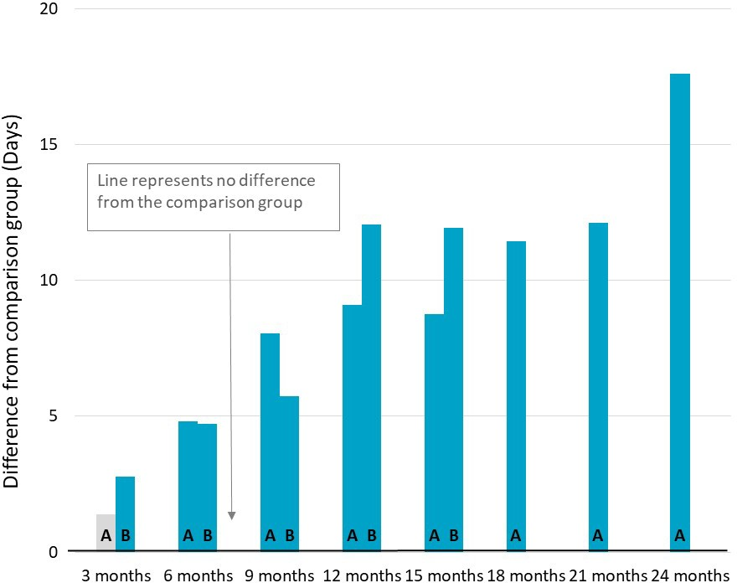
A – Support for VET Students
B – Rewire the Brain
Significant increase Significant decrease
No significant difference

Notes: Difference between TTL clients’ outcomes in the quarter compared to the comparison group. Impact analyses were run for 571 Young Students clients; 75% of those who commenced the project as recorded in DEX

Figure D-16 Amount of employment income while on income support – Young Students
A – Support for VET Students
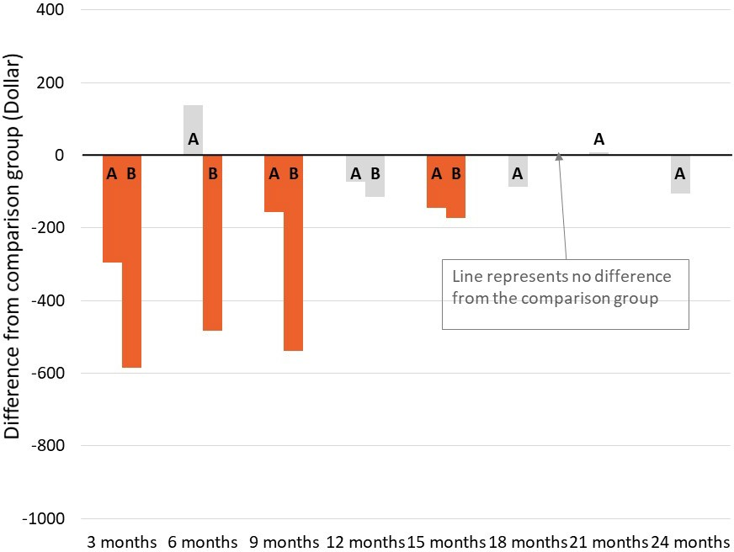
B – Rewire the Brain
Significant increase Significant decrease
No significant difference

Notes: Difference between TTL clients’ outcomes in the quarter compared to the comparison group. Impact analyses were run for 571 Young Students clients; 75% of those who commenced the project as recorded in DEX
 TTL clients’ self-reported barriers
Figure D-17 presents the self-reported barriers experienced by Young Students clients as reported in the TTL Client Survey at the beginning (baseline) of a TTL client’s participation in the TTL project. Clients are defined as experiencing a given barrier where they respond either ‘Strongly Agree’ or ‘Agree’ to negatively worded items (i.e. items where the issue ‘makes it hard to work or study’). See Appendix C-2-4 for further details on TTL Client Survey analysis.

Figure D-17 TTL clients’ self-reported vocational and non-vocational barriers on TTL Client Survey items – Young Students
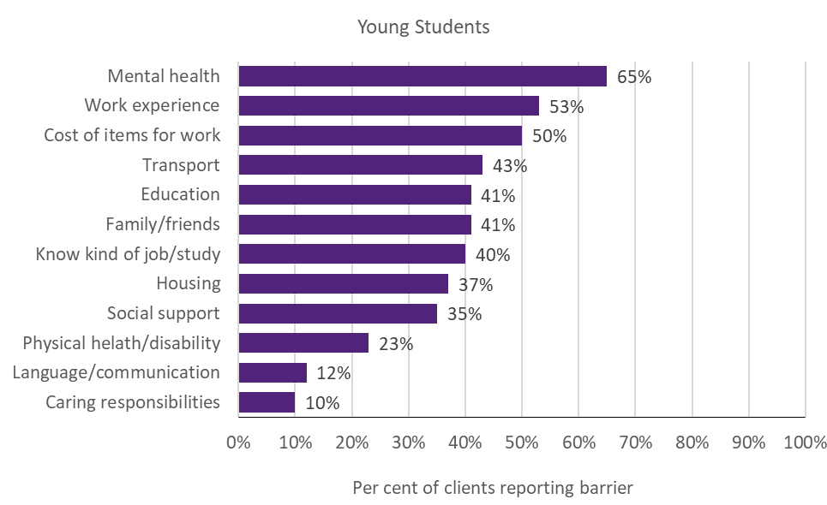
Notes: Data are from the TTL Client Survey at baseline (first survey not near the end of participation). Collected from 11% of Young Students TTL clients across 2 out of 3 projects
 TTL clients’ change in circumstances and goals
TTL service providers were required to collect data through DEX SCORE measures at the beginning (baseline) and end of a TTL client’s participation in the TTL project (follow-up). Figure D-18 presents the proportion of Young Students TTL clients who improved. Improvement is defined as having recorded a more favourable SCORE measurement at the follow-up than at baseline. (See Appendix C-2-3 for detail on DEX SCORE analysis.)

Figure D-18 TTL clients’ change in circumstances and goals on DEX SCORE measures – Young Students
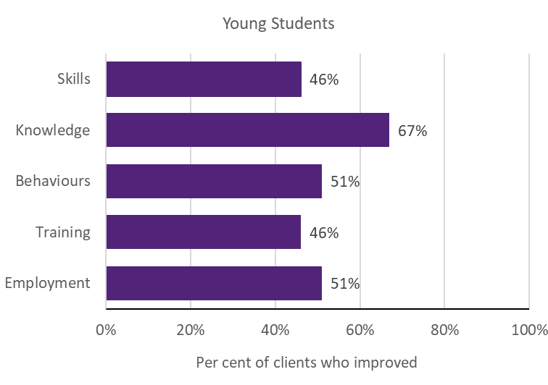
Notes: Improvement in SCORE outcomes for clients with both a baseline (pre) SCORE and a follow-up (post) SCORE, separated by at least 7 days, are reported for instances where there are at least 20 clients with available pre-post data of this kind. SCORE data were collected for 2 of the 3 projects. Twenty-one per cent of Young Students TTL clients
were observed with baseline and follow-up data

Young Carers
 Project level details
Priority group eligibility criteria: Young people aged under 25 who are eligible for Carer Payment, or are at risk of claiming Carer Payment, because they are undertaking the care of a person with a disability or medical condition.
Table D-5 provides details of the 4 Young Carers projects, including the projects’ primary objective(s), and the number of clients and main service type recorded in DEX.
Table D-5 Project objectives and service delivery recorded in DEX - Young Carers

TTL project | Project start date | Primary objective | Number of clients in DEX | Main service type delivered
26. Carer Achievement  Pathway | 01-Mar-18 | Skills | 42 | Info/advice/referral
27. Skills for Micro-  enterprise | 01-Mar-18 | Skills | 32 | Education and skill  building
28. Data-driven Job Opportunities | 04-Apr-18 | Workforce participation, Educational participation  & Skills | 56 | Mentoring/peer support
29. Young Carer School  Accreditation project | 12-Dec-18 | Educational participation | 73 | Mentoring/peer  support
Notes: Project start date is defined as the start of the project after the contract is signed. Primary objective is categorised according to project objective detailed in AWPs. Number of clients in DEX are to 30 June 2020; includes clients who may have participated in more than one TTL project. Main service type delivered is based on the most frequently recorded DEX session service type for each TTL project
 TTL clients’ level of disadvantage
Table D-6 presents the 4 indicators used to estimate the average level of disadvantage experienced by TTL clients, compared to the average income support recipient who met the eligibility criteria. These are presented by project, priority group and PIA level. (See Appendix C-2-1 for description of analyses.)
Table D-6 Disadvantage variables – Young Carers

26. Carer Achievement  Pathway |  | 28. Data- driven Job  Opportunities | Priority Group | Ave. IS recipient
Total number of days on income support in last 2 years (mean) | 91 | 479 | 170 | 592
Highest level of education (less than Year 12) | 13% | * | 7% | 28%
Index of Relative Socio-economic  Disadvantage (bottom 20%) | 38% | 28% | 30% | 45%
Unemployment rate SA4 (high) | 62% | ≈ 100% | 55% | 64%
Notes: Data are from DOMINO. Total days on income support in the last 2 years was calculated as the total days on income support unrelated to study across the 2-year period ending at their treatment start date. Highest level of education is presented as the percentage of TTL clients who had less than a Year 12 education level at the time of their treatment start date (note: there were a lot of missing data for this variable). Index of Relative Socio-Economic Disadvantage is an ABS measure that quantifies the relative disadvantage of an area using broad criteria such as income, qualifications and low-skill occupation rates. The ABS unemployment rate was used to divide all SA4 regions into high and low, based on the median value

 Summary of overarching outcomes
This This section summarises the results for the 4 overarching outcomes used to measure the extent to which TTL projects helped to increase the skills and capacity of individuals to participate in social and economic life and live independently of welfare from the various data sources.
Workforce participation: Using receipt of income support unrelated to study as a measure of workforce participation showed that neither project for which there are data had a significant impact on the rate of income support receipt unrelated to study 9 or 12 months after client commencement (Figure D-19). According to information reported in the AWP reports of 3 TTL projects, on average 24% of Young Carers clients had increased workforce participation. Similarly, 5 of the 18 Young Carers clients interviewed (28%) specifically reported an increase in workforce participation. There is insufficient data for change in DEX SCORE.
Educational participation: Using student income support receipt as a proxy measure of educational participation showed that TTL clients from one project for which there are data had a significant increase in the rate of student income support receipt 12 months after client commencement (Figure D-13). That is, TTL clients were 17 percentage points more likely to be on student income support compared to the comparison group. TTL service providers from 4 projects reported an increase of an average 36% in educational participation in their AWP reports. However, only 3 of the 18 TTL clients interviewed

specifically reported increased educational participation or attainment. There is insufficient data for change in DEX SCORE.
Skills to participate in work or study: Fourteen of the 18 Young Carers clients interviewed (78%) specifically reported an improvement in skills.
These were predominantly in job search skills (n=8; 44%). There is insufficient data for change in DEX SCORE or TTL Client Survey outcomes.
Capacity: Client interviews were the only source of data to measure clients’ capacity. Eleven of the 18 Young Carers clients interviewed (61%) reported an improvement in their capacity to participate in work or study. This was predominantly related to improved career or other aspirations (n=7; 39%). There is insufficient data for TTL Client Survey results.
 Impact analysis
Figure D-19 – Figure D-23 are results from the impact analysis for projects for Young Carers. The bars represent average quarterly post- commencement outcomes of TTL clients relative to their comparison group. The number of quarters that outcomes are measured over varies by project, depending on their being at least 20 client observations for robust estimation of impacts. Where results are statistically insignificant, this means that we cannot be certain that the impact of a project (for the given outcome and quarter) are different from zero. (See Appendix C-2-2 for details of the impact analyses.)

Figure D-19 Income support unrelated to study – Young Carers

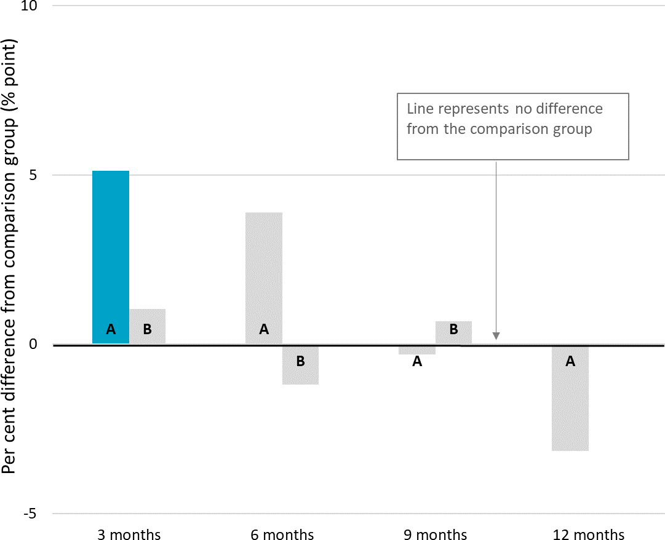
A – Carer Achievement Pathway
B – Data-Driven Job Opportunities

Significant increase Significant decrease
No significant difference

Notes: Difference between TTL clients’ outcomes compared to the comparison group at the end of each quarter. Impact analyses were run for 66 Young Carers clients; 35% of those who commenced the project as recorded in DEX
Figure D-20 Student income support receipt – Young Carers

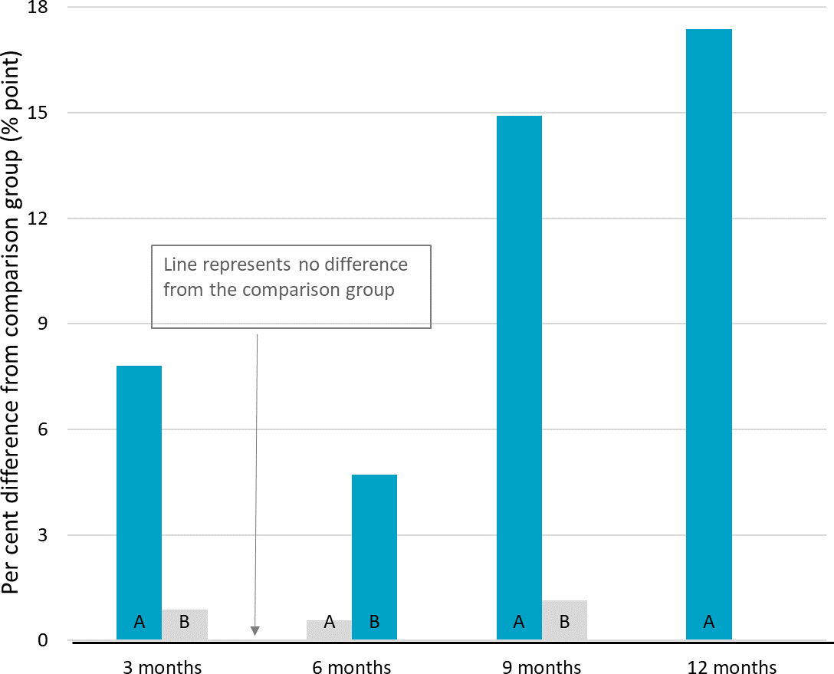
A – Carer Achievement Pathway
B – Data-Driven Job Opportunities

Significant increase Significant decrease
No significant difference

Notes: Difference between TTL clients’ outcomes compared to the comparison group at the end of each quarter. Impact analyses were run for 66 Young Carers clients; 35% of those who commenced the project as recorded in DEX

Figure D-21 Any employment income receipt while on income support – Young Carers

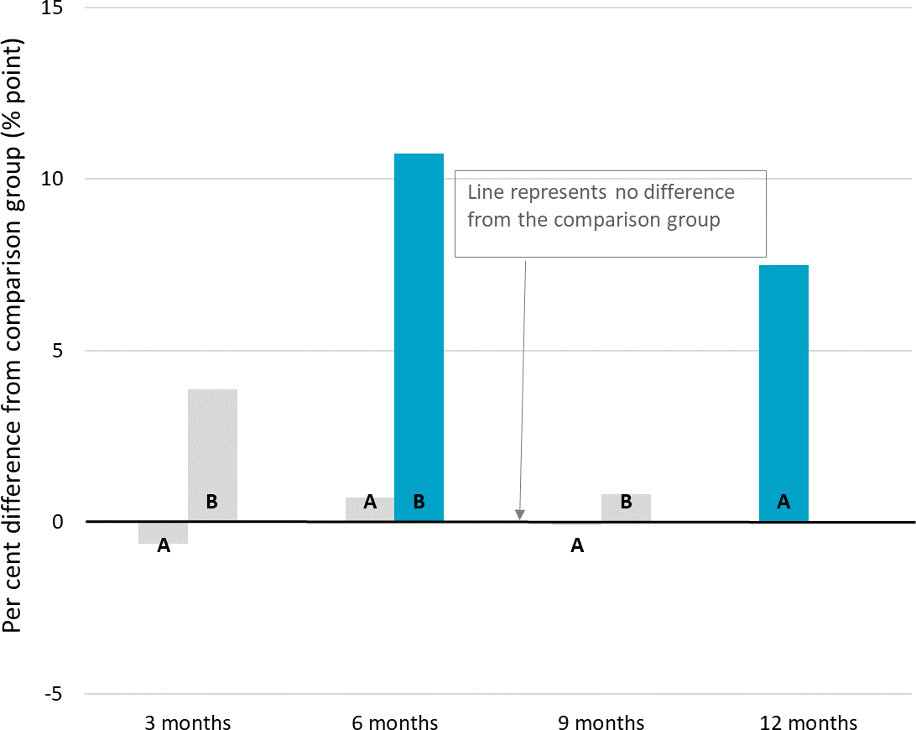
Income support.A – Carer Achievement Pathway
B – Data-Driven Job Opportunities

Significant increase Significant decrease
No significant difference

Notes: Difference between TTL clients’ outcomes in the quarter compared to the comparison group. Impact analyses were run for 66 Young Carers clients; 35% of those who commenced the project as recorded in DEX
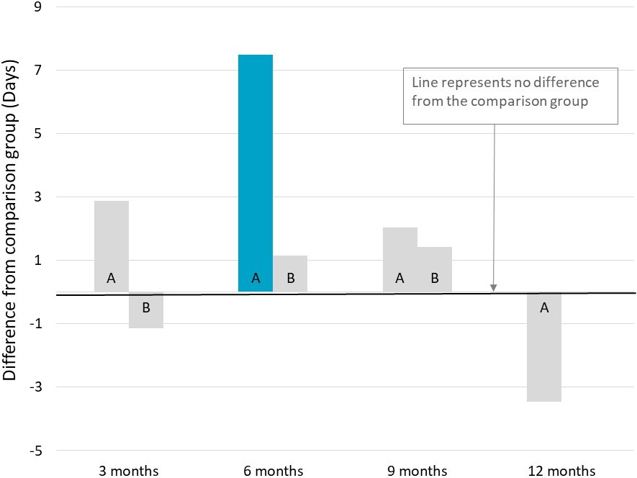
Figure D-22 Days on income support – Young Carers

A – Carer Achievement Pathway
B – Data-Driven Job Opportunities

Significant increase Significant decrease
No significant difference

Notes: Difference between TTL clients’ outcomes in the quarter compared to the comparison group. Impact analyses were run for 66 Young Carers clients; 35% of those who commenced the project as recorded in DEX

Figure D-23 Amount of employment income support while on income support – Young Carers
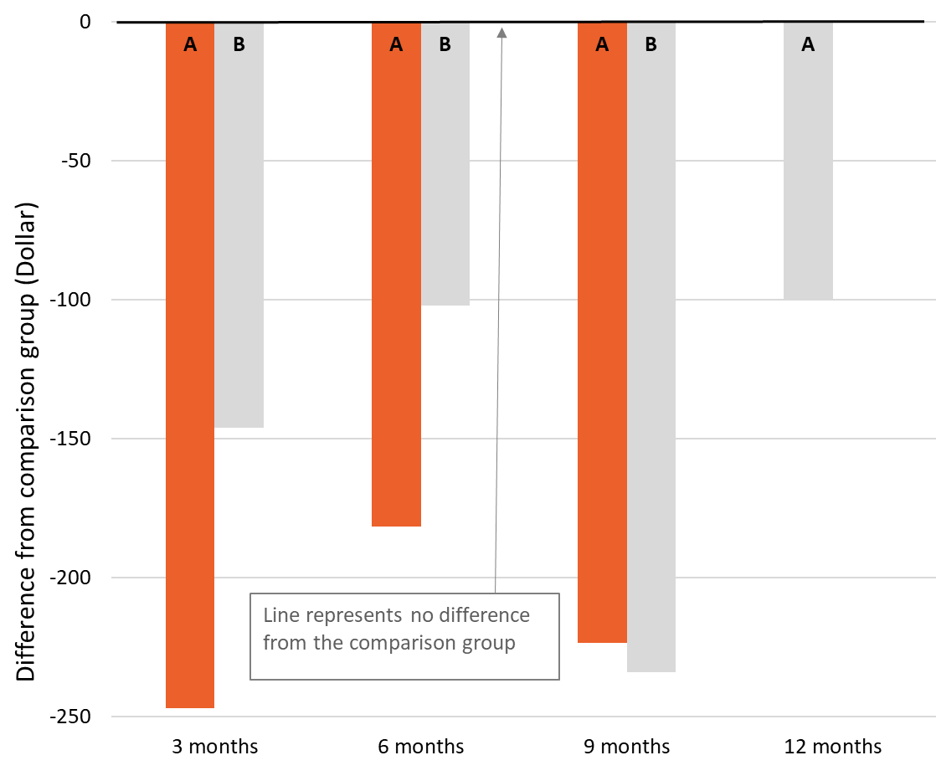
A – Carer Achievement Pathway
B – Data-Driven Job Opportunities

Significant increase Significant decrease
No significant difference

Notes: Difference between TTL clients’ outcomes in the quarter compared to the comparison group. Impact analyses were run for 66 Young Carers clients; 35% of those who commenced the project as recorded in DEX

At-risk Young People (tranche 1)
 Project level details
Priority group eligibility criteria: At-risk people aged 16–25 and receiving income support.
Table D-7 provides details of the 4 At-risk Young People (tranche 1) projects, including the projects’ primary objective(s), and the number of clients and main service type recorded in DEX.
Table D-7 Project objectives and service delivery recorded in DEX - At-risk Young People (tranche 1)

TTL project | Project start date | Primary objective | Number of clients in DEX | Main service type delivered
8. Mentoring 2 Work | 15-Feb-18 | Workforce participation &  Skills | 195 | Info/advice/referral
9. Y4Y Youth Force | 20-Mar-18 | Workforce participation &  Skills | 80 | Facilitate employment  pathways
10. Build and Grow | 15-Mar-18 | Workforce participation, Skills & Health and  wellbeing | 452 | Education and skill building
11. My Maintenance  Crew | 15-Feb-18 | Workforce participation &  Skills | 67 | Education and skill  building
Notes: Project start date is defined as the start of the project after the contract is signed. Primary objective is categorised according to project objective detailed in AWPs. Number of clients in DEX are to 30 June 2020; includes clients who may have participated in more than one TTL project. Main service type delivered is based on the most frequently recorded DEX session service type for each TTL project
 TTL clients’ level of disadvantage
Table D-8 presents the 4 indicators used to estimate the average level of disadvantage experienced by TTL clients, compared to the average income support recipient who met the eligibility criteria. These are presented by project, priority group and PIA level. (See Appendix C-2-1 for description of analyses.)
Table D-8 Disadvantage variables – At-risk Young People (tranche 1)

 | 8.  Mentoring 2 Work | 9. Y4Y  Youth Force | 10. Build and Grow | 11. My  Maintena nce Crew | Priority Group | Ave. IS recipient
Total number of days on income support in last 2 years  (mean) | 456 | 244 | 52 | 378 | 192 | 414
Highest level of education (less  than Year 12) | * | 24% | 13% | 48% | 18% | 29%
Index of Relative Socio- economic Disadvantage  (bottom 20%) | 9% | 19% | 27% | 48% | 23% | 34%
Unemployment rate SA4 (high) | 97% | 51% | 53% | 0% | 59% | 58%
Notes: Data are from DOMINO. Total days on income support in the last 2 years was calculated as the total days on income support unrelated to study across the 2-year period ending at their treatment start date. Highest level of education is presented as the percentage of TTL clients who had less than a Year 12 education level at the time of their treatment start date (note: there were a lot of missing data for this variable). Index of Relative Socio-Economic Disadvantage is an ABS measure that quantifies the relative disadvantage of an area using broad criteria such as income, qualifications and low-skill occupation rates. The ABS unemployment rate was used to divide all SA4 regions into high and low, based on the median value

 Summary of overarching outcomes
This section summarises the results for the 4 overarching outcomes used to measure the extent to which TTL projects helped to increase the skills and capacity of individuals to participate in social and economic life and live independently of welfare from the various data sources.
Workforce participation: Using receipt of income support unrelated to study as a measure of workforce participation showed that 3 projects had significant impacts on the rate of income support receipt unrelated to study 18 months after client commencement (Figure D-24). Two projects saw a reduction in the rate of income support (7 or 10 percentage points less than the comparison group). In contrast, one saw a significant increase in the rate of income support receipt (11 percentage points higher than the comparison group) 18 months after client commencement. According to information reported in the AWP reports of all 4 TTL projects, on average 38% of At-risk Young People (tranche 1) had increased workforce participation. Four of the 25 TTL clients interviewed (16%) specifically reported an increase in workforce participation. That said, for clients with pre-post DEX SCORE data (27% of At-risk Young People (tranche 1) clients), the results showed an improvement in clients’ reported employment outcomes (76%) (Figure D-30).
Educational participation: Using student income support receipt as a proxy measure of educational participation showed that 2 of the 3 projects for which there are 18 months of data had a significant decrease in the rate of student income support receipt (5 or 8 percentage points less than the comparison group) 18 months after client commencement (Figure D-25). Service providers from 3 of the 4 projects, reported on average a 17% increase in educational participation in their AWP reports. Similarly, 6 of the 25 clients interviewed (24%) reported

increased educational outcomes. That said, the results from DEX SCORE pre-post analyses showed 74% of clients reporting improvement in training outcomes (Figure D-30).
Skills to participate in work or study: The results from DEX SCORE pre-post analyses (Figure D-30) showed that 80% of clients reported an improvement in their skills outcomes. Similarly, 21 of the 25 clients interviewed (84%) reported increased skills, particularly soft skills (n=12; 48%), job-specific knowledge or skills (n=9; 36%) and jobseeking skills (n=9; 36%). The most prevalent vocational barriers for At-risk Young People (tranche 1) clients who responded to the TTL Client Survey (8%) include: a lack of work experience (69%) and education (42%) (Figure
D-29).
Capacity: Client interviews were the only source of data to measure clients’ capacity. Sixteen of the 25 clients interviewed (64%) reported an improvement in their capacity to participate in work or study. The most prevalent non- vocational barriers for those who responded to the TTL Client Survey (8%) include cost of items for work (45%), transport (42%) and mental health (20%) (Figure D-29).
 Impact analysis
Figure D-24 – Figure D-28 are results from the impact analysis for projects for At-risk Young People (tranche 1). The bars represent average quarterly post-commencement outcomes of TTL clients relative to their comparison group. The number of quarters that outcomes are measured over varies by project, depending on their being at least 20 client observations for robust estimation of impacts. Where results are statistically insignificant, this means that we cannot be certain that the impact of a project (for the given outcome and quarter) are different from zero. (See Appendix C-2-2 for details of the impact analyses.)

Figure D-24 Income support unrelated to study – At-risk Young People (tranche 1)

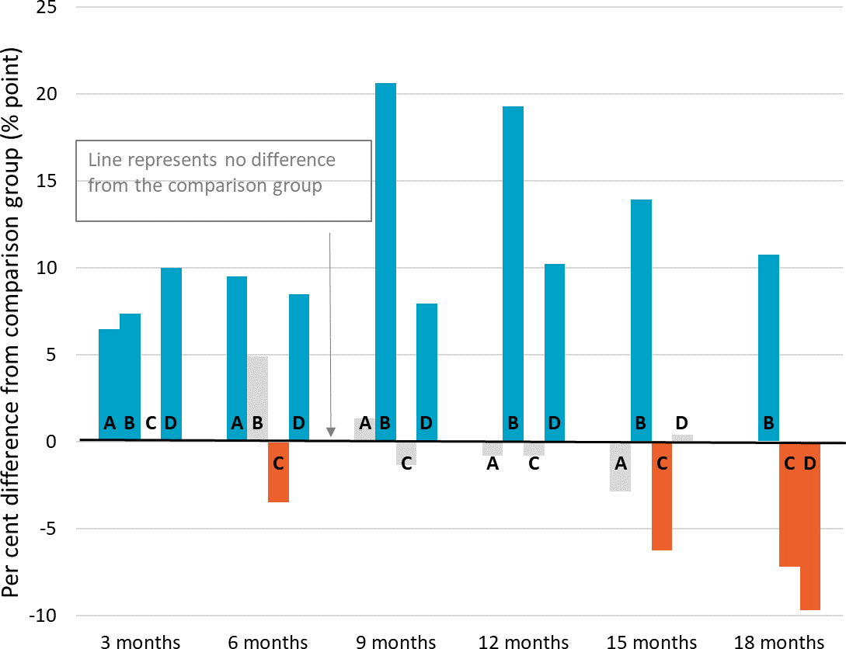
A – Mentoring 2 Work
B – Y4Y Youth Force
C – Build and Grow
D – My Maintenance Crew
Significant increase Significant decrease
No significant difference

Notes: Difference between TTL clients’ outcomes compared to the comparison group at the end of each quarter. Impact analyses were run for 518 At-risk Young People (tranche 1) clients; 67% of those who commenced the project as recorded in DEX
Figure D-25 Student income support receipt – At-risk Young People (tranche 1)

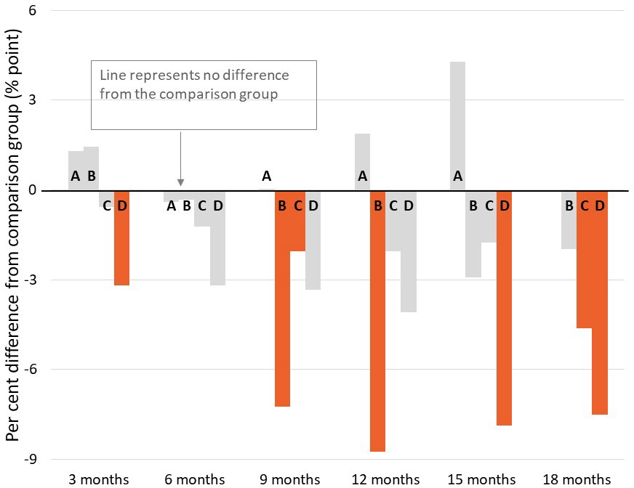
A – Mentoring 2 Work
B – Y4Y Youth Force
C – Build and Grow
D – My Maintenance Crew
Significant increase Significant decrease
No significant difference

Notes: Difference between TTL clients’ outcomes compared to the comparison group at the end of each quarter. Impact analyses were run for 518 At-risk Young People (tranche 1) clients; 67% of those who commenced the project as recorded in DEX

Figure D-26 Any employment income receipt while on income support – At-risk Young People (tranche 1)
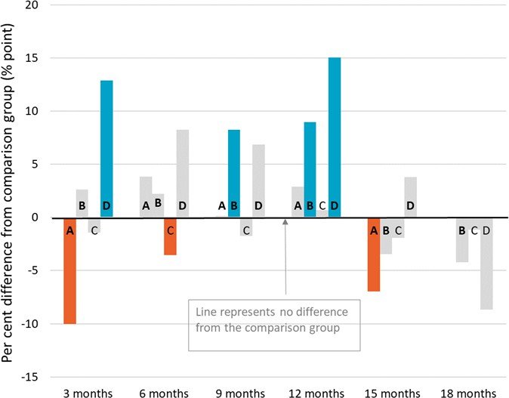
A – Mentoring 2 Work
B – Y4Y Youth Force
C – Build and Grow
D – My Maintenance Crew
Significant increase Significant decrease
No significant difference

Notes: Difference between TTL clients’ outcomes compared to the comparison group at the end of each quarter. Impact analyses were run for 518 At-risk Young People (tranche 1) clients; 67% of those who commenced the project as recorded in DEX
Figure D-27 Days on income support – At-risk Young People (tranche 1)
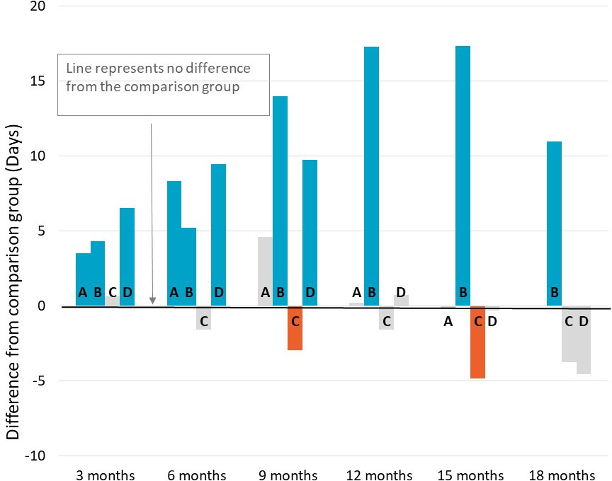
A – Mentoring 2 Work
B – Y4Y Youth Force
C – Build and Grow
D – My Maintenance Crew
Significant increase Significant decrease
No significant difference

Notes: Difference between TTL clients’ total days on income support in the quarter compared to the comparison group. Impact analyses were run for 518 At-risk Young People (tranche 1) clients; 67% of those who commenced the project as recorded in DEX

Figure D-28 Amount of employment income while on income support – At-risk Young People (tranche 1)
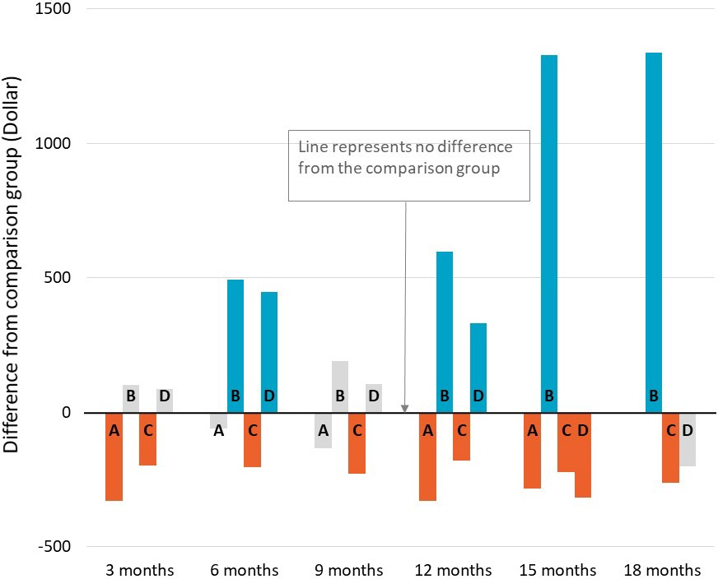
A – Mentoring 2 Work
B – Y4Y Youth Force
C – Build and Grow
D – My Maintenance Crew
Significant increase Significant decrease
No significant difference

Notes: Difference between TTL clients’ total days on income support in the quarter compared to the comparison group. Impact analyses were run for 518 At-risk Young People (tranche 1) clients; 67% of those who commenced the project as recorded in DEX
Table D-9 Mentoring 2 Work impact estimates for clients who attended higher number of sessions (greater than median). Table D-9 and Table D-10 present the additional sensitivity analysis examining whether impact results would differ for various subsets of the treatment group. (See Appendix C-2-2-3 for details on the sensitivity tests.) The average treatment effect and p-value is compared to the original impact analysis to test whether different patterns occurred. Table D-9 shows the comparisons of estimated impacts for clients whose total number of sessions is above the median number of sessions of all clients. The negative impacts (i.e. positive estimates) on rate of income support (IS) receipt is much higher than all clients during the project participation, and the impacts at quarter 5 are similar to all clients. The evidence indicates that the negative impacts in the first few quarters are due to the locked-in effects and they were stronger for clients with higher participation intensity. As Build and Grow had a large proportion of clients under age 16 at client commencement, sensitivity analyses were carried out to examine the differential impacts by age. As shown in Table D-10 the impacts on income support receipts are much larger for those 18 years or older.
Table D-9 Mentoring 2 Work impact estimates for clients who attended higher number of sessions (greater than median)

 | All clients |  |  | Clients with high number of sessions
 | Average  treatment effect | Standard  error | P-value | Average  treatment effect | Standard  error | P-value
On IS end of quarter 1 | 0.065 | 0.023 | 0.005 | 0.136 | 0.021 | 0.000
On IS end of quarter 2 | 0.095 | 0.027 | 0.000 | 0.141 | 0.031 | 0.000
On IS end of quarter 3 | 0.013 | 0.031 | 0.666 | 0.048 | 0.035 | 0.169
On IS end of quarter 4 | -0.008 | 0.035 | 0.823 | 0.050 | 0.040 | 0.211
On IS end of quarter 5 | -0.029 | 0.037 | 0.445 | -0.025 | 0.044 | 0.567

Table D-10 Build and Grow impact estimates by age

 | Age under 18 |  |  | Age 18+
 | Average treatment effect | Standard error | P-value | Average treatment effect | Standard error | P-value
On IS end of quarter 1 | -0.009 | 0.011 | 0.414 | 0.005 | 0.022 | 0.825
On IS end of quarter 2 | -0.045 | 0.011 | 0.000 | -0.009 | 0.035 | 0.789
On IS end of quarter 3 | 0.004 | 0.024 | 0.875 | -0.077 | 0.031 | 0.012
On IS end of quarter 4 | 0.021 | 0.031 | 0.505 | -0.100 | 0.036 | 0.005
On IS end of quarter 5 | -0.029 | 0.031 | 0.343 | -0.174 | 0.033 | 0.000
On IS end of quarter 6 | -0.050 | 0.033 | 0.132 | -0.187 | 0.036 | 0.000
 TTL clients’ self-reported barriers
Figure D-29 presents the self-reported barriers experienced by At-risk Young People (tranche 1) clients as reported in the TTL Client Survey at the beginning (baseline) of a TTL client’s participation in the TTL project. Clients are defined as experiencing a given barrier where they respond either ‘Strongly Agree’ or ‘Agree’ to negatively worded items (i.e. items where the issue ‘makes it hard to work or study’). (See Appendix C-2-4 for further details on TTL Client Survey analysis.)
Figure D-29 TTL clients’ self-reported vocational and non-vocational barriers on TTL Client Survey items – At-risk Young People (tranche 1)
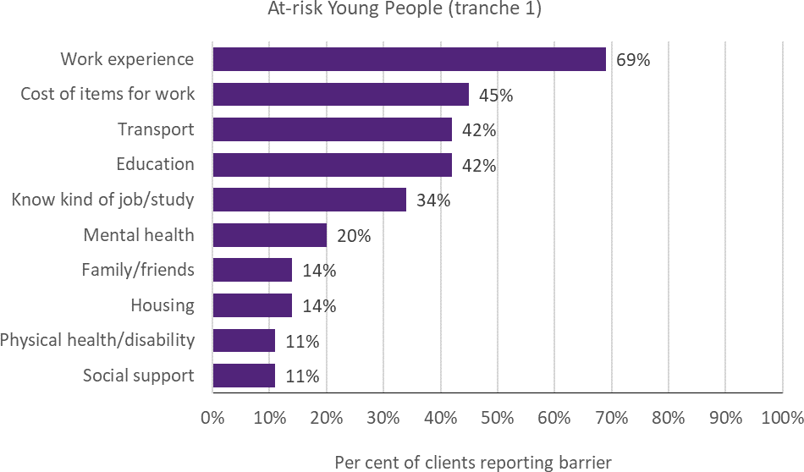
Note: Data are from the TTL Client Survey at baseline (first survey not near the end of participation). Collected from 8% of At-risk Young People (tranche 1) TTL clients across all 4 projects
 TTL clients’ change in circumstances and goals
TTL service providers were required to collect data through DEX SCORE measures at the beginning (baseline) and end of a TTL client’s participation in the TTL project (follow-up). Figure D-30 presents the proportion of At-risk Young People (tranche 1) TTL clients who improved. Improvement is defined as having recorded a more favourable SCORE measurement at the follow-up than at baseline. (See Appendix C-2-3 for detail on DEX SCORE analysis.)

Figure D-30 TTL clients’ change in circumstances and goals on DEX SCORE measures – At-risk Young People (tranche 1)
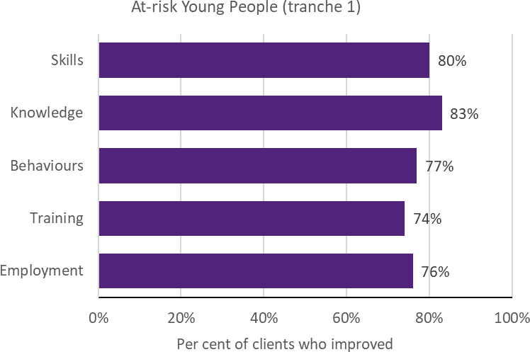
Notes: Improvement in SCORE outcomes for clients with both a baseline (pre) SCORE and a follow-up (post) SCORE, separated by at least 7 days, are reported for instances where there are at least 20 clients with available pre-post data of this kind. SCORE data were collected for all 4 projects. Twenty-seven per cent of At-risk Young People (tranche 1) TTL clients were observed with baseline and follow-up data. The priority group data was dominated by Build and Grow

At-risk Young People (tranche 2)
 Project level details
Priority group eligibility criteria: At-risk people aged 16–21 and receiving income support.
Table D-11 provides details of the 12 At-risk Young People (tranche 2) projects, including the projects’ primary objective(s), and the number of clients and main service type recorded in DEX.
Table D-11 Project objectives and service delivery recorded in DEX - At-risk Young People (tranche 2)

TTL project | Project start date | Primary objective | Number of clients in DEX | Main service type delivered
12. Lead with Culture | 12-Dec-18 | Workforce participation & Capacity | 248 | Mentoring/peer support
13. Dunn & Lewis  F3style | 12-Dec-18 | Workforce participation | 52 | Education and skill  building
14. Your Job Your Way | 01-Jan-19 | Workforce participation | 53 | Facilitate employment  pathways
16. Brighton Integrated Community  Engagement | 29-Jan-19 | Skills | 61 | Education and skill building
18. RIDE | 29-Jan-19 | Educational participation  & Skills | 132 | Mentoring/peer support
19. Leadership, Engagement and  Development | 29-Jan-19 | Educational participation | 58 | Education and skill building
20. Meeting the Youth  Gap | 21-Jun-19 | Skills | 63 | Education and skill  building
21. Support to Skills | 30-Jul-19 | Educational participation  & Health and wellbeing | 15 | Info/advice/referral
22. Explore, Discover  and Empower | 20-May-19 | Educational participation  & Skills | 37 | Education and skill  building
23. Dependence to  Independence | 01-Aug-19 | Health and wellbeing | 167 | Mentoring/peer support
24. The Opportunity  Account | 01-Jul-19 | Capacity | 0 | N/A
25. Care Plays | 20-Sep-19 | Educational participation | 0 | N/A
Notes: Project start date is defined as the start of the project after the contract is signed. Primary objective is categorised according to project objective detailed in AWPs. Number of clients in DEX are to 30 June 2020; includes clients who may have participated in more than one TTL project. Main service type delivered is based on the most frequently recorded DEX session service type for each TTL project
 TTL clients’ level of disadvantage
Table D-12 presents the 4 indicators used to estimate the average level of disadvantage experienced by TTL clients, compared to the average income support recipient who met the eligibility criteria. These are presented by project, priority group and PIA level. (See Appendix C-2-1 for description of analyses.)

Table D-12 Disadvantage variables – At-risk Young People (tranche 2)

12. Lead with Culture |  | 13. Dunn & Lewis F3style | 14. Your Job Your Way | 16. Brighton Integrated Community  Engagement | 18. RIDE
Total number of days on income support in last 2 years (mean) | 92 | 129 | 618 | 110 | 273
Highest level of education (less  than Year 12) | 15% | 23% | 33% | 18% | 61%
Index of Relative Socio- economic Disadvantage  (bottom 20%) | 32% | * | 76% | 86% | 55%
Unemployment rate SA4 (high) | 26% | 0% | 100% | 0% | 69%

Table D-12 continued

19. Leadership,  Engagement and Development |  | 20. Meeting the Youth Gap | 23.  Dependence to Independence | Priority Group | Ave. IS recipient
Total number of days on income support in last 2 years (mean) | 296 | 339 | 47 | 188 | 244
Highest level of education (less than  Year 12) | 16% | 67% | 15% | 28% | 23%
Index of Relative Socio- economic Disadvantage  (bottom 20%) | 41% | 100% | 40% | 45% | 31%
Unemployment rate SA4  (high) | ≈100% | 100% | 57% | 51% | 38%
Notes: Total days on income support in the last 2 years was calculated as the total days on income support unrelated to study across the 2-year period ending at their treatment start date. Highest level of education is presented as the percentage of TTL clients who had less than a Year 12 education level at the time of their treatment start date. Index of Relative Socio-Economic Disadvantage is an ABS measure that quantifies the relative disadvantage of an area using broad criteria such as income, qualifications and low-skill occupation rates. The ABS unemployment rate was used to divide all SA4 regions into high and low, based on the median value
 Summary of overarching outcomes

This section summarises the results for the 4 overarching outcomes used to measure the extent to which TTL projects helped to increase the skills and capacity of individuals to participate in social and economic life and live independently of welfare from the various data sources.
Workforce participation: Using receipt of income support unrelated to study as a measure of workforce participation showed that 3 of the 7
projects had a significant increase in the rate of income support unrelated to study 9 or 12 months after client commencement. In contrast, TTL clients from one project (that had only 6 months of data) saw a significant reduction in the rate of income support (9 percentage points less than the comparison) 6 months after client commencement (Figure D-31). According to information reported in the AWP reports from 7

TTL projects, on average 29% of At-risk Young People (tranche 2) had increased workforce participation. Fourteen of the 54 TTL clients interviewed (26%) specifically reported an increase in workforce participation. The results from DEX SCORE pre-post analyses (data available for 5% of clients) showed an improvement in employment outcomes for 40% of clients (Figure D-37).
Educational participation: Using student income support receipt as a proxy measure of educational participation showed that 3 of the 7 projects (for which there are 9 or 12 months of data) had a significant reduction in the rate of student income support receipt 9 or 12 months after client commencement (Figure D-32).
However, the impact was small for 2 projects — less than 2 percentage points less compared to the comparison group. Service providers from 3 TTL projects reported an average 18% increase in educational participation in their AWP reports.
Similarly, 18 of the 54 TTL clients interviewed (33%) specifically reported increased educational outcomes, and 54% of clients (for who there are data – 5%) reported improvements in training outcomes in the DEX SCORE pre-post analysis (Figure D-37).
Skills to participate in work or study: The results from DEX SCORE pre-post analyses (for clients with data – 5%) showed that 65% of clients reported an improvement in their skills outcomes (Figure D-37). Similarly, 38 of the 54 clients interviewed (70%) reported increased skills,
particularly soft skills (n=22; 41%), jobseeking skills (n=16; 30%) and job-specific knowledge or skills (n=15; 28%). The most prevalent vocational barriers for At-risk Young People (tranche 2) clients who responded to the TTL Client Survey (19%) include: a lack of work experience (36%) and having information about studying or getting a job (33%) (Figure D-36).
Capacity: Client interviews were the only source of data on clients’ capacity. Twenty-nine of the 54 clients interviewed (54%) reported an improvement in their capacity to participate in work or study, particularly improved career or other aspirations (n=23; 43%). The most prevalent non-vocational barrier for those who responded to the TTL Client Survey (19%) was mental health (33%) (Figure D-36).
 Impact analysis
Figure D-31 – Figure D-35 are results from the impact analysis for projects for At-risk Young People (tranche 2). The bars represent average quarterly post-commencement outcomes of TTL clients relative to their comparison group. The number of quarters that outcomes are measured over varies by project, depending on their being at least 20 client observations for robust estimation of impacts. Where results are statistically insignificant, this means that we cannot be certain that the impact of a project (for the given outcome and quarter) are different from zero. (See Appendix C-2-2 for details of the impact analyses.)

Figure D-31 Income support unrelated to study – At-risk Young People (tranche 2)

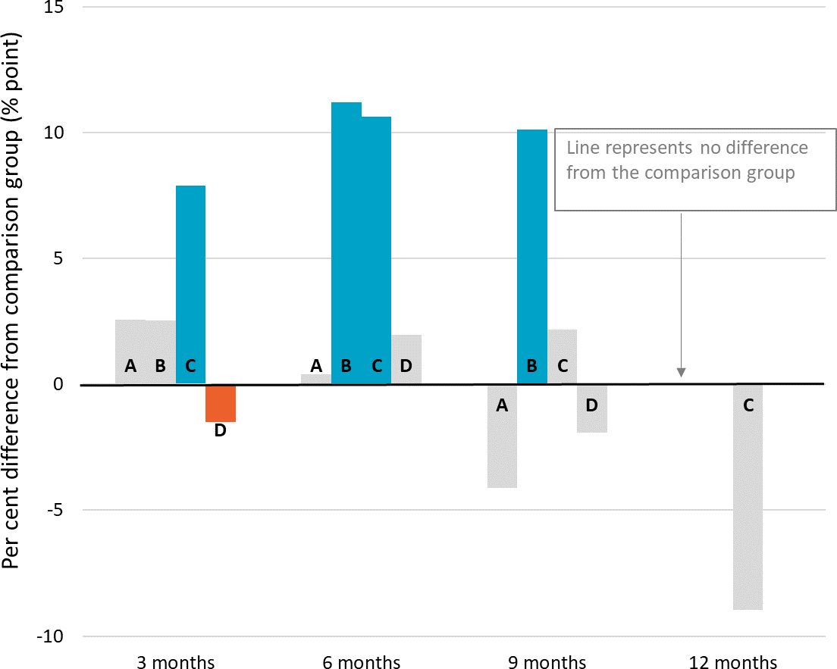
A – Lead with Culture
B – Dunn & Lewis F3style
C – Your Job Your Way
D – Brighton Integrated Community Engagement

Significant increase Significant decrease
No significant difference

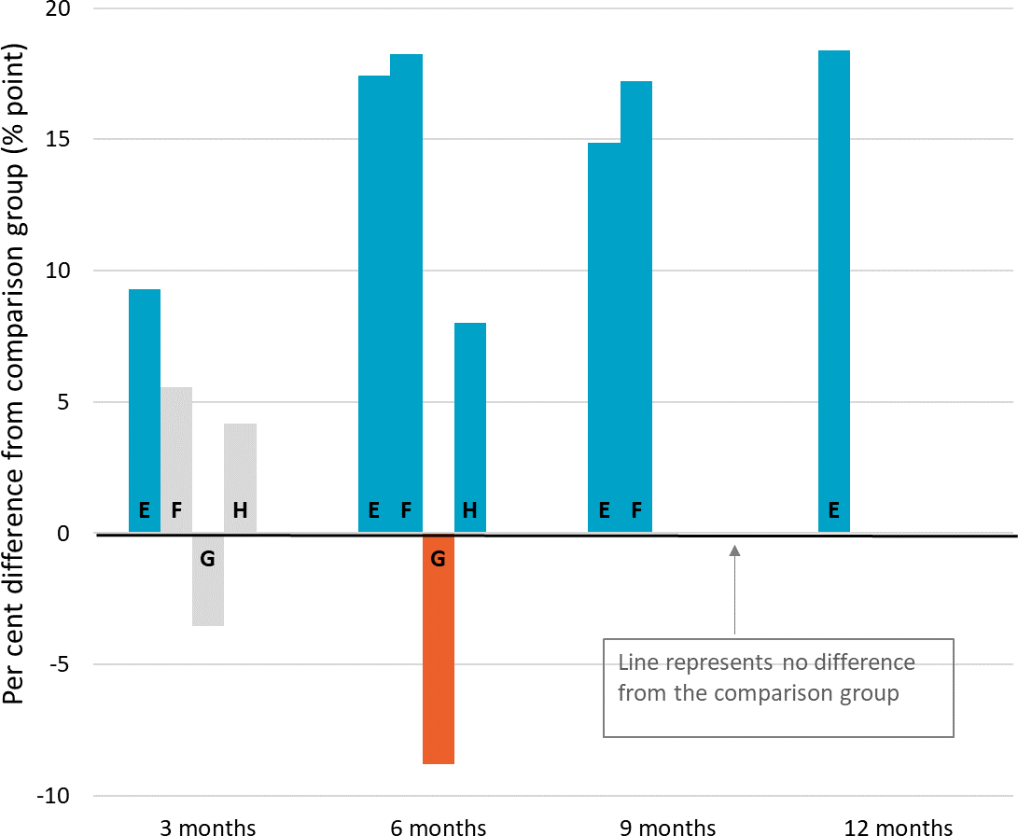
E – RIDE
F – Leadership, Engagement, and Development
G – Meeting the Youth Gap
H – Dependence to Independence
Significant increase Significant decrease
No significant difference

Notes: Difference between TTL clients’ outcomes compared to the comparison group at the end of each quarter. Impact analyses were run for 497 At-risk Young People (tranche 2) clients; 58% of those who commenced the project as recorded in DEX

Figure D-32 Student income support receipt – At-risk Young People (tranche 2)

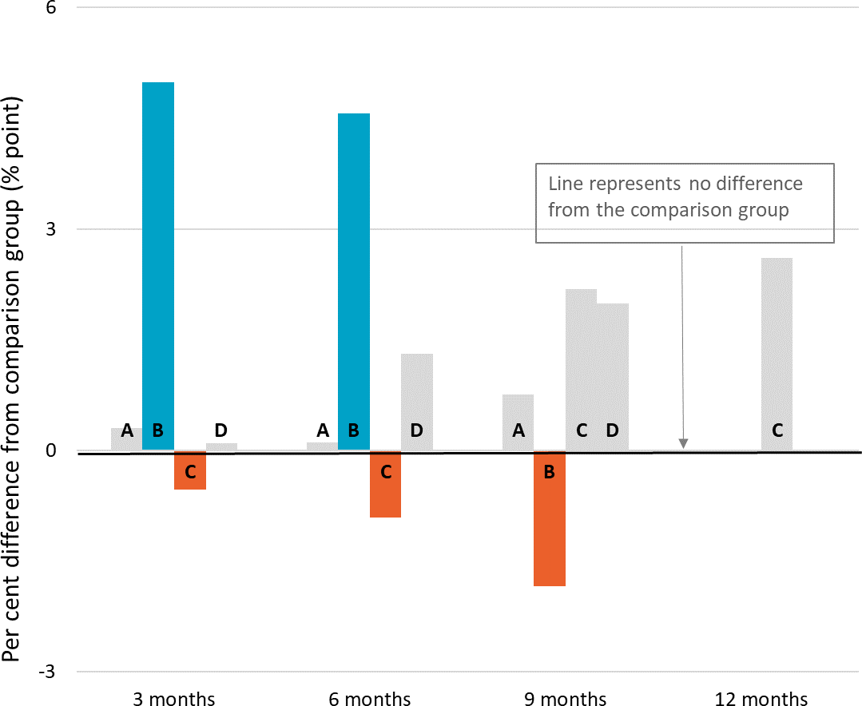
A – Lead with Culture
B – Dunn & Lewis F3style
C – Your Job Your Way
D – Brighton Integrated Community Engagement

Significant increase Significant decrease
No significant difference

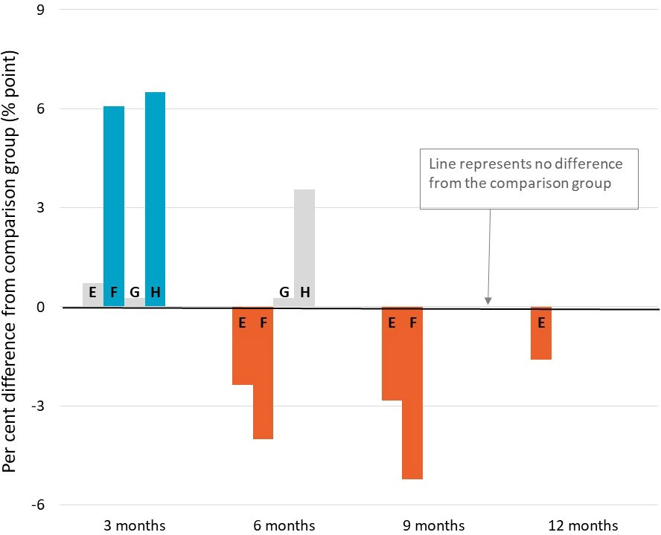
E – RIDE
F – Leadership, Engagement, and Development
G – Meeting the Youth Gap
H – Dependence to Independence
Significant increase Significant decrease
No significant difference

Notes: Difference between TTL clients’ outcomes compared to the comparison group at the end of each quarter. Impact analyses were run for 497 At-risk Young People (tranche 2) clients; 58% of those who commenced the project as recorded in DEX

Figure D-33 Any employment income while on income support – At-risk Young People (tranche 2)

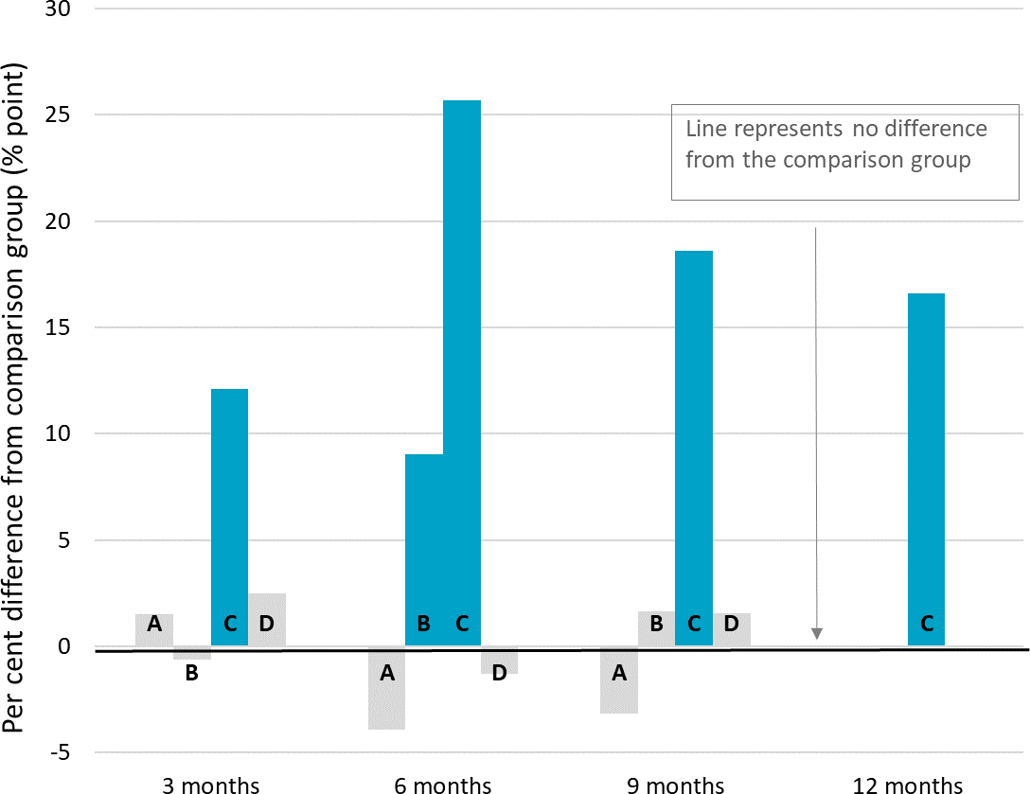
A – Lead with Culture
B – Dunn & Lewis F3style
C – Your Job Your Way
D – Brighton Integrated Community Engagement

Significant increase Significant decrease
No significant difference

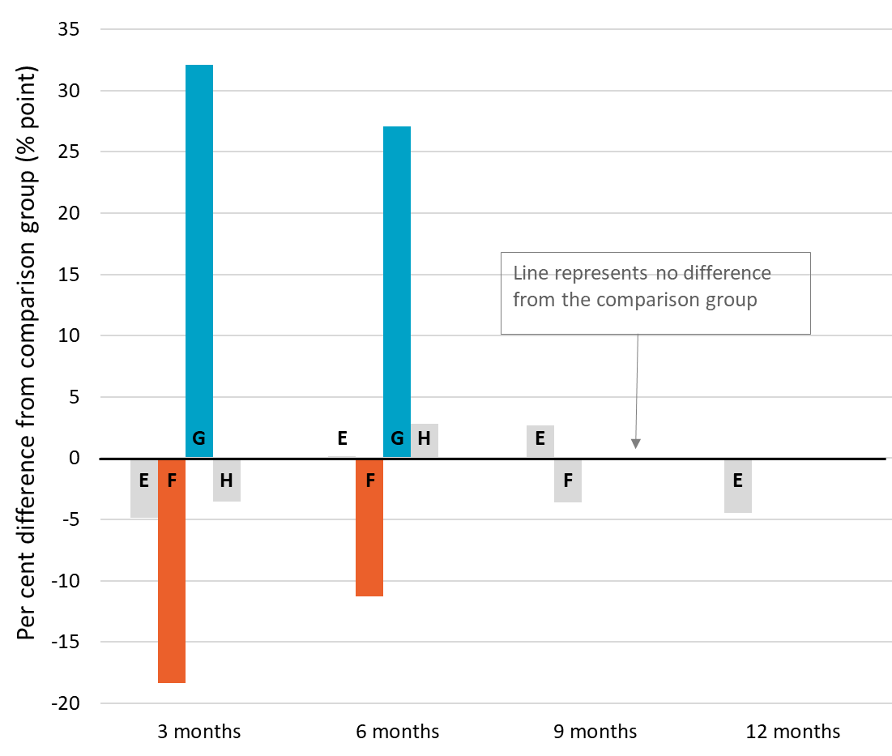
E – RIDE
F – Leadership, Engagement, and Development
G – Meeting the Youth Gap
H – Dependence to Independence
Significant increase Significant decrease
No significant difference

Notes: Difference between TTL clients’ outcomes in the quarter compared to the comparison group. Impact analyses were run for 497 At-risk Young People (tranche 2) clients; 58% of those who commenced the project as recorded in DEX

Figure D-34 Days on income support – At-risk Young People (tranche 2)

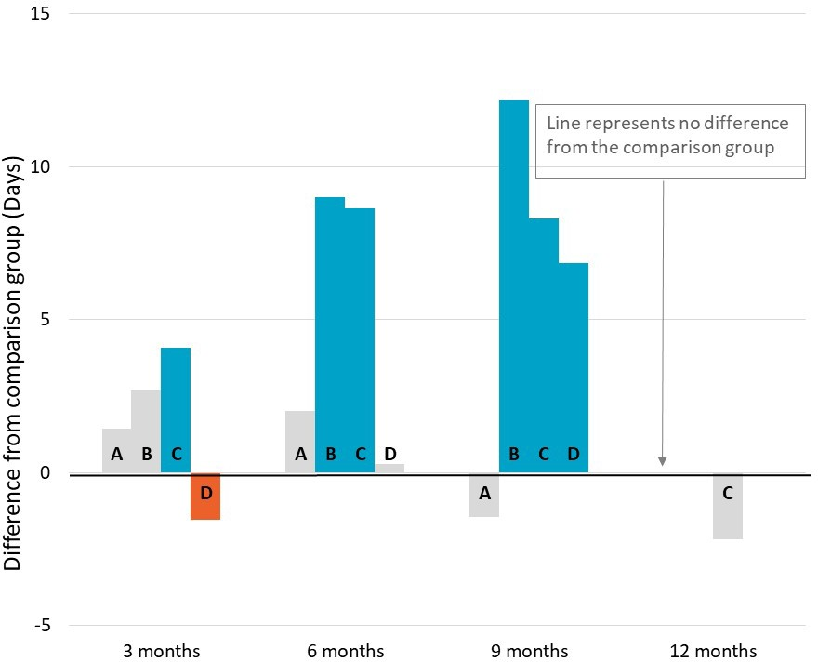
A – Lead with Culture
B – Dunn & Lewis F3style
C – Your Job Your Way
D – Brighton Integrated Community Engagement

Significant increase Significant decrease
No significant difference

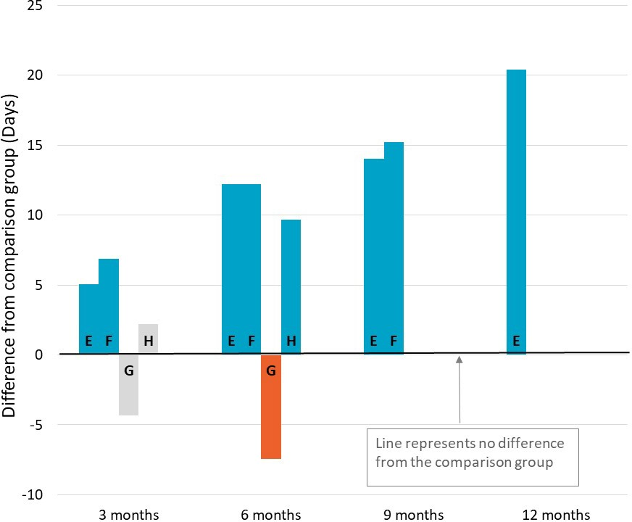
E – RIDE
F – Leadership, Engagement, and Development
G – Meeting the Youth Gap
H – Dependence to Independence
Significant increase Significant decrease
No significant difference

Notes: Difference between TTL clients’ outcomes in the quarter compared to the comparison group. Impact analyses were run for 497 At-risk Young People (tranche 2) clients; 58% of those who commenced the project as recorded in DEX

Figure D-35 Amount of employment income while on income support – At-risk Young People (tranche 2)

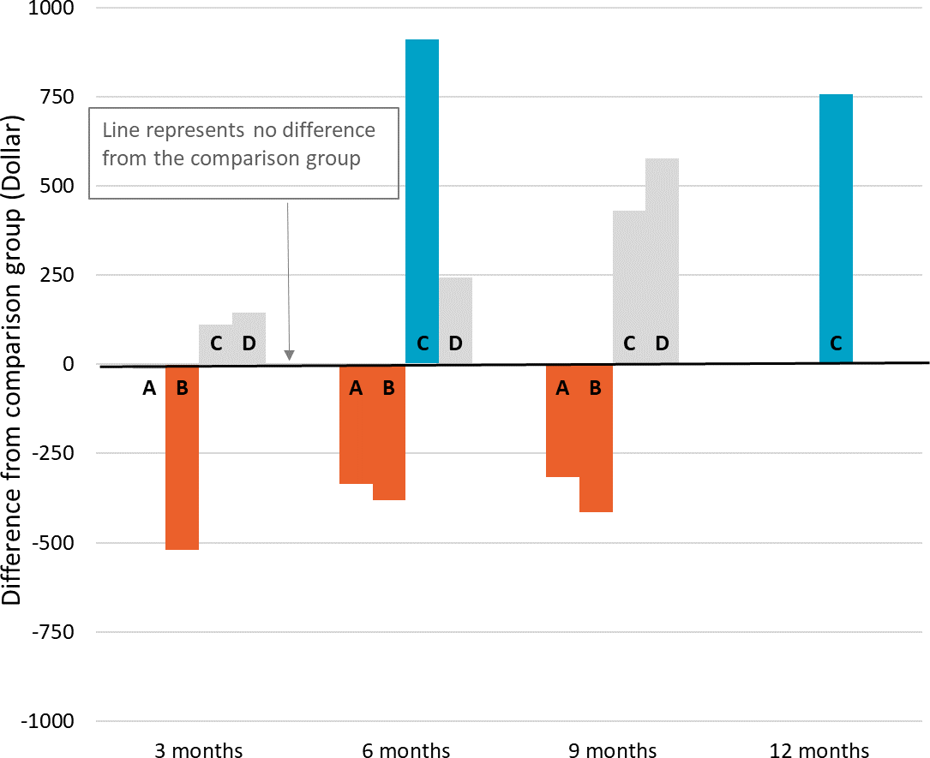
A – Lead with Culture
B – Dunn & Lewis F3style
C – Your Job Your Way
D – Brighton Integrated Community Engagement

Significant increase Significant decrease
No significant difference

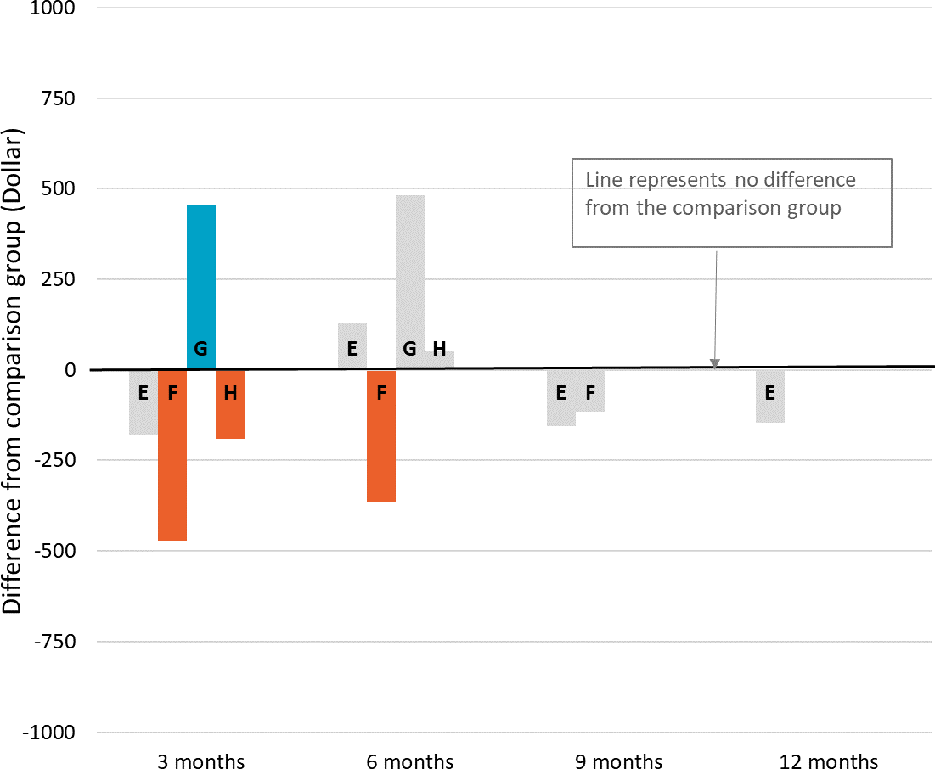
E – RIDE
F – Leadership, Engagement, and Development
G – Meeting the Youth Gap
H – Dependence to Independence
Significant increase Significant decrease
No significant difference

Notes: Difference between TTL clients’ outcomes in the quarter compared to the comparison group. Impact analyses were run for 497 At-risk Young People (tranche 2) clients; 58% of those who commenced the project as recorded in DEX

 TTL clients’ self-reported barriers
Figure D-36 presents the self-reported barriers experienced by At-risk Young People (tranche 2) clients as reported in the TTL Client Survey at the beginning (baseline) of a TTL client’s participation in the TTL project. Clients are defined as experiencing a given barrier where they respond either ‘Strongly Agree’ or ‘Agree’ to negatively worded items (i.e. items where the issue ‘makes it hard to work or study’). (See Appendix C-2-4 for further details on TTL Client Survey analysis.)
Figure D-36 TTL clients’ self-reported vocational and non-vocational barriers on TTL Client Survey items – At-risk Young People (tranche 2)
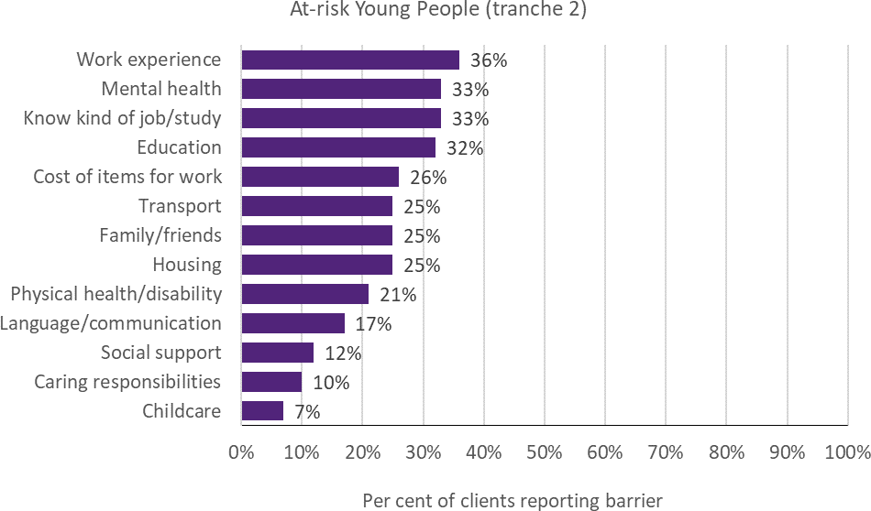
Notes: Data are from the TTL Client Survey at baseline (first survey not near the end of participation). Collected from 19% of At-risk Young People (tranche 2) TTL clients across 9 out of 12 projects
 TTL clients’ change in circumstances and goals
TTL service providers were required to collect data through DEX SCORE measures at the beginning (baseline) and end of a TTL client’s participation in the TTL project (follow-up). Figure D-37 presents the proportion of At-risk Young People (tranche 2) TTL clients who improved. Improvement is defined as having recorded a more favourable SCORE measurement at the follow-up than at baseline. (See Appendix C-2-3 for detail on DEX SCORE analysis.)

Figure D-37 TTL clients’ change in circumstances and goals on DEX SCORE measures – At-risk Young People (tranche 2)
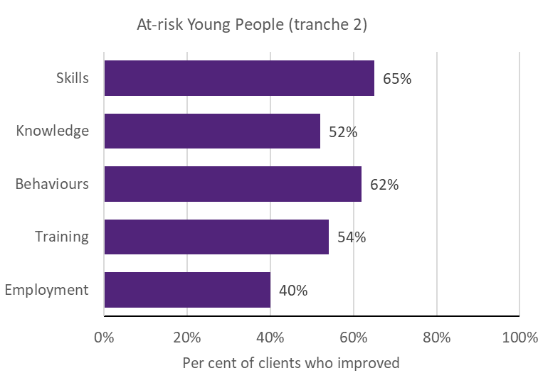
Notes: Improvement in SCORE outcomes for clients with both a baseline (pre) SCORE and a follow-up (post) SCORE, separated by at least 7 days, are reported for instances where there are at least 20 clients with available pre-post data of this kind. SCORE data were collected for 6 out of 12 projects. Five per cent of At-risk Young People (tranche
2) TTL clients were observed with baseline and follow-up data. The priority group data was dominated by RIDE

Migrants and Refugees
 Project level details
Priority group eligibility criteria: Migrants and refugees aged 16 to 64 years who are in receipt of a working-age payment.
Table D-13 provides details of the 7 Migrants and Refugees projects, including the projects’ primary objective(s), and the number of clients and main service type recorded in DEX.
Table D-13 Project objectives and service delivery recorded in DEX - Migrants and Refugees

TTL project | Project start date | Primary objective | Number of clients in DEX | Main service type delivered
31. The Australian Way | 18-Dec-18 | Skills | 0 | N/A
32. Employer-led Refugee  Employment project | 12-Dec-18 | Workforce participation | 128 | Mentoring/peer  support
33. Women’s Employment  Into Action | 29-Jan-19 | Workforce participation | 78 | Info/advice/referral
34. Sonder Employment  Solutions | 29-Jan-19 | Workforce participation  & Health and wellbeing | 305 | Facilitate employment  pathways
35. UpCycLinc | 29-Jan-19 | Skills | 97 | Education and skill  building
36. A Bridge to Regional Employment and  Opportunities | 21-Jun-19 | Workforce participation, Skills & Capacity | 0 | N/A
37. Multicultural Enterprise Development  Project | 25-Mar-19 | Skills | 90 | Education and skill building
Notes: Project start date is defined as the start of the project after the contract is signed. Primary objective is categorised according to project objective detailed in AWPs. Number of clients in DEX are to 30 June 2020; includes clients who may have participated in more than one TTL project. Main service type delivered is based on the most frequently recorded DEX session service type for each TTL project
 TTL clients’ level of disadvantage
Table D-14 presents the 4 indicators used to estimate the average level of disadvantage experienced by TTL clients, compared to the average income support recipient who met the eligibility criteria. These are presented by project, priority group and PIA level. (See Appendix C-2-1 for description of analyses.)

Table D-14 Disadvantage variables – Migrants and Refugees

32.  Employer- led Refugee Employment  project |  | 33.  Women's Employment Into Action | 34. Sonder Employment  Solutions | 35.  UpCycLinc | 37.  Multicultural Enterprise Development Project | Priority Group | Ave. IS recipient
Total number of days on income support in  last 2 years (mean) | 514 | 423 | 516 | 320 | 325 | 455 | 563
Highest level of education (less than  Year 12) | 35% | 35% | 25% | 52% | 14% | 30% | 18%
Index of Relative Socio- economic Disadvantage (bottom  20%) | 69% | 59% | 68% | 48% | 24% | 59% | 36%
Unemployment rate  SA4 (high) | 87% | ≈ 100% | 100% | 100% | 100% | 97% | 65%
Notes: Total days on income support in the last 2 years was calculated as the total days on income support unrelated to study across the 2-year period ending at their treatment start date. Highest level of education is presented as the percentage of TTL clients who had less than a Year 12 education level at the time of their treatment start date (note: there were a lot of missing data for this variable). Index of Relative Socio-Economic Disadvantage is an ABS measure that quantifies the relative disadvantage of an area using broad criteria such as income, qualifications and low-skill occupation rates. The ABS unemployment rate was used to divide all SA4 regions into high and low, based on the median value
 Summary of overarching outcomes

This section summarises the results for the 4 overarching outcomes used to measure the extent to which TTL projects helped to increase the skills and capacity of individuals to participate in social and economic life and live independently of welfare from the various data sources.
Workforce participation: Using receipt of income support unrelated to study as a measure of workforce participation showed that 2 projects had significant impacts on the rate of income support receipt unrelated to study 12 or 15 months after client commencement (Figure
D-38). One project had a reduction in the rate of income support receipt (36 percentage points less than the comparison group) 15 months after client commencement. In contrast, the other project saw an increase in the rate of income support (9 percentage points higher than the comparison group) 12 months after client commencement. The results from DEX SCORE pre-post analyses conducted for 8% of clients showed an improvement in clients’ employment
outcomes (65%) (Figure D-44). Twelve of the 23 Migrants and Refugees clients interviewed (52%) also specifically reported an increase in workforce participation. This was further supported by TTL service providers from 4 projects, who reported on average an increase in workforce participation (42%) in their AWP reports.
Educational participation: Using student income support receipt as a proxy measure of educational participation showed that none of the projects, for which there are data, had a significant impact on the rate of student income support receipt 12 or 15 months after client commencement. The results from DEX SCORE pre-post analyses (for 8% of clients) showed an improvement in clients’ training outcomes for 41% of clients (Figure D-44). Five of the 23 Migrants and Refugees clients interviewed (22%) specifically reported an increase in educational participation. This was supported by TTL service providers from 5 projects, who reported an

average increase of 11% in educational participation in their AWP reports.
Skills to participate in work or study: The results from DEX SCORE pre-post analyses showed an improvement in clients’ skills outcomes (73%) (Figure D-44). Nineteen of the 23 Migrants and Refugees clients interviewed (83%) also specifically reported an improvement in skills, particularly job search skills (n=14; 61%) and job- specific knowledge or skills (n=10; 43%). The most prevalent vocational barriers for those who responded to the TTL Client Survey (17%) were: a lack of work experience (62%), language and communication difficulties (47%), a lack of education (42%) and a having information about studying or getting a job (36%).
Capacity: Client interviews were the only source of data to measure clients’ capacity. Nine of the 23 Migrants and Refugees clients interviewed (39%) reported an improvement in their capacity to participate in work or study. The most
prevalent non-vocational barriers for those who responded to the TTL Client Survey (17%) were: cost of items for work (32%), physical health/disability (27%), mental health (25%),
caring responsibilities (25%) and housing (24%) (Figure D-43).
 Impact analysis
Figure D-38 – Figure D-42 are results from the impact analysis for projects for Migrants and Refugees. The bars represent average quarterly post-commencement outcomes of TTL clients relative to their comparison group. The number of quarters that outcomes are measured over varies by project, depending on their being at least 20 client observations for robust estimation of impacts. Where results are statistically insignificant, this means that we cannot be certain that the impact of a project (for the given outcome and quarter) are different from zero. (See Appendix C-2-2 for details of the impact analyses.)

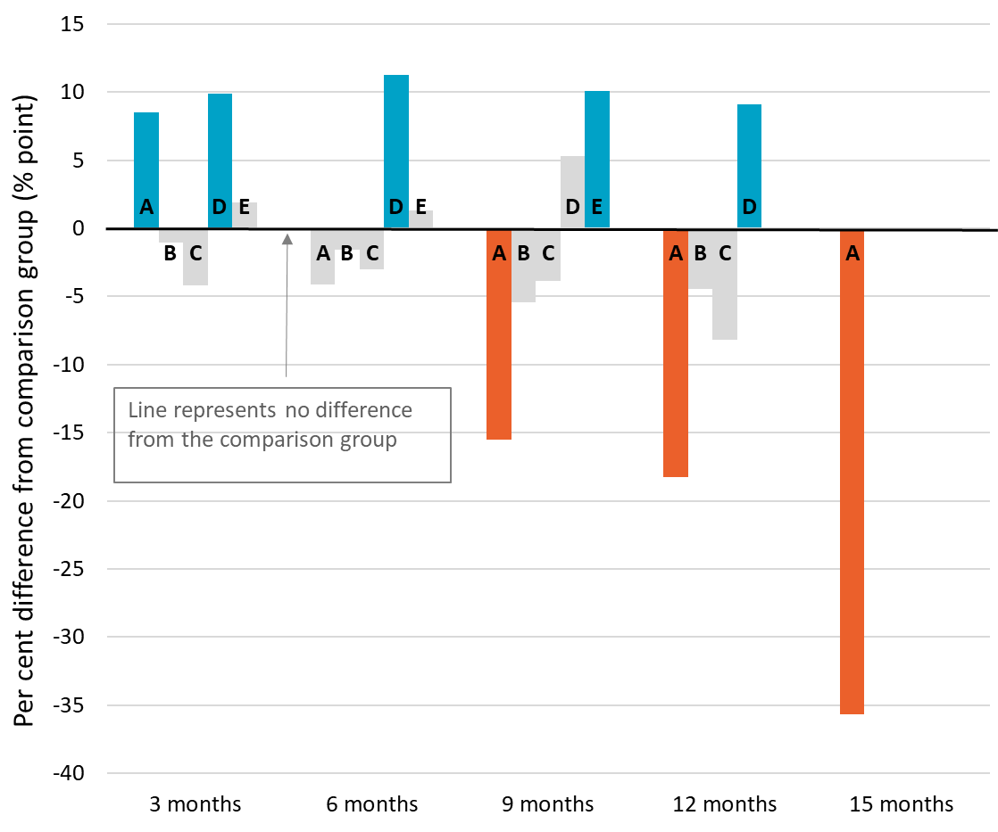
Figure D-38 Income support unrelated to study – Migrants and Refugees

A – Employer-led Refugee Employment project
B – Women's Employment Into Action
C – Sonder Employment Solutions
D – UpCycLinc
E – Multicultural Enterprise Development
Significant increase Significant decrease
No significant difference

Notes: Difference between TTL clients’ outcomes compared to the comparison group at the end of each quarter. Impact analyses were run for 498 Migrants and Refugees clients; 72% of those who commenced the project as recorded in DEX

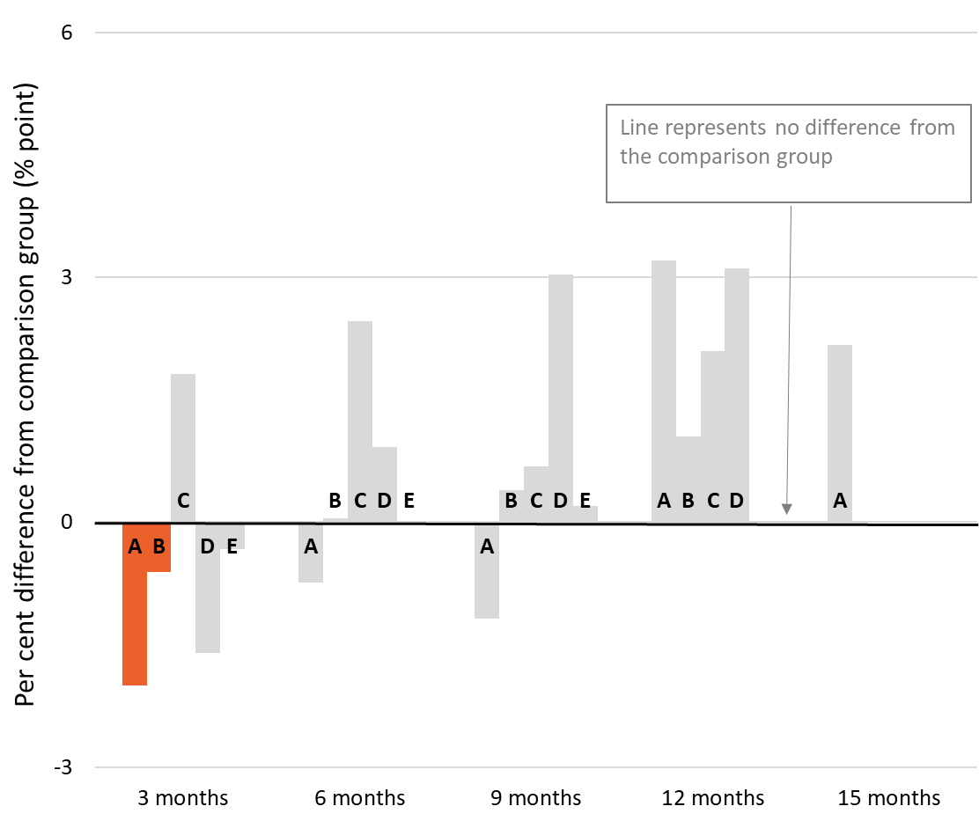
Figure D-39 Student income support receipt – Migrants and Refugees

A – Employer-led Refugee Employment project
B – Women's Employment Into Action
C – Sonder Employment Solutions
D – UpCycLinc
E – Multicultural Enterprise Development
Significant increase Significant decrease
No significant difference

Notes: Difference between TTL clients’ outcomes compared to the comparison group at the end of each quarter. Impact analyses were run for 498 Migrants and Refugees clients; 72% of those who commenced the project as recorded in DEX
Figure D-40 Any employment income while on income support – Migrants and Refugees

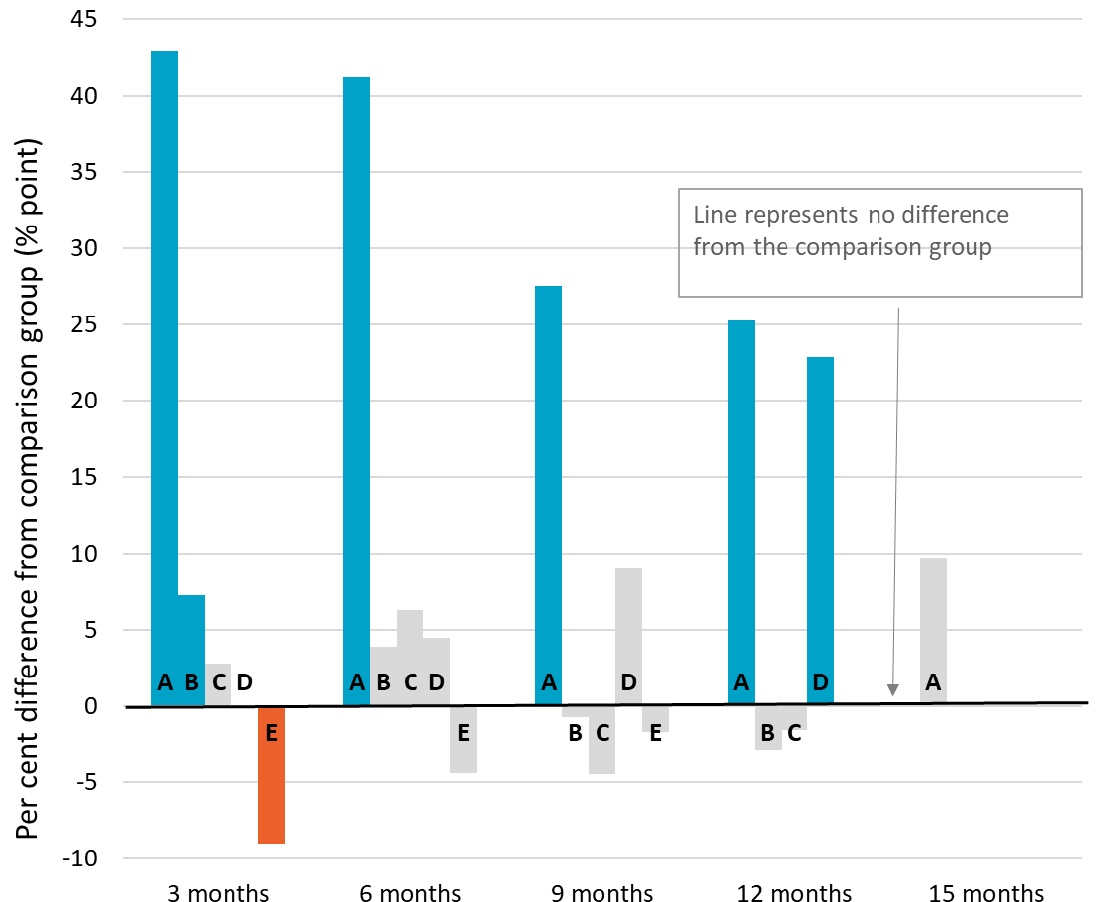
A – Employer-led Refugee Employment project
B – Women's Employment Into Action
C – Sonder Employment Solutions
D – UpCycLinc
E – Multicultural Enterprise Development
Significant increase Significant decrease
No significant difference

Notes: Difference between TTL clients’ outcomes in the quarter compared to the comparison group. Impact analyses were run for 498 Migrants and Refugees clients; 72% of those who commenced the project as recorded in DEX

Figure D-41 Days on income support – Migrants and Refugees

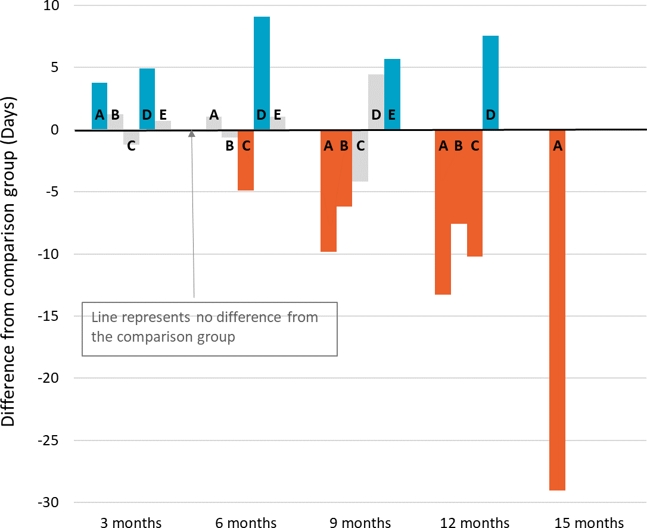
A – Employer-led Refugee Employment project
B – Women's Employment Into Action
C – Sonder Employment Solutions
D – UpCycLinc
E – Multicultural Enterprise Development
Significant increase Significant decrease
No significant difference

Notes: Difference between TTL clients’ outcomes in the quarter compared to the comparison group. Impact analyses were run for 498 Migrants and Refugees clients; 72% of those who commenced the project as recorded in DEX
Figure D-42 Amount of employment income while on income support – Migrants and Refugees
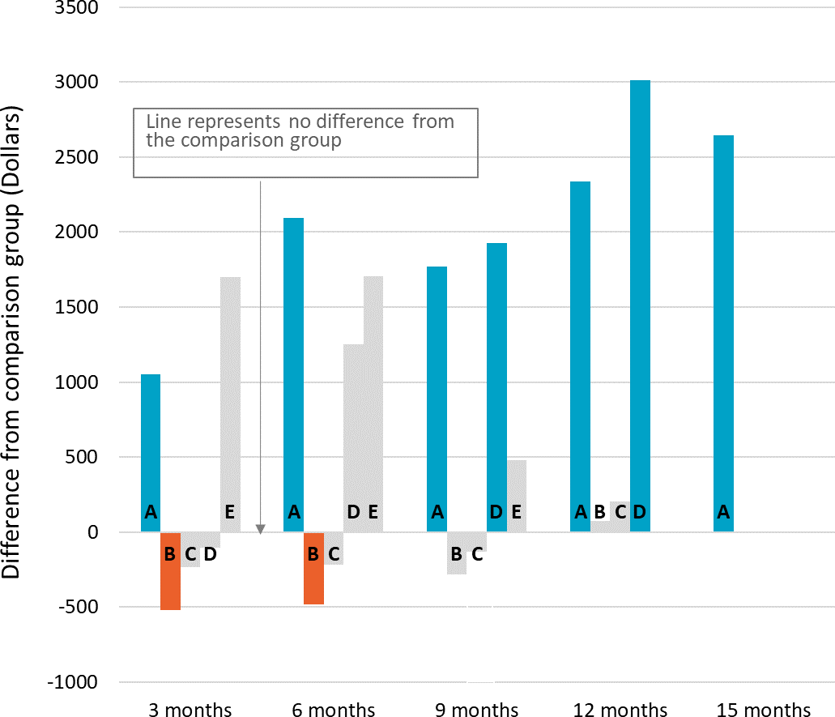
A – Employer-led Refugee Employment project
B – Women's Employment Into Action
C – Sonder Employment Solutions
D – UpCycLinc
E – Multicultural Enterprise Development
Significant increase Significant decrease
No significant difference

Notes: Difference between TTL clients’ outcomes in the quarter compared to the comparison group. Impact analyses were run for 498 Migrants and Refugees clients; 72% of those who commenced the project as recorded in DEX

 TTL clients’ self-reported barriers
Figure D-43 presents the self-reported barriers experienced by Migrants and Refugees clients as reported in the TTL Client Survey at the beginning (baseline) of a TTL client’s participation in the TTL project. Clients are defined as experiencing a given barrier where they respond either ‘Strongly Agree’ or ‘Agree’ to negatively worded items (i.e. items where the issue ‘makes it hard to work or study’). (See Appendix C-2-4 for further details on TTL Client Survey analysis.)
Figure D-43 TTL clients’ self-reported vocational and non-vocational barriers on TTL Client Survey items – Migrants and Refugees
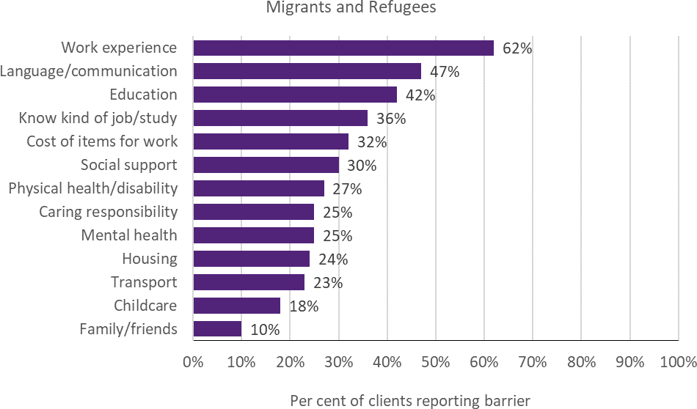
Notes: Data are from the TTL Client Survey at baseline (first survey not near the end of participation). Collected from 17% of Migrant and Refugees TTL clients across 4 out of 7 projects
 TTL clients’ changes in circumstances and goals
TTL service providers were required to collect data through DEX SCORE measures at the beginning (baseline) and end of a TTL client’s participation in the TTL project (follow-up). Figure D-44 presents the proportion of Migrants and Refugees TTL clients who improved. Improvement is defined as having recorded a more favourable SCORE measurement at the follow-up than at baseline. (See Appendix C-2-3 for detail on DEX SCORE analysis.)

Figure D-44 TTL clients’ change in circumstances and goals on DEX SCORE measures – Migrants and Refugees
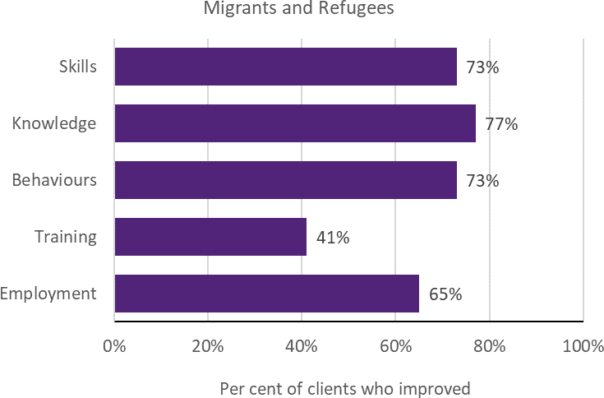
Notes: Improvement in SCORE outcomes for clients with both a baseline (pre) SCORE and a follow-up (post) SCORE, separated by at least 7 days, are reported for instances where there are at least 20 clients with available pre-post data of this kind. SCORE data were collected for 5 out of 7 projects. Eight per cent of TTL clients were observed with baseline and follow-up data. The priority group data was dominated by Sonder Employment Solutions

Older Unemployed People
 Project level details
Priority group eligibility criteria: JobSeeker (formally Newstart Allowance) recipients aged 50 or over.
Table D-15 provides details of the 6 Older Unemployed People projects, including the projects’ primary objective(s), and the number of clients and main service type recorded in DEX.
Table D-15 Project objectives and service delivery recorded in DEX - Older Unemployed People

TTL project | Project start date | Primary objective | Number of clients in DEX | Main service type delivered
38. Next Steps | 14-Jan-19 | Skills & Health and wellbeing | 366 | Info/advice/referral
39. Work Work | 29-Jan-19 | Skills | 36 | Education and skill  building
40. Sisters Support  Business Together | 04-Mar-19 | Skills | 36 | Education and skill  building
41. Reach, Train and  Employ | 30-Jul-19 | Educational  participation | 37 | Education and skill  building
42. Career Skills for New  Jobs | 20-May-19 | Skills | 71 | Facilitate employment  pathways
43. Building Bridges for  Mature Jobseekers | 20-Jun-19 | Workforce  participation | 35 | Facilitate employment  pathways
Notes: Project start date is defined as the start of the project after the contract is signed. Primary objective is categorised according to project objective detailed in AWPs. Number of clients in DEX are to 30 June 2020; includes clients who may have participated in more than one TTL project. Main service type delivered is based on the most frequently recorded DEX session service type for each TTL project
 TTL clients’ level of disadvantage
Table D-16 presents the 4 indicators used to estimate the average level of disadvantage experienced by TTL clients, compared to the average income support recipient who met the eligibility criteria. These are presented by project, priority group and PIA level. (See Appendix C-2-1 for description of analyses.)

Table D-16 Disadvantage variables – Older Unemployed People

 | 38. Next Steps | 39. Work Work | 42. Career Skills for New Jobs | 43. Building Bridges for Mature Job  seekers | Priority Group | Ave. IS recipient
Total number of days on income support in last 2 years (mean) | 263 | 605 | 538 | 536 | 344 | 588
Highest level of education (less than Year 12) | 7% | 23% | 18% | * | 10% | 27%
Index of Relative Socio- economic Disadvantage  (bottom 20%) | 18% | 23% | 67% | 79% | 28% | 32%
Unemployment rate SA4 (high) | 90% | 23% | ≈ 100% | 100% | 85% | 59%
Notes: Total days on income support in the last 2 years was calculated as the total days on income support unrelated to study across the 2-year period ending at their treatment start date. Highest level of education is presented as the percentage of TTL clients who had less than a Year 12 education level at the time of their treatment start. Index of Relative Socio-Economic Disadvantage is an ABS measure that quantifies the relative disadvantage of an area using broad criteria such as income, qualifications and low-skill occupation rates. The ABS unemployment rate was used to divide all SA4 regions into high and low, based on the median value
 Summary of overarching outcomes

This section summarises the results for the 4 overarching outcomes used to measure the extent to which TTL projects helped to increase the skills and capacity of individuals to participate in social and economic life and live independently of welfare from the various data sources.
Workforce participation: Using receipt of income support unrelated to study as a measure of workforce participation showed that 3 of the 4 projects had significant impacts on the rate of income support receipt unrelated to study in the last period for which they have data (Figure
D-45). One project saw a significant decrease (21 percentage points less than comparison group) in the rate of support unrelated to study 9 months after client commencement. For the other 2 projects, the TTL clients were, respectively, 5 or 10 percentage points more likely to be in receipt of income support unrelated to study 6 or 15 months after client commencement. The results from DEX SCORE pre-post analyses (conducted for 6% of clients) showed an improvement in clients’ employment outcomes (65%) (Figure
D-51). However, only 7 of the 36 clients interviewed (19%) specifically reported an
increase in workforce participation. This was supported by TTL service providers from 4 projects, who reported an average 26% increase in workforce participation in their AWP reports.
Educational participation: Using student income support receipt as a proxy measure of educational participation showed that 2 projects for which there were 9 months and 15 months of data respectively had significant reductions in the rate of student income support receipt. However, the impacts are small — less than 1.5 percentage points lower than the comparison group. The results from DEX SCORE pre-post analyses (6% of clients) showed 58% of clients with these data had improved training outcomes (Figure D-51).
Thirteen of 36 clients interviewed (36%) specifically reported an increase in educational participation.
Skills to participate in work or study: The results from DEX SCORE pre-post analyses (6% of clients) showed an improvement in clients’ skills outcomes (73%) (Figure D-51). Similarly, 28 of the 36 clients interviewed (78%) also specifically reported an improvement in skills, particularly job search skills (n=14; 39%). The most prevalent

vocational barriers for those who responded to the TTL Client Survey (17%) were cost of items for work (33%) and a lack of work experience (30%) (Figure D-50).
Capacity: Client interviews were the only source of data to measure clients’ capacity. Eight of the 36 clients interviewed (22%) reported an improvement in their capacity to participate in work or study. The most prevalent non- vocational barriers for those who responded to the TTL Client Survey (17%) were mental health (33%), transport (32%) and physical health or disability (30%) (Figure D-50).
 Impact analysis
Figure D-45 – Figure D-49 are results from the impact analysis for projects for Older Unemployed People. The bars represent average quarterly post-commencement outcomes of TTL clients relative to their matched comparison group. The number of quarters that outcomes are measured over varies by project, depending on their being at least 20 client observations for robust estimation of impacts. Where results are statistically insignificant, this means that we cannot be certain that the impact of a project (for the given outcome and quarter) are different from zero. (See Appendix C-2-2 for details of the impact analyses.)

Figure D-45 Income support unrelated to study – Older Unemployed People

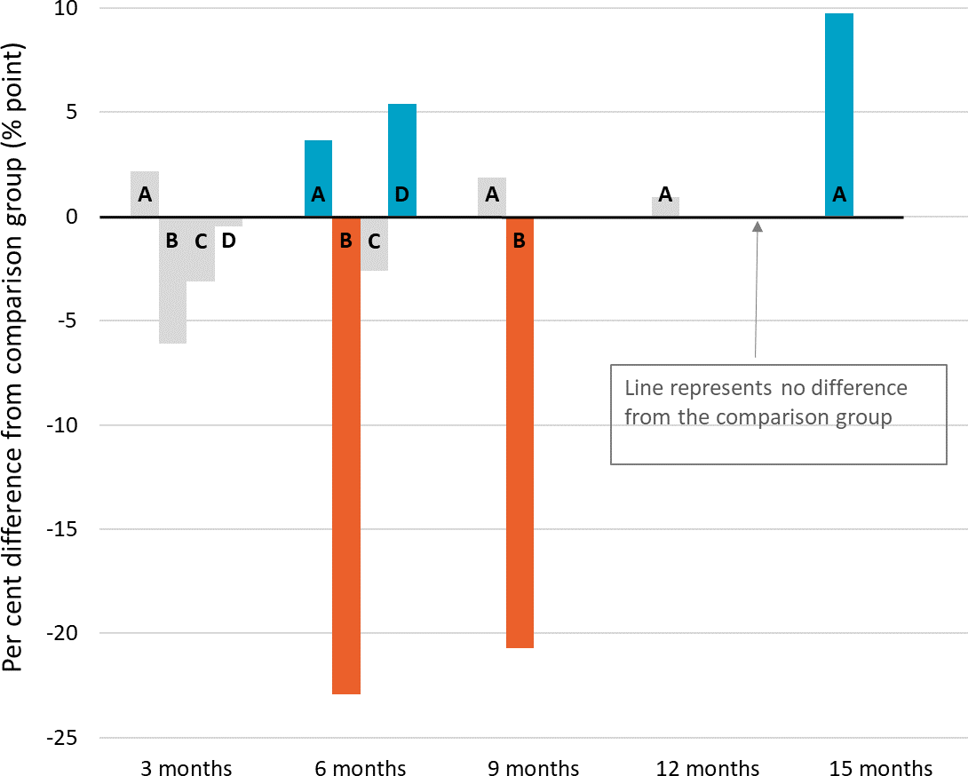
A – Next Steps
B – Work Work
C – Career Skills for New Jobs
D – Building Bridges for Mature Jobseekers

Significant increase Significant decrease
No significant difference

Notes: Difference between TTL clients’ outcomes compared to the comparison group at the end of each quarter. Impact analyses were run for 420 Older Unemployed People clients; 72% of those who commenced the project as recorded in DEX

Figure D-46 Student income support receipt – Older Unemployed People

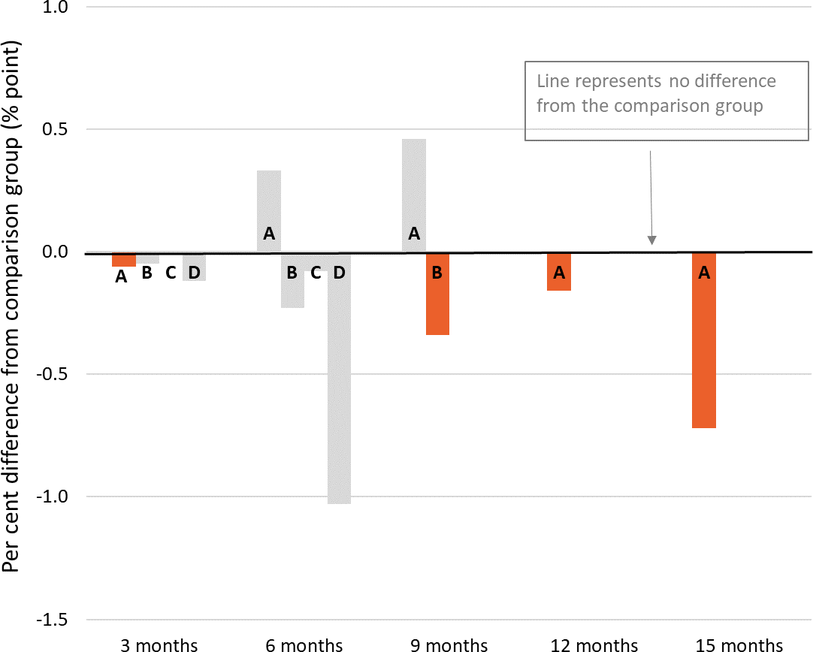
A – Next Steps
B – Work Work
C – Career Skills for New Jobs
D – Building Bridges for Mature Jobseekers

Significant increase Significant decrease
No significant difference

Notes: Difference between TTL clients’ outcomes compared to the comparison group at the end of each quarter. Impact analyses were run for 420 Older Unemployed People clients; 72% of those who commenced the project as recorded in DEX
Figure D-47 Any employment income while on income support – Older Unemployed People

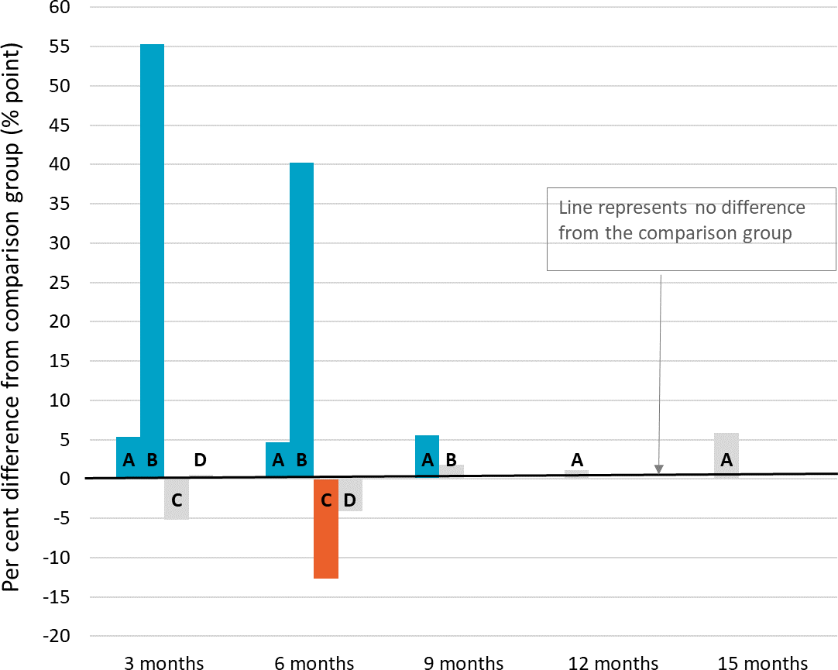
A – Next Steps
B – Work Work
C – Career Skills for New Jobs
D – Building Bridges for Mature Jobseekers

Significant increase Significant decrease
No significant difference

Notes: Difference between TTL clients’ outcomes in the quarter compared to the comparison group. Impact analyses were run for 420 Older Unemployed People clients; 72% of those who commenced the project as recorded in DEX

Figure D-48 Days on income support – Older Unemployed People

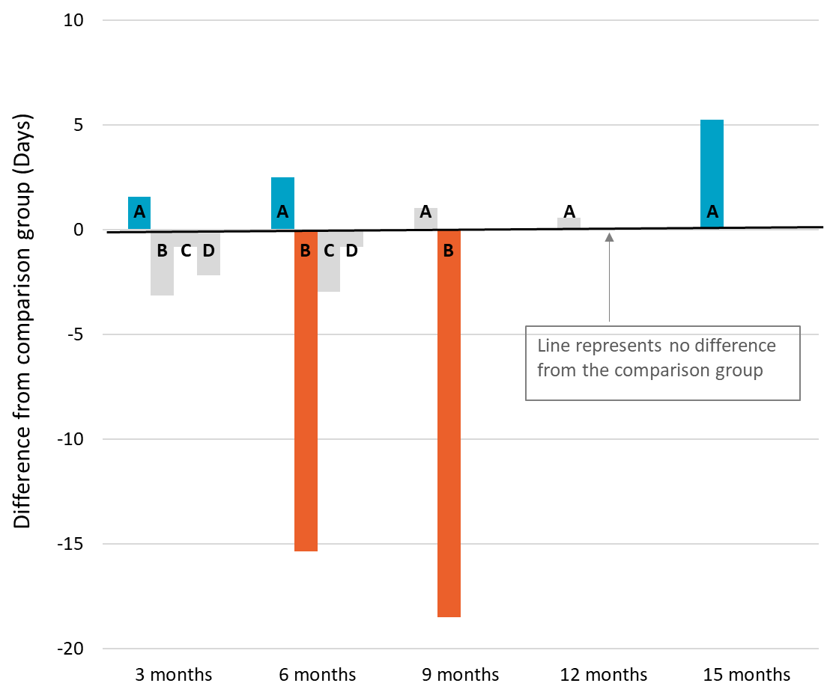
A – Next Steps
B – Work Work
C – Career Skills for New Jobs
D – Building Bridges for Mature Jobseekers

Significant increase Significant decrease
No significant difference

Notes: Difference between TTL clients’ outcomes in the quarter compared to the comparison group. Impact analyses were run for 420 Older Unemployed People clients; of those who commenced the project as recorded in DEX
Figure D-49 Amount of employment income while on income support– Older Unemployed People

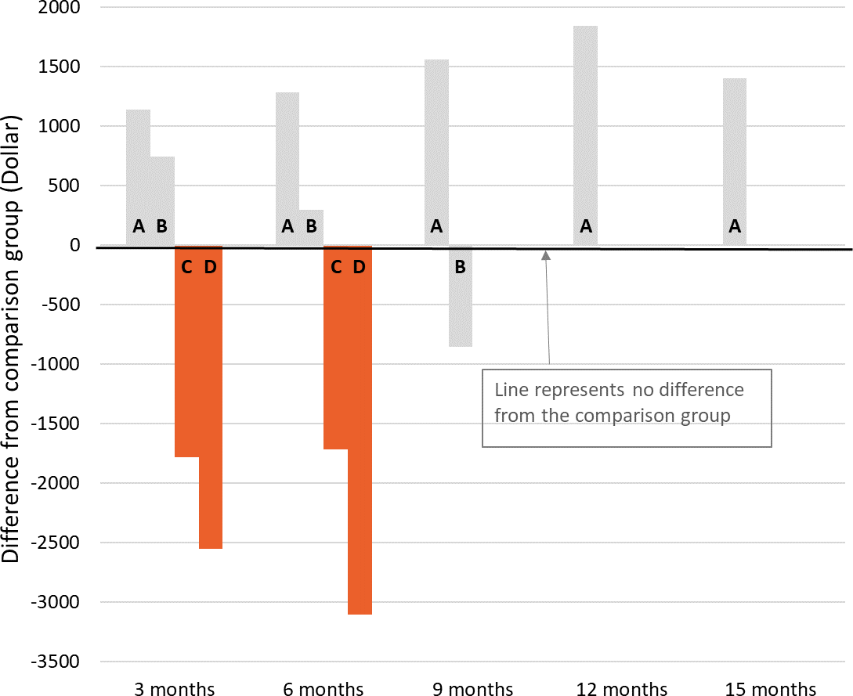
A – Next Steps
B – Work Work
C – Career Skills for New Jobs
D – Building Bridges for Mature Jobseekers

Significant increase Significant decrease
No significant difference

Notes: Difference between TTL clients’ outcomes in the quarter compared to the comparison group. Impact analyses were run for 420 Older Unemployed People clients; 72% of those who commenced the project as recorded in DEX

 TTL clients’ self-reported barriers
Figure D-50 presents the self-reported barriers experienced by Older Unemployed People clients as reported in the TTL Client Survey at the beginning (baseline) of a TTL client’s participation in the TTL project. Clients are defined as experiencing a given barrier where they respond either ‘Strongly Agree’ or ‘Agree’ to negatively worded items (i.e. items where the issue ‘makes it hard to work or study’). (See Appendix C-2-4 for further details on TTL Client Survey analysis.)
Figure D-50 TTL clients’ self-reported vocational and non-vocational barriers on TTL Client Survey items – Older Unemployed People
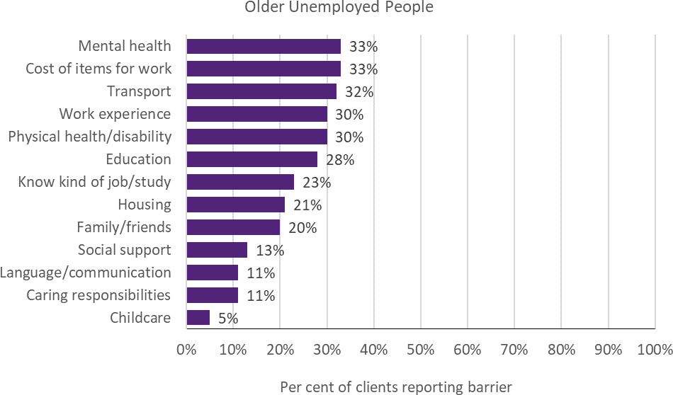
Notes: Data are from the TTL Client Survey at baseline (first survey not near the end of participation). Collected from 17% of Older Unemployed People TTL clients across 5 out of 6 projects
 TTL clients’ change in circumstances and goals
TTL service providers were required to collect data through DEX SCORE measures at the beginning (baseline) and end of a TTL client’s participation in the TTL project (follow-up). Figure D-51 presents the proportion of Older Unemployed People TTL clients who improved. Improvement is defined as having recorded a more favourable SCORE measurement at the follow-up than at baseline. (See Appendix C-2-3 for detail on DEX SCORE analysis.)

Figure D-51 TTL clients’ change in circumstances and goals on DEX SCORE measures – Older Unemployed People
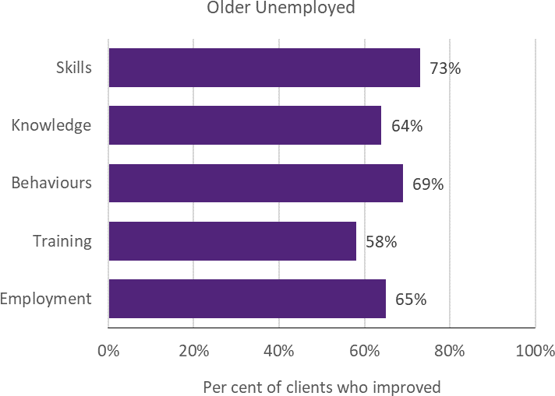
Notes: Improvement in SCORE outcomes for clients with both a baseline (pre) SCORE and a follow-up (post) SCORE, separated by at least 7 days, are reported for instances where there are at least 20 clients with available pre-post data of this kind. SCORE data were collected for 4 out of 6 projects. Six per cent of Older Unemployed TTL clients were observed with baseline and follow-up data. The priority group data was dominated by Next Steps clients

Other
 Project level details
Priority group eligibility: There was no fixed eligibility criteria for the Other priority group as it includes projects that focused on clients who fit into more than one of the primary priority groups, or who had specific circumstances (e.g. people with a musculoskeletal condition; young people with an incarcerated parent or guardian).
Table D-17 provides details of the 11 Other projects, including the projects’ primary objective(s), and the number of clients and main service type recorded in DEX. Note, for the purpose of the evaluation, Community Voices was reclassified from the At-risk Young People (tranche 2) priority group to Other based on its clients’ characteristics being dissimilar to the At-risk Young People priority group definition.
Table D-17 Project objectives and service delivery recorded in DEX - Other

TTL project | Project start date | Primary objective | Number of clients in  DEX | Main service type delivered
17. Community Voices | 29-Jan-19 | Capacity & Health and wellbeing | 125 | Info/advice/referral
44. The Coach Project | 03-Oct-19 | Workforce participation & Skills | 11 | Advocacy/support
45. Getting Ready for Take  Off | 01-Apr-19 | Educational participation | 100 | Advocacy/support
46. Giving it a Go | 21-Jun-19 | Health and wellbeing | 0 | N/A
47. Finding Strengths | 07-Oct-19 | Educational participation & Skills | 30 | Education and skill  building
48. Warra Warra Kanyi | 15-Jul-19 | Health and wellbeing | 85 | Info/advice/referral
49. Online Business Lift-  Off | 20-May-19 | Skills | 65 | Education and skill  building
50. Demand-led Education  to Employment in Care | 30-Jul-19 | Workforce participation | 43 | Education and skill  building
51. I Am Ready | 12-Dec-18 | Workforce participation,  Educational participation & Skills | 91 | Education and skill  building
52. Ability School  Engagement Partnership | 21-Jun-19 | Educational participation | 0 | N/A
53. IMPACT Club | 30-Jul-19 | Capacity | * | Education and skill  building
Notes: Project start date is defined as the start of the project after the contract is signed. Primary objective is categorised according to project objective detailed in AWPs. Number of clients in DEX are to 30 June 2020; includes clients who may have participated in more than one TTL project. Main service type delivered is based on the most frequently recorded DEX session service type for each TTL project. Community Voices was reclassified by the evaluation team from the At-risk Young People (tranche 2) priority group to the Other group as this project recruited migrants and refugees, and older unemployed people, in addition to at-risk young people, and thus had a diverse sample that was substantially different from the rest of the projects in the At-risk Young People (tranche 2) priority group. IMPACT Club had 5 or fewer clients recorded in DEX at 30 June 2020, as such the data are suppressed and represented by *
 TTL clients’ level of disadvantage
Table D-18 presents the 4 indicators used to estimate the average level of disadvantage experienced by TTL clients, compared to the average income support recipient who met the eligibility criteria. These are presented by project, priority group and PIA level. (See Appendix C-2-1 for description of analyses.)

Table D-18 Disadvantage variables – Other

17.Community Voices |  | 45. Getting Ready for Take  Off | 48. Warra Warra  Kanyi | 49. Online Business Lift-  Off | 51. I Am  Ready | Priority Group
Total number of days on income support in last 2 years (mean) | 456 | 89 | 362 | 222 | 29 | 260
Highest level of education  (less than year 12) | 31% | 21% | 53% | * | * | 22%
Index of Relative Socio- economic Disadvantage  (bottom 20%) | 88% | 35% | 100% | 32% | 17% | 53%
Unemployment rate SA4 (high) | 100% | ≈ 100% | 100% | 35% | 100% | 83%
Notes: Total days on income support in the last 2 years was calculated as the total days on income support unrelated to study across the 2-year period ending at their treatment start date. Highest level of education is presented as the percentage of TTL clients who had less than a Year 12 education level at the time of their treatment start date. Index of Relative Socio-Economic Disadvantage is an ABS measure that quantifies the relative disadvantage of an area using broad criteria such as income, qualifications and low-skill occupation rates. The ABS unemployment rate was used to divide all SA4 regions into high and low, based on the median value
 Summary of overarching outcomes

This section summarises the results for the 4 overarching outcomes used to measure the extent to which TTL projects helped to increase the skills and capacity of individuals to participate in social and economic life and live independently of welfare from the various data sources.
Workforce participation: Using receipt of income support unrelated to study as a measure of workforce participation showed that none of the projects, for which there are data had significant impacts on the rate of income support receipt at the last period for which they have data (Figure D-52). Only 4 of the 36 clients interviewed reported increased workforce participation.
However, of the 11% of clients with pre-post DEX SCORE data, 66% reported improved employment outcomes (Figure D-59). Service providers (4 projects) reported an average 26% increase in workforce participation in AWP reports.
Educational participation: Using student income support receipt as a proxy measure of educational participation showed that 2 of 5 the projects saw a significant increase in the rate of student income support in the last month for which they had data (6 and 9 months after client
commencement, respectively) (Figure D-53). The results from DEX SCORE pre-post analyses (for 11% of clients) showed that 47% of clients reported improved training outcomes (Figure
D-59). Similarly, 14 of 36 clients interviewed (39%) specifically reported an increase in educational participation. TTL service providers from 3 projects reported an average of 64% of clients participating in education or training in their AWP reports.
Skills to participate in work or study: Of the 11% of clients with pre-post DEX SCORE data, 59% reported improved skills outcomes (Figure D-59). Twenty-seven of the 36 clients interviewed (75%) also reported an improvement in skills, particularly soft skills (n=13; 36%). The most prevalent vocational barrier for those who responded to the TTL Client Survey (11%) was a lack of work experience (41%) (Figure D-58).
Capacity: Client interviews were the only source of data on clients’ capacity. Twenty-three of the 36 clients interviewed (64%) reported an improvement in their capacity to participate in work or study. The most prevalent non- vocational barriers for those who responded to the TTL Client Survey (11%) were transport (46%),

cost of items for work (44%), mental health (32%) and physical health or disability (29%) (Figure
D-58).
 Impact analysis
Figure D-52 – Figure D-56 are results from the impact analysis for projects from the Other priority group. The bars represent average quarterly post-commencement outcomes of TTL clients relative to their comparison group. The
Figure D-52 Income support unrelated to study – Other
number of quarters that outcomes are measured over varies by project, depending on their being at least 20 client observations for robust estimation of impacts. Where results are statistically insignificant, this means that we cannot be certain that the impact of a project (for the given outcome and quarter) are different from zero. (See Appendix C-2-2 for details of the impact analyses.)

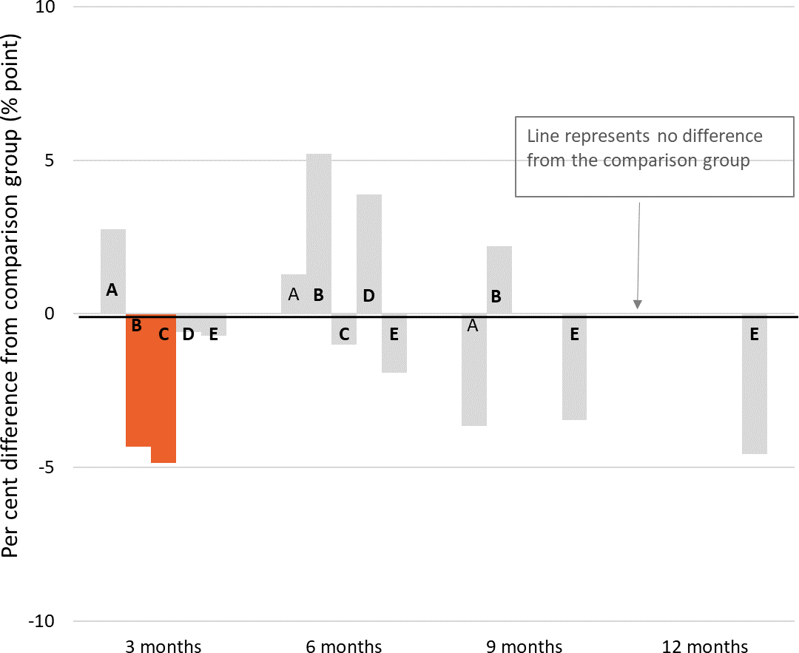
A – Community Voices
B – Getting Ready for Take Off
C – Warra Warra Kanyi
D – Online Business Lift-Off
E – I Am Ready
Significant increase Significant decrease
No significant difference

Notes: Difference between TTL clients’ outcomes compared to the comparison group at the end of each quarter. Impact analyses were run for 274 Other clients; 50% of those who commenced the project as recorded in DEX

Figure D-53 Student income support receipt – Other

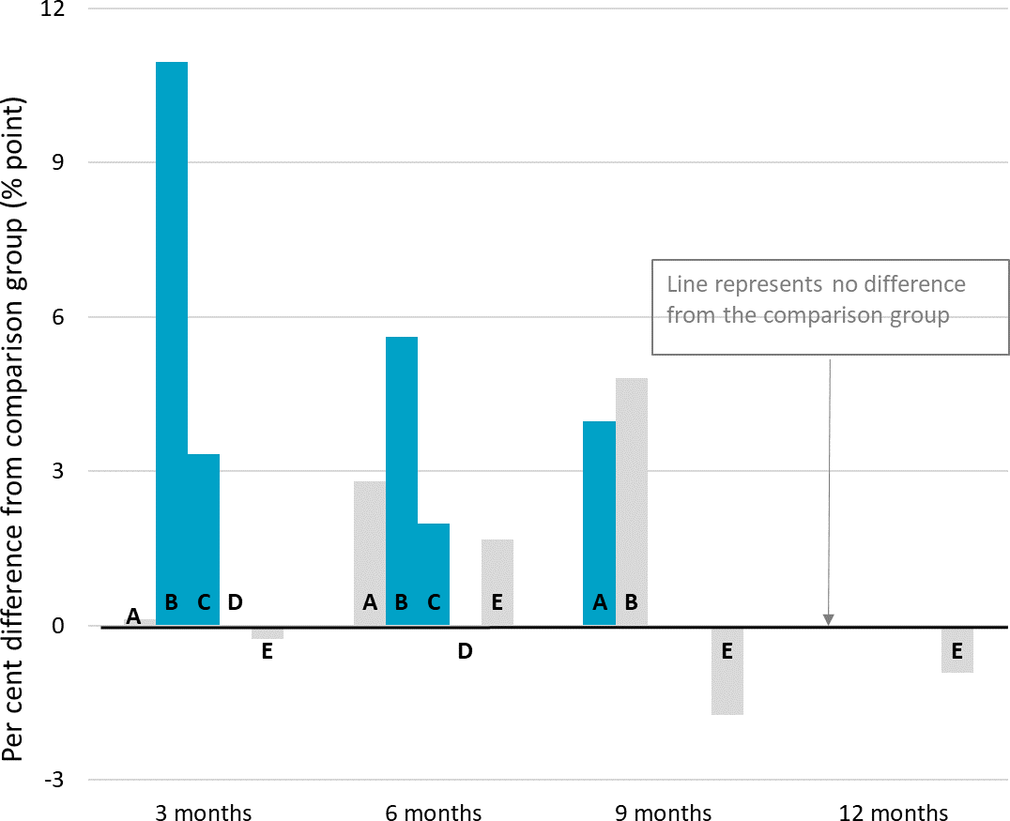
A – Community Voices
B – Getting Ready for Take Off
C – Warra Warra Kanyi
D – Online Business Lift-Off
E – I Am Ready
Significant increase Significant decrease
No significant difference

Notes: Difference between TTL clients’ outcomes compared to the comparison group at the end of each quarter. Impact analyses were run for 274 Other clients; 50% of those who commenced the project as recorded in DEX
Figure D-54 Any employment income while on income support – Other

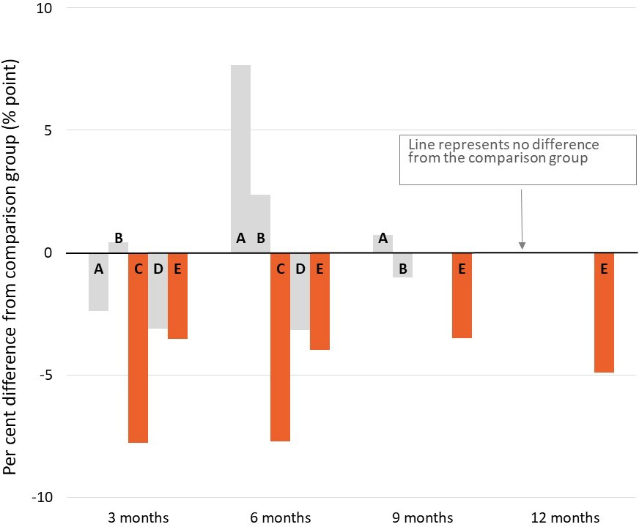
A – Community Voices
B – Getting Ready for Take Off
C – Warra Warra Kanyi
D – Online Business Lift-Off
E – I Am Ready
Significant increase Significant decrease
No significant difference

Notes: Difference between TTL clients’ outcomes in the quarter compared to the comparison group. Impact analyses were run for 274 Other clients; 50% of those who commenced the project as recorded in DEX

Figure D-55 Days on income support – Other

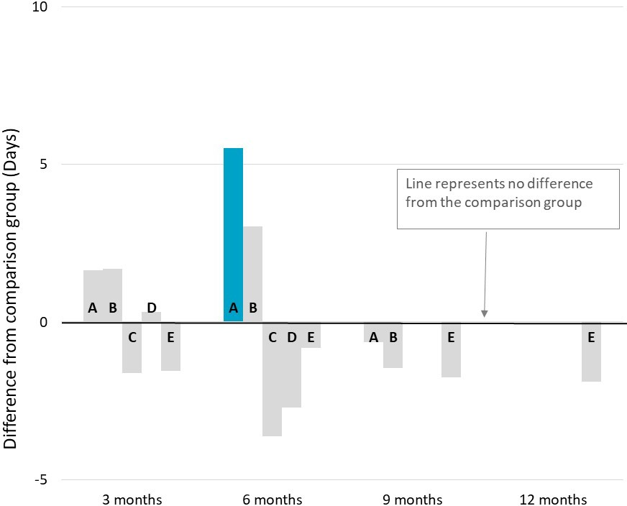
A – Community Voices
B – Getting Ready for Take Off
C – Warra Warra Kanyi
D – Online Business Lift-Off
E – I Am Ready
Significant increase Significant decrease
No significant difference

Notes: Difference between TTL clients’ outcomes in the quarter compared to the comparison group. Impact analyses were run for 274 Other clients; 50% of those who commenced the project as recorded in DEX
Figure D-56 Amount of employment income while on income support – Other

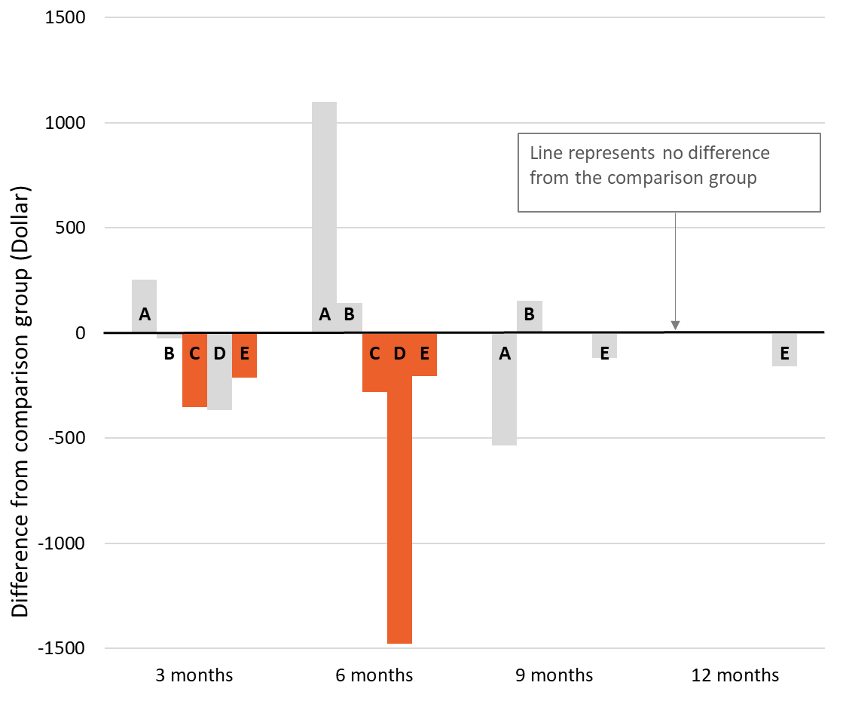
A – Community Voices
B – Getting Ready for Take Off
C – Warra Warra Kanyi
D – Online Business Lift-Off
E – I Am Ready
Significant increase Significant decrease
No significant difference

Notes: Difference between TTL clients’ outcomes in the quarter compared to the comparison group. Impact analyses were run for 274 Other clients; 50% of those who commenced the project as recorded in DEX

Figure D-57 New study commencement – Other

A – Community Voices
B – Getting Ready for Take Off
C – Warra Warra Kanyi
D – Online Business Lift-Off
E – I Am Ready

Significant increase Significant decrease
No significant difference

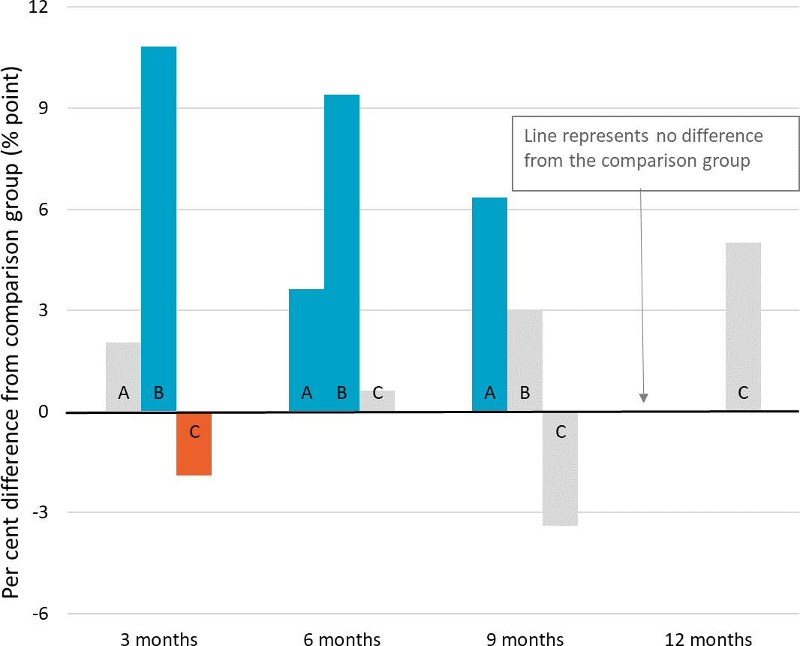
Notes: Difference between TTL clients’ outcomes in the quarter compared to the comparison group. Impact analyses were run for 274 Other clients; 50% of those who commenced the project as recorded in DEX

Table D-19 and Table D-20 present the results from the additional sensitivity tests. This was to examine whether impact results would differ for various age groups in the treatment group. The average treatment effect and p-value is compared to the original impact analysis to test whether different patterns occurred. (See Appendix C-2-2-3 for details of sensitivity tests.) The results suggested that beneficial effects on educational participation (measured by student income support receipt) were primarily among younger clients: aged up to 25 compared to over 25 in the case of Community Voices (Table D-19); over 18 compared to the main impact analyses in the case of Warra Warra Kanyi (Table D-20).
Table D-19 Community Voices impact estimates for clients who were aged 25 and under, and over 25

 | All clients |  |  | Clients aged 25 and under |  |  | Clients aged over 25
 | Average treatment  effect | Standard error | P-  value | Average treatment  effect | Standard error | P-  value | Average treatment  effect | Standard error | P-value
On student IS end  of quarter 1 | 0.001 | 0.014 | 0.923 | -0.032 | 0.017 | 0.056 | 0.029 | 0.014 | 0.034
On student IS end  of quarter 2 | 0.028 | 0.019 | 0.134 | 0.024 | 0.027 | 0.378 | 0.005 | 0.004 | 0.231
On student IS end  of quarter 3 | 0.040 | 0.011 | <.001 | 0.069 | 0.017 | <.001 | -0.006 | 0.005 | 0.175
On New Study commencements  end of quarter 1 | 0.021 | 0.013 | 0.104 | 0.009 | 0.012 | 0.446 | 0.024 | 0.014 | 0.085
On New Study commencements  end of quarter 2 | 0.036 | 0.015 | 0.014 | 0.074 | 0.024 | 0.002 | -0.010 | 0.003 | 0.002
On New Study commencements  end of quarter 3 | 0.063 | 0.020 | 0.002 | 0.064 | 0.021 | 0.003 | 0.026 | 0.010 | 0.015

Table D-20 Warra Warra Kanyi impact estimates for clients aged 18 and over

 | All clients |  |  | Clients aged 18 and over
 | Average treatment effect | Standard error | P-value | Average treatment effect | Standard error | P-value
On student IS end of quarter 1 | 0.033 | 0.010 | 0.001 | 0.007 | 0.008 | 0.375
On student IS end of quarter 2 | 0.020 | 0.009 | 0.030 | -0.011 | 0.006 | 0.079
On New Study commencements end of  quarter 1 | 0.030 | 0.008 | 0.000 | -0.002 | 0.002 | 0.280
On New Study commencements end of  quarter 2 | -0.014 | 0.004 | 0.001 | -0.006 | 0.002 | 0.006
 TTL clients’ self-reported barriers
Figure D-58 presents the self-reported barriers experienced by Other clients as reported in the TTL Client Survey at the beginning (baseline) of a TTL client’s participation in the TTL project. Clients are defined as experiencing a given barrier where they respond either ‘Strongly Agree’ or ‘Agree’ to negatively worded items (i.e. items where the issue ‘makes it hard to work or study’). (See Appendix C-2-4 for further details on TTL Client Survey analysis.)

Figure D-58 TTL clients’ self-reported vocational and non-vocational barriers on TTL Client Survey items – Other
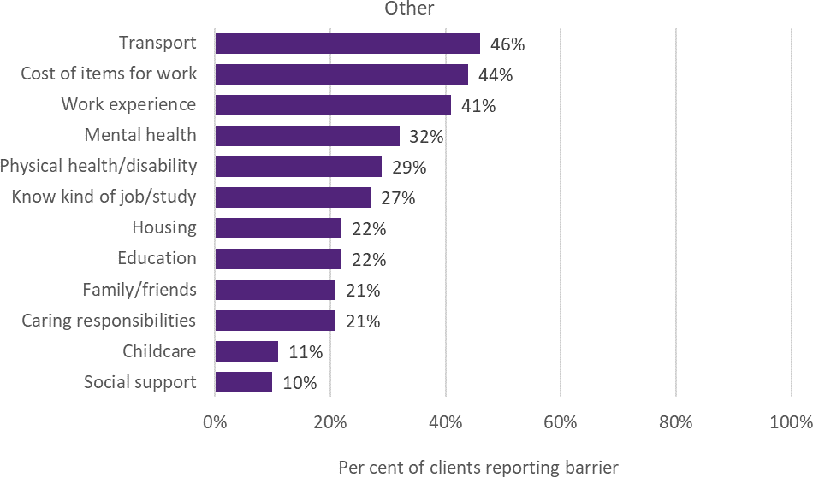
Notes: Data are from the TTL Client Survey at baseline (first survey not near the end of participation). Collected from 11% of Other TTL clients across 4 out of 11 projects

 TTL clients’ change in circumstances and goals
TTL service providers were required to collect data through DEX SCORE measures at the beginning (baseline) and end of a TTL client’s participation in the TTL project (follow-up). Figure D-59 presents the proportion of Other TTL clients who improved. Improvement is defined as having recorded a more favourable SCORE measurement at the follow-up than at baseline. (See Appendix C-2-3 for detail on DEX SCORE analysis.)
Figure D-59 TTL clients’ change in circumstances and goals on DEX SCORE measures – Other
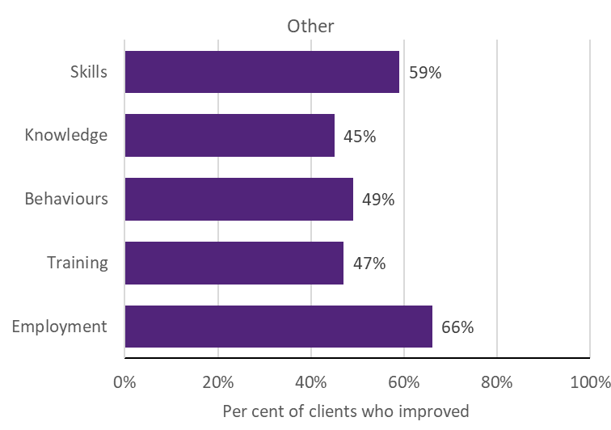
Notes: Improvement in SCORE outcomes for clients with both a baseline (pre) SCORE and a follow-up (post) SCORE, separated by at least 7 days, are reported for instances where there are at least 20 clients with available pre-post data of this kind. SCORE data were collected for 3 out of 11 projects. Eleven per cent of Other TTL clients were observed with baseline and follow-up data

Working Age Carers
 Project level details
Priority group eligibility: Carers aged 16–64 years who are in receipt of a Carer Payment.
Table D-21 provides details of the Working Age Carers project, including the project’s primary objective, and the number of clients and main service type recorded in DEX.
Table D-21 Project objectives and service delivery recorded in DEX - Working Age Carers

TTL project | Project start date | Primary objective | Number of clients in DEX | Main service type delivered
30. Carers Connect to  Education and Employment | 20-Sep-19 | Educational  participation | 78 | Carer support
Notes: Project start date is defined as the start of the project after the contract is signed. Primary objective is categorised according to project objective detailed in AWPs. Number of clients in DEX are to 30 June 2020; includes clients who may have participated in more than one TTL project. Main service type delivered is based on the most frequently recorded DEX session service type for each TTL project
 TTL clients’ level of disadvantage
Table D-22 presents the 4 indicators used to estimate the average level of disadvantage experienced by TTL clients, compared to the average income support recipient who met the eligibility criteria. These are presented by project, priority group and PIA level. (See Appendix C-2-1 for description of analyses.)
Table D-22 Disadvantage variables – Working Age Carers

30. Carers Connect to Education  and Employment |  | Ave. IS recipient
Total number of days on income support in last 2 years (mean) | 356 | 674
Highest level of education (less than year 12) | * | *
Index of Relative Socio-economic Disadvantage  (bottom 20%) | 10% | 39%
Unemployment rate SA4 (high) | 78% | 62%
Notes: Total days on income support in the last 2 years was calculated as the total days on income support unrelated to study across the 2-year period ending at their treatment start date. Highest level of education is presented as the percentage of TTL clients who had less than a Year 12 education level at the time of their treatment start. Index of Relative Socio-Economic Disadvantage is an ABS measure that quantifies the relative disadvantage of an area using broad criteria such as income, qualifications and low-skill occupation rates. The ABS unemployment rate was used to divide all SA4 regions into high and low, based on the median value
 TTL clients’ self-reported barriers
Figure D-60 presents the self-reported barriers experienced by Working Age Carers clients as reported in the TTL Client Survey at the beginning (baseline) of a TTL client’s participation in the TTL project. Clients are defined as experiencing a given barrier where they respond either ‘Strongly Agree’ or ‘Agree’ to negatively worded items (i.e. items where the issue ‘makes it hard to work or study’). (See Appendix C-2-4 for further details on TTL Client Survey analysis.)

Figure D-60 TTL clients’ self-reported vocational and non-vocational barriers on TTL Client Survey items – Working Age Carers
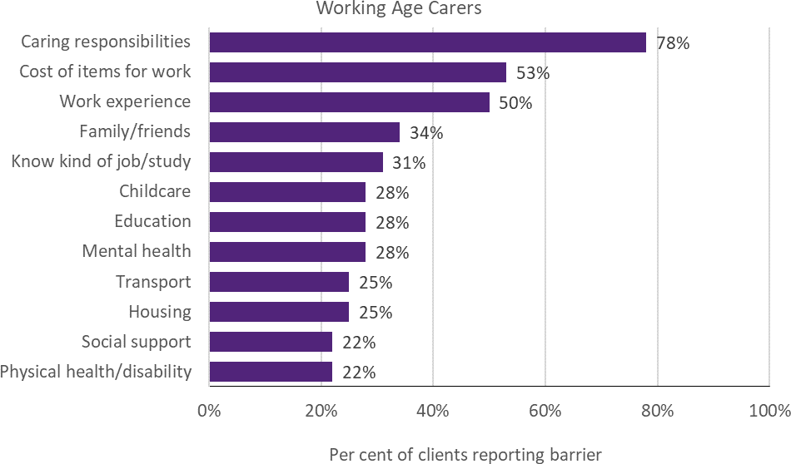
Notes: Data are from the TTL Client Survey at baseline data (first survey not near the end of participation). Collected from 41% of Working Age Carers TTL clients from 1 project


– Efficiency

E-1 Analytical approach for the economic evaluation
This appendix presents the detailed methodology underlying the economic evaluation analyses.
The reported results by priority group include only those projects that had sufficient data to carry out the quantitative impact analyses based on DOMINO data. This selection is needed as the results from the impact analyses are used as input into the PIA model to simulate lifetime costs under a base case scenario, as well as the lifetime costs when incorporating the estimated impacts on student and non-student income support receipt for the clients in the TTL projects.²² All 3,513 TTL clients in these projects who could be found in the DOMINO data were included in the simulation. Unfortunately, it was not possible to include all results from the impact analyses in the PIA simulation (i.e. changes in the probability of employment while on income support and/or increased earnings while on income support could not be included).
The results from the PIA form the basis for our quantitative cost-benefit comparison. However, as it has been impossible to quantitatively assess other important outcomes such as improvements in health and wellbeing, and additional educational attainment, the analysis is complemented by using qualitative data where possible. Using qualitative information, an indication is provided of whether the quantitative CBA should be seen as under- or over-estimating the costs relative to the benefits generated by the projects.
The following sections contain more detail on the methodology used to determine benefits and costs. Table E-5 contains results by project, and Table E-3 contains results by priority group.

 The benefit component of the CBA
The economic evaluation uses the results from the impact evaluation to inform the benefits component of the CBA. These results are based on relatively short-term outcomes of up to 2 years after commencement in a TTL project. Our aim was to use estimated impacts on employment (through income support dependence) and education of the TTL client, and enter the changed characteristics of a client group in the PIA modelling to simulate expected lifetime welfare cost (and shorter term welfare costs for a 5-year period) before and after participating in the TTL project. Subsection E-1-2 contains information on the PIA modelling and simulation.
Among a limited number of characteristics that can vary within the PIA modelling, only education and income support receipt are relevant to the TTL evaluation.²³ To use the PIA modelling, our estimated outcome changes need to align with how these characteristics are defined in the PIA model. However, PIA modelling of education relies on qualification attainment, which could not be observed from TTL due to the short observation window post-commencement (and a limited coverage of educational attainment in DOMINO). The available information on education also did not allow an impact analysis on education outcomes, whereas the change in earnings from employment while on income support, estimated in the impact analysis, could not be incorporated in the PIA simulation. This means that the changes in lifetime welfare costs simulated by PIA are completely driven by the changes in the probability of receiving student and non-student income support.
Therefore, in addition to the PIA modelling, we also examined the impact evaluation results on the change in earnings from employment while on income support separately. These are expressed in

²² We acknowledge the contributions of Ben Cherian, who has greatly assisted us with understanding the PIA modelling, and has run the 2 alternative scenarios for the TTL clients who participated in the relevant projects.
²³ See Appendix C in PwC (2016b). Valuation Report 30 June 2015 Baseline Valuation, Department of Social Services, Final report 2016.

a change in dollars per quarter, and can be more readily quantified than the qualitative information on health and wellbeing.
Other important outcomes that cannot be reflected in the PIA modelling are health and wellbeing. Given the likely importance of health and wellbeing outcomes for later outcomes, and given the focus of several TTL projects on improving health and wellbeing of clients, we paid specific attention to this outcome separately where possible, to at least reflect a qualitative valuation of the impact of a change in health and wellbeing.
The quality of the benefit component estimate depends on the quality of the impact evaluation, which again depends on the quality of the available data. We can only quantify those outcomes that can be measured, and for which measurements are available to the Evaluation Team.
 The Priority Investment Approach modelling
As we have limited access to the details of the PIA modelling, we provide a brief high-level overview. More details can be found in PricewaterhouseCoopers (PwC) (2016a and 2016b), which provide a high-level overview of the proposed approach, but no detailed description of the modelling. However, they provide an insight into which factors (or characteristics) affect individual’s year-to-year outcomes in terms of income support receipt in the model. The PIA model is used on a regular basis internally in the department.
The PIA model is based on actuarial analysis undertaken by PwC, and it produces forward estimates of income support receipt by using estimated year-by-year transitions from one income support state to another. These transitions depend on the individual’s characteristics (such as age and education) and on the current income support state. The model uses data representative of the Australian population, incorporating administrative data on all welfare recipients. As a result, most TTL clients observed
in the DOMINO data can be found in the administrative data used for the base population in the PIA model. This means the simulations can be done for our specific group of TTL clients. The estimation results from the impact analyses are used as input into the PIA model to complement simulation of lifetime costs under a base case scenario (of no participation in the TTL project) with the simulation of lifetime costs in the alternative scenario when allowing for the estimated impacts on student and non-student income support receipt resulting from participation in the TTL projects.
The link between the impact analysis modelling results and the PIA model was made after numerous discussions with Ben Cherian, a departmental expert in the PIA modelling, and the TTL Evaluation Team members to ensure a joint understanding of what was needed.
All TTL clients who were included in the impact analyses were included in the simulation. This TTL client dataset had 3,513 customer reference numbers (CRNs), of these, 212 could not be matched via CRN to the PIA 2018 population dataset. In these cases, instead of using the CRN, the TTL commencement characteristics on gender, age, Indigenous status, payment type, partnership, number of children, Socio-Economic Indexes for Areas (SEIFA) and education level were used to find people in the PIA 2018 population dataset who had the same characteristics.²⁴
If a TTL client matched to multiple people in the PIA population dataset, then each PIA person would have multiple simulations such that each TTL client had 10,000 simulations in total. For example, if one TTL client was matched to 5 PIA people (i.e. there were 5 people that had the same matching characteristics), then each of the 5 PIA people would be simulated 2,000 times, resulting in 10,000 total simulations for the TTL client.
The characteristics of TTL clients as observed in the TTL programs are not automatically the same as those observed for the same TTL clients in the PIA data. This could be due to misreporting or due to the different time at which the characteristic is

²⁴ We are grateful to Ben Cherian for providing us with detailed notes on his approach. This and the following paragraphs in this subsection draw heavily on these notes.

measured. To ensure that the simulation results match the starting point characteristics from the TTL programs, the simulation forces certain characteristic transitions in the first year to align the information in PIA with that in TTL. The characteristics that are forced are payment type, partnership, number of children, SEIFA and level of education. For example, if a TTL client reported that they were partnered then the simulation would force that person to be partnered in the first year of the simulation. The TTL variable p_paytype (payment type) corresponds to the PIA variables Payment class (see Table E-1) and Payment (payment classes 1, 2 and 3 comprise multiple payments, this variable delineates them), and the following mapping was used:

p_paytype | PIA payment class | PIA payment
0 =nonIS | 7,8,9, 10 or 12 | N/A
1=Study | 1 | N/A
2=YA unem | 2 | Youth Allowance
3=NSA,SKA,JSP, | 2 | Newstart Allowance
4=DSP | 5 | N/A
5=PP | 3 | N/A
6=CP | 4 | N/A
7=OthIS | 2 | N/A
Note: NewStart Allowance replaced by JobSeeker Payment in March 2020
For example, a TTL client with p_paytype = 0 would be forced to be in PIA class 7, 8, 9, 10 or 12 in the first year of the simulation. A TTL client with p_paytype = 2 would be forced to class 2 and payment = Youth Allowance Other in the first year of the simulation.
Education has only been aligned if it would imply an increase in the individual’s education. If a person has a lower education level in the TTL data compared to the PIA data, their education level has not been aligned, as the simulation assumes that education level can only increase over a person’s lifetime.
There is no alignment for Indigenous status because it is treated as a static (non-changeable) variable in the simulation. There are some people whose TTL Indigenous status does not match their PIA Indigenous status. This issue occurs only for clients matched via a CRN. They may state that they are Indigenous to Centrelink and not Indigenous to the TTL provider or vice versa, causing a misalignment. There are also gender mismatches, most likely caused by the same issue, and these are also not aligned.

Table E-1 Payment class definitions including relevant payment types

Active – income support (IS) | Active – non- IS | Inactive classes
1 Studying  People receiving Austudy, ABSTUDY or Youth Allowance (Student) as their most recent income support payment | 7 Non-IS Family  People not receiving any Carer Payments but receiving one or more family supplement payments, e.g.  FTB, Child Care Benefit in the previous year | 10 Previous welfare recipient*  People who were previously in one of classes 1 to 9 but are not for the latest year  *These are people who were captured in classes 1 to 9 from 2001–02 onwards
2 Working Age  People receiving Newstart (or JobSeeker) Allowance or Youth Allowance (Other) as their most recent income support payment (a small number of other recipients are  also included in this class) | 8 Non-IS Carer  People receiving Carer Allowance | 11 Dead  People have died during the previous year or in prior years
3 Parenting  People receiving Parenting Payment (Partnered or Single) as their most recent income support payment. | 9 Non-IS Other  People receiving payments but not in any other welfare recipient class | 12 Rest of Aust. population  Rest of modelled population
4 Carers
People receiving Carer Payment as their most recent income support payment
5 Disability support
People receiving Disability Support Pension as their most recent income support payment
6 Pension Age
People receiving any Age Pension as their most recent income support payment (a small number of Widow B Pension and Wife Pension recipients are also included in this
class)
Note: Adapted version of Table 15 in PwC (2019).
The impact analysis probabilities were applied in the second year of the PIA simulation (i.e. when transitioning from the 2018–19 financial year to the 2019–20 financial year). Firstly, the student income support impact is applied by adding the estimated impact on student income support to the probability of going to class 1 (subject to restricting the resulting probability to a minimum of zero and a maximum of one). Then the probability of going to other IS classes (2–6) was adjusted using the estimated impact on non-student IS. The remaining non-IS classes (7–10 & 12) were adjusted such that the probability of going to all classes summed to one.
To give an example starting from baseline transition probabilities as reported in Table E-2 and applying a 15 percentage point impact on student IS and a 15 percentage point impact on non-student IS, treatment transition probabilities as outlined in the bottom row of Table E-2 are obtained.

Table E-2 Baseline and treatment transition probabilities by payment class as defined in Table E-1

pc_1 | pc_2 | pc_3 | pc_4 | pc_5 | pc_6 | pc_7 | pc_8 | pc_9 | pc_10 | pc_11 | pc_12
Student IS | Other IS | Other IS | Other IS | Other IS | Other IS | No IS | No IS | No IS | No IS | No IS | No IS
Baseline transition probabilities
10% | 10% | 10% | 5% | 5% | 0% | 10% | 10% | 10% | 30% | 0% | 0%
Treatment transition probabilities
25.0% | 15.0% | 15.0% | 7.5% | 7.5% | 0.0% | 5.0% | 5.0% | 5.0% | 15.0% | 0.0% | 0.0%
In summary, as a result of applying the estimated impacts, transition probabilities would go from a probability of 10% for student IS to a probability of 25% for student IS, and from a probability of 30% for other IS to a probability of 45% for other IS, with the probability of non-IS going from 60% to 30%.
Unfortunately, it was not possible to include all results from the impact analyses in the PIA simulation — changes in the probability of employment while on IS or increased earnings while on IS could not be included. We therefore considered the estimated change in increased earnings from the impact analyses separately as it could not be allowed for in the PIA estimates. Table E-3 reports the lifetime and 5-year welfare costs changes simulated by PIA.
Table E-3 Simulated welfare costs changes by priority group

 | Change in simulated lifetime welfare costs | Change in simulated 5-year welfare costs | Number of TTL clients in PIA simulation
Young Parents | -1879.38 | -642.62 | 509
Young Carers | 1781.19 | 1017.011 | 68
At-risk Young People (t1) | -3682.18 | -681.187 | 553
At-risk Young People (t2) | 2548.81 | 488.344 | 579
Young Students | 10703.07 | 2250.758 | 571
Migrants and Refugees | -8784.84 | -2290.758 | 507
Older Unemployed People | 4910.59 | 1249.07 | 446
Other | -1666.03 | -135.004 | 280
TTL Fund | 565.1 | 82.883 | 3513

 Calculation of other benefits
Although the PIA simulation accounts for changes in student IS, this only allows for whether a TTL client participated in education. Our data do not provide information on the area of study or whether the TTL client partly or fully completed the course, or did not complete any part of the course. As a result, the impact from the TTL projects on education cannot be assessed quantitatively. Therefore, any education outcomes arising from the projects are not observed and cannot be included in the CBA.
The PIA simulation accounts for all IS and family payments provided to the TTL clients, but it does
not allow for changes in tax paid by the client. Therefore, we add an estimated amount of tax paid, based on the information on the estimated change in probability of receiving any IS for each of the projects and a few assumptions. To calculate an upper bound for these additional benefits, we assume that TTL clients who leave IS would obtain a full-time job for 40 hours per week at $20 per hour (which is just over the minimum wage), and be taxed as a single person. Under this optimistic assumption, their gross income would be $41,600, from which the tax-free area of
$18,200 is subtracted and the remainder taxed at 19%, leading to $4,446 tax to be paid. From this, the low income tax offset of $495 ($700 minus

$205 (5% of $41,600 – $37,500)) is subtracted and a Medicare levy of $832 is added. For many TTL clients who exit IS, no additional tax may be received by the government as they did not exit due to employment, or much less additional tax is received as they work only part-time. It is therefore assumed that $0 is a lower bound for additional benefits from tax payments.
Then a 2% indexation of the tax paid and a 6% annual discounting rate is applied (like in the PIA model), to find an expected increase in tax paid of
$22,177 over a 5-year period (assuming that the TTL client remains off welfare for this period).
Assuming slightly lower hours of work of 35 hours per week and making the same calculations as above would lead to an expected increase in tax paid of $16,163 for a 5-year period.
When a significant decrease in the probability of any IS receipt is estimated, we multiply the above expected increases in tax paid for one TTL client in full employment over 5 years by the percentage point decrease. In Table E-5 (and in the main text) only the results for 40 hours of work per week are presented.
 The cost component of the CBA
 Project costs
On the cost side of CBA, the AWP for the TTL projects contain information on the funding granted to each of the projects. From this information, combined with the number of clients, the average project cost per client is computed.
We can compute the budgeted cost per client using the information in the approved AWPs, as well as the actual cost per client based on the actual number of clients assisted up to 30 June 2020 and the actual expenditure up to 30 June 2020. The actual number of clients is observed through the entries made into the DEX system.²⁵
Information received from the department regarding the allocated amounts of funding by financial year for each project are used; these amounts include variations and rollovers as well as the amount provided for co-development for some of the projects in tranche 2. The amount of funding that was allocated up to 30 June 2020 was
used to match the period over which the TTL clients were observed. Funding allocated to the 2020–21 financial year has not been included. The provided numbers are GST exclusive, so they have been multiplied by 1.1 to obtain GST inclusive numbers.
 Departmental costs
We have information on the aggregate expenditure by the department for the years that TTL has been in place, and information from the years previous to that when preparations for the TTL launch were undertaken (e.g. Commonwealth of Australia 2016). Where possible, the most recent estimated actual amounts published in the Portfolio Budget Statements or in the Portfolio Additional Estimates Statements of the next year are used (e.g. for 2018–19 the estimated actual amount published in the 2019–20 Portfolio Additional Estimates Statements are used). The first expenditures for TTL took place in the financial year 2016–17, which is why we start collecting this information from the Portfolio Budget Statements published since 2016, and the Portfolio Additional Estimates Statements since 2017. Table E-4 shows the numbers reported in the various Budget Statements, and computes the total expenditure on TTL, and the total expenditure on TTL up to 30 June 2020.
The total expenditure across all projects is compared to the information on administered expenses (which should equal the total expenditure on project grants) in Table E-4 to ensure the different sources of information are consistent. The expenditure on all TTL projects up to 30 June 2020 is reported to be $65,850,000 in the Portfolio Budget Statements, compared to
$66,985,393 from the allocated amounts of funding calculation.
The expenses encountered by the department in running and administering the projects (the non- grant costs) have only been reported separately for TTL under departmental expenses and departmental capital in Commonwealth of Australia (2016). From 2017 onwards, this information is no longer reported separately for the Priority Investment Approach to Welfare. We

²⁵ In the cases where we do not observe the number of clients in DEX, we use the latest information on the targeted number of clients. For these projects, we cannot estimate impacts anyway, so they are not included in the CBA.

therefore use the information provided in 2016, assuming that the total amount has not changed. We have no detail of what the funding within the department has been spent on, so we cannot easily distinguish between ongoing and set-up costs. Originally, we planned to assume that the earlier years at least partly included these set-up costs, while later years do not.²⁶ However, we do not have any updates regarding how these departmental expenses were actually spread out over the financial years, and given the shifts in the planned and actual administered expenses for TTL observed in Table E-4, it seems likely that the planned and actual departmental expenses have shifted too.
Therefore, we have counted the total number of project financial years up to 30 June 2020 (equal to the sum on the bottom row in Table E-4) to compute the non-grant cost per financial year that a project is active: ($13,913,000 +
$2,924,000)/107=$157,356.²⁷ We assume that this equals the required cost to continue the TTL program for a project for another financial year.
This is a rough estimate of the cost, but it is the best we can do with the available information. As long as a similar or larger number of projects continues so that similar or better economies of scale apply, the actual cost to continue the TTL Fund is likely to be lower than this estimated cost, due to one-off costs being included in the continuing total cost.
Table E-5 reports the total estimated costs per client under the above assumptions as well as the simulated welfare cost savings and estimated changes in earnings from employment while on income support.

²⁶ Using information on when projects start and end, we had planned to determine the number of projects active in a financial year versus the amount of funding allocated in the departmental budget for support to the projects. This would have provided an overview of the cost per project in each of the relevant financial years, but this approach was not feasible with the available data.
²⁷ We do not know how the number of projects affects the non-grant costs to the department. In our calculation, we have assumed that each project (independent of the number of clients that they service) requires the same amount of departmental support. Given that staff liaise with projects and not with the projects’ clients, we consider this to be a reasonable assumption.

Table E-4 Expenditures on the Investment Approach to Welfare as reported in budget statements
in $'000 | 2016–17 | 2017–18 | 2018–19 | 2019–20 | 2020–21 | Total | Additional one-off costs^{c} | Total up to 30 June  2020
Full TTL Fund expenditure projection
(PBS 2016–17)ª
administered expenses | 26,713 | 27,357 | 21,195 | 4,361 |  | 79,626
departmental expenses | 4,269 | 3,598 | 2,732 | 2,957 |  | 13,556 | 357 | 13,913
departmental capital | 703 | 466 | 875 | 880 |  | 2,924
Administered expenses
only^{b}
PAES 2016–17 | 26,913 | 27,557 | 21,395 | 4,561 |  | 80,426
PBS 2017–18 | 2,140 | 20,190 | 30,938 | 27,158 |  | 80,426
PAES 2017–18 | 1,592 | 20,190 | 30,938 | 27,158 |  | 79,878
PBS 2018–19 | 1,592^{d} | 7,953 | 40,720 | 29,613 |  | 79,878
PAES 2018–19 | 1,592 | 7,194 | 40,720 | 29,613 |  | 79,119
PBS 2019–20 | 1,592 | 7,194^{d} | 29,720 | 32,613 | 8,200 | 79,319 |  | 71,119
PAES 2019–20 | 1,592 | 7,194 | 24,797 | 37,370 | 9,400 | 80,353 |  | 70,953
PBS 2020–21 | 1,592 | 7,194 | 24,797^{d} | 32,267 | 21,003 | 86,853 |  | 65,850
PAES 2020–21 | 1,592 | 7,194 | 24,797 | 32,267 | 21,003 | 86,853 |  | 65,850
Number of active projects up to 30 June  2020 |  | 14 | 41 | 52 |  |  |  | 107
Notes: PBS stands for Portfolio Budget Statements, and PAES stands for Portfolio Additional Estimates Statements.
a) Commonwealth of Australia (2016) reports this allocation of the $96.1 million TTL budget. b) After 2016, the Commonwealth of Australia (2017a, 2017b, 2018a, 2018b, 2019a, 2019b, 2020a, 2020b, 2021) publications only include the annual administered expenses (which are equal to the administered expenses in Commonwealth of Australia (2016) plus an additional $200,000 in each financial year). c) This figure reflects the total cost of contracting 3 contractors for set periods of time ($336,224.57 GST inclusive), who were appointed to work with TTL projects especially around the hard close of DEX and the collecting of the metadata. This was a one-off cost associated with implementing TTL. The figure is based on internal information provided by the department on 18 December 2020. In addition, $20,900 (GST inclusive) was spent on the co-development of a project that did not proceed beyond the development stage. These amounts are additional to the $16.48 million total departmental expenses and capital. d) This financial year is no longer reported in the relevant Portfolio Budget Statements, and from that time on, the last value reported is used, as this is the most reliable number

Table E-5 Estimated costs and benefits by project

No | Priority group | Project | ‘new target number’ taking midpoints as a proxy target number when a range was provided for the target number | actual number of participants as reported  in DEX | cost per participant incl GST and DSS staff cost (in $) [allocated amounts  incl. variations & rollovers]ª | change in simulated lifetime welfare cost (PIA results)  (in $) | number of TTL clients  in simulation | change in simulated 5- year welfare  cost (PIA results) (in  $) | estimated change in fortnightly earnings while on IS (*indicates significance  at 5%) | estimated change in tax and Medicare levy paid over  a 5-year period (*indicates significance of underlying estimated probability of  any IS)
1 | YP | Career Readiness for  Young Parents | 60 | 85 | 18,705.56 | -9383.81 | 69 | -3144.21 | 50.55077 | 885.04
2 | YP | In-School Parent Employment  Services | 65 | 87 | 12,380.09 | -33048.75 | 32 | -10191.15 | 125.9262* | 5172.44*
3 | YP | Train and Care | 135 | 73 | 24,548.88 | 3311.25 | 66 | 955.76 | -27.2969 | -3369.56
4 | YP | Supporting Expecting &  Parenting Teens | 350 | 427 | 11,410.00 | 1549.5 | 342 | 447.06 | -39.3985* | -186.31
5 | YS | Support for VET  Students | 400 | 406 | 5,904.11 | 13281.65 | 338 | 3024.956 | -16.2615 | -4485.13
6 | YS | Rewire the Brain | 240 | 353 | 7,610.42 | 6962.38 | 233 | 1127.672 | -26.6923* | -9.09
7 | YS | Strengthening  Students’ Resilience | 6000 | 6000^{b} | 317.01
8 | ARY | Mentoring 2  Work | 240 | 195 | 14,631.20 | -848.53 | 158 | 283.472 | -43.6646* | -319.95
9 | ARY | Y4Y Youth Force | 80 | 80 | 24,871.88 | 6611.53 | 72 | 1520.797 | 205.6385* | -1956.83
10 | ARY | Build and Grow | 430 | 452 | 6,502.30 | -6209.67 | 271 | -1361.532 | -40.1877* | 2624.17*

No | Priority group | Project | ‘new target number’ taking midpoints as a proxy target number when a range was provided for the target number | actual number of participants as reported  in DEX | cost per participant incl GST and DSS staff cost (in $) [allocated amounts  incl. variations & rollovers]ª | change in simulated lifetime welfare cost (PIA results)  (in $) | number of TTL clients  in simulation | change in simulated 5- year welfare  cost (PIA results) (in  $) | estimated change in fortnightly earnings while on IS (*indicates significance  at 5%) | estimated change in tax and Medicare levy paid over  a 5-year period (*indicates significance of underlying estimated probability of  any IS)
11 | ARY | My Maintenance  Crew | 125 | 67 | 44,806.99 | -13373 | 52 | -3115.526 | -30.9138 | 3808.29*
12 | ARY | Lead with  Culture | 250 | 248 | 9,386.35 | -3755.53 | 161 | -718.3 | -48.6754* | 744.21
13 | ARY | Dunn Lewis  F3style | 83 | 52 | 23,567.54 | 11712.91 | 40 | 1670.285 | -63.6031* | -1832.06
14 | ARY | Your Job Your  Way | 70 | 53 | 14,121.55 | -7717.78 | 49 | -1650.192 | 116.6169* | 1407.37
16 | ARY | Brighton Integrated  Community Engagement | 50 | 61 | 8,371.18 | -1285.81 | 43 | -58.348 | 88.78 | -15.77
17 | ARY | Community  Voices | 120 | 125 | 11,317.70 | -2474.25 | 99 | -482.25 | -82.52 | 99.88
18 | ARY | RIDE | 132 | 132 | 14,884.18 | 10,194.5 | 117 | 2343.578 | -22.5954 | -3728.19
19 | ARY | Leadership, Engagement and  Development | 80 | 58 | 15,386.76 | 10154.84 | 49 | 1916.114 | -17.6985 | -2663.09
20 | ARY | Meeting the  Youth Gap | 25 | 63 | 22,455.75 | -8805.63 | 42 | -2180.746 | 74.20462 | 1730.84*
21 | ARY | Support to Skills | 1000 | 15 | 105,300.72

No | Priority group | Project | ‘new target number’ taking midpoints as a proxy target number when a range was provided for the target number | actual number of participants as reported  in DEX | cost per participant incl GST and DSS staff cost (in $) [allocated amounts  incl. variations & rollovers]ª | change in simulated lifetime welfare cost (PIA results)  (in $) | number of TTL clients  in simulation | change in simulated 5- year welfare  cost (PIA results) (in  $) | estimated change in fortnightly earnings while on IS (*indicates significance  at 5%) | estimated change in tax and Medicare levy paid over  a 5-year period (*indicates significance of underlying estimated probability of  any IS)
22 | ARY | Explore, Discover and  Empower | 100 | 37 | 18,613.84
23 | ARY | Dependence to  Independence | 250 | 167 | 6,394.87 | 8059.06 | 56 | 1717.58 | 8.209231 | -2564.92
24 | ARY | The Opportunity  Account | 100 | 100^{b} | 22,198.56
25 | ARY | Care Plays | 130 | 130^{b} | 6,301.57
26 | YC | Carer Achievement  Pathway | 200 | 42 | 30,620.67 | 1184.28 | 39 | 1520.832 | -15.4102 | -3154.00
27 | YC | Skills for Micro-  enterprise | 70 | 32 | 42,252.13
28 | YC | Data-driven Job  Opportunities | 65 | 56 | 42,804.79 | 2583.87 | 29 | 339.465 | -35.978 | -402.38
29 | YC | Young Carer School  Accreditation Project | 130 | 73 | 12,511.82
30 | Carers | Carers Connect  to Education | 100 | 78 | 9,981.81

No | Priority group | Project | ‘new target number’ taking midpoints as a proxy target number when a range was provided for the target number | actual number of participants as reported  in DEX | cost per participant incl GST and DSS staff cost (in $) [allocated amounts  incl. variations & rollovers]ª | change in simulated lifetime welfare cost (PIA results)  (in $) | number of TTL clients  in simulation | change in simulated 5- year welfare  cost (PIA results) (in  $) | estimated change in fortnightly earnings while on IS (*indicates significance  at 5%) | estimated change in tax and Medicare levy paid over  a 5-year period (*indicates significance of underlying estimated probability of  any IS)
and
Employment
31 | M&R | The Australian  Way | 500 | 500^{b} | 3,333.58
32 | M&R | Employer-led Refugee Employment  project | 100 | 128 | 7,614.94 | -35,876.12 | 103 | -9387.656 | 407.1231* | 7423.33*
33 | M&R | Women's  Employment Into Action | 80 | 78 | 17,262.11 | -4687.81 | 66 | -1394.883 | 11.77231 | 756.06
34 | M&R | Sonder Employment  Solutions | 300 | 305 | 11,851.51 | -8482.15 | 207 | -2323.703 | 31.35692 | 1356.34
35 | M&R | UpCycLinc | 180 | 97 | 20,254.76 | 8252.19 | 61 | 2589.32 | 463.0785* | -2711.68
36 | M&R | A Bridge to Regional Employment and  Opportunities | 50 | 50^{b} | 41,718.64
37 | M&R | Multicultural  Enterprise | 84 | 90 | 16,511.67 | 11473.41 | 70 | 3151.93 | 73.35077 | -2275.93

No | Priority group | Project | ‘new target number’ taking midpoints as a proxy target number when a range was provided for the target number | actual number of participants as reported  in DEX | cost per participant incl GST and DSS staff cost (in $) [allocated amounts  incl. variations & rollovers]ª | change in simulated lifetime welfare cost (PIA results)  (in $) | number of TTL clients  in simulation | change in simulated 5- year welfare  cost (PIA results) (in  $) | estimated change in fortnightly earnings while on IS (*indicates significance  at 5%) | estimated change in tax and Medicare levy paid over  a 5-year period (*indicates significance of underlying estimated probability of  any IS)
Development
Project
38 | OU | Next Steps | 350 | 366 | 3,619.60 | 9420.5 | 309 | 2522.927 | 215.3677 | -2101.22
39 | OU | Work Work | 48 | 36 | 33,063.53 | -25,891.87 | 30 | -7973.617 | -131.472 | 4664.30*
40 | OU | Sisters Support Business  Together | 40 | 36 | 29,587.00
41 | OU | Reach, Train and  Employ | 50 | 37 | 16,301.73
42 | OU | Career Skills for  New Jobs | 250 | 71 | 50,597.46 | -2956.81 | 51 | -1020.535 | -264.223* | 596.29
43 | OU | Building Bridges for Mature  Jobseekers | 150 | 35 | 14,171.20 | 3529.85 | 33 | 1236.308 | -477.76* | -972.04
44 | Other | The Coach  Project | 100 | 11 | 82,305.09
45 | Other | Getting Ready  for Take Off | 160 | 100 | 21,512.72 | 3278.97 | 40 | 828.186 | 23.82923 | -1555.20
46 | Other | Giving it a Go | 430 | 430^{b} | 3,307.93
47 | Other | Finding  Strengths | 165 | 30 | 33,754.71

No | Priority  group | Project | ‘new target  number’ taking midpoints as a proxy target number when a range was provided for the target number | actual  number of participants as reported  in DEX | cost per  participant incl GST and DSS staff cost (in $) [allocated amounts  incl. variations & rollovers]ª | change in  simulated lifetime welfare cost (PIA results)  (in $) | number of  TTL clients  in simulation | change in  simulated 5- year welfare  cost (PIA results) (in  $) | estimated  change in fortnightly earnings while on IS (*indicates significance  at 5%) | estimated  change in tax and Medicare levy paid over  a 5-year period (*indicates significance of underlying estimated probability of  any IS)
48 | Other | Warra Warra  Kanyi | 75 | 85 | 13,123.01 | -2324.57 | 34 | -343.234 | -42.9446* | -516.21
49 | Other | Online Business  Lift-Off | 63 | 65 | 17,285.02 | 5384 | 37 | 1429.567 | -227.569* | -852.33
50 | Other | Demand-led  Education to Employment in Care | 150 | 43 | 24,828.05
51 | Other | I Am Ready | 90 | 91 | 9,195.56 | -6755.38 | 70 | -920.148 | -24.4831 | 1216.45
52 | Other | Ability School  Engagement Partnership | 300 | 300^{b} | 5,598.39
53 | Other | IMPACT Club | 50 | 50^{b} | 7,893.95
Note: a) Actual cost per participant was calculated by dividing the actual funding allocated up to 30 June 2020 by the actual number of participants in DEX as of 30 June 2020. For the project Strengthening Students’ Resilience, no DEX information is available and therefore the most recent target number is used instead. b) Data from DEX on actual numbers is not available for these projects, so the most recent target number is reported instead


– Data collection tools

Activity Work Plan report – additional questions
TTL projects were required to answer 7 additional questions included at the end of the AWP reports specifically for the TTL Evaluation. The 7th question was added in July 2019, 12 months after the commencement of the first TTL projects from tranche 1.
    - In the current reporting period, have you changed anything about how you deliver the project? Please describe the changes and why you decided to make them.
    - Please let us know which recruiting strategies are working well and which are not. Have you changed your recruiting strategy in any way?
    - You have reported against those risks that are identified in your AWP in a previous section. Please describe here any other challenges or risks that you are experiencing and how you are managing them. These might include unexpected changes to your local community or changes in the work environment.
    - In the current reporting period, what has your team learnt about your target priority group, the challenges they are facing, and what supports them to work or study?
    - Have there been any unexpected outcomes from your project — either positive or negative? If so, please provide examples.
    - Are there any good news stories or anything else you would like to share? For example, promotional materials, internal reports, testimonials, case studies etc.
    - How many clients have completed the core component of your project since it began? Of the clients who have completed the core component of the project, how many:
      - have been employed (which could be part-time or unpaid) since completing the project?
      - have been enrolled in formal education or training since completing the project?
      - have not been employed or enrolled in formal education or training since completing the project?
      - have not been in contact and their circumstances since completing the project are unknown?

TTL service provider group interview topic guide – time point 1
Welcome and introductions Design and planning
- Thinking back to the design and planning stages of the [TTL project name] program, what worked well?
- Were there any challenges in the design and planning stages of the [TTL project name] program? If yes, tell me about those challenges.
- Were potential participants engaged in the design stage? If yes, how did this impact the design of [TTL project name]? What aspects of [TTL project name] changed due to this input?
DSS & partners
- Did you find working with the department in the design and planning phase useful? PROBES: How did the department’s input impact the final program? What worked well? Were there any challenges?
- Do you think working with the department on the design of [TTL project name] increased collaboration among organisations working on similar programs? PROBES: If yes, can you give me some examples of what happened previously and how this has changed?
- How has being involved with TTL affected how you work with other organisations delivering similar programs?
- Did you end up collaborating with any partners? PROBES: If yes, was that something new for you? How did you find that process?
Uptake
- Thinking about participant recruitment:
  - What strategies are you using?
  - What has worked well?
  - What strategies have not worked well?
  - What makes it difficult for your clients to participate in the program? PROBES: Have you implemented any strategies to help reduce some of these challenges for your clients? Were these strategies successful?
  - Were there any other challenges the organisation or delivery staff encountered? Implementation
- Thinking about the implementation of your program:
  - When did the first participant start in your program?
  - So far, has the program been implemented exactly as planned? PROBES: If no, tell me about the changes that have been made and the reasons for the changes?
  - What worked well?
  - What were some of the challenges you experienced regarding implementing the [TTL project name] program? PROBES: partners; ethics; frontline staff; etc.
Reporting
- Thinking about entering data on the department’s portal (DSS Data Exchange) for the project:

  - Did your organisation find the DEX training useful? PROBES: Does your organisation feel competent to upload data every month? Can you share some of the challenges your organisation has experienced? Does your organisation feel competent to monitor the progress of your program using Qlik Sense? Can you share some of the challenges you anticipate?
  - Did you experience any challenges in setting up the DEX system and obtaining your AUSkey?
  - Is the data you are reporting through DEX useful for the [TTL project name] program?
  - Do you think there is any benefit for your project to capture the data reported on DEX? PROBES: If yes, can you describe how you have used/plan to use the data? If no, what data do you plan to use?
  - Were there any other challenges experienced by your team related to DEX? Evaluation training
- Did you find the evaluation training provided by the TTL Evaluation Team useful?
  - What training have you participated in?
  - What aspects of the training worked well?
  - What could improve?
  - Were there any barriers to participation?
  - What other support would you find useful to help you capture data and evaluate the [TTL project name] program?
  - Have you accessed the ttle.org.au website? Early impressions
- Can you tell me some of the early feedback about your program, under what circumstances your program is working?
  - Does your program work better for some participants compared to others?
  - What aspects of your program work well?
  - What role would you say your providers/frontline staff/partners had in this success?
- Under what circumstances is your program not working as you planned?
  - Can you identify any characteristics about the participants who have dropped out or not fully engaged with the program?
  - What were some of the barriers participants experienced that influenced the effectiveness of your program?
  - What aspects of your program are not working as you planned?
  - Do you have any insights into the reasons your program is not working as you planned?
- What are some of the early lessons? PROBES: Have you made any adjustments to the [TTL project name] program or the implementation process based on these insights?

TTL service provider group interview topic guide – time point 2
Welcome and introductions Project status quo
- Can you tell me, what is currently happening with the [TTL project name] program? PROBES: Are you still recruiting? Is the project still anticipated to end (or did it end) in [insert month of end date from excel summary file]?
Project communication
- In the past 9–12 months, what has been your experience with communication between the [TTL project name] project team and the department, regarding the [TTL project name]? PROBES: Communication with the Funding Arrangement Manager, policy area? TTL team? DSS TTL Evaluation team? DEX?
- In the past 9–12 months, how would you describe the communication within the [TTL project name] project team? PROBES: Engaging? Consistent? Timely?
Working with other service providers
- Since starting the [TTL project name] have you connected (formally or informally) with other service providers outside the [TTL project name] who are working with clients from your target group? PROBES: Who have you connected with? How did you connect with them? What kind of support did you seek or did you offer? Can you tell me about what worked well and if there were any challenges? For t1 service providers: problem about communities of practice with other TTL projects.
Key learnings in implementation and delivery of the project
- Tell me about the key learnings you have about:
  - Reaching your target cohort? PROBES: Have you experienced any challenges reaching the target number or reaching the target cohort? Do your clients reflect the original target cohort or has this changed over time?
  - The needs of your target cohort?
  - What works for your target cohort?
- Has your project been implemented exactly as outlined in the initial AWP or final grant agreement?
PROBES: Have there been any changes to your project design/program logic?
Engagement with the project
- Have you experienced any issues retaining clients — for example, have any participants dropped out of the project, or attended only intermittently?
  - What do you think made it difficult for these clients to participate? PROBES: Attending other projects concurrently?
  - Has this had an impact on how you have been able to run the project? PROBES: Did this affect other clients enrolled in this project?
  - Have you implemented any strategies to address these challenges? IF SO: Have they been successful? IF NOT: Are you considering any strategies to address them?
- Have any of your clients returned to the project after dropping out or completing the project?
  - What do you think attracted these clients back to the project? PROBES: How has this been beneficial for these clients? Were there any personal circumstances or barriers to work or study participation that contributed to clients completing the project more than once?

  - Has this had an impact on how you have been able to run the project? PROBES: Did this affect other project clients? Have you implemented any strategies to address this? If so, have they been successful?
- In what ways, if any, do you encourage attendance or completion of the project? PROBES: Incentives?
- Were there any other challenges project staff encountered regarding retention or attendance? Theory of change and early outcomes
I’d now like to spend some time thinking about the objectives of your project, which I have noted from your grant agreement as:

[INSERT ‘SPECIFIC OBJECTIVE FROM FUNDING AGREEMENT’ FROM OBJECTIVES DOC]
- To what extent has your project achieved this/these objective(s) outlined in your grant agreement? PROBES: Tell me about any particular aspects of the project that influenced meeting this/these objective(s). Do you have any concerns about meeting this/these objectives?
- Do you have early evidence that these objectives are being achieved? PROBES: [INSERT RELEVANT QUESTIONS FROM OBJECTIVES DOC]
  - Have you seen any positive outcomes that you didn’t expect at the start of the project? PROBES: [INSERT RELEVANT QUESTIONS FROM OBJECTIVES DOC]
  - Have you seen any negative outcomes from your project that you didn’t expect at the start of the project? PROBES: [INSERT RELEVANT QUESTIONS FROM OBJECTIVES DOC]
- IF MADE CHANGES TO PROJECT DESIGN/PROGRAM LOGIC: What effect did these changes have on your objectives?
Circumstances that impact project success
- Now I’d like you to talk about the circumstances where the [TTL project name] program has been working or not working.
- Has your project been working/worked better for some clients, compared to others? PROBES: How have the characteristics or circumstances of the clients influenced its success? What have been some of the challenges?
- How has the location (or multiple locations) impacted the success of your project? If applicable, has your project been working/worked better in some sites or locations compared to others? PROBES: How does the location or characteristics of the site influence its success? Is the project being delivered differently at different locations/sites? In what ways?
- How have the project staff contributed to the success of your project? Has your project been working/worked better for some partners or service providers (IF APPLICABLE) compared to others? PROBES: What worked well? What were the challenges? How does the partner/mentor/service provider influence its success? Is the project being delivered differently by different partners/service providers? In what ways?
- Have you learned anything else about how your project does or doesn’t work? Reporting
- Thinking about the past 9–12 months, please tell me about your experiences of collecting and entering data for your project onto the department’s portal, DSS Data Exchange (DEX). PROBES: Are you entering/uploading your data as planned? Are you aware of what is required of you? Are you using other data, e.g. from your own survey? Any interference on project delivery?

- Were there any other challenges you have experienced related to data entry, including DEX? PROBES: How have you engaged with the DEX client survey? Has the DEX client survey had an impact on any other data collection?
- Has your organisation experienced any benefits associated with DEX? PROBES: Have you used the data collected? Produced reports? Used QlikSense?
- How are you using DEX SCORE? PROBES: Have you made any adaptions? Please elaborate.
Monitoring and evaluation
- Now thinking more broadly about the monitoring and evaluation of your project.
- Tell me a bit about how you are monitoring and evaluating/ have monitored and evaluated the progress of your project? PROBES: Feel competent to monitor project progress? Used QlikSense as a monitoring and evaluation tool? What [software/programs] are you using? Who is responsible for this? Have these aspects had any interference on the delivery of your project?
- Are you conducting the evaluation activities internally or working with an external consultant? PROBES:
What influenced your decision? Budgetary constraints? Team capacity?
- Were there any other challenges you have experienced related to the monitoring and evaluation of your project? PROBES: Budget constraints? Team capacity? Working with consultants?
- Were there/do you foresee any benefits related to the monitoring and evaluation of your project? Sustainability
- Thinking forward to the end of your TTL funding:
  - What will your project have achieved that you couldn’t have done without the TTL funding?
  - What do you think the lasting effects of your TTL project will be for your clients? For your organisation?
  - Do you have plans for the future of your project and participants? PROBES: Lessons learned for future projects? Future funding sources? Referral to other projects or supports?

TTL client interview topic guide
Welcome and introductions
Today I would like to talk about your experience of the [TTL Project name] program, how you got involved, what you did in the program, what you found most useful, and what could be improved.
- To start, I’d really like to get to know you. Can you tell me a little bit about yourself, your background and family life? PROBES: Education? Work history? Support networks? Who do you live with? Did you previously struggle to find work? Start or finish studying? Some of the challenges you have faced?
- Thanks for sharing that with me, that was very useful. I’d like to talk about the [TTL Project name] program. Are you currently doing the [TTL Project name] program? Y/N (Question helps determine the tense for the subsequent questions.)
- Tell me how you heard about the [TTL Project name] program? PROBES: Did someone encourage you to join? Were you referred from another service provider? Did you hear about it through someone who participated in the program? Did you see it advertised somewhere?
- What were the reasons you wanted to take part in the [TTL Project name] program? PROBES: Did you previously struggle to: find work/start or finish studying?
- What kinds of things did you want to get out of the [TTL Project name] program? PROBES: Did you expect it to help you find work/start or finish studying? Develop work-related skills? Gain work experience? Gain confidence related to work or study?
- What did/does participating in the [TTL Project name] program involve? Tell me about a typical day/session. PROBES: How long was/is the program? How often did/do you see your contact (e.g. mentor) from the program? What kinds of activities did you need to do/are you doing? How often did/do you take part in these program activities?
- How has/is the [TTL Project name] program helped/helping you to [responses to Q4 /Q5]?
- What other changes have you noticed in your life since participating in the [TTL Project name] program? Did the program help you to: find work; start/find studying; develop any work or study related skills; feel better about yourself; feel more confident in your work or study related skills and ability to work; feel more motivated to study or work?
- What do you think is the most important change that the [TTL Project name] program has helped you with?
- Has/Is the [TTL Project name] program had/having any impact on other people in your life?
- What activities in the [TTL Project name] program were/are the most useful?
- What do you think the [TTL Project name] program could do better to help you?
- Were there times when you stopped participating? If no go to Q14. If yes, can you tell me what was happening at those times? Did you/do you plan to continue with the program? Y/N. If no, can you tell me the reason(s) you chose not/don’t want to continue with the program?
- Were there any parts of the program you didn’t take part in that you wish you had? If yes, tell me about those parts and the reason you didn’t participate.
- Tell me what made/makes it difficult to take part in the [TTL Project name] program? PROBES: Timing? Frequency? Childcare? Costs? Transport? Mental/physical health? Capability? Housing stability? Uniforms?
- If they experienced difficulties in participating, ask: How did you manage those?

- Tell me what made/makes it easy to take part in the program? PROBES: What enabled you to take part? Timing? Frequency? Childcare? Costs? Transport? Mental/physical health? Capability? Housing stability? Uniforms?
- What else might have helped you to take part in the program? PROBES: Childcare? Financial support?
- Were/are you involved with any other programs while participating in the [TTL Project name] program? If yes, tell me a little bit about these programs.
- Would you recommend the [TTL Project name] program to others?
- Were you aware of any opportunities to be involved in helping change how the program was designed? Or delivered? PROBES: If yes, what input did you provide? Did your input influence the program in any way? Were you more inclined to participate given that you had the opportunity to provide input?

TTL Client Survey
Nineteen items identifying strengths and barriers experienced by clients form the basis of reporting, each of which is scored on a Likert-scale from ‘Strongly Agree’ to ‘Strongly Disagree’:
- I have people in my life who support my goals
- I have people in my life who can help me study or get a job
- I am someone who can be successful at work or study
- I can get information about studying or getting a job
- I have goals for my future study and work
- I know where to go to get help for my physical or mental health if I need it
- Physical health or disability issues make it hard for me to be able to work or study
- Mental health issues make it hard for me to be able to work or study
- Problems with my housing or living arrangements make it hard for me to be able to work or study
- Problems with transport or the distance I have to travel make it hard for me to be able to work or study
- It is hard for me to be able to work or study because I don’t have the education
- It is hard for me to be able to find work or study because I don’t have enough work experience
- It is hard for me to be able to work or study because I don’t know what kind of work or study I can do
- Language or communication difficulties make it hard for me to be able to work or study
- It is hard for me to be able to work or study because I don’t have people in my life who can help me
- It is hard for me to be able to work or study because of issues accessing suitable childcare
- It is hard for me to be able to work or study because of my caring responsibilities (excluding childcare)
- Problems with my family or friends make it hard for me to be able to work or study
- The cost of things I would need to buy (e.g. clothing, tools, insurance) make it hard for me to be able to work or study


– References

Abadie, A. & Imbens, G.W. (2006). Large sample properties of matching estimators for average treatment effects. Econometrica, 74 (1), 235–
267. https://doi.org/10.1111/j.1468- 0262.2006.00655.x
Agency for Clinical Innovation. (2019). A Guide to Build Co‑design Capability. https://aci.health.nsw.gov.au/ data/assets/pd f_file/0013/502240/Guide-Build-Codesign- Capability.pdf
Australian Bureau of Statistics. (2019). Australian Demographic Statistics, cat. No. 3101.0.
Retrieved from: https://www.ausstats.abs.gov.au/ausstats/subs criber.nsf/0/ACFD01ECA5FD8A88CA258488001
54862/$File/31010_mar%202019.pdf
Australian Bureau of Statistics. (2020). Gender Indicators, Australia. Retrieved from: https://www.abs.gov.au/statistics/people/peop le-and-communities/gender-indicators- australia/latest-release#work-and-family- balance
Australian Government, Department of Social Services. (2016). Valuation Report 30 June 2015 Baseline Valuation. Retrieved from: https://www.dss.gov.au/sites/default/files/doc uments/09_2016/baseline_valuation_results_re port_accessible_version_12_july_2016_2pwc._ 2.pdf
Australian Government. (2017). Vocational Training and Employment Centres (VTEC) Factsheet. Available at: https://www.niaa.gov.au/sites/default/files/pu blications/VTEC-Factsheet-2017.pdf
Australian Human Rights Commission. (2017). Children’s Rights Report 2017. Retrieved from: https://www.humanrights.gov.au/sites/default/ files/document/publication/AHRC_CRR_2017.p df
Australian Human Rights Commission. (2018). Face the Facts: Gender Equality. Available at: https://humanrights.gov.au/our-
work/education/face-facts-gender-equality- 2018
Australian Institute of Health and Welfare. (2017). Australia’s Welfare 2017. Retrieved from: https://www.aihw.gov.au/getmedia/088848dc- 906d-4a8b-aa09-79df0f943984/aihw-aus-214- aw17.pdf.aspx?inline=true
Australian Institute of Health and Welfare. (2019). Understanding Welfare and Wellbeing. Retrieved from: https://www.aihw.gov.au/reports/australias- welfare/understanding-welfare-and-wellbeing
Axelrad, H., Malul, M. & Luski, I. (2018). Unemployment among younger and older individuals: does conventional data about unemployment tell us the whole story? Journal for Labour Market Research, 52(1), 3. https://doi.org/10.1186/s12651-018-0237-9
Becker, G. (1993). Human Capital. A Theoretical and Empirical Analysis. Chicago: University of Chicago Press.
Bowman, D., McGann, M., Kimberley, H. & Biggs,
S. (2017). ‘Rusty, invisible and threatening’: ageing, capital and employability. Work, Employment and Society, 31(3), 465–482. https://doi.org/10.1177/0950017016645732
Brand, J.E. (2015). The Far-Reaching Impact of Job Loss and Unemployment. Annual Review of Sociology, 41(1), 359–375.
Bronfenbrenner, U. (1979). The Ecology of Human Development. Cambridge, Mass: Harvard University Press.
Campo, M. & Commerford, J. (2016). Supporting young people leaving out-of-home care (CFCA Paper 41). Melbourne: Australian Institute of Family Studies.
Cass, B., Smyth, C., Hill, T., Blaxland, M. & Hamilton, M. (2009). Young Carers in Australia: understanding the advantages and disadvantages of their care giving (Social Policy Research Paper No. 38). Canberra: Department

of Families, Housing, Community Services and Indigenous Affairs.
Cobb-Clark, D., Dahman, S., Salamanca, N. & Zhu,
A. (2017). Intergenerational Disadvantage: Learning about Equal Opportunity from Social Assistance Receipt (IZA Discussion Paper No. 11070). IZA Institute of Labour Economics: Bonn, Germany.
Colic-Peisker, V. & Tilbury, F. (2007). Integration into the Australian Labour Market: The Experience of Three 'Visibly Different' Groups of Recently Arrived Refugees. International Migration, 45(1), 59–72. https://doi.org/10.1111/j.1468- 2435.2007.00396.x
Commonwealth of Australia. (2016). Portfolio Budget Statements 2016–17: Budget Related Paper No. 1.15A, Social Services Portfolio, Canberra. Retrieved from: https://www.dss.gov.au/sites/default/files/doc uments/05_2016/2016- 17_social_services_pbs.pdf
Commonwealth of Australia. (2017a). Portfolio Additional Estimates Statements 2016–17, Social Services Portfolio, Canberra. Retrieved from: https://www.dss.gov.au/sites/default/files/doc uments/02_2017/2016- 17_dss_portfolio_additional_estimates_statem ent_for_on_line_publica.pdf
Commonwealth of Australia. (2017b). Portfolio Budget Statements 2017–18: Budget Related Paper No. 1.15A, Social Services Portfolio, Canberra. Retrieved from: https://www.dss.gov.au/about-the- department/publications-articles/corporate- publications/budget-and-additional-estimates- statements/budget-2017-18
Commonwealth of Australia. (2018a). Portfolio Additional Estimates Statements 2017–18, Social Services Portfolio, Canberra. Retrieved from: https://www.dss.gov.au/sites/default/files/doc uments/05_2018/social_services_saes_2017- 18.pdf
Commonwealth of Australia. (2018b). Portfolio Budget Statements 2018–19: Budget Related Paper No. 1.15A, Social Services Portfolio, Canberra. Retrieved from: https://www.dss.gov.au/publications-articles- corporate-publications-budget-and-additional- estimates-statements/budget-2018-19
Commonwealth of Australia. (2019a). Portfolio Additional Estimates Statements 2018–19, Social Services Portfolio, Canberra. Retrieved from: https://www.dss.gov.au/sites/default/files/doc uments/02_2019/social_services_portfolio_add itional_estimates_statements_2018-19.pdf
Commonwealth of Australia. (2019b). Portfolio Budget Statements 2019–20: Budget Related Paper No. 1.15A, Social Services Portfolio, Canberra. Retrieved from: https://www.dss.gov.au/sites/default/files/doc uments/04_2019/social_services_portfolio_bud get_statements_2019-20tr408uh.pdf
Commonwealth of Australia. (2020a). Portfolio Additional Estimates Statements 2019–20, Social Services Portfolio, Canberra. Retrieved from: https://www.dss.gov.au/sites/default/files/doc uments/03_2020/portfolio-additional- estimates-statements-2019-20.pdf
Commonwealth of Australia. (2020b). Portfolio Budget Statements 2020–21: Budget Related Paper No. 1.12, Social Services Portfolio, Canberra. Retrieved from: https://www.dss.gov.au/about-the- department/publications-articles/corporate- publications/budget-and-additional-estimates- statements/budget-2020-21
Commonwealth of Australia. (2021). Portfolio Additional Estimates Statements 2020–21, Social Services Portfolio, Canberra. Retrieved from: https://www.dss.gov.au/about-the- department/publications-articles/corporate- publications/budget-and-additional-estimates- statements
Danziger, S.K. & Seefeldt, K.S. (2002). Barriers to employment and the ‘hard to serve’: implications for services, sanctions, and time limits. Focus, 22(1), 76–81.

Department of Health. (2004). Module 3: young people, risk and resilience: learner's workbook. Retrieved from: https://www1.health.gov.au/internet/publicati ons/publishing.nsf/Content/drugtreat-pubs- front3-wk-toc
Dixon, J. (2007). Obstacles to participation in education, employment and training for young people leaving care. Social Work and Social Sciences Review, 13(2), 18–34.
Dulfer, N., Rice, S. & Clarke, K. (2017). Student engagement, non-completion and pedagogy: development of a measurement tool. Australian Journal of Education, 61(1), 40–53.
Elder, G.H. Jr., Johnson, M.K. & Crosnoe, R. (2003). The Emergence and Development of Life Course Theory. In J.T. Mortimer & M.J. Shanahan (Eds.) (pp. 3–19). New York: Kluwer Academic/Plenum Publishers.
Encel, S. & Studencki, H. (2004). Older workers: can they succeed in the job market?
Australasian Journal on Ageing, 23(1), 33–37. https://doi.org/10.1111/j.1741- 6612.2004.00006.x
Flanagan, J. (2007). Dropped from the moon: the settlement experiences of refugee communities in Tasmania. Social Action and Research Centre, Anglicare Tasmania. Retrieved from: https://www.anglicare- tas.org.au/research/dropped_from_the_moon/
Fletcher, D.R. (2004). Demand-led Programmes: Challenging Labour-Market Inequalities or Reinforcing them? Environment and Planning C: Government and Policy, 22(1), 115–128. https://doi.org/10.1068/c0329
Gallo, W.T., Bradley, E.H., Dubin, J.A., Jones, R.N.,
Falba, T.A., Teng, H.M. & Kasl, S.V. (2006). The persistence of depressive symptoms in older workers who experience involuntary job loss: results from the health and retirement survey. The Journals of Gerontology. Series B, Psychological Sciences and Social Sciences, 61(4), S221–S228.
https://doi.org/10.1093/geronb/61.4.s221
Glazerman, S., Levy, D.M. & Myers, D. (2003). Nonexperimental versus experimental
estimates of earnings impacts. The ANNALS of the American Academy of Political and Social Science, 589(1), 63-93.
https://doi.org/10.1177/0002716203254879 Goldberg, H. (2002). Improving TANF program
outcomes for families with barriers to
employment. Centre on Budget Priorities. Retrieved from: http://www.cbpp.org/1-22- 02tanf3.pdf
Hagen, P., Collin, P., Metcalf, A., Nicholas, M., Rahilly, K. & Swainston, N. (2012). Participatory Design of evidence-based online youth mental health promotion, prevention, early intervention and treatment. Young and Well Cooperative Research Centre, Melbourne.
Hammond, C., Linton, D., Smink, J. & Drew, S. (2007). Dropout risk factors and exemplary programs. Clemson, SC: National Dropout Prevention Center, Communities In Schools, Inc.
Jeon, S., Kalb, G. & Vu, H. (2011). The Dynamics of Welfare Participation among Women Who Experienced Teenage Motherhood in Australia. The Economic Record, 87(277), 235–251.
Kalb, G., Le, T. & Leung, F. (2015). Outcomes for Teenage Mothers in the First Years after Birth. Australian Journal of Labour Economics, 18(3), 255–279.
Kemp, P. A. & Neale, J. (2005). Employability and problem drug users. Critical Social Policy, 25(1), 28–46.
Leigh, A. & Ryan, C. (2008). How and why has teacher quality changed in Australia? Australian Economic Review, 41(2), 141–159. https://doi.org/10.1111/j.1467- 8462.2008.00487.x
Liebig, T. (2006). The Labour Market Integration of Immigrants to Australia. Organisation for Economic Cooperation and Development Social, Employment and Migration Working Papers, Paris.
McClure, P., Sinclair, S. & Aird, W. (2015). A New System for Better Employment and Social Outcomes. Report of the Reference Group on Welfare Reform to the Minister for Social Services. Canberra, Australia. Retrieved from: https://www.dss.gov.au/sites/default/files/doc

uments/02_2015/dss001_14_final_report_acce ss_2.pdf
Midgley, J., Dahl, E. & Wright, A. C. (2017). Social investment and social welfare: International and critical perspectives. Cheltenham, UK: Edward Elgar Publishing.
Moore, T. H., Kapur, N., Hawton, K., Richards, A., Metcalfe, C. & Gunnell, D. (2017). Interventions to reduce the impact of unemployment and economic hardship on mental health in the general population: a systematic review.
Psychological Medicine, 47(6), 1062–1084. https://doi.org/10.1017/S0033291716002944
Mortensen, D. (1986). Job Search and Labor Market Analysis. In: O. Ashenfelter & R. Layard (Eds.) Handbook of Labor Economics, 2:849– 919. Amsterdam: North-Holland.
Mullainathan, S. & Shafir, E. (2013). Scarcity: Why Having Too Little Means So Much. New York, NY: Times Books.
Nap, H.H., Hoefman, R., de Jong, N., Lovink, L.,
Glimmerveen, L., Lewis, F., ... Hanson, E. (2020). The awareness, visibility and support for young carers across Europe: a Delphi study. BMC Health Serv Res 20, 921. https://doi.org/10.1186/s12913-020-05780-8
OECD. (2016). Society at a Glance 2016: OECD Social Indicators, OECD Publishing Paris.
PricewaterhouseCoopers (2016a). Method Report 30 June 2015 baseline valuation. Department of Social Services, Final Report April 2016.
PricewaterhouseCoopers. (2016b). Valuation Report 30 June 2015 baseline valuation.
Department of Social Services, Final Report 2016. Retrieved from: https://www.dss.gov.au/sites/default/files/doc uments/09_2016/baseline_valuation_results_re port_accessible_version_12_july_2016_2pwc._ 2.pdf
PricewaterhouseCoopers. (2019). 30 June 2018 Supplementary Valuation Report. Department of Social Services, Final Report 2019.
Refugee Council of Australia. (2010). What works: Employment strategies for refugee and humanitarian entrants. Retrieved from: https://www.refugeecouncil.org.au/what- works-report/2/
Roper, C., Grey, F. & Cadogan, E. (2018). Co- production: Putting principles into practice in mental health contexts. Melbourne School of Health Sciences. Available at: https://healthsciences.unimelb.edu.au/ data/ assets/pdf_file/0007/3392215/Coproduction_p utting-principles-into-practice.pdf
Sen, A.K. (1985). Commodities and capabilities.
Amsterdam: North-Holland.
Sen, A.K. (1999). Development as Freedom.
Oxford: Oxford University Press.
Sissons, P. & Green, A.E. (2017). More than a match? Assessing the HRM challenge of engaging employers to support retention and progression. Human Resource Management Journal, Vol 27, no 4, 565–580.
Timo, D., Trischler, J., Schuster, L. & Rundle- Thiele, S. (2017). Co-designing services with vulnerable consumers. Journal of Service Theory and Practice, 27 (3), 663–688. https://doi.org/10.1108/JSTP-02-2016-0036
Unruh, D., Povenmire-Kirk, T. & Yamamoto, S. (2009). Perceived Barriers and Protective Factors of Juvenile Offenders on their Developmental Pathway to Adulthood. Journal of Correctional Education, 60(3), 201–224.
Ward, M.E., De Brún, A., Beirne, D., Conway, C., Cunningham, U., English, A., … McAuliffe, E. (2018). Using co-design to develop a collective leadership Intervention for healthcare teams to improve safety culture. International Journal of Environmental Research and Public Health, (15), 1182. doi:10.3390/ijerph15061182
Warren, D. & Edwards, B. (2017). Young Carers. In The longitudinal study of Australian children annual statistical report 2016 (pp. 85–118).
Melbourne: Australian Institute of Family Studies.


.
Contact details
Jenny Povey
T +61 7 3346 7474
E j.povey@uq.edu.au W uq.edu.au
CRICOS Provider Number 00025B

