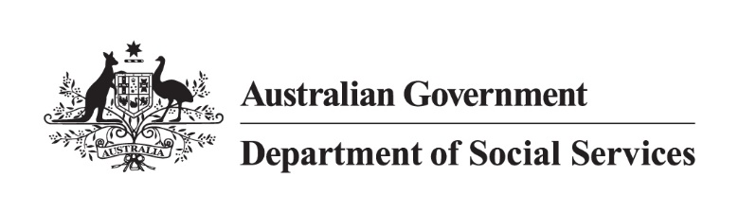

Data and Analytics Strategy

2025-2027

Data-driven improvements to economic and social wellbeing

## Acknowledgment of Country

The Department of Social Services acknowledges Aboriginal and Torres Strait Islander peoples throughout Australia and their continuing connection to land, water, culture and community. We pay our respects to the Elders both past and present.

An image of Australia as an indigenous design

This is an image of Australia depicted as an indigenous design of paths coming together as connected communities.

Artwork: Reconciliation Journeys.  
Artists: Mr James (Jim) Abednego and Ms Nikki Gallagher

© Commonwealth of Australia (Department of Social Services) 2024

## Secretary’s foreword

I am pleased to present the Data and Analytics Strategy 2025-2027: Data-driven improvements to economic and social wellbeing.

The Strategy emphasises the importance of using data and analytics to deliver better services and outcomes for individuals, families and Australian communities.

All departmental staff should use our data and analytic tools to turn data into insights and insights into evidenced-based policy decisions, in line with our Corporate Plan outcomes.

The Strategy inspires a data-driven culture. It supports innovation and our commitment to serving the public compassionately, ethically, safely and with integrity.

I encourage everyone to actively champion the use of data and analytics in the department to deliver better outcomes for Australian people.

**Michael Lye**  
Secretary

# 

Contents

Acknowledgment of Country 1

Secretary’s foreword 2

A few words from our Chief Data Officer 4

Introduction 5

Unlocking benefits of data and analytics 5

Vision 6

Measuring success 7

Purpose 8

Influences 8

The data and analytics landscape 9

Data Maturity Assessment Tool target areas 10

The data ecosystem 11

The journey so far 12

Key achievements 2022-2024 12

Opportunities identified from our 2022-2024 experience 13

Areas of focus and goals 14

Our 6 key areas of focus 15

Next steps 16

## A few words from our Chief Data Officer

I am proud of the Department of Social Services’ (the department’s) Data and Analytics Strategy for 2025–2027 – a blueprint to transform how we harness and use data to deliver payments, and evidence-based policies, programs, and services to improve the economic and social wellbeing of individuals, families and vulnerable members of Australian communities.

The Strategy builds on the department’s inaugural Data Strategy 2022-2024 to empower every person in the department to achieve more with data. We have laid solid foundations by building capability, uplifting governance, improving culture, enabling data access and sharing, and using technology.

The Strategy builds on these foundations and emphasises data use and analytics. Having data is one thing, using it is the goal!

We are also not operating in isolation. The Strategy responds to the direction set in the 2024 [Data and Digital Government Strategy](https://www.dataanddigital.gov.au/); the 2021 [Intergovernmental Agreement on Data Sharing](https://www.finance.gov.au/government/public-data/data-and-digital-ministers-meeting/intergovernmental-agreement-data-sharing) committing all jurisdictions to share public data by default where it can be shared securely, safely, lawfully and ethically; the 2024 APS [policy for the responsible use of AI in Government](https://www.digital.gov.au/policy/ai/policy), and the department’s commitment to the [Framework for the Governance of Indigenous Data](https://www.niaa.gov.au/resource-centre/framework-governance-indigenous-data) co-designed by the APS and Aboriginal and Torres Strait Islander and non-government partners.

The Strategy, combined with the department’s Evaluation Strategy, emphasises how data drives evidence-based improvements to economic and social wellbeing in Australia.

Together, we are shaping a department where data-driven practices are seamlessly embedded into operations, empowering us to deliver improved outcomes for the people, families and communities we serve.

**Gemma Van Halderen PSM**Group Manager, Data and Evaluation  
Chief Data Officer

## Introduction

The Strategy provides a clear blueprint for the department’s data and analytic requirements. It builds on the foundations of the first Data Strategy 2022-24 to empower every person in the department to achieve more with data.

The Strategy enables the department to deliver with purpose - to improve the economic and social wellbeing of individuals, families and vulnerable members of Australian communities. It enables us to:

* ensure Australia’s social security system is sustainable and provides support to people when they need it most
* contribute to stronger and more resilient individuals, children, families and communities

support independence as well as economic and social participation for people with disability.

Data is vital to this purpose. Data provides the evidence to support improvements to payments, policies, programs and services. It enables us to monitor the management and delivery of payments, programs and services. It drives the design of evidence-based policies, programs and services. It provides transparency and builds trust in the payments, policies, programs and services the department is responsible for.

## Unlocking benefits of data and analytics

Using data and analytics is the key to unlocking benefits and targeted interventions for people, particularly vulnerable individuals, families and communities. Data and analytics drives more equitable outcomes by informing decision making and shaping effective solutions.

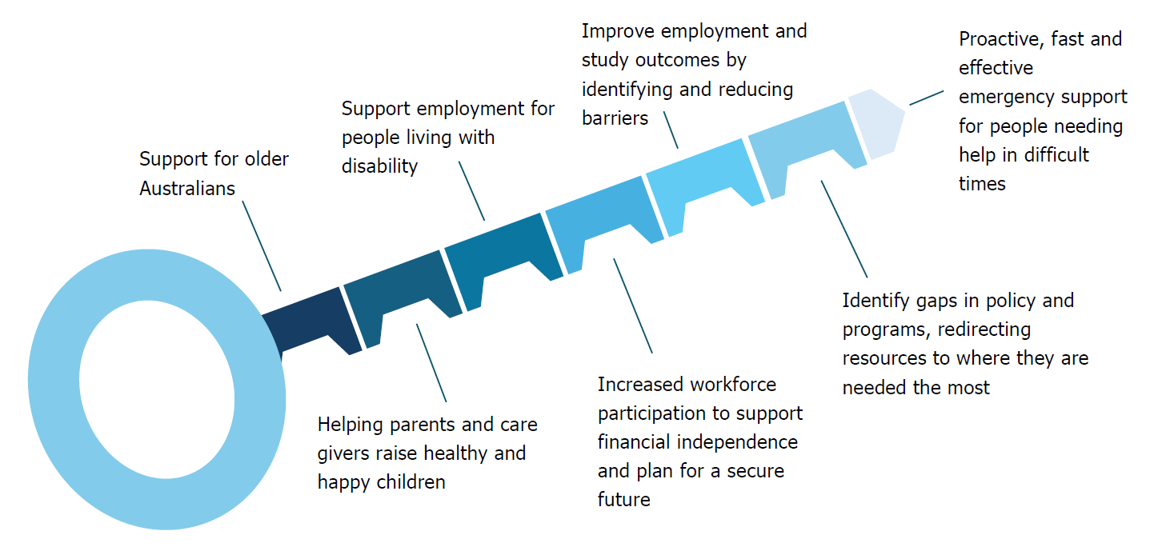

## Vision

The department’s vision for data and analytics is that **all staff can achieve more with data.**

We are dedicated to delivering trusted self-service data, attracting and retaining empowered skilled staff. We will be transparent and open with our data management, building a collaborative mindset to achieve more with data, and unlocking its full potential through evidence-based decision making and policy development.

**Using data, analytics and insights to improve the economic and social wellbeing of individuals, families and vulnerable members of Australian communities.**

Data, analytics and insights from the payments, policies, programs and services we administer are used to influence and inform our work.

Community support which includes the provision of social security payments and supports, emergency support, support for older Australians, and gambling support.

Families and Children which includes the provision of family support services, parenting payments and benefits, empowering and supporting parents, and services for vulnerable or at-risk families.

Ending violence and abuse which includes child protection, safety programs, prevention and evidence, supporting survivors, and sexual consent. 

Work and study includes the provision of support for people looking for work, mental health support, support for students and apprentices, and disability employment. 

## Measuring success

We will know we have been successful when…

|  |  |  |  |  |
| --- | --- | --- | --- | --- |
| Our data is trusted and, where appropriate, access to it is open by default |  | We inform decisions with evidence and data and support value creation from data |  | Our data and insights, expertise and experience are sought out |
|  |  |  |  |  |
| We use data safely, securely, lawfully and ethically |  | We deliver with impact and influence informed by data-driven insights |  | We are efficient and maximise use of the data and insights we already have |
|  |  |  |  |  |
| We provide supported access to trusted self-service processes and systems |  | Mechanisms for maintaining consistency and meaning in metadata including standards and practices identified, tested against Whole of Government standards and practices | | |
|  |  |  |  |  |
| Procedures and controls for managing quality of analysis and reporting are agreed, tested and embedded |  | Data integration capability and use supports strategic planning including corporate outcomes |  | Data capability investment needs are understood, and gaps identified and addressed |
|  |  |  |  |  |
| An increase in the assessment under the APS Data Maturity Assessment Tool from the 2024 maturity stage of **developing** to a minimum of **measured and managed**. Defined as the department having operationalised and consistently applied data usage and management practices across all areas, with a focus on improving and optimising established capabilities through defined metrics. Data is used for strategy formulation, for operational and mission critical processes and for decision making, predictive analytics are applied. | | | | |

## Purpose

The Strategy outlines how the department will achieve its data and analytics vision.

The Strategy builds the capability of all staff to achieve more with data and analytics to support the department’s priorities including:

* [Provision of targeted payments and assistance as part of the social security safety net](https://www.dss.gov.au/income-support-payments)
* [National Framework for Protecting Australia's Children 2021–2031](https://www.dss.gov.au/system/files/resources/dess5016-national-framework-protecting-childrenaccessible.pdf)
* [National Plan to End Violence against Women and Children 2022-2032](https://www.dss.gov.au/national-plan-end-gender-based-violence/resource/national-plan-end-violence-against-women-and-children-2022-2032)
* [The Early Years Strategy 2024-2034](https://www.dss.gov.au/early-years-strategy/resource/early-years-strategy-2024-2034)
* [National Autism Strategy 2025-2031](https://www.dss.gov.au/national-autism-strategy/resource/national-autism-strategy-2025-2031)
* [Disability Employment Services Reforms](https://www.dss.gov.au/disability-employment-reforms)
* [The National Agreement on Closing the Gap](https://www.closingthegap.gov.au/national-agreement)
* [Entrenched disadvantage package](https://www.dss.gov.au/supporting-community-change/resource/entrenched-disadvantage-package).

### Influences

The Strategy is informed by:

* the 2024 [Data and Digital Government Strategy](https://www.dataanddigital.gov.au/)
* the 2021 [Intergovernmental Agreement on Data Sharing](https://www.finance.gov.au/government/public-data/data-and-digital-ministers-meeting/intergovernmental-agreement-data-sharing) committing all jurisdictions to share public sector data by default where it can be shared securely, safely, lawfully and ethically
* the 2024 APS [policy for the responsible use of AI in Government](https://www.digital.gov.au/policy/ai/policy) and [Data, digital and cyber workforce plan](https://www.dataanddigital.gov.au/workforce)
* the department’s commitment to the [Framework for the Governance of Indigenous Data](https://www.niaa.gov.au/resource-centre/framework-governance-indigenous-data) co-designed by the APS and Aboriginal and Torres Strait Islander and non-government partners
* our results of the 2024 Data Maturity Assessment led by the Department of Finance
* our review of other data and analytics strategies from across the APS including Attorney-Generals, Department of Health, Disability and Ageing, Treasury and Defence
* staff feedback and an all-staff survey
* the department’s Evaluation Strategy 2025-2027.

## The data and analytics landscape

The [Data and Digital Government Strategy (DDGS)](https://www.dataanddigital.gov.au/) serves as the roadmap for the use and management of data and digital technologies through to 2030, supported through world class data and digital capabilities. The DDGS recognises the importance of building broad data and digital literacy and embedding data and digital capabilities into all APS roles.

The Strategy implements this roadmap and vision. It ensures alignment and consistency with the whole of government data agenda and includes actions to build data and analytics capability in the department and wider APS, while keeping people and business at the centre.

The Department of Finance’s 2024 Australian Public Service (APS) Data Maturity Assessment Tool (DMAT) supports the data agenda as set by the DDGS. The department has used the DMAT to identify where we need to mature. While the department understands the importance of using and managing data effectively at the enterprise level, and has some initiatives for improving data capability, being slightly ahead of the APS average, this is still a work in progress.

Strategy and governance, integration and risk were identified as areas requiring greater maturity with areas for focus being analytics, architecture, operations and quality, reference and metadata.

## Enhancing the application of robust data governance practices. Accessing emerging technological systems to support quality data. Data risk. Data integration. Uplifting data and analytics and analysis capabilities. Timely data access, sharing and use. Data quality, reference and metadata.Data Maturity Assessment Tool target areas

The Strategy also supports our commitments in the [Australian Data Strategy](https://www.finance.gov.au/sites/default/files/2022-10/australian-data-strategy-snapshot.pdf), the [APS Data Ethics Framework](https://www.finance.gov.au/sites/default/files/2024-12/aps-data-ethics-framework.pdf) for the ethical use of data and analytics, the [APS Data Capability Framework](https://www.apsc.gov.au/publication/aps-data-capability-framework) and the [Framework for the Governance of Indigenous Data](https://www.niaa.gov.au/our-work/evaluations-and-evidence/framework-governance-indigenous-data-gid).

Timely and quality insights are vital to inform decision making and support accountability and transparency. Government recognises data as a critical national asset. They expect it to be managed as such, with its value maximised through broader access (use and reuse), sharing and release.

By maximising the value of data through leveraging it, analysing it and building trust in using it, the department aims to ensure our payments, policies, programs and services have impact and influence; are effective, efficient, and evidence-based, enhancing the economic and social well-being of the people we serve.

### The data ecosystem

By contributing to the data ecosystem, the department drives outcomes and builds trust with providing open and transparent data.

We invest over $20 million annually in:

* Living in Australia: The Household, Income and Labour Dynamics in Australia (HILDA) Survey
* Footprints in Time: The Longitudinal Study of Indigenous Children (LSIC)
* Growing Up in Australia: The Longitudinal Study of Australian Children (LSAC)
* Building a New Life in Australia Longitudinal Study of Humanitarian Migrants (BNLA).

Further, we:

* make use of data collected by government entities, particularly Services Australia, who collect data under our enabling legislation for inclusion in the Services Australia Enterprise Data Warehouse
* collect, assure and use data collected by the department’s Community Grants Hub
* lead and participate in various Centres of Excellence and the APS Data Profession
* contribute to the growing integrated data asset ecosystem
* share our income support payment data and program performance data into the Person Level Integrated Data Asset (PLIDA) for research and statistical uses
* invest in ABS data collections including the Disability, Ageing and Carers Survey and the Personal Safety Survey
* support improvements in the way administrative data is collected and used through the Data Exchange - a program performance reporting solution for our service providers
* make our data available on [data.gov.au](https://data.gov.au/home)
* have expanded our data offerings in the [Digital Atlas of Australia](https://digital.atlas.gov.au/).

## The journey so far

The department has made significant steps in implementing the first DSS Data Strategy 2022-24. It laid the foundation for a data-driven culture and enhanced our data and analytics and analysis capabilities.

The department achieved several milestones and identified areas for improvement and lessons learnt. These are reinforced in the 2024 DMAT maturity rating.

### Graph showing timeline from 2022 to 2024. Established a data governance framework, including the Data Asset Owners and Data Stewardship Policy. Facilitated data sharing and collaboration with project partners through data sharing agreements and self-service data visualisation tools. Implemented metadata standards, guidelines, and a data catalogue to improve data documentation and quality. Invested in building data capabilities and promoting a data-driven culture through learning and development programs and data-related job roles. Significantly uplifted safe access and secure use of our social security data housed in Services Australia, our IT service provider. Provided leadership to the endorsement of the APS Framework for the Governance of Indigenous Data. Established the National Disability Data Asset and the underlying Australian National Data Integration Infrastructure, in partnership with the disability community, Australian Bureau of Statistics, Australian Institute of Health and Welfare, and data custodians across Australian state and territory governments. Expanded our open data footprint in data.gov.au and the Digital Atlas of Australia.Key achievements 2022-2024

### Opportunities identified from our 2022-2024 experience

* Strengthening inter-agency **collaboration** and addressing governance concerns for data sharing initiatives.
* Investing in staff capability and incentivising retention.
* Promoting a data-driven culture supported by **curiosity**.
* Developing a comprehensive strategy and engagement plan to unlock the potential of data analysis.
* Exploring innovation within an adaptive risk framework with **courage**.
* Demonstrated **contestability** and improvement of data ecosystem architecture to address challenges that impede access, use and reporting.
* Developing an evaluation framework and a holistic governance framework.

## Areas of focus and goals

Building on the 5 areas of focus established in the Data Strategy 2022-2024, **Data Analytics** has been added as a specific focus area. Data Access and Sharing has been expanded to **Data Access, Sharing and Use**.

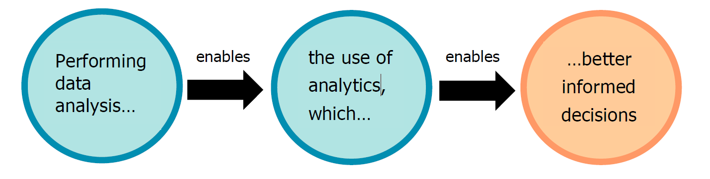The addition of **Data Analytics** includes the ability to conduct data analysis. This is the process of investigating and transforming data to produce informative metrics. The metrics are then used and interpreted to conduct data analytics to inform business decisions with impact, and support staff to have the skills and confidence to tell a powerful story with data.

Analytics in the department includes:

* **Exploratory analytics** to identify patterns and distributions within datasets.
* **Statistical analytics** to produce informative statistics that support evidence-based decisions.
* **Advanced analytics** leveraging advanced techniques such as geospatial analysis and microsimulation.
* **Business intelligence analytics** extracting insights from operational data to guide strategic decisions.

The emphasis on the inclusion of use (data access, sharing and use) drives the department’s efforts to improve the economic and social wellbeing of individuals, families and vulnerable members of Australian communities. Having data is necessary but is not sufficient. We must use it and use it for a purpose.

There is also an emphasis on uplifting data and analytics and analysis capability. We need to enhance our understanding and application of robust data governance practices. We need to acquire and provide access to technological systems that support quality data and timely access to it. This will increase our data maturity.

If we provide a structured approach to managing data it will ensure it is used responsibly, efficiently, and innovatively to enhance service delivery and policy development.

## Our 6 key areas of focus

|  |  |
| --- | --- |
| Capability | * Our staff have the capability and support to effectively collect, manage, use, analyse and interpret data. * Our staff can confidently use data to inform the robust evaluation of operations, advice and decisions. * We attract, develop and retain data professionals who deliver robust insights and analytics, supporting all areas of the department. |
|  |  |
| Governance | * Our governance arrangements provide clear responsibility and accountability for data management, reflect best practice and enable safe, lawful (including privacy) and ethical access, sharing and use. * Our data governance forums are effective, active and empowered by collaborating with internal and external stakeholders. * Data assets are managed effectively, and our Senior Executive Staff meet their obligations in the SES Accountabilities for Data. |
|  |  |
| Culture | * Data drives our curiosity; we have the courage to use it, share it and derive insights from it. * We are open and transparent with our data, encouraging contestability. * We collaborate instinctively to produce, access, share and use data. * We use data to inform advice to Senior Executive Staff and Ministers. |
|  |  |
| Data sharing, access and use | * We embed robust data access and sharing. * We ensure data resources are optimised, fostering a seamless and cohesive flow of information across systems, facilitating interoperability and collaboration. * We ensure our data assets are open and accessible, as appropriate, and discoverable through the Australian Government Data Catalogue. |
|  |  |
| Technology | * We use current technology to remain agile in our use of data and analytics. * We are committed to the APS [policy for the responsible use of AI in Government](https://www.digital.gov.au/policy/ai/policy). * We leverage existing technology to support a ‘build once, use often’ mindset. |
|  |  |
| Analytics | * We produce analytics products relevant to data use requirements. * We build data literacy and expectations around the possibilities of data analysis. * We empower policy, program and operational areas to seek data analytics support for enhanced operations. * We promote the value of analytics and insights to support evaluation through showcasing analytics models and insights. |

## Next steps

We will measure success of the Strategy through performance monitoring.

We are developing an Implementation Plan and Roadmap to identify the metrics to measure success, monitor progress and identify areas for improvement. The Implementation Plan and Roadmap will be aligned with the DDGS Implementation Plan and the department’s implementation plan for the Framework for Governance of Indigenous Data. Metrics will be aligned with the APS Data Maturity Assessment Tool metrics framework and results from the annual APS Census.

Ongoing monitoring and evaluation will inform the department’s assessment against data maturity in the next APS Data Maturity Assessments and the next Strategy from 2028.