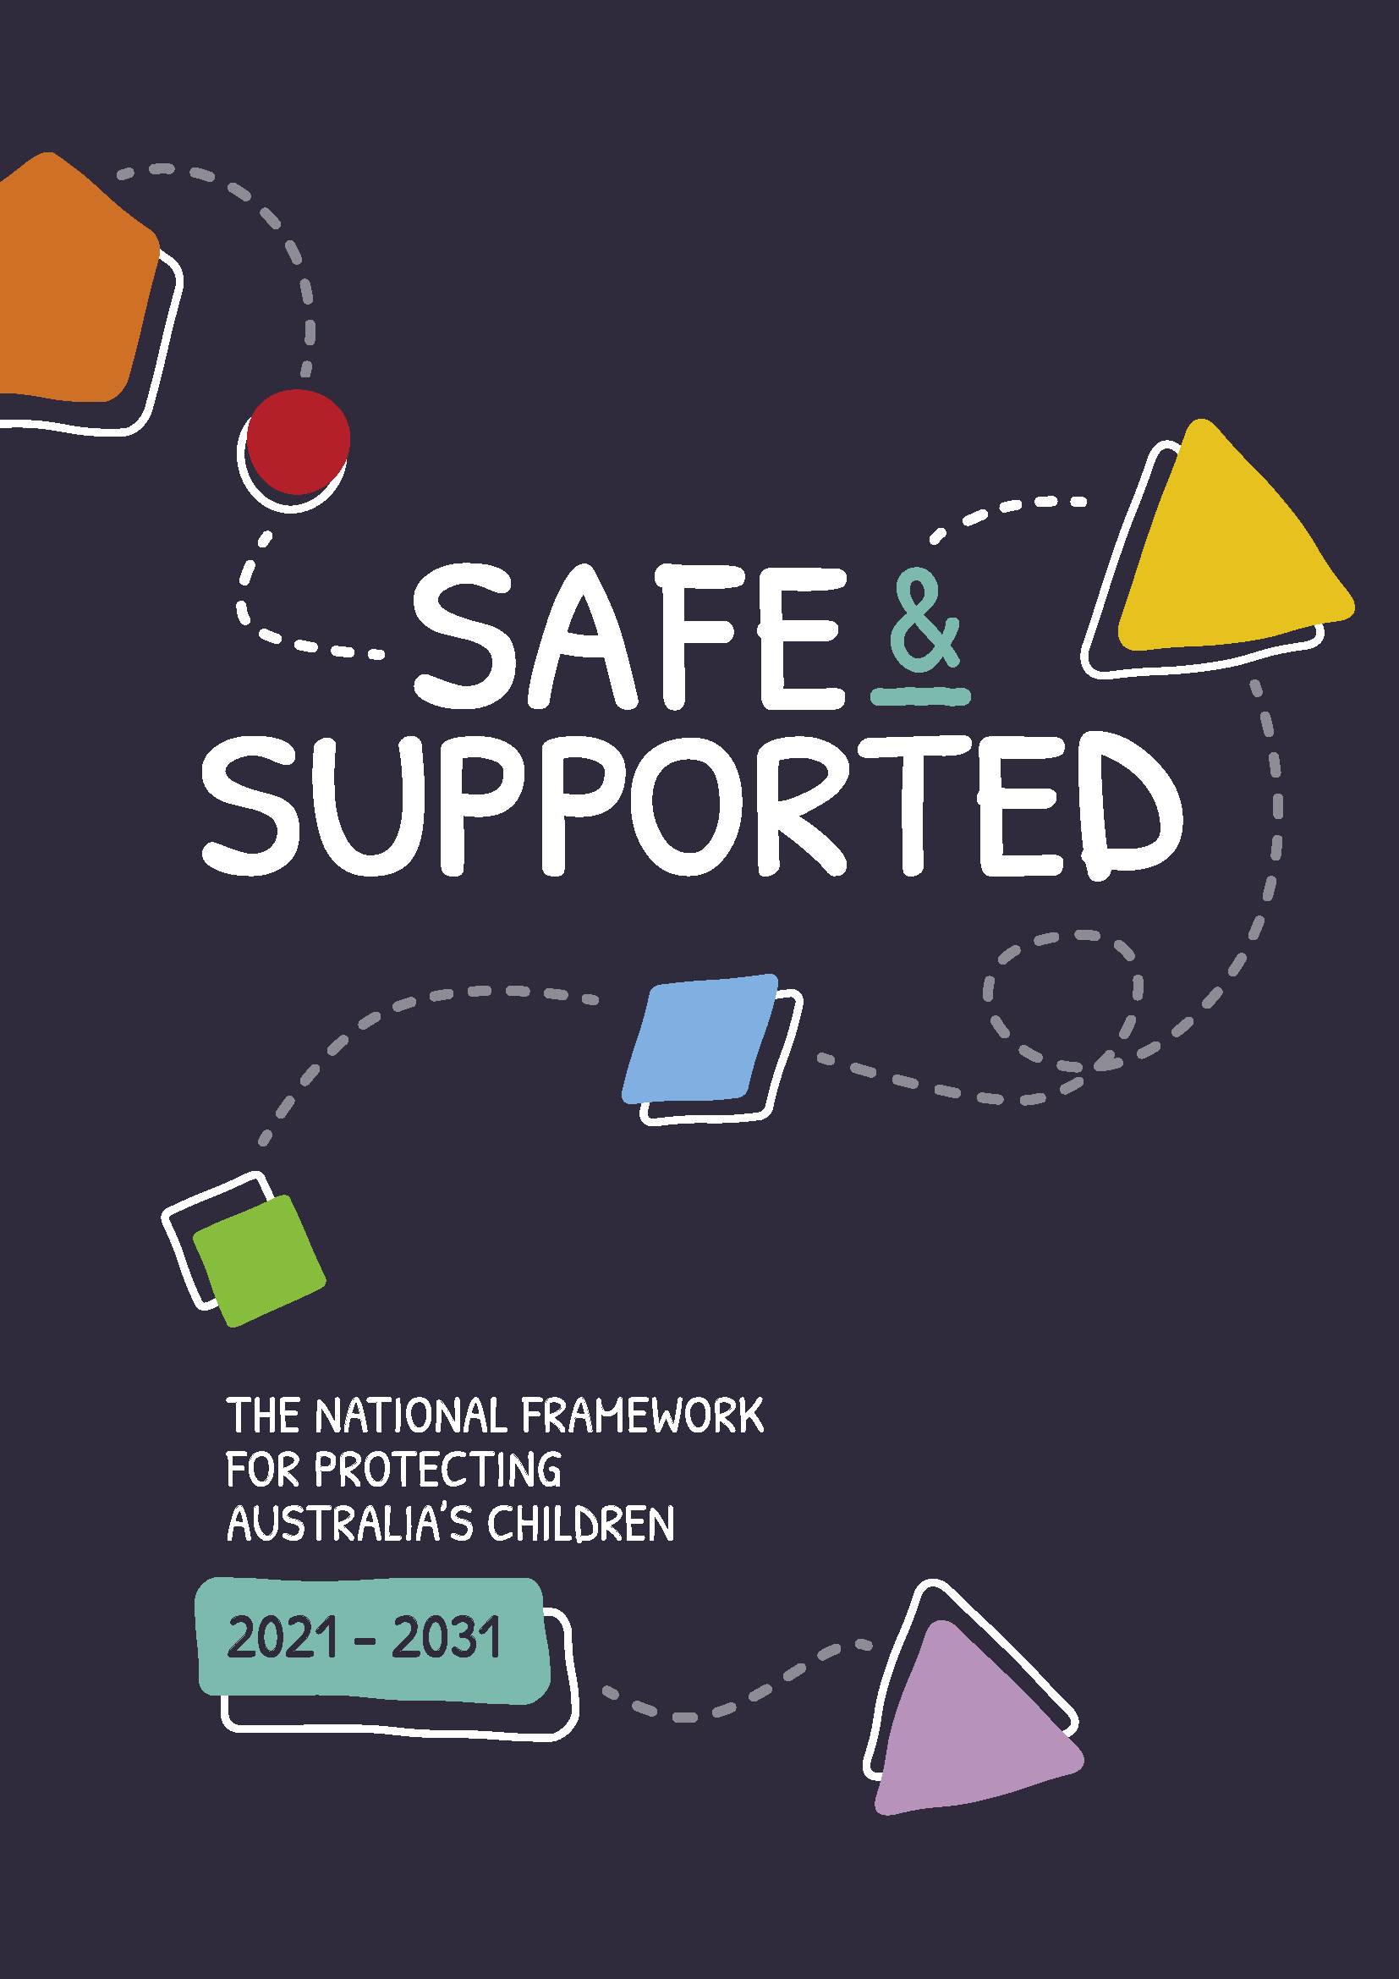

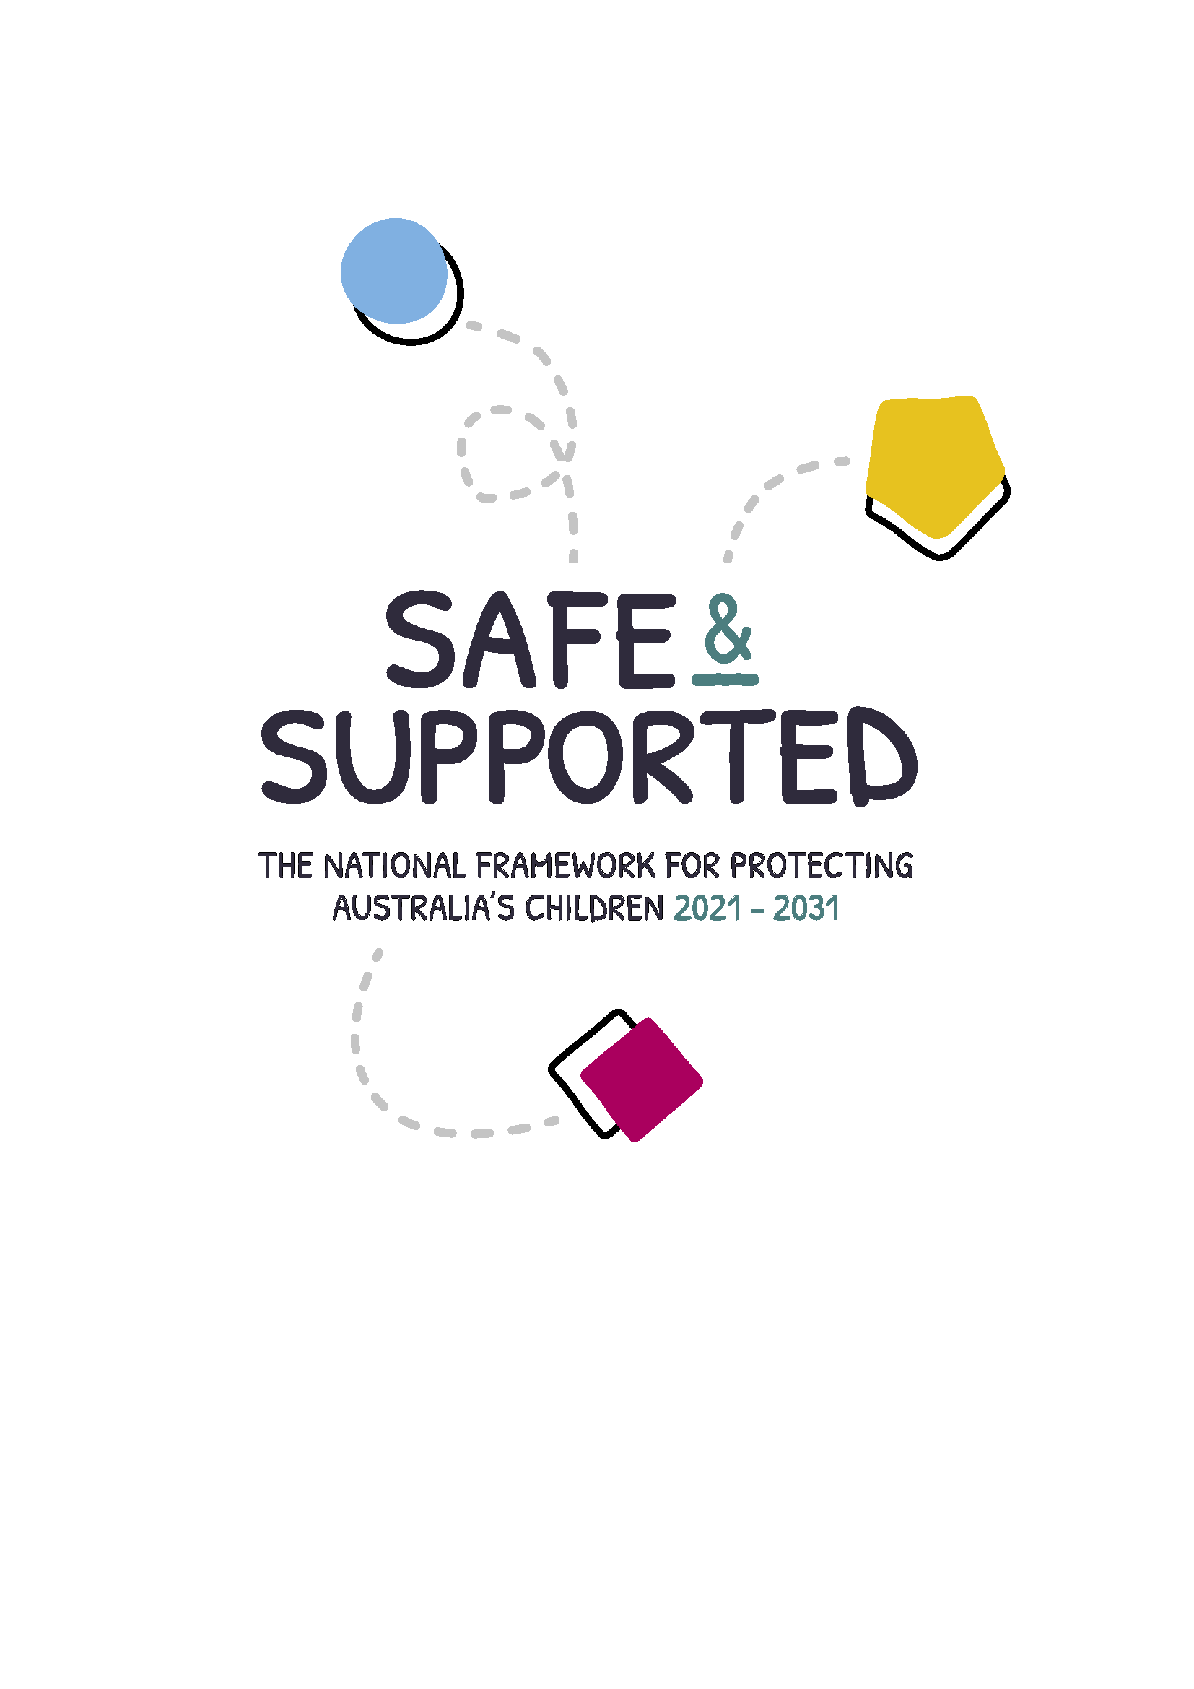THE NATIONAL FRAMEWORK FOR PROTECTING  
AUSTRALIA’S CHILDREN 2021 - 2031

© Commonwealth of Australia 2021 ISBN 978-1-921130-12-0 (PRINT)

ISBN 978-1-921130-13-7 (ONLINE)

Copyright notice – 2021



This document *Safe and Supported: the National Framework for Protecting Australia’s Children 2021–2031* (the National Framework) is licensed under the Creative Commons Attribution 4.0 International Licence https://creativecommons.org/licenses/by/4.0/legalcode

**Licence URL**: https://creativecommons.org/licenses/by/4.0/legalcode

Please attribute: © Commonwealth of Australia (Department of Social Services) 2021

Notice:

1. If you create a derivative of this document, the Department of Social Services requests the following notice be placed on your derivative: Based on Commonwealth of Australia (Department of Social Services) data.
2. Inquiries regarding this licence or any other use of this document are welcome. Please contact: Branch Manager, Communication Services Branch, Department of Social Services. Phone: 1300 653 227. Email: [communications@dss.gov.au](mailto:communications@dss.gov.au)

ii

## Contents

Acknowledgments 1

Foreword 2

Seeking support 3

Introduction 6

The National Framework 8

Supporting the National Agreement on Closing the Gap 9

Why we need a new National Framework 13

Priority Groups 21

Focus Areas 25

How we will do it 35

Appendices 43

Appendix A: Roles and responsibilities 45

Appendix B: Glossary 48

Appendix C: National strategies and state and territory initiatives 52

Appendix D: Summary of consultations 55

Appendix E: Key elements underpinning the National Framework 58

## Acknowledgements

We pay our respects to all Aboriginal and Torres Strait Islander peoples and Elders past and present.

We acknowledge they have cared for this country since its creation. We respect their unique cultural and spiritual relationships to the land, waters and seas on which we live and work.

We acknowledge their rich contribution to society and commit ourselves to building a brighter future for Australia’s children together.

All governments acknowledge the significant contribution of everyone involved in the development of *Safe and Supported: the National Framework for Protecting Australia’s Children 2021–2031* (the National Framework).

This includes SNAICC – National Voice for our Children (SNAICC), the national peak body for Aboriginal and Torres Strait Islander children; the National Aboriginal and Torres Strait Islander Leadership Group; Families Australia; the

non-government sector and academia, particularly those who are part of the National Forum for Protecting Australia’s Children.

Most importantly, we acknowledge those

who have experienced child abuse and neglect. We acknowledge that your lived experience and knowledge are critical to the development of actions under this National Framework.

Your insights have helped and continue to help create a future where children and

young people can grow up safe and supported in Australia.

## Foreword

Protecting Australia’s children is everyone’s business.

*Safe and Supported: the National Framework for Protecting Australia’s Children 2021–2031* was developed by the Australian Government, state and territory governments, with Aboriginal and Torres Strait Islander representatives and the non-government sector. The use of the word ‘we’ represents our continuing shared commitment to support children, young people and families.

The best interests of the child are at the centre of the National Framework and the subsequent Action Plans. We are committed to ongoing meaningful engagement with children, young people, parents, carers and communities.

Listening to the voices of children will be key to our success.

All Australians need to work together to keep children safe and to achieve the best outcomes for vulnerable children and those experiencing disadvantage. This includes all jurisdictions working together in areas such as disability, early childhood education and care, health and mental health, alcohol and other drug treatment and prevention, domestic and family violence, justice, housing and employment.

Governments recognise that Aboriginal and Torres Strait Islander peoples have the right to self-determination. Recognising and building on the strengths and leadership of the community- controlled sector is vital to achieving this goal. The National Framework has been developed with Aboriginal and Torres Strait Islander people, marking a fundamental shift in the way governments are working to ensure that Aboriginal and Torres Strait Islander people

are leading the decisions that impact their lives. The National Framework embeds the 4 Priority Reforms of the National Agreement on Closing the Gap (Closing the Gap) to transform how governments work to accelerate progress.

We want all children, young people, families and communities in Australia to be safe and resilient and to have the opportunity to thrive.

Children and young  
people in Australia have  
the right to grow up safe,  
connected and supported  
in their family, community  
and culture. They have  
the right to grow up in an environment that enables  
them to reach their full  
potential.

Our shared vision is that children and young people in Australia have the right to grow up safe, connected and supported in their family, community and culture. They have the right to grow up in an environment that enables them to reach their full potential.

Our shared goal is to make significant and sustained progress in reducing the rate of child abuse and neglect and its intergenerational impacts.

Endorsed by:

* Senator the Hon Anne Ruston,

Minister for Families and Social Services, Minister for Women’s Safety

* The Hon Michelle Landry MP,

Assistant Minister for Children and Families, Assistant Minister for Regional Tourism

* Ms Rachel Stephen-Smith MLA, Australian Capital Territory Minister for Families and Community Services
* The Hon Alister Henskens MP,

New South Wales Minister for Families, Communities and Disability Services

* The Hon Kate Worden MLA,

Northern Territory Minister for Territory Families and Urban Housing

* The Hon Leanne Linard MP,

Queensland Minister for Children and Youth Justice and Minister for Multicultural Affairs

* The Hon Rachel Sanderson MP,

South Australia Minister for Child Protection

* The Hon Sarah Courtney MP,

Tasmania Minister for Children and Youth, Minister for Disability Services

* The Hon Richard Wynne MP, Victoria Minister for Child Protection
* The Hon Simone McGurk MLA,

Western Australia Minister for Child Protection; Women’s Interests; Prevention of Family and Domestic Violence; Community Services

## Seeking support

Crisis and suicide prevention

**If you or someone else  
is in immediate danger call Triple Zero (000)**

**Lifeline**

13 11 14

[www.lifeline.org.au](http://www.lifeline.org.au/)

Please refer to state and territory-specific child safety websites if you have a child protection concern.

Mental health support  
and advice

**Kids Helpline**

**1800 551 800**

[www.kidshelpline.com.au](http://www.kidshelpline.com.au/)

**eheadspace**

1800 650 890

[www.headspace.org.au](http://www.headspace.org.au/)

**ReachOut**

[www.au.reachout.com](http://www.au.reachout.com/)

**Beyond Blue**

1300 22 4636

[www.beyondblue.org.au](http://www.beyondblue.org.au/)

**MensLine Australia**

1300 78 99 78

[www.mensline.org.au](https://mensline.org.au/)

[**Head to Health**](https://mensline.org.au/)

[www.headtohealth.gov.au](https://mensline.org.au/)

**If you speak a language  
other than English and need help  
understanding this document,  
you can contact the free Translatingand Interpreting Service on 131 450.**

**If you are deaf and/or find it hard  
hearing or speaking with people who  
use a phone, the Nation Relay Service  
(NRS) can help you. Please contact  
the NRS Helpdesk on  
1800 555 660.**

Domestic and family violence support

**1800Respect**

1800 737 732

[www.1800respect.org.au](https://www.1800respect.org.au/)

Child sexual abuse  
support and advice

**Bravehearts Support Line**

1800 272 831

[www.bravehearts.org.au](http://www.bravehearts.org.au/)

Links and contact details for support services for parents and carers are below:

**New South Wales: Parentline NSW**

1300 130 052

[www.parentline.org.au](https://www.parentline.org.au/)

**Australian Capital Territory: Parentline ACT**

(02) 6287 3833

www.r[aisingchildren.net.au](https://raisingchildren.net.au/_media/external-links/p/parentline-act)

**Northern Territory: FACES Family Support Line**

1800 999 900

[https://tfhc.nt.gov.au](https://tfhc.nt.gov.au/children-and-families/territory-faces)

**Queensland: Parentline Queensland and Northern Territory**

1300 301 300

www[.parentline.com.au](https://parentline.com.au/)

**South Australia: Parent Helpline South Australia**

1300 364 100

[www.cyh.com](http://www.cyh.com/SubContent.aspx?p=102)

**Tasmania: Parentline Tasmania**

1300 808 178

[www.health.tas.gov.au](http://www.health.tas.gov.au/service_information/children_and_families/parentline)

**Victoria: Parentline Victoria**

132 289

www[.services.dffh.vic.gov.au](https://services.dffh.vic.gov.au/parentline)

**Western Australia: Ngala Helpline**

(08) 9368 9368 (metropolitan) or

1800 111 546 (regional callers) [www.ngala.com.au](https://www.ngala.com.au/service/ngala-parenting-line-2/)

## Introduction

Children and young people in Australia have the right to grow up safe, connected and supported in their family, community and culture. They have the right to grow up in an environment that enables them to reach their full potential.

*Safe and Supported: the National Framework for Protecting Australia’s Children 2021–2031* is Australia’s framework to reduce child abuse and neglect and its intergenerational impacts. It builds on the *National Framework for Protecting Australia’s Children 2009–2020*, which laid the critical foundation for national collaboration on protecting Australia’s children. It will drive change through collective effort across governments and sectors that impact the safety and wellbeing of children and

young people.

The National Framework sets out our 10-year strategy to improve the lives of children, young people and families experiencing disadvantage or who are vulnerable to abuse and neglect.

It includes an agreed vision and goal, priority groups, focus areas and underpinning principles.

The National Framework will be delivered by 2, 5-year Action Plans. For the first time, Aboriginal and Torres Strait Islander peoples will have their

own specific Action Plan across all aspects of the Framework. These plans will describe the actions and outcomes needed to deliver sustained progress in reducing child abuse and neglect.

The Aboriginal and Torres Strait Islander Action Plan will be developed in partnership with Aboriginal and Torres Strait Islander leaders and communities.

The National Framework will align and interact with other national initiatives to support systemic change for children, young people and families. Most importantly, it will have close linkages with the next National Plan to End Violence against Women and Children, recognising that the 2 issues are closely intertwined at all levels. The National Framework will align with the *National Strategy to Prevent and Respond to Child Sexual Abuse 2021–2030* and the *National Aboriginal and Torres Strait Islander Early Childhood Strategy*.

The National Framework will support commitments under Closing the Gap and its 4 Priority Reform areas. All governments recognise that meaningful and sustained change requires Aboriginal and Torres Strait

Islander-led solutions. Through Closing the Gap, all governments are committed to shifting

how we develop and implement policies relating to Aboriginal and Torres Strait Islander children and families.



The National Framework is for all Australian children, young people and families, with a targeted focus on groups that are experiencing disadvantage or are vulnerable to abuse and neglect. Achieving safety and wellbeing outcomes for these families will help the National Framework achieve its goal.

| **Priority** | **The National Framework has 4 priority groups:** | **We will improve outcomes for these groups through actions in 4 focus areas:** |
| --- | --- | --- |
| **1** | children and families with multiple and complex needs | a national approach to early intervention and targeted support for children and families experiencing vulnerability or disadvantage |
| **2** | Aboriginal and Torres Strait Islander children and young people experiencing disadvantage or who are vulnerable | addressing the over- representation of Aboriginal and Torres Strait Islander children in child protection systems |
| **3** | children and young people and/or parents/carers with disability experiencing disadvantage or who are vulnerable | improving information sharing, data development and analysis |
| **4** | children and young people who have experienced abuse and/or neglect, including children in out-of-home care and young people leaving out-of-home care and transitioning to adulthood. | strengthening the child and family sector and workforce capability. |



# Supporting the National Agreement on Closing the Gap



## How Closing the Gap creates better outcomes for Aboriginal and Torres Strait Islander children and young people

For the first time, the National Agreement on Closing the Gap has been developed in genuine [partnership](https://www.closingthegap.gov.au/node/20) between Australian governments and the Coalition of Aboriginal and Torres Strait Islander Peak Organisations (the Coalition of Peaks), comprising over 50 Aboriginal and Torres Strait Islander community-controlled peak organisations.

Closing the Gap is a shared commitment that aims to enable and empower Aboriginal and Torres Strait Islander people to live healthy and prosperous lives. It aims to achieve transformative change in education, employment, health, wellbeing, safety, languages, land and waters for Aboriginal and Torres Strait Islander people.

The National Framework will support achieving Target 12 under Closing the Gap, which aims to reduce the rate of over-representation of Aboriginal and Torres Strait Islander children

in out-of-home care by 45% by 2031. While the National Framework will focus on Target 12,

all 17 of the socio-economic targets in Closing the Gap are interconnected and contribute to creating safe and supported environments for Aboriginal and Torres Strait Islander children and young people.

Central to Closing the Gap are its 4 Priority Reforms, which will underpin all actions for Aboriginal and Torres Strait Islander people.

**The 4 Priority Reforms are:**

1. **formal partnerships and shared decision-making**
2. **building the community-controlled sector**
3. **transforming government organisations**
4. **shared access to data and information at a regional level.**



Governments recognise that shared decision- making supports self-determination

and understanding of and respect for the lived experiences of Aboriginal and Torres Strait Islander people.1 Additionally, governments recognise that Aboriginal and Torres Strait Islander community control is an act of self- determination.2

#### Jurisdictional Closing the Gap Implementation Plans

Australian, state and territory governments and the Coalition of Peaks outline how they will deliver on Closing the Gap through Implementation Plans. These plans include

commitments to transforming systems, including child protection systems and family support services. Jurisdictional Implementation Plans are developed and delivered in partnership between governments, the Coalition of Peaks and other Aboriginal and Torres Strait Islander partners.

Both Australian and jurisdictional Implementation Plans are living documents that will be monitored, reviewed and updated regularly.

#### Accountability and governance

All Australian governments and the Coalition of Peaks share accountability for the implementation of Closing the Gap and are

jointly accountable for its outcomes and targets.

The National Framework will be subject to existing accountability and governance arrangements under Closing the Gap. This includes:3

* the Productivity Commission annually updating a publicly accessible data dashboard on progress against Closing the Gap, covering all jurisdictions
* the Productivity Commission undertaking a comprehensive independent review of progress every 3 years
* each party preparing an annual public report including information on the measures and actions taken to implement Closing the Gap
* at the national level, independent Aboriginal and Torres Strait Islander-led reviews of progress will be carried out within 12 months of each Productivity Commission review.

The National Framework  
will be subject to

existing accountability and governance arrangements under Closing the Gap.

* 1. Joint Council on Closing the Gap, [National Agreement on Closing the Gap](https://www.closingthegap.gov.au/national-agreement), Commonwealth of Australia, 2020, Clause 32, p. 6.
  2. Joint Council on Closing the Gap, [National Agreement on Closing the Gap](https://www.closingthegap.gov.au/national-agreement), Clause 44, p. 8.
  3. Joint Council on Closing the Gap, [National Agreement on Closing the Gap](https://www.closingthegap.gov.au/national-agreement), p. 43-49.

The Joint Council on Closing the Gap will play an ongoing role in monitoring implementation

of Closing the Gap, including progress by the Parties against their implementation plans.

The Joint Council includes ministers from each jurisdiction, a representative from the Coalition of Peaks from each state and territory and the President of the Australian Local Government Association.

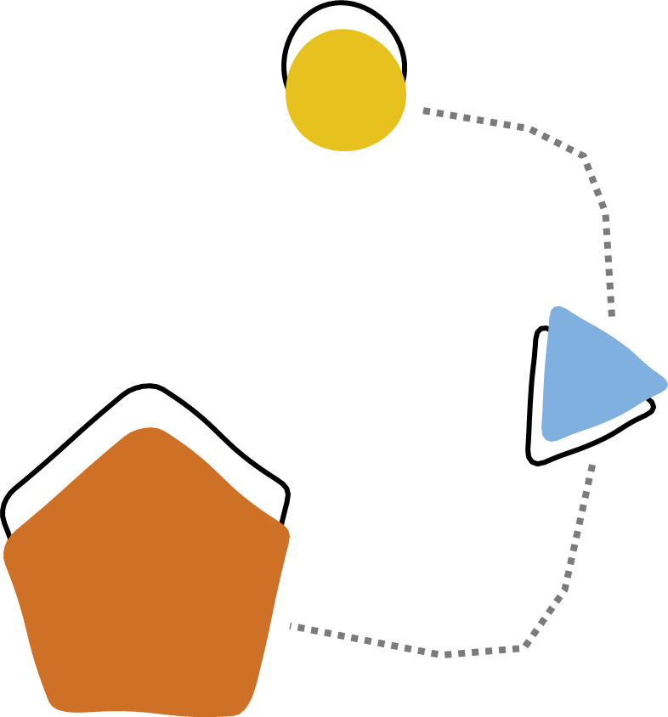In the spirit of cooperation, good faith and mutual trust, the Parties will endeavour to resolve any difficulties or misunderstandings with respect to the Partnership Agreement on Closing the Gap.4

* 1. Joint Council on Closing the Gap, [Partnership Agreement on Closing the Gap 2019–2029](https://federation.gov.au/sites/default/files/about/agreements/partnership-agreement-on-closing-the-gap_0.docx), Commonwealth of Australia, 2019, p. 36.



# Why we need a new National Framework

###### Protecting children is everyone’s business

The first National Framework made progress but there is much more to be done to reduce child abuse and neglect and its intergenerational impacts.

State and territory governments manage child protection systems, but we are all responsible for keeping children safe. This includes all levels of government, non-government organisations (NGOs), service providers, researchers and Australian families and communities.

The Royal Commission into Institutional Responses to Child Sexual Abuse recommended that Australian governments develop a new framework for child safety after the *National Framework for Protecting Australia’s Children 2009–2020* ended.5 This National Framework responds to that recommendation and builds on the first National Framework.

We recognise there is an urgent need to address the over-representation of Aboriginal and Torres Strait Islander children in child protection systems. One of the primary aims of the National Framework is to achieve Target 12 under Closing the Gap.

The National Framework focuses on the best interests of the child. It aims to provide protection for vulnerable and disadvantaged children in line with their needs. Another aim is to help children express their views in developing and implementing activities. This is

consistent with the United Nations *Convention on the Rights of the Child* (UNCRC) and its

4 core principles of non-discrimination; the right to life; survival and development; respect for the views of the child and devotion to the best interest of the child.6 There are many services and programs that help families and keep children and young people safe. State and territory governments deliver family support, health, housing and education, mental health and therapy services and youth justice. They are responsible for child protection and areas of law, policies and services relating to child safety.

1. Commission into Institutional Responses to Child Sexual Abuse, [Final report](https://www.childabuseroyalcommission.gov.au/final-report), Commonwealth of Australia, 2017,  
   recommendation 6.15.
2. [Convention on the Rights of the Child,](https://www.ohchr.org/EN/ProfessionalInterest/Pages/CRC.aspx) opened for signature 20 November 1989, 1577 UNTS 3 (entered into force 2 September 1990).

The Australian Government provides national leadership in improving the wellbeing of Australia’s children, families and communities. The Australian Government provides a range of services that support child safety. These include income and family support payments, the Child Care Subsidy, the child support scheme, Medicare, family support services, legal assistance and the family law system.

Information sharing, data development and analysis across government and with NGOs needs to be better coordinated. This will allow early support for families before the risk of child abuse and neglect arises.7 No single government or service can be the solution; a collective approach is needed to reach the National Framework’s goal of reducing child abuse

and neglect.8

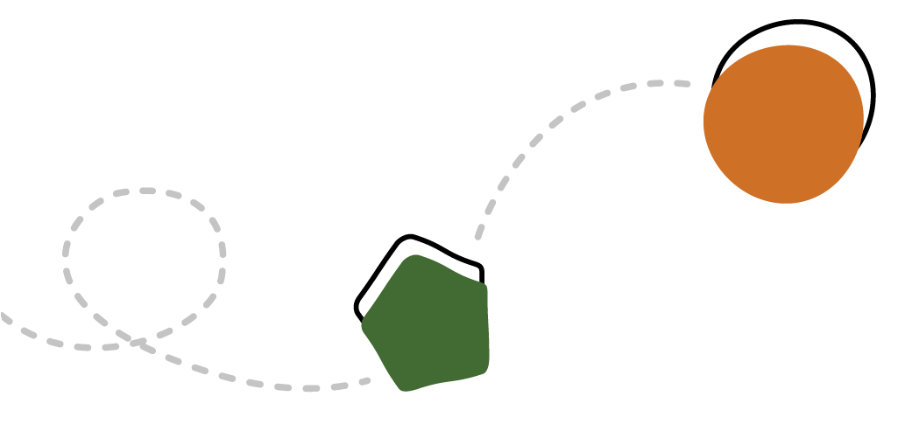Together, we can forge a positive child safety culture. This can be achieved through initiatives such as better implementation of the National Principles for Child Safe Organisations,9 which was a key achievement under the first

National Framework.

The roles and responsibilities of governments, NGOs, families and communities are outlined in Appendix A.

The National Framework will focus on delivering real outcomes through better coordination with other programs and supporting families to keep their children and young people safe. It will focus on areas where there is the biggest need to have the greatest impact and avoid duplication.

A glossary of the key terms used throughout this document is at Appendix B. The key initiatives relating to the National Framework are at Appendix C.

1. R Price-Robertson, D Kirkwood, A Dean, T Hall, N Paterson and K Broadley, Working together to keep children and families safe: Strategies for developing collaborative competence, Australian Institute of Family Studies, 2020, p. 22.
2. Price-Robertson et al., [Working together to keep children and families safe](https://aifs.gov.au/cfca/publications/working-together-keep-children-and-families-safe); NSW Government, [Their Futures Matter: A new](https://www.theirfuturesmatter.nsw.gov.au/__data/assets/pdf_file/0006/723606/Their-Futures-Matter-A-new-approach-Reform-directions-from-the-Independent-Review.pdf) [approach](https://www.theirfuturesmatter.nsw.gov.au/__data/assets/pdf_file/0006/723606/Their-Futures-Matter-A-new-approach-Reform-directions-from-the-Independent-Review.pdf), 2018.
3. Australian Human Rights Commission, [National Principles for Child Safe Organisations](https://childsafety.pmc.gov.au/what-we-do/national-principles-child-safe-organisations), Australian Human Rights Commission, 2018. Implementation of the National Principles for Child Safe Organisations will be progressed under the National Strategy to Prevent and Respond to Child Sexual Abuse.

**Children and young people in out-of-home care can experience a range of adverse outcomes. Early, targeted supports for families experiencing disadvantage and/or vulnerability can help to prevent further harm for children and young people in Australia.**

Child abuse and neglect in Australia – what we know

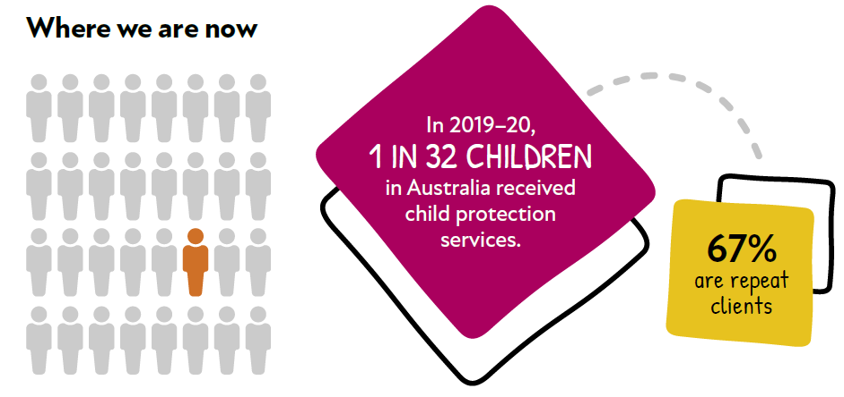

In 2019–20:

* **275,000 Children subject to notifications**
* **117,900 Children investigated**
* **48,900 Children substantiated**
* **Children under 1 were most likely to be subjects of substantiations, at 16 per 1000 children.**

Types of abuse substantiated in 2019–20:

* **53.9% Emotional**
* **22.5% Neglect**
* **14.1% Physical**
* **9.2% Sexua**

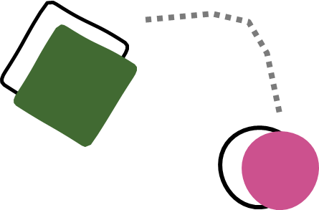

Trends

Between 2015–16 and 2019–20, the numbers of children involved in the system have increased by:

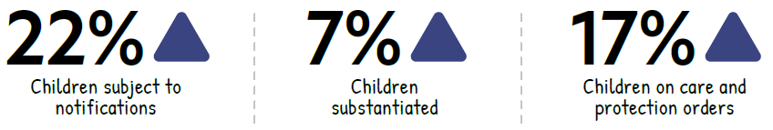

#### Out-of-home care

* There are 46,000 children in out-of-home care as at 30 June 2020.

Out of these children, **67% or 30,600 have been in care longer than 2 years.**

* The rate of Aboriginal and Torres Strait Islander children in out-of-home care is

**11 times higher** than non-Indigenous children.

#### Intergenerational impacts

Current data and modelling on the trajectories of children who have contact with child protection services show they are:

#### 10 TIMES

More likely to have their  
child enter out-of-home  
care compared  
to the general  
population.a

#### 4 TIMES

More likely to  
stay on income  
support payments  
for longer periods  
compared to other  
young people

1. Their Futures Matter: A New Approach, The intergenerational cycle of abuse and neglect, from https:/[/www.](http://www/) childabuseroyalcommission.gov.au/sites/default/files/WEB.0189.001.1036.pdf
2. AIHW, Income support receipt for young people transitioning from out-of-home care, from [https://www.aihw.gov.au/reports/](https://www.snaicc.org.au/understanding-applying-aboriginal-torres-strait-islander-child-placement-principle/) [child-protection/incomesupport-receipt-oohc/summary](https://www.snaicc.org.au/understanding-applying-aboriginal-torres-strait-islander-child-placement-principle/)

Data from AIHW, Child protection Australia 2019–20, rounded to nearest hundred

Data trends

The Australian Institute of Health and Welfare (AIHW) has been working with states and territories to facilitate child protection data and definitions that are nationally consistent.

This includes the 2018–19 national implementation of a consistent definition for out-of-home care and the 2012–13 implementation of the Child Protection National Minimum Data Set. AIHW notes that, due to the introduction of a nationally consistent definition of out-of-home care in 2018-19, that 2019–20 data should not be compared with data in Child protection Australia reports prior to 2018-19.

AIHW’s *Child protection Australia 2019–20* report does, however, include out-of-home care trend data that have been back-cast to 2016–17, allowing comparison from that time to the present.10 The data in the National Framework are reported in the same manner as those reported in AIHW’s *Child protection Australia 2019–20*. Further information on child protection data comparability is in Appendix C of the *Child protection Australia 2019*–*20* report. 11

The proportion of children receiving child protection services (that is, investigations of reports of child abuse/neglect, being on a protection order and/or being in out-of-home care) in 2017 was 3.1% of all children in Australia. Over 4 years this rose by about 4% — from 168,300 children in 2016–17 to 174,700 children

in 2019–20.12 Between 30 June 2017 and 30 June 2020, the number of children in out-of-home care rose 7% from 43,100

to 46,000.13

While the rate of all children receiving child protection services (31 per 1,000) and in out-of- home care (8 per 1,000) remained relatively stable between 2016–17 and 2019–20,14 the rate of Aboriginal and Torres Strait Islander children receiving child protection services and in out-of- home care has continued to rise.

Aboriginal and Torres Strait Islander children are over-represented in child protection services, including out-of-home care. In 2019–20, 55,300 or 16.6% of all Aboriginal and Torres Strait Islander children received child protection services. This is an increase from 15.1% of all Aboriginal and Torres Strait Islander children in 2016–17.

As at 30 June 2020, 18,900 or 5.6% of Aboriginal and Torres Strait Islander children were in

out-of-home care. This is 11 times the rate of non-Indigenous children.15 Evidence shows that once a child has engaged with child protection services, they are likely to engage with these services again. In 2019–20, 67% of children

receiving child protection services had previously been involved with the child protection system.16

**18,900 or 5.6% of  
Aboriginal and  
Torres Strait Islander  
children were in  
out-of-home care.**

As at 30 June 2020

1. Australian Institute of Health and Welfare (AIHW), [Child protection Australia 2010-](https://www.aihw.gov.au/reports/child-protection/child-protection-australia-2010-11/contents/summary)11, AIHW, 2012, p. 49.
2. AIHW, Child protection Australia 2019–20: [Appendixes B to](https://www.aihw.gov.au/getmedia/4600243d-a715-4334-afb5-7324b706ae04/aihw-cws-78-appendixes.pdf.aspx) E, Child welfare series no. 74, Cat. No. CWS 78, AIHW, Canberra, 2021.
3. AIHW, Child protection Australia 2019–20, Child welfare series no. 74, Cat. No. CWS 78, AIHW, Canberra, 2021, p. 16.
4. AIHW, Child protection Australia 2019–20, p. 58.
5. AIHW, Child protection Australia 2019–2[0](https://www.aihw.gov.au/getmedia/c3b0e267-bd63-4b91-9ea6-9fa4d14c688c/aihw-cws-78.pdf.aspx?inline=true), p. 16, 58.
6. AIHW, Child protection Australia 2019–20, p. 54.
7. AIHW, Child protection Australia 2019–20, p. 7.

Consultations

Over 2 years of consultation has shaped the National Framework. This includes:

* + nationwide consultations led by Families Australia, the national peak body for improving the wellbeing of Australian families
  + an evaluation of the first National Framework led by PricewaterhouseCoopers, focusing on the Third and Fourth Action Plans
  + Aboriginal and Torres Strait Islander consultations led by SNAICC – National Voice for our Children.

These consultations identified how to better support vulnerable children and young people. They recommended the National Framework focus on:

* + listening and responding to the voice of children, young people and families in all aspects of the National Framework
  + prioritising issues where a national approach will deliver the greatest impact, through

the combined efforts of all Australian governments, NGOs, the research sectors and the broader community

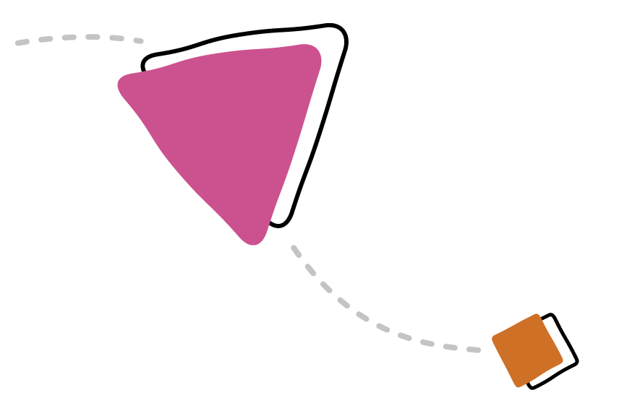prioritising groups with the greatest need, including children and families who are experiencing disadvantage or vulnerability and Aboriginal and Torres Strait Islander children, families and communities

* strengthening the focus on wellbeing, including child safety and protection
* achieving transformational change and improving early and holistic support for families and children
* addressing Aboriginal and Torres Strait Islander over-representation in child protection
* genuine self-determination and empowerment for Aboriginal and Torres Strait Islander people
* building the capability of the workforce, including an Aboriginal and Torres Strait Islander workforce and improved cultural competency of non-Indigenous workers
* enabling the full implementation of the Aboriginal and Torres Strait Islander Child Placement Principle across all jurisdictions
* building Aboriginal and Torres Strait Islander community-controlled organisations
* strengthening culturally safe and healing- focused services for Aboriginal and Torres Strait Islander children and families
* making stronger links between the Framework’s outcomes and actions and better monitoring and reporting
* developing data and improving information sharing, including benchmark data to measure against outcomes.

More information on these consultations is at Appendix D.

Based on these findings and other research,  
the National Framework aims to:

* focus on specific priority groups so that resources can be directed to the children most likely to need support
* 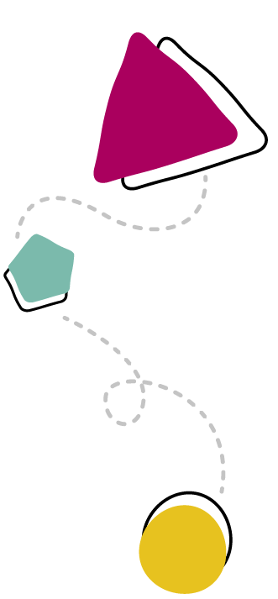target areas of wellbeing for these groups
* have 4 key focus areas for collective effort:
  1. a national approach to early intervention and targeted support
  2. addressing Aboriginal and Torres Strait islander over-representation in child protection systems
  3. improved information sharing, data development and analysis
  4. strengthening the child and family sector and workforce capability
* link actions to outcomes through an outcomes framework and measure progress through a monitoring and evaluation strategy
* develop governance and partnerships that include listening and responding to children and young people.

More consultations were held to inform the first 5-year Action Plans. The National Children’s Commissioner led consultations with children and young people across Australia. Public consultations were held through the Australian Government Department of Social Services’ online platform *DSS Engage*.



# Priority Groups



The National Framework is for all children and young people but it focuses on **children and families who are experiencing disadvantage and/or are vulnerable**, particularly the 4 groups that are at significant risk of entering out-of-home care.17

The 4 priority groups are:

* children and families with multiple and complex needs
* Aboriginal and Torres Strait Islander children and young people experiencing disadvantage or who are vulnerable
* children and young people and/or parents/ carers with disability, experiencing disadvantage or who are vulnerable
* children and young people who have experienced abuse and/or neglect, including children in out-of-home care and young people leaving out-of-home care and transitioning to adulthood.

These groups have been identified through evidence and data on the children that are significantly over-represented in child protection systems and through the consultations for the National Framework. Recognising these groups will guide the direction of future actions.

These groups are not mutually exclusive.

Australian families have diverse experiences. Actions under the National Framework will adapt to the different needs of Australian families. This includes children and young people from culturally and linguistically diverse backgrounds, children and young people who are of diverse genders and sexualities and those living in regional and remote areas.

We recognise that children’s safety and wellbeing is dependent on many aspects of life including social, economic, cultural and physical aspects. The National Framework aims to support these groups to be strong

and resilient. We will aim to achieve a broad range of safety and wellbeing outcomes for these priority groups, including in health, education, participation and connection to culture. This will be a key consideration when developing an outcomes framework for the Action Plans.

**Children and families with multiple and complex needs**

Some families have multiple and complex needs. These can be due to mental health issues, alcohol and drug misuse, domestic and family violence, disability, social exclusion, poverty, housing uncertainty, unemployment and underemployment.18

Families with multiple and complex needs have become the main clients of child protection services.19 A 2020 audit in Queensland found almost three-quarters of children coming to the attention of child protective services were from families with multiple risk factors.20

Different levels of government deliver support services under different agreements, governance and policies. Interagency systems that are integrated and coordinated should increase uptake and engagement with services.21

1. The definition of children and young people, including age range, is included in the Glossary.
2. L Bromfield, K Sutherland & R Parker, Families with multiple and complex needs: Best interests case practice model, Victorian Government Department of Human Services, Melbourne, 2012.
3. Bromfield et al., Families with multiple and complex needs, p. 7.
4. Queensland Audit Office, Family support and child protection system, Queensland Government, Brisbane, 2020.
5. K Arabena and C Austin, ‘Improving the engagement of Aboriginal families with maternal and child health services: a new model of care’, Public Health Research & Practice, 2021, 31(2):e30232009.

#### Aboriginal and Torres Strait Islander children and young people

Reducing the over-representation of Aboriginal and Torres Strait Islander children and young people in child protection systems is an urgent priority.

The AIHW reports that on 30 June 2020, 18,900 Aboriginal and Torres Strait Islander children were in out-of-home care, a rate of 56 per 1,000 children. This is 11 times the rate for non-Indigenous children, at 5 per 1,000 children.22 For longitudinal context, on 30 June 2017, there were 16,700 Aboriginal and Torres Strait Islander children in out-of-home care – a rate of 51 per 1,000 or 10 times the rate of non-Indigenous children. 23

Closing the Gap includes a target to reduce the over-representation of Aboriginal and Torres Strait Islander children in out-of-home care by 45% by 2031 (Target 12). The 45% reduction refers to the reduction in rate per 1,000 from the 30 June 2019 baseline rate of

54.2 per 1,000. This means the rate needs to decrease to 29.8 per 1,000 Aboriginal and Torres Strait Islander children by 2031. The National Framework and its Aboriginal and Torres Strait Islander Action Plan are key tools to support reaching this target.

#### Children and young people with disability and/or parents/carers with disability

Children with a disability are over-represented in out-of-home care compared with children without disability. As at June 2020, there were 6,424 children with a disability in out-of-home care, or 15.3%.24 The Royal Commission into Violence, Abuse, Neglect and Exploitation of People with Disability heard that, on average, 12% of children in out-of-home care were reported as having a disability.25

While directly comparable data is not available, the rate of disability in children and young people in the general population was 7.7% for the 0–14 age group and 9.3% for the 15–24

age group.26

Similarly, children of parents or carers with disability, particularly intellectual disability, can be over-represented in child protection systems.27 In 2015, it was estimated that

**Children with disability  
are over-represented in  
out-of-home care  
compared with  
children without  
disability.**

1. AIHW, [Child protection Australia 2019–20](https://www.aihw.gov.au/reports/child-protection/child-protection-australia-2019-20/summary), p. 54; AIHW, [Data tables: Child protection Australia 2019-20](https://www.aihw.gov.au/reports/child-protection/child-protection-australia-2019-20/data), 2021, Tables S5.5 &P4.
2. AIHW, [Child protection Australia 2019–20](https://www.aihw.gov.au/reports/child-protection/child-protection-australia-2019-20/summary), p. 54; AIHW, [Data tables: Child protection Australia 2019-20](https://www.aihw.gov.au/reports/child-protection/child-protection-australia-2019-20/data), Table T2.
3. AIHW, [Data tables: Child protection Australia 2019-20](https://www.aihw.gov.au/reports/child-protection/child-protection-australia-2019-20/data), Table S5.8. Note: In 2019–20, data on disability status were available for 57% of children in out-of-home care at 30 June. The available data show that about 15% of children in out-of-home care at 30 June 2020 were reported as having a disability (excludes South Australia).
4. Royal Commission into Violence, Abuse, Neglect and Exploitation of People with Disability, [Interim report,](https://disability.royalcommission.gov.au/publications/interim-report) Commonwealth of Australia, Canberra, 2020.
5. Australian Bureau of Statistics, [Disability, Ageing and Carers, Australia: Summary of Findings,](https://www.abs.gov.au/statistics/health/disability/disability-ageing-and-carers-australia-summary-findings/latest-release) ABS, Canberra, 2018
6. AIFS, [Parental intellectual disability and child protection: key issues,](https://aifs.gov.au/cfca/publications/parental-intellectual-disability-and-child-protection-key-i) AIFS, Canberra, 2009.

15% (669,000) of children aged 0–14 lived with one or both parents with disability.28 There are many factors that may influence the capacity of a parent with intellectual disability to provide adequate care to their children. The problems associated with parental intellectual disability are likely compounded by other problems that make parenting difficult, such as unemployment, social isolation, stress, parental substance abuse and domestic and family violence.29

Many parents with disability will be able to provide sufficient and supportive care to their children, but others will need additional support. Timely provision of appropriate support services, including specialist disability services, may help to prevent the over-representation of parents and children with disability in the child protection system.30

**Children and young people who have experienced abuse and/or neglect including children in out-of-home care and young people leaving out-of-home care and transitioning to adulthood**

Research demonstrates that children who have experienced child abuse and neglect are more likely to have poorer life outcomes.31 Children who have been in out-of-home care are more likely to face intergenerational cycles of child protection engagement. A study in New South Wales showed that almost one-third of children and young people involved with the New South Wales child protection system in 2014–15 had at least one parent who had been reported to child protection or was in out-of-home care

as a child.32

Young people leaving out-of-home care can face greater vulnerability as they move to independent living. This can be caused by traditional support such as family, friendship circles and communities being fractured. This limits the social support individuals can rely on to break the cycle of disadvantage, which can span several generations.33 Young people who have been in out-of-home care are 3 times more likely to receive income support in young adulthood as the general Australian population of the same age.34 Additionally, they are less likely to remain on student payment and more likely to remain on unemployment payments.35



1. AIHW, [Australia’s Children,](https://www.aihw.gov.au/reports/children-youth/australias-children/contents/health/the-health-of-australias-children) AIHW, Canberra, 2020.
2. AIFS, [Parental intellectual disability and child protection: key issues](https://aifs.gov.au/cfca/publications/parental-intellectual-disability-and-child-protection-key-i).
3. AIFS, [Parental intellectual disability and child protection: key issues](https://aifs.gov.au/cfca/publications/parental-intellectual-disability-and-child-protection-key-i).
4. Select Committee on Intergenerational Welfare Dependence, [Living on the Edge: Entrenched disadvantage,](https://www.aph.gov.au/Parliamentary_Business/Committees/House/Former_Committees/Intergenerational_Welfare_Dependence/IGWD/Final_Report) Parliament of Australia, Canberra, 2019.
5. Family and Community Services, [The prevalence of intergenerational links in child protection and out-of-home care in NSW](https://www.facs.nsw.gov.au/__data/assets/pdf_file/0016/421531/FACS_SAR.pdf), NSW Government, Sydney, 2017, p. 1
6. M Van Wert, I Anreiter, B A Fallon and M B Sokolowski, ‘Intergenerational transmission of child abuse and neglect: a transdisciplinary analysis’, Gender and the Genome, 2019, 347(6229): 1480–85.
7. AIHW, [Income support receipt for young people transitioning from out-of-home car](https://www.aihw.gov.au/reports/child-protection/incomesupport-receipt-oohc/summary)e, AIHW, Canberra, 2021, p. vii.
8. AIHW, [Income support receipt for young people transitioning from out-of-home care](https://www.aihw.gov.au/reports/child-protection/incomesupport-receipt-oohc/summary).



# Focus Areas

Based on research, evidence and consultations, the National Framework has 4 focus areas to improve outcomes for the 4 priority groups.

## Focus Area 1: A national approach to early intervention and targeted support for children and families experiencing vulnerability or disadvantage

The National Framework aims to define effective, targeted support for children and families who have experienced or are at risk of harm.

We will focus on the known causes and drivers of child abuse and neglect to better target responses to keep children safe and minimise long-term impacts. Combined action from all Australian governments and NGOs will support families in a holistic, coordinated and timely way.

Early intervention and targeted supports include programs that help parents to address risk factors such as domestic and family violence, alcohol and other drug use, mental health issues or homelessness. States and territories generally deliver these programs.

All Australian governments have agreed the importance of providing effective supports to people with disability.36 This is critical if we are to achieve an inclusive Australian society that enables all people with disability — including children and parents — to fulfil their potential as equal citizens.

To support achieving this vision, the National Disability Insurance Scheme, family support services and child protection services work closely together at the local level. This includes to plan and coordinate streamlined services for children and families with disability.

State and territory governments remain responsible for meeting the needs of children with disability in out-of-home care and support to carers of children in out-of-home care, where these supports are not additional to the needs of children of similar age in similar out-of-home care arrangements. All Australian governments will continue to work together to help children and young people with disability, as well as parents or carers with disability, to access the National Disability Insurance Scheme and/or appropriate mainstream supports.



1. Australian Government, [Applied Principles and Tables of Support,](https://www.ndis.gov.au/understanding/ndis-and-other-government-services/ndia-working-state-and-territory-governments) Commonwealth of Australia, Canberra, 2015.

Priorities for action under this focus area include:

* + - * better integration of government services through redesigning systems to allow for shared agency and jurisdictional data
      * developing multidisciplinary models that work for families with multiple and complex needs so that families can navigate service systems and get the right help at the right time
      * understanding and addressing barriers experienced by children and families when accessing early intervention and targeted supports to improve service uptake
      * strengthening the interface between children and family services and services for:
  + drugs and alcohol
  + domestic and family violence
  + health (including mental health)
  + disability
  + education
  + justice
  + housing
  + employment services
    - * delivering and expanding services that are shown to work, based on evaluation, data and evidence
      * improving systems and services to respond to the needs of Aboriginal and Torres Strait Islander children, children and parents with disability and children who have been abused and neglected, including by recognising the importance of healing for these children and their families and communities.



## Focus Area 2: Addressing the over-representation of Aboriginal and Torres Strait Islander children in child protection systems

All Australian governments will work collaboratively to reduce the factors causing over-representation of Aboriginal and Torres Strait Islander children in out-of-home care. Over the life of the National Framework, all governments commit to progressive systems transformation that has Aboriginal and Torres Strait Islander self-determination at its centre. This includes taking active steps towards families, communities and Aboriginal and Torres Strait Islander community-controlled organisations partnering in child protection system design and administration. Additionally, it includes a commitment to undertake reform in each jurisdiction’s next review of relevant legislation and policy, with a view to:

* fully embedding the 5 elements of the Aboriginal and Torres Strait Islander Child Placement Principle (outlined on page 30)
* supporting delegation of authority in child protection to families, communities and Aboriginal and Torres Strait Islander community-controlled organisations
* supporting the principle of self- determination.

Collective efforts will be consistent with commitments under Closing the Gap Target 12 and the Closing the Gap Priority Reforms.

Governments acknowledge that Aboriginal and Torres Strait Islander community-controlled services are better for Aboriginal and Torres Strait Islander people, achieve better results, employ more Aboriginal and Torres Strait Islander people and are often preferred over mainstream services.37

The Australian Government is supporting Aboriginal and Torres Strait Islander community- controlled organisations to play a central role in social service provision, with funding committed in the first Commonwealth Closing the Gap Implementation Plan to assess their needs

and increase their involvement in child and family services and to embed cultural competency in Commonwealth-funded child and family services.

Through Closing the Gap, state and territory governments have committed to transforming child protection systems and services. This includes enabling self-determination in child protection decision-making, actively supporting children and families to remain safely together and ensuring that child protection systems meet the needs of Aboriginal and Torres Strait Islander children and young people, their families and communities.

Priorities for action under this focus area include:

* promoting and enabling full implementation of the Aboriginal and Torres Strait Islander Child Placement Principle, including identifying, implementing and reporting on active efforts across each of its 5 elements, and through legislation, policy, programs, processes and practice
* aligning activities with the 4 Priority Reforms of Closing the Gap, including:38
  + formal partnerships and shared decision- making with Aboriginal and Torres Strait Islander representatives for the oversight, monitoring, evaluation and implementation of the National Framework

1. Joint Council on Closing the Gap, [National Agreement on Closing the Gap](https://www.closingthegap.gov.au/national-agreement), Clause 43, p. 8.
2. Joint Council on Closing the Gap, Na[tional Agreement on Closing the Gap](https://www.closingthegap.gov.au/national-agreement), Clause 25, p. 5.
   * building the Aboriginal and Torres Strait Islander community-controlled sector so that it is equipped to deliver more services to Aboriginal and Torres Strait Islander children and families. This includes agreeing and implementing measures to increase the proportion of services delivered to Aboriginal and Torres Strait Islander people by Aboriginal and Torres Strait Islander organisations, particularly community- controlled organisations. Under the National Framework, this includes (as per clause 55 of Closing the Gap):39

º implementing funding prioritising policies that require decisions about the provision of services to Aboriginal and Torres Strait Islander people and communities to preference Aboriginal and Torres Strait Islander community- controlled organisations and other Aboriginal and Torres Strait Islander organisations

º where new, relevant funding initiatives are decided by governments which are intended to service the broader population, that a meaningful proportion is allocated to Aboriginal and Torres Strait Islander organisations with relevant expertise, particularly community-controlled organisations

* + transforming government organisations to identify and eliminate institutional racism and embed and practice meaningful cultural safety
  + shared access to data and information at a regional level.
* improving outcomes for Aboriginal and Torres Strait Islander children and families by collectively:
  + improving access to quality, culturally safe, universal and targeted services
  + supporting Aboriginal and Torres Strait Islander people and organisations to participate in and have increased say over policies that affect Aboriginal and Torres Strait Islander children
  + further developing the Aboriginal and Torres Strait Islander evidence base for community designed and delivered approaches to child and family welfare
  + making policies and practice under the National Framework culturally safe and responsive
  + establishing clear responsibilities and strong monitoring, evaluation and reporting of outcomes
  + building capacity in the Aboriginal and Torres Strait Islander workforce in the child and family sector to support increased focus on cultural safety and Aboriginal and Torres Strait Islander-led services.

## **The Five Core Elements of the Aboriginal and Torres Strait Islander Child Placement Principle**

PREVENTION

Protecting children’s rights to grow up in family, community and culture by redressing causes of child protection intervention.

PARTNERSHIP

Ensuring the participation of community representatives in service design, delivery and individual case decisions.

PLACEMENT

Placing children in out-of-home care in accordance with the established ATSICPP placement hierarchy:

* + - with Aboriginal and Torres Strait Islander relatives or extended family members, or other relatives and family members; or
    - with Aboriginal and Torres Strait Islander members of the child’s community; or
    - with Aboriginal and Torres Strait Islander family-based carers.If the above preferred options are not available, as a last resort the child may be placed with:
    - a non-Indigenous carer or in a residential setting.

If the child is not placed according to the highest priority, the placement must be within close geographic proximity to the child’s family.

PARTICIPATION

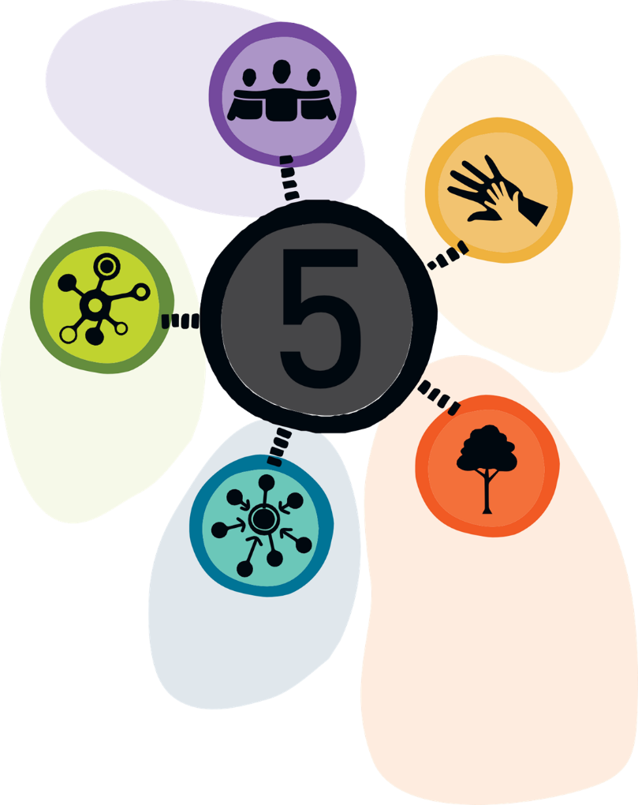Ensuring the participation of children, parents and family members in decisions regarding the care and protection of their children.

CONNECTION

Maintaining and supporting connections to family,  
community, culture and country for  
children in out-of-home care.

SOURCE SNAICC – National Voice for Our Children Understanding and  
Applying the Aboriginal and Torres Strait Islander Child Placement  
Principle: A Resource for Legislation, Policy and Program  
Development (2017), p. 3

<https://www.snaicc.org.au/understanding-applying-aboriginal-torres- strait-islander-child-placement-principle/>

**The Aboriginal and Torres Strait Islander Child Placement Principle**

The 5 elements of the Aboriginal and Torres Strait Islander Child Placement Principle are Prevention, Partnership, Participation, Placement and Connection.

The Aboriginal and Torres Strait Islander Child Placement Principle aims to:

* + embed an understanding that culture is integral to safety and wellbeing for Aboriginal and Torres Strait Islander children and young people and is embedded in policy and practice
  + recognise and protect the rights of Aboriginal and Torres Strait Islander children, family members and communities in child safety matters
  + support self-determination of Aboriginal and Torres Strait Islander people in child safety matters
  + reduce the over-representation of Aboriginal and Torres Strait Islander children in child protection and out-of-home care systems.

In the *Wiyi Yani U Thangani Report: Women’s Voices*, led by June Oscar AO, Aboriginal and Torres Strait Islander women called for a system that allows self-determination in child welfare, acknowledges the importance of children remaining connected to family, country and culture and prioritises reunification of children with their families.40 While the Aboriginal and Torres Strait Islander Child Placement Principle embodies these priorities, the Women’s Voices Report states that there is poor compliance with the Principle. A closer partnership between Aboriginal and Torres Strait Islander people and all levels of government is needed to keep children connected to their families, communities and country.

## **Focus Area 3: Improved information sharing, data development and analysis**

Increasing the capacity to collect, share and measure outcomes in child safety is a priority. Improved information sharing, data development and analysis will help us measure progress and the effectiveness of policies, identify areas of concern faster and tailor our responses to prevent children, young people and families entering child protection systems.

Since the launch of the first National Framework, the Australian, state and territory governments have made progress in how we collect, share and use data. Improvements to the Child Protection National Minimum Data Set since 2012–13 have provided a more comprehensive and accurate picture of children in the child protection system.

These improvements allowed reporting on new National Framework indicators and measures for the National Standards for out-of-home care.

These measures include numbers of children receiving child protection services in each state and territory; the number of child abuse substantiations per child; types of abuse and neglect; and socioeconomic status.

The Child Protection National Minimum Data Set was a major step towards improving the comparability of child protection data across states and territories.41

Data-linking projects have helped us understand the experiences of children in out-of-home care and other systems (such as education, justice and health). We have used data to help identify vulnerable groups so they can be prioritised and targeted for additional supports.

Connect for Safety42 shows the importance of data matching in protecting vulnerable children from abuse and neglect, through enhanced information sharing between child protection agencies. Connect for Safety uses information- matching software to allow child protection authorities to identify when a child or adult is known to authorities in other jurisdictions.

This triggers the need to contact the other jurisdictions for further information.

It acts as a near real-time alert system and is a valuable resource for child protection workers.

While there have been improvements in data collection, further efforts are needed to broaden and deepen our understanding of at-risk children and families’ engagement with and experience of services, to improve information sharing practices and to assess the impact of the National Framework.

Priorities for action under this focus area include:

* improving information and data sharing and analysis across governments and NGOs to better understand what is and isn’t working
* contributing to work under the *National Strategy to Prevent and Respond to Child Sexual Abuse 2021–2030* to enhance national arrangements for sharing child safety and wellbeing information
* strengthening datasets at the national level under the National Framework – such as through a Strategic Information Group –

to target actions and measure the outcomes

1. AIHW, A new approach to national child protection data: implementation of the Child Protection National Minimum Data Set, AIHW, Canberra, 2014.
2. Australian Government: Itree Pty Ltd, Business.gov.au website, 2020, accessed 12 August 2021.
   * continuing to build the evidence base and addressing any research gaps, and improving our understanding of the long-term impacts of the Coronavirus pandemic and other disasters and crisis events, such as bushfires and droughts, on the safety of children

and families

* + 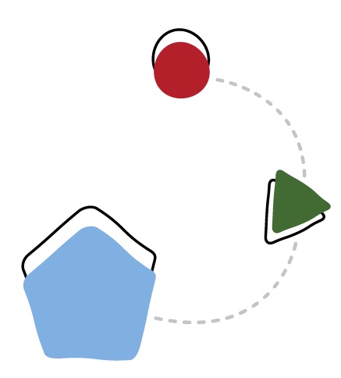consistent with Priority Reform 4 of Closing the Gap, supporting Aboriginal and Torres Strait Islander people to have access to, and the capability to use, locally relevant data and information to monitor the implementation of efforts to close the gap, set their priorities and drive their own development43
  + sharing resources, tools and practices regarding the Aboriginal and Torres Strait Islander Child Placement Principle to support best practice
  + better data integration across all levels of governments and services.

## **Focus Area 4: Strengthening the child and family sector and workforce capability**

This focus area aims to strengthen the child and family sector, including by improving the capability and capacity of the workforce. NGOs are a key partner in delivering the National Framework and continued partnership with these organisations is important.

Support services for families include counselling, alcohol and other drugs services, intensive family support, family violence services, mental health and housing. This focus area will seek to improve trust in services and encourage vulnerable children, young people and families to seek assistance earlier. We will do this by working with NGOs and Aboriginal and Torres Strait Islander community-controlled organisations that work with priority groups.

Child and family welfare practitioners come from a range of professional backgrounds with different qualifications, knowledge and skills.

They have varying degrees of training in the impacts of child abuse and neglect, child trauma and child development. Practitioners in this sector may belong to other sectors as well, such as education or mental health.44

Priorities for action under this focus area include:

* + increasing the capability and capacity of the workforce to meet the needs of vulnerable and disadvantaged children and young people, including through improving the skills, knowledge and practice of staff
  + improving awareness and understanding among the child and family sector and increasing trust in services and systems
  + building knowledge across other sectors that work with the target groups
  + improving the capability of the workforce to deliver trauma-informed services
* developing genuine relationships between government organisations and Aboriginal and Torres Strait Islander people, organisations and/or businesses to enhance the quality and cultural safety of mainstream service delivery45
* building a sustainable workforce, including attracting, supporting and retaining frontline staff, carers and kinship carers
* supporting more holistic responses across relevant disciplines and sectors.

For Aboriginal and Torres Strait Islander children and families, actions will align with Closing the Gap to:

* build strong community-controlled sectors to deliver Closing the Gap services and programs, particularly through the Sector Strengthening Plan in early childhood care and development46
* identify and eliminate institutional racism and embed and practice meaningful cultural safety, including through delivering services in partnership with Aboriginal and Torres Strait Islander organisations, communities and people47
* upskilling the mainstream child and family workforce with robust and evidence-based training
* prioritise building the Aboriginal and Torres Strait Islander workforce in the child and family sector to support increased focus on cultural safety and Aboriginal and Torres Strait Islander led early intervention.48

1. Joint Council on Closing the Gap, [National Agreement on Closing the Gap](https://www.closingthegap.gov.au/national-agreement), p. 22.
2. Joint Council on Closing the Gap, [National Agreement on Closing the Gap](https://www.closingthegap.gov.au/national-agreement), Clause 59a, p. 11.
3. Joint Council on Closing the Gap, [National Agreement on Closing the Gap](https://www.closingthegap.gov.au/national-agreement), pp. 9–10.
4. Joint Council on Closing the Gap, [National Agreement on Closing the Gap](https://www.closingthegap.gov.au/national-agreement), pp. 9–10.
5. Joint Council on Closing the Gap, [National Agreement on Closing the Gap](https://www.closingthegap.gov.au/national-agreement), Clause 44, p. 9.



# How we will do it

The National Framework is underpinned by guiding principles, governance structures and monitoring strategies so all parties can work towards the goal and track progress.

## **Principles**

The consultations highlighted that how we work together to keep children safe and achieve the best possible outcomes is just as important as what we do. The six principles below reflect how we should work to achieve the National Framework’s goal.

Policies and actions must be evidence-based, culturally safe and fit-for-purpose. We will be clear about our roles and responsibilities and provide families with the right supports at the right time.

**PRINCIPLE 1: Access to quality, universal and targeted services designed to improve outcomes for children, young people and families**

Early support is critical to strengthen families and help children to thrive. This includes helping children, young people and families get access to material basics, health services and education, which is their fundamental right.

**PRINCIPLE 2: Excellence in practice and policy development, based on evidence, data and information sharing**

Actions under the National Framework will be data-driven and based on current evidence. This evidence base includes the knowledge, insights and experiences of children, young people and families, Aboriginal and Torres Strait Islander peoples and children with disability and their carers.

**PRINCIPLE 3: Listening and responding to the voices and views of children and young people and the voices and views of those who care for them**

Children and young people have the right to participate in decisions that affect them.

We recognise the critical role that parents, carers, grandparents and kin play in keeping Australia’s children safe and supported.

**PRINCIPLE 4: Clear responsibilities and strong monitoring, evaluation and achievement of outcomes**

Australian, state and territory governments,

as well as NGOs, share responsibilities under the National Framework. Ongoing monitoring and evaluation will track the National Framework’s progress towards the goal.

**PRINCIPLE 5: Trauma-informed, culturally safe and inclusive policies and actions**

Trauma-informed policies and practices are particularly important for children who have experienced abuse and for helping them to recover.49 Policies that are culturally safe create an environment that does not challenge a person’s identity or needs. This can be through shared respect, shared knowledge and supporting people to express their culture.50 Inclusive policies aim to support people with disability to participate and reach their potential as equal citizens.

**PRINCIPLE 6: Embedding the 5 elements of the Aboriginal and Torres Strait Islander Child Placement Principle – Prevention, Partnership, Placement, Participation and Connection**

The 5 elements of the Aboriginal and Torres Strait Islander Child Placement Principle outline how to support children to maintain and strengthen their connection to culture, country and community, which nurtures and supports their wellbeing, spirituality and identity development.

1. L Wall, D Higgins & C Hunter, [Trauma-informed care in child/family welfare services](https://aifs.gov.au/cfca/publications/trauma-informed-care-child-family-welfare-services), CFCA Paper No 37, AIFS, Canberra, 2016.
2. See Glossary for further information on cultural safety.

## **Early supports**

Identifying risk and protective factors for child abuse and neglect can take place at the individual, family and community levels.51

Risk factors can include family conflict or violence, health problems, housing stress, isolation and a lack of access to support. Protective factors can include strong family bonds, positive social connection and access to health and services.52 When risk factors are combined with limited protective factors, children are more likely to experience abuse or neglect.

Leading experts highlight the need to prioritise prevention and early intervention, with child protection services as a last resort.53

Children, young people and families experiencing disadvantage and vulnerability can be referred to support services to prevent them entering child protection systems. Evidence has shown, however, that services often operate in isolation from each other and could be more client- centred and/or evidence-informed.54

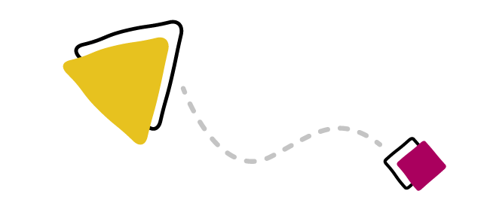

As an example, the Productivity Commission report into *Expenditure on Children in the Northern Territory* found duplication of effort and gaps in spending between and within governments. Additionally, it found that family support services were poorly targeted and did not always account for the cultural strengths or needs of children and families.55

Since the start of the first National Framework, states and territories have led significant reforms to their early support services, which provides a basis on which to build.

Nonetheless, some families do not feel safe accessing some supports and services. They may see a service as associated with having a ‘problem’, fear being judged for using a service or fear being reported to child protection services.56

Research shows that strengthening workforce capability through evidence-based service models and trauma-informed and culturally appropriate practices57 may assist in overcoming this reluctance.

Using trauma-informed, culturally appropriate or other practices that empower families will help to build trust. It will encourage families and communities to access services and improve outcomes for children and families.58

1. AIFS, [Risk and protective factors for child abuse and neglect.](https://aifs.gov.au/cfca/publications/risk-and-protective-factors-child-abuse-and-neglect)
2. AIFS, Risk and protective factors for child abuse and neglect.
3. T Herrenkohl, R Leeb & D Higgins, ‘Public health model of child maltreatment prevention’, Trauma, Violence and Abuse, 2016, 17(4):363–65.
4. Price-Robertson et al., [Working together to keep children and families safe](https://aifs.gov.au/cfca/publications/working-together-keep-children-and-families-safe); NSW Government, [Their Futures Matter](https://www.theirfuturesmatter.nsw.gov.au/__data/assets/pdf_file/0006/723606/Their-Futures-Matter-A-new-approach-Reform-directions-from-the-Independent-Review.pdf).
5. Productivity Commission, Expenditure on Children in the Northern Territory: Productivity Commission Study Report, Commonwealth of Australia, Canberra, 2020.
6. M McDonald, [Are disadvantaged families ‘hard to reach’? Engaging disadvantaged families in child and family services, AIFS,](https://aifs.gov.au/cfca/publications/are-disadvantaged-families-hard-reach-engaging-disadva) [Canberra, 2010](https://aifs.gov.au/cfca/publications/are-disadvantaged-families-hard-reach-engaging-disadva).
7. D Coates & D Howe, ‘Working with families who experience parental mental health and/or drug and alcohol problems in the context of child protection concerns: recommendations for service improvement. Australian and New Zealand Journal of Family Therapy, 2015, 36(3):325-41; C Gibson, H Francis, S McDougall, F Arney, R Grauwelman-Smith and S Parkinson, The Evaluation of the Protecting and Nurturing Children: Building Capacity, Building Bridges Initiative, Australian Centre for Child Protection, University of South Australia, Adelaide, 2014.
8. McDonald, [Are disadvantaged families ‘hard to reach’?](https://aifs.gov.au/cfca/publications/are-disadvantaged-families-hard-reach-engaging-disadva)



**Supports for Aboriginal and Torres Strait Islander children and young people**

The majority of Aboriginal and Torres Strait Islander children live safely with their families and grow up strong in their cultures, nurtured and cared for by their kin and communities.59

Culturally responsive and supportive services need to continue to be developed for Aboriginal and Torres Strait Islander children and young people at risk. Policies, services and systems must support healing for families impacted by trauma and disadvantage. This will help prevent its perpetuation in future generations.

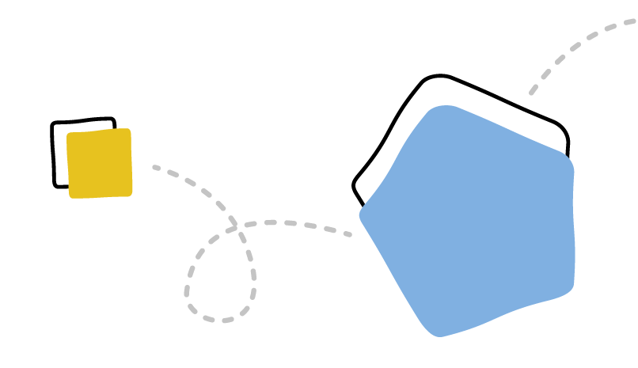The *Wiyi Yani U Thangani Report: Women’s Voices* notes that culture and community are what keeps children strong. Aboriginal and Torres Strait Islander women want a child protection system that acknowledges this and prioritises the reunification of children with families, communities and culture.60 The National Framework supports this in the context of the best interests of the child.

A range of factors can affect the safety and wellbeing of Aboriginal and Torres Strait Islander children and young people, including but not limited to:61

* institutional racism, discrimination and unconscious bias62
* entrenched disadvantage, political exclusion and intergenerational trauma63
* limited recognition of Aboriginal and Torres Strait Islander child-rearing practices and strengths64
* culturally unsafe services and systems, including a lack of community-led responses and community-controlled service provision.65

1. S Lohoar, N Butera & E Kennedy, Strengths of Australian Aboriginal cultural practices in family and child rearing, AIFS, Melbourne, 2014.
2. Oscar, Wiyi Yani U Thangani Report.
3. Human Rights and Equal Opportunity Commission, [Bringing them home: Report of the National Inquiry into the Separation of](https://humanrights.gov.au/our-work/bringing-them-home-report-1997) [Aboriginal and Torres Strait Islander children from Their Families](https://humanrights.gov.au/our-work/bringing-them-home-report-1997), HREOC, Sydney, 1997.
4. Joint Council on Closing the Gap, [National Agreement on Closing the Gap](https://www.closingthegap.gov.au/national-agreement), p. 11.
5. Joint Council on Closing the Gap, [National Agreement on Closing the Gap](https://www.closingthegap.gov.au/national-agreement), p. 2.
6. A Titterton, Indigenous access to family law in Australia and caring for Indigenous children. University of NSW Law Journal, 2017, 40(1), p.146–185.
7. Joint Council on Closing the Gap, [National Agreement on Closing the Gap](https://www.closingthegap.gov.au/national-agreement).

There is a substantial body of evidence66 on the factors that are critical to addressing and responding to these issues, which include:

* + focusing on family, community and culture67
  + increased holistic, early supports that extend beyond child protection services68
  + 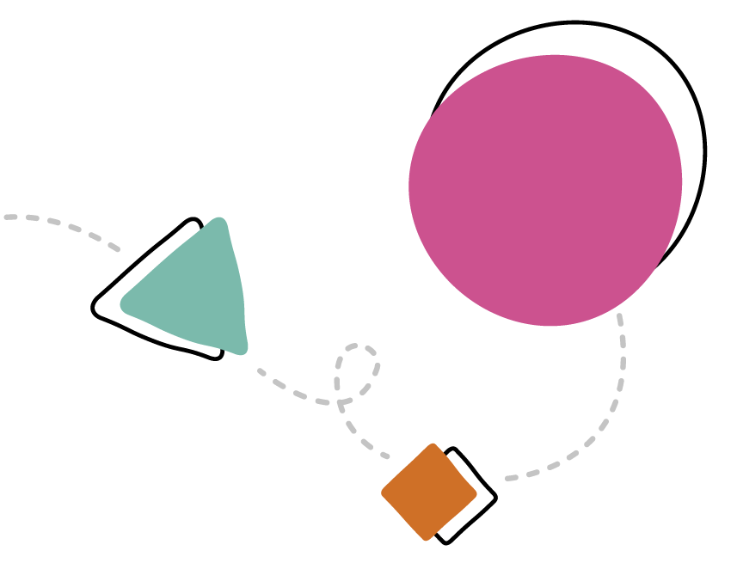focusing on healing trauma for families and communities69
  + community-led approaches to prevention and early intervention
* addressing the drivers of child abuse and neglect
* ensuring cultural safety and responsiveness of governments, policies and services for Aboriginal and Torres Strait Islander children and families.

1. Aboriginal and Torres Islander Healing Foundation, (ATSIHF) Growing Our Children Up Strong and Deadly: Healing for children and young people, ATSIHF, Canberra, 2013; J Atkinson, Trauma trails, recreating song lines: The transgenerational effects of trauma in Indigenous Australia, Spinifex Press, Geelong, 2002; C Tilbury, Moving to prevention research report: Intensive family support services for Aboriginal and Torres Strait Islander children, SNAICC, Melbourne, 2015; TG Moore, ‘Engaging and partnering with vulnerable families and communities: The keys to effective place-based approaches’, Keynote address at WACOSS Social Policy Forum on Child and Parent Centre, Perth, 19 June 2015; Human Rights and Equal Opportunity Commission, Social justice and human rights for Aboriginal and Torres Strait Islander peoples, HREOC, 2003.
2. Joint Council on Closing the Gap, [National Agreement on Closing the Gap](https://www.closingthegap.gov.au/national-agreement); C Tilbury et al., [Aboriginal and Torres Strait Islander](http://www.snaicc.org.au/wp-content/uploads/2015/12/03167.pdf) [Child Placement Principle: Aims and Core Elements](http://www.snaicc.org.au/wp-content/uploads/2015/12/03167.pdf)*,* SNAICC, 2013.
3. D Scott, ‘Think child, think family: How adult specialist services can support children at-risk of abuse and neglect’, *Family Matters*, 2009, *81*, pp. 37–42.
4. ATSIHF, Healing Centres: Final Report, ATSIHF, Canberra, 2012.

## **Implementation, governance and partnerships**

**Implementing the National Framework**

2, 5-year Action Plans will support the National Framework and detail how we will achieve our goal:

* + First Action Plan: 2022–2026
  + Second Action Plan: 2027–2031

The first Action Plan will be informed by a range of Australian, state and territory reports, reforms and by national consultations undertaken by the National Children’s Commissioner and online public consultation through DSS Engage.

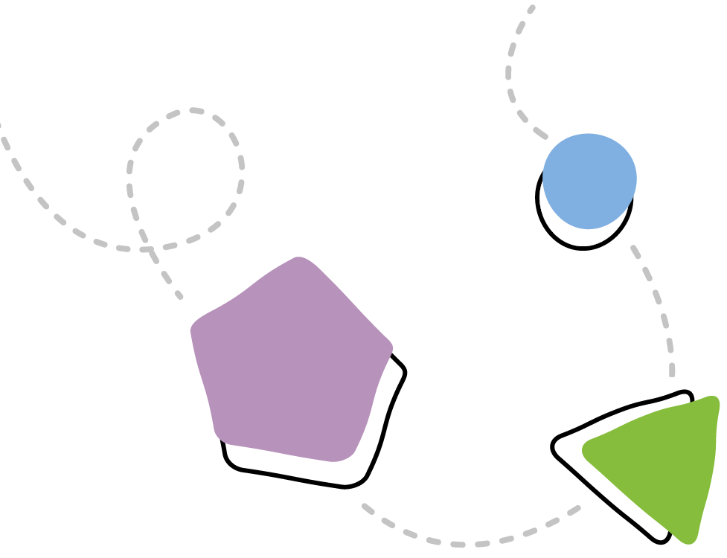The first Action Plan will include an outcomes framework, governance arrangements and a monitoring and evaluation strategy. These are discussed further in Tracking and Sharing Progress.

There will be an Aboriginal and Torres Strait Islander-specific Action Plan that will cover all aspects of the National Framework – including targeted strategies and actions to respond to Closing the Gap Target 12 and drive actions under Focus Area 2 – and outline governance and reporting arrangements. This will recognise that Aboriginal and Torres Strait Islander children and families have unique strengths and needs.

For further information on the Action Plans, the outcomes framework and monitoring and evaluation strategy, see Appendix E.

## **Governance and partnerships**

The first National Framework was supported by governance arrangements that cut across government boundaries and included NGOs.

This approach mirrored the shared responsibilities of governments and NGOs in keeping children safe. This approach will continue to help all parties work together to build trust with families and communities and improve access to supports and services.

The governance framework will be developed as part of implementation planning. Key features will remain consistent with the approach to governance established over the past 10 years. This includes:

* relevant Commonwealth and state and territory ministers overseeing and acting as formal decision-makers for the National Framework
* collaboration across governments continuing via the Children and Families Secretaries forum
* a continuing role for a representative National Coalition on Child Safety and Wellbeing in working with governments to achieve the National Framework goal
* a continuing role for a representative Aboriginal and Torres Strait Islander Leadership Group (Leadership Group).70

The governance framework will be enhanced to include:

* a truly whole-of-government approach, recognising coordinated effort is required across all areas of government, including health, education, justice, housing, disability, family safety, employment and child safety
* ways to better listen and respond to the voices of children, young people, families, carers and communities
* partnerships between governments and Aboriginal and Torres Strait Islander people in line with Priority Reform 1 of Closing

the Gap71

* mechanisms for independent oversight, including through existing mechanisms under Closing the Gap.

Governments will establish a formal partnership with national Aboriginal and Torres Strait Islander leaders to support each 5-year Action Plan. Accountability and governance structures and shared decision processes will be outlined in each 5-year Action Plan and will be in line with Priority Reform 1 under Closing the Gap.72

**Data development, analysis and information sharing**

Under the first National Framework, there was significant investment in developing child protection-related data and reporting. The Families Australia consultations highlighted that collecting the right data can improve our understanding of how at-risk children and

families engage with early supports and services and can help guide future actions and policies.73

Better sharing and linking of data across different levels of government and with NGOs can improve our understanding of children and young people’s experience of child protection and other service systems and of the service design and models that are required.

1. The Leadership Group was established under the first National Framework and comprises Aboriginal and Torres Strait Islander leaders and experts in the child and family sector. The Leadership Group will have an integral role in supporting and informing the development of Aboriginal and Torres Strait Islander governance structures, as well as in developing the dedicated 5-year implementation plans for Aboriginal and Torres Strait Islander children.
2. Joint Council on Closing the Gap, [National Agreement on Closing the Gap](https://www.closingthegap.gov.au/national-agreement), Clause 28, p. 5
3. Joint Council on Closing the Gap, [National Agreement on Closing the Gap](https://www.closingthegap.gov.au/national-agreement), Clause 32, p. 6.
4. Families Australia, [Beyond 2020: Towards a successor plan for the National Framework for Protecting Australia’s Children](https://familiesaustralia.org.au/about/beyond-2020/) [2009–2020. Final Report on National Consultations – May 2020](https://familiesaustralia.org.au/about/beyond-2020/), Families Australia, Canberra, 2020.

## **Tracking and sharing progress**

**Monitoring and evaluation**

There will be a strong focus on monitoring implementation and measuring progress of the National Framework.

An outcomes framework will support the Action Plans. This will document how we measure whether activities under the National Framework are helping to achieve

the Framework’s goal. The outcomes framework will be developed in partnership with Aboriginal and Torres Strait Islander leaders to support alignment with the Child Placement Principle and Closing the Gap.

The outcomes framework will outline the outcomes of actions under each focus area and agreed measures of success.

The actions will relate to the concepts outlined in the National Framework, including the principles and focus areas and Australia’s

obligations as a signatory to the UN Convention on the Rights of the Child, the UN Declaration on the Rights of Indigenous Peoples and the UN Declaration on the Rights of Persons

with Disabilities.

To improve understanding of child and family outcomes, a range of indicators will help to measure change over time and build on data development activities under the Fourth Action Plan of the first National Framework.

Annual data from the AIHW’s *Child protection Australia 2019–20* report and other reports will help track trends over the 10-year life of the National Framework.

The Australian Child Maltreatment Study74

is the first national study of the prevalence and impacts of all 5 forms of child maltreatment in Australia: child sexual abuse, physical abuse, emotional abuse, neglect and witnessing domestic and family violence. Results will be published on an ongoing basis from late 2022 and the final report will be available in 2023.

The monitoring and evaluation strategy will provide a way to regularly monitor and publicly report progress. Regular review of points of action under the National Framework, including independent evaluations, will be undertaken during the implementation.

All governments are committed to the accountability measures and reporting requirements agreed to as part of Closing the Gap.



1. [The Australian Child Maltreatment Study (ACMS)](https://www.australianchildmaltreatmentstudy.org/), n.d.



# Appendices

44

# Appendix A: Roles and responsibilities

## **The Australian Government**

The Australian Government delivers universal support and services to families, assisting them to raise their children, along with targeted early intervention services. These include:

* income and family support payments (pensions, family payments, Child Care Subsidy and tax rebates) and the child support scheme, to provide a broad social safety net and to support families in their parenting role
* services such as Medicare, settlement support, employment services, child and parenting support services, family relationship services and the family law system
* support to states and territories for key services such as hospitals, schools, social housing, homelessness support and disability services
* supports to eligible children with permanent and significant disability and

children requiring early intervention, through the National Disability Insurance Scheme, consistent with the requirements under

the *National Disability Insurance Scheme Act 2013*

* targeted programs for vulnerable individuals and families, including mental health, alcohol and other drug use, intensive parenting services, intensive employment assistance and allowances to help young people leaving care transition to independent living
* services for families at higher risk of disadvantage, including those in Aboriginal and Torres Strait Islander communities
* supporting research into child and family supports
* supporting prevention activities to reduce alcohol-related harms, including fetal alcohol spectrum disorder, such as the National Awareness Campaign for Pregnant and Breastfeeding Women
* supporting the provision of diagnostic services for fetal alcohol spectrum disorder through funding contributions
* an emerging role in data through the DSS performance reporting system, the Department of Social Services’ Data Over Multiple Individual Occurrences data set, the AIHW and the Australian Bureau

of Statistics.

## **State and territory governments**

State and territory governments are responsible for child protection systems, including support for children and young people in out-of-home care. They deliver a range of universal services and early intervention initiatives to prevent child abuse and neglect. They fund and coordinate many services provided by NGOs and Aboriginal and Torres Strait Islander community-controlled organisations.

Other responsibilities include:

* therapeutic and support services for families, children and young people who have experienced or are at risk of abuse or neglect
* supporting research into child protection and collection of child protection data
* health and education services, including maternal and child health services, schools and specialist services for at-risk children and young people and their families
* delivery of supports to children with disability as agreed in the Australian Government’s Applied Principles and Table of Supports (including supports through mainstream service systems for health, mental health, early childhood development, child protection and family support, school education, housing and community infrastructure and youth justice)
* police and justice systems, including court services to consider child/youth care and protection matters.

## **Local governments**

Local governments deliver a range of services to vulnerable families, including youth and family centres and local infrastructure. They play a pivotal role in engaging vulnerable children and their families in those services*.*

## **Roles shared by all Australian governments**

While statutory child protection is a state and territory government responsibility, the National Framework acknowledges that all governments are responsible for supporting children and families. They must work together to improve services and systems integration and to take a national approach to improving outcomes.

## **Non-government sector**

NGOs are the primary providers of services for families and children across Australia. They have direct contact with priority groups and often see how problems co-occur in families and communities.75 NGOs are involved in delivering prevention, early intervention and tertiary services.

1. Productivity Commission, [Introducing competition and informed user choice in human services: Reforms to human services Inquiry](https://www.pc.gov.au/inquiries/completed/human-services/reforms/report), Report No. 85, Commonwealth of Australia, Canberra, 2017.

## **Aboriginal and Torres Strait Islander community-controlled organisations (ACCOs)**

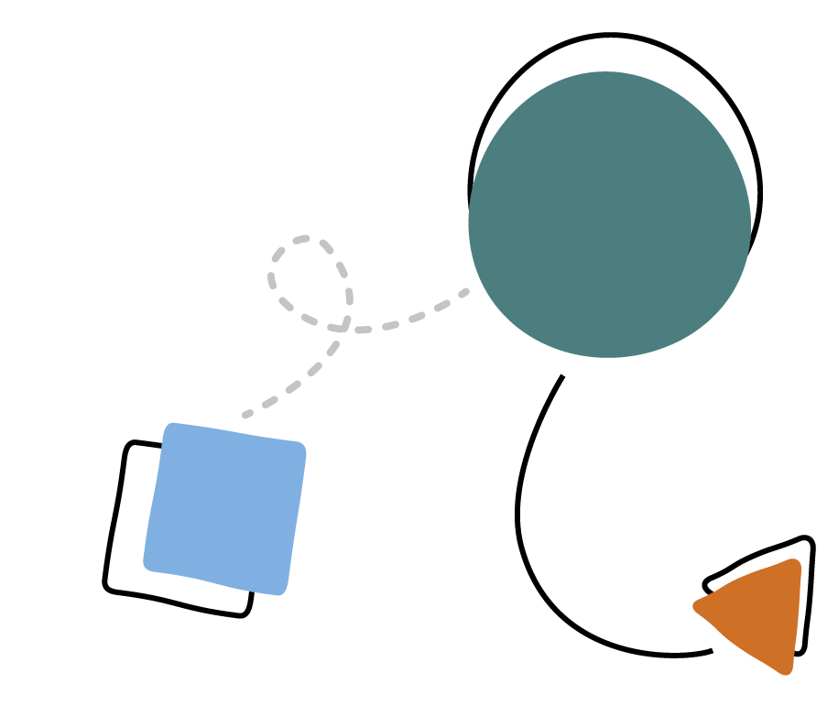As recognised in Closing the Gap, Aboriginal and Torres Strait Islander community control is an act of self-determination.76 Aboriginal and Torres Strait Islander community-controlled organisations deliver services that build on the strengths of and empower Aboriginal and Torres Strait Islander communities and people. ACCOs are controlled by and accountable to the Aboriginal and Torres Strait Islander peoples in the areas in which they operate. They play a significant role in supporting families to remain connected to culture and country.77 ACCOs support self-determination for children, families and communities in matters related to the care and protection of their children.

## **Academia and research sectors**

Research is critical in informing policy, practice and implementation and benefits policy-makers, service providers and the broader community.

## **Role of the Australian community**

While parents have ultimate authority for making decisions about a child, other members of the family may be involved in the care and support of a child.

A child’s best interests are paramount in decisions and views expressed by a child must be considered.78

All community members can help to keep children safe by being aware of and responding to potential child abuse and neglect. There are a wide range of signs that a child is being abused or neglected. These signs do not necessarily mean that abuse or neglect is occurring. It is important to consider the context or any other vulnerabilities the child may be experiencing.

1. Joint Council on Closing the Gap, [National Agreement on Closing the Gap](https://www.closingthegap.gov.au/national-agreement).
2. Productivity Commission, Expenditure on children in the Northern Territory study report, Commonwealth of Australia, Canberra, 2020.
3. Australian Government Federal Register of Legislation, [Family Law Act 1975](https://www.legislation.gov.au/Details/C2019C00182).



# Appendix B: Glossary

Note: the definitions below are in the context of the National Framework. They are not exhaustive and there may be differences in definitions across the literature and

across jurisdictions.

## **Active efforts**

Active efforts are purposeful, thorough and timely, supported by legislation and/or policy and enable the safety and wellbeing of Aboriginal and Torres Strait Islander children. Active efforts encompass a variety of strategies to support Aboriginal and Torres Strait Islander children’s connection to family, culture, community and country is maintained.79

## **At risk**

Refers to children, young people and families whose circumstances are causing concern for the safety and/or welfare of the child or young person.

## **Child abuse and neglect**

The World Health Organization defines child abuse and neglect as ‘all forms of physical and/or emotional ill-treatment, sexual abuse, neglect or negligent treatment or commercial or other exploitation, resulting in actual or potential harm to the child’s health, survival, development or dignity in the context of a relationship of responsibility, trust or power’.80

**Child protection**

Services and systems provided by state and territory departments to assist vulnerable children who are suspected of being abused, neglected or harmed, or whose parents are unable to provide adequate care and protection.

## **Children**

Individuals under the age of 18, in line with the United Nations *Convention on the Rights of the Child*.81

## **Children and families who are experiencing disadvantage and/or are vulnerable**

In the context of the National Framework, this refers to a child/family who experience(s) a condition or circumstance that places them at a higher risk of child abuse or neglect when compared to the general population. These conditions/circumstances are those that

evidence indicates are related to the risk factors associated with child abuse and neglect.

## **Collective effort**

Refers to where the Australian Government and state and territory governments can make an impact through a national approach. This is in contrast to focusing on individual

Commonwealth, state or territory government reforms.

1. SNAICC, [The Aboriginal and Torres Strait Islander Child Placement Principle](https://www.snaicc.org.au/wp-content/uploads/2019/06/928_SNAICC-ATSICPP-resource-June2019.pdf).
2. World Health Organization (WHO), [Preventing child maltreatment: A guide to taking action and generating evidence](https://apps.who.int/iris/handle/10665/43499), WHO, Geneva, 2006.
3. [Convention on the Rights of the Child](https://www.ohchr.org/EN/ProfessionalInterest/Pages/CRC.aspx).

## **Community-led**

A community-led approach means that a policy or program is supported, developed, delivered and evaluated by, or in consultation with, the community or group that will be impacted by the policy or program.

## **Culturally safe**

The term ‘cultural safety’ can be defined as referring to an environment that is safe for people: where there is no assault, challenge or denial of their identity, of who they are and what they need. It includes shared respect, shared meaning and shared knowledge and experience of learning, living and working together with dignity and truly listening. Culturally safe service provision is important across all areas of operation, including governance, workforce and relationships with communities.

In the context of child safety, cultural safety includes the child being provided with a safe, nurturing and positive environment in which they are comfortable with being themselves and expressing their culture, spiritual and belief systems and are supported to do so by parents, carers or frontline staff.82

## **Disability**

People with disability include, but are not restricted to, those who have long-term physical, mental, cognitive, intellectual or sensory impairments. The social model of disability recognises attitudes, practice and structures

can be disabling and act as barriers preventing people from fulfilling their potential and exercising their rights as equal members of the community.83

## **Early intervention**

Refers to initiatives and actions designed to alter the behaviour or trajectory of individuals who show signs of, risk factors for or vulnerabilities to an identified problem, by providing the resources and skills needed to combat the identified risks. One of the goals of early intervention is to prevent escalation to serious issues that may require a more intensive response involving child protection systems.84

The National Framework uses the terms ‘early intervention’ and ‘early support’ interchangeably. Early intervention is often used when talking about public health models, which aim to ‘prevent problems occurring in the first place by targeting policies and interventions at the known risk factors for the problem, quickly identifying and responding if they do occur and minimising the long-term effects of

the problem’.85

In child protection, the public health model ranges from primary intervention services that target everyone, to secondary or early intervention services that target families in need, through to tertiary intervention services that target families where abuse and neglect has already occurred.86

## **Investigation**

The process by which departments gather more information about a child involved in a notification. Staff assess the harm or degree of harm to the child and their protective needs.

Investigations may include sighting or interviewing the child where practical.87



1. SNAICC, [Cultural safety](https://www.supportingcarers.snaicc.org.au/connecting-to-culture/cultural-safety/), SNAICC, n.d.
2. AIHW, [Child protection Australia 2019–20](https://www.aihw.gov.au/reports/child-protection/child-protection-australia-2019-20/summary).
3. SNAICC, [Cultural safety](https://www.supportingcarers.snaicc.org.au/connecting-to-culture/cultural-safety/).
4. AIFS, Defining the public health model for the child welfare services context, AIFS, Canberra, 2014, paragraph 4.
5. AIFS, Defining the public health model for the child welfare services context, AIFS, Canberra, 2014.
6. AIHW, [Child protection Australia 2019–20](https://www.aihw.gov.au/reports/child-protection/child-protection-australia-2019-20/summary).

## **Multiple and complex needs**

Families with multiple and complex needs can have differing needs across different family members, such as disability, alcohol and other drug use and mental health concerns. Other risk factors may be present as well, such as domestic and family violence, or a lack of access to suitable housing and employment.

## **Notification**

A notification is a report made to a child protection department alleging child abuse/ neglect, child maltreatment or harm to a child. These reports can be made by individuals or organisations.88

## **Out-of-home care**

Generally, out-of-home care is overnight care for children aged under 18 who are unable to live with their families due to child safety concerns. It is a medium or long-term arrangement when there is a high level of risk determined by child protection or when parents cannot care for their children for a time.

This includes placements approved by the department responsible for child protection for which there is ongoing case management and financial payment (including where a financial payment has been offered but has been declined by the carer).89

## **Parties**

Stakeholders involved in the National Framework and its implementation, as determined by its governance structure. This includes Commonwealth, state and territory governments, NGOs and Aboriginal and Torres Strait Islander representatives.

## **Trauma-informed**

There is not yet a common definition of a ‘trauma-informed approach’ or ‘trauma-informed care’. Principles of trauma-informed approaches and care include:

* having a sound understanding of the prevalence and nature of trauma and its impacts on people’s development and functioning
* organisational and operational practices promoting the physical, psychological and emotional safety of people who have experienced trauma
* adopting service cultures and practices that empower people in their recovery, by emphasising autonomy, collaboration and strengths-based approaches
* recognising and being responsive to the lived, social and cultural contexts of people, which shape their needs as well as their recovery and healing pathways
* recognising the relational nature of both trauma and healing.

Principles such as Aboriginal and Torres Strait Islander peoples’ ownership, definition, design and evaluation of healing initiatives, and designing initiatives based on Aboriginal and Torres Strait Islander worldviews rather than Western health understandings alone, are other important considerations.90

A trauma-informed approach does not necessarily require a service to provide therapeutic treatment addressing the symptoms of trauma.

1. AIHW, [Child protection Australia 2019–20](https://www.aihw.gov.au/reports/child-protection/child-protection-australia-2019-20/summary).
2. AIHW, [Child protection Australia 2019–20](https://www.aihw.gov.au/reports/child-protection/child-protection-australia-2019-20/summary).
3. A Quadara & C Hunter, [Principles of trauma-informed approaches to child sexual abuse: A discussion paper](https://aifs.gov.au/publications/principles-trauma-informed-approaches-child-sexual-abuse), AIFS, 2016.

## **Self-determination**

Self-determination is a collective right of Aboriginal and Torres Strait Islander peoples to determine and control their own destiny. It is a right of Aboriginal and Torres Strait Islander peoples to exercise autonomy in their own affairs and to maintain and strengthen distinct political, legal, economic, social and cultural institutions.91

## **Shared decision-making**

Shared decision-making means that Aboriginal and Torres Strait Islander organisations are equal partners with government. In line with Closing the Gap, shared decision-making allows for transparency, with both parties receiving the same amount of information and having adequate time to review and understand the implications of decisions. It allows Aboriginal and Torres Strait Islander peoples to have their voices heard, including Elders, young people, women and Aboriginal and Torres Strait Islander people with a disability.92

## **Strengths-based**

A strengths-based approach recognises,

fosters and builds on a person’s skills, capacities and competencies. This approach recognises that each person already has skills and expertise in relation to their lives and their families. A strengths-based approach aims to enhance motivation, participation and realisation of identified goals and positive outcomes.93

## **Substantiation**

A substantiation is the result of a finalised investigation which concludes that there is reasonable cause to believe that a child has been, is being or is likely to be abused, neglected or otherwise harmed. This may include cases where children have no suitable caregiver.94

## **Services and systems**

Services are provided by governments or NGOs that aim to better the wellbeing of individuals.

Systems are a combination of processes and structures and are made up of numerous components, including agencies and organisations, funding and accountability arrangements. 95

Under the National Framework, a systems approach is defined as one that aims to address child abuse and neglect holistically, bringing a greater focus to early supports and strengthening the role of everyone involved in protecting children. This includes governments, NGOs, the community, parents and carers.

## **Young people**

Individuals aged between 15 and 24 years, in line with the United Nations’ definition.

The definition of young people may vary across policies and programs and between states and territories. It often includes individuals up to age 25.

1. [United Nations Declaration on the Rights of Indigenous Peoples: resolution / adopted by the General Assembly](https://www.un.org/development/desa/indigenouspeoples/declaration-on-the-rights-of-indigenous-peoples.html), GA Res 61/295, UN GAOR, 61st sess, 107th plen mtg, Supp No 49, UN Doc A/RES/61/295 (2 October 2007, adopted 13 September 2007).
2. Joint Council on Closing the Gap, [National Agreement on Closing the Gap](https://www.closingthegap.gov.au/national-agreement).
3. NSW Government, [Prevention and Early Intervention Strategies](https://www.facs.nsw.gov.au/providers/children-families/interagency-guidelines/prevention-and-early-intervention2/chapters/our-policy-context-what-does-the-evidence-say), 2021.
4. AIHW, [Child protection Australia 2019–20](https://www.aihw.gov.au/reports/child-protection/child-protection-australia-2019-20/summary).
5. Productivity Commission, [Introducing competition and informed user choice in human services](https://www.pc.gov.au/inquiries/completed/human-services/reforms/report).

# Appendix C:

National strategies and state and territory initiatives

## **National initiatives**



The National Framework will align with

other national initiatives that support children, young people and families to be safe. The Commonwealth, state and territory governments are working together so that actions are aligned and do not duplicate effort. We will achieve this through the National Framework’s governance structure and monitoring and evaluation strategy. Key national initiatives relating to the National Framework include the following, noting this is not an exhaustive list.

* + **National Agreement on Closing the Gap.** This aims to enable Aboriginal and Torres Strait Islander people and government to work together to overcome the inequality experienced by Aboriginal and Torres Strait Islander people. It aims to enable them to achieve life outcomes equal to all Australians. This includes outcomes in education, languages, employment, health, wellbeing, safety, land and waters for Aboriginal and Torres Strait Islander people.
* **National Aboriginal and Torres Strait Islander Health Plan 2021–2031**

**[to be released].** The plan’s vision is that ‘Aboriginal and Torres Strait Islander people enjoy long, healthy lives centred in culture, with access to services that are prevention- focused, culturally safe and responsive, equitable and free of racism’. The plan recognises that all health and wellbeing approaches must include the following foundations for a healthy life:

* holistic health and wellbeing
* the cultural determinants of health
* the social determinants of health
* a life course approach, including a focus

on healthy babies and children and healthy youth and adolescents.

* + **National Aboriginal and Torres Strait Islander Early Childhood Strategy.**

The strategy’s vision is that ‘Aboriginal and Torres Strait Islander children (0–5 years) are born and remain healthy, nurtured by strong families and enabled to thrive in their early years’. The strategy will aim to address outcomes across all Aboriginal and Torres Strait Islander young children’s lives.

This includes early learning, health, disability, wellbeing, care and development.

* + **National Disability Strategy 2010–2020 and Australia’s Disability Strategy 2021-2031.** The National Disability Strategy aims to improve outcomes for all people with disability through mainstream and specialist policies, programs and strategies across Australia.
  + **National Strategy to Prevent and Respond to Child Sexual Abuse 2021–2030.**

The strategy aims for children and young people in Australia to be protected and safe from sexual abuse in all settings and for victims and survivors of child sexual abuse to be supported and empowered. The National Strategy will reduce the risk, extent and impact of child sexual abuse and related harms in Australia and online.

* + **National Plan to Reduce Violence against Women and their Children 2010–2022 and its next plan.** The Plan’s vision is that Australian women and their children live free from violence in safe communities. It aims to reduce the levels of violence against women and their children.
  + **National Children’s Mental Health and Wellbeing Strategy.** The strategy provides a framework to guide investment in the mental health and wellbeing of children and families. The strategy outlines the requirements for an effective system of care for children and seeks to create a new, shared understanding of the roles of families, communities, services and educators in promoting and supporting child mental health and wellbeing.
* **Australia’s Youth Policy Framework**. The Commonwealth released Australia’s Youth Policy Framework in August 2021,

the result of extensive consultations with young Australians throughout 2019 and 2020. The Framework demonstrates the whole-of-Government efforts underway to support young people and outlines the Government’s commitment to continuing to work with young people on the issues that matter to them.

* **National Action Plan for the Health of Children and Young People 2020–2030.** The Action Plan’s vision is that all Australian children and young people, from all backgrounds and all walks of life, have the same opportunities to fulfil their potential and are healthy, safe and thriving. It aims to drive improvement in the health of all of children and young people across the life course, including children and young people who experience violence and abuse and children in out-of-home care.
* **National Strategic Framework for Information Sharing Between the Family Law and Family Violence and Child Protection Systems**, due to be considered in late 2021.
* **National Fetal Alcohol Spectrum Disorder (FASD) Strategic Action Plan 2018–2028.** The Strategic Action Plan aims to reduce the prevalence of fetal alcohol spectrum disorder and the impact it has on individuals, families, carers and communities. It provides a clear pathway of priorities and opportunities to improve the prevention, diagnosis, support and management of fetal alcohol spectrum disorder in Australia.

## **State and territory initiatives**

All states and territories are delivering their own initiatives to improve outcomes for children.

This includes those who are in or at risk of entering child protection and Aboriginal and Torres Strait Islander children.

### **Australian Capital Territory**

* + A Step Up for Our Kids – One Step Can Make a Lifetime of Difference (Out of Home Care Strategy 2015–2020).
  + Our Booris, Our Way.

### **New South Wales**

* + Family Is Culture Review Report 2019, Independent Review of Aboriginal Children and Young People in out-of-home care.
  + NSW Government response to the Family is Culture Review Report, 2020.

### **Northern Territory**

* + Safe, Thriving and Connected: Generational Change for Children and Families 2018–2023.

### **Queensland**

* Supporting Families Changing Futures 2019–2023.
* Our Way: A generational strategy for Aboriginal and Torres Strait Islander children and families 2017–2037.

### **South Australia**

* Safe and well: Supporting families, protecting children.

### **Tasmania**

* It takes a Tasmanian village: Child and Youth Wellbeing Strategy.
* Strong Families, Safe Kids.
* Safe Homes, Families, Communities: Tasmania’s Action Plan for family and sexual violence

2019-2022.

### **Victoria**

* Roadmap for Reform: Strong Families, Safe Children.
* Wungurilwil Gapgapduir: Aboriginal Children and Families Agreement.

### **Western Australia**

* Building Safe and Strong Families: Earlier Intervention and Family Support Strategy.

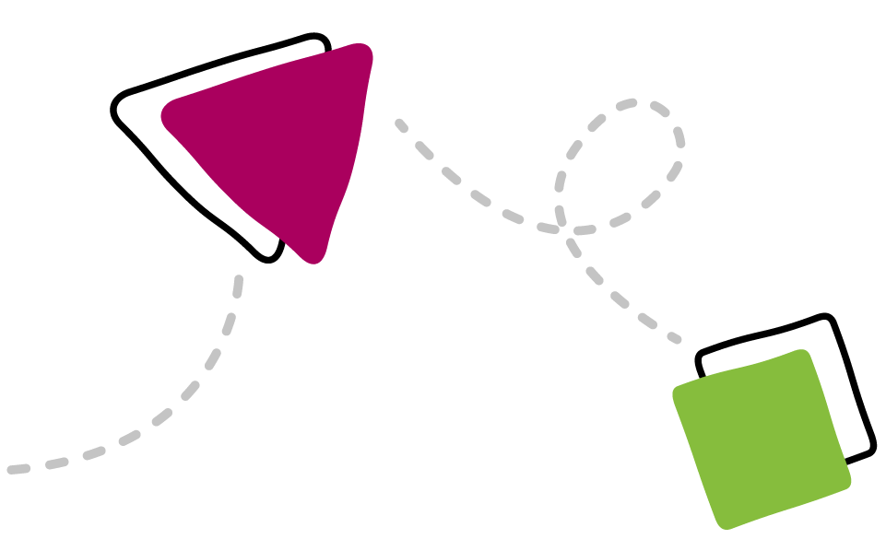

# Appendix D: Summary of consultations

## **National consultations**

In 2019 and early 2020, Families Australia convened nationwide workshops and consultations on the future of national child and family wellbeing policy. Nearly 800 participants from government, non-government, research and community backgrounds as well as young people, carers and families were involved.



The consultations96 found the National Framework should:

* + strengthen the focus on wellbeing, including child safety and protection
  + strengthen the focus on early supports, including prevention and early intervention
  + listen and respond to the voices of children, young people and families better
  + emphasise activities that support key cohorts, especially Aboriginal and Torres Strait Islander children and families
  + improve data, evaluation and reporting.

The successor

to the National Framework must drive real change by galvanising collective effort

across governments, sectors and disciplines in actions that evidence tells us will prevent children, young people and families entering

child protection systems, over time.98

1. Families Australia, [Beyond 2020: Towards a successor plan for the National Framework for Protecting Australia’s](https://familiesaustralia.org.au/about/beyond-2020/) [Children 2009–2020](https://familiesaustralia.org.au/about/beyond-2020/).
2. Families Australia, [Beyond 2020: Towards a successor plan for the National Framework for Protecting Australia’s](https://familiesaustralia.org.au/about/beyond-2020/) [Children 2009–2020](https://familiesaustralia.org.au/about/beyond-2020/), p. 6.

## **Evaluation of the first National Framework**

In 2020, PricewaterhouseCoopers completed an evaluation of the first National Framework, focusing on the Third and Fourth Action Plans (the Evaluation).98

The Evaluation found that the National Framework was important for national collaboration on protecting Australia’s children. Additionally, it found that reducing child abuse and neglect remains a significant challenge

for Australia.

The Evaluation highlighted 5 key opportunities for the new National Framework:

* + - improve the services system to better support children and their families experiencing vulnerability
    - establish a governance structure that enables greater involvement of other portfolios
    - adopt an outcomes framework to guide and measure efforts
    - implement independent monitoring and reporting
    - give children, families and communities the opportunity to inform the new National Framework.

The Evaluation defined a service system approach as focusing on policies and systems where the National Framework can have the greatest impact. This is in comparison to focusing on the operational detail of how child

protection-related services are delivered in each state and territory.99

This means having the Australian Government and state and territory governments working together to coordinate and identify improvements to services for vulnerable and disadvantaged children across all relevant portfolios. This includes child maternal health, early childhood, school education, housing, justice and family and parenting services.100 This could include national consistency in information sharing as well.

## **Aboriginal and Torres Strait Islander consultations**

In early 2021, SNAICC – National Voice for our Children, the national peak body for Aboriginal and Torres Strait Islander children, led consultations with Aboriginal and Torres Strait Islander communities and organisations to guide the development of the National Framework.

Consultations were held with Aboriginal and Torres Strait Islander Elders, carers, Aboriginal community-controlled organisations, non- Indigenous organisations and government representatives. SNAICC held 12 national consultations around Australia and received over 450 responses through an online survey.



1. Department of Social Services and PricewaterhouseCoopers, Ev[aluation of the National Framework for Protecting Australia’s](https://www.dss.gov.au/families-and-children-publications-articles/evaluation-of-the-national-framework-for-protecting-australias-children-2009-2020) Childr[en 2009–2020,](https://www.dss.gov.au/families-and-children-publications-articles/evaluation-of-the-national-framework-for-protecting-australias-children-2009-2020) PwC, 2020.
2. Department of Social Services and PricewaterhouseCoopers, Ev[aluation of the National Framework for Protecting Australia’s](https://www.dss.gov.au/families-and-children-publications-articles/evaluation-of-the-national-framework-for-protecting-australias-children-2009-2020) Childr[en 2009–2020, p](https://www.dss.gov.au/families-and-children-publications-articles/evaluation-of-the-national-framework-for-protecting-australias-children-2009-2020). v.
3. Department of Social Services and PricewaterhouseCoopers, Ev[aluation of the National Framework for Protecting Australia’s](https://www.dss.gov.au/families-and-children-publications-articles/evaluation-of-the-national-framework-for-protecting-australias-children-2009-2020) Childr[en 2009–2020, p](https://www.dss.gov.au/families-and-children-publications-articles/evaluation-of-the-national-framework-for-protecting-australias-children-2009-2020). v.

In these consultations, Aboriginal and Torres Strait Islander communities reflected on progress under the first National

Framework and on priorities for this framework. The outcomes of these consultations and the review reflected a high level of frustration and concern that systems and outcomes have not shifted to prevent the growing over- representation of Aboriginal and Torres Strait Islander children in out-of-home care.

Participants identified a range of issues, including areas where transformational change is required. These areas included:

* + greater accountability and transparency of child protection systems to Aboriginal and Torres Strait Islander communities and leaders
  + genuine self-determination for Aboriginal and Torres Strait Islander communities, families and children in child protection
  + building Aboriginal and Torres Strait Islander community-controlled organisations
  + stronger focus on prevention and early intervention
  + moving the system towards family support
  + championing Aboriginal and Torres Strait Islander kinship care
  + upholding the rights of the children and young people
  + connection to family, community and culture
  + culturally safe and healing-focused practice
  + workforce development – both improved support and empowerment of Aboriginal and Torres Strait Islander workers and improved cultural competency of non-Indigenous workers.

## **Children and young people consultations**

Children’s Commissioners in Australia play a vital role in protecting the rights of children and

young people, including their right to be heard.

In 2021, the National Children’s Commissioner, Anne Hollonds, led consultations with children and young people across Australia. These consultations will inform the first 5-year Action Plans of the National Framework.

The consultations sought feedback on what services and supports help children to stay safe and what could be improved. They informed us about how the views of children and young people can be considered in the Framework.

These consultations will help the National Framework to be child-centred and will help us better listen and respond to the voices of children, young people, families, carers and communities.



# Appendix E:

Key elements underpinning the National Framework

### Safe and Supported:

**the National Framework for Protecting Australia’s Children 2021–2031**

**Contains**

* **General scope of what we want to do** – what *Safe and Supported* aims to do, for who and why
* **Evidence base, consultations and principles** underpinning what we aim to do and why
* **Priority areas** under *Safe and Supported*

### To be released first half of 2022



Action Plan

Contains:

* **Specific activities** under S*afe and Supported*

With two Action Plans per five year period:

* A general Action Plan
* An Aboriginal and Torres Strait Islander specific Action Plan, co-designed with specific actions, outcomes and measures.

Outcomes Framework

Contains:

* **Specific approach** to achieving the goal and vision of *Safe and Supported*
* **Outcomes** for the priority groups
* **Measures** for the outcomes
* **Logic** underpinning the approach taken.

Performance and Evaluation Strategy

Contains processes to:

* **Track progress** towards the outcomes, goal and vision of *Safe and Supported*
* **Evaluate efforts** under

*Safe and Supported.*

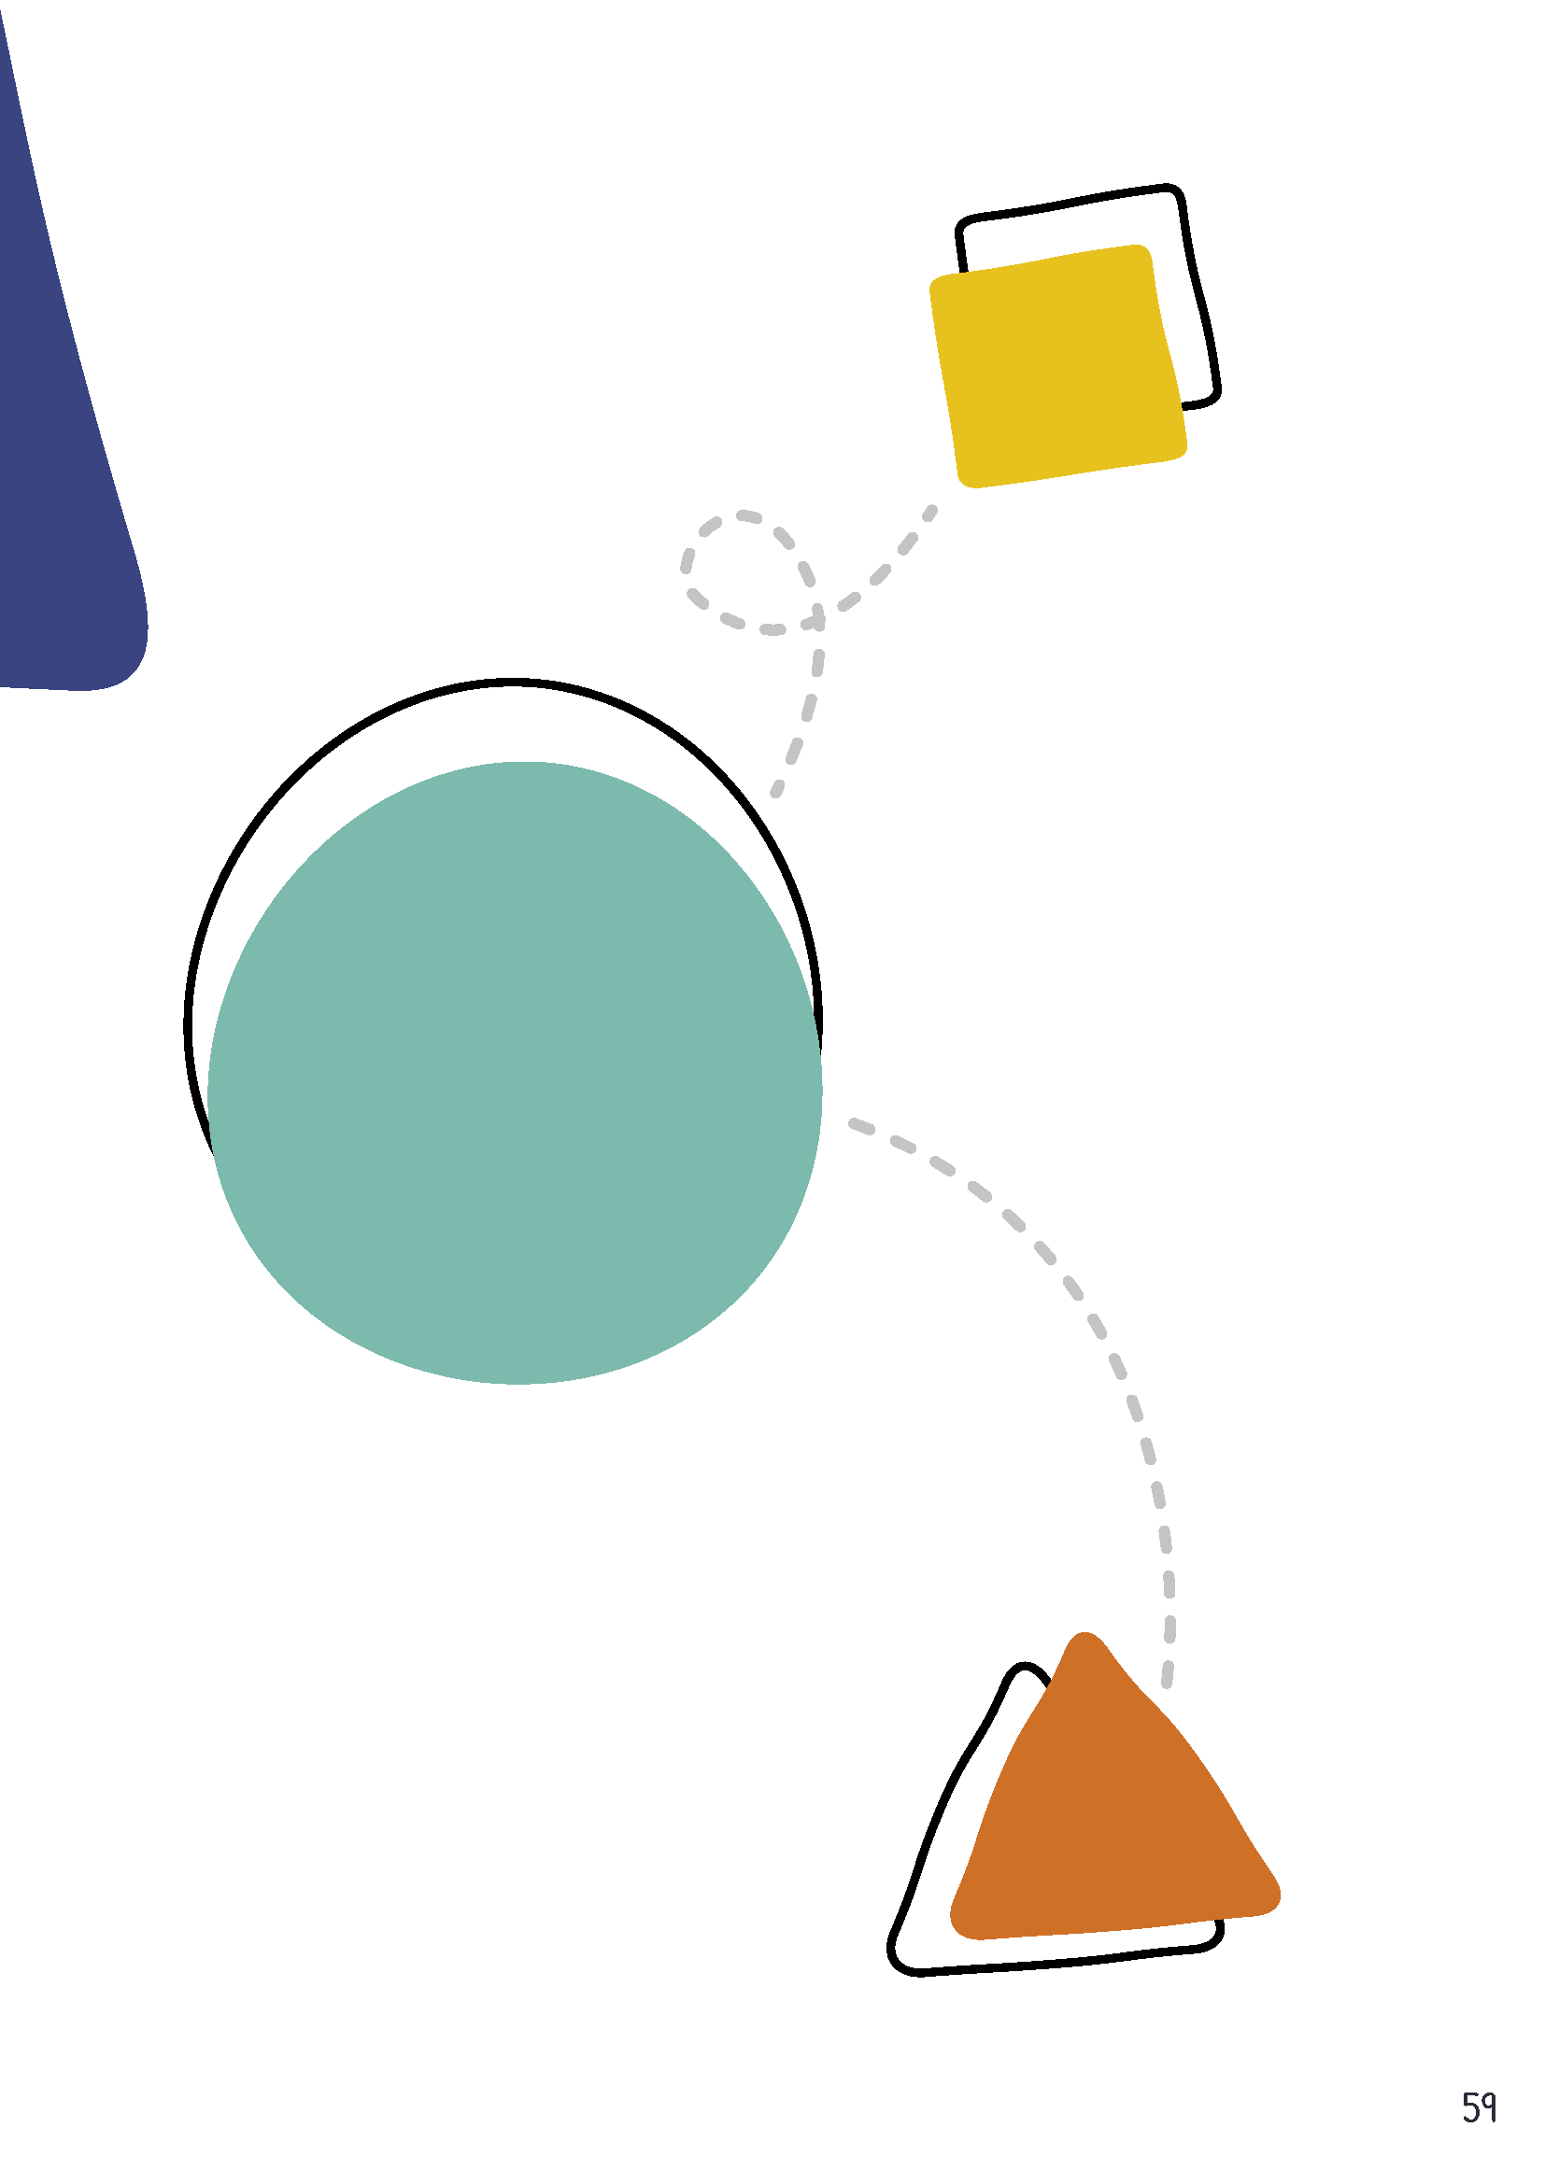

59

