Commonwealth, State and Territory Disability Ministers met on 6 June in Adelaide for the second DRMC meeting of 2025.

Disability Ministers welcomed the new Chair, Senator the Hon Jenny McAllister,   
Minister for the National Disability Insurance Scheme (NDIS) and the Hon Mark Butler MP, Minister for Health and Ageing, Minister for Disability and the National Disability Insurance Scheme.

Ministers welcomed the new Western Australian Disability Minister, the Hon Hannah Beazley MLA.

Ministers noted an update on work underway on NDIS pricing reforms aimed at driving better quality services in a stronger, well-functioning market. Ministers also received a briefing from the NDIA about their upcoming Annual Pricing Review, and discussed the critical importance of pricing in supporting the delivery of quality services, in particular for people with the highest needs and in regional and remote areas.

Ministers noted the new NDIS Evidence Advisory Committee (EAC) will be operational from 1 July 2025 and endorsed its Annual 2025-26 Work Plan. The Evidence Advisory Committee will guide expert reviews of disability supports throughout the year, in consultation with states and territories and other stakeholders.

Ministers also endorsed membership nominations for the NDIS Reform Advisory Committee, which will bring together the diverse voices of people with disability. The Committee will advise DRMC on the progress of implementation of disability reforms, with members to be publicly announced in the coming weeks following formal appointment processes.

Ministers reiterated their commitment to the implementation of the joint government response to the Disability Royal Commission recommendations as a priority for the DRMC and agreed to endorse the Biannual Report out of session by the end of August 2025.

Ministers also reiterated their continued commitment to progressing the 6 December 2023 National Cabinet commitment to secure the future of the NDIS, in parallel to work underway by Health Ministers to strengthen the health system. Ministers reaffirmed the National Cabinet commitment relating to the combined health and disability reforms that will see all states and territories better off.

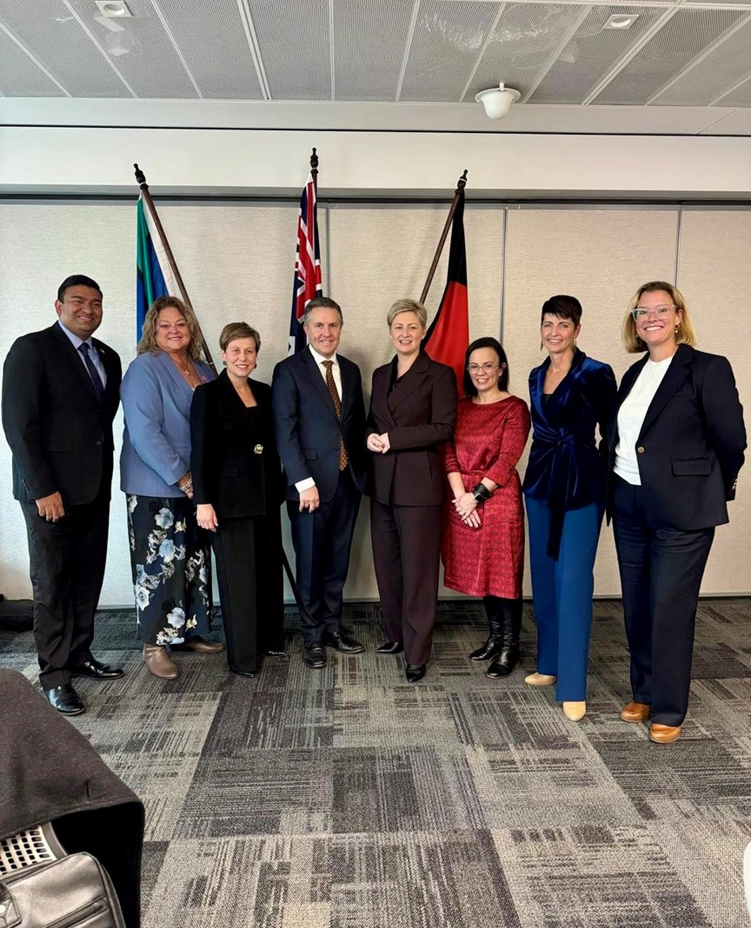

Image – Clockwise from left:

Minister Charls (NT), Minister Cook (SA), Minister McAllister (Minister for the NDIS), Minister Butler (Minister for Disability and the NDIS), Minister Camm (QLD),   
Minister Blandthorn (VIC), Minister Washington (NSW), Minister Beazley (WA).  
[Minister Palmer (TAS) and Minister Orr (ACT) joined the meeting online]