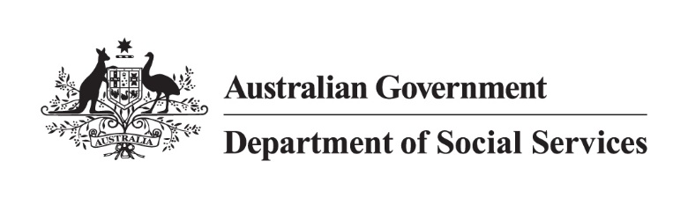

Disability Employment Services (DES)

Participant Job Plan – Factsheet

## What is a Job Plan?

A Job Plan describes how you and your DES provider will work together to help you prepare for, find, and keep a job. This includes activities you will do and the support your provider will give you.

You must agree to a Job Plan with your DES Provider to get DES services. Your provider will update your Job Plan when needed, so t it always describes your current plan for employment.

## How to develop your Job Plan

When you start in the DES program, you will need to meet with your DES provider. They will help create a Job Plan with you. They will talk to you about things like:

* what work you like to do
* what skills and education you have
* whether you need further training
* things that might make it hard for you to look for and keep a job
* how to write a resume and get ready for a job
* other supports that can help you.

Talk to your DES provider about the services or supports that are available.

## What you can include in your Job Plan

Your Job Plan can include things like:

* job search activities
* work experience placements
* education placements
* training to prepare you for employment.

Other services to support you working could include:

* counselling
* physiotherapy
* pain management counselling.

Talk to your DES provider about the types of supports you want to include in your Job Plan.

## Review and agree to your Job Plan

Once you and your DES provider have created your Job Plan, you will need to review and agree to the plan. This is a chance for you to think about your goals and make sure that your Job Plan suits your needs. You can agree to your Job Plan by:

* accessing the Job Seeker Dashboard via the Workforce Australia website or app
* signing a hard copy with your DES provider, who will upload your Job Plan into the system.

For you to receive support through DES, you must have a Job Plan. If you disagree with your Job Plan or have a question, start by talking to your provider. If you both don’t agree, then you can contact the National Customer Service Line via phone or email. Their contact details are at the bottom of this fact sheet.

Mutual obligation requirements

Mutual obligation requirements are the tasks you agree to complete for your income support payments which are made through Services Australia. For some DES participants, the mutual obligations will be **compulsory** and for others, they will be **voluntary**. Talk to your DES provider or Services Australia to learn about your mutual obligations.

A Job Plan with **compulsory** mutual obligations could include activities such as:

* entering into a Job Plan and meeting the requirements in your Job Plan
* attending all appointments with Services Australia and/or a DES provider
* actively looking for jobs, including acting on job referrals and attending job interviews with employers
* participating in activities that will help to improve your job prospects.

A participant without mutual obligations must have a **voluntary** Job Plan. A voluntary Job Plan will only include activities that you choose to complete. There is no penalty for not undertaking a planned activity.

You may already be meeting your mutual obligation requirements. To learn more, talk to your DES provider or visit the [Services Australia website](https://www.servicesaustralia.gov.au/what-your-commitments-are-for-disability-support-pension-dsp?context=22276).

## Updating your Job Plan

As a DES participant, you can choose the services you want and how you get them. Talk to your DES provider to change the activities in your Job Plan at your regular appointment. Your Job Plan must include any required activities, especially if you have mutual obligations. It should also reflect your current job and training goals, tailored to your situation.

## Need help with your Job Plan?

If you need help with your Job Plan, talk to your DES provider or contact the National Customer Service Line.

**1800 805 260**

[NationalCustomerServiceLine@dewr.gov.au](mailto:NationalCustomerServiceLine@dewr.gov.au)