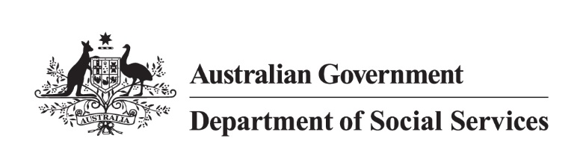

Disability Employment Programs

Information for young people with disability (School Leavers) factsheet

## Overview

Disability Employment Service (DES) provides Eligible School Leavers (ESL) with disability additional support during the transition from school into the workplace.

Within this factsheet you can find more information on ESL and other available supports for young people with disability.

## Who are Eligible School Leavers?

ESL is a person who is:

* under 22 years of age
* with a significant disability
* of legal working age
* needing assistance from study to post-school open employment
* able to work 8+ hours per week.

A person with a ‘significant disability’ refers to a person who has major barriers to employment and may require ongoing support in employment.

An ESL could be:

* in their final year of schooling
* exiting an eligible post-school employment
* in a work transition program
* exiting School Leaver Employment Supports (SLES) through the NDIS.

An ESL’s final year of schooling is generally Year 12, but may be earlier if the student, parents and school have agreed this will be the student’s final schooling year.

An ESL participant will have a physical or mental impairment that limits their functional capacity relating to:

* mobility
* communication
* self-care
* self-direction
* work tolerance
* work skills.

How can DES providers help?

A DES providers can help ESL participants with:

* writing a resume
* getting ready to work
* training in specific job skills
* writing job applications
* looking for jobs that suits you
* preparing for a job interview.

The [DES participant factsheet](https://www.dss.gov.au/disability-employment-reforms/resource/des-participant-information-pack) will provide you with more information on the program.

Please note an ESL participant:

* **Does not** need to be a NDIS participant to enter the DES program.
* **Will** need your own Centrelink Customer Reference Number (CRN) to access ESL.

## Other programs to help young people

There are other programs available to support young people with disability with their employment needs.

A few of these relevant programs are:

* Mental health support through headspace:
  + [Individual Placement and Support (IPS) program](https://www.dss.gov.au/mental-health-support#center)
  + [Digital Work and Study Service (DWSS)](https://www.dss.gov.au/mental-health-support#center)
* [Job Access and Employment Assistance Fund (EAF)](https://www.jobaccess.gov.au/i-am-a-person-with-disability/looking-applying-job/government-services-help-you/funding-workplace-changes/what-eaf)
* [School Leaver Employment Support (SLES)](https://www.ndis.gov.au/providers/working-provider/delivering-capacity-building-employment-assistance#employment-for-school-leavers) (For NDIS Participants)

ESL participants may be eligible to an extra payment, if they receive an income support payment. For more information, please visit [Youth Disability Supplement - Services Australia](https://www.servicesaustralia.gov.au/youth-disability-supplement).

## Do you need more information?

If you would like more information on the programs available to you, you can speak with a DES provider or contact the National Customer Service Line:

**1800** **805 260**

[NationalCustomerServiceLine@dewr.gov.au](mailto:NationalCustomerServiceLine@dewr.gov.au)