

# TILA Communication materials

Transition to Independent Living Allowance

DSS 3578.04.25

The following communication materials have been developed to assist you and your organisation promote TILA in:

* news items for your newsletters
* social media messaging and images for Facebook, Twitter etc.
* a web badge that can be added to your homepage and linked to the [Towards adulthood TILA](https://www.dss.gov.au/towards-adulthood/applying-transition-independent-living-allowance) webpage.

## Newsletter / article template

The following article has been designed to help you communicate general information about TILA. Please feel free to publish this article on your website, in your newsletters, on your noticeboards and in your communications about TILA.

**Please note**: The information below has been checked for factual accuracy. Please contact the Department of Social Services at [TILA@dss.gov.au](mailto:TILA@dss.gov.au) for approval if any amendments are made.

**Young people leaving out-of-home care**

Leaving care and moving to independent living can be a positive time in a young person’s life, but it can also be stressful. The Transition to Independent Living Allowance (TILA) can help make it easier for you. If you are 15 to 25 years old and are leaving or have left formal out-of-home care, you may be eligible for up to $1,500 to help you cover the basic costs to set yourself up. You may also be eligible for TILA if you decide to stay at home with your foster parents after your care order expires.

You will need to work with your caseworker on your leaving care plan and agree on what the payment will be used for and when. Your caseworker will apply for TILA on your behalf, manage the payment for you and help you buy the essential items or services you both agree on. These items can include a fridge, a couch, counselling, education and training courses, medical expenses, or a driver’s licence or lessons, and much more.

If you don’t have a caseworker, contact your [local state or territory government department](https://www.dss.gov.au/towards-adulthood/applying-transition-independent-living-allowance) for assistance.

If you think you might be eligible, talk to your caseworker or go to [www.dss.gov.au/tila](http://www.dss.gov.au/TILA) for more information or email the TILA Team at [TILA@dss.gov.au](mailto:TILA@dss.gov.au)

The Department of Social Services website also has links to a range of [support services](https://www.dss.gov.au/towards-adulthood/help-and-support-young-people) to help you find a place to live, get a job or find training, get financial advice, counselling or emotional support.

## Social media messaging

The following message can be used on social media (Facebook, X, Instagram) with the 238x238 graphic images:

#### Post 1

[Transition to Independent Living Allowance](http://www.dss.gov.au/tila) is a payment of up to $1,500 to help young people leave out-of-home care.

If you are 15 to 25 years old and are leaving or have left formal out-of-home care, you may be eligible.

To learn more, visit [www.dss.gov.au/tila](http://www.dss.gov.au/tila)

### Post 2

[Transition to Independent Living Allowance](http://www.dss.gov.au/tila) helps young people with leaving out-of-home care expenses.

If you are 15 to 25 years old and are leaving or have left formal out-of-home care, you may be eligible.

For more, visit [www.dss.gov.au/tila](http://www.dss.gov.au/tila)

## Website and linkage guidelines

More information about TILA can be found at [www.dss.gov.au/tila](http://www.dss.gov.au/tila).

The website includes information for young people leaving out-of-home care, caseworkers and support services.

By including a link on your website, you can help young people leaving out-of-home care access much needed support as they transition to independent living. A graphic image is available to help you highlight the payment (please see below).

## Web badge and banner

The Department can provide you with a web badge that you can use to link to the TILA information on the DSS website. To request a copy email us at [TILA@dss.gov.au](mailto:TILA@dss.gov.au)

Web badges and banner are available as a .jpeg and in the following formats:

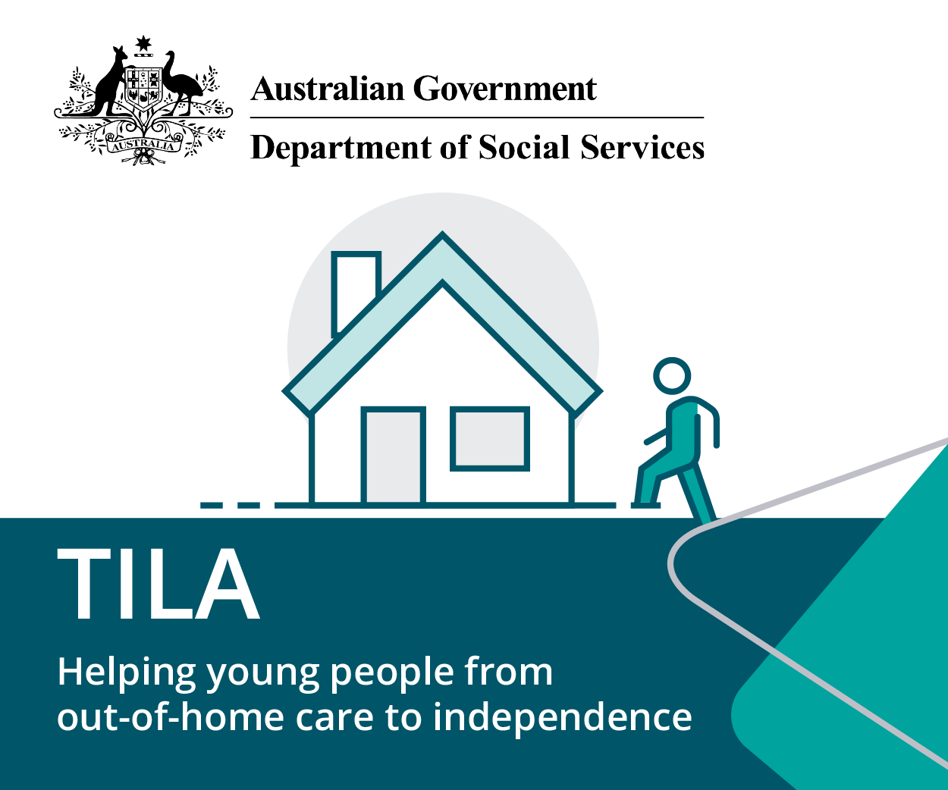

Medium rectangle: 300x250

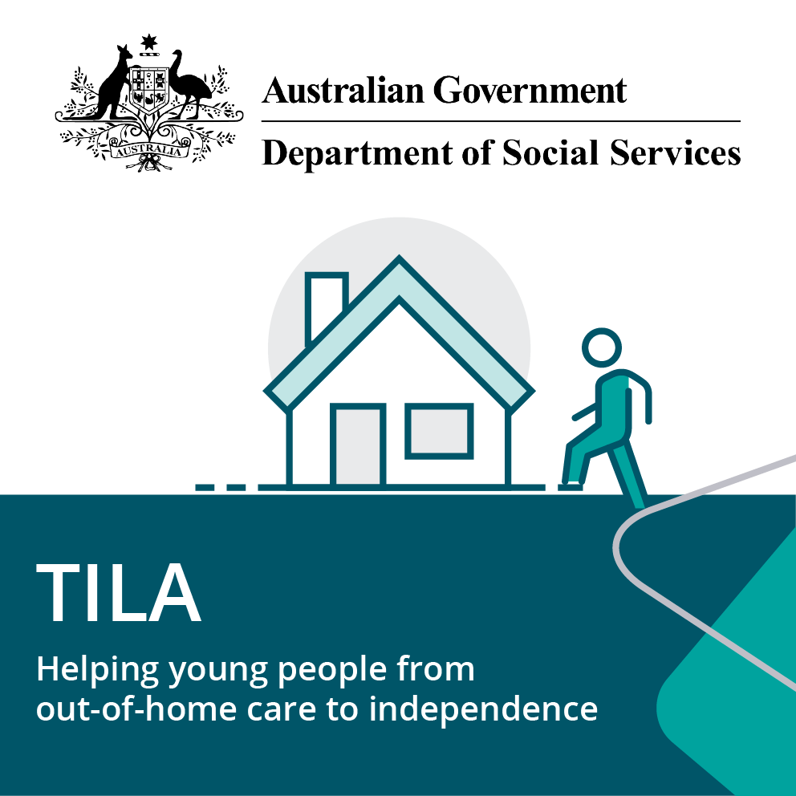

Square: 238x238



Web banner: 728x90

If you need an alternative format, please contact us at [TILA@dss.gov.au](mailto:TILA@dss.gov.au)

## Samples

Please upload graphics in combination with the text below, to provide your website visitors with more information about what they will see when they click through to the link.

Transition to Independent Living Allowance is a payment of up to $1,500 to help young people cover basic costs as they leave formal out-of-home care. Go to [www.dss.gov.au/tila](http://www.dss.gov.au/tila) for more information about TILA eligibility and other support services.

## Version History

**Version 1, 14 April 2025**

Release of document.