**Why these two sisters think every young person should volunteer**

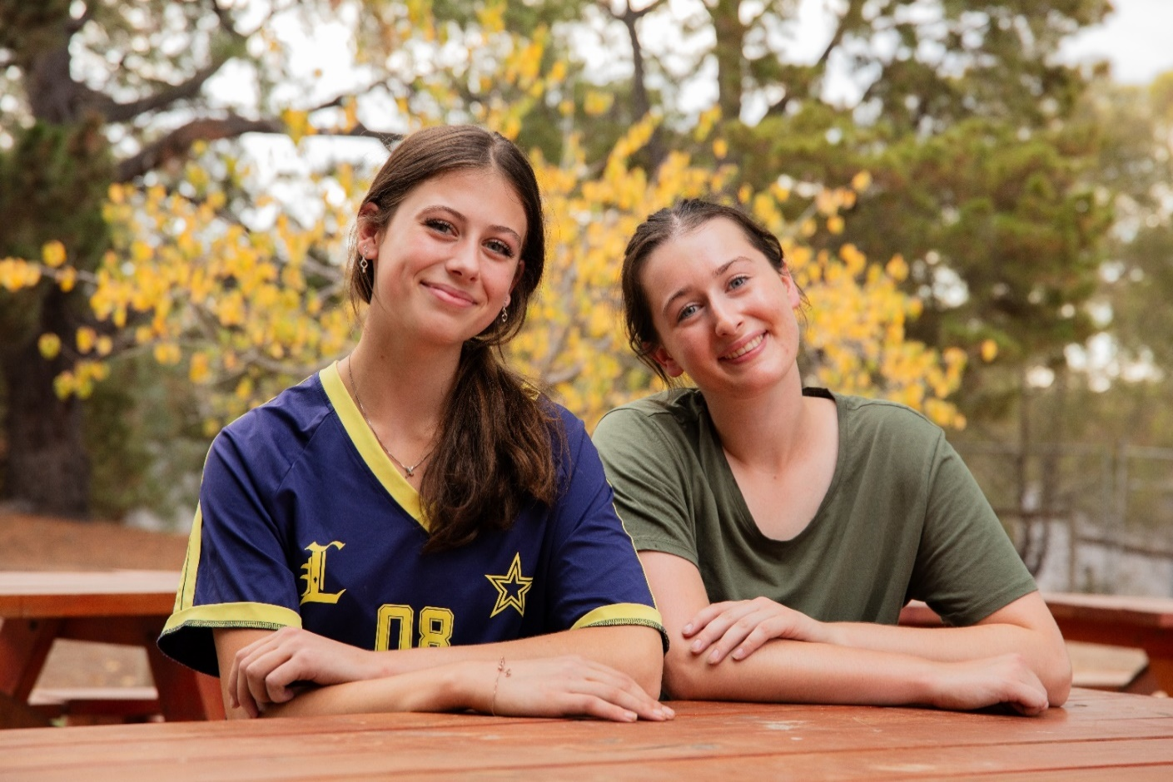

Pictured above: Grace and Claire

It’s a sunny morning at a campsite north of Melbourne where Claire and Grace are getting strapped in to take a turn on the giant swing.

Next up? Canoeing on the lake, followed by a round of games and campfire stories with their friends. It’s the kind of weekend most teens would dream of.

But for these two sisters, it’s just another day volunteering.

“We’ll get paired up with a kid who has a disability,” explains Grace, “our goal is to help them have the best day possible.”

Claire and Grace are part of Interchange Outer East, a disability support service that runs recreation programs and group outings for kids with disability.

As volunteers, they’ve been exposed to a whole range of new experiences from watching a Disney on Ice show, to attending a day out at the theme park.

While the activities have been a highlight, it's the connections that keep the duo coming back.

“Every single time we volunteer, we’re helping someone do something they might not otherwise get the chance to do,” says Claire.

“It’s fun, but it also feels really meaningful – especially when you get to do it with your friends.”

Inspired by their mum, who volunteered with the same organisation when she was 15, Claire and Grace couldn’t be more proud to continue the family tradition.

Over time, they’ve become part of a regular recreation group, which means they hang out with the same kids and volunteers each month.

“There’s one boy I support in particular, he’s always really excited to see me and runs up to give me a hug,” recalls Grace.

“It's the little moments like that I remember most.”

After encouraging a few of their own mates to join, the sisters say they’ve both built a friendship group around their volunteering gig.

And with nearly 20% of Australians aged 15-24 feeling lonely, that kind of in-person connection is more powerful than ever.

“I think it's important for young people to volunteer because it really opens up new opportunities and ways to connect,” says Claire.

When the sun sets at camp and the kids are tucked in, the volunteers often stay up playing games and chatting under the stars.

“You make so many friendships because you're all here for the same reason,” says Claire.

“You go in knowing you're helping someone else, but you also walk away with a whole new community.”