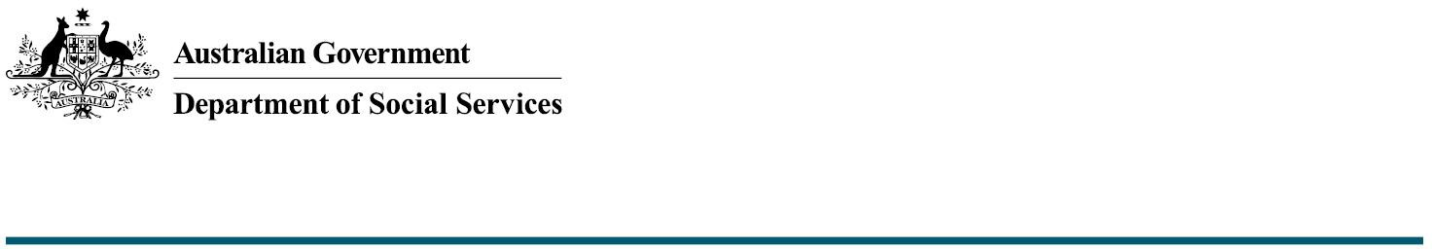

Inclusive National Parks

The Commonwealth Accessible Australia Initiative:

Increasing inclusion in Australian communities

The Australian Government is investing $17.1 million from 2024-25 to 2027-28 to increase inclusion in community spaces for people with disability across Australia through the Commonwealth Accessible Australia initiative (Accessible Australia).

Under Accessible Australia, the Australian Government will be providing funding for up to **100 per cent** of the total portable amenity cost for **inclusive national parks** to state and territory governments via Federation Funding Agreements (FFAs). For information regarding funding, please refer to the *Funding and Federation Funding Agreements* fact sheet.

What are inclusive national parks?

Accessible Australia will improve access to the natural environment for people living with disability and their carers. National parks are a key part of the Australian natural landscape.

Inclusive national parks incorporate access for people living with disability and their carers.

Inclusive national parks’ portable amenities may include:

* All-terrain wheelchairs: wheelchairs that allow visitors to access more rugged walking trails that are not otherwise accessible with conventional wheelchairs. They often have adjustable seating and supports, making them suitable for adults and children with varying abilities.
* Accessible paths: these modular systems provide temporary, wheelchair-accessible pathways for outdoor areas and can be placed on various terrains including gravel.

What funding is available for inclusive national parks?

Under Accessible Australia, the Commonwealth will provide up to 100 per cent of funding towards the cost/purchase of the proposed portable amenity. Applications for funding must be supported by an itemised quote.

Are all parks eligible for Accessible Australia funding?

Only national parks are eligible for Commonwealth funding under the Accessible Australia inclusive national parks funding offer. Urban parks are not eligible for funding under this offer.

Is there a maximum amount that can be applied for?

While there is no maximum funding amount that can be applied for, all proposals will be considered based on their merits. This includes location, community impact and value for money.

Are there any costs associated with inclusive national parks that are not eligible for Commonwealth funding?

All ongoing operational or maintenance costs are the responsibility of the funding recipient.

The Commonwealth reserves the right not to fund items it deems ineligible.

How long after receiving funding is building expected to commence?

Purchase of inclusive national park amenities must commence within 12 months of receiving funding. Proof of purchase must be provided to the Commonwealth.

Installation of amenities must be complete within 18 months of purchase. Inclusive national parks will be considered complete once amenities are purchased and available for public use (acknowledging this may be weather dependent).

Is there a maximum amount that can be applied for?

While there is no maximum funding amount that can be applied for, all proposals will be considered based on their merits. This includes location, community impact and value for money.

What needs to be included in a project plan for an inclusive national park?

Information regarding project plan requirements can be found in the *Applications, Project Plans and Progress* *Reporting* fact sheet.

Who can I contact for more information?

Further information and Frequently Asked Questions on Accessible Australia can be found on the [Department of Social Services website.](https://www.dss.gov.au/disability-support-services/changing-places)

The department can be contacted directly via email at [AccessibleAustralia@dss.gov.au](mailto:AccessibleAustralia@dss.gov.au).